Original Research Article
PCR-Based Assessment of Quinapyramine Di-methyl sulphate Efficacy Against Naturally Occurring Equine Surra in Eastern Uttar Pradesh, India

Abstract
Equine surra caused by Trypanosoma evansi is a major vector-borne haemoprotozoan disease responsible for significant economic losses and reduced working efficiency in horses. The present study was undertaken to evaluate the therapeutic efficacy of quinapyramine di-methyl sulphate and its ability to achieve parasite clearance in naturally infected horses using polymerase chain reaction (PCR)-based monitoring. A total of 12 indigenous horses from Ghazipur district of Uttar Pradesh, India, were included in the study. Six horses naturally infected with T. evansi were treated with quinapyramine di-methyl sulphate at a dose rate of 5.0 mg/kg body weight subcutaneously, while six PCR-negative horses served as healthy controls. Blood samples were collected on Days 0, 3, 7, 14 and 21 post-treatment and evaluated by parasitological examination, ISG-PCR targeting the 196 bp repetitive satellite DNA sequence of T. evansi, and antibody-ELISA.
Microscopic examination failed to detect parasitaemia from Day 3 onwards in treated horses, indicating a rapid reduction of circulating parasites. However, ISG-PCR revealed gradual parasite clearance, with 33.33%, 66.67%, and 50.00% of horses becoming PCR-negative on Days 3, 7, and 14–21 post-treatment, respectively. One relapse case was detected during the observation period, suggesting incomplete parasite elimination. ELISA results showed high antibody levels during the early post-treatment period, followed by a decline in relative percentage positivity (RPP) values from Day 14 onwards, indicating reduced antigenic stimulation following treatment. The findings demonstrate that quinapyramine di-methyl sulphate is effective in reducing parasitaemia and improving the clinical status of horses affected with surra. Nevertheless, persistence of PCR positivity and relapse in some animals indicate that a single therapeutic dose may not completely eliminate T. evansi infection. ISG-PCR proved to be a sensitive tool for monitoring treatment efficacy and detecting residual infections, emphasizing its utility in post-treatment surveillance of equine surra.
Keywords: Trypanosoma evansi, Equine surra, Quinapyramine di-methyl sulphate, Therapeutic efficacy, Parasite clearance, ISG-PCR, ELISA.
1. Introduction
Surra, caused by the haemoflagellate protozoan Trypanosoma evansi, is one of the most important vector-borne diseases affecting equines and other domestic animals. Among several health problems affecting equines, haemoprotozoan diseases such as Equine Trypanosomosis cause a serious threat to the equine’s population in respect of mortality and lowered draft power. Animal trypanosomosis caused by T. evansi, a haemoflagellate protozoan represent probably the most extensive group of vertebrate blood parasites. It influences a vast range of the hosts including horse, dog, camel, buffalo, elephant, pig and cat etc. The most severe disease found in camel, horses and dog. The serious disease entity in the Indian landmass occurs in equines and is known as Surra (a Hindi word meaning rotten) and is always fatal to the horses if treatment is not applied. Cattle and buffaloes act as reservoirs of the infection for equines (Soulsby, 2005). T. evansi is transmitted mechanically from the infected or carrier animal to healthy animals through the blood sucking dipteran flies belonging to the genera Tabanus, Stomoxys, Lypersia, Hippobosca and Haematopota. Transmission can also be vertical, horizontal, and iatrogenic with various epidemiological significances, depending on the season, location and host species (Desquesnes et al., 2013). The clinical signs of ‘surra’ in equines usually progresses through two distinct phases, mild to moderate and severe cases. The clinical signs are intermittent fever, progressive anaemia, weakness, petechial haemorrage on third eyelid, conjunctivitis, ventral and genital oedema and keratitis.
The effective control of vector-borne haemoprotozoan diseases requires rapid, authentic and most sensitive diagnostic tests. Chemotherapy and chemoprophylaxis are mainly responsible for the control of animal trypanosomosis, establishing animal health and production throughout the world. Although, most of the available animal anti-trypanosomal drugs are inadequate, obsolete and outmoded but only six are licensed currently. Mostly three drugs are used against animal trpanosomosis, viz. Diminazene aceturate, Quinapyramine sulphate and Isometamidium chloride in developing countries. Quanapyramine sulphate consequently reintroduced in 1984 to treat Trypanosoma brucei evansi in camels and horses (Peregrine, 1994), and is used till now (Ranjithkumar et al., 2014). This dug is unable to cross the blood brain barrier as the other charged anti-trypanocidal drugs therefore unable to cure T. evansi infection in CNS affected equines (Ranjithkumar et al., 2014). These drugs are in use for very long time and their reports of development of drug resistance due to its discriminatory use. So, there is need to monitor the efficacy of this drug in equine for effective control of disease. Therefore, the objective of the present study was to evaluate as per the PCR-Based Assessment of Therapeutic Efficacy and Parasite Clearance of commercially available Quinapyramine sulphate against naturally infected equine trypanosomosis recruited from Uttar Pradesh, India.
2. Material and methods
2.1 Ethical Approval:
Prior to the commencement of the study, ethical approval was obtained from the Institutional Animal Ethics Committee (IAEC) of Acharya Narendra Deva University of Agriculture and Technology (ANDUAT), Kumarganj, Ayodhya, Uttar Pradesh (Approval No. IAEC/CVSc/2/P-32/2020/26.
2.2 Recruitment of study animals
Animals for the study were selected from Ghazipur district of Uttar Pradesh, India. Based on information provided by local field veterinarians, several horses exhibiting clinical signs suggestive of T. evansi infection (Figs.1) were identified. Blood samples were collected from these suspected animals and transported to the Department of Veterinary Parasitology, ANDUAT, Kumarganj, Ayodhya, Uttar Pradesh, for laboratory examination. The presence of T. evansi was confirmed using Giemsa-stained blood smear examination. Horses that had received trypanocidal treatment within the preceding month, as reported by their owners, as well as those exhibiting neurological manifestations or suffering from other severe concurrent illnesses, were excluded from the study to minimize the risk of mortality and potential confounding effects during the experimental period.
2.3 Experimental design
The therapeutic efficacy of commonly used Quanapyramine sulphate drugs and its ability to achieve parasite clearance were evaluated in naturally infected indigenous working horses diagnosed with T. evansi infection. A total of 12 apparently healthy indigenous horses, all above two years of age, were enrolled in the study. Among them, six PCR-positive horses were allocated a treatment group (T-1) and other six PCR-negative horses served as the healthy control group (C). Prior to administration, the drug was prepared according to the manufacturers’ recommendations. Horses in Group T-1 were treated with quinapyramine di-methyl sulphate (Triquin®, Vetoquinol) at a recommended dose rate of 5.0 mg/kg body weight. The control group remained untreated throughout the study period (Table 1). At the time of investigation, this drug was routinely employed for the treatment of equine trypanosomosis in the study area. Supportive therapy, including nutritional and symptomatic management, was provided to treated animals whenever required. Clinical observations were recorded before treatment and at regular intervals thereafter. The efficacy of drug was assessed through monitoring of clinical recovery and molecular detection of T. evansi by PCR at predetermined post-treatment intervals to determine parasite clearance and identify any evidence of persistent infection or relapse.
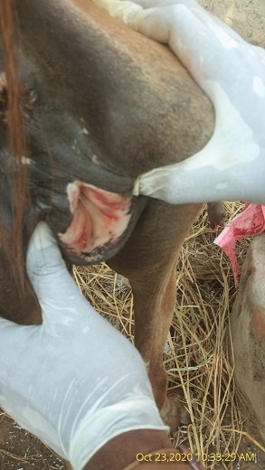
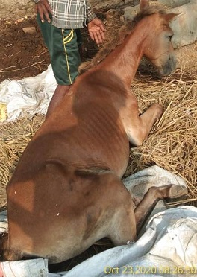

Fig. 1. Petechial haemorrhages on vaginal mucosa and surra infected horse.
2.4 Estimation of body weight of equine for calculation of drug doses
Body weight of equine was calculated by following formula developed by Carroll and Huntington, (1988) which used the body length and heart girth in centimeters to calculate weight of animals in kilograms. The formula is:

Table 1: Trypanoscidal drug, dose and route of administration on “0” day.
Groups  (No. of animals) | Drug | Dose | Concentration | Site | Rout of administration
T-1 (06) | Quinapyramine di-methylsulphate | 5.0 mg/kg body weight | 10 % | Neck region | S/C, using a 20g 1.5 inch needle
Control | Negative Control | - | - | - | -

2.5 Parameters measured before and after drug administration
Selected animals were subjected to estimation of following observations during pre and post drugs administration as shown in Table 2.

Table 2: Observations recorded during post drug administration
S.N. | Parameters | Values (methods) | Duration of estimation
1. | Parasitological Examination | MHCT and Geimsa staining | - Pre- treatment on 0-day.  - Post- treatment on 3, 7, 14 and 21 days.
2. | Molecular Diagnosis | Diagnostic PCR | - Pre- treatment on 0-day.  - Post- treatment on 3, 7, 14 and 21 days.
3. | Serological Diagnosis | Antibody ELISA | - Pre- treatment on 0-day.  - Post- treatment on 3, 7, 14 and 21 days.

2.6 Collection of blood samples
Approximately, 5 ml jugular vein blood was collected aseptically from each experimental animal in 10 ml sterilized disposable syringe (20 gauge 1.5 inch needle). For the assessment of anti trypanosomal drug efficacy in study, blood samples from a total 12 animals across 5 studies were used at day 0, 3, 7, 14 and 21 pre and post treatment. These specimens were used for evaluation of parasitological examination, molecular and serological diagnostic parameters (Table 2). Blood samples were collected in two collecting tube with and without anticoagulant (K3 EDTA vials and Clot activator vials).

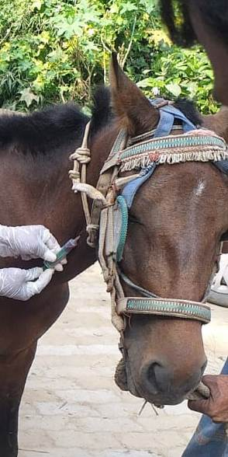 | 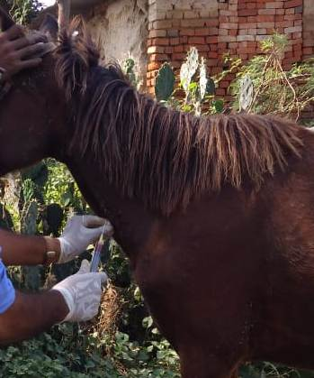

Fig. 2. Blood samples collection from equines
2.7 Parasitological examination
2.7.1 Microhaematocrit centrifugation technique (MHCT):
The blood samples with anticoagulant were assessed for the presence of parasite by MHCT (Woo, 1970), and examined under microscope (Fig.3).
2.7.2 Blood smear examination (BSE):
Thin Blood smears (about 3-5μl blood) were prepared. They were air dried and fixed with absolute methanol for 10 minutes. The fixed slides were stained with working dilution (1:10) of Giemsa stain (Qualigen) in PBS pH 7.2 for 45 minutes (Godfrey and Killick-Kendrick, 1961). They were examined under x1000 magnification with oil immersion for the presence and identification of blood protozoan (Fig.3).

Fig. 3. Parasitological examination by MHCT and BSE.
2.8 Molecular diagnosis
2.8.1 Isolation of T. evansi DNA
Total genomic DNA was extracted from whole blood using DNeasy Blood and Tissue Kit-50 (Qiagen India Pvt. Ltd., New Delhi) according to the manufa cturer’s instructions. Non-nucleated 100 µl blood was mixed with 20 µl proteinase K in 2 ml micro-centrifuge tube. Total volume was adjusted to 220 µl with PBS, then 200 µl buffer AL was added and vertexing properly. Blood sample was mixed with 200 µl absolute ethanol after incubation at 56ºC for 10 minutes. Total volume of sample was transferred into a DNeasy mini spin column available in kit and centrifuge at 8000 rpm (6080 x g) for 1 min. After discard the flow- through, added 500 µl buffer AW1 followed by buffer AW2 and centrifuge at 12000 rpm for 3 min. Finally, sample DNA was eluted by adding 30 µl buffer AE to the centre of spin column and stored at -40ºC for further use.
2.8.2 Polymerase Chain Reaction (PCR)
Molecular detection of T. evansi was performed using a conventional PCR assay targeting the repetitive mini-chromosome satellite DNA sequence of the parasite. Amplification was carried out using the species-specific primer pair ISG-F and ISG-R, which generates a diagnostic amplicon of 196 bp (Masiga et al., 1992; Kumar et al., 2016) (Table 3). PCR reactions were conducted in a final volume of 25 µL containing 12.5 µL of 2× TopTaq Master Mix (Qiagen), 0.4 µM of each forward and reverse primer, approximately 40 ng of genomic DNA template, and nuclease-free water to make up the final volume. Amplification was performed in a thermal cycler with an initial denaturation step at 95°C for 5 min, followed by 35 cycles of denaturation at 94°C for 30 s, primer annealing at 58°C for 30 s, and extension at 72°C for 30 s. A final extension step was carried out at 72°C to ensure complete synthesis of PCR products. The amplified PCR products were resolved by electrophoresis on 1.5% agarose gel containing an appropriate nucleic acid stain and visualized under ultraviolet light using a gel documentation system. Samples exhibiting a distinct band corresponding to 196 bp were considered positive for T. evansi infection (Table 4).
Table 3: Primers used for ISG-PCR
Oligo Name | Sequence | Length (bp) | Product size
ISG 196-F | 5ʹ AAAGCCACCGAAGATGCAGA 3ʹ | 20 | 196 bp
ISG 196-R | 5ʹ TTGTCCCAATCCAGCCACTC 3ʹ | 20 | 196 bp
Table 4: Optimization of ISG- PCR
Test | Component | Quantity | PCR conditions
ISG PCR | Top Taq Master mix | 12.5μl | Initial denaturation: 95°C for 5min.
ISG PCR | Primer forward (10μM/μl) | 1.0μl | Denaturation: 95°C for 30sec. | X 32
ISG PCR | Primer reverses (10μM/μl) | 1.0μl | Annealing: 58°Cfor 30 sec. | X 32
ISG PCR | Nuclease free water | 8.5μl | Extension: 72°C for 30sec. | X 32
ISG PCR | Template DNA | 2.0 μl | Final extension: 72°C for 10 min.
Total reaction volume |  | 25.0μl

2.9 Serological diagnosis
2.9.1 Indirect Enzyme-Linked Immunosorbent Assay (ELISA):
Serum samples were separated by centrifugation and preserved at −20°C until use. Detection of antibodies against T. evansi was performed using a whole-cell lysate (WCL) antigen-based indirect ELISA, following the protocol described by Kumar et al. (2013). ELISA plates were coated overnight at 4°C with 500 ng of WCL antigen diluted in carbonate-bicarbonate buffer (0.1 M, pH 9.6). Following washing with phosphate-buffered saline containing 0.05% Tween-20 (PBS-T), the plates were blocked with 5% skimmed milk in PBS-T and incubated at 37°C for one hour. Field serum samples diluted at 1:100 were added in duplicate and incubated for one hour at 37°C. After washing, anti-horse IgG conjugate diluted at 1:15,000 was added and incubated under similar conditions. Colour development was achieved using tetramethylbenzidine (TMB) substrate and the reaction was terminated using 1 M sulphuric acid. Optical density values were measured at 450 nm using an ELISA reader, and the mean absorbance of duplicate wells was recorded.

A test serum sample exhibiting RPP value above cut off was appraised serologically positive. A relative percent positivity value of 15% was appraised as cut off threshold to assess serologically positivity of test serum sample. (Kumar et al., 2013a).
2.10 Statistical Analysis
All statistical analyses were performed using GraphPad Prism software (Version 8.0.2), and differences were considered statistically significant at p < 0.05.
3. Results & Discussion
3.1 Evaluation of Quinapyramine di-methyl sulphate by parasitological observations:
Blood samples were subjected to MHCT and BSE techniques for the detection of T. evansi in experimental animals (Fig.2). On day 3 post treatment (PT), parasitaemia was not microscopically seen in all treated groups throughout the observation period. This shows the anti trypanosomal activity of drug under evaluation.
Singh et al., 2012 reported that the T. evansi was not seen in equine blood (MHCT, Giemsa’s staining) after administrating single dose of quinapyramine di-methyl sulphate on day 7 PT. Hota et al. (2019) reported that no parasitaemia was observed microscopically on day 3 PT with Quinapyramine compound of Sulphate and Chloride @ 4.4 mg/kg.b.wt, S/C in crossbred cattle infected with trypanosomosis. Kumar et al. (2012a) also recorded no parasitaemia in cows after 24 hrs of treatment with quinapyramine sulphate and chloride combination (Triquin). The therapeutic efficacy of quinapyramine sulphate in the current study is in the agreement with previous authors (Joshi et al., 2000; Raina et al., 2000; Rajesh et al., 2010; Yadav et al., 2012).
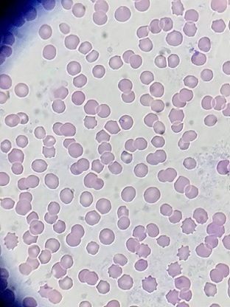
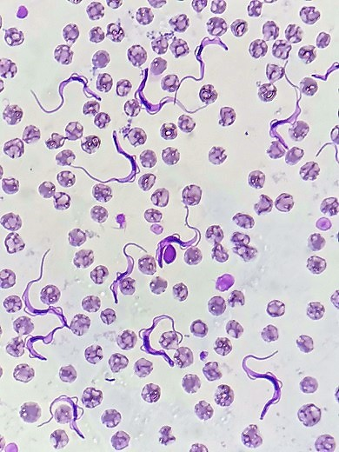
Fig. 4. Giemsa-stained blood smear in T-1 and C groups pretreatment (x100)
3.2 Evaluation of Quinapyramine di-methyl sulphate by ISG-PCR
The therapeutic efficacy of quinapyramine di-methyl sulphate against naturally occurring T. evansi infection in horses was evaluated using ISG-PCR over a 21-day post-treatment period (Table 5). Prior to treatment (Day 0), all six horses in T-1 group were PCR-positive for T. evansi, whereas the C group remained negative throughout the study period. Following administration of quinapyramine di-methyl sulphate, a gradual increase in PCR-negative animals was observed. On Day 3 post-treatment, 2 out of 6 (33.33%) treated horses became PCR-negative, while 4 (66.67%) remained PCR-positive. By Day 7, the number of PCR-negative animals increased to 4 out of 6 (66.67%), with only 2 animals (33.33%) remaining PCR-positive. However, on Day 14 post-treatment, the number of PCR-negative animals decreased to 3 out of 6 (50.00%), indicating relapse in one horse that had previously tested negative (Fig. ). The same pattern persisted until Day 21, with 3 animals (50.00%) remaining PCR-negative and 3 animals (50.00%) PCR-positive. One relapse case was recorded during the post-treatment monitoring period. The findings indicate that quinapyramine di-methyl sulphate effectively reduced T. evansi parasitemia in treated horses, achieving a maximum molecular clearance rate of 66.67% by Day 7. However, the occurrence of relapse and persistent PCR positivity in some animals suggests incomplete parasite elimination in all treated horses.

Table 5: Evaluation of T. evansi clearance using ISG-PCR in horses pre and post treatment against T. evansi infection.
Group (No. of animals) |  | C (n=6) | T (n=6)
Drugs |  | - | Quinapyramine di-methyl sulphate
Treatment | Day | PCR Negative | PCR Positive | PCR Negative | Relapse no.
Pre | D-0 | 6 | 6 | 0 | 0
Post | D-3 | 6 | 4 | 2 | 0
Post | D-7 | 6 | 2 | 4 | 0
Post | D-14 | 6 | 3 | 3 | 1
Post | D-21 | 6 | 3 | 3 | 1

Similar finding was observed by previous authors (Jatau et al., 2010; Aregawi et al., 2020). Aregawi et al. (2020) who reported that the standard doses of anti trypanosomal drugs failed to totally eliminate T. evansi parasites from the infected mice as relapses occurred three weeks after treatments. In some other studies, single dose of anti trypanosomal drug was observed unsuccessful for the treatment of trypanosomosis in buffalos, horses, dogs and mules (Lun et al., 1991; Colpo et al., 2005; Da Silva et al., 2008; Howes et al., 2011). Ranjithkumar et al. (2014) reported that quinapyramine di-methyl sulphate was not able to eliminate T. evansi from the central nervous system of animals because of its incapacity to cross the blood–brain barrier. The results of the present study indicated that the therapeutic efficacy of quinapyramine di-methyl sulphate was good against equine trypanosomosis. There are two types of Trypanocides, curative and chemo prophylactic drugs. Curative trypanocidal drugs can kill the parasites but not eliminate the parasites completely from host body and have a have a short-term effect. The chemo prophylactics trypanocidal drugs have both curative and preventive properties. Quinapyramine prosalt compound was the first prophylactic drug accessible for animal trypanosomosis developed from previously used trypanocide Surfen C (Curd and Davey, 1950). After 1976, it was back away from many areas due to the development of resistance and afterward reestablished in 1984 to treat T. evansi especially in camels and horses (Peregrine, 1994), and is still used today (Ranjithkumar et al., 2014). It is considered the most effective drug for acute equine trypanosomosis (Auty et al., 2008). The single recommended dose of quinapyramine di-methyl sulphate was observed with low therapeutic efficacy. It may be due to incapability to cross the blood brain barrier, which explains its failure to cure trypanosoma infections in equids when the central nervous system is affected which might results in relapse of parasite in peripheral blood circulation of equines (Ranjithkumar et al., 2014). Joshi and Singh, (2000) observed that relapse of T. evansi after administration of quinapyramine sulphate and chloride has been attributed to survival of T. evansi in CNS fluid as the drug could not penetrate the blood brain barrier.
Overall, the results suggest that quinapyramine di-methyl sulphate remains an effective therapeutic option for equine surra; however, its inability to completely eliminate parasites from certain tissue compartments may contribute to relapse and persistent infection. Further studies involving extended treatment protocols, combination chemotherapy, and longer post-treatment monitoring periods are warranted to improve parasite clearance and minimize recurrence of the disease.
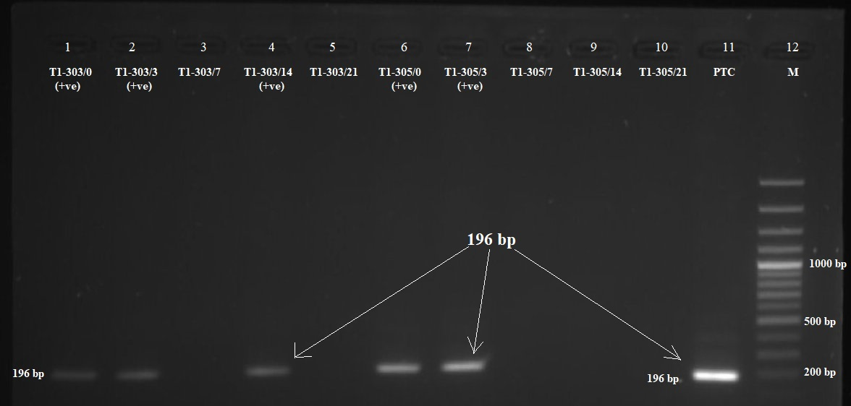
Fig. 5. Agarose gel electrophoresis showing ISG-PCR amplification of the 196 bp T. evansi-specific fragment in two naturally infected horses (TI-303 and TI-305) before and after treatment with quinapyramine di-methyl sulphate. Lanes 1–5 represent horse TI-303: lane 1 (Day 0, pre-treatment), lane 2 (Day 3), lane 3 (Day 7), lane 4 (Day 14), and lane 5 (Day 21) post-treatment. Lanes 6–10 represent horse TI-305: lane 6 (Day 0, pre-treatment), lane 7 (Day 3), lane 8 (Day 7), lane 9 (Day 14), and lane 10 (Day 21) post-treatment. Amplification of the 196 bp fragment was observed in lanes 1, 2 and 4 of TI-303, and lanes 6, 7 and 10 of TI-305, indicating persistence/relapse of T. evansi infection at respective sampling intervals. Lane 11: positive control (PTC); Lane 12: 100 bp DNA ladder (M).

3.3 Evaluation of trypanocidal drugs using indirect-ELISA
The humoral immune response in horses naturally infected with Trypanosoma evansi was monitored using antibody-ELISA by measuring the Relative Percentage of Positivity (RPP) before and after treatment with quinapyramine di-methyl sulphate (Table 6). Before treatment (Day 0), the mean RPP value in the treated group was 75, indicating a high level of anti-T. evansi antibodies, whereas the control group showed a low RPP value of 3. Following treatment, the RPP values in the treated horses increased to 90 and 91 on Days 3 and 7, respectively. This transient rise in antibody levels may be attributed to the release of parasitic antigens following drug-induced parasite destruction, resulting in enhanced antibody production. Subsequently, a marked decline in RPP values was observed in the treated group, decreasing to 50 on Day 14 and remaining nearly unchanged at 51 on Day 21 post-treatment. The reduction in antibody levels corresponded with the molecular clearance of T. evansi detected by ISG-PCR, suggesting a favorable therapeutic response to quinapyramine di-methyl sulphate. In contrast, the control group exhibited consistently low RPP values throughout the study period, ranging from 3 to 11 (Fig. 6).
Overall, the ELISA results demonstrated a gradual decline in anti-T. evansi antibody levels following treatment, indicating reduced antigenic stimulation and supporting the efficacy of quinapyramine di-methyl sulphate in the management of equine surra.
Table 6: Relative percentage of positivity (RPP) in antibody-ELISA of pre and post treated horses naturally infected with T. evansi.
Group (No. of animals) |  | C (6) | T (6)
Drug |  | Non-treated | Quinapyramine di-methyl sulphate
Pre-treatment | D-0 | 03 | 75
Post treatment | D-3 | 05 | 90
Post treatment | D-7 | 08 | 91
Post treatment | D-14 | 11 | 50
Post treatment | D-21 | 07 | 51

Similar finding was noticed by previous workers (Luckins et al., 1978; Monzon, 1993; Monzon et al., 2003; Yadav et at., 2012). The results of present study showed that the high RPP value on day 3 to 7 PT suggest high level of antibodies in treated animals by day 3 to day 7 PT. This is in agreement with some previous reports. Yadav et at. (2012) had observed peak level of anti T. evansi antibody on day 10–14 post treatment in eight equines. The earlier authors had also reported a progressive decrease of their circulating antibodies titers after successful trypanocidal therapy (Luckins et al., 1978; Monzon et al., 2003; Yadav et at., 2012). Yadav et al. (2012) observed that majority of animals showed sharp antibody titres decline after anti trypanosomal treatment but low level persisted up to 180 days post treatment.
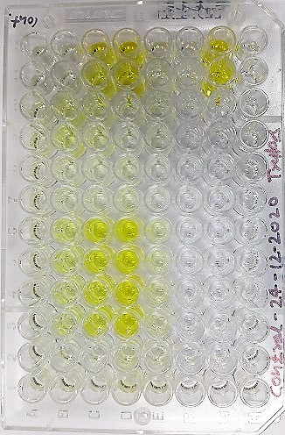
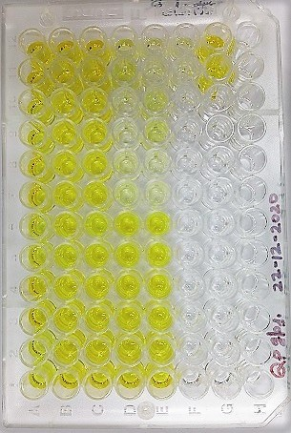

Fig. 6. Ab-ELISA plates of pre and post treated horses of T-1 and C groups equines.
4. Conclusion
The present study evaluated the response of naturally occurring equine surra to quinapyramine di-methyl sulphate using parasitological examination, ISG-PCR, and antibody ELISA. Following treatment, parasites were not detected microscopically from Day 3 onward, suggesting rapid reduction of circulating parasitaemia. However, ISG-PCR detected persistent T. evansi DNA in some treated horses during the post-treatment period. The highest molecular clearance was observed on Day 7, when 4 of 6 treated horses were PCR-negative. By Days 14 and 21, only 3 of 6 treated horses remained PCR-negative, and one relapse was recorded. ELISA findings showed a transient increase in antibody response during the early post-treatment period, followed by a decline, which may reflect reduced antigenic stimulation after treatment. Overall, quinapyramine di-methyl sulphate showed therapeutic activity against naturally occurring equine surra, but a single dose did not achieve complete PCR-confirmed parasite clearance in all treated animals within the 21-day observation period. These results support the use of molecular monitoring after treatment and indicate the need for longer follow-up and further evaluation of treatment regimens under field conditions.
Limitations
This study had several limitations. The number of treated horses was small, with only six PCR-positive animals included in the treatment group, limiting the strength of general conclusions. The follow-up period was restricted to 21 days after treatment, which may not be sufficient to detect late relapse or long-term parasite persistence. The study did not include an untreated infected control group or comparison with alternative trypanocidal drugs. Randomization and blinding were not described. Parasite burden was assessed by conventional PCR rather than quantitative PCR, so changes in parasite load could not be measured precisely. ELISA results were interpreted cautiously because antibodies may persist after treatment and do not necessarily indicate active infection. Possible tissue persistence, including central nervous system involvement, was not directly investigated. Further studies with larger sample sizes, longer monitoring periods, quantitative molecular methods, and comparative treatment protocols are needed.

Declaration of AI Use

This manuscript was prepared through the combined contributions of all author(s), including contributions to the study design, data, content development, results, interpretation, and related scholarly work. The author(s) acknowledge the use of Grammarly and ChatGPT to assist with grammar checking, language refinement, reference formatting. These AI-assisted tools were not used as authors and did not replace the intellectual contributions or scholarly judgment of the author(s). All AI-assisted outputs, including content, references, and interpretations, were carefully reviewed, revised, verified, and approved by the author(s). The author(s) accept full responsibility for the accuracy, integrity, and final content of the manuscript.

COMPETING INTERESTS DISCLAIMER:
Authors have declared that they have no known competing financial interests OR non-financial interests OR personal relationships that could have appeared to influence the work reported in this paper.
References
Aregawi, W.G., Agga, G.E., Abdi, R.D. and Buscher, P. (2020). Evaluation of the efficacy of
trypanocidal drugs against Trypanosoma evansi infection and occurrence of relapse following treatment. Veterinary Parasitology, 282: 109110.
Auty, H.K., Torr, S.J., Michoel, T., Jayaraman, S. and Morrison, L.J. (2008). Cattle
trypanosomosis: the diversity of trypanosomes and implications for disease epidemiology and control. Reviews in Science and Technology, 27: 239–251.
Carroll, C.L. and Huntington, P.J. (1988). Body condition scoring and weight estimation of
horses. Equine Veterinary Journal, 20: 41–45.
Colpo, C.B., Monteiro, S.G., Stainki, D.R., Colpo, E.T.B. and Henriques, G.B. (2005).
Natural infection by Trypanosoma evansi in dogs. Ciência Rural, 35: 717–719.
Curd, F.H.S. and Davey, D.G. (1950). Chemotherapy of trypanosomiasis. Development of
quinapyramine compounds for prophylaxis and treatment. British Journal of Pharmacology, 5: 25–38.
Da Silva, A.S., Zanette, R.A., Wolkmer, P., Costa, M.M., Garcia, H.A., Lopes, S.T.A. and
Monteiro, S.G. (2008). Diminazene aceturate in the treatment of canine trypanosomosis caused by Trypanosoma evansi. Veterinary Parasitology, 152: 335–338.
Desquesnes, M., Dargantes, A., Lai, D.H., Lun, Z.R., Holzmuller, P. and Jittapalapong, S.
(2013). Trypanosoma evansi and surra: A review and perspectives on transmission, epidemiology and control. BioMed Research International, 2013: 321237.
Godfrey, D.G. and Killick-Kendrick, R. (1961). A survey of blood parasites of domestic
animals in tropical regions using stained blood smears. Annals of Tropical Medicine and Parasitology, 55: 61–74.
Hota, S.K., Kumar, R., Yadav, S.C., Gupta, M.P. and Bera, B.C. (2019). Therapeutic
evaluation of quinapyramine in bovine trypanosomosis under field conditions. Indian Journal of Animal Sciences, 89: 1148–1152.
Howes, F.A., Bucheton, B., Büscher, P., Tasew, S. and Ducrotoy, M.J. (2011). Chemotherapy
of animal trypanosomosis and factors influencing treatment outcome. Parasites & Vectors, 4: 63.
Jatau, I.D., Abdullahi, S.U., Lawal, A.I., Agbede, R.I.S. and Haruna, M.K. (2010). Evaluation
of trypanocidal drugs in experimental Trypanosoma evansi infection. Veterinary Research Communications, 34: 517–527.
Joshi, P.P. and Singh, B. (2000). Relapse of Trypanosoma evansi infection following
quinapyramine treatment in equines. Indian Veterinary Journal, 77: 101–103.
Kumar, R., Kumar, S., Khurana, S.K., Yadav, S.C., Kumar, H. and Bera, B.C. (2012a). Evaluation of quinapyramine sulphate and chloride combination in bovine trypanosomosis.
Indian Journal of Animal Sciences, 82: 1272–1275.
Kumar, R., Kumar, S., Khurana, S.K., Yadav, S.C., Kumar, H. and Bera, B.C. (2013).
Development and validation of whole-cell lysate antigen-based indirect ELISA for diagnosis of Trypanosoma evansi infection. Veterinary Parasitology, 193: 153–160.
Kumar, R., Bera, B.C., Singh, V., Yadav, S.C. and Tiwari, A.K. (2016). Molecular detection
of Trypanosoma evansi using satellite DNA-based PCR assay. Journal of Parasitic Diseases, 40: 134–139.
Luckins, A.G., Boid, R., Rae, P.F. and Mahmoud, M.M. (1978). Serological responses
following chemotherapy in animal trypanosomosis. Tropical Animal Health and Production, 10: 177–184.
Lun, Z.R., Fang, Y. and Wang, C.J. (1991). Evaluation of trypanocidal drugs against
Trypanosoma evansi infection in livestock. Acta Tropica, 48: 147–154.
Masiga, D.K., Smyth, A.J., Hayes, P., Bromidge, T.J. and Gibson, W.C. (1992). Sensitive
detection of Trypanosoma evansi by amplification of repetitive nuclear DNA sequences. Molecular and Biochemical Parasitology, 51: 279–282.
Monzon, C.M. (1993). Serodiagnosis and post-treatment monitoring of surra in horses using
ELISA. Veterinary Parasitology, 48: 185–194.
Monzon, C.M., Mancebo, O.A. and Russo, A.M. (2003). Antibody kinetics following
treatment of equine surra. Veterinary Parasitology, 111: 79–86.
Peregrine, A.S. (1994). Chemotherapy and delivery systems: Haemoparasites. Veterinary
Parasitology, 54: 223–248.
Raina, A.K., Kumar, R., Rajora, V.S. and Yadav, S.C. (2000). Clinical efficacy of
quinapyramine in equine trypanosomosis. Indian Veterinary Journal, 77: 104–107.
Rajesh, K., Kumar, R., Yadav, S.C. and Bera, B.C. (2010). Evaluation of trypanocidal drugs
against naturally occurring surra in equines. Journal of Veterinary Parasitology, 24: 85–89.
Ranjithkumar, M., Bera, B.C., Kumar, R., Yadav, S.C. and Kumar, S. (2014). Therapeutic
limitations of quinapyramine against Trypanosoma evansi infection and its inability to cross the blood–brain barrier. Veterinary Parasitology, 206: 214–220.
Singh, V., Kumar, R., Yadav, S.C. and Bera, B.C. (2012). Therapeutic efficacy of
quinapyramine di-methyl sulphate against equine surra. Indian Journal of Veterinary Medicine, 32: 42–45.
Soulsby, E.J.L. (2005). Helminths, Arthropods and Protozoa of Domesticated Animals. 7th
Edition. Baillière Tindall, London.
Woo, P.T.K. (1970). The haematocrit centrifuge technique for the diagnosis of African
trypanosomiasis. Acta Tropica, 27: 384–386.
Yadav, S.C., Kumar, R., Bera, B.C., Khurana, S.K. and Kumar, S. (2012). Evaluation of
therapeutic efficacy of quinapyramine and antibody response in equines naturally infected with Trypanosoma evansi. Indian Journal of Animal Sciences, 82: 1145–1150.

