Original Research Article
Effects of birds, cracking, spoiling, and falling on the percent economic losses in four pomegranate varieties - Ganesh, Mridula, Bhagva, and Kandhari

ABSTRACT
A field investigation was undertaken at the Horticulture Research Farm of Chaudhary Charan Singh Haryana Agricultural University, Hisar, to document fruit production and major forms of preharvest damage in four pomegranate varieties: Ganesh, Mridula, Bhagva and Kandhari. Fruit numbers, cracked fruits, fallen fruits, vertebrate-damaged fruits and fruits harvested for sale were recorded from selected plants. Bird activity was monitored weekly, and spoilage was also observed during a short marketing period. The reported total fruit number per observational unit was highest in Ganesh at 106.1 ± 15.5 and lowest in Kandhari at 54.5 ± 4.7. Recorded cracked-fruit counts ranged from 9.8 ± 2.4 in Ganesh to 14.1 ± 3.3 in Kandhari. Fallen-fruit counts ranged from 23.6 ± 5.3 to 31.0 ± 5.5, while reported bird-damaged fruit counts ranged from 10.9 ± 1.6 to 13.9 ± 1.9. Red-vented bulbuls and rose-ringed parakeets were observed visiting the orchard, and damage attributed to bats and squirrels was also noted. Approximately 10% spoilage by weight was reported during the observed marketing period. The observations indicate cultivar-associated differences in fruit load and recorded damage. However, the overlapping causes of loss and differences in initial crop load should be considered when interpreting absolute damage counts. Replicated multi-season observations with tagged fruits and standardized wildlife monitoring are needed for reliable cultivar comparisons and economic-loss estimation.
INTRODUCTION
Pomegranate (Punica granatum L.), an important commercial fruit crop, is extensively cultivated in Asia, North Africa, the Mediterranean, and the Middle East countries. India is the world’s largest producer of pomegranates (Saroj and Kumar, 2019). It is grown commercially in Maharashtra, Gujrat, Karnataka, Andhra Pradesh, Tamilnadu, Madhya Pradesh, and Rajasthan (NHB, 2021).
In recent years, the area under pomegranate culture has increased from 2.53 lakh hectares (2018-19) to 2.61 lakh hectares (2019-20), but there was a decline in the production from 29.15 lakh tonnes to 23.15 lakh tonnes (NHB, 2021). This decline is due to devastating diseases like bacterial blight (also known as oily spot disease) caused by Xanthomonas axonopodis pv. punicae; fruit cracking, sunscald, frost damage, fungal spot, wilt disease, root not nematode, mite, fruit borer, squirrel, birds viz. red vented bulbul-Pycnonotus cafer, Myna, rose ringed parakeet (Jain and Desai, 2018) and bats (Pal et al., 2014).
The pome fruit - Pomegranate, contains approx. 50-52% arils and 48-50% peel, pith, and carpellary membrane. Every part contains various phytochemicals, i.e., ellagitannin, gallotannins, ellagic acid, catechins, and anthocyanins. Its juice has anthocyanins and antioxidative properties. Its seed contains fatty acids and is used for the production of Anardana. Nowadays, the peel is utilized to produce various nutraceuticals using various extraction techniques. Ellagitannin extracted from peel has antioxidative and antibacterial activities against multiple pathogens and can supplement sherbet to increase its antioxidant properties in humans. Bioactive components from pomegranate can control coronary heart disease and cancer and perform anti-inflammatory activities (Kushwaha et al., 2020).
Pomegranate yield and marketability are determined jointly by genotype, orchard environment, fruit maturity, and the incidence of physiological and biotic damage. Cultivars differ in fruit size, rind characteristics, productivity, and susceptibility to cracking, while postharvest deterioration can further reduce the proportion of fruit suitable for sale (Holland et al., 2009; Pareek et al., 2015). Fruit cracking is particularly important because it is influenced by genetic background and fluctuations in water relations, and cracked fruit is more vulnerable to secondary deterioration (Khadivi-Khub, 2015; Pareek et al., 2015). Bird injury also has direct economic relevance in high-value fruit crops because even partial feeding may render fruit unmarketable (Anderson et al., 2013; Holland et al., 2009).
MATERIALS AND METHODS

The present field study was conducted at the Horticulture Research Farm Area (29°09'17.6"N 75°41'39.9"E) at CCSHAU Hisar. It is plain and consists of pomegranate plants, of which four different varieties (Ganesh, Mridula, Bhagva, and Kandhari) of plants were selected with five plants in each replicate. The incidence of pre-harvest fruit losses by birds of four pomegranates varieties were surveyed.

Parameters to be recorded

Total number of pomegranate fruits on the trees

It includes all fruits present on the plants. It was also calculated by adding several fruits plucked, cracked fruits, bitten fruits by the birds etc.

Number of damaged fruits on the trees

The number of damaged fruits was counted and calculated by adding the number of fruits bitten by the birds and bats, etc. It was also calculated by subtracting the number of plucked and fallen fruits from the total number of fruits.

Number of cracked fruits on the trees

The number of cracked fruits was counted manually on each tree.

Number of fruits fallen on the ground

These are the pomegranate fruits, which fell on the ground due to physiological deficiencies orbiting the squirrels, birds, bats, and strong winds.

The total of fruits

The total of fruits was calculated by adding the number of fruits on the pomegranate trees (including damaged, cracked, and plucked fruits) and fallen fruits on the ground.

The population of birds damaging the pomegranate fruits
The people of birds damaging crops were recorded weekly.
RESULTS
The results of weekly observations on several damaged fruits, nature of damage to fruits, bird diversity, and their population on pomegranate of the present field experiment were presented as follows.

Total number of pomegranate fruits on the trees

The variety Kandhari had the least productivity and least number of pomegranate fruits, i.e., 54.5 ± 4.7; while variety Ganesh had maximum productivity, i.e., 106.1 ± 15.5 (Table 1). It was observed that variety Ganesh has the highest production of pomegranate fruits.

The cultivar-related differences in total fruit number observed here are consistent with the substantial genetic variation reported among pomegranate cultivars for yield components, fruit size, rind properties, and adaptation to orchard conditions (Holland et al., 2009; Pareek et al., 2015). Accordingly, the higher fruit number recorded for Ganesh should be interpreted as a site- and season-specific cultivar response rather than as a universally superior yield performance.

Table 1 Total number of pomegranate fruits on the plants and total of fruits
Variety | Total no. of fruits on the tree | The total of fruits
Ganesh | 82.4 ±17.09 | 106.1 ±15.50
Mridula | 63.1 ±11.81 | 89.1 ±10.37
Bhagva | 43.7 ±8.99 | 72.2 ±8.27
Kandhari | 23.5 ±5.32 | 54.5 ±4.79
C.D. | 16.9 | 15.5
SE(m) | 5.2 | 4.7
SE(d) | 7.3 | 6.7
C.V. | 19.6 | 11.8

Number of damaged fruits on the trees

The number of damaged fruits in variety Kandhari was maximum, i.e., 59 ± 5.5, while variety Ganesh has the least number of damaged fruits, i.e., 44.4 ± 3.2. From table 2, it is concluded that the fruits of variety Kandhari were more prone to damage by various means, i.e., environmental factors, birds, etc.; hence, the productivity was reduced.

The progressive increase in damaged fruit from Ganesh to Kandhari may reflect differences in crop load, rind attributes, maturity, and cultivar susceptibility to cracking or animal feeding. Such genotype-dependent variation is well documented in pomegranate, while physical injury can accelerate water loss and decay and thereby increase the final proportion of unmarketable fruit (Holland et al., 2009; Pareek et al., 2015).

Table 2 Number of damaged pomegranate fruits on the plants out of total damaged fruits
Variety | No. of damaged fruits on tree | Total of damaged fruits
Ganesh | 20.7 ±4.0 | 44.4 ±3.2
Mridula | 22.4 ±4.4 | 48.4 ±3.8
Bhagva | 24.9 ±4.9 | 53.4 ±4.6
Kandhari | 28.0 ±5.2 | 59.1 ±5.5
C.D. | 2.2 | 3.8
SE(m) | 0.7 | 1.1
SE(d) | 0.9 | 1.6
C.V. | 5.8 | 4.6

Number of cracked fruits on the trees

The number of cracked fruits counted on each tree was observed highest in variety Kandhari i.e. 14.1 ± 3.3 and almost equal in variety Mridula and Bhagva i.e. 10.5 ± 2.1 and 11.2 ± 2.3, respectively (Table 3 Fig. 1).

The greater cracking observed in Kandhari agrees with evidence that pomegranate cracking is a complex trait controlled by cultivar genetics, rind mechanical properties, fruit growth, and changes in plant-water relations. Irregular water supply and rapid aril expansion can increase internal pressure against the rind, although the relative contribution of these factors varies among cultivars and environments (Khadivi-Khub, 2015; Pareek et al., 2015).

Table 3 Number of cracked pomegranate fruits on the plants' total fruits

Variety | No. of cracked fruits | Total fruits
Ganesh | 9.8 ±2.4 | 106.1 ±15.5
Mridula | 10.5 ±2.1 | 89.1 ±10.3
Bhagva | 11.2 ±2.3 | 72.2 ±8.2
Kandhari | 14.1 ±3.3 | 54.5 ±4.7
C.D. | 1.9 | 15.5
SE(m) | 0.6 | 4.7
SE(d) | 0.8 | 6.7
C.V. | 10.5 | 11.8
Fig. 1 Cracked fruits on the pomegranate plants
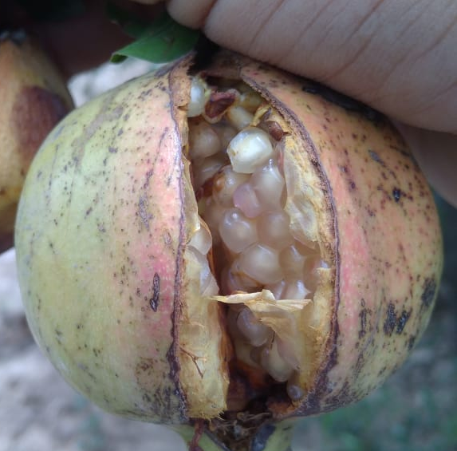 | 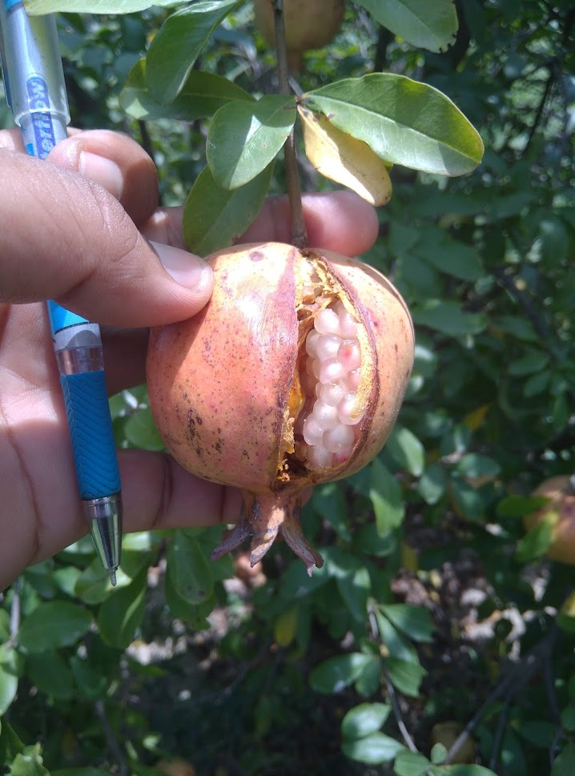

Number of fallen fruits on the ground

These are the pomegranate fruits, fallen due to some unknown reasons. These fruits included the fallen fruits due to physiological deficiencies or biting of the squirrels, birds, bats, and strong winds (Table 4, Fig. 2).

Fruit fall may arise from interacting physiological stress, mechanical injury, weather events, and damage by vertebrates; therefore, the recorded fallen fruit cannot be attributed to a single cause without direct observations. In pomegranate, cultivar, maturity, rind injury, and orchard water conditions influence fruit integrity and postharvest behavior, supporting a cautious interpretation of the higher fall recorded in Kandhari (Holland et al., 2009; Pareek et al., 2015).

Table 4 Number of fallen pomegranate fruits on the plants' ground out of whole fruits.

Variety | No. of fruits fallen on the ground | Total fruits
Ganesh | 23.6±5.3 | 106.1±15.5
Mridula | 26.0±5.2 | 89.1±10.3
Bhagva | 28.5±5.3 | 72.2±8.2
Kandhari | 31.0±5.5 | 54.5±4.7
C.D. | 1.6 | 15.5
SE(m) | 0.5 | 4.7
SE(d) | 0.7 | 6.7
C.V. | 3.6 | 11.8
Fig. 2 Fruits fallen on the pomegranate plants
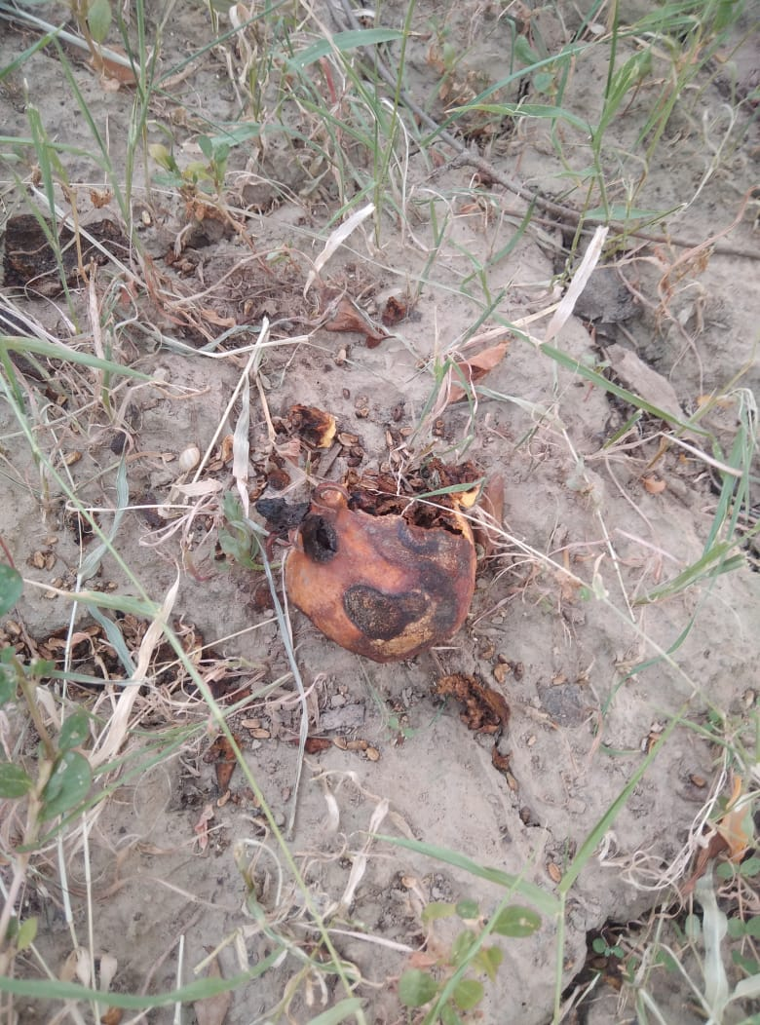 | 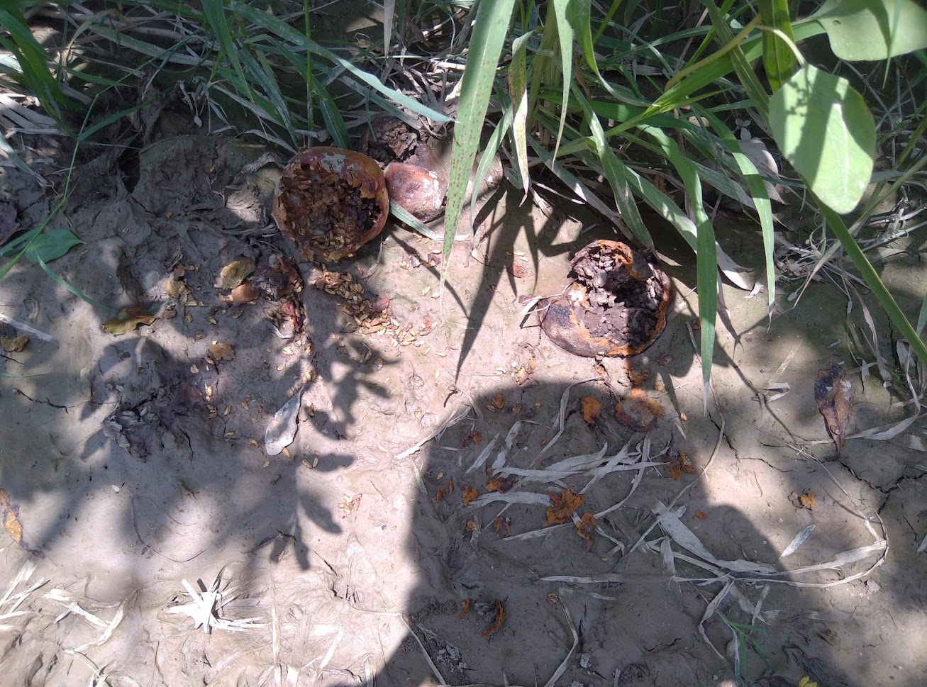

Fruits bitten by the birds and bats
The number of fruits bitten by the birds and bats is presented in Table 5. The number of bitten fruits in varieties Kandhari and Bhagva was almost identical, i.e., 13.9 ± 1.99 and 13.7 ± 2.5. The same trend was also reported in varieties Ganesh and Mridula, in which the number of fruits bitten was 10.9 ± 1.61 and 11.8 ± 2.36. These fruits were bitten by the red vented bulbul (Pycnonotus cafer), Rose-Ringed Parakeet (Alexandrinus krameri), and bats. The damage to the fruits was biting by the birds, bats, and squirrels. The red vented bulbul was found to cause minor damage to the fruits, and it bites a small area of fruits and removes fruit peel only while the rose-ringed parakeet caused significant damage to the pomegranate fruits by biting the fruits in a zigzag manner. The shape of biting of pomegranate by the A. krameri was zigzag and deep (Table 5, Fig. 3).
The observed feeding patterns are agronomically important because partial pecking or biting can reduce market value even when only a limited amount of tissue is consumed. Studies of commercial fruit production have shown that bird damage generates losses through both direct consumption and downgrading of injured fruit, and that damage intensity varies with bird abundance, fruit availability, and crop characteristics (Anderson et al., 2013; Holland et al., 2009).

Table 5 Number of birds bitten pomegranate fruits on the plants out of total fruits

Variety | No. of birds bitten fruits | total fruits
Ganesh | 10.9±1.61 | 106.1±15.50
Mridula | 11.8±2.36 | 89.1±10.37
Bhagva | 13.7±2.53 | 72.2±8.27
Kandhari | 13.9±1.91 | 54.5±4.79
C.D. | 1.66 | 15.52
SE(m) | 0.51 | 4.78
SE(d) | 0.72 | 6.76
C.V. | 8.12 | 11.88

Fig. 3 Fruits bitten by the Rose-Ringed Parakeet (Alexandrinus krameri) birds on the pomegranate plants
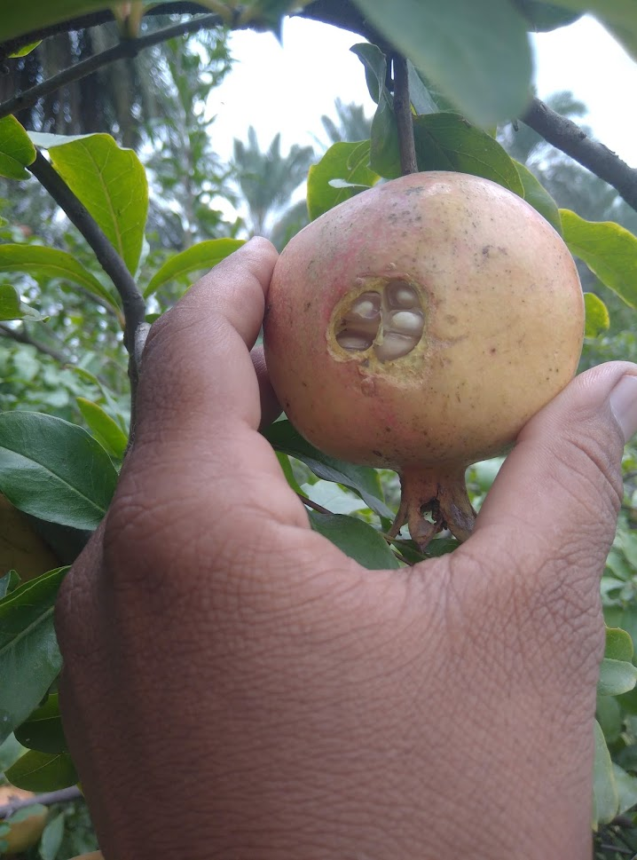 | 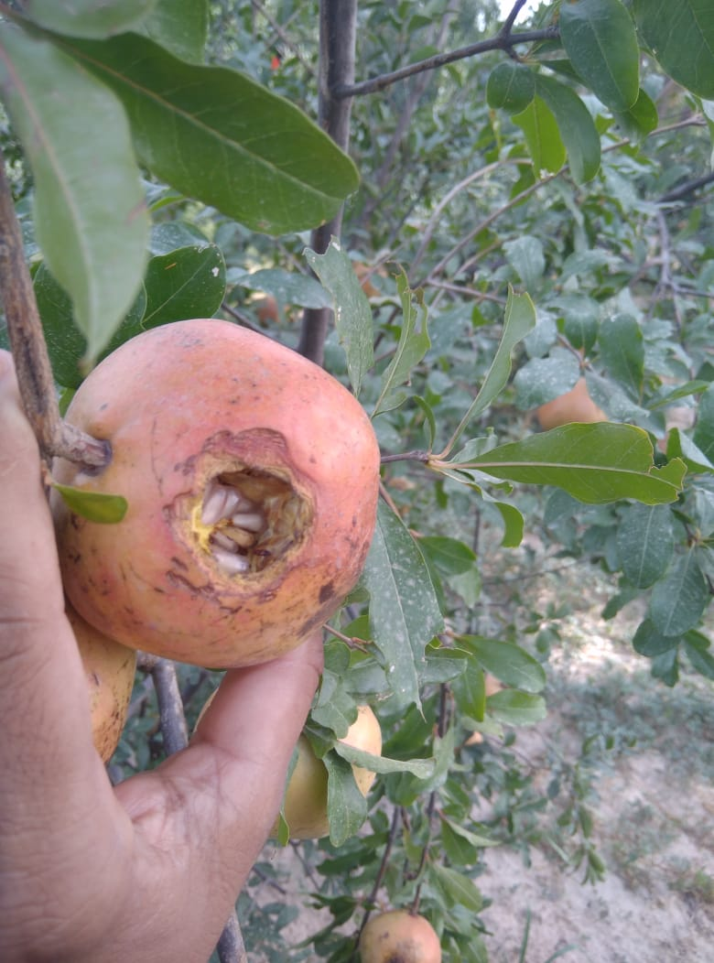 |  | 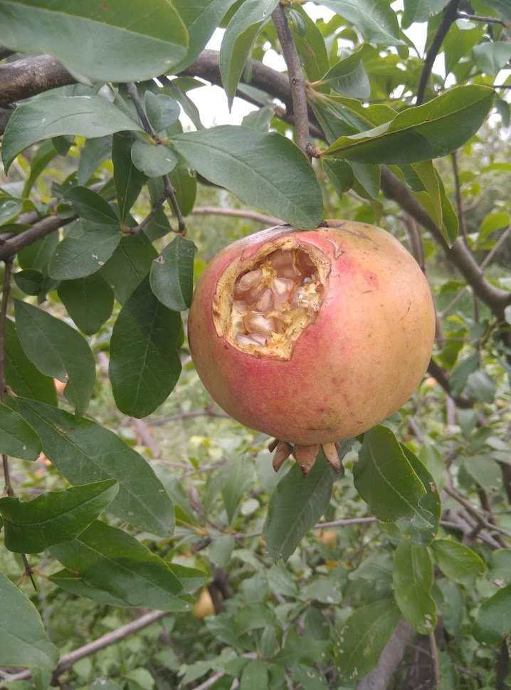
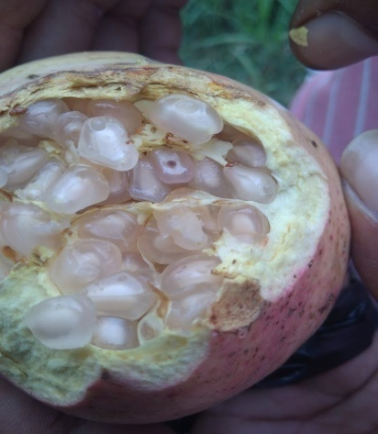 |  | 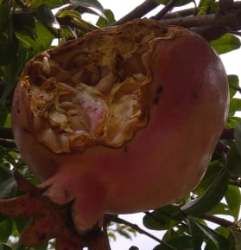 |  | 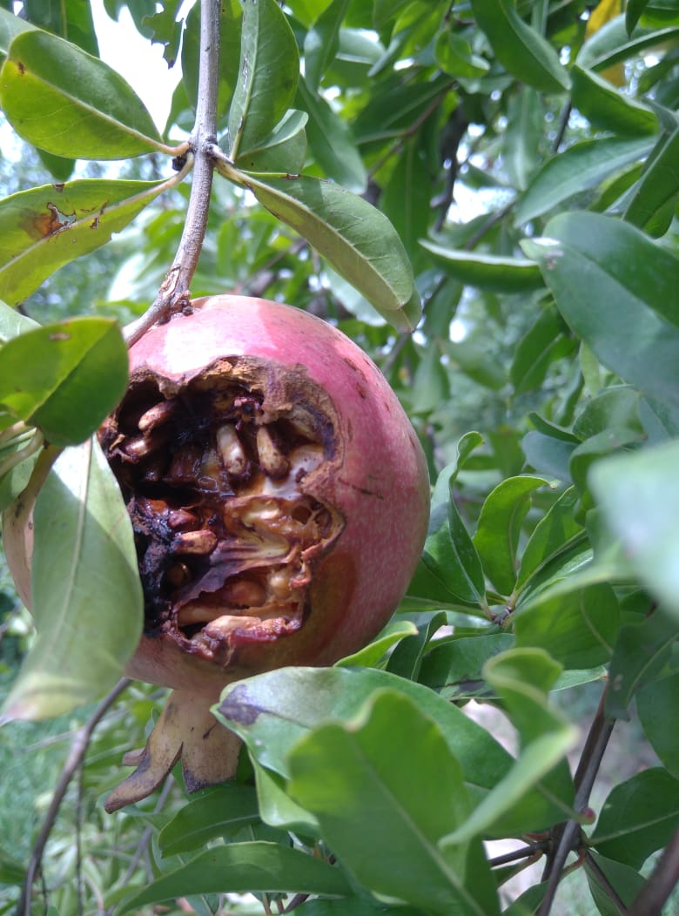

The bats also ate the fruits; they ate almost whole fruit. In the pre-ripening stage, minor damage of pomegranate was observed compared to the ripening stage. Bat caused damage in both locations i.e., pre-ripening and ripening stages (Fig. 4).
Fig. 4 Fruits bitten by the Bat on the pomegranate plants
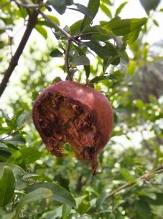 | 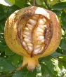

A total of fruits

The total of fruits was calculated by adding the number of fruits on the pomegranate trees (damaged, cracked, and plucked) and fallen fruits on the ground. The variety Ganesh had the highest number of fruits, i.e., 106.1 ± 15.50, followed by variety Mridula, i.e., 89.1 ± 10.37; variety Bhagva (72.2 ± 8.27). The few fruits were reported in variety Kandhari (table 6).

The ranking of total fruit number among cultivars likely reflects inherent differences in productivity together with the cumulative effects of cracking, fruit fall, and vertebrate damage. Because pomegranate cultivars vary markedly in crop load and fruit traits, comparisons of gross fruit number should be interpreted alongside the number and proportion of marketable fruits (Holland et al., 2009; Pareek et al., 2015).
Table 6: Showing number of damaged fruits, nature of damage to fruits, bird diversity and their population on pomegranate
Variety | Total no. of fruits on the tree | No. of damaged fruits on tree | No. of birds bitten fruits | No. of cracked fruits | No. of fruits fallen on the ground | Total of damaged fruits | Grand total of fruits | No. of plucked and sold
Ganesh | 82.4  ±17.09 | 20.7  ±4.05 | 10.9  ±1.61 | 9.8  ±2.44 | 23.6  ±5.32 | 44.4  ±3.27 | 106.1  ±15.50 | 61.7  ±13.60
Mridula | 63.1  ±11.81 | 22.4  ±4.46 | 11.8  ±2.36 | 10.5  ±2.15 | 26.0  ±5.24 | 48.4  ±3.87 | 89.1  ±10.37 | 40.7  ±7.60
Bhagva | 43.7  ±8.99 | 24.9  ±4.91 | 13.7  ±2.53 | 11.20  ±2.39 | 28.5  ±5.33 | 53.4  ±4.66 | 72.2  ±8.27 | 19.8  ±4.56
Kandhari | 23.5  ±5.32 | 28.0  ±5.25 | 13.9  ±1.91 | 14.1  ±3.34 | 31.0  ±5.51 | 59.1  ±5.57 | 54.5  ±4.79 | 3.0  ±0.97
C.D. | 16.93 | 2.28 | 1.66 | 1.95 | 1.62 | 3.86 | 15.52 | 17.41
SE(m) | 5.21 | 0.70 | 0.51 | 0.60 | 0.50 | 1.19 | 4.78 | 5.38
SE(d) | 7.38 | 0.99 | 0.72 | 0.85 | 0.71 | 1.68 | 6.76 | 7.61
C.V. | 19.62 | 5.85 | 8.12 | 10.55 | 3.67 | 4.64 | 11.88 | 34.41

The population of birds damaging the pomegranate fruits
The people of birds damaging crops were recorded weekly. Among the four pomegranate varieties i.e., Ganesh, Mridula, Bhagva and Kandhari; the birds preferred the variety Mridula more. The number of birds sited were 4 (Pycnonotus cafer) and 5 (Alexandrinus krameri). The rest three varieties i.e. Ganesh, Mridula and Bhagva were preferred almost equally by these birds. So, the damage caused by the birds was correlated (Table 7, Fig. 5).
The higher counts of Pycnonotus cafer and Alexandrinus krameri in Mridula indicate differential visitation, but bird abundance alone does not establish preference unless fruit availability and observation effort are standardized. Bird-related losses in fruit crops are shaped by local species composition, flock size, fruit maturity, and alternative food resources; consequently, repeated observations across seasons would strengthen conclusions concerning cultivar preference (Anderson et al., 2013; Holland et al., 2009).
Table 7 Birds damaging the pomegranate crop, their population
Variety | Bird(s) damaging crop | The population of Bird(s) damaging crop
Ganesh | Pycnonotus cafer | 03
Ganesh | Alexandrinus krameri | 03
Mridula | Pycnonotus cafer | 04
Mridula | Alexandrinus krameri | 05
Bhagva | Pycnonotus cafer | 01
Bhagva | Alexandrinus krameri | 04
Kandhari | Pycnonotus cafer | 02
Kandhari | Alexandrinus krameri | 04
Figure 5 Birds and nest of the bird as well as a nest of the squirrel on the pomegranate tree
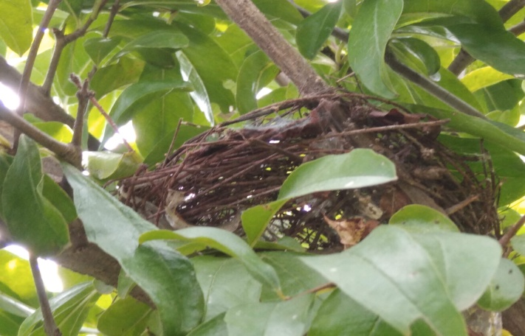 | 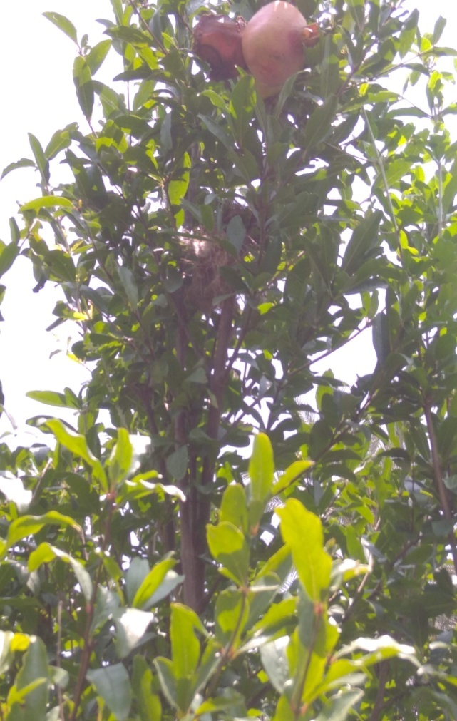
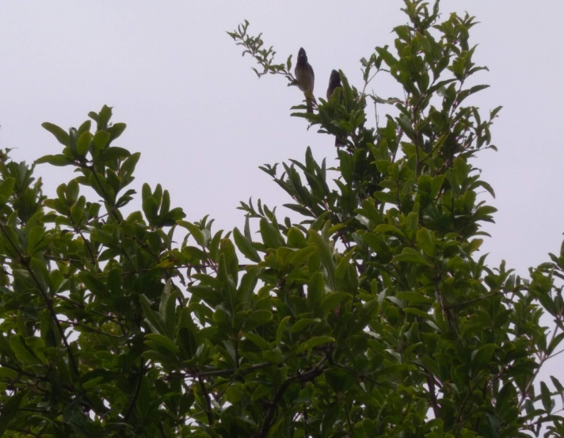 | 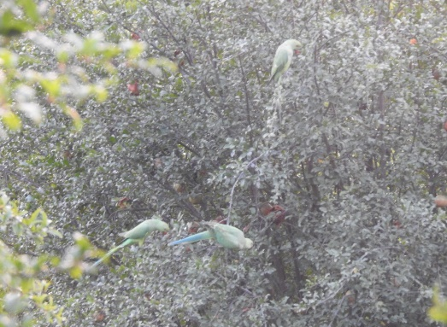
Table 8 Percent losses due to birds, cracking of pomegranate fruits for four weeks.
Treatment | % of damaged fruits on plants | % loss due to birds bite | % loss due to cracking | % loss due to fruit fall | % total loss
Ganesh | 19.5 | 10.2 | 9.2 | 22.2 | 41.8
Mridula | 25.1 | 13.2 | 11.8 | 29.1 | 54.3
Bhagva | 34.5 | 19.0 | 15.5 | 39.4 | 73.9
Kandhari | 51.3 | 25.4 | 25.9 | 56.8 | 100
The losses due to the damage of fruits on the tree by an unknown factor(s), birds, cracking, and fruit fall were higher in variety Kandhari; and almost equal in Ganesh and Mridula.
- Estimation of economic loss to fruit vendor (s)
The fruit vendors bought pomegranate fruits from the Horticulture Research Farm Area at CCS HAU Hisar. It was observed that 10% of fruits were wasted or spoiled, and the percentage loss was correlated with the weight of the rotten pomegranate fruits at fruit salesman price (Table 9, Fig. 6).
The approximately 10% spoilage recorded at the vendor stage demonstrates that economic loss continues after harvest. Pomegranate quality may decline through mechanical injury, water loss, senescence, and microbial decay, and these processes are strongly affected by handling, temperature, relative humidity, and storage duration (Pareek et al., 2015; Holland et al., 2009). The reported loss estimate is therefore best regarded as specific to the surveyed marketing period and handling conditions.
Table 9 Date-wise economic losses due to damage of birds, others (squirrel), and cracking of fruits from 20.07.2020 to 04.08.2020.
Date | Plucked fruit (a) | Whole price (Rs./Kg) (b) | Whole sale Value (a x b) | Fruit salesmen price (c) | Fruit salesman Total value (a x c) | Weight of spoiled fruits (kg) (d) | Loss value (Rs.)  (c x d)
20.07.2020 | 15 | 30 | 450 | 60 | 900 | 1.5 | 90
25.07.2020 | 27 | 30 | 810 | 60 | 1620 | 2.7 | 162
31.07.2020 | 27 | 30 | 810 | 60 | 1620 | 2.7 | 162
01.08.2020 | 54 | 30 | 1620 | 60 | 3240 | 5.4 | 324
02.8.2020 | 31 | 30 | 930 | 60 | 1860 | 3.1 | 186
03.08.2020 | 46 | 30 | 1380 | 60 | 2760 | 4.6 | 276
04.08.2020 | 12 | 30 | 360 | 60 | 720 | 1.2 | 72
Fig. 6 Pomegranate fruits wasted/spoiled during sale by the fruit vender
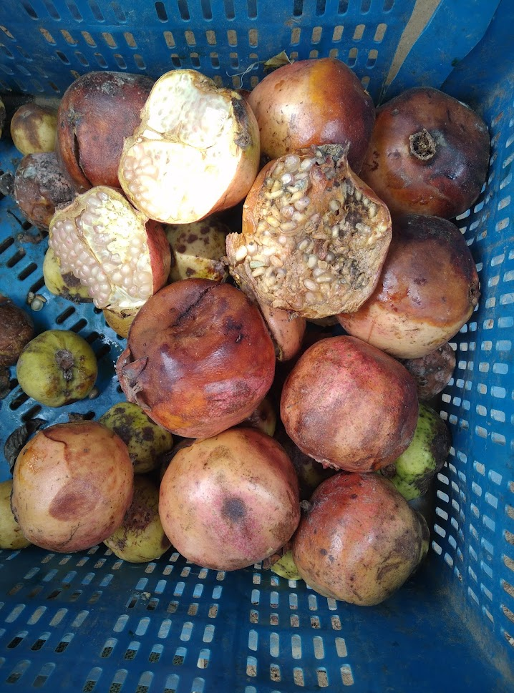

DISCUSSIONS
The available literature is scarce on the losses to pomegranate crops due to birds. Although the area under pomegranate culture is increased from 2.53 lakh hectares (2018-19) to 2.61 lakh hectares (2019-20), the decline in the production from 29.15 lakh tonnes to 23.15 lakh tonnes in 2018-19 and 2019-20, respectively (NHB, 2021) due to devastating disease oily spot disease, fruit cracking, sunscald, frost damage, fungal spot, wilt disease, root not nematode, mite, fruit borer, squirrel, birds (red vented bulbul-Pycnonotus cafer, Myna, rose-ringed parakeet) and bats was reported by Pal et al. (2014). The present field study reported the same pattern of losses due to fruit cracking, fruit falling, and damage caused by the birds, bats.
The cultivar pattern observed in this study suggests that crop loss was determined by a combination of biological damage and cultivar-specific fruit characteristics. Pomegranate genotypes differ in yield, rind structure, maturity behavior, and cracking susceptibility, all of which can influence whether fruits remain marketable under a given orchard environment (Holland et al., 2009; Khadivi-Khub, 2015). The comparatively high cracking and fruit fall in Kandhari may therefore indicate greater vulnerability under the study conditions, but confirmation would require replicated multi-season assessment of crop load, irrigation, rainfall, fruit maturity, and rind properties (Khadivi-Khub, 2015; Pareek et al., 2015).
The bird observations also support the need to distinguish between visitation frequency, feeding incidence, and economic damage. In fruit crops, birds can cause losses not only through the quantity consumed but also through the rejection or deterioration of partially damaged fruits; however, estimates vary substantially among sites, species, cultivars, and seasons (Anderson et al., 2013; Holland et al., 2009). Standardized observation periods, direct attribution of each damaged fruit, and calculation of loss as a proportion of available fruit would improve the comparability of future estimates.
The vendor-level spoilage recorded in this study is compatible with the high perishability of pomegranate fruit after physical injury. Appropriate harvesting, sorting, packaging, temperature management, and humidity control are important for limiting water loss and decay during marketing (Pareek et al., 2015; Holland et al., 2009). Nevertheless, because the economic assessment covered a short interval and one marketing setting, the resulting percentage should not be generalized beyond the observed conditions.

Conclusions
The four pomegranate varieties differed in recorded fruit load, cracking, fruit fall and vertebrate-associated damage under the observed orchard conditions. Ganesh had the highest reported total fruit number, while Kandhari had the lowest. Cracking, fruit fall and bird-associated damage were numerically higher in Kandhari, although absolute counts were influenced by differences in initial fruit load. Red-vented bulbuls and rose-ringed parakeets were observed in the orchard, while damage attributed to bats and squirrels was also recorded. Spoilage continued during the surveyed marketing period. Because several damage categories overlapped and causal attribution was not always direct, the findings should be interpreted as preliminary descriptive observations rather than definitive estimates of cultivar susceptibility or economic loss.

Limitations
The number of independent replicates and observation dates was not clearly reported. Damage categories overlapped, and fallen or spoiled fruits could not always be attributed to a specific cause. Bird observations were not standardized by survey duration or available fruit number. Bat and squirrel species were not identified, and no exclusion treatment was used. Rainfall, irrigation, fruit maturity, disease incidence and rind characteristics were not measured. The vendor assessment covered only seven dates and one marketing setting. Consequently, causal and economic conclusions are limited.

Declaration of AI Use

This manuscript was prepared through the combined contributions of all author(s), including contributions to the study design, data, content development, results, interpretation, and related scholarly work. The author(s) acknowledge the use of Grammarly and ChatGPT to assist with grammar checking, language refinement, reference formatting. These AI-assisted tools were not used as authors and did not replace the intellectual contributions or scholarly judgment of the author(s). All AI-assisted outputs, including content, references, and interpretations, were carefully reviewed, revised, verified, and approved by the author(s). The author(s) accept full responsibility for the accuracy, integrity, and final content of the manuscript.

COMPETING INTERESTS DISCLAIMER:
Authors have declared that they have no known competing financial interests OR non-financial interests OR personal relationships that could have appeared to influence the work reported in this paper.

REFERENCES
Jain K and Desai N (2018). Pomegranate the cash crop of India: a comprehensive review on agricultural practices and diseases. Int J Health Sci Res. 8(5):315-336.
Kushwaha S C, Bera M B and Kumar P (2020). Pomegranate. In: Nayik G.A., Gull A. (eds) Antioxidants in Fruits: Properties and Health Benefits. Springer, Singapore. https://doi.org/10.1007/978-981-15-7285-2_15
National Horticulture Board (2020). Promoting Horti Entrepreneurship Technology and Innovation in Indian Horticulture through NHB Schemes on Commercial Cultivation of Horticulture Crops and Creation of Post-Harvest Management Infrastructure. Annual Report 2019-20, Ministry of Agriculture and Farmers Welfare, Government of India. Pp. 1-148. http://nhb.gov.in/statistics/HorticultureCropsSecond/2019-20(2nd%20Advance%20Estimates)%20(1)_36.pdf
Pal R K, Dhinesh B K, Singh N V, Maity A and Gaikwad N (2014). Pomegranate research in India- status and future challenges. Progressive Horticulture, 46(2): 184-201.
Saroj P L and Kumar R (2019). Recent advances in pomegranate production in India-a review. Annals of Horticulture, 12(1):1-10. http://dx.doi.org/10.5958/0976-4623.2019.00010.0
Anderson, A., Lindell, C. A., Moxcey, K. M., Siemer, W. F., Linz, G. M., Curtis, P. D., Carroll, J. E., Burrows, C. L., Boulanger, J. R., Steensma, K. M. M., & Shwiff, S. A. (2013). Bird damage to select fruit crops: The cost of damage and the benefits of control in five states. Crop Protection, 52, 103-109. https://doi.org/10.1016/j.cropro.2013.05.019
Holland, D., Hatib, K., & Bar-Ya'akov, I. (2009). Pomegranate: Botany, horticulture, breeding. Horticultural Reviews, 35, 127-191. https://doi.org/10.1002/9780470593776.ch2
Khadivi-Khub, A. (2015). Physiological and genetic factors influencing fruit cracking. Acta Physiologiae Plantarum, 37, Article 171. https://doi.org/10.1007/s11738-014-1718-2
Pareek, S., Valero, D., & Serrano, M. (2015). Postharvest biology and technology of pomegranate. Journal of the Science of Food and Agriculture, 95(12), 2360-2379. https://doi.org/10.1002/jsfa.7069

