DIVERSITY AND DISTRIBUTION OF HERMIT CRABS (DECAPODA: ANOMURA) ALONG THE INTERTIDAL COAST OF SIKKA, GUJARAT, INDIA

Abstract
This study assessed the diversity, distribution and gastropod-shell utilisation of hermit crabs at the Vador site and GSFC Jetty on the intertidal coast of Sikka, Gujarat, from October 2020 to March 2021. Fortnightly hand collections were undertaken during low tide across sandy and muddy habitats, and specimens were identified to species level. Six species belonging to the family Diogenidae were recorded: four species of Diogenes and two species of Clibanarius. In total, 986 individuals were documented, including 538 from Vador and 448 from GSFC Jetty. Diogenes edwardsii was the most abundant species across the two sites, whereas Clibanarius longitarsus was the least abundant. Hermit crabs occupied shells of 20 gastropod species, with 717 shell-use records. Cerithium scabridum was the most frequently used shell species, followed by Eupica scripta, Cerithidia cingulata, Clypeomorus petrosa, Turbo brunneus and Littorina sp. Monthly Shannon–Wiener diversity values ranged from 1.18 to 1.58 at Vador and from 0.94 to 1.58 at GSFC Jetty. Margalef richness ranged from 0.75 to 1.12 and from 0.56 to 1.14, respectively, while Pielou’s evenness ranged from 0.79 to 0.91 and from 0.79 to 0.87. The findings provide a six-month baseline inventory of hermit crab assemblages and shell utilisation along the sampled Sikka coast.
Key words: Anomuran, Diversity indices, Hermit crabs, Gastropod shells, Sikka coast

- Introduction
India is one of the 17 megadiverse countries and includes four of the world's biodiversity hotspots, which encompass some of the richest and most threatened ecoregions. Anomurans form an important link in marine food webs and are prey for economically valuable fish species. The infraorder Anomura comprises approximately 1,500 species in 200 genera, 17 families, and seven superfamilies worldwide. Anomurans remain among the least studied groups of decapod crustaceans in Indian waters. To date, 112 hermit crab species (Paguroidea), representing 26 genera and five families, have been reported from Indian waters, including 13 species from Gujarat (Trivedi & Vachhrajani, 2017). A subsequent national synthesis catalogued 231 anomuran species from Indian waters and emphasised marked regional variation in recorded diversity (Patel et al., 2022).
The infraorder Anomura is among the most morphologically diverse groups of decapod crustaceans. Species classified within the superfamily Paguroidea generally have a membranous or weakly calcified abdomen and therefore require an external protective covering, typically a gastropod shell. Most hermit crab species are marine, although some are terrestrial. Marine hermit crabs occur from shallow coastal waters to the deep sea, whereas terrestrial species are generally associated with tropical regions (Gosavi et al., 2017). Recent intertidal surveys in Lakshadweep recorded eight hermit crab species and showed that abundance and distribution varied with habitat conditions (Naseem et al., 2025).

Hermit crabs are integral components of intertidal faunal communities and play an important role in coastal food webs. They depend on gastropod shells for protection from predators and physical stress, as well as for reproductive success and locomotion. Intertidal habitats are particularly susceptible to changes in temperature and salinity, and hermit crab species differ in their tolerance of these fluctuations (Trivedi & Vachhrajani, 2014). Along the Gujarat coast, shell occupancy and resource partitioning by sympatric Clibanarius species were strongly associated with shell diversity, morphology, and availability (Patel et al., 2023). Mangrove-based decapod surveys have also recorded hermit crabs as recurrent components of coastal assemblages, reinforcing the value of site-specific inventories (Milla et al., 2022). Recent distributional records of marine brachyuran crabs from Indian coastal and estuarine habitats further demonstrate the value of systematic regional surveys for refining knowledge of decapod diversity (Chowdhury & Mitra, 2026).
Despite previous regional records, site-specific information on the species composition, relative abundance, and gastropod-shell use of hermit crabs along the Sikka coast remains limited. A structured inventory of the Vador site and GSFC Jetty is therefore needed to establish baseline information for this intertidal sector.
Objectives:
- To assess hermit crab (anomuran) diversity along the Sikka coast, Gujarat.
- To examine gastropod-shell selection among the recorded species.

- Materials and Methods
The study was conducted in the intertidal zone of the Sikka coast, situated in the Gulf of Kachchh, Gujarat. Hermit crab specimens were collected by hand-picking during low tide from the Vador site and GSFC Jetty. The study area extends between 22°27'31.0"N and 69°48'17.4"E and 22°28'14.9"N and 69°49'31.9"E. Sampling was conducted fortnightly from October 2020 to March 2021. To assess quantitative abundance, random sampling was undertaken from the high-tide mark to the low-tide mark across all tidal levels. All hermit crab species encountered were collected and identified, and the numbers of individuals were recorded to assess abundance, density, and frequency. Specimens were identified to species level in the laboratory using identification keys. All collected hermit crabs were categorised and counted by species, and the number of individuals in each species was recorded for quantitative assessment of abundance and density.
Key species were selected on the basis of their occurrence in the study area. These organisms were among the most prominent and were present throughout the study period, thereby ensuring an adequate supply of specimens for laboratory examination. Collected animals, together with their shells, were preserved in 70% alcohol and transported to the laboratory. The abdomen of each crab was subsequently removed from its shell by gently twisting the animal against the direction of the shell spiral. A light hammer was used to crack the shell in difficult cases. Specimens were identified using the key provided by Kachhiya et al. (2017).
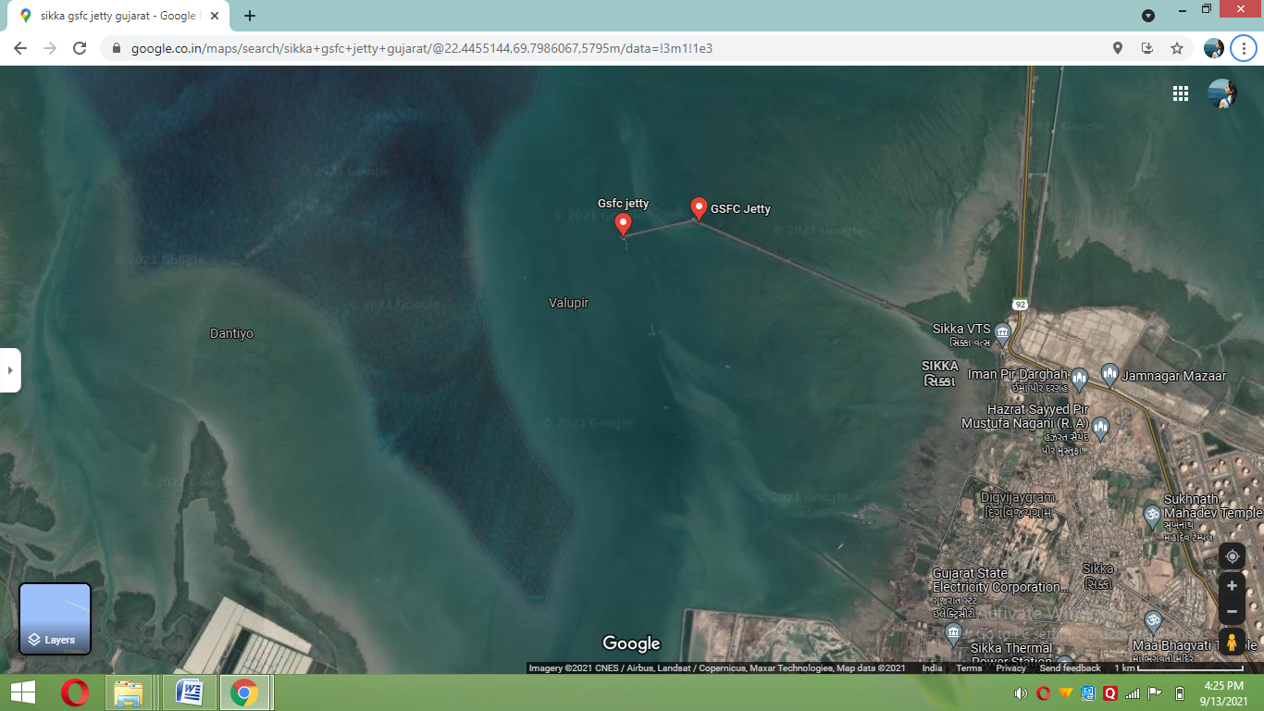

Fig.1. Satellite view of Sikka coast, Gujarat (Source: Google map, accessed, n.d.)
2.1 Biodiversity assessment
The total number of individuals of each species was recorded over six months (October 2020 to March 2021) at the Sikka coast. Monthly species data were used to calculate the following biodiversity indices separately for each sampling site and month.
2.1.1 Species diversity
Hermit crab species diversity was calculated using the Shannon-Wiener diversity index (H′) (Shannon & Weaver, 1949).
$$H^{'}=- \sum{pi }\ln{pi}$$
where pᵢ = S/N, S is the number of individuals of one species, N is the total number of individuals in the sample, and ln is the natural logarithm.

2.1.2 Species richness
Hermit crab species richness was calculated using the Margalef diversity index (D) (Margalef, 1958).
$$D= \frac{S-1}{ln (N)}$$
where S is the number of species, N is the total number of individuals in the sample, and ln is the natural logarithm.
2.1.3 Species evenness
Hermit crab species evenness was calculated using Pielou's evenness index (J′) (Pielou, 1977).
$$J'= \frac{H'}{ln (S)}$$
where H′ is the Shannon-Wiener diversity index, S is the total number of species in the sample, and ln is the natural logarithm.

- Results and Discussions
3.1 Gastropod shell utilization preferences of Hermit crab
The hermit crabs occupied shells of 20 gastropod species in varying proportions (Table 1), of which six shell species were most commonly used. The shells of Cerithium scabridum, Eupica scripta, Clypeomorus petrosa, Cerithidia cingulata, Littorina sp., and Turbo brunneus were commonly used by all categories, although their percentage utilisation varied considerably.
Cerithium scabridum (11.01%) was the most frequently occupied gastropod shell, followed by Eupica scripta (8.08%), Cerithidia cingulata (8.08%), Clypeomorus petrosa (7.81%), Turbo brunneus (6.13%), and Littorina sp. (5.71%), which were also frequently occupied by the recorded hermit crab species (Fig. 2). In general, the survival of a hermit crab population in a particular area may be limited by shell availability (Kellogg, 1976; Floeter et al., 2000), and hermit crabs follow particular patterns of gastropod-shell selection based on the adequacy and availability of shell resources (Reese, 1962; Conover, 1978).
Shell availability within a habitat is a major factor affecting shell utilisation and the survival of hermit crab populations (Kellogg, 1976; Floeter et al., 2000). In this study, the density of gastropod species commonly used by hermit crabs was recorded to assess the shell resources available in the habitat. The survival of hermit crabs in a particular area and their shell-utilisation patterns depend on factors such as shell architecture, shell density, and interspecific and intraspecific competition among crab species (Reese, 1969).

Table 1. Percentage utilization of gastropod shells by Hermit crabs from Vador site and GSFC Jetty at Sikka coast (whereas N=Total Number of Individuals, %= Relative percentage)
No. | Gastropod species | Total
No. | Gastropod species | N | %
1. | Clypeomorus petrosa | 56 | 7.81
2. | Turbo brunneus | 44 | 6.13
3. | Muricopsis bombayanus | 36 | 5.02
4. | Eupica scripta | 58 | 8.08
5. | Indptheis lacrea | 22 | 3.06
6. | Planaxis sulcatus | 19 | 2.64
7. | Phos textus | 16 | 2.23
8. | Nassarius nodifer | 22 | 3.06
9. | Nassarius reeveans | 23 | 3.20
10. | Cerithidia cingulate | 58 | 8.08
11. | Engina alveolate | 39 | 5.43
12. | Pollia undosa | 44 | 6.13
13. | Pyrene scripta | 28 | 3.90
14. | Lunella coronate | 22 | 3.06
15. | Cerithium scabridum | 79 | 11.01
16. | Nassarius dorsatus | 21 | 2.92
17. | Mitru guttata | 27 | 3.76
18. | Littorina sp. | 41 | 5.71
19. | Trochus radiates | 36 | 5.02
20. | Cronia contracta | 26 | 3.62
Total |  | 717

Fig. 2. Percentage utilization of gastropod shells by Hermit Crabs from Vador site and GSFC Jetty at Sikka coast

3.2 Check list of hermit crab
The checklist of hermit crabs was prepared from phylum to species. Six species, belonging to one superfamily, one family, and two genera, were identified from the Vador site and GSFC Jetty on the Sikka coast. The total numbers of individuals recorded at the two sites are presented in Figure 3. All available species were classified as Not Evaluated (NE) according to the International Union for Conservation of Nature criteria (IUCN, 2025). The checklist of hermit crabs from the Vador site and GSFC Jetty is presented in Table 2.
Of the two genera, Diogenes had the greatest representation, with four species, followed by Clibanarius with two species. The six recorded hermit crab species belonged to the family Diogenidae and comprised Clibanarius longitarsus (De Haan, 1849), C. padavensis (De Man, 1888), Diogenes avarus (Heller, 1865), D. klaasi (Rahayu & Forest, 1995), D. mannarensis (Henderson, 1893), and D. edwardsii (De Haan, 1849). These species were observed at the Vador site and GSFC Jetty on the Sikka coast, Gujarat.
Table 2. Checklist of Hermit crabs in Vador site and GSFC Jetty at Sikka coast of Gujarat

Super family | Family | Genus | Species | IUCN status
Paguroidea | Diogenidae | Diogenes | Diogenes avarus  (Heller, 1865) | NE
Paguroidea | Diogenidae | Diogenes | Diogenes klaasi  (Rahayu & Forest, 1995) | NE
Paguroidea | Diogenidae | Diogenes | Diogenes mannarensis  (Henderson, 1893) | NE
Paguroidea | Diogenidae | Diogenes | Diogenes edwardsii  (De Haan, 1849) | NE
Paguroidea | Diogenidae | Clibanarius | Clibanarius longitarsus  (De Haan, 1849) | NE
Paguroidea | Diogenidae | Clibanarius | Clibanarius padavensis  (De Man,1888) | NE

Figure 3. Total numbers of individuals recorded from Vador site and GSFC Jetty at Sikka coast during October 2020 to March 2021
Vaghela and Kundu (2012) conducted a similar study in the rocky intertidal area of the Saurashtra coast and reported two hermit crab species. Sardar et al. (2019) recorded only two hermit crab species, Clibanarius padavensis and Clibanarius infraspinatus, from the intertidal zone of the extended mudflats of Bakkhali and Frazerganj in the Indian Sundarbans over a one-year period.

Trivedi and Vachhrajani (2017) listed 112 hermit crab species belonging to 26 genera and five families in Indian waters. The east coast of India, with 81 species, was more diverse than the west coast, with 73 species. The greatest species diversity was recorded from the coastal areas of Tamil Nadu (50 species), whereas the fewest species were reported from Maharashtra (seven species). Nirmal et al. (2017) recorded four hermit crab species from the Maharashtra coast, India. Jhala et al. (2017) conducted a similar study from December 2012 to May 2013 at four sites in the southern Gulf of Kachchh and found that five crab species used shells of 27 gastropod species. In the present study, all available species were classified as Not Evaluated (NE), indicating the need for further studies to assess their conservation status. A total of six species, belonging to one order, one family, and two genera, was identified from the Vador site and GSFC Jetty, whereas Kachhiya et al. (2017) recorded seven Clibanarius species from the intertidal zone of Gujarat on the west coast of India.

The taxonomy, diagnostic characteristics, and distributions of the recorded hermit crabs are presented below.
Order: Decapoda
Infraorder: Anomura
Superfamily: Paguroidea

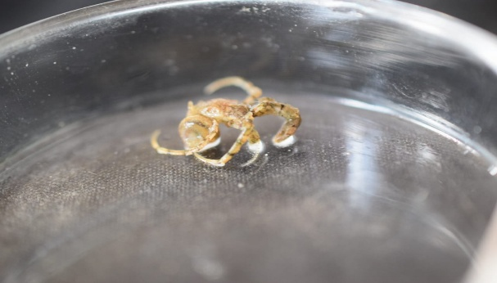
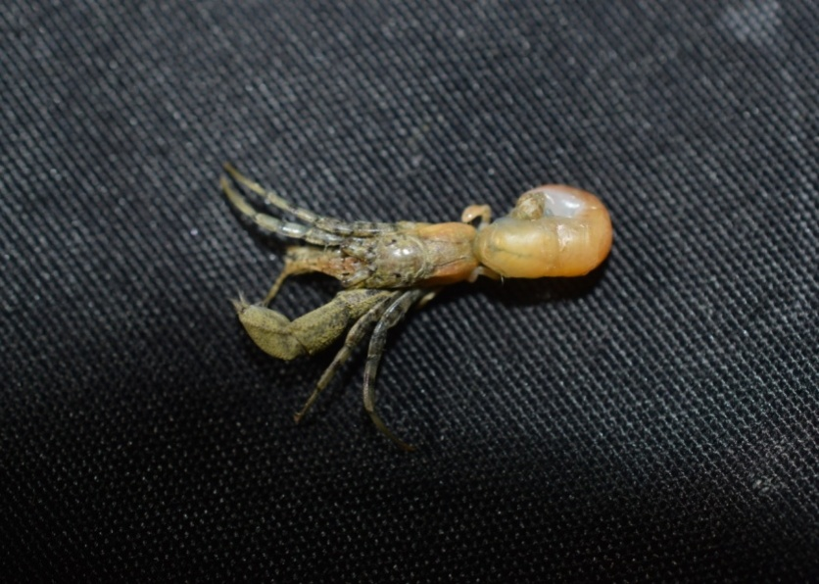
1 Diogenes avarus (Heller, 1865)
Fig 4. Diogenes avarus (Heller, 1865)
Description: The carapace is moderately elongated, with finely serrated anterolateral margins. The rostrum is slender and does not reach the tips of the ophthalmic scales. The ophthalmic scales are large, with teeth on the anterolateral margin. The eyestalks are stout, reaching the middle of the last antennal joint and extending beyond the third segment of the antennular peduncle. The antennal flagellum is shorter than the carapace and bears fewer setae. The antennal acicle is straight, bears spines on its inner aspect, and almost reaches the base of the last antennal joint. The chelipeds are unequal, with the left cheliped being much longer and approximately two and a half times the length of the carapace. It is closely granulose, with finer granules on the hand. The carpus is longer than the palm and merus. Teeth are present on the inner margins of the merus, carpus, and dactylus. The dactylus is less than half the length of the palm.
Colour: The general body colour is grey or pale yellow, with orange or yellow spots scattered over the legs and carapace.
Habitat: Sandy shores; the species usually occupies small gastropod shells.

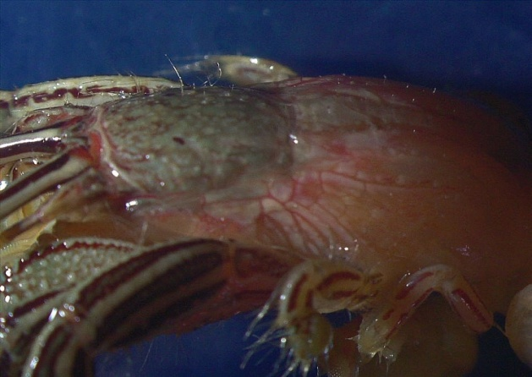
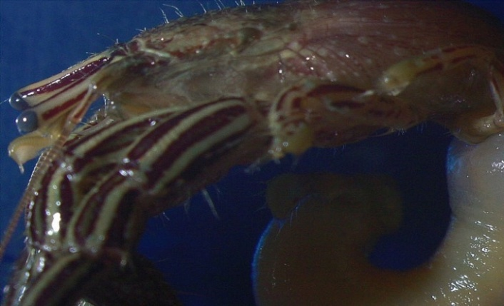
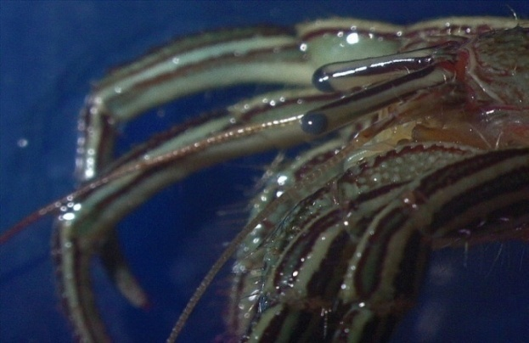
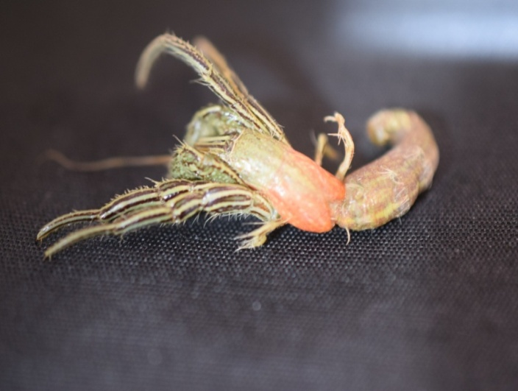
2. Clibanarius padavensis (De Man, 1888)
Fig 5. Clibanarius padavensis (De Man, 1888)

Description: The carapace is longer than broad. The rostrum is well formed, reaches the base of the ophthalmic scales, and extends beyond the level of the antennal angles of the carapace. The eyestalks extend beyond the anterior border of the carapace and are almost as long as the antennular peduncle. The cornea is approximately one-eighth the length of the eyestalk. The ophthalmic scales are situated close to one another and have a spinose outer margin. The antennal acicle has serrated margins and almost reaches the base of the terminal joint of the antennal peduncle. The flagellum is twice as long as the carapace. The chelipeds are equal in size and approximately one-third the length of the carapace. Two spinules occur on the distal and lower aspects of the merus, and the lower inner margin is serrulate. The carpus bears a strong spine distally on the dorsal inner aspect. The fingers bear rows of dorsal spines. The setae are long and sparsely distributed.
Colour: Live specimens are yellowish, with straight red longitudinal lines arranged in two or three rows on the second to fifth legs. The eyestalk bears one dorsal red band and another on its inner aspect. The chelipeds have less distinct and interrupted bands of the same colour. The carapace is yellow. The antennular and antennal peduncles have red bands, and the flagella are yellow.
Habitat: Muddy shores; the species usually occupies large gastropod shells.

3. Clibanarius longitarsus (De Haan, 1849)
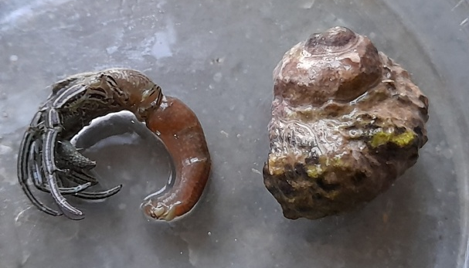
Fig 6. Clibanarius longitarsus (De Haan, 1849)

Description: The carapace is well developed and reaches the level of the base of the ophthalmic scale. The eyestalks lack colour bands, are as long as the antennular peduncle, and equal the anterior breadth of the carapace. The ophthalmic scales are small, with pointed tips. The antennal acicles extend slightly short of the last segment of the antennal peduncle and have serrated inner margins. The chelipeds are equal, with spoon-shaped fingers ending in dark corneous tips, and are uniformly provided with long setae. The palm and wrist bear dark-tipped spines in one or two rows on the fingers and irregularly arranged spines on the palm. The merus bears a spinule on its outer distal aspect, and the carpus has a well-developed spine dorsally towards the distal inner end. The dactylus of the third leg is longer than the propodus. The ambulatory legs have a blue band bordered with red.
Colour: The body is bluish green, with characteristic blue and red bands on the ambulatory legs.
Habitat: Muddy shores; the species usually occupies large gastropod shells.
4. Diogenes edwardsii (De Haan, 1849)
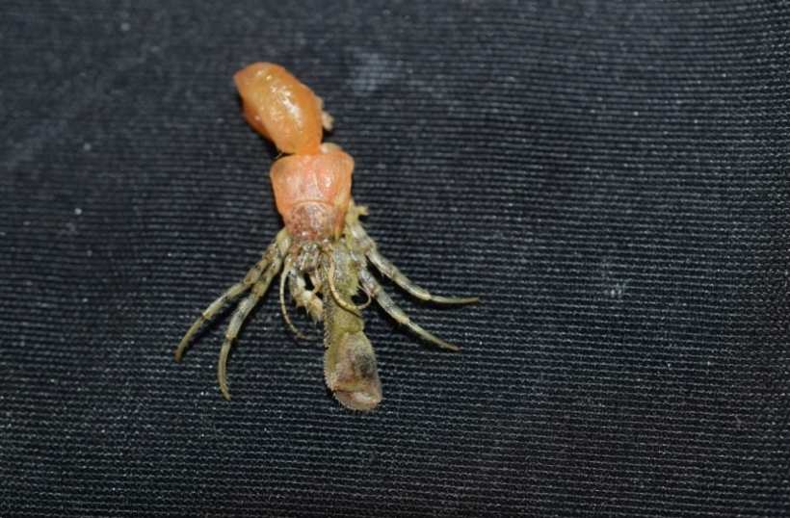
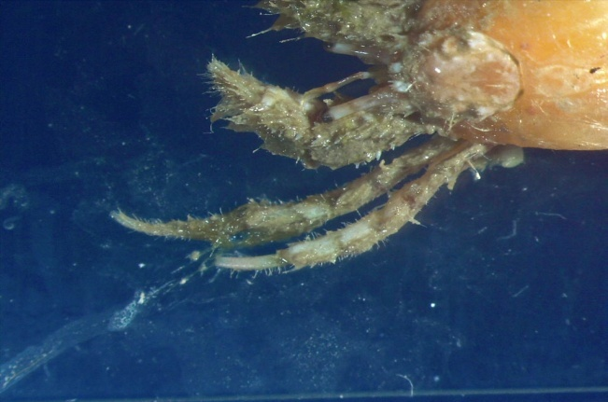

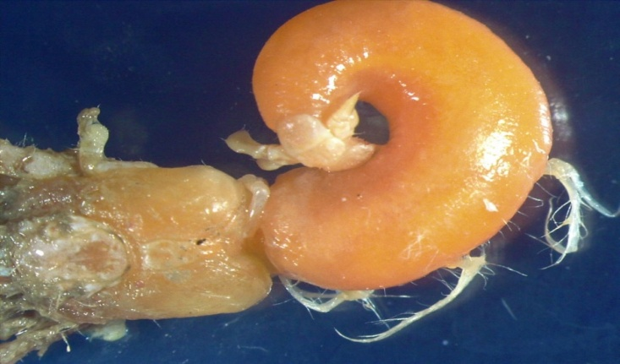
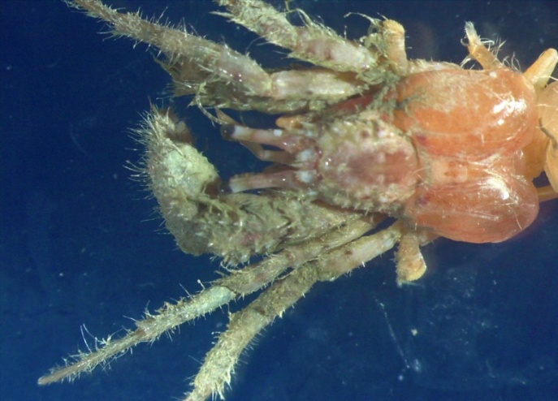

Fig 7. Diogenes edwardsii (De Haan, 1849)
Description: The shield is slightly broader than long. The anterior margin between the rostrum and the anterior part of the branchiostegite bears a row of approximately 10 small dorsal spines and is rounded. The ocular peduncles are equal in length. The antennular peduncle extends beyond the distal corneal margin by 0.4-0.5 times the length of the ultimate segment. The antennal flagellum is more than twice the length of the shield, and each article bears paired long setae on the ventral margin. The third maxillipeds are moderately slender. The merus bears a small spine at the dorsolateral distal angle. The left cheliped is much larger than the right. The chela has a narrow hiatus between the dactylus and fixed finger. The right cheliped is moderately stout and bears numerous tufts of long setae. The ambulatory legs are subequal in length.
Colour: The shield and the ocular, antennular, and antennal peduncles are cream. The left cheliped, carpus, and merus are also cream.
Habitat: Sandy or muddy shores; the species usually occupies small gastropod shells.
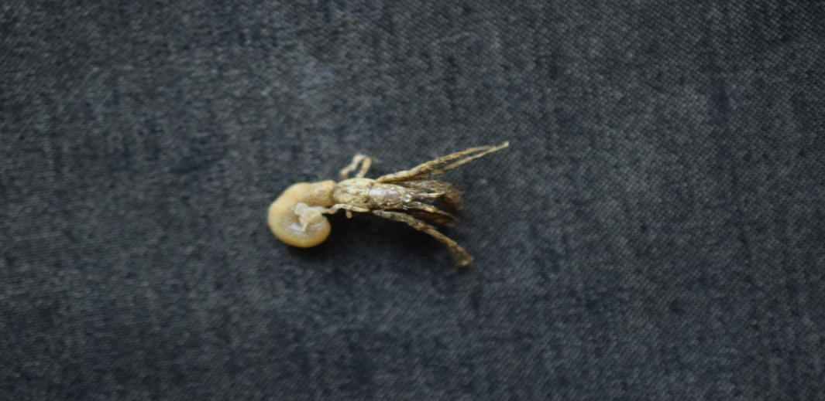
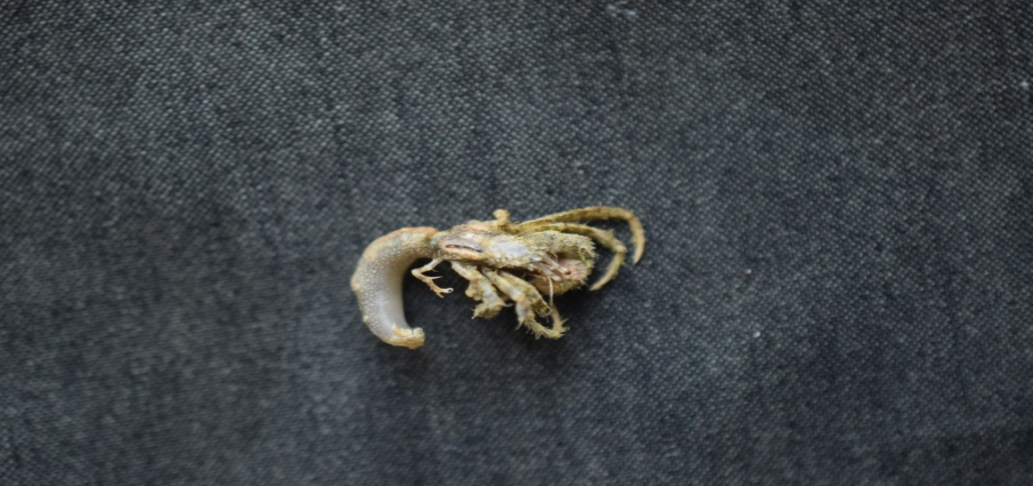
5. Diogenes mannarensis (Henderson, 1893)
Fig 8. Diogenes mannarensis (Henderson, 1893)

Description: The carapace, chelipeds, and ambulatory legs are covered with grey, muddy setae. The shield is longer than broad and has a rugose outer surface. The ocular peduncles are long and slender but do not extend beyond the antennal and antennular peduncles. The ocular acicles bear 6-9 spines on their distal outer margins, with a large apical spine. The chelipeds are unequal, with the left larger than the right; the carpus, palm, and fingers are spinose. The inner margins of the palm and dactylus bear spines, whereas much smaller spines occur on the upper surface and outer margin of the fixed finger. The right cheliped is strongly pubescent but bears fewer spines than the left. The carpus of the second pereopod bears a dorsodistal spine, and the meri have a row of small spines on the ventral margin. The segments are moderately pubescent. The telson is weakly asymmetrical, with a very small median cleft, and each terminal margin bears a row of spines extending onto the lateral margin.
Colour: The shield, carapace, and dorsal side of the abdomen are brick red with a slight bluish tinge and scattered pale and dark spots. The antennal, antennular, and ocular peduncles are light orange; the antennular flagella are white or cream, and the antennal flagella are
bluish.
Habitat: Sandy shores; the species usually occupies small gastropod shells.
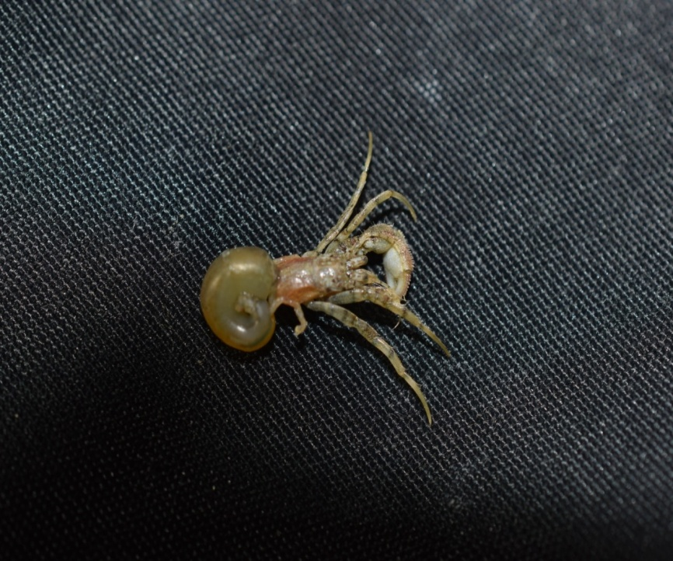
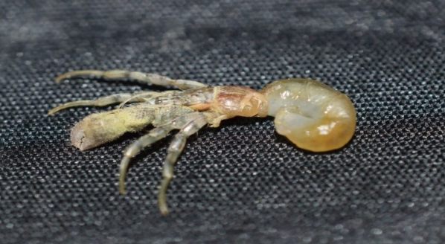
6. Diogenes klaasi (Rahayu and Forest, 1995)
Fig 9. Diogenes klaasi (Rahayu and Forest, 1995)

Description: The shield is longer than broad, and the rostrum is bluntly triangular and does not reach the ocular acicle projections. The chelipeds are unequal, with the left larger than the right. The upper and lower margins of the left cheliped bear irregular rows of spines. The palm is convex, and its outer surface bears small spines or tubercles and a median longitudinal row of spines. The carpus is also spinulose on the outer surface. The dactylus of the right chela is slender, and the carpus bears a dorsodistal spine. The ambulatory legs are thin and slender, with dactyli longer than the propodi. The carpi of the second and third pereopods bear a dorsodistal spine, with an additional spine at the proximal end of the carpus of the second pereopod. The chelipeds and ambulatory legs are covered with long setae. The telson is broad and asymmetrical, with a small median cleft. The left lobe is larger than the right, with an oblique terminal margin, approximately 25 large lateral spines, and a few spinules. The right lobe is smaller and bears 13 large lateral spines and a few smaller spinules on the terminal margin.
Colour: The shield is reddish orange. The ocular peduncles are light greenish orange, and the antennules and antennae are pale yellow. The chelipeds are dark brownish green. The ambulatory legs are pale yellow, with irregular dark green spots on different segments.
Habitat: Sandy shores; the species usually occupies gastropod shells.

3.3 Biodiversity assessments
The Shannon-Wiener diversity index (H′), Margalef diversity index (D), and Pielou's evenness index (J′) were calculated for the Vador site and GSFC Jetty on the Sikka coast from October 2020 to March 2021. The spatial and monthly variations in these indices are presented below.
    - Species diversity
The monthly Shannon-Wiener diversity index (H′) values for hermit crabs at the Vador site and GSFC Jetty are presented in Table 3 and Figure 10. Values ranged from 1.18 to 1.58 at Vador and from 0.94 to 1.58 at GSFC Jetty. At Vador, the highest H′ value was recorded in December, followed by February, whereas the lowest was recorded in November. At GSFC Jetty, the highest and lowest H′ values were recorded in February and November, respectively.
Table 3. Spatio-temporal variation in diversity (Shannon Wiener diversity index) of Hermit Crab species along Vador site and GSFC jetty at Sikka coast of Gujarat during October 2020 to March 2021
Locations | Months
Locations | Oct. | Nov. | Dec. | Jan. | Feb. | Mar.
Vador | 1.51 | 1.18 | 1.58 | 1.56 | 1.57 | 1.39
GSFC Jetty | 1.47 | 0.94 | 1.47 | 1.56 | 1.58 | 1.44

Figure 10. Spatio-temporal variation in diversity (Shannon Wiener diversity index) of Hermit Crab species along Vador site and GSFC jetty at Sikka coast of Gujarat during October 2020 to March 2021
3.3.2 Species richness
The Margalef diversity index (D) ranged from 0.75 to 1.12 at the Vador site and from 0.56 to 1.14 at GSFC Jetty (Table 4 and Figure 11). The maximum value was slightly higher at GSFC Jetty than at Vador. The highest values were recorded in December at Vador and in January at GSFC Jetty, whereas the lowest values at both sites were recorded in November.
Table 4. Spatio-temporal variation in richness (Margalef diversity index) of Hermit Crab species along Vador site and GSFC jetty at Sikka coast of Gujarat during October 2020 to March 2021
Locations | Months
Locations | Oct. | Nov. | Dec. | Jan. | Feb. | Mar.
Vador | 0.99 | 0.75 | 1.12 | 1.09 | 1.02 | 0.84
GSFC Jetty | 0.99 | 0.56 | 0.95 | 1.14 | 1.04 | 0.88

Figure 11. Spatio-temporal variation in richness (Margalef diversity index) of Hermit Crab species along Vador site and GSFC Jetty at Sikka coast of Gujarat during October 2020 to March 2021
3.3.3 Species evenness
Pielou's evenness index (J′) values for hermit crabs at the Vador site and GSFC Jetty are presented in Table 5 and Figure 12. Values ranged from 0.79 to 0.91 at Vador and from 0.79 to 0.87 at GSFC Jetty. The highest values were recorded in October at both sites, whereas the lowest values were recorded in January at both sites.
Table 5. Spatio-temporal variation in evenness (Pielou’s evenness index) of Hermit Crab species along Vador site and GSFC jetty at Sikka coast of Gujarat during October 2020 to March 2021
Locations | Months
Locations | Oct. | Nov. | Dec. | Jan. | Feb. | Mar.
Vador | 0.91 | 0.81 | 0.80 | 0.79 | 0.80 | 0.81
GSFC Jetty | 0.87 | 0.85 | 0.87 | 0.79 | 0.81 | 0.84

Figure 12. Spatio-temporal variation in evenness (Pielou’s evenness index) of Hermit Crab species along Vador site and GSFC Jetty at Sikka coast of Gujarat during October 2020 to March 2021
Monthly variation in the biodiversity indices at the Vador site and GSFC Jetty is shown in Figures 13 and 14, respectively.

Figure 13. Spatio-temporal variation in diversity, evenness and richness of Hermit Crabs species along Vador site at Sikka coast of Gujarat during October 2020 to March 2021

Figure 14. Spatio-temporal variation in diversity, evenness and richness of Hermit Crabs species along GSFC Jetty at Sikka coast of Gujarat during October 2020 to March 2021
- Conclusion

The six-month survey documented six hermit crab species of the family Diogenidae at the Vador site and GSFC Jetty along the Sikka coast. Four species belonged to Diogenes and two to Clibanarius. A total of 986 individuals were recorded, with 538 at Vador and 448 at GSFC Jetty. Diogenes edwardsii showed the highest combined abundance, whereas Clibanarius longitarsus showed the lowest. The recorded species occupied sandy and muddy intertidal habitats and used shells of 20 gastropod species. Cerithium scabridum was the most frequently occupied shell, while five other shell species also contributed substantially to overall utilisation. Diversity, richness and evenness varied among months and between the two sampling locations, although values generally indicated the presence of a moderately even assemblage during the study period. The morphological accounts and photographs provide supporting taxonomic documentation for the species recorded. These results should be considered a baseline for the sampled sites and period. Broader seasonal coverage, standardised sampling effort and measurement of habitat and environmental variables are needed to clarify longer-term patterns of hermit crab distribution, abundance and shell use along the Sikka coast.

FUTURE PROSPECTS AND RECOMMENDATIONS
- The present findings may provide a baseline database for further studies along the Sikka coast of Gujarat.
- Because gastropods are important resources for food, medicine, and ornamental use, their populations should be conserved along the Saurashtra coast, which is currently subject to substantial anthropogenic pressure.
- The discharge of industrial chemicals into coastal habitats should be strictly controlled.
- Microplastics may disrupt the ability of hermit crabs to select suitable shells (Crump et al., 2020).
- The conservation status of most hermit crab taxa has not been evaluated under IUCN criteria; therefore, further studies are required to support appropriate conservation strategies.

Limitations
The study covered two intertidal locations over six months and may not represent year-round or coast-wide hermit crab diversity. Sampling effort, sampled area, number of collectors, tidal timing and habitat-specific effort were not quantified, limiting direct comparisons between sites. Although diversity indices were calculated, detection probability and inferential statistical comparisons were not assessed. These constraints limit broader ecological interpretation and generalisation of the recorded assemblage.

Declaration of AI Use
This manuscript was prepared through the combined contributions of all author(s), including contributions to the study design, data, content development, results, interpretation, and related scholarly work. The author(s) acknowledge the use of Grammarly and ChatGPT to assist with grammar checking, language refinement, reference formatting. These AI-assisted tools were not used as authors and did not replace the intellectual contributions or scholarly judgment of the author(s). All AI-assisted outputs, including content, references, and interpretations, were carefully reviewed, revised, verified, and approved by the author(s). The author(s) accept full responsibility for the accuracy, integrity, and final content of the manuscript.
COMPETING INTERESTS DISCLAIMER:
Authors have declared that they have no known competing financial interests OR non-financial interests OR personal relationships that could have appeared to influence the work reported in this paper.

- References

Chowdhury, P., & Mitra, S. (2026). Expanding the known marine brachyuran crab fauna of West Bengal, India: Eight new distributional records. Journal of Biology and Nature, 18(2), 230–240. https://doi.org/10.56557/joban/2026/v18i210849
Conover, M. R. (1978). The importance of various shell characteristics to the shell-selection behavior of hermit crabs. Journal of Experimental Marine Biology and Ecology, 32(2), 131–142. https://doi.org/10.1016/0022-0981(78)90111-9
Crump, A., Mullens, C., Bethell, E. J., Cunningham, E. M., & Arnott, G. (2020). Microplastics disrupt hermit crab shell selection. Biology Letters, 16(4), Article 20200030. https://doi.org/10.1098/rsbl.2020.0030
De Haan, W. (1849). Crustacea. In P. F. von Siebold (Ed.), Fauna Japonica sive descriptio animalium, quae in itinere per Japoniam, jussu et auspiciis superiorum, qui summum in India Batavia Imperium tenent, suscepto, annis 1823–1830 collegit, notis, observationibus et adumbrationibus illustravit (Fascicle 7, pp. 197–243). Lugduni-Batavorum. https://www.biodiversitylibrary.org/item/217507
De Man, J. G. (1888). Report on the Podophthalmous Crustacea of the Mergui Archipelago, collected for the Trustees of the Indian Museum, Calcutta, by Dr. John Anderson, F.R.S., Superintendent of the Museum: Part III. Journal of the Linnean Society of London, Zoology, 22(138), 129–176. https://doi.org/10.1111/j.1096-3642.1888.tb01455.x
Floeter, S. R., Nalesso, R. C., Rodrigues, M. M. P., & Turra, A. (2000). Patterns of shell utilization and selection in two sympatric hermit crabs (Anomura: Diogenidae) in south-eastern Brazil. Journal of the Marine Biological Association of the United Kingdom, 80(6), 1053–1059. https://doi.org/10.1017/S0025315400003118
Google. (n.d.). Google Maps [Map]. Retrieved July 18, 2026, from https://maps.google.com/
Gosavi, S., Trivedi, J. N., Trivedi, D. J., & Vachhrajani, K. D. (2017). New records of anomurans (Crustacea: Decapoda) from Gujarat, India. Journal of Entomology and Zoology Studies, 5(4), 658–662. https://www.academia.edu/121240670
Heller, C. (1865). Crustaceen. In Reise der österreichischen Fregatte Novara um die Erde in den Jahren 1857, 1858, 1859 unter den Befehlen des Commodore B. von Wüllerstorf-Urbair: Zoologischer Theil (Vol. 2, Part 3, pp. 1–280). Kaiserlich-Königliche Hof- und Staatsdruckerei. https://www.biodiversitylibrary.org/part/92886
Henderson, J. R. (1893). A contribution to Indian carcinology. Transactions of the Linnean Society of London, 2nd Series: Zoology, 5(10), 325–458. https://doi.org/10.1111/j.1096-3642.1893.tb00653.x
IUCN. (2025). The IUCN Red List of Threatened Species (Version 2025-2). Retrieved July 15, 2026, from https://www.iucnredlist.org
Jhala, D., Munjpara, S. B., Joshi, J., Joshi, K., & Chettiar, S. S. (2017). Spatial distribution of intertidal hermit crab (Decapoda: Anomura) together with gastropod shell availability and utilization pattern on the southern coast of the Gulf of Kachchh, Gujarat, India. Indian Journal of Life Sciences, 6(1), 77–85. https://www.researchgate.net/publication/325169892
Kachhiya, P., Raval, J., Poriya, P., & Kundu, R. (2017). Diversity and new records of intertidal hermit crabs of the genus Clibanarius (Crustacea: Decapoda: Diogenidae) from Gujarat coast off the northern Arabian Sea, with two new records for the mainland Indian coastline. Journal of Threatened Taxa, 9(6), 10334–10339. https://doi.org/10.11609/jott.2268.9.6.10334-10339
Kellogg, C. W. (1976). Gastropod shells: A potentially limiting resource for hermit crabs. Journal of Experimental Marine Biology and Ecology, 22(1), 101–111. https://doi.org/10.1016/0022-0981(76)90112-X
Margalef, R. (1958). Information theory in ecology. General Systems, 3, 36–71. https://digital.csic.es/handle/10261/165563
Milla, M. R. C., Fernandez, E. B., & Elemino, M. M. (2022). Distribution of decapods in the selected mangrove sites in Sta. Maria, Davao Occidental, Philippines. Asian Journal of Fisheries and Aquatic Research, 19(1), 27–36. https://doi.org/10.9734/ajfar/2022/v19i130466
Naseem, N. M., Jayalakshmi, K. J., Nihal, D., & Kumar, A. A. (2025). Exploration of anomuran crabs from the intertidal zone of Kadmat and Amini Islands of the Lakshadweep Archipelago, India. Thalassas: An International Journal of Marine Sciences, 41, Article 45. https://doi.org/10.1007/s41208-025-00800-y
Nirmal, T., Jaiswar, A. K., Chakraborty, S. K., Kumar, A. P., Kantharajan, G., & Nuzaiba, P. M. (2017). New records of hermit crab (Crustacea: Decapoda: Anomura) from Maharashtra coast of India. International Journal of Current Microbiology and Applied Sciences, 6(8), 2871–2878. https://doi.org/10.20546/ijcmas.2017.608.343
Patel, K., Padate, V., Osawa, M., Tiwari, S., Vachhrajani, K., & Trivedi, J. (2022). An annotated checklist of anomuran species (Crustacea: Decapoda) of India. Zootaxa, 5157(1), 1–100. https://doi.org/10.11646/zootaxa.5157.1.1
Patel, K. J., Vachhrajani, K. D., & Trivedi, J. N. (2023). Study on shell utilization pattern of two sympatric hermit crab species on the rocky intertidal region of Veraval, Gujarat, India. Thalassas: An International Journal of Marine Sciences, 39, 125–137. https://doi.org/10.1007/s41208-022-00487-5
Pielou, E. C. (1977). Mathematical ecology (2nd ed.). Wiley. https://searchworks.stanford.edu/view/939728
Rahayu, D. L., & Forest, J. (1995). Le genre Diogenes (Decapoda, Anomura, Diogenidae) en Indonésie, avec la description de six espèces nouvelles. Bulletin du Muséum National d’Histoire Naturelle, 4e Série, Section A, Zoologie, 16(2–4), 383–415. https://www.biodiversitylibrary.org/partpdf/290284
Reese, E. S. (1962). Shell selection behaviour of hermit crabs. Animal Behaviour, 10(3–4), 347–360. https://doi.org/10.1016/0003-3472(62)90058-1
Reese, E. S. (1969). Behavioral adaptations of intertidal hermit crabs. American Zoologist, 9(2), 343–355. https://doi.org/10.1093/icb/9.2.343
Sardar, S., Ghosh, D., Ghosh, P. K., Bhattacharjee, K., & Pal, K. (2019). First report on the use of gastropod shells by hermit crabs from the eastern coast, India. The Pharma Innovation Journal, 8(3), 22–30. https://www.researchgate.net/publication/331556111
Shannon, C. E., & Weaver, W. (1949). The mathematical theory of communication. University of Illinois Press. https://www.press.uillinois.edu/books/?id=p725487
Trivedi, J. N., & Vachhrajani, K. D. (2014). Pattern of shell utilization in the hermit crab Clibanarius zebra (Dana, 1852) along the Saurashtra coast, Gujarat, India. Tropical Zoology, 27(4), 129–139. https://doi.org/10.1080/03946975.2014.964923
Trivedi, J. N., & Vachhrajani, K. D. (2017). An annotated checklist of hermit crabs (Crustacea, Decapoda, Anomura) of Indian waters with three new records. Journal of Asia-Pacific Biodiversity, 10(2), 175–182. https://doi.org/10.1016/j.japb.2017.01.001
Vaghela, A., & Kundu, R. (2012). Spatiotemporal variations of hermit crab (Crustacea: Decapoda) inhabiting rocky shore along Saurashtra coast, western coast of India. Indian Journal of Geo-Marine Sciences, 41(2), 146–151. https://nopr.niscpr.res.in/handle/123456789/13769

