Histochemical Insights into Brain Protein and Lipid Alterations in Aquatic and Terrestrial Molluscs under Heavy Metal Stress

.
ABSTRACT
Background: Heavy-metal contamination can disturb neural biomolecules and compromise nervous-system integrity in molluscs.
Aim: This study compared time-dependent histochemical alterations in brain proteins and lipids between the freshwater snail Bellamya bengalensis and the terrestrial slug Semperula maculata following mercuric chloride exposure.
Study Design: A laboratory-based comparative histochemical study of two molluscan species.
Place and Duration of Study: The study was conducted in the Department of Zoology under controlled laboratory conditions during the experimental period. Healthy specimens of both molluscan species were collected, acclimatised, and exposed to the heavy metal for the planned duration.
Methodology: Healthy specimens of Bellamya bengalensis and Semperula maculata were exposed to a sublethal concentration of mercuric chloride (1.5 ppm) under controlled laboratory conditions. Following exposure, brain tissues were dissected, fixed, processed, and subjected to histochemical analysis. Mercury bromophenol blue staining was used to demonstrate total proteins, whereas Sudan Black B staining was used to detect lipids. Histochemical alterations were examined microscopically and compared between the aquatic and terrestrial species to assess heavy-metal-induced neurotoxicity.
Results: Heavy-metal exposure produced marked neurochemical changes in the brain tissues of both species. Bellamya bengalensis showed a marked reduction in protein-staining intensity within the cerebral ganglia, accompanied by moderate lipid depletion. In contrast, Semperula maculata exhibited more extensive lipid loss, localised vacuolisation, and greater structural disruption of brain tissue, indicating greater susceptibility to heavy-metal toxicity. The differences in histochemical responses suggest that habitat and physiological characteristics influence the extent of neurotoxic damage caused by heavy-metal exposure.
Conclusion: Heavy-metal toxicity alters brain protein and lipid composition in both aquatic and terrestrial molluscs. The greater neurochemical damage observed in Semperula maculata indicates species-specific sensitivity to heavy-metal stress. These findings support the potential use of molluscs as bioindicators for monitoring environmental heavy-metal contamination and contribute to an understanding of heavy-metal-induced neurotoxicity in invertebrates.

Keywords: Histochemistry; mercuric chloride; cerebral ganglia; protein depletion; lipid depletion; neurotoxicity; Bellamya bengalensis; Semperula maculata; aquatic molluscs; terrestrial molluscs

1. INTRODUCTION
Environmental contamination by heavy metals such as lead (Pb), cadmium (Cd), and mercury (Hg) has become a major ecological concern because of their persistence, bioaccumulation, and toxic effects on biota. These pollutants adversely affect various physiological systems, with the nervous system being particularly sensitive because of its high metabolic rate and lipid-rich composition (Tchounwou et al., 2012). Aquatic and terrestrial molluscs are widespread and ecologically diverse and serve as useful bioindicators for monitoring heavy-metal pollution in freshwater and terrestrial ecosystems (Regoli & Giuliani, 2014; Ali et al., 2019).
Recent investigations have shown that freshwater gastropods and bivalves can accumulate metals in their shells or tissues, supporting their use in monitoring metal contamination in aquatic environments (Chukaeva & Petrov, 2023; Rahim et al., 2025).
Complementary assessment of heavy metals in river water and sediments further indicates the importance of continued ecological monitoring in contaminated aquatic systems (Okechukwu & Onwukeme, 2025).
Molluscs possess a comparatively simple yet functionally important nervous system that can reflect early signs of environmental neurotoxicity. Histochemical analysis provides a valuable tool for detecting biochemical changes, particularly in protein and lipid content, which are critical for maintaining neural structure and function. Lipids form the basis of myelin sheaths and neuronal membranes, whereas proteins are essential for neurotransmission, enzymatic regulation, and cellular repair (Macías-Mayorga et al., 2015). Disruption of these biomolecules by heavy-metal exposure can lead to impaired neural signalling and degeneration of brain tissues.
Experimental studies in molluscs have also demonstrated that mercury exposure can alter neural metabolism and neurotransmission-related responses, whereas exposure to non-essential elements can produce oxidative damage to proteins and lipids (Campoy-Diaz et al., 2023; Ma et al., 2024).
Previous studies have largely focused on physiological and enzymatic biomarkers in molluscs exposed to heavy metals; however, limited attention has been given to comparative neurohistochemical responses between aquatic and terrestrial species. The present study addresses this gap by investigating brain-tissue alterations in Bellamya bengalensis (a freshwater gastropod) and Semperula maculata (a terrestrial gastropod) exposed to sublethal concentrations of heavy metals under laboratory conditions.
Nevertheless, comparative evidence on time-dependent histochemical changes in neural proteins and lipids between freshwater and terrestrial gastropods exposed under equivalent laboratory conditions remains limited.
This study aims to evaluate histochemical changes in brain protein and lipid content in aquatic and terrestrial molluscs exposed to heavy metals and to assess their potential as bioindicators of environmental neurotoxicity.

2. MATERIALS AND METHODS

2.1 Animals for Investigation
In the present study, two gastropod species were selected for histochemical analysis. Specimens were collected from two distinct ecological habitats, terrestrial and freshwater, within Maharashtra, India. The collection sites and species are described below.
2.1.1 Semperula maculata (terrestrial slug) was collected from the Panmala region of Bedug village, located in Miraj Taluka, Sangli District, Maharashtra.
2.1.2 Bellamya bengalensis (freshwater snail) specimens were collected from Rajaram Tank, situated near Shivaji University in Kolhapur District, Maharashtra. All specimens were collected manually using the hand-picking method and were immediately transported to the laboratory under optimal conditions for further analysis.
2.1.3 Laboratory Maintenance
Following collection, all specimens were transported to the laboratory in well-ventilated plastic containers. Upon arrival, the animals were transferred to open-air troughs (50 individuals per trough), each covered with fine wire mesh to ensure adequate ventilation and prevent escape.
The molluscs were provided with fresh leaves of Morus indica (mulberry) as their primary food source. All specimens were allowed to acclimatise under controlled laboratory conditions, with continuous monitoring of ambient temperature, water quality (for the aquatic species), and air circulation to simulate their natural environments.
Routine maintenance included the daily removal of faecal matter and uneaten food to maintain hygiene. The cleanliness of the troughs was strictly maintained throughout the experimental period.
2.1.4 Heavy Metal under Investigation
For the present toxicological study, mercuric chloride (HgCl₂) was selected because of its environmental relevance and known toxic potential. The predetermined LC₅₀ value (lethal concentration for 50% of the population; 1.5 ppm) for HgCl₂ was used to determine the sublethal exposure level for B. bengalensis, as described by Londhe and Kamble (2013a). Similarly, the terrestrial slug S. maculata was exposed to the predetermined LC₅₀ concentration (1.5 ppm) of HgCl₂, following the method described by Londhe and Kamble (2013b). These concentrations were selected to evaluate the histochemical and neurochemical effects of acute heavy-metal stress on the selected molluscan species.
2.1.5 Tissue Preparation for Histochemical Investigation
Both control and metal-exposed experimental snails and slugs, intoxicated with predetermined concentrations of mercuric chloride (HgCl₂; 1.5 ppm) (Londhe & Kamble, 2013a, 2013b), were sampled at exposure intervals ranging from 24 to 96 h. At each time point, live specimens were carefully selected and humanely sacrificed for tissue extraction.
Target organs, including the cerebral ganglia, were promptly dissected under sterile conditions for subsequent histochemical processing. The collected tissues were immediately fixed in an appropriate fixative, namely Bouin's fixative, to preserve cellular integrity for analysis.
3. Histochemical Study
3.1 Chapman’s Mercury Bromophenol Blue Technique for Protein Localisation
For protein localisation, tissue sections were processed using G. Chapman’s mercury bromophenol blue staining method. Paraffin-embedded tissue sections were first deparaffinised and then gradually rehydrated through descending grades of alcohol: absolute, 90%, 70%, 50%, and 30%, followed by rinsing in distilled water for 5 min. The sections were then stained for 10 min in a solution containing 1% mercuric chloride, 0.05% sodium bromophenol blue, and 2% aqueous acetic acid. After staining, the slides were transferred to 0.5% acetic acid for a further 10 min to remove excess stain. The sections were then passed through tertiary butyl alcohol (two changes) for a total of 30 min, or until noticeable blue colouration began to develop. They were subsequently immersed in 0.5 mL of n-butylamine dissolved in 100 mL of xylene until the sections exhibited distinct blue staining. Finally, the sections were cleared in xylene and mounted using DPX mounting medium. Protein-rich regions stained intensely blue, indicating the presence and distribution of proteins within the tissue.
3.2 Sudan Black B Technique for Lipid Localisation (Chiffelle & Putt, 1951)
For the histochemical detection of lipids, tissue sections were processed using the Sudan Black B staining method described by Chiffelle and Putt (1951). Following standard deparaffinisation, the sections were rehydrated through graded alcohols and brought to distilled water. To enhance lipid fixation and resistance to solvents, the sections were treated with 1% potassium dichromate solution for 1 h, which oxidises phospholipids and stabilises lipid components. After chromate treatment, the slides were thoroughly washed with distilled water to remove excess reagent. The sections were then stained with Sudan Black B solution for 30 min. After staining, excess dye was removed by gentle differentiation in 70% alcohol until the background was sufficiently clear. Finally, the sections were cleared in xylene and mounted using DPX mounting medium. Lipid-containing regions appeared deep blue to brownish-black, indicating the presence and distribution of both neutral lipids and phospholipids.
3. RESULTS AND DISCUSSION

i. Control group
Protein and lipid contents were abundant in the cerebral ganglia of control animals of both species, as shown in Fig. 1A and B and Plate I (A–F) for the terrestrial slug S. maculata and the freshwater snail B. bengalensis, respectively. Histochemically, proteins and lipids in the extracellular matrix (ECM) and neuronal cells were well distributed throughout the central nervous system (CNS). The cerebral ganglia of S. maculata and B. bengalensis contained three distinct mucin zones: the periganglionic connective-tissue sheath, interperikaryonal space, and neuropil. Serfőző and Elekes (2010) reported similar findings in the cerebral ganglia of H. pomatia. The same authors documented different mucin zones in the aquatic snail Lymnaea stagnalis and the terrestrial snail Helix pomatia. Serfőző and Elekes (2007) reported that, according to habitat (terrestrial or aquatic), the ECM of the CNS has a marked role in maintaining the homeostasis of neuronal secretion and activity in response to sudden changes in humidity and temperature. Histochemical staining with mercury bromophenol blue (MBB) and Sudan Black B (SBB) showed proteins and lipids in different regions of the cerebral tissue of control animals (Plates I and II, A and B, respectively). Volpi and Maccari (2003) purified and characterised carboxyl groups from the molluscan species Mytilus galloprovincialis. Serfőző and Elekes (2010) noted the accumulation of less acidic oligosaccharide side chains (N-acetylglucosamines) and strongly acidic groups (N-acetylglucosamines) in the CNS of H. pomatia using lectin histochemistry. Syková (2004) noted that protein macromolecules contribute to the mechanical integrity of the ganglia, whereas proteoglycans, particularly negatively charged sulphated proteoglycans, store water and ionic salts and provide significant polarity to the ECM. The detailed colour intensities of MBB and SBB staining are presented in Table 1.
Following HgCl₂ exposure, protein and lipid contents in the cerebral ganglia decreased progressively as the exposure duration increased. Włostowski et al. (2016) demonstrated that cadmium accumulation in the midgut gland of the terrestrial snail Helix pomatia resulted in increased lipid peroxidation, vacuolisation, and pathological alterations, indicating disruption of lipid metabolism and oxidative damage caused by heavy-metal toxicity. Similar observations were reported by Dutta (2016), who observed a decrease in the total protein content of the freshwater snail Pila globosa following cadmium exposure, suggesting enhanced protein degradation and metabolic stress under heavy-metal toxicity. Lake et al. (1979) found that cadmium toxicity induced various alterations in histochemical composition at acute and subacute levels, including enzyme destruction and increases in acidic mucins, such as hyaluronic acid and sulphated mucosubstances. Kapoor and Lomte (1987) reported histochemical alterations in the freshwater mussel Indonaia caeruleus. Valarmathi (2000) reported decreased concentrations of neutral mucosubstances in different organs of Sesarma quadratum following aquatic contamination. Andhale and Zambare (2011) studied nickel-induced alterations in the freshwater bivalve Lamellidens marginalis and reported decreased protein content in exposed animals compared with controls.
The present findings showed that HgCl₂ altered the histochemical content of neuronal cells in the terrestrial slug and freshwater snail, as reflected by staining intensity (Table 1). Carbohydrates, proteins, and lipids are primary energy sources; during intoxication, these components were extensively utilised by the experimental animals in response to heavy-metal stress. From a toxicological perspective, HgCl₂ altered the biochemical content of the cerebral ganglia.

Table 1.Changes in Histochemical Staining Intensity of Brain Lipids and Proteins in Semperula maculata and Bellamya bengalensis Exposed to HgCl₂ at Different Time Intervals. Sudan Black B Technique for Lipid Localization( SBB), Chapman’s Mercury Bromophenol Blue Technique for Protein Localization (MBB), BV- Blue Violet, BB- Blue balck, +- moderate reaction, ++- strong reaction, +++- very strong reaction.
 |  | Procedure | Staining intensity
Animal | Heavy metal |  | Control | 24 hr | 48 hr | 72 hr | 96 hr
Semperula maculata | HgCl₂  induction | SBB  MBB | +++ BV  +++BB | +++BV  +++BB | + BV  ++BB | + BV  ++BB | +BV  +BB
Belemeya bengalensis | HgCl₂  induction | SBB  MBB | +++ BV  +++BB | ++BV  ++BB | + BV  ++BB | + BV  +BB | +BV  +BB

4. CONCLUSION

The present histochemical study demonstrates that exposure to HgCl₂ causes a progressive reduction in protein and lipid content in the cerebral ganglia of both the terrestrial slug Semperula maculata and the freshwater snail Bellamya bengalensis. The reduction became more pronounced with increasing exposure duration (24–96 h), indicating a time-dependent neurotoxic effect. Control animals exhibited strong protein and lipid localisation, reflecting normal neuronal metabolism and extracellular-matrix integrity. HgCl₂-induced depletion of these biomolecules suggests disruption of neuronal homeostasis and increased utilisation of energy reserves under toxic stress. These findings indicate that mercury adversely affects the central nervous system by altering the histochemical composition of neuronal tissues and suggest that protein and lipid depletion may serve as histochemical biomarkers of heavy-metal toxicity in molluscs.

Limitation
The study was limited to two molluscan species, a single heavy metal, one stated exposure concentration, and a 24–96 h laboratory exposure period. Histochemical staining intensity was evaluated qualitatively, without quantitative biochemical assays, morphometric measurements, statistical testing, or molecular confirmation. The manuscript also does not report replication details for each exposure interval. Consequently, the observed species differences and the proposed bioindicator value should be interpreted cautiously and validated under broader experimental and field conditions.

ACKNOWLEDGEMENTS

The authors express their sincere gratitude to the Head of the Department of Zoology for providing the facilities, guidance, and encouragement required throughout this research. The authors also thank Shivaji University, Kolhapur, for providing the infrastructure and support that enabled the successful completion of the work. The authors gratefully acknowledge this valuable assistance and cooperation.
Competing interests

The authors declare that they have no known competing financial interests or personal relationships that could have appeared to influence the work reported in this paper. The authors have declared that no competing interests exist.

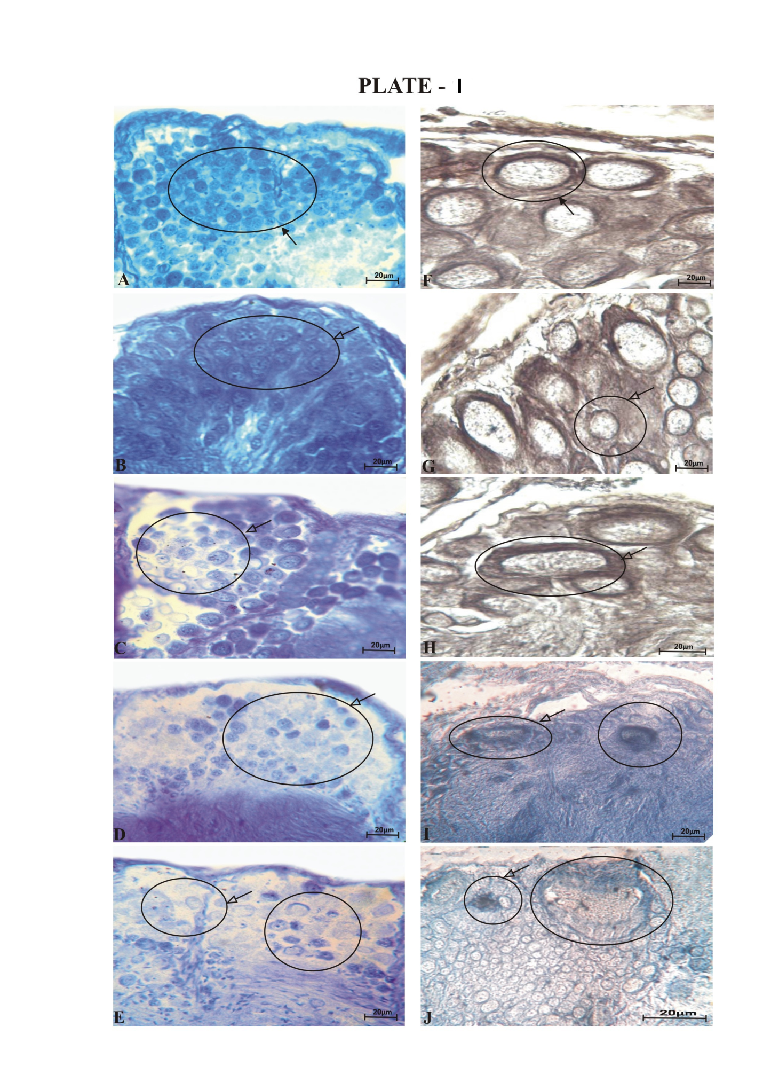
PLATE – I. Protein and lipid content in cerebral ganglia of S. maculata after HgCl2 intoxication.

Figure B - E Showed mercury bromophenol blue stained proteins in cerebral ganglia
Figure G - J Showed Sudan black B stained lipids in cerebral ganglia
Figure A, F - Control group 400 X, Figure B, G - 24 hr 400 X, Figure C, H - 48 hr 400 X, Figure D, I - 72 hr 400 X,
Figure E, J - 96 hr 400 X

Bold arrow – indicate presence of protein and lipid, Hollow arrow – indicate decreased protein and lipid.

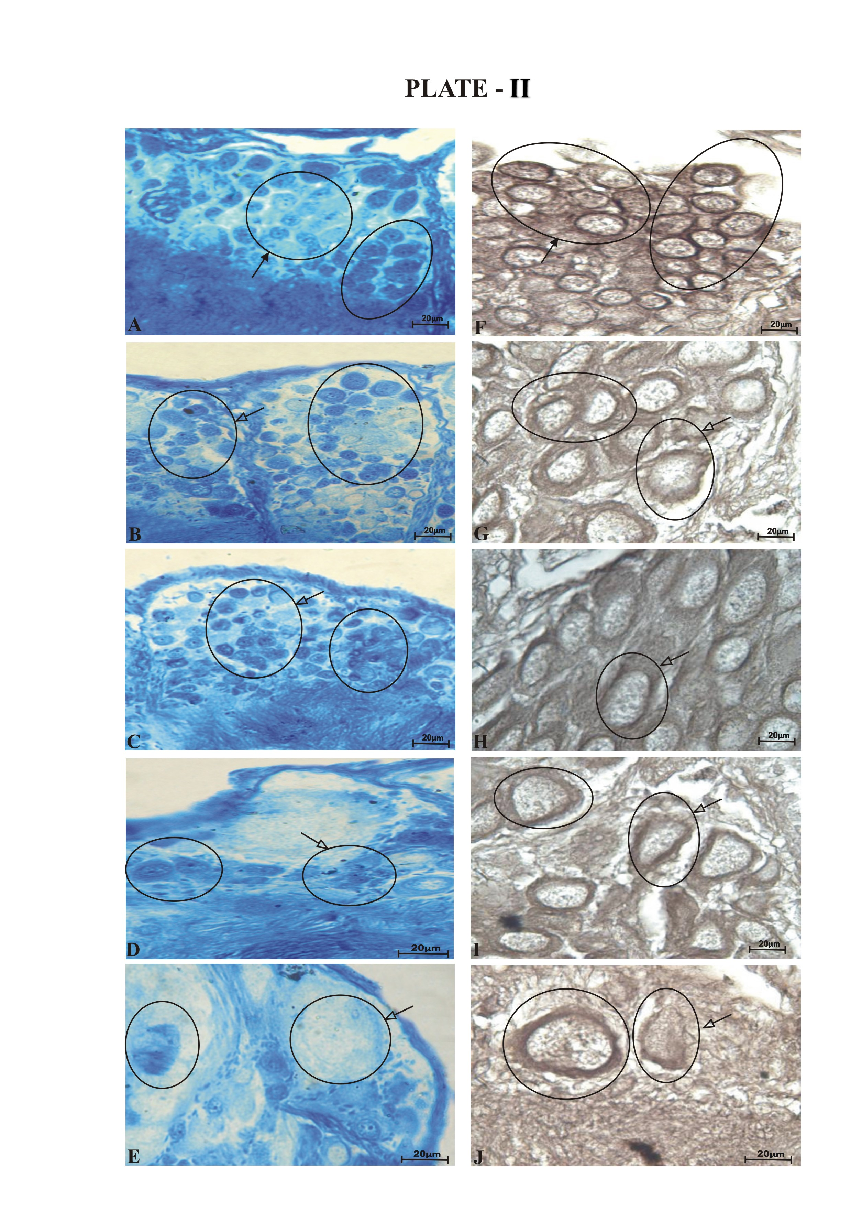
PLATE – II Protein and lipid content in cerebral ganglia of B. bengalensis after HgCl₂ intoxication.
Figure B - E Mercury bromophenol blue stained reduced proteins in cerebral ganglia
Figure G - J Sudan black B stained depleted lipids content in cerebral ganglia
Figure A, F - Control group 400 X, Figure B, G - 24 hr 400 X, Figure C, H - 48 hr 400 X , Figure D, I - 72 hr 400 X
Figure E, J - 96 hr 400 X,
Bold arrow – indicate presence of protein and lipid, Hollow arrow – indicate decreased protein and lipid

REFERENCES

Ali, H., Khan, E., & Ilahi, I. (2019). Environmental chemistry and ecotoxicology of hazardous heavy metals: Environmental persistence, toxicity, and bioaccumulation. Journal of Chemistry, 2019, Article 6730305. https://doi.org/10.1155/2019/6730305
Andhale, A. V., & Zambare, S. P. (2011). Fect of nickel-induced biochemical alterations in fresh water bivalve, Lamellidens marginalis. Journal of Ecobiotechnology, 3(11), 18–24.
Campoy-Diaz, A. D., Malanga, G., Giraud-Billoud, M., & Vega, I. A. (2023). Changes in the oxidative status and damage by non-essential elements in the digestive gland of the gastropod Pomacea canaliculata. Frontiers in Physiology, 14, Article 1123977. https://doi.org/10.3389/fphys.2023.1123977
Chiffelle, T. L., & Putt, F. A. (1951). Propylene and ethylene glycol as solvents for Sudan IV and Sudan Black B. Stain Technology, 26(1), 51–56. https://doi.org/10.3109/10520295109113178
Chukaeva, M., & Petrov, D. (2023). Assessment and analysis of metal bioaccumulation in freshwater gastropods of urban river habitats, Saint Petersburg (Russia). Environmental Science and Pollution Research, 30(3), 7162–7172. https://doi.org/10.1007/s11356-022-21955-8
Dutta, D. (2016). Effect of heavy metal cadmium on total protein content, amino acid content and alanine aminotransferase activity of freshwater snail, Pila globosa. International Journal of Scientific Research in Science and Technology, 2(3), 231–234.
Kapoor, S. G., & Lomte, V. S. (1987). Effect of toxic compounds (HgCl₂ and CuSO₄) on oxygen consumption of the freshwater mussel Indonaia caeruleus. In Proceedings of the National Symposium on Ecotoxicology (pp. 134–136).
Lake, P. S., Swain, R., & Mills, B. (1979). Lethal and sublethal effects of cadmium on freshwater crustaceans (Australian Water Resources Council Technical Paper No. 37). Australian Government Publishing Service. https://agris.fao.org/search/en/providers/122535/records/65ddfe4d4c5aef494fd83e46
Londhe, S. R., & Kamble, N. A. (2013a). Histopathology of cerebro neuronal cells in freshwater snail Bellamya bengalensis: Impact on respiratory physiology by acute poisoning of mercuric and zinc chloride. Toxicological & Environmental Chemistry, 95(2), 304–317. https://doi.org/10.1080/02772248.2013.771431
Londhe, S. R., & Kamble, N. A. (2013b). Mercuric chloride-induced gastrin/cholecystokinin-8 immunoreactivity in the central nervous system of the terrestrial slug Semperula maculata: An immunohistochemical study. Invertebrate Neuroscience, 13(2), 179–188. https://doi.org/10.1007/s10158-013-0162-0
Ma, B., Zhao, X., Zhang, X., Yang, B., Cai, Z., Xing, Z., Xu, M., Mi, L., Zhang, J., Wang, L., Zhao, Y., & Liu, X. (2024). The acute neurotoxicity of inorganic mercury in Mactra chinensis Philippi. Aquatic Toxicology, 270, Article 106896. https://doi.org/10.1016/j.aquatox.2024.106896
Macías-Mayorga, D., Laiz, I., Moreno-Garrido, I., & Blasco, J. (2015). Is oxidative stress related to cadmium accumulation in the mollusc Crassostrea angulata? Aquatic Toxicology, 161, 231–241. https://doi.org/10.1016/j.aquatox.2015.02.007
Okechukwu, V. U., & Onwukeme, V. I. (2025). Ecological and health risk assessment of heavy metals and organochlorine pesticides in water and sediments from Otamiri River in Imo State, Nigeria. Journal of Global Ecology and Environment, 21(1), 29–45. https://doi.org/10.56557/jogee/2025/v21i19080
Rahim, A. R., Utami, D. R., & Ubaidillah. (2025). Density of green mussels (Perna viridis) and its impact on growth and lead accumulation in polyculture systems in tropical waters. Asian Journal of Fisheries and Aquatic Research, 27(1), 79–89. https://doi.org/10.9734/ajfar/2025/v27i1865
Regoli, F., & Giuliani, M. E. (2014). Oxidative pathways of chemical toxicity and oxidative stress biomarkers in marine organisms. Marine Environmental Research, 93, 106–117. https://doi.org/10.1016/j.marenvres.2013.07.006
Serfőző, Z., & Elekes, K. (2007). Histochemistry of the extracellular matrix in the snail central nervous system. Ideggyógyászati Szemle, 60(3–4), 173–176. https://pubmed.ncbi.nlm.nih.gov/17451063/
Serfőző, Z., & Elekes, K. (2010). Chemical properties of the extracellular matrix of the snail nervous system: A comprehensive study using a combination of histochemical techniques. Micron, 41(5), 461–471. https://doi.org/10.1016/j.micron.2010.02.003
Syková, E. (2004). Extrasynaptic volume transmission and diffusion parameters of the extracellular space. Neuroscience, 129(4), 861–876. https://doi.org/10.1016/j.neuroscience.2004.06.077
Tchounwou, P. B., Yedjou, C. G., Patlolla, A. K., & Sutton, D. J. (2012). Heavy metal toxicity and the environment. In A. Luch (Ed.), Molecular, clinical and environmental toxicology: Volume 3: Environmental toxicology (Experientia Supplementum, Vol. 101, pp. 133–164). Springer. https://doi.org/10.1007/978-3-7643-8340-4_6
Valarmathi, S. (2000). Environmental quality of the coastal zone of Madras and impact of pollutants on Sesarma quadratum (Fabricius) [Doctoral dissertation, University of Madras].
Volpi, N., & Maccari, F. (2003). Purification and characterization of hyaluronic acid from the mollusc bivalve Mytilus galloprovincialis. Biochimie, 85(6), 619–625. https://doi.org/10.1016/S0300-9084(03)00083-X
Włostowski, T., Kozłowski, P., Łaszkiewicz-Tiszczenko, B., & Oleńska, E. (2016). Cadmium accumulation and pathological alterations in the midgut gland of terrestrial snail Helix pomatia L. from a zinc smelter area: Role of soil pH. Bulletin of Environmental Contamination and Toxicology, 96(4), 484–489. https://doi.org/10.1007/s00128-016-1748-0

