Prevalence of Ectoparasitic Mite Infestations in Cats with Special Reference to Sarcoptes scabiei, Notoedres cati, and Otodectes cynotis

ABSTRACT
Ectoparasitic mite infestations are among the most important dermatological disorders affecting cats and lead to pruritus, skin lesions, and otic disease. The present study was conducted at the Veterinary Clinical Complex (VCC), College of Veterinary Science, Rajendranagar, Hyderabad, from June 2025 to May 2026 to determine the occurrence and clinical presentation of major ectoparasitic mite infestations in cats. A total of 120 cats presenting with dermatological and otic clinical signs were examined during the study period. A detailed clinical history was obtained, and a physical examination was performed for each animal. Diagnostic procedures included the collection of deep skin scrapings and ear swabs for microscopic examination to identify mites based on standard morphological characteristics. Of the 120 cats presenting with dermatological and otic signs, 80 (66.67%) were confirmed to have ectoparasitic mite infestations. The identified ectoparasites were Notoedres cati, Sarcoptes scabiei, and Otodectes cynotis. The data obtained were analysed using the chi-square test to determine statistical significance among infestations. Notoedres cati was the predominant mite species, identified in 48 cats (60.0%), followed by Sarcoptes scabiei in 20 cats (25.0%) and Otodectes cynotis in 12 cats (15.0%). Clinically affected cats exhibited varying degrees of pruritus, alopecia, erythema, crust formation, skin scaling, and otitis externa, depending on the mite species involved. Statistical analysis revealed a highly significant difference in the occurrence of mite species (χ² = 26.81, df = 2, P < .001), indicating the predominance of Notoedres cati during the study period. These findings emphasise the importance of routine dermatological and otoscopic examinations, early laboratory diagnosis, and the implementation of effective parasite control measures for managing ectoparasitic mite infestations in clinically suspected cats.
Keywords: Cats, Notoedres cati, Sarcoptes scabiei, Otodectes cynotis, prevalence
1. INTRODUCTION
The skin is the largest and most visible organ of the body, performing numerous vital physiological functions, including protection, thermoregulation, sensory perception, and immune defence. However, it is continuously exposed to various physical, chemical, and biological stressors that may lead to a wide range of dermatological disorders (Lloyd & Patel, 2012).
Dermatological diseases are among the most common health problems encountered in companion animals. Although skin disorders in cats are frequently observed in clinical practice, advances in feline dermatology have lagged behind those in dogs, resulting in comparatively limited literature on and understanding of feline skin diseases. Dermatological conditions significantly affect the welfare, comfort, and aesthetic quality of life of cats and often pose diagnostic challenges because many dermatological diseases exhibit similar clinical manifestations (Miller et al., 2013). Feline dermatological disorders can be broadly classified into parasitic, bacterial, fungal, viral, and protozoal diseases; hypersensitivity disorders; autoimmune and immune-mediated dermatoses; endocrine and metabolic disorders; congenital and hereditary defects; nutritional dermatoses; cutaneous neoplasms; and miscellaneous skin diseases.
Skin diseases are estimated to affect approximately 6–15% of feline patients, with ectoparasitic infestations constituting a major proportion of these disorders. Among ectoparasites, mite infestations are of particular importance because of their prevalence, contagious nature, and substantial impact on skin health. Young cats are generally more susceptible to severe mite infestations because protective immunity develops with age (Ashwini & Chetan Kumar, 2023).
Recent case-based evidence from India further indicates that feline mite infestations may present with pruritus and crusting lesions, reinforcing their continuing clinical relevance in cats (Mishra et al., 2026).
Parasitological surveillance of Indian mammals has also documented mites within mixed ectoparasite communities, supporting systematic examination when evaluating parasite occurrence (Kumar et al., 2025).
Among the mange-causing mites, Sarcoptes scabiei is an important burrowing mite responsible for sarcoptic mange, one of the most contagious parasitic skin diseases affecting domestic and wild mammals. The mite burrows into the superficial layers of the epidermis and completes its entire life cycle within the host’s skin. Clinical manifestations are primarily associated with hypersensitivity reactions to mite antigens and metabolic products, resulting in intense pruritus, papules, erythema, alopecia, excoriations, and crust formation, which may progress to generalised dermatitis if left untreated (Arlian, 1989; Arlian & Morgan, 2017).
Notoedric mange is a highly contagious parasitic skin disease of cats and kittens caused by Notoedres cati. Although primarily a disease of cats, the mite may occasionally infest other animals and humans (Taylor et al., 2016). Notoedres cati mites are smaller than Sarcoptes scabiei mites and have ‘thumbprint’-like dorsal striations, shorter limb stalks, and a dorsal anus, compared with the terminal anus, dorsal pegs, and spines observed in Sarcoptes species (Scott et al., 2001).
A recent investigation of naturally infested cats similarly described Notoedres cati as a contagious burrowing mite associated with intense pruritus and dermatological signs (Sioutas et al., 2025).
Otodectes cynotis is a parasitic mite that inhabits the ear canal of cats and dogs. Otodectic mange causes otitis characterised by ceruminous gland hyperplasia (Van der Gaag, 1986), which induces intense pruritus and consequent scratching, self-mutilation, and head shaking. It is the main cause of otitis externa in dogs and cats (Lohse et al., 2002; Perego et al., 2014).
Recent epidemiological evidence confirms that Otodectes cynotis remains an important cause of feline otoacariasis and may produce variable otic and dermatological signs in affected cats (El-Dakhly et al., 2025).
In addition to their veterinary importance, certain feline mite infestations possess zoonotic potential. Both Sarcoptes scabiei and Notoedres cati have been reported to infest humans who come into close contact with affected animals, resulting in transient pruritic skin lesions (Chakrabarti, 1986; Walton et al., 2004; Beck, 2005). Companion animals, particularly dogs and cats, have been identified as common sources of human infestation, and several outbreaks associated with animal contact have been documented (Fain, 1978; Chakrabarti, 1986; Mitra et al., 1993; Morsy et al., 1994; Burroughs & Elston, 2003; Heukelbach & Feldmeier, 2006).
Despite increasing awareness of feline dermatological disorders, information regarding the occurrence and clinical presentation of mite infestations in cats remains limited in many regions of South India, particularly in Telangana. Knowledge of local prevalence patterns and associated clinical manifestations is essential for improving diagnostic accuracy, treatment outcomes, and preventive strategies. Therefore, the present study was undertaken to determine the prevalence and clinical presentation of major ectoparasitic mite infestations caused by Sarcoptes scabiei, Notoedres cati, and Otodectes cynotis in cats presented to the Veterinary Clinical Complex, Rajendranagar, Hyderabad.

2. MATERIALS AND METHODS
2.1 Study Area and Period
The present study was carried out at the Veterinary Clinical Complex (VCC), College of Veterinary Science, Rajendranagar, Hyderabad, and selected veterinary clinics in and around Hyderabad from June 2025 to May 2026 to determine the prevalence of ectoparasitic mite infestations in cats.
2.2 Study Design and Sample Size
A total of 120 cats presenting with dermatological and otic disorders were examined at the Veterinary Clinical Complex. Both domestic and feral cats of different age groups, sexes, and breeds were included in the study.
2.3 Selection of Animals
Cats presented with clinical signs suggestive of ectoparasitic infestation such as pruritus, erythema, alopecia, scaling, crusty lesions, dermatitis, and otitis externa were selected for the study.
2.4 Materials Used
The materials used in the study included a compound light microscope, glass slides, coverslips, sterile surgical blades (No. 22), cotton, cotton buds, and dropper pipettes. The reagents used were 70% alcohol, mineral oil, and 10% potassium hydroxide (KOH).
2.5 Clinical Examination
Information regarding age, sex, and breed was recorded for each cat at the time of clinical examination. Cats were categorised as kittens (<1 year), young adults (1–3 years), and adults (>3 years). Each cat was subjected to a thorough general physical examination, followed by dermatological and otoscopic examinations. Clinical examination was performed through systematic inspection and palpation from head to tail.
After examination and sampling, feral cats were marked on the head using coloured spray paint and photographed for identification to avoid repeat sampling (Siagian, 2022).

2.6 Collection of Clinical Samples
The following samples were collected from cats showing signs of dermatitis:
- Deep skin scrapings: Skin scrapings were obtained from affected areas, including the head, pinna, dorsal back, thoraco-abdominal region, limbs, and ears, and were then transferred into sterile vials for microscopic examination. They were collected using a sterile surgical blade (No. 22). A drop of mineral oil was applied either to the blade or directly onto the lesion to facilitate the adhesion of debris and prevent the escape of mites. Scraping was performed over approximately 1 cm² of affected skin in the direction of hair growth until mild capillary bleeding was observed. During scraping, gentle pressure was applied to the skin between the thumb and index finger to expose mites from deeper follicles (Shrestha et al., 2015). The number of sampling sites varied depending on lesion distribution, ranging from one site in localised cases to multiple sites in generalised infestations (Gortel, 2006).

- Earwax samples: These were collected using sterile cotton buds for the detection of Otodectes cynotis.
2.7 Sample Processing and Microscopic Examination
Skin scrapings and earwax samples were placed on a glass slide, and 1–2 drops of 10% KOH were added. The preparation was gently mixed, covered with a coverslip, and allowed to stand for 1–2 minutes. The KOH dissolved keratin and debris, thereby improving the visualisation of mites. The prepared slides were examined under a compound light microscope at 40× magnification (Siagian, 2022; Jannah & Siagian, 2021).
2.8 Identification of Mites
Identification of mites was carried out based on morphological characteristics, including body shape, leg structure, dorsal striations, and the position of the anus, as described in standard veterinary parasitology references (Taylor et al., 2016).
2.9 Statistical Analysis
The data were entered into Microsoft Excel and analysed using the chi-square (χ²) goodness-of-fit test to compare the distribution of Notoedres cati, Sarcoptes scabiei, and Otodectes cynotis among the positive cases. The null hypothesis (H₀) stated that there was no significant difference in the distribution of the three mite species, whereas the alternative hypothesis (H₁) stated that at least one mite species occurred at a significantly different frequency. A P value < 0.05 was considered statistically significant.
3. RESULTS
A total of 120 cats presenting to the Veterinary Clinical Complex (VCC), Rajendranagar, Hyderabad, with dermatological and otic clinical signs were examined during the study period. Microscopic examination of skin scrapings and ear swabs confirmed ectoparasitic mite infestations in 80 (66.67%) of the 120 clinically suspected cats, whereas 40 (33.33%) cats were negative for mite infestation (Table 1). Statistical analysis using the chi-square goodness-of-fit test revealed a highly significant difference in the distribution of mite species (χ² = 26.81, df = 2, P < .001).
Among the mites identified based on morphology, Notoedres cati was the predominant ectoparasite and was detected in 48 of the 80 positive cats (60.0%), followed by Sarcoptes scabiei in 20 cats (25.0%) and Otodectes cynotis in 12 cats (15.0%) (Table 2).
The distribution of ectoparasitic mite species according to the age, sex, and breed of the positive cats is presented in Table 3. Kittens (<1 year) accounted for the highest number of positive cases (56/80, 70.0%), followed by young adult cats (17/80, 21.25%) and adult cats (7/80, 8.75%). Female cats (43/80, 53.75%) were slightly more frequently affected than male cats (37/80, 46.25%). Purebred cats constituted the majority of positive cases (58/80, 72.5%), whereas non-purebred cats accounted for 22 cases (27.5%). Notoedres cati was the predominant mite species across all age, sex, and breed categories (Table 3).
Cats with Notoedres cati infestation exhibited intense pruritus, thick greyish crusts, scaling, alopecia, and thickening of the skin. Lesions were primarily distributed over the face and ear margins, with extension to the neck and forelimbs in advanced cases (Figure 1). Microscopic examination of deep skin scrapings revealed the characteristic morphology of Notoedres cati mites, characterised by a rounded body with concentric dorsal striations and a dorsal anus. Oval-shaped eggs were also observed (Figure 2).
Cats infested with Sarcoptes scabiei exhibited severe generalised pruritus, alopecia, erythema, and extensive crust formation. Lesions were predominantly distributed over the ears, face, limbs, and ventral body regions. Persistent scratching and self-trauma were evident in several animals (Figure 3). Confirmation was achieved through microscopic examination of skin scrapings, which demonstrated the characteristic morphology of Sarcoptes scabiei mites, with a rounded body, short legs that did not extend beyond the body margin, dorsal spines, and a terminal anus (Figure 4).
Cats infested with Otodectes cynotis exhibited signs of otitis externa characterised by head shaking, ear scratching, discomfort, the accumulation of dark brown ceruminous discharge in the external ear canal, and erythema of the external ear and adjacent facial region (Figure 5). Microscopic examination of ear debris revealed the characteristic morphology of Otodectes cynotis mites, which had an oval body and long legs extending beyond the body margin (Figure 6).

Table 1. Prevalence of ectoparasitic mite infestations among cats examined (n = 120)
Category | Number of cats | Percentage (%)
Positive for mite infestation | 80 | 66.67
Negative for mite infestation | 40 | 33.33
Total examined | 120 | 100

Table 2. Distribution of ectoparasitic mite infestations among positive cats (n = 80)
Mite species | Number of positive cases | Percentage (%)
Notoedres cati | 48 | 60.0
Sarcoptes scabiei | 20 | 25.0
Otodectes cynotis | 12 | 15.0
Total | 80 | 100

Table 3. Distribution of ectoparasitic mite species according to age, sex, and breed of positive cats (n = 80)
Variable | Category | Notoedres cati | Sarcoptes scabiei | Otodectes cynotis | Total
Age | Kitten (<1 year) | 34 | 15 | 07 | 56
 | Young adult (1–3 years) | 10 | 03 | 04 | 17
 | Adult (>3 years) | 04 | 02 | 01 | 07
Sex | Male | 21 | 09 | 07 | 37
 | Female | 27 | 11 | 05 | 43
Breed | Pure breed | 38 | 12 | 08 | 58
 | Non - purebred | 10 | 08 | 04 | 22

Statistical analysis using the chi-square goodness-of-fit test revealed a highly significant difference in the occurrence of mite species among positive cats (χ² = 26.81, df = 2, P < .001), indicating that Notoedres cati was significantly more prevalent than Sarcoptes scabiei and Otodectes cynotis during the study period.
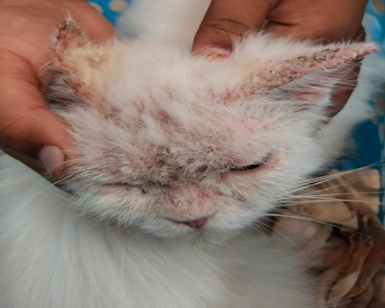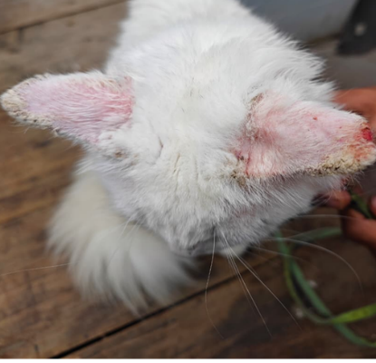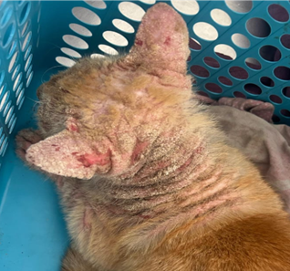
1a
1c
1b
Fig. 1. Clinical lesions in cats with Notoedres cati infestation
Fig. 1a. Facial crusting and alopecia; Fig. 1b. Erythema and crusting of the ear margins; Fig. 1c. Severe alopecia, skin thickening, and extensive crusting over the head and ears.
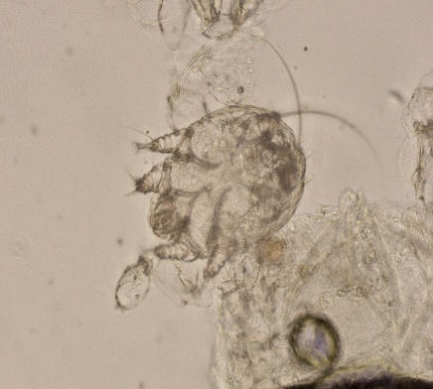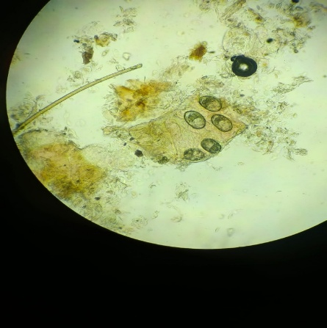
2b
2a
Fig. 2. Microscopic examination of deep skin scrapings showing Notoedres cati (100x).
Fig. 2a. Adult Notoedres cati mite showing a circular body with characteristic concentric striations; Fig. 2b. Oval shaped eggs of Notoedres cati.
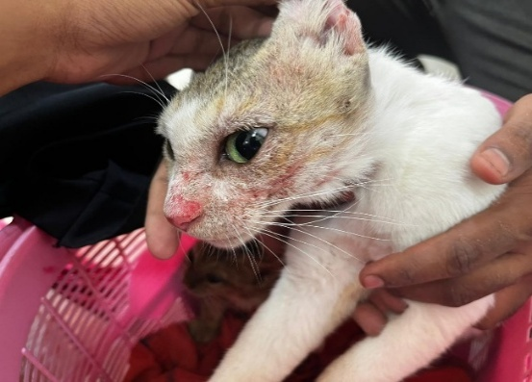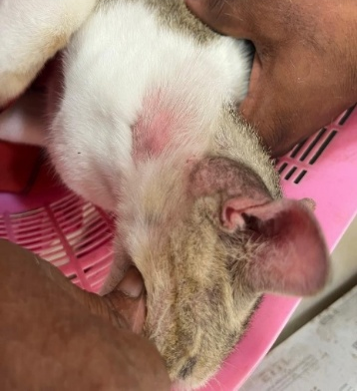
3b
3a
Fig. 3. Cats affected with sarcoptic mange
Fig. 3a. Severe alopecia, erythema and extensive crust formation over the face and ear; Fig. 3b. Generalized skin lesions with alopecia and crust on body.
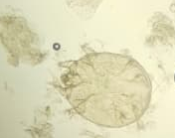
Fig. 4. Microscopic examination of deep skin scrapings showing the characteristic
morphology of Sarcoptes scabiei (100x)
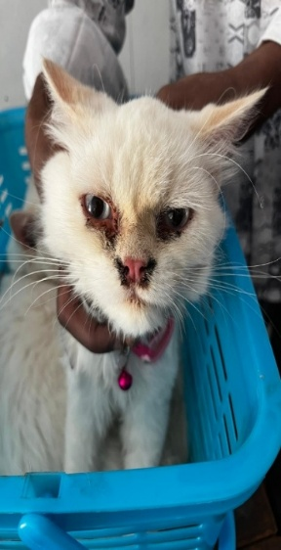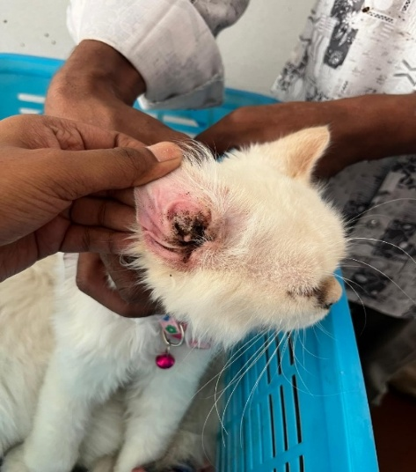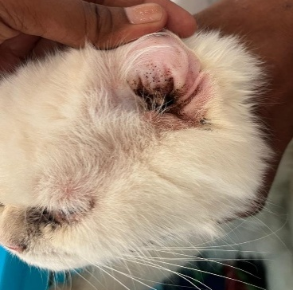
5c
5b
5a
Fig. 5. Cats with Otodectes cynotis infestation

Fig. 5a. Facial alopecia and excoriations associated with ear mite infestation; Fig. 5b. Erythema and inflammation of the pinna; Fig. 5c. Ceruminous debris in the external ear canal.
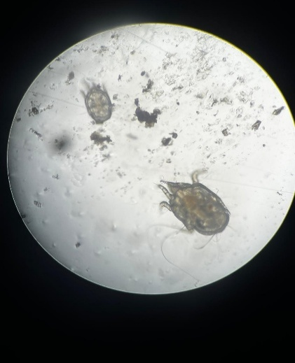
Fig 6. Microscopic examination showing characteristic morphology of Otodectes cynotis recovered from ear debris (100x).
4. DISCUSSION
In the present study, mites were identified based on characteristic morphological features observed under light microscopy, a standard method for diagnosing ectoparasitic infestations (Taylor et al., 2016; Soulsby, 1982). The presence of adult mites and eggs indicated an active infestation. Morphological differentiation was based on established taxonomic features, including the dorsal anus and concentric striations of Notoedres cati, the terminal anus and dorsal spines of Sarcoptes scabiei, and the elongated body with long legs extending beyond the body margin in Otodectes cynotis (Taylor et al., 2016; Soulsby, 1982).
Among the identified mite species, Notoedres cati was the most prevalent, accounting for 60.0% of the positive cases. Notoedric mange is a highly contagious parasitic skin disease of cats and is transmitted mainly through direct contact. Notoedres cati has a strong predilection for feline hosts and typically initiates infection in the head region before spreading to other body parts (Foley et al., 2016; Miller et al., 2013).
Sarcoptes scabiei infestation was recorded in 25.0% of the positive cases. The infestation is characterised by hypersensitivity reactions to mite antigens and burrowing activity within the superficial epidermis, resulting in intense pruritus. The relatively lower occurrence compared with Notoedres cati may reflect differences in the host specificity and ecological adaptation patterns of the mites (Miller et al., 2013; Arlian & Morgan, 2017).
Otodectes cynotis was identified in 15.0% of positive cases and remains clinically important because of its strong association with otitis externa. In the present study, otoscopic examination revealed variable inflammation of the external ear. This non-burrowing mite resides on the surface of the ear canal, feeds on epithelial debris, and spreads rapidly through direct contact, particularly in group-housed or young cats (Taylor et al., 2016).
The observed variations in prevalence may be attributed to differences in host susceptibility, environmental contamination, grooming behavior, immune status, and management practices. Similar epidemiological trends have been reported in previous studies (Beugnet et al., 2014).
The findings of the study indicate that ectoparasitic mite infestations continue to represent an important dermatological and otic health concern in cats. The occurrence of multiple mite species reflects continuous exposure of animals to infested environments and highlights the role of stray and free-roaming cats in maintaining the transmission cycle of these mites.
Similar observations have been reported by Beugnet et al. (2014), who emphasized that ectoparasites are among the most common causes of skin diseases in companion animals, particularly in populations with limited parasite control measures and high animal density.
Poor sanitation, overcrowding, and a lack of routine veterinary care contribute significantly to the persistence and spread of ectoparasitic infestations. In addition, Sarcoptes scabiei has zoonotic importance and may cause transient pruritic lesions in humans following close contact with infected animals (Arlian & Morgan, 2017).
The higher proportion of positive cases observed in kittens may be associated with their immature immune system and close contact with other cats, facilitating mite transmission. Female cats were slightly more frequently affected than males, while purebred cats constituted the majority of positive cases. However, these findings may reflect the characteristics of the cats presented to the Veterinary Clinical Complex rather than true population-level risk factors. Furthermore, because the study was hospital-based and included only cats presenting with dermatological or otic signs, the observed 66.67% positivity represents the occurrence of mite infestations among clinically suspected cats and should not be interpreted as the prevalence in the general cat population.
The present study demonstrates that ectoparasitic mite infestations were common among clinically suspected cats in the study settings, with Notoedres cati being the most frequently identified species, followed by Sarcoptes scabiei and Otodectes cynotis. The findings emphasise the need for routine dermatological and otoscopic examinations, early diagnosis, and the implementation of effective parasite control programmes to reduce the burden of these infestations.
5. CONCLUSION
The present study showed that ectoparasitic mite infestations were common among cats presenting with dermatological and otic signs at the Veterinary Clinical Complex, Rajendranagar, Hyderabad. Microscopic examination of skin scrapings and earwax samples confirmed ectoparasitic mite infestations in 66.67% of the clinically suspected cats. Notoedres cati was the predominant mite species, followed by Sarcoptes scabiei and Otodectes cynotis. The major clinical signs included pruritus, alopecia, erythema, crust formation, scaling, skin thickening, and otitis externa, depending on the mite species involved. The findings highlight the importance of routine dermatological and otoscopic examinations in cats with skin and ear lesions. Microscopic examination remains a practical and reliable diagnostic method for confirming mite infestations and guiding appropriate treatment. Preventive parasite control measures, improved hygiene, and owner awareness are essential for reducing transmission among susceptible cats.
Limitations:
This study was limited to cats presented with dermatological or otic signs at selected clinical settings, so the findings may not represent the true prevalence of ectoparasitic infestations in the general cat population. The study did not evaluate age, sex, breed, ownership status, housing, season, or treatment response in detail. Mite identification was based solely on morphological characteristics observed under light microscopy, and molecular confirmation was not performed. The sample size was relatively small, and follow-up data after treatment were not systematically reported. Future studies should include broader sampling and risk-factor analysis.

Ethical approval and Owner Consent:
The study involved client-owned cats presented to the Veterinary Clinical Complex (VCC), College of Veterinary Science, Rajendranagar, Hyderabad, for routine clinical examination and diagnosis. Skin scrapings and ear swabs were collected as part of standard diagnostic procedures. Informed verbal consent was obtained from the owners before clinical examination and sample collection.

Declaration of AI Use

This manuscript was prepared through the combined contributions of all author(s), including contributions to the study design, data, content development, results, interpretation, and related scholarly work. The author(s) acknowledge the use of Grammarly and ChatGPT to assist with grammar checking, language refinement, reference formatting. These AI-assisted tools were not used as authors and did not replace the intellectual contributions or scholarly judgment of the author(s). All AI-assisted outputs, including content, references, and interpretations, were carefully reviewed, revised, verified, and approved by the author(s). The author(s) accept full responsibility for the accuracy, integrity, and final content of the manuscript.

COMPETING INTERESTS:
Authors have declared that they have no known competing financial interests OR non-financial interests OR personal relationships that could have appeared to influence the work reported in this paper.

Reference
Arlian, L. G. (1989). Biology, host relations, and epidemiology of Sarcoptes scabiei. Annual Review of Entomology, 34, 139–161. https://doi.org/10.1146/annurev.en.34.010189.001035
Arlian, L. G., & Morgan, M. S. (2017). A review of Sarcoptes scabiei: Past, present and future. Parasites & Vectors, 10, Article 297. https://doi.org/10.1186/s13071-017-2234-1
Ashwini, A., & Chetan Kumar, G. K. (2023). Occurrence of mite infestation in cats. The Pharma Innovation Journal, 12(2), 129–133. https://www.academia.edu/97628897/Occurrence_of_mite_infestation_in_cats
Beck, W. (2005). Animal parasites and dermatophytes as a cause of epizoonoses in humans. Praktischer Tierarzt, 86, 426–434.
Beugnet, F., Bourdeau, P., Chalvet-Monfray, K., Cozma, V., Farkas, R., Guillot, J., Halos, L., Joachim, A., Losson, B., Miró, G., Otranto, D., Renaud, M., & Rinaldi, L. (2014). Parasites of domestic owned cats in Europe: Co-infestations and risk factors. Parasites & Vectors, 7, Article 291. https://doi.org/10.1186/1756-3305-7-291
Burroughs, R. F., & Elston, D. M. (2003). What’s eating you? Canine scabies. Cutis, 72(2), 107–109. https://ma1.mdedge.com/content/whats-eating-you-canine-scabies
Chakrabarti, A. (1986). Human notoedric scabies from contact with cats infested with Notoedres cati. International Journal of Dermatology, 25(10), 646–648. https://pubmed.ncbi.nlm.nih.gov/3804549/
Fain, A. (1978). Epidemiological problems of scabies. International Journal of Dermatology, 17(1), 20–30. https://doi.org/10.1111/j.1365-4362.1978.tb06040.x
Foley, J., Serieys, L. E. K., Stephenson, N., Riley, S., Foley, C., Jennings, M., Wengert, G., Vickers, W., Boydston, E., Lyren, L., Moriarty, J., & Clifford, D. L. (2016). A synthetic review of Notoedres species mites and mange. Parasitology, 143(14), 1847–1861. https://doi.org/10.1017/S0031182016001505
Gortel, K. (2006). Update on canine demodicosis. Veterinary Clinics of North America: Small Animal Practice, 36(1), 229–241. https://doi.org/10.1016/j.cvsm.2005.09.003
Heukelbach, J., & Feldmeier, H. (2006). Scabies. The Lancet, 367(9524), 1767–1774. https://doi.org/10.1016/S0140-6736(06)68772-2
Lloyd, D. H., & Patel, A. (2012). Structure and function of the skin. In H. Jackson and R. Marsella (Eds.), BSAVA manual of canine and feline dermatology (3rd ed., pp. 1–11). British Small Animal Veterinary Association. https://doi.org/10.22233/9781905319886.chap1
Lohse, J., Rinder, H., Gothe, R., & Zahler, M. (2002). Validity of species status of the parasitic mite Otodectes cynotis. Medical and Veterinary Entomology, 16(2), 133–138. https://doi.org/10.1046/j.1365-2915.2002.00355.x
Miller, W. H., Griffin, C. E., & Campbell, K. L. (2013). Muller and Kirk’s small animal dermatology (7th ed.). Elsevier Saunders. https://library.rvc.ac.uk/Record/10917
Mitra, M., Mahanta, S. K., Sen, S., Ghosh, C., & Hati, A. K. (1993). Sarcoptes scabiei in animals spreading to man. Tropical and Geographical Medicine, 45(3), 142–143.
Morsy, T. A., Bakr, M. E., Ahmed, M. M., & Kotb, M. M. (1994). Human scabies acquired from a pet puppy. Journal of the Egyptian Society of Parasitology, 24(2), 305–308. https://pubmed.ncbi.nlm.nih.gov/8077749/
Perego, R., Proverbio, D., Bagnagatti De Giorgi, G., Della Pepa, A., & Spada, E. (2014). Prevalence of otitis externa in stray cats in northern Italy. Journal of Feline Medicine and Surgery, 16(6), 483–490. https://doi.org/10.1177/1098612X13512119
Scott, D. W., Miller, W. H., & Griffin, C. E. (2001). Muller and Kirk’s small animal dermatology (6th ed.). W. B. Saunders. https://library.rvc.ac.uk/Record/1557
Shrestha, D., Thapa, B., Rawal, G., Dhakal, S., & Sharma, B. (2015). Prevalence of demodectic mange in canines of Kathmandu Valley having skin disorder and its associated risk factors. International Journal of Applied Sciences and Biotechnology, 3(3), 459–463. https://doi.org/10.3126/ijasbt.v3i3.13218
Siagian, T. B. (2022). Infestasi ektoparasit pada kucing liar di Kampus IPB Gunung Gede. Jurnal Sains Terapan, 12(2), 15–25. https://doi.org/10.29244/jstsv.12.2.15-25
Mishra, S., Hembram, A., Sahu, A., Mohanty, B. N., Paul, B. R., & Dehuri, M. (2026). Lynxacarus radovskyi infestation among pets of a household in Bhubaneswar, India: A case report. Journal of Scientific Research and Reports, 32(2), 644–648. https://doi.org/10.9734/jsrr/2026/v32i24013
Kumar, P., Tiwari, J., Singh, A. K., & Tiwari, V. K. (2025). Diversity and prevalence of ecto- and endoparasites of wild hares (Lepus nigricollis) from Mathura District, Uttar Pradesh, India. Journal of Biology and Nature, 17(2), 131–138. https://doi.org/10.56557/joban/2025/v17i29504
Sioutas, G., Gelasakis, A. I., Beugnet, F., & Papadopoulos, E. (2025). Treatment of notoedric mange with esafoxolaner, eprinomectin and praziquantel in naturally infested cats under in-home conditions. Veterinary Parasitology: Regional Studies and Reports, 59, 101228. https://doi.org/10.1016/j.vprsr.2025.101228
El-Dakhly, K. M., Bakry, M. A., Abdel-Rahim, M. M., Arafa, W. M., & Mohamed, H. I. (2025). Insights into the prevalence and diagnosis of feline otoacariasis in Egypt. Journal of Parasitic Diseases, 49, 193–206. https://doi.org/10.1007/s12639-024-01746-3
Soulsby, E. J. L. (1982). Helminths, arthropods, and protozoa of domesticated animals (7th ed.). Lea & Febiger. https://www.ncbi.nlm.nih.gov/nlmcatalog/8607874
Taylor, M. A., Coop, R. L., & Wall, R. L. (2016). Veterinary parasitology (4th ed.). Wiley-Blackwell. https://doi.org/10.1002/9781119073680
Van der Gaag, I. (1986). The pathology of the external ear canal in dogs and cats. Veterinary Quarterly, 8(4), 307–317. https://doi.org/10.1080/01652176.1986.9694061
Jannah, A. R. W., & Siagian, T. B. (2021). Prevalensi Otodectes cynotis pada kucing di Klinik Hewan Dunia Satwa Batusangkar, Sumatera Barat. ARSHI Veterinary Letters, 5(1), 7–8. https://doi.org/10.29244/avl.5.1.7-8
Walton, S. F., Holt, D. C., Currie, B. J., & Kemp, D. J. (2004). Scabies: New future for a neglected disease. Advances in Parasitology, 57, 309–376. https://doi.org/10.1016/S0065-308X(04)57005-7

