Original Research Article
MOLECULAR CHARACTERIZATION OF VIRULENCE GENES IN E. COLI ISOLATES FROM BOVINE MASTITIS CASES

Abstract
The pathogenicity of Escherichia coli associated with bovine mastitis is primarily governed by the presence of specific virulence genes. The present study investigated the distribution and combinations of virulence determinants in E. coli isolates recovered from mastitic milk samples. A total of 36 E. coli isolates, confirmed by 16S rRNA gene amplification, were analysed for the presence of six virulence-associated genes (Stx1, Stx2, TraT, eaeA, aer, and hly) using polymerase chain reaction (PCR). Among the tested genes, three virulence determinants (Stx2, TraT, and eaeA) were detected, whereas Stx1, aer, and hly were absent. The Stx2 gene was the most prevalent, being detected in 58.33% of isolates, followed by TraT (41.66%) and eaeA (19.44%). The absence of Stx1, together with the higher frequency of Stx2, indicated a predominance of Stx2 among the Shiga toxin genes examined. Analysis of virulence-gene combinations revealed that Stx2–TraT was the most frequent profile (22.22%), followed by Stx2–eaeA and TraT–eaeA. The findings indicated that E. coli isolates from bovine mastitis harboured multiple virulence determinants associated with adhesion, toxin production, and immune evasion. The predominance of Stx2 and its association with other virulence genes highlighted the potential pathogenic relevance of these isolates. This study provides insights into the virulence-gene profiles of mastitis-associated E. coli, which may contribute to understanding disease pathogenesis and informing targeted control strategies. Further phylogenetic analysis of the selected virulent isolate revealed genetic divergence among the E. coli sequences, with isolate SQ4647 forming a distinct lineage.
Keywords: Escherichia coli; bovine mastitis; virulence genes; polymerase chain reaction; Stx2; TraT; eaeA; molecular characterisation; phylogenetic analysis; dairy cattle

Introduction
Bovine mastitis is a multifactorial disease that significantly affects dairy production worldwide. Among its causative agents, E. coli is recognised as a major environmental pathogen responsible for both clinical and subclinical mastitis (Azevedo et al., 2016). The severity and outcome of infection largely depend on the virulence characteristics of the infecting strain rather than on the mere presence of the organism. Virulence in E. coli is mediated by a diverse array of genes encoding toxins, adhesins, invasins, iron-acquisition systems, and serum-resistance factors (Fernandes et al., 2011). These virulence determinants facilitate colonisation of the mammary gland, evasion of host immune responses, and tissue damage. Among these determinants, the Shiga toxin genes (Stx1 and Stx2), intimin (eaeA), the serum-resistance gene (TraT), aerobactin (aer), and haemolysin (hly) have recognised roles in pathogenesis (Ismail & Abutarbush, 2020). The presence and combinations of these genes define the virulence profile of an isolate and may influence its pathogenic potential (Neher et al., 2015). Recent studies have documented substantial genetic diversity among mastitis-associated E. coli and variation in virulence-gene profiles across isolates (Orsi et al., 2023; Olson et al., 2024). Comparative analysis of clinical and subclinical mastitis isolates has also shown differences in the distribution of selected virulence genes, including traT (Zuo et al., 2025). Related work from Cameroon likewise reported heterogeneous phylogenetic groups and virulence-gene profiles among bovine mastitis E. coli isolates (Abegewi et al., 2024). In addition, a bacteriological survey of subclinical mastitis identified E. coli among the recovered organisms and emphasised the value of routine screening (Ara et al., 2024). Despite these studies, information on the distribution and combination patterns of virulence genes in E. coli isolates from bovine mastitis remains limited in the study region. Therefore, the present study aimed to detect and characterise key virulence genes and their combinations in E. coli isolates.

Material and Methods
Collection of Mastitic Milk Samples
A total of 436 milk samples were collected from 10 dairy farms, comprising 339 cattle milk samples and 97 buffalo milk samples. Among the cattle milk samples, 24 (7.07%) were positive for clinical mastitis, whereas 133 (39.23%) were identified as subclinical mastitis cases. Among the buffalo milk samples, 3 (3.09%) were obtained from animals with clinical mastitis, whereas 40 (41.23%) were obtained from subclinical mastitis cases.
Subclinical mastitis cases were screened using the California Mastitis Test (CMT), and only CMT-positive milk samples were selected for further processing. Thus, a total of 200 mastitic milk samples, including both clinical and subclinical mastitis cases from cattle and buffaloes, were included in the study.
Milk samples (approximately 5–6 mL) were aseptically collected in duplicate from the affected quarter(s), after discarding the foremilk, and transferred to sterile glass vials. The samples were transported to the laboratory in an insulated ice box containing ice packs for immediate processing. Upon arrival, they were stored at 4 °C until further analysis.
Isolation and Identification of E. coli
Initially, a loopful from each of the 200 mastitic milk samples was inoculated separately into a test tube containing 3 mL of sterile nutrient broth and incubated at 37 °C for 12 h. Following incubation, the cultures were subcultured on MacConkey agar and incubated at 37 °C for 24–48 h. Pink, lactose-fermenting colonies presumptively identified as E. coli were then streaked on eosin methylene blue (EMB) agar and HiCrome E. coli agar and incubated overnight at 37 °C. All isolates were further identified by Gram staining and biochemical tests, including catalase, indole, methyl red, Voges–Proskauer, and citrate tests (Barrow, 1993).
Molecular Detection of Virulence Genes
Genomic DNA Extraction
E. coli isolates recovered from bovine mastitis milk samples were further processed for genomic DNA extraction (Sambrook & Russell, 2006).
Genomic DNA was extracted from overnight E. coli cultures using the phenol–chloroform method. Briefly, bacterial cells were pelleted by centrifugation and lysed using a lysis buffer containing SDS and proteinase K. An equal volume of phenol:chloroform:isoamyl alcohol (25:24:1) was added, mixed, and centrifuged to separate the phases. The aqueous phase was collected and purified with chloroform:isoamyl alcohol, and the DNA was precipitated using cold ethanol and sodium acetate. The DNA pellet was washed with 70% ethanol, air-dried, and dissolved in nuclease-free water for further use. Species-specific 16S rRNA gene amplification by PCR was performed for molecular confirmation of E. coli (Wang et al., 2002). PCR was performed in a final reaction volume of 25 µL in 0.2 mL PCR tubes. Each reaction contained 12.5 µL of master mix supplied with Taq DNA polymerase, MgCl2, and dNTPs; 1 µM each of the forward and reverse primers; 3 µL of template DNA; and 7.5 µL of nuclease-free water. PCR was conducted using a ProFlex PCR system (Applied Biosystems) under the standardised cycling conditions and with the specific primers listed in Table 1. Isolates confirmed by 16S rRNA gene amplification were further subjected to virulence-gene analysis.
Table 1: Details of primer sequences used for standardization of PCR assay to detect 16S rRNA of E.coli
Primer name | Nucleotide sequence (5'-3') | Amplicon size (bp)
16S rRNA | F: CCCCCTGGACGAAGACTGAC | 401
16S rRNA | R: ACCGCTGGCAACAAAGGATA | 401

Six virulence-associated genes representing major pathogenic mechanisms were selected, including toxin genes (Stx1 and Stx2), an adhesion gene (eaeA), a serum-resistance gene (TraT), an iron-acquisition gene (aer), and a haemolysin gene (hly) (Table 2). These genes were selected on the basis of their established roles in pathogenicity, including toxin production, host-cell adhesion, immune evasion, and survival within the host. PCR was performed to detect these virulence genes using the specific primers shown in Table 2.
Table 2 Sequence of primers used for the detection of virulent genes in E.coli
Sr. No. | Gene | Oligonucleotide sequence (5’ to 3’) | Amplicon  Size (bp) | Reference
1 | eaeA | F:ATGCTTAGTGCTGGTTTAGG  R: GCCTTCATCATTTCGCTTTC | 248 | Bisi -Johnson et al. (2011)
2 | TraT | F: GATGGCTGAACCGTGGTTATG  R: CACACGGGTCTGGTATTTATGC | 307 | Kaipainen et al. (2002)
3 | aer | F: TACCGGATTGTCATATGCAGACCGT  R: AATATCTTCCTCCAGTCCGGAGAAG | 602 | Oliveira et al. (2011)
4 | hly | F: AACAAGGATAAGCACTGTTCTGGCT  R: ACCATATAAGCGGTCATTCCCGTCA | 1177 | Younis et al. (2021)
5 | Stx1 | F: ACACTGGATGATCTCAGTGG  R: CTGAAATCCCCCTCCATTATG | 555 | Nguyen et al. (2011)
6 | Stx2 | F: CCATGACAACGGACAGCAGTT  R: CCTGTCAACTGAGCAGCACTTTG | 118 | Nguyen et al. (2011)

Each reaction was performed in a final volume of 25 µL containing 12.5 µL of PCR master mix, 1 µL each of the forward and reverse primers, 2 µL of template DNA, and 8.5 µL of nuclease-free water. Amplification was conducted in a thermal cycler under the optimised cycling conditions shown in Table 3.

Table 3 PCR protocol for detection of virulent genes in E. coli
Step name/gene targeted | Stx1 | Stx2 | aer | eaeA | hly | TraT
Initial denaturation | 94°C  10 min | 94°C  10 min | 94°C  1 min | 95°C  5 min | 94°C  5 min | 94°C  10 min
Denaturation | 94°C  30 sec | 94°C  30 sec | 94°C  1 min | 94°C  30 sec | 94°C  30 sec | 95°C  2 min
Annealing | 50°C  45 sec | 50°C  45 sec | 63°C  30 sec | 51°C  30 sec | 54°C  40 sec | 55°C  1 min
Extension | 70°C  90 sec | 70°C  90 sec | 70°C  90 sec | 72°C  30 sec | 72°C  45 sec | 72°C  1 min
Final extension | 72°C  10 min | 72°C  10 min | 72°C  5 min | 72°C  7 min | 72°C  10 min | 70°C  10 min

Sequencing and Phylogenetic Analysis of Virulent E. coli Isolates
The E. coli isolate that harboured the maximum number of three virulence genes (Stx2, TraT, and eaeA) was selected for sequencing and phylogenetic analysis. Nucleotide sequencing was performed by Genomic Sequencing Services, Pune Pvt. Ltd., India, using the same primers as those used for amplification. Sequences were edited and aligned using the EMBOSS Merger web tool, and global sequence comparisons were performed using the Basic Local Alignment Search Tool (BLAST) hosted by the National Center for Biotechnology Information (NCBI).
The evolutionary history was inferred using the maximum-likelihood method and Kimura two-parameter model (Kimura, 1980). Evolutionary analyses were conducted using MEGA11 (Tamura et al., 2021).

Results and Discussion
Of the 200 mastitic milk samples, comprising 27 clinical and 173 subclinical cases, 36 (18%) were positive for E. coli. Of these positive samples, 23 (11.5% of all samples) were obtained from cattle, whereas 13 (6.50% of all samples) originated from buffaloes. Presumptive E. coli colonies showed characteristic pink coloration and were further subcultured on eosin methylene blue (EMB) agar and HiCrome E. coli agar. Colonies with a distinctive metallic-green sheen were observed on EMB agar, whereas bluish colonies were observed on HiCrome E. coli agar, consistent with E. coli. On Gram staining, all isolates appeared as Gram-negative coccobacillary rods. The isolates were further confirmed using biochemical tests. They showed positive reactions in the indole and methyl red tests, indicated by the development of a red colour. In contrast, the isolates were negative in the Voges–Proskauer and citrate-utilisation tests, with no colour change, corresponding to an IMViC pattern of ++−−. Furthermore, in the triple sugar iron (TSI) agar test, the isolates produced a yellow slant and butt without gas formation.
All isolates (n = 36) presumptively identified as E. coli on the basis of cultural and biochemical characteristics were further subjected to molecular characterisation by PCR targeting the E. coli-specific 16S rRNA gene. The 16S rRNA gene was amplified in all 36 isolates, thereby confirming their identity as E. coli (Fig. 1).

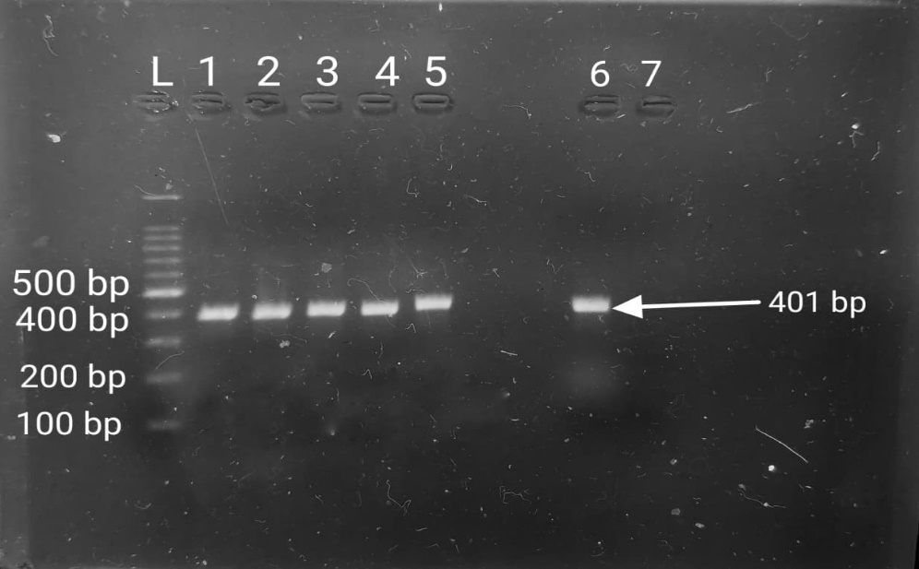
Fig. 1 Agarose gel electrophoresis showing amplification of 16S rRNA gene of
E.coli - 401 bp
L- Ladder
Lane 1, 2, 3, 4, 5 and 6 - Positive samples
Lane 7- Negative control

Earlier studies by Dowidar and Khalifa (2023) and Parveen et al. (2021) similarly reported molecular identification of E. coli isolates from milk or related biological samples.
Molecular analysis of the 36 E. coli isolates revealed a selective distribution of virulence genes. Of the six genes investigated, only Stx2, TraT, and eaeA were detected, whereas Stx1, aer, and hly were absent from all isolates (Figs. 2–4).

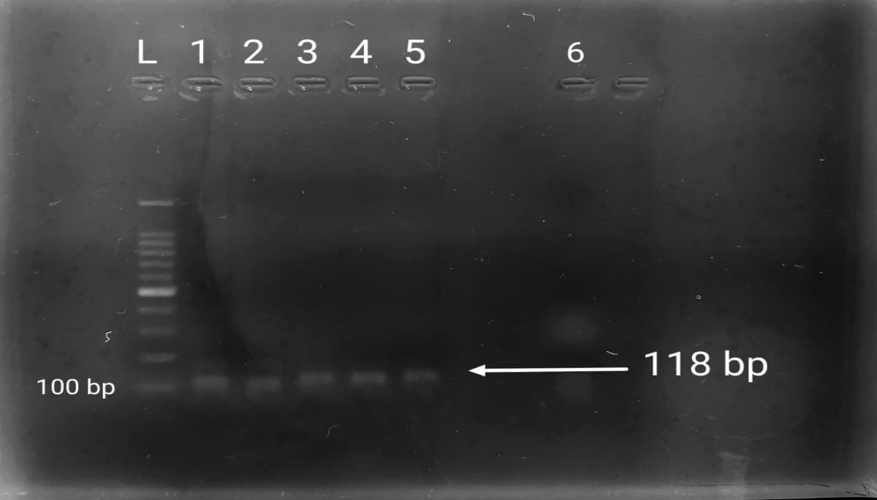
Fig. 2 Agarose gel electrophoresis showing amplification of
Stx2 gene - 118 bp
L – Ladder
Lane 1, 2, 3, 4, and 5 – Positive samples
Lane 6 – Negative control

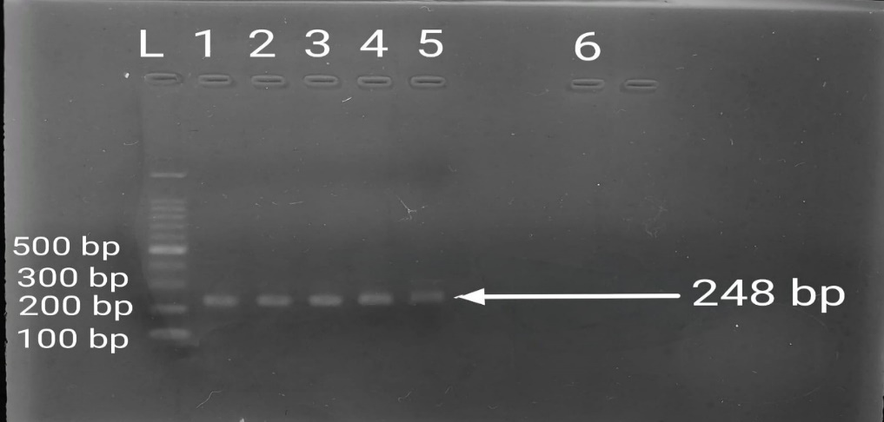
Fig. 3 Agarose gel electrophoresis showing amplification of
eaeA gene - 248 bp
L – Ladder
Lane 1, 2, 3, 4, and 5 – Positive samples
Lane 6 – Negative control

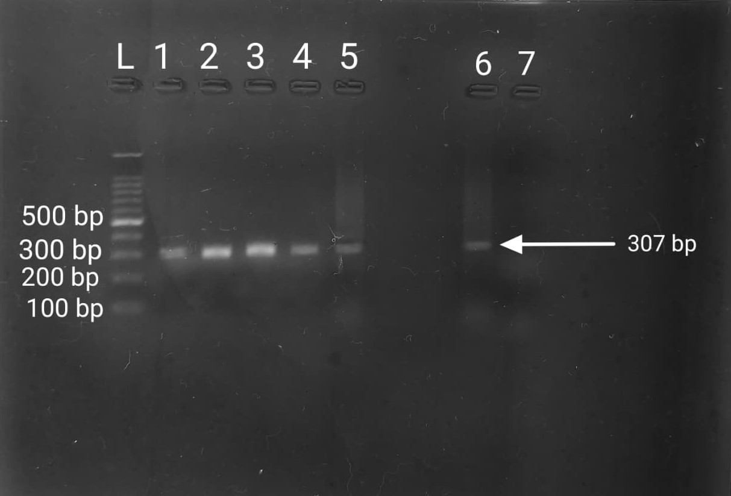
Fig. 4 Agarose gel electrophoresis showing amplification of
TraT gene - 307 bp
L – Ladder
Lane 1, 2, 3, 4, 5 and 6 – Positive samples
Lane 7 – Negative control

Stx2 was the most prevalent gene (58.33%), followed by TraT (41.66%) and eaeA (19.44%) (Table 4).
Table 4 Distribution of virulent genes in E.coli isolates
Sr. No | Virulent genes | Total samples | +Ve Samples | Prevalence
1 | Stx1 | 36 | 00 | 00
2 | Stx2 | 36 | 21 | 58.33%
3 | eaeA | 36 | 07 | 19.44%
4 | TraT | 36 | 15 | 41.66%
5 | aer | 36 | 00 | 00
6 | hly | 36 | 00 | 00
The absence of Stx1 and the higher prevalence of Stx2 indicated that Stx2 was the predominant Shiga toxin gene detected in these isolates, consistent with an earlier report (Younis et al., 2021), although variation has been observed in other studies (Neher et al., 2015; Cengiz et al., 2014).
The presence of eaeA suggested that certain isolates possessed an adhesion-associated determinant, whereas TraT indicated the presence of a serum-resistance-associated determinant. Together, these genes may contribute to colonisation and immune evasion. The absence of aer and hly indicates that these specific iron-acquisition and haemolysin determinants were not detected in the studied isolates, reflecting variability in virulence-gene profiles (Cengiz et al., 2014).
Analysis of virulence-gene combinations showed that Stx2–TraT was the most prevalent profile (22.22%), followed by Stx2–eaeA and TraT–eaeA (Table 5).

Table.5 Gene combination profiles of virulent genes in E. coli isolates
Total isolates | Gene combination | No of isolates | Prevalence
36 | Stx2 - eaeA | 03 | 8.33%
36 | Stx2 - TraT | 08 | 22.22%
36 | TraT - eaeA | 02 | 5.55%

These combinations represented the co-occurrence of determinants associated with toxin production, adhesion, and immune evasion. The findings support the view that the virulence profile of E. coli may reflect combinations of genes rather than individual determinants alone.
Overall, the study demonstrated that E. coli isolates associated with bovine mastitis possessed diverse virulence profiles, with Stx2 being the most frequently detected gene. The variability in gene distribution highlighted the multifactorial nature of pathogenicity and the value of continued molecular surveillance.
In the constructed phylogenetic tree, sequence SQ4647 formed a separate clade from the cluster containing the other reference sequences. The sequences MG817335.1, MG817336.1, MG197876.1, MF043881.1, MG966417.1, MG736060.1, and MG952583.1 grouped within the same major lineage, indicating closer genetic similarity. The independent placement of SQ4647 based on the 16S rRNA sequence suggests sequence divergence from the other sequences included in the analysis. This divergence may reflect variation within the analysed gene region (Fig. 5).
Fig. 5 Phylogenetic analysis of virulent E. coli isolates

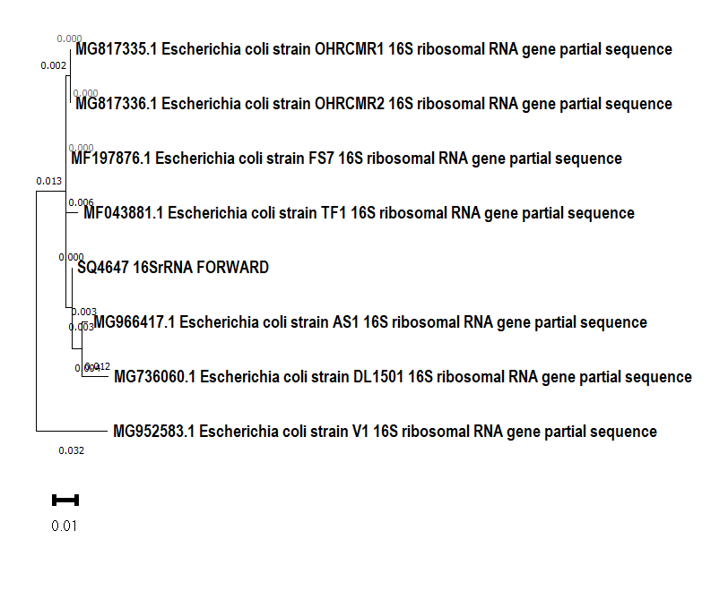
Evolutionary analysis by Maximum Likelihood method
The phylogenetic tree targeted the 16S rRNA gene. Isolate SQ4647, obtained from Satara, Maharashtra, India, showed 98–99% sequence identity with global E. coli isolates (Neamah et al., 2022).
The evolutionary history was inferred using the maximum-likelihood method and Kimura two-parameter model. The tree with the highest log-likelihood value (−2447.80) is shown. Initial trees for the heuristic search were obtained automatically by applying the neighbour-joining and BioNJ algorithms to a matrix of pairwise distances estimated using the maximum composite likelihood (MCL) approach, after which the topology with the superior log-likelihood value was selected. A discrete gamma distribution was used to model differences in evolutionary rates among sites (five categories; +G, parameter = 0.1000). The tree is drawn to scale, with branch lengths measured as the number of substitutions per site and shown next to the branches. This analysis involved eight nucleotide sequences and a total of 1,454 positions in the final dataset. Evolutionary analyses were conducted using MEGA11 (Tamura et al., 2021).

Overall, the phylogenetic analysis showed that SQ4647 formed a distinct lineage relative to the other sequences included in the analysis. This pattern indicated sequence divergence within the dataset and may contribute to understanding genetic variability and evolutionary relationships among the E. coli sequences analysed in this study.

Conclusion
The study identified a heterogeneous distribution of virulence-associated genes among Escherichia coli isolates recovered from bovine mastitis cases. Of the six genes examined, Stx2 was detected most frequently, followed by TraT and eaeA, whereas Stx1, aer, and hly were not detected. The predominance of Stx2 among the Shiga toxin genes screened and its frequent co-occurrence with TraT indicate that toxin-associated and serum-resistance determinants were present together in a subset of isolates. The additional detection of eaeA suggests that adhesion-associated potential was also represented. Stx2–TraT was the most common gene combination, followed by Stx2–eaeA and TraT–eaeA. The 16S rRNA-based phylogenetic analysis placed isolate SQ4647 in a separate lineage relative to the reference sequences analysed, indicating sequence divergence within the dataset. Overall, the results provide a molecular description of selected virulence determinants in mastitis-associated E. coli from the study area. However, the presence of these genes alone does not establish their expression or clinical effect. Broader genomic, phenotypic, and epidemiological investigations are therefore needed before firm conclusions about pathogenicity or disease severity can be drawn.

Limitation
The study included only 36 Escherichia coli isolates recovered from 200 mastitic milk samples collected in western Maharashtra. Screening was limited to six virulence-associated genes, and neither gene expression nor toxin production was assessed. Negative PCR findings require cautious interpretation in the absence of documented positive-control results. The phylogenetic analysis relied on limited 16S rRNA sequence information and therefore offers restricted strain-level resolution. Antimicrobial-resistance profiling, serotyping, whole-genome analysis, and correlation with clinical outcomes were not undertaken, limiting the broader epidemiological interpretation of the findings.
Declaration of AI Use

This manuscript was prepared through the combined contributions of all author(s), including contributions to the study design, data, content development, results, interpretation, and related scholarly work. The author(s) acknowledge the use of Grammarly and ChatGPT to assist with grammar checking, language refinement, reference formatting. These AI-assisted tools were not used as authors and did not replace the intellectual contributions or scholarly judgment of the author(s). All AI-assisted outputs, including content, references, and interpretations, were carefully reviewed, revised, verified, and approved by the author(s). The author(s) accept full responsibility for the accuracy, integrity, and final content of the manuscript.

COMPETING INTERESTS:
Authors have declared that they have no known competing financial interests OR non-financial interests OR personal relationships that could have appeared to influence the work reported in this paper.

REFERENCES
- Abegewi, U. A., Esemu, S. N., Ndip, R. N., & Ndip, L. M. (2024). Phylogenetic group and virulence gene profile of bovine mastitis Escherichia coli isolates from North West Cameroon. International Journal of Tropical Disease & Health, 45(6), 190–205. https://doi.org/10.9734/ijtdh/2024/v45i61551
- Ara, J., Chowdhury, S., & Chowdhury, G. M. (2024). Prevalence of bovine subclinical mastitis and antibiogram pattern of isolated organisms from mastitic milk in Chattagram, Bangladesh. Asian Journal of Advances in Research, 7(1), 681–690. https://doi.org/10.56557/ajoair/2024/v7i1495
- Azevedo, C., Pacheco, D., Soares, L., Romão, R., Moitoso, M., Maldonado, J., Guix, R., & Simões, J. (2016). Prevalence of contagious and environmental mastitis-causing bacteria in bulk tank milk and its relationships with milking practices of dairy cattle herds in São Miguel Island (Azores). Tropical Animal Health and Production, 48(2), 451–459. https://doi.org/10.1007/s11250-015-0973-6
- Bisi-Johnson, M. A., Obi, C. L., Vasaikar, S. D., Baba, K. A., & Hattori, T. (2011). Molecular basis of virulence in clinical isolates of Escherichia coli and Salmonella species from a tertiary hospital in the Eastern Cape, South Africa. Gut Pathogens, 3, Article 9. https://doi.org/10.1186/1757-4749-3-9
- Barrow, G. I., & Feltham, R. K. A. (Eds.). (1993). Cowan and Steel’s manual for the identification of medical bacteria (3rd ed.). Cambridge University Press. https://doi.org/10.1017/CBO9780511527104
- Dowidar, H. A., & Khalifa, M. I. (2023). Molecular isolation and identification of multidrug-resistant Escherichia coli from milk, meat, and product samples. Journal of Advanced Veterinary Research, 13(4), 643–646. https://www.advetresearch.com/index.php/AVR/article/view/1267
- Fernandes, J. B. C., Zanardo, L. G., Galvão, N. N., Carvalho, I. A., Nero, L. A., & Moreira, M. A. S. (2011). Escherichia coli from clinical mastitis: Serotypes and virulence factors. Journal of Veterinary Diagnostic Investigation, 23(6), 1146–1152. https://doi.org/10.1177/1040638711425581
- Ismail, Z. B., & Abutarbush, S. M. (2020). Molecular characterization of antimicrobial resistance and virulence genes of Escherichia coli isolates from bovine mastitis. Veterinary World, 13(8), 1588–1593. https://doi.org/10.14202/vetworld.2020.1588-1593
- Neher, S., Hazarika, A. K., Sharma, R. K., Barkalita, L. M., Bora, M., & Deka, P. (2015). Detection of Shiga-toxigenic Escherichia coli in milk samples of cattle by PCR. IOSR Journal of Agriculture and Veterinary Science, 8(5), 75–78. https://doi.org/10.9790/2380-08517578
- Kaipainen, T., Pohjanvirta, T., Shpigel, N. Y., Shwimmer, A., Pyörälä, S., & Pelkonen, S. (2002). Virulence factors of Escherichia coli isolated from bovine clinical mastitis. Veterinary Microbiology, 85(1), 37–46. https://doi.org/10.1016/S0378-1135(01)00483-7
- Kimura, M. (1980). A simple method for estimating evolutionary rates of base substitutions through comparative studies of nucleotide sequences. Journal of Molecular Evolution, 16(2), 111–120. https://doi.org/10.1007/BF01731581
- Neamah, A. A., Fahad, K. H., Sadeq, J. N., & Al-Fatlawi, M. A. (2022). Molecular characterization and phylogenetic analysis of Escherichia coli isolated from milk of cattle affected by mastitis. Iraqi Journal of Veterinary Sciences, 36(1), 251–254. https://doi.org/10.33899/ijvs.2021.129934.1702
- Neher, S., Hazarika, A. K., Sharma, R. K., Barkalita, L. M., Bora, M., & Deka, P. (2015). Detection of Shiga-toxigenic Escherichia coli in milk samples of cattle by PCR. IOSR Journal of Agriculture and Veterinary Science, 8(5), 75–78. https://doi.org/10.9790/2380-08517578
- Nguyen, T. D., Vo, T. T., & Vu-Khac, H. (2011). Virulence factors in Escherichia coli isolated from calves with diarrhoea in Vietnam. Journal of Veterinary Science, 12(2), 159–164. https://doi.org/10.4142/jvs.2011.12.2.159
- Oliveira, F. A., Paludo, K. S., Arend, L. N. V. S., Farah, S. M. S. S., Pedrosa, F. O., Souza, E. M., Surek, M., Picheth, G., & Fadel-Picheth, C. M. T. (2011). Virulence characteristics and antimicrobial susceptibility of uropathogenic Escherichia coli strains. Genetics and Molecular Research, 10(4), 4114–4125. https://doi.org/10.4238/2011.October.31.5
- Olson, M. A., Cullimore, C., Hutchison, W. D., Grimsrud, A., Nobrega, D., De Buck, J., Barkema, H. W., Wilson, E., Pickett, B. E., & Erickson, D. L. (2024). Genes associated with fitness and disease severity in the pan-genome of mastitis-associated Escherichia coli. Frontiers in Microbiology, 15, Article 1452007. https://doi.org/10.3389/fmicb.2024.1452007
- Orsi, H., Guimarães, F. F., Leite, D. S., Guerra, S. T., Joaquim, S. F., Pantoja, J. C. F., Hernandes, R. T., Lucheis, S. B., Ribeiro, M. G., Langoni, H., & Rall, V. L. M. (2023). Characterization of mammary pathogenic Escherichia coli reveals the diversity of Escherichia coli isolates associated with bovine clinical mastitis in Brazil. Journal of Dairy Science, 106(2), 1403–1413. https://doi.org/10.3168/jds.2022-22126
- Parveen, B., Junejo, Y., Safdar, M., & Özaslan, M. (2021). Molecular characterization of Escherichia coli isolated from raw cow milk samples collected from district Bahawalpur, Pakistan. Zeugma Biological Science, 2(2), 1–13. https://dergipark.org.tr/en/pub/zbs/article/913301
- Sambrook, J., & Russell, D. W. (2006). Detection of DNA in agarose gels. Cold Spring Harbor Protocols, 2006(1), Article pdb.prot4022. https://doi.org/10.1101/pdb.prot4022
- Cengiz, S., Dinç, G., & Söğüt, M. Ü. (2014). Detection of several virulence properties, antibiotic resistance and phylogenetic relationship in E. coli isolates originated from cow mastitis. Acta Veterinaria, 64(4), 413–425. https://doi.org/10.2478/acve-2014-0039
- Tamura, K., Stecher, G., & Kumar, S. (2021). MEGA11: Molecular evolutionary genetics analysis version 11. Molecular Biology and Evolution, 38(7), 3022–3027. https://doi.org/10.1093/molbev/msab120
- Wang, G., Clark, C. G., & Rodgers, F. G. (2002). Detection in Escherichia coli of the genes encoding the major virulence factors, the genes defining the O157 serotype, and components of the type 2 Shiga toxin family by multiplex PCR. Journal of Clinical Microbiology, 40(10), 3613–3619. https://doi.org/10.1128/JCM.40.10.3613-3619.2002
- Younis, W., Hassan, S., & Mohamed, H. M. A. (2021). Molecular characterization of Escherichia coli isolated from milk samples with regard to virulence factors and antibiotic resistance. Veterinary World, 14(9), 2410–2418. https://doi.org/10.14202/vetworld.2021.2410-2418
- Zuo, J., Lv, Z., Lian, L., Wu, Z., Fu, S., Zhang, H., Wu, J., Pan, Z., Yu, Y., Chen, W., Jiang, W., Yin, H., Chen, Z., Yi, Y., Han, X., & Miao, J. (2025). Difference analysis on virulence genes, biofilms and antimicrobial susceptibility of Escherichia coli from clinical and subclinical bovine mastitis. Veterinary Sciences, 12(2), Article 132. https://doi.org/10.3390/vetsci12020132

