Laboratory Evaluation of Plant-Based Mosquito Repellents against Adult Mosquitoes

Abstract
Mosquito-borne diseases remain a major public health concern, particularly in tropical and subtropical regions, creating a continued need for effective and sustainable vector-control approaches. Plant-based repellents offer a potentially affordable and environmentally compatible alternative to conventional synthetic mosquito-control products. This study evaluated plant-based mosquito repellents prepared as coils and incense sticks from locally available botanical materials: Cymbopogon citratus leaves, Eucalyptus globulus leaves, Citrus maxima peel, and Isodon ternifolius leaves. The selected plant parts are traditionally used by local communities as insect repellents. Each botanical material was processed separately, and a combined formulation containing all four materials was also prepared. Burning performance, repellency, knockdown, and 24-hour mortality were assessed against laboratory-reared adults of Culex quinquefasciatus, Aedes aegypti, and Anopheles longirostris under controlled chamber conditions. All formulations burned completely, with residual ash values ranging from 38.76% to 41.09%. Repellency generally increased with exposure time. Among the individual formulations, lemongrass and khoiju showed comparatively greater repellent activity, while pomelo peel and eucalyptus showed moderate activity. The combined botanical formulation produced the highest overall repellency among the plant-based treatments and caused 46.6% mortality after 24 hours. The synthetic coil used as the positive control produced 93.3% mortality, whereas the untreated negative control produced no mortality. These findings indicate that the selected botanical materials produced measurable repellent and knockdown effects under laboratory conditions, although their lethal activity was lower than that of the synthetic coil. Further work should standardise formulation ratios, characterise active compounds, assess smoke safety, establish adequate replication, and evaluate performance under field conditions.
Keywords
Botanical mosquito repellents; incense sticks; adult mosquitoes; repellency; knockdown; mortality; Cymbopogon citratus; Isodon ternifolius; vector control.

- Introduction
Mosquitoes are among the most dangerous vectors of several life-threatening diseases, including malaria and dengue (Katz et al., 2008). Female mosquitoes transmit pathogens while taking blood meals, thereby spreading viruses, protozoa, and nematodes from infected individuals to uninfected individuals. Many of these diseases are widespread in tropical and subtropical regions, including India. Beyond their medical and public health effects, these diseases reduce workforce productivity and hinder societal economic development.
As mosquito-borne diseases represent critical global challenges, there is an urgent need for effective and sustainable vector-control strategies. Plant-based mosquito coils represent one rational approach to repelling or killing these vectors. Mosquito control is particularly important in the present context of increasing mosquito-borne disease incidence (Fradin, 1998). The development of plant-based control measures is motivated by several limitations of conventional methods, including mosquito resistance to synthetic insecticides following prolonged use, environmental pollution, and adverse effects on non-target organisms (Hemingway & Ranson, 2000; World Health Organization [WHO], 2012a). Recent reviews indicate that the performance of plant-derived mosquito repellents depends on the botanical source, formulation, release characteristics, and experimental conditions, supporting direct evaluation of the finished product rather than inference from traditional use alone (Dagar & Ramakrishna, 2024; Kaushik et al., 2023).
Controlled laboratory assays have also shown that plant-derived blends can produce spatial repellency against adult Aedes aegypti, supporting chamber-based testing as an appropriate preliminary assessment of adult mosquito responses (Yavasoglu et al., 2025). A recent review of herbal dhoop formulations containing aromatic plant materials, including lemongrass, further identified the need for standardised evaluation of repellent efficiency and product safety (Yogapriya et al., 2026). Processing conditions and blend proportions have been reported to influence the measured phytochemical composition of products containing Cymbopogon citratus, indicating that the prepared botanical material should be evaluated in its final formulation (Ikegwu et al., 2023).
In recent years, attention has shifted towards eco-friendly and sustainable alternatives to chemical coils. Plant products are regarded as novel chemotherapeutic agents in pest management in different parts of the world because of their biodegradable nature (Hardin & Jackson, 2009; Iraqui et al., 2022). Some plants contain bioactive compounds such as citronellal, eucalyptol, and flavonoids; these phytochemicals may disrupt the olfactory and nervous systems of mosquitoes, thereby reducing host-seeking and survival (Isman, 2006; Nerio et al., 2010). In the present study, four selected plant materials were used to evaluate their efficacy by assessing repellent, knockdown, and mortality effects against mosquito vectors. The results highlight the potential of plant-based formulations as feasible, low-cost, and environmentally friendly tools for mosquito management.
Research gap: Despite the growing literature on botanical mosquito repellents, comparative evidence remains limited for coils and incense sticks prepared from these four locally available plant materials and evaluated together under a common laboratory protocol.
Objective: This study therefore aimed to formulate plant-based mosquito coils and incense sticks from Cymbopogon citratus, Eucalyptus globulus, Citrus maxima, and Isodon ternifolius and to evaluate their burning performance, repellency, knockdown, and 24-hour mortality effects against selected adult mosquitoes under controlled laboratory conditions.

- Materials and Methods
2.1 Plant Materials:
The following plant parts were used to prepare the botanical coils:
Lemongrass leaves (Cymbopogon citratus ) (Figure: 6 and 7)
Khoiju leaves (Isodon ternifolius) (Figure: 8 and 9)
Pomelo peel (Citrus maxima) (Figure: 10 and 11)
Eucalyptus leaves (Eucalyptus globulus) (Figure: 12 and 13)
All materials were collected from local residential areas, except for khoiju leaves (Isodon ternifolius), which were collected from their natural habitat. A sample of each plant was identified and deposited in the Department of Botany, Dhanamanjuri University, with the following herbarium voucher numbers: DHM-002/2026 - lemongrass (Cymbopogon citratus); DHM-003/2026 - pomelo (Citrus maxima); DHM-004/2026 - khoiju (Isodon ternifolius); and DHM-005/2026 - eucalyptus (Eucalyptus globulus).
  - Plant Profile:

- Local Name: Lemongrass leaves
Scientific Name: Cymbopogon citratus
Family: Poaceae
Description: This fast-growing, evergreen, aromatic herb reaches approximately 1-1.5 metres in height. The leaves are green and smooth when fresh.
Traditional use: The leaves are generally used to make herbal tea. Essential oil extracted from the plant is also used as an insect repellent (Susheela & Radha, 2014).

- Local Name: Pomelo
Scientific Name: Citrus maxima
Family: Rutaceae
Description: Citrus maxima is a large fruit tree that produces the largest citrus fruit. It is widely distributed in tropical and subtropical regions of Asia. The tree grows approximately 5-15 metres tall and has a rounded canopy, thorny branches, and glossy green leaves. The peel of mature fruits is yellow, while the interior is juicy.
Traditional use: People consume the juicy fruit as a sweet and refreshing food in tropical and subtropical regions. Some local people dry pomelo peels and use them as insect repellents, including against mosquitoes.

- Local Name: Khoiju leaves
Scientific Name: Isodon ternifolius
Family: Lamiaceae
Description: It is a prominent medicinal herb belonging to the mint family, Lamiaceae. Its leaves are verticillate, and the plant reaches approximately 0.5-2 metres in height (World Flora Online, n.d.). This herb commonly grows on elevated, bushy hill slopes.
Traditional use: This plant species is associated with considerable Indigenous Traditional Knowledge in Manipur and north-eastern India. Dried khoiju leaves are often burned together with leikham (Goniothalamus sesquipedalis) at home entrances during sacred rituals and in granaries at harvest time, particularly among the Meitei people (Sharma et al., 2024). Leaf extracts of Isodon ternifolius have also shown significant anthelmintic activity (Elangbam et al., 2026).

- Local Name: Eucalyptus leaves
Scientific Name: Eucalyptus globulus
Family: Myrtaceae
Description: Eucalyptus globulus is a fast-growing evergreen tree known for its aromatic foliage. It reaches approximately 30-70 metres in height. Its solitary flowers are creamy white and contain a dense ring of stamens (Akolade et al., 2012).
Traditional use: Eucalyptus leaves have been used by some local people as insect repellents against bedbugs and other stored-grain pests.

2.3 Plant based repellent preparation:
All plant materials were washed, air-dried, and ground into a fine powder. Five different coils (Figure 15) or herbal mosquito agarbatti (incense sticks) (Figure 16) were prepared from the selected plant parts using the method of Rani et al. (2013), with slight modifications. Four individual coils were prepared separately from each plant material, while the fifth, combined coil was prepared by mixing all four selected plant materials in fixed proportions. After drying, the prepared repellent coils were stored in airtight chambers until experimental use.
The plant powders were mixed with activated charcoal as a fuel and burning stabiliser, water, and a natural binder to form a dough. The dough was moulded into coil and agarbatti shapes and sun-dried for 2-3 days before repellent and knockdown testing. Uniform size and thickness were maintained to ensure consistent burning.
2.4 Evaluation of burning performance of prepared repellents:
To assess the flammability of the prepared coils, the weighed coils were burnt (Figures 17-19), and combustion completeness and ash residues were recorded according to Yang and Ma (2005).
Residual (%) = Ash weight/Dry weight X 100
2.5 Test setups
2.5.1 Test organism:
Fourth-instar larvae of three mosquito species, namely Culex quinquefasciatus, Aedes aegypti, and Anopheles longirostris, were collected from different aquatic breeding habitats and reared under laboratory conditions to obtain synchronised, same-age adult mosquitoes (Figure 20). Ten adults of each species were used in each test.
2.5.2 Chamber:
The test chamber (Figure 21), comprising a glass enclosure, was constructed according to WHO guidance (WHO, 2013, 2016), with a slight modification to the chamber dimensions (60 cm X 30 cm X 30 cm). The upper opening was covered with a fine mesh to ensure adequate ventilation while preventing mosquitoes from escaping. The transparent chamber allowed clear observation.
2.6 Treatments:
Mosquitoes were exposed to three treatment conditions:
- Prepared plant-based repellents
- Positive control (available synthetic coil)
- Negative control (left untreated)

2.7 Parameters recorded:
2.7.1 Repellency and knockdown rates (%): Observations were recorded after 10, 30, and 60 minutes.
2.7.2 Mortality rate: Mortality was assessed after 24 hours without disturbing the chamber.

3. Results and Discussion
3.1 Coil efficiency test:
Table1. Data recorded to check combustion capability of different prepared herbal coils
Sl. No. | Name of the sample | Dry weight (gram) | Ash Weight (gram) | Burning time (minute) | Residual (%) | Remarks
1 | Lemongrass coil | 14.38 | 5.76 | 75 | 40.05 | Completely burnt
2 | Pomelo  coil | 14.32 | 5.73 | 80 | 40.01 | Completely burnt
3 | Khoiju  coil | 13.13 | 5.09 | 60 | 38.76 | Completely burnt
4 | Eucalyptus coil | 15.50 | 6.37 | 70 | 41.09 | Completely burnt
5 | Combined  coil | 14.50 | 5.83 | 76 | 40.20 | Completely burnt

3.2 Repellent activity of all prepared biological repellents against the selected mosquito species.
Among the four individual plant-based repellents, lemongrass (Cymbopogon citratus) and khoiju (Isodon ternifolius) leaves showed strong mosquito-repellent activity. The lemongrass formulation produced 70% repellency within the first 10 minutes and 83.3% after 60 minutes, whereas the khoiju coils produced consistent repellency and knockdown activity ranging from 70% to 80%. Pomelo-peel coils also burned efficiently, and their repellency ranged from 66.6% to 76.6%. Eucalyptus coils produced a moderate repellent effect, ranging from 60% to 66.6%. The combined botanical coil produced the highest repellency, ranging from 60% to 86%, suggesting a possible combined effect of the plant materials. The synthetic coil used as the positive control showed high efficacy across all observation intervals, with repellency ranging from 63.3% to 76.6% between 10 and 60 minutes, a strong knockdown effect, and 93.3% mortality after 24 hours. The untreated negative control showed no response at any observation interval, supporting the validity of the chamber observations. Among the botanical formulations, the combined coil produced the highest mortality (46.6%), followed by the khoiju coil (Isodon ternifolius) at 36.6%. In comparison, the synthetic coil produced 93.3% mortality (Table 2), indicating that the prepared coils and agarbatti primarily acted as repellents rather than lethal agents. Repellency and knockdown increased gradually with exposure time for all plant-based coils.

Table2: Mortality test of different coils after twenty-four hour of observations.
Treatment | Mosquito released |  |  | Total mosquito exposed | Number of dead after 24 hour | Mortality (%)
Treatment | Culex | Aedes | Anopheles | Total mosquito exposed | Number of dead after 24 hour | Mortality (%)
Lemon grass | 10 | 10 | 10 | 30 | 8 | 26.6
Eucalyptus | 10 | 10 | 10 | 30 | 5 | 16.6
Pomelo | 10 | 10 | 10 | 30 | 9 | 30
Khoiju  (Isodon ternifolius) | 10 | 10 | 10 | 30 | 11 | 36.6
Combined repellent | 10 | 10 | 10 | 30 | 14 | 46.6
Positive Control  (Synthetic coil) | 10 | 10 | 10 | 30 | 28 | 93.3
Negative Control  (Untreated) | 10 | 10 | 10 | 30 | 0 | 0.0

Figure 1: Percentage repellency of lemon grass coil against selected Culex, Anopheles and Aedes species

Figure 2: Percentage repellency of Eucalyptus incense stick against selected Culex, Anopheles and Aedes species

Figure 3: Percentage repellency of Pomelon coil against selected Culex, Anopheles and Aedes species

Figure 4: Percentage repellency of Khoiju incense stick against three different species of Culex, Anopheles and Aedes.

Figure 5: Percentage repellency of combined (combination of all four selected plants in fixed proper) repellent prepared against selected three different species of Culex, Anopheles and Aedes .
The present study showed that plant-based mosquito coils and repellent incense sticks possess measurable repellent activity under controlled chamber conditions. In addition, all botanical coil formulations showed increased repellency and knockdown with longer exposure, while producing lower mortality than the synthetic-coil control.
The progressive increase in repellency with exposure time may indicate that the continuous release of volatile bioactive compounds during combustion plays a key role in altering mosquito behaviour, leading to repellency and knockdown within the one-hour observation period. Khoiju leaves (Isodon ternifolius) contain saponins, alkaloids, and terpenoids (Elangbam et al., 2026), compounds associated with insecticidal, antifeedant, and neurotoxic activities in insects. Similar observations have been reported in earlier studies in which plant smoke altered adult mosquito behaviour.
An important finding was that the combined coil formulation was more effective than the individual plant-based coils. This result suggests a possible synergistic interaction among the phytochemicals of the plants used. Further in-depth studies are required to provide broader and more detailed evidence regarding the bioactivity of multi-plant coil formulations and their potential for sustainable, eco-friendly herbal coil production.
Species-wise variation was also evident. Aedes and Anopheles species showed greater susceptibility, whereas Culex species were relatively less affected and more tolerant. These differences may reflect variation in behavioural responses, cuticular composition, or resistance capacity among mosquito genera following prolonged exposure to insecticides.
From the perspective of biological control of these disease-carrying vectors, plant-based coils targeting adults offer several advantages over synthetic chemical coils. These include the biodegradable nature and local availability of the materials, which may make them suitable for rural and low-income communities, together with a reduced risk of environmental pollution and potentially lower cost than synthetic coils. This approach is consistent with guidance from global health agencies emphasising environmentally safe control measures aligned with integrated vector management (WHO, 2012b, 2017).
Despite these advantages, several drawbacks should be considered, including smoke density and variability in the release of active ingredients, which may influence coil efficiency. In addition, prolonged exposure to smoke, even from plant sources, may present health concerns and requires further toxicological evaluation.
Plant-based mosquito coils represent a potentially promising, eco-friendly approach to mosquito control. Because repellents act before biting occurs, whereas mortality requires longer exposure, repellent activity was prioritised over killing or eradication in this study. The findings indicate that the selected plant materials may provide community-accessible alternatives for mosquito control.

Limitations
This study was conducted under laboratory chamber conditions using a small number of adult mosquitoes per treatment. The formulation ratios, binder composition, and concentrations of active compounds were not fully characterised. Repellency and knockdown were observed over short exposure periods, and mortality was recorded only after 24 hours. Field-level performance, user safety, smoke toxicity, and effects on non-target organisms were not evaluated. The study also lacked detailed statistical analysis and a clearly described replication structure. Therefore, the findings should be interpreted as preliminary laboratory observations rather than conclusive evidence for large-scale practical use.

Conclusion
Plant-based coils and incense sticks prepared from Cymbopogon citratus leaves, Eucalyptus globulus leaves, Citrus maxima peel, and Isodon ternifolius leaves produced measurable repellent and knockdown effects against adult mosquitoes under controlled laboratory conditions. All prepared formulations burned completely, and repellency generally increased with exposure time. Lemongrass and khoiju showed comparatively greater activity among the individual botanical treatments, whereas the combined formulation produced the highest overall repellency and mortality among the plant-based preparations. Nevertheless, the synthetic coil used as the positive control caused substantially greater mortality than any botanical formulation. The untreated negative control showed no response, supporting the validity of the chamber observations. The results therefore suggest that these locally available plant materials may be useful in the development of botanical mosquito-repellent formulations, particularly where repellency rather than rapid lethality is the primary objective. However, practical application cannot yet be recommended without standardisation of formulation ratios, identification of active compounds, adequate experimental replication, toxicological assessment of smoke exposure, and confirmation of efficacy under field conditions.

Declaration of AI Use

This manuscript was prepared through the combined contributions of all author(s), including contributions to the study design, data, content development, results, interpretation, and related scholarly work. The author(s) acknowledge the use of Grammarly and ChatGPT to assist with grammar checking, language refinement, reference formatting. These AI-assisted tools were not used as authors and did not replace the intellectual contributions or scholarly judgment of the author(s). All AI-assisted outputs, including content, references, and interpretations, were carefully reviewed, revised, verified, and approved by the author(s). The author(s) accept full responsibility for the accuracy, integrity, and final content of the manuscript.

Competing Interests:
Authors have declared that they have no known competing financial interests OR non-financial interests OR personal relationships that could have appeared to influence the work reported in this paper.

References

Akolade, J. O., Olajide, O. O., Afolayan, M. O., Akande, S. A., Idowu, D. I., & Orishadipe, A. T. (2012). Chemical composition, antioxidant and cytotoxic effects of Eucalyptus globulus grown in north-central Nigeria. Journal of Natural Product and Plant Resources, 2(1), 1–8. https://www.scholarsresearchlibrary.com/abstract/chemical-composition-antioxidant-and-cytotoxic-effects-of-eucalyptus-globulus-grown-in-northcentral-nigeria-4789.html
Dagar, P., & Ramakrishna, W. (2024). Plant based and synthetic products as mosquito repellents: Effects, target sites and their mechanism of action on mosquitoes. International Journal of Tropical Insect Science, 44, 1509–1530. https://doi.org/10.1007/s42690-024-01329-y
Elangbam, B., Pangambam, A., Phijam, C., Laishram, J., Singh, C. B., Sanathoi, L., Devi, O. N., & Raihing, V. (2026). In vitro evaluation of the anthelmintic potential of Isodon ternifolius leaf extracts against helminths. Uttar Pradesh Journal of Zoology, 47(8), 103–110. https://doi.org/10.56557/upjoz/2026/v47i85614
Fradin, M. S. (1998). Mosquitoes and mosquito repellents: A clinician's guide. Annals of Internal Medicine, 128(11), 931–940. https://doi.org/10.7326/0003-4819-128-11-199806010-00013
Hardin, J. A., & Jackson, F. L. C. (2009). Applications of natural products in the control of mosquito-transmitted diseases. African Journal of Biotechnology, 8(25), 7373–7378. https://academicjournals.org/journal/AJB/article-full-text-pdf/EDD4CCA32503.pdf
Hemingway, J., & Ranson, H. (2000). Insecticide resistance in insect vectors of human disease. Annual Review of Entomology, 45, 371–391. https://doi.org/10.1146/annurev.ento.45.1.371
Ikegwu, T. M., Obiora, C. U., Onwuemeri, J. N., Anene, N. N., Igwe, P. N., & Okolo, C. A. (2023). Nutritional, phytochemical and sensory properties of herbal tea: Cymbopogon citratus, Moringa oleifera and Zingiber officinale. Journal of Advances in Food Science & Technology, 10(3), 1–14. https://doi.org/10.56557/jafsat/2023/v10i38171
Iraqui, P., Kashyap, P. N., Dutta, R., & Rahman, P. S. (2022). Formulation of herbal-based low-cost mosquito repellent coils from neem (Azadirachta indica) and makhioti (Flemingia strobilifera) leaves. Journal of Intellectuals, 2(1), 18–25. https://journals.bahonacollege.edu.in/index.php/joi/article/view/65
Isman, M. B. (2006). Botanical insecticides, deterrents, and repellents in modern agriculture and an increasingly regulated world. Annual Review of Entomology, 51, 45–66. https://doi.org/10.1146/annurev.ento.51.110104.151146
Katz, T. M., Miller, J. H., & Hebert, A. A. (2008). Insect repellents: Historical perspectives and new developments. Journal of the American Academy of Dermatology, 58(5), 865–871. https://doi.org/10.1016/j.jaad.2007.10.005
Kaushik, M., Yadav, J., Singh, A., & Dubey, M. K. (2023). A systematic review of plant-based mosquito repellents and their activity. Indian Journal of Natural Products and Resources, 14(3), 347–359. https://doi.org/10.56042/ijnpr.v14i3.4615
Nerio, L. S., Olivero-Verbel, J., & Stashenko, E. (2010). Repellent activity of essential oils: A review. Bioresource Technology, 101(1), 372–378. https://doi.org/10.1016/j.biortech.2009.07.048
Rani, N., Wany, A., Vidyarthi, A. S., & Pandey, D. M. (2013). Study of citronella leaf-based herbal mosquito repellents using natural binders. Current Research in Microbiology and Biotechnology, 1(3), 98–103.
Sharma, B. P., Sandhyarani, D., Vimala, Behera, B., Mahendru, N., Devi, R. S., & Shivakumar, P. (2024). Less known ethnomedicinal plants (Isodon ternifolius & Goniothalamus sesquipedalis) of India & their indigenous traditional knowledge (ITK). African Journal of Biomedical Research, 27(4S), 4305–4311. https://doi.org/10.53555/AJBR.v27i4S.4396
Susheela, P., & Radha, R. (2014). Laboratory evaluation and comparative study of herbal mosquito coils against the filarial vector, Culex quinquefasciatus (Diptera: Culicidae). Journal of Research in Biology, 4(4), 1332–1337. https://ojs.jresearchbiology.com/index.php/jrb/article/view/347
World Flora Online. (n.d.). Isodon ternifolius (D. Don) Kudô. Retrieved July 11, 2026, from https://www.worldfloraonline.org/taxon/wfo-0000217983
World Health Organization. (2012a). Global plan for insecticide resistance management in malaria vectors. https://www.who.int/publications/i/item/9789241564472
World Health Organization. (2012b). Handbook for integrated vector management. https://www.who.int/publications/i/item/9789241502801
World Health Organization. (2013). Guidelines for efficacy testing of spatial repellents. https://www.who.int/publications/i/item/9789241505024
World Health Organization. (2016). Test procedures for insecticide resistance monitoring in malaria vector mosquitoes (2nd ed.). https://www.who.int/publications/i/item/9789241511575
World Health Organization. (2017). Global vector control response 2017–2030. https://www.who.int/publications/i/item/9789241512978
Yang, P., & Ma, Y. (2005). Repellent effect of plant essential oils against Aedes albopictus. Journal of Vector Ecology, 30(2), 231–234. https://www.researchgate.net/profile/Pin-Yang-3/publication/7180933_Repellent_effect_of_essential_oils_against_Aedes_albopictus/links/5c9d706192851cf0ae9e2740/Repellent-effect-of-essential-oils-against-Aedes-albopictus.pdf
Yavasoglu, S. I., Wood, M. J., Bull, J. C., Alkış, N., Doğan, E., Alkhaibari, A. M., & Butt, T. M. (2025). Novo plant-based mosquito repellent shows promise for exclusion of Aedes mosquitoes from "window" entry. Journal of Medical Entomology, 62(1), 39–46. https://doi.org/10.1093/jme/tjae137
Yogapriya, A., Abinaya, P., Preethi, P., Varsha, N., Yazhini, R., & Anushya, S. V. (2026). Organic herbal mosquito repellent formulation (herbal dhoop): A sustainable alternative to commercial chemical dhoops. Journal of Advances in Biology & Biotechnology, 29(4), 279–291. https://doi.org/10.9734/jabb/2026/v29i43790

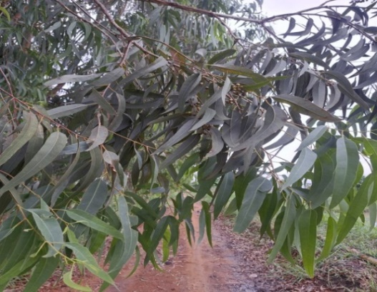
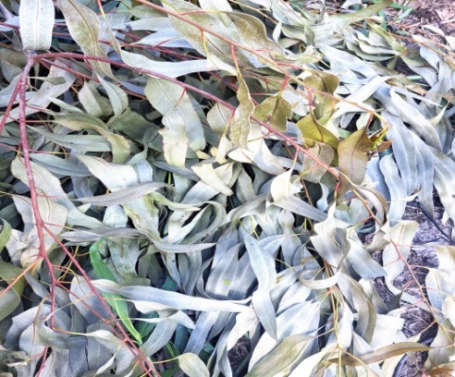
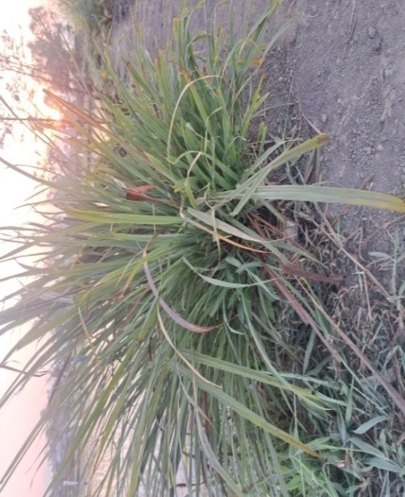
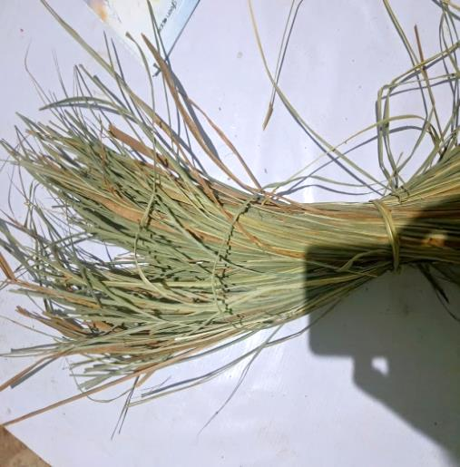
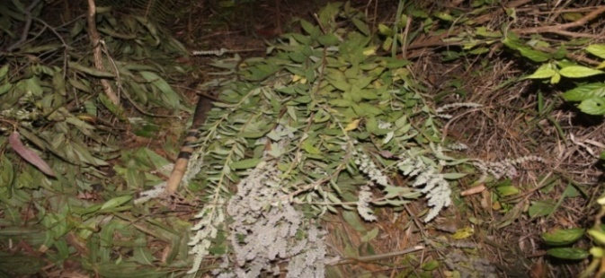
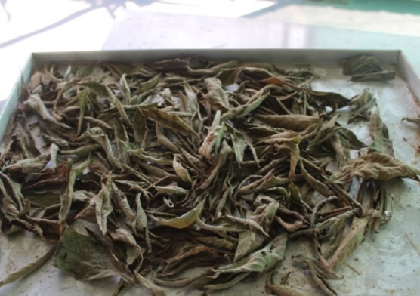
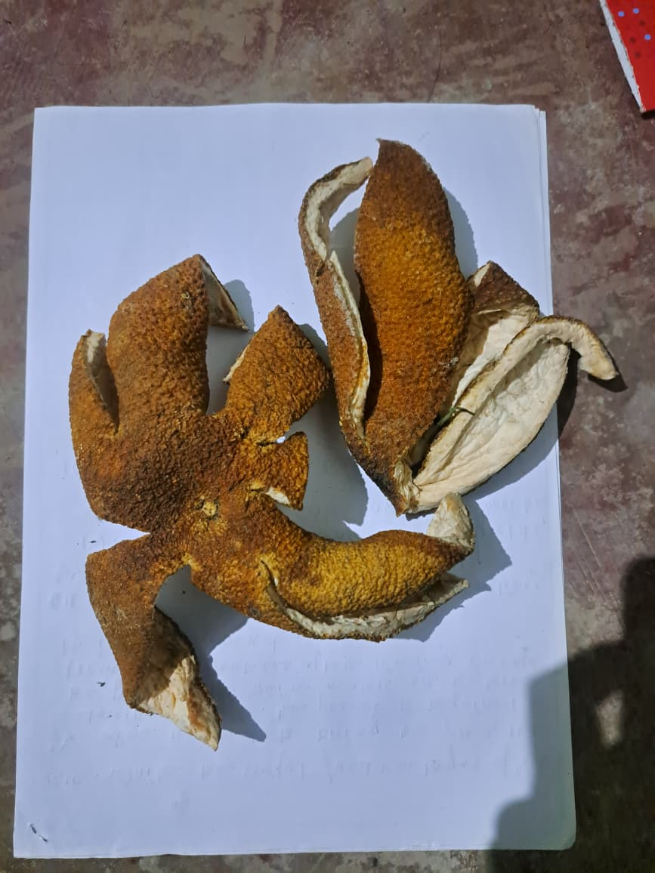
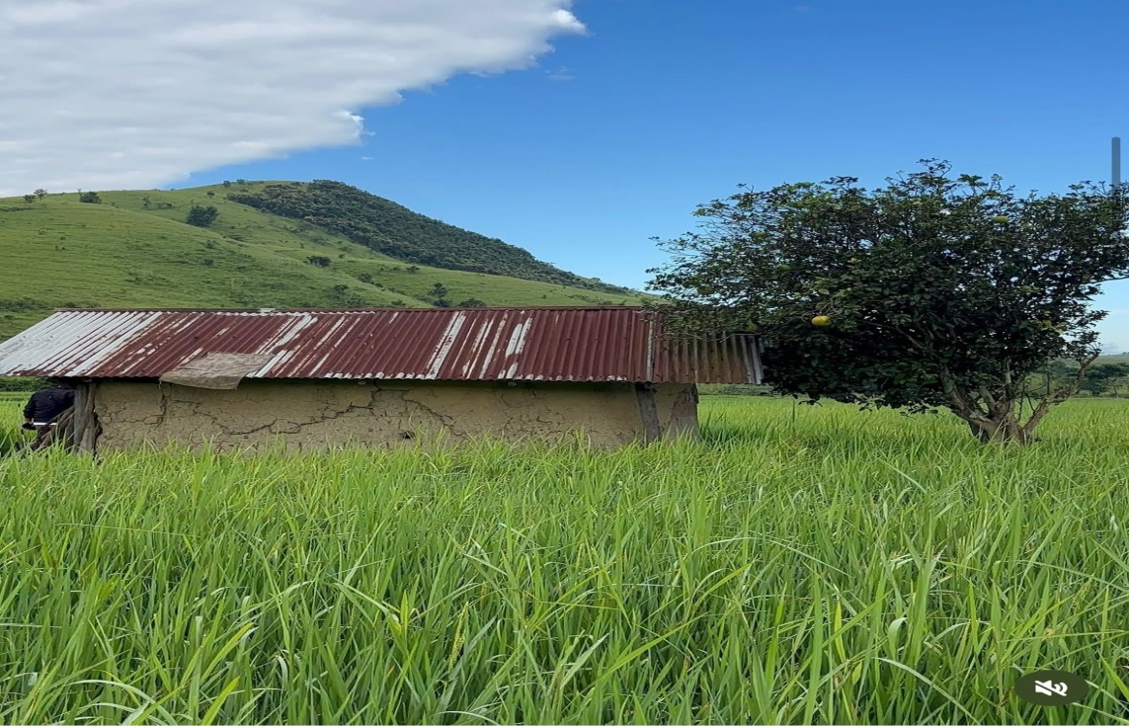
12 13
6 7
8 9
10 11

Figure 6-13: Different type of plant parts employed and used for the preparation of botanical coil. 6&7. Fresh live and dried Cymbopogon citratus; 8 &9. Fresh branches and dried leaves of Isodon ternifolius; 10&11. Growing tree and dried peels of Citrus maxima; 12 &13. Fresh branch and dried leaves of Eucalyptus globulus

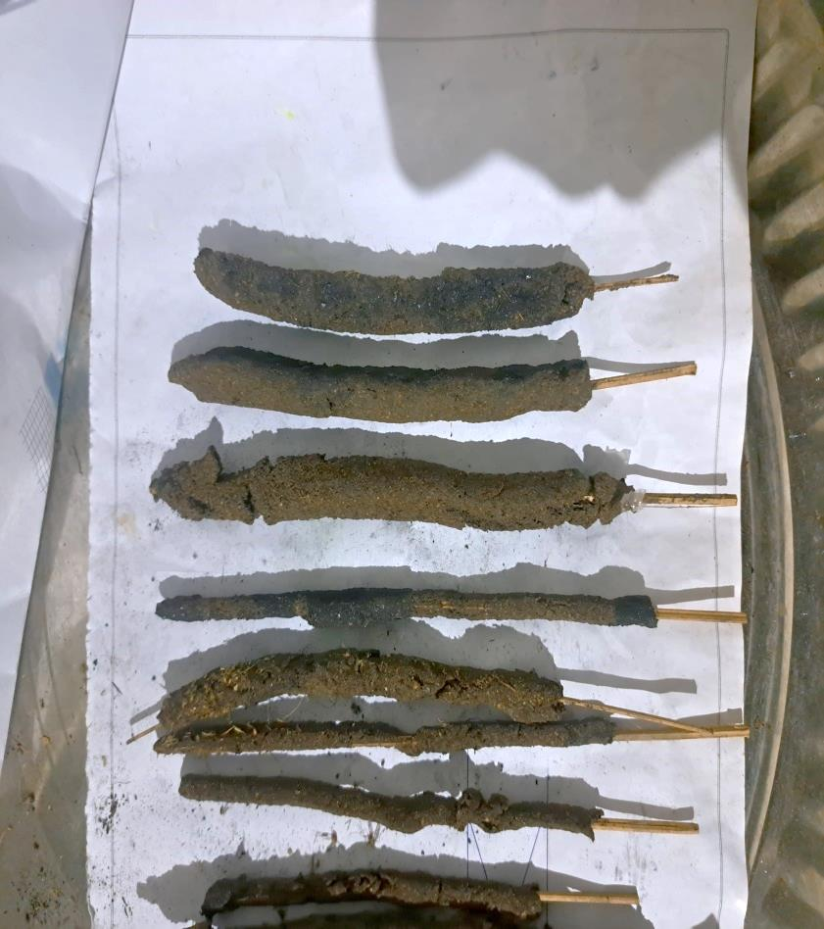
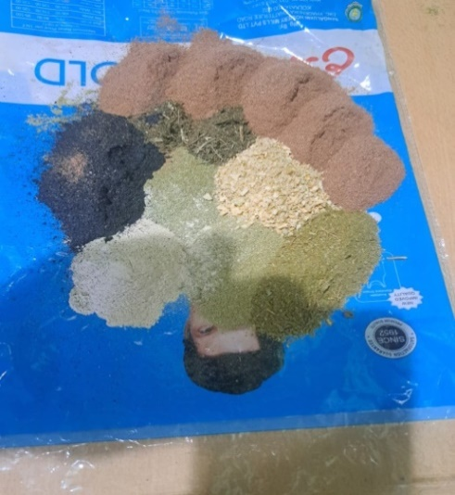
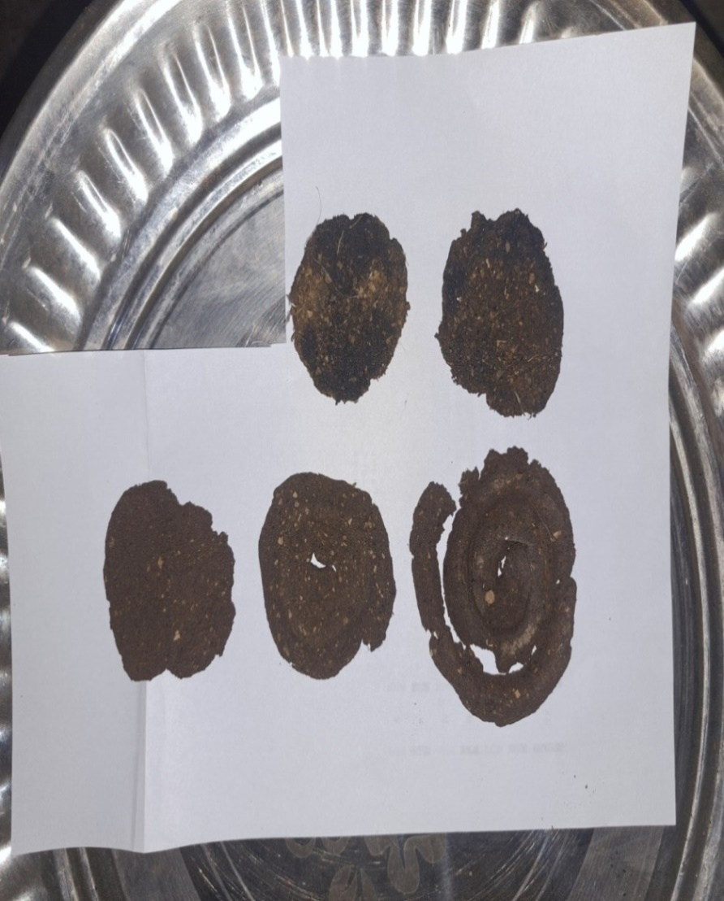
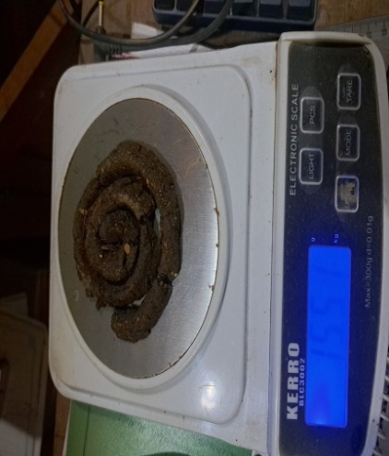
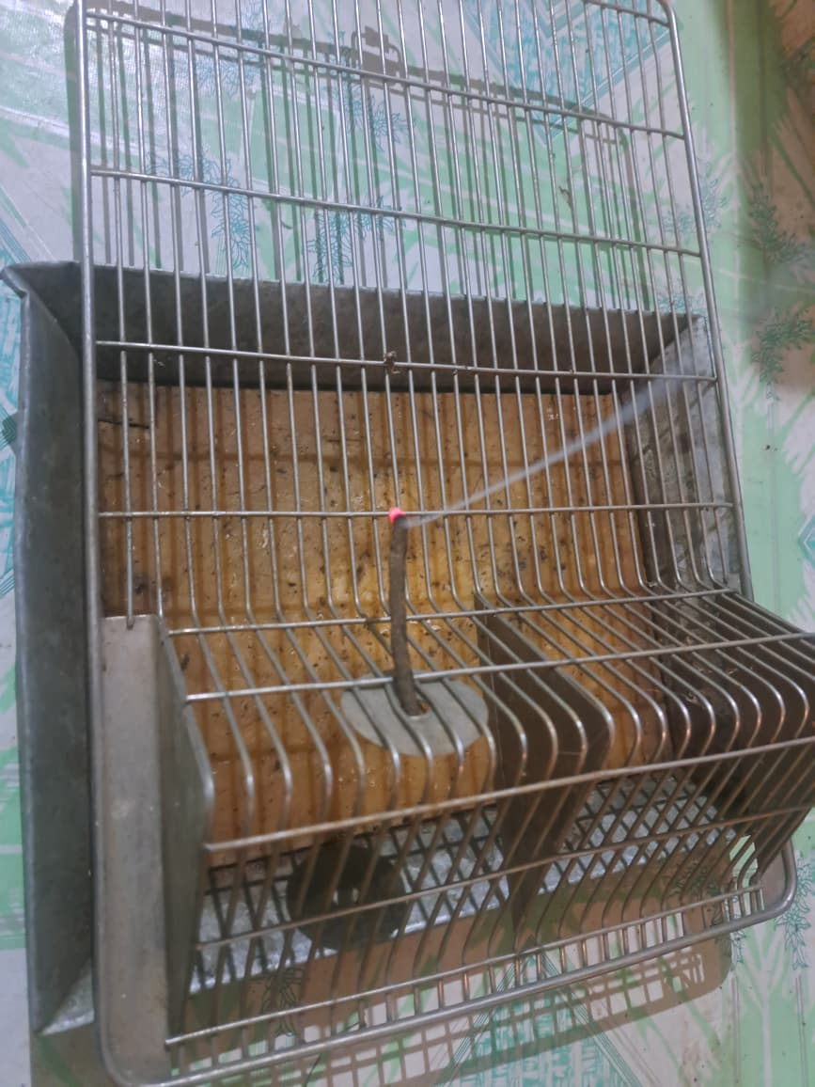
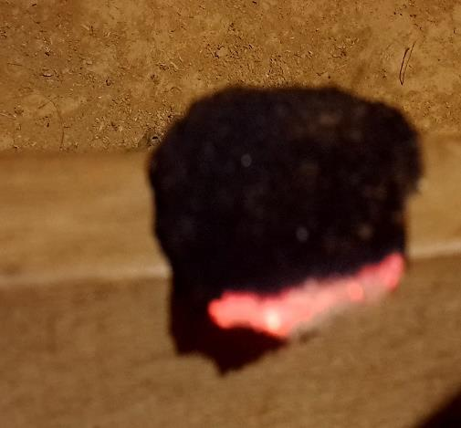
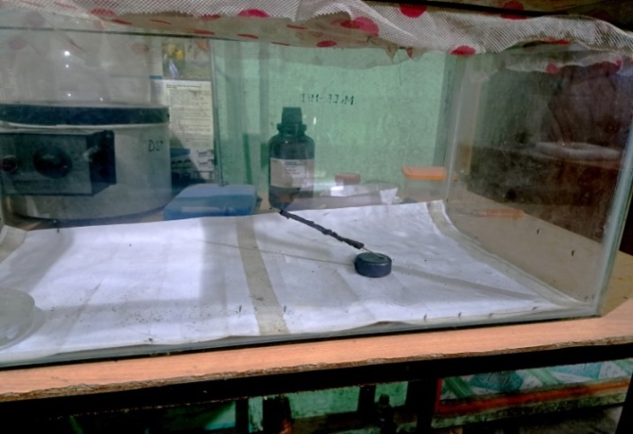
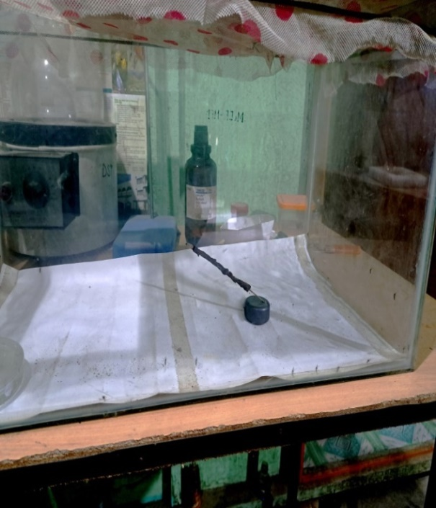
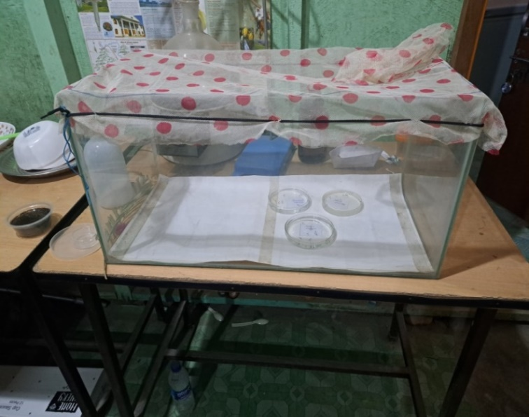
14 15 16
17 18 19

20 21

Figure: 14-21. Sequential steps for preparation of biological mosquito repellents, evaluation of burning efficiency and laboratory setup of control chambers; 14. Dried plant parts ground into fine powder; 15 &16. Prepared repellent coils and incense sticks; 17. Weighing of dried prepared coil before burning; 18 & 19. Burning efficiency test of two different plant based repellents; 20. Test chamber with larvae of three different selected species of Mosquito and 21. Test chamber for testing adult repellent test of selected Culex, Aedes and Anopheles species using biological repellent.

