Effects of Varying Salinity on Growth Performance, Osmoregulation, Stress Physiology and Histopathological Responses of Juvenile Silver Pompano (Trachinotus blochii) Cultured in a Periphyton-Based System
Abstract
The present study evaluated the effects of different salinity levels on the growth performance, osmoregulatory responses, stress physiology, and histopathological alterations of juvenile silver pompano (Trachinotus blochii) cultured in a periphyton-based system. A 60-day experiment was conducted using four salinity treatments (35, 25, 15, and 5 ppt), each maintained in triplicate under identical periphyton-based culture conditions. Fish growth, plasma cortisol, plasma glucose, haematocrit, antioxidant enzyme activities (CAT, SOD, and GPx), and histological changes in the gill and liver tissues were assessed. Although minor numerical differences were observed in initial body weight among the treatments, one-way ANOVA indicated that these differences were not statistically significant (P > 0.05), confirming the comparability of the treatment groups at stocking. At the end of the experimental period, fish reared at 15 ppt exhibited significantly greater weight gain (13.12 ± 0.53ᵃ g), weight gain percentage (615.77 ± 104.56ᵃ%), and specific growth rate (11.66 ± 0.23ᵃ) than fish maintained at the other salinity levels (P < 0.05). Physiological stress increased progressively as salinity decreased, as evidenced by significantly elevated plasma cortisol, plasma glucose, and antioxidant enzyme activities in fish reared at 5 ppt. Histopathological examination further revealed severe hepatic degeneration, cytoplasmic vacuolation, focal necrosis, haemorrhage, epithelial hyperplasia, and lamellar alterations in fish exposed to 5 ppt, whereas fish maintained at 15 ppt showed only mild tissue alterations and well-preserved organ architecture. The findings indicate that rearing juvenile silver pompano at 15 ppt provides favourable conditions for growth while minimising physiological stress and tissue damage.
Keywords: Trachinotus blochii; salinity acclimatisation; growth performance; osmoregulation; physiological stress; antioxidant enzymes; gill histopathology; liver histopathology; periphyton-based culture

Introduction
Silver pompano (Trachinotus blochii Lacepède, 1801) is a commercially important marine finfish belonging to the family Carangidae. The species has gained considerable attention in aquaculture because of its rapid growth, excellent flesh quality, high consumer demand, and adaptability to a wide range of environmental conditions. Its euryhaline nature enables it to tolerate different salinity levels following gradual acclimatisation, making it a suitable candidate for coastal and inland brackish-water aquaculture. However, identifying the optimum culture salinity is essential for maximising growth performance, maintaining physiological homeostasis, and improving production efficiency. The experiment was conducted for 60 days at the Mariculture Research Farm Facility (MRFF), Fisheries College and Research Institute, Thoothukudi, Tamil Nadu, India, to evaluate the effects of different salinity levels on the growth performance, osmoregulatory responses, stress physiology, and histopathological alterations of juvenile silver pompano (Trachinotus blochii) cultured in a periphyton-based system. A total of 1,000 juvenile silver pompano, with an initial mean body weight of 0.382 ± 0.213 g, were procured from the Rajiv Gandhi Centre for Sustainable Aquaculture (RGCA), Poozhiyur, Kerala, India. The fish were transported in oxygenated, double-layered polyethylene bags and acclimatised for two weeks in a 500-L circular tank under continuous aeration before the experiment. During acclimatisation, the fish were maintained at ambient seawater salinity (35 ppt) and fed a commercial floating-pellet diet containing 45% crude protein, 10% crude lipid, 4% crude fibre, and 12% ash.
The experiment followed a completely randomised design (CRD) comprising four salinity treatments: 35 ppt (control, C1), 25 ppt (T1), 15 ppt (T2), and 5 ppt (T3), each maintained in triplicate using 250-L FRP tanks. Twenty-one juveniles were randomly stocked in each experimental tank, corresponding to approximately 75 juveniles m⁻². Before random allocation, the experimental fish had an overall mean body weight of 1.75 ± 0.16 g and a mean total length of 4.46 ± 0.08 cm. Following randomisation, treatment-wise initial body weights showed only minor numerical variation and did not differ significantly among treatments (P > 0.05). Therefore, all treatment groups were considered statistically comparable before the salinity treatments were initiated.
Salinity was adjusted by mixing filtered seawater with freshwater to obtain the required treatment levels and was maintained within ±1 ppt throughout the experimental period through periodic water exchange. Fish were fed daily at 3% of body weight, divided into two equal meals (09:30 and 14:30 h), and the feeding rate was adjusted after each sampling according to the standing biomass. Recent studies indicate that culture conditions can influence growth, haematological characteristics, and stress indicators in farmed fish (Rahman et al., 2024), while physiological and histopathological responses provide complementary evidence of tissue-level effects under environmental stress (Reshma et al., 2026). Salinity acclimation in teleosts involves coordinated osmoregulatory, metabolic, and cellular adjustments, with the gills playing a central role in ion regulation and stress adaptation (Mkulo et al., 2025; Su et al., 2025). Despite the available information on salinity tolerance in pompano and other euryhaline fish, evidence remains limited regarding the concurrent assessment of growth, osmoregulatory stress indicators, antioxidant responses, and liver and gill histopathology in juvenile silver pompano maintained under uniform periphyton-based culture conditions across a broad salinity gradient.
Objective
The objective of the present study was to evaluate the effects of salinities of 35, 25, 15, and 5 ppt on growth performance, osmoregulatory responses, stress physiology, antioxidant enzyme activity, and liver and gill histopathology in juvenile silver pompano (Trachinotus blochii) cultured in a periphyton-based system.
Materials and Methods
Experimental Setup
The experiment was conducted for 60 days at the Mariculture Research Farm Facility (MRFF), Fisheries College and Research Institute, Thoothukudi, Tamil Nadu, India, to evaluate the effects of different salinity levels on the growth performance, osmoregulatory responses, stress physiology, and histopathological alterations of juvenile silver pompano (Trachinotus blochii) cultured in a periphyton-based system.
A total of 1,000 juvenile silver pompano, with an initial mean body weight of 0.382 ± 0.213 g, were procured from the Rajiv Gandhi Centre for Sustainable Aquaculture (RGCA), Poozhiyur, Kerala, India. The fish were transported in oxygenated, double-layered polyethylene bags and acclimatised for two weeks in a 500-L circular tank under continuous aeration before the experiment. During acclimatisation, the fish were maintained at ambient seawater salinity (35 ppt) and fed a commercial floating-pellet diet containing 45% crude protein, 10% crude lipid, 4% crude fibre, and 12% ash.
The experiment followed a completely randomised design (CRD) comprising four salinity treatments: 35 ppt (control, C1), 25 ppt (T1), 15 ppt (T2), and 5 ppt (T3), each maintained in triplicate using 250-L FRP tanks. Twenty-one juveniles were randomly stocked in each tank. Before random allocation, the experimental fish had an overall mean body weight of 1.75 ± 0.16 g and a mean total length of 4.46 ± 0.08 cm. Following randomisation, treatment-wise initial body weights showed only minor numerical variation and did not differ significantly among treatments (P > 0.05). Therefore, all experimental groups were considered statistically comparable before the salinity treatments were initiated.
Salinity was adjusted by mixing filtered seawater with freshwater to obtain the required treatment levels and was maintained within ±1 ppt throughout the experimental period through periodic water exchange. Fish were fed daily at 3% of body weight, divided into two equal meals (09:30 and 14:30 h), and the feeding rate was adjusted after each sampling according to the standing biomass.
Periphyton Development
To establish a uniform periphyton-based culture environment, eleven split-bamboo substrates (approximately 400 cm² surface area each) were installed vertically in every experimental tank 10 days before fish stocking to facilitate natural periphyton colonisation. All tanks received identical substrate arrangements throughout the experiment. As the objective of the present study was to evaluate the effect of salinity under a common periphyton-based culture system, periphyton was maintained as a constant culture condition and was not considered an independent experimental factor. Consequently, periphyton biomass and community composition were not evaluated as independent response variables.
Sampling for Histological Analysis during Salinity-Stress Assessment
Growth performance was monitored at 15-day intervals (Days 15, 30, 45, and 60) by measuring the body weight and total length of fish from each experimental tank. These measurements were primarily used to monitor growth progression and adjust the daily feeding rate according to biomass. Gill and liver tissues were collected at the end of the experiment from fish exposed to salinities of 35 ppt (natural habitat condition), 25 ppt, 15 ppt, and 5 ppt. For histological analysis, the operculum was lifted and the gills were excised by cutting at the base, while liver samples were carefully dissected from the visceral cavity. The collected tissue samples were immediately preserved in 10% neutral-buffered formalin (NBF) at room temperature for 24–48 h (Genten et al., 2009; Biswas et al., 2021). The NBF fixative was prepared by combining 4 g of sodium dihydrogen phosphate, 6.5 g of disodium hydrogen phosphate, 100 mL of formalin, and 900 mL of distilled water. Following fixation, the tissues were dehydrated through a graded series of alcohol solutions, cleared in xylene, and embedded in paraffin blocks using an automated tissue processor. Paraffin blocks were sectioned at a thickness of 3–5 µm using a microtome, placed in a water bath at 40 °C, and air-dried for 1 h. The sections were subsequently stained with haematoxylin and eosin (H&E) and examined under a light microscope at 400× magnification.
Trial at Different Salinities and Sampling
Sampling was conducted fortnightly to monitor and record growth-performance metrics. Fish from the control group and the three salinity treatments were carefully collected using a soft-mesh dip net. Individual body weights (g) were recorded using a high-precision digital balance, and total lengths (cm) were measured using a calibrated linear scale. Throughout sampling, specimens were handled carefully and kept in well-aerated water to minimise handling-induced stress.
Assessment of Osmoregulatory Parameters
Cortisol hormone analysis: Plasma cortisol levels were quantified using a commercially available enzyme-linked immunosorbent assay (ELISA) kit, following the protocol described by Zhang et al. (2022).
Estimation of plasma glucose concentration: Plasma glucose concentration was determined spectrophotometrically using a commercial enzymatic glucose oxidase (GOD–POD) assay kit, following standard diagnostic methods (Wedemeyer & Yasutake, 1977).
Estimation of haematocrit value: The haematocrit (packed-cell-volume) percentage of the experimental fish was determined using a microhaematocrit centrifuge (Micro Spin, Centribio, Shanghai, China). Blood-filled capillary tubes were sealed and centrifuged at 9,000 × g for 5 min, after which the percentage of packed red blood cells was read using a microhaematocrit reader card.
Antioxidant Enzyme Analysis
Superoxide Dismutase (SOD)activity: Superoxide dismutase activity was determined using the nitroblue tetrazolium (NBT) photochemical reduction method described by Kono (1978). One unit of SOD activity was defined as the amount of enzyme required to inhibit the NBT reduction rate by 50%. Specific activity was expressed as units per milligram of protein ${\text{U mg}}^{-1}\text{ protein}$.

Catalase (CAT) activity: Catalase activity was measured spectrophotometrically by monitoring the decrease in absorbance caused by hydrogen peroxide consumption at 240 nm, following the method of Takahara et al. (1960). One unit of CAT activity was defined as the amount of enzyme required to decompose hydrogen peroxide per minute. Activity was expressed as U mg⁻¹ protein.
GPx activity: Glutathione peroxidase activity was assayed using the method of Paglia and Valentine (1967). One unit of GPx activity was defined as the amount of enzyme required to oxidise $1 μ\text{mol}$ of reduced glutathione (GSH) per minute. Specific activity was expressed as ${\text{U mg}}^{-1}\text{ protein}$.

Statistical Analysis
All experimental data are expressed as the mean $±$ standard error (SE). Statistical analyses were performed using SPSS software (version 16.0). Normality and homogeneity of variance were verified before statistical analysis. Differences among salinity treatments were analysed using one-way analysis of variance (ANOVA). When significant differences (P < 0.05) were detected, treatment means were separated using Tukey’s honestly significant difference (HSD) test.
Results
Growth Performance under Different Salinity Levels
The growth-performance parameters of juvenile silver pompano (Trachinotus blochii) reared at different salinity levels in a periphyton-based culture system over the 60-day experimental period are presented in Table 1. The treatment groups showed no significant differences in initial body weight (P > 0.05), indicating that the fish were statistically comparable before the experiment began. After 60 days, salinity significantly influenced the growth performance of the experimental fish (P < 0.05). Fish reared at 15 ppt (T2) exhibited the highest final body weight, total weight gain, weight gain percentage, and specific growth rate, whereas fish maintained at 35 ppt (C1) and 5 ppt (T3) showed comparatively lower growth performance. These findings indicate that an intermediate salinity of 15 ppt provided the most favourable conditions for growth under the present experimental conditions.
Treatment | C1 | T1 | T2 | T3
Initial MBW(g) | 1.75± 0.160ᵃ | 1.91± 0.185ᵃ | 2.18± 0.440ᵃ | 1.64± 0.102ᵃ
Final MBW(g) | 5.78± 0.577ᵈ | 12.49 ± 0.793ᵇ | 15.3 ± 0.965ᵃ | 8.47 ± 1.075ᶜ
Total WG(g) | 4.03 ±0.475ᵈ | 10.58± 0.608ᵇ | 13.12± 0.525ᵃ | 6.83± 0.973ᶜ
Weight gain (%) | 229.95 ±11.58ᵈ | 553.54±228.05ᵇ | 615.77±104.56ᵃ | 413.423±32.63ᶜ
SGR | 2.86± 0.338ᵈ | 9.30± 0.521ᵇ | 11.66±0.23ᵃ | 5.73± 0.904ᶜ
Table 1. Growth performance of juvenile silver pompano (Trachinotus blochii) reared under different salinity levels for 60 days.
Histopathology of Liver
Histopathological examination demonstrated that salinity markedly influenced the structural integrity of the liver and gill tissues of juvenile silver pompano. Fish reared at 15 ppt exhibited nearly normal hepatic and branchial architecture, with only minor cellular alterations, indicating favourable physiological adaptation to this salinity. In contrast, fish exposed to 5 ppt exhibited severe pathological alterations, including hepatocellular degeneration, cytoplasmic vacuolation, pyknotic nuclei, focal necrosis, haemorrhage, epithelial hyperplasia, and lamellar fusion, demonstrating that prolonged exposure to low salinity induced marked tissue damage.

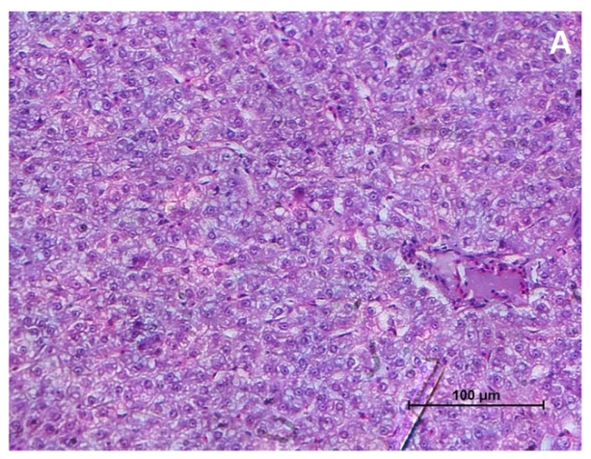

Figure 1. Photomicrograph of hepatic tissue from a juvenile silver pompano (Trachinotus blochii) reared under control conditions (C1, $35\text{ ppt}$) under ($400×$ magnification; scale bar = $100 μ\text{m}$). The parenchyma displays a well-defined, unremarkable architectural arrangement of hepatocytes characterized by intact, centrally located nuclei and clearly delineated sinusoidal spaces. Intravascular erythrocytes appear regular and uniform with no structural anomalies.
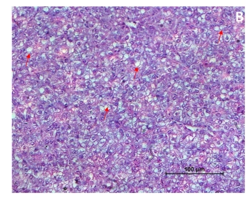

Figure 2. Photomicrograph of hepatic tissue from juvenile silver pompano (Trachinotus blochii) reared at $25\text{ ppt}$ (T1), observed under $(400×$ magnification: scale bar = $100 μ\text{m}\text{)}$. Hepatocytes exhibit mild intracytoplasmic vacuolation (indicated by the red arrow).
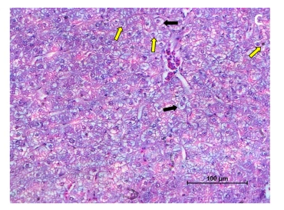

Figure 3. Light micrograph of hepatic parenchyma from juvenile silver pompano (Trachinotus blochii) reared at $15\text{ ppt}$ (T2) observed under $(400×$ magnification: scale bar = $100 μ\text{m}\text{)}$. The tissue maintains a well-preserved hepatic architecture, displaying only localized, minor histological alterations characterized by occasional hepatocytes with pyknotic nuclei (indicated by the yellow arrow).
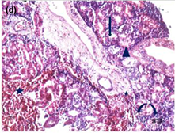

Figure 4. Light micrograph of hepatic tissue from juvenile silver pompano (Trachinotus blochii) exposed to a low salinity of $5\text{ ppt}$ (T3) under $(400×$ magnification: scale bar = $100 μ\text{m}\text{)}$. The section exhibits severe histopathological alterations characterized by hepatocellular degeneration, cytoplasmic vacuolation, pyknotic nuclei, focal necrosis, and localized haemorrhage, indicating marked hepatic damage associated with prolonged low-salinity stress.
Histology of silver pompano gills
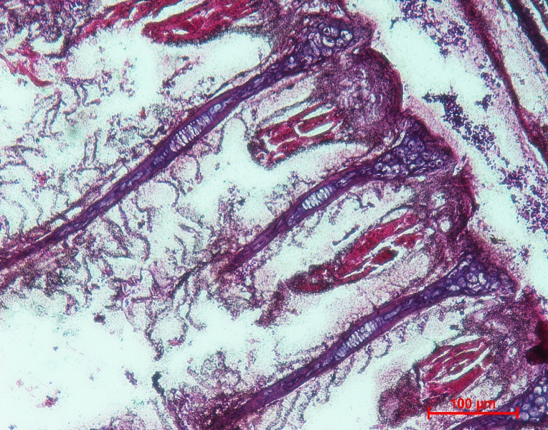

Figure 5. Light micrograph showing the branchial microarchitecture of a healthy juvenile silver pompano (Trachinotus blochii) reared under control conditions (C1, $35\text{ ppt}$) under $(400×$ magnification: scale bar = $100 μ\text{m}\text{)}$. The tissue displays typical structural integrity, characterized by well-defined primary and secondary lamellae alongside normally developed branchial ionocytes (chloride cells).

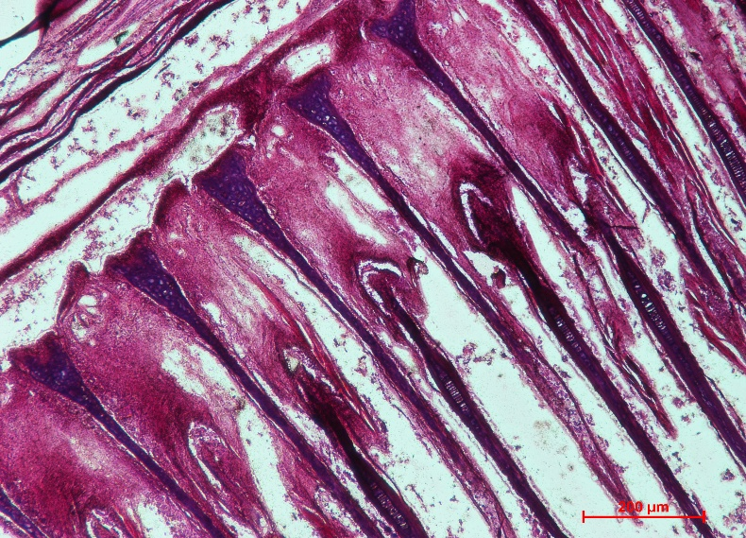

Figure 6. Light micrograph showing branchial tissues of juvenile silver pompano (Trachinotus blochii) reared at $25\text{ ppt}$ (T1) under $(400×$ magnification: scale bar = $100 μ\text{m}\text{)}$. . The specimen exhibits mild epithelial hyperplasia along the lamellae; however, distinct pathological cellular anomalies such as severe lamellar hypertrophy or intercellular edema are absent.
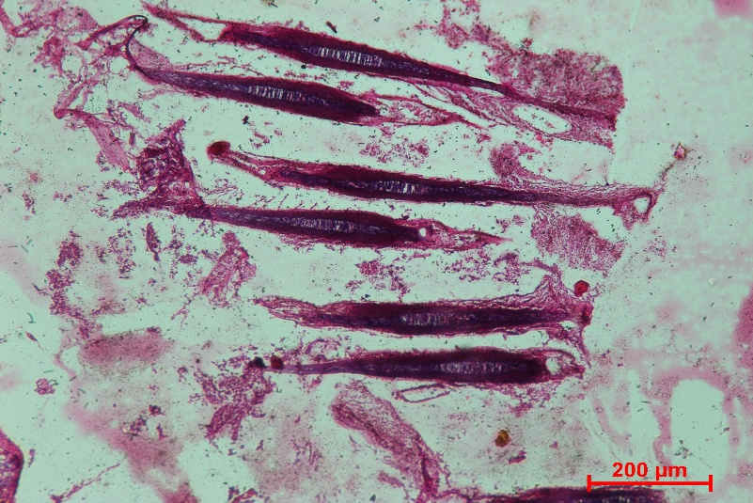

Figure 7. Light micrograph of the branchial microarchitecture from a juvenile silver pompano (Trachinotus blochii) reared at $15\text{ ppt}$ (T2) under 400× magnification (scale bar = ___ µm). Vital structural components, including functional pillar cells, blood lacunae, and clear secondary lamellae were well preserved, indicating normal branchial architecture. (cf. Wahyuni et al., 2017).
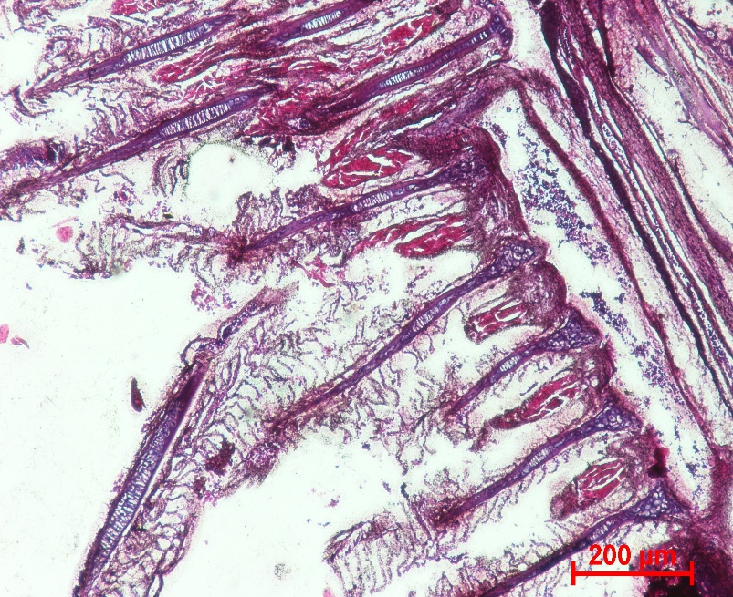

Figure 8. Light micrograph of the branchial tissue from a juvenile silver pompano (Trachinotus blochii) exposed to a low salinity of $5\text{ ppt}$ (T3) ($60×$ magnification). The section displays marked environmental stress responses, characterized by prominent lamellar epithelial hyperplasia, a reduction in working secondary lamellar thickness, and altered morphology/density of branchial ionocytes (chloride cells).
Histological examination revealed that fish reared at 35, 25, and 15 ppt maintained relatively normal gill architecture, with only minor alterations. In contrast, fish reared at 5 ppt exhibited marked hyperplasia, reduced gill epithelial thickness, and reductions in chloride-cell area and density, indicating structural modifications associated with hypoosmotic stress.
Observation of Osmoregulatory Parameters
Plasma Cortisol, Glucose, and Haematocrit Profiles
Salinity significantly affected the physiological stress responses of juvenile silver pompano (P < 0.05) (Table 2). Plasma cortisol and glucose concentrations increased progressively with decreasing salinity, indicating greater physiological stress under hypoosmotic conditions. The highest cortisol (73.28 ± 0.49 ng mL⁻¹) and plasma glucose (92.56 ± 1.40 mg dL⁻¹) values were recorded in fish reared at 5 ppt, whereas the lowest values were observed in the control treatment (35 ppt). In contrast, haematocrit values decreased significantly with decreasing salinity, indicating an altered physiological state under prolonged low-salinity exposure.
Table 2. Plasma cortisol, glucose, and haematocrit values of silver pompano (Trachinotus blochii) under different salinity treatments.
Treatment | Cortisol level (${\text{ng mL}}^{-1}$) | Plasma glucose level (${\text{mg }\text{dL}}^{-1}$) | Haematocrit value (%)
C1 | 41.98±1.64ª | 57.9±2.20ª | 41.7±1.13^{d}
T1 | 55.69±0.85^{b} | 74.23±0.46^{b} | 34.96±0.66^{c}
T2 | 63.43±2.22^{c} | 86.96±0.56^{c} | 30.42±0.92^{b}
T3 | 73.28±0.49^{d} | 92.56±1.40^{d} | 28.78±0.69ª
Values are presented as mean $±$ standard error (SE). Means within the same column sharing different superscript letters ($\text{a–d}$) indicate statistically significant differences ($p<0.05$) based on Tukey's HSD test.

Fig 9 Plasma cortisol levels (${\text{ng mL}}^{-1}$) of silver pompano (Trachinotus blochii) exposed to different salinity treatments over the experimental periods.
Plasma Glucose Concentration
Plasma glucose concentration served as a secondary stress indicator during the salinity challenges (Table 2; Figure 10). A distinct, time-dependent elevation in plasma glucose levels was observed in groups exposed to hypoosmotic conditions, showing a progressive increase from Day 10 through Day 60. The highest overall glucose levels were systematically recorded in the 5 ppt treatment group (T3) across all sampling intervals, reflecting a sustained metabolic mobilization to meet increased energy demands under low-salinity stress conditions$p<0.05$.

Fig.10 Plasma glucose concentration (${\text{mg dL}}^{-1}$) of silver pompano (Trachinotus blochii) subjected to different salinity treatments across Day 10, Day 30, and Day 60 sampling intervals.
Blood Haematocrit Value
The haematocrit (packed cell volume) percentages of silver pompano (Trachinotus blochii) showed an inverse relationship with decreasing environmental salinity over the 60-day trial (Table.2; Figure.11). The highest haematocrit values were systematically maintained in the control group (C1, 35 ppt) across all temporal sampling points (Day 10, 30, and 60). Conversely, progressive exposure to low salinity triggered a significant decrease ($p<0.05$) in haematocrit values, with the lowest measurements observed in the 5 ppt treatment group (T3). This downward trend became more pronounced over time, indicating a steady, long-term physiological shift across the experimental duration.

Fig 11 Changes in blood haematocrit values ($\%$) of silver pompano (Trachinotus blochii) exposed to different salinity levels on Day 10, Day 30, and Day 60.
Antioxidant Enzyme Profiles
Chronic exposure to reduced salinity significantly altered the antioxidant defence system of juvenile silver pompano (Table 3). The activities of catalase (CAT), superoxide dismutase (SOD), and glutathione peroxidase (GPx) increased progressively with decreasing salinity (P < 0.05). The highest enzyme activities were observed in fish maintained at 5 ppt, indicating increased oxidative stress under hypoosmotic conditions. Conversely, fish reared at 35 ppt exhibited the lowest antioxidant enzyme activities, suggesting comparatively lower oxidative stress.
Table 3. Antioxidant enzyme activites (CAT, SOD, and GPx) of silver pompano (Trachinotus blochii) under different salinity treatments
Treatment | CAT (${\text{U mg}}^{-1}\text{ protein}$) | SOD  (${\text{U mg}}^{-1}\text{ protein}$) | GPx  (${\text{U mg}}^{-1}\text{ protein}$)
C1 | 0.49±0.05ª | 0.206±0.003ª | 0.11±0.01ª
T1 | 0.62±0.01^{b} | 0.249±0.007^{b} | 0.15±0.007^{b}
T2 | 0.66±0.02^{c} | 0.307±0.002^{c} | 0.19±0.002^{c}
T3 | 0.71±0.012^{d} | 0.391±0.002^{d} | 0.22±0.034^{d}
Values are expressed as mean $±$ standard error (SE). Column values with different superscript letters ($\text{a–d}$) differ significantly ($p<0.05$) according to Tukey's HSD test.
Catalase Activity in T. blochii Reared under Different Salinity Treatments
The temporal changes in hepatic catalase (CAT) activity across the 60-day experimental period showed an upward trend as exposure time increased, particularly under low-salinity stress (Figure 12). On Day 10, variations between the treatments were minimal, though T3 remained elevated. By Day 30 and Day 60, a pronounced, significant increase ($p<0.05$) in CAT activity was clear in the low-salinity groups (T2 and T3) compared to the baseline values maintained in the control group (C1).

Fig. 12 Hepatic catalase (CAT) activity (${\text{U mg}}^{-1}\text{ protein}$) of silver pompano (Trachinotus blochii) subjected to different salinity levels on Day 10, Day 30, and Day 60.

SOD Activity in T. blochii Reared under Different Salinity Treatments
Hepatic superoxide dismutase (SOD) activity mirrors the trends seen in CAT, demonstrating a time-dependent and salinity-dependent response across all evaluation intervals (Figure 13). At all three sampling checkpoints (Day 10, 30, and 60), the 5 ppt low-salinity treatment group (T3) consistently exhibited the highest enzyme values ($p<0.05$). The mid-salinity treatment groups (T1 and T2) maintained intermediate levels, while the control group (C1, 35 ppt) presented stable, baseline values throughout the entire 60-day experimental timeline.

Fig. 13 Hepatic superoxide dismutase (SOD) activity (${\text{U mg}}^{-1}\text{ protein}$) of silver pompano (Trachinotus blochii) subjected to different salinity levels on Day 10, Day 30, and Day 60.
Glutathione Peroxidase (GPx) Activity
The temporal and treatment-specific variations in hepatic glutathione peroxidase (GPx) activity are illustrated in Figure14. Hepatic GPx activity showed a distinct, significant up-regulation as environmental salinity levels decreased ($p<0.05$). On Day 10, the lowest salinity group (T3, 5 ppt) exhibited a notable acute peak in activity compared to all other groups. By Day 30 and Day 60, while the values in T3 remained higher than the baseline control group (C1, 35 ppt), an overall time-dependent stabilization was observed across all treatments, with the mid-range salinities (T1 and T2) maintaining intermediate values throughout the trial.

Fig.14. Hepatic glutathione peroxidase (GPx) activity (${\text{U mg}}^{-1}\text{ protein}$) of silver pompano (Trachinotus blochii) subjected to different salinity levels on Day 10, Day 30, and Day 60.
Discussion
The present study demonstrated that environmental salinity plays a significant role in regulating the growth performance, physiological stress responses, and tissue integrity of juvenile silver pompano cultured under a common periphyton-based production system. Among the tested salinity levels, 15 ppt provided the most favourable conditions for growth, whereas prolonged exposure to 5 ppt induced pronounced physiological stress and histopathological damage. Fish reared at 15 ppt exhibited significantly higher survival (95.24 ± 2.35%), final body weight (15.30 ± 0.97 g), and total length (12.60 ± 0.10 cm) than fish reared at the other salinity levels. The improved performance at 15 ppt may be attributed to reduced osmoregulatory energy expenditure under near-isosmotic conditions. Furthermore, periphyton developed on the split-bamboo substrates likely provided supplementary natural food, enhanced microbial productivity, and contributed to a more favourable culture environment, thereby supporting improved growth and survival. These findings indicate that suitable salinity and periphyton-based culture may jointly improve the nursery performance of juvenile silver pompano. Similar benefits of periphyton-based culture systems have been reported previously (Azim et al., 2001; van Dam et al., 2002; Signor et al., 2015; van Dam et al., 2002).

Assessment of the Effects of Salinity Acclimatisation in T. blochii
The experimental outcomes indicate that juvenile T. blochii can acclimatise to environmental salinities ranging from seawater salinity (35 ppt) to severe hypoosmotic conditions (5 ppt), provided that progressive acclimatisation protocols are applied. As a marine teleost, silver pompano is adapted to maintaining homeostasis in a hyperosmotic medium; consequently, transfer to an extreme hypoosmotic environment, such as 5 ppt, challenges its homeostatic systems through passive ion loss and excessive water influx. This physiological strain may explain the marked elevations in plasma cortisol and glucose observed in the 5-ppt treatment group (T3). However, the absence of acute mortality and the stabilising trends in antioxidant defences during the 60-day trial suggest that the species can partly limit long-term cellular damage through physiological adaptation.
These outcomes align with previous studies by Kalidas et al. (2012) and Pathak et al. (2019), which demonstrated that T. blochii can sustain growth and high survival rates at reduced salinities ($5\text{–}10\text{ ppt}$) when subjected to systemic, step-down acclimation regimes. The present findings further suggest that periphyton acted as a complementary component of the culture system by improving natural food availability and supporting fish performance under the optimal salinity treatment. Besides the direct effect of salinity, periphyton likely contributed to the enhanced performance of fish by providing a continuous source of natural food rich in proteins, lipids, vitamins, minerals, algae, bacteria, and other microorganisms. Periphyton also improves nutrient recycling and assists in maintaining water quality by utilising dissolved nutrients. These combined benefits may have improved feed utilisation and reduced environmental stress, thereby supporting the superior growth and survival observed in fish reared at 15 ppt. Although the present study did not quantify the independent contribution of periphyton, its presence probably complemented the favourable salinity conditions and enhanced overall production performance. Similar observations have been reported by Azim et al. (2001) and van Dam et al. (2002). Notably, the juvenile pompano evaluated in the present study exhibited enhanced physiological resilience at an intermediate salinity ($15\text{–}25\text{ ppt}$) compared to historical baselines established for related carangids (Sampaio et al., 2003). While individuals across all salinity cohorts ($5$, $15$, $25$, and $35\text{ ppt}$) displayed uniform growth metrics during the initial experimental phases, environmental divergence became pronounced by the termination of the 60-day trial. At Day 60, the $15\text{ ppt}$ treatment group exhibited significantly superior somatic growth ($p<0.05$), confirming that an isosmotic environment minimises maintenance costs.
Hepatic Histopathological Alterations
Histopathological evaluations of the hepatic architecture revealed distinct structural variations among the experimental groups, diverging from the uniform profiles noted by Mulyadi et al. (2020). Control specimens ($35\text{ ppt}$) and those maintained at intermediate salinity ($15\text{ ppt}$, T2) exhibited normal parenchymal arrangements characterised by regular cord-like arrays of polygonal hepatocytes. Conversely, fish subjected to severe environmental variations demonstrated clear structural anomalies. Liver sections from the hypoosmotic group ($5\text{ ppt}$, T3) exhibited pronounced cellular pathologies, including diffuse intracytoplasmic vacuolation, localised hepatocyte hypertrophy, cellular swelling, and occasional pyknotic nuclei. Furthermore, the extreme low-salinity group (T3) revealed structural degradation marked by focal necrosis and intensive sinusoidal haemorrhage, indicating cellular stress from prolonged osmoregulatory strain.
Growth Dynamics and Periphyton Interaction
The experimental data indicate that extreme environmental salinities ($5\text{ ppt}$ and $35\text{ ppt}$) exert restrictive pressures on the growth indices and survival rates of juvenile T. blochii. In contrast, an intermediate salinity regimen ($15\text{ ppt}$, T2) significantly accelerated somatic growth metrics and fostered optimal periphyton colonization on the provided substrates. This optimisation matches the observations of Kalidas et al. (2012), who determined that acclimated T. blochii perform optimally within a $15\text{–}25\text{ ppt}$range, whereas performance collapses at $5\text{ ppt}$. Pompano reared at $15\text{ ppt}$exhibited a maximized specific growth rate ($\text{SGR}=11.66±0.23\%{\text{ day}}^{-1}$), confirming that intermediate salinities ($10\text{–}25\text{ ppt}$) minimise internal energy allocations toward osmotic regulation, as documented in both carangids and Atlantic cod (Gadus morhua) (Kalidas et al., 2012). Periphyton developed on the split bamboo substrates likely contributed to improved fish performance by providing a continuous source of natural food, enhancing microbial productivity, and improving water quality. Although periphyton biomass was not evaluated independently from salinity effects, the culture system supported enhanced growth under intermediate salinity, suggesting that periphyton-based substrates complemented the culture environment.
These findings indicate that an intermediate salinity environment reduces metabolic stress and provides optimal conditions for physiological acclimation and growth. Our results concur with Kalidas et al. (2012) and Pathak et al. (2019), who recommended maintaining environmental salinities above 10 ppt for related carangids, noting a sharp drop in survival below this threshold. Similarly, optimised growth performance at intermediate salinities ($10\text{–}25\text{ ppt}$) has been widely documented in euryhaline teleosts, including Atlantic cod (Gadus morhua) and various pompano species (Imsland et al., 2008; Kalidas et al., 2012). Furthermore, the present data reinforce the assertions of Jayakumar et al. (2014) that juvenile silver pompano thrive within a $10\text{–}25\text{ ppt}$ range. Conversely, fry exposed to extreme hypoosmotic ($5\text{ ppt}$, T3) and hyperosmotic ($35\text{ ppt}$, C1) regimes exhibited significantly suppressed growth, with specific growth rates dropping to $5.73±0.90\%{\text{ day}}^{-1}$ and $2.86±0.34\%{\text{ day}}^{-1}$, respectively. This response varies from patterns reported for the Florida pompano (T. carolinus), which demonstrated unexpected low-salinity tolerance in distinct coastal trials (Van Dam et al., 2002). Overall, the physiological resilience exhibited by the 2-month-old T. blochii juveniles (mean length: $12.60±0.10\text{ cm}$; mean weight: $15.30±0.97\text{ g}$) confirms their capacity to acclimate effectively to intermediate salinities ($15\text{–}25\text{ ppt}$), whereas extreme hypoosmotic ($5\text{ ppt}$) and marine baseline ($35\text{ ppt}$) conditions restrict their growth potential.
Osmoregulatory Parameters of T. blochii Reared at Different Salinities
The biological data indicate that extreme hypoosmotic and hyperosmotic environments impose severe osmoregulatory burdens on T. blochii, shifting energy budgets away from somatic growth toward basic homeostatic maintenance. This process is consistent with the established paradigm that teleost fishes exhibit minimised energy requirements for osmoregulation when reared close to their internal isosmotic point, which sits near $15\text{ ppt}$ (Mulyadi et al., 2020). The clear reduction in growth performance at $35\text{ ppt}$ demonstrates that while juvenile silver pompano survive under full marine conditions, they are physiologically optimised for brackish or estuarine environments ($15\text{ ppt}$) during their early developmental stages (Mulyadi et al., 2020).
Previous physiological models confirm that the elevated energy costs required to maintain ionic gradients under severe salinity variations significantly reduce the net energy available for mass accumulation (Imsland et al., 2008; Evans, 2010; Mahmudul et al., 2014). Consequently, juveniles exposed to the extreme low-salinity treatment ($5\text{ ppt}$, T3) faced heavy ion-regulatory workloads, contrasting with the metabolic comfort zone observed at the intermediate isosmotic salinity ($15\text{ ppt}$, T2). This physiological trend is consistent with patterns documented in other marine teleosts subjected to hypoosmotic environments (Rocha da Silva et al., 2005; Tsuzuki et al., 2007; Zheng et al., 2016). Ambient salinities that match the natural habitat or isosmotic point of a species typically minimise standard metabolic rates by optimizing energy allocation (Morgan & Iwama, 1991).
Furthermore, Retnani and Abdulgani (2013) demonstrated that the capacity for salinity adaptation depends heavily on body size and developmental stage, with osmoregulatory efficiency exhibiting clear ontogenetic shifts. According to Lantu (2010), the osmosensitivity of specialised ionocytes (chloride cells) plays an integral role in mediating homeostatic adjustments in euryhaline species. These cells function as specialised receptors that detect changes in external osmotic pressure. Upon exposure to fluctuating ambient salinities, branchial ionocytes participate in signalling cascades directed toward the neuroendocrine system, modulating the pituitary gland's secretion of growth hormone and prolactin to coordinate systemic acclimation. These endocrine pathways subsequently regulate the proliferation, size, and ion-transport capacity ofionocytes within primary osmoregulatory tissues, such as the gills. Consequently, a strong correlation exists between environmental salinity and the metabolic adjustments required for teleost osmoregulation. Acute, unmitigated shifts in environmental salinity can induce osmotic shock, disrupting systemic ion balances, exhausting cellular energy reserves, and ultimately leading to severe mortality. The initial physiological response of T. blochii transferred to reduced salinity regimes ($25$, $15$, and $5\text{ ppt}$) was characterized by a sharp elevation in circulating plasma cortisol levels on Day 10 relative to the control group ($35\text{ ppt}$; Figure 9). This immediate surge represents a classic primary neuroendocrine stress response elicited by acute osmotic disruption. As noted by Setiyoningsih (2014), environmental alterations stimulate the hypothalamic-pituitary-interrenal (HPI) axis, triggering the rapid systemic release of catecholamines and glucocorticoids to initiate homeostatic compensation.
Following the initial acute peak, plasma cortisol concentrations systematically declined from Day 30 to Day 60 in the $25\text{ ppt}$ (T1) and $15\text{ ppt}$ (T2) treatment cohorts, indicating effective long-term physiological adaptation. Conversely, the $5\text{ ppt}$ hypoosmotic treatment group (T3) maintained significantly elevated cortisol levels ($73.28±0.49{\text{ ng mL}}^{-1}$) up to Day 60, pointing to a state of chronic osmoregulatory stress. At an intermediate salinity of $15\text{ ppt}$, baseline stabilization of cortisol levels indicates an optimal osmoregulatory equilibrium. Prolactin and cortisol operate synergistically to coordinate teleost osmoregulation by modulating ion influx and efflux mechanisms, respectively (Pamungkas, 2012). Cortisol regulates hyperosmoregulatory pathways by driving the differentiation and up-regulation of branchial ionocytes to maintain systemic homeostatic balances.
This hormonal mobilisation is consistent with the model proposed by Scabra (2018), in which increased stress is associated with mobilisation of hepatic energy reserves to support metabolic demand. To sustain homeostatic adjustments, stressed teleosts increase basal metabolic activity, thereby increasing cellular oxygen consumption. By the end of the 60-day trial, plasma cortisol concentrations in the T1 and T2 groups indicated physiological adjustment to reduced salinity. However, cortisol in T2 remained significantly higher than that in the control group on Day 60, indicating that it had not returned completely to the basal level.
Euryhaline teleosts are characterized by their capacity to regulate internal osmotic and plasma ionic compositions when subjected to environmental salinity shifts (Mylonas et al., 2009; Nordlie, 2016; Tomy et al., 2009). In the present study, long-term exposure to varying salinities ($5\text{–}35\text{ ppt}$) induced distinct, permanent shifts in secondary stress indicators. Rather than returning completely to baseline, the sustained modifications in plasma glucose concentrations and haematocrit percentages reflect a continuous metabolic reorganisation required to support survival under chronic hypoosmotic conditions, matching the metabolic shift patterns documented by Herrera et al. (2012) and Sangiao-Alvarellos et al. (2003).
This trend represents a secondary stress response linked to modifications in energy pathways driven by osmoregulatory demands (Arjona et al., 2009; Tseng & Hwang, 2008). While literature suggests that stable acclimation to intermediate salinities typically yields well-regulated, baseline plasma glucose levels (Bystriansky et al., 2007; Jarvis & Ballantyne, 2003), chronic challenges provoke prolonged homeostatic shifts. Fluctuations in blood haematocrit levels reflect shifts in total blood water content, erythrocyte mobilisation, and metabolic adjustments (Iwama et al., 1989; Prodocimo etal., 2008). These parameters serve as sensitive biomarkers for evaluating the long-term physiological state of teleosts subjected to varying ambient salinities (Jarvis & Ballantyne, 2003). Consequently, the sustained elevations in glucose and diminished haematocrit observed on Day 60 demonstrate that while T. blochii survived the hyperosmotic andhypoosmotic trials, the extreme boundaries ($5\text{ ppt}$ and $35\text{ ppt}$) required continuous metabolic compensation.
Effects of Salinity on Growth Performance and Osmoregulation
Ambient salinity acts as a major limiting factor governing the growth dynamics and osmoregulatory budgets of teleosts, including carangids (Barman et al., 2005; Boeuf & Payan, 2001; Rocha da Silva et al., 2005). Interestingly, the growth response of T. blochii differs slightly from the patternsreported for juvenile Florida pompano (Trachinotus carolinus). While T. carolinus demonstrated excellent growth metrics when reared at a low salinity of $5\text{ ppt}$ over an extended 110-day trial, the juvenile T. blochii in the present study achieved maximum somatic growth (body length and weight gain) at an intermediate isosmotic salinity ($15\text{ ppt}$), outperforming both the full marine ($35\text{ ppt}$) and extreme hypoosmotic ($5\text{ ppt}$) cohorts over the 60-day trial (Weirich et al., 2009).
The active transport of ${\text{Na}}^{+}$ and ${\text{Cl}}^{-}$ ions across the branchial epithelium during osmotic transitions is mediated by specialised ionocytes (chloride cells) located within the gills, which orchestrate systemic ionic homeostasis in euryhaline species (Laiz-Carrión et al., 2005; McCormick et al., 2009). Comparative histomorphological evaluations among the experimental cohorts revealed profound alterations in gill epithelial thickness, ionocyte counts, and mucosal cell populations. Notably, juveniles reared at $5\text{ ppt}$ presented a lower density of mature mucosal cells and active branchial ionocytes relative to the hyperosmotic control cohort ($35\text{ ppt}$), matching the structural adaptations typically seen during long-term dilute-medium acclimation. Consequently, these observations suggest that in juvenile T. blochii exposed to hypoosmotic environments, homeostatic adjustments do not always change symmetrically with circulating physiological stress markers.
In teleosts, the hepatic tissue serves as the primary metabolic centre for fatty acid synthesis, ammoniogenesis, gluconeogenesis, and glycogen-glucose cycling (Mommsen et al., 1999; Peragón et al., 1998). The present study revealed that decreasing environmental salinity triggered a substantial depletion of hepatic glycogen reserves. This indicates that the energetic costs of hyper-osmoregulation in juvenile T. blochii increase significantly under severe hypoosmotic stress ($5\text{ ppt}$). Such elevated metabolic demands can subsequently alter feed ingestion, digestive enzyme activity, and nutrient absorption efficiency due to the high metabolic overhead dictated by active ion transport mechanisms in dilute media (Rubio et al., 2005).
Conclusion
Salinity significantly influenced the growth, physiological responses, antioxidant defence, and tissue condition of juvenile silver pompano cultured in the periphyton-based system. Among the tested treatments, 15 ppt produced the highest weight gain, weight-gain percentage, and specific growth rate, while the liver and gills retained comparatively well-preserved architecture. By contrast, exposure to 5 ppt was associated with increased plasma cortisol and glucose concentrations, enhanced catalase, superoxide dismutase, and glutathione peroxidase activities, reduced haematocrit, and pronounced histopathological alterations in the liver and gills. These responses indicate that prolonged exposure to very low salinity imposed substantial osmoregulatory and oxidative stress. Within the 60-day experimental conditions, 15 ppt provided the most favourable balance between growth and physiological condition for juvenile Trachinotus blochii. The findings therefore support the use of an intermediate salinity near 15 ppt for juvenile culture in comparable periphyton-based systems. Because periphyton was maintained as a common culture condition rather than an independent factor, the observed responses should primarily be interpreted as effects of salinity within this production system.

Limitation

The experiment was limited to a 60-day culture period, four fixed salinity levels, and juvenile fish maintained under one periphyton-based system. Periphyton biomass and community composition were not quantified, and a non-periphyton control was not included; therefore, its independent contribution to fish performance could not be determined. The findings may not directly represent other life stages, culture densities, production systems, or longer rearing periods. Additional trials across narrower salinity intervals and extended culture durations would help assess the consistency of the observed responses.

Ethical approval
The Institutional Animal Ethics Committee (IAEC) of Fisheries College and Research Institute, Thoothukudi, Tamil Nadu, India, reviewed and approved the experimental protocol in compliance with the suggestions made by the Ministry of Fisheries, Animal Husbandry, and Dairy, Government of India's Committee for the Purpose of Control and Supervision of Experiments on Animals (CPCSEA). All experimental procedures involving animals were conducted in accordance with the institutional ethical guidelines and applicable national regulations for the care and use of laboratory animals.
Declaration of AI Use
This manuscript was prepared through the combined contributions of all author(s), including contributions to the study design, data, content development, results, interpretation, and related scholarly work. The author(s) acknowledge the use of Grammarly and ChatGPT to assist with grammar checking, language refinement, reference formatting. These AI-assisted tools were not used as authors and did not replace the intellectual contributions or scholarly judgment of the author(s). All AI-assisted outputs, including content, references, and interpretations, were carefully reviewed, revised, verified, and approved by the author(s). The author(s) accept full responsibility for the accuracy, integrity, and final content of the manuscript.

References
Arjona, F. J., Vargas-Chacoff, L., Ruiz-Jarabo, I., Gonçalves, O., Páscoa, I., Martín del Río, M. P., & Mancera, J. M. (2009). Tertiary stress responses in Senegalese sole (Solea senegalensis Kaup, 1858) to osmotic challenge: Implications for osmoregulation, energy metabolism and growth. Aquaculture, 287(3–4), 419–426. https://doi.org/10.1016/j.aquaculture.2008.10.047
Azim, M. E., Wahab, M. A., van Dam, A. A., Beveridge, M. C. M., Milstein, A., & Verdegem, M. C. J. (2001). Optimization of fertilization rate for maximizing periphyton production on artificial substrates and the implications for periphyton-based aquaculture. Aquaculture Research, 32(9), 749–760. https://doi.org/10.1046/j.1365-2109.2001.00617.x
Barman, U. K., Jana, S. N., Garg, S. K., Bhatnagar, A., & Arasu, A. R. T. (2005). Effect of inland water salinity on growth, feed conversion efficiency and intestinal enzyme activity in growing grey mullet, Mugil cephalus (Linn.): Field and laboratory studies. Aquaculture International, 13(3), 241–256. https://doi.org/10.1007/s10499-004-2479-5
Biswas, A., Dash, G., Mali, P., Joardar, S. N., Dey, B., Roy, A., & Karmakar, S. (2021). Histopathology of head kidney tissues in challenged rohu, Labeo rohita Hamilton, after vaccinating with Aeromonas hydrophila antigens. Fish & Shellfish Immunology Reports, 2, 100025. https://doi.org/10.1016/j.fsirep.2021.100025
Boeuf, G., & Payan, P. (2001). How should salinity influence fish growth? Comparative Biochemistry and Physiology Part C: Toxicology & Pharmacology, 130(4), 411–423. https://doi.org/10.1016/S1532-0456(01)00268-X
Bystriansky, J. S., Frick, N. T., & Ballantyne, J. S. (2007). Intermediary metabolism of Arctic char, Salvelinus alpinus, during short-term salinity exposure. Journal of Experimental Biology, 210(11), 1971–1985. https://doi.org/10.1242/jeb.002568
van Dam, A. A., Beveridge, M. C. M., Azim, M. E., & Verdegem, M. C. J. (2002). The potential of fish production based on periphyton. Reviews in Fish Biology and Fisheries, 12, 1–31. https://doi.org/10.1023/A:1022689805031
Evans, T. G. (2010). Co-ordination of osmotic stress responses through osmosensing and signal-transduction events in fishes. Journal of Fish Biology, 76(8), 1903–1925. https://doi.org/10.1111/j.1095-8649.2010.02590.x
Genten, F., Terwinghe, E., & Danguy, A. (2009). Atlas of fish histology. CRC Press.
Herrera, M., Aragão, C., Hachero, I., Ruiz-Jarabo, I., Vargas-Chacoff, L., Mancera, J. M., & Conceição, L. E. C. (2012). Physiological short-term response to sudden salinity change in the Senegalese sole (Solea senegalensis). Fish Physiology and Biochemistry, 38(6), 1741–1751. https://doi.org/10.1007/s10695-012-9672-9
Imsland, A. K., Gústavsson, A., Gunnarsson, S., Foss, A., Árnason, J., Arnarson, I., Jónsson, A. F., Smáradóttir, H., & Thorarensen, H. (2008). Effects of reduced salinities on growth, feed-conversion efficiency and blood physiology of juvenile Atlantic halibut (Hippoglossus hippoglossus L.). Aquaculture, 274(2–4), 254–259. https://doi.org/10.1016/j.aquaculture.2007.11.021
Iwama, G. K., McGeer, J. C., & Pawluk, M. P. (1989). The effects of five fish anaesthetics on acid–base balance, haematocrit, blood gases, cortisol and adrenaline in rainbow trout. Canadian Journal of Zoology, 67(8), 2065–2073. https://doi.org/10.1139/z89-294
Jarvis, P. L., & Ballantyne, J. S. (2003). Metabolic responses to salinity acclimation in juvenile shortnose sturgeon, Acipenser brevirostrum. Aquaculture, 219(1–4), 891–909. https://doi.org/10.1016/S0044-8486(03)00074-2
Jayakumar, R., Tamilmani, G., Sakthivel, M., Kalidas, C., Rameshkumar, P., Hanumanta Rao, G., & Gopakumar, G. (2014). Evaluation of growth and production performance of hatchery-produced silver pompano, Trachinotus blochii (Lacépède, 1801), fingerlings under brackish-water pond farming in India. Indian Journal of Fisheries, 61(3), 1–6.
Kalidas, C., Sakthivel, M., Tamilmani, G., Rameshkumar, P., Nazar, A. A., Jayakumar, R., & Gopakumar, G. (2012). Survival and growth of juvenile silver pompano, Trachinotus blochii (Lacépède, 1801), at different salinities in tropical conditions. Indian Journal of Fisheries, 59(3), 95–99.
Kono, Y. (1978). Generation of superoxide radical during autoxidation of hydroxylamine and an assay for superoxide dismutase. Archives of Biochemistry and Biophysics, 186(1), 189–195. https://doi.org/10.1016/0003-9861(78)90479-4
Laiz-Carrión, R., Guerreiro, P. M., Fuentes, J., Canario, A. V. M., Martín del Río, M. P., & Mancera, J. M. (2005). Branchial osmoregulatory response to salinity in the gilthead sea bream, Sparus auratus. Journal of Experimental Zoology Part A: Comparative Experimental Biology, 303A(7), 563–576. https://doi.org/10.1002/jez.a.181
Lantu, S. (2010). Osmoregulasi pada hewan akuatik. Jurnal Perikanan dan Kelautan Tropis, 6(1), 46–50.
Mahmudul, A. I., Chowdhury, M. I., & Rahman, A. F. M. A. (2014). Effects of water salinity on feeding efficiencies, growth performances and survival rate of Thai-strain koi, Anabas testudineus (Bloch, 1792). World Journal of Fish and Marine Sciences, 6(5), 479–486.
McCormick, S. D., Regish, A. M., & Christensen, A. K. (2009). Distinct freshwater and seawater isoforms of Na+/K+-ATPase in gill chloride cells of Atlantic salmon. Journal of Experimental Biology, 212(24), 3994–4001. https://doi.org/10.1242/jeb.037275
Mkulo, E. M., Iddrisu, L., Yohana, M. A., Zheng, A., Zhong, J., Jin, M., Danso, F., Wang, L., Zhang, H., Tang, B., Zhou, H., Amoah, K., Huang, J., Wang, B., & Wang, Z. (2025). Exploring salinity adaptation in teleost fish, focusing on omics perspectives on osmoregulation and gut microbiota. Frontiers in Marine Science, 12, Article 1559871. https://doi.org/10.3389/fmars.2025.1559871
Mommsen, T. P., Vijayan, M. M., & Moon, T. W. (1999). Cortisol in teleosts: Dynamics, mechanisms of action and metabolic regulation. Reviews in Fish Biology and Fisheries, 9(3), 211–268. https://doi.org/10.1023/A:1008924418720
Morgan, J. D., & Iwama, G. K. (1991). Effects of salinity on growth, metabolism and ion regulation in juvenile rainbow and steelhead trout (Oncorhynchus mykiss) and fall Chinook salmon (Oncorhynchus tshawytscha). Canadian Journal of Fisheries and Aquatic Sciences, 48(11), 2083–2094. https://doi.org/10.1139/f91-247
Mulyadi, Tang, U. M., Amin, B., Sukendi, Pamukas, N. A., & Windarti. (2020). Osmotic performance rate, stress response and growth performance of silver pompano (Trachinotus blochii) reared at different salinities using a recirculating culture system. AACL Bioflux, 13(3), 1546–1556.
Mylonas, C. C., Pavlidis, M., Papandroulakis, N., Zaiss, M. M., Tsafarakis, D., Papadakis, I. E., & Varsamos, S. (2009). Growth performance and osmoregulation in the shi drum (Umbrina cirrosa) adapted to different environmental salinities. Aquaculture, 287(1–2), 203–210. https://doi.org/10.1016/j.aquaculture.2008.10.024
Nordlie, F. G. (2016). Adaptation to salinity and osmoregulation in Mugilidae. In D. Crosetti and S. J. M. Blaber (Eds.), Biology, ecology and culture of grey mullets (Mugilidae) (pp. 293–323). CRC Press.
Paglia, D. E., & Valentine, W. N. (1967). Studies on the quantitative and qualitative characterization of erythrocyte glutathione peroxidase. The Journal of Laboratory and Clinical Medicine, 70(1), 158–169. https://pubmed.ncbi.nlm.nih.gov/6066618/
Pamungkas, W. (2012). Aktivitas osmoregulasi, respons pertumbuhan, dan energetic cost pada ikan yang dipelihara dalam lingkungan bersalinitas. Media Akuakultur, 7(1), 44–51. https://doi.org/10.15578/ma.7.1.2012.44-51
Pathak, M. S., Lakra, W. S., Reddy, A. K., Chadha, N. K., Tiwari, V. K., & Srivastava, P. P. (2019). Growth and survival of silver pompano, Trachinotus blochii (Lacepede, 1801), at different salinities in inland saline groundwater. The Indian Journal of Animal Sciences, 89(5), 581–587. https://doi.org/10.56093/ijans.v89i5.90045
Peragón, J., Barroso, J. B., de la Higuera, M., & Lupiáñez, J. A. (1998). Relationship between growth and protein-turnover rates and nucleic acids in the liver of rainbow trout (Oncorhynchus mykiss) during development. Canadian Journal of Fisheries and Aquatic Sciences, 55(3), 649–657. https://doi.org/10.1139/f97-315
Prodocimo, V., Souza, C. F., Pessini, C., Fernandes, L. C., & Freire, C. A. (2008). Metabolic substrates are not mobilized from the osmoregulatory organs—gills and kidney—of the estuarine pufferfishes Sphoeroides greeleyi and S. testudineus upon short-term salinity reduction. Neotropical Ichthyology, 6(4), 613–620. https://doi.org/10.1590/S1679-62252008000400011
Rahman, M. M., Kunda, M., Saifullah, M. K., & Harun-Al-Rashid, A. (2024). Effect of stocking density on growth performance, proximate composition and hematology of Anabas testudineus in a biofloc culture system. Asian Journal of Fisheries and Aquatic Research, 26(10), 64–86. https://doi.org/10.9734/ajfar/2024/v26i10819
Reshma, P., Pournami, P., Lekshmi, L., & Suresh, S. (2026). Impact of exposure to carbofuran (Furadan) on the freshwater teleost fish, Tilapia mossambica. Journal of Biology and Nature, 18(1), 559–568. https://doi.org/10.56557/joban/2026/v18i110566
Retnani, H. T., & Abdulgani, N. (2013). Pengaruh salinitas terhadap kandungan protein dan pertumbuhan ikan bawal bintang (Trachinotus blochii). Jurnal Sains dan Seni ITS, 2(2), E177–E181. https://doi.org/10.12962/j23373520.v2i2.485
Rocha da Silva, A. J., Gomes, V., Van Ngan, P., Rocha, M. J. D. A. C., & Furia, R. R. (2005). Metabolic demand and growth of juveniles of Centropomus parallelus as a function of salinity. Journal of Experimental Marine Biology and Ecology, 316(2), 157–165. https://doi.org/10.1016/j.jembe.2004.09.017
Rubio, V. C., Sánchez-Vázquez, F. J., & Madrid, J. A. (2005). Effects of salinity on food intake and macronutrient selection in European sea bass. Physiology & Behavior, 85(3), 333–339. https://doi.org/10.1016/j.physbeh.2005.04.022
Sampaio, L. A., Tesser, M. B., & Burkert, D. (2003). Acute salinity tolerance of juvenile pompano, Trachinotus marginatus (Teleostei, Carangidae), under laboratory conditions. Ciência Rural, 33(4), 757–761. https://doi.org/10.1590/S0103-84782003000400023
Sangiao-Alvarellos, S., Laiz-Carrión, R., Guzmán, J. M., Martín del Río, M. P., Míguez, J. M., Mancera, J. M., & Soengas, J. L. (2003). Acclimation of Sparus aurata to various salinities alters energy metabolism of osmoregulatory and non-osmoregulatory organs. American Journal of Physiology-Regulatory, Integrative and Comparative Physiology, 285(4), R897–R907. https://doi.org/10.1152/ajpregu.00074.2003
Scabra, A. R. (2018). Response of eel fish (Anguilla bicolor bicolor) in media with different salinity. Jurnal Perikanan, 9(2), 180–187. [In Indonesian].
Setiyoningsih, P. R. (2014). Respon gelondongan ikan bandeng (Chanos chanos) akibat perubahan salinitas dengan penambahan kalsium klorida (CaCl₂) pada durasi yang berbeda. Jurnal Penelitian UNISLA, 5(2), 6–17.
Signor, A., Signor, A. A., Boscolo, W. R., Reidel, A., Klein, S., & Feiden, A. (2015). Biomassa de perifíton em substratos artificiais durante o verão e inverno. Ciência Rural, 45(1), 72–78. https://doi.org/10.1590/0103-8478cr20131298
Su, H., Ma, D., Fan, J., Zhong, Z., Tian, Y., & Zhu, H. (2025). A TMT-based proteomic analysis of osmoregulation in the gills of Oreochromis mossambicus exposed to three osmotic stresses. International Journal of Molecular Sciences, 26(6), Article 2791. https://doi.org/10.3390/ijms26062791
Takahara, S., Hamilton, H. B., Neel, J. V., Kobara, T. Y., Ogura, Y., & Nishimura, E. T. (1960). Hypocatalasemia: A new genetic carrier state. The Journal of Clinical Investigation, 39(4), 610–619. https://doi.org/10.1172/JCI104075
Tomy, S., Chang, Y. M., Chen, Y. H., Cao, J. C., Wang, T. P., & Chang, C. F. (2009). Salinity effects on the expression of osmoregulatory genes in the euryhaline black porgy, Acanthopagrus schlegeli. General and Comparative Endocrinology, 161(1), 123–132. https://doi.org/10.1016/j.ygcen.2008.12.003
Tsuzuki, M. Y., Ogawa, K., Strüssmann, C. A., Maita, M., Takashima, F., & Melo, C. M. R. (2007). The significance of cortisol on acclimation to salinity in pejerrey, Odontesthes bonariensis. Arquivo Brasileiro de Medicina Veterinária e Zootecnia, 59(5), 1301–1307. https://doi.org/10.1590/S0102-09352007000500031
Tseng, Y. C., & Hwang, P. P. (2008). Some insights into energy metabolism for osmoregulation in fish. Comparative Biochemistry and Physiology Part C: Toxicology & Pharmacology, 148(4), 419–429. https://doi.org/10.1016/j.cbpc.2008.04.009
van Dam, A. A., Beveridge, M. C. M., Azim, M. E., & Verdegem, M. C. J. (2002). The potential of fish production based on periphyton. Reviews in Fish Biology and Fisheries, 12(1), 1–31. https://doi.org/10.1023/A:1022689805031
Wahyuni, S., Windarti, W., & Putra, R. M. (2017). Comparative study on the histological structure of the gill and kidney of snakehead fish (Channa striata, Bloch 1793) from the Kulim and Sibam Rivers, Riau Province [Doctoral dissertation, Riau University].
Wedemeyer, G. A., & Yasutake, W. T. (1977). Clinical methods for the assessment of the effects of environmental stress on fish health (Technical Paper No. 89). U.S. Fish and Wildlife Service. https://pubs.usgs.gov/publication/2001039
Weirich, C. R., Wills, P. S., Baptiste, R. M., Woodward, P. N., & Riche, M. A. (2009). Production characteristics and body composition of Florida pompano reared to market size at two different densities in low-salinity recirculating aquaculture systems. North American Journal of Aquaculture, 71(2), 165–173. https://doi.org/10.1577/A07-045.1
Zhang, Z., Lu, K., Liang, X. F., Li, J., Tang, S., Zhang, Y., & Zhang, Q. (2022). Effects of early low-temperature exposure on growth, glycolipid metabolism and growth hormone (GH) gene methylation in the late stage of Chinese perch (Siniperca chuatsi). Comparative Biochemistry and Physiology Part B: Biochemistry and Molecular Biology, 259, 110705. https://doi.org/10.1016/j.cbpb.2021.110705
Zheng, P., Ma, Z., Guo, H., Zhang, D., Fu, M., Zhang, N., & Jiang, S. (2016). Effect of salinity on the rearing performance of juvenile golden pompano, Trachinotus ovatus (Linnaeus, 1758). Aquaculture Research, 47(6), 1761–1769. https://doi.org/10.1111/are.12605

