The study of gonadal development according to seasonal variation and comparison between the two species Puntius sophore and rasbora daniconius

Abstract
The reproductive biology of fish is strongly influenced by seasonal environmental changes, making the study of gonadal development important for understanding breeding patterns and supporting sustainable fisheries management. This study aimed to evaluate and compare the seasonal gonadal development of Puntius sophore and Rasbora daniconius collected from Upper Lake, Bhopal. Fish samples were collected across different seasons, and their gonads were examined to assess developmental stages and reproductive characteristics. Puntius sophore and rasbora daniconius serves as significant small native fish species of Bangladesh belonging to the family Cyprinidae under the order Cypriniformes. The main target of the present study was regularly monthly development of gonadal maturity stages provides the straight explicit findings for outlining the spawning season and insight the time –based dynamics of the reproductive cycle. In the present study, Gonadal maturity was evaluated by examining the gonads according to the maturity classification described by Nikolsky (1963) and Shafi and Quddus (1982). Five stages were identified for females (Immature, Maturing, Matured, Spawning, Spent) and six stages for males (Immature, Resting, Developing, Maturing, Mature, Spent). The sex ratio of P. sophore was significantly female-biased (1.93:1, p < 0.001), with maximum deviation during August and September. The present study shows that the spawning season of P. sophore was identified as June–August with peak spawning in June–July (GSI peak in May: 8.46%), while R. daniconius spawned from April–July with peak in July (GSI: 2.21%).The study provides valuable baseline information on the reproductive cycles of these native freshwater fishes and enhances our understanding of their breeding biology. These findings can support the identification of critical spawning periods and contribute to the development of effective conservation measures and sustainable fisheries management strategies.
Keywords : Gonadal development; reproductive biology; spawning season; sustainable fisheries management
Introduction
Reproductive biology is a key aspect of fisheries research because it provides insight into the breeding cycle, reproductive potential, and population dynamics of fish species Freshwater fish diversity in Bangladesh are facing varying degrees of conservation risk.Among them, about 3% are categorized as critically endangered , 12% as endangered, 10% as vulnerable and 25% as threatened. In addition, nearly 11% fall under the near threatened category, 48% are considered of least concern, while information regarding around 16% species remain insufficient due to lack of adequate data (IUCN Bangladesh, 2015). Small Indigenous species (SIS) are acquiring rising concentration due to their nutritional value, eco –friendly importance and addition to rural livelihood in South Asian countries including India, Bangladesh, Nepal and Mynmar. Recent histological studies have classified gonadal development stages in cyprinid fish, identifying phases including early-stage primary oocytes, secondary oocytes, vitellogenic oocytes, and mature stages (Huang et al., 2024).The study focuses on the gonadal development according to seasonal variation and comparison of both fish species and it is also essential for their conservation based management. Both the species Puntius sophore and rasbora daniconius belong to family Cyprinidae and are widely distributed across South and Southeast Asian freshwater systems. Understanding the gonadal development according to conservation oriented use and potential aquaculture development.Studying seasonal variations in gonadal development helps identify spawning periods, which is essential for designing effective conservation strategies and promoting the sustainable utilization of fishery resources. While reproductive characteristics of several freshwater cyprinid fishes have been documented, comparative information on the seasonal gonadal development of Puntius sophore and Rasbora daniconius inhabiting Upper Lake, Bhopal, remains scarce. Therefore, this study was conducted to examine and compare the seasonal patterns of gonadal development in these two species, with the aim of generating baseline information that can contribute to their conservation and the sustainable management of freshwater fisheries.
Puntius sophore and Rasbora daniconius are widely distributed freshwater cyprinid fishes that contribute significantly to the ecological balance and biodiversity of inland water bodies. Their reproductive characteristics are important for understanding population dynamics and assessing the impact of seasonal environmental changes. Although several studies have examined the reproductive biology of these species in different regions, comparative information on their seasonal gonadal development under the environmental conditions of Upper Lake, Bhopal, remains limited.
A comparative assessment of the reproductive cycles of these two species can provide valuable insights into their breeding strategies and seasonal reproductive responses. Such information is essential for identifying critical breeding periods, supporting conservation initiatives, and improving the sustainable management of native freshwater fish populations. Therefore, the present study was undertaken to investigate and compare the seasonal gonadal development of Puntius sophore and Rasbora daniconius and to generate baseline information for future fisheries research and management.
Despite the availability of studies on the reproductive biology of freshwater fishes, information comparing the seasonal gonadal development of Puntius sophore and Rasbora daniconius is still limited. Most previous investigations have examined these species independently or have focused on different geographical regions, making direct comparisons under the same environmental conditions difficult. In particular, there is a lack of comprehensive information on the reproductive characteristics of these two species from Upper Lake, Bhopal. Addressing this gap is important for improving our understanding of their breeding patterns and reproductive strategies, which can support species conservation and the sustainable management of freshwater fish resources. Therefore, the present study was designed to evaluate and compare the seasonal gonadal development of Puntius sophore and Rasbora daniconius and to generate baseline information for future research and fisheries management.
Objectives of the Study
The present study was undertaken with the following objectives:
- To investigate the seasonal pattern of gonadal development in Puntius sophore and Rasbora daniconius.
- To compare the gonadal development of the two species across different seasons.
- To identify the breeding period and reproductive cycle of both species based on seasonal variations in gonadal development.
2. Material and methods
2.1 Fishes and Sample Collection
The present study of two species Puntius sophore and Rasbora daniconius is used is being collected from Upper Lake (Bada Talab), Bhopal, Madhya Pradesh, India. Fish were recognized, and their length and weight were observed and noted. The fishes were dissected through a mid –ventral cut to extract gonads. Gonadal maturity stages were assessed based on size, colour, and texture (immature, maturing, mature, and spent stages).For microscopic study, gonadal tissues were preserved in 10% formalin solution. The tissue sections were stained using hematoxylin and eosin and subsequently examined under a microscope to evaluate gonadal development. Seasonal variation in gonadal maturity was compared between the two species based on macroscopic and microscopic observations. The study involved field sampling of wild fish for research purposes. Fish were collected in accordance with applicable local regulations and handled carefully to minimize stress during sampling. No experimental procedures or invasive manipulations were performed beyond those required for biological analysis. Where applicable, the study complied with the ethical guidelines of the authors' institution, and formal ethical approval was not required.
Identification of species
Based on their exterior physical traits such as body shape, colour pattern, fin arrangement, scale pattern and lateral line features the collected individuals were identified using conventional taxonomic keys. Each specimen was given a distinct laboratory code following identification in order to facilitate further observations.

Gonadosomatic Index (GSI)
To assess seasonal fluctuation in reproductive activity, the Gonad somatic Index (GSI) was computed
GSI (%) = (Gonad Weight / Total Body Weight) × 100

3. Result and Discussion
The interpretation of monthly maturity stages is strengthened when macroscopic staging, GSI and histological evidence are considered together, because these approaches collectively indicate follicular growth, final maturation, ovulation and post-spawning recovery in teleosts (Patiño & Sullivan, 2002; Murua & Saborido-Rey, 2003; Parenti & Grier, 2004). The gonadal development of both Puntius sophore and Rasbora daniconius exhibited clear seasonal variation throughout the study period. In Rasbora daniconius, advanced stages of gonadal maturation were observed earlier than in Puntius sophore, indicating an earlier onset of the reproductive cycle. Both species reached peak gonadal maturity during the breeding season, followed by a decline after spawning. Comparative analysis demonstrated species-specific differences in the timing and progression of gonadal development under similar environmental conditions.
The regularly monthly development of gonadal maturity stages provides the straight explicit findings for outlining the spawning season and insight the time –based dynamics of the reproductive cycle. In the present study, Gonadal maturity was evaluated by examining the gonads according to the maturity classification described by Nikolsky (1963) and Shafi and Quddus (1982). Five stages were identified for females (Immature, Maturing, Matured, Spawning, Spent) and six stages for males (Immature, Resting, Developing, Maturing, Mature, Spent).

3.1 Puntius sophore (Female)
Table 1: Monthly frequency distribution (%) of gonadal maturity stages of P. sophore (Female) from Upper Lake, Bhopal
Month | Immature | Maturing | Matured | Spawning | Spent | N | % Reprod.
January | 50.00 | 0.00 | 0.00 | 0.00 | 50.00 | 2 | 0.00
February | 50.00 | 33.33 | 0.00 | 0.00 | 16.67 | 6 | 0.00
March | 14.29 | 57.14 | 14.29 | 0.00 | 14.29 | 7 | 14.29
April | 25.00 | 37.50 | 25.00 | 12.50 | 0.00 | 8 | 37.50
May | 0.00 | 62.50 | 25.00 | 12.50 | 0.00 | 8 | 37.50
June | 0.00 | 30.00 | 10.00 | 60.00 | 0.00 | 10 | 70.00
July | 0.00 | 20.00 | 20.00 | 60.00 | 0.00 | 10 | 80.00
August | 0.00 | 72.73 | 27.27 | 0.00 | 0.00 | 11 | 27.27
September | 8.00 | 12.00 | 12.00 | 4.00 | 64.00 | 25 | 16.00
October | 0.00 | 6.25 | 0.00 | 0.00 | 93.75 | 16 | 0.00
November | 33.33 | 16.67 | 0.00 | 0.00 | 50.00 | 6 | 0.00
December | 33.33 | 66.67 | 0.00 | 0.00 | 0.00 | 3 | 0.00
% Reproductive = % Matured + % Spawning; Peak spawning: June–July (60% in spawning condition)
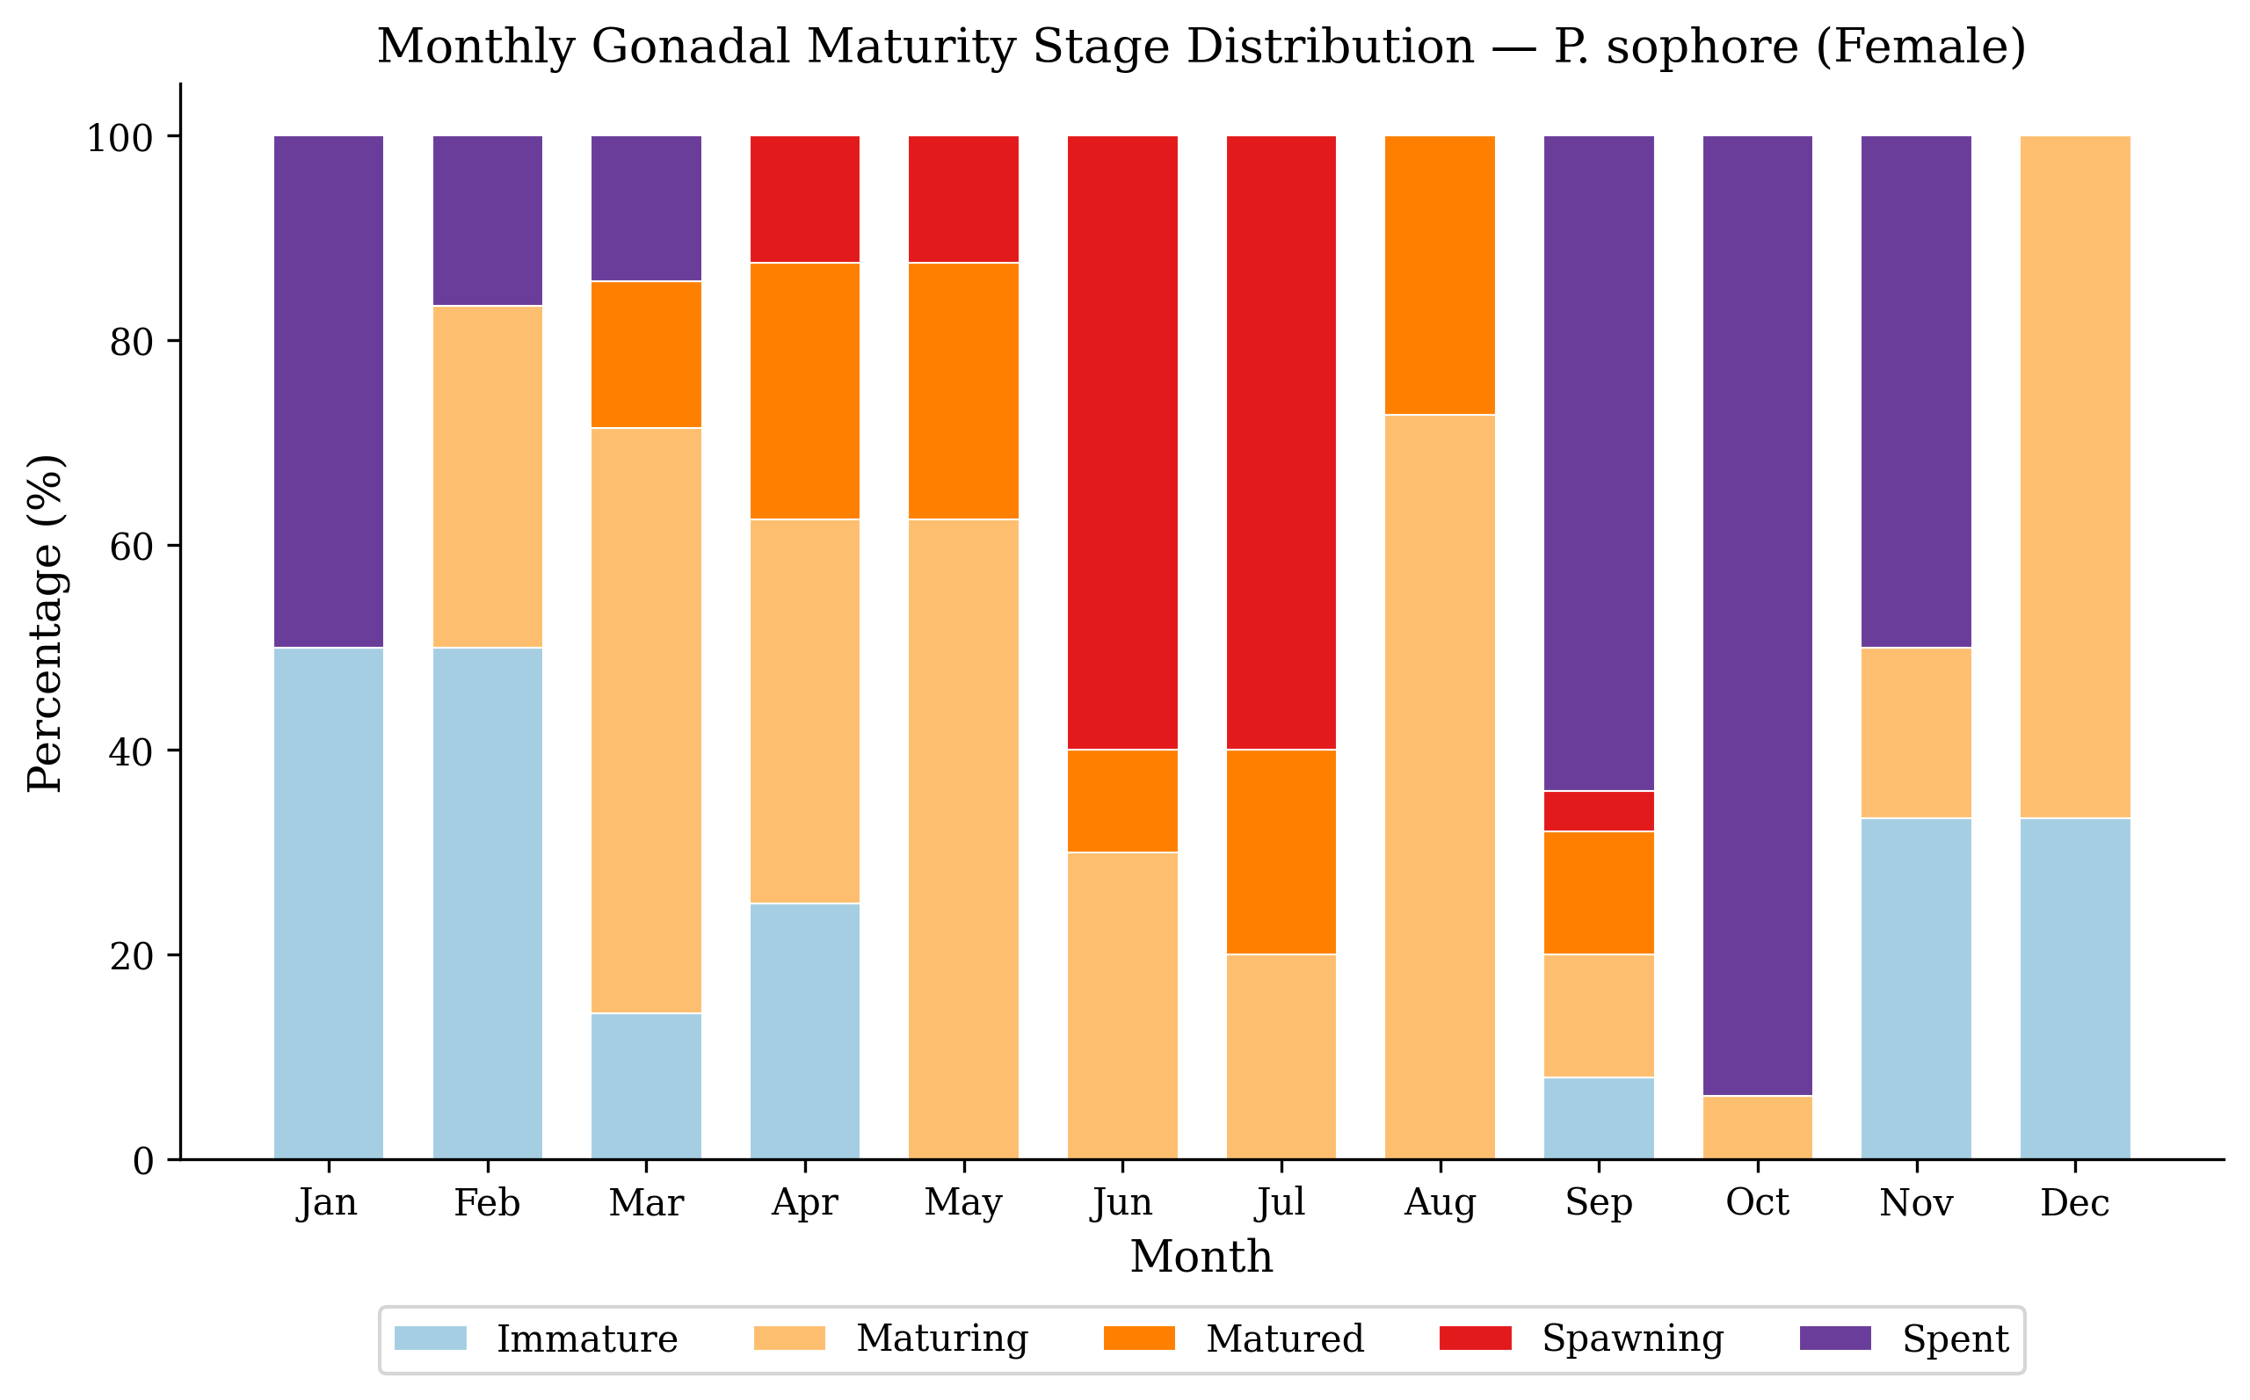
Figure 1: Stacked bar chart showing monthly percentage distribution of gonadal maturity stages of P. sophore (Female)
The maturity stages assessment outlines four phases on a yearly basis reproductive cycles in P.sophore females. The resting Phase (November –February) was marked by the prevalence of immature and spent individuals, depicting the post- spawning recovery and gonadal reorganization period. The Preparatory Phase (March–May) shows forward –looking gonadal development with maturing individuals increasing from 57.14% in March to 62.50% in May, and the first aspect of matured and spawning individuals. The Spawning Phase (June–July) was notable by the highest fraction of spawning-condition fish (60% in both months), confirming this period as the peak reproductive season. The Post-Spawning Phase (August–October) showed the abrupt change to spent condition, from 0% in July to 64% in September and 93.75% in October.
The spawning seson of P.sophore in Upper Lake, Bhopal was identified from the combined analysis of GSI variations, gonadal maturity stages and the proportion of fishes in spawning condition, indicating June to August as the breeding period with peak spawning activity during June-July. This is consistent with the reports of Choudhury et al. (2015) who identified March–July as the breeding season from Tripura, and Rafiquzzaman et al. (2018) who documented peak spawning during March–July in Bangladesh. The monsoon-associated spawning of Indian cyprinids is a well-established ecological phenomenon driven by environmental cues including rising water levels, turbidity, temperature, and rainfall (Jhingran, 1991; Lowe-McConnell, 1987).
The observed June-July peak in P. sophore therefore appears biologically plausible for a monsoon-influenced population, although the timing is slightly later than some Bangladeshi populations, where histological evidence indicated March-July spawning with regional peaks during April-May or May-July; such variation is consistent with the influence of local temperature, rainfall and water-level regimes on reproductive timing (Hasan et al., 2018; Yamahira, 2004).

3.2 Rasbora daniconius (Female)
Table 2: Monthly frequency distribution (%) of gonadal maturity stages of R. daniconius (Female) from Upper Lake, Bhopal
Month | Immature | Maturing | Matured | Spawning | Spent | N | % Reprod.
January | 20.00 | 40.00 | 0.00 | 0.00 | 40.00 | 5 | 0.00
February | 60.00 | 20.00 | 0.00 | 0.00 | 20.00 | 5 | 0.00
March | 0.00 | 50.00 | 50.00 | 0.00 | 0.00 | 6 | 50.00
April | 0.00 | 33.33 | 0.00 | 66.67 | 0.00 | 6 | 66.67
May | 0.00 | 14.29 | 28.57 | 57.14 | 0.00 | 7 | 85.71
June | 0.00 | 14.29 | 28.57 | 57.14 | 0.00 | 7 | 85.71
July | 0.00 | 0.00 | 75.00 | 25.00 | 0.00 | 8 | 100.00
August | 0.00 | 14.29 | 14.29 | 14.29 | 57.14 | 7 | 28.57
September | 0.00 | 0.00 | 0.00 | 0.00 | 100.00 | 1 | 0.00
October | 10.00 | 10.00 | 0.00 | 0.00 | 80.00 | 10 | 0.00
November | 40.00 | 20.00 | 0.00 | 0.00 | 40.00 | 5 | 0.00
December | 0.00 | 0.00 | 0.00 | 0.00 | 100.00 | 7 | 0.00
% Reproductive = % Matured + % Spawning; Peak: July (100% reproductive); Spawning season: April–July
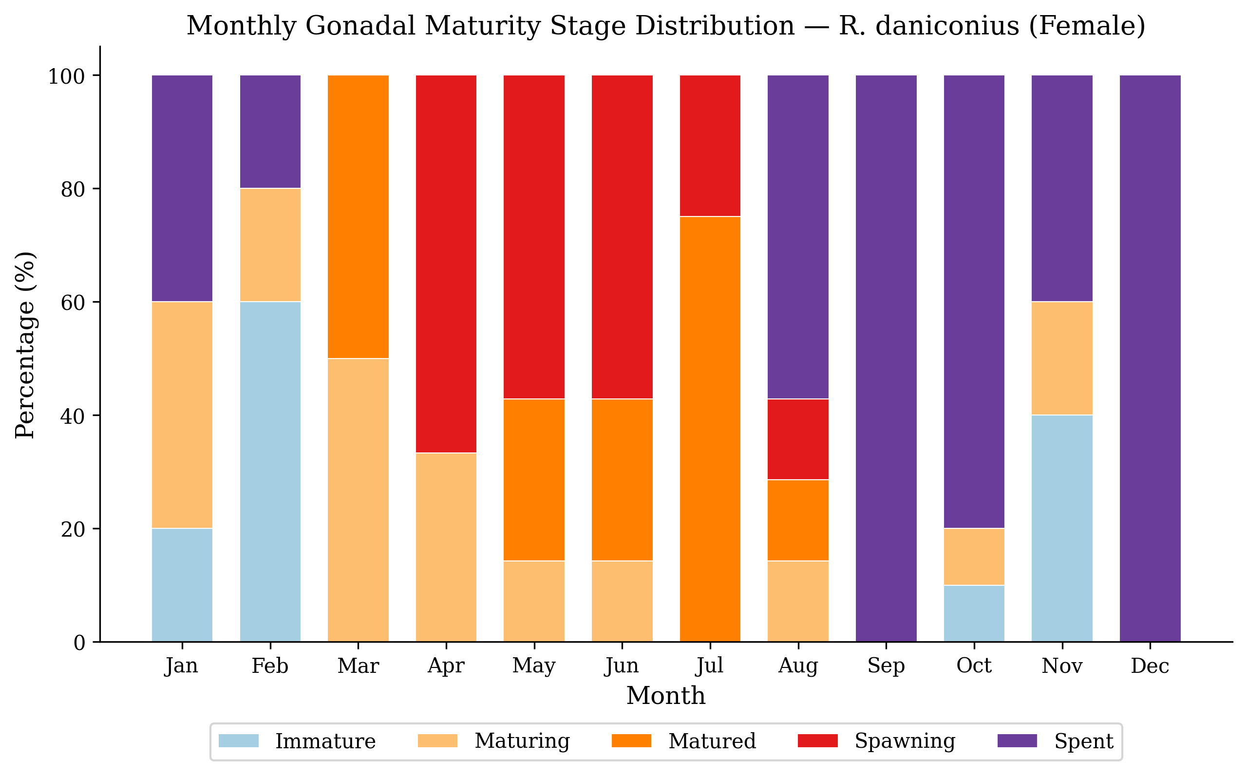
Figure 2: Stacked bar chart showing monthly percentage distribution of gonadal maturity stages of R. daniconius (Female)
In R. daniconius, reproductive activity showed an earlier onset compared to P. sophore. Matured individuals appeared as early as March (50%), and spawning-condition fish were present from April (66.67%) through August (14.29%). The highest reproductive activity was in July (100%), followed by May and June (85.71% each). The spawning season of R. daniconius was identified as April–July, which is approximately one month earlier than P. sophore (June–August). This temporal partitioning of spawning activity between the two sympatric species may represent an adaptive mechanism to reduce inter-specific competition for spawning habitat, food resources for early larvae, and nursery grounds (Lowe-McConnell, 1987; Ross, 1986).
The earlier reproductive onset in R. daniconius is also supported by earlier observations that female predominance in July-August coincides with the breeding season of this species, while the temporal separation from P. sophore may reduce overlap in spawning sites and early-life resource use in sympatric fish assemblages (Nagendran et al., 1981; Ross, 1986).

3.3 Histological Observations of Gonadal Development
Histological examination of the gonads using standard haematoxylin and eosin (H&E) staining technique provided detailed cellular-level confirmation of the macroscopic maturity staging and offered insights into the dynamics of gametogenesis in both species. The histological features observed at each stage of gonadal development are described below and summarized in Tables 3 and 4.
This agreement between gross maturity stages and cellular structure is important because ovarian and testicular histology provides direct evidence of gametogenic progression that cannot be fully resolved by external gonad appearance alone (West, 1990; Murua & Saborido-Rey, 2003; Parenti & Grier, 2004).

Female Ovarian Histology
Table 3. Summary of histological features of female gonadal maturity stages in P. sophore and R. daniconius
Stage | Period | Macroscopic | Histological | GSI Range
I | Immature | Small, translucent, <1/4 cavity | Oogonia, chromatin nucleolus | 0.5–1.5%
II | Previtellogenesis | Larger, pinkish, ~1/3 cavity | Perinucleolus, follicle forming | 1.5–3.0%
III | Vitellogenesis | Yellow, 1/3–2/3 cavity | Yolk vesicles, cortical alveoli | 3.0–8.0%
IV | Maturation | Turgid, fills cavity | Yolk-packed, GVBD, hydration | 8.0–25.0%
V | Spent | Flaccid, residual ova | Atretic follicles, POFs | 0.3–1.0%

Stage I (Immature/Resting): The ovaries were thin, elongated and translucent, occupying less than one-fourth of the body cavity. Morphological sections revealed predominantly oogonia and chromatin nucleolus stage oocytes embedded in abundant interstitial tissue. This stage was observed predominantly during November–February in both species, corresponding to the gonadal quiescent period following the previous spawning season. The histological appearance of Stage I ovaries is consistent with descriptions provided by West (1990) and Murua et al. (2003) for resting-phase teleost ovaries.
The predominance of oogonia and chromatin-nucleolus oocytes in the resting phase agrees with the general teleost pattern in which early oocytes and germline cysts are retained in the ovary before recruitment into active follicular growth (Lubzens et al., 2010; Patiño & Sullivan, 2002).
Stage II (Previtellogenesis/Maturing): Ovaries were slightly enlarged, pinkish in colour, and occupied approximately one-third of the body cavity. Histologically, perinucleolus stage oocytes dominated, characterized by large, round nuclei with multiple nucleoli arranged at the nuclear periphery. This stage was common during February–April in P. sophore and February–March in R. daniconius.
The perinucleolar condition observed at this stage indicates early follicular development before major yolk incorporation, which is a typical preparatory phase preceding vitellogenesis in teleost ovaries (Lubzens et al., 2010; Patiño & Sullivan, 2002).
Stage III (Vitellogenesis): This was the most prolonged and metabolically active stage of ovarian development. Ovaries occupied one-third to two-thirds of the body cavity and appeared yellowish due to the accumulation of yolk material. Histologically, three sub-stages were distinguishable: early vitellogenesis (yolk vesicle stage with cortical alveoli prominent in the peripheral ooplasm), mid-vitellogenesis (yolk granule stage with proteinaceous yolk granules filling the central ooplasm), and late vitellogenesis (yolk-packed oocytes with oil droplets and fully organized zona radiata). This stage was prevalent from April to August, with the highest proportion observed during May–August in P. sophore and March–July in R. daniconius.
The presence of yolk vesicles, cortical alveoli and yolk granules indicates active vitellogenic growth, a phase regulated by endocrine and hepatic vitellogenin pathways and commonly used as a reliable histological indicator of approaching reproductive readiness (Patiño & Sullivan, 2002; Lubzens et al., 2010).
Stage IV (Maturation/Ripe): Ovaries were turgid, highly vascularized, and filled the entire body cavity. Histologically, the oocytes were at their maximum diameter with completely packed yolk granules that had undergone partial or complete coalescence (yolk plate formation in some oocytes).The major histological characteristics observed were germinal vesicle migration (GVM) and subsequent germinal versicle breakdown (GVBD), which signified the onset of final oocyte maturation (Nagahama,1983). Oocyte hydration was evident in the most advanced oocytes, resulting in a translucent, swollen appearance. The zona radiata was thinned and the follicular layers were stretched. This stage coincided with the peak spawning period (June–July in P. sophore; April–July in R. daniconius).
The occurrence of germinal-vesicle migration, germinal-vesicle breakdown and oocyte hydration is consistent with final oocyte maturation and imminent ovulation, processes that are widely recognized as late-stage reproductive markers in teleost fishes (Patiño & Sullivan, 2002; Lubzens et al., 2010).
Stage V (Spent/Post-spawning): The ovaries became shrunken and flaccid after spawning , showing a reduced size and a reddish appearance due to vascular congestion and tissue resorption.Histologically, empty follicular envelopes (post-ovulatory follicles, POFs) were the most diagnostic feature, providing direct evidence of recent ovulation. Residual unspawned oocytes at various stages of atresia (alpha and beta atresia) were scattered throughout the ovarian tissue. Yellow-brown bodies — remnants of atretic oocytes undergoing phagocytic resorption — were present. Early-stage oogonia and chromatin nucleolus oocytes were also observed, indicating the onset of ovarian recovery and preparation for the next reproductive cycle. This stage was dominant from September to November in P. sophore and from August to December in R. daniconius.
Post-ovulatory follicles and atretic oocytes provide direct evidence of recent spawning and subsequent resorption of residual oocytes; therefore, the high spent-stage frequency after the spawning months supports the proposed reproductive calendar for both species (West, 1990; Murua & Saborido-Rey, 2003).

Male Testicular Histology
Table 4: Summary of histological features of male gonadal maturity stages in P. sophore
Stage | Period | Macroscopic | Histological | GSI Range
I | Immature | Thin, translucent, <1/4 cavity | Spermatogonia only | <0.5%
II | Resting | Pink, ~1/3 cavity | Primary spermatocytes | 0.5–1.0%
III | Developing | Off-white, ~1/2 cavity | Secondary spermatocytes | 1.0–2.0%
IV | Maturing | White, firm, >1/2 cavity | Spermatozoa accumulating | 2.0–4.0%
V | Mature | Soft, full cavity, milt runs | Packed spermatozoa | 4.0–8.0%
VI | Spent | Flaccid, yellow, <1/2 cavity | Residual sperm, collapsed | 0.2–0.5%

Six stages of testicular development were identified in P. sophore males. The spermatogenic process in P.sophore followed the typical teleost pattern involving spermatogonial proliferation, formation of primary spermatocytes through meiosis I, secondary spermatocytes through meiosis II, spermatids and finally spermatozoa (Grier, 1981). The testes exhibited an unrestricted lobular types of organization in which spermatogonia was deistributed throughout the lobular epithelium, a characteristic feature commonly observed in teleost fishes ( Parenti & Grier, 2004)
The staged testicular pattern reported here is consistent with cystic spermatogenesis in teleosts, where spermatogonia, spermatocytes, spermatids and spermatozoa occur in organized germ-cell cohorts within lobular testicular tissue (Grier, 1981; Schulz et al., 2010; de Oliveira et al., 2025).

Conclusions
The study indicates that Puntius sophore and Rasbora daniconius show distinct seasonal patterns of gonadal development in Upper Lake, Bhopal. In P. sophore, the reproductive cycle showed preparatory development during March–May, peak spawning activity during June–July, and post-spawning recovery during August–October. In R. daniconius, reproductive activity began earlier, with spawning observed mainly from April to July and the highest reproductive condition recorded in July. Histological observations supported the macroscopic maturity stages by demonstrating progressive changes in ovarian and testicular tissues during different reproductive phases. The presence of vitellogenic and mature oocytes during the breeding period, followed by spent-stage characteristics after spawning, supports the proposed seasonal reproductive calendar. Overall, the results suggest that the two species differ in the timing and duration of reproductive activity, with R. daniconius showing an earlier reproductive onset than P. sophore. These observations may assist in planning breeding-season protection and conservation-oriented management of small indigenous fish species.

Limitations
The study is limited by incomplete presentation of sampling design, total sample size, sex-wise monthly distribution, and statistical procedures. The manuscript reports sex ratio and GSI values, but detailed supporting data are not fully presented. Environmental variables such as water temperature, rainfall, photoperiod, dissolved oxygen, and water level were not systematically analysed, although these factors may influence reproductive timing. The comparison between the two species is mainly descriptive and requires stronger statistical support. Histological observations are useful, but representative microphotographs and clearer staging criteria would improve reproducibility. Therefore, the findings should be interpreted as preliminary seasonal observations.

Declaration of AI Use

This manuscript was prepared through the combined contributions of all author(s), including contributions to the study design, data, content development, results, interpretation, and related scholarly work. The author(s) acknowledge the use of Grammarly and ChatGPT to assist with grammar checking, language refinement, reference formatting. These AI-assisted tools were not used as authors and did not replace the intellectual contributions or scholarly judgment of the author(s). All AI-assisted outputs, including content, references, and interpretations, were carefully reviewed, revised, verified, and approved by the author(s). The author(s) accept full responsibility for the accuracy, integrity, and final content of the manuscript.

COMPETING INTERESTS DISCLAIMER:
Authors have declared that they have no known competing financial interests OR non-financial interests OR personal relationships that could have appeared to influence the work reported in this paper.

References
Biswas, S. P. (1993). Manual of methods in fish biology. South Asian Publishers. https://www.worldcat.org/search?q=Manual+of+methods+in+fish+biology+Biswas
Chakrabarti, P., & Kulshrestha, S. K. (1996). Reproductive biology of freshwater fishes of India. Journal of Inland Fisheries Society of India, 28(1), 1-10. https://www.worldcat.org/search?q=Reproductive+biology+of+freshwater+fishes+of+India+Chakrabarti+Kulshrestha
Das, S. M., & Moitra, S. K. (1955). Studies on the gonadal cycle of Indian freshwater fishes. Proceedings of the National Institute of Sciences of India. https://www.worldcat.org/search?q=Studies+on+the+gonadal+cycle+of+Indian+freshwater+fishes+Das+Moitra
de Oliveira, S. M., dos Santos, F. C. A., Taboga, S. R., & Mimura, K. K. O. (2025). Testicular morphology of the teleost fish Psalidodon xavante (Garutti & Venere, 2009): Insights from light and transmission electron microscopy. Zoomorphology, 144, 65. https://doi.org/10.1007/s00435-025-00749-9
Grier, H. J. (1981). Cellular organization of the testis and spermatogenesis in fishes. American Zoologist, 21(2), 345-357. https://doi.org/10.1093/icb/21.2.345
Hasan, T., Hossain, M. F., Mamun, M., Alam, M. J., Salam, M. A., & Rafiquzzaman, S. M. (2018). Reproductive biology of Puntius sophore in Bangladesh. Fishes, 3(2), 22. https://doi.org/10.3390/fishes3020022
IUCN Bangladesh. (2015). Red list of Bangladesh: A brief on assessment result 2015. IUCN, International Union for Conservation of Nature, Bangladesh Country Office. https://portals.iucn.org/library/node/46323
Jhingran, V. G. (1991). Fish and fisheries of India (3rd ed.). Hindustan Publishing Corporation. https://www.worldcat.org/search?q=Fish+and+fisheries+of+India+Jhingran+1991
Lagler, K. F., Bardach, J. E., Miller, R. R., & Passino, D. R. M. (1977). Ichthyology (2nd ed.). John Wiley & Sons. https://www.worldcat.org/search?q=Ichthyology+Lagler+Bardach+Miller+Passino+1977
Lowe-McConnell, R. H. (1987). Ecological studies in tropical fish communities. Cambridge University Press. https://doi.org/10.1017/CBO9780511721892
Lubzens, E., Young, G., Bobe, J., & Cerdà, J. (2010). Oogenesis in teleosts: How fish eggs are formed. General and Comparative Endocrinology, 165(3), 367-389. https://doi.org/10.1016/j.ygcen.2009.05.022
Murua, H., & Saborido-Rey, F. (2003). Female reproductive strategies of marine fish species of the North Atlantic. Journal of Northwest Atlantic Fishery Science, 33, 23-31. https://doi.org/10.2960/J.v33.a2
Nagahama, Y. (1983). The functional morphology of teleost gonads. In W. S. Hoar, D. J. Randall, & E. M. Donaldson (Eds.), Fish physiology: Reproduction, Part A (Vol. 9, pp. 223-275). Academic Press. https://doi.org/10.1016/S1546-5098(08)60303-7
Nagendran, R., Shakuntala, K., Natarajan, G. N., & Vasan, H. R. K. (1981). Observations on the fecundity of the cyprinid Rasbora daniconius (Hamilton). Proceedings: Animal Sciences, 90, 381-388. https://doi.org/10.1007/BF03186016
Nikolsky, G. V. (1963). The ecology of fishes. Academic Press. https://www.worldcat.org/search?q=The+ecology+of+fishes+Nikolsky+1963
Parenti, L. R., & Grier, H. J. (2004). Evolution and phylogeny of gonad morphology in bony fishes. Integrative and Comparative Biology, 44(5), 333-348. https://doi.org/10.1093/icb/44.5.333
Patiño, R., & Sullivan, C. V. (2002). Ovarian follicle growth, maturation, and ovulation in teleost fish. Fish Physiology and Biochemistry, 26, 57-70. https://doi.org/10.1023/A:1023311613987
Qasim, S. Z. (1973). An appraisal of the studies on the growth of fishes. Indian Journal of Fisheries, 20(2), 351-371. http://eprints.cmfri.org.in/id/eprint/1440
Ross, S. T. (1986). Resource partitioning in fish assemblages: A review of field studies. Copeia, 1986(2), 352-388. https://doi.org/10.2307/1444996
Schulz, R. W., de França, L. R., Lareyre, J. J., Le Gac, F., Chiarini-Garcia, H., Nobrega, R. H., & Miura, T. (2010). Spermatogenesis in fish. General and Comparative Endocrinology, 165(3), 390-411. https://doi.org/10.1016/j.ygcen.2009.02.013
Shafi, M., & Quddus, M. M. A. (1982). Bangladesher matsya sampad (Fisheries resources of Bangladesh). Bangla Academy. https://www.worldcat.org/search?q=Shafi+Quddus+Bangladesher+matsya+sampad+1982
Weatherley, A. H., & Gill, H. S. (1987). The biology of fish growth. Academic Press. https://www.worldcat.org/search?q=The+biology+of+fish+growth+Weatherley+Gill+1987
West, G. (1990). Methods of assessing ovarian development in fishes: A review. Australian Journal of Marine and Freshwater Research, 41(2), 199-222. https://doi.org/10.1071/MF9900199
Wootton, R. J. (1990). Ecology of teleost fishes. Chapman & Hall. https://doi.org/10.1007/978-94-009-0829-1
Yamahira, K. (2004). How do multiple environmental cycles in combination determine reproductive timing in marine organisms? A model and test. Functional Ecology, 18(1), 4-15. https://doi.org/10.1046/j.0269-8463.2004.00795.x
Saha N., Rakib M. H., Mredul M. H., Rahman A. and Ahamed F. (2021). Life History Traits of the Gangetic scissortail rasbora, Rasbora rasbora (Hamilton, 1822) in the Payra River, Southern Bangladesh // Jordan Journal of Biological Sciences, 14(1), 129-135. https://doi.org/10.54319/jjbs/140117
Salmatin, N., Mubarak, A.S., & Budi, D.S. (2021). Egg diameter of female silver rasbora (Rasbora argyrotaenia) at different gonadal maturity stage. Earth environmental sciences. 718 (2021) 012066. DOI: 10.1088/1755-1315/718/1/012066
Minare A., Vyas V. (2024). View of Study on Reproductive Biology of Two SIF’s Puntius sophore and Rasbora daniconius // Journal of Survey in Fisheries Sciences 10(1):3836-3834.

