Reproductive Strategy and Fecundity Patterns of Puntius sophore and Rasbora daniconius
Abstract:
Reproductive biology, including spawning season, gonadal development, and fecundity, is essential for understanding fish population dynamics and supporting sustainable fisheries management. Comparative information on these traits in the small indigenous cyprinids Puntius sophore and Rasbora daniconius remains limited for Upper Lake, Bhopal. The present study reports the reproductive strategies and fecundity (F) of two species, Puntius sophore and Rasbora daniconius, in relation to total length (L), total body weight (W), and gonad weight (G). Fish samples were collected over a one-year period, and reproductive parameters comprising gonadal development, the gonadosomatic index (GSI), and fecundity were assessed. Capture observations indicated that the spawning season of P. sophore extended from June to August, with peak spawning in June–July, although the GSI peaked in May (8.46%). R. daniconius spawned from April to July, with a peak in July (GSI: 2.21%). In both species, a highly significant positive correlation was found between GSI and fecundity (P. sophore: r = 0.358, p < 0.001; R. daniconius: r = 0.361, p = 0.002), indicating that gonadal maturity was closely associated with egg production. However, the correlations between fecundity and body size (length and weight) were not significant in either species. P. sophore showed significantly higher GSI and fecundity than R. daniconius, indicating greater reproductive investment per spawning event. Fecundity showed relationships with L, G, and W. The study provides fundamental insights into the reproductive biology of Puntius sophore and Rasbora daniconius.
Keywords: Fecundity; gonadosomatic index; reproductive biology; spawning season; gonadal development; maturity stages; total length; body weight; Puntius sophore; Rasbora daniconius
Introduction
Aquaculture is one of the fastest-growing sectors and involves the cultivation of aquatic animals, including vertebrates, molluscs, shrimps, and prawns. A review of reproductive biology is important for understanding the life-history patterns of fish species and plays a key role in their conservation and sustainable management (Wootton, 1990). Reproductive biology comprises various parameters, including gonadal development, spawning periodicity, fecundity, the gonadosomatic index (GSI), and correlations between reproductive parameters and environmental factors. The present study focuses on the comparative reproductive biology of two important small indigenous cyprinid species, Puntius sophore and Rasbora daniconius (Hamilton, 1822), which are commonly recognised in freshwater biodiversity and fisheries research (Jhingran, 1991; Lowe-McConnell, 1987; Talwar & Jhingran, 1991). Such information is critical for developing breeding protocols, conducting stock assessments, and formulating effective management strategies for wild populations and aquaculture development (Paul et al., 2011; Singha et al., 2024).
Fecundity refers to the number of eggs developed by a female fish and is a key indicator for evaluating reproductive potential and population variation. Understanding the correlation between fecundity and body-size parameters (length, weight, and gonad weight) assists in predicting egg production and evaluating the reproductive capacity of a fish population. Fecundity is influenced by several biological factors, including body size, gonad weight, age, and environmental conditions. Studies have identified these parameters as useful indicators of the reproductive potential of fishes (Murua & Saborido-Rey, 2003; Ganias, 2018). Recent work on freshwater cyprinids indicates that the timing of gametogenesis, spawning, and reproductive output can vary among species, populations, and environmental settings, reinforcing the need for site-specific assessments of gonadal development and fecundity (Liu et al., 2024; Koya et al., 2024; Debnath, 2025).
Fecundity and gonadosomatic index measurements have been used to describe seasonal reproductive patterns in small freshwater fishes, while controlled breeding studies demonstrate the practical value of reproductive performance data for propagation planning (Datta et al., 2023; Hastuti et al., 2024). However, comparative information on the seasonal reproductive biology and fecundity patterns of Puntius sophore and Rasbora daniconius in Upper Lake, Bhopal, remains limited, particularly regarding species-specific variation in GSI, spawning period, gonadal maturity, and the relationships of fecundity with body size and gonadal condition.
Research Objectives
- To examine the Gonadosomatic Index (GSI), spawning season, maturity stages, and gonadal development to improve understanding of the reproductive biology of Puntius sophore and Rasbora daniconius.
- To estimate the fecundity of Puntius sophore and Rasbora daniconius and compare their reproductive potential based on body weight, total length, ovary weight, and gonadal maturity.
- To examine seasonal changes in gonadal development and other reproductive parameters in both fish species.
2. Materials and Methods
Both Puntius sophore and Rasbora daniconius are commonly occurring cyprinid forage fishes in the freshwaters of India. The present study was therefore conducted from January to December, with particular attention to the monsoon months, in Bhopal, Madhya Pradesh. Fish were sampled randomly from Upper Lake, Bhopal. After total length and total weight were recorded, the fish were preserved in 5% formalin for further assessment. The cross-sectional diameter of each egg was measured at its widest point using a calibrated ocular micrometer.

Gonadal Development and Maturity Stages
The gonads were carefully removed, weighed, and examined to determine their maturity stage based on macroscopic characteristics. Gonadal maturity was classified according to the criteria described by Nikolsky (1963). Only mature female fish were selected for fecundity estimation.

Gonadosomatic Index (GSI)
The Gonadosomatic Index (GSI) was calculated monthly using the following formula:
GSI = (Gonad weight / Body weight) × 100

Results and Discussion

Fecundity
Fecundity is defined as the number of ripening eggs or ova present in the ovary before the next spawning event and constitutes a fundamental measure of the reproductive potential of fish populations (Bagenal & Braum, 1978; Murua et al., 2003). Reproductive biology provides essential information on breeding, gonadal maturation, fecundity, and spawning, which is fundamental to fish conservation and sustainable fisheries management (Lowerre-Barbieri et al., 2017; Ganias, 2018). In the present study, fecundity was estimated using the gravimetric method (Lagler, 1956), which involves weighing a representative subsample of the ovary, counting the number of mature ova in the subsample, and extrapolating the count to the total ovary weight.
The gravimetric approach is appropriate for small-bodied cyprinids when mature oocytes can be separated reliably; however, estimates should be interpreted with consideration of maturity stage, atresia, and spawning strategy, because the inclusion of immature or spent females can substantially reduce mean fecundity (Murua et al., 2003; West, 1990; Hossain et al., 2012).

Gonadosomatic Index (GSI)
The Gonadosomatic Index (GSI) is a widely used indicator of the reproductive state and spawning readiness of fish (Lagler, 1956; de Vlaming et al., 1982; West, 1990). It quantifies the proportion of body resources allocated to gonadal development and is calculated as GSI (%) = (Gonad Weight / Total Body Weight) × 100. Higher GSI values indicate active gonadal development and approaching spawning, whereas lower values indicate quiescent, immature, or spent reproductive phases.
Although GSI is a practical indicator of reproductive activity, it is best interpreted together with oocyte development and maturity stage because it can be affected by body size, ovarian allometry, and partial or protracted spawning patterns (de Vlaming et al., 1982; Somarakis et al., 2004; Flores et al., 2019).

Comparative GSI Analysis
Table 1: Comparative monthly variation in GSI (%) of P. sophore and R. daniconius from Upper Lake, Bhopal
Month | P.s ♀ (N) | P.s ♀ GSI | P.s ♂ (N) | P.s ♂ GSI | R.d ♀ (N) | R.d ♀ GSI
Jan | 2 | 1.27±0.69 | 0 | -- | 5 | 0.32±0.10
Feb | 6 | 0.31±0.08 | 4 | 0.17±0.02 | 5 | 0.21±0.05
Mar | 7 | 0.50±0.15 | 5 | 0.20±0.04 | 6 | 0.47±0.15
Apr | 8 | 1.68±0.82 | 5 | 0.38±0.05 | 6 | 0.96±0.21
May | 8 | 8.46±5.03 | 6 | 0.45±0.04 | 7 | 0.53±0.12
Jun | 10 | 3.90±2.49 | 6 | 0.50±0.05 | 7 | 1.36±0.43
Jul | 10 | 4.16±2.15 | 7 | 0.57±0.08 | 8 | 2.21±0.65
Aug | 11 | 7.03±1.81 | 0 | -- | 7 | 0.73±0.20
Sep | 25 | 2.95±1.16 | 8 | 0.38±0.02 | 1 | 0.80±0.00
Oct | 16 | 0.88±0.29 | 11 | 0.39±0.01 | 10 | 2.02±0.79
Nov | 6 | 0.31±0.08 | 4 | 0.16±0.02 | 5 | 0.39±0.13
Dec | 3 | 1.66±0.77 | 2 | 0.37±0.01 | 7 | 0.75±0.02
Annual | 112 | 3.05±0.59 | 58 | 0.38±0.02 | 74 | 1.02±0.15
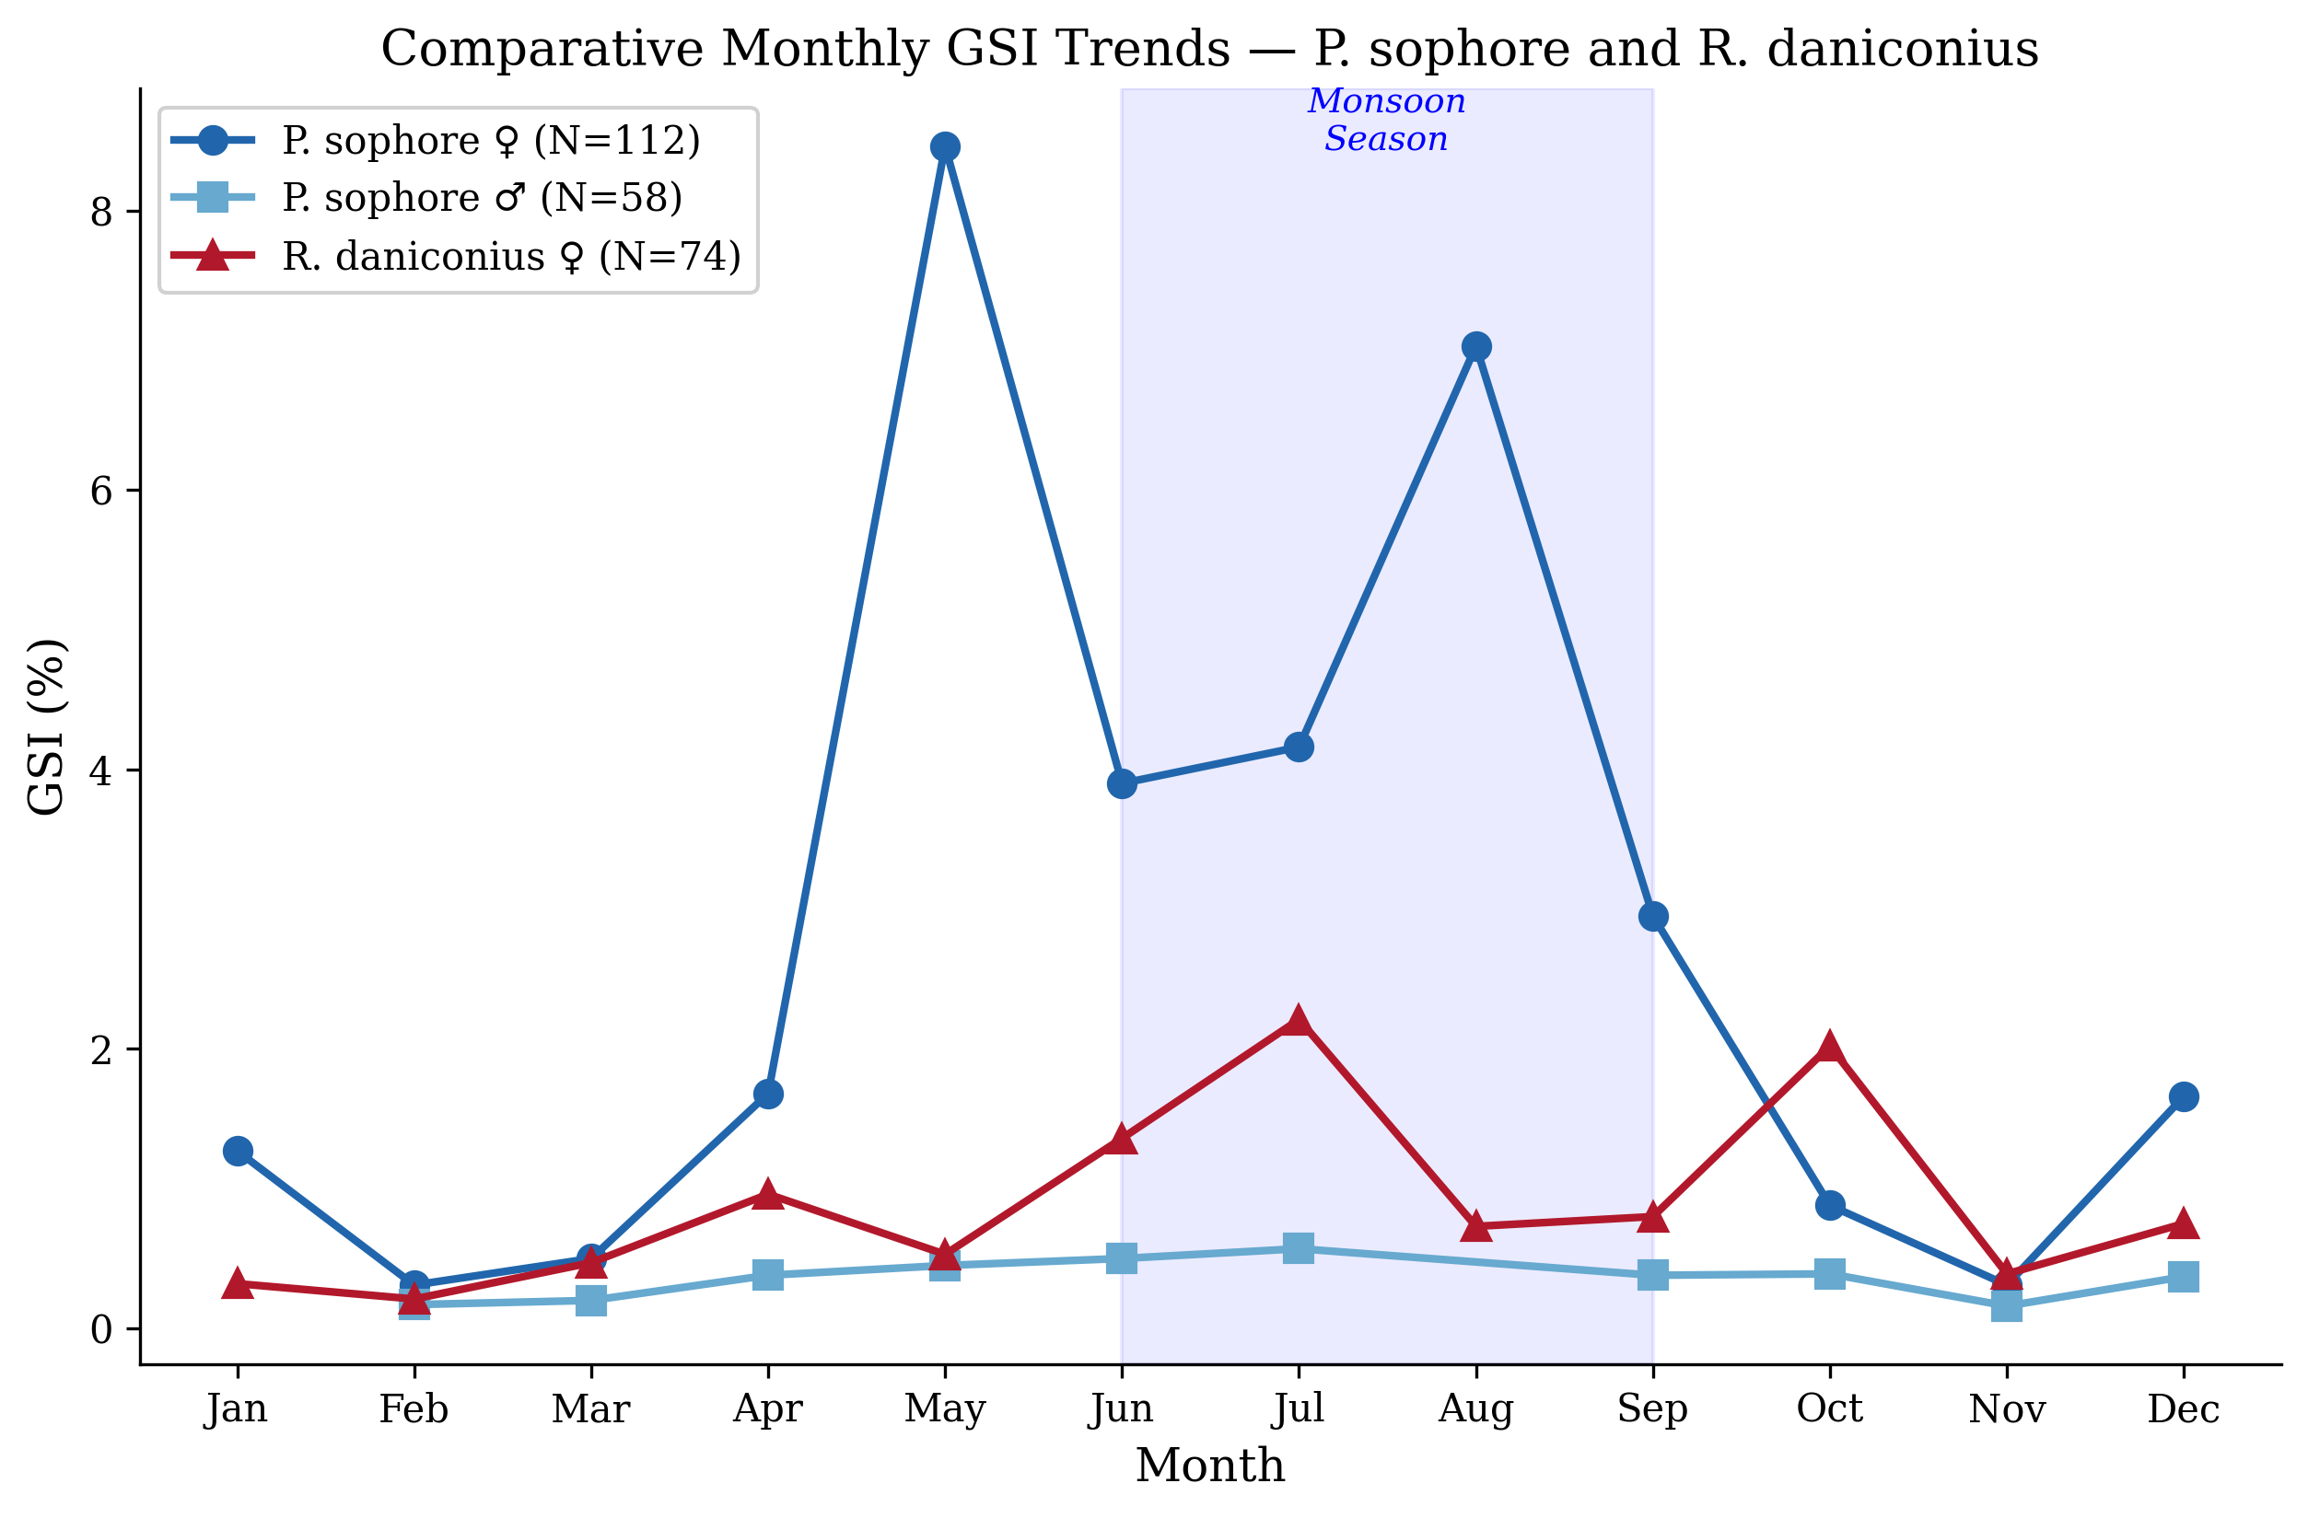
Figure 1: Comparative line graph showing monthly GSI trends of P. sophore (♀ and ♂) and R. daniconius (♀) from Upper Lake, Bhopal
The comparative GSI analysis revealed that, although both species exhibited monsoon-associated spawning, their peak GSI months differed slightly. Female P. sophore showed the highest GSI in May (8.46%), whereas R. daniconius peaked in July (2.21%). This temporal offset in peak reproductive activity may represent an adaptive mechanism that reduces interspecific competition for spawning habitat, food resources for larvae, and nursery grounds, a phenomenon commonly observed in sympatric fish communities in tropical freshwaters (Lowe-McConnell, 1987; Welcomme, 1979).
The higher female GSI of P. sophore during May–August is consistent with reports that the species often shows region-specific breeding peaks from the pre-monsoon to monsoon months; such variation may reflect local temperature, rainfall, water level, and food availability (Hossain et al., 2012; Hasan et al., 2018; Murua et al., 2003).
Table 2: Monthly variation in fecundity (number of ova) of P. sophore and R. daniconius (Female) from Upper Lake, Bhopal
Month | P.s ♀N | P.s ♀Fecundity | R.d♀ N | R.d ♀ecundity | Season
January | 2 | 64.80±40.80 | 5 | 11.80±1.80 | Winter
February | 6 | 401.00±349.16 | 5 | 25.20±9.33 | Winter
March | 7 | 143.29±106.33 | 6 | 10.00±0.00 | Pre-Mon.
April | 8 | 331.62±228.75 | 6 | 29.17±12.92 | Pre-Mon.
May | 8 | 104.25±47.04 | 7 | 12.43±0.87 | Pre-Mon.
June | 10 | 837.60±540.31 | 7 | 16.00±2.59 | Monsoon
July | 10 | 1548.40±1036.34 | 8 | 25.12±3.55 | Monsoon
August | 11 | 721.09±288.98 | 7 | 20.00±2.48 | Monsoon
September | 25 | 1195.68±714.91 | 1 | 15.00±0.00 | Monsoon
October | 16 | 186.36±160.16 | 10 | 23.02±10.65 | Post-Mon.
November | 6 | 34.33±24.33 | 5 | 10.00±0.00 | Post-Mon.
December | 3 | 712.43±441.35 | 7 | 14.86±1.22 | Winter
Annual | 112 | 661.02±196.70 | 74 | 18.37±1.98 | --
P.s ♀ANOVA: F=0.555, p=0.860 NS; R.d ♀ANOVA: F=0.976, p=0.473 NS; Values: Mean±SE
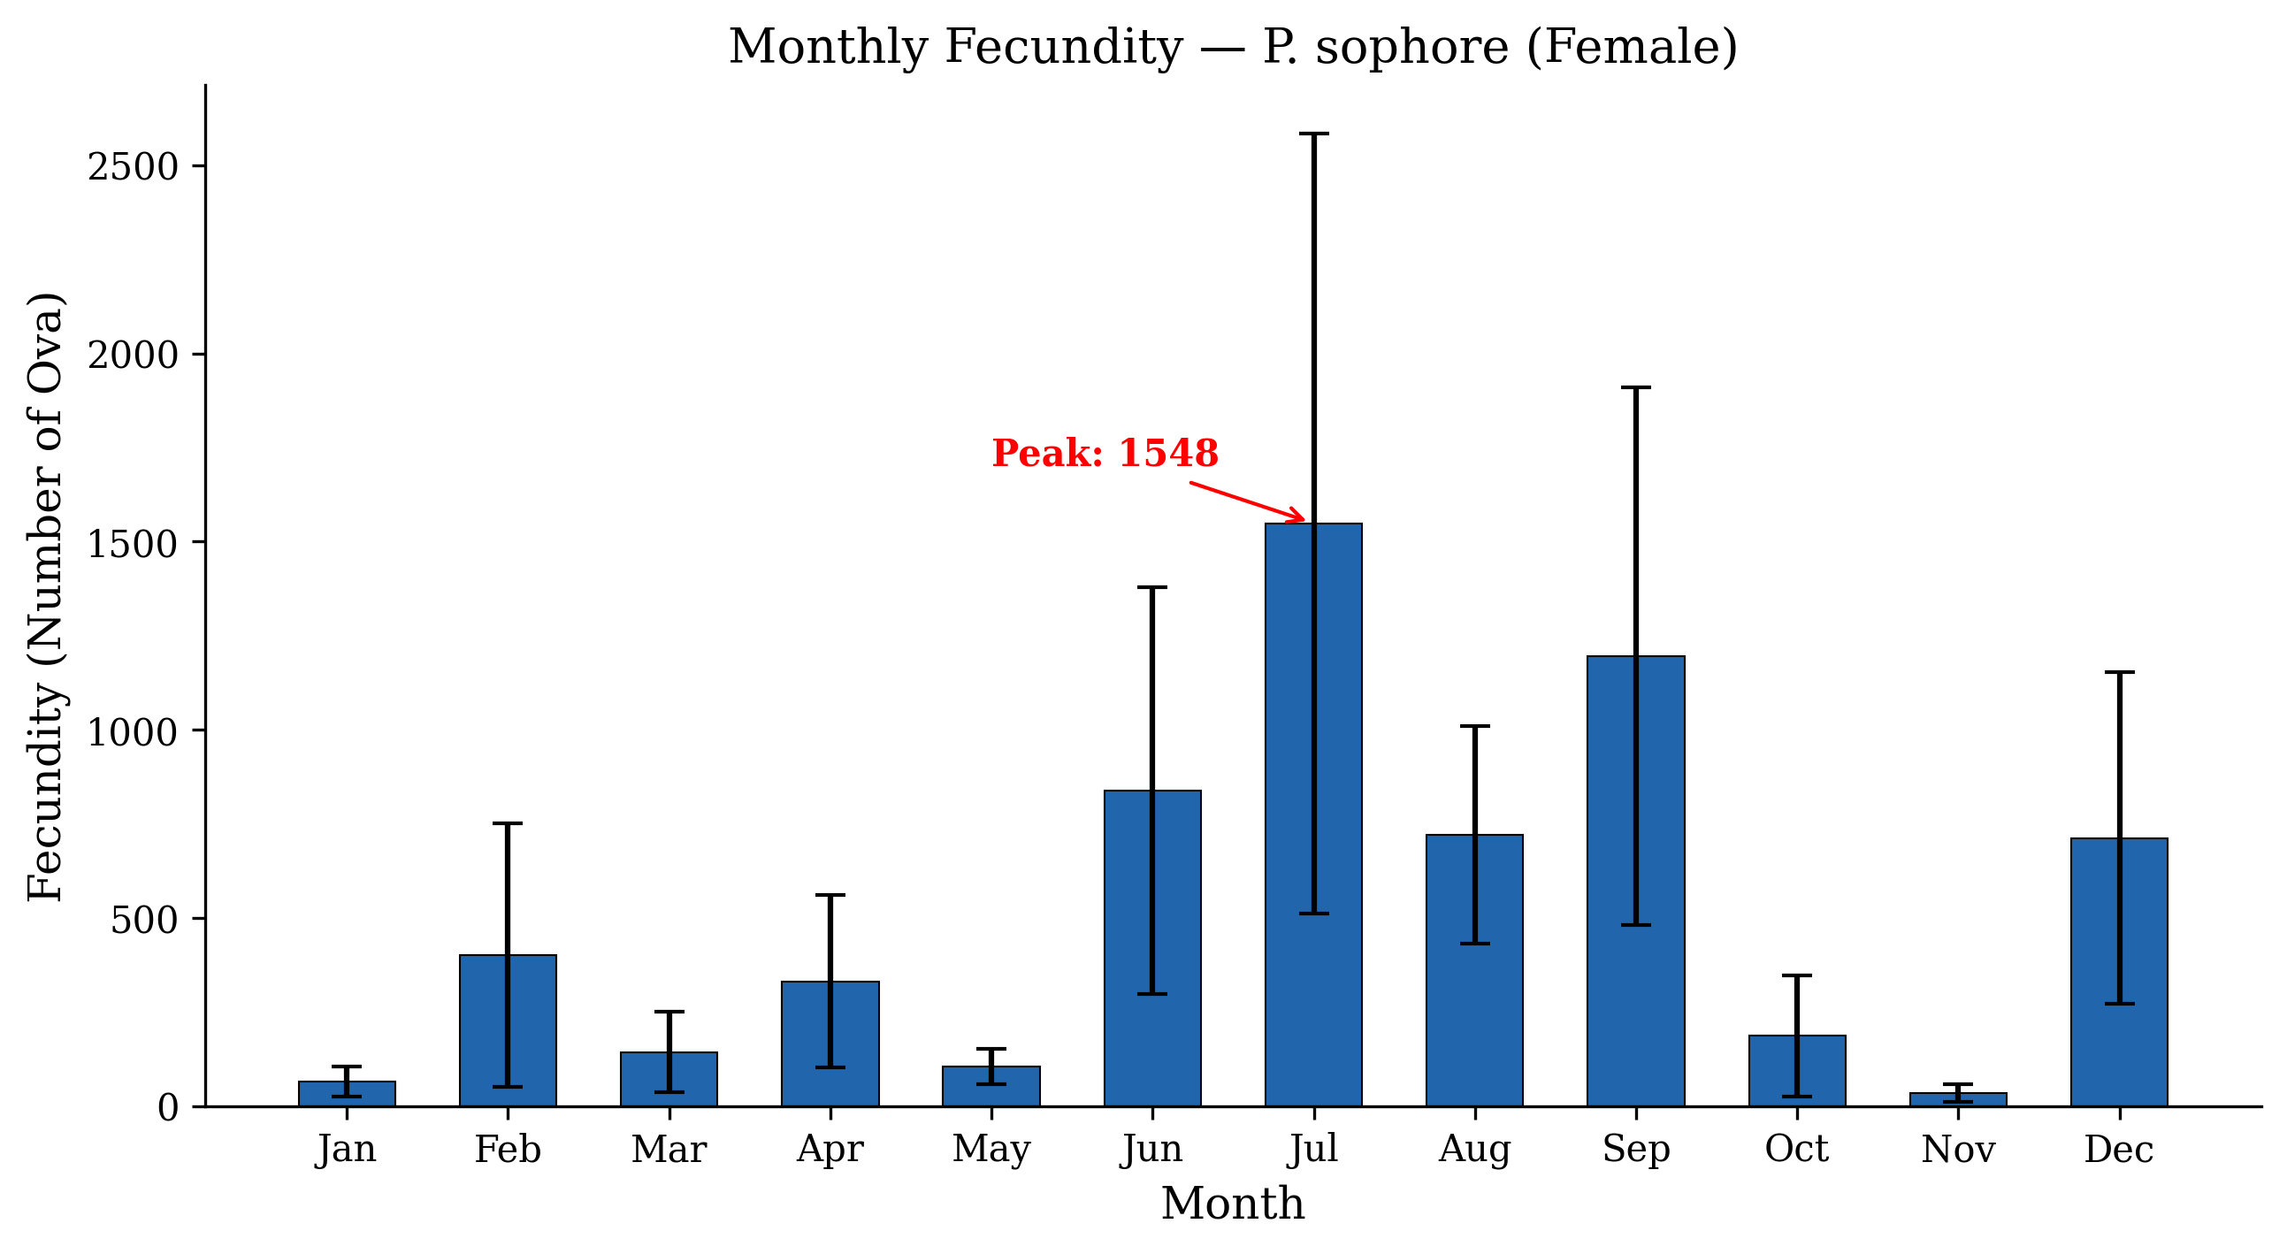
Figure 2: Bar graph showing monthly fecundity of P. sophore (Female) from Upper Lake, Bhopal with error bars (±SE)
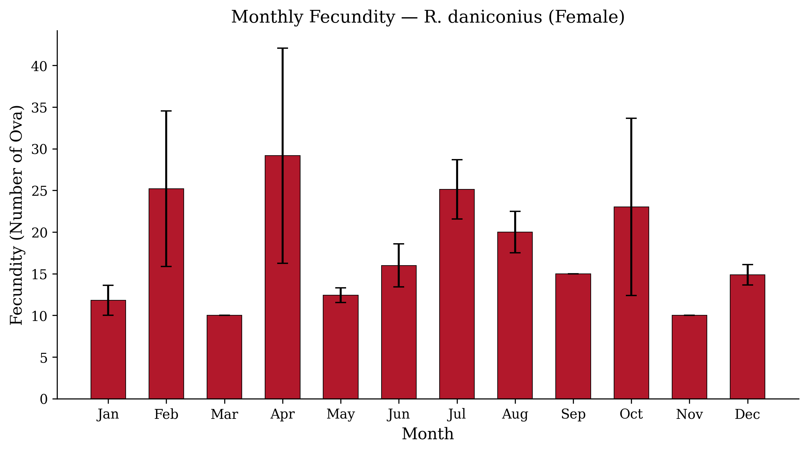
Figure 3: Bar graph showing monthly fecundity of R. daniconius (Female) from Upper Lake, Bhopal with error bars (±SE)
The annual mean fecundity of P. sophore females was 661.02 ± 196.70 ova (SD = 2081.65; range: 10–17,052). The highest mean fecundity was recorded in July (1548.40 ± 1036.34), followed by September (1195.68 ± 714.91) and June (837.60 ± 540.31). The lowest fecundity was recorded in November (34.33 ± 24.33). ANOVA indicated no significant monthly variation (F = 0.555, p = 0.860). This result may be attributable to substantial interindividual variability within months, owing to the presence of both immature fish (with very low fecundity) and fully mature fish (with high fecundity) in the same monthly sample.
Published fecundity values for P. sophore vary widely among studies. Kant et al. (2016) reported a fecundity range of 1,560–2,314 eggs in Jammu, India. Rahman et al. (2018) reported a much wider range of 1,488–18,708 ova (mean: 5,682 ± 3,703) from the Padma River, Bangladesh. Bithy et al. (2012) documented fecundity ranging from 7,951 to 23,053 in Bangladesh. Awal et al. (2023) recorded the highest fecundity values of 5,053 ± 878.27 in Gazipur and 5,433 ± 968.26 in Jessore. The present mean fecundity (661.02) is lower than most published values, possibly because the analysis included all maturity stages rather than only gravid females and because the Upper Lake population generally comprised smaller fish.
Therefore, the lower fecundity observed in Upper Lake should not be interpreted as inherently poor reproductive capacity; rather, it may reflect population size structure, sampling across maturity stages, and local environmental conditions affecting gonadal development (Hossain et al., 2012; Hasan et al., 2018; Murua et al., 2003).
R. daniconius females exhibited considerably lower fecundity, with an annual mean of 18.37 ± 1.98 ova (SD = 17.08; range: 5–80). The highest fecundity values were recorded in April (29.17 ± 12.92) and July (25.12 ± 3.55). This low fecundity is consistent with the species' reproductive strategy: R. daniconius is known to produce small clutches of relatively large eggs, reflecting a K-selected reproductive strategy that favours offspring quality over quantity (Pianka, 1970; Nagendran & Shakuntala, 1977). According to Paul and Sarmah (2019), the fertilised eggs are semi-adhesive and measure approximately 0.8–1.0 mm in diameter, which is considerably larger than the eggs of P. sophore.
Earlier work on R. daniconius reported that fecundity was positively related to body length, body weight, and gonad weight, indicating that the very low values in the present samples require careful interpretation in relation to the sampling period, maturity status, and possible differences in egg-counting criteria (Nagendran et al., 1981; West, 1990; Murua et al., 2003).

4.8.1 Fecundity Relationships with Morphometric Parameters
Table 3: Pearson correlation coefficients for fecundity relationships in P. sophore and R. daniconius
Relationship | P.s ♀ | P.s ♀p | R.d ♀ | R.d ♀p
Fecundity vs TL | 0.131 | 0.167 NS | -0.015 | 0.896 NS
Fecundity vs BW | 0.153 | 0.107 NS | 0.022 | 0.855 NS
Fecundity vs GSI | 0.358 | <0.001 ** | 0.361 | 0.002 **
** p < 0.01; NS = Not Significant; TL = Total Length; BW = Body Weight; GSI = Gonadosomatic Index
In both species, a highly significant positive correlation was found between GSI and fecundity (P. sophore: r = 0.358, p < 0.001; R. daniconius: r = 0.361, p = 0.002), indicating that gonadal maturity was associated with egg production. However, the correlations between fecundity and body size (length and weight) were not significant in either species. This contrasts with published reports in which fecundity was positively correlated with body size (Kant et al., 2016; Rahman et al., 2018). The non-significant relationship in the present study may have resulted from pooling all maturity stages in the analysis; in immature and spent fish, fecundity is minimal regardless of body size, which weakens the overall correlation.
The significant association between fecundity and GSI in both species supports the use of GSI as a field-level proxy for reproductive investment; however, the weak relationship with body size suggests that future analyses should separate mature, immature, and spent females because pooled maturity stages can mask size–fecundity relationships (de Vlaming et al., 1982; Flores et al., 2019; West, 1990).

Conclusions
The study indicates that Puntius sophore and Rasbora daniconius differ in reproductive timing, gonadosomatic index patterns, and fecundity levels in Upper Lake, Bhopal. P. sophore showed a higher female GSI and higher mean fecundity than R. daniconius, suggesting greater reproductive investment per spawning event. The spawning period of P. sophore was identified mainly from June to August, with peak spawning during June–July, whereas R. daniconius showed an earlier reproductive period from April to July, with peak activity in July. Fecundity was significantly associated with GSI in both species, indicating that gonadal development was closely linked to egg production. However, fecundity was not significantly related to total length or body weight when all maturity stages were pooled. This finding suggests that maturity stage should be considered carefully when assessing fecundity relationships. Overall, the findings provide preliminary information on the reproductive patterns of these two cyprinid fishes and may support the planning of breeding-season protection and sustainable fisheries management.

Limitations

The study was limited to a single freshwater site and a one-year sampling period, which may restrict the broader applicability of the findings. Fecundity analyses pooled females at different maturity stages, potentially obscuring relationships with body size. In addition, environmental factors such as temperature, rainfall, water level, dissolved oxygen, and food availability were not assessed, limiting interpretation of seasonal reproductive variation.

Declaration of AI Use

This manuscript was prepared through the combined contributions of all author(s), including contributions to the study design, data, content development, results, interpretation, and related scholarly work. The author(s) acknowledge the use of Grammarly and ChatGPT to assist with grammar checking, language refinement, reference formatting. These AI-assisted tools were not used as authors and did not replace the intellectual contributions or scholarly judgment of the author(s). All AI-assisted outputs, including content, references, and interpretations, were carefully reviewed, revised, verified, and approved by the author(s). The author(s) accept full responsibility for the accuracy, integrity, and final content of the manuscript.

COMPETING INTERESTS:
Authors have declared that they have no known competing financial interests OR non-financial interests OR personal relationships that could have appeared to influence the work reported in this paper.

Reference
Awal, M. R., Yesmine, S., Bhadra, A., Kohinoor, A. H. M., & Mahmud, Y. (2023). Reproductive biology and length–weight relationship of the pool barb Puntius sophore (Hamilton, 1832) in Mymensingh, Bangladesh. Archives of Agriculture and Environmental Science, 8(3), 358–363. https://doi.org/10.26832/24566632.2023.0803013
Bagenal, T. B., & Braum, E. (1978). Eggs and early life history. In T. B. Bagenal (Ed.), Methods for assessment of fish production in fresh waters (3rd ed., pp. 165–201). Blackwell Scientific Publications. https://agris.fao.org/search/en/providers/122621/records/64774bce5eb437ddff73249f
Bithy, K., Miah, M. I., Haque, M. S., Hasan, K. R., & Islam, M. F. (2012). Estimation of the fecundity of Jat Puti, Puntius sophore (Hamilton). Journal of Environmental Science and Natural Resources, 5(2), 295–300. https://jstu.ac.bd/bsfmstu/notice_document/Estimation_of_the_Fecundity_of_Jat_Puti%2C_Puntius_sophore_%28Hamilton%29.PDF
Datta, S. R. K., Miah, M. I., Islam, M. R., Talukdar, A., Rahman, M. H., Alam, M. A., Flura, Moniruzzaman, M., & Sultana, S. (2023). Estimation of fecundity and gonadosomatic index (GSI) of Somileptes gongota (Hamilton, 1822) from the River Padma in Rajshahi District, Bangladesh. Asian Journal of Fisheries and Aquatic Research, 24(5), 40–50. https://doi.org/10.9734/ajfar/2023/v24i5646
Debnath, C. (2025). Small indigenous cyprinids as bioindicators of freshwater ecosystem health: A comprehensive monitoring assessment from the Gumti River, Northeast India. Environmental Monitoring and Assessment, 197, Article 1037. https://doi.org/10.1007/s10661-025-14508-2
de Vlaming, V., Grossman, G., & Chapman, F. (1982). On the use of the gonosomatic index. Comparative Biochemistry and Physiology Part A: Physiology, 73(1), 31–39. https://doi.org/10.1016/0300-9629(82)90088-3
Flores, A., Wiff, R., Ganias, K., & Marshall, C. T. (2019). Accuracy of gonadosomatic index in maturity classification and estimation of maturity ogive. Fisheries Research, 210, 50–62. https://doi.org/10.1016/j.fishres.2018.10.009
Ganias, K. (2018). Visiting scientist, Kostas Ganias—expert on fish reproductive biology related to egg production methods (Project No. 2016/103). Fisheries Research and Development Corporation. https://www.frdc.com.au/sites/default/files/products/2016-103-DLD.pdf
Hasan, T., Hossain, M. F., Mamun, M., Alam, M. J., Salam, M. A., & Rafiquzzaman, S. M. (2018). Reproductive biology of Puntius sophore in Bangladesh. Fishes, 3(2), Article 22. https://doi.org/10.3390/fishes3020022
Hastuti, S., Yuniarti, T., & Subandiyono. (2024). Enhancing reproductive performance of Nilem fish (Osteochilus hasselti) through artificial spawning. Journal of Biology and Nature, 16(1), 8–14. https://doi.org/10.56557/joban/2024/v16i18549
Hossain, M. Y., Rahman, M. M., Miranda, R., Leunda, P. M., Oscoz, J., Jewel, M. A. S., Naif, A., & Ohtomi, J. (2012). Size at first sexual maturity, fecundity, length–weight and length–length relationships of Puntius sophore (Cyprinidae) in Bangladeshi waters. Journal of Applied Ichthyology, 28(5), 818–822. https://doi.org/10.1111/j.1439-0426.2012.02020.x
Jhingran, V. G. (1991). Fish and fisheries of India (3rd ed.). Hindustan Publishing Corporation. https://catalog.hathitrust.org/Record/008331887
Kant, K. R., Gupta, K., & Langer, S. (2016). Fecundity in fish Puntius sophore and relationship of fecundity with fish length, fish weight and ovary weight from Jammu water bodies J and K (India). International Journal of Fisheries and Aquaculture Sciences, 6(2), 99–110. https://www.irphouse.com/ijfas16/ijfasv6v2_01.pdf
Koya, Y., Morishita, R., & Ito, G. (2024). Process of gametogenesis in golden venus chub, Hemigrammocypris neglecta (Cyprinidae), with special regard to the comparison in initiation pattern of gametogenesis with other cyprinids. Ichthyological Research, 71, 410–421. https://doi.org/10.1007/s10228-024-00949-1
Lagler, K. F. (1956). Freshwater fishery biology (2nd ed.). Wm. C. Brown Company.
Liu, X., Ding, C., Bond, N., Sun, J., Ding, L., Chen, J., & Tao, J. (2024). Spawning cohort trade-offs of reproductive time and output in cyprinid fish along an elevation gradient. Ecology of Freshwater Fish, 33(2), e12763. https://doi.org/10.1111/eff.12763
Lowe-McConnell, R. H. (1987). Ecological studies in tropical fish communities. Cambridge University Press. https://doi.org/10.1017/CBO9780511721892
Lowerre-Barbieri, S. K., DeCelles, G., Pepin, P., Catalán, I. A., Muhling, B., Erisman, B., Cadrin, S. X., Alós, J., Ospina-Alvarez, A., Stachura, M. M., Tringali, M. D., Burnsed, S. W., & Paris, C. B. (2017). Reproductive resilience: A paradigm shift in understanding spawner–recruit systems in exploited marine fish. Fish and Fisheries, 18(2), 285–312. https://doi.org/10.1111/faf.12180
Murua, H., & Saborido-Rey, F. (2003). Female reproductive strategies of marine fish species of the North Atlantic. Journal of Northwest Atlantic Fishery Science, 33, 23–31. https://doi.org/10.2960/J.v33.a2
Murua, H., Kraus, G., Saborido-Rey, F., Witthames, P. R., Thorsen, A., & Junquera, S. (2003). Procedures to estimate fecundity of marine fish species in relation to their reproductive strategy. Journal of Northwest Atlantic Fishery Science, 33, 33–54. https://doi.org/10.2960/J.v33.a3
Nagendran, R., & Shakuntala, K. (1977). A note on the fecundity of Rasbora daniconius (Hamilton) in relation to the habitat. Matsya, 3, 95–98. ONLINE version not available
Nagendran, R., Shakuntala, K., Natarajan, G. N., & Vasan, H. R. K. (1981). Observations on the fecundity of the cyprinid Rasbora daniconius (Hamilton). Proceedings: Animal Sciences, 90(4), 381–388. https://doi.org/10.1007/BF03186016
Nikolsky, G. V. (1963). The ecology of fishes. Academic Press.
Paul, S., & Sarmah, S. K. (2019). Study of embryonic and larval development of Rasbora daniconius. Biological Forum—An International Journal, 11(2), 72–76. https://www.researchtrend.net/bfij/study-of-embryonic-and-larval-development-of-rasbora-daniconius-1673
Paul, S., Sarmah, S. K., & Dey, S. C. (2011). Mass propagation of ornamental fish species in north-eastern India—A case study on mottled nandus, Nandus nandus (Hamilton). Journal of the Inland Fisheries Society of India, 43(1), 103–106. https://doi.org/10.47780/jifsi.43.1.2011.121299
Pianka, E. R. (1970). On r- and K-selection. The American Naturalist, 104(940), 592–597. https://doi.org/10.1086/282697
Rahman, M. M., Hossain, M. Y., Jewel, M. A. S., Billah, M. M., & Ohtomi, J. (2018). Population biology of the pool barb Puntius sophore (Hamilton, 1822) (Cyprinidae) in the Padma River, Bangladesh. Zoology and Ecology, 28(2), 100–108. https://doi.org/10.1080/01694243.2018.1464703
Singha, S., Kumar, S., Gogoi, K., Saharia, P. K., Dutta, R., Patowary, A. N., Baishya, S., Bhagawati, K., Bordoloi, B., & Sarma, D. K. (2024). Can sympathetic induction be a convenient technique for breeding Amblypharyngodon mola (Hamilton, 1822)? Animal Reproduction Science, 264, Article 107473. https://doi.org/10.1016/j.anireprosci.2024.107473
Somarakis, S., Ganias, K., Tserpes, G., & Koutsikopoulos, C. (2004). Ovarian allometry and the use of the gonosomatic index: A case study in the Mediterranean sardine, Sardina pilchardus. Marine Biology, 146, 181–189. https://doi.org/10.1007/s00227-004-1419-2
Talwar, P. K., & Jhingran, A. G. (1991). Inland fishes of India and adjacent countries (Vols. 1–2). Oxford & IBH Publishing. https://books.google.com/books?id=Cr5PPgAACAAJ
Welcomme, R. L. (1979). Fisheries ecology of floodplain rivers. Longman. https://www.si.edu/object/siris_sil_111485
West, G. (1990). Methods of assessing ovarian development in fishes: A review. Australian Journal of Marine and Freshwater Research, 41(2), 199–222. https://doi.org/10.1071/MF9900199
Wootton, R. J. (1990). Ecology of teleost fishes. Chapman & Hall. https://doi.org/10.1007/978-94-009-0829-1

