Assessment of species diversity and assemblage patterns of mudskippers (Gobiidae: Oxudercinae) in the coastal region of Purba Medinipur, West Bengal, India

ABSTRACT
Aims: The present study examines species composition, ecological traits and temporal variation in mudskippers.
Study design: The study was designed to investigate species diversity and assemblage patterns through a field survey. After field collection, samples were transported to the laboratory of the Department of Fisheries Science, Ramnagar College, Depal, Ramnagar, Purba Medinipur, West Bengal, for further study.
Place and duration of the study: The present study was conducted in the coastal areas of Purba Medinipur over a five-month period (August-December 2025).
Methodology: Samples were collected weekly for five months. Live specimens were kept in plastic jars with perforated lids to ensure normal breathing. The collected samples were promptly transported to the laboratory for further examination.
Results: Five mudskipper species, namely Pseudapocryptes elongatus, Periophthalmus novemradiatus, Periophthalmus variabilis, Periophthalmus waltoni and Apocryptes bato, were identified in the study region, indicating moderate species diversity. Weekly occurrence data showed temporal variation in species distribution, which may be associated with environmental factors such as temperature, salinity, tidal cycles and habitat conditions. Conservation status assessment showed that most species were classified as Least Concern (LC). However, Periophthalmus novemradiatus was categorised as Data Deficient (DD), indicating the need for further study of its population status and conservation requirements. The Shannon index (H') peaked in September, indicating comparatively higher diversity during that month. Simpson's index (1-D) suggested low dominance, whereas evenness (J') values close to 1 in most months indicated relatively uniform species distribution.
Conclusion: Periophthalmus variabilis and Apocryptes bato exhibited comparatively higher and more consistent occurrence among the five recorded species, whereas the other species showed irregular distribution patterns that may reflect habitat specificity or sensitivity to environmental change. None of the identified species was reported as harmful to humans, supporting their ecological relevance in coastal and estuarine ecosystems.
Keywords: Mudskippers; Oxudercinae; Gobiidae; species diversity; assemblage pattern; coastal mudflats; temporal variation; diversity indices; estuarine ecosystem; conservation status.
1. INTRODUCTION
Mudskippers are among the most common resident intertidal fishes. They are commonly found on the mudflats of creeks, estuaries and coastal waters when these habitats are exposed during low tide¹. Mudskippers are amphibious, euryhaline, burrowing and crawling fishes that inhabit open mudflats, coastal waters and mangroves². Along the south-east coast of India, mudskippers are most common during the post-monsoon season, with mangrove and estuarine areas serving as preferred habitats³. Mudskippers, which belong to the oxudercine gobies, are widely distributed across tropical and subtropical coastal ecosystems of the Indo-West Pacific (IWP) and eastern Atlantic regions⁴⁻⁵. At present, 43 valid species of oxudercine gobies have been recognised and classified into 10 genera^{4,6-8}. Indian waters on both the east and west coasts harbour nine genera of mudskippers⁹. Eight Malay Peninsula species and twelve Sumatran species are found in the Straits of Malacca¹⁰. Mudskippers are known to live in burrows and prefer marshy areas, estuaries and intertidal zones⁴. The distribution pattern, species diversity, behavioural patterns and locomotor activities of mudskippers have long been studied. Research on morphological traits has supported their taxonomic classification. In addition, the relationships between Oxudercinae gobies and other groups and genera have also been examined⁴. Mudskippers consume a variety of food items, including insects, small crustaceans, sand worms and mud. In addition to mud and sand particles, they commonly consume algae, detritus, diatoms, nematodes, polychaetes and fish eggs¹¹.

The protruding eyes of mudskippers are adapted for vision in air, whereas their underwater vision is comparatively weak. Water is retained beneath the eyes in cups formed by skin folds, and the eyes can be retracted into these cups to maintain moisture during exposure to air. Their skin and gill chambers are structurally modified to support respiration both in and out of water. Mudskippers move across mudflats in search of food and serve as prey for migratory birds, which are among their major predators¹². They are called mudskippers because they can walk, climb and skip on land and in water. Mudskipper habitats are generally associated with estuarine areas, shallow coastal zones and subtidal or tidal areas. In addition, mudskipper occurrence is closely associated with the availability of mangrove forests, and these fishes occupy ecological roles as primary and secondary consumers in coastal food chains¹³⁻¹⁵. The length-weight relationship and condition factors of Periophthalmus novemradiatus have been studied in the coastal area of Purba Medinipur¹⁶. Distributional records of Indian mudskippers remain limited; therefore, the present study was conducted to examine the species diversity and assemblage patterns of mudskippers in mudflat habitats at four major coastal locations in the southern part of West Bengal, namely Digha Mohana, Sankarpur, Junput Sea Beach and Patuaghat. Recent research on gobiid fishes from mudflat habitats has used morphometric identification and stomach-content observations to interpret feeding-related ecological information in estuarine systems²³. Similarly, condition-factor studies on mudskippers have shown that length-weight data can provide baseline information for ecological monitoring of estuarine populations²⁴. Recent studies also indicate that habitat quality, mangrove association and environmental gradients may influence the abundance, behaviour and distribution of mudskippers in estuarine systems²⁵⁻²⁶. Molecular evidence further suggests that morphological similarity among Periophthalmus species can complicate field identification, supporting careful taxonomic confirmation in mudskipper diversity assessments²⁷.

Research gap: Although mudskippers have been reported from several Indian coastal habitats, site-specific information on their species composition and assemblage patterns in the selected mudflat habitats of Purba Medinipur remains limited.
Objective: Therefore, this study aimed to assess the species diversity and assemblage patterns of mudskippers in the mudflat habitats of Digha Mohana, Sankarpur, Junput Sea Beach and Patuaghat in coastal Purba Medinipur.

2. MATERIALS AND METHODS
2.1. STUDY AREA
The present investigation was conducted in the coastal region of Purba Medinipur, West Bengal. The selected sampling sites were Digha Mohana (21°38′18″N 87°30′35″E); Sankarpur (21.6491° N, 87.5699° E); Junput Sea Beach (21.7129° N, 87.8208° E); and Patuaghat (21.79472°N, 87.88333°E). The spatial locations of the sampling sites are illustrated in Plate 1.
2.2. SAMPLE COLLECTION
Samples were collected weekly from systematically selected sites along the mudflat coastal areas of Purba Medinipur, including Digha Mohana, Sankarpur, Junput Sea Beach and Patuaghat. These points were chosen based on preliminary habitat assessments, accessibility and visible mudskipper activity. Because mudskippers are burrowing and agile amphibious fishes, live specimens were captured by handpicking and handheld scoop nets during low tide, when they were most exposed. A plankton collection net and hand collection were used to collect samples. Five mudskipper species were collected during the survey period. The fishes (mudskippers) were identified using standard taxonomic resources^{4,17-18} and FishBase¹⁹.

2.3. STUDY PERIOD:
The current research was conducted from the first week of August 2025 to December 2025. Samples were collected weekly for five months. The samples were maintained under live conditions and stored in plastic jars for further study. During collection, perforated lids or caps were used on the plastic jars to ensure normal breathing of the collected species. The collected samples were promptly placed in plastic jars and transported to the laboratory for further examination. Photographs were taken using a mobile camera (Model No. Oppo CPH2179).

2.4. DIVERSITY INDICES:
2.4.1. Simpson index: Biodiversity was assessed using the Simpson index, which estimates the probability that two individuals randomly selected from a sample belong to different species. λ=∑ ni(ni-1) N(N−1). Here, “λ= Simpson index”; “𝑛𝑖= number of individuals in the ‘𝑖𝑡ℎ’ species”; “N = total number of individuals”; and “S = total number of species”.
2.4.2. Shannon index: Species diversity was calculated using the Shannon index, which combines the number of species within a site with the relative abundance of each species²⁰⁻²¹. H’ = - Σ pi ln pi. Here, pi is the proportion of the ith species in the total sample. Species richness and evenness in abundance (or equitability) are the two parameters that define H’.
2.4.3. Pielou’s Evenness index (Equitability) or J’: Species evenness is the relative abundance or proportion of individuals among species. It indicates how relative abundance is distributed in a particular sample or site²¹⁻²². J’ =H’/ ln S. Here, S is the number of species present at the site. The value of J’ ranges from 0 to 1. A higher value of J’ indicates less variation among species in the community.
2.4.4. Richness Index: Richness was assessed using Margalef’s index (R), which indicates the number of species in a sample or the abundance of species per unit area. R = S – 1 / ln (N). Here, R = Margalef richness index, S = total number of species and N = total number of individuals sampled.
2.4.5. Data analysis: Statistical analysis was performed using MS Excel and PAST software.
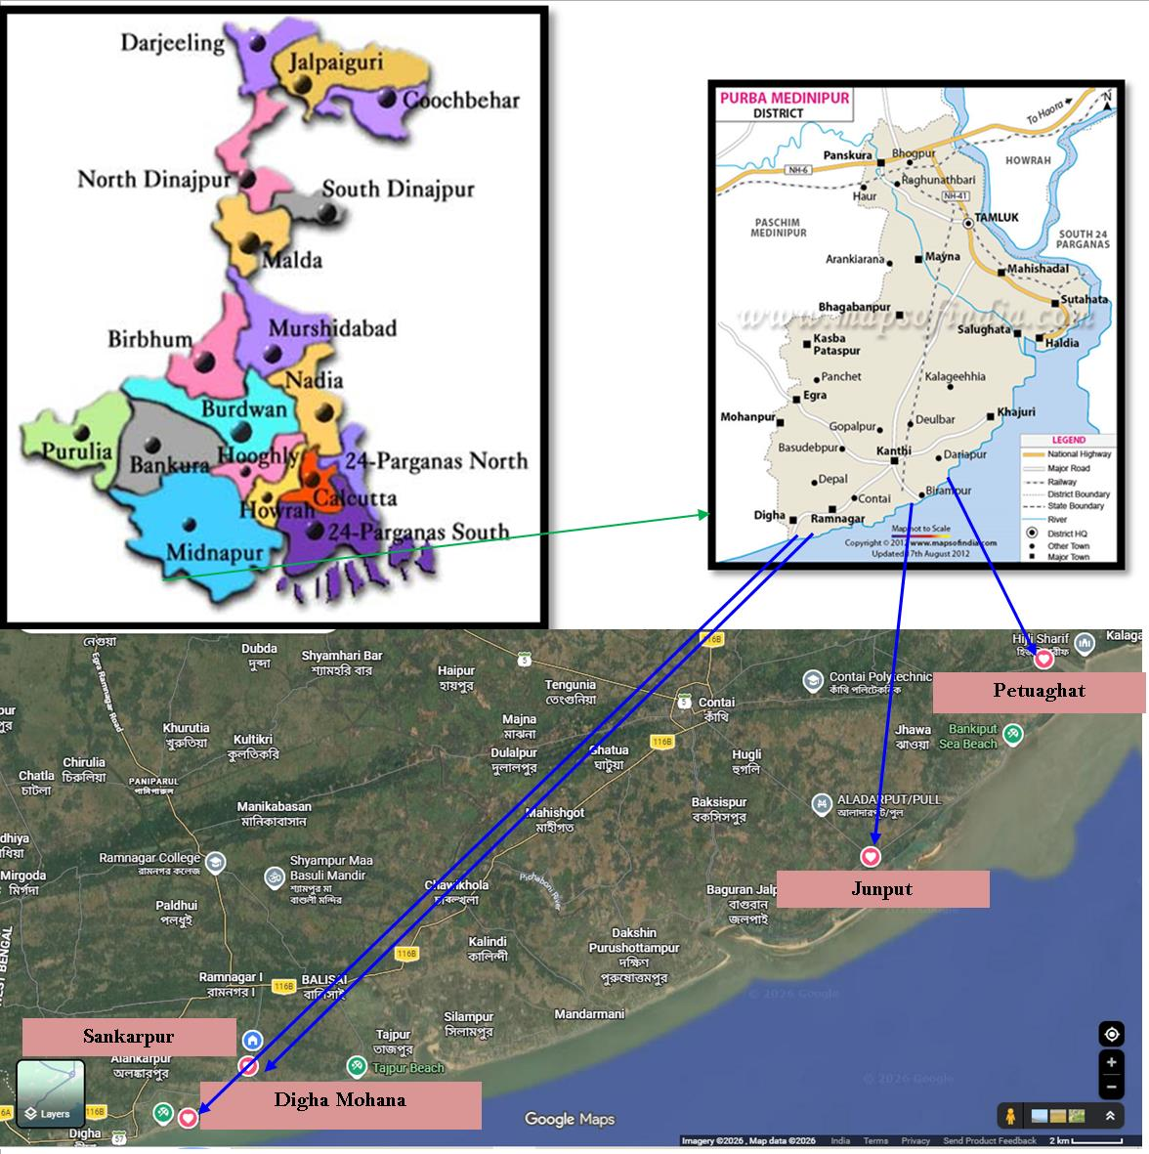
Plate 1: Satellite view of the study site
RESULTS AND DISCUSSION:
Table 1: Diversity and assemblage patterns of recorded mudskippers:
Sl.  No. | Order Name | Family Name | Scientific Name | August |  |  |  | September |  |  |  | October |  |  |  | November |  |  |  | December
 |  |  |  | 1st week | 2nd Week | 3rd Week | 4thWeek | 1st week | 2nd Week | 3rd Week | 4thWeek | 1st week | 2nd Week | 3rd Week | 4thWeek | 1st week | 2nd Week | 3rd Week | 4thWeek | 1st week | 2nd Week | 3rd Week | 4thWeek
 |  |  |  | S1 | S2 | S3 | S4 | S1 | S2 | S3 | S4 | S1 | S2 | S3 | S4 | S1 | S2 | S3 | S4 | S1 | S2 | S3 | S4
1. | Gobiiformes | Oxudercinae | Pseudapocryptes  elongatus | - | - | ++ | + | - | - | + | + | + | - | - | ++ | - | + | - | - | + | - | - | +
1. | Gobiiformes | Oxudercinae | Periophthalmus  novemradiatus | - | - | - | - | - | - | ++ | - | - | - | + | - | - | - | - | - | - | + | - | -
1. | Gobiiformes | Oxudercinae | Periophthalmus  variabilis | + | + | +++ | - | - | + | ++ | - | - | - | + | - | + | - | +++ | - | - | - | ++ | +
1. | Gobiiformes | Oxudercinae | Periophthalmus  waltoni | - | - | + | - | - | - | - | ++ | - | + | - | - | - | - | - | + | - | ++ | - | -
1. | Gobiiformes | Oxudercinae | Apocryptes bato | + | ++ | +++ | + | - | + | ++ | - | + | - | + | + | - | + | ++ | + | + | - | +++ | -
(S1= Digha Mohana; S2= Sankarpur; S3= Junput Sea Beach; S4= Petuaghat)
Table 1 presents the distribution and occurrence patterns of the selected fish species, namely Pseudapocryptes elongatus (Cuvier, 1816), Periophthalmus novemradiatus (Hamilton, 1822), Periophthalmus variabilis (Eggert, 1935), Periophthalmus waltoni (Koumans, 1941) and Apocryptes bato (Hamilton, 1822), belonging to the family Oxudercinae, over a five-month period (August to December). The data are organised by weeks within each month (1st to 4th week), indicating the presence (+) or absence (-) of each species during specific sampling periods. The table includes taxonomic details, such as order, family and scientific names of the species. It supports the assessment of seasonal variation, temporal abundance and weekly occurrence trends of these fish species in the study area. The data are systematically arranged to show the presence (+) and absence (-) of each species across four weeks within each month, based on sampling sessions (S1-S4).
Table 1 highlights temporal variation in species occurrence, revealing fluctuations in presence across different weeks and months. Some species, such as Periophthalmus variabilis (Eggert, 1935) and Apocryptes bato (Hamilton, 1822), showed relatively frequent occurrences, whereas others displayed more irregular or limited distribution patterns. This tabular representation helps in understanding seasonal trends, population dynamics and habitat utilisation of mudskipper species in the study area. It provides baseline information for ecological assessment, biodiversity monitoring and future conservation planning.
Table 2: Monthly Diversity Indices of Recorded Mudskippers (August-December, 2025):
Month | No. of species (S) | Total occurrences (N) | Shannon Index (H′) | Simpson’s Index (1–D) | Evenness (J′)
August, 2025 | 5 | 14 | 1.56 | 0.78 | 0.97
September,2025 | 5 | 16 | 1.60 | 0.80 | 0.99
October,2025 | 5 | 13 | 1.48 | 0.75 | 0.92
November, 2025 | 5 | 12 | 1.42 | 0.72 | 0.88
December, 2025 | 5 | 15 | 1.52 | 0.77 | 0.94
Table 2 shows temporal variation in fish diversity across the study area. Diversity indices were interpreted based on the frequency of species occurrence across different sampling weeks. The Shannon-Wiener diversity index (H’) indicated moderate diversity throughout the study period. Higher diversity was observed during August and September, when more species showed consistent presence across multiple weeks. This suggests favourable environmental conditions and resource availability during the monsoon and post-monsoon periods.
In contrast, diversity declined slightly in October and November, when fewer species were consistently recorded. This may be attributed to seasonal changes, migration patterns or fishing pressure. A slight improvement in diversity was again observed in December, indicating partial recovery or the appearance of winter-associated species. Simpson’s dominance index (D) showed low dominance overall, indicating that no single species overwhelmingly dominated the community. However, occasional increases in dominance were noted in certain weeks when only one or two species were present. The Evenness index (J’) suggested a relatively uniform distribution of species during peak diversity months (August-September), whereas uneven distribution was more evident in later months, particularly when fewer species were recorded. Overall, the study area exhibited moderate species diversity with seasonal fluctuations, with higher diversity during early sampling months and reduced diversity towards the later period.
Table 3: Taxonomic position, Conservational status with human impact or recorded mudskipper:
Order Name | Family | Scientific Name | Local Name/Vernacular Name | IUCN  Status | Threats to human
Gobiiformes | Oxudercinae | Pseudapocryptes  elongatus | Elongate Mudskipper/  Pointed-Tailed Goby | LC | Harmless
Gobiiformes | Oxudercinae | Periophthalmus  novemradiatus | Pearse's mudskipper/  dwarf Indian mudskipper | DD | Harmless
Gobiiformes | Oxudercinae | Periophthalmus  variabilis | Dusky-gilled Mudskipper | LC | Harmless
Gobiiformes | Oxudercinae | Periophthalmus  waltoni | Walton’s Mudskipper | LC | Harmless
Gobiiformes | Oxudercinae | Apocryptes  bato | Chewabele/ Chiring | LC | Harmless

Table 3 provides an overview of five recorded mudskipper species under the order Gobiiformes and family Oxudercinae. It includes scientific names and corresponding local or vernacular names, thereby supporting both scientific and common identification. The table also presents the conservation status of each species based on IUCN categories, indicating their risk levels in the wild. Information on their potential threats or impacts to humans is also included, showing that these species are generally harmless. Overall, the table serves as a concise reference for taxonomy, ecological importance, conservation awareness and human interaction in relation to these mudskipper species.
The table presents the taxonomic classification, vernacular identification, conservation status and potential human impact of the selected mudskipper species: Pseudapocryptes elongatus (Cuvier, 1816), Periophthalmus novemradiatus (Hamilton, 1822), Periophthalmus variabilis (Eggert, 1935), Periophthalmus waltoni (Koumans, 1941) and Apocryptes bato (Hamilton, 1822). For each species, scientific and local or vernacular names are provided to facilitate identification in scientific and community contexts. Conservation status is indicated according to IUCN Red List categories, with most species classified as Least Concern (LC), suggesting relatively stable populations, while Periophthalmus novemradiatus (Hamilton, 1822) is categorised as Data Deficient (DD), indicating insufficient information for a complete assessment. The table also indicates that all listed species are harmless and do not pose any direct risk to humans. This table provides a summary of the systematic position, ecological relevance, conservation status and human interaction of the selected mudskipper species, contributing to baseline data for biodiversity and ecological studies. Representative mudskipper specimens recorded during the study are shown in Plate 2.
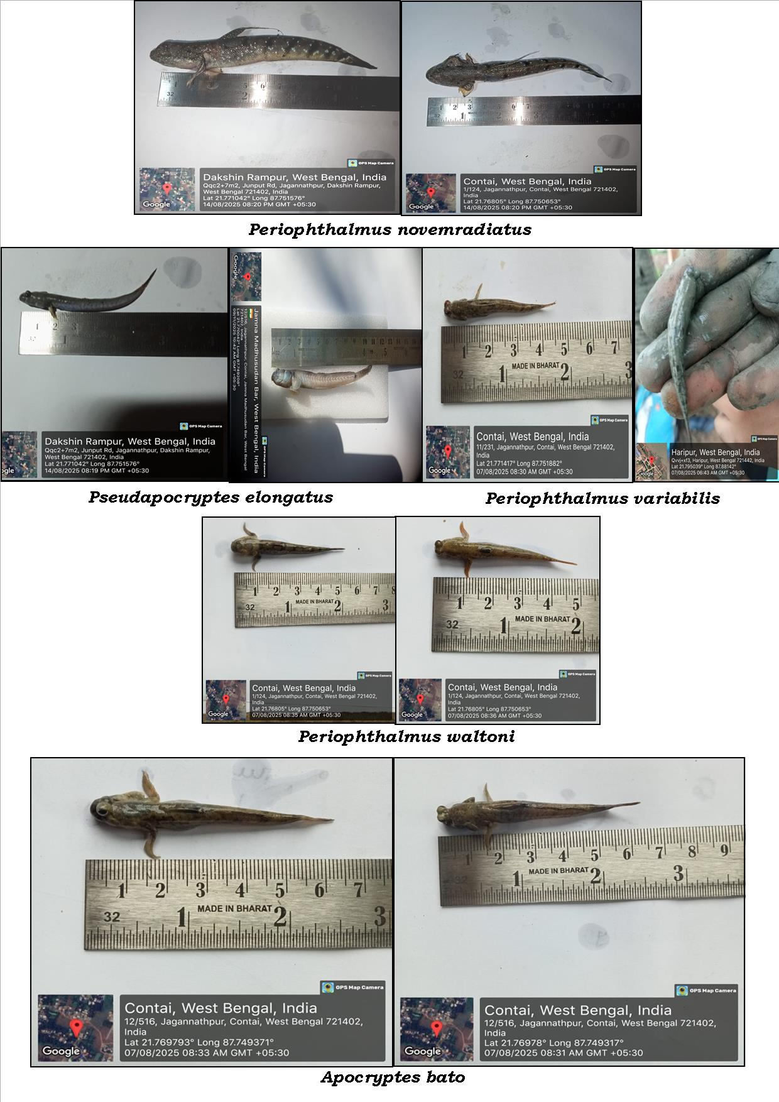
Plate 2: Different mudskippers recorded during study period

CONCLUSION:
The study reveals clear temporal variations in the occurrence and distribution of mudskipper species belonging to the family Oxudercinae in the study area over the five-month period (August-December). The mudskipper species Pseudapocryptes elongatus (Cuvier, 1816), Periophthalmus novemradiatus (Hamilton, 1822), Periophthalmus variabilis (Eggert, 1935), Periophthalmus waltoni (Koumans, 1941) and Apocryptes bato (Hamilton, 1822) were recorded, indicating moderate species diversity in coastal Purba Medinipur. The weekly and monthly data demonstrate that species occurrence was not uniform but fluctuated over time, suggesting the influence of seasonal and environmental factors such as tidal patterns, temperature, salinity and habitat conditions. Among the recorded species, Periophthalmus variabilis (Eggert, 1935) and Apocryptes bato (Hamilton, 1822) exhibited relatively higher and more consistent presence, indicating better adaptability and wider ecological tolerance. In contrast, the irregular occurrence of other species indicates more specific habitat preferences or sensitivity to environmental changes.
Conservation status assessment indicates that most species fall under the Least Concern (LC) category, suggesting relatively stable populations. However, the classification of Periophthalmus novemradiatus (Hamilton, 1822) as Data Deficient (DD) highlights the need for further research and monitoring to accurately determine its population status and potential conservation requirements.
The analysis of species occurrence data from August to December revealed temporal variations in fish diversity across the study area. Diversity indices were interpreted based on the frequency of species occurrence across different sampling weeks. The Shannon index (H’) indicated moderate diversity and was highest in September. Simpson’s index (1-D) showed low dominance, indicating that no single species dominated. Evenness (J’) was close to 1 in most months, indicating a relatively uniform distribution.
Moreover, the absence of any harmful impact on humans indicates that these species are ecologically important yet non-threatening, supporting their role in maintaining the health of coastal and estuarine ecosystems. The study highlights important patterns in species assemblage, temporal distribution and habitat utilisation of mudskippers. These findings provide baseline data for understanding population dynamics and contribute to biodiversity assessment in coastal Purba Medinipur. Furthermore, the results emphasise the need for continued monitoring and conservation efforts to protect these ecologically significant species and their fragile coastal and estuarine habitats.

Limitations
This study was limited to five months of sampling from selected coastal sites in Purba Medinipur and therefore does not represent complete annual or inter-annual variation. The assessment was based mainly on occurrence records rather than detailed abundance estimates. Environmental variables such as salinity, temperature, substrate type, tidal condition and habitat structure were not quantitatively analysed. Species identification was based on available taxonomic resources, without molecular confirmation.

Declaration of AI Use

This manuscript was prepared through the combined contributions of all author(s), including contributions to the study design, data, content development, results, interpretation and related scholarly work. The author(s) acknowledge the use of Grammarly and ChatGPT to assist with grammar checking, language refinement and reference formatting. These AI-assisted tools were not used as authors and did not replace the intellectual contributions or scholarly judgement of the author(s). All AI-assisted outputs, including content, references and interpretations, were carefully reviewed, revised, verified and approved by the author(s). The author(s) accept full responsibility for the accuracy, integrity and final content of the manuscript.

ACKNOWLEDGEMENT
The authors are grateful to Dr Ananta Mohan Mishra, Principal, Ramnagar College, for providing laboratory facilities during the investigation.
COMPETING OF INTERESTS
All authors declare that there is no any conflict of interest.
AUTHORS CONTRIBUTION
Prasun Maity: Data curation, methodology and visualisation. Mahendra Kumar Yadav: Methodology, investigation, analysis and writing - original draft. Shriparna Saxsena: Validation, visualisation and investigation. Pijush Payra: Conceptualisation, resources, supervision, investigation and writing - review and editing.

ETHICAL APPROVAL:
Since this study was conducted on mudskipper diversity and their community assemblage, we released the collected specimens in live conditions into their natural environment after their morphological identification. Thus ethics committee was not required.

REFERENCES:
Qureshi, M. R. (1971). Common gobioid fishes of sub-families Periophthalminae and Apocrypteinae. Pakistan Journal of Science, 23, 143–146.
Ravi, V. (2012). Habitat loss and population reduction of mudskippers (Family: Gobiidae) from Tamil Nadu, southeast coast of India. In P. Santhanam & P. Perumal (Eds.), Marine biodiversity: Present status and prospects (pp. 37–49). Narendra Publishing House. https://www.nphindia.com/book/9789380428550/marine-biodiversity-present-status-prospects
Ravi, V., Mahadevan, G., & Bharathi, R. (2021). Diversity of mudskippers along the selective mudflats of mangroves of east coast of India. Journal of the Marine Biological Association of India, 63(1), 110–116. https://doi.org/10.6024/jmbai.2021.63.1.2165-16
Murdy, E. O. (1989). A taxonomic revision and cladistic analysis of the oxudercine gobies (Gobiidae: Oxudercinae). Records of the Australian Museum, Supplement, 11, 1–93. https://doi.org/10.3853/j.0812-7387.11.1989.93
Clayton, D. A. (1993). Mudskippers. Oceanography and Marine Biology: An Annual Review, 31, 507–577. https://marineinfo.org/en/doc/publication/79448
Jaafar, Z., & Larson, H. K. (2008). A new species of mudskipper, Periophthalmus takita (Teleostei: Gobiidae: Oxudercinae), from Australia, with a key to the genus. Zoological Science, 25(9), 946–952. https://doi.org/10.2108/zsj.25.946
Polgar, G., Jaafar, Z., & Konstantinidis, P. (2013). A new species of mudskipper, Boleophthalmus poti (Teleostei: Gobiidae: Oxudercinae), from the Gulf of Papua, Papua New Guinea, and a key to the genus. The Raffles Bulletin of Zoology, 61(1), 311–321. https://lkcnhm.nus.edu.sg/wp-content/uploads/sites/11/app/uploads/2017/06/61rbz311-321.pdf
Jaafar, Z., Polgar, G., & Zamroni, Y. (2016). Description of a new species of Periophthalmus (Teleostei: Gobiidae) from the Lesser Sunda Islands. The Raffles Bulletin of Zoology, 64, 278–283. https://doi.org/10.5281/zenodo.5355323
Talwar, P. K., & Jhingran, A. G. (1991). Inland fishes of India and adjacent countries (Vol. 2). Oxford & IBH Publishing. https://catalogue.nla.gov.au/catalog/1719925
Takita, T., Agusnimar, & Ali, A. B. (1999). Distribution and habitat requirements of oxudercine gobies (Gobiidae: Oxudercinae) along the Straits of Malacca. Ichthyological Research, 46(2), 131–138. https://doi.org/10.1007/BF02675431
Ravi, V. (2013). Food and feeding habits of the mudskipper, Boleophthalmus boddarti (Pallas, 1770) from Pichavaram mangroves, southeast coast of India. International Journal of Marine Science, 3(12), 98–104. https://doi.org/10.5376/ijms.2013.03.0012
Tytler, P., & Vaughan, T. (1983). Thermal ecology of the mudskippers, Periophthalmus koelreuteri (Pallas) and Boleophthalmus boddarti (Pallas) of Kuwait Bay. Journal of Fish Biology, 23(3), 327–337. https://doi.org/10.1111/j.1095-8649.1983.tb02912.x
Tang, S. J., Liu, Z. Z., Tang, W. Q., & Yang, J. Q. (2009). A simple method for isolation of microsatellites from the mudskipper (Boleophthalmus pectinirostris), without constructing a genomic library. Conservation Genetics, 10(6), 1957–1959. https://doi.org/10.1007/s10592-009-9867-3
Polgar, G., & Lim, R. (2011). Mudskippers: Human use, ecotoxicology and biomonitoring of mangrove and other soft-bottom intertidal ecosystems. In J. N. Metras (Ed.), Mangroves: Ecology, Biology and Taxonomy (pp. 51–86). Nova Science Publishers. https://opus.lib.uts.edu.au/handle/10453/117614
Elviana, S., Sunarni, S., Maturbongs, M. R., Sajriawati, & Fakhriyyah, S. (2019). Mudskipper diversity and its relationship to an environmental condition in estuary. IOP Conference Series: Earth and Environmental Science, 343(1), Article 012191. https://doi.org/10.1088/1755-1315/343/1/012191
Sunarni, S., Melmambessy, E. H. P., Mote, N., Rahmatia, & Hamuna, B. (2019). Length-weight relationship and condition factor of mudskipper Boleophthalmus pectinirostris from Maro Estuary, Merauke Regency, Papua. Journal of Ecological Engineering, 20(8), 199–204. https://doi.org/10.12911/22998993/110841
Kottelat, M., Whitten, A. J., Kartikasari, S. N., & Wirjoatmodjo, S. (1993). Freshwater fishes of Western Indonesia and Sulawesi = Ikan air tawar Indonesia bagian Barat dan Sulawesi. Periplus Editions. https://search.library.ucla.edu/discovery/fulldisplay/alma9913473967006531/01UCS_LAL:UCLA
Polgar, G., Sacchetti, A., & Galli, P. (2010). Differentiation and adaptive radiation of amphibious gobies (Gobiidae: Oxudercinae) in semi-terrestrial habitats. Journal of Fish Biology, 77(7), 1645–1664. https://doi.org/10.1111/j.1095-8649.2010.02807.x
Froese, R., & Pauly, D. (Eds.). (2019). Species in genus Periophthalmus. FishBase. https://www.fishbase.se/Nomenclature/SpeciesList.php?genus=Periophthalmus
Shannon, C. E. (1948). A mathematical theory of communication. The Bell System Technical Journal, 27(3), 379–423. https://doi.org/10.1002/j.1538-7305.1948.tb01338.x
Magurran, A. E. (1988). Diversity indices and species abundance models. In Ecological diversity and its measurement (pp. 7–45). Springer Netherlands. https://doi.org/10.1007/978-94-015-7358-0_2
Pielou, E. C. (1969). Association tests versus homogeneity tests: Their use in subdividing quadrats into groups. Vegetatio, 18(1–6), 4–18. https://doi.org/10.1007/BF00332826
Ezenwaka, C. O., Harry, I. A., & Amuzie, C. C. (2024). Gastrointestinal helminth parasites, stomach contents and condition factor of Bostrychus africanus (sleeper gobies) and Periophthalmus papilio (mudskipper) found in Ikpukulu-Ama Creek, Port Harcourt, Rivers State, Nigeria. Asian Journal of Fisheries and Aquatic Research, 26(2), 74–80. https://doi.org/10.9734/ajfar/2024/v26i2738
Akpan, I. I., Udoinyang, E. P., Okoko, A. C., Achibong, I. B., & George, U. U. (2025). Length-weight relationship and condition factor of mudskipper, Periophthalamus barbarus (Linneaus 1766) from Iko River Estuary, Niger Delta Region, Nigeria. Asian Journal of Advances in Research, 8(1), 430–439. https://doi.org/10.56557/ajoair/2025/v8i1536
Jabing, P. N., Yusof, N. N. M., Amran, M. A. A., & Hatta, S. K. M. (2024). Abundance and behaviour variation of the giant mudskipper Periophthalmodon schlosseri (Oxudercidae) in two habitats with different environmental gradients. Journal of Ichthyology, 64(6), 1082–1091. https://doi.org/10.1134/S0032945224700619
Do, A. N. T., Do, T. A. T., Pham, L. V., & Tran, H. D. (2024). Assessment of the role of mangroves for Periophthalmus modestus applying machine learning and remote sensing: A case study in a large estuary from Vietnam. Aquatic Ecology, 58, 879–893. https://doi.org/10.1007/s10452-024-10111-8
Arisuryanti, T., Nuraliyah, T., Dwijayanti, V., Aji, K. W., Priyono, D. S., & Daryono, B. S. (2025). Genetic diversity of mudskipper species (Periophthalmus spp.) from the Southern Coast of Java, Indonesia, based on the mitochondrial 16S gene. HAYATI Journal of Biosciences, 32(5), 1352–1362. https://doi.org/10.4308/hjb.32.5.1352-1362

