Prevalence and Species Diversity of Ectoparasites Infesting Domestic Dog (Canis lupus familiaris) in Imphal East and Imphal West, Manipur, India

Abstract: Ectoparasite infestations in dogs (Canis lupus familiaris) are a significant health concern, affecting animal welfare and public health. This study examined the occurrence and species distribution of ectoparasites in dogs in two districts of Manipur. A total of 395 dogs, comprising 185 from Imphal West and 210 from Imphal East, were randomly selected and inspected for ectoparasites. The study was conducted over two years, from December 2023 to November 2025. The dogs were carefully examined, and ectoparasites were removed by combing and using forceps. The ectoparasites were preserved in 70% alcohol, transported to the Parasitology Laboratory, Department of Zoology, Dhanamanjuri University, and later mounted for species-level identification using standard identification keys. Among the dogs examined, 123 dogs from Imphal West (66.49%) and 145 dogs from Imphal East (69.05%) were infested with one or more ectoparasites. Five ectoparasite species from three taxa were identified: fleas, lice and ticks. The most prevalent ectoparasite identified was Ctenocephalides canis (74.63%), followed by Ctenocephalides felis (55.97%), Rhipicephalus sanguineus (26.12%), Rhipicephalus microplus (18.66%) and Heterodoxus spiniger (11.19%). The high prevalence observed in this study indicates insufficient veterinary care and suggests that dogs may serve as hosts for ectoparasites of public health importance. The study indicates that proper and regular care should be provided to dogs to reduce ectoparasite infestation and associated zoonotic risks.
Keywords: Ectoparasites; prevalence; domestic dogs; Canis lupus familiaris; fleas; ticks; lice; Ctenocephalides canis; Rhipicephalus sanguineus; Heterodoxus spiniger; Manipur.

.

Introduction:

The domestic dog (Canis lupus familiaris) is a domesticated subspecies of the wolf and belongs to the family Canidae within the order Carnivora. Beyond its longstanding role as a companion animal, the dog has been extensively trained to perform a wide range of specialised tasks that support human activities. Despite its close association with humans, dogs are susceptible to numerous parasitic infections involving both endoparasites and ectoparasites. Endoparasites encompass a broad spectrum of organisms, ranging from microscopic protozoa, including Giardia spp. (intestinal protozoa), Babesia spp. (intra-erythrocytic protozoa) and Trypanosoma spp. (inter-erythrocytic protozoa), to larger helminths such as cestodes and filarial nematodes.
Among these parasites, Babesia spp. invade erythrocytes and are recognised as important causative agents of canine babesiosis, which primarily leads to haemolytic anaemia. Several Babesia species exhibit varying degrees of host specificity; however, Babesia canis and Babesia gibsoni are the two species most frequently implicated in canine infections. Both pathogens are transmitted by ixodid ticks and have a widespread geographical distribution across Asia, Africa, Europe, the Middle East and North America, with B. canis reported to occur more commonly than B. gibsoni (Soulsby, 1982).
Haemoprotozoan infections constitute a major group of infectious diseases affecting dogs, particularly in tropical and subtropical regions. In countries such as India, canine ehrlichiosis, babesiosis, trypanosomiasis and hepatozoonosis are among the most frequently reported haemoprotozoan diseases (Bhagwan et al., 2024). The majority of these infections are vector-borne and are principally transmitted by ticks and mosquitoes, with ticks representing the second most important haematophagous arthropod vectors after mosquitoes.
Among canine haemoprotozoan diseases, ehrlichiosis, caused by the obligate intracellular pleomorphic rickettsial bacterium Ehrlichia canis, is regarded as a disease of considerable global significance. It represents a major clinical challenge for companion-animal practitioners because of its widespread occurrence and diverse clinical manifestations. A characteristic feature of canine ehrlichiosis is thrombocytopenia, which predisposes affected animals to haemorrhagic disorders ranging from petechial haemorrhages to extensive ecchymotic lesions (Aziz et al., 2023; Senthil & Chakravarthi, 2023).

Canine babesiosis is a globally distributed tick-borne disease caused by several Babesia species, including Babesia vogeli and Babesia gibsoni. Another clinically significant haemoprotozoan disease, canine trypanosomiasis, is mechanically transmitted by haematophagous biting flies, particularly species of Tabanus and Stomoxys. Affected dogs commonly show clinical manifestations such as anaemia, anorexia, intermittent pyrexia, generalised weakness, conjunctivitis, corneal opacity, oedema, dysphagia and an unsteady or staggering gait (Prasad et al., 2015).

Dogs are the most widely distributed members of the family Canidae and have successfully adapted to coexist with humans across diverse geographical regions. In addition to their roles as companion animals, working dogs make significant contributions to the physical, psychological and social well-being of their owners, particularly children (Robertson et al., 2000). Nevertheless, canine health is adversely affected by a wide range of parasitic diseases, among which arthropod infestations are among the most prevalent. Although such infestations rarely result in high mortality, they can substantially impair the health, welfare and functional performance of affected animals, thereby leading to economic losses for owners and compromising animal welfare.

In addition to causing direct pathological effects, numerous ectoparasites serve as vectors for pathogens of considerable veterinary importance, including Babesia spp., Bartonella spp. and Rickettsia spp. (Heukelbach et al., 2012). Heavy ectoparasitic infestations may also induce life-threatening anaemia and, particularly in young, immunocompromised or debilitated animals, may precipitate hypersensitivity reactions (Soulsby, 1982).

Among tick species infesting dogs in India, Rhipicephalus sanguineus is reported to be the predominant species, followed by Rhipicephalus haemaphysaloides, Rhipicephalus microplus, Haemaphysalis longicornis and Haemaphysalis bispinosa (Sahu et al., 2013; Augustine et al., 2017). Reports from other regions have also documented hard ticks in dogs, supporting the need for locality-specific tick surveillance (Zygner & Wedrychowicz, 2006). Ticks are recognised as competent vectors for a broad spectrum of infectious agents, including bacteria, rickettsiae, viruses and protozoa, and are responsible for transmitting diseases such as tick-borne encephalitis, Rocky Mountain spotted fever, Lyme disease, tularemia, Q fever, babesiosis and hepatozoonosis (Lema, 2020).
Recent canine tick surveys have also shown locality-level differences in tick species composition, reinforcing the need for field-based identification of tick fauna in dogs (Lebata & Lebofa, 2025).
A recent molecular survey from Agartala, Tripura, reported tick infestation in dogs and identified Rhipicephalus sanguineus using 16S rRNA analysis, indicating the value of species-level confirmation in regional canine tick studies (Bhowmik et al., 2024).

Flea infestations in dogs are predominantly associated with Ctenocephalides canis, Ctenocephalides felis, Pulex irritans and, less frequently, Echidnophaga gallinacea, the latter primarily originating from poultry. These flea species exhibit moderate host specificity and are commonly encountered in domestic dogs (Wall & Shearer, 2001). Pruritus is the principal clinical manifestation associated with ectoparasitic infestations and is particularly common in dogs infested with fleas and mites. Pediculosis, resulting from heavy louse infestation, also represents an important cause of pruritus in dogs. Trichodectes canis, commonly referred to as the canine chewing louse, parasitises both domestic dogs and wild canids and has a worldwide distribution. Domestic dogs (Canis lupus familiaris) play an integral role in human society, serving as

companions, guards and working animals in various capacities. However, their close proximity to humans also makes them potential reservoirs and vectors for a wide range of ectoparasites, which can transmit zoonotic diseases and pose significant public health concerns. Among these parasites, fleas, ticks, lice and mites are known to cause dermatological disorders in dogs, while others act as vectors for pathogens such as Rickettsia, Babesia and Ehrlichia species. Arthropod ectoparasites comprise a diverse and highly specialised group of organisms that inhabit the external surfaces of vertebrate hosts (Aldemir, 2007). Depending on their biological adaptations, these parasites may either reside permanently on the host or inhabit the host's surroundings, such as nests or shelters, and periodically return to feed. The phylum Arthropoda includes numerous ectoparasitic species belonging to the class Insecta, as well as mites and ticks of the class Arachnida (order Acari), all of which commonly infest domestic animals. In dogs, ectoparasites represent a major cause of dermatological disorders and significantly compromise animal health and welfare (Ettinger & Feldman, 1995). They are frequently associated with both pruritic and non-pruritic skin conditions and may induce hypersensitivity reactions of varying severity (Ettinger & Feldman, 1995). Furthermore, many arthropod species function as vectors of pathogens affecting both animals and humans, thereby contributing to the transmission of numerous infectious diseases. In severe infestations, particularly in young or debilitated animals, ectoparasites may also cause life-threatening anaemia (Araujo et al., 1998).
Ticks are obligate haematophagous ectoparasites that parasitise virtually all classes of vertebrates and are distributed throughout most regions of the world (Parola & Raoult, 2001). Tick infestations may result in varying degrees of discomfort and dermatological lesions through blood feeding, dermatitis and hypersensitivity reactions. Nevertheless, a substantial proportion of infested dogs may remain clinically asymptomatic despite harbouring ectoparasites.
After mosquitoes, ticks are regarded as the second most important arthropod vectors of infectious agents, transmitting a wide range of pathogens, including viruses, bacteria, particularly rickettsiae, protozoa and filarial nematodes, to both animals and humans. They are recognised as principal vectors of several pathogens of major veterinary importance, including Babesia, Theileria and Anaplasma species (Razmi et al., 2007). Among these, the brown dog tick, Rhipicephalus sanguineus, is the most widely distributed tick species globally and is a well-established vector of numerous pathogens affecting dogs and, occasionally, humans (Dantas-Torres, 2010).
Fleas are among the most prevalent ectoparasites infesting companion animals and survive by feeding on the blood of their hosts. In addition to causing direct clinical effects, they are responsible for transmitting several pathogens of medical and veterinary significance. Studies have consistently identified Ctenocephalides felis, Ctenocephalides canis and Pulex irritans as the predominant flea species infesting dogs, although their relative prevalence varies according to geographical location (Chee et al., 2008). As dogs can serve as reservoirs or sources of zoonotic infections, effective control of canine ectoparasites is essential not only to alleviate clinical manifestations in affected animals but also to reduce the risk of transmission of ectoparasite-borne pathogens to humans (Borji et al., 2011).
Although dermatological diseases associated with ectoparasitic infestations are seldom life-threatening, they frequently become chronic and can substantially impair animal welfare. Management generally involves topical and/or systemic therapeutic interventions, with simultaneous treatment of all in-contact animals to minimise the risk of reinfestation (Chiummo et al., 2020; Hay et al., 2012; Mueller et al., 2020). In many cases, repeated administration of treatment is required until complete clinical recovery is achieved. Moreover, therapy should be continued for an additional two to four weeks after clinical resolution, particularly in cases of generalised demodicosis, to reduce the likelihood of recurrence (Mueller et al., 2020).
Recent One Health-oriented literature further emphasises that surveillance and control of companion-animal parasites are important because parasite burdens affect animal health, human health, wildlife and the environment (Giannelli et al., 2024).
Given the considerable implications of ectoparasitic infestations for canine health, animal welfare and public health, the present study was undertaken in Manipur, India, to determine the prevalence and species diversity of ectoparasites infesting owned dogs in the districts of Imphal East and Imphal West.
Recent parasitological surveillance in a wildlife host from northern India also reported ectoparasites, including ticks, mites and Ctenocephalides canis, underscoring the relevance of routine parasite monitoring at the human-animal-environment interface (Kumar et al., 2025).

The prevalence and diversity of ectoparasites are influenced by numerous factors, including climate, host density, hygiene and veterinary care. In tropical and subtropical regions such as Manipur, India, these factors may create conditions conducive to ectoparasitic infestations. Despite the growing recognition of the risks associated with canine ectoparasites, region-specific studies that comprehensively assess their prevalence and species diversity remain limited, particularly in the Imphal East and Imphal West districts. Such data are essential for designing targeted control strategies and understanding local patterns of parasite-host interactions. This study aims to bridge that gap by examining the diversity of ectoparasites infesting dogs in these two districts. Through field surveys and morphological identification, this research provides insights into the parasitological profile of domestic dogs in Imphal East

and Imphal West districts, thereby contributing to the broader understanding of veterinary and zoonotic health in northeastern India.
Research gap and objective: Although canine ectoparasites are recognised as a concern for animal welfare and public health, comprehensive local data on the prevalence and species diversity of ectoparasites in dogs from Imphal East and Imphal West remain limited. Therefore, the objective of the present study was to determine the prevalence and species diversity of ectoparasites infesting domestic dogs in Imphal East and Imphal West districts of Manipur, India.

Materials and Methods:

Study Area and Data Collection:
The present study was conducted in different localities of two districts of Manipur, namely Imphal East and Imphal West. Dogs were examined through door-to-door visits with the informed consent of dog owners. Ectoparasites were carefully collected from different regions of the dogs using forceps, combing and manual-picking methods. The collected ectoparasites were preserved in 70% ethanol and brought to the Parasitology Laboratory, Department of Zoology, Dhanamanjuri University, Imphal, Manipur, India. A total of 395 dogs, comprising 185 from Imphal West and 210 from Imphal East, were randomly selected and inspected for the presence of ectoparasites.

Slide Preparation and Identification:

The collected ectoparasites were stored in 70% ethanol and later mounted for species-level identification using general and specialist identification keys. Fleas were cleaned with water, immersed in 10% potassium hydroxide (KOH) and kept for 24 hours. The samples were then transferred to 2.5% acid alcohol for 5 minutes to adjust the sample pH. For dehydration, the specimens were passed through a graded ethanol series of 30%, 50%, 70%, 90%, 95% and 100% (absolute) for 30 minutes each and were then cleared in xylene for 5 minutes. After mounting, species identification was performed under a light microscope based on standard morphological characters using recognised taxonomic keys (Bowman, 2014; Centers for Disease Control and Prevention, 2023). Thus, the present study was conducted to determine the incidence of ectoparasites in dogs in Imphal East and Imphal West.
Statistical Analysis:
The prevalence of ectoparasite infestation was calculated as :

Prevalence % = $\frac{number of host examined}{number of host infested}*100$
The association between ectoparasite infestation and different host-related factors, including district, age group and sex, was analysed using the chi-square test (X²). A p-value of <0.05 was considered statistically significant, whereas a p-value of >0.05 was considered statistically non-significant.

Results
A total of 395 dogs were examined for ectoparasite infestation from the two study areas, comprising 185 dogs from Imphal West and 210 dogs from Imphal East.

Table 1.: Prevalence of ectoparasites in dogs of Imphal West District of Manipur.

Sl.  No. | Site of collection | No. of specimen examined | No. of specimen infested | Prevalence (%)
1 | Thangmeiband | 25 | 17 | 68
2 | Uripok | 20 | 13 | 65
3 | Sagolband | 22 | 14 | 63.64
4 | Lamsang | 14 | 10 | 71.43
5 | Konthoujam | 15 | 11 | 60
6 | Keisamthong | 18 | 10 | 55.56
7 | Singjamei | 23 | 16 | 69.56
8 | Langthabal | 20 | 14 | 65
9 | Sekmai | 10 | 7 | 70
10 | Yaiskul | 18 | 11 | 72.22
11 | Total | 185 | 123 | 66.49

Table 2.: Prevalence of ectoparasites in dogs of Imphal East District of Manipur.

Sl. No. | Site of collection | No. of Host examined | No. of host infested | Prevalence %
1 | Thongju | 27 | 19 | 70.37
2 | Heingang | 30 | 22 | 73.33
3 | Bamon Kampu | 10 | 7 | 70
4 | Porompat | 8 | 4 | 50
5 | Andro | 20 | 15 | 75
6 | Pukhao | 15 | 9 | 60
7 | Khurai | 22 | 15 | 68.18
8 | Keirao | 15 | 11 | 73.33
9 | Khundrakpam | 20 | 14 | 70
10 | Kshetrigao | 25 | 18 | 72
11 | Wangkhei | 9 | 5 | 55.56
12 | Lamlai | 9 | 6 | 66.67
 | Total | 210 | 145 | 69.05

District-wise analysis showed that 123 out of 185 dogs examined in Imphal West were infested, recording a prevalence of 66.49%. In Imphal East, 145 out of 210 dogs were found to be infested, with a prevalence of 69.05%. The results therefore indicate that the occurrence of ectoparasite infestation was slightly higher among dogs from Imphal East than among those from Imphal West. The difference in prevalence between the two districts was 2.56%, indicating only a small variation in the level of infestation. However, there was no significant difference in prevalence between the two districts, as the p-value was 0.587. Overall, both districts showed a high prevalence of infestation. The results indicate that dogs from both Imphal East and Imphal West were commonly affected by ectoparasites, with Imphal East showing a slightly greater occurrence.

Charts showing the district wise prevalence of ectoparasites in domestic dogs of Imphal East and West Districts of Manipur.
Thongju
Thangmeiband
Heingang
Uripok
Bamon Kampu
Sagolband
Porompat
Lamsang
Andro
Konthoujam
Pukhao
Khurai
Keisamthong
Keirao
Singjamei
Khundrakpam
Langthabal
Kshetrigao
Sekmai
Wangkhei
Yaiskul
Lamlai
Fig 1.Ectoparasites infestation in the dogs of Imphal West
Districts

Prevalence %
No. of specimen infested
No. of specimen examined
10
9
8
7
6
5
4
3
2
1
80
70
60
50
40
30
20
10
0

No. of Host examined No. of host infested Prevalence %
12
11
10
9
8
7
6
5
4
3
2
1
80
70
60
50
40
30
20
10
0
Districts
Fig 2.Ectoparasites infestation in the dogs of Imphall East

As there was no statistically significant difference between the prevalence in Imphal East and Imphal West districts, the evaluation of the other parameters was pooled for both districts.

Table 3. Age wise prevalence of ectoparasites in dogs In Imphal East and West Districts in Manipur

Sl. No. | Age | No. of host examined | No. of host infested | Prevalence %
1. | <1yr | 128 | 101 | 78.91
2. | 1-3yr | 150 | 93 | 62
3. | >3yr | 117 | 64 | 54.70
Total |  | 395 | 268 | 67.85
*Note : p-value is 0.0002 showing significant difference between the age groups
Table 4 : Sex wise prevalence of ectoparasites in dogs In Imphal East and West Districts in Manipur

Sl.No. | Sex | No. of host examined | No. of host infested | Prevalence %
1. | Male | 205 | 135 | 65.85
2. | Female | 190 | 133 | 70
Total |  | 395 | 268 | 67.85
*Note: p-value is 0.439 showing not much significant difference

Age-wise analysis showed a statistically significant association between age and infestation, with a p-value of 0.0002, indicating higher infestation in younger dogs. In contrast, sex-wise prevalence showed only a slight difference between males and females, with a p-value of 0.439; therefore, the association was not statistically significant.
A total of five ectoparasite species were identified from the infested dogs. These included two flea species, Ctenocephalides canis and Ctenocephalides felis; two tick species, Rhipicephalus sanguineus and Rhipicephalus microplus; and one louse species, Heterodoxus spiniger. Among the identified ectoparasites, Ctenocephalides canis was the most prevalent species, with a prevalence of 74.63%, followed by Ctenocephalides felis with 55.97%. Among ticks, Rhipicephalus sanguineus showed a prevalence of 26.12%, while Rhipicephalus microplus recorded 18.66%. The least prevalent ectoparasite species was Heterodoxus spiniger, with a prevalence of 11.19%.

Table No.5: Species Distribution in dogs of Imphal East and West districts.

Sl.  No. | Ectoparasite species | No. of host infested by the particular ectoparasite | Total no. of infested host | Prevalence(%)
1 | Ctenocephalides canis | 200 | 268 | 74.63
2 | Ctenocephalides felis | 150 | 268 | 55.97
3 | Rhipicephalus sanguineus | 70 | 268 | 26.12
4 | Rhipicephalus microplus | 50 | 268 | 18.66
5 | Heterodoxus spiniger | 30 | 268 | 11.19

The dogs were found to be infested with one or more parasites. Most dogs had mixed infestations involving two or more parasites. Single infestation was less frequent, whereas mixed infestation with two parasites was higher.

Fig 3. No. of host infested by the particular ectoparasite
6%
10%
14% 40%

30%

1 Ctenocephalides canis 2 Ctenocephalides felis
3 Rhipicephalus sanguineus 4 Rhipicephalus microplus
5 Heterodoxus spiniger

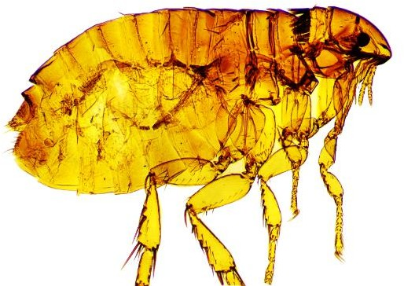
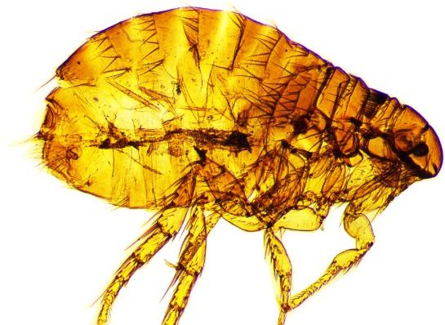
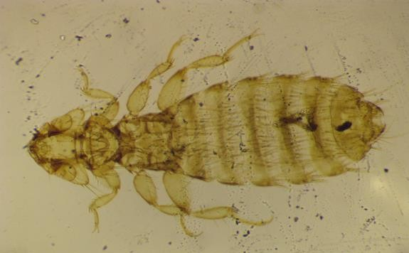
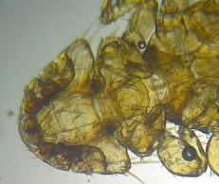

0.2mm
A
D
0.2mm
B
0.2mm

C

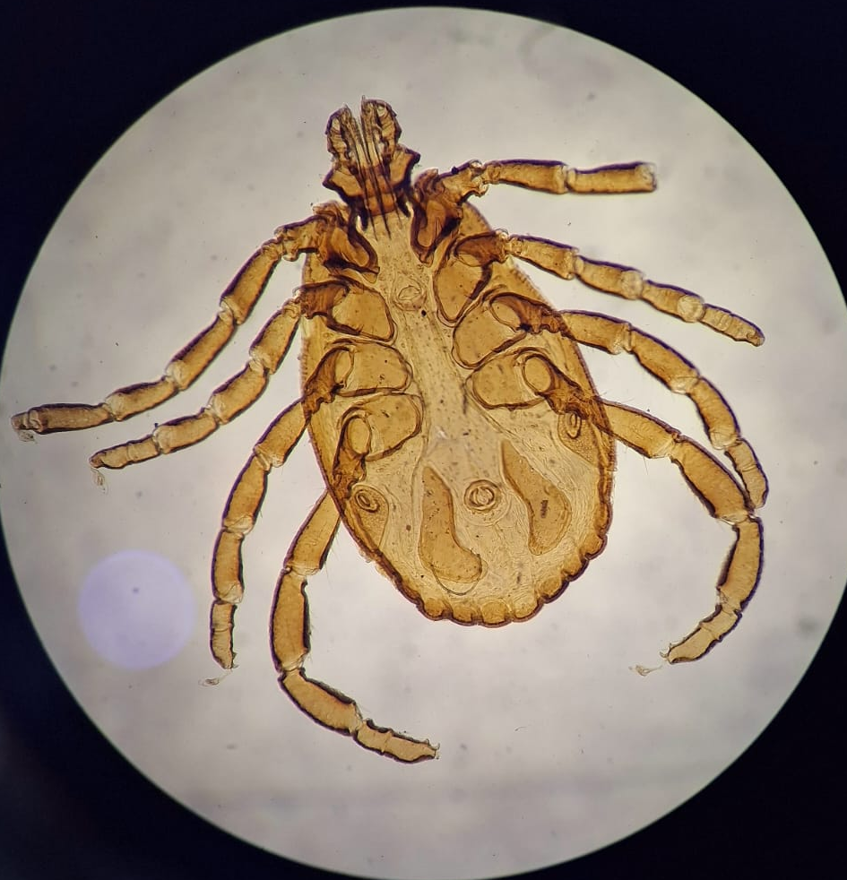

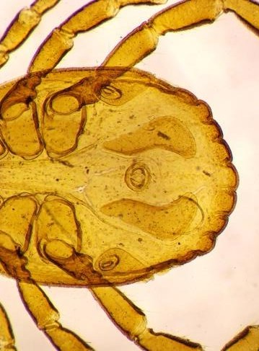
E

0.2mm

F
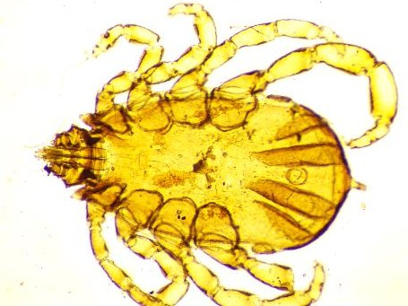

0.2mm

G
Fig 4.:(A)Ctenocephalides felis, (B) Ctenocephalides canis , (C)head and (D) full body of Heterodoxus spiniger, (E) Rhipicephalus sanguineus, (F) posterior end of Rhipicephalus sanguineus, (G) Rhipicephalus microplus.

Discussion
The findings of the present study are consistent with those reported by previous investigators (Felz et al., 1996). Similarly, a study conducted in Afghanistan documented tick infestation in 31 of 105 examined dogs, with five tick species identified; among these, Rhipicephalus turanicus and Rhipicephalus sanguineus were predominant (Le Riche et al., 1988). In contrast, R. turanicus was not detected in the present investigation. R. sanguineus has also been reported as the predominant tick species infesting dogs in Belo Horizonte, Brazil (Linardi & Nagem, 1973), further supporting its widespread distribution and epidemiological importance.

With respect to flea infestations, Ctenocephalides canis was identified as the predominant flea species in the present study, while Ctenocephalides felis was also detected but at a lower prevalence. This observation differs from several previous investigations in which C. felis was reported as the dominant flea species infesting dogs (Harman et al., 1987; Painter & Echerlin, 1985). Nevertheless, similar findings have been reported from Kanagawa, Japan, where C. canis was more prevalent than C. felis (Fukase et al., 1987). Comparable observations were also documented in Afghanistan and Nigeria, where C. canis was identified as the principal flea species infesting dogs (Chukwu, 1985; Le Riche et al., 1988). In Iran, both C. canis and C. felis have been reported from a variety of host species (Anvar et al., 1972), while Shoorijeh et al. (2008) identified C. canis as the most prevalent ectoparasite, occurring in 22 of the 160 dogs examined.

Conversely, numerous studies have documented C. felis as the predominant flea species infesting dogs in several geographical regions, with high prevalence reported in locations including Florida, Virginia, Wisconsin and Egypt (Amin, 1966, 1976; Cruz-Vazquez et al., 2001; Harman et al., 1987; Painter & Echerlin, 1985). Similar observations have also been reported from Germany, the United Kingdom and Spain, where C. felis was consistently identified as the dominant flea species parasitising domestic dogs (Beck et al., 2006; Bond et al., 2007; Gracia et al., 2008; Visser et al., 2001). These findings suggest that the relative predominance of C. canis and C. felis varies considerably across geographical regions, likely reflecting differences in environmental conditions, host populations and local ecological factors.

The present study showed a slightly higher prevalence of ectoparasitic infestation in female dogs than in males; however, this difference was not statistically significant (p = 0.439). Therefore, the observed sex-related variation should be interpreted cautiously. Differences in management practices, confinement, outdoor exposure and physiological status may contribute to variations in ectoparasite burdens, as reported in previous studies (Edwards, 1969; Mosallanejad et al., 2012). Age-wise analysis showed the highest infestation in dogs aged less than 1 year, followed by dogs aged 1-3 years and those older than 3 years, indicating a significant association between age and infestation (p = 0.0002). This pattern broadly agrees with reports indicating greater infestation in puppies or juvenile dogs (Sahu et al., 2013; Chee et al., 2008; Jamshidi et al., 2012; Colella et al., 2020), while it differs from studies reporting higher infestation in 1-3-year-old or older dogs (Mirzaei et al., 2016; Krishna Murthy et al., 2017). These variations may be influenced by management, hygiene, outdoor activity, parasite species, climate and sampling design. The present findings suggest that young dogs in Imphal East and Imphal West should receive particular attention in ectoparasite control, regular examination, owner awareness and preventive treatment programmes.

To the best of our knowledge, this is the first study to investigate the prevalence of ectoparasitic infestations in companion dogs in Manipur, India. Nevertheless, the study was confined to the districts of Imphal East and Imphal West, and therefore the findings may not be fully representative of the entire state. Further epidemiological investigations encompassing a wider geographical area are warranted to validate and expand upon these findings. Such studies would provide comprehensive baseline data to support veterinarians and public health authorities in developing effective strategies for the prevention, control and management of ectoparasites and the diseases they transmit.

Conclusions

This study documented a high prevalence of ectoparasite infestation among domestic dogs in Imphal East and Imphal West districts of Manipur. Of the 395 dogs examined, 268 were infested, giving an overall prevalence of 67.85%. District-wise prevalence was similar, with 66.49% in Imphal West and 69.05% in Imphal East, and the difference between districts was not statistically significant. Five ectoparasite species were recorded, comprising two flea species, two tick species and one louse species. Ctenocephalides canis was the most prevalent species, followed by Ctenocephalides felis, indicating that flea infestation was the dominant ectoparasitic condition in the examined dogs. Age showed a significant association with infestation, whereas sex did not show a significant association. These findings suggest that ectoparasites are common among domestic dogs in the study area and may affect animal health and welfare. Regular examination, improved owner awareness, hygienic management and appropriate veterinary ectoparasite-control practices are therefore necessary to reduce infestation and minimise potential veterinary and public health risks.

Limitations
This study was limited to Imphal East and Imphal West districts; therefore, the findings may not represent all areas of Manipur. Ectoparasites were identified morphologically, without molecular confirmation. Mixed infestations were observed, but co-infestation patterns were not analysed separately. The study did not screen the collected ectoparasites for pathogens; therefore, it cannot determine whether the parasites carried zoonotic agents. Seasonal variation and treatment efficacy were also not assessed.

Declaration of AI Use

This manuscript was prepared through the combined contributions of all author(s), including contributions to the study design, data, content development, results, interpretation and related scholarly work. The author(s) acknowledge the use of Grammarly and ChatGPT to assist with grammar checking, language refinement and reference formatting. These AI-assisted tools were not used as authors and did not replace the intellectual contributions or scholarly judgement of the author(s). All AI-assisted outputs, including content, references and interpretations, were carefully reviewed, revised, verified and approved by the author(s). The author(s) accept full responsibility for the accuracy, integrity and final content of the manuscript.

Recommendations:

Dog owners should regularly deworm their pets and apply appropriate acaricidal sprays or dips to reduce worm and tick-borne disease risks. Fumigation of dog kennels and houses may also help reduce ectoparasite occurrence. Meat and fish should be properly cooked before being served to pets. Dog handlers in markets should handle dogs carefully to avoid contact with potential infections. Regular visits to veterinary clinics are strongly recommended. Proper application of commonly used acaricides, accompanied by supportive treatment, is effective for management and can accelerate recovery. Management practices and owner awareness play an important role in controlling these parasites and their associated effects.

Ethical approval and Consent:
Informed consent was obtained from all animal owners prior to clinical examinations. All handling and evaluation protocols were strictly refined to minimize potential stress, inconvenience, or physical discomfort to the animals during the assessment process.

COMPETING INTERESTS:
Authors have declared that they have no known competing financial interests OR non-financial interests OR personal relationships that could have appeared to influence the work reported in this paper

References

Aldemir, O. S. (2007). Epidemiological study of ectoparasites in dogs from Erzurum region in Turkey. Revue de Médecine Vétérinaire, 158, 148–151. https://alex.vetagro-sup.fr/Record.htm?Record=19372721157911909039&idlist=2
Amin, O. M. (1966). The fleas (Siphonaptera) of Egypt: Distribution and seasonal dynamics of fleas infesting dogs in the Nile Valley and Delta. Journal of Medical Entomology, 3(3–4), 293–298. https://doi.org/10.1093/jmedent/3.3-4.293
Amin, O. M. (1976). Host associations and seasonal occurrence of fleas from southeastern Wisconsin mammals with observations on morphologic variations. Journal of Medical Entomology, 13(2), 179–192. https://doi.org/10.1093/jmedent/13.2.179
Anvar, M., Eslami, A., Mirza Yans, A., & Rak, H. (1972). List of endoparasites and ectoparasites of domesticated animals of Iran. Tehran University Press.
Araujo, F. R., Silva, M. P., Lopes, A. A., Ribeiro, O. C., Pires, P. P., Carvalho, C. M. E., Balbuena, C. B., Villas, A. A., & Ramos, J. K. M. (1998). Severe cat flea infestation of dairy calves in Brazil. Veterinary Parasitology, 80(1), 83–86. https://doi.org/10.1016/S0304-4017(98)00181-2
Augustine, S., Sabu, L., & Lakshmanan, B. (2017). Molecular identification of Babesia spp. in naturally infected dogs of Kerala, South India. Journal of Parasitic Diseases, 41(2), 459–462. https://doi.org/10.1007/s12639-016-0827-9
Aziz, M. U., Hussain, S., Song, B., Ghauri, H. N., Zeb, J., & Sparagano, O. A. (2023). Ehrlichiosis in dogs: A comprehensive review about the pathogen and its vectors with emphasis on South and East Asian countries. Veterinary Sciences, 10(1), Article 21. https://doi.org/10.3390/vetsci10010021
Beck, W., Boch, K., Mackensen, H., Wiegand, B., & Pfister, K. (2006). Qualitative and quantitative observations on the flea population dynamics of dogs and cats in several areas of Germany. Veterinary Parasitology, 137(1–2), 130–136. https://doi.org/10.1016/j.vetpar.2005.12.021
Bhagwan, J., Singh, Y., Jhambh, R., Chaudhari, M., & Kumar, P. (2024). Molecular and microscopic detection of haemoprotozoan diseases in dogs from Haryana, India. Parasitology Research, 123, Article 354. https://doi.org/10.1007/s00436-024-08376-x
Bhowmik, P., Islam, S., De, A., Tamuly, S., & Bouragohain, L. (2024). Prevalence and molecular characterization of ticks infesting dogs in Agartala, Tripura. The Indian Journal of Animal Sciences, 94(8), 669–673. https://doi.org/10.56093/ijans.v94i8.151086
Bond, R., Riddle, A., Mottram, L., Beugnet, F., & Stevenson, R. (2007). Survey of flea infestation in dogs and cats in the United Kingdom during 2005. Veterinary Record, 160(15), 503–506. https://doi.org/10.1136/vr.160.15.503
Borji, H., Razmi, G., Ahmadi, A., Karami, H., Yaghfoori, S., & Abedi, V. (2011). A survey on endoparasites and ectoparasites of stray cats from Mashhad (Iran) and association with risk factors. Journal of Parasitic Diseases, 35, 202–206. https://doi.org/10.1007/s12639-011-0057-0
Bowman, D. D. (2014). Georgis’ parasitology for veterinarians (10th ed.). Elsevier/Saunders. https://www.asia.elsevierhealth.com/georgis-parasitology-for-veterinarians-e-book-9781455739882.html
Centers for Disease Control and Prevention. (2023). DPDx: Laboratory identification of parasites of public health concern. https://www.cdc.gov/dpdx/index.html
Chee, J. H., Kwon, J. K., Cho, H. S., Cho, K. O., Lee, Y. J., El-Aty, A. M. A., & Shin, S. S. (2008). A survey of ectoparasite infestations in stray dogs of Gwang-ju City, Republic of Korea. Korean Journal of Parasitology, 46(1), 23–27. https://doi.org/10.3347/kjp.2008.46.1.23
Chiummo, R., Petersen, I., Plehn, C., Zschiesche, E., Roepke, R., & Thomas, E. (2020). Efficacy of orally and topically administered fluralaner (Bravecto) for treatment of client-owned dogs with sarcoptic mange under field conditions. Parasites & Vectors, 13, Article 524. https://doi.org/10.1186/s13071-020-04395-6
Chukwu, C. C. (1985). Prevalence of fleas on dogs in Anambra State of Nigeria. International Journal of Zoonoses, 12(3), 192–195. https://pubmed.ncbi.nlm.nih.gov/3833826/
Colella, V., Nguyen, V. L., Tan, D. Y., Lu, N., Fang, F., Zhijuan, Y., Wang, J., Liu, X., Chen, X., Dong, J., Nurcahyo, W., Hadi, U. K., Venturina, V., Tong, K. B. Y., Tsai, Y. L., Taweethavonsawat, P., Tiwananthagorn, S., Le, T. Q., Bui, K. L., ... Halos, L. (2020). Zoonotic vectorborne pathogens and ectoparasites of dogs and cats in Eastern and Southeast Asia. Emerging Infectious Diseases, 26(6), 1221–1233. https://doi.org/10.3201/eid2606.191832
Cruz-Vazquez, C., Gamez, E. C., Fernandez, M. P., & Parra, M. R. (2001). Seasonal occurrence of Ctenocephalides felis felis and Ctenocephalides canis (Siphonaptera: Pulicidae) infesting dogs and cats in an urban area in Cuernavaca, Mexico. Journal of Medical Entomology, 38(1), 111–113. https://doi.org/10.1603/0022-2585-38.1.111
Dantas-Torres, F. (2010). Biology and ecology of the brown dog tick, Rhipicephalus sanguineus. Parasites & Vectors, 3, Article 26. https://doi.org/10.1186/1756-3305-3-26
Edwards, F. B. (1969). Fleas. Veterinary Record, 85, 665.
Ettinger, S. J., & Feldman, E. C. (1995). Textbook of veterinary internal medicine: Diseases of the dog and cat (4th ed., Vol. 1). W. B. Saunders.
Felz, M. W., Durden, L. A., & Oliver, J. H., Jr. (1996). Ticks parasitizing humans in Georgia and South Carolina. Journal of Parasitology, 82(3), 505–508. https://doi.org/10.2307/3284095
Fukase, T., Itagaki, H., & Aihara, T. (1987). Frequency of fleas and ticks on dogs in Kanagawa Prefecture, Japan, and insecticidal effect of propoxur. Journal of the Japan Veterinary Medical Association, 40, 257–259. https://doi.org/10.12935/jvma1951.40.257
Giannelli, A., Schnyder, M., Wright, I., & Charlier, J. (2024). Control of companion animal parasites and impact on One Health. One Health, 18, Article 100679. https://doi.org/10.1016/j.onehlt.2024.100679
Gracia, M. J., Calvete, C., Estrada, R., Castillo, J. A., Peribanez, M. A., & Lucientes, J. (2008). Fleas parasitizing domestic dogs in Spain. Veterinary Parasitology, 151(2–4), 312–319. https://doi.org/10.1016/j.vetpar.2007.10.006
Harman, D. W., Halliwell, R. E., & Greiner, E. C. (1987). Flea species from dogs and cats in north-central Florida. Veterinary Parasitology, 23(1–2), 135–140. https://doi.org/10.1016/0304-4017(87)90031-8
Hay, R. J., Steer, A. C., Engelman, D., & Walton, S. (2012). Scabies in the developing world: Its prevalence, complications, and management. Clinical Microbiology and Infection, 18(4), 313–323. https://doi.org/10.1111/j.1469-0691.2012.03798.x
Heukelbach, J., Frank, R., Ariza, L., de Sousa Lopes, I., de Assis e Silva, A., Borges, A. C., Limongi, J. E., de Alencar, C. H. M., & Klimpel, S. (2012). High prevalence of intestinal infections and ectoparasites in dogs, Minas Gerais State (southeast Brazil). Parasitology Research, 111, 1913–1921. https://doi.org/10.1007/s00436-012-3037-0
Jamshidi, S., Maazi, N., Ranjbar-Bahadori, S., Rezaei, M., Morakabsaz, P., & Hosseininejad, M. (2012). A survey of ectoparasite infestation in dogs in Tehran, Iran. Revista Brasileira de Parasitologia Veterinária, 21(3), 326–329. https://doi.org/10.1590/S1984-29612012000300030
Krishna Murthy, C. M., Ananda, K. J., & Adeppa, J. (2017). Prevalence of ectoparasites in dogs of Shimoga, Karnataka. Journal of Parasitic Diseases, 41(1), 167–170. https://doi.org/10.1007/s12639-016-0770-9
Kumar, P., Tiwari, J., Singh, A. K., & Tiwari, V. K. (2025). Diversity and prevalence of ecto- and endoparasites of wild hares (Lepus nigricollis) from Mathura District, Uttar Pradesh, India. Journal of Biology and Nature, 17(2), 131–138. https://doi.org/10.56557/joban/2025/v17i29504
Le Riche, P. D., Soe, A. K., Alemzada, Q., & Sharifi, L. (1988). Parasites of dogs in Kabul, Afghanistan. British Veterinary Journal, 144(4), 370–373. https://doi.org/10.1016/0007-1935(88)90067-X
Lebata, P. S., & Lebofa, N. D. (2025). Prevalence and occurrence of various canine tick species in Roma Valley, Lesotho. Asian Journal of Research in Animal and Veterinary Sciences, 8(1), 29–37. https://doi.org/10.9734/ajravs/2025/v8i1331
Lema, S. Y., Haruna, A., Ibrahim, J., & Suleiman, J. (2020). The prevalence of ticks infestation of dogs in Runjin Sambo Area of Sokoto, Sokoto State, Nigeria. Asian Journal of Research in Zoology, 3(3), 15–20. https://doi.org/10.9734/ajriz/2020/v3i330092
Linardi, P. M., & Nagem, R. L. (1973). Pulicidae and other ectoparasites on dogs of Belo Horizonte and neighbouring municipalities. Revista Brasileira de Biologia, 33, 529–537. https://pubmed.ncbi.nlm.nih.gov/4804478/
Mirzaei, M., Khovand, H., & Akhtardanesh, B. (2016). Prevalence of ectoparasites in owned dogs in Kerman city, southeast of Iran. Journal of Parasitic Diseases, 40(2), 454–458. https://doi.org/10.1007/s12639-014-0525-4
Mosallanejad, B., Alborzi, A. R., & Katvandi, N. (2012). A survey on ectoparasite infestations in companion dogs of Ahvaz District, south-west of Iran. Journal of Arthropod-Borne Diseases, 6(1), 70–78. https://www.ncbi.nlm.nih.gov/pmc/articles/PMC3528164/
Mueller, R. S., Rosenkrantz, W., Bensignor, E., Karas-Tecza, J., Paterson, T., & Shipstone, M. A. (2020). Diagnosis and treatment of demodicosis in dogs and cats: Clinical consensus guidelines of the World Association for Veterinary Dermatology. Veterinary Dermatology, 31(1), 4–e2. https://doi.org/10.1111/vde.12806
Painter, H. F., & Echerlin, R. P. (1985). The status of the dog flea. Virginia Journal of Science, 36, 114–116.
Parola, P., & Raoult, D. (2001). Ticks and tickborne bacterial diseases in humans: An emerging infectious threat. Clinical Infectious Diseases, 32(6), 897–928. https://doi.org/10.1086/319347
Prasad, K. L., Kondaiah, P. M., Rayulu, V. C., & Srilatha, C. (2015). Prevalence of canine trypanosomiasis in certain areas of Andhra Pradesh. Journal of Parasitic Diseases, 39(2), 238–240. https://doi.org/10.1007/s12639-013-0326-1
Razmi, G. R., Glinsharifodini, M., & Sarvi, S. (2007). Prevalence of ixodid ticks on cattle in Mazandaran Province, Iran. Korean Journal of Parasitology, 45(4), 307–310. https://doi.org/10.3347/kjp.2007.45.4.307
Robertson, I. D., Irwin, P. J., Lymbery, A. J., & Thompson, R. C. A. (2000). The role of companion animals in the emergence of parasitic zoonoses. International Journal for Parasitology, 30(12–13), 1369–1377. https://doi.org/10.1016/S0020-7519(00)00134-X
Sahu, A., Mohanty, B., Panda, M. R., Sardar, K. K., & Dehuri, M. (2013). Prevalence of tick infestation in dogs in and around Bhubaneswar. Veterinary World, 6(12), 982–985. https://doi.org/10.14202/vetworld.2013.982-985
Senthil, N. R., & Chakravarthi, R. (2023). Epidemiology of canine haemoprotozoan diseases in Chennai, India. Indian Journal of Animal Research, 57(3), 372–376. https://doi.org/10.18805/IJAR.B-4311
Shoorijeh, S. J., Ghasrodashti, A. R., Tamadon, A., Moghaddar, N., & Behzadi, M. A. (2008). Seasonal frequency of ectoparasite infestation in dogs from Shiraz, southern Iran. Turkish Journal of Veterinary and Animal Sciences, 32, 309–313. https://journals.tubitak.gov.tr/veterinary/vol32/iss4/13/
Soulsby, E. L. J. (1982). Helminths, arthropods and protozoa of domesticated animals (7th ed.). Baillière Tindall. https://catalog.hathitrust.org/Record/004424840
Visser, M., Rehbein, S., & Wiedemann, C. (2001). Species of flea (Siphonaptera) infesting pets and hedgehogs in Germany. Journal of Veterinary Medicine Series B, 48(3), 197–202. https://doi.org/10.1046/j.1439-0450.2001.00445.x
Wall, R., & Shearer, D. (2001). Veterinary ectoparasites: Biology, pathology and control (2nd ed.). Blackwell Science. https://www.wiley.com/en-us/shop/general-introductory-veterinary-medicine/veterinary-ectoparasites-biology-pathology-and-control-2nd-edition-p-9780470690505
Zygner, W., & Wedrychowicz, H. (2006). Occurrence of hard ticks in dogs from Warsaw area. Annals of Agricultural and Environmental Medicine, 13, 355–359. https://www.aaem.pl/OCCURRENCE-OF-HARD-TICKS-IN-DOGS-FROM-WARSAW-AREA%2C90602%2C0%2C2.html

