First Regional Report on Equine Trypanosomosis in North-Eastern Plain Zone of Uttar Pradesh: Epidemiological Assessment and Risk Factor Analysis

Abstract
Equine trypanosomosis, commonly known as surra, is an important vector-borne disease of equines caused by Trypanosoma evansi. The present study assessed the prevalence of equine trypanosomosis and associated epidemiological risk factors in the North Eastern Plain Zone of Uttar Pradesh, India. A cross-sectional survey was conducted from February 2020 to February 2021 across eleven districts. A total of 192 equines, comprising 107 horses, 26 donkeys and 59 mules, were randomly sampled. Blood samples were examined using blood smear examination, wet blood film, micro-haematocrit centrifugation technique, polymerase chain reaction and indirect enzyme-linked immunosorbent assay. The overall prevalence detected by blood smear examination, wet blood film and micro-haematocrit centrifugation technique was 1.04%, 1.56% and 4.69%, respectively. Molecular detection by polymerase chain reaction recorded 10.93% positivity, whereas serological detection by indirect enzyme-linked immunosorbent assay recorded 15.62% positivity. Among the districts examined, Balrampur showed the highest prevalence by both polymerase chain reaction and indirect enzyme-linked immunosorbent assay. Risk-factor analysis indicated variation in prevalence according to species, age, helminth infestation status, sex and work type. Donkeys and mules showed higher positivity than horses, and animals younger than two years showed higher seropositivity than older animals. The findings indicate the presence of T. evansi infection in equines in the study region and highlight the value of sensitive diagnostic methods for epidemiological surveillance. Regular screening, vector control, deworming and improved management practices may help reduce infection risk in equine populations.
Keywords: Trypanosoma evansi; equine trypanosomosis; surra; epidemiology; risk factors; PCR; ELISA; micro-haematocrit centrifugation; North Eastern Plain Zone; Uttar Pradesh.
1. Introduction
Surra, caused by the haemoflagellate protozoan Trypanosoma evansi, is one of the most important vector-borne diseases affecting equines and other domestic animals. The parasite is transmitted mechanically through blood-feeding flies, primarily Tabanus spp. (horse flies) and Stomoxys spp. (stable flies). In India, the disease is endemic, particularly in the northern and north-western regions of the country (Yadav et al., 2014). Epidemiological studies have reported an overall seroprevalence of 11.36% for animal trypanosomosis in these regions, with the highest prevalence (19.69%) recorded in Uttar Pradesh (Kumar et al., 2013). Recent diagnostic reviews have emphasised that conventional parasitological tests may underestimate surra when parasitaemia is low or intermittent; therefore, molecular and serological assays are increasingly used as complementary tools for epidemiological surveillance (Kim et al., 2024).
Equine trypanosomosis manifests through a wide range of clinical signs, including intermittent fever, progressive emaciation, weakness, anaemia, haemoglobinuria, petechial haemorrhages on mucous membranes, ventral and genital oedema, urticarial plaques, conjunctivitis, keratitis and neurological disturbances. Advanced infections are often characterised by incoordination, hindquarter paralysis and paralysis of the lips, which may ultimately lead to death if left untreated (Aregawi et al., 2021). The severity and progression of the disease are influenced by parasite virulence, concurrent infections, environmental stressors and the immune status of the host. Recent equine observations further indicate that T. evansi infection can be associated with haematological impairment and oxidative stress, supporting the clinical relevance of laboratory-based assessment in suspected cases (Shoraba et al., 2024).
In equines, the chronic form of surra is more frequently encountered and may persist for several months to as long as two years. Chronic infections often predispose animals to secondary infections owing to the immunosuppressive effects of T. evansi (Ahmad, 2004). Consequently, surra poses a serious socio-economic burden on livestock owners by causing reduced productivity, reproductive losses, treatment expenses and mortality. The annual economic loss attributed to surra in India has been estimated at approximately INR 44,740 million (Kumar et al., 2016). Experimental infection studies in small ruminants have also documented substantial haematological alterations during T. evansi infection, supporting the wider veterinary importance of the parasite across susceptible domestic hosts (Bello et al., 2023).
According to the 20th Livestock Census, Uttar Pradesh possesses the largest equine population among the equine-rearing states of India. Equines in the state are predominantly owned by economically weaker sections of society and are extensively utilised for the transportation of goods, construction activities, brick-kiln operations, tourism, pilgrimage services and ceremonial functions. However, these animals are generally maintained under traditional management systems with limited attention to scientific husbandry practices. Despite the substantial equine population and the economic significance of the disease, comprehensive information on equine trypanosomosis in eastern Uttar Pradesh remains scarce. Although previous national and regional studies have documented surra in northern India, district-level evidence from the North Eastern Plain Zone remains limited, particularly for equines managed under field conditions; comparable equine investigations from other under-described regions have used combined parasitological, serological and molecular approaches to address similar local evidence gaps (Sousa et al., 2025). Therefore, the present investigation was undertaken to determine the prevalence of T. evansi and identify associated risk factors for equine trypanosomosis in the North Eastern Plain Zone (NEPZ) of Uttar Pradesh.
2. Material and methods
2.1 Study Area: The investigation was carried out in 11 districts covering an area of 2,955,485 hectares within the NEPZ of Uttar Pradesh, India. The climate of the area is characterised as moist sub-humid to dry sub-humid, with temperatures ranging from 4.9°C to 44.2°C and an average annual rainfall of approximately 1,240 mm (Fig. 1). The equine population in the study area mainly consisted of indigenous horses, donkeys and mules of different age groups and sexes. These animals were generally maintained under traditional extensive management systems with limited protection from adverse climatic conditions (Fig. 1). Feeding practices primarily involved natural grazing, crop residues and concentrate supplementation. Equines in this region are commonly utilised for transportation, draught and pack purposes.
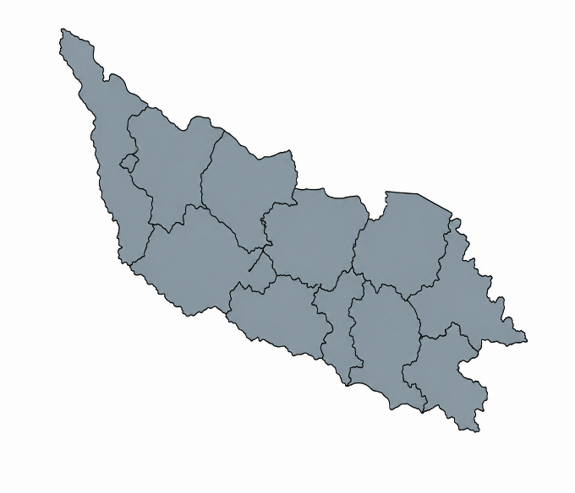
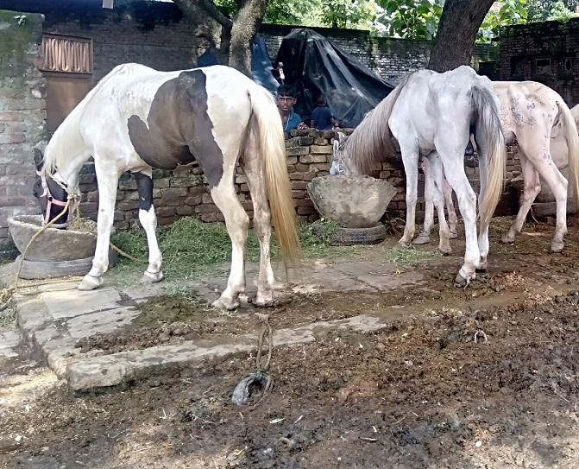
Fig.1 NEPZ of Uttar Pradesh and Equines maintained under traditional extensive system.
2.2 Study Design and Sampling Strategy: A cross-sectional survey was undertaken from February 2020 to February 2021 to determine the prevalence of T. evansi infection in equines. The sample size was calculated according to the method described by Thrusfield (2005), considering an expected prevalence of 50% and a confidence level of 95%. A total of 192 equines, comprising 107 horses, 26 donkeys and 59 mules, were selected through simple random sampling. Information regarding potential epidemiological risk factors was collected using a structured questionnaire. The recorded data included species, sex, age, work type and management practices. Helminth infestation was assessed using the sedimentation technique and standard parasitological procedures. Animals were categorised into two age groups: young (<2 years) and adult (>2 years).
2.3 Blood Sample Collection: Approximately 5 mL of blood was aseptically collected from the jugular vein of each animal and divided into two separate tubes. One aliquot was collected in EDTA-coated tubes for haematological analysis and genomic DNA extraction, while the second aliquot was collected in clot-activator tubes for serum separation and subsequent serological analyses (Fig. 2). Serum samples were stored at −20°C until further processing. Blood collection was performed with prior consent from the animal owners.

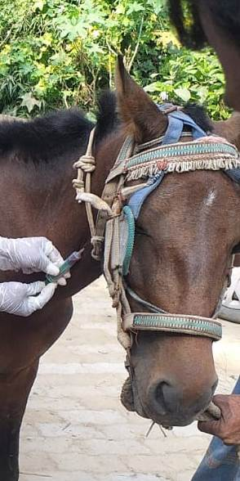
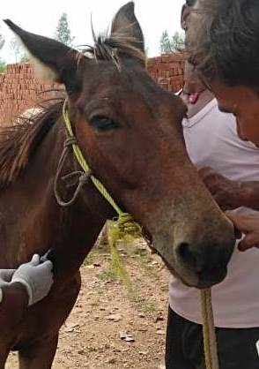

Fig. 2. Blood samples collection from equines
2.4 Prevalence study using microscopy
2.4.1 Wet blood film (WBF): A small drop (2-3 µL) of fresh whole blood was placed on a dust-free, thoroughly cleaned microscopic slide and covered with a clean coverslip to spread the blood as a monolayer of cells. The film was then observed under 100× or 400× magnification using a compound microscope for the detection of motile trypanosomes (Singh et al., 2002).
2.4.2 Micro-haematocrit centrifugation technique (MHCT): Blood samples collected with anticoagulant were examined for the presence of T. evansi by MHCT according to the method described by Woo (1970). Approximately 75 µL of whole blood was drawn into a capillary tube (75 mm × 1.5 mm) up to two-thirds of the capillary length. The wet end of the capillary tube was sealed with paraffin wax. The capillary tube was then centrifuged at 12,000 rpm for 4 minutes in a micro-haematocrit centrifuge.
2.4.3 Blood smear examination (BSE): Thin blood smears (about 3-5 µL of blood) were prepared, air-dried and fixed with absolute methanol for 10 minutes. The fixed slides were stained with a working dilution (1:10) of Giemsa stain (Qualigen) in PBS at pH 7.2 for 45 minutes (Godfrey & Killick-Kendrick, 1961). They were examined under 1000× magnification with oil immersion for the presence and identification of blood protozoa.
2.5 Sero-prevalence study
2.5.1 Indirect Enzyme-Linked Immunosorbent Assay (ELISA): Serum samples were separated by centrifugation and preserved at −20°C until use. Detection of antibodies against T. evansi was performed using a whole-cell lysate (WCL) antigen-based indirect ELISA at the National Research Centre on Equines (NRCE), Hisar, Haryana, following the protocol described by Kumar et al. (2013). ELISA plates were coated overnight at 4°C with 500 ng of WCL antigen diluted in carbonate-bicarbonate buffer (0.1 M, pH 9.6). Following washing with phosphate-buffered saline containing 0.05% Tween-20 (PBS-T), the plates were blocked with 5% skimmed milk in PBS-T and incubated at 37°C for one hour. Field serum samples diluted at 1:100 were added in duplicate and incubated for one hour at 37°C. After washing, anti-horse IgG conjugate diluted at 1:15,000 was added and incubated under similar conditions. Colour development was achieved using tetramethylbenzidine (TMB) substrate, and the reaction was terminated using 1 M sulphuric acid. Optical density values were measured at 450 nm using an ELISA reader, and the mean absorbance of duplicate wells was recorded.
2.6 Prevalence of equine trypanosomosis by molecular methods
2.6.1 DNA Extraction and Polymerase Chain Reaction (PCR): Genomic DNA was isolated from whole blood samples using the phenol-chloroform-isoamyl alcohol (PCI) extraction method with slight modifications from the protocol of Sambrook and Russell (2001). The extracted DNA pellet was dissolved in 30-50 µL of nuclease-free water and stored at −40°C until use. PCR amplification was carried out using ISG-F and ISG-R primers targeting a 196-base pair (bp) repetitive sequence (Table 1) of the mini-chromosome satellite DNA of T. evansi (Masiga et al., 1992; Kumar et al., 2016). Each 25 µL reaction mixture contained 2× TopTaq Master Mix (Qiagen), 0.4 µM of each primer, approximately 40 ng of template DNA and nuclease-free water. Thermal cycling conditions consisted of initial denaturation at 95°C for 5 minutes, followed by 35 amplification cycles comprising denaturation at 94°C for 30 seconds, annealing at 58°C for 30 seconds and extension at 72°C for 30 seconds. A final extension was performed at 72°C. Amplified products were separated on 1.5% agarose gel and visualised under UV illumination using a gel documentation system. Samples yielding a 196 bp amplicon were considered positive, as shown in Table 2.

Table 1: Primers used for ISG-PCR
Oligo Name | Sequence | Length (bp) | Product size
ISG 196-F | 5ʹ AAAGCCACCGAAGATGCAGA 3ʹ | 20 | 196 bp
ISG 196-R | 5ʹ TTGTCCCAATCCAGCCACTC 3ʹ | 20 | 196 bp
Table 2: Parameters used for optimization of ISG- PCR
Test | Component | Quantity | PCR conditions
ISG PCR | Top Taq Master mix | 12.5μl | Initial denaturation: 95°C for 5min.
ISG PCR | Primer forward (10μM/μl) | 1.0μl | Denaturation: 95°C for 30sec. | X 32
ISG PCR | Primer reverses (10μM/μl) | 1.0μl | Annealing: 58°Cfor 30 sec. | X 32
ISG PCR | Nuclease free water | 8.5μl | Extension: 72°C for 30sec. | X 32
ISG PCR | Template DNA | 2.0 μl | Final extension: 72°C for 10 min.
Total reaction volume |  | 25.0μl

2.7 Statistical Analysis
Serological and molecular prevalence estimates were calculated with 95% confidence intervals using an online confidence interval calculator. Associations between infection status and potential risk factors were evaluated using the Chi-square test. All statistical analyses were performed using GraphPad Prism software (version 8.0.2), and differences were considered statistically significant at p < 0.05.
3. Results & Discussion
3.1 Prevalence based on microscopic examinations: Microscopic examination of 192 blood samples collected from equines across eleven districts of the NEPZ of Eastern Uttar Pradesh revealed varying prevalence rates of T. evansi infection depending on the diagnostic technique employed. The overall prevalence recorded by BSE, WBF and MHCT was 1.04% (2/192; 95% CI: 0.13-3.71), 1.56% (3/192; 95% CI: 0.32-4.50) and 4.69% (9/192; 95% CI: 2.17-8.71), respectively (Table 3). District-wise analysis indicated that positive cases were detected in Bahraich, Balrampur, Gonda, Kushinagar and Deoria districts. Among these districts, the highest prevalence by MHCT was observed in Balrampur (11.54%; 3/26), followed by Gonda (8.57%; 3/35), Deoria (5.26%; 1/19), Bahraich (4.76%; 1/21) and Kushinagar (4.35%; 1/23). No positive animals were detected in Siddharth Nagar, Basti, Maharajganj, Gorakhpur, Sant Kabir Nagar and Shrawasti districts by any of the microscopic techniques employed. BSE detected positive cases only in Balrampur (3.85%) and Gonda (2.86%), whereas WBF detected infections in Balrampur (7.69%) and Gonda (2.86%). MHCT detected the highest number of infected animals compared with BSE and WBF, indicating its superior sensitivity for field diagnosis of equine trypanosomosis.
Table 3: Microscopic prevalence of Equine Trypanosomosis in NEPZ.

Districts | Total samples | Positive  BSE (%) | 95%CI | Positive  WBF (%) | 95%CI | Positive MHCT (%) | 95%CI
Behraich | 21 | 0.00 | 0.00-16.11* | 0.00 | 0.00-16.11* | 01(4.76) | 0.12-23.82
Balrampur | 26 | 01(3.85) | 0.10-19.64 | 02(7.69) | 0.95-25.13 | 03(11.54) | 2.45-30.15
Gonda | 35 | 01(2.86) | 0.07-14.92 | 01(2.86) | 0.07-14.92 | 03(8.57) | 1.80-23.06
Siddharth nagar | 8 | 0.00 | 0.00-36.94* | 0.00 | 0.00-36.94* | 0.00 | 0.00-36.94*
Basti | 3 | 0.00 | 0.00-70.76* | 0.00 | 0.00-70.76* | 0.00 | 0.00-70.76*
Maharajganj | 12 | 0.00 | 0.00-26.47* | 0.00 | 0.00-26.47* | 0.00 | 0.00-26.47*
Kushinagar | 23 | 0.00 | 0.00-14.82* | 0.00 | 0.00-14.82* | 01 (4.35) | 0.11-21.95
Gorakhpur | 16 | 0.00 | 0.00-20.59* | 0.00 | 0.00-20.59* | 0.00 | 0.00-20.59*
Deoria | 19 | 0.00 | 0.00-17.65* | 0.00 | 0.00-17.65* | 01 (5.26) | 0.13-26.03
Sant Kabir nagar | 11 | 0.00 | 0.00-28.49* | 0.00 | 0.00-28.49* | 0.00 | 0.00-28.49*
Srawasti | 18 | 0.00 | 0.00-18.53* | 0.00 | 0.00-18.53* | 0.00 | 0.00-18.53*
Total | 192 | 02 (1.04) | 0.13-3.71 | 03 (1.56) | 0.32-4.50 | 09 (4.69) | 2.17-8.71

*One sided 97.5% confidence interval.

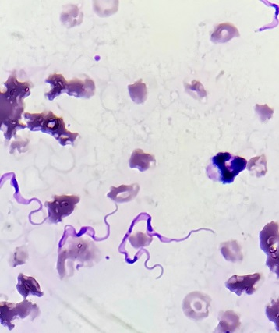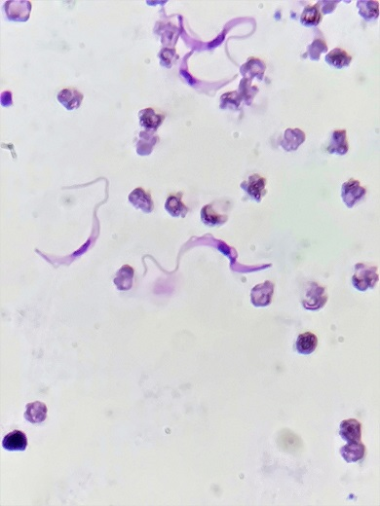

Fig.3. Trypanosoma evansi in Giemsa-stained equine blood smear.

3.2 Molecular and serological prevalence: Molecular and serological screening of 192 equine blood samples collected from 11 districts of the NEPZ of Eastern Uttar Pradesh revealed an overall prevalence of 10.93% (21/192; 95% CI: 6.90-16.23) by PCR and 15.62% (30/192; 95% CI: 10.80-21.55) by ELISA, as shown in Table 4. The higher prevalence detected by ELISA compared with PCR indicates greater exposure of equines to T. evansi than the number of animals harbouring detectable circulating parasite DNA at the time of sampling.
Table 4: Molecular and Serological prevalence of Equine Trypanosomosis in NEPZ.
Districts |  | Total samples | PCR Positive (%) |  | 95%CI |  | ELISA Positive (%) |  | 95%CI
Behraich |  | 21 | 03(14.28) |  | 3.05-36.34 |  | 03(14.28) |  | 3.05-36.34
Balrampur | 26 | 05(19.23) |  | 6.55-39.35 |  | 06(23.07) |  | 8.97-43.65
Gonda | 35 | 03(8.57) |  | 1.80-23.06 |  | 04(11.43) |  | 3.20-26.74
Siddharth nagar | 8 | 0.00 |  | 0.00-36.94* |  | 01(12.5) |  | 0.32-52.65
Basti | 3 | 0.00 |  | 0.00-70.76* |  | 0.00 |  | 0.00-70.76*
Maharajganj | 12 | 02 (16.67) |  | 2.09–48.41 |  | 02 (16.67) |  | 2.09–48.41
Kushinagar | 23 | 02 (8.69) |  | 1.07–28.04 |  | 05 (21.74) |  | 7.46–43.70
Gorakhpur | 16 | 01 (6.25) |  | 0.16–30.23 |  | 03 (18.75) |  | 4.05–45.65
Deoria | 19 | 03 (15.79) |  | 3.38–39.58 |  | 03 (15.79) |  | 3.38–39.58
Sant Kabir nagar | 11 | 0.00 |  | 0.00-28.49* |  | 0.00 |  | 0.00–28.49*
Srawasti | 18 | 02 (11.11) |  | 1.37–34.71 |  | 03 (16.67) |  | 3.58–41.42
Total | 192 | 21 (10.93) |  | 6.90–16.23 |  | 30 (15.62) |  | 10.80-21.55
*One sided 97.5% confidence interval.
District-wise analysis showed that PCR-positive animals were detected in eight districts, with the highest prevalence recorded in Balrampur (19.23%; 5/26), followed by Maharajganj (16.67%; 2/12), Deoria (15.79%; 3/19), Bahraich (14.28%; 3/21), Shrawasti (11.11%; 2/18), Kushinagar (8.69%; 2/23), Gonda (8.57%; 3/35) and Gorakhpur (6.25%; 1/16). No PCR-positive cases were detected in Siddharth Nagar, Basti and Sant Kabir Nagar districts.
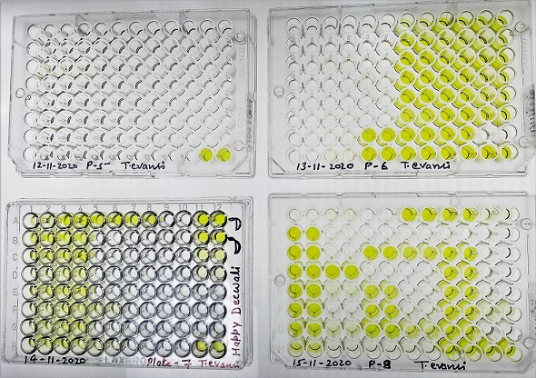
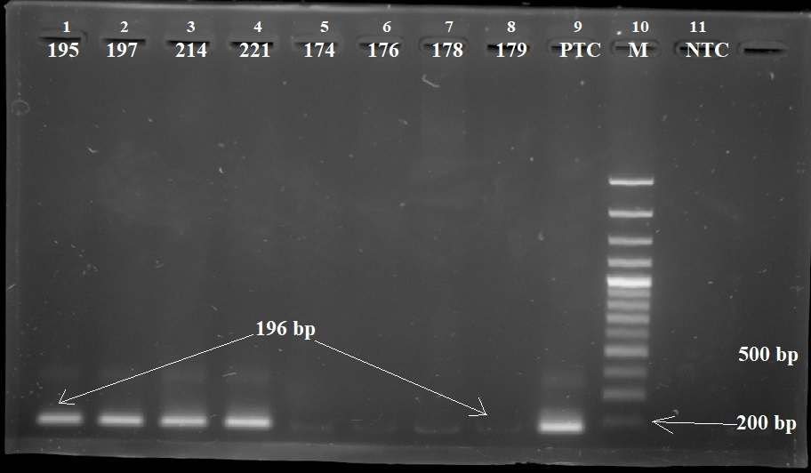
Fig. 4. 196 bp of PCR product and Ab-ELISA titre plates used for T. evansi.
Serological investigation by ELISA demonstrated a comparatively higher prevalence across the study area. The highest seroprevalence was observed in Balrampur (23.07%; 6/26), followed by Kushinagar (21.74%; 5/23), Gorakhpur (18.75%; 3/16), Maharajganj (16.67%; 2/12), Shrawasti (16.67%; 3/18), Deoria (15.79%; 3/19), Bahraich (14.28%; 3/21), Siddharth Nagar (12.50%; 1/8) and Gonda (11.43%; 4/35). No seropositive animals were detected in Basti and Sant Kabir Nagar districts.
3.3 Epidemiological risk factors associated with Equine Trypanosomosis
The association of epidemiological risk factors with equine trypanosomosis, as detected by PCR and indirect ELISA, is presented in Table 5. Both diagnostic techniques revealed variations in prevalence according to animal species, sex, age, helminth infestation status and work type.

Table 5: Equine trypanosomosis associated epidemiological risk factors diagnosed by
PCR and indirect-ELISA in the study areas.
Prevalence Type | Variables | Category | Total animals | Infected animals (%) | χ2 | RR | p-value
PCR | Species | Horse | 107 | 05 (4.67) | 9.45 |  | 0.0021**
PCR | Species | Donkey/Mule | 85 | 16 (18.82) | 9.45 | 4.03 | 0.0021**
PCR | Sex | Male | 72 | 07 (9.72) | 0.19 |  | 0.66^{NS}
PCR | Sex | Female | 120 | 14(11.66) | 0.19 | 0.83 | 0.66^{NS}
PCR | Age | <2 years | 32 | 06 (18.75) | 2.70 | 2.00 | 0.10^{NS}
PCR | Age | >2 years | 160 | 15 (9.37) | 2.70 |  | 0.10^{NS}
PCR | Helminth  parasites | Present | 88 | 05 (5.68) | 4.58 |  | 0.032*
PCR | Helminth  parasites | Absent | 104 | 16 (15.38) | 4.58 | 0.37 | 0.032*
PCR | Work type | Brick kiln | 65 | 08 (12.30) | 0.21 | 1.20 | 0.65^{NS}
PCR | Work type | Transport | 127 | 13 (10.23) | 0.21 |  | 0.65^{NS}
Indirect-ELISA | Species | Horse | 107 | 08 (7.47) | 12.17 |  | 0.0005*
Indirect-ELISA | Species | Donkey/Mule | 85 | 22 (25.88) | 12.17 | 3.46 | 0.0005*
Indirect-ELISA | Sex | Male | 72 | 11 (15.27) | 0.01 |  | 0.918 ^{NS}
Indirect-ELISA | Sex | Female | 120 | 19 (15.83) | 0.01 | 0.96 | 0.918 ^{NS}
Indirect-ELISA | Age | <2 years | 32 | 09 (28.12) | 4.55 | 2.14 | 0.033*
Indirect-ELISA | Age | >2 years | 160 | 21 (13.12) | 4.55 |  | 0.033*
Indirect-ELISA | Helminth  parasites | Present | 88 | 18 (20.45) | 2.87 | 1.77 | 0.090^{NS}
Indirect-ELISA | Helminth  parasites | Absent | 104 | 12 (11.53) | 2.87 |  | 0.090^{NS}
Indirect-ELISA | Work type | Brick kiln | 65 | 13 (20.00) | 1.43 | 1.49 | 0.232^{NS}
Indirect-ELISA | Work type | Transport | 127 | 17 (13.38) | 1.43 |  | 0.232^{NS}
χ2= Chi square, RR= relative risks-non significant (P>0.05), *significant (P<0.05), **highly significant (P<0.01)

Among the animal species examined, donkeys/mules exhibited significantly higher prevalence than horses by both PCR and indirect ELISA. ELISA detected infection in 25.88% (22/85) of donkeys/mules compared with 7.47% (8/107) of horses (χ² = 12.17, p = 0.0005), indicating a 3.46-fold higher risk of infection in donkeys/mules. Similarly, PCR showed significantly higher positivity in donkeys/mules (18.82%; 16/85) than in horses (4.67%; 5/107) (χ² = 9.45, p = 0.0021), with a relative risk of 4.03. Sex-wise analysis revealed comparable prevalence rates between males and females. Indirect ELISA positivity was recorded in 15.27% (11/72) of males and 15.83% (19/120) of females, while PCR detected positivity in 9.72% (7/72) and 11.66% (14/120) of males and females, respectively. The differences were statistically non-significant by both indirect ELISA (χ² = 0.01, p = 0.918) and PCR (χ² = 0.19, p = 0.66). Age-related analysis showed that animals younger than two years had higher prevalence rates than older animals. Indirect ELISA detected infection in 28.12% (9/32) of animals below two years of age compared with 13.12% (21/160) in animals older than two years. This difference was statistically significant (χ² = 4.55, p = 0.033), with younger animals showing a 2.14-fold greater risk of infection. Likewise, PCR revealed higher positivity in younger animals (18.75%; 6/32) than in older animals (9.37%; 15/160); however, the association was not statistically significant (χ² = 2.70, p = 0.10). Animals infested with helminth parasites showed a higher indirect ELISA prevalence (20.45%; 18/88) than non-infested animals (11.53%; 12/104), although the difference was statistically non-significant (χ² = 2.87, p = 0.090). In contrast, PCR demonstrated a significant association with helminth infestation (χ² = 4.58, p = 0.032), with molecular prevalence of 5.68% (5/88) in helminth-infested animals and 15.38% (16/104) in non-infested animals. The association of helminth infestation with serological and molecular detection is shown in Fig. 5. Based on work type, animals engaged in brick-kiln activities exhibited higher prevalence than transport animals by both diagnostic methods. Indirect ELISA seropositivity was observed in 20.00% (13/65) of brick-kiln animals and 13.38% (17/127) of transport animals, whereas PCR detected prevalence rates of 12.30% (8/65) and 10.23% (13/127), respectively. However, these differences were not statistically significant by indirect ELISA (χ² = 1.43, p = 0.232) or PCR (χ² = 0.21, p = 0.65).
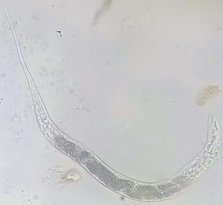
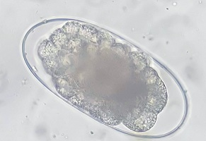
Fig. 5. Association of helminth infestation with serological (indirect-ELISA) and molecular (PCR) detection of Trypanosoma evansi infection in equines.
Parasitological (microscopic) examination is the gold-standard diagnostic method for detecting blood protozoan parasites (Fig. 3). This test is relatively simple and straightforward but has low sensitivity, particularly in the early stage of infection, chronic cases and infections with fluctuating levels of parasitaemia (Killick-Kendrick, 1968). Herbert and Lumsden (1976) observed that parasite concentrations below 2,500,000 parasites per mL of blood are not readily detected by microscopic examination. The present study demonstrated a relatively low microscopic prevalence of equine trypanosomosis in the NEPZ of Eastern Uttar Pradesh. The low prevalence detected by BSE (1.04%) and WBF (1.56%) may be attributed to intermittent parasitaemia and the low parasite burden commonly observed in chronic T. evansi infections. Similar observations were reported by Paris et al. (1982), Leeflang et al. (1978) and several other researchers, who noted that conventional blood-smear techniques often fail to detect infections during periods of low parasitaemia. The present results demonstrated that, among the three microscopic techniques evaluated, MHCT exhibited the highest detection rate (4.69%), confirming its greater diagnostic sensitivity. This finding is consistent with previous reports (Leeflang et al., 1978; Betancourt et al., 1979; Betancourt & Julio, 1979; Kalu et al., 1986; Desquesnes, 1997; Bedada & Dagnachew, 2012). The advantages of MHCT include easier detection of motile parasites in the blood film and suitability for field conditions.
The higher prevalence recorded by ELISA compared with PCR is expected because ELISA detects anti-T. evansi antibodies that may persist for several months following exposure or treatment, whereas PCR identifies active infections through amplification of parasite-specific DNA (Fig. 4). Consequently, animals previously exposed to the parasite but lacking detectable parasitaemia at the time of sampling may remain ELISA-positive while testing negative by PCR. Similar findings were reported by previous workers (Desquesnes, 1997; Kumar et al., 2013; Sumbria et al., 2014; Yadav et al., 2019). Kumar et al. (2013) reported a high prevalence of surra in equines by WCL indirect ELISA in the middle Gangetic Plain of Uttar Pradesh. Similarly, Yadav et al. (2019) reported that the highest seroprevalence (9.75%) of equine trypanosomosis was recorded in the Gangetic plains of Uttarakhand and Uttar Pradesh, India. Sumbria et al. (2014) reported seroprevalence of T. evansi as 6.8% and 13.63% by the T. evansi card agglutination test, whereas molecular assay detected 1.92% and 1.51% in central and western Punjab, India, respectively. The primer set ISG-F/R (forward/reverse) was used to target the ISG (invariable surface glycoprotein) gene sequence of the Indian isolate of T. evansi. The ISG proteins are distributed evenly over the complete surface of trypanosomes (Nolan et al., 1997). Similar findings were reported by previous authors (Desquesnes, 1997; Njiru et al., 2004; Ravindran et al., 2008; Migri et al., 2016). Ravindran et al. (2008) reported that, among 131 blood samples collected from different animals (camels, donkeys and dogs) from different parts of India, 26 samples were positive by PCR, whereas only two samples were positive by blood-smear examination for T. evansi. Likewise, Migri et al. (2016) reported that the incidence of T. evansi infection in buffaloes was 29.64% by PCR and 24.50% by conventional microscopic examination in the Mumbai region of India. García et al. (2005) found that PCR assay was a useful tool for epidemiological studies of equine trypanosomosis. In the current study, PCR assay was sensitive and useful among parasitological methods, especially where infected equines had low parasitaemia that was difficult to detect using parasitological techniques. The higher prevalence observed in Balrampur and Gonda districts may be associated with ecological and management factors favouring the transmission of T. evansi. These districts possess extensive riverine and marshy areas that support the breeding and proliferation of haematophagous flies, particularly tabanids and Stomoxys spp., which are recognised mechanical vectors of the parasite.
The present study demonstrated that animal species was a major determinant of both active infection and serological exposure to T. evansi. Donkeys and mules exhibited significantly higher PCR prevalence and seroprevalence than horses, indicating their greater susceptibility to infection. Similar findings were also reported by Suryanarayana et al. (1985), Kumar et al. (2013) and Camoin et al. (2019). Suryanarayana et al. (1985) reported that donkeys were at higher risk than horses in Haryana State, India. The comparatively higher risk of T. evansi infection in mules and donkeys might be due to traditional extensive rearing systems with poor management practices by underprivileged farmers in the study area. In the present study, mules and donkeys were also subjected to work stress, poor feeding, daily haulage and transport, where they were more exposed to flies than horses. Sex did not significantly influence either PCR prevalence or seroprevalence in the present study. This finding is consistent with earlier investigations (Bekele & Nasir, 2011; Tafese et al., 2012; Sumbria et al., 2014). This may be because both sexes had equal chances of exposure to infection and similar exposure to biting flies in grazing areas; therefore, parasite distribution was similar between sexes (Mihret & Mamo, 2007; Abebayehu et al., 2011). Age was identified as a significant risk factor for indirect ELISA positivity, with animals younger than two years showing more than twice the risk of infection compared with older animals. Similar findings have been reported by Abebayehu et al. (2011) in animal trypanosomosis. Sumbria et al. (2014) reported that young equines were at three times greater risk of T. evansi infection than adults. This may be because young animals do not have sufficiently strong immune responses against T. evansi infection to control parasitaemia. Contrary results have been reported by several authors (Sinshaw, 2004; Bekele & Nasir, 2011; Tesfaye & Basa, 2017; Sharma et al., 2019). Animals infested with helminth parasites showed higher indirect ELISA prevalence than non-infested animals, suggesting that concurrent parasitic infections may predispose equines to trypanosomosis by impairing host immunity; however, the association was not statistically significant. In contrast, PCR results indicated a significant association between helminth status and infection, with higher PCR prevalence in non-infested animals. Sumbria et al. (2014) reported that unorganised equines were at greater risk of T. evansi infection than organised animals. Equines engaged in brick-kiln activities showed higher infection and seroprevalence compared with transport animals, although the differences were not statistically significant. This record supports previous observations by Burn et al. (2010), who reported that equines used for brick transport were 2.5 times more prone to skin lesions and had a 3.4 times greater chance of sole abnormalities than those used for other transport purposes. The current study suggests that animals used in brick kilns were generally subjected to prolonged working hours, overcrowding, poor nutrition and greater exposure to vector-rich environments, which may increase their susceptibility to infection.
Conclusion
The present study provides regional epidemiological evidence on equine trypanosomosis in the North Eastern Plain Zone of Uttar Pradesh. Examination of 192 equines from eleven districts showed that prevalence differed according to the diagnostic method used. Conventional microscopic methods detected lower positivity, whereas polymerase chain reaction and indirect enzyme-linked immunosorbent assay identified higher levels of active infection or previous exposure. Among the microscopic techniques, micro-haematocrit centrifugation showed better detection than blood smear examination and wet blood film. Balrampur recorded the highest molecular and serological prevalence. Risk-factor assessment indicated significantly higher positivity in donkeys and mules than in horses, while animals younger than two years showed greater seropositivity than older animals. Sex and work type were not significantly associated with infection. These findings suggest that equine trypanosomosis occurs in the study region and that reliance solely on conventional microscopy may underestimate infection. Routine surveillance using sensitive diagnostic methods, together with vector control, strategic deworming and improved husbandry practices, may support better management of T. evansi infection in equine populations.
Limitations
This study was limited to 192 equines from eleven districts during a defined cross-sectional sampling period. The small number of animals sampled from some districts may restrict strong district-wise interpretation. Seasonal variation, temporal changes in parasitaemia and long-term infection dynamics could not be fully assessed. Although polymerase chain reaction and indirect enzyme-linked immunosorbent assay improved detection compared with microscopy, parasite isolation, sequencing and vector analysis were not included. Risk-factor assessment was based on selected field variables, and wider management-related factors require further evaluation.

Ethical Approval and Consent: The present study was conducted after obtaining approval from the Institutional Animal Ethics Committee (IAEC) of Acharya Narendra Deva University of Agriculture and Technology (ANDUAT), Kumarganj, Ayodhya, Uttar Pradesh (Approval No. IAEC/CVSc/2/P-32/2020/26). Blood collection was performed with prior consent from the animal owners.

Declaration of AI Use

This manuscript was prepared through the combined contributions of all author(s), including contributions to the study design, data, content development, results, interpretation, and related scholarly work. The author(s) acknowledge the use of Grammarly and ChatGPT to assist with grammar checking, language refinement, reference formatting. These AI-assisted tools were not used as authors and did not replace the intellectual contributions or scholarly judgment of the author(s). All AI-assisted outputs, including content, references, and interpretations, were carefully reviewed, revised, verified, and approved by the author(s). The author(s) accept full responsibility for the accuracy, integrity, and final content of the manuscript.

COMPETING INTERESTS:
Authors have declared that they have no known competing financial interests OR non-financial interests OR personal relationships that could have appeared to influence the work reported in this paper.
References
Abebayehu, T., Eset, H., Berhanu, M., Rahmeto, A., & Solomon, M. (2011). Mechanically transmitted bovine trypanosomosis in Tselemty Woreda, Western Tigray, Northern Ethiopia. Agricultural Journal, 6(1), 10–13.
Mihret, A., & Mamo, G. (2007). Bovine trypanosomosis in three districts of East Gojjam Zone bordering the Blue Nile River in Ethiopia. Journal of Infection in Developing Countries, 1(3), 321–325. https://doi.org/10.3855/jidc.371
Ahmad, S., Butt, A. A., Muhammad, G., Athar, M., & Khan, M. Z. (2004). Haematobiochemical studies on the haemoparasitized camels. International Journal of Agriculture & Biology, 6(2), 331–334. https://api.fspublishers.org/viewPaper/87169_..pdf
Aregawi, W. G., Gutema, F., Tesfaye, J., Sorsa, A., Megersa, B., Teshome, P., Agga, G. E., & Ashenafi, H. (2021). Efficacy of diminazene diaceturate and isometamidium chloride hydrochloride for the treatment of Trypanosoma evansi in mice model. Journal of Parasitic Diseases, 45, 131–136. https://doi.org/10.1007/s12639-020-01289-3
Bedada, H., & Dagnachew, S. (2012). Study on the prevalence of donkey trypanosomosis in Awi Zone, northwest Ethiopia. Ethiopian Veterinary Journal, 16(2), 65–76. https://doi.org/10.4314/evj.v16i2.6
Bekele, M., & Nasir, M. (2011). Prevalence and host-related risk factors of bovine trypanosomosis in Hawagelan district, West Wellega Zone, western Ethiopia. African Journal of Agricultural Research, 6(22), 5055–5060. https://doi.org/10.5897/AJAR11.462
Betancourt, A. E., & Julio, T. M. (1979). La técnica de centrifugación en tubo capilar en el diagnóstico de infecciones naturales por Trypanosoma sp. Revista ICA, 14, 105–108. https://biblat.unam.mx/es/revista/revista-ica/articulo/la-tecnica-de-centrifugacion-en-tubo-capilar-en-el-diagnostico-de-infecciones-naturales-por-trypanosoma-sp
Betancourt, A. E., Ramírez, L. E., Wells, E. A., & Bazalar, H. (1979). La técnica de centrifugación en tubo capilar en el diagnóstico de tripanosomiasis experimental. Revista ICA, 14(2), 97–104. https://agris.fao.org/search/ar/records/64745b7f542a3f9f03b4c102
Burn, C. C., Dennison, T. L., & Whay, H. R. (2010). Environmental and demographic risk factors for poor welfare in working horses, donkeys and mules in developing countries. The Veterinary Journal, 186(3), 385–392. https://doi.org/10.1016/j.tvjl.2009.09.016
Camoin, M., Kocher, A., Chalermwong, P., Yangtarra, S., Kamyingkird, K., Jittapalapong, S., & Desquesnes, M. (2019). The indirect ELISA Trypanosoma evansi in equids: Optimisation and application to a serological survey including racing horses, in Thailand. BioMed Research International, 2019, Article 2964639. https://doi.org/10.1155/2019/2964639
Desquesnes, M. (1997). Evaluation of a simple PCR technique for the diagnosis of Trypanosoma vivax infection in the serum of cattle in comparison to parasitological techniques and antigen–enzyme-linked immunosorbent assay. Acta Tropica, 65(3), 139–148. https://www.sidalc.net/search/Record/dig-cirad-fr-389004
García, H., García, M. E., Pérez, H., & Mendoza-León, A. (2005). The detection and PCR-based characterization of the parasites causing trypanosomiasis in water buffalo herds in Venezuela. Annals of Tropical Medicine & Parasitology, 99(4), 359–370. https://doi.org/10.1179/136485905X36271
Godfrey, D. G., & Killick-Kendrick, R. (1961). Bovine trypanosomiasis in Nigeria. I. The inoculation of blood into rats as a method of survey in the Donga Valley, Benue Province. Annals of Tropical Medicine & Parasitology, 55, 287–297. https://europepmc.org/article/MED/13899415
Herbert, W. J., & Lumsden, W. H. R. (1976). Trypanosoma brucei: A rapid “matching” method for estimating the host’s parasitaemia. Experimental Parasitology, 40(3), 427–431. https://doi.org/10.1016/0014-4894(76)90110-7
Kalu, A. U., Edeghere, H. U., & Lawani, F. A. (1986). Comparison of diagnostic techniques during subclinical single infections of trypanosomiasis in goats. Veterinary Parasitology, 22(1–2), 37–47. https://doi.org/10.1016/0304-4017(86)90005-1
Killick-Kendrick, R. (1968). The diagnosis of trypanosomiasis of livestock: A review of current techniques. Veterinary Bulletin, 38, 191–197.
Kumar, R., Gaur, D. K., Goyal, S. K., Sharma, P., Kankar, S. K., Jain, S., & Kumar, S. (2016). Sensitive detection of Trypanosoma evansi infection by polymerase chain reaction targeting invariable surface glycoprotein gene. Indian Journal of Animal Sciences, 86(6), 639–642. https://doi.org/10.56093/ijans.v86i6.59148
Kumar, R., Kumar, S., Khurana, S. K., & Yadav, S. C. (2013). Development of an antibody-ELISA for seroprevalence of Trypanosoma evansi in equids of North and North-western regions of India. Veterinary Parasitology, 196(3–4), 251–257. https://doi.org/10.1016/j.vetpar.2013.04.018
Leeflang, P., Buys, J., & Blotkamp, C. (1978). Studies on Trypanosoma vivax: Comparison of parasitological diagnostic methods. International Journal for Parasitology, 8(1), 15–18. https://doi.org/10.1016/0020-7519(78)90045-0
Masiga, D. K., Smyth, A. J., Hayes, P., Bromidge, T. J., & Gibson, W. C. (1992). Sensitive detection of trypanosomes in tsetse flies by DNA amplification. International Journal for Parasitology, 22(7), 909–918. https://doi.org/10.1016/0020-7519(92)90047-O
Migri, S., Bharkad, G. P., & Gatne, M. L. (2016). Prevalence of clinical and subclinical forms of Trypanosoma evansi infection in buffaloes of Mumbai region (MS) of India. Buffalo Bulletin, 35(4), 679–685. https://kuojs.lib.ku.ac.th/index.php/BufBu/article/view/1461
Bekele, M., & Nasir, M. (2011). Prevalence and host-related risk factors of bovine trypanosomosis in Hawagelan district, West Wellega Zone, western Ethiopia. African Journal of Agricultural Research, 6(22), 5055–5060. https://doi.org/10.5897/AJAR11.462
Njiru, Z. K., Constantine, C. C., Ndung’u, J. M., Robertson, I., Okaye, S., Thompson, R. C. A., & Reid, S. A. (2004). Detection of Trypanosoma evansi in camels using PCR and CATT/T. evansi tests in Kenya. Veterinary Parasitology, 124(3–4), 187–199. https://doi.org/10.1016/j.vetpar.2004.06.029
Nolan, D. P., Jackson, D. G., Windle, H. J., Pays, A., Geuskens, M., Michel, A., Voorheis, H. P., & Pays, E. (1997). Characterization of a novel, stage-specific, invariant surface protein in Trypanosoma brucei containing an internal, serine-rich, repetitive motif. Journal of Biological Chemistry, 272(46), 29212–29221. https://doi.org/10.1074/jbc.272.46.29212
Paris, J., Murray, M., & McOdimba, F. (1982). A comparative evaluation of the parasitological techniques currently available for the diagnosis of African trypanosomiasis in cattle. Acta Tropica, 39(4), 307–316. https://europepmc.org/article/MED/6131590
Ravindran, R., Rao, J. R., Mishra, A. K., Pathak, K. M. L., Babu, N., Satheesh, C. C., & Rahul, S. (2008). Trypanosoma evansi in camels, donkeys and dogs in India: Comparison of PCR and light microscopy for detection—Short communication. Veterinarski Arhiv, 78(1), 89–94. https://hrcak.srce.hr/24252
Sambrook, J., & Russell, D. W. (2001). Molecular cloning: A laboratory manual (3rd ed.). Cold Spring Harbor Laboratory Press. https://search.library.nyu.edu/discovery/fulldisplay?context=L&docid=alma990017218650107871&vid=01NYU_INST%3ANYU
Sharma, A., Singla, L. D., Kaur, P., Bal, M. S., Sumbria, D., & Setia, R. (2019). Spatial seroepidemiology, risk assessment and haemato-biochemical implications of bovine trypanosomiasis in low-lying areas of Punjab, India. Comparative Immunology, Microbiology and Infectious Diseases, 64, 61–66. https://doi.org/10.1016/j.cimid.2019.03.010
Singh, N., Chaudhri, S. S., Gupta, S. L., & Singh, A. (2002). Chemoprophylaxis with quinapyramine prosalt against Trypanosoma evansi in buffalo calves. Journal of Veterinary Parasitology, 16(1), 31–34.
Sinshaw, A. (2004). Prevalence of trypanosomosis of cattle in three woreda of Amhara Region [MSc thesis, Addis Ababa University, Faculty of Veterinary Medicine].
Sumbria, D., Singla, L. D., Sharma, A., Moudgil, A. D., & Bal, M. S. (2014). Equine trypanosomosis in central and western Punjab: Prevalence, haemato-biochemical response and associated risk factors. Acta Tropica, 138, 44–50. https://doi.org/10.1016/j.actatropica.2014.06.003
Suryanarayana, C., Gupta, S. L., & Singh, R. P. (1985). Prevalence of Trypanosoma evansi infection in equines of Hisar, Haryana. Indian Journal of Animal Sciences, 55(10), 883–884.
Tafese, W., Melaku, A., & Fentahun, T. (2012). Prevalence of bovine trypanosomosis and its vectors in two districts of East Wollega Zone, Ethiopia. Onderstepoort Journal of Veterinary Research, 79(1), Article 385, 1–4. https://doi.org/10.4102/ojvr.v79i1.385
Tesfaye, W., & Basa, E. B. (2017). Study on prevalence of bovine trypanosomosis and its risk factors in Zala Woreda, SNNPRS, southern Ethiopia. International Journal of Advanced Research in Biological Sciences, 4(6), 136–143. https://doi.org/10.22192/ijarbs.2017.04.06.020
Thrusfield, M. (2005). Veterinary epidemiology (3rd ed.). Blackwell Science.
Woo, P. T. K. (1970). The haematocrit centrifuge technique for the diagnosis of African trypanosomes. Acta Tropica, 27(4), 384–386. https://europepmc.org/abstract/MED/4396363
Yadav, S. C., Kumar, P., Khurana, S., & Kumar, R. (2019). Seroprevalence of Trypanosoma evansi infection in equines of North and North Western States of India. Journal of Equine Veterinary Science, 79, 63–67. https://doi.org/10.1016/j.jevs.2019.05.019
Yadav, S. C., Kumar, R., Manuja, A., Goyal, L., & Gupta, A. K. (2014). Early detection of Trypanosoma evansi infection and monitoring of antibody levels by ELISA following treatment. Journal of Parasitic Diseases, 38(1), 124–127. https://doi.org/10.1007/s12639-012-0204-2
Bello, A. M., Abdulsalam, H., Dauda, J., Mbaya, A. W., & Mani, A. U. (2023). Influence of diaminazene aceturate (Berenil®) on the haematology of Yankasa sheep experimentally infected with Trypanosoma evansi. Asian Journal of Research in Animal and Veterinary Sciences, 6(4), 380–393. https://doi.org/10.9734/ajravs/2023/v6i4264
Kim, J., Álvarez-Rodríguez, A., Li, Z., Radwanska, M., & Magez, S. (2024). Recent progress in the detection of surra, a neglected disease caused by Trypanosoma evansi with a One Health impact in large parts of the tropic and sub-tropic world. Microorganisms, 12(1), Article 44. https://doi.org/10.3390/microorganisms12010044
Shoraba, M., Shoulah, S. A., Arnaout, F., & Selim, A. (2024). Equine trypanosomiasis: Molecular detection, hematological, and oxidative stress profiling. Veterinary Medicine International, 2024, Article 6550276. https://doi.org/10.1155/2024/6550276
Sousa, J. A., Miranda, L. M., Coutinho, D. J. B., Costa, T. F., Costa, S. P., Freitas, Ú. S., Costa, F. B., Machado, R. Z., Nogueira, R. M. S., & Costa, A. P. (2025). Trypanosoma evansi in Brazil: First evidence of infection in equines from Northeast region. Brazilian Journal of Veterinary Parasitology, 34(2), Article e000125. https://doi.org/10.1590/S1984-29612025032

