Two new lynx spider species of Hamadruas and Oxyopes, and the first record of Hamadruas Thorell, 1887 (Araneae: Oxyopidae) from Wai, Maharashtra, India
Abstract:
The present study reports two oxyopid spider species from Wai, Satara District, Maharashtra, India, based on morphological examination of specimens collected from the Kisan Veer Mahavidyalaya campus. The specimens were collected using hand-collection and sweep-net methods, preserved in 70% ethanol, and examined under a stereotrinocular microscope. Diagnostic structures, including the female epigyne and male palp, were studied after dissection, and distribution maps were prepared using QGIS. Hamadruas kvmensis sp. nov. is characterised by distinct dark elongated spermathecal lobes, a rounded central region forming the median fertilisation duct, curved copulatory ducts, and a male palp with an elongated curved cymbium, large bulb, prominent tegulum, slender embolus, conductor, tibial apophysis and sensory setae. Oxyopes waiensis sp. nov. is distinguished by its pale yellow carapace with an orange median band, elongated silvery abdomen with a reddish-brown longitudinal band, spiny legs, reniform coiled spermathecae, curved copulatory ducts and broad atrium. The diagnostic characters were compared with related taxa reported from India and nearby regions to support species-level separation. The study also records Hamadruas from Wai for the first time and updates the regional distributional information for the documented taxa. These findings add to knowledge of lynx spider diversity in Maharashtra and indicate the need for further local surveys of under-documented habitats.
Keywords: lynx spiders; Oxyopidae; Hamadruas kvmensis sp. nov.; Oxyopes waiensis sp. nov.; epigyne; spermathecae; male palp; taxonomy; Wai; Maharashtra; Western Ghats; species distribution
Introduction
Spiders are among the most abundant predatory arthropods. The family Oxyopidae (lynx spiders) currently includes 448 species in 10 genera worldwide (World Spider Catalog, 2026). Members of this family are useful indicators of environmental conditions and may function as biological control agents in agricultural ecosystems. The present study was conducted on the K.V.M. College campus. The lynx spider genus Hamadruas was first described by Thorell (1891). Spiders of the genus Oxyopes Latreille (Araneae: Oxyopidae) were reported from Buxa Tiger Reserve, West Bengal, by Biswas et al. (1996). Deeleman-Reinhold (2009) described lynx spiders collected during a canopy-fogging project in northern Borneo (Araneae: Oxyopidae), including a new genus and six new species of Hamataliwa. Hamadruas keralensis and Hamadruas hieroglyphica were reported from Kerala by Sen and Sudhin (2023). Sankaran (2024) reported taxonomic notes on two poorly known lynx spider species from India. This genus is mainly distributed in Asia (World Spider Catalog, 2024). Recent campus- and locality-based spider surveys from India have further emphasised the value of systematic field collection and adult-stage identification for documenting local arachnid assemblages in Indian habitats (Dave & Trivedi, 2024; Mustak & Kadakol, 2025). Recent regional first-record studies also show that targeted hand collection in under-surveyed Indian habitats can refine state-level spider distributional data (Nayak et al., 2026).
Species of Hamadruas possess distinctive abdominal markings that resemble hieroglyphic symbols. Members of this genus can be distinguished from other oxyopid genera by their abdominal pattern and by the structure of the female epigyne (Deeleman-Reinhold, 2009). In the Sahyadri ranges of the Western Ghats, Oxyopes sataricus was reported from Satara by Kulkarni and Deshpande (2012). In recent lynx-spider taxonomy, detailed genital morphology and, where available, integrative delimitation have remained important for distinguishing closely related Oxyopidae taxa (Lo et al., 2024; Bhattacharya et al., 2026). Despite these recent additions, the Oxyopidae fauna of Wai, Satara District, remains insufficiently documented, especially for Hamadruas and Oxyopes specimens collected from local habitats. Currently, Hamadruas includes ten valid species, of which only four, namely Hamadruas insulana Thorell, 1891, Hamadruas sikkimensis Tikader, 1970, Hamadruas rukminiae Gajbe, 1999, and Hamadruas keralensis Sen & Sudhin, 2023, have been reported from India. The objective of the present study is to describe and illustrate Hamadruas kvmensis sp. nov. and Oxyopes waiensis sp. nov. from Wai, Maharashtra, and to document the first record of Hamadruas from this locality.
Materials and Methods:
The specimens were collected using hand-collection and sweep-net methods. They were immediately preserved in 70% ethanol after collection and later examined for morphological analysis using a stereotrinocular microscope (OLYMPUS SZ61, Japan). Images were captured using a Nikon 5300 camera. Selected specimens were dissected to examine the male palpal organ and female epigyne. For examination of the female genital organs, the epigyne and internal genital structures were cleaned using a heated 10% potassium hydroxide (KOH) solution (Tikader, 1987). Distribution maps were prepared using QGIS software (QGIS.org, 2026). All measurements are recorded in millimetres. The description of leg segment length includes total length (femur, patella + tibia, metatarsus, tarsus). Abdominal length was recorded from the ventral side, while height was measured from the spinnerets to the apex. The specimens are deposited in the Western Regional Centre (WRC), Zoological Survey of India (ZSI), Pune, under Registration Nos. AR/1825 and AR/1826.
The abbreviations used in the text and figures are as follows: ALE – anterior lateral eye, AME – anterior median eye, PLE – posterior lateral eye, PME – posterior median eye, CD – copulatory duct, FD – fertilisation duct, S – spermathecae, WRC – Western Regional Centre and ZSI – Zoological Survey of India.

Results:
Taxonomy
Family OXYOPIDAE Thorell, 1869
Genus Hamadruas Thorell (1887)
Type species: Hamadruas hieroglyphica Thorell (1887)
Hamadruas hieroglyphica (Figs.18-22).
Hamadruas keralensis Sen & Sudhin, 2023 (Figs. 13–17).
Hamadruas kvmensis sp. nov. (Figure 1)
Type Material: Holotype: 1 female (Western Regional Centre, WRC, ZSI, Pune, Reg. No. AR/1825), India, Maharashtra, Satara, Wai, Kisan Veer Mahavidyalaya Campus, 17°56′42″N, 73°52′36″ E, h = 738 m, collected by Rahul Tayade and Vishwas Deshpande.

FIGURES 1–2 Preserved habitus of the holotype Hamadruas kvmensis sp. nov.:
FIGURES 3–4 3. Cephalothorax, ventral view; 4. cephalothorax, dorsal view. Scale lines: 10 mm (Figs. 1–2); 4 mm (Figs. 3–4).
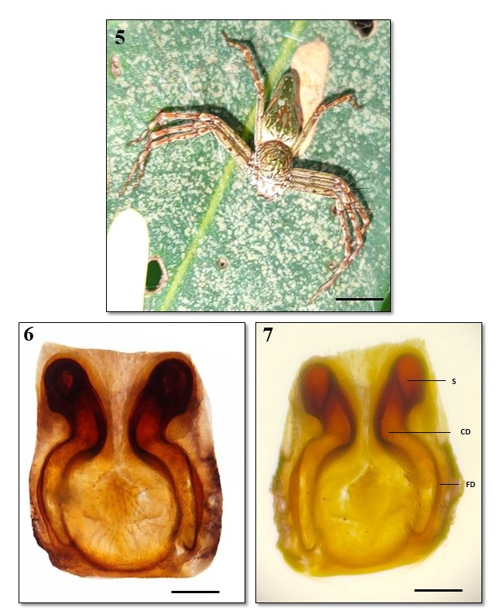
FIGURES 5–7 Hamadruas kvmensis sp. nov.; female (Fig. 5).
Figs. 6–7: epigynum; Fig. 6: dorsal view; Fig. 7: ventral view. Scale lines: 10 mm (Fig. 5); 0.3 mm (Figs. 6–7).
Etymology: The species name is derived from the initials of Kisan Veer Mahavidyalaya, Wai, from where the species was collected.
Diagnosis: The female of H. kvmensis sp. nov. can be distinguished from all other described species by two distinct dark elongated lobes of spermathecae, with the upper part resembling comma-shaped structures. The central area is rounded and forms the median fertilisation duct. The darker curved ducts extending towards the centre indicate the copulatory ducts (Fig. 1).
Description: Female (Holotype: 1 female; deposited in the Western Regional Centre, WRC, ZSI, Pune, Reg. No. AR/1825) (Fig. 1).
Measurements: Body length 15.1 mm. Carapace length 5.31 mm, width 4.35 mm. Abdomen length 9.54 mm, width 3.55 mm. Eye diameters (mm): AME 0.11; ALE 0.22; PME 0.17; PLE 0.18. Eye interdistances: AME–AME 0.09; AME–ALE 0.13; PME–PME 0.28; PME–PLE 0.42. The first eye row is 0.30 wide, the second eye row is 0.64 wide, the third eye row is 1.35 wide, and the fourth eye row is 0.63 wide. Clypeus height 0.54.
Measurements of legs (mm): I: 18.32 (5.26, 6.0, 5.2, 1.86); II: 18.98 (5.1, 6.2, 5.9, 1.78); III: 15.52 (4.42, 5.15, 4.25, 1.70); IV: 17.84 (5.80, 5.55, 4.78, 1.71). Leg formula: 1243.
Carapace reddish-brown (Fig. 4), with scattered grey hairs; margins with dense grey hairs; posteriorly broader and anteriorly narrowed; longer than wide; cephalic region slightly elevated; thoracic region with a longitudinal reddish-brown fovea. Clypeus brown, margins slightly grey with two longitudinal median grey lines. Eyes white, surrounded by black rings; anterior row strongly recurved, posterior row procurved; ocular area greenish. Chelicerae yellow-brown; fangs brown; pro- and retromargins with a single brown tooth. Labium anteriorly brownish and posteriorly yellowish. Sternum yellow. Legs brown, long, with spines and hairs. Abdomen long and anteriorly wider; dorsum grey with yellow spots and median markings (Fig. 1); laterally yellow with irregular grey lines; venter yellow with lateral black longitudinal lines and a broad median black band; spinnerets brown. Epigyne as shown in Figs. 6–7. Two distinct dark elongated lobes of spermathecae are present, with the upper part resembling comma-shaped structures. The central area is rounded and forms the median fertilisation duct. The darker curved ducts extending towards the centre indicate the copulatory ducts.

FIGURES 8–10 Hamadruas kvmensis sp. nov.; male: Fig. 8, dorsal view;
Fig. 9, ventral view; Fig. 10, carapace, dorsal view. Scale lines: 10 mm (Figs. 8–9); 0.4 mm (Fig. 10).

FIGURES 11–12. Hamadruas kvmensis sp. nov.; male, left palp: Fig. 11, dorsal view; Fig. 12, ventral view. Scale lines: 0.1 mm (Figs. 11–12).
Description: Male (Paratype: 1 male; Figs. 8–9).
Male Measurements: Total length 10 mm; carapace length 4 mm, width 4 mm, height 3 mm. Abdomen length 6 mm, height 4 mm. Leg measurements: Leg I: 3/5/2/4/2; Leg II: 3/5/2/4/2; Leg III: 3/5/2/5/2; Leg IV: 3/5/2/4/4.
Cephalothorax: The carapace is oval, slightly arched, reddish-brown to orange, smooth and polished (Fig. 10), and covered with long setae. The clypeus is smooth, slightly convex and reddish-brown; very fine setae are present on the cuticular region. Eye arrangement and colour are similar to those of the female. Chelicerae, labium and maxillae are pale white (Figs. 8–9).
Legs: Colour pattern similar to that of the female, with cylindrical forwardly pointed setae and without flattened setae.
Abdomen: Abdomen long and anteriorly wider; dorsum grey with yellow spots and median markings (Figs. 8–9).
Palp: Cymbium elongated and slightly curved, with a blunt apical region. Bulb large, globular to oval. Tegulum prominent and sclerotised, forming the main central part of the bulb. Embolus slender and curved. Conductor membranous to semi-sclerotised, providing support. Tibia with a distinct apophysis. Sensory setae present on tibial and cymbial regions (Figs. 11–12).
Type Species: Hamadruas keralensis Sen & Sudhin, 2023:
FIGURE 13. Habitus of Hamadruas keralensis; Figs. 14 and 16: epigyne, dorsal view; Figs. 15 and 17: epigyne, ventral view. Scale lines: Fig. 13, 2 mm; Fig. 14, 0.3 mm (Sen & Sudhin, 2023).
Type Material: Holotype: 1♀ (ZSI/WGRC/I.R.INV.17220), India: Kerala, Kakkavayal, 11°38'34.27"N, 76°08'07.80"E, h = 751 m, 30.xi.2019, collected by S. Sen.
Etymology: The species name is derived from the name of the state from where the species was collected.
Diagnosis: The female of Hamadruas keralensis can be distinguished from congeners by its triangular spermathecae, thick fertilisation ducts that are anteriorly broad and posteriorly narrow, and pot-shaped epigynal atrium (Figs. 14–15).
Description: Female (Holotype, ZSI/WGRC/I.R.INV.17220) (Fig. 13).
Measurements: Body length 13.44 mm. Carapace length 4.31 mm, width 3.63 mm. Abdomen length 8.74 mm, width 2.81 mm. Eye diameters: AME 0.10; ALE 0.20; PME 0.18; PLE 0.18. Eye interdistances: AME–AME 0.08; AME–ALE 0.11; PME–PME 0.29; PME–PLE 0.40. The first eye row is 0.29 wide, the second eye row is 0.65 wide, the third eye row is 1.30 wide, and the fourth eye row is 0.62 wide. Clypeus height 0.53. Measurements of legs: I: 17.92 (5.20, 6.0, 5.0, 1.72); II: 17.40 (5.0, 6.0, 5.0, 1.40); III: 14.73 (3.98, 4.50, 4.85, 1.40); IV: 16.50 (4.75, 5.60, 4.55, 1.60). Leg formula: 1243. Carapace yellowish-brown (Fig. 13), longer than wide, and bearing scattered grey hairs. The eyes are arranged in characteristic recurved and procurved rows, with the ocular area covered by grey hairs. Legs are long, brown and spiny, with a leg formula of 1243. The abdomen is elongated, grey dorsally with yellow spots and distinct lanceolate markings, while the ventral surface is yellow with black longitudinal bands. Chelicerae are yellow-brown, with a single tooth on both margins. The epigyne is characterised by an almost pot-shaped atrium, triangular spermathecae, long S-shaped copulatory ducts and thick fertilisation ducts (Sen & Sudhin, 2023).

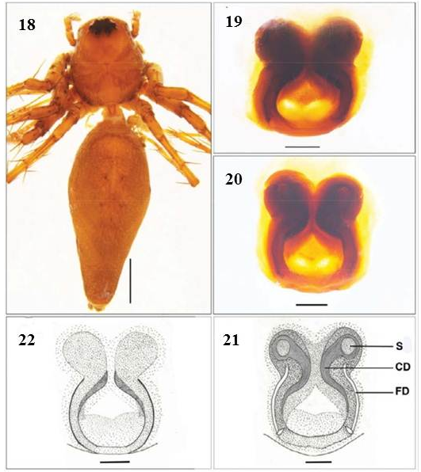
FIGURE 18. Habitus of Hamadruas hieroglyphica; Figs. 19 and 22: epigyne, dorsal view; Figs. 20 and 21: epigyne, ventral view. Scale lines: Fig. 18, 2 mm; Figs. 19–20, 0.3 mm (Sen & Sudhin, 2023).

Taxonomy
Family OXYOPIDAE Thorell, 1870
Genus Hamadruas Thorell, 1887
Type Species: Hamadruas hieroglyphicus Thorell (1887)
Diagnosis: For the diagnosis of the genus, see Deeleman-Reinhold (2009).
Distribution: China and Myanmar (World Spider Catalog, 2026); India: Kerala (Sen & Sudhin, 2023) (Fig. 18), and Maharashtra, Satara, Wai (new record, Fig. 1).
Genus Oxyopes:
In 1870, Thorell established the family Oxyopidae, with Oxyopes Latreille, 1804 as its type genus. Significant contributions to the family Oxyopidae in India were made by Thorell (1887), Tikader (1965), Gajbe and Gajbe (1999, 2000), Gajbe (2008), and Biswas and Roy (2005). Bodkhe and Vankhede (2012) reported two new species of Oxyopes from Koha and Bori villages, Amravati, Maharashtra. During examination of the collections from the Wai region of Satara District, Maharashtra, we diagnosed, described and illustrated a new species in the present study under the name Oxyopes waiensis sp. nov.
Taxonomy
Family OXYOPIDAE Thorell (1870)
Genus Oxyopes, Latreille (1804)
Type species: Oxyopes kohaensis Bodkhe & Vankhede, 2012.
Oxyopes waiensis sp. nov. (Figs. 23–30)
Diagnosis: Carapace pale yellow in colour dorsally, with an orange band bearing black setae at the middle fovea. Carapace elongated and slightly narrowed anteriorly, semi-translucent, with a distinct median longitudinal marking extending from the foveal region towards the posterior margin. Ocular area distinctly darker brownish and slightly raised. Surface smooth, sparsely covered with fine setae; lateral margins gently rounded without prominent spines; fovea shallow and indistinct.
Abdomen: The abdomen is elongated, cylindrical, and significantly narrowed towards the posterior end. Its colour is mainly whitish to silvery, with a broad continuous reddish-brown median longitudinal band extending from the anterior edge to near the spinnerets. The lateral margins are marked by thin irregular dark (blackish) lines, which may appear fragmented. The dorsal surface is smooth and sparsely covered with short fine setae, giving it a slightly reflective appearance. The posterior end is narrow, with short and inconspicuous spinnerets.
Ventral view of Oxyopes waiensis (opisthosoma and prosoma): The sternum is suboval to elongated, pale yellow and weakly sclerotised, covered with sparse fine setae; its margins are smooth without noticeable spines. The coxae are similar in colour to the sternum, and the endites (maxillae) are elongated, light yellow and converging anteriorly. The labium is short, subtriangular and pale. The chelicerae are light brown to yellowish and relatively slender, without any significant modifications.
Legs: The legs are long, slender, and spiny, typical of cursorial lynx spiders, and are mainly pale yellow to green in colour. The femora of all legs are elongated and greenish with scattered long black spines, while the patellae are short and light coloured. The tibiae and metatarsi range from yellowish to light brown and bear numerous strong upright black spines arranged in longitudinal rows. The tarsi are slender, tapering distally, and pale with fine setae.
The first and second pairs of legs are significantly more robust and longer than the hind pairs, adapted for prey capture. The femora and tibiae of these legs exhibit distinct dark (blackish) longitudinal bands, especially on their dorsal and lateral surfaces. In contrast, the third and fourth pairs of legs are comparatively slender, lighter in colour, and show less prominent banding. The joints, particularly between the distal tibia and metatarsus and between the metatarsus and tarsus, often display a reddish to pinkish tint. The spination is strong and distinct, with long black upright spines on the femora, tibiae, and metatarsi. The legs appear elongated and spiny, adapted for active hunting.
Epigyne (ventral view): The epigynal plate is small to moderately sclerotised, wider than long, and ranges in colour from pale yellow to light brown. The central region possesses a distinct darkened atrial area with a pair of closely placed copulatory openings. These openings are situated anteriorly and separated by a narrow median septum. The lateral margins are rounded and lack prominent projections. The surface is smooth with fine setae. The posterior margin is slightly curved, without a prominent scape.
Etymology: The species name is derived from the name of Wai tehsil, Maharashtra, India, where the species was collected.
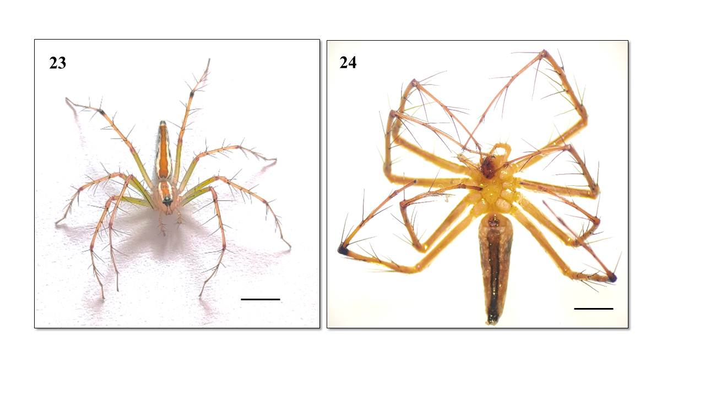
FIGURES 23–24. Habitus of the holotype Oxyopes waiensis sp. nov.; Fig. 23, dorsal view; Fig. 24, ventral view. Scale lines: 13.4 mm (Figs. 23–24).

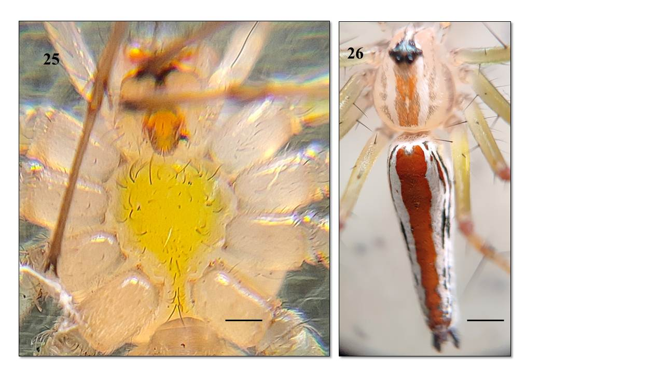
FIGURE 25. Cephalothorax, ventral view; Fig. 26, cephalothorax and abdomen, dorsal view. Scale lines: 0.5 mm (Fig. 25); 4 mm for cephalothorax and 9.40 mm for abdomen (Fig. 26).
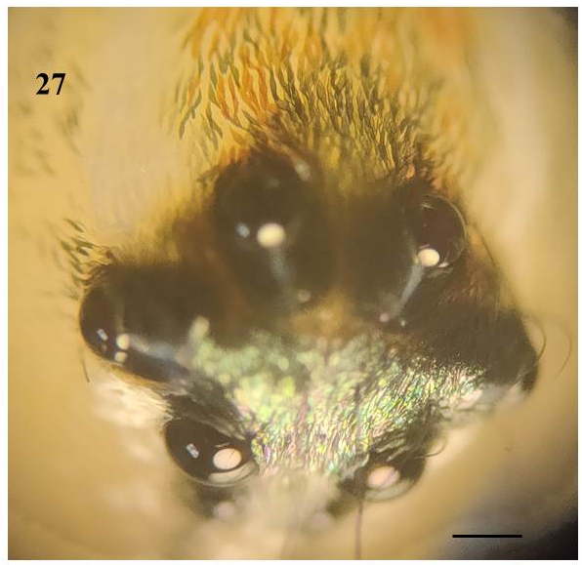
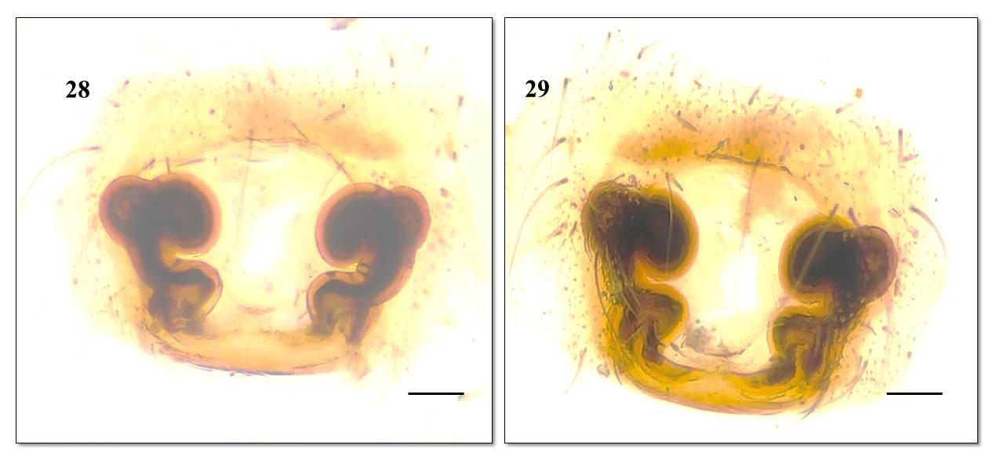

FIGURES 27–29. Fig. 27, eye arrangement; Fig. 28, female epigynum, ventral view; Fig. 29, dorsal view. Scale lines: 0.4 mm (Fig. 27); 0.4 mm (Figs. 28–29).
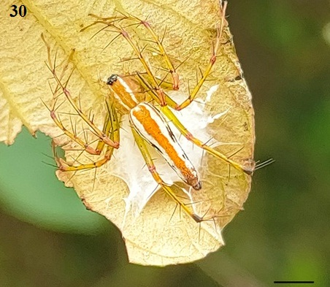
FIGURE 30. Oxyopes waiensis sp. nov.; female with egg sac. Scale line of egg sac: 8 mm (Fig. 30).

Type Material: Holotype: 1 female (Western Regional Centre, WRC, ZSI, Pune, Reg. No. AR/1826), India, Maharashtra, Satara, Wai, Kisan Veer Mahavidyalaya Campus, 17°56′41″N, 76°52′36″E, h = 738 m, collected by Rahul Tayade and Vishwas Deshpande.
Description: Oxyopes waiensis sp. nov. Female (Holotype).
Measurements: Total length 13.4 mm; carapace length 5 mm, width 4 mm, height 1.8 mm. Abdomen length 8 mm, height 1.5 mm. Leg measurements: Leg I: 7/1/6/5/2; Leg II: 6.5/1/4.9/6/2; Leg III: 7/1/5/6/2; Leg IV: 7/1/6/5/2.
Epigynum: Spermathecae reniform, more coiled or spiral-shaped (Figs. 28–29). They appear thicker and more compact, with a bulbous anterior part and a curved posterior extension.
Copulatory ducts: Curved tubular structures, highly coiled and prominent, forming a clear spiral pattern leading to the spermathecae.
Atrium: The central area between the spermathecae forms a broad atrium.
Epigynal plate: Smooth, rounded and weakly sclerotised at the margins. Margins indistinct, gradually blending with the surrounding tissue.
FIGURE 31: Distribution of the type locality of Hamadruas kvmensis sp. nov., Hamadruas keralensis Sen & Sudhin, 2023 and Hamadruas hieroglyphica Thorell, 1887 in India.
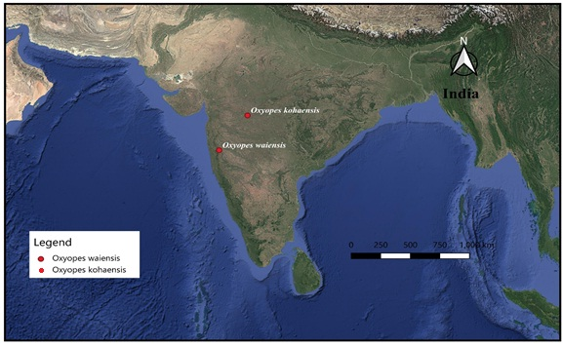
FIGURE 32: Distribution of the type locality of Oxyopes waiensis sp. nov. and
Oxyopes kohaensis Bodkhe & Vankhede, 2012 in Maharashtra, India.

Discussion:
Hamadruas kvmensis possesses two distinct dark elongated lobes of spermathecae, with the upper part resembling comma-shaped structures. The central area is rounded and forms the median fertilisation duct. The darker curved ducts extending towards the centre indicate the copulatory ducts. However, in H. keralensis Sen & Sudhin, 2023, the epigynal atrium is almost pot-shaped, the epigynal rim is laterally concave, copulatory openings are situated at the posterior end of the lateral edges, spermathecae are triangular, copulatory ducts are long and nearly S-shaped, and the fertilisation ducts are thick, anteriorly broad and posteriorly narrow. In H. hieroglyphicus Thorell, 1887, the epigynal atrium is nearly apple-shaped with highly sclerotised rims, spermathecae are globular, copulatory openings are situated at the lateral edges, copulatory ducts are thick and arch upward, while the fertilisation ducts are long and thin.
Oxyopes waiensis shows a close relationship with Oxyopes kohaensis Bodkhe & Vankhede, 2012, but differs from it in the following characters:
(i) The carapace is pale yellow dorsally, with an orange band bearing black setae at the middle fovea. It is elongated and slightly narrowed anteriorly, semi-translucent, and has a distinct median longitudinal marking extending from the foveal region towards the posterior margin, whereas in O. kohaensis the cephalothorax possesses two black bands just above the fovea. (ii) The abdomen in O. waiensis is elongated and tapers posteriorly, with a whitish to silvery base colour and a distinct dark median line extending from the epigastric furrow to the spinnerets, whereas in O. kohaensis the abdomen laterally bears black patches, and in O. chittrae the abdomen possesses conspicuous deep brown longitudinal dorsal bands (Tikader, 1965).
(iii) The epigynal plate in O. waiensis is small to moderately sclerotised, wider than long, pale yellow to light brown, with a darkened atrial area containing a pair of closely placed copulatory openings situated anteriorly and separated by a narrow median septum.
The lateral margins are rounded without significant projections, the surface is smooth with fine setae, and the posterior margin is slightly curved without a prominent scape. However, in O. kohaensis, the epigyne has oval spermathecae and short copulatory ducts (Bodkhe & Vankhede, 2012).
Acknowledgements: We thank Dr. S. S. Kulkarni (Scientist, C.C.M.B., Hyderabad) for cooperation and guidance in spider studies. We also thank Mrs. Suvarna Deshpande and all V.Y.D. team members, Mr. Abhijit Pathare, Mr. Pratik Badade, Mr. Shubham Mane, Ms. Smita Magade, Mr. Dhiraj Bhapkar and friends, for their support and assistance in spider collection. We express our sincere gratitude to Hon. Shri Madan Bhosale (Dada), President, Janata Shikshan Sanstha, Wai; Hon. Dr. G. J. Fagare, Principal, K.V.M. College, Wai; and all staff members for their valuable support and encouragement. We are also thankful to the Principal Chief Conservator of Forests and Member Secretary, Maharashtra State Biodiversity Board, Nagpur, for granting permission and providing support for the collection of biological resources. We also acknowledge the Western Regional Centre (WRC), Zoological Survey of India (ZSI), Pune; Mr. Sen; Mr. Sudhin; Mr. Bodkhe and Mr. Vankhede; Dr. Dhriti Banerjee, Director, Zoological Survey of India; and all staff members for their help with literature and encouragement.
Conclusions
The present study documents two oxyopid spider species from Wai, Satara District, Maharashtra, India, based on the morphological examination of collected specimens. Hamadruas kvmensis sp. nov. is recognised mainly by the structure of the female epigyne and the male palp, both of which provide important diagnostic characters for species-level identification. The female genitalia show elongated spermathecal lobes, a rounded central region and curved ducts, while the male palp possesses a distinct cymbium, bulb, tegulum, embolus, conductor and tibial apophysis. Oxyopes waiensis sp. nov. is distinguished by its body colour pattern, leg spination, abdominal markings and the form of the female epigyne, with coiled spermathecae and curved copulatory ducts. The record of Hamadruas from Wai expands the known occurrence of the genus in the region and contributes to the documentation of lynx spider diversity in Maharashtra. The findings also indicate that local habitats, such as college campuses, may support taxonomically significant arachnid diversity. Further surveys in nearby areas are likely to improve understanding of the distribution and diversity of Oxyopidae in the Western Ghats and adjoining regions.
Limitations
The study is based on a limited number of specimens collected from a single locality in Wai, Maharashtra. As a result, information on intraspecific variation, seasonal occurrence, habitat preference and population status remains incomplete. The descriptions are based primarily on external morphology and genital structures, and no molecular analysis was included to support species delimitation. Ecological observations are also limited, and the study does not provide detailed data on microhabitat, abundance, behaviour or prey interactions. For Oxyopes waiensis sp. nov., the description is based on female morphology, and additional material, including males, would strengthen future comparisons. Broader sampling from surrounding areas and comparison with more regional specimens would help confirm the distributional range and diagnostic stability of the proposed species. Future studies combining morphology, molecular data and ecological information would provide a more complete understanding of these taxa.
Declaration of AI Use
This manuscript was prepared through the combined contributions of all author(s), including contributions to the study design, data, content development, results, interpretation and related scholarly work. The author(s) acknowledge the use of Grammarly and ChatGPT to assist with grammar checking, language refinement and reference formatting. These AI-assisted tools were not used as authors and did not replace the intellectual contributions or scholarly judgment of the author(s). All AI-assisted outputs, including content, references and interpretations, were carefully reviewed, revised, verified and approved by the author(s). The author(s) accept full responsibility for the accuracy, integrity and final content of the manuscript.

References:
Bhattacharya, U., Sudhin, P. P., & Sen, S. (2026). A new species of the lynx spider genus Hamataliwa Keyserling, 1887 (Araneae: Oxyopidae) from Meghalaya, India. National Academy Science Letters. https://doi.org/10.1007/s40009-026-02315-3
Biswas, B., & Roy, R. (2005). Description of three new species of the genus Peucetia and genus Oxyopes (family: Oxyopidae: Araneae) from India. Records of the Zoological Survey of India, 105(1–2), 37–43. https://wsc.nmbe.ch/reference/9920
Biswas, V., Kundu, B., Kundu, M., Saha, S., & Raychaudhuri, D. (1996). Spiders of the genus Oxyopes Latreille (Araneae: Oxyopidae) of Buxa Tiger Reserve, West Bengal. Acta Arachnologica, 45(1), 53–61. https://doi.org/10.2476/asjaa.45.53
Bodkhe, A. K., & Vankhede, G. N. (2012). On two new species of spiders of the genus Oxyopes Latreille from central India (Arachnida: Araneae: Oxyopidae). Indian Journal of Arachnology, 1(1), 150–155. https://wsc.nmbe.ch/reference/11934
Dave, J. K., & Trivedi, V. M. (2024). Spider diversity (Arachnida: Araneae) at Saurashtra University Campus, Rajkot, Gujarat during the monsoon. Journal of Threatened Taxa, 16(3), 24930–24941. https://doi.org/10.11609/jott.8751.16.3.24930-24941
Deeleman-Reinhold, C. L. (2009). Description of the lynx spiders of a canopy fogging project in northern Borneo (Araneae: Oxyopidae), with a description of a new genus and six new species of Hamataliwa. Zoologische Mededelingen, 83(17), 673–700. https://repository.naturalis.nl/pub/311947
Gajbe, U. A. (2008). Fauna of India and the adjacent countries: Spider (Arachnida: Araneae: Oxyopidae) (Vol. 3). Zoological Survey of India. https://wsc.nmbe.ch/reference/10733
Gajbe, U. A., & Gajbe, P. (1999). Two new species of Oxyopes Latreille (Araneae: Oxyopidae) from Jabalpur, Madhya Pradesh, India. Geobios New Reports, 18, 13–16. https://wsc.nmbe.ch/reference/8731
Gajbe, U. A., & Gajbe, P. (2000). A new species of the genus Oxyopes Latreille (Araneae: Oxyopidae) from Jabalpur, Madhya Pradesh, India. Records of the Zoological Survey of India, 98, 123–125. https://wsc.nmbe.ch/reference/8911
Kulkarni, S., & Deshpande, V. Y. (2012). A new species of the genus Oxyopes Latreille (Araneae: Oxyopidae) from Sahyadri ranges of Western Ghats. Records of the Zoological Survey of India, 112(2), 35–37. https://www.gbif.org/species/7404259
Latreille, P. A. (1804). Histoire naturelle générale et particulière des crustacés et des insectes (Vol. 7, pp. 144–305). F. Dufart. https://www.biodiversitylibrary.org/item/53337
Lo, Y.-Y., Cheng, R.-C., & Lin, C.-P. (2024). Integrative species delimitation and five new species of lynx spiders (Araneae, Oxyopidae) in Taiwan. PLOS ONE, 19(5), e0301776. https://doi.org/10.1371/journal.pone.0301776
Mustak, M. S., & Kadakol, S. (2025). Arachnid diversity revisited: An updated checklist of spiders (Araneae) from Dakshina Kannada District, Karnataka, India. Asian Journal of Biology, 21(11), 257–285. https://doi.org/10.9734/ajob/2025/v21i11588
Nayak, J., Nichat, A. R., Harris, K. K., Warte, H. K., & Chaure, M. (2026). First record of a crab spider (Araneae: Thomisidae) species of genus Strigoplus Simon, 1886 in Chhattisgarh State, India. Bionature, 46(1), 218–225. https://doi.org/10.56557/bn/2026/v46i12104
QGIS.org. (2026). QGIS Geographic Information System [Computer software]. QGIS Association. https://www.qgis.org
Sankaran, P. M. (2024). Taxonomic notes on two poorly known lynx spider species from India (Araneae: Oxyopidae). Zootaxa, 5458(2), 297–300. https://doi.org/10.11646/zootaxa.5458.2.9
Sen, S., & Sudhin, P. P. (2023). A new species and a new record of Hamadruas Deeleman-Reinhold, 2009 (Araneae: Oxyopidae) from India. Records of the Zoological Survey of India, 122(4), 345–348. https://doi.org/10.26515/rzsi/v122/i4/2022/172386
Thorell, T. (1870). Araneae nonnullae Novae Hollandie, descriptae. Öfversigt af Kongliga Vetenskaps-Akademiens Förhandlingar, 27, 367–389. https://wsc.nmbe.ch/reference/410
Thorell, T. (1887). Viaggio di L. Fea in Birmania e regioni vicine. II. Primo saggio sui ragni birmani. Annali del Museo Civico di Storia Naturale di Genova, 25, 5–417. https://www.biodiversitylibrary.org/part/68239
Thorell, T. (1891). Spindlar från Nikobarerna och andra delar af södra Asien. Bihang till Kongliga Svenska Vetenskaps-Akademiens Handlingar, 24(2), 1–149. https://www.biodiversitylibrary.org/part/78009
Tikader, B. K. (1965). On some new species of spiders of the family Oxyopidae from India. Proceedings of the Indian Academy of Science, 62(B), 140–144. https://wsc.nmbe.ch/reference/3758
Tikader, B. K. (1970). Spider fauna of Sikkim. Records of the Zoological Survey of India, 64, 1–83. https://wsc.nmbe.ch/reference/4176
Tikader, B. K. (1987). Handbook of Indian spiders: A manual for the study of the spiders and their relatives. Zoological Survey of India. https://www.si.edu/object/handbook-indian-spiders-manual-study-spiders-and-their-relatives-bk-tikader%3Asiris_sil_1109335
World Spider Catalog. (2024). World Spider Catalog (Version 25.0). Natural History Museum Bern. https://doi.org/10.24436/2
World Spider Catalog. (2026). World Spider Catalog (Version 27.0). Natural History Museum Bern. https://doi.org/10.24436/2

