Original Research Article

A study of life cycle and ovipositional behavioral patterns of the pomegranate butterfly, Deudorix (Virachola) isocrates Fabricius in Bhagalpur, Bihar, India

.

ABSTRACT

The present study examined the life history, developmental biology, morphometry, ovipositional behaviour, and survival of the pomegranate fruit borer, Deudorix isocrates (Fabricius), under laboratory conditions in Bhagalpur, Bihar. Developmental stages were collected from pomegranate orchards at Bihar Agricultural University, Sabour, and reared at 27 ± 1 °C and approximately 70% relative humidity during 2025. Observations were recorded on egg-laying site preference, incubation period, larval instars, prepupal and pupal duration, adult longevity, fecundity, survival, and morphometric characters. Females showed a marked preference for oviposition in the calyx cup region of developing fruits, where 64.68% of the total 358 eggs were deposited. Oviposition also occurred on exposed fruit surfaces, flower buds, and other plant or cage surfaces. Eggs were shiny white and dome-shaped, measuring 1.09 ± 0.01 mm in length and 0.54 ± 0.01 mm in diameter. The incubation period ranged from 6 to 9 days, with a mean hatchability of 73.33%. Five larval instars were recorded, and the total larval period ranged from 25 to 39 days, with a mean duration of 29.8 ± 1.35 days. The prepupal and pupal periods had means of 2.9 ± 0.18 and 15.1 ± 0.74 days, respectively. Adult females were larger and lived longer than males, with mean longevity of 24.70 ± 3.49 days compared with 18.30 ± 2.79 days in males. Mean fecundity was 34 eggs per female. The complete life cycle from egg to adult ranged from 45 to 68 days, with a mean duration of 54.9 ± 2.13 days. These observations provide baseline information on the biology of D. isocrates under laboratory conditions and may support stage-specific pest monitoring in pomegranate.

Keywords: [Pomegranate fruit borer; Deudorix isocrates (Fabricius); biology; ovipositional behaviour; larval instars; life cycle; morphometry; pomegranate pest management]

1. INTRODUCTION

Pomegranate (Punica granatum L.) is an economically important fruit crop valued for its wide adaptability to diverse environmental conditions. It grows well under arid and semi-arid climates and tolerates drought, high temperatures, and relatively low soil fertility, making it suitable for regions where the cultivation of many other fruit crops is limited (Nafees, 2023). Recent work on pomegranate pest management has also examined crop-specific intervention strategies in the pomegranate ecosystem (Maradi et al., 2024). Despite these advantages, its productivity is adversely affected by the pomegranate fruit borer, Deudorix isocrates (Fabricius), a destructive pest that causes more than 50% fruit damage (Balikai et al., 2011), whose larvae bore into developing fruits and feed internally, causing considerable losses in both yield and fruit quality (Kumar et al., 2017). A recent survey of wild pomegranate fruit in the Jammu division also identified D. isocrates among damaging agents associated with symptomatic fruits (Ahmed et al., 2025). Although pomegranate is cultivated across different regions of India, its productivity in eastern India, including Bihar, is comparatively lower than in the western and southern regions (Madrewar et al., 2025). This highlights the need for region-specific information on the biology of D. isocrates under the agro-climatic conditions of eastern India. Recent observations from Jhalawar further examined the occurrence of D. isocrates on pomegranate in relation to plant phenology and abiotic conditions (Jat et al., 2026). However, information on the life cycle, morphometry, survival, and ovipositional behaviour of D. isocrates under controlled conditions in Bhagalpur remains limited, particularly for identifying vulnerable developmental stages under local conditions. Therefore, the present study was undertaken to investigate the biology, developmental stages, morphometry, and behavioural characteristics of D. isocrates under controlled laboratory conditions. The results of this study provide baseline information on the biology of the pest under laboratory conditions.

2. MATERIALS AND METHODS

2.1 Field collection and establishment of laboratory culture
Different developmental stages of the pomegranate fruit borer, Deudorix isocrates, including eggs, larvae, pupae, and adults, were collected from a 15-year-old pomegranate orchard comprising 360 trees of the cultivars 'Ganesh' and 'Bhagwa' (3 × 2 m spacing) at Bihar Agricultural University, Sabour, Bhagalpur. Field collections were made at three-day intervals during the morning hours (07:00-09:00 h) from August to September 2025 by scouting randomly selected trees, with emphasis on flower buds, calyx regions, and developing fruits showing infestation symptoms. Infested fruits and plant parts were carefully collected and transferred to the laboratory in labelled containers to prevent damage and mixing of developmental stages; the insects were subsequently reared under laboratory conditions.

2.2 Laboratory rearing conditions
Collected specimens were maintained individually in ventilated rearing containers under a single standardised laboratory condition (27 ± 1 °C and approximately 70% relative humidity). Ten randomly selected individuals were monitored continuously throughout their development. Fresh pomegranate fruits and floral buds were provided as food and replaced regularly to maintain freshness and hygiene. Rearing containers were cleaned periodically to minimise microbial contamination. Each individual was labelled separately and observed daily until completion of its developmental period.

2.3 Observations on biology and developmental stages
Freshly emerged adults were identified following Kehimkar (2016) and maintained in acrylic mating chambers supplied with fresh pomegranate twigs, flowers, and fruits for oviposition. A 10% honey solution soaked in cotton was provided as adult food (Kumar et al., 2017). Observations on ovipositional preference (Patil, 2022), egg distribution, fecundity, incubation period, hatchability, larval instars, larval duration, prepupal and pupal duration, pupation site, and adult longevity were recorded following Kaushal et al. (2021) and Khandare et al. (2018). Randomly selected larvae (n = 10) were reared individually and observed daily until pupation. Larval instars were identified based on successive moults, and the duration of each instar and the total larval period were recorded from hatching to pupation (Bharti et al., 2021). Freshly laid eggs, larvae, prepupae, pupae, and adults were examined under a Leica stereomicroscope for morphological and morphometric studies. Measurements of egg length and width, larval body length and width, pupal dimensions, adult body length, wingspan, forewing dimensions, and antennal length were recorded using Leica image-analysis software (Kumar et al., 2017; Kaushal et al., 2021). Daily observations were also made to record developmental duration, colour changes, and survival of different life stages (Khandare et al., 2018).

2.4 Sampling and data collection

The experiment was conducted twice under identical laboratory conditions. Ten individuals were randomly selected at the beginning of the study and monitored throughout successive developmental stages for recording developmental and morphometric parameters. Morphometric data are presented as mean ± SE, whereas reproductive parameters were recorded over the entire experimental population throughout the study period.

3. RESULTS AND DISCUSSION

3.1 Ovipositional preference and egg distribution

Females of Deudorix isocrates showed clear ovipositional preference under laboratory and field conditions. Out of 358 eggs recorded, maximum oviposition occurred within the calyx cup region of developing fruits (64.68% of eggs; Fig. 1), followed by exposed fruit surfaces (23.12%; Fig. 2), flower buds (7.79%), and non-fruit structures such as pedicels (Fig. 3), leaves, nearby plant parts, and cage walls (4.42%). Eggs were laid singly, in pairs, and occasionally in clusters of 15-25 eggs (Fig. 1), mainly in the calyx region. The preference for the calyx cup indicated selective oviposition behaviour, which may provide shelter, a favourable microclimate, and immediate food access for neonate larvae. Similar oviposition behaviour on the calyx or young fruits was reported by Kumar et al. (2017), while Patil (2022) also identified the calyx end as the preferred oviposition site. In contrast, Chhetry et al. (2015) observed preference for the middle region of sweet orange fruits, suggesting that oviposition sites may vary with host fruit characteristics.

3.2 Egg stage

Freshly laid eggs were shiny white, slightly dome-shaped, circular to oval, and possessed distinct reticulate chorionic sculpturing with a centrally located micropyle (Fig. 5). The diameter of the egg micropyle ranged from 0.13 to 0.17 mm, with a mean of 0.154 ± 0.004 mm. Mean egg length and diameter were 1.09 ± 0.01 mm and 0.54 ± 0.01 mm, respectively (Table 2). The incubation period ranged from 6 to 9 days, with a mean of 7.10 ± 0.31 days (Table 1). Egg colour gradually changed from translucent white to creamy white and then to darker shades before hatching. The larval head capsule became visible through the chorion before emergence. A few eggs failed to hatch because of parasitism, fungal infection, or absence of embryonic development. The incubation period observed in the present study (7.10 ± 0.31 days) was comparable with that reported by Kumar et al. (2017) (7.15 ± 0.10 days) and Khandare et al. (2018) (7.20 ± 0.92 days), whereas Chhetry et al. (2015), Kaushal et al. (2021), and Tiwari et al. (2007) reported comparatively longer incubation periods of 8.0 ± 0.38, 8.66 ± 2.05, and 9.2 ± 0.72 days, respectively.

3.3 Unfertilised eggs and fecundity

A small proportion of malformed and non-viable eggs was observed under laboratory conditions (Fig. 4). These eggs were flattened, elongated, weakly attached, and lacked proper chorionic symmetry. The chorion appeared thinner and less shiny, and no embryonic development occurred throughout incubation. Such eggs were mainly produced by unmated females. Mean fecundity was 34 eggs per female. The occurrence of unfertilised eggs indicated the importance of successful mating for reproduction. Similar observations were reported by Mallikarjun and Pal (2018). The fecundity observed in the present study exceeded the values reported by Mallikarjun and Pal (2018) and Tiwari et al. (2007), probably because of favourable laboratory conditions and the inclusion of unfertilised eggs in total counts.

3.4 Larval development

Five larval instars were observed through continuous monitoring of successive moults. The total larval period ranged from 25 to 39 days, with a mean of 29.8 ± 1.35 days, representing the longest developmental stage (Tables 1 and 2). Progressive increases in body size, pigmentation, head capsule width, and feeding intensity were observed in successive instars.

3.4.1 First instar

Newly hatched larvae were creamy white with a black head capsule and terminal abdominal segment (Fig. 6). Mean body length and width were 2.44 ± 0.16 mm and 0.69 ± 0.04 mm, respectively (Table 2). Larvae initially fed on floral tissues before entering fruits. The duration ranged from 4 to 7 days, with a mean of 4.7 ± 0.33 days (Table 1), which was longer than the 2.66 ± 0.46 days reported by Kaushal et al. (2021), 3.5 ± 0.52 days reported by Mohi-Ud-Din et al. (2015), and 4.8 ± 1.10 days reported by Bhut et al. (2013). These differences possibly resulted from variation in temperature, host substrate, and feeding conditions. Furthermore, Patil (2023) reported a mean body length of 2.38 mm.

3.4.2 Second instar

Second instar larvae became pale brown with prominent dorsal patches (Fig. 7). Mean body length and width increased to 6.63 ± 0.19 mm and 1.93 ± 0.09 mm, respectively (Table 2). Feeding intensity increased with enlargement of fruit entry holes. The duration ranged from 6 to 8 days, with a mean of 6.5 ± 0.27 days (Table 1). Comparable observations were reported by Patil (2023), Bhut et al. (2013), and Mohi-Ud-Din et al. (2015).

3.4.3 Third instar

Third instar larvae were robust and reddish brown with yellowish abdominal spots and a flattened posterior segment (Fig. 8). Mean body length and width were 11.78 ± 0.29 mm and 3.40 ± 0.05 mm, respectively (Table 2). Larvae penetrated deeper into fruit tissues, and the stage lasted 6 to 9 days, with a mean of 6.9 ± 0.41 days (Table 1). Head capsule width was 1.26 mm. Similar findings were documented by Patil (2023), Bhut et al. (2013), and Kaushal et al. (2021).

3.4.4 Fourth instar

Fourth instar larvae became dark reddish brown with thickened integument and dense setae (Fig. 9). Feeding became highly voracious, with heavy frass expulsion through bore holes. Mean body length and width were 17.71 ± 0.19 mm and 5.38 ± 0.14 mm, respectively (Table 2). The duration ranged from 5 to 8 days, with a mean of 6.3 ± 0.42 days (Table 1). Head capsule width was 1.68 mm. Similar observations were reported by Bhut et al. (2013), who recorded body length of 17.4 ± 1.95 mm, breadth of 4.6 ± 0.52 mm, and duration of 6.3 ± 0.62 days, which closely matched the present findings.

3.4.5 Fifth instar

The fifth instar represented the final and most destructive feeding stage. Larvae were deep reddish brown with pale abdominal patches and heavily thickened integument (Fig. 10). Mean body length and width were 23.07 ± 0.48 mm and 6.59 ± 0.21 mm, respectively (Table 2). The duration ranged from 4 to 7 days, with a mean of 5.4 ± 0.34 days (Table 1). Head capsule width was 1.92 mm. Progressive increase in head capsule width followed Dyar's rule. Bhut et al. (2013) reported body length of 22.5 ± 1.90 mm, breadth of 5.78 ± 1.20 mm, and duration of 5.22 ± 1.02 days, which closely agreed with the present findings. Overall, the present findings were comparable with the durations reported by Bharti et al. (2021), who observed 26 to 32 days, Chhetry et al. (2015), who observed 24 to 38 days, and Latif et al. (2022), who observed a mean of 32.22 days. Kaushal et al. (2021) reported a comparatively shorter duration of 15.33 ± 6.94 days, while Khan (2016) recorded a wider range of 17 to 46 days.

3.5 Pre-pupal stage

Fully grown larvae entered a quiescent prepupal stage characterised by body contraction, dark bluish dorsal colouration, and a dirty white ventral surface (Fig. 11). Mean body length and width were 16.53 ± 0.47 mm and 7.17 ± 0.21 mm, respectively (Table 1). The prepupal period ranged from 2 to 4 days, with a mean of 2.9 ± 0.18 days (Table 2). The reduction in body size reflected physiological reorganisation before metamorphosis. Similar durations were reported by Bhut et al. (2013), who observed 2.4 ± 0.48 days, and by Tiwari et al. (2007) and Kabade and Gangawane (2015), who observed 3.4 ± 0.45 days. Kumar et al. (2017) observed 4.35 ± 0.12 days. Latif et al. (2022) reported a combined prepupal and pupal period of 17.60 days.

3.6 Pupal stage

Pupation mainly occurred inside damaged fruits, feeding tunnels, and calyx cups. The pupa was obtect, adecticous, and non-feeding, gradually changing from light greenish to dark brown before adult emergence (Fig. 12). Mean pupal length and width were 14.25 ± 0.33 mm and 6.49 ± 0.22 mm, respectively (Table 2). The pupal period ranged from 12 to 19 days, with a mean of 15.1 ± 0.74 days (Table 1). Concealed pupation provided protection from environmental stress and natural enemies. These findings agreed with those of Kaushal et al. (2021), who reported 15.33 ± 6.94 days, and Latif et al. (2022), who reported 17.60 days. Comparable durations were also reported by Chhetry et al. (2015), who recorded 13 to 16 days, with a mean of 14.55 ± 0.32 days on citrus; Tiwari et al. (2007), who reported 14.5 ± 2.79 days; Bhut et al. (2013), who reported 10.8 ± 2.20 days; Kumar et al. (2017), who reported 10.25 ± 0.10 days; and Mohi-Ud-Din et al. (2015), who reported 7.4 ± 0.42 days for the second generation under temperate conditions.

3.7 Adult morphometry and longevity

Adults exhibited clear sexual dimorphism (Figs. 13 and 14). Females were larger and more robust than males. Female body length ranged from 18.85 to 30.38 mm (mean 24.80 ± 1.69 mm), wingspan from 34.38 to 40.77 mm (mean 37.69 ± 1.13 mm), and antennal length from 7.73 to 8.52 mm (mean 8.02 ± 0.14 mm). In contrast, males measured 15.75 to 24.90 mm in body length (mean 21.22 ± 1.53 mm), with a wingspan of 31.69 to 38.15 mm (mean 34.26 ± 1.17 mm) and longer antennae ranging from 8.36 to 9.43 mm (mean 8.93 ± 0.22 mm) (Table 2), indicating their probable role in mate searching. Females possessed broader wings, a distinct orange patch on the forewing, orange-tinged spotted hindwings, and a well-developed ovipositor, whereas males showed bluish forewing colouration, consistent with the observations of Bharti et al. (2021). Khan (2016) reported a mean male body length of 16.90 mm, antennal length of 10.35 mm, and forewing length of 16.00 to 18.00 mm, values that were slightly higher than those recorded in the present study, possibly because of host plant or geographic variation. Female longevity ranged from 11 to 53 days (mean 24.70 ± 3.49 days), while male longevity ranged from 9 to 31 days (mean 18.30 ± 2.79 days) (Table 1). The larger body size and longer lifespan of females were likely associated with reproductive investment and egg production, whereas the longer antennae of males may enhance mate-searching efficiency. The female longevity observed in the present study exceeded that reported by Kumar et al. (2017) (10.28 ± 0.20 days), Tiwari et al. (2007) (10.5 ± 1.08 days), Latif et al. (2022) (6.58 days), Khan (2016) (4 to 7 days), Chhetry et al. (2015) (15 to 18 days; mean 16.75 ± 0.35 days), and Mallikarjun and Pal (2018) (12.05 ± 1.52 days on pomegranate and 13.06 ± 1.62 days on artificial diet), possibly because favourable laboratory conditions reduced environmental stress.

3.8 Behavioural observations prior to oviposition

Adults showed a distinct behavioural sequence before oviposition. Newly emerged butterflies remained inactive for 5 to 10 minutes for wing expansion and hardening, followed by walking, short flights, wing fluttering, basking, and searching for suitable oviposition sites. Oviposition commenced 6 to 8 days after adult emergence. The organised behavioural sequence indicated a regulated reproductive strategy favouring careful oviposition site selection. Similar observations were reported by Mallikarjun and Pal (2018) and Mohi-Ud-Din et al. (2015).

3.9 Total developmental period and ecological significance

The complete life cycle ranged from 45 to 68 days, with a mean duration of 54.9 ± 2.13 days (Tables 1 and 2). The prolonged larval period, concealed feeding habit, and protected pupation behaviour contributed substantially to the pest status of the insect. The present findings were broadly comparable with those of Bharti et al. (2021) (52.3 ± 1.40 days), Kumar et al. (2017) (63.92 ± 2.87 days), Kaushal et al. (2021) (40 ± 4.08 days), and Mallikarjun and Pal (2018) (45.3 ± 1.82 days), confirming considerable developmental differences under different agro-climatic conditions. Preference for oviposition within the calyx region and concealed larval feeding emphasised the importance of early monitoring and timely management interventions. Early larval instars appeared to be the most vulnerable stages for effective pest management, whereas concealed pupation reduced the effectiveness of contact insecticides during later developmental stages (Patil, 2022).

Table 1. Duration of different developmental stages of Deudorix Isocrates in 2025

Sl. No | Life stage | Periods (days)
Sl. No | Life stage | Range | Mean ± SE
1 | Incubation period | 6-9 | 7.10 ± 0.31
2 | Instars
2 | 1st instar | 4-7 | 4.7 ± 0.33
2 | 2nd instar | 6-8 | 6.5 ± 0.27
2 | 3rd instar | 6-9 | 6.9 ± 0.41
2 | 4th instar | 5-8 | 6.3 ± 0.42
2 | 5th instar | 4-7 | 5.4 ± 0.34
2 | Total larval period | 25 -39 | 29.8 ± 1.35
3 | Prepupal period | 2-4 | 2.9 ± 0.18
4 | Pupal period | 12-19 | 15.1 ± 0.74
5 | Total development period | 45- 68 | 54.9 ± 2.13
6 | Adult longevity
6 | Male | 9 - 31 | 18.30 ± 2.79
6 | Female | 11-53 | 24.70 ± 3.49
*Values are averages of 10 observations, SE= Standard Error.

Table 2. Morphometrics of different developmental stages of Deudorix isocrates in 2025

Sl.no | Life stage | Length Range (mm) | Length (mm)  (Mean ± SE) | Width  Range (mm) | Width (mm)  (Mean ± SE)
1 | Egg | 1.02 - 1.13 | 1.09 ± 0.01 | 0.46 - 0.71 | 0.54 ± 0.01**
2 | Larva
2 | 1st instar | 1.79 – 3.26 | 2.44 ± 0.16 | 0.49 – 0.89 | 0.69 ± 0.04
2 | 2nd instar | 5.82 – 7.97 | 6.63 ± 0.19 | 1.42 – 2.45 | 1.93 ± 0.09
2 | 3rd instar | 10.55 – 13.97 | 11.78 ± 0.29 | 3.22 – 3.67 | 3.40 ± 0.05
2 | 4th instar | 16.81 – 18.86 | 17.71 ± 0.19 | 4.87 – 6.05 | 5.38 ± 0.14
2 | 5th instar | 20.26 – 25.88 | 23.07 ± 0.48 | 5.24 – 7.29 | 6.59 ± 0.21
3 | Prepupa | 14.20 – 17.99 | 16.53 ± 0.47 | 5.78 – 7.85 | 7.17 ± 0.21
4 | Pupa | 12.68 - 15.99 | 14.25 ± 0.33 | 5.54 - 7.67 | 6.49 ± 0.22
5 | Adult | Body length |  | Wingspan
5 | Male | 15.75 – 24.90 | 21.22 ± 1.53 | 31.69 - 38.15 | 34.26 ± 1.17*
5 | Female | 18.85 - 30.38 | 24.80 ± 1.69 | 34.38 – 40.77 | 37.69 ± 1.13*
6 |  | Forewing length |  | Forewing width
6 | Male | 13.64 – 19.02 | 15.99 ± 0.98 | 9.85 – 12.30 | 11.35 ± 0.48
6 | Female | 16.39 – 19.62 | 17.69 ± 0.58 | 10.91 – 14.39 | 13.16 ± 0.64
7 |  | Antennal length
7 | Male | 8.36 – 9.43 |  | 8.93 ± 0.22
7 | Female | 7.73 – 8.52 |  | 8.02 ± 0.14
* Width with expanded wings, ** diameter of egg, Values are averages of 10 observations, SE= Standard Error.

4. CONCLUSION
This study documented the developmental biology, morphometry, ovipositional behaviour, and life cycle of Deudorix isocrates under controlled laboratory conditions at Bhagalpur, Bihar. Females showed a distinct preference for laying eggs in the calyx cup region of developing pomegranate fruits, indicating that this site may be important for infestation by newly hatched caterpillars. The insect completed five larval instars, and the larval stage occupied the longest part of the developmental period. The concealed feeding habit of larvae and pupation within damaged fruits and feeding tunnels may contribute to the persistence of this pest in pomegranate orchards. The complete life cycle ranged from 45 to 68 days, with a mean duration of 54.9 ± 2.13 days. Adult females were larger and had greater longevity than males, with a mean fecundity of 34 eggs per female. These results provide baseline information on the life history of D. isocrates in the study region and indicate that monitoring egg laying and early larval stages may improve the timing of pest-management interventions in pomegranate cultivation.

Limitations
This study was conducted under controlled laboratory conditions at 27 ± 1 °C and approximately 70% relative humidity; therefore, the results may not fully represent development, survival, or behaviour under variable field conditions. Observations were based on laboratory-reared individuals collected from pomegranate orchards at a single location; seasonal and multi-location variation was not assessed. The study used descriptive statistics and did not include comparative treatment, host, temperature, or humidity experiments. Field validation across seasons and agro-climatic conditions is required before these developmental and ovipositional observations are applied to pest-management decisions.

COMPETING INTERESTS:
Authors have declared that they have no known competing financial interests OR non-financial interests OR personal relationships that could have appeared to influence the work reported in this paper.

Declaration of AI Use

This manuscript was prepared through the combined contributions of all author(s), including contributions to the study design, data, content development, results, interpretation, and related scholarly work. The author(s) acknowledge the use of Grammarly and ChatGPT to assist with grammar checking, language refinement, reference formatting. These AI-assisted tools were not used as authors and did not replace the intellectual contributions or scholarly judgment of the author(s). All AI-assisted outputs, including content, references, and interpretations, were carefully reviewed, revised, verified, and approved by the author(s). The author(s) accept full responsibility for the accuracy, integrity, and final content of the manuscript.

References

- Ahmed, M., Shandalya, K., Khajuria, A., & Verma, S. (2025). First report of fruit borer and fungal pathogens affecting wild pomegranate (Punica granatum L.) fruit in different agroclimatic zones of Jammu Division, India. Applied Fruit Science, 67, Article 298. https://doi.org/10.1007/s10341-025-01509-1
- Balikai, R. A., Kotikal, Y. K., & Prasanna, P. M. (2011). Status of pomegranate pests and their management strategies in India. Acta Horticulturae, 890, 569–583. https://doi.org/10.17660/ActaHortic.2011.890.81
- Bharti, V., Rana, V. K., & Kumar, S. (2021). Biology of pomegranate fruit borer Deudorix isocrates. Indian Journal of Entomology, 83(1), 51–53. https://doi.org/10.5958/0974-8172.2020.00244.8
- Bhut, J. B., Borad, P. K., & Gadhiya, H. A. (2013). Bionomics and evaluation of different biocides against anar butterfly, Virachola isocrates (Fabricius) infesting pomegranate. International Journal of Plant Protection, 6(2), 338–343. https://researchjournal.co.in/online/IJPP/IJPP%206%282%29/6_338-343_A.pdf
- Chhetry, M., Gupta, R., & Tara, J. S. (2015). Bionomics of Deudorix isocrates Fabricius (Lepidoptera: Lycaenidae), a new potential host of sweet orange, Citrus sinensis L. Osbeck in J&K, India. International Journal of Science and Nature, 6(2), 238–241. https://www.scienceandnature.org/IJSN/IJSN_Vol6%282%29J2015/IJSN-VOL6%282%2915-21.pdf
- Jat, S. K., Sharma, A., & Choudhary, A. (2026). Study of fruit-borer Deudorix (Virachola) isocrates on pomegranate (Punica granatum) and its fluctuation through abiotic stress. Current Horticulture, 14(2), 107–109. https://doi.org/10.5958/2455-7560.2026.00028.1
- Kabade, K. H., & Gangawane, S. B. (2015). Biology of fruit borer (Deudorix isocrates Fabr.) on Emblica officinalis. Medicinal Plants - International Journal of Phytomedicines and Related Industries, 7(1), 71–73. https://doi.org/10.5958/0975-6892.2015.00011.8
- Kaushal, H., Thakur, M. S., Singh, J., & Lal, R. (2021). Biology of anar butterfly: Deudorix (Virachola) isocrates Fabricius (Lepidoptera: Lycaenidae) in mid hill of Himachal Pradesh. Annual Research & Review in Biology, 36(4), 43–47. https://doi.org/10.9734/arrb/2021/v36i430362
- Kehimkar, I. D. (2016). Butterflies of India: BNHS field guides. Bombay Natural History Society. https://searchworks.stanford.edu/view/12133815
- Khan, M. M. H. (2016). Biology and management of fruit borer, Virachola isocrates (Fab.) infesting guava. Bangladesh Journal of Agricultural Research, 41(1), 41–51. https://doi.org/10.3329/bjar.v41i1.27666
- Khandare, R. Y., Kadam, D. R., & Jayewar, N. E. (2018). Biology of pomegranate fruit borer, Deudorix isocrates (Fab.) (Lycaenidae: Lepidoptera) on pomegranate, Punica granatum L. Journal of Pharmacognosy and Phytochemistry, 7(5), 328–330. https://www.phytojournal.com/archives/2018/vol7issue5/PartF/7-5-35-129.pdf
- Kumar, K. P., Jayanthi, P. D. K., Naik, S. O., Verghese, A., & Chakravarthy, A. K. (2017). Biology of anar butterfly, Deudorix isocrates (Fab.) (Lycaenidae: Lepidoptera) on pomegranate, Punica granatum L. International Journal of Pure & Applied Bioscience, 5(1), 498–503. https://doi.org/10.18782/2320-7051.2564
- Latif, A., Sattar, S., Maula, F., Khan, I., Iqbal, A., & Shah, S. H. (2022). Biology and management of pomegranate fruit borer, Virachola isocrates (Lepidoptera: Lycaenidae), through chemicals and botanical extracts. Pakistan Journal of Agricultural Research, 35(2), 425–433. https://doi.org/10.17582/journal.pjar/2022/35.2.425.433
- Madrewar, S., Gholave, B., Kalkhaire, S., Bhujabal, A., & Patil, R. (2025). State-wise analysis of area, production and productivity of pomegranate in India (2023–24): A regional comparative study. International Journal of Business and Management Practices, 3(6), 397–406. https://doi.org/10.59890/ijbmp.v3i6.119
- Maradi, R. M., Jagginavar, S. B., Keerthana, A., & Doggalli, G. (2024). Synergistic strategies for the management of thrips, Scirtothrips dorsalis in pomegranate ecosystem. Journal of Experimental Agriculture International, 46(9), 354–361. https://doi.org/10.9734/jeai/2024/v46i92832
- Mallikarjun, M. H., & Pal, R. K. (2018). Laboratory rearing protocol for pomegranate fruit borer (Deudorix isocrates). International Journal of Current Microbiology and Applied Sciences, Special Issue 6, 883–888. https://ijcmas.com/special/6/M.%20H.%20Mallikarjun%20and%20R.%20K.%20Pal.pdf
- Mohi-Ud-Din, S., Wani, N. A., Ahmad, M. J., Mir, G. M., & Sofi, M. A. (2015). Seasonal incidence of anar butterfly and its correlation with weather parameters. The Bioscan, 10(4), 1561–1566. https://thebioscan.com/index.php/pub/article/view/1431
- Nafees, M., Hussain, S., Usman, M., & Jaskani, M. J. (2023). Prospects of climate resilience in pomegranate. In A. A. Abul-Soad & J. M. Al-Khayri (Eds.), Cultivation for climate change resilience, Volume 2: Temperate fruit trees (pp. 213–232). CRC Press. https://doi.org/10.1201/9781003351153-11
- Patil, R. D. (2022). Behavior of pomegranate fruit borer, Deudorix isocrates (Fab.) (Lepidoptera: Lycaenidae). Arthropods, 11(2), 72–80. https://www.iaees.org/publications/journals/arthropods/articles/2022-11%282%29/1-Patil-Abstract.asp
- Patil, R. D. (2023). Thoracic morphology of the pomegranate fruit borer (Lepidoptera: Lycaenidae) larva. Arthropods, 12(1), 57–68. http://www.iaees.org/publications/journals/arthropods/articles/2023-12(1)/thoracic-morphology-of-pomegranate-fruit-borer.pdf
- Tiwari, A. K., Mishra, P., & Tiwari, S. C. (2007). Biology of Deudorix isocrates Fabr. on aonla, Emblica officinalis. Annals of Plant Protection Sciences, 15(2), 335–337. https://www.indianjournals.com/article/apps-15-2-013

Figures

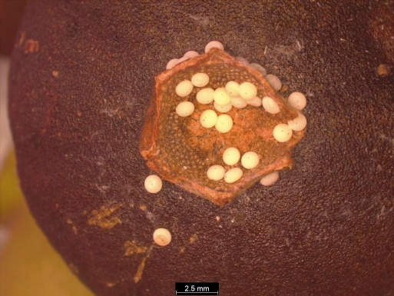  Fig. 1: Cluster eggs on calyx cup | 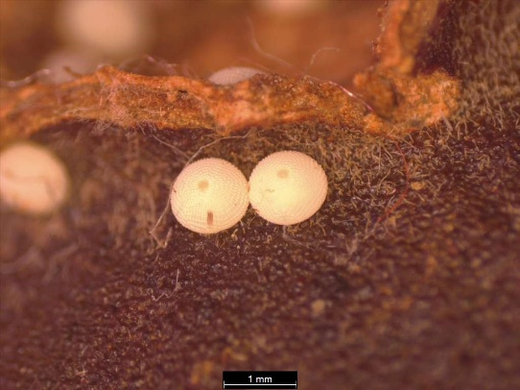  Fig. 2: Paired eggs on fruit surface
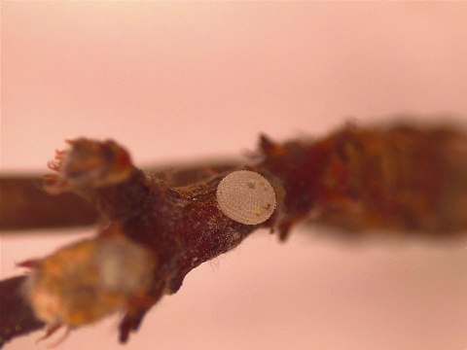  Fig. 3: Single egg on pedicel | 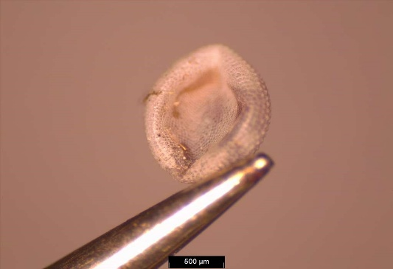  Fig. 4: Defective egg
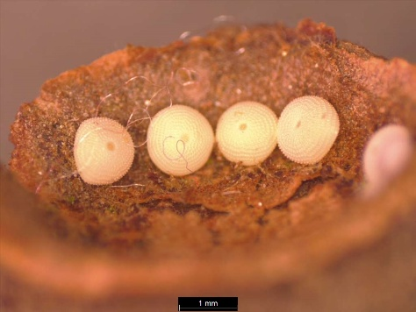  Fig. 5: Cluster of eggs | 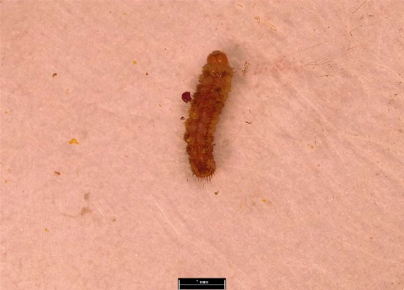  Fig. 6: First instar caterpillar
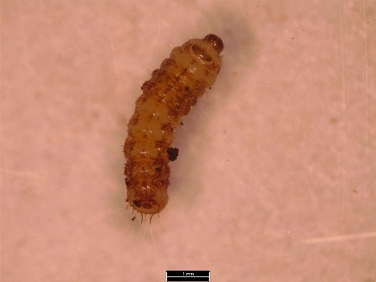  Fig. 7: Second instar caterpillar | 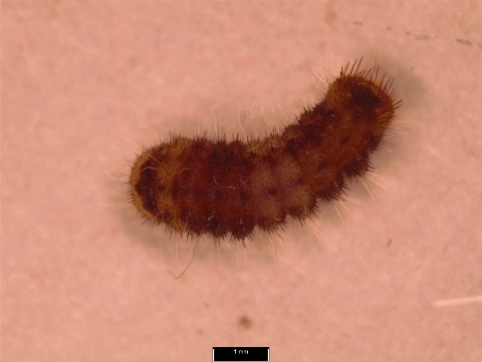  Fig. 8: Third instar caterpillar
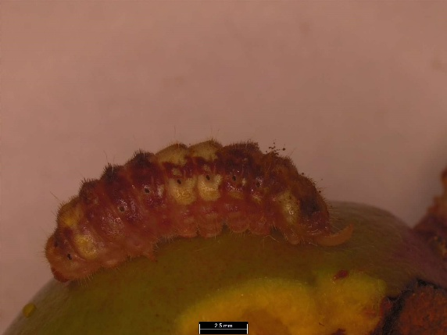  Fig. 9: Fourth instar caterpillar | 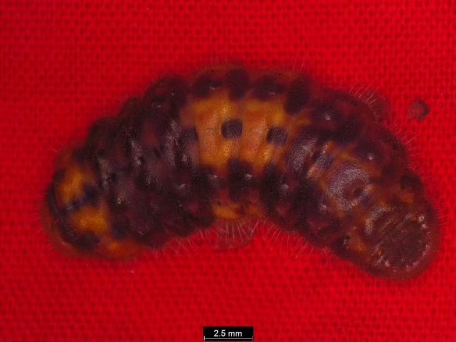  Fig. 10: Fifth instar caterpillar
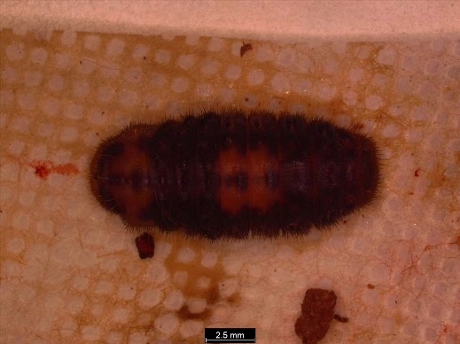  Fig. 11: Pre-pupal stage | 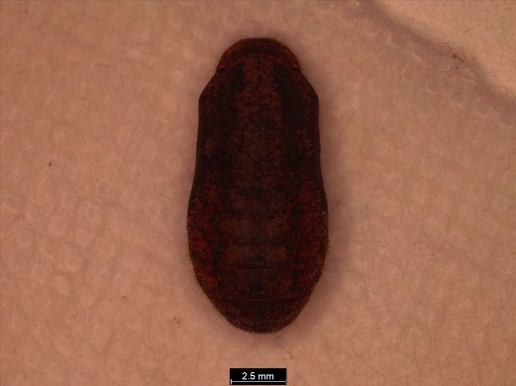  Fig. 12: Pupal stage
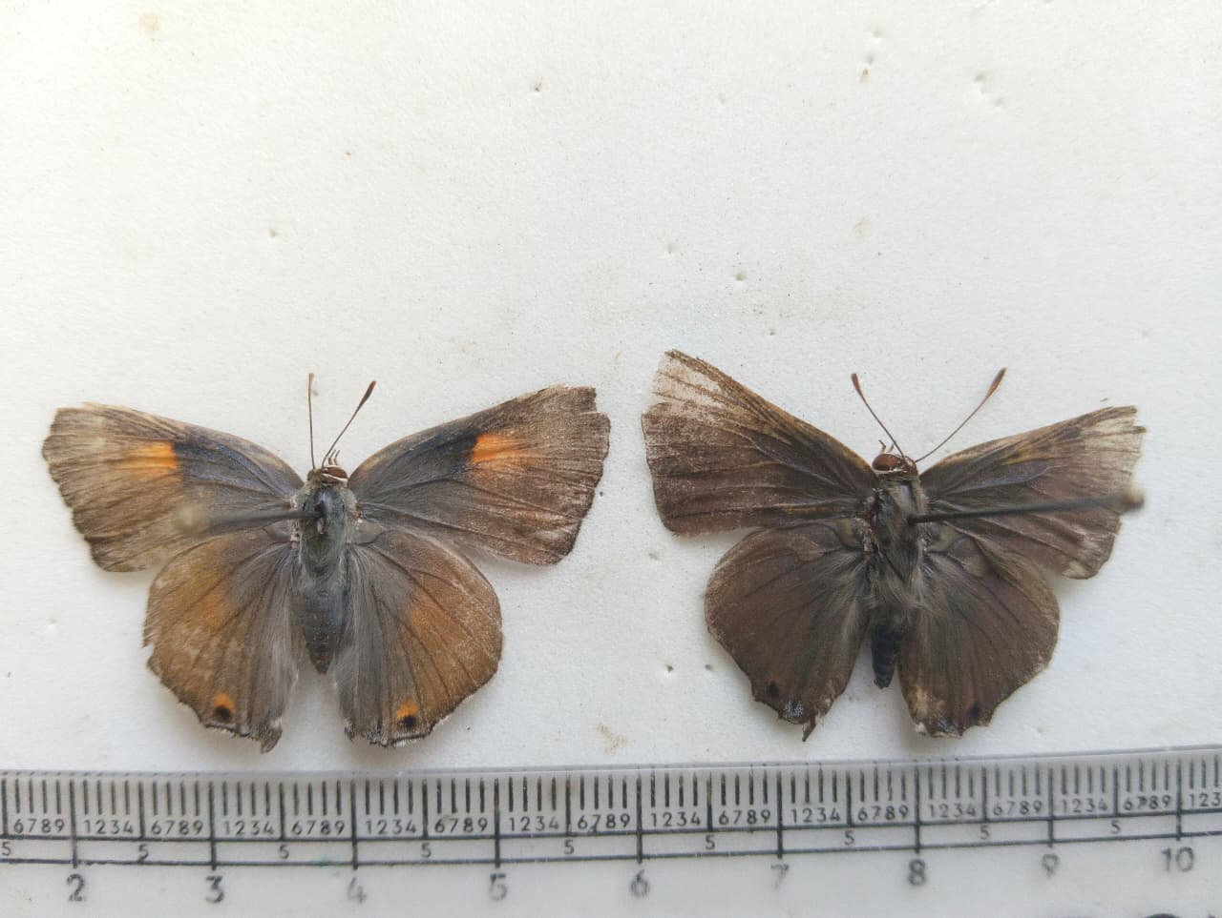  Fig. 13: Adult female | Fig. 14: Adult male

