Studies on fishing crafts and gears along Ujani backwater region of Bhigwan of Pune district, Maharashtra, iNDIA

Abstract
The present study documented the fishing crafts and gears used by local fishermen in the Ujani backwater region of Bhigwan, Pune district, Maharashtra, India. The survey was conducted from January to March 2026 through field visits, direct observations, measurements and personal interviews with fishermen. Three fishing crafts were recorded: thermocol rafts, plank-built boats and rubber tube platforms. Thermocol rafts and plank-built boats were commonly used for routine fishing operations, whereas rubber tube platforms were used less frequently for small-scale fishing. Five major fishing gears were documented: gill nets, drag nets, cast nets, box traps, and hooks and lines. Gill nets and drag nets were the most commonly used gears in the study area. Gill nets were operated in shallow and deeper waters and were mainly used for catching Indian major carps, Chanda spp., prawns and other fishes, with an observed average catch of 12-14 kg/day. Drag nets were used for larger catches and recorded an average catch of 40-64 kg per operation. Cast nets, hooks and lines, and box traps were used according to fishing site, target species and fishermen's affordability. Box traps were mainly observed at selected sites and recorded an average catch of 0.5-2.5 kg/day per trap. The study indicates that local fishermen use both traditional and modified fishing methods according to available resources, local conditions and operational needs. This documentation may support future studies on indigenous fishing practices and sustainable inland fishery management.
Keywords: Inland fisheries; fishing crafts; fishing gears; plank-built boats; gill nets; cast nets; drag nets; traditional fishing practices; Ujani Reservoir; sustainable fisheries management.

INTRODUCTION:
Inland fisheries are currently at a critical stage because of the combined pressures of increasing demand for fish production, overfishing and climate change. A transition towards sustainable fishing methods has therefore become a socio-economic and ecological necessity. Fishing crafts and gears serve as the primary interface between fishery operations and aquatic ecosystems. The availability, design and use of these tools directly influence catch composition, species selectivity, fish production and fishing operations (Dar et al., 2024). Recent review evidence indicates that abandoned, lost and otherwise discarded fishing gear remains understudied in inland fisheries, particularly in developing regions, reinforcing the need for systematic gear documentation (Ssempijja et al., 2024). Most inland fishermen in India depend on traditional fishing methods. However, the scientific and economic management of capture fisheries through indigenous fishing methods, gears and crafts has not been adequately documented (Wanjari et al., 2024). Comparable work in an oxbow lake in Bangladesh recorded multiple categories of fishing gears and crafts and linked destructive or illegal gear use with biodiversity-conservation concerns (Talukdar et al., 2024).
Several reports from India have documented the crafts and gears used in different inland fishery resources, including riverine networks, reservoirs, lakes and ponds. Manna et al. (2011) highlighted the use of wooden plank-built boats, gill nets and specialised bamboo traps for capturing prawns. These indigenous techniques were used in the shallow environment of lagoons. A detailed survey by Bhakta et al. (2016) documented five types of fishing crafts and seven types of fishing gears used in the Ukai Reservoir, Gujarat. The study reported additional fishing crafts, namely catamarans and tin-made boats, along with additional fishing gears, including hand nets, pole and line and scoop nets. Manna et al. (2011) reported two additional fishing crafts, namely coracles and palm canoes, and the lantern net as a fishing gear in the Krishna River basin. A comparative study by Biswas et al. (2022) on fishing practices revealed that wooden plank-built boats are the most commonly used durable crafts for fishing operations in deeper and shallow reservoir waters. Among fishing gears, gill nets were widely used in passive catching practices, drag nets in active sweeping operations and strategically installed trap nets to lure and retain fishes. An investigation by Kamble et al. (2022) on comparative fishing crafts and gears in the Tapi River basin highlighted the use of dugout canoes during the pre-monsoon and post-monsoon seasons in the upper region of the river. Recent evidence from gill-net operations in Central Java further shows that fishing time and immersion duration can influence catch outcomes, indicating the importance of recording operational details together with gear types (Yulianto et al., 2023).
Similarly, major contributions from India have been reported by Sharma (2001), George (2002), Bhattacharjya et al. (2005), Sakhare (2007), Gurumayum and Choudhury (2009), Mali and Bondhare (2012), Joshi et al. (2013), Upadhyay and Singh (2013), Sakhare and Jetithor (2013), Syed et al. (2020), Yousuf et al. (2023), Wanjari et al. (2024) and Dar et al. (2025). However, very few reports are available on the crafts and gears used in the Ujani backwater region of Bhigwan. Studies on motorised crafts and traditional gears in Kerala also indicate that gear choice is influenced by craft type, trip duration, affordability, target species, season and fishing-ground location (Hridayadasan et al., 2025). A focused local account of craft types, gear dimensions, materials and operational practices is therefore required for the Ujani backwater region of Bhigwan. Accordingly, the objective of the present study was to document the fishing crafts and gears used by local fishermen in the Ujani backwater region of Bhigwan, Pune district, Maharashtra.

METHODOLOGY:
The present study on fishing crafts and gears was carried out in the Ujani backwater region of Bhigwan, Pune district. The study area is located at 18°17'12.45"N latitude and 74°47'19.80"E longitude (Fig. 1). A detailed survey of fishing crafts and gears was conducted from January 2026 to March 2026 for three months at four sites in the Ujani backwater region of Bhigwan (Fig. 2). An exploratory survey was adopted considering the documentary nature of the investigation and the qualitative aspects of the study. Data were collected through direct observations during field visits, measurements and personal interviews with fishermen. A total of 48 fishermen from selected sites were interviewed. Two visits per week were scheduled throughout the three-month study period. Information on crafts was collected based on technical specifications, including the materials used in building and fabrication, size, shape and measurements. Information on gears was collected based on rope type, mesh size, materials used and supporting gear accessories. Gear design was recorded according to the guidelines of FAO (1975). The methods outlined by Lal (1969) and Von Brandt (1972) were used to categorise fishing practices.
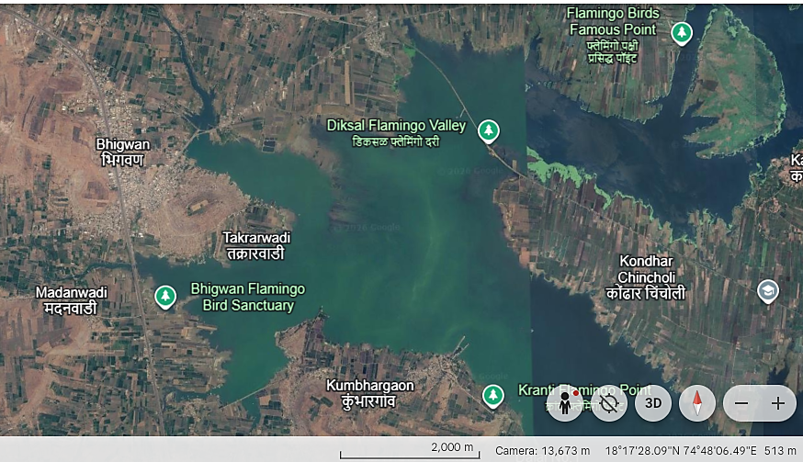
Fig.1) Geographical location map of the study sites in the Ujani Reservoir backwaters, Pune district (Source: Google Earth).

Fig. 2) Map of the study sites in the Ujani Reservoir backwaters, Pune district (Source: Google Map).
RESULTS:
- Fishing crafts:
- Thermocol rafts: These primitive fishing crafts were used frequently, along with other crafts, in the Ujani backwater region of Bhigwan. They were constructed by tying thermocol boxes and slices together using long bamboo strips and nylon ropes (Fig. 4). They measured approximately 7 feet in length, 2 feet in width and 5-8 inches in height. They were covered with green nets and supported by a lower weighted bag at one end during active fishing operations. More than 60 rafts were observed in the study area and were commonly used for deploying drag nets and gill nets.
- Plank-built boats: These spindle-shaped fishing crafts were commonly used and were made by joining wooden planks with iron nails. Coal tar was applied over the joints to prevent leakage. Their dimensions varied, with a length of 4-5 m, a middle width of 1.2-1.6 m and a height of 1.8-2.2 m (Fig. 3). These boats were used for carrying fishing equipment, including gears, and harvested fish catch. They were non-mechanised and required manual operation. Larger boats were 6-8 m long and motorised, but they were mostly used for passenger transport between villages and for tourists rather than for fishing purposes.
- Rubber tube platform: These were used less frequently by fishermen than other fishing crafts. They were economical fishing crafts because of their low cost, ease of construction, low weight, portability and suitability for operation by a single individual. A rubber tube was tightly secured with an upper woollen or cloth platform using rope to provide stability and seating support during operation. These platforms were suitable for small-scale fishing operations in both stagnant and flowing water bodies. They were primarily used by fishermen for setting small-mesh gill nets.
- Fishing gears:
- Gill net: Gill nets were the most commonly used gear, especially during the rainy season, at all four investigated sites in the Ujani backwater region. They were operated in shallow and deeper areas because of their simple operating procedure, efficiency and low energy requirement. Locally, they are also known by names such as chat jal and fash jal. These single-layered nets were made of multifilament nylon, with a diameter of 0.2-0.3 mm, a length of 8-35 m and a mesh size of 1-10 cm. Gill nets with varying mesh sizes were operated regularly according to need. They were often anchored with bamboo stakes set across the water flow and with small stones used as sinkers (Fig. 5). The catch was collected after approximately 10 hours, with the major target groups including Indian major carps, Chanda, prawns and other fishes. The average fish catch was observed to be 12-14 kg/day (Table 1).
- Drag net: The most common drag net used by fishermen was the Fy-Jal, a circular net mainly used to capture Labeo catla, Labeo rohita, Cirrhinus mrigala, Channa marulius, Channa gachua, Channa striata, Channa punctata, Chanda nama and small fishes. Its length varied from 25 to 90 m. The centre boat held one end of the net in the water body, while the associated boats spread the net around the designated area in an encircling manner. The net was made of nylon, with a mesh size ranging from 0.5 to 2.4 cm. The average fish catch by drag net was observed to be 40-64 kg per catch (Table 1).
- Cast net: This circular net, popularly known as Chhatri jal, had lengths ranging from 7 to 20 m and mesh sizes ranging from 2.3 to 5 cm. Iron balls were used as sinkers. A long, thin rope was fastened to the apex of the net, and the net was folded inward to form circular pockets around its circumference. Sinkers were inserted into the pockets. The net was folded into three equal parts, with the left hand holding the fold near the rope, the central fold remaining free and the final fold positioned at the periphery. The final fold was placed over the head and thrown to a reachable distance in a circular spread over the water surface. Fishes were trapped from the covered area and eventually retained in the pockets. The total fish catch ranged from 2 to 5 kg/day, with Indian major carps as the target catch (Table 1).
- Hooks and lines: This was also a common fishing technique used by fishermen who could not afford other nets. It consisted of a hook, nylon string and a rod. The nylon string was attached to the baited hook at one end and to the rod at the other. Hooks and lines were operated near the marginal sites of the Ujani backwater. Mostly carnivorous fishes were caught using various baits, including flesh tissue, earthworms, insects and cockroaches (Table 1).
- Box traps (Pinjara): Fishing traps are a passive fishing method in which fishes become trapped during migration and movement. Such traps vary in construction, design, materials and functional aspects according to target fish species and local conditions. Bamboo splits and steel rods were mostly used for trap construction. Box traps, locally known as Pinjara, were observed at Sites C and D (Fig. 6). The trap framework consisted of steel rods measuring approximately 3.20 feet in length, 2.0 feet in height and 1.90 feet in width. The traps had one-way entrance openings on two opposite sides, serving as unidirectional non-returning entry points for fish and prawns. The trap was kept vertically under water. The entrance openings allowed fish and prawns to enter and then closed automatically using sticks. These traps were usually deployed before and after the monsoon season. They mostly targeted Channa spp. The average fish catch with this gear was 0.5-2.5 kg/day per trap (Table 1).
DISCUSSION:
Studies on sustainable fisheries support the management of fishing practices through the conservation of fish populations and habitats, maintenance of ecosystem balance, enhancement of economic benefits and support for dependent communities. They also contribute to the sustained productivity of inland water bodies. Sustainable fisheries management can be achieved by integrating social, economic and cultural values while conserving fishery resources for future generations (Los Huertos, 2020). Fisheries studies mainly focus on fishing crafts and gears, fish productivity and the improvement of the socio-economic status of fishing communities. Several studies have documented the use of various fishing crafts and gears in different inland water resources.
Bhattacharjya et al. (2005) documented four major fishing crafts and 13 fishing gears from Northeast India. The recorded fishing crafts were banana rafts, bamboo rafts, dugout canoes and plank-built boats. Grappling and wounding gears, stupefying devices, aerial traps, seine nets, drive-in nets, lift nets, falling nets, and gill and tangle nets were among the commonly used fishing gears. Gurumayum and Choudhury (2009) documented various fishing gears and practices in the rivers of Northeast India, including encircling gears, entangling gears, scooping gears, lift gears, traps and electric fishing techniques. Upadhyay and Singh (2013) documented two types of gill nets, five types of drag nets, four types of bag nets, two types of falling gears, one lift net, eight types of fishing hooks and seven types of fishing traps in their study on capture fisheries in Tripura.
Few studies have been conducted in Maharashtra. A survey by Sakhare and Jetithor (2013) in ten reservoirs of the Marathwada region of Maharashtra recorded three fishing crafts, namely coracles, thermocol rafts and rubber tube platforms, along with five fishing gears, namely rod and line, gill nets, cast nets, drag nets and seine nets. Joshi et al. (2013) reported five commonly used fishing methods, namely disabling types, trap-and-barrier types, filtering types, entangling types and miscellaneous types, including hand nets, sticks and iron rods. Wanjari et al. (2024) recorded nine fishing gears, namely gill nets, triangular push nets, drag nets, hook and line, box traps, cylindrical traps, V-shaped traps, long traps and cast nets, from the Wainganga River of Maharashtra. The same study also documented three commonly used fishing crafts, namely dugout canoes, plank-built boats and wooden-framed boats with iron, tin or aluminium sheets.
Similarly, the present investigation conducted in the Ujani backwater region of Bhigwan recorded three fishing crafts and five fishing gears, indicating that the fishing practices in the study area are comparable to those reported from other inland water bodies in India.

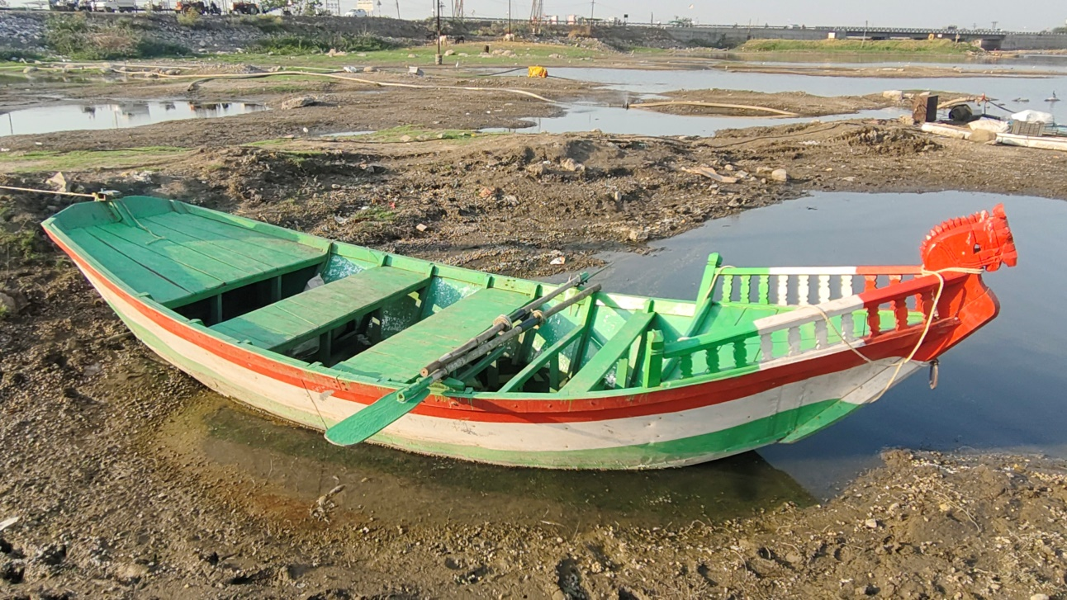
Fig. 3) Photographic view of traditional plank built fishing boats deployed in the study area

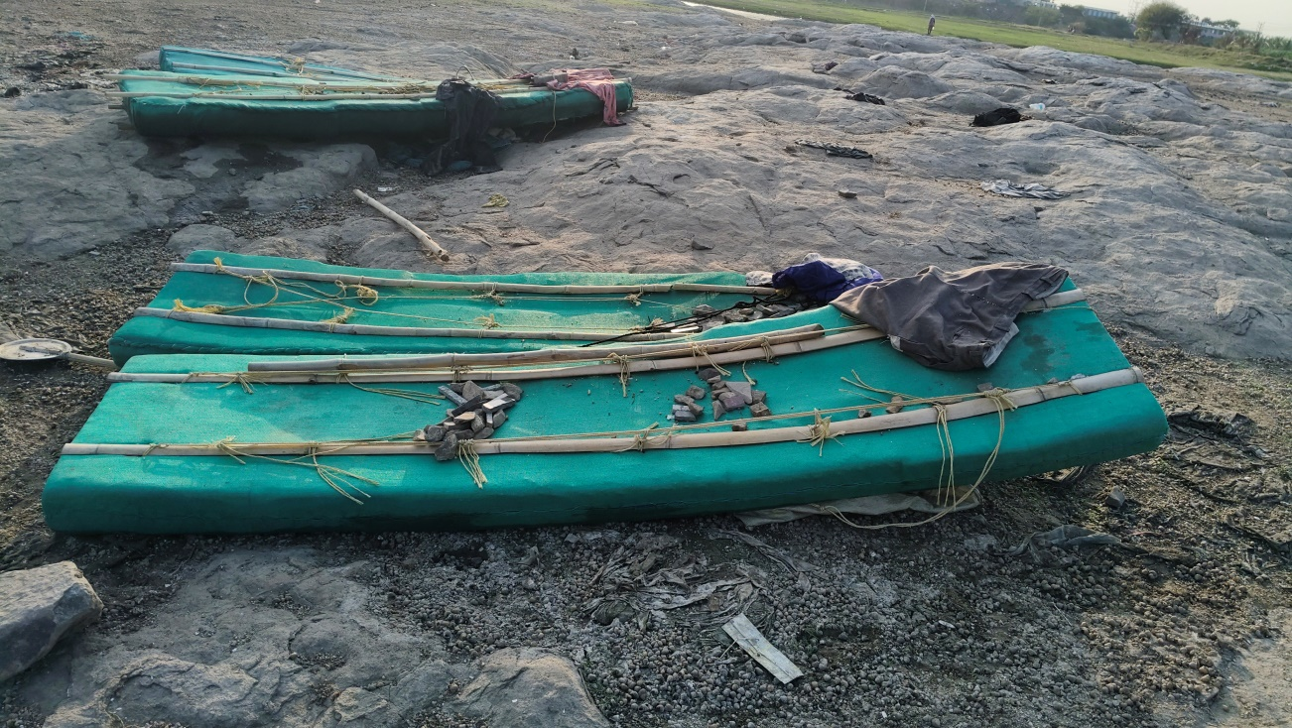
Fig. 4) Photographic view of thermocol raft used by local fishermen for drag net and gill net operations

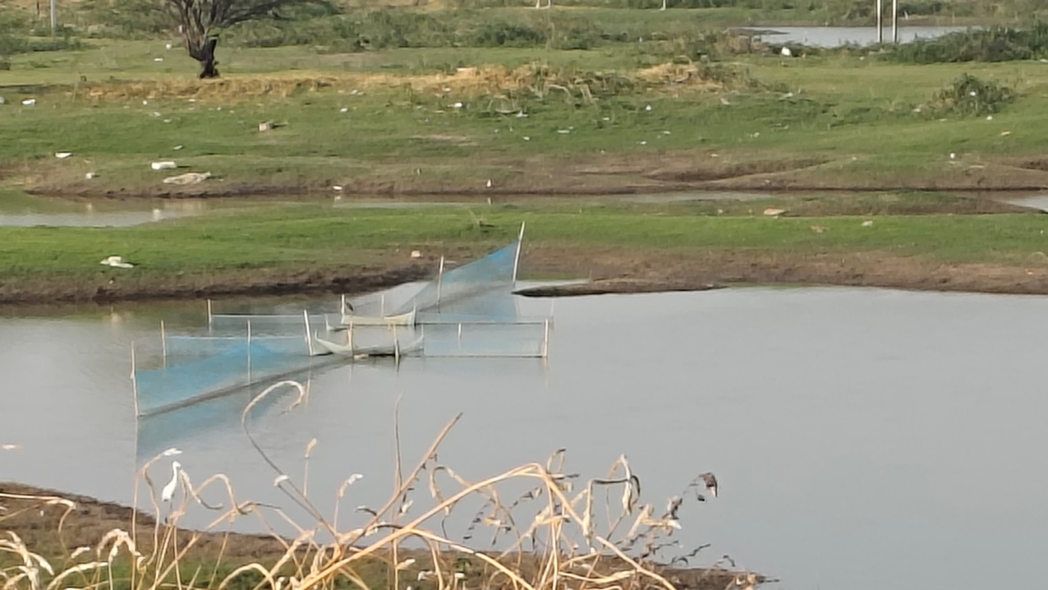
Fig. 5) Field photograph showing gill net supported by bamboo stakes in the shallow backwaters of the Ujani Reservoir
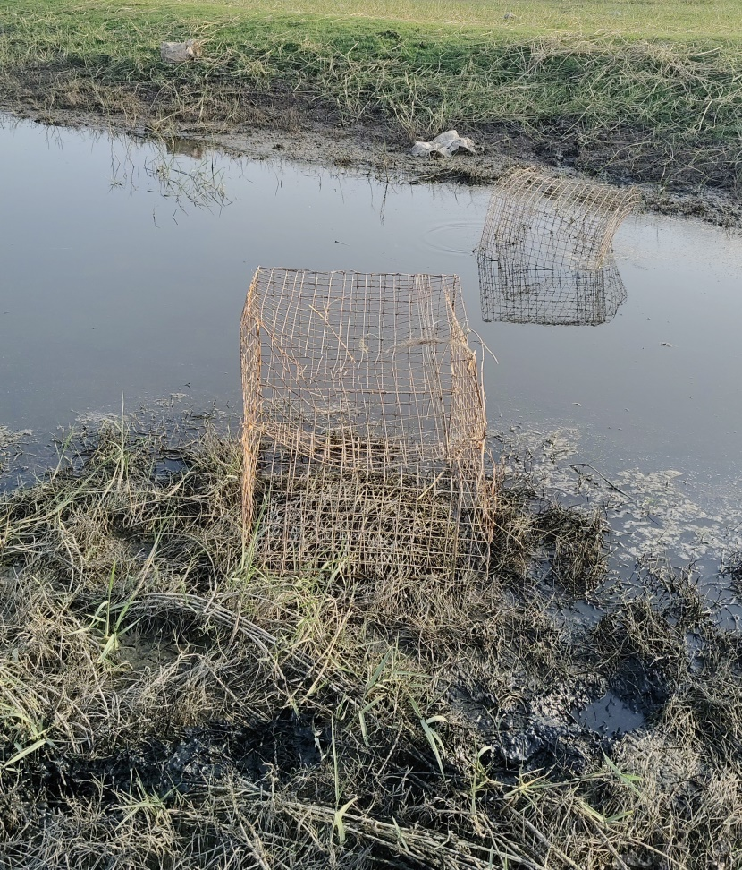
Fig. 6) Field photograph illustrating the deployment of traditional rectangular box traps in the littoral zone at the backwater region of the Ujani Reservoir.

Fishing Gear / Method | Gill Net | Drag Net | Cast Net | Hooks and Lines | Box Trap
Local Name(s) | Chat jal, Fash jal | Fy-Jal | Chhatri jal | - | Pinjara
Material & Technical Specifications | - Single-layered multifilament nylon (0.2 to 0.3 mm diameter).  - Anchored with bamboo stakes and stone sinkers. | - Nylon construction;  - Circular design deployed via multiple boats. | Circular net featuring inward-folded peripheral pockets weighted with iron ball sinkers. | - Single hook attached via nylon string to a structural rod.  - Low-cost passive gear. | - Passive rigid trap.  - Steel rod framework with automated bamboo split openings.
Mesh / Dimension Limits | Length: 8 to 35 m  Mesh: 1 to 10 cm | Length: 25 to 90 m  Mesh: 0.5 to 2.4 cm | Length: 7 to 20 m  Mesh: 2.3 to 5 cm | Variable | 3.20 feet (length) × 2.0 feet (height) × 1.90 feet (width)  Mesh: Rigid bar matrix
Operational Mechanics & Deployment | - Passive/Stationary.  - Set across water flow in shallow and deep regions.  - Fishes collected after ~10 hours.  - Low energy requirement. | - Active.  - Center boat holds one end while associated boats encircle the designated area to trap fish. | - Active  - Manually folded into three parts, thrown over the shoulder to spread in a circle over the water surface. | - Passive/Active marginal deployment.  - Use live bait like flesh tissue, earthworms, insects and cockroaches. | - Passive.  - Placed vertically underwater pre and post-monsoon.  - Features unidirectional, non-returning entry points.
Target Species | Labeo rohita, Labeo catla, Cirrhinus mrigala, Chanda nama & Prawns | Labeo catla, L. rohita, Cirrhinus mrigala, Channa spp., Chanda nama & small fish | Labeo rohita, Labeo catla and Cirrhinus mrigala | Carnivorous fish species | Channa spp., Prawns
Average fish Catch Efficiency | 12 to 14 Kg/ day | 40 to 64 Kg/ catch | 2 to 5 Kg/ day | 0.5 – 1.5 Kg per day | 0.5–2.5 Kg/ day per trap

Table 1) Comparative technical and operational specifications of fishing gears utilized in the backwater region of Ujani Reservoir at Bhigwan

Conclusion
The survey conducted in the Ujani backwater region of Bhigwan, Pune district, Maharashtra, recorded the use of three fishing crafts and five fishing gears by local fishermen. The documented fishing crafts were thermocol rafts, plank-built boats and rubber tube platforms. Thermocol rafts and plank-built boats were used more commonly than rubber tube platforms and were mainly associated with gill-net and drag-net operations. The fishing gears recorded during the study were gill nets, drag nets, cast nets, box traps, and hooks and lines. Among these, gill nets and drag nets were the most frequently used gears because of their operational simplicity and suitability for local fishing conditions. Cast nets and hooks and lines were used for small-scale or individual fishing activities, whereas box traps were used at selected sites, mainly for fishes and prawns. The study shows that fishermen in the Ujani backwater region use a combination of traditional and modified fishing practices based on local needs, target catch, affordability and available materials. The documentation of these crafts and gears provides baseline information on local fishing practices and may be useful for further assessment of inland fishery operations and sustainable management planning in the region.

Limitations
The present study was descriptive and limited to selected sites in the Ujani backwater region of Bhigwan. The survey was conducted only from January to March 2026; therefore, seasonal variation in craft use, gear use and catch composition could not be fully assessed. Reported catch values were based on field observations and fishermen's responses during the survey period and require validation through long-term monitoring. Environmental parameters, fish stock status and ecological impacts of different gears were not evaluated.

COMPETING INTERESTS:
Authors have declared that they have no known competing financial interests OR non-financial interests OR personal relationships that could have appeared to influence the work reported in this paper.

Declaration of AI Use

This manuscript was prepared through the combined contributions of all author(s), including contributions to the study design, data, content development, results, interpretation, and related scholarly work. The author(s) acknowledge the use of Grammarly and ChatGPT to assist with grammar checking, language refinement, reference formatting. These AI-assisted tools were not used as authors and did not replace the intellectual contributions or scholarly judgment of the author(s). All AI-assisted outputs, including content, references, and interpretations, were carefully reviewed, revised, verified, and approved by the author(s). The author(s) accept full responsibility for the accuracy, integrity, and final content of the manuscript.

REFERENCES:
Manna, R. K., Das, A. K., Krishna, R. D. S., Karthikeyan, M., & Singh, D. N. (2011). Fishing crafts and gears in river Krishna. Indian Journal of Traditional Knowledge, 10(3), 491–497. https://nopr.niscpr.res.in/bitstream/123456789/12026/1/IJTK%2010%283%29%20491-497.pdf
Bhakta, D., Manna, R. K., Meetei, W. A., Solanki, J. K., & Sah, R. K. (2016). Traditional fishing crafts and gears of Ukai Reservoir, Gujarat, India. International Journal of Fisheries and Aquatic Studies, 4(4), 142–145.
Bhattacharjya, B. K., Manna, R. K., & Choudhury, M. (2005). Fishing crafts and gear of Northeast India (Bulletin No. 142). CIFRI.
Biswas, A., Behera, S., Sau, S. K., & Ziauddin, G. (2022). Fishing crafts and gears used in Moutore Reservoir, Purulia District, West Bengal. Environment and Ecology, 40(3C), 1638–1642. https://environmentandecology.com/wp-content/uploads/2024/07/MS7-1.pdf
Dar, S. A., Hussain, N., Bhat, T. H., Qayoom, I., Verma, H. L., & Peerzada, Z. A. (2024). Need for socio-economic upliftment of fishers, more unfinished than achieved: A review. International Journal of Agriculture Extension and Social Development, 7(9), 942–949.
Dar, S. A., Wani, G. B., & Qayoom, I. (2025). Fishing gears and crafts of Manasbal Lake: Insights from the Kashmir Himalayas. International Journal of Agriculture Extension and Social Development, 8(1), 66–73.
Food and Agriculture Organization of the United Nations. (1975). FAO catalogue of small-scale fishing gear. Fishing News Books. https://agris.fao.org/search/en/providers/122621/records/64711cc89dd8810bf64b2d8c
George, V. C. (2002). Fishing techniques of riverine and reservoir systems: Present status and future challenges. In M. R. Boopendranath, B. Meenakumari, J. Joseph, T. V. Sankar, P. Pravin, & L. Edwin (Eds.), Riverine and reservoir fisheries of India (pp. 192–196). Society of Fisheries Technologists (India).
Gurumayum, S. D., & Choudhury, M. (2009). Fishing methods in the rivers of Northeast India. Indian Journal of Traditional Knowledge, 8(2), 237–241. https://nopr.niscpr.res.in/handle/123456789/3961
Joshi, P. S., Tantarpale, V. T., & Kulkarni, K. M. (2013). Fishing methods commonly employed in Buldhana district and neighbourhood, Maharashtra State, India. Bioscience Discovery, 4(1), 54–57. https://jbsd.in/Volume%204%20No1%20Jan%2013/Joshi%2054-57.pdf
Kamble, S. P., Bhakta, D., Meetei, W. A., Vaisakh, G., Solanki, J. K., Koushlesh, S. K., Chanu, T. N., Behera, B. K., Suresh, V. R., Samanta, S., & Das, B. K. (2022). A comprehensive account of fishing crafts and gears of River Tapti, India. Fishery Technology, 59(3), 215–218. https://doi.org/10.56093/ft.v59i3.109842
Lal, K. B. (1969). An introduction to fishing gear technology. Metropolitan Book Co.
Los Huertos, M. (2020). Developing and appropriating water. In Ecology and management of inland waters: A Californian perspective with global applications (pp. 283–313). Elsevier.
Mali, R. P., & Bondhare, S. O. (2012). Fishing craft and gear in River Godavari at Nanded, Maharashtra. Ecology and Fisheries, 5, 37–40.
Manna, R. K., Das, A. K., Krishna, R. D. S., Karthikeyan, M., & Singh, D. N. (2011). Fishing crafts and gears in River Krishna. Indian Journal of Traditional Knowledge, 10(3), 491–497. https://nopr.niscpr.res.in/bitstream/123456789/12026/1/IJTK%2010%283%29%20491-497.pdf
Sakhare, V. B. (2007). Reservoir fisheries and limnology. Narendra Publishing House. https://www.nphindia.com/book/9788188355440/reservoir-fisheries-and-limnology
Sakhare, V. B., & Jetithor, S. G. (2013). Crafts and gears used in reservoirs of Marathwada region, Maharashtra. Sustainability, Agri, Food and Environmental Research, 1(1), 46–51.
Sharma, R. (2001). Traditional methods and fishing gears of Assam. Fishing Chimes, 20(12), 23–26.
Syed, N., Mohite, A., Sadawarte, R., Desai, A., & Shah, T. H. (2020). Design aspects of fishing crafts and gears of Wular Lake of Kashmir, India. Journal of Experimental Zoology India, 23(Suppl. 1), 861–867. https://connectjournals.com/file_full_text/3094000H_861-867.pdf
Upadhyay, A. D., & Singh, B. K. (2013). Indigenous fishing devices in use of capture fishing in Tripura. Indian Journal of Traditional Knowledge, 12(1), 149–156. https://nopr.niscpr.res.in/handle/123456789/15353
von Brandt, A. (1972). Fish catching methods of the world (2nd ed.). Fishing News Books.
Wanjari, R. N., Shah, T. H., Telvekar, P., Ramteke, K. K., Dhanalakshmi, M., & Rashid, I. (2024). A preliminary study of fishing crafts and gears operating along the Wainganga River of Maharashtra State, India. Journal of the Inland Fisheries Society of India, 56(2), 185–196. https://doi.org/10.56093/jifsi.v56i2.2024.163418
Yousuf, Z., Shah, T. H., Bhat, F. A., Abubakr, A., Bhat, B. A., Ahmad, I., Shah, F. A., & Syed, N. (2023). Fishing gears and craft of Anchar Lake: Design specifications and operational aspects. Journal of Experimental Zoology India, 26(2), 1485–1490. https://doi.org/10.51470/jez.2023.26.2.1485
Talukdar, A., Shaha, A., Begum, N., Islam, R., Hasan, M., & Nima, A. (2024). Fishing gears and practices in the Bukbhora Oxbow Lake: Implications for biodiversity conservation in south-west Bangladesh. Annual Research & Review in Biology, 39(11), 70–83. https://doi.org/10.9734/arrb/2024/v39i112157
Yulianto, R. A., Setyawan, H. A., Jayanto, B. B., & Kurohman, F. (2023). The effects of variations in fishing time and gill nett immersion on mackerel catch (Rastrelliger spp.) in Demak Waters, Central Java, Indonesia. Asian Journal of Current Research, 8(2), 23–28. https://doi.org/10.56557/ajocr/2023/v8i28268
Ssempijja, D., Einarsson, H. A., & He, P. (2024). Abandoned, lost, and otherwise discarded fishing gear in world’s inland fisheries. Reviews in Fish Biology and Fisheries, 34, 671–683. https://doi.org/10.1007/s11160-024-09843-5
Hridayadasan, S., Antony, S. C., & Umajyothi, V. (2025). Traditional fishing gear usage and its sustainability among motorised fishing crafts on the southernmost coast of Kerala, India. Marine Economics and Management, 8(2), 162–171. https://doi.org/10.1108/MAEM-02-2025-0004

