Ecological Assessment of Lichens Diversity in the Anamalai Tiger Reserve, Southern Western Ghats, India

.

ABSTRACT
The Western Ghats of India are recognised as a global biodiversity hotspot; however, lichen diversity in many protected forest landscapes remains insufficiently documented, particularly in the Anamalai Tiger Reserve, India. The present study investigated the diversity, distribution patterns, substratum preference and elevational variation of lichens in the Anamalai Tiger Reserve. Field surveys conducted across 50 plots representing different forest types recorded 81 lichen species belonging to 27 genera and 12 families. Parmeliaceae was the dominant family, followed by Physciaceae and Caliciaceae. Diversity analysis indicated high species richness with uneven distribution patterns, as reflected by the Shannon-Wiener diversity index (H′ = 1.363) and Simpson's diversity index (1-D = 0.98). Evergreen and moist deciduous forests supported greater species richness and diversity than dry deciduous forests, indicating the influence of humid microclimatic conditions on lichen assemblages. Multivariate analysis using principal component analysis (PCA) revealed clear variation in species composition among forest types. With the highest Importance Value Index (IVI) of 10.82, Heterodermia japonica was identified as the most dominant and widely distributed lichen species. Notably, Cetrelia braunsiana, Heterodermia dactyliza, Heterodermia hypochraea and Pyxine petricola var. pallida are reported here for the first time from Tamil Nadu. The study provides valuable baseline information on lichen diversity and emphasises the importance of conserving forest habitats in the Western Ghats for long-term biodiversity monitoring and ecosystem management.

Keywords: Lichens; Anamalai Tiger Reserve; Western Ghats; species richness; substratum preference; elevational gradient; forest types; Heterodermia japonica; principal component analysis; biodiversity monitoring.

1. INTRODUCTION
India's diverse landscape and distinct phytogeographical regions host a broad range of biota, reflecting wide ecological and climatic variation. The Western Ghats are recognised as one of the 36 global biodiversity hotspots and one of the four hotspots in India, owing to their extraordinary species richness and endemism (Dalui et al., 2024). This mountain range supports higher indigenous floristic diversity than many other phytogeographical regions of the country. India harbours exceptionally high lichen diversity, shaped by its heterogeneous topography and climatic regimes. The Himalayan region and North-eastern states represent primary hotspots of lichen richness, while the Western Ghats, Eastern Ghats, and Andaman and Nicobar Islands support distinctive assemblages with a notable proportion of endemic taxa (Lucking et al., 2017). In India, a comprehensive taxonomic assessment has documented 3,236 lichen taxa, comprising 3,200 species, 29 varieties, 6 subspecies and one forma, distributed across 487 genera and 88 families. Of these, 2,239 are crustose lichens, 755 are foliose and 242 are fruticose forms (Joshi and Upreti, 2016). The Western Ghats exhibit substantial lichen diversity, comprising 1,706 taxa, including more than 250 endemic species (Nayaka and Upreti, 2006; Sinha, 2021). Recent site-level work in the Western Ghats has similarly demonstrated that small permanent forest plots can yield important distributional records, including 38 lichen species from the Sholayar 10 ha Permanent Plot (Nayana Prakash et al., 2024). A recent survey in Pushpagiri Wildlife Sanctuary, Central Western Ghats, recorded 135 lichen species and 73 bryophyte species, further demonstrating the cryptogamic richness of protected evergreen, semi-evergreen and shola forests (Vinayaka et al., 2025).
Lichens represent a unique life form that has developed through a mutualistic association between a fungus and an alga. They exhibit marked ecological adaptability and can colonise a wide range of substrates, including rocks, soil, tree bark, leaf surfaces, metallic objects and even insect exoskeletons (Phukhamsakda et al., 2022; Hyde et al., 2024). Lichens occur in habitats ranging from tropical rainforests to arctic regions (Hawksworth and Grube, 2020). They also play a pioneering role in establishing colonies on barren habitats. Lichens contribute substantially to ecosystem functioning by providing food and shelter for various organisms, participating in nutrient cycling and promoting soil formation processes (Jackson, 2015). In addition to their ecological importance, lichens are prolific producers of secondary metabolites, many of which possess valuable bioactive properties. These compounds have demonstrated antibacterial, antifungal, anti-inflammatory, antitumour and antioxidant activities, highlighting their growing importance in pharmaceutical and industrial applications (Calcott et al., 2018). Recent work on epiphytic lichen communities in India further supports their application in assessing forest condition through diversity and multivariate analyses (Naincy et al., 2024).
Most lichen research in India has been conducted in the Himalayan foothills (Divakar and Upreti, 2005). Notable collections have also been documented from Bihar, Madhya Pradesh, Tamil Nadu, Uttar Pradesh, Andhra Pradesh, Arunachal Pradesh, Assam, Jammu and Kashmir, Manipur, Meghalaya, Odisha and Rajasthan (Madhusudhana Reddy et al., 2011; Nayaka et al., 2011). The lichen diversity of Tamil Nadu is largely attributed to the extensive stretch of the Western Ghats and the presence of several biodiversity-rich regions, including the Nilgiris, Anamalais, Palani and Shevaroy Hills (Kalidoss et al., 2019). Tamil Nadu, located in the peninsular region of India, is particularly rich in lichens, with a record of 1,044 species (Sinha et al., 2024). Biodiversity-rich regions such as the Nilgiri Biosphere Reserve and the Western and Eastern Ghats contribute substantially to the high lichen diversity observed in the state. However, many regions within the Western Ghats remain insufficiently explored, emphasising the need for systematic surveys and detailed evaluations to understand the lichen wealth of the region (Nayaka and Haridas, 2024). A recent review of Indian protected areas also reported that cryptogamic groups, habitat-wise floristic patterns, long-term monitoring and periodic revisions are often insufficiently addressed in floristic studies (Bheemalingappa et al., 2026).
The Anamalai Tiger Reserve (ATR) in Tamil Nadu, located within the Western Ghats, represents one such comparatively unexplored area for lichen studies. It harbours several interesting and endemic lichen taxa, and this region is considered among the richer lichen zones in the country. However, the reserve remains largely unexplored and has been studied less extensively for lichens than for higher plants. In recent decades, lichen flora has declined substantially across the country. Among various anthropogenic pressures, overexploitation and the selective removal of economically important lichens have emerged as major threats to lichen diversity (Sharath and Jabeen, 2021). Despite these regional records, plot-scale information on lichen diversity, substratum preference and forest-type variation remains limited for the Anamalai Tiger Reserve. To address this gap, the present study aimed to document the diversity and ecological distribution of lichens across different forest types in the ATR. The present study evaluated lichen diversity and ecological patterns across different forest types to provide a clearer understanding of lichen distribution within the Anamalai Tiger Reserve.
2. MATERIALS AND METHODS
2.1. Study Area
The Anamalai Tiger Reserve is situated in the Coimbatore District of Tamil Nadu, India, between the geographical coordinates of 76⁰49.3'' to 77⁰21.4''E and 10⁰13.2'' to 10⁰33.3''N, south of the Palakkad Gap in the Western Ghats (Fig. 1). The Reserve covers an area of about 1,479.87 km² and shares its boundaries with the Parambikulam Tiger Reserve to the east, and with Chinnar Wildlife Sanctuary and Eravikulam National Park along its south-western flank. The Reserve is divided into six forest ranges, namely Manombolly, Pollachi, Ulandy, Udumalpet, Amaravathy and Valparai, comprising a total of 32 forest divisions. The altitudinal gradient ranges from 340 m to 2,400 m above mean sea level, while mean annual rainfall varies markedly from approximately 500 mm in the south-western fringes to nearly 5,000 mm in the north-eastern sector. The climate remains moderately warm throughout the year, with comparatively cool conditions during the winter months of November and December.
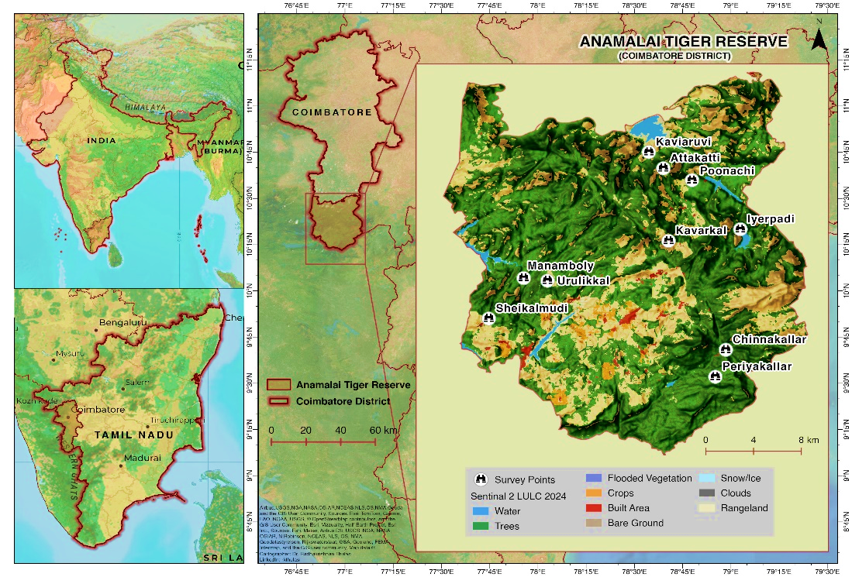
Fig. 1: Study sites and location of the Anamalai Tiger Reserve (ATR), Tamil Nadu, India
Owing to pronounced heterogeneity in topography, climate, temperature and precipitation, the Reserve supports rich lichen diversity. The present study was conducted at ten sites, namely Kaviyaruvi, Attakatti, Poonachi, Iyerpadi, Urulikkal, Kavarkal, Manamboly, Sheikalmudi, Chinnakallar and Periyakallar, which were located within the Manamboly, Valparai and Pollachi ranges of the Anamalai Tiger Reserve. These sites encompass a wide range of vegetation types, including evergreen, moist deciduous and dry deciduous forests.
2.2. Lichen Sampling and Identification
The present study was conducted during 2021-2022 in the ATR. A plot-based sampling design was used to assess lichen diversity, with 50 × 10 m plots laid at 10 sampling sites representing three forest types along an altitudinal gradient. A total of 50 plots were established across the ten sampling sites. In each plot, all visible lichen species occurring on all substrata, including tree bark, twigs, mosses, leaves, rocks and soil surfaces, were recorded (Nimis et al., 2002). Nearly 300 lichen specimens were collected from ten selected sites within the study area. The collected specimens were cleaned, air-dried and stored in standard herbarium packets labelled with details of the collection site, collector's name, substratum type, date of collection and specimen number (Nayaka, 2014). The voucher specimens were deposited in the LWG Herbarium of the CSIR-National Botanical Research Institute, Lucknow, and the Department of Botany, NGM College, Pollachi, Coimbatore, India.
The collected specimens were identified through detailed morphological, anatomical and chemical analyses using stereo and light microscopes. Standard chemical spot tests were carried out with potassium hydroxide (K), calcium hypochlorite (C) and para-phenylenediamine (P) reagents. Microcrystallographic methods were employed to detect lichen substances present within the thallus. Furthermore, thin-layer chromatography (TLC) was performed to characterise cortical and medullary secondary metabolites using a solvent system consisting of toluene, 1,4-dioxane and acetic acid (Orange et al., 2001). Species identification was subsequently confirmed with the aid of relevant literature, taxonomic keys and monographs (Awasthi, 1988, 2007; Divakar and Upreti, 2005).
2.3 Ecological assessment
Ecological assessment of lichen diversity was carried out using plot-based sampling analysis to determine species availability and distribution across the study area. The selected study sites were located along different altitudinal gradients. A total of 50 plots were laid randomly across ten sites, with five plots established at each site for ecological data collection. Each plot was systematically surveyed, and all lichen species occurring within the plots were numbered and carefully recorded. Species diversity was assessed using standard ecological parameters, including frequency (F), density (D) and abundance (A). The ecological significance of each species within the community was further determined through the Importance Value Index (IVI), calculated using standard formulae that integrate relative density (RD), relative frequency (RF) and relative abundance (RA). These indices collectively provide a comprehensive measure of species dominance and distribution within the vegetation community (Curtis and McIntosh, 1950; Phillips, 1972). The diversity of lichen communities across the study sites was assessed using species richness (S), calculated from the total number of species recorded. Shannon-Wiener (H′) and Simpson's (1−D) indices were used to measure diversity and dominance patterns, whereas the Sørensen similarity index was employed to compare species composition and similarity among sites.
2.3.1. Frequency (F)
Frequency refers to the percentage occurrence of a species in the sampled quadrats and indicates how frequently a particular species is distributed within the study area.
$Frequency (\%) = \frac{Number of quadrats where species occurs}{Total quadrats studied}×100$ (Eq-1)
2.3.2. Density (D)
Density refers to the numerical strength of a species in a community and is defined as the number of individuals of a species present per unit area or volume.
$Density =\frac{Total individuals of a species}{Total number of sampling units studied}$ (Eq-2)
2.3.3. Abundance (A)
Abundance refers to the number of individuals of a species per quadrat in which the species actually occurs.
$Abundance =\frac{Total individuals of a species}{Number of quadrats where species occurs}$ (Eq-3)
2.3.4. Relative Frequency (RF)
Relative frequency refers to the contribution of one species' frequency compared with the total frequency of all species in the study area.
$Relative frequency \left(\%\right)= \frac{Frequency of a species}{Total frequency of all species}×100$ (Eq-4)
2.3.5. Relative Density (RD)
Relative density refers to the numerical strength of one species in relation to the total number of individuals of all species in the study area.
$Relative Density (\%) =\frac{Number of individuals of a species}{Total individuals of all species}×100$ (Eq-5)
2.3.6. Relative Abundance (RA)
Relative abundance refers to the abundance value of a species in relation to the total abundance of all species in the study area.
$Relative Abundance (\%) =\frac{Abundance of a species}{Total abundance of a species}×100$ (Eq-6)
2.3.7. Important Value Index (IVI)
The Importance Value Index (IVI) is a quantitative measure used in ecology to assess the overall ecological significance of a species within a plant community. According to Curtis and McIntosh (1950) and Phillips (1972), the IVI is calculated as the sum of relative frequency, relative density and relative abundance.
Important Value Index (IVI) = Relative Frequency (RF) + Relative Density (RD)
+ Relative Abundance (RA) (Eq-7)
2.4. Species diversity indices
2.4.1. Shannon-Wiener Index (H’)
The Shannon-Wiener Index (H') measures species diversity by considering the proportional abundance of each species (Shannon and Weaver, 1949).
$Shannon-Wiener Index (H’) = -\sum_{i=1}^{s}{(p_{i} ln p_{i})}$ (Eq-8)
Where,
Pi: Proportion of individuals of a species
S: Species richness
Ln: Natural logarithm of the proportion (pi)
2.4.2 Simpson’s Index (1-D)
Simpson's index is a measure of species diversity that quantifies the degree of dominance within a community. It represents the probability that two individuals randomly selected from a sample belong to different species (Simpson, 1949).
$Simpson’s Index (D) = \frac{\sum{n_{i} (n_{i}-1)}}{N (N-1)}$ (Eq-9)
Where,
ni: Total number of individuals of a species
N: Total number of individuals of all species
2.4.3. Sørensen Similarity Index
The Sørensen Similarity Index is used to compare species composition between two sites based on shared species. The index ranges from 0 to 1, with values closer to 1 indicating greater similarity in species composition between sites and values closer to 0 indicating greater dissimilarity (Sørensen, 1948).
$Sørensen Similarity Index (SI) =\frac{2C}{A+B}$ (Eq-10)
Where,
C: Number of species common to both sites
A: Total number of species in site A
B: Total number of species in site B
2.4.4. Pearson correlation coefficient and principal components analysis
Pearson's correlation analysis was used to investigate relationships among lichen diversity indices, while Principal Component Analysis (PCA) was used to summarise correlations in lichen diversity and community structure across the study sites. This multivariate technique was used to analyse ecological variables into principal components, identify relationships between species and environmental variables, and highlight the major factors influencing lichen distribution patterns. All data variables represented in the graph were designed using OriginPro 2026.
3. RESULTS AND DISCUSSION
The present study documented a total of 81 species belonging to 27 genera and 12 families from the Anamalai Tiger Reserve, Tamil Nadu. This diversity aligns with broader regional patterns reported from the Western Ghats, where Rajaprabu and Ponmurugan (2023) documented nearly 1,500 lichen species, with Tamil Nadu being the second richest state, hosting 938 species. In the present study, corticolous lichens were the most abundant, accounting for 70 species, followed by saxicolous (9 species), terricolous (2 species) and foliicolous forms (1 species), indicating a strong preference for tree trunks and rocks as primary microhabitats for lichens. Similarly, studies from various regions of South India have documented corticolous lichens as the dominant substrate group (Balu et al., 2021; Rajaprabu and Ponmurugan, 2023; Nayaka and Haridas, 2024). Morphologically, foliose lichens were predominant in the study area, represented by 63 species, followed by fruticose, crustose and squamulose forms with 12, 5 and 1 species, respectively. This distribution pattern highlights the strong influence of environmental factors and microhabitat characteristics on lichen community structure, further emphasising the sensitivity of lichens to subtle ecological variations and environmental changes (Fryday, 2001).
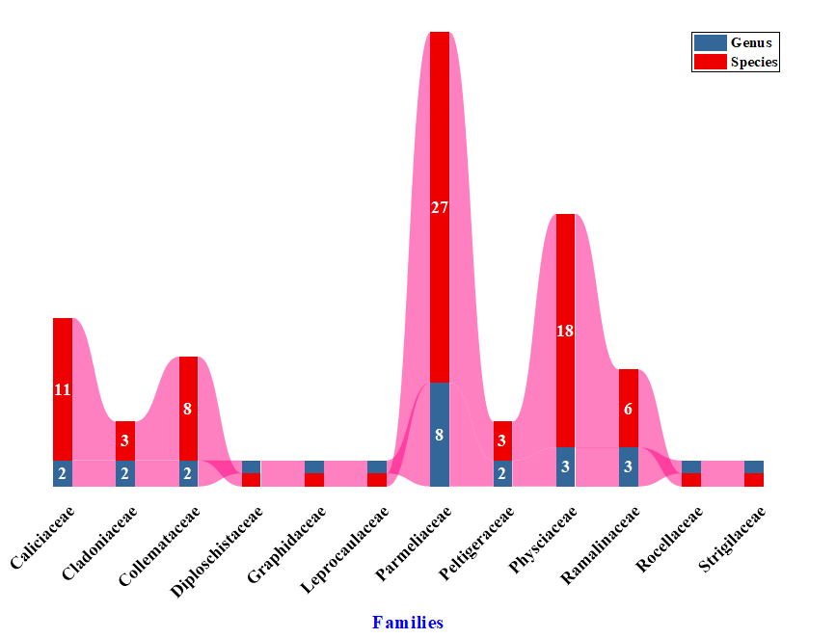
Fig. 2: Distribution pattern of genera and species among families
The state's rich lichen population is largely attributed to the extensive stretch of the Western Ghats and key biodiversity hotspots, including the Nilgiris, Anamalais, Palani and Shevaroy Hills. A survey conducted across seven localities in the Nilgiris documented 39 lichen species, representing 23 genera and 9 families (Arun Prasath et al., 2022). In the Siruvani Hills (Bolampatti II forest range), 103 macrolichen species representing 27 genera across nine families were reported (Balaji and Hariharan, 2013), whereas Maruthamalai Hill supported 31 species belonging to 21 genera and 11 families (Arun Prasath et al., 2022). Similarly, Haridas and Aliyarukunju (2024) reported 147 lichen species, comprising both macrolichens and microlichens and representing 65 genera from various locations in the Thiruvananthapuram and Kollam districts of Kerala within the Agasthyamalai Biosphere Reserve. Among the 12 families, Parmeliaceae was the most dominant family, followed by Physciaceae, Caliciaceae, Collemataceae and Ramalinaceae, respectively (Fig. 2). This pattern of family-level dominance is consistent with earlier reports from different regions of India that highlight Parmeliaceae and Physciaceae as major contributors to lichen diversity (Kumar et al., 2024).
The analysis of species richness at the family level revealed the occurrence of two dominant families, Parmeliaceae and Physciaceae, comprising 46 species and accounting for 57% of the total recorded species. Polytypic families, including Caliciaceae, Collemataceae and Ramalinaceae, contributed 24 species, representing 30% of the overall diversity. In contrast, two oligotypic families collectively harboured 5 species (6%), while six monotypic families were each represented by a single species, making up 7% of the total (Table 1). The Anamalai Tiger Reserve supports rich vegetation diversity shaped by complex gradients of topography, climate and rainfall. Differences in soil characteristics, rainfall and altitudinal variation have resulted in the development of five major vegetation types: grassland, evergreen, moist deciduous, dry deciduous and dry semi-desert (Ganesan, 2019). The lichen survey conducted within the study area focused on three forest types: evergreen, moist deciduous and dry deciduous. Lichen diversity showed clear variation across the three ecological regions, with the highest taxonomic richness observed in evergreen forests, followed by moist deciduous and dry deciduous forests. Species, genus and family richness declined consistently along this gradient. Corticolous substrates emerged as the most favourable, supporting maximum species richness, particularly in evergreen forests. Saxicolous and terricolous substrates contributed moderately, while foliicolous substrates supported minimal diversity. Among growth forms, foliose lichens were predominant in all regions, especially in evergreen forests, indicating their preference for humid and environmentally stable conditions. Overall, the observed distribution pattern highlights the strong influence of habitat moisture and substrate type on lichen diversity (Fig. 3). Notably, Cetrelia braunsiana, Heterodermia dactyliza, Heterodermia hypochraea and Pyxine petricola var. pallida are reported here as new lichen records for Tamil Nadu.
Table 1. Statistical analysis of genera and species level diversity of lichens in the study area
 | Name of Family | Number of genera contained | Percentage of the total number of genera (%) | Number of species | Percentage of the total number of species (%)
Dominant families  (> 15 Species) | Parmeliaceae | 8 | 29.63 | 27 | 33.33
Dominant families  (> 15 Species) | Physciaceae | 3 | 11.11 | 18 | 22.22
Polytypic families  (6 < Species < 14) | Caliciaceae | 2 | 7.41 | 11 | 13.58
Polytypic families  (6 < Species < 14) | Collemataceae | 2 | 7.41 | 8 | 9.88
Polytypic families  (6 < Species < 14) | Ramalinaceae | 3 | 11.11 | 6 | 7.41
Oligotypic families  (2 < Species < 5) | Cladoniaceae | 2 | 7.41 | 3 | 3.70
Oligotypic families  (2 < Species < 5) | Peltigeraceae | 2 | 7.41 | 3 | 3.70
Monotypic families  (Species = 1) | Graphidaceae | 1 | 3.70 | 1 | 1.23
Monotypic families  (Species = 1) | Leprocaulaceae | 1 | 3.70 | 1 | 1.23
Monotypic families  (Species = 1) | Strigulaceae | 1 | 3.70 | 1 | 1.23
Monotypic families  (Species = 1) | Diploschitaceae | 1 | 3.70 | 1 | 1.23
Monotypic families  (Species = 1) | Rocellaceae | 1 | 3.70 | 1 | 1.23
 | Total | 27 |  | 81

Among the ten study sites surveyed, the evergreen forests of Iyerpadi, Kavarkal, Urulikkal, Manamboly, Chinnakallar and Periyakallar are situated at elevations above 800 m and together supported a rich lichen diversity comprising 67 identified species. The dominant families in this zone were Parmeliaceae, Physciaceae, Collemataceae and Cladoniaceae, with Parmotrema, Hypotrachyna, Heterodermia, Polyblastidium, Leptogium and Usnea as the most prevalent genera. Moist deciduous forests are sporadically distributed within the reserve at Attakati, Poonachi and Sheikalmudi, ranging in elevation from 700 m to 1,020 m, and a total of 29 lichen species were identified within this vegetation. Among the recorded taxa, Parmeliaceae, Physciaceae, Collemataceae, Ramalinaceae and Cladoniaceae were the dominant families, whereas Parmelinella, Parmotrema, Hypotrachyna, Pyxine, Collema, Ramalina, Heterodermia, Polyblastidium, Leptogium and Usnea represented the predominant genera. The dry deciduous forests represented by the Kaviyaruvi falls region, at an altitudinal range of 300 m to 550 m, recorded 28 lichen species. The predominant families included Caliciaceae, Parmeliaceae, Collemataceae and Graphidaceae, with prevalent genera comprising Parmotrema, Dirinaria, Pyxine, Collema, Leptogium and Diorygma. Similarly, Nayaka et al. (2001) reported notable variation in lichen diversity across different vegetation types, including evergreen forest, moist deciduous forest, dry deciduous forest and scrub forest. Among these, evergreen forest supported the highest lichen diversity, with 50 species recorded in Meghamalai Wildlife Sanctuary, Kambam. Dry deciduous forest has higher light intensity and a more open canopy, which are suitable for crustose and foliose lichens (Balaji and Hariharan, 2004).
Lichen diversity across ecological regions in the study area revealed notable variation influenced by altitude and forest type (Tumur et al., 2025). Increasing lichen populations were closely related to the altitudinal gradient (Subbaiyan et al., 2023). The highest number of species was observed at high-altitude stations. These zones, often characterised by evergreen and moist deciduous forests, provide favourable microclimatic conditions that support diverse lichen communities (Haridas and Aliyarukunju, 2024). The diversity of forest species at high altitude, together with high rainfall, may also contribute to the richness of lichen biodiversity in the ATR. In contrast, lower-altitude dry deciduous regions showed comparatively fewer species, indicating a clear ecological influence on lichen distribution patterns.
Ecological assessment
The basic ecological analysis of the documented lichen species is presented in Table 2. Frequency (F %) indicates the percentage of sampling units in which a species occurred. The frequency of documented lichen species ranged from 36% to 4%. Among the 81 species, Heterodermia japonica showed the highest frequency (36%), suggesting its wide distribution in the study area, followed by H. diademata (32%), while the lowest frequency was observed in Strigula sp. (4%). Density (D) represents the number of individuals per unit area. H. japonica showed the highest density (3.32), followed by Parmotrema tinctorum (2.86), whereas the lowest density was observed in Pyxine petricola var. pallida Swinscow (0.2). Abundance (A) represents the average number of individuals per occupied quadrat in the study area. The highest abundance values were recorded for Roccella montagnei (18.25), followed by P. austrosinense (12.75), while the lowest abundance was observed in Bulbothrix isidiza (2.57).

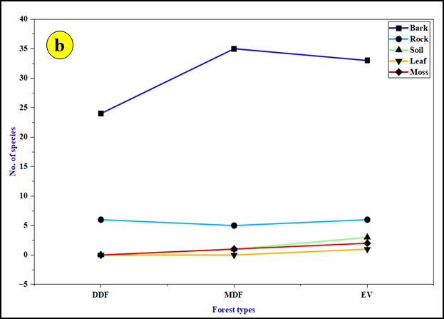
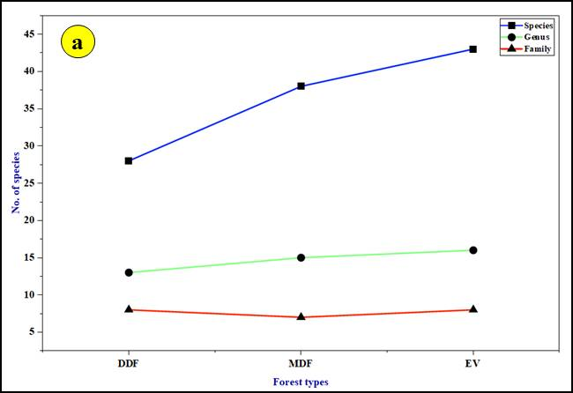

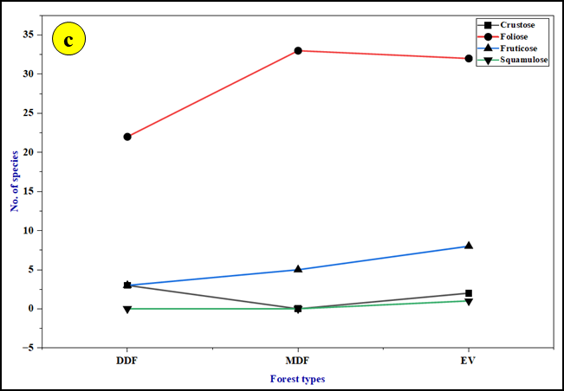

Fig. 3: Lichen distribution across ecological regions.
a- the cumulative diversity at the species, genus, and family levels; b- habitat-specific accumulation patterns across distinct substrates such as bark, rock, soil, and leaf; c- the stratification of lichens according to their morphological growth forms.

Table 2. Ecological analysis of lichens in the ATR, Western Ghats, Tamil Nadu, India
S. No | Name of the species | F (%) | D | A | RF | RD | RA | IVI
 | Heterodermia japonica (Satô) Swinsco & Krog. | 36 | 3.32 | 9.22 | 3.95 | 5.16 | 1.71 | 10.82
 | Parmotrema tinctorum (Despr. ex Nyl.) Hale | 24 | 2.86 | 11.92 | 2.63 | 4.44 | 2.20 | 9.27
 | Heterodermia diademata (Taylor) D.D. Awasthi | 32 | 2.64 | 8.25 | 3.51 | 4.10 | 1.53 | 9.14
 | Heterodermia magellanica (Zahlbr.) Swinscow & Krog | 24 | 2.46 | 10.25 | 2.63 | 3.82 | 1.90 | 8.35
 | Parmotrema austrosinense (Zahlbr.) Hale | 16 | 2.04 | 12.75 | 1.75 | 3.17 | 2.36 | 7.28
 | Parmotrema reticulatum (Taylor) M. Choisy | 24 | 1.9 | 7.92 | 2.63 | 2.95 | 1.46 | 7.04
 | Heterodermia dissecta (Kurok.) D.D. Awasthi | 22 | 1.92 | 8.73 | 2.41 | 2.98 | 1.61 | 7
 | Heterodermia microphylla (Kurok.) Skorepa | 24 | 1.76 | 7.33 | 2.63 | 2.73 | 1.36 | 6.72
 | Ramalina nervulosa (Müll.Arg.) Abbayes | 16 | 1.8 | 11.25 | 1.75 | 2.80 | 2.08 | 6.63
 | Roccella montagnei Bél. | 8 | 1.46 | 18.25 | 0.88 | 2.27 | 3.38 | 6.53
 | Parmelinella wallichiana (Taylor) Elix & Hale | 22 | 1.68 | 7.64 | 2.41 | 2.61 | 1.41 | 6.43
 | Parmotrema planatilobatum (Hale) Hale | 16 | 1.46 | 9.13 | 1.75 | 2.27 | 1.69 | 5.71
 | Heterodermia hypoleuca (Ach.) Trevis. | 16 | 1.38 | 8.63 | 1.75 | 2.14 | 1.60 | 5.49
 | Leptogium javanicum Mont. | 16 | 1.12 | 7.00 | 1.75 | 1.74 | 1.29 | 4.78
 | Parmelinella simplicior (Hale) Elix & Hale | 16 | 1.08 | 6.75 | 1.75 | 1.68 | 1.25 | 4.68
 | Heterodermia speciosa (Wulfen) Trevis. | 16 | 1.06 | 6.63 | 1.75 | 1.65 | 1.23 | 4.63
 | Heterodermia obscurata (Nyl.) Trevis. | 16 | 1.04 | 6.50 | 1.75 | 1.62 | 1.20 | 4.57
 | Leptogium denticulatum Nyl. | 16 | 1.02 | 6.38 | 1.75 | 1.58 | 1.18 | 4.51
 | Heterodermia dactyliza (Nyl.) Swinscow & Krog* | 16 | 1 | 6.25 | 1.75 | 1.55 | 1.16 | 4.46
 | Heterodermia boryi (Fée) Kr. P. Singh & S.R. Singh | 14 | 0.98 | 7.00 | 1.54 | 1.52 | 1.29 | 4.35
 | Parmotrema indicum Hale | 16 | 0.96 | 6.00 | 1.75 | 1.49 | 1.11 | 4.35
 | Usnea stigmatoides G. Awasthi | 12 | 0.98 | 8.17 | 1.32 | 1.52 | 1.51 | 4.35
 | Ramalina pacifica Asahina | 12 | 0.96 | 8.00 | 1.32 | 1.49 | 1.48 | 4.29
 | Heterodermia angustiloba (Müll.Arg.) D.D. Awasthi | 18 | 0.88 | 4.89 | 1.97 | 1.37 | 0.90 | 4.24
 | Ramalina conduplicans Vain. | 12 | 0.9 | 7.50 | 1.32 | 1.40 | 1.39 | 4.11
 | Parmotrema praesorediosum (Nyl.) Hale | 12 | 0.88 | 7.33 | 1.32 | 1.37 | 1.36 | 4.05
 | Collema furfuraceum (Schaer.) Du Rietz | 14 | 0.8 | 5.71 | 1.54 | 1.24 | 1.06 | 3.84
 | Usnea galbinifera Asahina | 10 | 0.78 | 7.80 | 1.10 | 1.21 | 1.44 | 3.75
 | Parmotrema hababianum (Gyeln.) Hale | 14 | 0.76 | 5.43 | 1.54 | 1.18 | 1.00 | 3.72
 | Polyblastidium hypocaesium (Yasuda ex Räsänen) D.D. Awasthi | 14 | 0.76 | 5.43 | 1.54 | 1.18 | 1.00 | 3.72
 | Heterodermia rubricosa (Stirt.) Poelt | 6 | 0.6 | 10.00 | 0.66 | 0.93 | 1.85 | 3.44
 | Usnea ghattensis G. Awasthi | 6 | 0.6 | 10.00 | 0.66 | 0.93 | 1.85 | 3.44
 | Dirinaria confluens (Fr.) D.D. Awasthi | 12 | 0.66 | 5.50 | 1.32 | 1.03 | 1.02 | 3.37
 | Usnea stigmata Motyka | 8 | 0.64 | 8.00 | 0.88 | 0.99 | 1.48 | 3.35
 | Cladonia fruticulosae Kremp. | 16 | 0.56 | 3.50 | 1.75 | 0.87 | 0.65 | 3.27
 | Cladonia ochrochlora Florke | 14 | 0.6 | 4.29 | 1.54 | 0.93 | 0.79 | 3.26
 | Lepraria lobificans Nyl. | 8 | 0.6 | 7.50 | 0.88 | 0.93 | 1.39 | 3.2
 | Dirinaria applanata (Fée) D.D. Awasthi | 14 | 0.56 | 4.00 | 1.54 | 0.87 | 0.74 | 3.15
 | Parmotrema crinitoides J.C. Wei | 8 | 0.58 | 7.25 | 0.88 | 0.90 | 1.34 | 3.12
 | Remototrachyna flexilis (Kurok.) Divakar & A. Crespo | 6 | 0.52 | 8.67 | 0.66 | 0.81 | 1.60 | 3.07
 | Hypotrachyna cirrhatum (Fr.) Divakar, A.Crespo, Sipman, Elix & Lumbsch | 8 | 0.56 | 7.00 | 0.88 | 0.87 | 1.29 | 3.04
 | Heterodermia comosa (Eschw.) Follmann & Redón | 8 | 0.54 | 6.75 | 0.88 | 0.84 | 1.25 | 2.97
 | Heterodermia hypochraea (Vain.) Swinscow & Krog* | 8 | 0.54 | 6.75 | 0.88 | 0.84 | 1.25 | 2.97
 | Parmotrema crinitum (Ach.) M. Choisy | 8 | 0.54 | 6.75 | 0.88 | 0.84 | 1.25 | 2.97
 | Hypotrachyna boquetensis (Hale) Hale | 8 | 0.52 | 6.50 | 0.88 | 0.81 | 1.20 | 2.89
 | Hypotrachyna crenata (Kurok.) Hale | 6 | 0.48 | 8.00 | 0.66 | 0.75 | 1.48 | 2.89
 | Leprocaulon pseudoarbuscula (Asahina) I.M. Lamb & A. Ward | 8 | 0.52 | 6.50 | 0.88 | 0.81 | 1.20 | 2.89
 | Pyxine cocoes (Sw.)Nyl. | 12 | 0.48 | 4.00 | 1.32 | 0.75 | 0.74 | 2.81
 | Parmotrema andinum (Müll.Arg.) Hale | 6 | 0.46 | 7.67 | 0.66 | 0.71 | 1.42 | 2.79
 | Ramalina leiodea (Nyl.) Nyl. | 6 | 0.46 | 7.67 | 0.66 | 0.71 | 1.42 | 2.79
 | Parmotrema kamatii Patw. & Prabhu | 8 | 0.48 | 6.00 | 0.88 | 0.75 | 1.11 | 2.74
 | Sticta weigelii (Ach.) Vain. | 10 | 0.46 | 4.60 | 1.10 | 0.71 | 0.85 | 2.66
 | Parmotrema mesotropum (Müll.Arg.) Hale | 8 | 0.46 | 5.75 | 0.88 | 0.71 | 1.06 | 2.65
 | Parmotrema xanthinum (Müll.Arg.) Hale | 6 | 0.42 | 7.00 | 0.66 | 0.65 | 1.29 | 2.6
 | Bulbothrix isidiza (Nyl.) Hale | 14 | 0.36 | 2.57 | 1.54 | 0.56 | 0.48 | 2.58
 | Leptogium pichneum (Ach.) Malme. | 8 | 0.44 | 5.50 | 0.88 | 0.68 | 1.02 | 2.58
 | Usnea pectinata Stirt | 6 | 0.4 | 6.67 | 0.66 | 0.62 | 1.23 | 2.51
 | Dirinaria consimilis (Stirt.) D.D. Awasthi | 8 | 0.4 | 5.00 | 0.88 | 0.62 | 0.92 | 2.42
 | Dirinaria papillulifera (Nyl.) D.D. Awasthi | 8 | 0.4 | 5.00 | 0.88 | 0.62 | 0.92 | 2.42
 | Myelochroa xantholepis (Mont. & Bosch) Elix & Hale | 6 | 0.38 | 6.33 | 0.66 | 0.59 | 1.17 | 2.42
 | Phyllopsora furfuracea (Pers.) Zahlbr. | 6 | 0.38 | 6.33 | 0.66 | 0.59 | 1.17 | 2.42
 | Leptogium cyanescens (Rabenh.) Körb. | 6 | 0.36 | 6.00 | 0.66 | 0.56 | 1.11 | 2.33
 | Leptogium isidiosellum (Riddle) Sierk | 6 | 0.36 | 6.00 | 0.66 | 0.56 | 1.11 | 2.33
 | Pyxine subcinerea Stirt. | 6 | 0.36 | 6.00 | 0.66 | 0.56 | 1.11 | 2.33
 | Diorygma hieroglyphicum (Pers.) Staiger & Kalb | 8 | 0.36 | 4.50 | 0.88 | 0.56 | 0.83 | 2.27
 | Cetrelia braunsiana (Müll. Arg.) W.L. Culb. & C.F. Culb* | 8 | 0.34 | 4.25 | 0.88 | 0.53 | 0.79 | 2.2
 | Collema actinoptychum Nyl. | 8 | 0.34 | 4.25 | 0.88 | 0.53 | 0.79 | 2.2
 | Diploschistes candissimus (Kremp.) Zahlbr. | 6 | 0.32 | 5.33 | 0.66 | 0.50 | 0.99 | 2.15
 | Physcia tribacoides Nyl. | 6 | 0.32 | 5.33 | 0.66 | 0.50 | 0.99 | 2.15
 | Pseudocyphellaria aurata (Ach.) Vain. | 6 | 0.32 | 5.33 | 0.66 | 0.50 | 0.99 | 2.15
 | Pyxine austroindica D.D. Awasthi | 6 | 0.32 | 5.33 | 0.66 | 0.50 | 0.99 | 2.15
 | Pyxine cognata Stirt. | 6 | 0.32 | 5.33 | 0.66 | 0.50 | 0.99 | 2.15
 | Pyxine sorediata (Ach.) Mont. | 6 | 0.32 | 5.33 | 0.66 | 0.50 | 0.99 | 2.15
 | Collema flaccidum (Ach.) Ach. | 6 | 0.3 | 5.00 | 0.66 | 0.47 | 0.92 | 2.05
 | Physcia dimidiata (Arn.) Nyl. | 6 | 0.3 | 5.00 | 0.66 | 0.47 | 0.92 | 2.05
 | Lithocalla ecorticata (J.R. Laundon) Orange | 6 | 0.28 | 4.67 | 0.66 | 0.44 | 0.86 | 1.96
 | Dirinaria aegialita (Afzel. ex Ach.) B.J. Moore | 6 | 0.26 | 4.33 | 0.66 | 0.40 | 0.80 | 1.86
 | Physcia aipolia (Ehrh. ex Humb.) Fürnr. | 6 | 0.26 | 4.33 | 0.66 | 0.40 | 0.80 | 1.86
 | Pseudocyphellaria crocata (L.) Vain. | 6 | 0.26 | 4.33 | 0.66 | 0.40 | 0.80 | 1.86
 | Strigula sp. | 4 | 0.22 | 5.50 | 0.44 | 0.34 | 1.02 | 1.8
 | Pyxine petricola var. pallida Swinscow & Krog* | 6 | 0.2 | 3.33 | 0.66 | 0.31 | 0.62 | 1.59
F- Frequency; RF- Relative Frequency; D- Density; RD- Relative Density; A; Abundance; RA- Relative Abundance; IVI- Important Value Index; * New record to Tamil Nadu.

Relative frequency (RF) followed a similar pattern, with H. japonica recording the highest value (3.95). Relative density (RD) was also highest for H. japonica (5.16), showing its numerical dominance compared with other species. Relative abundance (RA) was higher for Roccella montagnei (18.25), indicating greater concentration where it occurred. According to Sharath and Jabeen (2021), H. diademata exhibited the highest frequency (100%) with relatively low density (1.6) and abundance (1.6), followed by H. japonica, which showed moderate frequency (66.6%) but recorded the highest density (2.5) and abundance (3.7). P. austrosinense demonstrated high frequency (93.3%) with moderate density (1.33) and abundance (1.6) in the Mattavara forest, Karnataka. Similarly, in the Biligiriranga Hills, characterised by high mountain peaks and elevations ranging from 1,350 to 1,450 m, only a few lichen species belonging to Heterodermia and Parmotrema were recorded, with comparatively lower density and abundance (Rashmi and Rajkumar, 2015). These findings indicate that ecological characteristics strongly influence lichen species diversity.
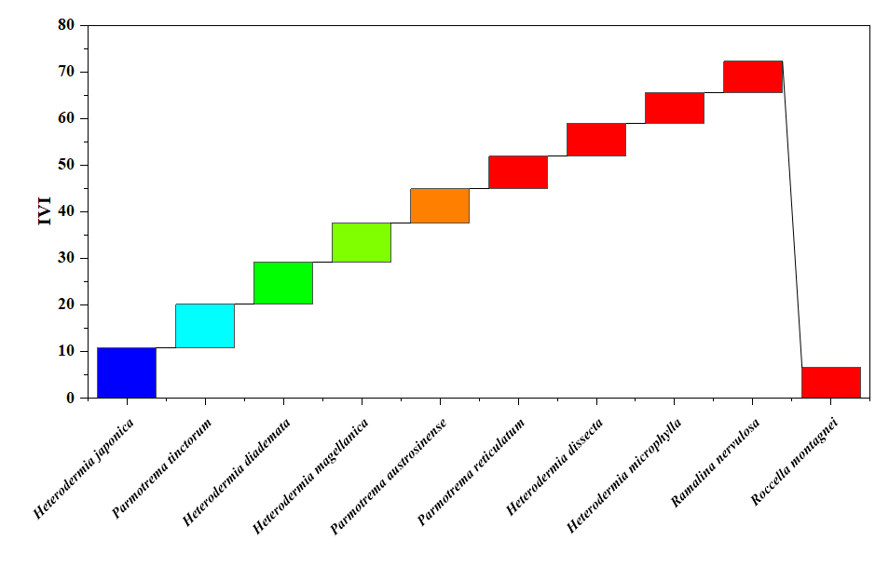
Fig: 4. Comparative Importance Value Index (IVI) of dominant lichen species
The Importance Value Index (IVI), which combines relative frequency, relative density and relative abundance, provides an overall measure of ecological significance. IVI values ranged from 10.82 to 1.59 (Fig. 4). H. japonica was the most important species, with the highest IVI (10.82), followed by P. tinctorum (9.27), H. diademata (9.14) and H. magellanica (8.35), indicating their dominant role in the lichen community in the study area. The lowest IVI was observed in Pyxine petricola var. pallida (1.59). Overall, H. japonica was the most dominant and commonly distributed lichen species in the study area. A high IVI reflects the dominance and ecological success of a species, attributed to its strong regenerative capacity and greater ecological amplitude (Thakur and Khare, 2009). Conversely, H. japonica showed a lower IVI value (0.39) in the Western Himalaya, India (Gupta et al., 2018).
The site-wise variation in lichen diversity across the ten study sites was summarised using standard diversity indices (Table 3). Species richness (S), ranging from 4 to 28, reveals the variety of species present in a specific area and is commonly used in environmental monitoring and conservation assessment. The total number of individuals (N) also showed marked variation, with the highest abundance recorded at S1 (661) and the lowest at S8 (103), indicating differences in population size and habitat suitability among sites. The Shannon-Wiener diversity index (H′) revealed moderate to high diversity across sites, with values ranging from 1.32 to 3.17. Higher H′ values at Sites S1 (3.17) and S3 (3.00) indicate greater species diversity and a more even distribution of individuals, whereas lower values at S8 (1.32) and S10 (1.76) suggest reduced diversity and dominance by fewer species. The Shannon-Wiener diversity values (H′) recorded in the present study were comparable to those reported from the Western Ghats (Shravanakumara et al., 2010). Simpson's diversity index (1-D) values ranged from 0.73 to 0.95, indicating generally high diversity across most sites. Sites S1 and S3 (0.95) exhibited the highest Simpson diversity, reflecting low dominance and high species heterogeneity, while S2 (0.31) showed comparatively lower diversity, suggesting dominance by a few species. A low Simpson's index indicates that dominance within a community is shared by only one or two species. Several studies have reported diversity values comparable to those observed in the present study (Knight, 1975; Vignesh et al., 2022).
Table 3. Site wise diversity indices of lichen species across ten sites
S. No | Sites | S | N | H’ | 1-D
 | S1 | 28 | 661 | 3.17 | 0.95
 | S2 | 18 | 412 | 2.63 | 0.31
 | S3 | 21 | 538 | 3.00 | 0.95
 | S4 | 11 | 265 | 2.33 | 0.90
 | S5 | 8 | 229 | 1.97 | 0.85
 | S6 | 11 | 288 | 2.39 | 0.91
 | S7 | 8 | 218 | 2.04 | 0.87
 | S8 | 4 | 103 | 1.32 | 0.73
 | S9 | 13 | 354 | 2.51 | 0.92
 | S10 | 6 | 150 | 1.76 | 0.83
1- Kaviaruvi; 2- Attakatti; 3- Poonachi; 4- Iyerpadi; 5- Kavarkal; 6- Urulikkal; 7- Manamboly; 8- Sheikalmudi; 9- Chinnakallar; 10- Periyakallar; S- Species richness; N- No. of individuals; H’- Shannon-Wiener Index; 1-D- Simpson’s Index.
The results suggest an inverse relationship between Shannon-Wiener and Simpson's indices, where sites with higher Shannon-Wiener values exhibit lower Simpson's dominance values and vice versa. The observed variation in biodiversity across sites reflects differences in ecological conditions influenced by factors such as habitat type, anthropogenic disturbance and environmental variables (Balu et al., 2021; Sharath and Jabeen, 2021).
Similarity Index for the sampling sites
The Sørensen similarity index was used to assess the degree of similarity among sites based on species presence-absence and abundance data, with values ranging from 0 (completely dissimilar) to 1 (completely similar) (Darshni et al., 2025). A lichen diversity survey conducted across ten sampling sites documented a total of 81 species, and inter-site compositional similarity was quantified using the Sørensen similarity index (Table 4). S1 and S2 are positioned close to each other on the left side of the ordination, indicating moderate similarity in their lichen assemblages. Previous studies have shown that even small-scale environmental heterogeneity can significantly affect lichen diversity and distribution (Aptroot and van Herk, 2007). S3 and S4 occur very close together near the centre of the plot, showing high similarity in species composition. These sites share many lichen species and likely represent a core lichen community typical of the study area. S5 and S6 are also located near the centre and close to S3 and S4, indicating moderate to high similarity with the core group. Similar clustering patterns have been reported in tropical and subtropical forests, where lichen communities are primarily structured by bark characteristics, canopy cover, moisture availability and air quality (Nimis et al., 2002). These sites share several species with the central cluster but show slight differentiation. S7 is positioned to the right of the central cluster, indicating a distinct but partially overlapping lichen community. S8 lies further to the right and away from most sites, reflecting low similarity with other sites. S9 is located toward the upper part of the ordination, showing clear separation from other sites. S10 is placed at the lower extreme of the plot, indicating very low similarity with other sites.
Table 4. Sørensen similarity matrix between and within the study sites
 | S2 | S3 | S4 | S5 | S6 | S7 | S8 | S9 | S10
S1 | 0.30 | 0.16 | 0.10 | 0.00 | 0.00 | 0.11 | 0.00 | 0.00 | 0.00
S2 |  | 0.10 | 0.21 | 0.08 | 0.07 | 0.08 | 0.09 | 0.00 | 0.00
S3 |  |  | 0.31 | 0.14 | 0.19 | 0.07 | 0.08 | 0.12 | 0.22
S4 |  |  |  | 0.11 | 0.09 | 0.11 | 0.00 | 0.08 | 0.24
S5 |  |  |  |  | 0.21 | 0.13 | 0.00 | 0.10 | 0.14
S6 |  |  |  |  |  | 0.22 | 0.13 | 0.08 | 0.24
S7 |  |  |  |  |  |  | 0.00 | 0.29 | 0.14
S8 |  |  |  |  |  |  |  | 0.12 | 0.00
S9 |  |  |  |  |  |  |  |  | 0.11
S1- Kaviaruvi; S2- Attakatti; S3- Poonachi; S4- Iyerpadi; S5- Kavarkal; S6- Urulikkal; S7- Manamboly; S8- Sheikalmudi; S9- Chinnakallar; S10- Periyakallar
Pearson correlation coefficient and principal components analysis (PCA)
The Pearson correlation coefficient matrix revealed strong positive relationships among the major lichen diversity parameters (Fig. 5). Species richness (S) showed a very strong positive correlation with the number of individuals (N) (r = 0.99), indicating that habitats with higher lichen abundance also supported greater species richness. Similarly, species richness was strongly correlated with the Shannon-Wiener diversity index (H′) (r = 0.94), while abundance exhibited a strong positive association with Shannon diversity (r = 0.96). These findings suggest that species-rich communities contribute substantially to overall diversity and ecosystem stability. Similar positive relationships between abundance, species richness and diversity indices have been reported in epiphytic lichen communities and forest ecosystems, where increased species abundance enhances community complexity and ecological resilience (Nash, 2008; Giordani et al., 2012). In contrast, Simpson's diversity index (1-D) exhibited weak positive correlations with species richness (r = 0.035), abundance (r = 0.11) and Shannon diversity (r = 0.13). The relatively low correlations indicate that dominance patterns among lichen species remained comparatively stable across sampling sites. Similar observations have been reported in mature forest ecosystems where high species heterogeneity reduces the influence of dominant taxa on overall diversity patterns (Aptroot and Seaward, 2003). The diversity analysis recorded a total of 81 lichen species in the study area. The overall Shannon-Wiener diversity index (H′ = 1.363) indicated moderate species diversity, whereas the high Simpson's diversity value (1-D = 0.98) reflected high species heterogeneity and low dominance by individual species. High Simpson's diversity values have been reported from tropical and montane forests characterised by favourable microclimatic conditions and diverse substrate availability that support the coexistence of numerous lichen taxa (Wolseley et al., 2006; Vignesh et al., 2022). The observed diversity pattern therefore suggests that the ATR provides suitable environmental conditions for the establishment and persistence of diverse lichen assemblages.
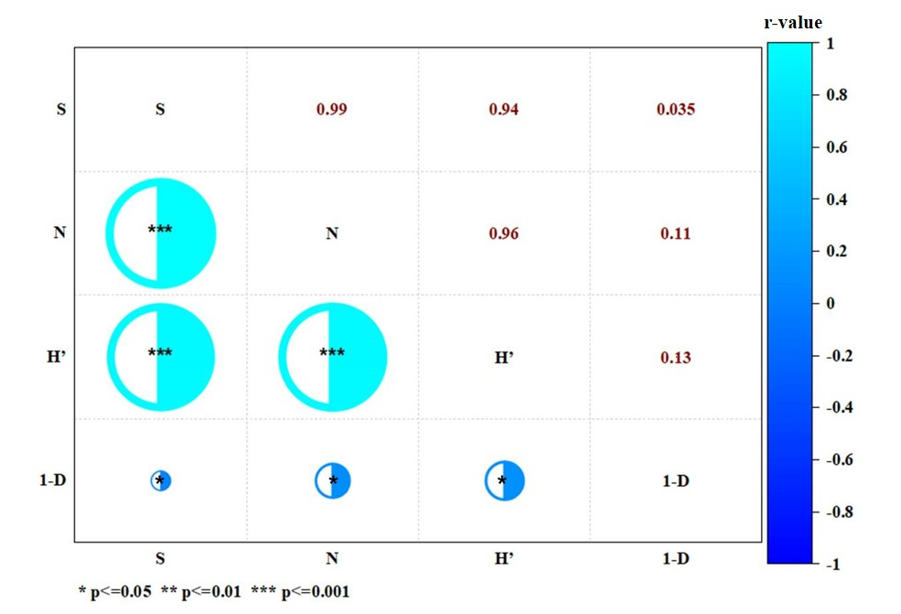
Fig. 5. Pearson correlation coefficient analysis among diversity indices of lichen species
PCA was performed using ecological parameters, including F, D, A, RF, RD, RA and IVI (Fig. 6). The first two principal components explained 99.40% of the total variation, with PC1 accounting for 78.61% and PC2 accounting for 20.79%. The high cumulative variance indicates that the selected ecological variables effectively captured the major patterns of variation within the lichen community. Similar PCA studies on lichen and forest vegetation communities have demonstrated that the first two principal components often explain a substantial proportion of ecological variability and are effective in identifying dominant species and community gradients (Nimis et al., 2002; Giordani et al., 2012). The PCA biplot showed that SP1, SP2, SP3, SP4, SP5 and SP10 were distinctly separated from the main cluster, indicating their greater influence on community composition.
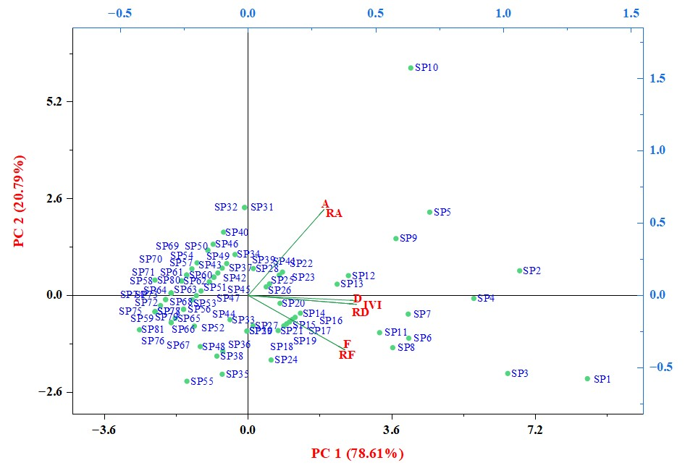
Fig. 6. Principal Components Analysis (PCA) of diversity indices of lichen species
Species SP10 exhibited a strong association with abundance and relative abundance, suggesting its dominance in terms of population size. In contrast, SP1, SP2, SP3 and SP4 were closely associated with density, relative density, frequency, relative frequency and IVI, indicating their ecological importance and wider distribution within the study area. Similar patterns have been reported in phytosociological studies where a limited number of dominant species account for a major proportion of community variation, while the majority of species contribute moderately to ecosystem structure and function (Odum and Barrett, 2005). Most of the remaining species were clustered near the origin of the ordination space, reflecting similar ecological characteristics and moderate contributions to the measured variables. Such clustering suggests overlapping ecological niches and comparable responses to environmental conditions. Species positioned farther from the origin contributed more strongly to community differentiation and may therefore serve as indicator species for monitoring habitat quality and ecological change (Canters et al., 1991). The PCA highlights the coexistence of a few ecologically influential species alongside a larger group of species with similar ecological attributes, demonstrating the heterogeneous nature of lichen assemblages in the ATR.
4. CONCLUSIONS
The present study provides a comprehensive assessment of lichen diversity in the Anamalai Tiger Reserve, Western Ghats, documenting 81 species belonging to 27 genera and 12 families across different forest types and elevational gradients. Diversity analyses revealed high species richness with uneven distribution patterns, indicating the dominance of a few ecologically adapted taxa. H. japonica was identified as the most dominant and widely distributed species within the reserve. Multivariate analyses demonstrated distinct variations in species composition among forest types, while evergreen and moist deciduous forests supported greater species richness and diversity than dry deciduous forests. These findings highlight the strong influence of vegetation structure, humidity and microclimatic conditions on lichen distribution. The study also reports C. braunsiana, H. dactyliza, H. hypochraea and P. petricola var. pallida as new records for Tamil Nadu, expanding the known lichen flora of the state. Furthermore, the occurrence of habitat-specific and elevation-dependent species demonstrates the ecological sensitivity of lichens and their potential as bioindicators of forest health and environmental change. The findings provide valuable baseline data for future ecological monitoring and conservation planning in the Western Ghats.

Limitations
The study was restricted to selected sites and three forest types within the Anamalai Tiger Reserve. Seasonal variation, long-term population trends, air-quality parameters and detailed microclimatic measurements were not included. Therefore, future studies with repeated seasonal sampling and broader environmental monitoring would strengthen interpretation of lichen distribution patterns.

AcknowledgEments
The authors express their sincere gratitude to the Principal Chief Conservator of Forests and the Field Director of Anamalai Tiger Reserve, Tamil Nadu for granting permission to conduct lichen survey. The authors also thank the director of CSIR-NBRI, Lucknow for providing the necessary facilities for this work. Further appreciation is extended to the Head, Department of Botany, NGM College, Coimbatore for their laboratory assistance and continuous support.
COMPETING INTERESTS
The authors declare that they have no competing interests.
Authors’ Contributions
Alahupreeti J: Conceptualization, data curation, methodology, investigation and writing- original draft. Rajalakshmi K: Project administration, writing- supervision reviewing and editing the manuscript. Nayaka S: Formal analysis, writing- review & editing and validation. Pavithra K: Investigation, writing- review & editing. All authors read and approved the final manuscript. All the data were generated in-house, and no paper mill was used. All authors agree to be accountable for all aspects of work ensuring integrity and accuracy.
ETHICAL APPROVAL
Not applicable.
REFERENCES
Aptroot, A., & Seaward, M. R. D. (2003). Freshwater lichens. Fungal Diversity Research Series, 10, 101–110.
Aptroot, A., & van Herk, C. M. (2007). Further evidence of the effects of global warming on lichens, particularly those with Trentepohlia phycobionts. Environmental Pollution, 146(2), 293–298. https://doi.org/10.1016/j.envpol.2006.03.018
Arun Prasath, K., Kalidoss, R., Mariraj, M., Muniappan, V., & Ponmurugan, P. (2022). Diversity distribution of lichens from Maruthamalai Hills of Tamil Nadu, India. Journal of Phytological Research, 35(1–2), 23–31. https://jphytolres.org/paper/1353
Awasthi, D. D. (1988). A key to the macrolichens of India, Nepal and Sri Lanka. Bibliotheca Lichenologica, 40, 1–337.
Awasthi, D. D. (2007). A compendium of the macrolichens from India, Nepal and Sri Lanka. Bishen Singh Mahendra Pal Singh.
Balaji, P., & Hariharan, G. N. (2013). Diversity of macrolichens in Bolampatti II Forest Range (Siruvani Hills), Western Ghats, Tamil Nadu, India. ISRN Biodiversity, 2013, Article 124020. https://doi.org/10.1155/2013/124020
Balaji, P., & Hariharan, G. N. (2004). Lichen diversity and its distribution pattern in tropical dry evergreen forest of Guindy National Park (GNP), Chennai. The Indian Forester, 130(10), 1155–1168. https://doi.org/10.36808/if/2004/v130i10/2131
Balu, G., Rasmi, A. R., Sequeira, S., & Haridas, B. (2021). Diversity and distribution of macro lichens from Kalpetta Municipality of Wayanad District, Kerala, India. Journal of Threatened Taxa, 13(14), 20253–20257. https://doi.org/10.11609/jott.6706.13.14.20253-20257
Calcott, M. J., Ackerley, D. F., Knight, A., Keyzers, R. A., & Owen, J. G. (2018). Secondary metabolism in the lichen symbiosis. Chemical Society Reviews, 47(5), 1730–1760. https://doi.org/10.1039/C7CS00431A
Canters, K. J., Schöller, H., Ott, S., & Jahns, H. M. (1991). Microclimatic influences on lichen distribution and community development. The Lichenologist, 23(3), 237–252. https://doi.org/10.1017/S0024282991000403
Curtis, J. T., & McIntosh, R. P. (1950). The interrelations of certain analytic and synthetic phytosociological characters. Ecology, 31(3), 434–455. https://doi.org/10.2307/1931497
Dalui, T., Kushari, S., Chowdhury, S., & Mondal, A. (2024). Faunal diversity in Western Ghats, India: A review. Journal of Advanced Zoology, 45(4). https://doi.org/10.53555/jaz.v45i4.4750
Darshni, P., Gupta, P., Shrivastava, A., Bhat, M., Dhupper, R., & Singh, L. (2025). Assessing lichen diversity in the Himalayan region of Reasi, Jammu and Kashmir. International Journal of Environmental Sciences, 11(2), 714–725. https://doi.org/10.64252/0gcs3z04
Divakar, P. K., & Upreti, D. K. (2005). Parmelioid lichens in India: A revisionary study. Bishen Singh Mahendra Pal Singh.
Fryday, A. M. (2001). The lichen vegetation associated with areas of late snow-lie in the Scottish Highlands. The Lichenologist, 33(2), 121–150. https://doi.org/10.1006/lich.2000.0308
Ganesan, V. (2019). History of Anamalais: Teak to tiger. Anamalai Tiger Conservation Foundation Tamil Nadu Trust.
Giordani, P., Brunialti, G., Bacaro, G., & Nascimbene, J. (2012). Functional traits of epiphytic lichens as potential indicators of environmental conditions in forest ecosystems. Ecological Indicators, 18, 413–420. https://doi.org/10.1016/j.ecolind.2011.12.006
Gupta, S., Bajpai, O., Rai, H., Upreti, D. K., Sharma, P. K., & Gupta, R. K. (2018). Untangling quantitative lichen diversity in and around Badrinath holy pilgrimage of Western Himalaya, India. Journal of Graphic Era University, 6(1), 36–46. https://www.journal.riverpublishers.com/index.php/JGEU/article/view/88
Haridas, B., & Aliyarukunju, S. (2024). A preliminary checklist on the lichen flora of Agasthyamalai Biosphere Reserve, Kerala, India. Cryptogam Biodiversity and Assessment, 8(1), 13–22. https://doi.org/10.21756/cab.v8i1.02
Hawksworth, D. L., & Grube, M. (2020). Lichens redefined as complex ecosystems. New Phytologist, 227(5), 1281. https://doi.org/10.1111/nph.16630
Hyde, K. D., Noorabadi, M. T., Thiyagaraja, V., He, M. Q., Johnston, P. R., Wijesinghe, S. N., Armand, A., Biketova, A. Y., Chethana, K. W. T., Erdoğdu, M., Ge, Z. W., Groenewald, J. Z., Hongsanan, S., Kušan, I., Leontyev, D. V., Li, D. W., Lin, C. G., Liu, N. G., Maharachchikumbura, S. S. N., ... Zvyagina, E. (2024). The 2024 outline of fungi and fungus-like taxa. Mycosphere, 15(1), 5146–6239. https://doi.org/10.5943/mycosphere/15/1/25
Jackson, T. A. (2015). Weathering, secondary mineral genesis, and soil formation caused by lichens and mosses growing on granitic gneiss in a boreal forest environment. Geoderma, 251–252, 78–91. https://doi.org/10.1016/j.geoderma.2015.03.012
Joshi, S., & Upreti, D. K. (2016). Lichens of the Western Ghats new to India. Current Research in Environmental & Applied Mycology, 6(4), 328–333. https://doi.org/10.5943/cream/6/4/11
Kalidoss, R., Merlin, J., Charumathy, M., Surekha, S., Arun Prasath, K., Mariraj, M., Shenbagam, M., Rajaprabu, N., & Ponmurugan, P. (2019). Lichen collections from Nilgiris of Western Ghats in Tamil Nadu and screening for antimicrobial, antioxidant efficacy of some selected species. Pramana Research Journal, 9(6).
Knight, D. H. (1975). A phytosociological analysis of species-rich tropical forest on Barro Colorado Island, Panama. Ecological Monographs, 45(3), 259–284. https://doi.org/10.2307/1942424
Kumar, A., Thangjam, N. M., Laldingliani, T. B. C., & Singh, C. B. (2024). Lichens in the Himalayan region: Present and future perspectives. In High-value plants: Novel insights and biotechnological advances (pp. 243–262). Apple Academic Press. https://doi.org/10.1201/9781003457572-12
Lücking, R., Hodkinson, B. P., & Leavitt, S. D. (2017). The 2016 classification of lichenized fungi in the Ascomycota and Basidiomycota—Approaching one thousand genera. The Bryologist, 119(4), 361–416. https://doi.org/10.1639/0007-2745-119.4.361
Nash, T. H. (Ed.). (2008). Lichen biology (2nd ed.). Cambridge University Press. https://doi.org/10.1017/CBO9780511790478
Nayaka, S. (2014). Methods and techniques in collection, preservation and identification of lichens. In Plant taxonomy and biosystematics: Classical and modern methods (pp. 101–105). https://www.indianlichenology.com/pdfFiles/3%20Chapter%20Nayaka%20Lichen%20collection.pdf
Nayaka, S., & Haridas, B. (2024). Lichen-forming and lichenicolous fungi of the Western Ghats, India. In Biodiversity hotspot of the Western Ghats and Sri Lanka (pp. 89–107). Apple Academic Press. https://doi.org/10.1201/9781003408758-6
Nayaka, S., & Upreti, D. K. (2006). Status of lichen diversity in Western Ghats, India. Sahyadri E-News, Western Ghats Biodiversity Information System, 16, 1–28. https://wgbis.ces.iisc.ac.in/biodiversity/sahyadri_enews/newsletter/issue16/main_index.htm
Nayaka, S., Upreti, D. K., & Divakar, P. K. (2001). Distribution and diversity of lichens in Meghamalai Wildlife Sanctuary, Kambam District, Tamil Nadu, India. Biological Memoirs, 27(1), 51–58.
Nayaka, S., Upreti, D. K., & Khare, R. (2011). Diversity and distribution of lichens in Katarniaghat Wildlife Sanctuary, Uttar Pradesh. The Journal of Indian Botanical Society, 90(3–4), 360–366.
Nimis, P. L., Scheidegger, C., & Wolseley, P. A. (2002). Monitoring with lichens—monitoring lichens: An introduction. In P. L. Nimis, C. Scheidegger, & P. A. Wolseley (Eds.), Monitoring with lichens—monitoring lichens (pp. 1–4). Springer. https://doi.org/10.1007/978-94-010-0423-7_1
Odum, E. P., & Barrett, G. W. (2005). Fundamentals of ecology (5th ed.). Thomson Brooks/Cole.
Orange, A., James, P. W., & White, F. J. (2001). Microchemical methods for the identification of lichens. British Lichen Society.
Phillips, W. J. (1972). An evaluation of the relative importance index to the study of forest vegetation on Mont St. Hilaire, Quebec, Canada [Master’s thesis, McGill University]. eScholarship@McGill. https://escholarship.mcgill.ca/concern/theses/jq085m736
Phukhamsakda, C., Nilsson, R. H., Bhunjun, C. S., de Farias, A. R. G., Sun, Y.-R., Wijesinghe, S. N., Raza, M., Bao, D.-F., Lu, L., Tibpromma, S., Dong, W., Tennakoon, D. S., Tian, X.-G., Xiong, Y.-R., ... Hyde, K. D. (2022). The numbers of fungi: Contributions from traditional taxonomic studies and challenges of metabarcoding. Fungal Diversity, 114, 327–386. https://doi.org/10.1007/s13225-022-00502-3
Rajaprabu, N., & Ponmurugan, P. (2023). Additions to the cryptogamic lichen biota from the Republic of India from Tamil Nadu (Version 1) [Preprint]. Research Square. https://doi.org/10.21203/rs.3.rs-2604149/v1
Rashmi, S., & Rajkumar, H. G. (2015). Enumeration and new records of lichens in Kodagu district: A micro hotspot in Western Ghats of Karnataka, India. International Research Journal of Environmental Sciences, 4(12), 17–25. https://www.isca.in/IJENS/Archive/v4/i12/3.ISCA-IRJEVS-2015-168.php
Madhusudhana Reddy, A., Nayaka, S., Shankar, P. C., Reddy, S. R., & Rao, B. R. P. (2011). New distributional records and checklist of lichens for Andhra Pradesh, India. Indian Forester, 137(12), 1371–1376. https://doi.org/10.36808/if/2011/v137i12/12262
Shannon, C. E., & Weaver, W. (1949). The mathematical theory of communication. University of Illinois Press.
Sharath, K. P., & Jabeen, F. T. Z. (2021). Diversity and distribution of lichens in Mattavara forest of Chikkamagaluru, Karnataka, India. International Journal of Botany Studies, 6(5), 246–251.
Shravanakumara, S., Vinayaka, K. S., Kumaraswamy Udupa, E. S., Shashirekha, B., Praveena, V., & Krishnamurthy, Y. L. (2010). Diversity and host specificity of lichens in Koppa Taluk of Central Western Ghats, Karnataka, India. Indian Journal of Forestry, 33(3), 437–442.
Simpson, E. H. (1949). Measurement of diversity. Nature, 163, 688. https://doi.org/10.1038/163688a0
Sinha, G. P. (2021). Documentation of lichen diversity in India. ILS eLetter, 1, 5–7. https://www.indianlichenology.com/Admin/Uploads/Attched/20220328210749230_ILS%20eLetter_VOL_01.pdf
Sinha, G. P., Nayaka, S., & Mishra, G. K. (2024). A comprehensive checklist of lichens from India—2024. Cryptogam Biodiversity and Assessment, 8(2), 1–134. https://doi.org/10.21756/cab.v8i2.01
Sørensen, T. (1948). A method of establishing groups of equal amplitude in plant sociology based on similarity of species content and its application to analyses of the vegetation on Danish commons. Biologiske Skrifter, 5, 1–34.
Subbaiyan, R., Ganesan, A., & Dhanuskodi, S. (2023). Ecolichenology of Eastern Ghats diversity against climatic fluctuations in Kolli Hills, India. Biodiversitas Journal of Biological Diversity, 24(1), 625–635. https://doi.org/10.13057/biodiv/d240171
Thakur, A. S., & Khare, P. K. (2009). Composition of forest vegetation and floristics of Sagar district, central India. Journal of the Indian Botanical Society, 88(1–2), 11–17.
Tumur, A., Mamut, R., & Seaward, M. R. D. (2025). Diversity and elevational levels of lichens in Western Tianshan National Nature Reserve in Xinjiang, China. Diversity, 17(2), Article 102. https://doi.org/10.3390/d17020102
Vignesh, A., Sivalingam, R., & Vasanth, K. (2022). Diversity of woody flora and physico-chemical attributes of soil in the Nilgiri Hills, Tamil Nadu, India. Proceedings of the National Academy of Sciences, India Section B: Biological Sciences, 92(1), 95–103. https://doi.org/10.1007/s40011-021-01279-2
Wolseley, P. A., James, P. W., Theobald, M. R., & Sutton, M. A. (2006). Detecting changes in epiphytic lichen communities at sites affected by atmospheric ammonia from agricultural sources. The Lichenologist, 38(2), 161–176. https://doi.org/10.1017/S0024282905005487
Bheemalingappa, M., Ranjan, V., Murugan, C., & Kumar, A. (2026). Floristic exploration of wildlife sanctuaries in Central India: A review on progress, gaps and future priorities. BIONATURE, 46(1), 191–209. https://doi.org/10.56557/bn/2026/v46i12102
Naincy, Bhardwaj, N., Bhatia, A., & Mishra, G. K. (2024). Epiphytic lichen communities use as: A tool for assessing forest condition in Himachal Pradesh, India. Biology Bulletin, 51, 1652–1661. https://doi.org/10.1134/S1062359024607298
Nayana Prakash, V., Pranav, K., Christy, A., Joseph, S., Sreejith, K. A., Sreekumar, V. B., & Jincy, T. S. (2024). Lichens of the Sholayar 10 ha permanent plot, Western Ghats with Allographa cinerea as new to India. Biology Bulletin, 51, 948–953. https://doi.org/10.1134/S1062359023606225
Vinayaka, K. S., Sudhama, V. N., Devama, A. A., & Kuladeep, P. P. (2025). Spatial distribution pattern and diversity of bryophyte & lichen biota in Pushpagiri Wildlife Sanctuary, Central Western Ghats, India. Asian Journal of Biology, 21(5), 26–43. https://doi.org/10.9734/ajob/2025/v21i5504

