Original Research Article

Diversity and Density of Zooplankton in Active and Non-Active Fishing Zones off Kollam, Southwest Coast of India
ABSTRACT
Zooplankton constitute a fundamental component of marine pelagic ecosystems, serving as a critical trophic link between primary producers and higher trophic levels, including commercially important fish species. Understanding the distribution and abundance of zooplankton is essential for elucidating ecosystem processes and supporting ecosystem-based fisheries management. The present study investigated the diversity, composition, and density of zooplankton communities in active fishing zones (FZs) and adjacent non-fishing zones (NFZs) off Kollam, Keralam, along the southwestern Arabian Sea, a region of considerable ecological and economic significance.
Sampling was conducted monthly from November 2019 to February 2020 across near-shore, coastal, and offshore waters. Active fishing zones were identified using the Indigenous Traditional Knowledge (ITK) of local fishers in conjunction with acoustic observations from a GPS-coupled fish finder, whereas non-fishing zones were selected from nearby areas lacking active fishing operations and visible fish aggregations. Zooplankton samples were collected using a 200 µm mesh plankton net, preserved in 4% buffered formalin, and analysed using a Sedgwick–Rafter counting cell and standard taxonomic identification keys.
A total of 53 zooplankton taxa were recorded during the study period, contributing valuable baseline information on zooplankton biodiversity from the coastal waters off Kollam. Total zooplankton density ranged from 422 to 503 ind. m⁻³, with the highest density observed at FZ-1 during November and the lowest at NFZ-3 during December. Copepods constituted the dominant component of the zooplankton assemblage in both fishing and non-fishing zones, accounting for 49.6–72.1% of total abundance, followed by decapod larvae (9.7–24.4%) and chordates. Two-way analysis of variance (ANOVA) revealed significant spatial and temporal variations in zooplankton density among sampling zones and months. However, a consistent distinction between fishing and non-fishing zones was not evident, as elevated zooplankton densities occurred in both zone categories during different sampling periods.
The results indicate that temporal environmental variability exerts a stronger influence on zooplankton distribution than fishing-zone status alone in the coastal waters off Kollam. The study enhances understanding of plankton–fish trophic interactions in the southwestern Arabian Sea and provides a scientific foundation for future investigations on fish aggregation processes, marine ecosystem dynamics, and ecosystem-based fisheries management.
Keywords: Zooplankton; fishing zones; non-fishing zones; copepods; coastal ecosystem; Arabian Sea; Kollam; ecosystem-based fisheries; abundance.
1. INTRODUCTION
Zooplankton are fundamental components of marine pelagic ecosystems, occupying a pivotal position in aquatic food webs by linking primary producers to higher trophic levels, including commercially important fish species. They serve as one of the most important biotic components influencing all functional aspects of an ecosystem, including food chains, food webs, energy flow, and cycling of matter (Sonekar & Chahal, 2025). Through their contribution to secondary production, nutrient regeneration, and energy transfer, zooplankton play a crucial role in maintaining ecosystem structure and functioning (Waters, 1977; Verity & Smetacek, 1996). Recent synthesis also emphasises that sustained zooplankton observation is necessary because changes in zooplankton communities can influence biogeochemical processes, energy transfer, and interactions with higher trophic levels (Ratnarajah et al., 2023).
The distribution and population dynamics of zooplankton are regulated by a combination of physical, chemical, and biological processes. Environmental variables such as temperature, salinity, dissolved oxygen, pH, nutrient availability, hydrodynamic conditions, and predation pressure strongly influence zooplankton community structure and biomass (Horne & Schneider, 1994; Greenwood et al., 2001; Greene, 1983). Consequently, spatial and temporal variations in zooplankton assemblages often reflect broader ecosystem processes and environmental fluctuations. Previous studies have also demonstrated that zooplankton abundance is closely linked to phytoplankton productivity and the availability of food resources, thereby influencing higher trophic-level productivity and fishery yields (Sheldon et al., 1977; Mitra et al., 2014).
Marine fisheries productivity is intrinsically linked to plankton dynamics. Zooplankton constitute a major dietary component for many pelagic fish species and have long been recognised as indicators of fishery potential and habitat productivity (Tiwari & Nair, 1991). In India, approximately 54% of the total fish landings are contributed by pelagic fisheries (CMFRI, 2025). A substantial portion of the pelagic fishery comprises small pelagic schools of sardines, mackerel, and anchovies, which are planktivorous. Prasad (1969) suggested that plankton are considered an index of fertility, as the fishery resources of any aquatic system depend mainly on the magnitude of phytoplankton and zooplankton production. Consequently, understanding the relationship between zooplankton distribution and fish aggregation is essential for advancing ecosystem-based fisheries management and improving the prediction of productive fishing grounds. A recent marine zooplankton inventory from the Maheshkhali Channel recorded copepods as the dominant group and emphasised the value of baseline taxonomic information for coastal ecosystem assessment (Ayshi et al., 2024).
The Arabian Sea is among the most productive marine ecosystems in the tropical Indian Ocean. Its high biological productivity is driven by monsoon-induced oceanographic processes, including coastal upwelling, nutrient enrichment, wind-driven mixing, mesoscale eddies, and lateral advection (Madhupratap et al., 1996). These processes promote elevated primary production and support abundant zooplankton populations, which in turn sustain diverse and productive fisheries. Along the southwest coast of India, several studies have documented the composition, abundance, and seasonal variability of zooplankton communities and highlighted the dominance of copepods in pelagic food webs (Rao et al., 1990; Sharma & Cyril, 2007). However, despite increasing interest in ecosystem-based fisheries management, information on zooplankton assemblages in relation to active fishing grounds remains limited. Recent acoustic and net-sampling work in the eastern Arabian Sea further indicates that zooplankton distribution during the monsoon system can be shaped by upwelling, circulation, mesoscale eddies, stratification, and subsurface chlorophyll-a patterns (Jadhav & Smitha, 2025). Despite the availability of regional zooplankton records, the present study indicates that comparative information from simultaneously sampled active fishing and adjacent non-fishing zones off Kollam remains insufficient. This limits interpretation of whether local fish aggregation areas correspond to consistent differences in zooplankton density and composition during the sampled period.
Therefore, the present study was undertaken to investigate the diversity and density of zooplankton communities in active fishing zones and adjacent non-active fishing zones off Kollam, along the southwest coast of India. Specifically, the study aimed to (i) characterize the taxonomic composition of zooplankton assemblages in fishing and non-fishing zones, (ii) compare zooplankton density between the two habitat categories, and (iii) assess temporal variations in zooplankton abundance during the study period. The findings provide baseline ecological information on zooplankton distribution in relation to fishing activity and contribute to a broader understanding of ecological processes underlying fish aggregation and fisheries productivity in the southwestern Arabian Sea.

2. MATERIAL AND METHODS
2.1 Study Area and Sampling Strategy
The present study was conducted in the nearshore, coastal, and open waters off Kollam, located along the southwest coast of India in the southwestern Arabian Sea. Sampling was performed monthly from November 2019 to February 2020. Although the study was originally designed to cover a continuous six-month period extending up to April 2020, subsequent sampling could not be undertaken because of restrictions imposed during the COVID-19 pandemic.
Sampling was carried out in the early morning hours (between 5 AM and 8 AM) without disturbing the fishing operations. The sampling sites for active fishing and non-fishing zones varied each month because of changes in fish school congregations and availability.
2.2 Identification of Fishing Zones
Active fishing zones were identified based on the Indigenous Traditional Knowledge (ITK) of experienced local fishers, in combination with acoustic observations obtained using a GPS-coupled fish finder (TF350 Plus). The area and location of active fishing zones varied throughout the day because of the dynamic nature of the ocean. Non-fishing zones were selected from adjacent coastal waters that lacked active fishing operations and visible fish shoals during the sampling period.
2.3 Zooplankton collection
Zooplankton samples for qualitative and quantitative analyses were collected by filtering 5 L of surface seawater through a 200 µm mesh-size zooplankton hand net. These were allowed to settle, filtered, and transferred to 1 L dark plastic sample bottles that were pre-labelled, kept in ice boxes, and brought to the laboratory. After collection, the sample bottles were fixed with 4% buffered formalin (Goswami, 2004).
2.4 Qualitative and Quantitative Analysis of Zooplankton:
Zooplankton analysis was carried out using the standard methods described in the zooplankton field manual (Goswami, 2004).
2.5 Estimation of zooplankton biomass
According to Biju (2018), biomass or bio-volume is the live weight or quantity of living matter present in the zooplankton and is expressed as average mass per volume of water (mg m-3) or relative to sea surface (mg m-2).
Volumetric method – displacement volume for zooplankton analysis was determined using the standard methods described by Biju, A. (2018). In this method, plankton is filtered through a piece of clean, dried netting material, with the same or smaller mesh size as that of the sampling net. The interstitial water between the organisms was removed using blotting paper. After all water had drained, the concentrated zooplankton is transferred with a spatula to a measuring cylinder with a known volume of 4% buffered formalin. The resulting increase in the formalin level with the addition of zooplankton was taken as a measure of its volume.
After estimating zooplankton biomass, the standing stock values were converted into per cubic metre and calculated as follows:
$$Volume of zooplankton \left(\frac{ml}{m3}\right)=\frac{Total volume of zooplankton}{Volume of water filtered (v)}$$
2.6 Counting zooplankton using Sedgwick Rafter counting cell (SRCC)
The quantitative analysis of zooplankton organisms was carried out using a Sedgwick-Rafter plankton counting cell in accordance with Archana Devi et al. (2023).
The Sedgwick-Rafter (S-R) counting cell had dimensions of 50×20×1 mm, with square markings on the inner side. Before the S-R cell was filled with the sample, a cover glass was placed diagonally across the cell to protect the sample from drying and to minimise disturbance from air currents. The samples were then transferred into the cell using large droppers. The S-R cell was left undisturbed for at least 15 min to allow the zooplankton to settle, and the plankton at the bottom of the S-R cell were enumerated using a trinocular microscope (LM 52-1803).
Faunal composition:
$$total number of zooplankton specimens/ individuals of all groups$$
$$(No/m3) =\frac{Total counts of the specimens (x)}{volume of water filtered (V)}$$

Zooplankton samples were sorted and identified to the species level using a Trinocular Microscope with LM 52-1803 and Binocular Microscope (LM 52-1707) following standard taxonomic keys of Kasturirangan (1963), Wellershaus (1974), Santhanam and Srinivasan (1994), Conway et al. (2003), Sahu et al. (2013) and Biju (2018).
3. RESULTS AND DISCUSSION

Figure 1. Total zooplankton density between fishing zones and non-fishing zones

Total zooplankton density recorded from the active fishing and non-fishing zones during the study period is presented by month in Fig. 1. Across the months and zones, the maximum density was reported in FZ-1 during November (503 no./m3), whereas the minimum was recorded in NFZ-3 during December (422 no./m3). In general, higher zooplankton density was reported in active fishing zones during certain months; however, a clear trend was not evident between fishing and non-fishing zones in other instances, as non-fishing zone 1 recorded a higher zooplankton density than the fishing zones.
3.2 Analysis of Variance (2 way) for total zooplankton density recorded in the fishing and non-fishing zones during the study period.
Table 1. Total zooplankton density recorded in the fishing and non-fishing zones
 | SS | df | MS | F | P-value | F crit
Between months | 9352.125 | 3 | 3117.375 | 132.2322 | 5.19 *10⁻¹¹ | 3.2874
Between zones | 2663.208 | 5 | 532.6417 | 22.5935 | 1.72 * 10⁻⁶ | 2.9013
Error | 353.625 | 15 | 23.575
Total | 12368.958 | 23

The two-way analysis of variance calculated for total zooplankton density recorded in the fishing and non-fishing zones showed that total zooplankton density differed significantly among zones and among months (Table 1).
Table 2: Check list of zooplankton species recorded during the study period
No. | Zooplankton Species | FZ-1 | FZ-2 | FZ-3 | NFZ-1 | NFZ-2 | NFZ-3
 | Calanoids
1 | Acartia clausi | + | + | + | + | + | +
2 | Acartia danae | + | + | + | + | + | +
3 | Acartia erythraea | + | + | + | + | + | +
4 | Acartia southwelli | + | + | + | + | + | +
5 | Acartia tonsa | + | + | + | + | + | +
6 | Acrocalanus gibber | + | + | + | + | + | +
7 | Acrocalanus longicornis | + | + | + | + | + | +
8 | Bestiolina arabica | + | + | + | + | + | +
9 | Calanopia elliptica | + | + | + | + | + | +
10 | Canthocalanus pauper | + | + | + | + | + | +
11 | Centropages typicus | + | + | + | + | + | +
12 | Labidocera acuta | + | + | + | + | + | +
13 | Labidocera pavo | + | + | + | + | + | +
14 | Paracalanus indicus | + | + | + | + | + | +
15 | Paracalanus parvus | + | + | + | + | + | +
16 | Parvocalanus crassirostris | + | + | + | + | + | +
17 | Parvocalanus elegans | + | + | + | + | + | +
18 | Pontella danae | + | + | + | + | + | +
19 | Pseudodiaptomus Serricaudatus | + | + | + | + | + | +
20 | Rhincalanus nastus | + | + | + | + | + | +
21 | Subeucalanus crassus | + | + | + | + | + | +
22 | Temora discaudata | + | + | + | + | + | +
 | Cyclopoid
23 | Corycaeus dahil | + | + | + | + | + | +
24 | Farranula gibbula | + | + | + | + | + | +
25 | Oithona linearis | + | + | + | + | + | +
26 | Oithona rigida | + | + | + | + | + | +
27 | Oithona similis | + | + | + | + | + | +
28 | Oithona spinirostris | + | + | + | + | + | +
29 | Oncaea mediterranea | + | + | + | + | + | +
30 | Oncaea venusta | + | + | + | + | + | +
 | Harpacticoid
31 | Clytemnestra scutellata | + | + | + | + | + | +
32 | Euterpina acutifrons | + | + | + | + | + | +
33 | Longipedia coronata | + | + | + | + | + | +
34 | Longipedia weberi | + | + | + | + | + | +
35 | Macrosetella gracilis | + | + | + | + | + | +
 | Decapods
36 | Nauplius | + | + | - | + | - | -
37 | Lucifer hanseni | + | + | - | + | + | -
38 | Brachyuran larva | + | - | + | + | + | +
39 | Zoea | - | + | - | + | + | +
40 | Protozoea | + | + | - | - | + | +
 | Amphipods
41 | Hyperia macrocephala | + | + | + | + | + | +
 | Isopods
42 | Eurydice sp. | + | + | + | + | + | +
 | Ostracods
43 | Parasterope sp. | + | + | + | + | + | +
 | Chordates
44 | Oikopleura dioica | + | + | + | + | + | +
45 | Fish eggs | + | + | + | + | + | +
46 | Fish larvae | + | + | + | + | + | +
47 | Post-larvae Polynemus sextarius | - | + | - | + | - | -
 | Chaetognaths
48 | Sagitta sp. | + | + | + | + | + | +
 | Molluscans
49 | Heteropod (Atlantid) sp. | + | + | + | + | + | +
50 | Janthina sp. | + | + | + | + | + | -
 | Ciliophora
51 | Globigerina sp. | + | + | + | + | + | +
52 | Metacylis tropica | + | - | - | - | - | -
53 | Salpingella attenuata | + | + | + | + | + | +

Figure 2. Percentage composition of major zooplankton groups recorded between fishing and non-fishing zones

Fishing zone (November) Non-fishing zone (November)

Fishing zone(December) Non-fishing zone(December)

Fishing zone (January) Non-fishing zone(January)

Fishing zone (February) Non-fishing zone (February)
Figure 3. Photo showing some zooplankton species encountered during study period
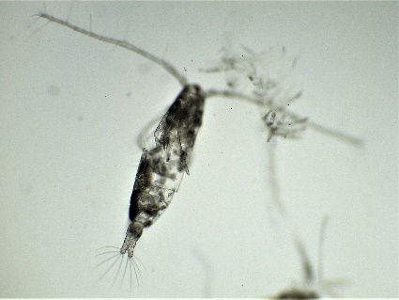 | 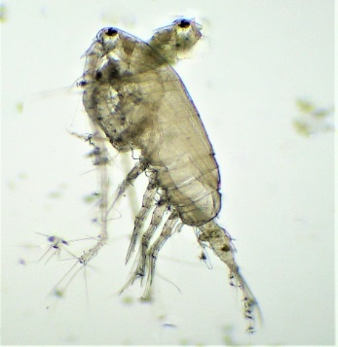
Acartia erythraea | Acrocalanus longicornis
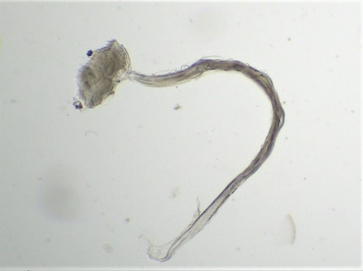 | 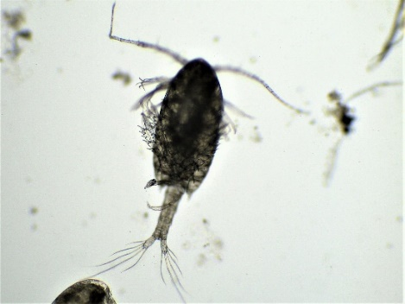
Appendicularians | Calanopia elliptica
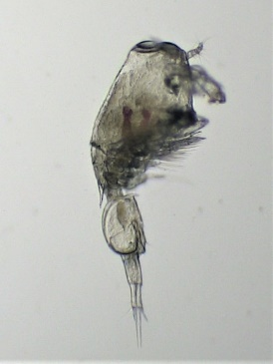 | 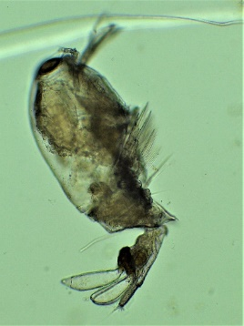
Corycaeus dahil | Farranula gibbula
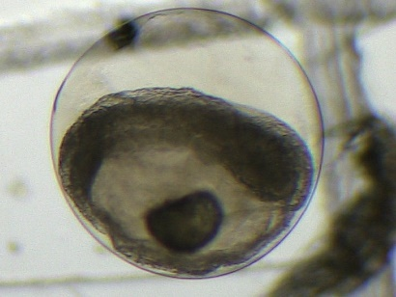 | 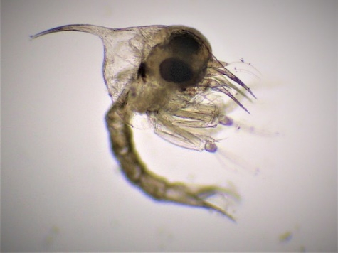
Fish egg | Brachyuran Larvae
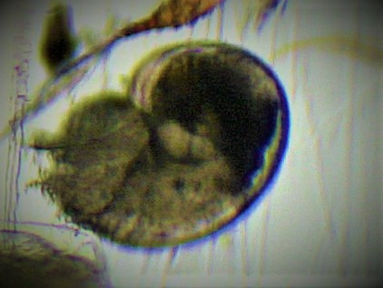 | 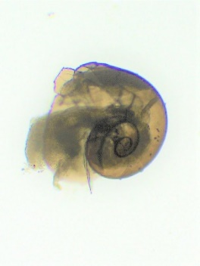
Gastropod larvae | Gastropod larvae
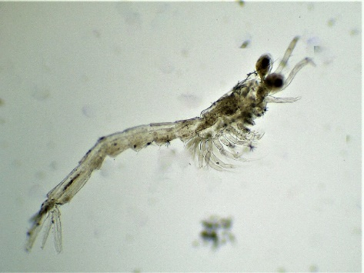 | 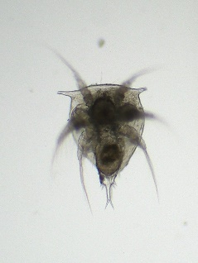
Lucifer hanseni | Nauplius
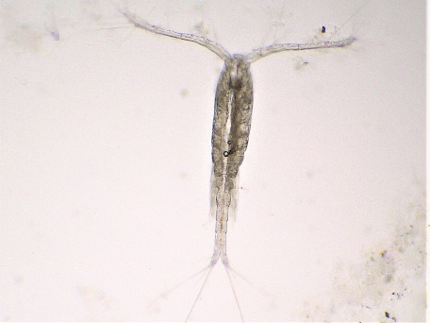 | 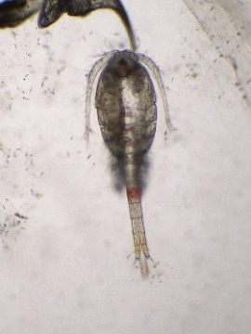
Oithona linearis | Oithona rigida
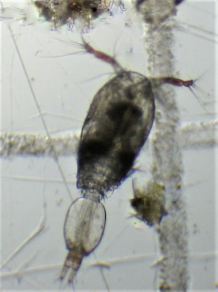 | 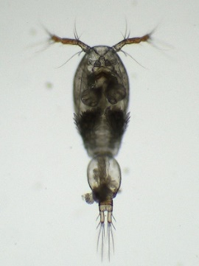
Oncaea mediterranea | Oncaea venusta
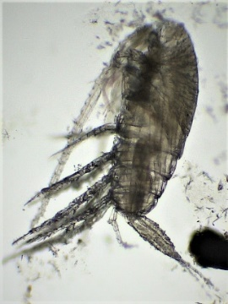 | 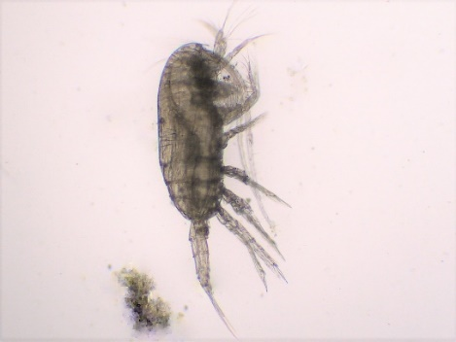
Paracalanus indicus | Paracalanus parvus
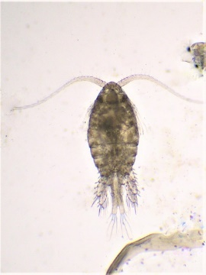 | 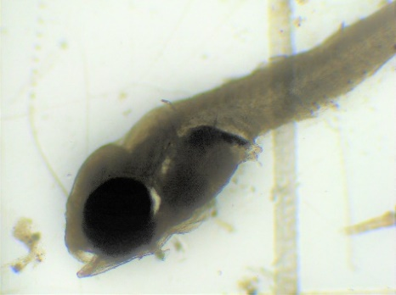
Parvocalanus crassirostris | Post larva of Polynemus Sextarius
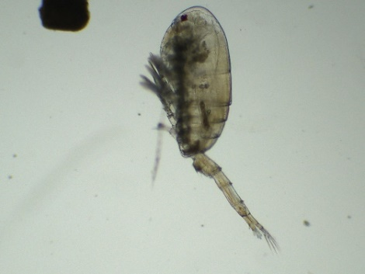 | 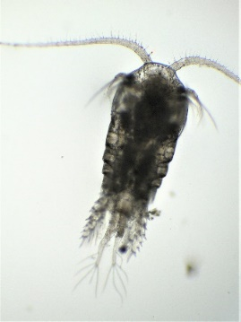
Pseudodiaptomus serricaudatus | Temora discaudata

Copepods were the dominant group in the zooplankton community recorded throughout the study period across all fishing and non-fishing zones, constituting 49.6–72.1% of the total zooplankton. The dominance of copepods on the south-central west coast of India has been reported by Sumitra-Vijayaraghavan et al. (1982).
Decapod larvae ranked second in abundance after copepods in the zooplankton community recorded throughout the study period in all fishing and non-fishing zones, constituting 9.7–24.4%, which was consistent with the findings of Sharma and Cyril (2007).
Among amphipods, only one species was encountered, Hyperia macrocephala, which appeared in noticeable percentages throughout the study period and was encountered uniformly between the fishing and non-fishing zones. Its abundance was highest in November and lowest in January, which was consistent with the results of Antony et al. (1997).
Isopods were represented by a single genus, Eurydice sp. They were collected throughout the study period in all fishing and non-fishing zones. In general, the abundance was higher in November, followed by December, and lowest in January and February.
Among ostracods, Parasterope sp. was recorded throughout the study period and appeared noticeable at all fishing and non-fishing zones, constituting only 0.1–0.6% of the total zooplankton. It exhibited an almost uniform distribution, with a slight increase in November and December.
Throughout the study period, across all fishing and non-fishing zones, chordates ranked third in abundance after copepods and decapods, constituting 10.9–13.6% of the total zooplankton. In some months, such as January, they outnumbered the decapod population.
Appendicularians constituted the major group in terms of density, followed by fish eggs and fish larvae, which was consistent with the findings of Sharma and Cyril (2007).
Chaetognaths were represented by a single species, Sagitta sp. This group appeared in noticeable numbers, as reported by Sumitra-Vijayaraghavan et al. (1982). The highest density was recorded in February, whereas the group was absent in December.
Holoplanktonic molluscan larvae comprised a single genus, Heteropod (Atlantids), which was sporadically present in the fishing and non-fishing zones during December, with a maximum average density of 12 no./m3 (January).
Among ciliophores, one genus, Globigerina sp., and two species, Metacylis tropica and Salpingella attenuata, were encountered throughout the research period at all fishing and non-fishing zones, constituting 2.0–5.8% of the total zooplankton, which was consistent with the findings of Sharma and Cyril (2007). Salpingella attenuata was the dominant species in this group, followed by Globigerina sp. and Metacylis tropica.
The total composition revealed that copepods dominated in all months in both the fishing and non-fishing zones, followed by decapods, chordates, ciliophores, amphipods, molluscans, isopods, and ostracods, whereas chaetognaths were the least abundant group, with one species.
Conclusions
This study provides a comprehensive assessment of zooplankton community structure in active fishing and non-fishing zones off Kollam, located in the southwestern Arabian Sea. A total of 53 zooplankton taxa were recorded, with copepods consistently dominating the assemblage, followed by decapod larvae and chordates. Significant spatial and temporal variations in zooplankton density were observed among sampling zones and months, indicating the dynamic nature of plankton distribution in the coastal marine environment.
Despite the observed differences in zooplankton abundance, no consistent distinction was evident between active fishing and non-fishing zones, suggesting that fishing-zone status alone does not adequately explain patterns of zooplankton distribution in the study area. The predominance of copepods and other meroplanktonic groups highlights their ecological significance in supporting pelagic food webs and sustaining higher trophic levels, including commercially important fish populations.
The findings indicate that temporal environmental variability may exert a stronger influence on zooplankton community dynamics than localised fishing activity. By establishing baseline information on zooplankton diversity, composition, and abundance in the coastal waters off Kollam, this study contributes to a better understanding of plankton–fish interactions and ecosystem functioning in the southwestern Arabian Sea. Future investigations integrating long-term monitoring, fixed georeferenced sampling stations, and environmental variables such as hydrographic conditions, primary productivity, and nutrient dynamics are necessary to elucidate the mechanisms governing zooplankton distribution and their implications for ecosystem-based fisheries management.
Limitations
The present study was limited by its relatively short sampling period (November 2019–February 2020), which may not fully represent annual variability in zooplankton communities. The locations of fishing and non-fishing zones varied among sampling months due to the dynamic nature of fish aggregations, potentially affecting spatial comparability. In addition, sampling was restricted to surface waters and did not account for vertical variations in zooplankton distribution. Concurrent measurements of key environmental variables, including temperature, salinity, nutrients, and chlorophyll-a, were not conducted, limiting the assessment of environmental influences on zooplankton dynamics. Future studies incorporating long-term monitoring, fixed sampling stations, multi-depth sampling, and integrated environmental observations are recommended to improve understanding of zooplankton distribution patterns and their ecological significance.
ACKNOWLEDGEMENTS
This study was supported by the Department of Aquatic Environment Management, Kerala University of Fisheries and Ocean Studies, Panangad, Kochi, Keralam, India.
COMPETING INTERESTS:
Authors have declared that they have no known competing financial interests OR non-financial interests OR personal relationships that could have appeared to influence the work reported in this paper.

Declaration of AI Use

This manuscript was prepared through the combined contributions of all author(s), including contributions to the study design, data, content development, results, interpretation, and related scholarly work. The author(s) acknowledge the use of Grammarly and ChatGPT to assist with grammar checking, language refinement, reference formatting. These AI-assisted tools were not used as authors and did not replace the intellectual contributions or scholarly judgment of the author(s). All AI-assisted outputs, including content, references, and interpretations, were carefully reviewed, revised, verified, and approved by the author(s). The author(s) accept full responsibility for the accuracy, integrity, and final content of the manuscript.

REFERENCES
- Antony, G., Kurup, K. N., Naomi, T. S., Solomon, K., & Mathew, K. J. (1997). Zooplankton abundance and secondary production in the seas around the Andaman-Nicobar Islands. Indian Journal of Fisheries, 44(2), 141–154. https://epubs.icar.org.in/index.php/IJF/article/view/8860
- Archana Devi, V. D., Balamurali, R. S., & Thara, S. (2023). Advances in zooplankton studies: An overview. Sustainability, Agri, Food and Environmental Research, 12(1). https://doi.org/10.7770/safer-V12N1-art2793
- Biju, A. (2018). Handbook of marine zooplankton. Narendra Publishing House. https://www.nphindia.com/book/9789386110589/handbook-of-marine-zooplankton
- CMFRI, Kochi. (2025). Marine Fisheries Information Service No. 264 (Marine Fisheries Information Service; Technical and Extension Series). ICAR - Central Marine Fisheries Research Institute. https://eprints.cmfri.org.in/19646
- Conway, D. V. P., White, R. G., Hugues-Dit-Ciles, J., Gallienne, C. P., & Robins, D. B. (2003). Guide to the coastal and surface zooplankton of the south-western Indian Ocean (Occasional Publication of the Marine Biological Association of the United Kingdom, No. 15). Marine Biological Association of the United Kingdom. https://plymsea.ac.uk/id/eprint/279/
- Goswami, S. C. (2004). Zooplankton methodology, collection & identification: A field manual (V. K. Dhargalkar & X. N. Verlecar, Eds.). National Institute of Oceanography. https://drs.nio.res.in/drs/handle/2264/95
- Greenwood, A., O’Riordan, R. M., & Barnes, D. K. A. (2001). Seasonality and vertical zonation of zooplankton in a semi-enclosed sea lough. Journal of the Marine Biological Association of the United Kingdom, 81(2), 213–220. https://doi.org/10.1017/S0025315401003666
- Greene, C. H. (1983). Selective predation in freshwater zooplankton communities. Internationale Revue der Gesamten Hydrobiologie und Hydrographie, 68(3), 297–315. https://doi.org/10.1002/iroh.19830680302
- Horne, J. K., & Schneider, D. C. (1994). Analysis of scale-dependent processes with dimensionless ratios. Oikos, 70(2), 201–211. https://doi.org/10.2307/3545631
- Kasturirangan, L. R. (1963). A key for the identification of the more common planktonic Copepoda of Indian coastal waters (Indian National Committee on Oceanic Research Publication No. 2). Council of Scientific & Industrial Research. https://eprints.cmfri.org.in/15629/
- Madhupratap, M., Gopalakrishnan, T. C., Haridas, P., Nair, K. K. C., Aravindakshan, P. N., Padmavati, G., & Paul, S. (1996). Lack of seasonal and geographic variation in mesozooplankton biomass in the Arabian Sea and its structure in the mixed layer. Current Science, 71(11), 863–868. https://drs.nio.res.in/drs/handle/2264/2154
- Mitra, A., Castellani, C., Gentleman, W. C., Jónasdóttir, S. H., Flynn, K. J., Bode, A., Halsband, C., Kuhn, P., Licandro, P., Agersted, M. D., Calbet, A., Lindeque, P. K., Koppelmann, R., Møller, E. F., Gislason, A., Nielsen, T. G., & St. John, M. (2014). Bridging the gap between marine biogeochemical and fisheries sciences: Configuring the zooplankton link. Progress in Oceanography, 129, 176–199. https://doi.org/10.1016/j.pocean.2014.04.025
- Prasad, R. R. (1969). Zooplankton biomass in the Arabian Sea and the Bay of Bengal with a discussion on fisheries of the region. Proceedings of the National Institute of Sciences of India, 35(5), 399–437.
- Rao, S. N., Chaubey, R., & Srinivasan, K. V. (1990). Ganga water quality in Bihar. Indian Journal of Environmental Health, 32(4), 393–400. https://jglobal.jst.go.jp/en/detail?JGLOBAL_ID=200902091611747168
- Santhanam, R., & Srinivasan, A. (1994). A manual of marine zooplankton. Oxford & IBH Publishing.
- Sahu, B. K., Baliarsingh, S. K., Srichandan, S., & Sahu, K. C. (2013). Seasonal variation of zooplankton abundance and composition in Gopalpur Creek: A tropical tidal backwater on the east coast of India. Journal of the Marine Biological Association of India, 55(1), 59–64. https://doi.org/10.6024/jmbai.2013.55.1.01715-10
- Sharma, B. S., & Cyril, W. (2007). Distribution and abundance of zooplankton in relation to petroleum hydrocarbon content along the coast of Kollam (Quilon), south-west coast of India. Journal of Environmental Biology, 28(1), 53–62. https://pubmed.ncbi.nlm.nih.gov/17717986/
- Sheldon, R. W., Sutcliffe, W. H., Jr., & Paranjape, M. A. (1977). Structure of pelagic food chain and relationship between plankton and fish production. Journal of the Fisheries Research Board of Canada, 34(12), 2344–2353. https://doi.org/10.1139/f77-314
- Sonekar, R., & Chahal, P. (2025). Role of zooplankton in aquatic food webs and their influence on fisheries management. International Journal of Aquatic Research and Environmental Studies, 5(2), 635–644.
- Sonekar, D. R., & Chahal, D. P. (2025). Role of zooplankton in aquatic food webs and their influence on fishery management. International Journal of Aquatic Research and Environmental Studies, 5(2), 635–644.
- Tiwari, L. R., & Nair, V. R. (1991). Contribution of zooplankton to the fishery of Dharamtar Creek, adjoining Bombay Harbour. Journal of the Indian Fisheries Association, 21, 15–19.
- Verity, P. G., & Smetacek, V. (1996). Organism life cycles, predation, and the structure of marine pelagic ecosystems. Marine Ecology Progress Series, 130, 277–293. https://doi.org/10.3354/meps130277
- Sumitra-Vijayaraghavan, R. S., Selvakumar, R. A., & Rao, T. S. S. (1982). Studies on zooplankton from the Arabian Sea off the south-central west coast of India. Indian Journal of Marine Sciences, 11(1), 70–74. https://drs.nio.res.in/drs/handle/2264/6661
- Waters, T. F. (1977). Secondary production in inland waters. In Advances in ecological research (Vol. 10, pp. 91–164). Academic Press. https://doi.org/10.1016/S0065-2504(08)60235-4
- Wellershaus, S. (1974). Seasonal changes in the zooplankton population in the Cochin Backwater (a South Indian estuary). Hydrobiological Bulletin, 8(1–2), 213–223. https://doi.org/10.1007/BF02254921
- Ayshi, F. A., Mugdha, A. R., & Jahan, R. (2024). Identification of marine zooplankton in the Maheshkhali Channel, Cox’s Bazar, Bangladesh. Asian Journal of Fisheries and Aquatic Research, 26(3), 12–22. https://doi.org/10.9734/ajfar/2024/v26i3742
- Jadhav, S. J., & Smitha, B. R. (2025). Abundance distribution pattern of zooplankton associated with the eastern Arabian Sea monsoon system as detected by underwater acoustics and net sampling. Acoustics Australia, 53, 25–46. https://doi.org/10.1007/s40857-024-00336-w
- Ratnarajah, L., Abu-Alhaija, R., Atkinson, A., Batten, S., Bax, N. J., Bernard, K. S., Canonico, G., Cornils, A., Everett, J. D., Grigoratou, M., Ahmad Ishak, N. H., Johns, D., Lombard, F., Muxagata, E., Ostle, C., Pitois, S., Richardson, A. J., Schmidt, K., Stemmann, L., . . . Yebra, L. (2023). Monitoring and modelling marine zooplankton in a changing climate. Nature Communications, 14, Article 564. https://doi.org/10.1038/s41467-023-36241-5

