Evaluation of Habitat Manipulation-Based IPM Modules for Enhancing Natural Enemy Populations in Okra (Abelmoschus esculentus (L.) Moench) Ecosystems
Abstract
This study evaluated habitat manipulation-based integrated pest management (IPM) modules for encouraging natural enemy populations in okra (Abelmoschus esculentus (L.) Moench) ecosystems under field conditions at the College of Horticulture, Bagalkot, Karnataka, India. The experiment was laid out in a randomised complete block design with four treatments and five replications. The treatments comprised a habitat manipulation-based bio-intensive module (M1), a habitat manipulation-based adoptable module (M2), recommended plant protection (M3) and an untreated check (M4). The bio-intensive module included okra with border crops comprising two rows of 25-day-old maize, one row of 25-day-old marigold and two rows of cowpea, along with okra intercropped with coriander at a 5:1 ratio. It also included seed treatment with imidacloprid 600 FS at 10 ml/kg, application of neem powder at 2.5 q/ha, release of Trichogramma chilonis at one lakh/ha, installation of five pheromone traps/ha and 15 yellow sticky traps/ha, and sequential application of azadirachtin 10,000 ppm, Lecanicillium lecanii, Bacillus thuringiensis, chilli garlic extract and bio-digester. Natural enemies, namely coccinellids, chrysopids, syrphids and spiders, were recorded at 10-day intervals from 20 days after sowing until the final harvest. Among the evaluated modules, M1 recorded the highest mean abundance of coccinellids (0.37/plant), chrysopids (0.40/plant), syrphids (0.45/plant) and spiders (0.62/plant). These values were higher than those observed under the adoptable module, recommended plant protection and untreated check. The findings indicate that habitat manipulation integrated with bio-intensive IPM components can support natural enemy populations in okra and may offer an economically feasible and practically adoptable approach for pest management.
Keywords: habitat manipulation; integrated pest management; okra; Abelmoschus esculentus; natural enemies; bio-intensive module; crop diversification; biological control; coccinellids; chrysopids; syrphids; spiders.
Introduction
Vegetable crops constitute important components of horticulture and play a substantial role in ensuring food and nutritional security. Among them, okra [Abelmoschus esculentus (L.) Moench] is an economically important vegetable crop cultivated both for domestic consumption and export. It originated in Africa and belongs to the family Malvaceae, with a chromosome number of 2n = 130. Okra is closely related to hibiscus and cotton and is commonly known as ‘lady’s finger’. China, India and Nigeria are among the leading okra-producing countries in the world. India ranks second after China in terms of both area and production. In India, okra is cultivated on approximately 0.528 million hectares, with a production of 61.46 lakh tonnes and a productivity of 11.64 t/ha. The major okra-growing states in India include Andhra Pradesh, Arunachal Pradesh, Assam, Bihar, Chhattisgarh, Himachal Pradesh, Jammu and Kashmir, Jharkhand and Karnataka. In Karnataka, okra is predominantly grown in districts such as Bagalkot, Mandya, Belagavi, Haveri, Bengaluru and Vijayapur. Despite its economic and nutritional importance, okra production is constrained by several biotic and abiotic factors, among which insect pest infestation is one of the most serious limitations. Okra is attacked by as many as 45 species of insect pests during different stages of its cropping period (Nair, 1986). Among these, leafhopper, Amrasca biguttula biguttula (Ishida), whitefly, Bemisia tabaci (Gennadius), shoot and fruit borer, Earias vittella (Fabricius), Earias insulana, and fruit borer, Helicoverpa armigera (Hubner), are considered the most destructive and economically important biotic constraints in okra cultivation. Estimated crop losses caused by major pests range from 32.06 to 40.85% due to leafhoppers, up to 90.0% due to whiteflies and from 3.5 to 90.0% due to fruit borers (Nair, 1986). In general, an economic loss of 48.97% in fruit yield has been reported as a result of overall insect damage (Kanwar & Ameta, 2007). A recent synthesis on okra pest constraints further emphasises that arthropod-pest management in okra should integrate biological, cultural and physical approaches rather than relying on a single intervention (Ounis et al., 2024).
Recent seasonal monitoring studies in okra have reported coccinellids and spiders as major natural enemies, with predator abundance exhibiting a positive association with aphid and leafhopper populations. These findings support the ecological significance of predators in regulating pest populations within the okra ecosystem (Mohapatra et al., 2022). The presence and conservation of such natural enemies are therefore important for maintaining ecological balance and reducing pest pressure under field conditions. The indiscriminate use of chemical pesticides for insect pest management in okra has raised serious concerns regarding environmental safety, ecological stability and human health. Excessive and injudicious pesticide application may pollute natural resources such as water and soil, reduce the density and activity of beneficial insects and soil microorganisms, and adversely affect pollinators and natural enemies, including predators and parasitoids, which play a key role in suppressing pest populations. The use of spurious or inappropriate chemicals on fresh vegetable crops may also lead to pesticide residues in the harvested produce, thereby causing potential health hazards to consumers. In addition, repeated and unregulated pesticide use may contribute to the development of resistance and resurgence in pest populations, making pest management increasingly difficult over time. Field evidence from organic okra also indicates that selected botanical and microbial biorational formulations can suppress sucking pests while remaining comparatively safer to coccinellids and spiders, supporting their inclusion in ecologically compatible IPM modules (Singh et al., 2021).
In this context, habitat manipulation practices have been employed as ecologically sound strategies against major pests of okra. These practices include the integration of barrier crops, trap crops, border crops and intercrops with the main crop. Border crops act as physical barriers and help restrict the movement of sucking pests from one field to another. Trap crops attract insect pests such as fruit borers and thereby help reduce egg-laying or infestation on the main crop. Similarly, intercrops during the effective flowering period support the conservation of natural enemies by providing supplementary food resources such as pollen and nectar, along with shelter and refuge. Such habitat diversification can make the crop environment less favourable for pests while enhancing its suitability for beneficial insects (Gopi et al., 2019). Recent evidence from okra further indicates that integrated pest management modules can reduce pest damage while improving fruit yield and economic returns compared with untreated or chemical-intensive approaches (Mohapatra et al., 2024). The compatibility of pest-control inputs with beneficial organisms is also an important consideration in developing sustainable pest management strategies. Recent research in okra has reported effective suppression of whitefly and leafhopper through the use of flupyradifurone, while also indicating its relative safety to spiders, rove beetles and honey bees (Kodandaram et al., 2024). Recent meta-analytic evidence also shows that intercropping and field-edge diversification can enhance predators and parasitoids, although outcomes depend on the crop system and the design of diversification (Yousefi et al., 2024; Judt et al., 2023).
Therefore, there is a clear need to explore alternative pest management approaches that integrate available control techniques and reduce sole dependence on synthetic insecticides. In this regard, integrated pest management, particularly with reference to habitat manipulation, appears to be a suitable approach for promoting sustainability in okra production. Such strategies can encourage the multiplication and conservation of native natural enemies and strengthen their role in suppressing insect pests within the okra ecosystem. Similarly, integrated pest management frameworks that combine cultural, biological and chemical approaches have been emphasised as essential tools for sustainable pest suppression across field crops (Dwarka et al., 2024). Although habitat manipulation and different components of integrated pest management have been examined in okra, information on the relative performance of habitat manipulation-based IPM modules in promoting natural enemy populations under the specific agro-ecological conditions of Bagalkot remains limited. However, comparative field evidence on how bio-intensive and adoptable habitat-manipulation modules influence major predator groups in okra under Bagalkot conditions remains insufficiently documented. The present study was therefore undertaken to evaluate habitat manipulation-based bio-intensive and adoptable modules in comparison with recommended plant protection practices and an untreated check, with particular emphasis on the abundance and activity of coccinellids, chrysopids, syrphids and spiders in the okra ecosystem.
Materials and Methods
The field experiment to evaluate habitat manipulation-based modules against insect pests of okra was conducted at the College of Horticulture, Bagalkot. Okra seeds were sown at a spacing of 60 cm × 45 cm in a randomised complete block design (RCBD), with four treatments and five replications in plots measuring 6 m × 4 m. The crop was raised by following all agronomic practices recommended in the package of practices of the University of Horticultural Sciences, Bagalkot.
Observations on natural enemies
The total number of natural enemies, including coccinellids, Chrysoperla, syrphids and spiders per plant, was recorded at 10-day intervals from 20 days after sowing until the final harvest of the crop on a whole-plant basis through visual observation.
Statistical analysis
The data collected from the experiments were subjected to suitable transformation. The data were then subjected to single-factor ANOVA using statistical software (WASP-2), and different treatments were compared using Duncan’s multiple range test (DMRT).
Table 1. Treatment details for evaluation of habitat manipulation based IPM modules for encouraging natural enemies against insect pests of okra
Sl.  No. | Modules | Treatment details
M1 | Habitat manipulation bio-intensive module | - Okra + Border crops (two rows 25 days old maize + one row of 25 days old marigold + two rows of cowpea) + okra intercropped with coriander (5:1)  - Seed treatment with imidacloprid 600 FS at 10 ml/kg  - Application of neem powder at 2.5 q/ha  - Trichogramma chilonis one lakh per hectare  - Pheromone traps five per hectare  - Yellow sticky traps 15 per hectare  - Azadirachtin 10,000 ppm at 1.0 ml/l + Lecanicillium lecanii (1×10⁸ CFU/g) at 5 g/l  - Spraying of Bacillus thuringiensis at 2.0 ml/l  - Chilli garlic extract at 0.5%  - Bio-digester at 20%
M2 | Habitat manipulation based adoptable module | - Okra + Border crops (two rows 25 days old maize + one row of 25 days old marigold + two rows of cowpea) + okra intercropped with coriander (5:1)  - Seed treatment with imidacloprid 600 FS 10 ml/kg  - Application of neem powder 2.5 q/ha  - Pheromone traps five per hectare  - Yellow sticky traps 15 per hectare  - Azadirachtin 10,000 ppm at 1.0 ml/l + Lecanicillium lecanii (1×10⁸ CFU/g) at 5 g/l  - Tolfenpyrad 15 EC at 1.5 ml/l  - Thiamethoxam 25 WG at 0.2 g/l  - Cyantraniliprole 10.26 OD at 1.0 ml/l  - Chlorantraniliprole 18.5 SC at 0.2 ml/l
M3 | Recommended plant | - Dimethoate 30 EC at 1.7 ml/l  - Imidacloprid 17.8 SL at 0.3 ml/l

 | protection | - Thiamethoxam 25 WG at 0.2 g/l  - Acephate 75 SP at 1.0 g/l  - Acetamiprid 20 SP at 0.2 ml/l  - Profenophos 50 EC at 2.0 ml/l  - Quinalphos 25 EC at 2.0 ml/l  - Spinosad 45 SC at 0.2 ml/l  - Chlorantraniliprole 18.5 EC at 0.2 ml/l
M4 | Untreated check | Okra as sole crop

Results
Abundance of natural enemies
Recommended plant protection registered the significantly lowest mean number of coccinellids (0.10/plant). The habitat manipulation-based adoptable module (M2) recorded 0.27/plant, which was statistically on par with the untreated check (0.21/plant). The superior treatment was M1, the habitat manipulation-based bio-intensive module (0.37/plant), indicating its effectiveness in encouraging the coccinellid population (Table 2). This pattern is consistent with the role of coccinellids as generalist predators that can persist in crop habitats by using prey and alternative resources when suitable habitat conditions are present (Romero et al., 2023; Stowe et al., 2021). Recent okra field evidence has also shown that selected insecticides can suppress major pest populations while maintaining coccinellid abundance, reinforcing the need to consider natural-enemy safety when selecting IPM-compatible inputs (Dalei et al., 2025).
Chrysopid populations varied among the different modules, with M1, the habitat manipulation-based bio-intensive module (0.40/plant), recording the significantly highest population. The second-best module was M2, the habitat manipulation-based adoptable module (0.31/plant), which was statistically on par with the untreated check (0.24/plant). In contrast, M3, the recommended plant protection module, registered the lowest chrysopid population (0.13/plant) (Table 3). The higher chrysopid abundance under the bio-intensive module is also in agreement with recent evidence that habitat diversity can support Chrysoperla abundance and that Chrysoperla carnea functions as an important generalist predator within IPM-compatible systems (Paredes et al., 2024; Hassan & Shad, 2024).
Among the various treatments, M1, the habitat manipulation-based bio-intensive module, recorded the highest syrphid population (0.45/plant), which was statistically on par with M2, the habitat manipulation-based adoptable module (0.39/plant), revealing that both modules were effective in encouraging syrphid populations. These treatments were also statistically on par with the untreated check (0.34/plant). In contrast, recommended plant protection (M3) resulted in toxicity to the syrphid population (0.14/plant) (Table 4). The relative maintenance of syrphids under the habitat-manipulation modules is ecologically plausible because syrphids contribute to pest suppression as predatory larvae while adults often depend on floral resources supplied by diversified habitats (Dunn et al., 2020).
The habitat manipulation-based bio-intensive module (M1) registered the highest spider population (0.62/plant), which was statistically on par with both M2, the habitat manipulation-based adoptable module (0.59/plant), and the untreated check (0.55/plant). In contrast, M3, the recommended plant protection module, registered the lowest spider population (0.23/plant) (Table 5). These observations are supported by recent okra-based evidence indicating that bio-intensive pest management modules are safer to spiders and coccinellid predators than routine pest-management modules, thereby supporting natural enemy conservation in okra ecosystems (Meenambigai & Bhuvaneswari, 2024). The comparatively greater spider population in M1 and M2 is also supported by evidence from vegetable systems showing that local management and surrounding habitat structure can influence spider abundance and species richness (Saqib et al., 2020).

Table 2: To evaluate habitat manipulation based modules against coccinellids in okra

Treatments | Number of coccinellids/plant |  |  |  |  |  |  |  | Mean
Treatments | 30  DAS | 40  DAS | 50  DAS | 60  DAS | 70  DAS | 80  DAS | 90  DAS | 100  DAS | Mean
M1-Habitat manipulation based bio-intensive  module | 0.10 ª  (0.31) | 0.34 ª  (0.57) | 0.45 ª  (0.66) | 0.46 ª  (0.67) | 0.45 ª  (0.66) | 0.53 ª  (0.72) | 0.39 ª  (0.61) | 0.21 ª  (0.45) | 0.37 ª  (0.60)
M2-Habitat manipulation based adoptable  module | 0.05 ^{b}  (0.22) | 0.21 ^{b}  (0.45) | 0.31 ^{b}  (0.55) | 0.45 ª  (0.66) | 0.35 ^{ab}  (0.58) | 0.37 ^{b}  (0.60) | 0.30 ^{ab}  (0.54) | 0.10 ^{b}  (0.31) | 0.27 ^{b}  (0.51)
M3-Recommended Plant Protection | 0.02 ^{d}  (0.13) | 0.10 ^{c}  (0.31) | 0.10 ^{c}  (0.31) | 0.10 ^{b}  (0.31) | 0.13 ^{c}  (0.35) | 0.20 ^{c}  (0.44) | 0.10 ^{c}  (0.31) | 0.07 ^{b}  (0.26) | 0.10 ^{c}  (0.31)
M4-Untreated check | 0.03 ^{c}  (0.17) | 0.16 ^{b}  (0.39) | 0.25 ^{b}  (0.49) | 0.25 ^{b}  (0.49) | 0.26 ^{b}  (0.50) | 0.35 ^{b}  (0.58) | 0.29 ^{b}  (0.53) | 0.08 ^{b}  (0.28) | 0.21 ^{b}  (0.45)
S. Em ± | 0.01 | 0.02 | 0.02 | 0.04 | 0.03 | 0.02 | 0.01 | 0.03 | 0.03
C.D. at 5% | 0.04 | 0.06 | 0.08 | 0.13 | 0.07 | 0.08 | 0.05 | 0.07 | 0.07
DAS; Days After Sowing, S. Em ±; Standard Error Mean, CD; Critical Difference Figures in parenthesis indicate square root √(x+0.5) transformed values
In a column, means followed by same alphabet do not differ significantly (P=0.05) by DMRT

Table 3: To evaluate habitat manipulation based modules against chrysopids in okra

Treatments | Number of chrysopids/plant |  |  |  |  |  |  |  | Mean
Treatments | 30  DAS | 40  DAS | 50  DAS | 60  DAS | 70  DAS | 80  DAS | 90  DAS | 100  DAS | Mean
M1-Habitat manipulation based bio-intensive  module | 0.15 ª  (0.38) | 0.33 ª  (0.57) | 0.41 ª  (0.63) | 0.55 ª  (0.73) | 0.63 ª  (0.78) | 0.78 ª  (0.87) | 0.20 ª  (0.44) | 0.15 ª  (0.38) | 0.40 ª  (0.62)
M2-Habitat manipulation based adoptable  module | 0.12 ª  (0.34) | 0.25 ^{b}  (0.49) | 0.35 ^{ab}  (0.58) | 0.50 ^{ab}  (0.70) | 0.47 ^{ab}  (0.68) | 0.50 ^{b}  (0.70) | 0.17 ª  (0.41) | 0.13 ^{ab}  (0.35) | 0.31 ^{b}  (0.52)
M3-Recommended Plant Protection | 0.01 ^{b}  (0.10) | 0.02 ^{c}  (0.13) | 0.21 ^{c}  (0.45) | 0.20 ^{c}  (0.44) | 0.25 ^{c}  (0.49) | 0.30 ^{c}  (0.54) | 0.02 ^{c}  (0.13) | 0.01 ^{c}  (0.10) | 0.13 ^{c}  (0.35)
M4-Untreated check | 0.01 ^{b}  (0.10) | 0.20 ^{b}  (0.44) | 0.28 ^{bc}  (0.52) | 0.40 ^{b}  (0.63) | 0.45 ^{b}  (0.66) | 0.35 ^{c}  (0.58) | 0.11 ^{b}  (0.33) | 0.10 ^{b}  (0.31) | 0.24 ^{b}  (0.51)
S. Em ± | 0.01 | 0.02 | 0.03 | 0.03 | 0.03 | 0.03 | 0.01 | 0.01 | 0.02
C.D. at 5% | 0.05 | 0.06 | 0.09 | 0.10 | 0.10 | 0.11 | 0.05 | 0.04 | 0.07
DAS; Days After Sowing, S. Em ±; Standard Error Mean, CD; Critical Difference
Figures in parenthesis indicate square root √(x+0.5) transformed values
In a column, means followed by same alphabet do not differ significantly (P=0.05) by DMRT

Table 4: To evaluate habitat manipulation based modules against syrphids in okra

Treatments | Number of syrphids/plant |  |  |  |  |  |  |  | Mean
 | 30  DAS | 40  DAS | 50  DAS | 60  DAS | 70  DAS | 80  DAS | 90  DAS | 100  DAS | Mean
M1-Habitat manipulation based bio-intensive  module | 0.17 ª  (0.40) | 0.22 ª  (0.46) | 0.27 ª  (0.51) | 0.42 ª  (0.64) | 0.73 ª  (0.85) | 0.85 ª  (0.91) | 0.50 ª  (0.70) | 0.40 ª  (0.62) | 0.45 ª  (0.66)
M2-Habitat manipulation based adoptable  module | 0.14 ^{ab}  (0.37) | 0.20 ª  (0.44) | 0.21  ab  (0.45) | 0.31 ^{b}  (0.55) | 0.70 ª  (0.83) | 0.80 ª  (0.89) | 0.41 ^{ab}  (0.63) | 0.34 ª  (0.57) | 0.39 ^{ab}  (0.62)
M3-Recommended Plant Protection | 0.10 ^{c}  (0.31) | 0.12 ^{b}  (0.34) | 0.13 ^{c}  (0.35) | 0.12 ^{d}  (0.34) | 0.18 ^{b}  (0.42) | 0.17 ^{b}  (0.41) | 0.16 ^{c}  (0.40) | 0.15 ^{b}  (0.38) | 0.14 ^{c}  (0.36)
M4-Untreated check | 0.12 ^{bc}  (0.34) | 0.18 ª  (0.42) | 0.19 ^{b}  (0.43) | 0.20 ^{c}  (0.44) | 0.69 ª  (0.82) | 0.77 ª  (0.87) | 0.39 ^{b}  (0.62) | 0.20 ^{b}  (0.44) | 0.34 ^{b}  (0.57)
S. Em ± | 0.01 | 0.02 | 0.03 | 0.02 | 0.04 | 0.03 | 0.01 | 0.02 | 0.02
C.D. at 5% | 0.05 | 0.06 | 0.06 | 0.07 | 0.12 | 0.11 | 0.05 | 0.08 | 0.09
DAS; Days After Sowing, S. Em ±; Standard Error Mean, CD; Critical Difference Figures in parenthesis indicate square root √(x+0.5) transformed values
In a column, means followed by same alphabet do not differ significantly (P=0.05) by DMRT

Table 5: To evaluate habitat manipulation based modules against spiders in okra

Treatments | Number of spiders/plant |  |  |  |  |  |  |  | Mean
 | 30  DAS | 40  DAS | 50  DAS | 60  DAS | 70  DAS | 80  DAS | 90  DAS | 100  DAS | Mean
M1-Habitat manipulation based bio-intensive  module | 0.35 ª  (0.58) | 0.50 ª  (0.70) | 0.64 ª  (0.79) | 0.77 ª  (0.87) | 0.85 ª  (0.91) | 0.90 ª  (0.94) | 0.58 ª  (0.75) | 0.40 ª  (0.62) | 0.62 ª  (0.78)
M2-Habitat manipulation based adoptable  module | 0.33 ª  (0.57) | 0.45 ª  (0.66) | 0.60 ª  (0.77) | 0.70 ª  (0.83) | 0.80 ª  (0.89) | 0.87 ª  (0.92) | 0.50 ª  (0.70) | 0.43 ª  (0.65) | 0.59 ª  (0.76)
M3-Recommended Plant Protection | 0.20 ^{b}  (0.44) | 0.30 ^{b}  (0.54) | 0.40 ^{b}  (0.63) | 0.40 ^{b}  (0.63) | 0.10 ^{b}  (0.31) | 0.05 ^{b}  (0.22) | 0.30 ^{b}  (0.54) | 0.05 ^{b}  (0.22) | 0.23 ^{b}  (0.47)
M4-Untreated check | 0.30 ª  (0.54) | 0.38 ^{ab}  (0.61) | 0.57 ª  (0.75) | 0.67 ª  (0.81) | 0.78 ª  (0.88) | 0.81 ª  (0.89) | 0.47 ª  (0.68) | 0.38 ª  (0.61) | 0.55 ª  (0.73)
S. Em ± | 0.03 | 0.03 | 0.03 | 0.03 | 0.02 | 0.03 | 0.03 | 0.02 | 0.04
C.D. at 5% | 0.10 | 0.11 | 0.11 | 0.11 | 0.07 | 0.11 | 0.10 | 0.07 | 0.12
DAS; Days After Sowing, S. Em ±; Standard Error Mean, CD; Critical Difference
Figures in parenthesis indicate square root √(x+0.5) transformed values
In a column, means followed by same alphabet do not differ significantly (P=0.05) by DMRT

Discussion
The superior effectiveness of the habitat manipulation-based bio-intensive module, followed by the adoptable module, was primarily attributed to the systematic adoption and implementation of crop diversification through barrier crops, trap crops, border crops and intercrops. These practices promoted the activity and conservation of natural enemies by modifying the crop habitat, enhancing ecological diversification and suppressing pest populations in okra (Gopi et al., 2019). The use of maize as a barrier crop, marigold as a trap crop, cowpea as a border crop and coriander during its effective flowering period appeared to support the multiplication and persistence of natural enemies by providing supplementary food resources, such as pollen and nectar, as well as shelter and favourable microhabitats. This interpretation is consistent with broader evidence from conservation biological control, which indicates that habitat management can provide food resources, alternative prey or hosts and refuge for natural enemies, while plant diversification and intercropping generally increase the abundance and activity of predators and parasitoids (Landis et al., 2000; Letourneau et al., 2011; Rakotomalala et al., 2023). This interpretation is further supported by recent synthesis showing that plant diversification can improve biological pest-control services by increasing predator and parasitoid abundance when the design and spatial scale of diversification are suitable (Yousefi et al., 2024).
Furthermore, crop diversification, combined with seed treatment using imidacloprid, neem cake application, the installation of yellow sticky traps for monitoring sucking pests, pheromone traps for monitoring fruit borers, and the application of bio-pesticides such as azadirachtin and bio-agents such as L. lecanii and Bt, followed by chilli garlic extract and bio-digester application, did not adversely affect beneficial arthropods. These included parasitoids such as tachinids, braconids, Nepiera sp. and Neofacydes sp.; predators such as coccinellids, chrysopids, syrphids, spiders, wasps and reduviid bugs; and predatory birds such as the yellow wagtail and cattle egret. The conservation of these natural enemies contributed to the reduced incidence of okra leafhoppers and whiteflies, as well as lower fruit damage caused by fruit borers (Gopi et al., 2019). This suggests that ecologically compatible pest management interventions can suppress key pest complexes without disrupting the beneficial fauna associated with the crop ecosystem. The inclusion of botanical and microbial inputs is also consistent with okra-based field evidence that naturally derived formulations can suppress sucking pests while remaining relatively safe to coccinellid and spider predators (Singh et al., 2021). Evidence from natural-enemy-based pest-control strategies also indicates that biological approaches involving parasitoids, predators, botanicals and microbial agents can contribute to more resilient pest management where chemical risk is a concern (Qadir & Islam, 2025).
Similarly, the ETL-based application of green-labelled molecules, including chlorantraniliprole 18.5 SC, cyantraniliprole 10.26 OD, thiamethoxam 25 WG and tolfenpyrad 15 EC, represented a more suitable option than broad-spectrum conventional insecticides, which are often toxic and detrimental to natural enemies. Finally, M1, the habitat manipulation-based bio-intensive module, followed by M2, the crop diversification-based adoptable module, reduced four insecticide sprays compared with the recommended plant protection schedule. This reduction indicates that these modules may offer a cost-effective, environmentally safer and more ecologically balanced approach to managing major insect pests of okra. This is relevant because selective or comparatively safer insecticide choices are important for integrating chemical and biological control without severely disrupting natural enemy populations (Hassan & Shad, 2024; Kodandaram et al., 2024).
The present findings are comparable with the observations of Rao et al. (2008) and Birah et al. (2012), who reported that the integration of crop diversification into an IPM module is effective, eco-friendly, economically feasible and practically adaptable under field conditions. The crop diversification-based adoptable module comprised seed treatment with imidacloprid at 5 g/kg seed, neem cake application at 250 kg/ha at the time of sowing, sowing of maize along the borders as a barrier crop, weekly clipping of infested shoots and fruits, erection of pheromone traps at 100 traps/ha for mass trapping, and foliar sprays of neem seed kernel extract at 30 ml/l, spinosad 45 SC at 0.5 ml/l and karanj oil at 30 ml/l at 45, 60 and 75 days after sowing.
This module recorded significantly lower incidences of leafhoppers, whiteflies, shoot borers and fruit borers, together with the highest fruit yield. A higher density of predators in okra was reported by Preetha and Nadarajan (2006), who recommended an integrated module consisting of seed treatment with imidacloprid, release of T. chilonis at 6 cc/ac, release of Chrysoperla at 2,000 eggs/acre and spraying of B. thuringiensis (Spicturin FC) at 2.0 ml/l. Border cropping with maize and sorghum might have contributed to the conservation and augmentation of coccinellids by providing shelter, alternative prey and pollen. In addition, the selective systemic action of imidacloprid seed treatment may have helped retain a moderate predator population during the early crop stage, as reported by Nemade et al. (2019).
Similarly, a greater proportion of predators was likely conserved because of the selective toxicity of foliar application of spinosad 45 SC. Earlier workers, including Udikeri et al. (2004), Dhanalakshmi and Mallapur (2008), and Mohanasundaram and Sharma (2011a), reported higher populations of spiders and coccinellids in cotton and okra crops sprayed with spinosad 45 SC. Thus, IPM modules incorporating comparatively safer interventions, such as seed treatments, neem-based products, biological agents, habitat diversification and selective newer insecticides, were ecologically sustainable and effective in suppressing the target pests. Overall, the findings support the practical relevance of bio-intensive and crop diversification-based IPM strategies for reducing insecticide dependence while maintaining pest suppression, natural enemy conservation and fruit yield in okra. Recent meta-analyses and field-based studies therefore support the broader conclusion that habitat and resource diversification can increase natural enemies, but the magnitude of the response may vary across crop systems, landscape context and target natural-enemy groups (Judt et al., 2023; Rakotomalala et al., 2023; Saqib et al., 2020).
Conclusions
The results of the present study indicate that habitat manipulation-based IPM can improve the abundance of major natural enemies in the okra ecosystem. Among the evaluated treatments, the habitat manipulation-based bio-intensive module (M1) recorded the highest mean populations of coccinellids (0.37/plant), chrysopids (0.40/plant), syrphids (0.45/plant) and spiders (0.62/plant). This module combined okra with maize, marigold, cowpea and coriander, along with seed treatment, neem powder application, Trichogramma chilonis release, pheromone and yellow sticky traps, and selected bio-rational inputs. The habitat manipulation-based adoptable module (M2) also supported natural enemy populations and performed better than the recommended plant protection module for most observations. In contrast, the recommended plant protection module recorded the lowest mean populations of coccinellids, chrysopids, syrphids and spiders, indicating that conventional plant protection practices were less favourable to beneficial arthropods. Overall, the bio-intensive module provided a more supportive habitat for predators and parasitoids while integrating pest management components that are practically relevant to okra cultivation. These findings support the use of crop diversification and bio-intensive interventions as part of a sustainable IPM strategy for okra. The module may be considered a feasible option for farmers where similar agro-ecological and management conditions prevail, subject to local validation for site-specific local needs.
Limitations
The present study was conducted at a single location, the College of Horticulture, Bagalkot, under the specific crop, soil and management conditions of the experimental site. Therefore, the results may vary under different agro-climatic zones, seasons, okra varieties and pest-pressure situations. The observations were limited to selected natural enemies, namely coccinellids, chrysopids, syrphids and spiders, and did not quantify all parasitoids, pollinators or other beneficial arthropods occurring in the okra ecosystem. The study focused mainly on natural enemy abundance and did not include detailed ecological measurements such as prey availability, floral resource use or predator-prey interactions. Although the bio-intensive module was described as economically feasible and practically adoptable based on the study outcome, broader validation across farmers’ fields and seasons would strengthen its recommendation. Future studies may also assess long-term effects on pest suppression, yield stability and compatibility of individual module components before wider extension to diverse production systems and contexts.
COMPETING INTERESTS
Authors have declared that they have no known competing financial interests OR non-financial interests OR personal relationships that could have appeared to influence the work reported in this paper.

Declaration of AI Use
This manuscript was prepared through the combined contributions of all author(s), including contributions to the study design, data, content development, results, interpretation, and related scholarly work. The author(s) acknowledge the use of Grammarly and ChatGPT to assist with grammar checking, language refinement, reference formatting. These AI-assisted tools were not used as authors and did not replace the intellectual contributions or scholarly judgment of the author(s). All AI-assisted outputs, including content, references, and interpretations, were carefully reviewed, revised, verified, and approved by the author(s). The author(s) accept full responsibility for the accuracy, integrity, and final content of the manuscript.

References
• Birah, A., Srivastava, R. C., Kumar, K., Singh, P. K., & Bhagat, S. (2012). Efficacy of pest management practices against pest complex of okra (Abelmoschus esculentus) in Andaman. The Indian Journal of Agricultural Sciences, 82(5), 470–472. https://doi.org/10.56093/ijas.v82i5.17816
• Dhanalakshmi, D. N., & Mallapur, C. P. (2008). Evaluation of promising molecules against sucking pests of okra. Annals of Plant Protection Sciences, 16(1), 29–32. https://www.ijour.net/article/apps-16-1-007
• Dwarka, Ghugal, S. G., Thakur, S., Chadar, N., Parmar, S., & Babli. (2024). Introduction to insect pests of wheat (Triticum aestivum L.) crop and their management: A review. BIONATURE, 44(2), 108–115. https://doi.org/10.56557/bn/2024/v44i22051
• Gopi, S., Gopali, J. B., Allolli, T. B., Venkateshalu, Waseem, M. A., & Awati, M. G. (2019). Evaluation of crop diversification-based IPM modules against insect pests of okra. International Journal of Chemical Studies, 7(4), 2772–2777.
• Kanwar, N., & Ameta, O. P. (2007). Assessment of losses caused by insect pests of okra. Pestology, 31(5), 45–47.
• Kodandaram, M. H., Divekar, P. A., Wangi, N., Mohite, N. R., & Rai, A. B. (2024). Optimizing sucking pest control in okra: An analysis of flupyradifurone 200 SL effectiveness, phytotoxicity, safety to natural enemies, pollinators and cost-efficiency. Journal of Plant Diseases and Protection, 131, 757–771. https://doi.org/10.1007/s41348-024-00885-2
• Landis, D. A., Wratten, S. D., & Gurr, G. M. (2000). Habitat management to conserve natural enemies of arthropod pests in agriculture. Annual Review of Entomology, 45, 175–201. https://doi.org/10.1146/annurev.ento.45.1.175
• Letourneau, D. K., Armbrecht, I., Salguero Rivera, B., Montoya Lerma, J., Jiménez Carmona, E., Daza, M. C., Escobar, S., Galindo, V., Gutiérrez, C., Duque López, S., López Mejía, J., Acosta Rangel, A. M., Herrera Rangel, J., Rivera, L., Saavedra, C. A., Torres, A. M., & Reyes Trujillo, A. (2011). Does plant diversity benefit agroecosystems? A synthetic review. Ecological Applications, 21(1), 9–21. https://doi.org/10.1890/09-2026.1
• Meenambigai, C., & Bhuvaneswari, K. (2024). Impact of IPM modules on natural enemies in okra. Indian Journal of Entomology, 86(2), 644–648. https://doi.org/10.55446/IJE.2024.1306
• Mohanasundaram, A., & Sharma, R. K. (2011a). Abundance of pest complex of okra in relation to abiotic and biotic factors. Annals of Plant Protection Sciences, 19(2), 286–290. https://www.ijour.net/article/apps-19-2-006
• Mohapatra, S., Padhi, J., Samal, T., Tripathy, P., & Kumar, S. (2022). Seasonal incidence of sucking pests and their natural enemies in okra Abelmoschus esculentus (L.) Moench. International Journal of Environment and Climate Change, 12(11), 3605–3611. https://doi.org/10.9734/ijecc/2022/v12i111408
• Mohapatra, S., Padhi, J., & Singh, S. (2024). Enhancing yield and economic benefits through sustainable pest management in okra cultivation. Scientific Reports, 14, Article 22220. https://doi.org/10.1038/s41598-024-72997-6
• Nair, M. R. G. K. (1986). Insects and mites of crops in India (Rev. ed.). Indian Council of Agricultural Research. https://library.niti.gov.in/cgi-bin/koha/opac-ISBDdetail.pl?biblionumber=27338
• Nemade, P. W., Wadnerkar, D. W., Bansod, R. S., Kulkarni, C. G., & Mali, A. K. (2019). Effect of newer insecticides on natural enemies of Earias vittella in okra field. Indian Journal of Agricultural Research, 43(2), 124–128. https://arccjournals.com/journal/indian-journal-of-agricultural-research/ARCC1515
• Preetha, G., & Nadarajan, L. (2006). Evaluation of IPM modules against bhendi fruit borer, Earias vittella (Fabricius) in Karaikal. Pest Management in Horticultural Ecosystems, 12(2), 116–122. https://www.ijour.net/ijor.aspx?target=ijor:pmhe&volume=12&issue=2&article=007
• Rakotomalala, A. A. N. A., Ficiciyan, A. M., & Tscharntke, T. (2023). Intercropping enhances beneficial arthropods and controls pests: A systematic review and meta-analysis. Agriculture, Ecosystems & Environment, 356, Article 108617. https://doi.org/10.1016/j.agee.2023.108617
• Rao, N. V., Rao, V. N., & Bhavani, V. (2008). Evaluation of integrated pest management modules against bhendi shoot and fruit borer, Earias vittella (Fabricius). Pestology, 32(12), 16–18.
• Udikeri, S. S., Patil, S. B., Rachappa, V., & Khadi, B. M. (2004). Emamectin benzoate 5 SG: A safe and promising biorational against cotton bollworms. Pestology, 28, 78–81.
• Dunn, L., Lequerica, M., Reid, C. R., & Latty, T. (2020). Dual ecosystem services of syrphid flies (Diptera: Syrphidae): Pollinators and biological control agents. Pest Management Science, 76(6), 1973–1979. https://doi.org/10.1002/ps.5807
• Hassan, S., & Shad, S. A. (2024). Polygenic, autosomal, and stable spirotetramat resistance in Chrysoperla carnea resulting in increased fitness. PLOS ONE, 19(9), Article e0310142. https://doi.org/10.1371/journal.pone.0310142
• Judt, C., Korányi, D., Zaller, J. G., & Batáry, P. (2023). Floral resources and ground covers promote natural enemies but not pest insects in apple orchards: A global meta-analysis. Science of the Total Environment, 903, Article 166139. https://doi.org/10.1016/j.scitotenv.2023.166139
• Ounis, S., Turóczi, G., & Kiss, J. (2024). Arthropod pests, nematodes, and microbial pathogens of okra (Abelmoschus esculentus) and their management: A review. Agronomy, 14(12), Article 2841. https://doi.org/10.3390/agronomy14122841
• Paredes, D., Mendes, S., & Sousa, J. P. (2024). Habitat diversity increases Chrysoperla carnea s.l. (Stephens, 1836) (Neuroptera, Chrysopidae) abundance in olive landscapes. Agriculture, 14(2), Article 298. https://doi.org/10.3390/agriculture14020298
• Romero, V., Zaviezo, T., Sánchez, R., & Grez, A. A. (2023). More than aphids in the guts of coccinellids revealed by molecular and visual analyses. BioControl, 68, 435–446. https://doi.org/10.1007/s10526-023-10204-7
• Saqib, H. S. A., Chen, J., Chen, W., Pozsgai, G., Akutse, K. S., Ashraf, M. F., You, M., & Gurr, G. M. (2020). Local management and landscape structure determine the assemblage patterns of spiders in vegetable fields. Scientific Reports, 10, Article 15130. https://doi.org/10.1038/s41598-020-71888-w
• Singh, S., Yadav, G. S., Das, A., Das, B., Devi, H. L., Raghuraman, M., & Kumar, A. (2021). Bioefficacy, environmental safety and synergistic impacts of biorational formulations against whitefly, leafhopper and blister beetle in organic okra ecosystem. The Journal of Agricultural Science, 159(5–6), 373–384. https://doi.org/10.1017/S0021859621000654
• Stowe, H. E., Michaud, J. P., & Kim, T. N. (2021). Floral resources enhance fecundity, but not flight activity, in a specialized aphid predator, Hippodamia convergens (Coleoptera: Coccinellidae). Frontiers in Ecology and Evolution, 9, Article 748870. https://doi.org/10.3389/fevo.2021.748870
• Yousefi, M., Marja, R., Barmettler, E., Six, J., Dray, A., & Ghazoul, J. (2024). The effectiveness of intercropping and agri-environmental schemes on ecosystem service of biological pest control: A meta-analysis. Agronomy for Sustainable Development, 44, Article 15. https://doi.org/10.1007/s13593-024-00947-7
• Qadir, J., & Islam, T. (2025). Natural control strategies of Bihar hairy caterpillar (Spilarctia obliqua Walker) in moriculture. BIONATURE, 45(2), 113–121. https://doi.org/10.56557/bn/2025/v45i22073
• Dalei, J., Kar, A., & Dash, S. S. (2025). Efficacy of insecticides against major insect pests of okra (Abelmoschus esculentus L.): Impact on pest populations, natural enemies, yield and economic. International Journal of Plant & Soil Science, 37(6), 221–228. https://doi.org/10.9734/ijpss/2025/v37i65502
Fig. 1. Field view
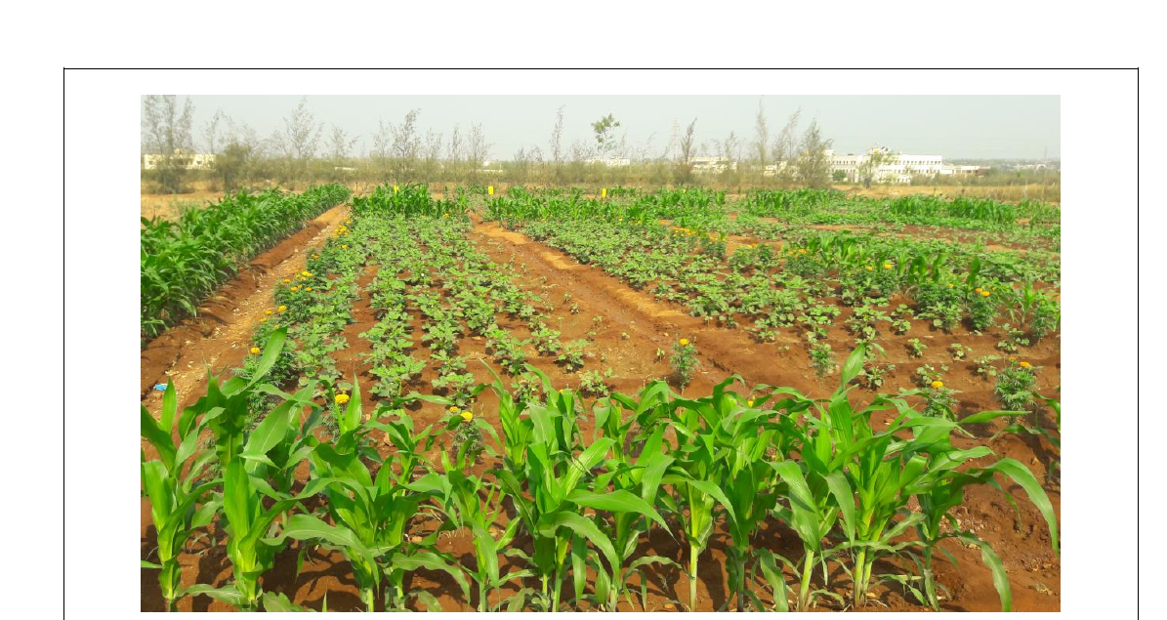
Fig. 2. Predators observed in the okra ecosystem
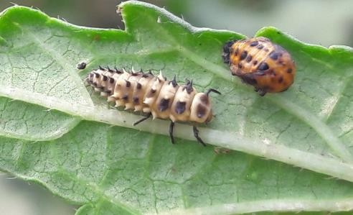  Coccinellid grub and pupa | 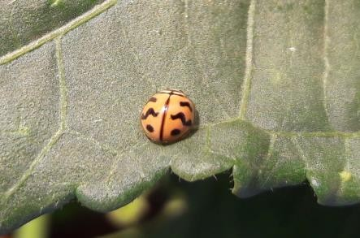  Coccinellid adult
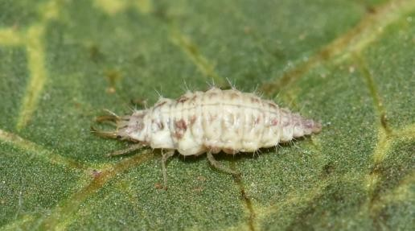  Chrysoperla grub | 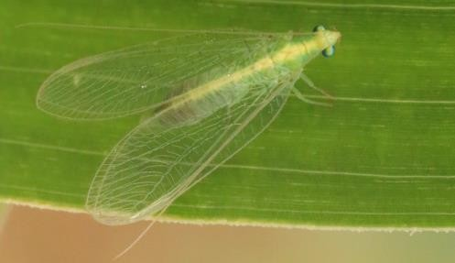  Chrysoperla adult
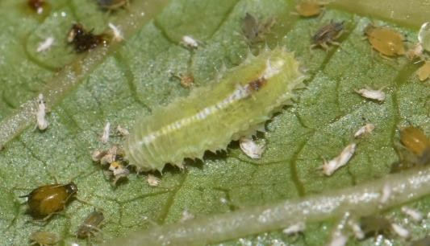  Syrphid fly maggot | 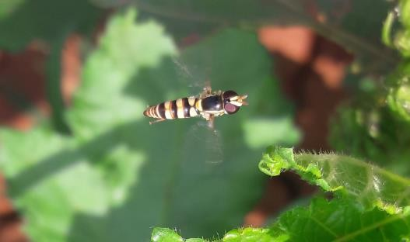  Syrphid fly adult
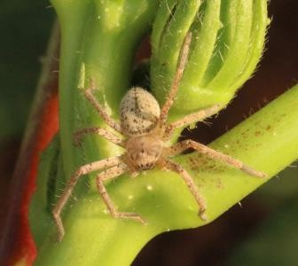  Spider | 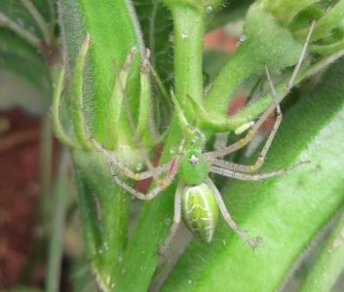  Spider

