Poecilobdella lakshmikantai, A New Leech from Arunachal Pradesh, India
Abstract:
Leeches of the class Hirudinea include diverse aquatic and terrestrial forms, and the Indian fauna continues to receive taxonomic additions from under-documented regions. This study describes Poecilobdella lakshmikantai sp. nov. from Dirang, West Kameng District, Arunachal Pradesh, India, based on a specimen collected from a freshwater habitat at 1500 m altitude and deposited in the General Non-Chordata collection of the Zoological Survey of India, Kolkata. The holotype was examined using external and internal morphological characters. The species is assigned to Poecilobdella and diagnosed by a combination of characters, including a dorsoventrally flattened body measuring 35 mm in length and 8 mm in width, 110 annuli, five pairs of eyes, seven black dorsal stripes with dot-like patterning, and a circular posterior sucker with 42 rays. The male gonopore is positioned between annuli 31 and 32, while the female gonopore lies on segment 38, with six annuli separating the gonopores. Internally, the species has well-developed toothed jaws, numerous salivary papillae, elongated crop caeca, an enlarged last pair of caeca, a short-stalked vaginal canal, and a long tubular epididymis. These features distinguish it from known congeners. The record increases the documented leech fauna of Arunachal Pradesh to seven species and supports the taxonomic importance of continued morphological surveys in northeastern India.

Key words: Hirudinidae; Poecilobdella lakshmikantai; Poecilobdella; new species; leech taxonomy; Hirudinea; Arunachal Pradesh; West Kameng; freshwater habitat; morphological diagnosis; annuli; gonopores
Introduction:
Leeches are often perceived as slimy, black, blood-feeding worms inhabiting unclean ponds and marshes; however, they occur in a diverse range of aquatic environments, including freshwater, estuarine and marine habitats, as well as moist terrestrial habitats worldwide. The world is home to approximately 921 leech species (Phillips et al., 2020). Early research on Indian leeches provided foundational insights, including Baugh's (1960) focus on Indian rhynchobdellid leeches and Harding and Moore's (1927) comprehensive review, which identified 54 species (36 freshwater, nine terrestrial and 10 marine species) across 25 genera and five families. Mandal's research has contributed three Poecilobdellid leeches in India: Poecilobdella sukhendui Mandal et al., 2026, Poecilobdella kananbalaae Mandal et al., 2025, and Poecilobdella tarubalaae Hasan et al., 2026. The taxonomic framework for Indian leeches has been substantially shaped by Chandra (1982) and Ghosh (1998), building on earlier global contributions, such as Soós's (1965) work. Recent Indian leech inventories indicate that freshwater habitats continue to provide important taxonomic records, including records from Dal Lake, Jammu and Kashmir (Khan et al., 2024). Recent zoological taxonomic studies also show that careful morphological examination remains necessary when establishing distinct taxa in invertebrate groups (Shaikh, 2025; Saglam et al., 2025), while faunal record updates continue to refine Indian biodiversity documentation (Bindu, 2025). Recent molecular work on Indian leeches further demonstrates that DNA-based identification can complement morphological comparisons in resolving species identity (Shannan et al., 2024). However, the Poecilobdella fauna of Dirang, West Kameng District, remains inadequately documented, and the diagnostic status of the collected specimen requires comparison with known congeners using external and internal morphological characters. The present study describes a newly discovered species from Dirang, West Kameng District, Arunachal Pradesh, India (latitude 27.3584° N, longitude 92.2409° E; altitude 1500 m).
Objective: This study aimed to describe the Dirang specimen taxonomically and compare its diagnostic characters with those of known species of Poecilobdella.

Materials and Methods: Collection and Preservation: The collected leeches were cleaned and sterilised before being placed in a shallow water bath. Gradual anaesthesia was induced by applying 70% alcohol dropwise at regular intervals. This method ensured the slow and humane death of the leeches. Immediately after death, the specimens were preserved in 70% ethanol for long-term storage. After identification, they were officially deposited and catalogued in the General Non-Chordata (GNC) collection of the Zoological Survey of India, Kolkata, for future reference and study.
Material Examined: Holotype: Dirang, located in the West Kameng District of Arunachal Pradesh, India (latitude 27.3584° N, longitude 92.2409° E), at an altitude of 1500 m. One specimen (ZSI-GNC-An 8093/2) was collected on 10 September 1984 by Debasish Banerjee.

Results and Discussion: During a survey conducted by Debasish Banerjee in 1984 on behalf of the Zoological Survey of India (ZSI), several leech specimens, along with other non-chordate groups, were collected from Arunachal Pradesh. Among these specimens, one leech species was taxonomically identified by the authors as new to science. With this discovery, the total number of leech species recorded in India has now reached 84, with Arunachal Pradesh accounting for seven of these.
Poecilobdella lakshmikantai sp. nov. (Plates 1-3):
Diagnostic characters: Well-developed jaws and teeth. Jaws with numerous salivary papillae. The vaginal stalk and caecum are moderate in size. This species is distinguished from all known congeners by the separation of the male and female gonopores by six annuli, a characteristic not observed in other species of the genus Poecilobdella. The crop possesses elongated caeca; the last pair of caeca is particularly enlarged, occupying nearly one-fifth of the body length. The vaginal canal is short-stalked and shorter than the vaginal caecum. The epididymis is a long tubular structure and shorter than the vaginal caecum. The species also possesses distinctive morphological features, such as 110 annuli, five pairs of eyes, seven black dorsal stripes with dot-like patterning, and a caudal sucker with 42 rays, morphologically resembling the mouth of a sea anemone. Body Size and Shape: Length: 35 mm; Width: 8 mm. Body dorsoventrally flattened, tapering anteriorly and posteriorly. In life, the body is reddish-brown; the colouration fades in preservation. The anterior region comprises 6 segments, the central body has 84 segments, and the caudal sucker has 10 segments. Anterior body segments are biannulate, while the remaining segments are quadrannulate. Anterior Sucker: Semicircular, 1 mm wide, with six annuli and bearing three jaws. Two jaws are smaller and anteriorly positioned, while the third jaw is larger and obliquely sloped. Salivary papillae are abundant on the jaws. Posterior Sucker: Circular, 3 mm in diameter. The base exhibits six additional ray-like structures, giving the sucker a sea anemone-like appearance. Position of Clitellum: Clitellar region indistinct in preservation but observed between segments 31 and 38. The clitellum spans 8 annuli. Male and Female Gonopores: An oval-shaped male gonopore is situated between annuli 31 and 32, and the female gonopore is located on segment 38. Each annulus bears sensory receptor organs on small papillae. Additionally, white sensillae are present on every segment, allowing the count of 24 sensillar segments. The jawed pharynx has three distinct jaws; the jaws are well developed and toothed, indicating a predatory or haematophagous habit. The male and female reproductive openings are widely spaced, with external morphology confirming the separation. Ecology: Aquatic species collected from a freshwater habitat in Arunachal Pradesh at high altitude (1500 m), indicating cold-water ecological adaptation.
Distribution: India: Arunachal Pradesh.
Etymology: The specific epithet lakshmikantai is dedicated to the cherished memory of Shri Lakshmi Kanta Mandal (12 February 1937 - 16 November 1989), the late father of Dr Chandra Kanta Mandal, Scientist-C, Zoological Survey of India (ZSI). This nomenclature honours his enduring legacy and commemorates his role in inspiring scientific pursuit through his son's distinguished contributions to annelid taxonomy.
Historical Review:
Taxonomic studies on leeches (Hirudinea) have increased substantially worldwide. Several new species are described every year from different regions of the world. Globally, more than two decades ago, the number of known leech species exceeded 300 (Ghosh, 1998). Early important and classical accounts of leeches were provided by Linnaeus (1767), Müller (1774) and Savigny (1820). Baird (1869) described some new suctorial annelids found in the British Museum. Whitman (1886) provided considerable information on the leeches of Japan.
Annandale (1913) examined the leeches of Lake Tiberius. Harding (1924) and Harding and Moore (1927) made significant contributions to the taxonomy of Indian leeches, describing several new species of both aquatic and terrestrial forms. In their comprehensive account of the leech fauna of India, Harding and Moore (1927) documented the majority of known species from the region. Moore (1898) described leeches in the U.S. National Museum collection, and Harding and Moore (1927) published the significant book on The Fauna of British India: Hirudinea. Soós (1965) made a major contribution to leech taxonomy.
Soota and Ghosh (1977), Chandra (1982) and Ghosh (1998) made significant contributions to the taxonomic classification of Indian leeches, providing valuable references for future researchers. Chandra (1991) also authored a comprehensive handbook on Indian leeches. Additionally, Mandal et al. (2021, 2022; Hasan et al., 2026) worked on both aquatic and terrestrial leeches of India. Siddall and Burreson (1995) investigated the evolutionary origins of blood-feeding behaviour in leeches. Bandyopadhyay and Mandal (2005) conducted useful taxonomic work on glossiphonid leeches of West Bengal, India.
Summary: Leeches, among the specialised members of the phylum Annelida, exhibit ecological adaptability and predatory efficiency. Although many annelids, such as polychaetes, are fully aquatic with diverse feeding modes, and oligochaetes occur across marine, freshwater, terrestrial and even glacial habitats, leeches stand apart because of their adaptive features. Unlike detritivorous oligochaetes, certain leeches display specialised predatory behaviour, often preying on entire oligochaetes, as observed in cases such as the Giant Red Leech. Their highly muscular bodies and resilient integuments make them more resistant to damage, positioning them competitively above many annelid relatives in predatory interactions. The newly described species shows distinct morphological features, including a total of 110 annuli, five pairs of eyes and a reddish-brown colouration that fades upon preservation. A key taxonomic character distinguishing this species from other members of Poecilobdella is the spacing and placement of the gonopores, which are separated by six annuli, a trait not previously documented in the genus. The male gonopore is located between segments 31 and 32 and is oval in shape, while the female gonopore lies at segment 38. The clitellar region, although faint, spans eight segments from 31 to 38. These defining anatomical and reproductive traits support the designation of this leech as a novel species within the genus Poecilobdella.

Conclusions
The present study documents Poecilobdella lakshmikantai sp. nov. from Dirang, West Kameng District, Arunachal Pradesh, India, and provides a morphological basis for its recognition within the genus Poecilobdella. The specimen shows a distinct combination of external and internal characters, including 110 annuli, five pairs of eyes, seven black dorsal stripes, a posterior sucker with 42 rays, well-developed toothed jaws and a reproductive arrangement in which the male and female gonopores are separated by six annuli. The enlarged last pair of crop caeca, short-stalked vaginal canal and long tubular epididymis further support its distinction from described congeners. The record contributes to the known leech diversity of Arunachal Pradesh and indicates that freshwater habitats in the eastern Himalayan region remain relevant for taxonomic documentation. The description is based on the available preserved material and therefore provides a morphological foundation for future comparative studies, including broader sampling and complementary molecular analysis when suitable material becomes available.

Limitation
This study is based on a single preserved specimen, which limits assessment of intraspecific variation, live colour patterns and population-level distribution. Molecular data were not available, so the diagnosis is based on external and internal morphology. Additional specimens from Dirang and neighbouring freshwater habitats would help confirm the range of morphological variation and ecological preferences of the species.

Acknowledgement: We sincerely express our gratitude to the Director of the Zoological Survey of India for her invaluable guidance and constant encouragement throughout the course of this study. We also extend our thanks to Dr N. Marimuthu, Scientist E and Officer-in-Charge, General Non-Chordata Section, for his continued support and assistance in the preparation of this manuscript. We are also thankful to Mr Biju Mukherjee and Biswajit Sarkar for their assistance in photographing the species.
References:
• Annandale, N. (1913). The leeches of the Lake of Tiberias. Journal and Proceedings of the Asiatic Society of Bengal, New Series, 9(6), 211–214. https://www.biodiversitylibrary.org/item/98645
• Baird, W. (1869). Descriptions of some new suctorial annelides in the collection of the British Museum. Proceedings of the Zoological Society of London, 1869, 310–318. https://www.biodiversitylibrary.org/part/73798
• Bandyopadhyay, P. K., & Mandal, C. K. (2005). On the occurrence of five leeches, Barbronia weberi, Glossiphonia annandalei, Glossiphonia heteroclita, Glossiphonia reticulata, and Placobdella undulata in West Bengal, India. Records of the Zoological Survey of India, 105(3–4), 93–101. https://doi.org/10.26515/rzsi/v105/i3-4/2005/159236
• Baugh, S. C. (1960). Studies on Indian rhynchobdellid leeches. II. Zoologischer Anzeiger, 165, 468–477.
• Bindu, L. (2025). Extended distribution of two species of testate amoebae (Tubulinea: Centropyxidae) to Indian fauna. Bionature, 45(1), 10–13. https://doi.org/10.56557/bn/2025/v45i12053
• Chandra, M. (1982). A check-list of leeches of India. Records of the Zoological Survey of India, 80(3–4), 265–290. https://doi.org/10.26515/rzsi/v80/i3-4/1982/161193
• Chandra, M. (1991). The leeches of India: A handbook. Zoological Survey of India. https://uasbagrilibindia.org/cgi-bin/koha/opac-detail.pl?biblionumber=130101
• Ghosh, G. C. (1998). Annelida: Hirudinea. In Fauna of West Bengal (Part 10, State Fauna Series 3, pp. 227–249). Zoological Survey of India. https://zsi.gov.in/fauna-of-india-auth?authid=11784&author=Ghosh%2C+G.+c.
• Harding, W. A. (1924). Descriptions of some new leeches from India, Burma, and Ceylon. Annals and Magazine of Natural History, Series 9, 14(82), 489–499. https://doi.org/10.1080/00222932408633143
• Harding, W. A., & Moore, J. P. (1927). The fauna of British India, including Ceylon and Burma: Hirudinea. Taylor & Francis. https://www.biodiversitylibrary.org/item/180056
• Khan, N. A., Mir, Z. A., & Bakhtiyar, Y. (2024). The present state of leech fauna (Annelida: Hirudinea) in Dal Lake, Jammu & Kashmir, India. Journal of Threatened Taxa, 16(8), 25700–25711. https://doi.org/10.11609/jott.8971.16.8.25700-25711
• Lesson, R. P. (1842). Description d’une nouvelle espèce de sangsue. Revue Zoologique par la Société Cuvierienne, 5, 8. https://www.gbif.org/species/9102666
• Linnaeus, C. (1767). Systema naturae per regna tria naturae: Secundum classes, ordines, genera, species, cum characteribus, differentiis, synonymis, locis (12th ed., Vol. 1, Part 2). Laurentii Salvii. https://www.biodiversitylibrary.org/item/83650
• Hasan, M. N., Ghosh, S., Mandal, C. K., et al. (2026). Leech fauna of West Bengal: A collection-based study. Proceedings of the National Academy of Sciences, India Section B: Biological Sciences, 96, 371–382. https://doi.org/10.1007/s40011-026-01757-5
• Mandal, C. K., Mridha, S., Sharma, P., Bose, M., Hassan, N., Sachi, A., & Ghosh, S. (2025). Poecilobdella kananbalaae: A new species of leech from Karnataka, India. Uttar Pradesh Journal of Zoology, 46(23), 201–210. https://doi.org/10.56557/upjoz/2025/v46i235394
• Mandal, C. K., Mridha, S., Yasir, M., Kalam, A., Jameel, M., Anwar, M., & Ghosh, S. (2021). Poecilobdella aligarhensis: A new leech (Clitellata: Hirudinida) from Aligarh, India. Journal of Applied Zoological Research, 32(2), 145–149.
• Mandal, C. K., Reynolds, J. W., Hassan, M. N., & Deuti, K. (2022). One new leech Haemadipsa zelanica dhritii (Annelida: Hirudinida, Haemadipsidae) from Nagaland, India. Megadrilogica, 27(4), 34–39.
• Mandal, C. K., Sharma, P., Bose, M., Mridha, S., Hasan, N., Sikdar, R., Sachi, A., & Ghosh, S. (2026). Morphological description and taxonomic notes on Poecilobdella tarubalaae sp. nov. from Karnataka, India. Uttar Pradesh Journal of Zoology, 47(3), 63–72. https://doi.org/10.56557/upjoz/2026/v47i35486
• Moore, J. P. (1898). The leeches of the U.S. National Museum. Proceedings of the United States National Museum, 21(1160), 543–563. https://doi.org/10.5479/si.00963801.21-1160.543
• Moore, J. P. (1927). Hirudinaria (Poecilobdella) viridis. In W. A. Harding & J. P. Moore, The fauna of British India, including Ceylon and Burma: Hirudinea (pp. 239–243). Taylor & Francis. https://www.biodiversitylibrary.org/item/180056
• Müller, O. F. (1774). Vermium terrestrium et fluviatilium, seu animalium infusoriorum, helminthicorum et testaceorum, non marinorum, succincta historia (Vol. 1, Part 2). Heineck & Faber. https://doi.org/10.5962/bhl.title.46299
• Phillips, A. J., Govedich, F. R., & Moser, W. E. (2020). Leeches in the extreme: Morphological, physiological, and behavioral adaptations to inhospitable habitats. International Journal for Parasitology: Parasites and Wildlife, 12, 318–325. https://doi.org/10.1016/j.ijppaw.2020.09.003
• Saglam, N., Saunders, R., & Shain, D. H. (2025). Species delimitation recovers undescribed Erpobdellidae (Annelida: Hirudinea) from USA and Türkiye. Zootaxa, 5627(3), 455–479. https://doi.org/10.11646/zootaxa.5627.3.3
• Savigny, J.-C. (1820). Système des annélides, principalement de celles des côtes de l’Égypte et de la Syrie. Description de l’Égypte. https://doi.org/10.5962/bhl.title.66284
• Shaikh, I. V. (2025). New cestode of the genera Diplopylidium (Eucestoda: Dipylidiiae) parasitizing Felis domesticus in Maharashtra: A morphological study. Asian Journal of Research in Zoology, 8(3), 9–15. https://doi.org/10.9734/ajriz/2025/v8i3201
• Shannan, P. Z. T., Suganya, S. G., Ramesh, M., & Jemima, E. A. (2024). Molecular-based identification and phylogenetic relationship of the leech Hirudinaria manillensis from India by using mitochondrial cytochrome c oxidase subunit I gene. Molecular Biology Reports, 51, Article 787. https://doi.org/10.1007/s11033-024-09720-1
• Siddall, M. E., & Burreson, E. M. (1995). Phylogeny of the Euhirudinea: Independent evolution of blood feeding by leeches? Canadian Journal of Zoology, 73(6), 1048–1064. https://doi.org/10.1139/z95-125
• Soós, Á. (1965). Identification key to the leech (Hirudinoidea) genera of the world, with a catalogue of the species. I. Family: Piscicolidae. Acta Zoologica Academiae Scientiarum Hungaricae, 11(3–4), 417–463. https://real-j.mtak.hu/4329/
• Soota, T. D., & Ghosh, G. C. (1977). On some Indian leeches. Newsletter of the Zoological Survey of India, 3(6), 359–360.
• Wahlberg, P. F. (1856). Nya hirudineer. Öfversigt af Kongliga Vetenskaps-Akademiens Förhandlingar, 13, 231–234. https://tb.plazi.org/GgServer/xhtml/E4B9B14B31DE6FD88FB57468F4BEC9A6
• Whitman, C. O. (1886). The leeches of Japan. Quarterly Journal of Microscopical Science, 26, 317–416. https://www.biodiversitylibrary.org/part/77077
• Yang, T. (1980). On a new species of Poecilobdella (Hirudinea: Hirudinidae) from Hubei Sheng, China. Zoological Research, 1(4), 541–546. https://www.zoores.ac.cn/en/article/id/1516

Table-I. Showing comparison Poecilobdella lakshmikantai new sp. with the other 9 species of the genus Poecilodella in the world.
Characters | Poecilobdella manillensis | Poecilobdella granulosa | Poecilobdella viridis | Poecilobdella javanica | Poecilobdella aligarhensis | Poecilobdella sukhendui | Poecilobdella hubeiensis | Poecilobdella kananbalaae | Poecilobdella tarubalaae | Poecilobdella lakshmikantai
Stripe | Single black median | One black median broken constricted line. | No median stripe Marginal orange stripes with metameric spots. | Broken stripe with metameric spots. | Six dorso-lateral stripes. | No stripe on dorsal and vetral region | Two black squired stripe | 3 Pairs Black Dark | One medial black stripe. 2 black spotted line. | 5 black broken stripes
Colour | Brown dorsally, Green ventrally | Olive green dorsally reddish orange ventrally | Dorsal olive green. Ventral grayish green | Olive green to grass green. Margins yellow or orange. | Brown dorsally, cream colored ventrally | Brown dorsally, fade up ventrally | Grayish green Dorsal, Blackish background ventral with white spots | Brown dorsaly yellowish ventrally | Dark brown dorsally dark green ventrally | Reddish brown
Body length | 12.3cm | 9.5cm. | 11.2cm. | 10.7cm. | 41mm. | 14.5 cm. | No records | 9.9cm | 4cm | Length 35 mm. 8mm.
Breadth | 2.8cm. | 2.3cm. | 2.4cm. | 2.1cm. | 9mm. | 3.5 cm. | No records | 1.4cm. | 5cm | 8mm.
Breadth of anterior sucker | 1.8mm. | 1.9mm. | 1.7mm. | 1.3mm. | 2mm in diameter, | Anterior sucker 2.1mm. Almost ten times little than posterior sucker. | No records | 6cm | 3.5mm | Anterior sucker 1mm.
Breadth of posterior sucker | Caudal sucker larger than anterior | Caudal sucker little larger than anterior | Caudal sucker smaller than anterior | Caudal suckers larger than anterior and almost broad like maximum breadth of the body | Posterior sucker 5.2mm almost third time larger than the anterior sucker. Not equal to breadth. | Posterior sucker is almost round 2.3cm broad. Sucker rays are 110. | Large in size | 1.1cm | 3mm. | Caudal sucker is round in shape, 3mm. diameter,
Clitellum | Prominent | Prominent | Not prominent | Prominent | Moderate | 37-45 annuli,  9annuli | Somite XI-XII | 33-39  7 annuli | Somite XI-XII | 31-38 annuli  8 annuli
Gonophores separated by | 5 annuli | Separated by 5 annuli | Separated by 5 annuli | Separated by 7 annuli | Separated by 5 annuli. Male pore between 33-34 rings. Female pore between 38-39 rings. | Male gonopore large in between 29 and 30 segment. Female genital pore minute between 34-35 segments nearer to 34 segments | 5 annuli | Gonopores separated by 5 annuli | 5 annuli | Gonopores separated by 6 annuli
Vaginal Stalk | Almost equal  in length of caecum | Equal in length of caecum | Twice the length of caecum | Absent | Larger than the anterior crop caecum | Shorter than caecum. | Short | Very short | Absent | Short
Breading season | - | - | June-July | - | April-July | May-July | No records | July- September | August-September | July-September
Eyes | Five pairs | Five pairs | Five pairs | Five pairs eyes on 2,3,4,6 and 9th annuli. | Nine pairs of eyes on rings 3, 4, 6, 8 and 11th rings. | Five pairs eyes on 2,3,5,6 and 8th annuli. | Five pairs on 2, 3, 4, 5, 6 segments | Five pairs | Five pairs on 2,4, 5, 7 and 10th annuli | Five pairs  on 3,4, 5, 7 and 10th annuli
Ring | 112 | 101 | 107 | 105 | 108(including 5 rings of posterior sucker). | Total 111 rings | No records | 110 | 113 | Total 110 rings
Reference | (Lesson, 1842) | ( Sevigny, 1820) | Moore, 1927 | ( Wahlberg, 1856) | Mandal et.al., 2021 | Mandal et.al., 2021 | Yang, 1980 | Mandal et.al., 2025 | Mandal et.al., 2025 | Recent authors

Plate 1. Poecilobdella lakshmikantai
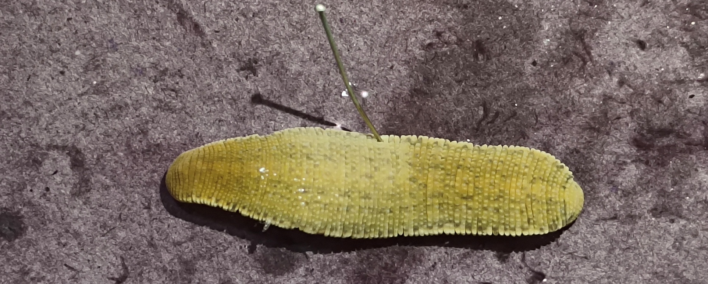
Poecilobdella lakshmikantai (Dorsal view showing breaking black stripes)

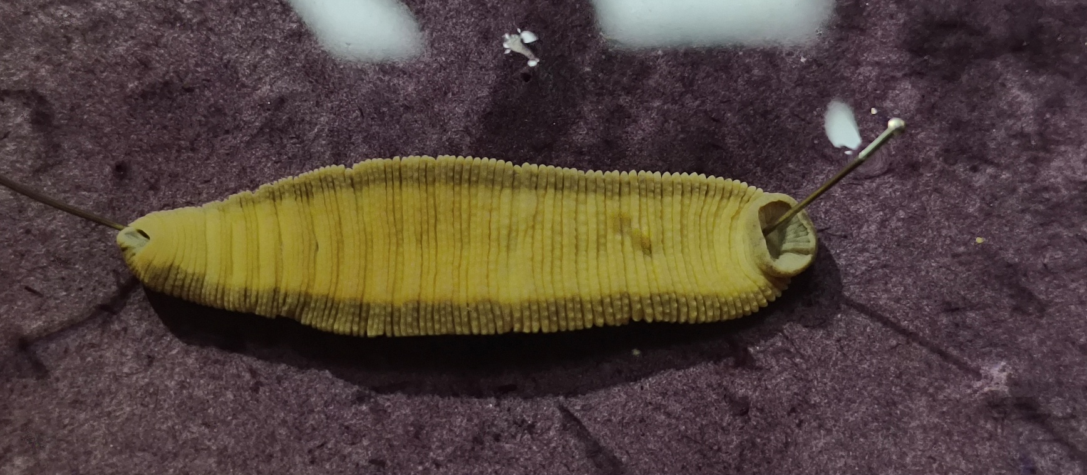
Poecilobdella lakshmikantai (Ventral view showing single pair black stripes)
Plate-2 Head, Anterior part, Posterior part, Genital pores, Anterior sucker and Posterior sucker of P. lakshmikantai
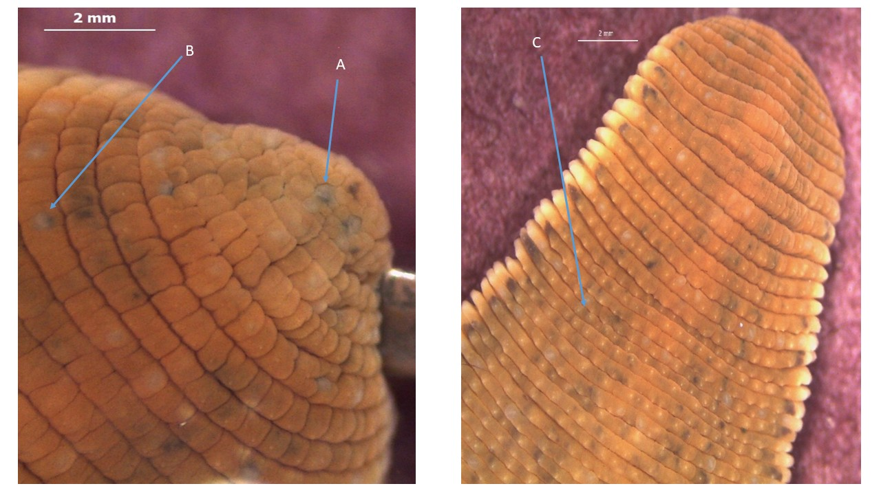
Poecilobdella lakshmikantai(A-Eyes 1st pair, B- 5th pair, C-stripes of Anterior part)

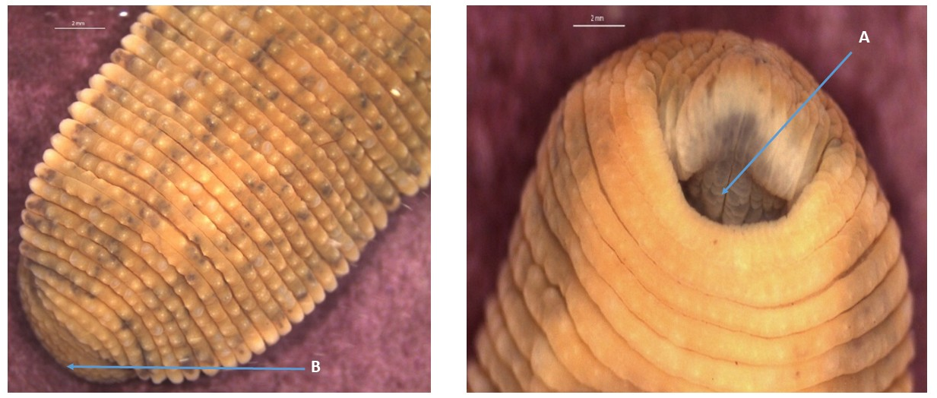
B-Posterior sucker of Poecilobdella lakshmikantai, A- Jaws of Anterior sucker

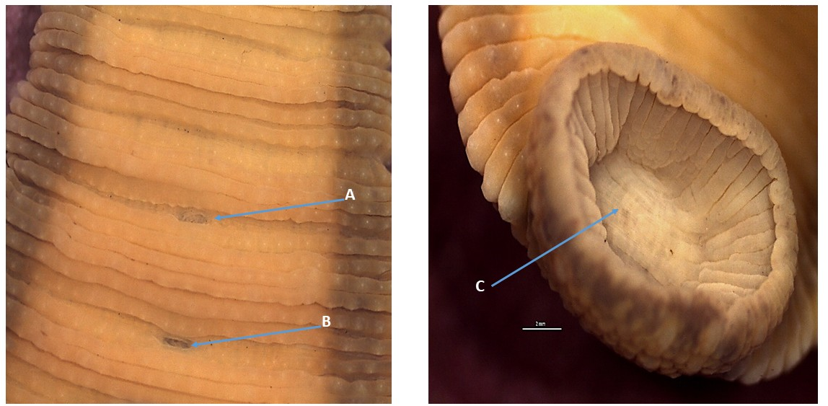
- Male genital pore, B- Female pore, C-Posterior sucker of P. lakshmikantai
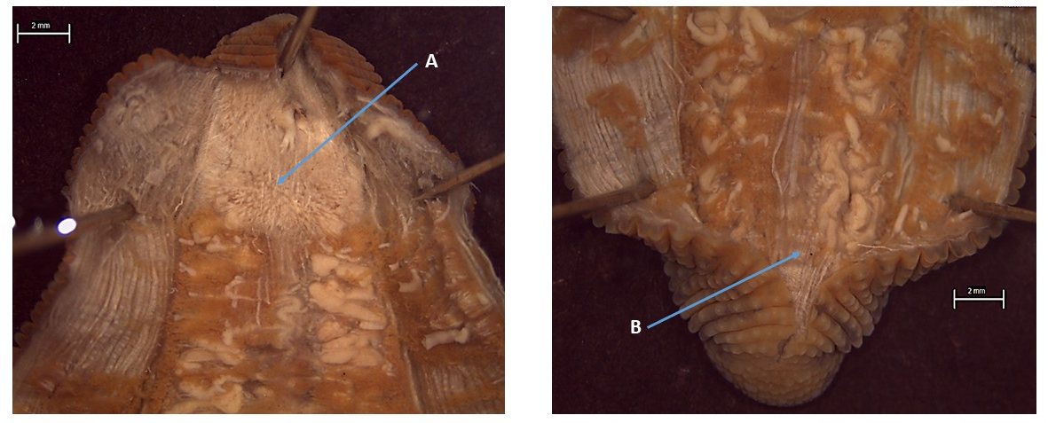
Plate- 3. A-Pharynx with salivary glands, B- Last crop caecum of Poecilobdella lakshmikantai

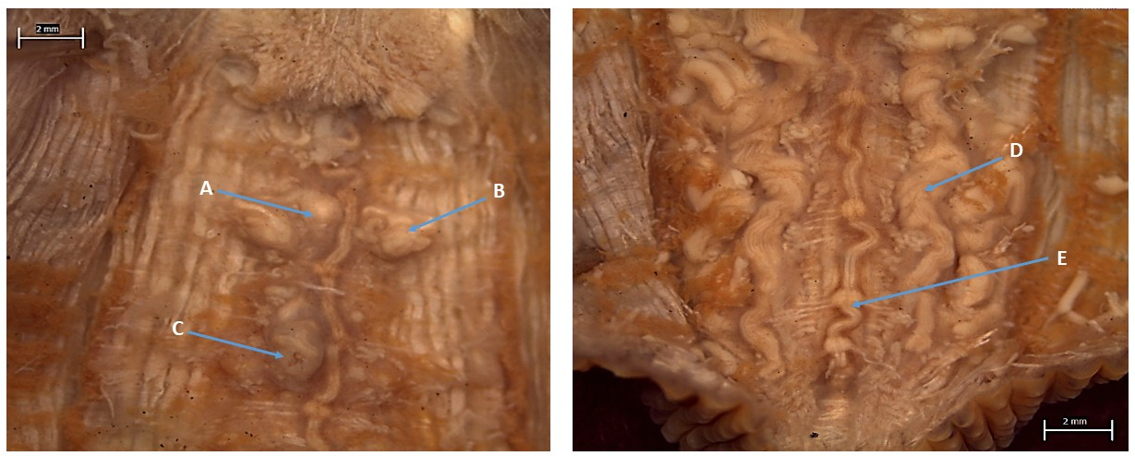
Poecilobdella lakshmikantai A- Prostate, B- Epididymis, C-Vaginal caecum, D-Last crop
caecum, E-Ganglion.

