Original Research Article
MOLECULAR CHARACTERIZATION OF VIRULENCE GENES IN E. COLI ISOLATES FROM BOVINE MASTITIS CASES

Abstract
The pathogenicity of Escherichia coli associated with bovine mastitis is primarily governed by the presence of specific virulence genes. The present study was undertaken to investigate the distribution and combinations of virulence determinants in E. coli isolates recovered from mastitic milk samples. A total of 36 E. coli isolates, confirmed by 16S rRNA gene amplification, were analyzed for six virulence-associated genes (Stx1, Stx2, TraT, eaeA, aer, and hly) using polymerase chain reaction (PCR). Among the tested genes, three virulence determinants (Stx2, TraT, and eaeA) were detected, whereas Stx1, aer, and hly were absent. The Stx2 gene was the most predominant, detected in 58.33% of isolates, followed by TraT (41.66%) and eaeA (19.44%). The absence of Stx1 suggests a dominance of Stx2-mediated pathogenicity. Analysis of virulence gene combinations revealed that Stx2–TraT was the most frequent profile (22.22%), followed by Stx2–eaeA and TraT–eaeA combinations. The findings indicate that E. coli isolates from bovine mastitis harbor multiple virulence determinants contributing to adhesion, toxin production, and immune evasion. The predominance of Stx2 and its association with other virulence genes highlights the potential pathogenic risk of these isolates. This study provides valuable insights into the virulence gene profile of mastitis-associated E. coli, which is essential for understanding disease pathogenesis and developing targeted control strategies. Further phylogenetic analysis of the virulent isolate revealed genetic divergence among the isolates, with sequence of virulent isolate SQ4647 forming a distinct lineage
Keywords: E. coli, virulence genes, bovine mastitis, PCR, Stx2, TraT, eaeA

Introduction
Bovine mastitis is a multifactorial disease significantly affecting dairy production worldwide. Among the causative agents, E.coli is recognized as a major environmental pathogen responsible for both clinical and subclinical mastitis (Azevedo et al., 2016). The severity and outcome of infection largely depend on the virulence characteristics of the infecting strain rather than mere presence of the organism. Virulence in E. coli is mediated by a diverse array of genes encoding toxins, adhesins, invasins, iron acquisition systems, and serum resistance factors (Fernandese et al.,2011). These virulence determinants enable the pathogen to colonize the mammary gland, evade host immune responses, and cause tissue damage. Among these, Shiga toxin genes (Stx1 and Stx2), intimin (eaeA), serum resistance gene (TraT), aerobactin (aer), and hemolysin (hly) play crucial roles in pathogenesis (Ismail et al., 2020). The presence and combination of these genes define the virulence profile of an isolate and determine its pathogenic potential. Despite several studies on mastitis, limited information is available on the distribution and combination patterns of virulence genes in E. coli isolates from bovine mastitis in this region. Therefore, the present study aimed to detect and characterize key virulence genes and their combinations in E. coli isolates.

Material and Methods
Collection of Mastitis milk samples
For the present study, total 200 mastitis milk samples were collected from different species including Cow (157 no.) and buffaloes (43 no.) milk samples from various dairy farms across Western Maharashtra from clinical and subclinical cases Among cattle, 24 (7.07%) milk samples, were from clinical mastitis cases and 133 (39.23%) from subclinical mastitis. In contrast, 03 (3.09%) milk sample of buffalo were from clinical mastitis, while 40 (41.23%) were identified from subclinical mastitis cases. Milk samples from subclinical cases were collected by screening after California Mastitis Test. Only CMT-positive milk samples were selected for further processing. The foremilk was discarded, and approximately 5-6 ml of milk from the infected quarter(s) was aseptically collected into sterile glass vials in duplicate, labeled appropriately, and transported in an ice box with ice packs to the laboratory for immediate processing. The samples were stored in a refrigerator at 4°C until further analysis, which was conducted within 48 hours.
Isolation and Identification of E.coli
Initially, a loopful 200 mastitic milk samples were inoculated separately into a test tubes containing 3 ml of sterile nutrient broth and incubated at 37 °C for 12 hours. Following incubation, the cultures were sub-cultured onto the MacConkey agar and incubated at 37°C for 24–48 hours. The lactose-fermenting colonies of E.coli showing pink colour were then streaked onto Eosin Methylene Blue (EMB) agar and Hicrome E.coli agar, incubated overnight at 37°C. All isolates obtained were further identified by Gram’s staining and biochemical test.
Molecular Detection of Virulent Genes
Genomic DNA Extraction
E. coli isolates recovered from bovine mastitis milk samples were further processed for genomic DNA extraction
Genomic DNA was extracted from overnight E.coli cultures using the phenol–chloroform method. Briefly, bacterial cells were pelleted by centrifugation and lysed using lysis buffer containing SDS and proteinase K. An equal volume of phenol: chloroform: isoamyl alcohol (25:24:1) was added, mixed, and centrifuged to separate phases. The aqueous phase was collected, purified with chloroform: isoamyl alcohol, and DNA was precipitated using cold ethanol and sodium acetate. The DNA pellet was washed with 70% ethanol, air-dried, and dissolved in nuclease-free water for further use. Species-specific 16S rRNA gene amplification PCR was done for molecular confirmation of E.coli (Wang et al., 2002). The PCR reactions were performed in a total volume of 25 μl in 0.2 ml PCR tubes. The PCR process was conducted using a Proflex PCR system (Applied Biosystems), following the standardized cycling conditions using specific primers mentioned in table no 1. Isolates confirmed for 16SrRNA were further subjected to virulence gene analysis.
Table No.1: Details of primer sequences used for standardization of PCR assay to detect 16S rRNA of E.coli
Primer name | Nucleotide sequence | (5'-3') PCR Amplicon/ product size (bp)
16S rRNA | -F CCCCCTGGACGAAGACTGAC | 401
16S rRNA | -R ACCGCTGGCAACAAAGGATA | 401

Six virulence-associated genes representing major pathogenic mechanisms were selected, including toxin genes (Stx1 and Stx2), adhesion gene (eaeA), serum resistance gene (TraT), iron acquisition gene (aer), and hemolysin gene (hly) (Table.1). These genes were chosen based on their established roles in pathogenicity, such as toxin production, host cell adhesion, immune evasion, and survival within the host. PCR was performed to detect these genes using specific primers, as shown in Table 2
Table.2 Sequence of primers used for the detection of virulent genes in E.coli
Sr. No. | Gene | Oligonucleotide sequence (5’ to 3’) | Amplicon  Size (bp) | Reference
1 | eaeA | F; ATGCTTAGTGCTGGTTTAGG  R; GCCTTCATCATTTCGCTTTC | 248 bp | Bisi Johnson et al. (2011)
2 | TraT | F: GATGGCTGAACCGTGGTTATG  R: CACACGGGTCTGGTATTTATGC | 307 bp | Kaipainen et al. (2002)
3 | aer | F: TACCGGATTGTCATATGCAGACCGT  R: AATATCTTCCTCCAGTCCGGAGAAG | 602 bp | Oliveira et al. (2011)
4 | hly | F: AACAAGGATAAGCACTGTTCTGGCT R: ACCATATAAGCGGTCATTCCCGTCA | 1177 bp | Younis et al. (2021)
5 | Stx1 | F: ACACTGGATGATCTCAGTGG  R: CTGAAATCCCCCTCCATTATG | 555 bp | Nguyen et al. (2011)
6 | Stx2 | F: CCATGACAACGGACAGCAGTT  R: CCTGTCAACTGAGCAGCACTTTG | 118bp | Nguyen et al. (2011)

Polymerase chain reaction (PCR) was carried out for the detection of these virulence genes using gene-specific primers. Each reaction was performed in a final volume of 25 µL containing 12.5 µL of PCR master mix, 1 µL each of forward and reverse primers, 2 µL of template DNA, and 8.5 µL of nuclease-free water. Amplification was carried out in a thermal cycler under optimized cycling conditions (Table.3).

Table.3 PCR protocol for detection of virulent genes
Step name/gene targeted | Stx1 | Stx2 | aer | eaeA | hly | TraT
Initial denaturation | 94°C  10 min | 94°C  10 min | 94°C  1 min | 95°C  5 min | 94°C  5 min | 94°C  10 min
Denaturation | 94°C  30 sec | 94°C  30 sec | 94°C  1 min | 94°C  30 sec | 94°C  30 sec | 95°C  2 min
Annealing | 50°C  45 sec | 50°C  45 sec | 63°C  30 sec | 51°C  30 sec | 54°C  40 sec | 55°C  1 min
Extension | 70°C  90 sec | 70°C  90 sec | 70°C  90 sec | 72°C  30 sec | 72°C  45 sec | 72°C  1 min
Final extension | 72°C  10 min | 72°C  10 min | 72°C  5 min | 72°C  7 min | 72°C  10 min | 70°C  10 min

Sequencing and phylogenetic analysis of virulent E.coli isolates
Nucleic acid sequence determination was carried out by the Sequencing Service, Genomic, Pune, Pvt. Ltd India with the same primers that were used for amplification. Sequences were edited and aligned by using Emboss Merger Website and global sequence comparisons were performed by using basic local alignment search tool (BLAST) hosted by the National Center for Biotechnology Information (NCBI).
The evolutionary history was inferred by using the Maximum Likelihood method and Kimura 2-parameter model (Kimura M. 1980). Evolutionary analyses were conducted in MEGA11 (Tamura et al.2021)
Results and Discussion
Of the 200 mastitis milk samples comprising of 27 from clinical and 173 from subclinical cases, 36 samples (18%) were found to be positive for E. coli. Among these positive samples, 23 (11.5%) were obtained from cattle, while 13 (06.50%) originated from buffaloes. Presumptive E. coli colonies, showed characteristic pink coloration, which were further sub-cultured onto eosin methylene blue (EMB) agar and HiCrome E.coli agar. On EMB agar, distinctive metallic green sheen colonies was observed while on HiCrome E.coli agar bluish colour colonies were recorded, indicative of E. coli. On gram staining, all showed gram negative coccobacilli rods. The isolates were further confirmed on the basis of biochemical tests. Isolates showed positive reactions for the indole and methyl red test, indicated by the development of a red colour. In contrast, the isolates were negative for the Voges–Proskauer and Citrate utilization tests, showing no colour change, corresponding to an IMViC pattern of ++– –. Furthermore, in the triple sugar iron (TSI) agar test, the isolates produced a yellow slant and butt without the formation of hydrogen sulfide or gas..
All isolates (n=36) that were presumptively identified as E. coli based on cultural and biochemical characteristics were further subjected to molecular characterization using polymerase chain reaction (PCR) targeting the E. coli–species specific 16S rRNA gene. Amplification of the 16S rRNA gene was detected in all 36 isolates, thereby confirming their identity as E. coli and indicating that each isolate harbored the E. coli–specific 16S rRNA gene (Fig:1).

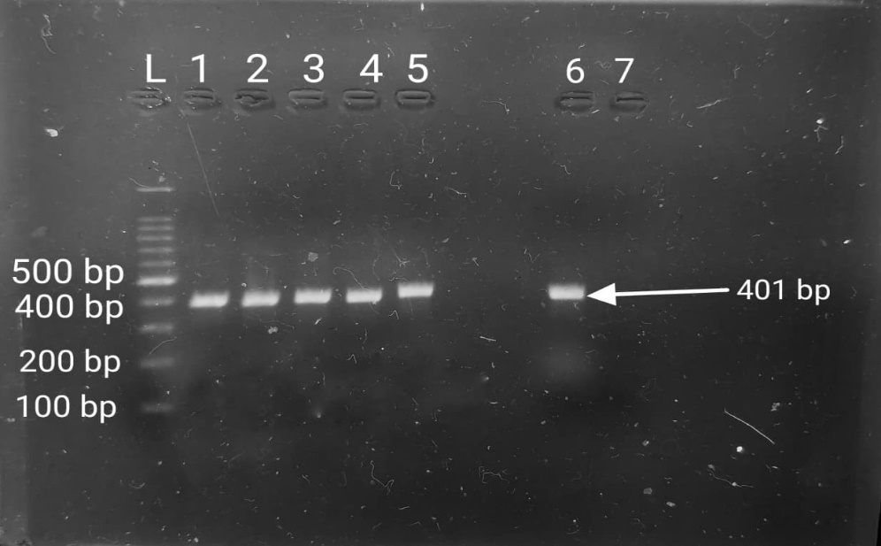

Fig. 1 Agarose gel electrophoresis showing amplification of 16S rRNA gene of
E.coli - 401 bp
L- Ladder
Lane 1, 2, 3, 4, 5 and 6 - Positive samples
Lane 7- Negative control

Earlier studies conducted by Dowidar et al. (2023) and Parveen et al. (2021) have similarly confirmed the presence of the 16S rRNA gene in E. coli isolates obtained from cows and various biological samples.
The molecular analysis of 36 E. coli isolates revealed a selective distribution of virulence genes. Among the six genes investigated, only Stx2, TraT, and eaeA were detected, while Stx1, aer, and hly were absent in all isolates (Fig. 2,3,4).

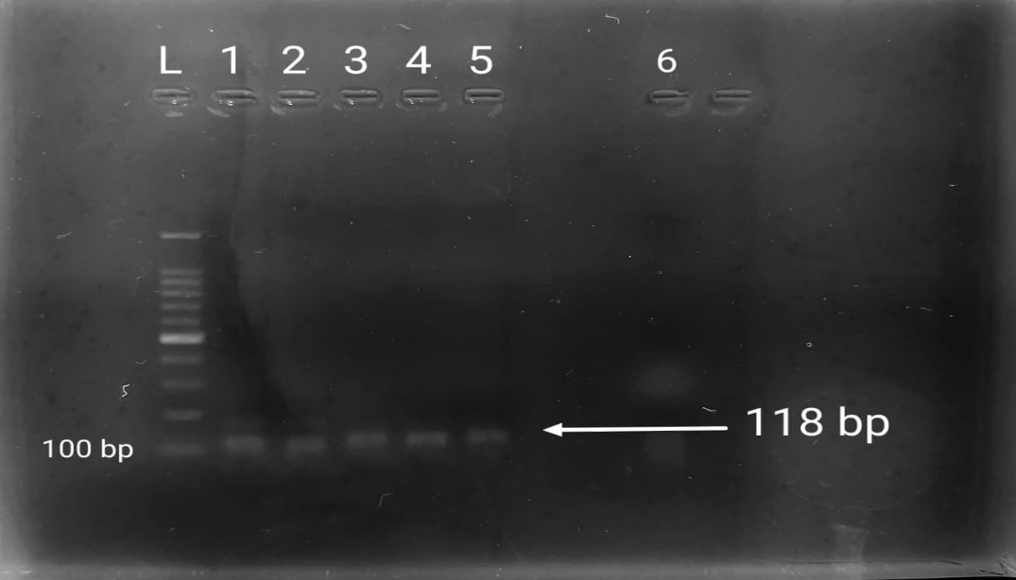
Fig. 2 Agarose gel electrophoresis showing amplification of
Stx2 gene - 118 bp
L – Ladder
Lane 1, 2, 3, 4, and 5 – Positive samples
Lane 6 – Negative control

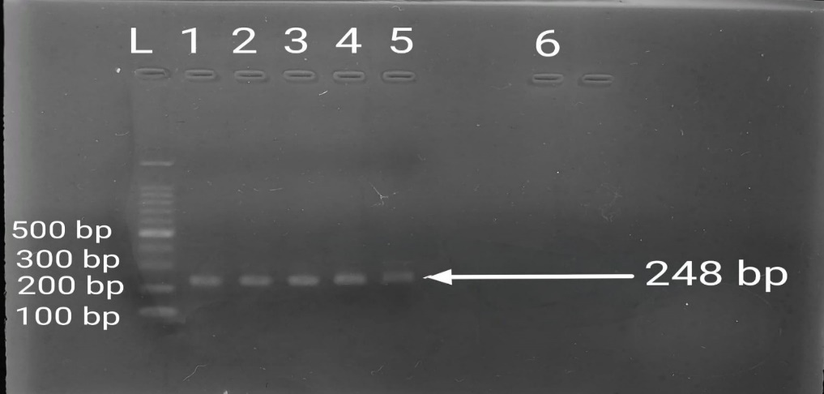
Fig. 3 Agarose gel electrophoresis showing amplification of
eaeA gene - 248 bp
L – Ladder
Lane 1, 2, 3, 4, and 5 – Positive samples
Lane 6 – Negative control

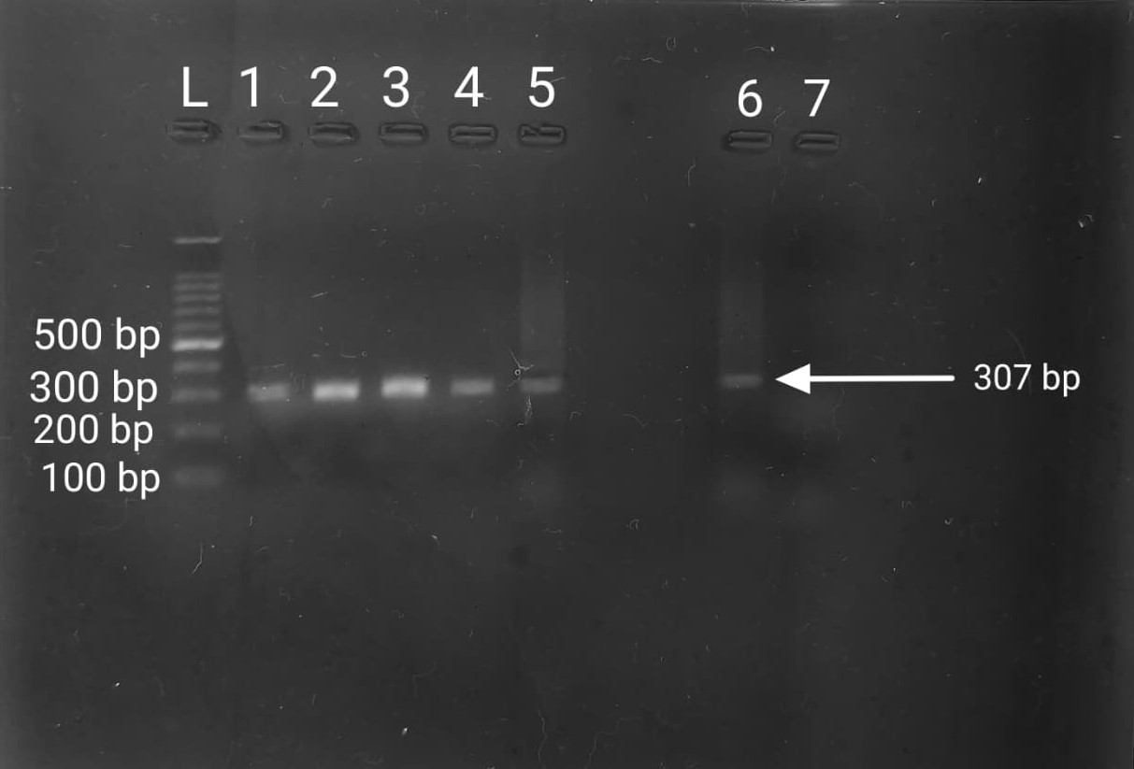
Fig. 4 Agarose gel electrophoresis showing amplification of
TraT gene - 307 bp
L – Ladder
Lane 1, 2, 3, 4, 5 and 6 – Positive samples
Lane 7 – Negative control

The Stx2 gene was the most prevalent (58.33%), followed by TraT (41.66%) and eaeA (19.44%) (Table. 4).
Table.4 Distribution of virulent genes in E.coli isolates
Sr. No | Virulent genes | Total samples | +Ve Samples | Prevalence
1 | Stx1 | 36 | 00 | 00
2 | Stx2 | 36 | 21 | 58.33%
3 | eaeA | 36 | 07 | 19.44%
4 | TraT | 36 | 15 | 41.66%
5 | aer | 36 | 00 | 00
6 | hly | 36 | 00 | 00
The absence of Stx1 and predominance of Stx2 indicate that Stx2-mediated virulence is the major pathogenic mechanism in these isolates, consistent with earlier reports (Younis et al., 2021), though variations have been observed in other studies (Neher et al., 2015; Seyda et al., 2014).
The presence of eaeA suggests the ability of certain isolates to adhere to host epithelial cells, while TraT indicates enhanced survival through serum resistance. Together, these genes contribute to colonization and immune evasion. The absence of aer and hly indicates that iron acquisition and hemolytic activity may not play a significant role in the studied isolates, reflecting variability in virulence mechanisms (Seyda et al., 2014).
Analysis of virulence gene combinations showed that Stx2–TraT was the most predominant profile (22.22%), followed by Stx2–eaeA and TraT–eaeA (Table. 5).
Table.5 Gene combination profiles of virulent genes in E.coli isolates
Total samples | Gene combination | No of isolates | Prevalence
36 | Stx2 - eaeA | 03 | 8.33%
36 | Stx2 - TraT | 08 | 22.22%
36 | TraT - eaeA | 02 | 5.55%

These combinations suggest a synergistic interaction between toxin production, adhesion, and immune evasion, enhancing the pathogenic potential of the isolates. Similar findings indicate that virulence in E. coli is determined by the combined effect of multiple genes rather than individual factors (Fernandes et al., 2011).

Overall, the study demonstrates that E. coli isolates associated with bovine mastitis possess diverse virulence profiles, with Stx2 playing a key role. The variability in gene distribution highlights the multifactorial nature of pathogenicity and the need for continuous molecular surveillance.
In the constructed phylogenetic tree, the SQ4647 sequence formed a separate clade distinct from the cluster of other reference sequences. The sequences MG817335.1, MG817336.1, MG197876.1, MF043881.1, MG966417.1, MG736060.1, and MG952583.1 showed closer evolutionary relationships among themselves and grouped within the same major lineage, indicating greater genetic similarity. The formation of an independent clade by SQ4647 (16S rRNA) suggests that this sequence has significant genetic differences compared to the other sequences. This divergence may reflect variations in the sequence, evolutionary changes, or possible strain differences within the studied gene region.(Fig 5)
Fig. 5 Phylogenetic analysis of virulent E.coli isolates

Overall, the phylogenetic analysis shows that SQ4647 represents a genetically distinct lineage compared to the other sequences in the study. This highlights potential evolutionary divergence within the dataset. Such divergence can help us understand genetic variability, evolutionary history, and possible functional differences among the E. coli sequences analyzed in this study.

Conclusion
The present study demonstrated that E. coli isolates recovered from bovine mastitis cases carried selected virulence-associated genes with variable distribution patterns. Among the six genes investigated, Stx2 was the most frequently detected, followed by TraT and eaeA, while Stx1, aer, and hly were not detected. The presence of Stx2 suggests the occurrence of toxin-associated virulence potential in a proportion of isolates, while detection of TraT and eaeA indicates possible involvement of serum resistance and adhesion-related mechanisms. The most frequent gene combination was Stx2–TraT, followed by Stx2–eaeA and TraT–eaeA. These findings support the view that mastitis-associated E. coli may possess multiple virulence determinants, although pathogenic expression and clinical relevance require further confirmation. Molecular screening of virulence genes can support epidemiological understanding of bovine mastitis and may help guide future surveillance and control strategies.

Limitation
This study was limited to 36 E. coli isolates recovered from 200 mastitic milk samples from Western Maharashtra. Only six virulence-associated genes were screened, and gene expression or toxin production was not evaluated. Negative PCR results should be interpreted with caution unless supported by appropriate positive controls. The phylogenetic analysis was based on limited 16S rRNA sequence information and may not provide sufficient strain-level resolution. Antimicrobial resistance profiling, serotyping, whole-genome analysis, and clinical outcome correlation were not included. Future studies should use larger sample sizes, validated controls, broader virulence panels, and sequence-based strain characterization.

Declaration of AI Use

This manuscript was prepared through the combined contributions of all author(s), including contributions to the study design, data, content development, results, interpretation, and related scholarly work. The author(s) acknowledge the use of Grammarly and ChatGPT to assist with grammar checking, language refinement, reference formatting. These AI-assisted tools were not used as authors and did not replace the intellectual contributions or scholarly judgment of the author(s). All AI-assisted outputs, including content, references, and interpretations, were carefully reviewed, revised, verified, and approved by the author(s). The author(s) accept full responsibility for the accuracy, integrity, and final content of the manuscript.

Disclaimer (Artificial Intelligence)
Author(s) hereby declare that NO generative AI technologies such as Large Language Models (ChatGPT, COPILOT, etc.) and text-to-image generators have been used during the writing or editing of this manuscript.
COMPETING INTERESTS DISCLAIMER:
Authors have declared that they have no known competing financial interests OR non-financial interests OR personal relationships that could have appeared to influence the work reported in this paper.

REFERENCES
Azevedo, C., Pacheco, D., Soares, L., Romão, R., Moitoso, M., Maldonado, J., ... and Simões, J. (2016). Prevalence of contagious and environmental mastitis-causing bacteria in bulk tank milk and its relationships with milking practices of dairy cattle herds in São Miguel Island (Azores). Tropical animal health and production, 48, 451-459.
Bisi-Johnson, M. A., Obi, C. L., Vasaikar, S. D., Baba, K. A., and Hattori, T. (2011). Molecular basis of virulence in clinical isolates of Escherichia coli and Salmonella species from a tertiary hospital in the Eastern Cape, South Africa. Gut pathogens, 3(1), 9.
Dowidar, H. A., and Khalifa, M. I. (2023). Molecular Isolation and Identification of Multidrug-resistant Escherichia coli from Milk, Meat, and Product Samples. Journal of Advanced Veterinary Research, 13(4),643-646.
Fernandes, J. B. C., Zanardo, L. G., Galvão, N. N., Carvalho, I. A., Nero, L. A., and Moreira, M. A. S. (2011). Escherichia coli from clinical mastitis: serotypes and virulence factors. Journal of Veterinary Diagnostic Investigation, 23(6), 1146-1152.
Ismail, Z. B., and Abutarbush, S. M. (2020). Molecular characterization of antimicrobial resistance and virulence genes of Escherichia coli isolates from bovine mastitis. Veterinary World, 13(8), 1588.
Neher, S., Hazarika, A. K., Sharma, R. K., Barkalita, L. M., Bora, M., and Deka, P. (2015). Detection of Shiga-toxigenic Escherichia coli in milk samples of cattle by PCR. Journal of Agriculture and Veterinary Science, 8(5), 75-78.
Kaipainen, T., Pohjanvirta, T., Shpigel, N. Y., Shwimmer, A., Pyörälä, S., and Pelkonen, S. (2002). Virulence factors of Escherichia coli isolated from bovine clinical mastitis. Veterinary microbiology, 85(1), 37-46.
Nguyen, T. D., Vo, T. T., and Vu-Khac, H. (2011). Virulence factors in Escherichia coli isolated from calves with diarrhea in Vietnam. Journal of Veterinary Science, 12(2), 159-164.
Oliveira, F. A., Paludo, K. S., Arend, L. N. V. S., Farah, S. M. S. S., Pedrosa, F. O., Souza, E. M.,and Fadel-Picheth, C. M. (2011). Virulence characteristics and antimicrobial susceptibility of uropathogenic Escherichia coli strains. Genetics and Molecular Research Journal, 10(4), 4114-25.
Parveen B., Y. Junejo, M. Safdar and M. Özaslan (2021). Molecular characterization of Escherichia coli isolated from raw cow milk samples collected from district Bahawalpur, Pakistan. Zeugma Biological Science. 2(2), 1-13.
Seyda, C. E. N. G. I. Z., Gökçen, D. I. N. Ç., and Ünlü, S. M. (2014). Detection of several virulence properties, antibiotic resistance and phylogenetic relationship in E. coli isolates originated from cow mastitis. Acta Veterinaria, 64(4), 413-425.
Tamura K., Stecher G., and Kumar S. (2021). MEGA 11: Molecular Evolutionary Genetics Analysis Version 11. Molecular Evolution https://doi.org/10.1093/molbev/msab120. Biology and
Wang, G., Clark, C. G., and Rodgers, F. G. (2002). Detection in Escherichia coli of the genes encoding the major virulence factors, the genes defining the O157: H7 serotype, and components of the type 2 Shiga toxin family by multiplex PCR. Journal of clinical microbiology, 40(10), 3613-3619.
Younis, W., Hassan, S., and Mohamed, H. M. (2021). Molecular characterization of Escherichia coli isolated from milk samples with regard to virulence factors and antibiotic resistance. Veterinary World, 14(9), 2410.

