Assessment of Plankton Diversity in Balua Chaur Wetland of Muzaffarpur, Bihar

Abstract

The present study aimed to assess plankton diversity in relation to the physicochemical parameters of the Balua Chaur wetland in Dholi, Muzaffarpur, Bihar. The study tested whether there were statistically significant differences in physicochemical parameters and plankton communities among the sampling locations. Water quality parameters such as temperature, pH, dissolved oxygen (DO), turbidity, alkalinity, and hardness, along with plankton diversity, were measured at three sampling stations. One-way analysis of variance (ANOVA) was used to determine differences among stations, while Pearson correlation was employed to assess relationship between water quality parameters and plankton abudance. The water quality index (WQI) was computed to assess the overall status of water quality. ANOVA revealed no statistically significant differences (p > 0.05) in water quality parameters among the three stations. A total of seven plankton classes were recorded in Balua Chaur Wetland, namely Chlorophyceae, Cynophyceae, Bacillariophyceae, Euglenophyceae, Rotifera, Cladocera, and Copepoda. The physicochemical parameters indicated favourable water quality throughout the study period, suggesting that Balua Chaur Wetland provides suitable environmental conditions for sustaining a diverse plankton community. These findings provide baseline information on plankton biodiversity and water quality, highlighting the ecological importance of Balua Chaur Wetland for biodiversity conservation and sustainable wetland management.
Keywords: Plankton diversity, Floodplain wetland, Physicochemical parameters, Balua Chaur

Introduction

Wetlands are crucial for maintaining biological variety and a healthy ecology. The roles of the hydrological and ecosystems affected this utility's performance (Ramesh et al. 2019). This system was extremely effective at performing crucial hydrological process control responsibilities within the watershed (Banner et al. 1988). Wetlands, in their natural state, provide as a crucial home for a variety of wildlife, including fish species, animals, birds, amphibians, and mammals, as well as plant species (macrophytes, plankton diversity), and serve as a focal ecosystem for a variety of other organisms (Hernandez & Mitsch, 2007; Palit & Mukherjee, 2012). Wetlands are a distinct ecosystem that is flooded by water, either permanently or seasonally, and provides habitat for different aquatic organisms. Different wetlands, like tropical rainforests & coral reefs, form one of the most prolific ecosystems on the globe, offering a wide range of environmental products and services that support millions of people (Sarkar et al., 2020). Around 50% of the planet's wetlands have changed (Palmer et al., 2009). India is blessed with abundant floodplain wetland resources as low-lying regions bordering large rivers that endure seasonal floods from overflowing the main river channel (Sarkar et al., 2021). They are a highly productive ecosystem of the river basin which comprises rich flora and fauna, including fish, shellfish, microorganisms, algae, planktons, etc. Plankton is a collection of tiny organisms that live at sub surface water of lakes, rivers, ponds, and oceans across the planet. They’re named for the Greek word planktos, meaning to drift or float. The term plankton refers to any small biota (from microns to centimeters) living in the water and drifting at the mercy of currents, ranging from bacteria to jellyfish (Suthers et al., 2019). It is an essential component of an aquatic ecosystem because the productivity of an aquatic environment is directly proportional to the density of plankton, and it maintains the aquatic food chain. Primary production in an aquatic system depends on phytoplankton biomass and composition, which are food for primary consumers in the food pyramid, including planktivore fishes (Gogoi et al., 2019). The spatial and temporal distribution of plankton has a very close relationship with the hydrological conditions, which gives an indication of environmental changes, and the changes of the water environment can also directly or indirectly affect the community structure of plankton (Luan et al., 2007).
Materials and Methods

The current research work was conducted in Balua Chaur, Bihar. All the physicochemical characteristics and plankton abundance on a monthly basis were examined in the Fisheries Resource Management Laboratory of the College of Fisheries, Dholi, Bihar.

Fig 1. Description of Study Area

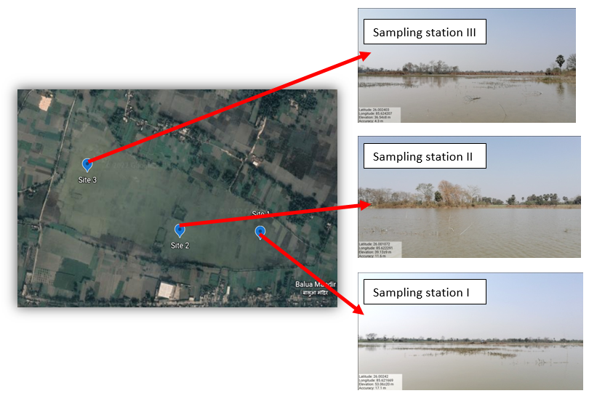

Balua chaur is a natural floodplain wetland situated in border of Muzaffarpur district and located between 26.000801°N, 85.625682°E and 26.003861°N, 85.617673°E. The chaur with total water spread area of 64 acre and water depth ranges from 4 meter to 5 meters. In Balua Chaur three sampling stations were selected based on the significance difference in the ecological and hydrological characteristics.
Table 1. Details of Sampling sites of Balua Chaur, Bihar

Sl. No. | Sampling site | Sampling Location |  | Elevation | Habitat | Description of sampling site
Sl. No. | Sampling site | Latitude | Longitude | Elevation | Habitat | Description of sampling site
1. | Balua site I | 26.002403 ºN | 85.624207 ºE | 36.54±8m | Upper stretches | The bottom is muddy; silt accumulates with weed infested mud flats. The depth is about 5 meters and area 64 acre.
2. | Balua site II | 26.001072 ºN | 85.622291 ºE | 39.13±9 m | Middle stretches
3. | Balua site III | 26.00242 ºN | 85.621669 ºE | 53.06±20 m | Lower stretches

Field sampling and Water Quality Analysis

Monthly sampling was conducted from December 2021 to August 2022 from the selected sampling sites. For water quality analysis, the subsurface water samples were collected to determine the physiochemical water quality of the river. Water quality was recorded using mercury thermometer (±0.1°C accuracy). DO was estimated using Winkler’s methods (APHA 2012), pH was measured using portable handhandle pH meter. Transparency was measured using secchi disc (20 cm diameter). Other water quality parameters including Free Carbondioxide, Alkalinity, Hardness, Nitrite, Ammonia were determined using standard methodology of APHA (2012).

Plankton Collection and Identification

Plankton sample collected using a plankton net of mesh size 10µm from each sampling site, 50 liter of water were filtered and collected the concentrates of 10ml. The collected plankton samples were preserved with Lugol’s solution and then kept in cool and dark room. Quantitative and qualitative estimation were done use Sedgwick rafter cell under microscope with 4x, 10x, and 40x magnification. Phytoplankton were identified using the standard manual/Books referring Ward & Whipple 1992; Cox (1996); Bellinger & Sigee (2010). The observed plankton counts were converted into Organism/liter (Org/L) using the equation given below:

Plankton (org/l)=A×(B/C×1/d)×103

Where,

A- Total number of individuals in observed strips

B- Volume of sample in cell

C- Volume of observed strips

d- Concentration factor

Diversity Indices

Diversity refers to both species richness and evenness in species abundances, which are the two fundamental compositional characteristics of assemblages. Species diversity of the ecosystem was determined using the Past Software (Version 5.1). The species diversity can be expressed through three main key indices which are given below.

Diversity indices

- Shannon-Wiener Index (Shannon-Weaver, 1949)
It is a measure of the average degree of "uncertainty" in predicting to what species an individual chosen at random from a collection of 'S' species and 'N' individual will belong. The average uncertainty increases as the number of species increase and the distribution of individual among the species becomes even.
s
H' = ∑ (p_{i} ln p_{i})
i=1
Where,
H' = Shannon-Wiener index

2.) Richness indices
These indicate the total number of species present in the community
Margalef index (1958)
S – 1
R1 =
In (n)
Where,
R1 = Margalef species richness index
S = total number of species in the sample
n = total number of individual in the sample
p_{i} = Proportion of the individual of the species in the sample
s = total number of the species

3.) Evenness indices
Evenness refers to how the species abundances are distributed among the species. When all the species in the sample are equally abundant, evenness index should be maximum and decreases towards zero as the relative abundance of the species diverge away from the evenness
- Pielou's Evenness index
This is given by Pielou (1975) and is indicated by 'J' and probably the most common evenness index by ecologist.
H'
E1 (J) =
ln (S)
Where,
H' = Shannon-Wiener index
S = Total number of species

Statistical Analysis
Basic fundamental statistical analysis were done with Excel (2013). Diversity analysis were carried out using PAST software (Version 5.1). Descriptive statistics and Pearson correlation was carried out using SPSS (Version 23).
Result and Discussion

Hydrological variables of water.

Table 2. Descriptive statistics of monthly water quality variation of the studied Balua Chaur, Bihar.
Month | Dissolved oxygen (mg/l) | Temp  (ºC) | pH | Trans. (cm) | Free CO₂ (mg/l) | Alkalinity  (mg/l) | Hardness  (mg/l) | Ammonia  (mg/l) | Nitrite  (mg/l)
Month | (Mean±SD) | (Mean±SD) | (Mean±SD) | (Mean±SD) | (Mean±SD) | (Mean±SD) | (Mean±SD) | (Mean±SD) | (Mean±SD)
Dec | 6.26±0.15 | 18±1 | 7.16±0.25 | 27.3±3.05 | 0.46±0.28 | 178.3±3.05 | 163.33±1.52 | 0.004±0.1 | 0.001±0
Jan | 5.5±0.26 | 19±1.15 | 7.43±0.30 | 25.6±1.52 | 0.5±0.2 | 176.3±8.7 | 162.6±2.08 | 0.04±0.05 | 0.017±0.05
Feb | 4.56±0.25 | 19.6±0.57 | 7.36±0.32 | 25.4±2.08 | 0.5±0.1 | 172.8±4.4 | 160±1 | 0.02±0.11 | 0.01±0.0
Mar | 5.6±0.2 | 24±1 | 7.86±0.35 | 24.6±1.52 | 0.6±0.36 | 168±6 | 156.33±2.08 | 0.01±0.46 | 0.01±0
Apr | 5.1±0.2 | 26.3±0.57 | 7.63±0.30 | 26.6±1.5 | 0.6±0.1 | 139.67±6.80 | 131.3±2.08 | 0.02±0.05 | 0.002±0.05
May | 4.33±0.20 | 30.3±1.5 | 8.06±0.40 | 25.3±2.51 | 0.83±0.15 | 139.6±7.6 | 157.3±1 | 0.032±0.12 | 0.002±0.05
Jun | 5.1±0.88 | 28.33±0.57 | 7.6±0.29 | 26±2 | 0.66±0.15 | 137.4±6.7 | 143.3±1.5 | 0.02±0.05 | 0.002±0
Jul | 4.83±0.25 | 27.33±0.57 | 7.7±0.22 | 25.33±1.52 | 0.8±0.3 | 163.6±6.65 | 157±1 | 0±0 | 0±0.05
Aug | 6.03±0.25 | 28±1 | 7.3±0.1 | 26.3±1.5 | 0.56±0.15 | 168±16.4 | 163.3±1.5 | 0±0 | 0±0

Plankton Abundance and Diversity
Plankton descriptive statistics

The plankton community in Balua Chaur was represented by the members of Chlorophyceae, Cyanophyceae, Bacillariopyceae, Euglenophyceae, Rotifer, Cladocera and Copepod. In this chaur 32 genera were identified during the months of investigation period out of which four genera belong to cyanophyceae and three to dinophyceae. In the present study, total 32 genera and 7 classes were identified from both the sampling sites. The 7 classes were Chlorophyceae, Cyanophyceae, Bacillariopyceae, Euglenophyceae, Rotifer, Cladocera and Copepod. The study revealed high abundance of plankton with occurrence of different classes, which showed variation on monthly basis in Balua Chaur. Cymbella genus of class Bacillariophyceae was recorded highest abundance in Balua Chaur. The common plankton observed during study period in both the sampling sites were Oedogonium, Volvox sp., Spirogyra sp., Pediastrum sp., Microspora sp., Bacillaria sp., Navicula sp., Cymbella sp., Nitzschia sp., Brachionus falcatus, Daphnia sp., Moina sp., Dicyclops sp., Pseudodiaptomus annadalei and Leptodiaptomus ashlandii (Jyoti et al. 1990; Huddar 1995; Baruah et al. 1998; Islam Azizul et al. 2001).
Table 3. Seasonal variation of plankton abundance in Balua Chaur, Bihar, India .
Species | Winter |  |  | Summer |  |  | Monsoon
Species | Dec | Jan | Feb | Mar | Apr | May | Jun | July | Aug
Phormidium sp. | + | + | + | + | + | + | + | + | +
Oscillataria sp. | + | + | ++ | + | + | ++ | + | + | +
Microspora sp. | + | + | ++ | ++ | +++ | ++ | + | + | ++
Zygnema sp. | + | + | + | + | + | ++ | ++ | + | +
Volvox sp. | ++ | + | ++ | ++ | +++ | ++ | + | + | +
Spirogyra sp. | ++ | + | +++ | ++ | ++ | + | + | + | +
Scenedesmus sp. | + | + | ++ | +++ | ++ | + | + | + | +
Ulothrix subconstricta sp. | + | + | ++ | ++ | + | ++ | +++ | ++ | +
Gonotozygon sp. | ++ | + | ++ | + | + | + | - | - | -
Odeogonium sp. | + | + | +++ | ++ | ++ | ++ | ++ | ++ | ++
Pediastrum sp. | + | + | + | + | + | ++ | ++ | ++ | ++
Nitzchia sp. | + | + | + | ++++ | ++ | + | + | + | +
Gyrosigma sp. | + | + | + | ++++ | +++ | + | + | + | +
Pinnularia sp. | + | ++ | ++ | +++ | +++ | + | + | + | +
Fragilaria sp. | + | + | + | + | + | + | + | + | +
Petrodyction sp. | + | + | + | + | + | + | + | + | +
Parlibellus sp. | + | + | + | + | + | + | + | + | +
Bacillaria sp. | + | + | - | + | + | + | + | + | +
Closterium sp. | + | + | + | + | + | + | + | + | +
Cymbella sp. | + | ++ | + | +++ | ++ | +++ | ++ | ++ | +
Navicula sp. | + | ++ | +++ | +++ | ++ | +++ | ++ | ++ | +
Euglena sp. | + | + | + | ++ | + | ++ | ++ | ++ | +
Paramecium sp. | + | + | + | + | ++ | + | + | + | +
Platyias sp. | + | + | + | + | ++ | + | + | + | +
Brachionus urceolaris sp. | + | - | + | + | + | + | + | + | +
Brachionus calycifloras sp. | + | + | + | + | + | + | + | + | +
Brachionus plicatlis sp. | + | + | + | + | + | + | + | + | +
Asplanchna sp. | + | - | - | - | + | - | + | + | +
Keratella sp. | + | + | + | + | + | ++ | + | + | +
Brachionus quadridentatus | + | + | + | - | + | + | + | + | +
Brachionus diversiconis | + | + | + | + | + | + | + | + | +
Brachionus falcatus | + | + | + | + | + | ++ | + | + | +
Daphnia sp. | + | + | + | + | + | + | + | + | +
Moina sp. | + | + | + | + | + | + | + | + | +
Dicyclops sp. | + | + | + | ++ | + | + | + | + | +
Pseudodiaptomus annadalei | + | + | + | + | + | + | + | + | +
Leptodiaptomus ashlandii | + | + | + | + | + | + | + | - | -

Phytoplankton Density of Balua Chaur

Phytoplankton from Balua Chaur was observed in the current study between December 2021 to August 2022. They belongs to 23 different genera, including the class Cyanophyceae (2 genera), Euglenophyceae (2 genera), Bacillariophyceae (10 genera), and Chlorophyceae (9 genera). Similar observations were recorded by Laskar & Gupta, (2009), as they recorded Bacillariophyceae as the most dominant group in the in wetland of Barak Valley, Assam.

Zooplankton Density of Balua Chaur

In the current investigation, zooplankton abundance from the Balua Chaur between December 2021 to August 2022 was recorded. They belongs to 16 distinct genera, including Rotifer (9 genera), Cladocera (2 genera), and Copepod (3 genera). Rotifera recorded the highest amongst zooplanktonic groups. Similar observations were found in the study done by D’Ambrosio et al., (2016) in Liancanelo basin wetland where they reported 16 zooplankton taxa, including individuals from the Rotifer, Cladocera, and Copepod.

Fig. 2: Monthly distribution planktonic groups
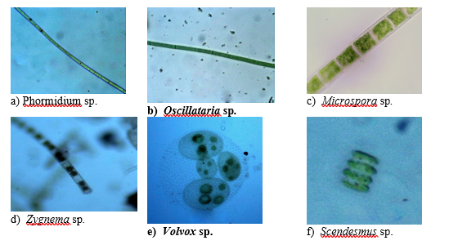
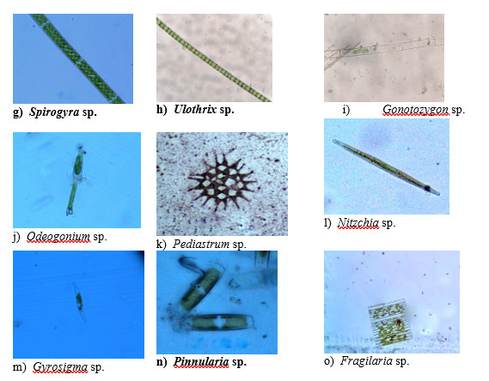
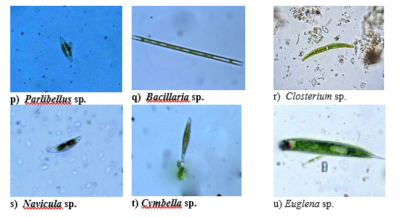
Fig 3. (a to u)Showing the phytoplankton available in Balua chaur, Bihar.
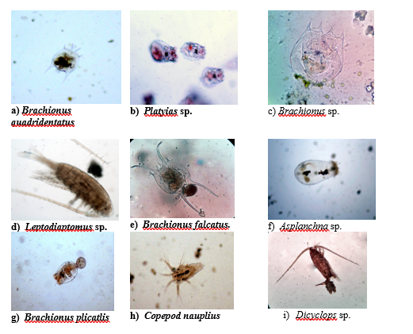

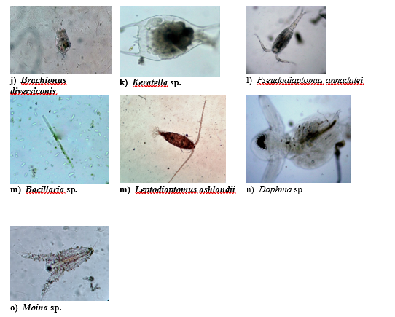
Fig. 4 (a to o): Showing the zooplankton available in Balua chaur, Bihar.

Plankton diversity indices of Balua Chaur
In Balua Chaur the highest Shannon diversity index (H) (Table. was recorded during the February (1.9) indicating the high abundance of phytoplankton as it is observed as a common phenomenon in the water bodies of ganga basin (Sarkar et al., 2025) and the lowest value was observed during the month of December and April (1.66) indicating less abundance of phytoplankton species. But most the studies in the ganga plain often reported the high diversity during monsoon, pre-monson and least during winter season (Lasker and Gupta 2009). Evenness was highest during the January (0.95) indicating the favorable growth of most of the phytoplankton species, similar observation was made by Khanna et al., (2012); Kumari (2022) and lowest during three different months viz., December, May, June and August (0.88). The Margalef richness (d’) was highest during the month of August (5.46) and lowest during the January month (2.88).
Table 4: Diversity indices of the phytoplankton abundance in Balua chaur, Bihar

 | DEC | JAN | FEB | MCH | APL | MAY | JUN | JLY | AUG
Shannon (H) | 1.66 | 1.89 | 1.90 | 1.83 | 1.66 | 1.81 | 1.82 | 1.83 | 1.82
Evenness (j’) | 0.88 | 0.95 | 0.96 | 0.89 | 0.87 | 0.88 | 0.88 | 0.89 | 0.88
Margalef (d) | 4.55 | 2.88 | 3.08 | 3.08 | 3.10 | 3.34 | 3.34 | 3.72 | 5.46
Note: H= Shanon diversity index; J’= evenness index; d= Margalef index.

Relationship between water quality and plankton abundance of Balua Chaur, Bihar
A Pearson’s correlation between water quality and total phytoplankton was estimated to assess their correlation pattern (Table 5). It has been found that planktonic highly correlated with pH (r=0.78 at p>0.01) only, while others were not significant. Similar observation are also observed in other research as by Khatun and Rashidula (2020) observed that there were no significant correlation during the phytoplankton assemblage and physical and chemical characteristics in summer season.
Table 5. Correlation between plankton and physico-chemical parmeters

 | DO | pH | Temp. | NH4 | FCO2 | ALK | NO2 | Hrd. | Tran. | Plankton
DO (mg/l) | 1
pH | -0.622 | 1
Temp. | -0.394 | 0.664 | 1
NH4 | -0.524 | 0.596 | 0.247 | 1
FreeCO₂ | -0.641 | .821** | .821** | 0.377 | 1
Alk | 0.535 | -0.620 | -.779* | -0.474 | -0.639 | 1
NO2 | -0.274 | 0.480 | -0.209 | 0.660 | 0.065 | 0.159 | 1
Hrd | 0.289 | -0.306 | -0.405 | -0.556 | -0.224 | .776* | -0.009 | 1
Trans. | 0.526 | -.668* | -0.214 | -0.472 | -0.436 | 0.011 | -.693* | -0.169 | 1
Plankton | -0.648 | .780** | 0.341 | 0.634 | 0.394 | -0.548 | 0.603 | -0.510 | -0.624 | 1
**. Correlation is significant at the 0.01 level (2-tailed).
*. Correlation is significant at the 0.05 level (2-tailed).
DO= Dissolved oxygen

Conclusions
The study shows that Balua Chaur wetland supports a diverse planktonic assemblage consisting of phytoplankton and zooplankton groups. Seven major plankton groups were recorded, including Cyanophyceae, Chlorophyceae, Bacillariophyceae, Euglenophyceae, Rotifera, Cladocera, and Copepoda. Bacillariophyceae and Chlorophyceae formed important components of the phytoplankton community, while Rotifera was the dominant zooplankton group. Monthly variation in plankton abundance and diversity indices indicates that the plankton community is influenced by seasonal and environmental changes. The recorded Shannon diversity, evenness, and Margalef richness values suggest moderate plankton diversity in the wetland during the study period. Among the measured physicochemical parameters, pH showed a significant positive correlation with plankton abundance, whereas other parameters did not show significant relationships. Overall, the findings provide useful baseline information on plankton diversity and water quality of Balua Chaur. Regular monitoring of plankton communities and water-quality parameters is recommended to support wetland conservation and fisheries-resource management.

Limitations
The study was limited to monthly observations from December 2021 to August 2022 and may not fully represent long-term seasonal or annual variation in plankton diversity. Sampling was restricted to three stations within a single wetland. The study did not provide detailed station-wise plankton abundance, complete species-level identification, or full ANOVA and Water Quality Index outputs. Some plankton were identified only up to genus level, and molecular confirmation was not performed. Future studies should include longer monitoring, detailed species-level taxonomy, stronger statistical reporting, and assessment of additional ecological factors such as nutrients, chlorophyll, sediment quality, and fish-plankton interactions.

Declaration of AI Use

This manuscript was prepared through the combined contributions of all author(s), including contributions to the study design, data, content development, results, interpretation, and related scholarly work. The author(s) acknowledge the use of Grammarly and ChatGPT to assist with grammar checking, language refinement, reference formatting. These AI-assisted tools were not used as authors and did not replace the intellectual contributions or scholarly judgment of the author(s). All AI-assisted outputs, including content, references, and interpretations, were carefully reviewed, revised, verified, and approved by the author(s). The author(s) accept full responsibility for the accuracy, integrity, and final content of the manuscript.

COMPETING INTERESTS DISCLAIMER:
Authors have declared that they have no known competing financial interests OR non-financial interests OR personal relationships that could have appeared to influence the work reported in this paper.

References

APHA AWWA, W. E. F. (2005). Standard methods for the examination of water and wastewater. APHA WEF AWWA.
Banner, A., & MacKenzie, W. (2000). The ecology of wetland ecosystems. The ecology of wetland ecosystems., (45).
Belcher, H., & Swale, E. (1976). A beginner's guide to freshwater algae. HMSO, 3-43.
Bellinger EG, Sigee DC. Freshwater algae: Identification and use as bioindicators. J Appl Phycol. 2010;25(4):1265–6. https://doi.org/10.
Bellinger, E. G., & Sigee, D. C. (2015). Freshwater algae: identification, enumeration and use as bioindicators. John Wiley & Sons, 1-240.
Bidyasagar, S., Ringjonmeilu, K., Haobam, E. et al. Spatio-temporal dynamics of phytoplankton community and their relationship with water quality in a sub-tropical young reservoir of Northeast India. Discov Appl Sci 7, 1193 (2025). https://doi.org/10.1007/s42452-025-07130-x
Cox EJ. Identification of freshwater diatoms from live material. Chapman and Hall Publisher. California; 1996. p.158. https://doi.org/10.
D’Ambrosio, D. S., Claps, M. C., & García, A. (2016). Zooplankton diversity of a protected and vulnerable wetland system in southern South America (Llancanelo area, Argentina). International Aquatic Research, 8(1), 65–80.
Das, B., Chandra, G., Kumari, S., Meena, D., Koushlesh, S., Baitha, R., & Trivedi, R. (2019). Roadmap for Fisheries Development in Mauns and Chaurs of Bihar.
Datta, T. (2011). Zooplankton diversity and physicochemical conditions of two wetlands of Jalpaiguri district, India. International Journal of Applied Biology and Pharmaceutical Technology, 2(3), 576–583.
Dutta, A., Kar, S., Das, P., Das, U., Das, S., & Kar, D. (2017). Studies on physico-chemical aspects and zooplankton diversity of a freshwater wetland in Cachar, Assam. Int J Sci Environ Technol, 6(3), 1877-1885.
Hernandez, M. E., & Mitsch, W. J. (2007). Denitrification in created riverine wetlands: Influence of hydrology and season. Ecological Engineering, 30(1), 78-88.
Hilton, J., O’Hare, M., Bowes, M. J., & Jones, J. I. (2006). How green is my river? A new paradigm of eutrophication in rivers. Science of The Total Environment, 365(1), 66–83. https://doi.org/10.1016/j.scitotenv.2006.02.055
Jyothi, B., Sudhakar, G., & Venkateswarlu, V. (1990). Ecological evaluation of chlorococcalean blooms-A comparative account.
Khanna, D.R., Bhutiani, Rakesh, Matta, Gagan, Singh, Vikas and Bhadauriya, Gaurav: Study of planktonic diversity of river Ganga from Devprayag to Roorkee, Uttarakhand (India), Environment conservation journal 2012, 13(182):211-217.
Khatun, M., & Rashidul, A. A. (2020). Phytoplankton assemblage with relation to water quality in Turag River of Bangladesh.
Kumari, D. (2022). STUDIES ON THE ABUNDANCE, SPECIES DIVERSITY AND SPECIES EVENNESS OF PHYTOPLANKTON TO ASSESS THE WATER QUALITY OF RIVER GANGA AT CHAPRA, BIHAR.
Laskar, H. S., & Gupta, S. (2009). Phytoplankton diversity and dynamics of Chatla floodplain lake, Barak Valley, Assam, North East India-A seasonal study. Journal of Environmental Biology, 30(6), 1007–1012.
Lind, O. T. (1979). Handbook of common methods in limnology. The CV Mosley Company.
Malik, D. S., & Bharti, U. (2012). Status of plankton diversity and biological productivity of Sahastradhara stream at Uttarakhand, India. Journal of Applied and Natural Science, 4(1), 96.
Needham, J.G and Needham, P.K. (1962). A guide to the study of fresh water biology. Holders – day, Inc. San Fransisco.
Palit, D., & Mukherjee, A. (2012). Studies on water quality and macrophyte composition in wetlands of Bankura district, West Bengal, India. Indian Journal of Plant Science, 1(2-3), 97-115.
Pielou E.C. 1975. Ecological diversity. New York: Wiley Interscience.
Rameshkumar, S., Radhakrishnan, K., Aanand, S., & Rajaram, R. (2019). Influence of physicochemical water quality on aquatic macrophyte diversity in seasonal wetlands. Applied Water Science, 9(1), 1-8.
Sarkar, U. K., Mishal, P., Borah, S., Karnatak, G., Chandra, G., Kumari, S., … Das, B. K. (2021). Status, Potential, Prospects, and Issues of Floodplain Wetland Fisheries in India: Synthesis and Review for Sustainable Management. Reviews in Fisheries Science & Aquaculture, 29(1), 1–32.
Shannon, C.E., Weaver, W., 1963. The Mathematical Theory of Communication. TheUniversity of Illinois Press, Illinois.
Ward HB, Whipple GC. Fresh water biology. In: Edmondson, WT (Ed.), Second Ed. John Willey and Sons. Inc. New York. 1992.
Welch, P. S. (1948). Limnological methodsß Mc-Graw-Hill Book Co. Inc., New York, 381.
Wetzel, R. G. (2001). Limnology: lake and river ecosystems. Gulf professional publishing.

