Original Research Article

Prevalence of Escherichia coli-H7 in diarrhoeic cattle from Jaipur Region, Rajasthan

ABSTACT
Shiga toxin-producing Escherichia coli (STEC), particularly serotype O157:H7, is an important food-borne pathogen associated with severe gastrointestinal disease in humans and animals. The present study was undertaken to investigate the occurrence of E. coli O157:H7 among diarrhoeic cattle in and around Jaipur, Rajasthan. A total of 100 diarrhoeic faecal samples were collected and processed for isolation and identification of E. coli using conventional bacteriological techniques. Of the 100 samples examined, 82 E. coli isolates were recovered and confirmed based on cultural characteristics on MacConkey agar and Eosin Methylene Blue (EMB) agar. All isolates were screened on Sorbitol MacConkey (SMAC) agar for presumptive detection of E. coli O157:H7. None of the isolates exhibited the characteristic sorbitol non-fermenting phenotype associated with O157:H7. Molecular confirmation was performed by PCR targeting the rfbO157 and fliCH7 genes. All 77 isolates were negative for the rfbO157 gene, whereas six isolates (7.31%) yielded the expected 625 bp amplicon specific for the fliCH7 gene. The findings indicate the absence of E. coli O157 among the studied cattle population, although a small proportion of isolates possessed the H7 flagellar antigen gene. These results suggest that diarrhoeic cattle in the study area may harbour non-O157 E. coli strains carrying H7-associated genetic markers and highlight the importance of molecular surveillance for accurate characterization of potentially pathogenic E. coli.
Keywords: Escherichia coli, STEC, O157:H7, diarrhoeic cattle, rfbO157, fliCH7
Introduction
Shiga toxin-producing Escherichia coli (STEC) constitutes an important group of food-borne pathogens capable of causing disease in both humans and animals. Among the diarrhoeagenic E. coli pathotypes, STEC is of particular public health significance because of its zoonotic potential and its association with severe gastrointestinal disorders in humans (Fadel et al., 2017). Although numerous STEC serotypes have been identified, serotype E. coli O157:H7 remains the most frequently implicated in outbreaks and severe clinical cases worldwide (Mead and Griffin, 1998).
The World Health Organization has recognized E. coli O157 together with six additional STEC serogroups (O26, O45, O103, O104, O111 and O145) as the major serotypes associated with human infections globally (Panel et al., 2020). The organism gained prominence as a human pathogen following outbreaks of haemorrhagic colitis in the United States linked to the consumption of contaminated undercooked beef products (Riley et al., 1983). Since then, STEC infections have emerged as an important public health concern due to their ability to cause illnesses ranging from mild diarrhoea to haemorrhagic colitis, haemolytic uraemic syndrome (HUS) and thrombotic thrombocytopenic purpura (TTP) (Excler et al., 2021).
Cattle are considered the principal reservoir of STEC and may harbour the organism asymptomatically in their intestinal tract, thereby facilitating contamination of food products and the environment (Mishra et al., 2016). The prevalence of STEC in cattle faeces has been reported to be particularly high in young animals and diarrhoeic calves (Islam et al., 2014). Transmission to humans occurs primarily through the consumption of contaminated meat and milk products or through contact with contaminated faecal material (WHO, 2018). Certain population groups, including children, elderly individuals and immunocompromised persons, are especially susceptible to severe complications such as HUS (Kiranmayi et al., 2010).
Information regarding the occurrence of E. coli O157 in cattle from different geographical regions of India remains limited. Therefore, the present study was undertaken to investigate the prevalence of E. coli O157 among diarrhoeic cattle in and around Jaipur, Rajasthan, using conventional bacteriological methods and polymerase chain reaction (PCR)-based detection of the rfbO157 and fliCH7 genes for molecular characterization.
Material and methods
A total of 100 diarrhoeic cattle (irrespective of age, sex and breed) were screened from various locations in and around Jaipur from November 2025 to April 2026. Samples of faeces were collected using sterile faecal swabs (Hi-media, India), which were then carefully transferred to the laboratory to isolate E. coli.
The isolation and identification of E. coli were carried out as per Ewing(1986) and Quinn et al. (2005) with minor modifications. A loopful of enriched inoculum from nutrient broth was streaked on MacConkey agar medium. After 24 h incubation, colonies showing bright pink to red colonies were picked up and streaked on streaked on eosin methylene blue (EMB) agar plates and incubated at 37°C for 24 h.
The purified culture of E. coli was streaked on SMAC plates for detection of O157:H7 serotype. After streaking, the plates were incubated at 37℃ for 24 h and were examined for sorbitol fermentation and fluorescence under UV light. The typical sorbitol negative (Sorbitol non-fermenting colourless) colonies indicate positive for E. coli O157:H7. The sorbitol negative colonies of E. coli O157:H7 appeared small, circular and colourless with a smoky centre measuring 1-2 mm in diameter. Sorbitol positive (Sorbitol fermenting pink-coloured) colonies indicate negative for E. coli O157:H7.
Molecular identification by PCR
Molecular confirmation of Escherichia coli O157:H7 was performed using species-specific primers targeting the rfbO157 and fliCH7 genes by polymerase chain reaction (PCR), according to Maurer et al. (1999) and Seker and Kus (2019). PCR mixture (10µl total volume) comprised 2.0µl of genomic DNA template, 1.0µl of dNTP mix, "1.0µl of 10×PCR buffer, 1.0µl of each primer, 0.4µl of Taq DNA polymerase, along with 4.6µl of nuclease-free water. Positive Control used were precured from himedia (MBT 102).
Table 1: Thermal cycling profile for E coli 0157: H7 Genes
Name of primer | Specific genomic region | Primer sequence | Size of amplicon
rfbO157 | E. coli 0157 | F: CGTGATGATGTTGAGTTG  R: AGATTGGTTGGCATTACTG | 420 bp
flicH7 | E. coli H 7 | F: GCGCTGTCGAGTTCTATCGAGC  R:CCACGGTGACTTTATCGCCATTCC | 625 bp

The PCR amplification for molecular confirmation of Escherichia coli O157:H7 was performed under specific cycling conditions for each target gene. For amplification of the rfbO157 gene, the reaction was initiated with an initial denaturation step at 94°C for 1 min, followed by 35 cycles consisting of denaturation at 94°C for 1 min, annealing at 51°C for 1 min, and extension at 72°C for 1 min. A final extension step was carried out at 72°C for 7 min. For amplification of the fliCH7 gene, PCR was initiated with an initial denaturation at 94°C for 1 min, followed by 35 cycles of denaturation at 94°C for 1 min, annealing at 59°C for 1 min 30 sec, and extension at 72°C for 1 min, followed by a final extension at 72°C for 10 min.
The PCR products (for species-specific) were subjected to electrophoresis at 100 V/cm for 1hour in 1.5% agarose gel prepared in 1x TAE buffer containing 4µl/100ml of ethidium bromide. The PCR products (5 µl) were run along with a 100 bp DNA ladder (Hi-Media) and amplicons were visualized under gel documentation system (VILBER, Fusion Solo S).
Result
A total of 82 E. coli isolates were isolated from 100 diarrheic faecal samples on Mac conkey then EMB agar. All the studied isolates were inoculated on selective isolation medium SMAC and incubated for 24 h at 37°C for screening of O157:H7serotype of E. coli. In this study, none of the isolates showed sorbitol non-fermenting colourless colonies on SMAC medium. The results are in accordance with Bist et al. (2023) who did not find E. coli O157:H7 in 216 faecal samples on CT- SMAC medium.
PCR assay for the detection of rfbO157gene in E. coli was standardized as per Maurer et al.,1999 with slight modification, which gave a specific amplification of 420 bp product and FlicH7gene in E. coli was standardized as per Seker and Kus 2019 with slight modification, which gave a specific amplification of 625 bp product. E. coli O157 among all 77 isolates, all samples tested negative. all the isolates did not show any amplification for rfb0157 gene except the positive control. The positive control produced the expected amplicon of 420 bp for the rfbO157 gene, as shown in Figure 1. Furthermore, a total of six isolates were found to be positive for the fliCH7 gene, yielding the expected amplicon size of 625 bp, as shown in Figure 2.

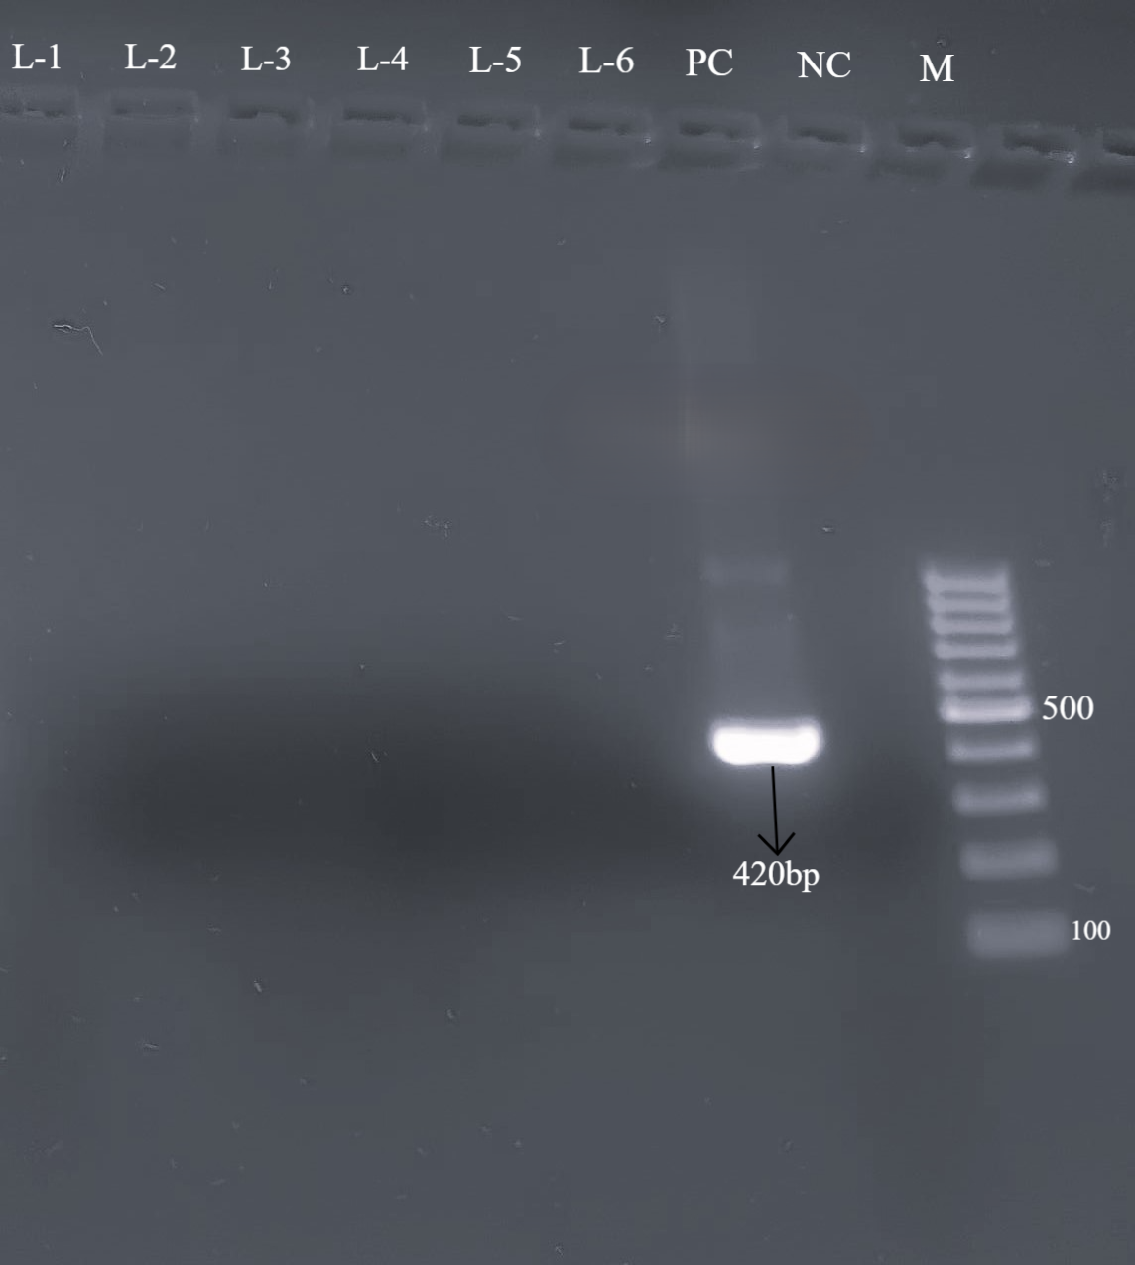
Figure-1 Agarose gel showing PCR amplified product (420bp) for rfbO157gene in positive control, and NC= negative control and M=100bp DNA ladder
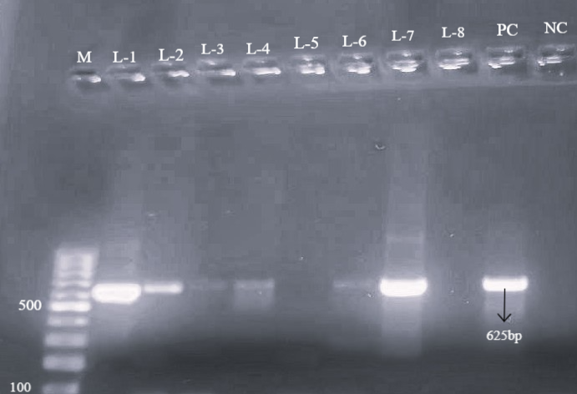
Figure- 2 Agarose gel showing PCR amplified product (420bp) for flic H7gene In PC= positive control, and NC= negative control and M=100bp DNA ladder
Discussion
In the present investigation, 82 E. coli isolates were recovered from 100 diarrhoeic cattle faecal samples, indicating a substantial occurrence of E. coli among diarrhoeic animals. The isolates were initially screened on Sorbitol MacConkey agar for the detection of E. coli O157:H7. None of the isolates produced characteristic sorbitol non-fermenting colonies, suggesting the absence of presumptive O157:H7 strains in the examined samples. Similar findings have been reported by Bist et al. (2023), who failed to detect E. coli O157:H7 among cattle faecal samples using CT-SMAC medium. The absence of O157:H7 in the present study may reflect geographical variation, differences in management practices, environmental conditions, or the predominance of non-O157 STEC serogroups in cattle populations.
To further confirm the presence of E. coli O157:H7, PCR assays targeting the rfbO157 and fliCH7 genes were employed. The rfbO157 gene is a specific marker for the O157 somatic antigen and is widely used for molecular identification of E. coli O157 strains. None of the 82 isolates yielded amplification of the rfbO157 gene, while the positive control produced the expected 420 bp amplicon, confirming the reliability of the assay. These findings corroborate the cultural screening results and indicate the absence of E. coli O157 among the isolates examined.
Interestingly, six isolates generated the expected 625 bp amplicon corresponding to the fliCH7 gene. The fliCH7 gene encodes the H7 flagellar antigen and is commonly associated with E. coli O157:H7; however, its presence alone is insufficient for confirming the O157:H7 serotype. The occurrence of fliCH7-positive but rfbO157-negative isolates suggests the circulation of non-O157 Escherichia coli strains carrying the H7 flagellar antigen. Comparable findings were reported by Shinde et al. (2020), who documented a prevalence of 27.61% for E. coli H7 in Pune, India. Similarly, Bonardi et al. (2015) and Srivani et al. (2022) reported a higher prevalence of E. coli H7 among adult and diarrhoeic bovines, respectively
The detection of fliCH7-positive isolates highlights the genetic diversity of E. coli circulating in cattle and emphasizes that reliance solely on phenotypic screening methods may not reveal all potentially important strains. Although none of the isolates were confirmed as E. coli O157:H7, the identification of H7-associated isolates warrants further characterization through virulence gene profiling and serotyping to assess their pathogenic potential and epidemiological significance.
Overall, the findings indicate that E. coli O157:H7 was not prevalent among diarrhoeic cattle sampled in the Jaipur region during the study period. Nevertheless, the presence of fliCH7-positive isolates demonstrates the circulation of genetically diverse E. coli populations and underlines the importance of integrating molecular methods with conventional bacteriological techniques for comprehensive surveillance.
Conclusion
The study showed that E. coli was frequently isolated from diarrhoeic cattle faecal samples collected in and around Jaipur. However, cultural screening on Sorbitol MacConkey agar and PCR targeting the rfbO157 gene did not detect E. coli O157 among the tested isolates. Six isolates were positive for the fliCH7 gene, suggesting the presence of H7-bearing non-O157 E. coli strains in the sampled cattle population. These findings indicate that E. coli O157 was not prevalent among the diarrhoeic cattle examined during the study period, but genetically diverse non-O157 E. coli may be circulating in the region. Because the presence of the fliCH7 gene alone does not confirm the O157 serotype or pathogenicity, further testing is required. Future studies should include serotyping, virulence gene detection, antimicrobial susceptibility testing, and wider epidemiological sampling to assess the zoonotic significance of these isolates.
Limitations
This study was limited to 100 diarrhoeic cattle faecal samples from a restricted geographical area around Jaipur, which limits wider generalization. The study focused only on rfbO157 and fliCH7 genes and did not include important virulence genes such as stx1, stx2 and eae. Serological confirmation, sequencing, antimicrobial resistance profiling and extended molecular typing were not performed. The sampling design did not include detailed analysis by age, breed, sex, farm management, season or location. Therefore, the findings should be interpreted as preliminary surveillance data requiring confirmation through larger and more comprehensive studies.

Declaration of AI Use

This manuscript was prepared through the combined contributions of all author(s), including contributions to the study design, data, content development, results, interpretation, and related scholarly work. The author(s) acknowledge the use of Grammarly and ChatGPT to assist with grammar checking, language refinement, reference formatting. These AI-assisted tools were not used as authors and did not replace the intellectual contributions or scholarly judgment of the author(s). All AI-assisted outputs, including content, references, and interpretations, were carefully reviewed, revised, verified, and approved by the author(s). The author(s) accept full responsibility for the accuracy, integrity, and final content of the manuscript.
.
COMPETING INTERESTS DISCLAIMER:
Authors have declared that they have no known competing financial interests OR non-financial interests OR personal relationships that could have appeared to influence the work reported in this paper.
References
Bist, P. B., Sharma, B., Kumar, A., Singh, S., Jain, U., Goswami, M., Mishra, R. P. and Basak, G. (2023). Seasonal effect on the prevalence of virulence genes of non-O157 Verotoxic E. coli serogroups in faeces of cattle calves. The Indian Journal of Animal Sciences, 93(11): 1046-1052.
Bonardi, S., Alpigiani, E., Tozzoli, A., Lucchi, G., Settanni, G., Morabito, P., & Caprioli, A. (2015). Shiga toxin-producing Escherichia coli O157, O26 and O111 in cattle faeces and hides in Italy. Veterinary Record Open, 2, e000061.
Ewing, W. H. (1986) Edwards and Ewing's Identification of Enterobacteriaceae, 4th edition Elsevier, New York.
Excler, J. L., Saville, M., Berkley, S. and Kim, J. H. (2021). Vaccine development for emerging infectious diseases. Nature Medicine, 27(4):591-600.
Fadel, H. M., Afifi, R. and Al-Qabili, D. M. (2017). Characterization and zoonotic impact of Shiga toxin producing Escherichia coli in some wild bird species. Veterinary World, 10(9): 1118.
Islam, M. Z., Musekiwa, A., Islam, K., Ahmed, S., Chowdhury, S., Ahad, A. and Biswas, P. K. (2014). Regional variation in the prevalence of E. coli O157 in cattle: A Meta-Analysis and Meta-Regression. 9(4): 93299.
Kiranmayi, C. B., Krishnaiah, N. and Mallika, E. N. (2010). Escherichia coli O157: H7-an emerging pathogen in foods of animal origin. Veterinary World, 3(8): 382-389.
Manna, S.K., Brahmane, M.P., Manna, C., Batabyal, K., & Das, R. (2006). Occurrence, virulence characteristics and antimicrobial resistance of Escherichia coli O157 in slaughtered cattle and diarrhoeic calves in West Bengal, India. Letters in Applied Microbiology, 43(4), 405-409.
Maurer, J.J., Schmidt, D., Petrosco, P., Sanchez, S., Bolton, L. and Lee, M.D., (1999). Development of primers to O-antigen biosynthesis genes for specific detection of Escherichia coli O157 by PCR. Applied and Environmental Microbiology 65(7): 2954 - 2960.
Mead, P. S. and Griffin, P. M. (1998). Escherichia coli O157: H7. The Lancet, 352(9135): 1207-1212.
Mishra, R. P., Jain, U., Bist, B., Verma, A. K. and Kumar, A. (2016). Prevalence of vero toxic Escherichia coli in fecal samples of domestic as well as wild ruminants in Mathura districts and Kanpur zoo. Veterinary World, 9(1): 71-74.
Panel, E. B., Koutsoumanis, K., Allende, A., Alvarez-Ordónez, A., Bover-Cid, S., Chemaly, M., Davies, R., De Cesare, A., Herman, L. and Bolton, D. (2020). Pathogenicity assessment of Shiga toxin‐producing Escherichia coli (STEC) and the public health risk posed by contamination of food with STEC. EFSA Journal, 18(1): 5967.
Quinn, P. J., Carter, M. E., Markey, B., Carter, R.G., Clinical Veterinary Microbiology, 7th edition, (Elsevier Health Science Ltd., Philadelphia), 2005.
Riley, L. W., Remis, R. S., Helgerson, S. D., McGee, H. B., Wells, J. G., Davis, B. R., Hebert, R. J., Olcott, E. S., Johnson, L. M., Harett, N, T., Blake, P. A. and Cohen, M. L. (1983). Hemorrhagic colitis associated with a rare Escherichia coli serotype. New England Journal of Medicine, 308(12): 681-685.
Seker, E. and Kus, F. S. (2019). The prevalence, virulence factors and antibiotic resistance of Escherichia coli O157 in faeces of adult ruminants 19 slaughtered in three provinces of Turkey. Veterinarski Arhiv, 89(1): 107- 121.
Shinde, D.B., Singhvi, S., Koratkar, S.S., & Saroj, S.D. (2020). Isolation and characterization of Escherichia coli serotype O157:H7 and other verotoxin-producing E. coli in healthy Indian cattle. Veterinary World, 13(10), 2269-2274.
Shinde, D.B., Singhvi, S., Koratkar, S.S., & Saroj, S.D. (2020). Isolation and characterization of Escherichia coli serotype O157:H7 and other verotoxin-producing E. coli in healthy Indian cattle. Veterinary World, 13(10), 2269-2274.
Srivani, M., Reddy, Y.N., Subramanyam, K.V., & Lakshman, M. (2022). Association Between Virulence Genes and Serogroups of Escherichia coli Isolates from Calves. Journal of Animal Research, 12(03), 439-446.
World Health Organisation (2018) https://www.who.int › Newsroom › Fact sheets › Detai

