Original Research Article

Assessment of species diversity and assemblage patterns of mudskippers (Gobiidae: Oxudercinae) in the coastal region of Purba Medinipur, West Bengal, India

ABSTRACT
Aims: Present study looks at the species composition, ecological traits, and temporal variation of mudskippers
Study design: Study was designed to investigate the species diversity and assemblage pattern by field survey. After collection of samples form fields samples were taken into laboratory of Dept. of Fisheries Science, Ramnagar College, for further study.
Place and duration of the study: Present study was conducted in the coastal areas of Purba Medinipur for a five month period (August-December, 2025).
Methodology: Samples were collected on weekly basis for five months. The samples were taken under live conditions and stored in the perforated plastic jars to d to ensure the normal breathing process of the collected species. The collected samples were promptly then taken to the laboratory to study further.
Results: Five mudskipper species, namely- Pseudapocryptes elongatus, Periophthalmus novemradiatus, Periophthalmus variabilis, Periophthalmus waltoni and Apocryptes bato were identified in the study region, indicating a moderate level of species diversity. Significant temporal variations in species distribution were found by analyzing weekly occurrence data, which were impacted by environmental elements as temperature, salinity, tidal cycles and habitat conditions. Assessment of conservation status revealed that the majority of species are classified as Least Concern (LC), indicating rather stable populations. Periophthalmus novemradiatus however, is categorized as Data Deficient (DD), emphasizing the need for additional study to evaluate its population status and conservation needs. The Shannon index (H’) peaked in September, indicating modest species richness, according to diversity indexes. Low species dominance was suggested by Simpson’s index (1-D), whilst a relatively uniform distribution of species was indicated by evenness (J’) values near 1 in the majority of the months.
Conclusion: Periophthalmus variabilis and Apocryptes bato exhibited comparatively higher and more consistent occurrence among the five observed species, on the other hand, showed erratic distribution patterns that would indicate habitat specialization or sensitive to environmental changes. Furthermore, none of the identified species are harmful to humans, highlighting their ecological importance in preserving the stability and health of coastal and estuarine ecosystems.
Keywords: Coastal Purba Medinipur, Diversity indexes, Mudskippers, Species diversity and temporal variation

1. INTRODUCTION
The most common resident intertidal fish is probably the mudskipper. Mudskippers are the fish commonly found swimming in the mudflats of creeks, estuaries and coastal waters when they are uncovered by low tide¹. Mudskippers are amphibious, euryhaline, burrowing and crawling fish, which dwell in open mudflats, coastal waters and mangroves². Mudskippers were commonest during the post-monsoon season along the southeast coast of India and their habitats of choice are the mangrove and estuarine areas. Eight Malay Peninsula and twelve Sumatran species are found in the Straits of Malacca³. It is known that mudskippers live in burrows and favour the marshy arears, estuaries and intertidal zones⁴. The distribution pattern, species variety, behavioural patterns and locomotion activities of mudskippers have been studied by researchers for a long time. Research on the morphological traits of mudskippers allowed for their taxonomic classification. Additionally, the relationships between Oxudericnae gobies and other groups and genera⁴. Mudskippers consume varieties of food such as insects, small crustaceans, sand worms and mud. In addition to mud and sand particles, mudskippers typically consume algae, detritus, diatoms, nematodes, polychaetes and fish egg⁵.

Their bulging eyes are adapted to the sharp eye view in the air that their underwater vision is weak. It has water filled up beneath the eyes that has formed because of the skin folds. To moisten the eyes in case of dehydration by exposure to air, the eyes can be retracted into these cups. Their skin and gill chambers are structurally modified so that they can breathe in and out of the water. They move on the mud in search of their food. This fish on mud flats is the prey of migrating birds which are their major predators⁶. Mudskippers are so called because they can walk, climb and skip around on land and in water. Mudspringer or mudskipper habitats normally the estuary area that is the portion of sea, shallow sea and sub tidal area of sea tidal areas. Moreover, in addition of mudskipper is highly dependent on the availability of mangrove forests and occupies a niche as a primary and secondary consumer in the food chain in the coastal ecosystem⁷⁻⁹. The length weight relationship and condition factors of Periophthalmus novemradiatus was studied in this coastal area of Purba Medinipur¹⁰. Distributional record of Indian mudskippers is rare and therefore the current study was done to study species diversity and assemblage of mudskippers in the mudflat habitats of four major coastal areas of the southern parts of West Bengal, namely- Digha Mohana, Sankarpur, Junput Sea Beach and Patuaghat.

2. MATERIALS AND METHODS
2.1. STUDY AREA
Present investigation was conducted in the coastal regions of Purba Medinipur, West Bengal. The selected sampling sites were – Digha Mohana (21°38′18″N 87°30′35″E); Sankarpur (21.6491° N, 87.5699° E); Junput Sea Beach (21.7129° N, 87.8208° E) and Patuaghat (21.79472°N, 87.88333°E).
2.2. SAMPLE COLLECTION
The samples were collected from the mudflat coastal areas of Purba Medinipur such as Digha Mohana, Sankarpur, Junput Sea Beach and Patuaghat. The plankton collection net and the hand were used to collect samples. The number of samples of mudskippers gathered in the survey period was five. Fishes (mudskippers) have been identified by^{4,11-12} and fishbase¹³.

2.3. STUDY PERIOD:
The current research work has been carried out in between the first week of August, 2025 and December, 2025. Samples were collected on weekly basis for five months. The samples were taken under live conditions and stored in the plastic jar to be studied further. In the collection of the samples, the perforated lid or cap of a plastic jar was utilized to ensure the normal breathing process of the collected species. The collected samples were promptly put in to the plastic jar and then taken to the laboratory to study further. The mobile camera (Model No. Oppo- CPH2179) was used to take photographs.

2.4. DIVERSITY INDICES:
2.4.1. Simpson index: Biodiversity was assessed using the Simpson index, which estimates the probability that two individuals randomly selected from a sample belong to different species. . S i=1 λ=∑ ni(ni-1) N(N−1) Here, “λ= Simpson index” “𝑛𝑖= Number of individuals in the ‘𝑖𝑡ℎ’ species” 20 21 “N = total number of individuals” “S = total number of species”
2.4.2. Shannon index: Species diversity was calculated using the Shannon index, which combines the number of species with in a site with the relative abundance of each species¹⁴⁻¹⁵. H’ = - Σ pi ln pi Here, pi is the proportion of the i^{th} species in the total sample. The number of species (species richness) in the community and their evenness in abundance (or equitability) are the two parameters that define H’.
2.4.3.Pielou’s Evenness index (Equitability) or J’: The species evenness is the relative abundance or proportion of individuals among the species. Evenness of species reveals how their relative abundance is distributed in a particular sample or site¹⁵⁻¹⁶. J’ =H’/ ln S Here, S is the number of species present in the site. The value of J’ ranges from 0 to 1. The less variation in communities between the species, the higher the value of J’.
2.4.4.Richness Index: Richness index has been used as Margalef’s Index (R). This index designates the number of species in a sample or the abundance of the species per unit area. R = S – 1 / ln (N) Here; R = Margalef richness Index, S = Total of species, N = Total of individuals sampled.
2.4.5.Data analysis: The statistical analysis was done through Ms-Excel and Past software.
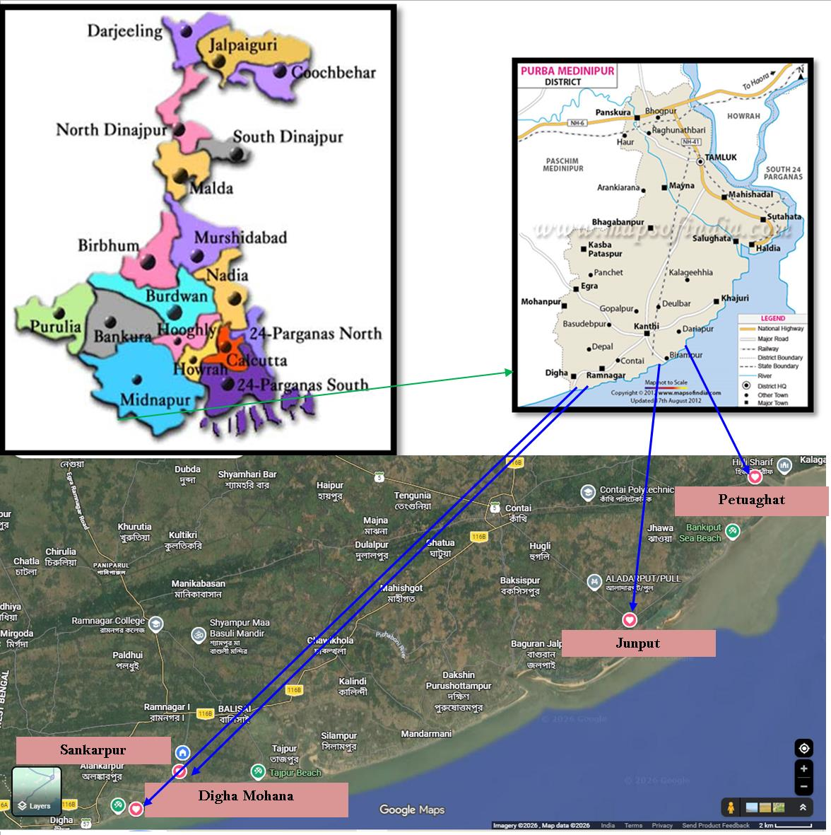
Plate 1: Satellite view of the study are
RESULTS AND DISCUSSIONS:
Table 1: Diversity and assemblage patterns of recorded mudskippers:
Sl.  No. | Order Name | Family Name | Scientific Name | August |  |  |  | September |  |  |  | October |  |  |  | November |  |  |  | December
 |  |  |  | 1st week | 2nd Week | 3rd Week | 4thWeek | 1st week | 2nd Week | 3rd Week | 4thWeek | 1st week | 2nd Week | 3rd Week | 4thWeek | 1st week | 2nd Week | 3rd Week | 4thWeek | 1st week | 2nd Week | 3rd Week | 4thWeek
 |  |  |  | S1 | S2 | S3 | S4 | S1 | S2 | S3 | S4 | S1 | S2 | S3 | S4 | S1 | S2 | S3 | S4 | S1 | S2 | S3 | S4
1. | Gobiiformes | Oxudercidae | Pseudapocryptes  elongatus | - | - | ++ | + | - | - | + | + | + | - | - | ++ | - | + | - | - | + | - | - | +
1. | Gobiiformes | Oxudercidae | Periophthalmus  novemradiatus | - | - | - | - | - | - | ++ | - | - | - | + | - | - | - | - | - | - | + | - | -
1. | Gobiiformes | Oxudercidae | Periophthalmus  variabilis | + | + | +++ | - | - | + | ++ | - | - | - | + | - | + | - | +++ | - | - | - | ++ | +
1. | Gobiiformes | Oxudercidae | Periophthalmus  waltoni | - | - | + | - | - | - | - | ++ | - | + | - | - | - | - | - | + | - | ++ | - | -
1. | Gobiiformes | Oxudercidae | Apocryptes bato | + | ++ | +++ | + | - | + | ++ | - | + | - | + | + | - | + | ++ | + | + | - | +++ | -
(S1= Digha Mohana; S2= Sankarpur; S3= Junput Sea Beach; S4= Petuaghat)
Table 1 presents the distribution and occurrence patterns of selected fish species namely Pseudapocryptes elongatus, Periophthalmus novemradiatus, Periophthalmus variabilis, Periophthalmus waltoni and Apocryptes bato. Belonging to the family Oxudercidae over a five months period (August to December). The data is organized by weeks within each month (1st to 4th week), indicating the presence (+) or absence (-) of each species during specific sampling periods. The table includes taxonomic details such as order name, family name, and scientific names of the species. It helps in understanding seasonal variation, temporal abundance, and weekly occurrence trends of these fish species in the studied area. The data is systematically arranged to show the presence (+) and absence (-) of each species across four weeks within each month, based on sampling sessions (S1-S4).
A total of five species were recorded: Pseudapocryptes elongatus, Periophthalmus novemradiatus, Periophthalmus variabilis, Periophthalmus waltoni and Apocryptes bato. The table highlights temporal variation in species occurrence, revealing fluctuations in their presence across different weeks and months. Some species, such as Periophthalmus variabilis and Apocryptes bato showed relatively frequent occurrences while others display more irregular or limited distribution patterns.
This tabular representation helped in understanding seasonal trends, population dynamics and habitat utilization of mudskipper species in the study area. It provides valuable baseline information for ecological assessment, biodiversity monitoring, and future conservation planning.
Table 2: Monthly Diversity Indices of Recorded Mudskippers (August-December, 2025):
Month | No. of species (S) | Total occurrences (N) | Shannon Index (H′) | Simpson’s Index (1–D) | Evenness (J′)
August, 2025 | 5 | 14 | 1.56 | 0.78 | 0.97
September, 2025 | 5 | 16 | 1.60 | 0.80 | 0.99
October, 2025 | 5 | 13 | 1.48 | 0.75 | 0.92
November, 2025 | 5 | 12 | 1.42 | 0.72 | 0.88
December, 2025 | 5 | 15 | 1.52 | 0.77 | 0.94
The analysis of above table (Table 2) revealed temporal variation in fish diversity along the study area. Diversity indices were interpreted based on the frequency of occurrence of species across different sampling weeks. The Shannon-Wiener diversity index (H’) indicated moderate diversity throughout the study period. Higher diversity was observed during August and September, where more species showed consistent presence across multiple weeks. This suggests favorable environmental conditions and resource availability during the monsoon and post-monsoon periods.
In contrast, diversity slightly declined in October and November, as fewer species were consistently recorded. This may be attributed to seasonal changes, migration patterns, or fishing pressure. A slight improvement in diversity was again observed in December, indicating partial recovery or the appearance of winter-associated species. The Simpson’s dominance index (D) showed low dominance overall, indicating that no single species overwhelmingly dominated the community. However, occasional increases in dominance were noted in certain weeks where only one or two species were present. The Evenness index (J’) suggested a relatively uniform distribution of species during peak diversity months (August-September), while uneven distribution was more evident in later months, particularly when fewer species were recorded. Overall, the study area exhibited moderate species diversity with seasonal fluctuations, with higher diversity during early sampling months and reduced diversity toward the later period.
Table 3: Taxonomic position, Conservational status with human impact or recorded mudskipper:
Order Name | Family | Scientific Name | Local Name/Vernacular Name | IUCN  Status | Threats to human
Gobiiformes | Oxudercidae | Pseudapocryptes  elongatus | Elongate Mudskipper/  Pointed-Tailed Goby | LC | Harmless
Gobiiformes | Oxudercidae | Periophthalmus  novemradiatus | Pearse's mudskipper/  dwarf Indian mudskipper | DD | Harmless
Gobiiformes | Oxudercidae | Periophthalmus  variabilis | Dusky-gilled Mudskipper | LC | Harmless
Gobiiformes | Oxudercidae | Periophthalmus  waltoni | Walton’s Mudskipper | LC | Harmless
Gobiiformes | Oxudercidae | Apocryptes  bato | Chewabele/ Chiring | LC | Harmless

The above table (Table 3) provides an overview of 5 recorded mudskipper species under the order Gobiiformes and family Oxudercidae. It includes scientific names along with their corresponding local or vernacular names, offering both scientific and common identification. Additionally, the table highlights the conservation status of each species based on IUCN categories, indicating their risk levels in the wild. Information on their potential threats or impacts to humans is also included, showing that these species are generally harmless. Overall the table serves as a concise reference for taxonomy, ecological importance, conservation awareness and human interaction of these mudskipper species. The table presents the taxonomic classification, vernacular identification, conservation status and potential human impact of selected mudskipper species are included: Pseudapocryptes elongatus, Periophthalmus novemradiatus, Periophthalmus variabilis, Periophthalmus waltoni and Apocryptes bato.
For each species, both scientific names and local/vernacular names are provided to facilitate easier identification across scientific and community contexts. The conservation status is indicated according to the IUCN Red List categories, where most species are classified as Least Concern (LC), suggesting relatively stable populations, while Periophthalmus novemradiatus is categorized as Data Deficient (DD), indicating insufficient information for proper assessment. Additionally, the table includes information on threats to humans, showing that all listed species are harmless and do not pose any direct risk. This table serves as a comprehensive summary of the systematic position, ecological relevance, conservation standing and human interaction of selected mudskipper species contributing to baseline data for biodiversity and ecological studies.
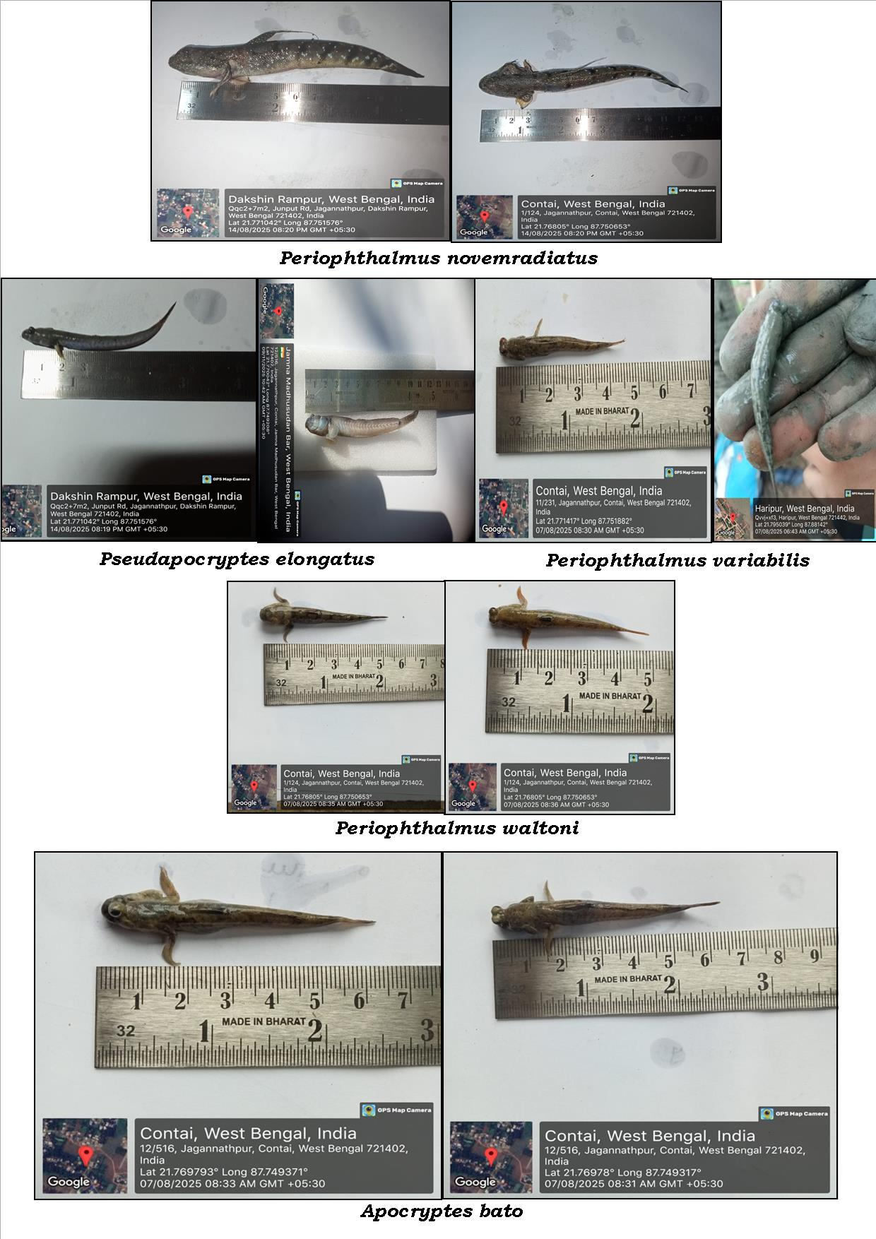
Plate 2: Different mudskippers recorded during study period

Conclusions
The present study documented five mudskipper species from selected coastal mudflat habitats of Purba Medinipur, West Bengal, during August to December 2025. The recorded species were Pseudapocryptes elongatus, Periophthalmus novemradiatus, Periophthalmus variabilis, Periophthalmus waltoni, and Apocryptes bato. The occurrence data showed temporal variation among months and sampling weeks, indicating that mudskipper assemblages in the study area were not uniform during the observation period. Among the recorded species, Periophthalmus variabilis and Apocryptes bato showed comparatively higher and more consistent occurrence, while other species were recorded less regularly. The diversity indices indicated moderate species diversity, low dominance, and relatively even distribution of species in most months. The highest Shannon diversity value was observed in September, whereas November showed the lowest value. Conservation status information indicated that most recorded species are currently categorized as Least Concern, while Periophthalmus novemradiatus is listed as Data Deficient. Overall, the study provides preliminary baseline information on the diversity and assemblage patterns of mudskippers in coastal Purba Medinipur. Continued monitoring with stronger sampling design and environmental data would improve understanding of mudskipper population patterns and habitat associations in the region.

Limitations
This study was limited by its short sampling duration of five months, from August to December 2025, and therefore does not represent complete annual or inter-annual variation in mudskipper assemblages. The assessment was based on selected coastal sites of Purba Medinipur, and the findings may not fully represent all mudflat, mangrove, or estuarine habitats of the wider region. The study primarily used occurrence records, and detailed abundance data for each species were not presented. As a result, the interpretation of diversity indices should be considered preliminary. Environmental parameters such as salinity, temperature, substrate type, tidal condition, and habitat structure were not quantitatively analyzed, although these factors may influence mudskipper distribution. Species identification was based on available taxonomic resources, but additional confirmation using detailed morphometric, meristic, or molecular methods was not included. Future studies should include longer seasonal coverage, larger sample size, standardized abundance estimates, habitat measurements, and repeated monitoring across additional sites.

Declaration of AI Use

This manuscript was prepared through the combined contributions of all author(s), including contributions to the study design, data, content development, results, interpretation, and related scholarly work. The author(s) acknowledge the use of Grammarly and ChatGPT to assist with grammar checking, language refinement, reference formatting. These AI-assisted tools were not used as authors and did not replace the intellectual contributions or scholarly judgment of the author(s). All AI-assisted outputs, including content, references, and interpretations, were carefully reviewed, revised, verified, and approved by the author(s). The author(s) accept full responsibility for the accuracy, integrity, and final content of the manuscript.

ETHICAL APPROVAL:
Since this study was conducted on mudskipper diversity and their community assemblage, we released the collected specimens in live conditions into their natural environment after their morphological identification. Thus, ethics committee was not required.

COMPETING INTERESTS DISCLAIMER:
Authors have declared that they have no known competing financial interests OR non-financial interests OR personal relationships that could have appeared to influence the work reported in this paper.
REFERENCES:
1.Qureshi, M.R.(1971). Common gobioid fishes of sub-families Periophthalminae and Apocrypteinae. Pakistan Journal of Science, 23:143-6.
2.Ravi, V. (2012). Habitat loss and population reduction of mudskippers (Family: Gobiidae) from Tamil Nadu, SE Coast of India. Marine Biodiversity: Present Status and Prospects, 37-49.
3.Takita, T., Agusnimar, & Ali, A. B. (1999). Distribution and habitat requirements of oxudercine gobies (Gobiidae: Oxudercinae) along the Straits of Malacca. Ichthyological Research, 46(2), 131-138.
4.Murdy, E. O. (1989). A taxonomic revision and cladistic analysis of the oxudercine gobies (Gobiidae: Oxudercinae).
5.Ravi, V. (2013). Food and feeding habits of the mudskipper, Boleophthalmus boddarti (Pallas, 1770) from Pichavaram mangroves, southeast coast of India. International Journal of Marine Science, 3(12).
6.Tytler, P. & Vaughan, T. (1983). Thermal ecology of the mudskippers, Periophthalmus koelreuteri (Pallas) and Boleophthalmus boddarti (Pallas) of Kuwait Bay. Journal of Fish Biology, 23(3), 327-337.
7.Tang, S. J., Liu, Z. Z., Tang, W. Q. & Yang, J. Q. (2009). A simple method for isolation of microsatellites from the mudskipper (Boleophthalmus pectinirostris), without constructing a genomic library. Conservation Genetics, 10(6), 1957-1959.
8.Polgar, G. & Lim, R. (2011). Mudskippers: Human use, ecotoxicology and biomonitoring of mangrove and other soft bottom intertidal ecosystems. Mangroves: ecology, biology and taxonomy.
9.Elviana, S., Sunarni, S., Maturbongs, M. R., Sajriawati, & Fakhriyyah, S. (2019). Mudskipper diversity and its relationship to an environmental condition in estuary. In IOP Conference Series: Earth and Environmental Science (Vol. 343, No. 1, p. 012191). IOP Publishing.
10.Samanta, M., Das, M., Bhanja, A., Sahoo, P. & Payra, P.(2026). Length-weight Relationship and Condition Factors of Periophthalmus novemradiatus (Hamilton, 1822) from Negua Diversion Canal, Purba Medinipur, West Bengal, India.
11.Kottelat, M., Whitten, A. J., Kartikasari, S. N. & Wirjoatmodjo, S. (1993). Ikan air tawar Indonesia bagian barat dan Sulawesi. Periplus, Hongkong, 293.

12.Polgar, G., Sacchetti, A. & Galli, P. A. O. L. O. (2010). Differentiation and adaptive radiation of amphibious gobies (Gobiidae: Oxudercinae) in semi‐terrestrial habitats. Journal of Fish Biology, 77(7), 1645-1664.

13.Froese, R. & Pauly, D. (2019). Species of Family Gobiidae with Genus Periophthalmus (Gobies).
14.Shannon, C. E. (1948). A mathematical theory of communication. The Bell system technical journal, 27(3), 379-423.
15. Magurran, A. E. (1988). Diversity indices and species abundance models. In Ecological diversity and its measurement (pp. 7-45). Dordrecht: Springer Netherlands.
16. Pielou, E. C. (1969). Association tests versus homogeneity tests: their use in subdividing quadrats into groups. Vegetatio, 18(1), 4-18.

