Studies on fishing crafts and gears along Ujani backwater region of Bhigwan of Pune district, Maharashtra

Abstract
The present study documented the fishing crafts and gears used by local fishermen in the Ujani backwater region of Bhigwan, Pune district, Maharashtra. The survey was conducted from January to March 2026 through field visits, direct observations, measurements, and personal interviews with fishermen operating in the study area. The investigation recorded three types of fishing crafts, namely thermocol rafts, plank-built boats, and rubber tube platforms. Among these, thermocol rafts and plank-built boats were commonly used for routine fishing operations, while rubber tube platforms were used less frequently for small-scale fishing activities. Five major fishing gears were documented, including gill nets, drag nets, cast nets, box traps, and hooks with lines. Gill nets and drag nets were the most commonly used gears in the study area. Gill nets were operated in shallow as well as deeper waters and were mainly used for catching Indian major carps, Chanda spp., prawns, and other fishes, with an observed average catch of 12–14 kg/day. Drag nets were used for larger catches and recorded an average catch of 40–64 kg per operation. Cast nets, hooks with lines, and box traps were used depending on fishing site, target species, and affordability of fishermen. Box traps were mainly observed at selected sites and were used for catching fishes and prawns, with an average catch of 0.5–2.5 kg/day per trap. The study indicates that local fishermen use both traditional and modified fishing methods according to available resources, local conditions, and operational needs. The information generated may help in documenting indigenous fishing practices and supporting future studies on sustainable inland fishery management.
Keywords: Fishing crafts, gears, fishery operations, etc.

INTRODUCTION:
Inland fisheries are currently at a turning movement due to the dual pressures of increased demand of fish production, overfishing and climate change. A transition to sustainable fishing methods has become a socioeconomic and ecological need due to increased demand for aquaculture and fishery products. The strategic management of fishing boats and gear serve as the primary interface between fishery operations and aquatic ecosystems. The availability and provisions of these tools directly affect the catch composition, species selectivity, fish production and fishing operations (Dar et al., 2024).
The majority of inland fishermen from India depend on traditional methods to fishing. The scientific and economical management of the capture fisheries through indigenous fishing methods, gears and other fishing crafts have not been documented well (Wanjari et al., 2024).
Several reports throughout India have documented about crafts and gears used in various sources of inland fishery sector include riverine network, reservoirs, lakes and ponds. The major contribution from India have been given by Sharma (2001), Behra et al. (2001), George (2002), Bhattacharya et al. (2005), Sakhare (2007), Gurumayum and Choudhary (2009), Manna et al. (2011), Mali and Bondhare (2012), Joshi et al. (2013), Upadhyay & Singh (2013), Bhakta et al. (2016), Sakhare & Jetithor (2016), Syed et al. (2020), Biswas et al. (2022), Kamble et al. (2022), Yousuf et al. (2023), Wanjari et al. (2024) and Dar et al. (2025). However, there are very less reports are available on crafts and gears used in Ujani backwater region of Bhigwan.Tthe present study was conducted to provide information about the different types of fishing gear and crafts used in fisheries operations across the Ujani backwater region of Bhigwan of Pune district.
METHODOLOGY:
The present study on fishing crafts and gears was carried out at Ujani backwater region of Bhigwan of Pune district. It is situated at 18⁰29’47”N lattitude and 74⁰77’48”E longitude (Fig. 1). The detailed survey for fishing crafts and gears was conducted between January to March-2026 at the four sites of Ujani backwater region of Bhigwan. An exploratory survey was adopted with consideration of the documentary nature of the current investigation and the qualitative aspect of the involved data. The data was recorded by direct observation through field visits, measurement and personal interviews with the fishermen. The information about crafts was collected based on technical specifications including material used in building and fabrication, size, shape and measurements. The information about gears was collected based on type of rope, mesh size, material used and supportive gear accessories, etc. The gear designing was recorded as per the guidelines of FAO (1975). The methods outlined by Lal (1969) and Von Brandt (1972) were used to categorize fishing practices.
Fig. 1: A view of Ujani Backwater region of Bhigwan of Pune district
RESULTS AND DISCUSSION:
- Fishing craft:
- Thermocol rafts: These are primitive type of fishing crafts used more frequently along with other crafts in Ujani backwater region of Bhigwan. It is constructed by tied attachment of thermocol boxes and slices together via long bamboo strip and nylon ropes (Fig. 3). These are measuring about 7 feet long, 2 feet width and height 5 to 8 inch. These are covered with green nets and supported by a lower weighted bag on one end during active fishing operations. More than 60 rafts were noticed at the study area and found to be commonly used for deployment of drag net and gill net.
- Plank built boats: These are spindling shaped fishing crafts commonly used and made by connecting wooden planks with iron nails. Coal tar is applied over joints to prevent leakage. They are varying in dimensions with length between 4 to 5m long with 1.2 to 1.6m width at middle and height ranged within 1.8 to 2.2m (Fig. 2). These are used for carrying all necessary fishing equipment including gears and harvested fish catch. They are not mechanized and require manual operation. Larger boats are 6 to 8 meters long and motorized but mostly used for passengers between villages and visiting tourists instead of for fishing purpose.
- Rubber tube platform: These were rarely used by fishermen as compare to other fishing crafts. These are most economical fishing crafts with advantages of lower cost, ease of construction, light weighted, portable and operated by a single individual. A rubber tube is tightly secured with upper woolen or cloth platform with rope to provide stability and seating support during operation. These were efficient for small-scale fishing operations in both stagnant and flowing water bodies. Primarily these are used by fishermen for small mesh sized gill net setting operations.
- Fishing gears:
- Gill net: Gill nets are the most commonly used gear especially in rainy season in all four investigated sites of the Ujani backwater region. These are operated specifically in shallow and deeper region due to simplicity with respect to operational procedure, efficient and requirement of very less energy. Locally these are also known with different names like chat jal and fash jal, etc. These are single layered nets made up from multifilament nylon with diameter between 0.2 to 0.3 mm and ranged in length from 8 to 35m with mesh size of 1 to 10 cm. The gill nets with varying mesh size were operated regularly as per the necessity. They are often anchored with bamboo stakes set up across the water flow and small stones as a sinker (Fig. 4). The catch is gathered after around 10 hours with major target species includes Indian Major Carps, Chanda, Prawns, etc. The average fish catch was observed between 12 to 14 Kg/Day.
- Drag net: The most common drag net used by fisherman is the Fy-Jal, a circular net that is mostly used to capture Indian Major Carps, small fish, Channa spp., and Chanda spp. Its length varies between 25 to 90 meters. The center boat held one end of the net in the water body and associated subsequent boats were found to be spreading the net up to designated area in encircle manner. It is made up of nylon with mesh size ranging between 0.5 to 2.4 cm. The average fish catch by drag net was observed between 40 to 64 Kg/Catch.
- Cast net: It is circular net popularly known as ‘Chhatri jal’ with different lengths between 7 to 20 meters and mesh sizes ranged within 2.3 to 5 cm. Iron balls are used as sinkers. A long, thin rope is fastened to the net's apex, and the net is folded inward to give circular pockets at its circumference. Sinkers are inserted in the pockets. The net is folded into three equal parts, with the left hand holding the fold near the rope, the center one remaining free, and the final fold in the periphery. The final fold was set over the head and thrown up to reachable distance in a circle over the water surface. The fishes are trapped from the area and eventually in the pockets. The total fish catch ranges between 2 to 5 Kg/Day with target fish catch of Indian major carps.
- Hooks and lines: It is also common fishing techniques used by fisherman who can't afford other nets. It is made up of a hook, nylon string and a rod. The nylon string is attached to the baited hook on one side and a rod on the other. These are operated near the marginal sites of Ujani Backwater. Mostly carnivorous fish are caught due to the use of various baits including flesh tissue, earthworms, insects and cockroaches, etc.
- Box traps (Pinjara): Fishing traps are a type of passive fishing method in which fishes get trapped during migration and movement. There is versatility in construction of such traps with varying design, material and functional aspects adopted as per the target fish species and local conditions. Mostly bamboo splits and steel rods are used for construction of traps. The box trap also known as Pinjara were notice to be operated at site-C and D by fishermen (Fig. 5). The trap framework are consists of steel rods measuring about 3.20 feet length × 2.0 feet height × 1.90 feet width. They only have one-way entrance openings on both opposite sides which serve as a unidirectional non-returning entry for fish and prawns. The trap is kept vertically under the water. These entrance openings allow the inside entry of fishes and prawns and get close the sticks automatically. These types of fishing traps are usually deployed before and after the monsoon season. It mostly targets Channa species. The average fish catch with this gear is between 0.5 to 2.5 kg/day per trap.

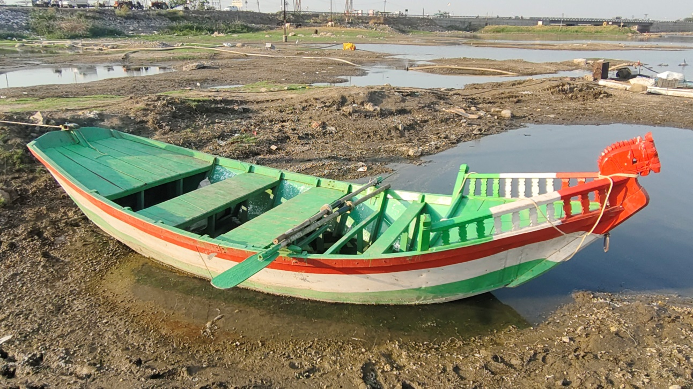
Fig. 2) Plank built boats

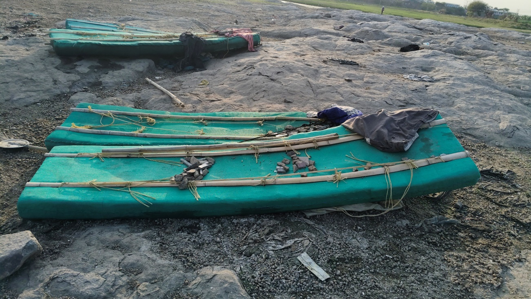
Fig. 3) Thermocol rafts

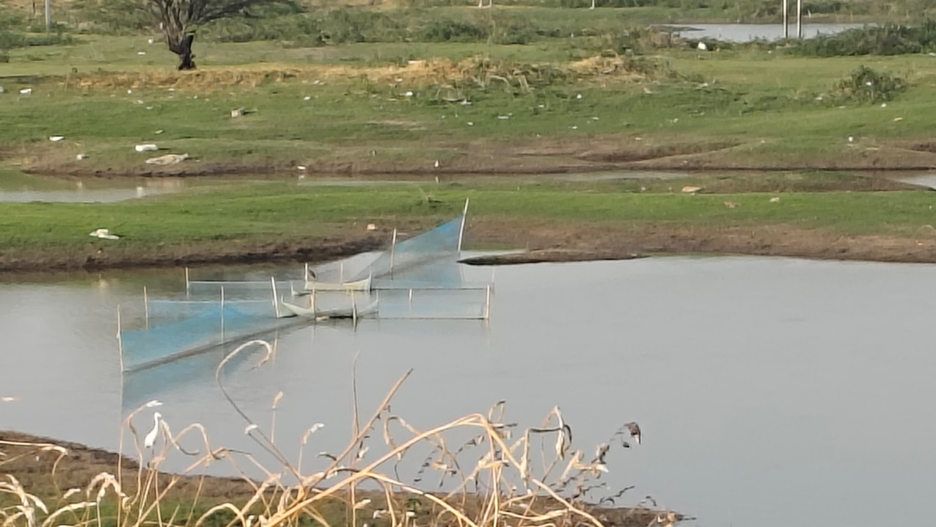
Fig. 4) Gill net set-up with Bamboo
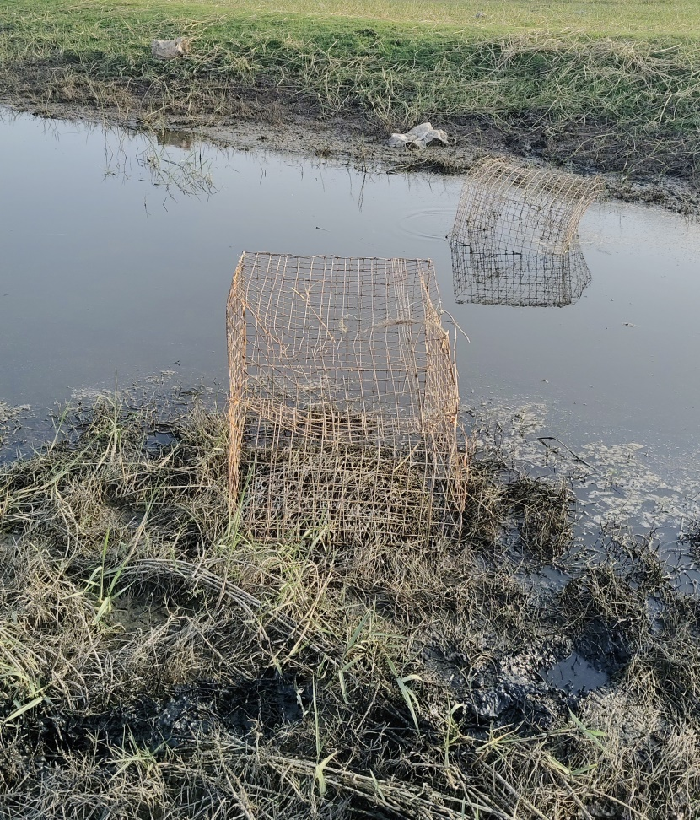
Fig. 5) Box traps set up

Conclusion
The survey conducted in the Ujani backwater region of Bhigwan, Pune district, Maharashtra, recorded the use of three fishing crafts and five fishing gears by local fishermen. The fishing crafts documented were thermocol rafts, plank-built boats, and rubber tube platforms. Thermocol rafts and plank-built boats were more commonly used than rubber tube platforms and were mainly associated with gill net and drag net operations. The fishing gears recorded during the study were gill nets, drag nets, cast nets, box traps, and hooks with lines. Among these, gill nets and drag nets were the most frequently used gears because of their operational simplicity and suitability for local fishing conditions. Cast nets and hooks with lines were used for small-scale or individual fishing activities, while box traps were used at selected sites, mainly for fishes and prawns. The study shows that fishermen in the Ujani backwater region follow a combination of traditional and modified fishing practices based on local needs, target catch, affordability, and available materials. The documentation of these crafts and gears provides baseline information on local fishing practices and may be useful for further assessment of inland fishery operations and sustainable management planning in the region.

Limitations
The present study was descriptive in nature and was limited to selected sites of the Ujani backwater region of Bhigwan. The survey was conducted only from January to March 2026; therefore, seasonal variation in fishing crafts, gear use, and catch composition could not be fully assessed. The study documented the types, dimensions, materials, and operational aspects of major crafts and gears, but detailed quantitative information on the number of fishermen interviewed, total fishing effort, income, species-wise catch composition, and gear-wise catch efficiency was limited. The reported catch values were based on field observations and information collected during the survey period and require further validation through long-term monitoring. Environmental parameters, fish stock status, and ecological impacts of different gears were not evaluated. Future studies should include wider seasonal coverage, larger respondent numbers, standardized catch-effort data, and assessment of ecological sustainability of the fishing gears used in the region.

DISCLAIMER (ARTIFICIAL INTELLIGENCE):
Author hereby declare that NO any generative AI tool such as Large Language Models such as ChatGPT, COPILOT, etc and text-to-image generators have been used during writing and drafting of this manuscript.

COMPETING INTERESTS DISCLAIMER:
Authors have declared that they have no known competing financial interests OR non-financial interests OR personal relationships that could have appeared to influence the work reported in this paper.

REFERENCES:
- Behra, B. K., Mishra, C. K., Samantaray, B. R., & Kohli, M. P. S. (2001). A survey of various gear, craft and fishing methods adopted by the fishermen of Chilka Lake. Applied Fisheries Aquacology, 1, 91.
- Bhakta, D., Manna, R. K., Meetei, W. A., Solanki, J. K., & Sah, R. K. (2016). Traditional fishing crafts and gears of Ukai reservoir, Gujarat, India. International Journal of Fisheries and Aquatic Studies, 4(4), 142–145.
- Bhattacharjya, B. K., Manna, R. K., & Choudhary, M. (2005). Fishing crafts and gear of northeast India. Bulletin No. 142, CICRI, Barrackpore, West Bengal, 67.
- Biswas, A., Behera, S., Sau, S. K., & Ziauddin, G. (2022). Fishing crafts and gears used in Moutore Reservoir, Purulia District, West Bengal. Environment and Ecology, 40(3C), 1638–1642.
- Dar, S. A., Hussain, N., Bhat, T. H., Qayoom, I., Verma, H. L., & Peerzada, Z. A. (2024). Need for socio-economic upliftment of fishers, more unfinished than achieved: A review. International Journal of Agricultural Extension and Social Development, 7(9), 942–949.
- Dar, S. A., Wani, G. B., & Qayoom, I. (2025). Fishing gears and crafts of Manasbal Lake: Insights from the Kashmir Himalayas. International Journal of Agriculture Extension and Social Development, 8(1), 66–73.
- FAO. (1975). FAO catalogue of small scale fishing gear. Fishing News Books Ltd., Farnham Printers and Publishers, Cochin, 1–101.
- George, V. C. (2002). Fishing techniques of riverine and reservoir systems: Present status and future challenges. In M. R. Boopendranath, B. Meenakumari, J. Joseph, T. V. Sankar, P. Pravin, & L. Edwin (Eds.), Riverine and reservoir fisheries of India (pp. 192–196). Society of Fisheries Technologists (India), Cochin.
- Gurumayom, S. D., & Choudhury, M. (2009). Fishing methods in the rivers of northeast India. Indian Journal of Traditional Knowledge, 8, 237–241.
- Joshi, P. S., Tantrapale, V. T., & Kulkarni, K. M. (2013). Fishing methods commonly employed in Buldhana district and neighborhood, Maharashtra State, India. Bioscience Discovery, 4, 54–57.
- Kamble, S. P., Bhakta, D., Meetei, W. A., Vaisakh, G., Solanki, J. K., Koushlesh, S. K., Chanu, T. N., Behera, B. K., Suresh, V. R., Samanta, S., & Da, B. K. (2022). A comprehensive account of fishing crafts and gears of River Tapti, India. Fishery Technology, 59, 215–218.
- Lal, K. B. (1969). An introduction to fishing gear technology. Metropolitan Book Co. Pvt. Ltd.
- Mali, R. P., & Bondhare, S. O. (2012). Fishing craft and gear in river Godavari at Nanded, Maharashtra. Ecology and Fisheries, 5, 37–40.
- Manna, D. R. K., Archan, K., Krishna Rao, D. S., Karthikeyon, M., & Sing, D. N. (2011). Fishing crafts and gears in river Krishna. Indian Journal of Traditional Knowledge, 10, 491–497.
- Sakhare, V. B. (2007). Reservoir fisheries and limnology. Narendra Publishing House, Delhi.
- Sakhare, V. B., & Jetithor, S. G. (2013). Crafts and gears used in reservoirs of Marathwada region, Maharashtra. Sustainability, Agri, Food and Environmental Research, 1(1), 46–51.
- Sharma, R. (2001). Traditional methods and fishing gears of Assam. Fishing Chimes, 20, 23.
- Syed, N., Mohite, A., Sadawarte, R., Desai, A., & Shah, T. H. (2020). Design aspects of fishing crafts and gears of Wular Lake of Kashmir, India. Journal of Experimental Zoology India, 23(Suppl. 1), 861–867.
- Upadhyay, A. D., & Singh, B. K. (2013). Indigenous fishing devices in use of capture fishing in Tripura. Indian Journal of Traditional Knowledge, 12(1), 149–156.
- Von Brandt, A. (1972). Fish catching methods of the world. Fishing News Books Ltd.
- Wanjari, R. N., Shah, T. H., Telvekar, P., Ramteke, K. K., Dhanalakshmi, M., & Rashid, I. (2024). A preliminary study of fishing crafts and gears operating along the Wainganga River of Maharashtra State, India. Journal of the Inland Fisheries Society of India, 56(2), 185–196.
- Yousuf, Z., Shah, T. H., Bhat, F. A., Abubakr, A., Bhat, B. A., Ahmad, I., Shah, F. A., & Syed, N. (2023). Fishing gears and craft of Anchar Lake: Design specifications and operational aspects. Journal of Experimental Zoology India, 26, 1485–1490.

