Original Research Article
Ecological Assessment of Lichens Diversity in the Anamalai Tiger Reserve, Southern Western Ghats, India

ABSTRACT
Lichens are important components of forest ecosystems and respond sensitively to variation in habitat, substrate, and microclimatic conditions. The present study assessed the diversity, distribution, substrate preference, and ecological importance of lichens in the Anamalai Tiger Reserve, Southern Western Ghats, Tamil Nadu, India. Field surveys were conducted during 2021–2022 across ten sites representing evergreen, moist deciduous, and dry deciduous forest types. A total of 50 plots were surveyed, and nearly 300 lichen specimens were collected and identified using morphological, anatomical, and chemical methods. The study recorded 81 lichen species belonging to 27 genera and 12 families. Parmeliaceae was the dominant family, followed by Physciaceae and Caliciaceae. Corticolous lichens were the most common substrate group, while foliose lichens represented the dominant growth form. Evergreen forests supported the highest species richness, followed by moist deciduous and dry deciduous forests, indicating the role of humid and stable microhabitats in supporting lichen diversity. Ecological analysis showed that Heterodermia japonica was the most dominant species, with the highest importance value index of 10.82. Diversity indices indicated heterogeneous species distribution across the study sites. Multivariate analysis further showed variation in lichen assemblages among sites and ecological regions. The study also recorded Cetrelia braunsiana, Heterodermia dactyliza, Heterodermia hypochraea, and Pyxine petricola var. pallida as new records for Tamil Nadu. These findings provide baseline information on lichen diversity in the Anamalai Tiger Reserve and support the importance of forest habitat conservation for maintaining cryptogamic biodiversity in the Western Ghats.

Key words: Lichens; Ecological distribution; Principal component analysis; Multivariate analyses; Heterodermia japonica.

1. INTRODUCTION
India's diverse landscape and distinct phytogeographical regions host an array of biota, reflecting wide ecological and climatic range. The Western Ghats are recognized as one of the 36 global biodiversity hotspots and one of the four hotspots in India, owing to their extraordinary levels of species richness and endemism (Dalui et al., 2024). This mountain chain shows distinctly include higher indigenousness and floristic diversity than other phytogeographical regions of the country. India harbours exceptionally high lichen diversity, shaped by its heterogeneous topography and climatic regimes. The Himalayan region and Northeastern states represent primary hotspots of lichen richness, while the Western Ghats, Eastern Ghats, and Andaman and Nicobar Islands support distinctive assemblages with a notable proportion of endemic taxa (Lucking et al., 2017). In India, a comprehensive taxonomic assessment has documented 3,236 lichen taxa, encompassing 3,200 species, 29 varieties, 6 subspecies, and some single forma, distributed across 487 genera and 88 families. Of these, 2,239 are classified as crustose lichens, while 755 are foliose, and 242 are fruticose forms (Joshi and Upreti, 2016). The Western Ghats exhibit a significant diversity of lichens, encompassing 1,706 taxa, including over 250 endemic species (Nayaka and Upreti, 2006; Sinha, 2021).
Lichens represent a unique life form that developed from the mutualistic relationship between a fungus and an alga. Lichens exhibit remarkable ecological adaptability and are capable of colonizing a wide range of substrates including rocks, soil, tree bark, leaf surfaces, metallic objects and even the exoskeletons of insects (Phukhamsakda et al., 2022; Hyde et al., 2024). The lichen can be found in habitats ranging from tropical rainforests to arctic regions (Hawksworth and Grube, 2020). Remarkably, lichens are also known for their pioneering role in establishing successful colonies on barren habitats. Lichens contribute significantly to ecosystem functioning by serving as food and shelter for various organisms, participating in nutrient cycling, and promoting soil formation processes (Jackson, 2015). In addition to their ecological importance, lichens are prolific producers of secondary metabolites, many of which possess valuable bioactive properties. These compounds have demonstrated antibacterial, antifungal, anti-inflammatory, antitumor, and antioxidant activities, highlighting their growing importance in pharmaceutical and industrial applications (Calcott et al., 2018).
The majority of lichen research in India has been done in the Himalayan foothills (Divakar and Upreti, 2005). As well, notable collections have been documented from Bihar, Madhya Pradesh, Tamil Nadu, Uttar Pradesh, Andhra Pradesh, Arunachal Pradesh, Assam, Jammu and Kashmir, Manipur, Meghalaya, Odisha, and Rajasthan Reddy et al. (2011) and Nayaka et al. (2011). The lichen diversity of Tamil Nadu is largely attributed to the extensive stretch of the Western Ghats and the presence of several biodiversity rich regions, including the Nilgiris, Anamalais, Palani and Shevaroy Hills (Kalidoss et al., 2019). It is located in the peninsular region of India is particularly rich in lichens with a record of 1,044 species (Sinha et al., 2024). The presence of biodiversity rich regions such as Nilgiri Biosphere Reserves, Western and Eastern Ghats, significantly contributes to the high lichen diversity observed in the state. However, many regions within the Western Ghats remain unexplored, emphasizing the need for systematic surveys and detailed evaluations to understand the lichen wealth of the region (Nayaka and Haridas, 2024).
The study area Anamalai Tiger Reserve (ATR) in Tamil Nadu which falls on the tract of Western Ghats represents one such unexplored area for lichen studies. It harbours numerous interesting and endemic lichen taxa, this region is considered richest among the lichen zones in the country. However, this reserve remained largely unexplored and comparatively less studied than higher plants. In recent decades; the diversity of lichen flora has undergone a substantial decline across the country. Among various anthropogenic pressures, overexploitation and selective removal of economically important lichens have emerged as major threats to lichen diversity (Sharath and Jabeen, 2021). To address this gap, the present study constitutes a pioneer study in the ATR, aiming to document the diversity and ecological distribution of lichens across different forest types. Lichen diversity was carried out to focussing on ecological analysis among forest types were assessed using the alpha and beta diversity indices, thereby providing a comprehensive understanding of lichen distribution patterns within the Anamalai Tiger reserve.
2. MATERIALS AND METHODS
2.1. Study Area
The Anamalai Tiger Reserve is situated in the Coimbatore District of Tamil Nadu, India, between the geographic co-ordinates of 76⁰ 49.3’’ to 77⁰ 21.4’’E and 10⁰13.2’’ to 10⁰33.3’’ N that lies south of the Palakkad gap in Western Ghats (Fig. 1). The Reserve covers an area of about 1,479.87 km² and shares its boundaries with the Parambikulam Tiger Reserve to the east, and with Chinnar Wildlife Sanctuary and Eravikulam National Park along its south-western flank. The Reserve is divided into six forest ranges Manombolly, Pollachi, Ulandy, Udumalpet, Amaravathy, and Valparai comprising a total of 32 forest divisions. The altitudinal gradient ranges from 340 m to 2,400 m above mean sea level, while mean annual rainfall varies markedly from approximately 500 mm in the south-western fringes to nearly 5,000 mm in the north-eastern sector. The climate remains moderately warm throughout the year, while comparatively cool in winter months of November and December.
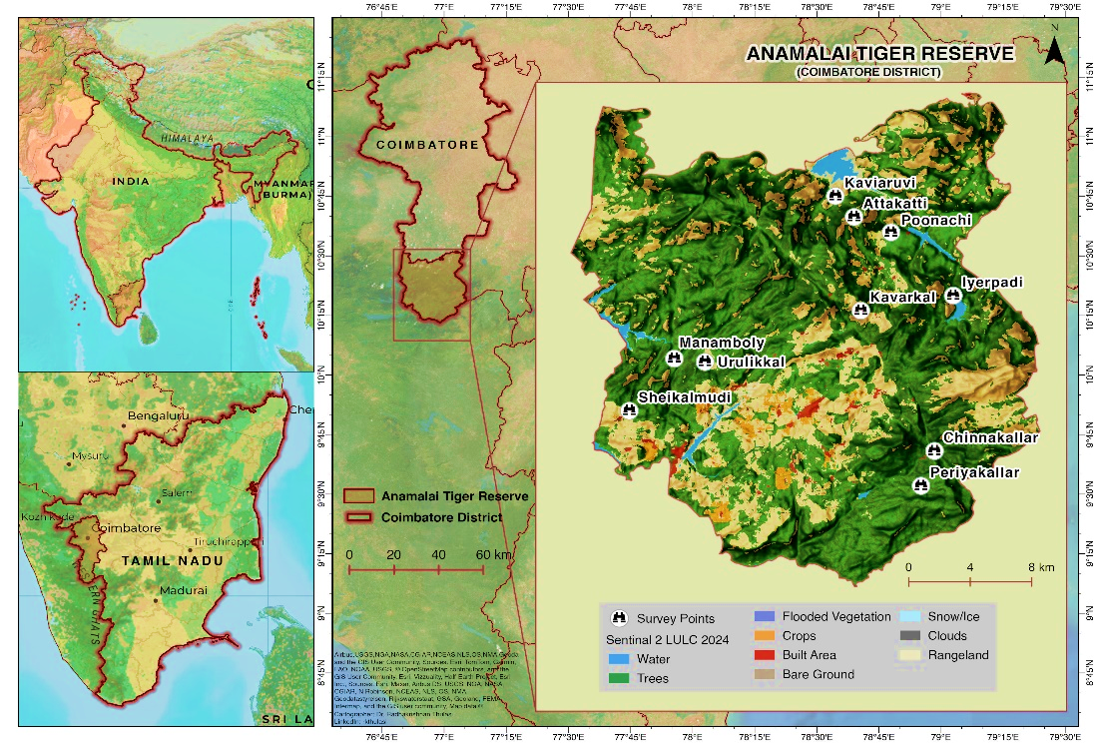
Fig. 1: Study sites and location of the Anamalai Tiger Reserve (ATR), Tamil Nadu, India
Owing to pronounced heterogeneity in topography, climate, temperature, and precipitation, the Reserve supports exceptionally rich lichen diversity. The present study was conducted at ten sites, namely Kaviyaruvi, Attakatti, Poonachi, Iyerpadi, Urulikkal, Kavarkal, Manamboly, Sheikalmudi, Chinnakallar and Periyakallar, which were located within the Manamboly, Valparai, and Pollachi ranges of the Anamalai Tiger Reserve. These sites encompass as a wide range of vegetation types, including evergreen, moist deciduous and dry deciduous forests.
2.2. Lichen Sampling and Identification
The present study was conducted during 2021-2022 in the ATR. A plot-based sampling design was involved to assess the lichen diversity, measuring 50 × 10 m laid at 10 sampling sites representing three different forest types with an altitudinal gradient, study area with a total of 50 plots established in ten sampling sites. In each plot, all visible lichen species occurring on all substrata, including tree bark, twigs, mosses, leaves, rocks and soil surfaces were recorded (Nimis et al. 2002). Nearly 300 lichen specimens were collected from ten selected sites within the study area. The collected specimens were cleaned, air-dried and stored in standard herbarium packets, labeled with details of the collection site, collector’s name, substratum type, date of collection and specimen number (Nayaka, 2014). The voucher specimens were deposited in the LWG Herbarium of the CSIR-National Botanical Research Institute, Lucknow and Department of Botany, NGM College, Pollachi, Coimbatore, India.
The collected specimens were identified through detailed morphological, anatomical and chemical analyses using stereo and light microscopes. Standard chemical spot tests were carried out with potassium hydroxide (K), calcium hypochlorite (C) and para-phenylenediamine (P) reagents. Microcrystallographic methods were employed to detect lichen substances present within the thallus. Furthermore, thin-layer chromatography (TLC) was performed to characterize cortical and medullary secondary metabolites using a solvent system consisting of toluene, 1,4-dioxane, and acetic acid (Orange et al., 2001). Species identification was subsequently confirmed with the aid of relevant literature, taxonomic keys and monographs (Awasthi, 1988, 2007; Divakar & Upreti, 2005).
Ecological assessment
Ecological assessment on lichen diversity was carried out using plot-based sampling analysis to determine species availability and distribution across the study area. The selected study sites were located at different altitudinal gradients. A total of 50 plots were laid down randomly across ten sites, with five plots established at each site for the collection of ecological data. Each plot was systematically surveyed and all lichen species occurring within plots were numbered and their occurrences were carefully recorded. Species diversity was assessed using standard ecological parameters, including frequency (F), density (D) and abundance (A). The ecological significance of each species within the community was further determined through the Importance Value Index (IVI), calculated using standard formulae that integrate relative density (RD), relative frequency (RF) and relative abundance (RA). These indices collectively provide a comprehensive measure of species dominance and distribution within the vegetation community (Curtis and McIntosh 1950; Phillips, 1972). The diversity of lichen communities across the study sites were assessed using species richness (S), calculated from the total number of species recorded. Shannon–Wiener (H′) and Simpson’s (1−D) indices were used to measure diversity and dominance patterns, whereas the Sørensen similarity index was employed to compare species composition and similarity among sites.
2.1. Ecological analysis
2.1.1. Frequency (F)
Frequency refers to the percentage occurrence of a species in the sampled quadrats and represents how frequently a particular species is distributed within the study area.
$Frequency (\%) = \frac{Number of quadrats where species occurs}{Total quadrats studied}×100$ (Eq-1)
2.1.2. Density (D)
Density refers to the numerical strength of the species in a community and is defined as the number of individuals of a species present per unit area (or volume).
$Density =\frac{Total individuals of a species}{Total number of sampling units studied}$ (Eq-2)
2.1.3. Abundance (A)
Abundance refers to the number of individuals of a species per quadrat in which the species actually occurs.
$Abundance =\frac{Total individuals of a species}{Number of quadrats where species occurs}$ (Eq-3)
2.1.4. Relative Frequency (RF)
Relative frequency refers to the contribution of one species frequency compared to the total frequency of all species in the study area.
$Relative frequency \left(\%\right)= \frac{Frequency of a species}{Total frequency of all species}×100$ (Eq-4)
2.1.5. Relative Density (RD)
Relative density refers to the numerical strength of one species in relation to the total number of individuals of all species in the study area.
$Relative Density (\%) =\frac{Number of individuals of a species}{Total individuals of all species}×100$ (Eq-5)
2.1.6. Relative Abundance (RA)
Relative abundance refers to the abundance value of a species in relation to the total abundance of all species in the study area.
$Relative Abundance (\%) =\frac{Abundance of a species}{Total abundance of a species}×100$ (Eq-6)
2.1.7. Important Value Index (IVI)
The Important Value Index (IVI) is a quantitative measure used in ecology to assess the overall ecological significance of a species within a plant community. According to Curtis and McIntosh (1950) and Phillips (1972), the IVI is calculated as the sum of relative frequency, relative density and relative abundance.
Important Value Index (IVI) = Relative Frequency (RA) + Relative Density (RD)
+ Relative Abundance (RA) (Eq-7)
3. Species diversity indices
3.1. Shannon-Wiener Index (H’)
The Shannon-Wiener Index (H’) measures species diversity by considering the proportional abundance of each species (Shannon and Wiener, 1949).
$Shannon-Wiener Index (H’) = -\sum_{i=1}^{s}{(p_{i} ln p_{i})}$ (Eq-8)
Where,
Pi: Proportion of individual of a species
S: Species richness
Ln: Natural logarithm of the proportion (p_{i})
3.2 Simpson’s Index (1-D)
Simpson’s index is a measure of species diversity that quantifies the degree of dominance within a community. It represents the probability that two individuals randomly selected from a sample belong to different species (Simpson, 1949).
$Simpson’s Index (D) = \frac{\sum{n_{i} (n_{i}-1)}}{N (N-1)}$ (Eq-9)
Where,
n_{i}: Total number of individuals of a species
N: Total number of individuals of all species
3.3. Sørensen Similarity Index
The Sørensen Similarity Index is used to compare species composition between two sites based on shared species. The index ranges from 0 to 1, with values closer to 1 indicating greater similarity in species composition between sites, and values closer to 0 indicating greater dissimilarity (Sørensen, 1948).
$Sørensen Similarity Index (SI) =\frac{2C}{A+B}$ (Eq-10)
Where,
C: Number of species common to both sites
A: Total number of species in site A
B: Total number of species in site B
3.4. Pearson correlation coefficient and principal components analysis
Pearson’s correlation analysis is used to investigate relationships among lichen diversity indices, while Principal Component Analysis (PCA) is summarize these correlations of lichen diversity and community structure across the study sites. This multivariate technique used to analysis the ecological variables into principal components, to identify relationship between species and environmental variables also highlighting the major factors influencing lichen distribution patterns. All data variables represented in the graph were designed using OriginPro 2026.
4. RESULTS AND DISCUSSION
The present study documented a total of 81 species belonging to 27 genera and 12 families from the Anamalai Tiger Reserve, Tamil Nadu. This diversity aligns with broader regional patterns reported from the Western Ghats, where Rajaprabu and Ponmurugan (2023) documented nearly, 1,500 lichen species with Tamil Nadu being the second richest state, hosting 938 species. In the present study, corticolous lichens were the most abundant, accounting for 70 species, followed by saxicolous (9 species), terricolous (2 species) and foliicolous forms (1 species), indicating a strong preference for tree trunk and rocks as primary microhabitats for lichens. Similarly, studies from various regions of south India have also documented the corticolous lichens as the dominant substrate group (Balu et al., 2021; Rajaprabu and Ponmurugan, 2023; Nayaka and Haridas, 2024). Morphologically, foliose lichens were predominant in the study area, represented by 63 species, followed by fruticose, crustose, and squamulose forms with 12, 5, and 1 species, respectively. This distribution pattern highlights the strong influence of environmental factors and microhabitat characteristics on lichen community structure, further emphasizing the sensitivity of lichens to subtle ecological variations and environmental changes (Fryday, 2000).
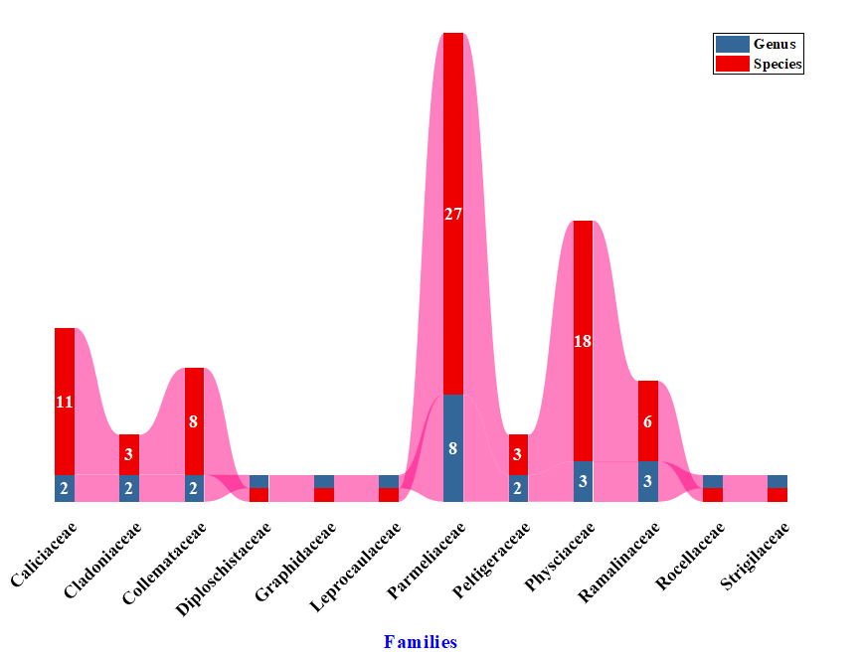
Fig. 2: Distribution pattern of genera and species among families
The state’s rich lichen population is largely attributed to the extensive stretch of the Western Ghats and key biodiversity hotspots, including the Nilgiris, Anamalais, Palani, and Shevaroy Hills (Arun Prasath et al., 2022). The survey conducted across seven localities in the Nilgiris documented 39 lichen species, representing 23 genera and 9 families (Arun Prasath et al., 2022). In the Siruvani Hills (Bolampatti II forest range), 103 macrolichen species representing 27 genera across nine families were reported (Balaji and Hariharan, 2013), whereas Maruthamalai Hill supported 31 species belonging to 21 genera and 11 families (Arun Prasath et al., 2022). Similarly, Haridas and Aliyarukunju (2024) reported 147 lichen species, comprising both macrolichens and microlichens, representing 65 genera from various locations in the Thiruvananthapuram and Kollam districts of Kerala within the Agasthyamalai Biosphere Reserve. Among the 12 families, Parmeliaceae was the most dominant family, followed by Physciaceae, Caliciaceae, Collemataceae, and Ramalinaceae respectively (Fig. 2). Interestingly, this pattern of family level dominance is consistent with earlier reports from different regions of India that highlight Parmeliaceae and Physciaceae as major contributors to lichen diversity (Kumar et al., 2024).
The analysis of species richness at the family level reveals the occurrence of two dominant families such as parmeliaceae and physciaceae comprising 46 species, accounting for 57% of the total recorded species. Polytypic families, including Caliciaceae, Collemataceae and Ramalinaceae contribute 24 species, representing 30% of the overall diversity. In contrast, two oligotypic families collectively harbour 5 species (6%), while six monotypic families are each represented by a single species, making up 7% of the total (Table 1). The Anamalai Tiger Reserves supports a rich diversity of vegetation, shaped by complex gradients of topography, climate, and rainfall. The differences in soil characteristics, rain fall and altitudinal variations, have resulted in the development of five major vegetation types: Grassland, Evergreen, Moist Deciduous, Dry Deciduous, and Dry Semi Desert (Ganesan, 2019). The lichen survey conducted within the study area focused on three forest types of Evergreen, Moist Deciduous, and Dry Deciduous. The lichen diversity showed clear variation across the three ecological regions, with the highest taxonomic richness observed in evergreen forests, followed by moist deciduous and dry deciduous forests. Species, genus, and family richness declined consistently along this gradient. Corticolous emerged as the most favourable substrate, supporting maximum species richness, particularly in evergreen forest. Saxicolous and terricolous substrates contributed moderately, while follicolous substrates supported minimal diversity. Among growth forms, foliose lichens were predominant in all regions, especially in evergreen forests, indicating their preference for humid and environmentally stable conditions. Overall, the observed distribution pattern highlights the strong influence of habitat moisture and substrate type on lichen diversity (Fig.3). Notably, Cetrelia braunsiana, Heterodermia dactyliza, Heterodermia hypochraea and Pyxine petricola var. pallida are identified to be new lichen species reported from Tamil Nadu.
Table: 1 Statistical analysis of genera and species level diversity of lichens in the study area
 | Name of Family | Number of genera contained | Percentage of the total number of genera (%) | Number of species | Percentage of the total number of species (%)
Dominant families  (> 15 Species) | Parmeliaceae | 8 | 29.63 | 27 | 33.33
Dominant families  (> 15 Species) | Physciaceae | 3 | 11.11 | 18 | 22.22
Polytypic families  (6 < Species < 14) | Caliciaceae | 2 | 7.41 | 11 | 13.58
Polytypic families  (6 < Species < 14) | Collemataceae | 2 | 7.41 | 8 | 9.88
Polytypic families  (6 < Species < 14) | Ramalinaceae | 3 | 11.11 | 6 | 7.41
Oligotypic families  (2 < Species < 5) | Cladoniaceae | 2 | 7.41 | 3 | 3.70
Oligotypic families  (2 < Species < 5) | Peltigeraceae | 2 | 7.41 | 3 | 3.70
Monotypic families  (Species = 1) | Graphidaceae | 1 | 3.70 | 1 | 1.23
Monotypic families  (Species = 1) | Leprocaulaceae | 1 | 3.70 | 1 | 1.23
Monotypic families  (Species = 1) | Strigulaceae | 1 | 3.70 | 1 | 1.23
Monotypic families  (Species = 1) | Diploschitaceae | 1 | 3.70 | 1 | 1.23
Monotypic families  (Species = 1) | Rocellaceae | 1 | 3.70 | 1 | 1.23
 | Total | 27 |  | 81

Among the ten study sites surveyed, the evergreen forests of Iyerpadi, Kavarkal, Urulikkal, Manamboly, Chinnakallar and Periyakallar are situated at elevations above 800 m and together supported a rich lichen diversity comprising 67 identified species. The dominant families in this zone were Parmeliaceae, Physciaceae, Collemataceae, and Cladoniaceae, with Parmotrema, Hypotrachyna, Heterodermia, Polyblastidium, Leptogium, and Usnea as the most prevalent genera. Moist deciduous forests are sporadically distributed within the reserve at Attakati, Poonachi, and Sheikalmudi, ranging in elevation between 700 m to 1020 m and a total of 29 lichen species were identified within this vegetation. Among the recorded taxa, Parmeliaceae, Physciaceae, Collemataceae, Ramalinaceae, and Cladoniaceae were the most dominant families, whereas Parmelinella, Parmotrema, Hypotrachyna, Pyxine, Collema, Ramalina, Heterodermia, Polyblastidium, Leptogium and Usnea represented the predominant genera. The dry deciduous forests represented by the Kaviyaruvi falls region at altitudinal range between 300 m to 550 m, recorded 28 lichen species. The predominant families viz., include Caciaceae, Parmeliaceae, Collemataceae, and Graphidaceae, with prevalent genera comprising Parmotrema, Dirinaria, Pyxin, Collema, Leptogium, and Dirrygma. Similarly, Nayaka et al. (2001) reported notable variation in lichen diversity across different vegetation types, including evergreen forest, moist deciduous forest, dry deciduous forest, and scrub forest. Among these, the evergreen forest supported the highest lichen diversity, with 50 species recorded in Meghamalai Wildlife Sanctuary, Kambam. Deciduous forest has highest intensity and open canapy which is suitable for crustose and foliose lichens (Balaji and Hariharan, 2004).
Lichen diversity across ecological regions in the study area revealed notable variation influenced by altitude and forest type (Tumur et al., 2025). The increasing populations of lichen is closely related to the altitudinal gradient (Subbaiyan et al., 2023). The highest number of species was observed in high altitude stations. These zones, often characterized by evergreen and moist deciduous forests, provide favourable microclimatic conditions that support diverse lichen communities (Haridas and Aliyarukunju, 2024). The diversity of forest species at high altitude with high rainfall may also cause the richness in lichen biodiversity in the ATR. In contrast, lower altitude dry deciduous regions showed comparatively fewer species, indicating a clear ecological influence on lichen distribution patterns.
Ecological assessment
The basic ecological analysis of the documented lichen species were presented in Table 2. Frequency (F %) indicates the percentage of sampling units in which a species occurred. Frequency of documented lichen species ranged from 36 % to 4%. Among the 81species, Heterodermia japonica showed the highest frequency (36%), suggesting its wide distribution in the study area, followed by H. diademata (32%) while the lowest frequency was observed in Strigula sp (4%). Density (D) revealed the number of individuals per unit area. H. japonica showed the highest density (3.32) followed by Parmotrema tinctorum (2.86), whereas the lowest density was observed in Pyxine petricola var. pallida Swinscow (0.2). Abundance (A) represents the average number of individuals per occupied in study area. The highest abundance values were recorded for Roccella montagnei (18.25), followed by P. austrosinense (12.75), while the lowest abundance was observed in Bulbothrix isidiza (2.57).

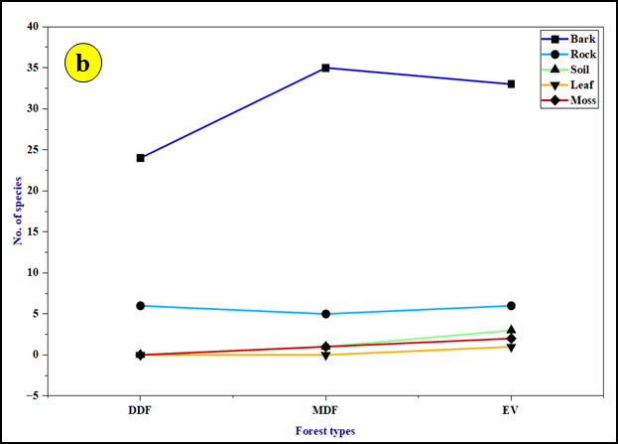
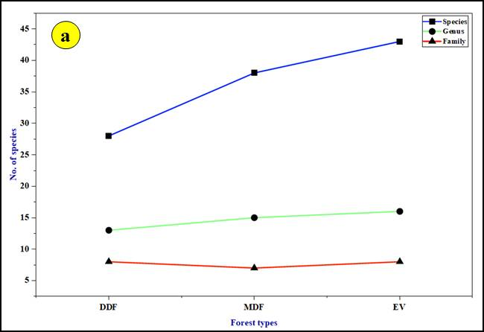

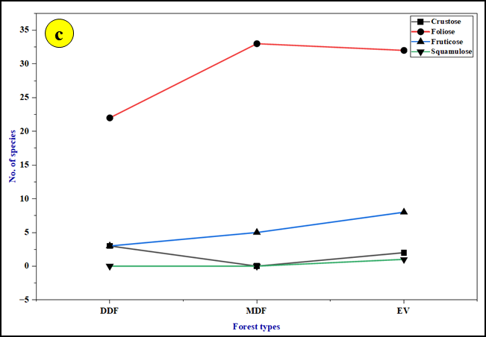
Fig. 3: Lichen distribution across ecological regions is analyzed under three major parameters
a- the cumulative diversity at the species, genus, and family levels; b- habitat-specific accumulation patterns across distinct substrates such as bark, rock, soil, and leaf; c- the stratification of lichens according to their morphological growth forms.

Table: 2 Ecological analysis of lichens in the ATR, Western Ghats, Tamil Nadu, India
S. No | Name of the species | F (%) | D | A | RF | RD | RA | IVI
 | Heterodermia japonica (Satô) Swinsco & Krog. | 36 | 3.32 | 9.22 | 3.95 | 5.16 | 1.71 | 10.82
 | Parmotrema tinctorum (Despr. ex Nyl.) Hale | 24 | 2.86 | 11.92 | 2.63 | 4.44 | 2.20 | 9.27
 | Heterodermia diademata (Taylor) D.D. Awasthi | 32 | 2.64 | 8.25 | 3.51 | 4.10 | 1.53 | 9.14
 | Heterodermia magellanica (Zahlbr.) Swinscow & Krog | 24 | 2.46 | 10.25 | 2.63 | 3.82 | 1.90 | 8.35
 | Parmotrema austrosinense (Zahlbr.) Hale | 16 | 2.04 | 12.75 | 1.75 | 3.17 | 2.36 | 7.28
 | Parmotrema reticulatum (Taylor) M. Choisy | 24 | 1.9 | 7.92 | 2.63 | 2.95 | 1.46 | 7.04
 | Heterodermia dissecta (Kurok.) D.D. Awasthi | 22 | 1.92 | 8.73 | 2.41 | 2.98 | 1.61 | 7
 | Heterodermia microphylla (Kurok.) Skorepa | 24 | 1.76 | 7.33 | 2.63 | 2.73 | 1.36 | 6.72
 | Ramalina nervulosa (Müll.Arg.) Abbayes | 16 | 1.8 | 11.25 | 1.75 | 2.80 | 2.08 | 6.63
 | Roccella montagnei Bél. | 8 | 1.46 | 18.25 | 0.88 | 2.27 | 3.38 | 6.53
 | Parmelinella wallichiana (Taylor) Elix & Hale | 22 | 1.68 | 7.64 | 2.41 | 2.61 | 1.41 | 6.43
 | Parmotrema planatilobatum (Hale) Hale | 16 | 1.46 | 9.13 | 1.75 | 2.27 | 1.69 | 5.71
 | Heterodermia hypoleuca (Ach.) Trevis. | 16 | 1.38 | 8.63 | 1.75 | 2.14 | 1.60 | 5.49
 | Leptogium javanicum Mont. | 16 | 1.12 | 7.00 | 1.75 | 1.74 | 1.29 | 4.78
 | Parmelinella simplicior (Hale) Elix & Hale | 16 | 1.08 | 6.75 | 1.75 | 1.68 | 1.25 | 4.68
 | Heterodermia speciosa (Wulfen) Trevis. | 16 | 1.06 | 6.63 | 1.75 | 1.65 | 1.23 | 4.63
 | Heterodermia obscurata (Nyl.) Trevis. | 16 | 1.04 | 6.50 | 1.75 | 1.62 | 1.20 | 4.57
 | Leptogium denticulatum Nyl. | 16 | 1.02 | 6.38 | 1.75 | 1.58 | 1.18 | 4.51
 | Heterodermia dactyliza (Nyl.) Swinscow & Krog* | 16 | 1 | 6.25 | 1.75 | 1.55 | 1.16 | 4.46
 | Heterodermia boryi (Fée) Kr. P. Singh & S.R. Singh | 14 | 0.98 | 7.00 | 1.54 | 1.52 | 1.29 | 4.35
 | Parmotrema indicum Hale | 16 | 0.96 | 6.00 | 1.75 | 1.49 | 1.11 | 4.35
 | Usnea stigmatoides G. Awasthi | 12 | 0.98 | 8.17 | 1.32 | 1.52 | 1.51 | 4.35
 | Ramalina pacifica Asahina | 12 | 0.96 | 8.00 | 1.32 | 1.49 | 1.48 | 4.29
 | Heterodermia angustiloba (Müll.Arg.) D.D. Awasthi | 18 | 0.88 | 4.89 | 1.97 | 1.37 | 0.90 | 4.24
 | Ramalina conduplicans Vain. | 12 | 0.9 | 7.50 | 1.32 | 1.40 | 1.39 | 4.11
 | Parmotrema praesorediosum (Nyl.) Hale | 12 | 0.88 | 7.33 | 1.32 | 1.37 | 1.36 | 4.05
 | Collema furfuraceum (Schaer.) Du Rietz | 14 | 0.8 | 5.71 | 1.54 | 1.24 | 1.06 | 3.84
 | Usnea galbinifera Asahina | 10 | 0.78 | 7.80 | 1.10 | 1.21 | 1.44 | 3.75
 | Parmotrema hababianum (Gyeln.) Hale | 14 | 0.76 | 5.43 | 1.54 | 1.18 | 1.00 | 3.72
 | Polyblastidium hypocaesium (Yasuda ex Räsänen) D.D. Awasthi | 14 | 0.76 | 5.43 | 1.54 | 1.18 | 1.00 | 3.72
 | Heterodermia rubricosa (Stirt.) Poelt | 6 | 0.6 | 10.00 | 0.66 | 0.93 | 1.85 | 3.44
 | Usnea ghattensis G. Awasthi | 6 | 0.6 | 10.00 | 0.66 | 0.93 | 1.85 | 3.44
 | Dirinaria confluens (Fr.) D.D. Awasthi | 12 | 0.66 | 5.50 | 1.32 | 1.03 | 1.02 | 3.37
 | Usnea stigmata Motyka | 8 | 0.64 | 8.00 | 0.88 | 0.99 | 1.48 | 3.35
 | Cladonia fruticulosae Kremp. | 16 | 0.56 | 3.50 | 1.75 | 0.87 | 0.65 | 3.27
 | Cladonia ochrochlora Florke | 14 | 0.6 | 4.29 | 1.54 | 0.93 | 0.79 | 3.26
 | Lepraria lobificans Nyl. | 8 | 0.6 | 7.50 | 0.88 | 0.93 | 1.39 | 3.2
 | Dirinaria applanata (Fée) D.D. Awasthi | 14 | 0.56 | 4.00 | 1.54 | 0.87 | 0.74 | 3.15
 | Parmotrema crinitoides J.C. Wei | 8 | 0.58 | 7.25 | 0.88 | 0.90 | 1.34 | 3.12
 | Remototrachyna flexilis (Kurok.) Divakar & A. Crespo | 6 | 0.52 | 8.67 | 0.66 | 0.81 | 1.60 | 3.07
 | Hypotrachyna cirrhatum (Fr.) Divakar, A.Crespo, Sipman, Elix & Lumbsch | 8 | 0.56 | 7.00 | 0.88 | 0.87 | 1.29 | 3.04
 | Heterodermia comosa (Eschw.) Follmann & Redón | 8 | 0.54 | 6.75 | 0.88 | 0.84 | 1.25 | 2.97
 | Heterodermia hypochraea (Vain.) Swinscow & Krog* | 8 | 0.54 | 6.75 | 0.88 | 0.84 | 1.25 | 2.97
 | Parmotrema crinitum (Ach.) M. Choisy | 8 | 0.54 | 6.75 | 0.88 | 0.84 | 1.25 | 2.97
 | Hypotrachyna boquetensis (Hale) Hale | 8 | 0.52 | 6.50 | 0.88 | 0.81 | 1.20 | 2.89
 | Hypotrachyna crenata (Kurok.) Hale | 6 | 0.48 | 8.00 | 0.66 | 0.75 | 1.48 | 2.89
 | Leprocaulon pseudoarbuscula (Asahina) I.M. Lamb & A. Ward | 8 | 0.52 | 6.50 | 0.88 | 0.81 | 1.20 | 2.89
 | Pyxine cocoes (Sw.)Nyl. | 12 | 0.48 | 4.00 | 1.32 | 0.75 | 0.74 | 2.81
 | Parmotrema andinum (Müll.Arg.) Hale | 6 | 0.46 | 7.67 | 0.66 | 0.71 | 1.42 | 2.79
 | Ramalina leiodea (Nyl.) Nyl. | 6 | 0.46 | 7.67 | 0.66 | 0.71 | 1.42 | 2.79
 | Parmotrema kamatii Patw. & Prabhu | 8 | 0.48 | 6.00 | 0.88 | 0.75 | 1.11 | 2.74
 | Sticta weigelii (Ach.) Vain. | 10 | 0.46 | 4.60 | 1.10 | 0.71 | 0.85 | 2.66
 | Parmotrema mesotropum (Müll.Arg.) Hale | 8 | 0.46 | 5.75 | 0.88 | 0.71 | 1.06 | 2.65
 | Parmotrema xanthinum (Müll.Arg.) Hale | 6 | 0.42 | 7.00 | 0.66 | 0.65 | 1.29 | 2.6
 | Bulbothrix isidiza (Nyl.) Hale | 14 | 0.36 | 2.57 | 1.54 | 0.56 | 0.48 | 2.58
 | Leptogium pichneum (Ach.) Malme. | 8 | 0.44 | 5.50 | 0.88 | 0.68 | 1.02 | 2.58
 | Usnea pectinata Stirt | 6 | 0.4 | 6.67 | 0.66 | 0.62 | 1.23 | 2.51
 | Dirinaria consimilis (Stirt.) D.D. Awasthi | 8 | 0.4 | 5.00 | 0.88 | 0.62 | 0.92 | 2.42
 | Dirinaria papillulifera (Nyl.) D.D. Awasthi | 8 | 0.4 | 5.00 | 0.88 | 0.62 | 0.92 | 2.42
 | Myelochroa xantholepis (Mont. & Bosch) Elix & Hale | 6 | 0.38 | 6.33 | 0.66 | 0.59 | 1.17 | 2.42
 | Phyllopsora furfuracea (Pers.) Zahlbr. | 6 | 0.38 | 6.33 | 0.66 | 0.59 | 1.17 | 2.42
 | Leptogium cyanescens (Rabenh.) Körb. | 6 | 0.36 | 6.00 | 0.66 | 0.56 | 1.11 | 2.33
 | Leptogium isidiosellum (Riddle) Sierk | 6 | 0.36 | 6.00 | 0.66 | 0.56 | 1.11 | 2.33
 | Pyxine subcinerea Stirt. | 6 | 0.36 | 6.00 | 0.66 | 0.56 | 1.11 | 2.33
 | Diorygma hieroglyphicum (Pers.) Staiger & Kalb | 8 | 0.36 | 4.50 | 0.88 | 0.56 | 0.83 | 2.27
 | Cetrelia braunsiana (Müll. Arg.) W.L. Culb. & C.F. Culb* | 8 | 0.34 | 4.25 | 0.88 | 0.53 | 0.79 | 2.2
 | Collema actinoptychum Nyl. | 8 | 0.34 | 4.25 | 0.88 | 0.53 | 0.79 | 2.2
 | Diploschistes candissimus (Kremp.) Zahlbr. | 6 | 0.32 | 5.33 | 0.66 | 0.50 | 0.99 | 2.15
 | Physcia tribacoides Nyl. | 6 | 0.32 | 5.33 | 0.66 | 0.50 | 0.99 | 2.15
 | Pseudocyphellaria aurata (Ach.) Vain. | 6 | 0.32 | 5.33 | 0.66 | 0.50 | 0.99 | 2.15
 | Pyxine austroindica D.D. Awasthi | 6 | 0.32 | 5.33 | 0.66 | 0.50 | 0.99 | 2.15
 | Pyxine cognata Stirt. | 6 | 0.32 | 5.33 | 0.66 | 0.50 | 0.99 | 2.15
 | Pyxine sorediata (Ach.) Mont. | 6 | 0.32 | 5.33 | 0.66 | 0.50 | 0.99 | 2.15
 | Collema flaccidum (Ach.) Ach. | 6 | 0.3 | 5.00 | 0.66 | 0.47 | 0.92 | 2.05
 | Physcia dimidiata (Arn.) Nyl. | 6 | 0.3 | 5.00 | 0.66 | 0.47 | 0.92 | 2.05
 | Lithocalla ecorticata (J.R. Laundon) Orange | 6 | 0.28 | 4.67 | 0.66 | 0.44 | 0.86 | 1.96
 | Dirinaria aegialita (Afzel. ex Ach.) B.J. Moore | 6 | 0.26 | 4.33 | 0.66 | 0.40 | 0.80 | 1.86
 | Physcia aipolia (Ehrh. ex Humb.) Fürnr. | 6 | 0.26 | 4.33 | 0.66 | 0.40 | 0.80 | 1.86
 | Pseudocyphellaria crocata (L.) Vain. | 6 | 0.26 | 4.33 | 0.66 | 0.40 | 0.80 | 1.86
 | Strigula sp. | 4 | 0.22 | 5.50 | 0.44 | 0.34 | 1.02 | 1.8
 | Pyxine petricola var. pallida Swinscow & Krog* | 6 | 0.2 | 3.33 | 0.66 | 0.31 | 0.62 | 1.59
F- Frequency; RF- Relative Frequency; D- Density; RD- Relative Density; A; Abundance; RA- Relative Abundance; IVI- Important Value Index; * New record to Tamil Nadu.

Relative frequency (RF) also followed a similar pattern, with H. japonica recording the highest value (3.95). Relative Density (RD) was also highest for H. japonica (5.16), showing its numerical dominance compared to other species. Relative abundance (RA) was also higher for Roccella montagnei (18.25), showing their greater concentration where they occurred. According to Saratha and Jabeen (2021), H. diademata exhibited the highest frequency (100%) with relatively low density (1.6) and abundance (1.6), followed by H. japonica, which showed moderate frequency (66.6%) but recorded the highest density (2.5) and abundance (3.7). P. austrosinense demonstrated high frequency (93.3%) with moderate density (1.33) and abundance (1.6) in the Mattavara forest, Karnataka. Similarly, in the Biligiriranga Hills, characterized by high mountain peaks and elevations ranging from 1350 to 1450 m, only a few lichen species belonging to Heterodermia and Parmotrema were recorded, with comparatively lower density and abundance (Rashmi et al., 2019). These findings indicate that ecological characteristics strongly influence lichen species diversity.
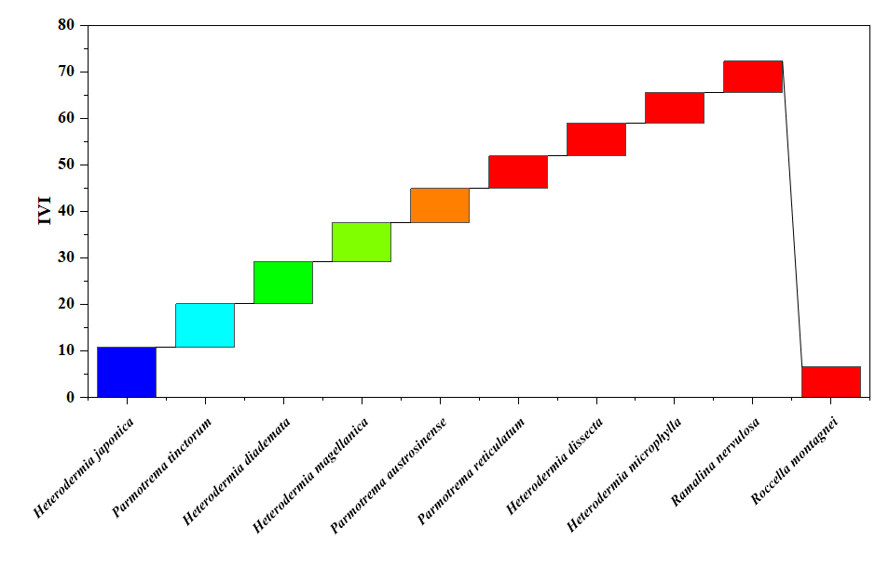
Fig: 4. Comparative Importance Value Index (IVI) of dominant lichen species
The Important index value (IVI), which combines relative frequency, relative density and relative abundance, provides an overall measure of ecological significance. IVI values ranged from 10.82 to 1.59 (Fig. 5). H. japonica as the most important species with the highest IVI (10.82) followed by P. tinctorium (9.27), H. diademata (9.14) and H. magellanica (8.35), indicating their dominant role in lichen community in the study area, whereas the lowest IVI was observed in Pyxine petricola var. pallida (1.59). Overall, H. japonica showed as the most dominant and commonly distributed lichen species in the study area. A high IVI reflects the dominance and ecological success of a species, attributed to its strong regenerative capacity and greater ecological amplitude (Thakur and Khare, 2009). Conversely, H. japonica showed a lower IVI value (0.39) in the Western Himalaya, India (Gupta et al., 2018).
The site wise variation in lichen diversity across the ten study sites using standard diversity indices summarizes (Table 2 and fig. 4). Species richness (S), ranging from 4 to 28, it reveals the variety of species present in a specific area and is commonly used in environmental monitoring and conservation assessment. The total number of individuals (N) also showed marked variation, with the highest abundance recorded at S1 (661) and the lowest at S8 (103), indicating differences in population size and habitat suitability among sites. The Shannon-Wiener diversity index (H′) revealed moderate to high diversity across sites, with values ranging from 1.32 to 3.17. Higher H′ values at Sites S1 (3.17) and S3 (3.00) indicate greater species diversity and a more even distribution of individuals, whereas lower values at S8 (1.32) and S10 (1.76) suggest reduced diversity and dominance by fewer species. The Shannon-Wiener diversity values (H′) recorded in the present study was comparable to those reported from the Western Ghats (Shravanakumara et al., 2010). Simpson’s diversity index (1-D) values ranged from 0.73 to 0.95, indicating generally high diversity across most sites. Sites S1 and S3 (0.95) exhibited the highest Simpson diversity, reflecting low dominance and high species heterogeneity, while S2 (0.31) showed comparatively lower diversity, suggesting dominance of a few species. A low Simpson’s index indicates that dominance within a community is shared by only one or two species. Several studies have reported diversity values comparable to those observed in the present study (Knight, 1975; Vignesh et al., 2022).
Table: 3 Site wise diversity indices of lichen species across ten sites
S. No | Sites | S | N | H’ | 1-D
 | S1 | 28 | 661 | 3.17 | 0.95
 | S2 | 18 | 412 | 2.63 | 0.31
 | S3 | 21 | 538 | 3.00 | 0.95
 | S4 | 11 | 265 | 2.33 | 0.90
 | S5 | 8 | 229 | 1.97 | 0.85
 | S6 | 11 | 288 | 2.39 | 0.91
 | S7 | 8 | 218 | 2.04 | 0.87
 | S8 | 4 | 103 | 1.32 | 0.73
 | S9 | 13 | 354 | 2.51 | 0.92
 | S10 | 6 | 150 | 1.76 | 0.83
1- Kaviaruvi; 2- Attakatti; 3- Poonachi; 4- Iyerpadi; 5- Kavarkal; 6- Urulikkal; 7- Manamboly; 8- Sheikalmudi; 9- Chinnakallar; 10- Periyakallar; S- Species richness; N- No. of individuals; H’- Shannon-Wiener Index; 1-D- Simpson’s Index.
The results suggest an inverse relationship between Shannon-Wiener and Simpson’s indices, where sites with higher Shannon-Wiener values exhibit lower Simpson’s dominance values vice versa. The observed variation in biodiversity across sites reflects differences in ecological conditions influenced by factors such as habitat type, anthropogenic disturbance and environmental variables (Balu et al., 2021; Sharath & Jabeen, 2021).
Similarity Index for the sampling sites
The Sørensen similarity index was used to assess the degree of similarity among sites based on species presence–absence and abundance data, with values ranging from 0 (completely dissimilar) to 1 (completely similar) (Darshni et al., 2025). A lichen diversity survey conducted across ten sampling sites documented a total of 81 species, and inter-site compositional similarity was quantified using the Sørensen similarity index (Table 4). S1 and S2 are positioned close to each other on the left side of the ordination, indicating moderate similarity in their lichen assemblages. S3 and S4 occur very close together near the centre of the plot, showing high similarity in species composition. These sites share many lichen species and likely represent a core lichen community typical of the study area. S5 and S6 are also located near the centre and close to S3 and S4, indicating moderate to high similarity with the core group. These sites share several species with the central cluster but show slight differentiation. S7 is positioned to the right of the central cluster, indicating a distinct but partially overlapping lichen community. S8 lies further to the right and away from most sites, reflecting low similarity with other sites. S9 is located toward the upper part of the ordination, showing clear separation from other sites. S10 is placed at the lower extreme of the plot, indicating very low similarity with other sites.
Table: 4 Sørensen similarity matrix between and within the study sites
 | S2 | S3 | S4 | S5 | S6 | S7 | S8 | S9 | S10
S1 | 0.30 | 0.16 | 0.10 | 0.00 | 0.00 | 0.11 | 0.00 | 0.00 | 0.00
S2 |  | 0.10 | 0.21 | 0.08 | 0.07 | 0.08 | 0.09 | 0.00 | 0.00
S3 |  |  | 0.31 | 0.14 | 0.19 | 0.07 | 0.08 | 0.12 | 0.22
S4 |  |  |  | 0.11 | 0.09 | 0.11 | 0.00 | 0.08 | 0.24
S5 |  |  |  |  | 0.21 | 0.13 | 0.00 | 0.10 | 0.14
S6 |  |  |  |  |  | 0.22 | 0.13 | 0.08 | 0.24
S7 |  |  |  |  |  |  | 0.00 | 0.29 | 0.14
S8 |  |  |  |  |  |  |  | 0.12 | 0.00
S9 |  |  |  |  |  |  |  |  | 0.11
S1- Kaviaruvi; S2- Attakatti; S3- Poonachi; S4- Iyerpadi; S5- Kavarkal; S6- Urulikkal; S7- Manamboly; S8- Sheikalmudi; S9- Chinnakallar; S10- Periyakallar
Pearson correlation coefficient and principal components analysis (PCA)
The Pearson correlation coefficient matrix revealed strong positive relationships among the major lichen diversity parameters (Fig. 5). Species richness (S) showed a very strong positive correlation with the number of individuals (N) (r = 0.99), indicating that habitats with higher lichen abundance also supported greater species richness. Similarly, species richness was strongly correlated with the Shannon-Wiener diversity index (H′) (r = 0.94), while abundance exhibited a strong positive association with Shannon diversity (r = 0.96). These findings suggest that species-rich communities contribute substantially to overall diversity and ecosystem stability. Similar positive relationships between abundance, species richness, and diversity indices have been reported in epiphytic lichen communities and forest ecosystems, where increased species abundance enhances community complexity and ecological resilience (Nash, 2008; Giordani et al., 2012). In contrast, Simpson’s diversity index (1-D) exhibited weak positive correlations with species richness (r = 0.035), abundance (r = 0.11), and Shannon diversity (r = 0.13). The relatively low correlations indicate that dominance patterns among lichen species remained comparatively stable across sampling sites. Similar observations have been reported in mature forest ecosystems where high species heterogeneity reduces the influence of dominant taxa on overall diversity patterns (Aptroot and Seaward, 2003). The diversity analysis recorded a total of 81 lichen species in the study area. The Shannon-Wiener diversity index (H′ = 1.363) indicated moderate species diversity, whereas the high Simpson’s diversity value (1-D = 0.98) reflected high species heterogeneity and low dominance by individual species. High Simpson’s diversity values have been reported from tropical and montane forests characterized by favourable microclimatic conditions and diverse substrate availability that support the coexistence of numerous lichen taxa (Wolseley et al., 2006; Vignesh et al., 2022). The observed diversity pattern therefore suggests that the ATR provides suitable environmental conditions for the establishment and persistence of diverse lichen assemblages.
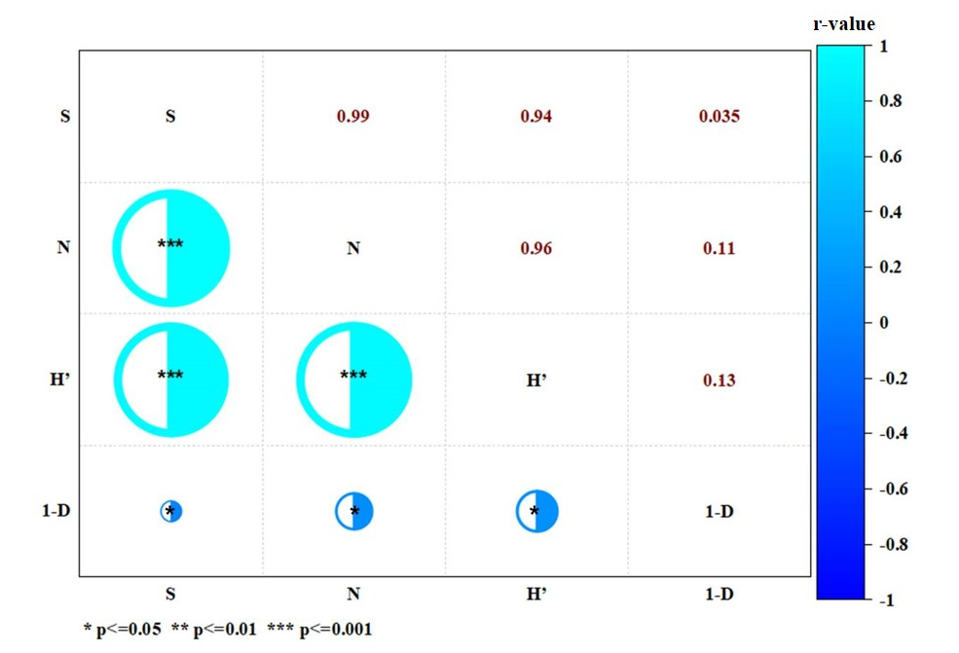
Fig. 5. Pearson correlation coefficient analysis among diversity indices of lichen species
PCA was performed using ecological parameters including F, D, A, RF, RD, RA, and IVI (Fig. 6). The first two principal components explained 99.40% of the total variation, with PC1 accounting for 78.61% and PC2 accounting for 20.79%. The high cumulative variance indicates that the selected ecological variables effectively captured the major patterns of variation within the lichen community. Similar PCA studies on lichen and forest vegetation communities have demonstrated that the first two principal components often explain a substantial proportion of ecological variability and are effective in identifying dominant species and community gradients (Nimis et al., 2002; Giordani et al., 2012). The PCA biplot showed that SP1, SP2, SP3, SP4, SP5, and SP10 were distinctly separated from the main cluster, indicating their greater influence on community composition.
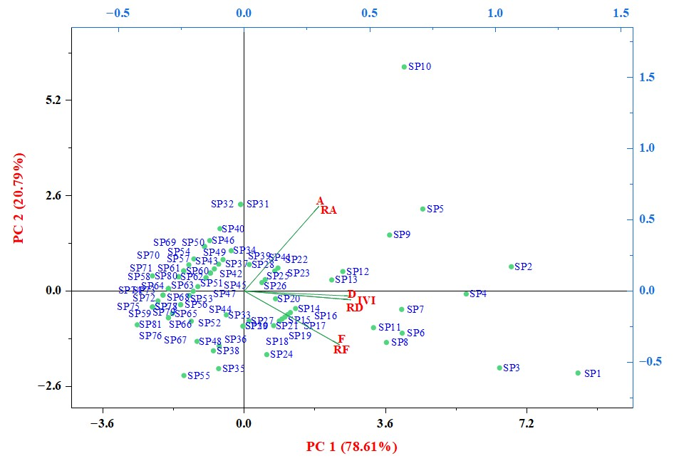
Fig. 6. Principal Components Analysis (PCA) of diversity indices of lichen species
Species SP10 exhibited a strong association with abundance and relative abundance, suggesting its dominance in terms of population size. In contrast, SP1, SP2, SP3, and SP4 were closely associated with density, relative density, frequency, relative frequency, and IVI, indicating their ecological importance and wider distribution within the study area. Similar patterns have been reported in phytosociological studies where a limited number of dominant species account for a major proportion of community variation, while the majority of species contribute moderately to ecosystem structure and function (Odum and Barrett, 2005). Most of the remaining species were clustered near the origin of the ordination space, reflecting similar ecological characteristics and moderate contributions to the measured variables. Such clustering suggests overlapping ecological niches and comparable responses to environmental conditions. Species positioned farther from the origin contributed more strongly to community differentiation and may therefore serve as indicator species for monitoring habitat quality and ecological change. The PCA highlights the coexistence of a few ecologically influential species alongside a larger group of species with similar ecological attributes, demonstrating the heterogeneous nature of lichen assemblages in the ATR.

Conclusions
The present study documents substantial lichen diversity in the Anamalai Tiger Reserve, with 81 species representing 27 genera and 12 families recorded from ten study sites. The results show clear differences in lichen distribution among forest types, with evergreen forests supporting greater species richness than moist deciduous and dry deciduous forests. This pattern indicates that humidity, vegetation structure, altitude, and substrate availability influence lichen assemblages in the reserve. Corticolous and foliose lichens were the dominant ecological and morphological groups, suggesting that tree bark provides an important substrate for lichen colonization in the study area. Among the recorded taxa, Heterodermia japonica showed the highest ecological importance and was the most widely distributed species based on frequency, density, and importance value index. The occurrence of four taxa as new records for Tamil Nadu expands the known lichen flora of the state. Overall, the study provides useful baseline data for future ecological monitoring, taxonomic studies, and conservation planning in the Southern Western Ghats.
Limitations
The study was limited to selected sites within the Anamalai Tiger Reserve and covered three major forest types. Although 50 plots were surveyed, the sampling did not include all habitat types and seasonal conditions present in the reserve. The results therefore represent the observed diversity within the sampled areas and should not be interpreted as a complete inventory of all lichens in the reserve. Some ecological patterns, including the influence of altitude, rainfall, humidity, and host-tree characteristics, require more detailed quantitative assessment. Molecular identification was not included, and species confirmation was based on morphological, anatomical, and chemical characters. Long-term monitoring across additional sites and seasons would help clarify changes in species composition, habitat preference, and the indicator value of lichens in the region.

COMPETING INTERESTS DISCLAIMER:
Authors have declared that they have no known competing financial interests OR non-financial interests OR personal relationships that could have appeared to influence the work reported in this paper.

REFERENCES
- Aptroot A. & Seaward M.R.D. 2003. - Freshwater lichens. Fungal Diversity Research Series, 10, 101-110.
- Awasthi DD, (1988). A key to the macrolichens of India, Nepal and Sri Lanka. Bibliotheca Lichenologica 40: 1-337.
- Awasthi DD, (2007). A Compendium of the Macrolichens from India, Nepal and Sri Lanka. Bishen Singh Mahendra Pal Singh, DehraDun, India, 1-580.
- Balaji, P., & Hariharan, G. N. (2013). Diversity of Macrolichens in Bolampatti II Forest Range (Siruvani Hills), Western Ghats, Tamil Nadu, India. International Scholarly Research Notices, 2013(1), 124020. https://doi.org/10.1155/2013/124020
- Balu, G., Rasmi, A. R., Sequeira, S., & Haridas, B. (2021). Diversity and distribution of macro lichens from Kalpetta Municipality of Wayanad District, Kerala, India. Journal of Threatened Taxa, 13(14), 20253-20257. https://doi.org/10.11609/jott.6706.13.14.20253-20257
- Calcott, M. J., Ackerley, D. F., Knight, A., Keyzers, R. A., & Owen, J. G. (2018). Secondary metabolism in the lichen symbiosis. Chemical Society Reviews, 47(5), 1730-1760. https://doi.org/10.1039/C7CS00431A
- Canters, K. J., Schöllerj, H., Ott, S., & Jahns, H. M. (1991). Microclimatic influences on lichen distribution and community development. The Lichenologist, 23(3), 237-252. https://doi.org/10.1017/S0024282991000403
- Curtis J.T. and McIntosh R.P. (1950). The interrelations of certain analytic and synthetic phytosociological characters. Ecology. 31: 434-455.
- Dalui, Tirthankar & Kushari, Saheli & Chowdhury, Soumik & Mondal, Ankita. (2024). Faunal Diversity in Western Ghats, India: A Review. Journal of Advanced Zoology. 45. 10.53555/jaz.v45i4.4750.
- Darshni, P., Gupta, P., Shrivastava, A., Bhat, M., Dhupper, Renu and Sing, L (2025). Assessing lichen diversity in the Himalayan Region of Reasi, Jammu and Kashmir, International Journal of Environmental Sciences, 11 (2): 714-725. https://doi.org/10.64252/0gcs3z04
- Divakar PK, Upreti DK, (2005). Parmelioid lichens in India (a revisionary study). Bishen Singh, Mahendra Pal Singh, Dehradun, India.
- Faisal, S., Iqbal, Z., Shah, G. M., & Haq, F. (2025). Diversity, distribution, and environmental influences on epiphytic lichens in the Hazara Division, Khyber Pakhtunkhwa. Ecological Frontiers. https://doi.org/10.1016/j.ecofro.2025.08.008
- Fryday, A. M. (2001). The lichen vegetation associated with areas of late snow-lie in the Scottish Highlands. The Lichenologist, 33(2), 121-150. https://doi.org/10.1006/lich.2000.0308
- Ganesan V, (2019). History of Anamalais - Teak to Tiger, Anamalai Tiger Conservation Foundation, Tamil Nadu Trust, Pollachi.
- Giordani, P., Brunialti, G., Bacaro, G., Nascimbene, J., (2012). Functional traits of epiphytic lichens as potential indicators of environmental conditions in forest ecosystems. Ecol. Indic. 18, 413–420. https://doi.org/10.1016/j.ecolind.2011.12.006
- Gupta, S., Bajpai, O., Rai, H., Upreti, D. K., Sharma, P. K., & Gupta, R. K. (2018). Untangling Quantitative Lichen Diversity in and Around Badrinath Holy Pilgrimage of Western Himalaya, India. Journal of Graphic Era University, 36-46.
- Haridas B, Aliyarukunju S, (2024). A Preliminary Checklist on the Lichen Flora of Agasthyamalai Biosphere Reserve, Kerala, India. Cryptogam Biodiversity and Assessment 8(01):13-22.https://doi.org/10.21756/cab.v8i1.02
- Hawksworth DL, Grube M (2020). Lichens redefined as complex ecosystems. New Phytologist. https://doi.org/10.1111/nph.16630
- Hyde KD, Noorabadi MT, Thiyagaraja V, Mq H, Johnston PR, Wijesinghe SN, Armand A, Biketova AY, Kwt C, Erdogdu M, Zw G (2024). The 2024 Outline of Fungi and fungus-like taxa. Mycosphere 15(1): 5146-6239. https://doi.org/10.5943/mycosphere/15/1/25
- Jackson, T. A. (2015). Weathering, secondary mineral genesis, and soil formation caused by lichens and mosses growing on granitic gneiss in a boreal forest environment. Geoderma, 251, 78-91.
- Joshi S, Upreti DK (2016). Lichens of the Western Ghats new to India. Curr Res Environ Appl Mycol 6(4): 328-333.
- Kalidoss. R, Merlin. J, Charumathy. M, Surekha. S, Arun Prasath. K, Mariraj. M, Shenbagam. M, Rajaprabu. N, and Ponmurugan. P , 2019. Lichen collections from Nilgiris of Western Ghats in Tamil Nadu and screening for antimicrobial, antioxidant efficacy of some selected species, Pramana research journal, 9 (6).
- Knight DH (1975) A phytosociological analysis of species-rich tropical forest on Barro Colorado Island, Panama. Ecol Monogr, 45(3): 259–284. https://doi.org/10.2307/1942424
- Kumar, A., Thangjam, N. M., Laldingliani, T. B. C., & Singh, C. B. (2024). Lichens in the Himalayan region: Present and future perspectives. In High-Value Plants (pp. 243-262). Apple Academic Press.
- Lucking R, Hodkinson BP, Leavitt SD (2017). The 2016 classification of lichenized fungi in the Ascomycota and Basidiomycota - Approaching one thousand genera. The Bryologist 119(4): 361-416. https://doi.org/10.1639/0007-2745-119.4.361
- Nash, T.H. (2008) Lichen Biology. 2nd Edition, Cambridge University Press, Cambridge. http://dx.doi.org/10.1017/CBO9780511790478
- Nayaka S, (2014). Methods and techniques in collection, preservation and identification of lichens. Plant Toxonomy and Biosystematics: Classical and Modern Methods 101-105.
- Nayaka S, Haridas B, (2024). Lichen-Forming and Lichenicolous Fungi of the Western Ghats, India. In Biodiversity Hotspot of the Western Ghats and Sri Lanka, 89-107. Apple Academic Press. https://doi.org/10.1201/9781003408758-6
- Nayaka S, Upreti DK (2006). Status of lichen diversity in Western Ghats, India. Sahyadri E-News, Western Ghats Biodiverstity Information System 16: 1-28.
- Nayaka, S., D.K. Upreti & P.K. Divakar (2001). Distribution and diversity of lichens in Meghamalai Wildlife Sanctuary, Kambam District, Tamil Nadu, India. Biological Memoirs 27(1): 51.
- Nayaka, S., Upreti, D. K., & Khare, R. (2011). Diversity and distribution of lichens in Katarniaghat Wildlife Sanctuary, Uttar Pradesh. The Journal of Indian Botanical Society, 90(3and4), 360-366.
- Nimis, P. L., Scheidegger, C., & Wolseley, P. A. (2002). Monitoring with lichens—monitoring lichens: an introduction. In Monitoring with lichens—monitoring lichens (pp. 1-4). Dordrecht: Springer Netherlands.
- Odum EP, Barrett GW (2005) Fundamentals of Ecology, 5th edn. Thomson Brooks/Cole, Belmont.
- Orange A, James PW, White FJ, (2001). Microchemical methods for the identification of lichens. Twayne Publishers.
- Phillips, W. J. (1972). An evaluation of the relative importance index to the study of forest vegitation on Mont St. Hilaire, Quebec, Canada.
- Phukhamsakda C, Nilsson RH, Bhunjun CS, De Farias ARG, Sun YR, Wijesinghe SN, Raza M, Bao DF, Lu L, Tibpromma S, Dong W (2022). The numbers of fungi: contributions from traditional taxonomic studies and challenges of meta barcoding. Fungal Diversity 114: 327–386. https://doi.org/10.1007/s13225-022-00502-3
- Pielou, E. C. (1966). Species-diversity and pattern-diversity in the study of ecological succession. Journal of theoretical biology, 10(2), 370-383.https://doi.org/10.1016/0022-5193(66)90133-0
- Rajaprabu N, Ponmurugan P. Additions to the cryptogamic lichen biota from the Republic of India from Tamil Nadu, 21 February 2023, PREPRINT (Version 1) available at Research Square https://doi.org/10.21203/rs.3.rs-2604149/v1
- Reddy, M. A., Nayaka, S., Shankar, P. C., Reddy, S. R., & Rao, B. R. P. (2011). New distributional records and checklist of lichens for Andhra Pradesh, India. Indian Forester, 137(12), 1371-1376.
- Shannon, C. E., & Weiner, W. (1949). The mathematical theory of communication. University of Illinois Press, Urbana.
- Sharath, K. P., & Jabeen, F. T. Z. (2021). Diversity and distribution of Lichens in Mattavara forest of Chikkamagaluru, Karnataka, India. International Journal of Botany Studies, 6 (5): 246-251.
- Shravanakumara, S., Vinayaka, K. S., Kumaraswamy Udupa, E. S., Shashirekha, B., Praveena, V., & Krishnamurthy, Y. L. (2010). Diversity and host specificity of lichens in Koppa Taluk of Central Western Ghats, Karnataka, India. Indian Journal of Forestry, 33(3), 437-442.
- Simpson, E. H. (1949). Measurement of diversity. Nature, 163, 688.https://doi.org/10.1038/163688a0
- Sinha GP, (2021). Documentation of lichen diversity in India. ILS eLetter 1: 5-7.
- Sinha GP, Nayaka S, Mishra GK, (2024). A comprehensive checklist of lichens from India-2024. Cryp Biodivers Assess 8(02): 1-134. https://doi.org/10.21756/cab.v8i2.01
- Sørenson, T. (1948). A method of establishing groups of equal amplitude in plant sociology based on similarity of species content and its application to analyses of the vegetation on Danish commons. Biol Skar, 5, 1.
- Subbaiyan R, Ganesan A, Dhanuskodi S, (2023). Ecolichenology of Eastern Ghats diversity against climatic fluctuations in Kolli Hills, India. Biodiversitas J. Biolog Divers 24(1). https://doi.org/10.13057/biodiv/d240171
- Thakur, A. S., & Khare, P. K. (2009). Composition of forest vegetation and floristics of Sagar district, central India. Journal of the Indian Botanical Society 88(1&2): 11–17.
- Tumur A, Mamut R, Seaward MR, (2025). Diversity and Elevational Levels of Lichens in Western Tianshan National Nature Reserve in Xinjiang, China. Divers 17(2): 102. https://doi.org/10.3390/d17020102
- Vignesh, A., Sivalingam, R., & Vasanth, K. (2022). Diversity of woody flora and physico-chemical attributes of soil in the Nilgiri Hills, Tamil Nadu, India. Proceedings of the National Academy of Sciences, India Section B: Biological Sciences, 92(1), 95-103. https://doi.org/10.1007/s40011-021-01279-2
- Wolseley, P. A., James, P. W., Theobald, M. R., & Sutton, M. A. (2006). Detecting changes in epiphytic lichen communities at sites affected by atmospheric ammonia from agricultural sources. The Lichenologist, 38(2), 161-176.

Supplementary document

Table S1: List of lichen species identified in Anamalai Tiger Reserve, Western Ghats, Tamil Nadu, India
S. No | Name of the species | Family | Growth forms | Substratum | Collection localities |  |  |  |  |  |  |  |  |  | Forest Type
 |  |  |  |  | 1 | 2 | 3 | 4 | 5 | 6 | 7 | 8 | 9 | 10
 | Heterodermia japonica (Satô) Swinsco & Krog. | Physciaceae | Foliose | Moss | - | - | + | + | + | + | - | - | - | + | MDF, EV
 | Parmotrema tinctorum (Despr. ex Nyl.) Hale | Parmeliaceae | Foliose | Bark & Rock | + | + | + | - | - | - | - | - | - | - | DDF, MDF
 | Heterodermia diademata (Taylor) D.D. Awasthi | Physciaceae | Foliose | Bark | - | - | + | - | - | + | - | + | + | - | MDF, EV
 | Heterodermia magellanica (Zahlbr.) Swinscow & Krog | Physciaceae | Foliose | Moss | - | - | - | - | + | - | + | - | + | - | EV
 | Parmotrema austrosinense (Zahlbr.) Hale | Parmeliaceae | Foliose | Bark | + | + | - | - | - | - | - | - | - | - | DDF, MDF
 | Parmotrema reticulatum (Taylor) M. Choisy | Parmeliaceae | Foliose | Bark | - | - | + | - | - | + | - | - | - | + | MDF, EV
 | Heterodermia dissecta (Kurok.) D.D. Awasthi | Physciaceae | Foliose | Bark | + | - | + | + | - | - | - | - | - | - | DDF, MDF, EV
 | Heterodermia microphylla (Kurok.) Skorepa | Physciaceae | Foliose | Bark | - | + | - | + | - | - | + | - | - | - | MDF, EV
 | Ramalina nervulosa (Müll.Arg.) Abbayes | Ramalinaceae | Fruticose | Bark | + | + | - | - | - | - | - | - | - | - | DDF, MDF
 | Roccella montagnei Bél. | Rocellaceae | Fruticose | Bark | + | - | - | - | - | - | - | - | - | - | DDF
 | Parmelinella wallichiana (Taylor) Elix & Hale | Parmeliaceae | Foliose | Bark | - | - | + | + | - | - | - | - | - | + | MDF, EV
 | Parmotrema planatilobatum (Hale) Hale | Parmeliaceae | Foliose | Bark | - | - | - | - | - | - | - | - | + | + | EV
 | Heterodermia hypoleuca (Ach.) Trevis. | Physciaceae | Foliose | Bark | - | - | + | - | - | - | - | - | + | - | MDF, EV
 | Leptogium javanicum Mont. | Collemataceae | Foliose | Bark | - | - | - | - | - | - | + | - | - | + | EV
 | Parmelinella simplicior (Hale) Elix & Hale | Parmeliaceae | Foliose | Bark | - | + | - | - | - | + | - | - | - | - | MDF, EV
 | Heterodermia speciosa (Wulfen) Trevis. | Physciaceae | Foliose | Bark | - | - | + | - | - | + | - | - | - | - | MDF, EV
 | Heterodermia obscurata (Nyl.) Trevis. | Physciaceae | Foliose | Rock | - | - | + | + | - | - | - | - | - | - | MDF, EV
 | Leptogium denticulatum Nyl. | Collemataceae | Foliose | Bark | + | - | - | - | - | - | + | - | - | - | DDF, EV
 | Heterodermia dactyliza (Nyl.) Swinscow & Krog* | Physciaceae | Foliose | Rock | - | - | - | - | - | + | + | - | - | - | EV
 | Heterodermia boryi (Fée) Kr. P. Singh & S.R. Singh | Physciaceae | Foliose | Rock & Bark | - | + | - | + | - | - | - | - | - | - | MDF, EV
 | Parmotrema indicum Hale | Parmeliaceae | Foliose | Bark | - | - | - | - | - | - | + | - | + | - | EV
 | Usnea stigmatoides G. Awasthi | Parmeliaceae | Fruticose | Rock | - | - | - | - | + | + | - | - | - | - | EV
 | Ramalina pacifica Asahina | Ramalinaceae | Fruticose | Bark | - | - | + | - | + | - | - | - | - | - | MDF, EV
 | Heterodermia angustiloba (Müll.Arg.) D.D. Awasthi | Physciaceae | Foliose | Rock | + | - | - | + | - | - | - | - | - | - | DDF, EV
 | Ramalina conduplicans Vain. | Ramalinaceae | Fruticose | Bark | + | - | + | - | - | - | - | - | - | - | DDF, MDF
 | Parmotrema praesorediosum (Nyl.) Hale | Parmeliaceae | Foliose | Bark & Rock | + | - | + | - | - | - | - | - | - | - | DDF, MDF
 | Collema furfuraceum (Schaer.) Du Rietz | Collemataceae | Foliose | Bark | - | - | + | - | - | - | + | - | - | - | MDF
 | Usnea galbinifera Asahina | Parmeliaceae | Fruticose | Bark | - | - | - | + | - | - | - | - | + | - | EV
 | Parmotrema hababianum (Gyeln.) Hale | Parmeliaceae | Foliose | Bark | - | + | + | - | - | - | - | - | - | - | MDF
 | Polyblastidium hypocaesium (Yasuda ex Räsänen) D.D. Awasthi | Physciaceae | Foliose | Bark | - | - | + | + | - | - | - | - | - | - | MDF, EV
 | Heterodermia rubricosa (Stirt.) Poelt | Physciaceae | Foliose | Bark | - | - | - | - | - | - | - | + | - | - | MDF
 | Usnea ghattensis G. Awasthi | Parmeliaceae | Fruticose | Bark | - | - | - | - | - | + | - | - | - | - | EV
 | Dirinaria confluens (Fr.) D.D. Awasthi | Caliciaceae | Foliose | Rock | + | + | - | - | - | - | - | - | - | - | DDF, MDF
 | Usnea stigmata Motyka | Parmeliaceae | Fruticose | Bark | - | - | - | - | - | - | - | - | + | - | EV
 | Cladonia fruticulosae Kremp. | Cladoniaceae | Fruticose | Bark & Soil | - | + | - | - | + | - | - | - | - | - | MDF, EV
 | Cladonia ochrochlora Florke | Cladoniaceae | Fruticose | Bark | - | - | - | - | - | - | + | - | + | - | EV
 | Lepraria lobificans Nyl. | Cladoniaceae | Crustose | Soil | - | - | - | - | - | - | - | - | + | - | EV
 | Dirinaria applanata (Fée) D.D. Awasthi | Caliciaceae | Foliose | Bark | + | + | - | - | - | - | - | - | - | - | DDF, MDF
 | Parmotrema crinitoides J.C. Wei | Parmeliaceae | Foliose | Bark | - | - | - | - | - | - | - | + | - | - | EV
 | Remototrachyna flexilis (Kurok.) Divakar & A. Crespo | Parmeliaceae | Foliose | Bark | - | - | - | - | - | - | - | - | + | - | EV
 | Hypotrachyna cirrhatum (Fr.) Divakar, A.Crespo, Sipman, Elix & Lumbsch | Parmeliaceae | Foliose | Bark | - | - | - | - | - | + | - | - | - | - | EV
 | Heterodermia comosa (Eschw.) Follmann & Redón | Physciaceae | Foliose | Bark | - | - | - | - | - | - | - | - | + | - | EV
 | Heterodermia hypochraea (Vain.) Swinscow & Krog* | Physciaceae | Foliose | Bark | - | - | - | - | + | - | - | - | - | - | EV
 | Parmotrema crinitum (Ach.) M. Choisy | Parmeliaceae | Foliose | Bark | + | - | - | - | - | - | - | - | - | - | DDF
 | Hypotrachyna boquetensis (Hale) Hale | Parmeliaceae | Foliose | Bark | - | - | - | - | + | - | - | - | - | - | EV
 | Hypotrachyna crenata (Kurok.) Hale | Parmeliaceae | Foliose | Bark | - | - | - | - | - | + | - | - | - | - | EV
 | Leprocaulon pseudoarbuscula (Asahina) I.M. Lamb & A. Ward | Leprocaulaceae | Squmolous | Rock | - | - | - | - | - | - | - | - | + | - | EV
 | Pyxine cocoes (Sw.)Nyl. | Caliciaceae | Foliose | Bark | + | + | - | - | - | - | - | - | - | - | DDF, MDF
 | Parmotrema andinum (Müll.Arg.) Hale | Parmeliaceae | Foliose | Bark | + | - | - | - | - | - | - | - | - | - | DDF
 | Ramalina leiodea (Nyl.) Nyl. | Ramalinaceae | Fruticose | Bark | - | - | + | - | - | - | - | - | - | - | MDF
 | Parmotrema kamatii Patw. & Prabhu | Parmeliaceae | Foliose | Soil | - | - | - | + | - | - | - | - | - | - | EV
 | Sticta weigelii (Ach.) Vain. | Peltigeraceae | Foliose | Bark | - | + | - | + | - | - | - | - | - | - | MDF, EV
 | Parmotrema mesotropum (Müll.Arg.) Hale | Parmeliaceae | Foliose | Bark | + | - | - | - | - | - | - | - | - | - | DDF
 | Parmotrema xanthinum (Müll.Arg.) Hale | Parmeliaceae | Foliose | Bark | - | - | - | - | - | + | - | - | - | - | EV
 | Bulbothrix isidiza (Nyl.) Hale | Parmeliaceae | Foliose | Bark | + | + | - | - | - | - | - | - | - | - | DDF, MDF
 | Leptogium pichneum (Ach.) Malme. | Collemataceae | Foliose | Bark | - | - | + | - | - | - | - | - | - | - | MDF
 | Usnea pectinata Stirt | Parmeliaceae | Fruticose | Bark | - | - | - | - | + | - | - | - | - | - | EV
 | Dirinaria consimilis (Stirt.) D.D. Awasthi | Caliciaceae | Foliose | Bark | + | - | - | - | - | - | - | - | - | - | DDF
 | Dirinaria papillulifera (Nyl.) D.D. Awasthi | Caliciaceae | Foliose | Bark | + | - | - | - | - | - | - | - | - | - | DDF
 | Myelochroa xantholepis (Mont. & Bosch) Elix & Hale | Parmeliaceae | Foliose | Bark | - | - | - | - | - | - | - | - | + | - | EV
 | Phyllopsora furfuracea (Pers.) Zahlbr. | Ramalinaceae | Foliose | Bark | - | + | - | - | - | - | - | - | - | - | MDF
 | Leptogium cyanescens (Rabenh.) Körb. | Collemataceae | Foliose | Bark | - | - | + | - | - | - | - | - | - | - | MDF, EV
 | Leptogium isidiosellum (Riddle) Sierk | Collemataceae | Foliose | Bark | - | + | - | - | - | - | - | - | - | - | MDF
 | Pyxine subcinerea Stirt. | Caliciaceae | Foliose | Bark | + | - | - | - | - | - | - | - | - | - | DDF
 | Diorygma hieroglyphicum (Pers.) Staiger & Kalb | Graphidaceae | Crustose | Bark | + | - | - | - | - | - | - | - | - | - | DDF
 | Cetrelia braunsiana (Müll. Arg.) W.L. Culb. & C.F. Culb* | Parmeliaceae | Foliose | Bark | - | - | - | - | - | - | - | - | - | + | EV
 | Collema actinoptychum Nyl. | Collemataceae | Foliose | Bark | + | - | - | - | - | - | - | - | - | - | DDF
 | Diploschistes candissimus (Kremp.) Zahlbr. | Diploschistaceae | Crustose | Rock | + | - | - | - | - | - | - | - | - | - | DDF
 | Physcia tribacoides Nyl. | Physciaceae | Foliose | Bark | + | - | - | - | - | - | - | - | - | - | DDF
 | Pseudocyphellaria aurata (Ach.) Vain. | Peltigeraceae | Foliose | Bark | - | + | - | - | - | - | - | - | - | - | MDF
 | Pyxine austroindica D.D. Awasthi | Caliciaceae | Foliose | Bark | - | - | + | - | - | - | - | - | - | - | MDF
 | Pyxine cognata Stirt. | Caliciaceae | Foliose | Bark | + | - | - | - | - | - | - | - | - | - | DDF
 | Pyxine sorediata (Ach.) Mont. | Caliciaceae | Foliose | Bark | - | - | + | - | - | - | - | - | - | - | MDF
 | Collema flaccidum (Ach.) Ach. | Collemataceae | Foliose | Bark | + | - | - | - | - | - | - | - | - | - | DDF
 | Physcia dimidiata (Arn.) Nyl. | Physciaceae | Foliose | Bark | - | - | + | - | - | - | - | - | - | - | MDF
 | Lithocalla ecorticata (J.R. Laundon) Orange | Ramalinaceae | Crustose | Rock | + | - | - | - | - | - | - | - | - | - | DDF
 | Dirinaria aegialita (Afzel. ex Ach.) B.J. Moore | Caliciaceae | Foliose | Bark | + | - | - | - | - | - | - | - | - | - | DDF
 | Physcia aipolia (Ehrh. ex Humb.) Fürnr. | Physciaceae | Foliose | Bark | - | + | - | - | - | - | - | - | - | - | MDF
 | Pseudocyphellaria crocata (L.) Vain. | Peltigeraceae | Foliose | Bark | - | + | - | - | - | - | - | - | - | - | MDF
 | Strigula sp. | Strigulaceae | Crustose | Leaf | - | - | - | - | - | - | - | + | - | - | EV
 | Pyxine petricola var. pallida Swinscow & Krog* | Caliciaceae | Foliose | Bark | + | - | - | - | - | - | - | - | - | - | DDF
1- Kaviaruvi; 2- Attakatti; 3- Poonachi; 4- Iyerpadi; 5- Kavarkal; 6- Urulikkal; 7- Manamboly; 8- Sheikalmudi; 9- Chinnakallar; 10- Periyakallar; DDF- Dry Deciduous forest; MDF- Moist Deciduous forest; EV- Evergreen Forest; *New record to Tamil Nadu.

