Laboratory based Evaluation of Plant-Based Mosquito Repellents Activity against Adult Mosquitoes

Abstract
The present study focus on formulation of plant based mosquito repellents in the shape coils and incense sticks as fumigants and its laboratory based evaluation against selected adult mosquitoes. Repellents were made from locally available botanical materials namely Cymbopogon citratus (lemongrass), Eucalyptus globulus (eucalyptus), Citrus maxima (pomelo peel) and Isodon tenifolius (khoiju). The different parts of these four plants have traditional knowledge on repellent activity for insects by local people. The prepared repellents were tested for repellence and knockdown effect under controlled (laboratory) systems. Results indicated significant mosquito repellence and moderate mortality rates with lemon grass (Cymbopogon citratus) and khoiju (Isodon ternifolius) leaves were found to be strong and effective repellence to mosquito among the selected four plants followed by pomelo and eucalyptus. This piece of work suggested that plant-based coils can serve as an effective, affordable, and environmentally sustainable alternative to synthetic mosquito coils. Repellence as one of the most accepted method being followed for a long period in the management of mosquitoes, this study support eco-friendly, cost- effective and locally available solutions. It also supports the traditional knowledge rooted from our ancestors and keeping them alive. Greater research on the specifics of the bioactive substances found in the chosen plants is required and larger field based evaluations are recommended to enhance their effectiveness and practical application.
Keywords
Mosquitoes, vectors, deathly diseases, control, plant-based coil, eco-friendly repellent.

- Introduction
Mosquitoes are among one of the most dangerous vectors of many life threatening diseases like malaria, dengue, hepatitis B and others [Kartz et al., 2008]. As female mosquitoes transmit pathogens while sucking on blood, spread the virus, protozoa and nematodes from an infected person to the healthy ones. Most of these diseases are wide spread in tropical and subtropical regions of the world including India. Beyond these medical and health impacts, such diseases pull back the workforce, productivity and hinder the economic development of the society.
As these mosquito borne diseases represent critical global challenges, urgent need for effective and sustainable vector control strategies like plant based mosquito coil preparation is one rational step for the control measures to repel or kill of this vector. Controlling mosquitoes is of utmost importance in the present-day scenario with rising number of mosquitos borne diseases (Fardin, 1998). The study for the production of plant based control measures are aggravated by several limitations, including insecticides resistance of mosquitoes to conventional synthetic chemicals after prolong used, environmental pollution as well as adverse effects on non-targeted organisms (WHO, 2012; Hemingway & Ranson, 2000).
In recent trends, attentions have been made towards eco-friendly and sustainable alternative instead of chemical coils. Use of Plant products is known as novel chemo therapeutants in pest management in different parts of the world, because of their biodegradable nature. (Hardin and Jackson, 2009). Some plants were also found to presence bioactive compound like citronellal, eucalyptol and flavonoid; these phytochemicals are found to disrupting the olfactory and nervous systems of mosquitoes thereby reducing their host seeking and survival (Isman, 2006; Nerio et al., 2010). In present study, four of the selected plant materials are used to evaluate their efficacy were tested and observed through repellent, knockdown and mortality effect against the mosquito vectors. The results obtained were quite promising and highlights the potential of plant- based formulations as a feasible, low cost and environment friendly tools for mosquito management.

- Materials and Methods
2.1 Plant Materials:
The following plant parts were employed and used for the preparation of botanical coil:
Lemongrass leaves (Cymbopogon citratus ) (Figure: 6 and 7)
Khoiju leaves (Isodon ternifolius) (Figure: 8 and 9)
Pomelo peel (Citrus maxima) (Figure: 10 and 11)
Eucalyptus leaves (Eucalyptus globulus) (Figure: 12 and 13)
All materials were collected from local residential areas except for the Khoiju leaves (Isodon ternifolius) from its natural habitat. A sample of each plant were identified and deposited to Dhanamanjuri University, Department of Botany with the herbarium voucher number DHM-002/2026 -Lemongrass (Cymbopogon citratus ); DHM-003/2026- Pomelo (Citrus maxima); DHM-004/2026- Khoiju (Isodon ternifolius) and DHM-005/2026- Eucalyptus (Eucalyptus globulus) respectively.
  - Plant Profile:

- Local Name: Lemongrass leaves
Scientific Name: Cymbopogon citratus
Family: Poaceae
Description: These herbs are fast growing, evergreen and aromatic plant. The height of the plant is about 1-1.5 metre. The leaves are green and smooth in fresh conditions.
Traditional use: Leaves of the plants are generally used for making herbal tea. But the essential oil extract from the plant are also found using as insect repellent (Susheela, P. and Radha, R., 2014)

- Local Name: Pomelo
Scientific Name: Citrus maxima
Family: Rutaceae
Description: Citrus maximum is a large fruit tree which is considered as the largest citrus fruit. It is found widely in tropical and subtropical regions of Asia. Tree length is about 5-15 metres tall with a rounded canopy; thorny, glossy green leaves and matured fruits peel appears yellow outside juicy inside the fruits.
Traditional use: People prefer the Juicy fruits to consume as sweet and refreshing juice in tropic and subtropical regions. Some local people use to dried pomelo peels as insect repellent including mosquitoes.

- Local Name: Khoiju leaves
Scientific Name: Isodon ternifolius
Family: Lamiaceae
Description: It is a prominent medicinal herbs belonging to mint family, Lamiaceae. Their leaves are verticillate in nature and height of about 0.5- 2 metres tall (WFO, 2026). This herb is commonly found growing in elevate bushy hill slopes.
Traditional use: This plant species have lot Indigenous Traditional Knowledge in the state, Manipur and the North-eastern India, Dried leaves of Khoiju are often burned with Leikham (Goniothalamus sesquipedalis) together at the home entrance during scared rituals (Sharma et al., 2024) and granary at the time of harvest particularly by Meitei people. Leaves extracts of Isodon ternifolius are found to have a significant anthelmintic property (Elangbam et al., 2026)

- Local Name: Eucalyptus leaves
Scientific Name: Eucalyptus globulus
Family: Myrtaceae
Description: Eucalyptus globulus is a fast growing evergreen plant. They are known for its aromatic foliage. Their immense heights grow about 30- 70 metre. Its blooms solitary, creamy white flower packed with a dense ring (Akolade et al., 2012)
Traditional use: Leaves of eucalyptus have been used as insect repellent to some of the local people like bed bug and other store grain pest.

2.3 Plant based repellent Preparation:
All the plant materials were washed, air-dried and ground into fine powder. Five different coils (Figure: 15) or herbal mosquito agarbatti (inscence stick) (Figure: 16) were prepared from the selected plant parts using the technique of Rani et al., 2013 with slight modification. Four individual coils were prepared separately from each of the plant parts, while the fifth, combined one was prepared by mixing all the four selected plant materials in fixed proportions. After drying, the prepared repellent coils were kept in air tight chambers for experimental use.
Plant powders were mixed with additional ingredients like activated charcoal as fuel burning stabiliser, water and natural blinder for dough formation. The dough was moulded into coil and agarbatti shapes for testing their repellent and knockdown test after sun-dried for 2–3 days. Uniform size and thickness were maintained for efficient burning rate.
2.4 Evaluation of burning performance of prepared repellents:
To check the flammability of the prepared coils, the weighed coils were burnt (Fig.17-19), combustion completeness and ash residues were recorded according to Yang et al., 2005.
Residual (%) = Ash weight/dry weight X 100
2.5 Test setups
2.5.1Test organism:
The fourth instar larvae of three different species of mosquito i.e. Culex quinquifaciatus, Aedes aegypti and Anopheles longirostris were collected from different breeding aquatic habitats and reared under laboratory conditions to obtain synchronised and same day old adult mosquitoes (Figure:20). Ten in number of each adult species were used for the test.
2.5.2 Chamber:
Test Chamber (Figure: 21) equipped with a glass chamber was made according to WHO, 2013 with slight changed in chamber size (60cm X 30cm X 30cm) and upper lid cover with close mesh net to ensure proper ventilation and just enough not to escape the mosquito. The chamber was also made transparent for clear observation.
2.6 Treatments:
Treatment of the mosquito were done in three different ways-
- Prepared Plant-based repellents
- Positive control (available synthetic coil)
- Negative control (left untreated)

2.7 Parameters recorded:
2.7.1 Repellency and Knockdown rate (%): Test were measure at an interval of 10, 30 and 60 minutes
2.7.2 Mortality rate: The mortality rate was examined after 24 hours without disturbing the chamber.

3. Results & Discussion
3.1 Coil efficiency test:
Table1. Data recorded to check combustion capability of different prepared herbal coils
Sl. No. | Name of the sample | Dry weight (gram) | Ash Weight (gram) | Burning time (minute) | Residual (%) | Remarks
1 | Lemongrass coil | 14.38 | 5.76 | 75 | 40.05 | Completely burnt
2 | Pomelo  coil | 14.32 | 5.73 | 80 | 40.01 | Completely burnt
3 | Khoiju  coil | 13.13 | 5.09 | 60 | 38.76 | Completely burnt
4 | Eucalyptus coil | 15.50 | 6.37 | 70 | 41.09 | Completely burnt
5 | Combined  coil | 14.50 | 5.83 | 76 | 40.20 | Completely burnt

3.2 Repellent test of all biological repellents prepared against the selected mosquito species.
Among the four different plants based repellents, lemon grass (Cymbopogon citratus) and khoiju (Isodon ternifolius) leaves were found strong and effective repellence to mosquito. Lemon grass with 70% of mosquito repellence in first 10 minutes and 83.3% in 60 minutes. While khoiju coils showed effective range from 70% to 80% of strong, consistent repellence and knockdown activity. Coils of pomelo peel were another good efficient burning coil, its repellence ranges from 66.6% -76.6%. Coil of eucalyptus depicted moderate effect on mosquito repellence range from 60% to 66.6%. The repellent rate of the combined botanical coil showed highest repellence of 60% to 86% highlighting a combined synergistic effect of all plants. The positive control using synthetic coil show higher efficacy in all the time intervals ranging from 63.3% to 76.6 %( 10-60 minutes) with a strong knockdown effect and mortality rate of 93.33% after 24 hours of observation. While the negative control chamber showed 0% response to all the intervals validating the reliability of the experiment with no external interferences. The mortality rate of combined coil showed highest mortality rate of 46.6% among botanical coils following next by coil made from khoiju (Isodon ternifolius) with 36.6 %. But synthetic coil caused almost complete mortality rate of 93.3% (Table 2), concluding that the prepared coils and agarbatti were more repellent than mortality or lethality of mosquitoes. With increase of exposure time, the repellence and knockdown of all plant-based coils gradually increased.

Table2: Mortality test of different coils after twenty-four hour of observations.
Treatment | mosquito released |  |  | Total mosquito exposed | Number of dead after 24 hour | Mortality (%)
Treatment | Culex | Aedes | Anopheles | Total mosquito exposed | Number of dead after 24 hour | Mortality (%)
Lemon grass | 10 | 10 | 10 | 30 | 8 | 26.6
Eucalyptus | 10 | 10 | 10 | 30 | 5 | 16.6
Pomelo | 10 | 10 | 10 | 30 | 9 | 30
Khoiju  (Isodon ternifolius) | 10 | 10 | 10 | 30 | 11 | 36.6
Combined repellent | 10 | 10 | 10 | 30 | 14 | 46.6
Positive Control  (Synthetic coil) | 10 | 10 | 10 | 30 | 28 | 93.3
Negative Control  (Untreated) | 10 | 10 | 10 | 30 | 0 | 0.0

Figure 1: Graph showing the percentage repellency of lemon grass coil against selected Culex, Anopheles and Aedes species

Figure 2: Graph showing the percentage repellency of Eucalyptus incense stick against selected Culex, Anopheles and Aedes species

Figure 3: Graph showing the percentage repellency of Pomelon coil against selected Culex, Anopheles and Aedes species

Figure 4: Graph showing the percentage repellency of Khoiju incense stick against three different species of Culex, Anopheles and Aedes .

Figure 5: Graph showing the percentage repellency of combined (combination of all four selected plants in fixed proper) repellent prepared against selected three different species of Culex, Anopheles and Aedes .

The results from the present study concluded and confirm that plant-based mosquito coils or repellent incense sticks possess significant repellent activity under controlled chamber conditions. In addition all the botanical coil formulations show increase in repellency and knockdown with increase in time interval and comparatively lower mortality rates than the synthetic coil control.
The progressive increase repellency with increase in time interval might suggest the continuous release of volatile bio-active compounds through combustions which play a key role in disturbance of mosquito’s behaviours leading to repellent and knockdown within hour of the studied period. Leaves of Khoiju leaves (Isodon ternifolius) are known for the presence of saponins, alkaloids and terpenoids (Bikendra Elangbam et al., 2026) which are known for their insecticidal, anti-feedant and neurotoxic activities on insect. The similar patterns have also been reported in earlier studies where the plant smoke disturbed mosquito adult in behaviours.
One interesting outcome from the study is that the combined coil formulation shows more effective as compared to those of rest individual plant based coils. This infers a possible synergistic interaction among the phytochemicals of the plants used. In-depth further study are one important suggestion for broader and more details knowledge on potent of bioactivity of multi- plant coil formation for sustainable and eco-friendly production of herbal coils.
Species wise variation was also one evident. Aedes and Anopheles species showed higher susceptibility, while Culex species were relatively unharmed and more tolerant. Such different may be due to different in behavioural responses, cuticular composition or difference in resistance capability among different mosquito genera over prolongs exposer to insecticides.
From the perspective of bio control of this disease carrying vector, plant based coils method targeting mainly to adult provide several advantages over synthetic chemical coils. These include biodegradable nature of materials used, locally available making it suitable for rural and low-income communities, reduced risk of environmental pollution and more over they are cost effective as compared to synthetic coils. Also this approach is promoted by global health agencies emphasizing the use of environmentally safe control measures as align with integrated vector management (IVM).
Above all advantages some of its drawbacks should also be considered like burning smoke density and consistency of active ingredient release which might influence the coil efficiency. In addition prolong exposure to smoke; even from plant sources may have health consciousness which require further toxicological evaluation.
The study on plant-based mosquito coils are promising way of controlling mosquito in an eco-friendly manner. As repellent act before the bite occurs but killing proceed after exposure to longer period, repellent strategies were prioritised over killing and eradication. So this attempt clearly indicates the effectiveness of mosquito repellency by using the selected plant materials which are community friendly alternative for mosquito control.

Conclusion
The study showed that plant-based coils and incense sticks prepared from lemongrass leaves, eucalyptus leaves, pomelo peel, and khoiju leaves produced measurable repellent and knockdown effects against adult mosquitoes under laboratory conditions. All formulations burned completely and showed increasing repellency with longer exposure time. Among the individual botanical formulations, lemongrass and khoiju showed comparatively better repellent activity, while the combined formulation produced the highest overall repellency and mortality among the plant-based treatments. However, the synthetic coil used as positive control showed greater mortality than all botanical formulations. These results indicate that the selected plant materials have potential for use in mosquito repellent formulations, particularly as locally available and plant-based alternatives. Further studies are needed to standardize formulation ratios, identify active compounds, assess smoke safety, include adequate replication, and evaluate performance under field conditions before practical application can be recommended.

Limitations
This study was conducted only under laboratory chamber conditions using a small number of adult mosquitoes per treatment. The formulation ratios, binder composition, and active compound concentrations were not fully characterized. Repellency and knockdown were observed over short exposure periods, and mortality was recorded only after 24 hours. Field-level performance, user safety, smoke toxicity, and effects on non-target organisms were not evaluated. The study also lacks detailed statistical analysis and replication structure. Therefore, the findings should be interpreted as preliminary laboratory observations rather than final evidence for large-scale practical use.

Declaration of AI Use

This manuscript was prepared through the combined contributions of all author(s), including contributions to the study design, data, content development, results, interpretation, and related scholarly work. The author(s) acknowledge the use of Grammarly and ChatGPT to assist with grammar checking, language refinement, reference formatting. These AI-assisted tools were not used as authors and did not replace the intellectual contributions or scholarly judgment of the author(s). All AI-assisted outputs, including content, references, and interpretations, were carefully reviewed, revised, verified, and approved by the author(s). The author(s) accept full responsibility for the accuracy, integrity, and final content of the manuscript.

Disclaimer (Artificial Intelligence):
Author(s) hereby declare that NO generative AI technologies such a Large Language Models (ChatGPT, COPILOT, etc.) and text- to- image generators have been used during the writing or editing of this manuscript.
COMPETING INTERESTS DISCLAIMER:
Authors have declared that they have no known competing financial interests OR non-financial interests OR personal relationships that could have appeared to influence the work reported in this paper.

References
Akolade, J. O., Olajide, O. O., Afolayan, M. O., Akande, S. A., Idowu, D. I., & Orishadipe, A. T. (2012). Chemical composition, antioxidant and cytotoxic effects of Eucalyptus globulus grown in north-central Nigeria. Journal of Natural Product and Plant Resources, 2(1), 1–8.
Elangbam, B., Pangambam, A., Phijam, C., Laishram, J., Singh, C. B., Sanathoi, L., Devi, O. N., & Raihing, V. (2026). In vitro evaluation of the anthelmintic potential of Isodon ternifolius leaf extracts against helminths. Uttar Pradesh Journal of Zoology, 47(8), 103–110.
Fradin, M. S. (1998). Mosquitoes and mosquito repellents: a clinician's guide. Annals of internal medicine, 128(11), 931-940.
Hardin JA and Jackson FLC. 2009. Applications of natu-ral products in the control of mosquito-transmitted diseases. Afr J Biotechnol., 8(25): 7373-8.
Hemingway, J., & Ranson, H. (2000). Insecticide resistance in insect vectors of human disease. Annual Review of Entomology, 45, 371–391. https://doi.org/10.1146/annurev.ento.45.1.371⁠(Explains mechanisms of resistance due to prolonged insecticide exposure)
Isman, M. B. (2006). Botanical insecticides, deterrents, and repellents in modern agriculture and an increasingly regulated world. Annual Review of Entomology, 51, 45–66. https://doi.org/10.1146/annurev.ento.51.110104.151146⁠
Katz, T. M., Miller, J. H., & Hebert, A. A. (2008). Insect repellents: historical perspectives and new developments. Journal of the American Academy of Dermatology, 58(5), 865-871.
Nerio, L. S., Olivero-Verbel, J., & Stashenko, E. (2010). Repellent activity of essential oils: A review. Bioresource Technology, 101(1), 372–378.https://doi.org/10.1016/j.biortech.2009.07.048⁠
Prabin Iraqui, Kashyap, P. N., Dutta, R., & Rahman, P. S. (2022). Formulation of herbal-based low-cost mosquito repellent coils from neem (Azadirachta indica) and makhioti (Flemingia strobilifera) leaves. Journal of Intellectuals, 2(1), 18–25.
Rani, N., Wany, A., Vidyarthi, A. S., & Pandey, D. M. (2013). Study of citronella leaf based herbal mosquito repellents using natural binders. Current Research in Microbiology and Biotechnology, 1(3), 98–103.
Susheela, P. & Radha R. (2014). Laboratory evaluation and comparative study of herbal mosquito coils against the filarial vector Culex quinquefasciatus. International Journal of Scientific and Research Publications, 4(3), 1–6.
World Flora Online (WFO). (2026). Ocimum tenuiflorum L. World Flora Online. Retrieved June 18, 2026, from https://www.worldfloraonline.org/taxon/wfo-0000253537
World Health Organization. (2012). Global plan for insecticide resistance management in malaria vectors. WHO Press. https://www.who.int/publications/i/item/9789241564472⁠
World Health Organization. (2013). Guidelines for efficacy testing of spatial repellents. World Health Organization, Geneva, Switzerland.

World Health Organization. (2013). Test procedures for insecticide resistance monitoring in malaria vector mosquitoes (2nd ed.). World Health Organization, Geneva.
Yang, P., & Ma, Y. (2005). Repellent effect of plant essential oils against Aedes albopictus. Journal of Vector Ecology, 30(2), 231–234.

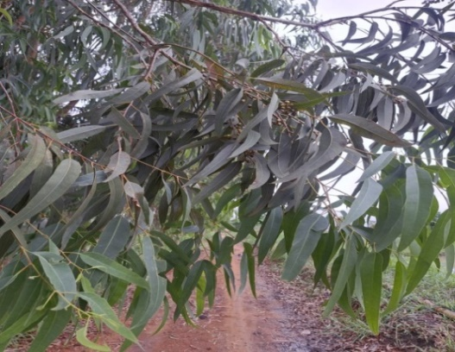
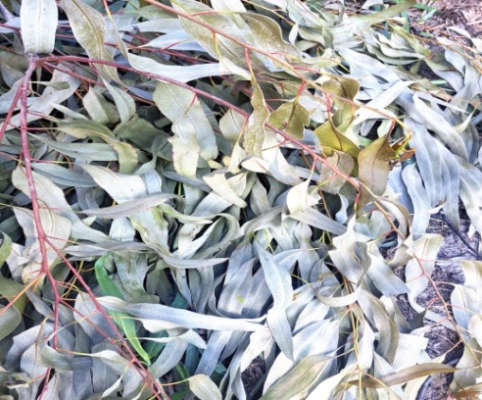
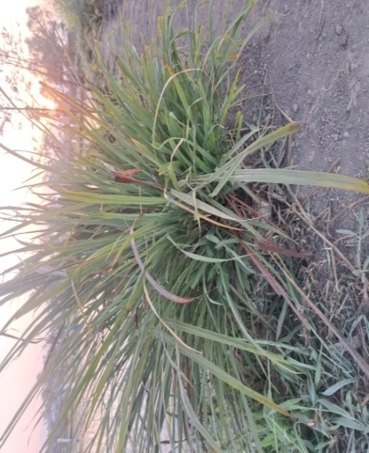
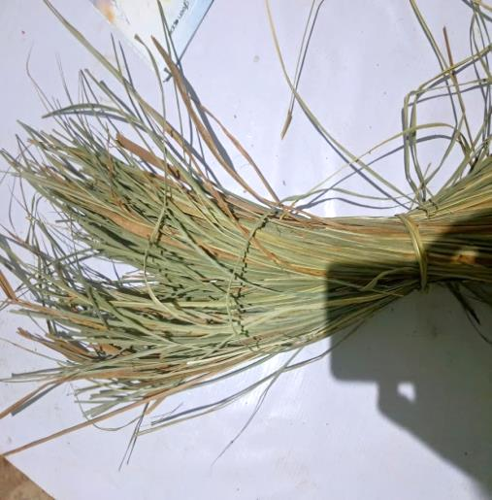
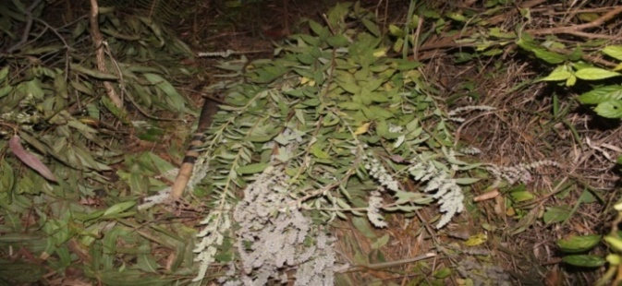
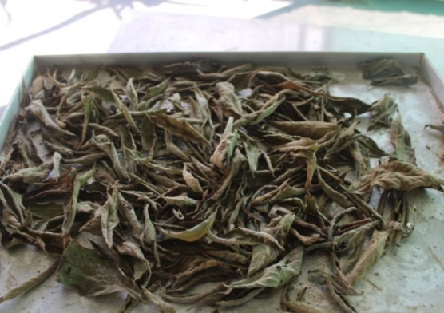
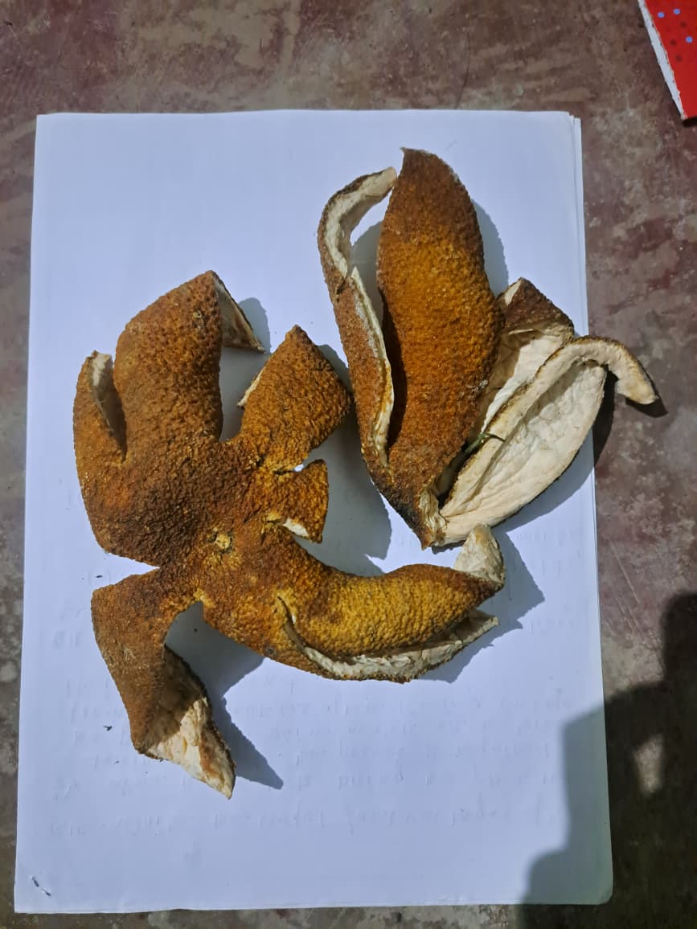
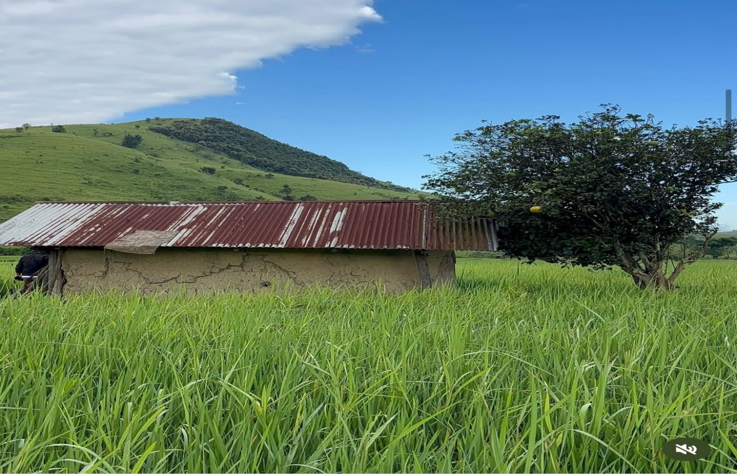
12 13
6 7
8 9
10 11

Figure 6-13: Showing different type of plant parts employed and used for the preparation of botanical coil. 6&7. Fresh live and dried Cymbopogon citratus; 8 &9. Fresh branches and dried leaves of Isodon ternifolius; 10&11. Growing tree and dried peels of Citrus maxima; 12 &13. Fresh branch and dried leaves of Eucalyptus globulus

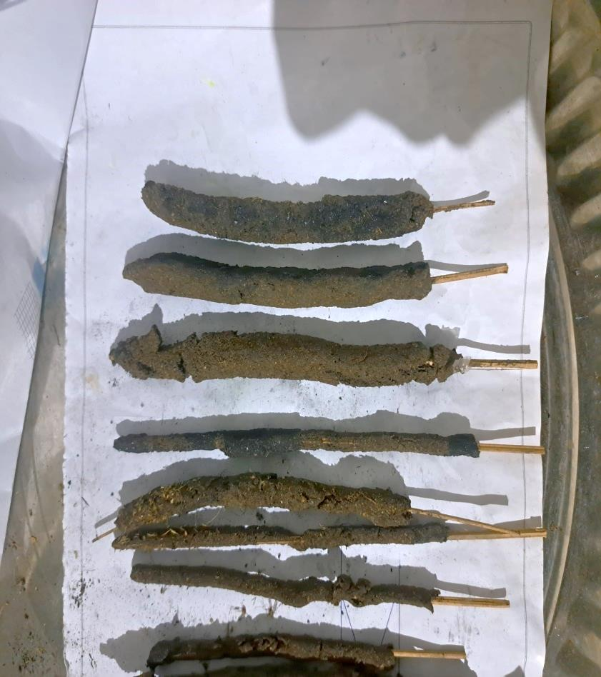
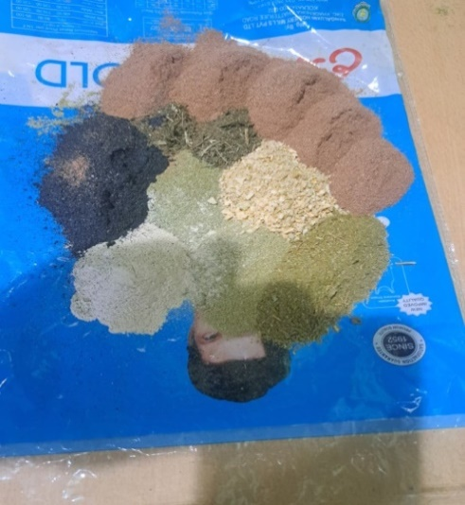
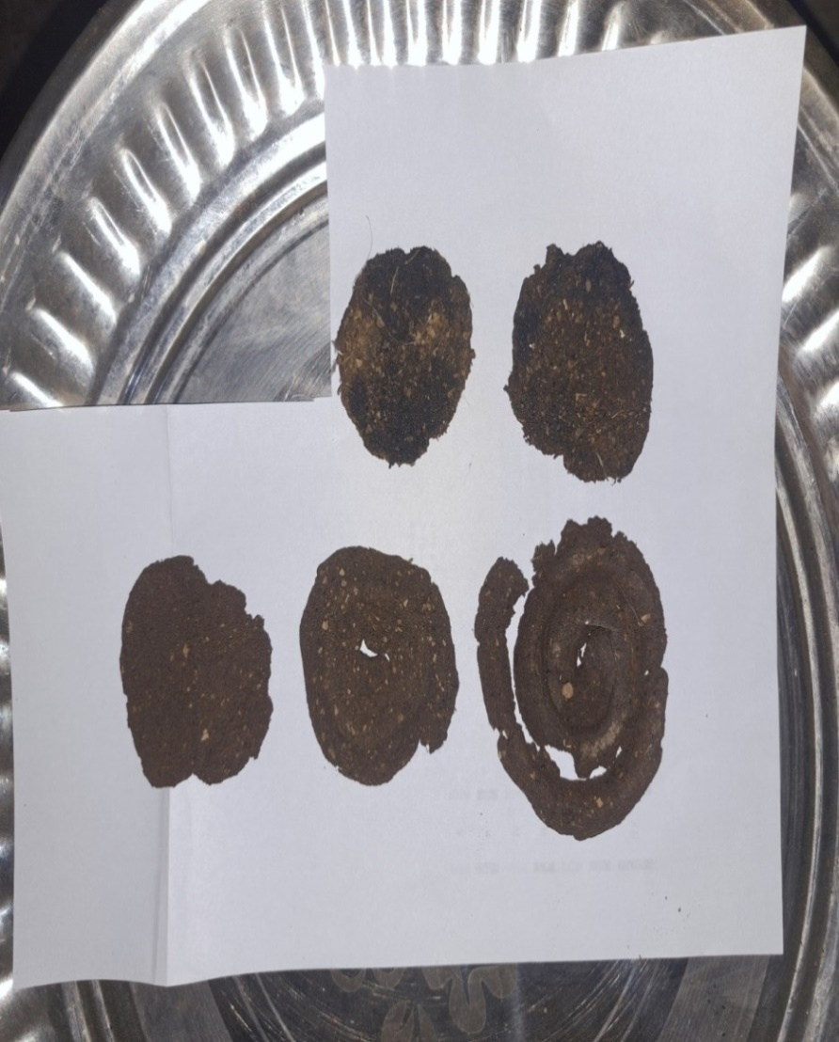
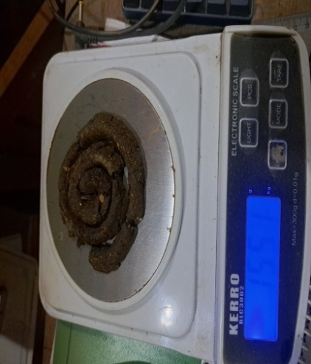
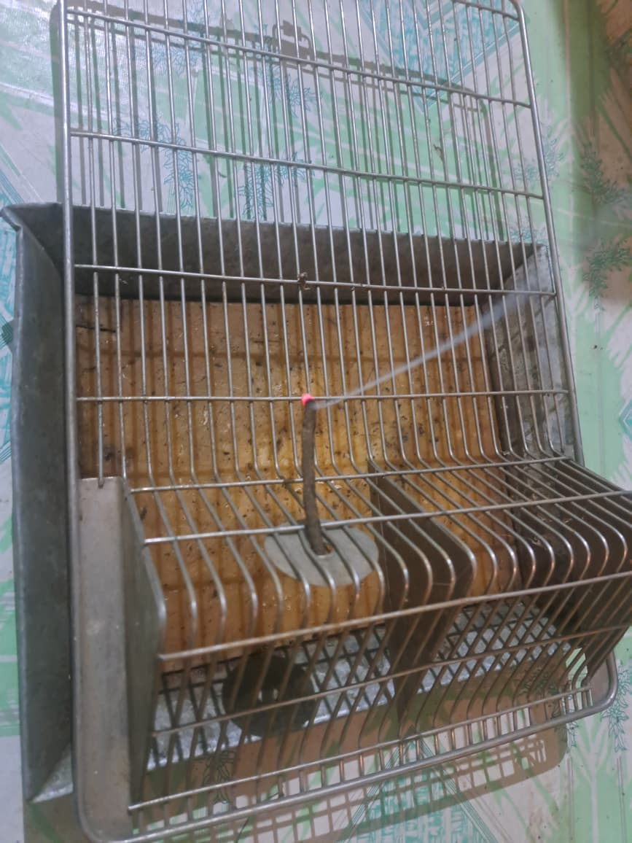
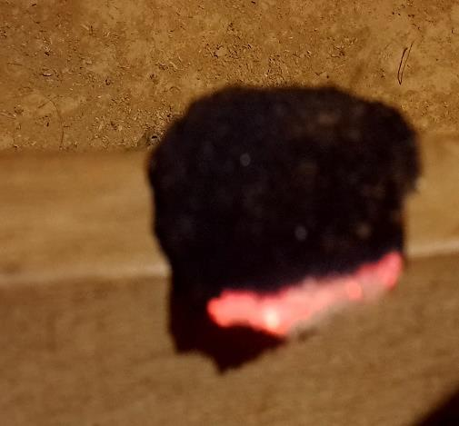
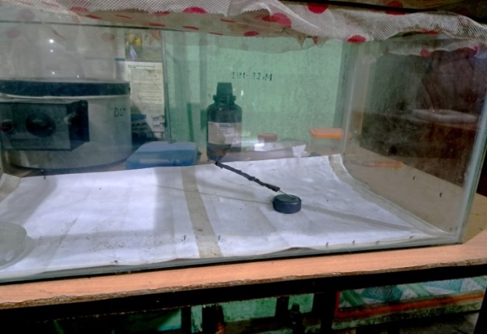
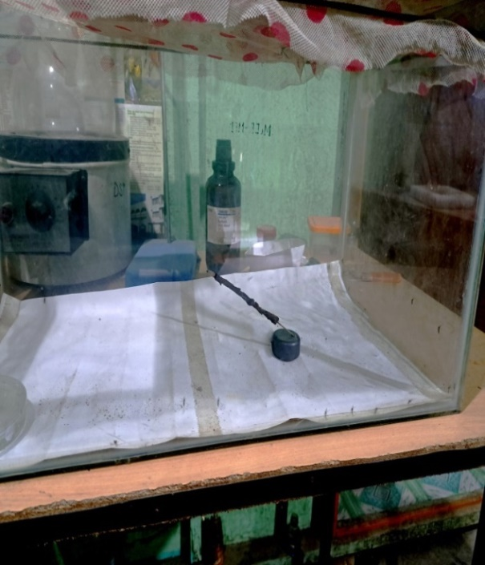
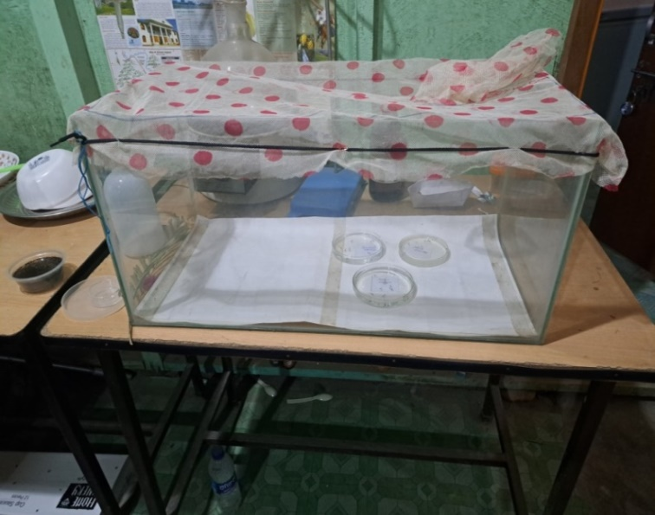
14 15 16
17 18 19

20 21

Figure: 14-21. Showing sequential steps for preparation of biological mosquito repellents, evaluation of burning efficiency and laboratory setup of control chambers; 14. Dried plant parts ground into fine powder; 15 &16. Prepared repellent coils and incense sticks; 17. Weighing of dried prepared coil before burning; 18 & 19. Burning efficiency test of two different plant based repellents; 20. Test chamber with larvae of three different selected species of Mosquito and 21. Test chamber for testing adult repellent test of selected Culex, Aedes and Anopheles species using biological repellent.

