Original Research Article
Interactive Effects of Salinity and Periphyton on Growth, Osmoregulation and Stress Physiology of Silver pompano (Trachinotus blochii) Under Varying Salinities

Abstract
In the present study, Interactive Effects of Salinity and Periphyton on Growth, Osmoregulation and Stress Physiology of Silver pompano (Trachinotus blochii) Under Varying Salinities was investigated. In aquaculture systems, salinity has a significant impact on physiological function, water quality, and total productivity. The experiment was done in Mariculture Research Farm Facility (MRFF), Tharuvaikulam where the rearing experiment was conducted for a period of 60 days. Seeds were procured from Central Research Institute (CMFRI or RGCA). The procured silver pompano will be acclimatized and reared in the raceway system until the start of the experimental study. Four salinity treatments—35 ppt for C1, 25 ppt for T1, 15 ppt for T2, and 5 ppt for T3 were applied in triplicate over 60-day experiment in FRP tanks. Split bamboo substrates one bamboo piece substrate area around 400 cm², total eight pieces in each tank were set up and given ten days to allow periphyton colonization before stocking. Salinity stress assessment through histological structure examination of the gills and kidney. The pompano acclimatized to different salinities will be stocked in FRP tanks of 250 Litres capacity Height 40 cm, Width 10 cm at a stocking density of 75 juveniles/m². A total of 750 T. blochii seeds (average length of 11-13 cm, weight of 28-29 g) were reared in an experimental container (capacity 250L) filled with 200 L of water. Commercial pellet was used, The specimens were fed at 3% of their weight, three times a day.
Fish growth indices (initial and final mean body weight, daily weight gain, specific growth rate) were among the parameters assessed. The findings showed that the 15 ppt salinity treatment (T2) considerably increased silver pompano growth, backed by strong periphyton development. Osmoregulatory parameters like osmotic performance rate, Hematocrit value, glucose concentration was analysed. Antioxidant enzymes such as Superoxidase Dismutase (SOD) and Catalase (CAT) along with hormone analysis (Cortisol) were evaluated at the end of the experiment as it represent stress physiology. Histological observations of the gills and kidney were documented during the final day of the experiment.The antioxidant enzymes, such as Superoxidase Dismutase (SOD) and Catalase (CAT) activities, were higher in C1. The highest cortisol level was recorded in C1. The histological sections of the liver of T.blochii showed the hepatocytes of liver section of T2(15 ppt) group were quite normal with mild abnormalities when compared with other salinity treatments and T3(5ppt) showed high necrosis, intensive hemorrhage and vacuolated cells. After 60 days of the experiment, higher body weight gain was observed in T2 at 15ppt (13.12± 0.525ᵃg), followed by T1 at 25ppt (10.58± 0.608ᵇg). Maximum average daily growth (ADWG) and weight gain percentage (WG %) were recorded in T2 (15ppt) with 15.26±0.958ᵃand 615.77±104.56ᵃ respectively. The highest total biomass and specific growth rate (SGR) were observed in T2 (15ppt) with 270.24±14.04g, 211.66±0.23ᵃ % and the lowest was recorded in C1 with 99.92±3.9217.83, 2.86± 0.338ᵈ in the first trial.

Keywords: Salinity, Silver pompano, Osmoregulation, Stress tolerance

Introduction
The silver pompano, Trachinotus blochii, is sometimes known as the American pomfret or snub nose pompano belongs to the order Carangiformes and the jack family Carangidae. It is a pelagic, characterized by superior meat quality, rapid growth rate, and significant market (Jayakumar et al., 2014). It withstands a broad spectrum of salinities (McMaster et al., 2003). Silver pompano has an extremely high tolerance to lower salinity, and the minimum salinity required for silver pompano survival is 4 ppt, which affects its development and survival, particularly in environments where periphyton is a major food source. Optimizing culture procedures in environments with varying salinity shows how salinity variation affects both pompano performance and periphyton development. Optimum salinity required for better growth of silver pompano (14-19 ppt) (Pathak et al.,2019) characterize silver pompano larvae, fingerlings, and adults as resilient and readily acclimatized to reduced salinities. Tolerance across the wide range of 7-58 ppt on individuals exposed to acclimated seawater and then gradually exposed to diluted seawater with lower salinities.
One of the most significant abiotic variables affecting the general growth performance of many aquatic species is salinity (Lisboa et al. 2015). Changes in salinity disrupt homeostasis, resulting in stress, sluggish growth, and poor survival rates. Numerous research papers that have been published have discussed the long-term effects of salinity on growth performance, survival, oxygen consumption (Lemos et al.,2001), and histological alterations. A variety of ionic and osmoregulatory systems regulate the osmolality of internal fluids in response to variations in the salinity of the environment (Lemos et al.,2001), (Lisboa et al. 2015). Changes in salinity affect aquatic organisms' growth, development, metabolism, and osmoregulation, even though some species can withstand a broad range of salinity (Chanda et al, Honorato et al) distinct species have distinct ideal salinities for growth and development (Bertucci et al). Understanding the optimum salinity of specific species will contribute in expansion of aquaculture productions by utilizing wide range of culturing environments including the brackish waters. Inadequate rearing salinity levels for both freshwater and marine fish species directly affects fish physiology which results in the reduction of growth, survival, immune respond and disease resistance (Semra et al.,2013). Therefore, fish are constantly adjusting to their external surroundings environments and maintaining the proper balance of salt solutions within their bodies (isosmotic) by osmoregulation (Lisboa et al., 2015) ^{[12]}. Nevertheless, osmoregulation mechanism is energy demanding processes, species with lower metabolic rates utilizing about 20 to 50% of the total energy available (Ramos et al., 2010).
osmoregulation mechanism is energy demanding processes, species with lower metabolic rates utilizing about 20 to 50% of the total energy available (Ramos et al., 2010) addition the effects of salinity in fish growth performance and survival rates. Salinity is one of the most important environmental factors that affect the distribution and physiological activities of aquatic organisms (Huang et al., 2019). Salinity is closely related to osmotic pressure. When aquatic organisms are under non‐isotonic salinity conditions, they will maintain the water and salt balance in the body through the regulation of osmotic pressure (Chourasia, D'Cotta, Baroiller, Slosman & Cnaani, 2018). The energy used for osmotic pressure adjustment can account for 20%–50% of the total energy consumption (Ern, Huong, Cong, Bayley & Wang, 2014). Although some organisms can tolerate a wide range of salinity, changes in salinity have an impact on the growth, development, metabolism and osmoregulation of aquatic organisms (Bertucci et al., 2017; Honorato, Boni, da Silva & Marques‐Santos, 2017; Lee et al., 2017; Moorman, Yamaguchi, Lerner, Grau & Seale, 2016). The optimal salinity for growth and development varies for different species (Chand et al., 2015; Le et al., 2009). Riche et al. (2012) demonstrated that raising the salinity to 12 ppt helped alleviate osmoregulatory stress, while Weirich et al. (2009) found that both juveniles and adults could withstand salinities as low as 5 ppt. Teleost fish that experience osmoregulatory stress due to suboptimal rearing salinities may develop aberrant gills (Abou Anni et al., 2016). Gill structural vulnerability is influenced by the gills' exterior placement and direct contact with the water (Reis et al., 2009). Gill morphological changes are easily identifiable (Fanta et al., 2003) and indicate damage caused by stress (Lauren and Wails, 2018). According to numerous studies, harmful morphological changes in fish gills might be a sign of a widespread stress response and frequently occur in conjunction with adverse environmental conditions (Heath, 1995; Humphrey, 2006). Respiratory and osmoregulatory stress typically co-occur with histopathological alterations in the structure of the gills because these organs carry out essential activities like as respiration, osmoregulation, and waste excretion (Smith and Piper, 1975).
The definition of periphyton is "a complex of sessile organisms, including algae, invertebrates, detritus, and microorganisms, attached to submerged substrates such as stones and sticks"(Azim et al.,2001). It is regarded as a crucial part of fish nutrition. Aquaculture farming has advanced significantly thanks to periphyton-based technology, which is also inexpensive, eliminates the need for additional feeding, and produces fewer pollutants.
Salinity acclimatization
Salinity is one of the most important environmental elements influencing their physiology, survival, and growth for euryhaline fish species like the silver pompano (Trachinotus blochii). The physiological and biochemical adaptations fish make to preserve homeostasis while exposed to shifting salinity regimes are referred to as salinity acclimation. These adaptations have a strong correlation with energy consumption, osmoregulatory capacity, and general health (Evans et al., 2005). Salinity changes directly affect osmolarity of the medium requiring an adjustment in the metabolic rate and activity of the organism. It may also modify reproduction, development, size and meristic characters. Salinity may be an important factor in the distribution of a species. It will also affect the physical properties of the medium. Reviews that include salinity effects on marine organisms have been published by (Kumpf et al.,1972). Salinity tolerances and survival of fishes were tabulated by (Altman and Dittmer,1966). The effect of salinity acclimation was shown by (Garside and Jordan,1968) who found that by using isosmotic acclimation the upper lethal temperatures were highest in an isosmotic medium as compared with normal seawater and freshwater (Kalidas et al.,2012) acclimatised pompano Trachinotus carolinus to 9 ppt and then to 1.3 ppt salinity without any mortality. Minimum salinity for survival of the ovate pompano Trachinotus ovatus was determined by gradual adaptation and the fish could withstand 1.5 ppt salinity. Chervinski (1973) reported that on direct transfer it could withstand 20 ppt salinity.
Mc Master et al. (2006) found that T. carolinus grew as well in 19 ppt salinity water as they do in normal seawater (35 ppt). wide range of salinity (35 to 3 ppt) and grew to marketable size (approximately 500 g) in one year under moderate salinity. Juveniles of pompano have been captured in water bodies with salinities as low as 9 ppt and as high as 50 ppt (Finucane, 1969; Perret et al., 1971; Gilbert and Parsons, 1986).Main et al. (2008) found that, T. carolinus reared in salinities as low as 5 ppt suffered high mortality and reported that minimum salinity concentration of 10 ppt may be better for pompano farming. Wills et al. (2007) studied the growth and survival of T. carolinus in different salinities of 1, 3 and 28 ppt and observed 42%, 52% and 96% survival respectively at 28 °C. Jian-sheng et al. (2008) studied the effect of different salinity levels (10, 15, 20, 25, 30 and 35 ppt) on T. ovatus juveniles and concluded that salinity of 25 ppt is favourable for its growth and the maximum SGR observed was 3.21% day-1. Chavez et al. (2011) reported that in T. blochii cultured in the salinity range of 30-35 ppt, the SGR ranged from 2.63 to 2.72% BW day-1.
McMaster (2003) reared silver pompano fingerlings with size of 10 gat salinity of 19 ppt using artificial feed that consist of 43% protein and 10% lipid, after four months the fish reached 110 g/fish. Lan et al. (2007) conducted a trial on rearing fingerlings in sea cages of 100 m³ at density of 96 number/m³ weighing 19 - 26 g/number were fed with protein 43% and lipid 12% diet. After 146 days of culture, fish were weighed 577-640 g, survival was 99.2-99.5%, productivity of 54.6-61.3 kg/m³, and FCR: 2.43-2.76.Several studies have been conducted to assess the culture of silver pompano (Gopakumar et al., 2012; Kalidas et al., 2012) like other marine species, and successful culture of pompano requires high dietary crude protein (CP), with a diet containing 45% CP for growth of juvenile pompano (Lazo et al., 1998).
Osmoregulation of Silver pompano
Fish maintain osmotic and ionic balance through complex physiological mechanisms involving the gill, kidney and intestine, with the gill being the primary organ responsible for ion regulation via chloride cells and Na⁺/K⁺-ATPase activity (Evans, 2005). According to Mulyadi et al. (2020) Optimum growth and homeostasis are often achieved at low–moderate salinities (10–15 ppt), where plasma osmolality is closer to isotonic levels and the osmoregulatory burden is minimized. At salinity extremes (5 ppt or >30 ppt), fish expend more energy to maintain ionic balance, which can reduce growth and survival (Bradshaw et al., 2023). T. blochii shows modulation of gill ATPase activity depending on environmental salinity, with lower activity around the isosmotic point and higher activity at both hypo- and hypersaline conditions where active ion uptake or secretion is required (Abou Anni et al., 2016). Osmoregulatory efficiency, Na+/K+-ATPase activity in gill tissues is known to rise in hypo- or hyperosmotic environments to make up for ionic imbalance (McCormick, 1995). This regulation is achieved through a suite of ionic and osmoregulatory processes, which are energy demanding (Lisboa et al., 2015a, b; Nordlie, 2009). Cortisol plays a central endocrine role in salinity acclimation, enhancing ion transporter expression and stimulating gill Na⁺/K⁺-ATPase activity (Evans, 2005). salinity transfers trigger elevations in plasma cortisol and glucose, supporting osmoregulatory adjustments and providing energy for ion transport (Abou Anni et al., 2016)

Ethical approval
The Institutional Animal Ethics Committee (IAEC) of Fisheries College and Research Institute, Thoothukudi, Tamil Nadu, India, reviewed and approved the experimental protocol titled " Interactive Effects of Salinity and Periphyton on Growth, Osmoregulation and Stress Physiology of Silver pompano (Trachinotus blochii) Under Varying Salinities" in compliance with the suggestions made by the Ministry of Fisheries, Animal Husbandry, and Dairy, Government of India's Committee for the Purpose of Control and Supervision of Experiments on Animals (CPCSEA). Every process involving the animals was carried out in accordance with the institution's ethical standards as well as applicable national rules for the use and care of laboratory animals.
Material and methods
Experimental Setup
The Mariculture Research Farm Facility (MRFF) of the Fisheries College and Research Institute in Thoothukudi, Tamil Nadu, India served as the site of this 60-day study to assess “Interactive Effects of Salinity and Periphyton on Growth, Osmoregulation and Stress Physiology of Silver pompano (Trachinotus blochii) Under Varying Salinities " One thousand (1000) silver pompano fry were procured from Rajiv Gandhi Centre for Sustainable Aquaculture (RGCA) Poozhiyur, Kerala, Tamil Nadu weighing 0.382±0.213g.Silver pompano was transported using oxygenated, double-layered polythene bags with a packing density of 125 numbers/bag.The transported seeds were carefully acclimatized by placing them for two weeks in a circular 500 L trough with aeration. In this time frame, their dietary requirements were satisfied by commercial feed. The fish were attentively observed in this time for indications of illness, stress, or unusual behaviour. This initial acclimation period allowed the fish to adapt to the new environment gradually.
After acclimatization, seeds were stocked at 21 numbers per each tank in all treatment tanks and the control tank with average body weight and average body length values of 1.75± 0.16ᵃ g and 4.46± 0.08ᵇ cm in C1 (35 ppt), 1.91± 0.185ᵃ and 4.41± 0.49ᵇ cm in T1 (25 ppt), 2.18± 0.44ᵃ and 4.82± 0.26ᵃ cm in T2 (15 ppt), and 1.64± 0.10ᵃ and 4.16± 0.05ᵇ cm in T3 (5 ppt). Gentle aeration with an air stone was provided in all the tanks, and during the experiment, the water level was kept at 220 cm. The fish were hand-fed twice (9:30 and 14:30 hours) daily with commercial pellet feed.
Sampling for histological analysis through salinity stress assessment
Sampling was done at end of the experiment for 60 days. During every sampling, 5 numbers of fish were collected from each treatment tanks and control including the triplicates. The samples were collected in the morning before feeding the fishes in order to have empty gut. The length and weight of the fishes were noted down before preserving. The gill and liver tissue of the fish specimens subjected to salinities of 35 ppt (natural habitat condition), 25 ppt, 15 ppt, and 5 ppt were collected at the end of the experiment. The gill was released by lifting the gill cover (operculum) and cutting off the base. The collected samples were preserved in 10% Neutral Buffer Formalin (NBF) (Genten et al., 2009; Biswas et al., 2021) and stored at room temperature for further histological analysis of gills and liver.

Organ fixation was done for 24 to 48 hours using 10% phosphate-buffered formalin (NBF). Following fixation, the tissues were embedded in paraffin after being dried in a succession of progressively stronger alcohol and xylol solutions. Tissue processors were used for each of these steps. The resulting slices were sliced to a thickness of 3–5 µm, incubated at 40°C in a water bath, and then promptly allowed to air dry for one hour. After that, it was stained with hematoxylin-eosin (HE) and examined at 400x magnification using a light microscope. Neutral Buffer Formalin (NBF) preparation includes Sodium dihydrogen phosphate – 4g, Disodium hydrogen phosphate – 6.5g, Formalin – 100ml and Distilled water – 900ml kept at ambient temperature.
Trial with different salinities
Once a fortnight, fishes were sampled for recording growth performance, Fish from the three salinity treatments and control tank were collected, and their weights (g) were measured on a digital weighing balance. The total length (cm) was measured using a scale to note the growth. Careful handling of fishes was done to minimize handling stress during the sampling.
Observation of osmoregulatory parameters
Cortisol hormone analysis: The enzyme-linked immunosorbent assay was used to conduct the analysis on day 56 of the experiment. Hormone analyses were performed according to the method described by Zhang et al, (2022). Tissue samples were homogenized in cold PBS and centrifuged at 3000 rpm for 20 minutes in refrigerated centrifuge (4°C). The supernatants were collected and the levels of cortisol were measured using Sigma ELISA kits.
Estimation of Plasma Glucose Concentration: Following a 60-day experiment, the fish were sedated with 50 ppm benzocaine (Okamoto et al., 2009), assessed for body weight and total length, and had their caudal vein punctured using a heparinized syringe and needle to extract approximately 1 ml of blood. With the aid of a portable glucose meter (Accu-Chek Advantage, Roche, São Paulo, São Paulo, Brazil), the concentration of glucose in freshly drawn blood was determined.
Estimation of Haematocrit value of silver pompano fingerlings: A micro-haematocrit centrifuge (Micro spin, Centribio, Shanghai, China) was used to determine the haematocrit value following a 9000 ×g centrifugation of the blood at room temperature for 15 minutes. After centrifuging blood (6000 ×g) for 20 minutes at 4 °C (Micro 22R Hettich Zentrifugen, Global Medical Instrumentation, Ramsey, Minnesota, USA), plasma was obtained.
Antioxidant enzyme analysis
Superoxide Dismutase activity
Superoxide Dismutase (SOD) activity was estimated using the method described by Kono (1978). The sample volume of 70 μl was mixed with the following reagents. 50 mM Sodium Carbonate was prepared by taking 0.529 g of sodium carbonate in 100 ml distilled water. Nitro blue tetrazolium (0.096 M) was prepared by taking 0.004 g of NBT in 50 ml distilled water. Triton X-100 was prepared by taking 0.06 g in 100 ml distilled water. Hydroxylamine Hydrochloride (20 mM) was prepared by taking 0.138 g in 100 ml distilled water, and the pH was adjusted to 6.0. The OD value was observed for 5 minutes at 540 nm at room temperature. The enzyme activity was expressed as SOD units/min/mg protein. One unit of SOD activity is defined as the amount of enzyme needed to inhibit the reaction of O₂ with NBT by 50%.

Catalase activity
Catalase activity (CAT) was estimated according to the method of Takahara et al. (1960). Whole fish samples were taken for the analysis. To 50 μl of tissue homogenate, 2.45 ml of phosphate buffer (50 mM, pH 7.0) was added, and the reaction was initiated by adding 1.0 ml of H₂O₂ solution. The decrease in absorbance was measured at 240 nm at 15 s intervals for 3 min. The enzyme blank was run simultaneously with the phosphate buffer. The CAT activity was expressed as moles of H₂O₂ decomposed/ min/protein. One unit of CAT is defined as the amount of enzyme needed to reduce 1 μmol of H₂O₂/min.
GPx activity
Glutathione peroxidase (GPx) was estimated following paglia and Valentine (1967) 0.2ml of tissue homogenate was added to a 0.2ml of PO₄ buffer,0.2ml of EDTA,0.1 ml of sodium azide ,0.1 ml of reduced Glutathione and mixed well. To this mixture 0.2 ml of Glutathione reduced (GSH), 0.1 ml of hydrogen peroxide and 0.1ml NADPH wad added and incubated in a water bath at 37ºC for 10 minutes. At the end of the incubation period,0.5mlof 10% TCA (Trichloroacetic acid) was added and centrifuge at 10000 rpm for 5 minutes. In a test tube 1ml of the supernatant was taken and 2.0 ml of Tris buffer and 50 μl of DTNB (5,5-dithio-bis-2-nitrobenzoic aid) was added The OD value was measured at 412 nm for 3 minutes. The enzyme activity was expressed as unit/min/mg protein. One unit of activity is defined as the amount of enzyme needed to reduced 1 μmol/L of GSH per min.
Results
The present study was undertaken to assess the Interactive Effects of Salinity and Periphyton on Growth, Osmoregulation and Stress Physiology of Silver pompano (Trachinotus blochii) Under Varying Salinities. The impact of salinity acclimation was assessed through transferring juvenile pompanos to the experimental salinities of 35 ppt (Control – C1), 25 ppt (T1), 15 ppt (T2), and 5 ppt (T3) to examine any visible physical abnormalities, scale reduction and lesions. The pompano acclimatized to different salinities were stocked in FRP tanks of 250 Litres capacity Height 40 cm, Width 10 cm at a stocking density of 75 juveniles/m². Salinity stress assessment through histological structure examination of the gills and liver was done. The effect of salinity was studied, focusing on the tissue histology (gills and liver), Gill and liver tissue of the sample was collected at last days of the experiment, from the fish specimens exposed to all four salinity treatments. Evaluation of the growth performance of silver pompano (Trachinotus blochii) in different salinities with substrate was assessed in terms of Mean Weight Gain and Specific Growth Rate (SGR). Osmoregulatory parameters like blood cortisol, plasma glucose concentration and hematocrit value were analyzed. Antioxidant enzyme analysis (Super oxidase dismutase, Catalase activity, Glutathione peroxide GPx analysis was done.

Histopathology
At the end of the experiment, the liver and gill of the fish specimens subjected to salinities of 35 ppt (natural habitat condition), 25 ppt, 15 ppt, and 5 ppt were collected. The gill was released by lifting the gill cover (operculum) and cutting off the base. The abdominal cavity was then opened in order to remove the kidney. Organ fixation was done for 24 to 48 hours using 10% phosphate-buffered formalin (NBF) (Raškoviae et al., 2011). Following fixation, the tissues were embedded in paraffin after being dried in a succession of progressively stronger alcohol and xylol solutions. Tissue processors were used for each of these steps. The resulting slices were sliced to a thickness of 3–5 µm, incubated at 40°C in a water bath, and then promptly allowed to air dry for one hour. After that, it was stained with hematoxylin-eosin (HE) and examined at 400x magnification using a light microscope.In comparison to those raised in the other experimental salinities, histological investigations revealed that the gill epithelium of juvenile pompanos raised at salinity 5 ppt exhibited reduced thickness, chloride cell area and density. The gill epithelium of fish raised at 35 ppt was thicker than that of fish kept at salinities 5 and 15 ppt. Additionally, the area and density of chloride cells were larger than those of fish raised at salinity 5 ppt.
Histopathology of silver pompano Liver
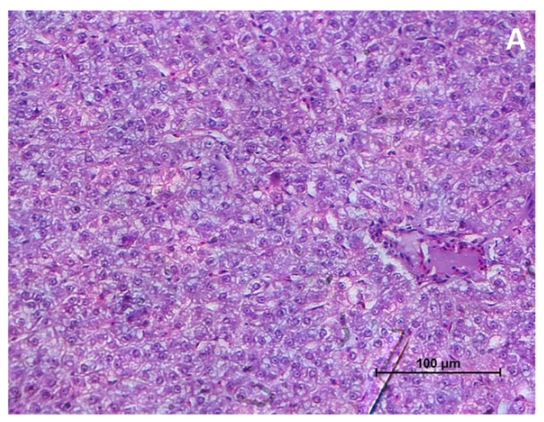

Figure 1. Under 20X magnification, the Liver tissue of a healthy silver pompano reared at control C1(35ppt) salinity was seen. The image displayed normal architecture of hepatic tissue with hepatocytes with normal nucleus. The erythrocytes found in the blood vessels are normal.
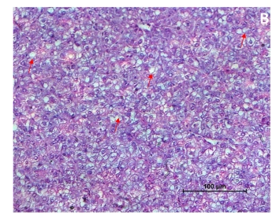

Figure 2. Liver cells of silver pompano reared at T1(25 ppt) salinity observed under 20x magnification showing the hepatocytes with mild intracytoplasmic vacuolation (red arrow)
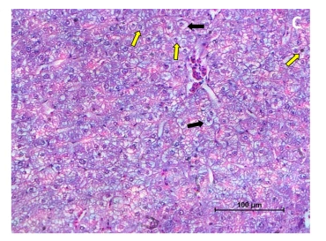

Figure 3. Under light microscopy the liver cell of silver pompano reared at T2(15 ppt) salinity was observed in 60X magnification. The hepatocytes of liver section are quite normal and no abnormalities are seen. Only few hepatocytes with few pyknotic nucleus (yellow arrow).
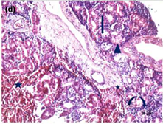

Figure 4. The liver cell of a silver pompano reared at T3(5 ppt) salinity has been examined under light microscopy at a 60X magnification. The liver section showing the hepatocytes with few pyknotic nucleus (arrow), and very few hepatocytes with hypertrophy (black arrow) are also present. The erythrocytes found in the blood vessels are normal.
Histology of silver pompano gills
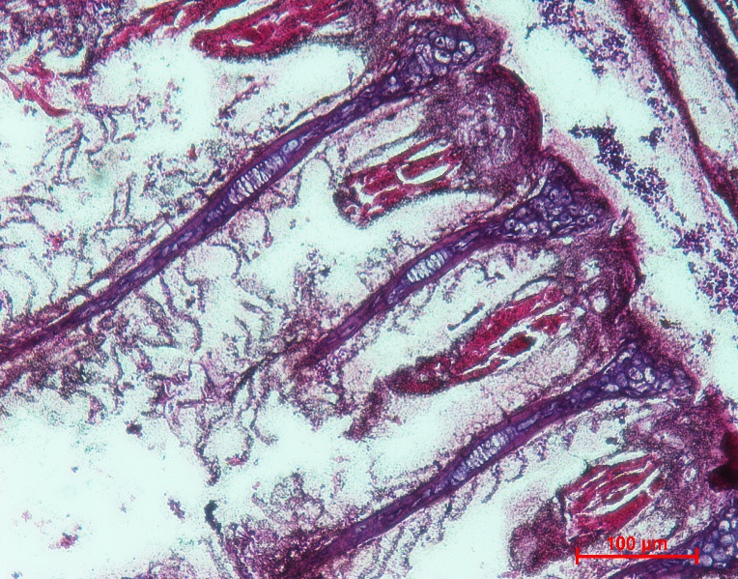

Figure 5. Under 20X magnification, the gill chloride cells of a healthy silver pompano reared at control C1(35ppt) salinity was seen. The image displayed normal architecture of hepatic tissue with hepatocytes with normal nucleus. The erythrocytes found in the blood vessels are normal with thicker gill epithelium.

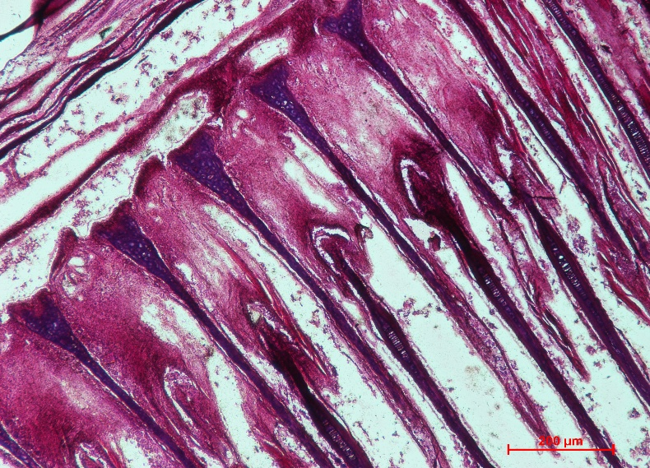

Figure 6. Gill chloride cells of silver pompano reared at T1(25 ppt) salinity observed under 20x magnification showing a moderate hyperplasia, no abnormalities, such as hypertrophy or edema, were seen in gill chloride cells.
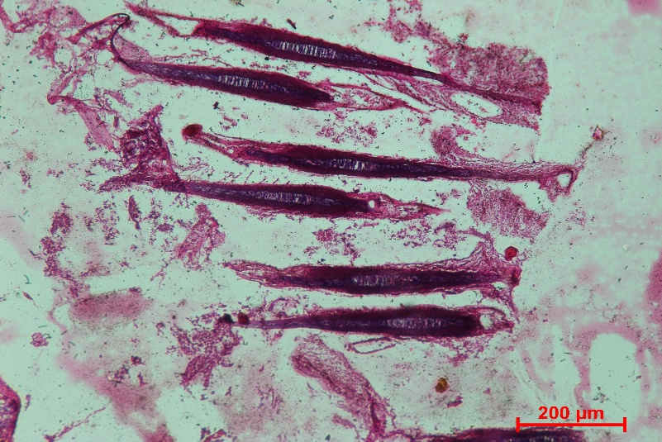

Figure 7. Under light microscopy the gill chloride cells of silver pompano reared at T2(15 ppt) salinity was observed in 60X magnification. Histological examination of the silver pompano gills revealed no abnormalities in gill chloride cells. Thrombocytes, pillar cells, lacunae, and secondary lamellae were all clearly visible in the normal tissue of fish gills (Wahyuni et al.,2017).
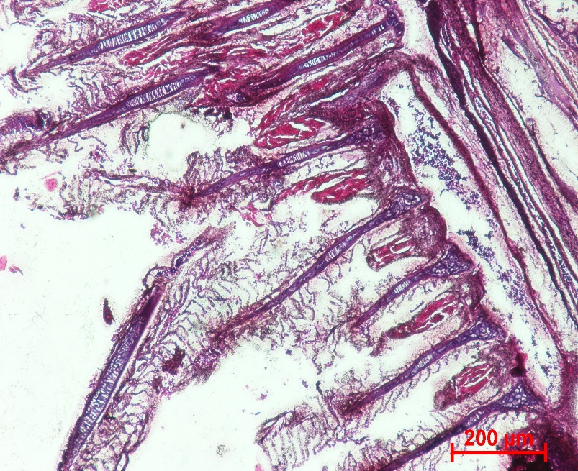

Figure 8. The gill of a silver pompano reared at T3(5 ppt) salinity has been examined under light microscopy at a 60X magnification. The gill section showing the gill chloride cells where, parasites in the media were connected to hyperplasia showing reduced thickness, chloride cell area and density.
The silver pompano gills' histological analysis showed no anomalies in any of the treatments studied, as demonstrated by the unique appearance of the secondary lamellae, epithelium, thrombocytes, and pillar cells. Gill chloride cells showed no abnormalities, including hypertrophy or oedema, despite a significant hyperplasia (Figure 6). In this case, hyperplasia was linked to parasites in the media. In the normal tissue of fish gills, thrombocytes, pillar cells, lacunae, and secondary lamellae were all readily apparent (Wahyuni et al., 2017).
Observation of osmoregulatory parameters
Cortisol hormone level in T.blochii reared in different stocking densities
Fish with elevated cortisol levels are under stress. According to our data, cortisol decreased to varying degrees in each salinity treatment over the course of the trial, suggesting that the fish had adaptive abilities to reduce salinity.
Table 1.and Figure 9 show the cortisol concentrations that were measured during the culture phase of T. blochii from various salinities. Cortisol levels were found to range from 41.98±1.64 (ng/ml) to 73.28±0.49 (ng/ml). T3 showed the highest concentration of cortisol, whereas T1 showed the lowest level. There were statistically significant (p<0.05) variations in cortisol levels between the treatments and the control group.
Table 1 Cortisol hormone level of silver pompano in different salinity treatments
Treatment | Cortisol level (ng/ml)
C1 | 41.98±1.64
T1 | 55.69±0.85
T2 | 63.43±2.22
T3 | 73.28±0.49
Values with different superscripts within the column differ significantly (p<0.05)

Fig 9 Cortisol hormone level of silver pompano in different salinity treatments
Plasma glucose concentration
Fish experience a significant osmotic water inflow at very low salinity (5 ppt). Silver pompano responds to this by activating their stress axis (cortisol release), which raises plasma glucose levels.
These levels serve as a source of energy for osmoregulatory and ion transport processes. Fish may attain a new osmotic balance at greater salinities (35 ppt), which would lower the amount of glucose in the blood and lessen stress activity.
Table 2 Plasma glucose level of silver pompano in different salinity treatments
Treatment | Plasma glucose level (mg/dL)
C1 | 57.9±2.20
T1 | 74.23±0.46
T2 | 86.96±0.56
T3 | 92.56±1.40

Fig 10 Plasma glucose level of silver pompano in different salinity treatments
Haematocrit value (%) of silver pompano in different salinity treatments
Hypersaline exposure (35 ppt) tends to concentrate the blood (haemoconcentration), and stress hormones can mobilize erythrocytes from the spleen, which raises haematocrit. Chronic hyposaline conditions (5 ppt) cause water influx and haemodilution.
Table 3 Haematocrit value (%) of silver pompano in different salinity treatments
Treatment | Haematocrit value (%)
C1 | 41.7±1.13
T1 | 34.96±0.66
T2 | 30.42±0.92
T3 | 28.78±0.69

Fig 11 Haematocrit value (%) of silver pompano in different salinity treatments
Antioxidant enzyme activity
The antioxidant enzyme activity of T.blochii reared at different salinities was depicted in Table 4. The highest catalase (CAT) activity was observed in treatment group T3, measuring 0.71 ± 0.012 U/mg protein, while the lowest CAT activity was found in treatment group C1, at 0.49 ± 0.05 U/mg protein. Similarly, superoxide dismutase (SOD) activity peaked in T3 at 0.391± 0.02 U/mg protein, with the lowest level recorded in C1 at 0.206 ± 0.003 U/mg protein. Additionally, the maximum glutathione peroxidase (GPx) enzyme activity was also observed in T3, at 0.22 ± 0.034 U/mg protein, whereas the minimum was documented in C1, at 0.11 ± 0.034 U/mg protein. Notable differences were identified among all treatment groups, with statistical significance at P < 0.05.

Table 4 Antioxidant enzyme activity of silver pompano reared in different salinity treatments
Treatment | CAT (U/mg protein) | SOD (U/mg protein) | GPx (U/mg protein)
C1 | 0.49±0.05 | 0.206±0.003 | 0.11±0.01
T1 | 0.62±0.01 | 0.249±0.007 | 0.15±0.007
T2 | 0.66±0.02 | 0.307±0.002 | 0.19±0.002
T3 | 0.71±0.012 | 0.391±0.002 | 0.22±0.034

Catalase activity level in T.blochii reared in different stocking densities
Catalase activity peaked at 5 ppt, increasing osmoregulatory cost and oxidative pressure, elevating reactive oxygen species, and inducing antioxidant defences. CAT activity was lower at 35 ppt due to effective acclimation and reduced oxidative load under rearing conditions.

Fig. 12 Catalase activity of silver pompano in different salinity treatments
SOD activity level in T.blochii reared in different stocking densities
Superoxide dismutase activity peaked at 5 ppt and was lowest at 35 ppt, indicating enhanced production of superoxide under hypo-osmotic challenge and a coordinated up-regulation of the antioxidant system (SOD→CAT) to detoxify Reactive Oxygen Species (ROS); mid-salinities (15–25 ppt) showed intermediate values consistent with reduced oxidative load.

Fig. 13 SOD activity of silver pompano in different salinity treatments
GPx activity level in T.blochii reared in different stocking densities
Glutathione peroxidase activity was highest at 5 ppt, indicating enhanced demand for peroxide detoxification under hypo-saline stress, whereas the lowest activity was recorded at 35 ppt, suggesting reduced oxidative challenge and effective acclimation under high salinity. Mid-range salinities (15–25 ppt) showed intermediate values consistent with minimal oxidative stress.

Fig. 14 GPx activity of silver pompano in different salinity treatments
Discussion
The current study looked at how different salinity levels impacted the growth performance, osmoregulation and periphyton development of silver pompano (Trachinotus blochii) fry. Periphyton growth is supported by four salinity levels: 35 ppt (C1, control), 25 ppt (T1), 15 ppt (T2), and 5 ppt (T3). Each tank has 11 pieces of split bamboo substrate to enhance periphyton growth. The results unequivocally show that fish performance, periphyton growth, and salinity are all positively correlated similar to some studies with strong periphytic community that supported water quality and acted as an auxiliary food source was encouraged by intermediate salinities, which promoted growth (Dutta et al.,2018).
Assessment of the impact of salinity acclimatization in T. blochii
Juvenile silver pompano is extremely euryhaline and can tolerate a wide variety of salinities when transitioned gradually, according to the acclimatization data. Marine-origin species must actively control ion loss and water gain in hypoosmotic settings, the elevated stress seen at 5 ppt may be explained by these osmotic difficulties. However, when appropriate acclimatization procedures are followed, the lack of protracted stress responses and quick behavioral recovery indicate that pompano juveniles are physiologically capable of adjusting to low salinity. Previous research by Pillai et al. (2011) and Sahu et al. (2013), which found that silver pompano can grow and survive at salinities as low as 5–10 ppt with proper acclimation, supports these findings.
Indeed, our results show that young pompanos are more resistant to salinity (15 ppt) than prior reports (Sampaio et al., 2003). However, it's important to keep in mind that the 35 ppt acclimation salinity used in this experiment was quite similar to that used by Sampaio et al., (2003). Furthermore, juvenile pompanos exposed to 5, 15, 25, and 35 ppt showed no appreciable differences in growth during the early phases of the study; however, at the conclusion of the 60-day experimental period, there was a significant difference, with 15 ppt showing higher growth than the other salinities.
Histopathology of silver pompano reared at different salinities
Histological observation of liver of silver pompano didn’t find anomalies in all the four salinity treatments studied. No traceable differences were observed between the histological slides from the salinity treatments similar to one of the studies (Mulyadi et al., 2012). Considerable differences were present among the treatments of liver sections of snub nose pompano from various treatments were illustrated shows the hepatocytes with mild intracytoplasmic vacuolation, very few mild vacuolated hepatocytes, hepatocytes with few pyknotic nucleus, and very few hepatocytes with hypertrophy were present. The hepatocytes of liver section of T2(15 ppt) group were quite normal with mild abnormalities when compared with other salinity treatments and T3(5ppt) showed high necrosis, intensive hemorrhage and vacuolated cells.
Growth performance of silver pompano reared at different salinity treatments with substrate
The results show that extreme salinities (5 ppt and 35 ppt) had a detrimental effect on fish growth and survival. Intermediate salinity (15 ppt) considerably enhanced the overall performance of silver pompano and periphyton formation similar to the growth performance of acclimatized T.blochii was best from 15-25 ppt and very low in (5 ppt) (Hamed et al., 2016). The silver pompano fry raised at 15 ppt (T2) showed the highest specific growth rate (SGR: 11.66±0.23%) among the treatments and high growth performance similar to the number of studies indicate increase in growth performance of juvenile pompano and Atlantic cod in intermediate salinities range 10-25 ppt (Kalidas et al., 2012). This finding implies that ideal conditions for physiological acclimation, osmoregulatory stress reduction,and growth are provided by moderate salinity. The findings are in line with earlier research, including that of (Signor et al., 2015) who suggested keeping salinities above 10 ppt and noted that T. carolinus had poor survivability below this level. These results are consistent with several studies that show young Atlantic cod and pompano fish perform better in terms of growth in intermediate salinities between 10 and 25 ppt (Imsland et al., 2011, Kalidas et al., 2012). Additionally, the current study supports (Jayakumar et al., 2012) assertion that silver pompano thrives at intermediate salinities between 10 and 25 ppt. On the other hand, fry exposed to salinity levels of 5 ppt (T3) and 35 ppt (C1) showed decreased growth (SGR: 5.73±0.90% and 2.86±0.34%, respectively) might be different from the results observed in the juvenile florida pompano T.carolinus, a fish found in saltwater, which showed better growth performance when reared in low salinities(5 ppt) (Van Dam et al., 2002). T. blochii may adapt to medium salinity at 15 ppt, according to this study, indicating that the juvenile (average length of 12.6±0.10ᵃ cm, weight of 15.3±0.965ᵃ g, and age of 2 months) can withstand the condition. Acclimatized T. blochii grew particularly well in intermediate salinity (15–25 ppt), declining in extremely low salinity (5 ppt) and seawater salinity (34 ppt)
Osmoregulatory parameters of T.blochii reared at different salinities
According to these results, osmoregulatory difficulties were brought on by both hypo- and hypersaline conditions, which decreased the fish's energy allocation for growth and raised mortality might be same as some studies reported that several species of teleost fishes have a lower energy requirement for osmoregulation when kept near to isosmotic point (Mulyadi et al., 2015).The obvious decline in performance at high salinities indicates that silver pompano juveniles are better adapted to brackish habitats, even if the survival rate was acceptable across treatments is similar to study reveals T. blochii is able to adapt to the medium salinity at 15 ppt (Mulyadi et al., 2015).
Furthermore, prior research indicated that a high energy need for osmoregulation may be linked to a decrease in fish growth in extremely low or high salinity circumstances (Imsland et al., 2008, Evans et al., 2010, Mahmudul et al., 2014). Juveniles raised at low salinities (5 and 15 ppt) exhibited higher whole-body osmoregulation than those kept at 35 ppt. This is entirely consistent with findings for other saltwater teleost fishes exposed to low salinities (Rocha et al., 2005; Tsuzuki et al., 2007; Zheng et al., 2008). Actually, salinities that are comparable to those of the waters in which the fish species are typically found in nature tend to have lower metabolic rates (Morgan and Iwama, 1991).
Furthermore, Retnani & Abdulgani (2013) contended that fish's capacity for adaptation depended on their size and stage of development, with osmoregulatory activity varying with age. According to Lantu (2010), osmo-sensitivity of chloride cells is closely linked to osmoregulation of euryhaline fish. They act as receptors, primarily reacting to the medium's salt level. Chloride cells in euryhaline fish provide signals to the central nervous system, mainly to the pituitary gland, which regulates growth hormone secretion, when the fish are submerged in aqueous medium with varying salinities.
The hormone then controls the growth of chloride cells in osmoregulatory organs such the liver, kidney, and gills. There is a correlation between salinity and aquatic creatures' osmoregulation. An abrupt change in salinity causes difficulty with body osmoregulation and ultimately results in animal death.
Figure 9 illustrates that on day 1, when the salinity was lower than the control (35‰), the cortisol levels increased. This obviously showed a stress response to the new environment. According to Setiyoningsih (2014), stress is a rapid response to environmental pressure, and fish respond to stress by releasing catecholamine hormones and glucocorticoids (cortisol).
Furthermore, the cortisol level gradually dropped from day 30 to day 60 in both T1 and T2 therapies, indicating adaptive capacity. T3 (5‰) had the highest cortisol level (73.28±0.49 ng/ml) on day 60. By controlling cortisol levels at a salinity of 15‰, the fish demonstrated excellent osmoregulatory function. Prolactin and cortisol are the two hormones that control fish osmoregulation, according to Pamungkas (2012). In euryhaline fish, cortisol is a vital hormone because it controls ion excretion through gills that can activate chloride cells. Consequently, during migration, the amount of plasma cortisol increases.
According to Scabra (2018), stressed fish showed a decrease in liver glycogen but an increase in cortisol levels. Fish under stress activate homeostatic systems by increasing their metabolic activity, which raises oxygen intake. Stress conditions are primarily caused by exogenous factors, such as salinity. At the conclusion of the trial, the cortisol levels in salinities of 15 and 25 °C approached the value recorded for the control salinity of 30 °C. This shows that the fish's attempt to stabilize was successful.
Euryhaline teleost fishes are well known for their excellent capacity to control and preserve osmotic concentration and plasma ionic composition following variations in the salinity of the surrounding water (Aragão et al., 2010; Mylonas et al., 2009; Nordlie, 2009; Tomy et al., 2009).As can be shown, after 60 days of exposure to varying salinities (5–35 ppt), the juvenile pompanos T. blochii evaluated in the experiment showed no change in their plasma glucose level or hematocrit. Acclimatization to variations in salinity is typically linked to elevated plasma glucose levels (Herrera et al., 2009; Sangiao-Alvarellos et al., 2003).
A secondary stress response linked to modifications in energy metabolism to address osmoregulation may be the cause of this (Arjona et al., 2009; Tseng and Hwang, 2008). However, it has been noted that once fish have adapted to variations in salinity, their plasma glucose levels are well-regulated (Bystriansky et al., 2007; Martínez-Álvarez et al., 2002). Hematocrit readings, in turn, typically show changes in blood, water content, and/or metabolic rate (Iwama et al., 1989; Prodocimo et al., 2008). Actually, these changes have been used to assess how fish react physiologically to variations in the salinity of the surrounding water (Martínez-Álvarez et al., 2002; Jarvis and Ballantyne, 2003). Thus, after 60 days of being transferred to the new salinity conditions examined in the experiment, the juvenile pompanos T. blochii were totally acclimated, as evidenced by the absence of alterations in plasma glucose level and hematocrit as a function of ambient water salinity.
Impact of salinity on growth performance and osmoregulation
Numerous studies have demonstrated the direct impact of salinity on the growth of teleost fishes, including pompanos (Ma et al., 2016), in addition to its effects on osmoregulation (Barman et al., 2005; Boeuf and Payan, 2001; Martinez-Palácios et al., 2004; Rocha et al., 2005). In contrast to juvenile Florida pompano Trachinotus carolinus, a fish frequently found in salt water, which demonstrated superior growth performance when reared at low salinity (5 ppt) for 110 days, juvenile pompanos T.blochii exposed to low salinities (15 ppt) exhibited greater growth (body length and weight) than those reared at 35 ppt for 60 days (Weirich et al., 2009).
The active movements of Na+ and Cl− through the gill epithelium during environmental salinity changes are actually caused by chloride cells in the gills, which are essential to the iono- and osmoregulatory processes in euryhaline teleost fishes (Kaplan et al., 2002; Herrera et al., 2009; Laiz-Carrión et al., 2005; McCormick et al., 2009).Fish from these various salinity groups were compared in terms of gill epithelium thickness, chloride content, and mucous cell regions. Additionally, young pompanos raised at 5 ppt had lower densities of mucous cells and chloride than those kept at 35 ppt. Thus, it appears that in young pompanos exposed to low salinities, the anticipated corresponding changes in gill structure do not always match the observed changes in physiological parameters.
In teleosts, the liver is the primary location for fatty acid synthesis, ammoniogenesis, gluconeogenesis, and glycogen/glucose cycling (Mommsen et al., 1999; Peragón et al., 1998). The current investigation found that as salinities decreased, the amount of liver glycogen decreased dramatically. The results of this study indicate that the hyper-osmoregulatory and development processes of juvenile pompano T. marginatus are enhanced when exposed to intense hypo-osmotic water (5ppt). Fish feed intake, digestion, and absorption may alter as a result of a greater metabolic rate brought on by osmotic regulation at low salinities (Rubio et al., 2005).

Conclusion
The study indicates that salinity influenced the growth performance, osmoregulatory response, antioxidant enzyme activity, and tissue condition of juvenile silver pompano reared with periphyton substrates. Among the tested salinity levels, 15 ppt showed better growth performance and comparatively normal histological features in the liver and gill tissues. Fish maintained at 5 ppt showed higher cortisol, plasma glucose, and antioxidant enzyme activities, suggesting increased physiological stress under low-salinity conditions. The control salinity of 35 ppt showed lower growth performance than the intermediate salinity treatment under the reported experimental conditions. These findings suggest that moderate brackish-water salinity may support better adaptation and growth of juvenile silver pompano during nursery rearing. However, the results should be interpreted within the limits of the present 60-day experimental design. Further studies with clearer treatment structure, standardized periphyton measurement, and detailed statistical validation are needed before broader culture recommendations are made.

Limitations
This study was limited to a 60-day experimental period and four salinity treatments. Although periphyton substrates were used, the manuscript does not clearly present a non-periphyton control, which limits interpretation of the claimed interactive effect between salinity and periphyton. Some methodological details, including exact tank dimensions, water level, seed source, and replication structure, require clarification. Growth, periphyton biomass, and survival data are not presented consistently. The study also requires stronger statistical description and correction of internal numerical inconsistencies before firm conclusions can be drawn.

Declaration of AI Use

This manuscript was prepared through the combined contributions of all author(s), including contributions to the study design, data, content development, results, interpretation, and related scholarly work. The author(s) acknowledge the use of Grammarly and ChatGPT to assist with grammar checking, language refinement, reference formatting. These AI-assisted tools were not used as authors and did not replace the intellectual contributions or scholarly judgment of the author(s). All AI-assisted outputs, including content, references, and interpretations, were carefully reviewed, revised, verified, and approved by the author(s). The author(s) accept full responsibility for the accuracy, integrity, and final content of the manuscript.

COMPETING INTERESTS DISCLAIMER:
Authors have declared that they have no known competing financial interests OR non-financial interests OR personal relationships that could have appeared to influence the work reported in this paper.

References
Abou Anni, I.S., Bianchini, A., Barcarolli, I.F., Junior, A.S.V., Robaldo, R.B., Tesser, M.B. & Sampaio, L.A., 2016. Salinity influence on growth, osmoregulation and energy turnover in juvenile pompano Trachinotus marginatus Cuvier 1832. Aquaculture, 455, pp.63–72.
Arjona, F.J., Vargas-Chacoff, L., Ruiz-Jarabo, I., Gonçalves, O., Páscoa, I., del Río, M.P.M. & Mancera, J.M., 2009. Tertiary stress responses in Senegalese sole (Solea senegalensis Kaup, 1858) to osmotic challenge: Implications for osmoregulation, energy metabolism and growth. Aquaculture, 287(3–4), pp.419–426.
Altman, P.L. & Dittmer, D.S. (Eds.), 1966. Environmental biology. Bethesda, Maryland: Federation of American Societies for Experimental Biology.
Azim, M.E., Wahab, M.A., Van Dam, A.A., Beveridge, M.C.M., Milstein, A. & Verdegem, M.C.J., 2001. Optimization of fertilization rate for maximizing periphyton production on artificial substrates and the implications for periphyton-based aquaculture. Aquaculture Research, 32(9), pp.749–760.
Barman, U.K., Jana, S.N., Garg, S.K., Bhatnagar, A. & Arasu, A.R.T., 2007. Effect of inland water salinity on growth, feed conversion efficiency and intestinal enzyme activity in growing grey mullet, Mugil cephalus (Linn.): Field and laboratory studies. Aquaculture International, 13(3), pp.241–256.
Bertucci, J.I., Tovar, M.O., Blanco, A.M., Gómez-Requeni, P., Unniappan, S. & Canosa, L.F., 2017. Influence of water salinity on genes implicated in somatic growth, lipid metabolism and food intake in Pejerrey (Odontesthes bonariensis). Comparative Biochemistry and Physiology Part B: Biochemistry and Molecular Biology, 210, pp.29–38. https://doi.org/10.1016/j.cbpb.2017.05.005
Biswas, A., Dash, G., Mali, P., Joardar, S.N., Dey, B., Roy, A. & Karmakar, S., 2021. Histopathology of head kidney tissues in challenged rohu, Labeo rohita Hamilton after vaccinating with Aeromonas hydrophila antigens. Fish and Shellfish Immunology Reports, 2, 100025.
Boeuf, G. & Payan, P., 2001. How should salinity influence fish growth? Comparative Biochemistry and Physiology Part C: Toxicology & Pharmacology, 130(4), pp.411–423.
Bystriansky, J.S., Frick, N.T. & Ballantyne, J.S., 2007. Intermediary metabolism of Arctic char Salvelinus alpinus during short-term salinity exposure. Journal of Experimental Biology, 210(11), pp.1971–1985.
Canosa, L.F. & Bertucci, J.I., 2023. The effect of environmental stressors on growth in fish and its endocrine control. Frontiers in Endocrinology, 14, 1109461.
Chanda, M., Paul, M., Dash, G. & Yonzone, P., 2011. Histopathological changes in Labeo rohita (Hamilton) fingerlings to various acclimation temperatures. Chronicles of Young Scientists, 2.
Chand, B.K., Trivedi, R.K., Dubey, S.K., Rout, S.K., Beg, M.M. & Das, U.K., 2015. Effect of salinity on survival and growth of giant freshwater prawn Macrobrachium rosenbergii (de Man). Aquaculture Reports, 2, pp.26–33.
Chavez, H.M., Fang, A.L. & Carandang, A.A., 2011. Effect of stocking density on growth performance, survival and production of silver pompano, Trachinotus blochii (Lacépède, 1801) in marine floating cages. Asian Fisheries Science, 24(3), pp.321–330.
Chervinski, J. & Hering, E., 1973. Tilapia zillii (Gervais) (Pisces, Cichlidae) and its adaptability to various saline conditions. Aquaculture, 2, pp.23–29.
Chourasia, T.K., d'Cotta, H., Baroiller, J.F., Slosman, T. & Cnaani, A., 2018. Effects of the acclimation to high salinity on intestinal ion and peptide transporters in two tilapia species that differ in their salinity tolerance. Comparative Biochemistry and Physiology Part A: Molecular & Integrative Physiology, 218, pp.16–23.
Dutta, M.P., Kalita, K., Phukan, B., Baishya, S. & Bordoloi, R., 2018. Periphyton growth on natural substrates and its efficacy in aquaculture. Chronicle of Aquatic Science,2(2), pp.121–128.
Ern, R., Huong, D.T.T., Cong, N.V., Bayley, M. & Wang, T., 2014. Effect of salinity on oxygen consumption in fishes: a review. Journal of Fish Biology, 84(4), pp.1210–1220.
Evans, D.H., Piermarini, P.M. & Choe, K.P., 2005. The multifunctional fish gill: dominant site of gas exchange, osmoregulation, acid–base regulation, and excretion of nitrogenous waste. Physiological Reviews, 85(1), pp.97–177.
Evans, T.G., 2010. Co-ordination of osmotic stress responses through osmosensing and signal transduction events in fishes. Journal of Fish Biology, 76(8), pp.1903–1925.
Evans, D.H., 2010. A brief history of fish osmoregulation: the central role of the Mt. Desert Island Biological Laboratory. Frontiers in Physiology, 1, p.1894.
Finucane, J.H., 1969. Ecology of the pompano (Trachinotus carolinus) and the permit (T. falcatus) in Florida. Transactions of the American Fisheries Society, 98(3), pp.478–486.
Garg, S.K., Kumar, A., Arasu, A.R.T., Bhatnagar, A., Jana, S.N. & Barman, U.K., 2007. Effect of periphyton and supplementary feeding on growth performance and nutritive physiology of Nile tilapia, Oreochromis niloticus, and pearlspot, Etroplus suratensis, under polyculture. Journal of Applied Aquaculture, 19(3), pp.19–45.
Garside, E.T. & Jordan, C.M., 1968. Upper lethal temperatures at various levels of salinity in the euryhaline cyprinodontids Fundulus heteroclitus and F. diaphanus after isosmotic acclimation. Journal of the Fisheries Board of Canada, 25(12), pp.2717–2720.
Genten, F., Terwinghe, E. & Danguy, A., 2009. Atlas of fish histology. Boca Raton: CRC Press.
Gilbert, C. & Parsons, J., 1986. Species profile: Life histories and environmental requirements of coastal fishes and invertebrates (South Florida): Florida pompano. U.S. Fish and Wildlife Service Report 82(11.42). Washington, DC: U.S. Fish and Wildlife Service.
Hamed, S.S., Jiddawi, N.S., Bwathondi, P.O. & Mmochi, A.J., 2016. Effect of feeding frequency and feeding rate on growth performance of juvenile silver pompano, Trachinotus blochii. Western Indian Ocean Journal of Marine Science, 15(1), pp.39–47.
Herrera, B.M., Lockstone, H.E., Taylor, J.M., Wills, Q.F., Kaisaki, P.J., Barrett, A., ... & Lindgren, C.M., 2009. MicroRNA-125a is over-expressed in insulin target tissues in a spontaneous rat model of Type 2 Diabetes. BMC Medical Genomics, 2(1), p.54.
Honorato, T.B.M., Boni, R., da Silva, P.M. & Marques-Santos, L.F., 2017. Effects of salinity on the immune system cells of the tropical sea urchin Echinometra lucunter. Journal of Experimental Marine Biology and Ecology, 486, pp.22–31.
Huang, Y.H., Zhang, M., Li, Y.M., Wu, D.L., Liu, Z.Q., Jiang, Q.C. & Zhao, Y.L., 2019. Effects of salinity acclimation on the growth performance, osmoregulation and energy metabolism of the oriental river prawn, Macrobrachium nipponense (De Haan). Aquaculture Research, 50(2), pp.685–693.
Imsland, A.K., Gústavsson, A., Gunnarsson, S., Foss, A., Árnason, J., Arnarson, I., et al. (2008) Effects of reduced salinities on growth, feed conversion efficiency and blood physiology of juvenile Atlantic halibut (Hippoglossus hippoglossus L.). Aquaculture, 274(2–4), pp.254–259.
Imsland, A.K., Koedijk, R., Stefansson, S.O., Foss, A., Hjörleifsdóttir, S., Hreggvidsson, G.O., et al. (2011) A retrospective approach to fractionize variation in body mass of Atlantic cod Gadus morhua. Journal of Fish Biology, 78(1), pp.251–264.
Iwama, G.K., McGeer, J.C. & Pawluk, M.P. (1989) The effects of five fish anaesthetics on acid–base balance, hematocrit, blood gases, cortisol, and adrenaline in rainbow trout. Canadian Journal of Zoology, 67(8), pp.2065–2073.
Jarvis, P.L. & Ballantyne, J.S. (2003) Metabolic responses to salinity acclimation in juvenile shortnose sturgeon Acipenser brevirostrum. Aquaculture, 219(1–4), pp.891–909.
Jayakumar, R., Tamilmani, G., Sakthivel, M., Kalidas, C., Rameshkumar, P., Hanumanta Rao, G. & Gopakumar, G. (2014) Evaluation of growth and production performance of hatchery produced silver pompano Trachinotus blochii (Lacépède, 1801) fingerlings under brackishwater pond farming in India. Indian Journal of Fisheries, 61(3), pp.1–6.
Joseph, B., Otta, S.K., Karunasagar, I. and Karunasagar, 1. (2001) Biofilm formation by Salmonella spp. on food contact surfaces and their sensitivity to sanitizers. Int. J. Food Microbiol. 64, 367-437.
Kalidas, C., Sakthivel, M., Tamilmani, G., Kumar, P.R., Nazar, A.A., Jayakumar, R., et al. (2012) Survival and growth of juvenile silver pompano Trachinotus blochii (Lacépède, 1801) at different salinities in tropical conditions. Indian Journal of Fisheries, 59(3), pp.95–99.
Kaplan, S., Cogez, V., Gak, E., Puskas, A. & Bohin, J.P. (2002) The opgGIH and opgC genes of Rhodobacter sphaeroides form an operon that controls backbone synthesis and succinylation of osmoregulated periplasmic glucans. European Journal of Biochemistry, 269(10), pp.2473–2484.
Kono, Y. (1978) Generation of superoxide radical during autoxidation of hydroxylamine and an assay for superoxide dismutase. Archives of Biochemistry and Biophysics, 186(1), pp.189–195.
Kumpf, H.E. (1972) Temperature-salinity tolerance of the Florida pompano, Trachinotus carolinus (Linnaeus). Miami: University of Miami.
Lantu, S. (2010) Osmoregulasi pada hewan akuatik. Jurnal Perikanan dan Kelautan Tropis, 6(1), pp.46–50.
Lazo, J.P., Davis, D.A. & Arnold, C.R. (1998) The effects of dietary protein level on growth, feed efficiency and survival of juvenile Florida pompano (Trachinotus carolinus). Aquaculture, 169(3–4), pp.225–232.
Lazo, J.P., Davis, D.A. & Arnold, C.R. (1998) The effects of dietary protein level on growth, feed efficiency and survival of juvenile Florida pompano (Trachinotus carolinus). Aquaculture, 169(3–4), pp.225–232.
Laiz‐Carrión, R., Guerreiro, P.M., Fuentes, J., Canario, A.V., Martín del Río, M.P. & Mancera, J.M. (2005) Branchial osmoregulatory response to salinity in the gilthead sea bream, Sparus auratus. Journal of Experimental Zoology Part A: Comparative Experimental Biology, 303(7), pp.563–576.
Lee, S.H., Lee, M.C., Puthumana, J., Park, J.C., Kang, S., Hwang, D.S. & Han, J., 2017. Effects of salinity on growth, fatty acid synthesis, and expression of stress response genes in the cyclopoid copepod Paracyclopina nana. Aquaculture, 470, pp.182–189. https://doi.org/10.1016/j.aquaculture.2016.12.037
Lemos, D., Phan, V.N. & Alvarez, G., 2001. Growth, oxygen consumption, ammonia-N excretion, biochemical composition and energy content of Farfantepenaeus paulensis Pérez-Farfante (Crustacea, Decapoda, Penaeidae) early postlarvae in different salinities. Journal of Experimental Marine Biology and Ecology, 261(1), pp.55–74.
Lisboa, V., Barcarolli, I.F., Sampaio, L.A. & Bianchini, A., 2015. Effect of salinity on survival, growth and biochemical parameters in juvenile lebranch mullet Mugil liza (Perciformes: Mugilidae). Neotropical Ichthyology, 13(2), pp.447–452.
Mahmudul, A.I., Chowdhury, M.I. & Rahman, A.F.M.A., 2014. Effects of water salinity on feeding efficiencies, growth performances and survival rate of Thai strain koi, Anabas testudineus (Bloch, 1792). World Journal of Fish and Marine Sciences, 6(5), pp.479–486.
Martinez-Palacios, C.A., Morte, J.C., Tello-Ballinas, J.A., Toledo-Cuevas, M. & Ross, L.G., 2004. The effects of saline environments on survival and growth of eggs and larvae of Chirostoma estor estor Jordan 1880 (Pisces: Atherinidae). Aquaculture, 238, pp.509–522.
Moorman, B.P., Yamaguchi, Y., Lerner, D.T., Grau, E.G. & Seale, A.P., 2016. Rearing Mozambique tilapia in tidally-changing salinities: Effects on growth and the growth hormone/insulin-like growth factor I axis. Comparative Biochemistry and Physiology Part A: Molecular & Integrative Physiology, 198, pp.8–14.
McMaster, M.F., Kloth, T.C., Coburn, J.F. & Stolpe, N.E., 2003. Florida pompano, Trachinotus carolinus, is an alternative species for low salinity shrimp pond farming. World Aquaculture-Baton Rouge, 38(4), pp.50.
McCormick, S.D., Regish, A.M. & Christensen, A.K., 2009. Distinct freshwater and seawater isoforms of Na+/K+-ATPase in gill chloride cells of Atlantic salmon. Journal of Experimental Biology, 212(24), pp.3994–4001.
Mommsen, T.P., Vijayan, M.M. & Moon, T.W., 1999. Cortisol in teleosts: dynamics, mechanisms of action, and metabolic regulation. Reviews in Fish Biology and Fisheries, 9(3), pp.211–268.
Morgan, J.D. & Iwama, G.K., 1991. Effects of salinity on growth, metabolism, and ion regulation in juvenile rainbow and steelhead trout (Oncorhynchus mykiss) and fall chinook salmon (Oncorhynchus tshawytscha). Canadian Journal of Fisheries and Aquatic Sciences, 48(11), pp.2083–2094.
Mulyadi, Tang, U.M., Amin, B., Sukendi, Pamukas, N.A. & Windarti, 2020. Osmotic performance rate, stress response and growth performance of silver pompano (Trachinotus blochii) reared in different salinities using recirculating culture system.
Mylonas, C.C., Pavlidis, M., Papandroulakis, N., Zaiss, M.M., Tsafarakis, D., Papadakis, I.E. & Varsamos, S., 2009. Growth performance and osmoregulation in the shi drum (Umbrina cirrosa) adapted to different environmental salinities. Aquaculture, 287(1–2), pp.203–210.
Nordlie, F.G., 2016. Adaptation to salinity and osmoregulation in Mugilidae. In: Biology, ecology and culture of grey mullets (Mugilidae). CRC Press, Boca Raton, FL, pp.293–323.
Okamoto, N., Yamanaka, N., Yagi, Y., Nishida, Y., Kataoka, H., O’Connor, M.B. & Mizoguchi, A., 2009. A fat body-derived IGF-like peptide regulates postfeeding growth in Drosophila. Developmental Cell, 17(6), pp.885–891.
Oyedemi, S.O., Bradley, G. & Afolayan, A.J., 2010. In-vitro and in-vivo antioxidant activities of aqueous extract of Strychnos henningsii Gilg. African Journal of Pharmacy and Pharmacology, 4(2), pp.70–78.
Pamungkas, W., 2012. Aktivitas osmoregulasi, respons pertumbuhan, dan energetic cost pada ikan yang dipelihara dalam lingkungan bersalinitas. Media Akuakultur, 7(1), pp.44–51.
Pathak, M.S., Lakra, W.S., Reddy, A.K., Chadha, N.K., Tiwari, V.K. & Srivastava, P.P., 2019. Growth and survival of silver pompano Trachinotus blochii (Lacepede, 1801) at different salinities in inland saline ground water. Indian Journal of Animal Sciences, 89(5), pp.581–587.
Peragón, J., Barroso, J.B., de la Higuera, M. & Lupiáñez, J.A., 1998. Relationship between growth and protein turnover rates and nucleic acids in the liver of rainbow trout (Oncorhynchus mykiss) during development. Canadian Journal of Fisheries and Aquatic Sciences, 55(3), pp.649–657.
Perret, W.S., Barrett, B., Latapie, W.R., Pollard, J.F., Mock, W.R., Adkins, G.B., Gaidry, W.J. & White, C.J., 1971. Cooperative Gulf of Mexico estuarine inventory and study, Louisiana. Phase I, area description and Phase IV, biology. Louisiana Wildlife Fishery Commission, New Orleans, Louisiana. 175 pp.
Pillai, N.G.K., 2011. Marine fisheries and mariculture in India. Marine Fisheries and Mariculture in India, pp.1–326.
Prodocimo, V., Souza, C.F., Pessini, C., Fernandes, L.C. & Freire, C.A., 2008. Metabolic substrates are not mobilized from the osmoregulatory organs (gills and kidney) of the estuarine pufferfishes Sphoeroides greeleyi and S. testudineus upon short-term salinity reduction. Neotropical Ichthyology, 6, pp.613–620.
Ramos, E., Selleghin-Veiga, G., Magpali, L., Daros, B., Silva, F., Picorelli, A., ... & Nery, M.F., 2010. Molecular footprints on osmoregulation-related genes associated with freshwater colonization by cetaceans and sirenians. Journal of Molecular Evolution, 91(6), pp.865–881.
Retnani, H.T. & Abdulgani, N., 2013. Pengaruh salinitas terhadap kandungan protein dan pertumbuhan ikan bawal bintang (Trachinotus blochii). Jurnal Sains dan Seni ITS, 2(2), pp.E177–E181.
Reis, A.B., Sant’Ana, D.M.G., Azevedo, J.F., Merlini, L.S. & Araújo, E.J.A., 2009. The influence of the aquatic environment in tanks sequentially interconnected with PVC pipes on the gill epithelium and lamellas of tilapia (Oreochromis niloticus). Pesquisa Veterinaria Brasileira, 29, pp.303–311.
Rocha da Silva, A.J., Gomes, V., Van Ngan, P., Rocha, M.J.D.A.C. & Furia, R.R., 2005. Metabolic demand and growth of juveniles of Centropomus parallelus as function of salinity. Journal of Experimental Marine Biology and Ecology, 316(2), pp.157–165.
Rubio, V.C., Sánchez-Vázquez, F.J. & Madrid, J.A., 2005. Effects of salinity on food intake and macronutrient selection in European sea bass. Physiology & Behavior, 85(3), pp.333–339.
Sahu, N.P., Akhtar, M.S., Pal, A.K. & Ciji, A., 2013. Hemato-immunological responses of Labeo rohita juveniles to temperature and salinity stress: effect of dietary L-tryptophan. Israeli Journal of Aquaculture-Bamidgeh, 65.
Sampaio, L.A., Tesser, M.B. & Burkert, D., 2003. Acute salinity tolerance of juvenile pompano Trachinotus marginatus (Teleostei, Carangidae) under laboratory conditions. Ciência Rural, 33, pp.757–761.
Sangiao-Alvarellos, S., Laiz-Carrion, R., Guzmán, J.M., Martín del Río, M.P., Miguez, J.M., Mancera, J.M. & Soengas, J.L., 2003. Acclimation of S. aurata to various salinities alters energy metabolism of osmoregulatory and non-osmoregulatory organs. American Journal of Physiology-Regulatory, Integrative and Comparative Physiology, 285(4), pp.R897–R907.
Scabra, A.R., 2018. Response of eel fish (Anguilla bicolor bicolor) in media with different salinity. Jurnal Perikanan, 9(2), pp.180–187. [In Indonesian]
Semra, K., Karul, A., Yildirim, Ş. & Gamsiz, K., 2013. Effects of salinity on growth and metabolism in blue tilapia (Oreochromis aureus). African Journal of Biotechnology, 12(19).
Setiyoningsih, P.R., 2014. Respon gelondongan ikan bandeng (Chanos chanos) akibat perubahan salinitas dengan penambahan kalsium klorida (CaCl₂) pada durasi yang berbeda. Jurnal Penelitian UNISLA, 5(2), pp.6–17.
Signor, A., Signor, A.A., Boscolo, W.R., Reidel, A., Klein, S. & Feiden, A., 2015. Biomassa de perifíton em substratos artificiais durante o verão e inverno. Ciência Rural, 45, pp.72–78.
Takahara, S., Hamilton, H.B., Neel, J.V., Kobara, T.Y., Ogura, Y. & Nishimura, E.T., 1960. Hypocatalasemia: a new genetic carrier state. The Journal of Clinical Investigation, 39(4), pp.610–619.
Tomy, S., Chang, Y.M., Chen, Y.H., Cao, J.C., Wang, T.P. & Chang, C.F., 2009. Salinity effects on the expression of osmoregulatory genes in the euryhaline black porgy Acanthopagrus schlegeli. General and Comparative Endocrinology, 161(1), pp.123–132.
Tsuzuki, M.Y., Ogawa, K., Strüssmann, C.A., Maita, M., Takashima, F. & Melo, C.M.R., 2007. The significance of cortisol on acclimation to salinity in pejerrey Odontesthes bonariensis. Arquivo Brasileiro de Medicina Veterinária e Zootecnia, 59, pp.1301–1307.
Tseng, Y.C. & Hwang, P.P., 2008. Some insights into energy metabolism for osmoregulation in fish. Comparative Biochemistry and Physiology Part C: Toxicology & Pharmacology, 148(4), pp.419–429.
van Dam, A.A., Beveridge, M.C., Azim, M.E. & Verdegem, M.C., 2002. The potential of fish production based on periphyton. Reviews in Fish Biology and Fisheries, 12, pp.1–31.
Wahyuni, S., Windarti, W. & Putra, R.M., 2017. Comparative study on histological structure of gill and kidney of snakehead fish (Channa striata, BLOCH 1793) from the Kulim and Sibam Rivers, Riau Province. Doctoral dissertation, Riau University.
Weirich, C.R., Wills, P.S., Baptiste, R.M., Woodward, P.N. & Riche, M.A., 2009. Production characteristics and body composition of Florida pompano reared to market size at two different densities in low-salinity recirculating aquaculture systems. North American Journal of Aquaculture, 71(2), pp.165–173.
Zhang, Z., Lu, K., Liang, X.F., Li, J., Tang, S., Zhang, Y. & Zhang, Q., 2022. Effects of early low temperature exposure on the growth, glycolipid metabolism and growth hormone (GH) gene methylation in the late stage of Chinese perch (Siniperca chuatsi). Comparative Biochemistry and Physiology Part B: Biochemistry and Molecular Biology, 259, 110705.
Zheng, P., Ma, Z., Guo, H., Wang, L., Jiang, S., Zhang, D. & Qin, J.G., 2008. Effect of salinity on the rearing performance of juvenile golden pompano Trachinotus ovatus (Linnaeus 1758). Aquaculture Research, 47(6), pp.1761–1769.

