EVALUATION OF FISH SILAGE AS A SUSTAINABLE FISH MEAL SUBSTITUTION
IN FEED FORMULATION FOR PACU, Piaractus brachypomus (CUVIER, 1818) FINGERLINGS

Abstract

The study was conducted to evaluate the sustainability of fish silage to replace fish meal in the diet of pacu fingerlings (Piaractus brachypomus). A 90-day experiment involving fifteen experimental tanks was carried out to rearing of pacu fingerlings. These tanks were assigned to five dietary treatments, with three replicates for each treatment. The treatments were: Control (100% fish meal), T1 (25% replacement of fish meal protein with fish silage), T2 (50% replacement), T3 (75% replacement), and T4 (100% replacement). Fifteen healthy fingerlings were stocked in each tank with proper aeration and feeding twice a day with 5% body weight. Fifteen healthy fingerlings were introduced into each aerated tank and fed with experimental diet twice daily at a rate of 5% of their body weight during the experiment. The prepared fish silage achieves a pH level of 3.5 after a 30-day ensiling period, indicating its effective preservation and suitability as an ingredient for aqua-feed. Water quality parameters such as temperature, pH, dissolved oxygen, total dissolved solids (TDS), total ammonia and nitrite were monitored weekly and no significant differences (p>0.05) were observed among the various groups. The growth parameters evaluated were: body length, weight, percentage weight gain (WG %), specific growth rate (SGR), feed conversion ratio (FCR), protein efficiency ratio (PER), and survival

rate. The results revealed significant (p<0.05) differences in growth and survival among the various dietary treatments. Treatment T2, in which 50% of the fish meal was replaced with fish silage, exhibited the highest final body length (10.26±0.03 cm) and weight (25.87 ± 0.04 gm), percentage weight gain (871.54±35.19%), SGR (2.16±0.04%/day), PER (0.72 ± 0.06), and survival rate (97.08±0.75%), as well as the lowest FCR (2.18±0.01) than the control and other treatment groups. The experiment concluded that replacing fish meal protein up to 50% with fish silage in the diet of P. brachypomus fingerlings is a sustainable feeding strategy.

Keywords: Fish silage, Fish meal, Piaractus brachypomus, Water quality parameters, Growth parameters

Introduction
The growing global population and the demand for high-quality food have placed increasing pressure on agriculture and traditional food production methods. In this context, aquaculture has emerged as one of the fastest-growing sectors in food production, playing a pivotal role in ensuring global food and nutritional security. Beyond providing nutritious food, aquaculture has significantly contributed to creating employment opportunities and alleviating poverty in both coastal and inland regions. The global production from fisheries and aquaculture has reached an all-time high, with aquaculture accounting for more than half of the aquatic animal production intended for human consumption (FAO, 2026). This rapid expansion has increased the need for sustainable production practices and efficient feed management strategies to maintain continuous growth. India is one of the world's leading nations in fish farming and aquaculture production after China play a vital role in the national economy by providing sources of income, employment, and food security (Department of Fisheries, 2025). Economic viability in aquaculture production depends largely on feed supply and costs, as feed alone accounts for approximately 50–60% of the total production cost (Ragasa et al., 2022). This situation has created an urgent need to explore alternative feed ingredients that are economically viable, environmentally friendly, and nutritionally effective. Since protein influences fish growth and feed utilization efficiency, it is the most critical and expensive component of aquatic diets. Fish meal is considered the best source of protein due to its excellent digestibility, balanced amino acid profile, and palatability (Hussain et al., 2024). However, the sustainability of fish meal has

become a major issue due to rising demand and decreasing supplies. Although global fish meal production has remained relatively stable, rising demand within the aquaculture industry has led to the depletion of marine fish resources and increased feed costs (Majluf et al., 2024; Tacon and Metian, 2008). These challenges have accelerated the search for alternative protein sources for aquaculture. Fish silage is one of several highly promising options that produced by fermenting whole fish or fish processing waste, or by adding acid, a process that breaks down proteins into amino acids (Maksimenko et al., 2024; Raziye et al., 2023). Fish silage is rich in proteins, lipids, minerals, and essential fatty acids, which aid in fish growth and nutrient absorption (Vidotti et al., 2002; Mach et al., 2010). Beyond its nutritional benefits, fish silage offers a sustainable method for managing fish processing waste and mitigating pollution caused by fish by-products (Rustad, 2003; Santana et al., 2023). Numerous studies indicate that fish silage can be effectively incorporated into aquafeed without adversely affecting fish growth (Costa et al., 2022; Abd El-Hakim et al., 2007). The red-bellied pacu (Piaractus brachypomus) is one of the new species used in aquaculture that has recently garnered significant attention due to its rapid growth potential, hardiness, and consumer preference. It is highly suitable for evaluating alternative protein sources because it is omnivorous (consuming both plant and animal matter) and adaptable to a wide range of feeds (Ferreira et al., 2023; Bicudo et al., 2010). The use of fish silage as feed for this species had not been investigated previously; therefore, this study was conducted to evaluate fish silage as a potential alternative to fish meal for pacu fingerlings.

MATERIALS AND METHODS

Declaration of ethics
The experimental fish were maintained and sampled after the trial in accordance with the recommendations of Acharya Narendra Deva University of Agriculture and Technology, Kumarganj, Ayodhya, Uttar Pradesh, India.

2.2 Experimental animal
Healthy fingerlings of P. brachypomus with an average weight of 2.58 ± 0.03 g and an average length of 4.24 ± 0.02 cm were obtained from the Tamsha Fish Seed Production Center, Bikapur, Ayodhya, Uttar Pradesh. These fish were acclimatized for fifteen days in 150-liter FRP tanks filled with aerated fresh water. Prior to the start of the experiment, and throughout this acclimatization period, the fish were fed a commercial feed containing 32% crude protein twice

daily. To reduce stress, waste materials such as feces and uneaten feed were regularly removed, the water was changed daily, and continuous aeration was maintained.

Preparation of fish silage
Fish silage was prepared using the organic acid method, utilizing fish waste (such as viscera, gills, tails, and heads) collected from the local market. The collected fish waste was thoroughly washed with tap water to remove impurities; subsequently, the washed waste was finely ground to facilitate the action of acids and enzymes. Then, 3% (w/v) formic acid was added to the ground fish waste, bringing the mixture's pH level to 3.5. This pH level inhibited bacterial growth while promoting autolysis (a self-breakdown process) driven by enzymatic reactions. To prevent lipid oxidation or rancidity, Butylated Hydroxytoluene (BHT) was added to the acid-treated sample as an antioxidant at a concentration of 250 mg/L. Subsequently, the sample was stored in a glass bottle at room temperature (approximately 28–30°C) for 30 days. To ensure uniform distribution of the acid and facilitate tissue digestion, the sample was mixed daily during storage. The pH was maintained at 3.5 by monitoring it and making necessary adjustments at regular intervals. Initially, the mixture was semi-solid in consistency. After three to four days, the process of liquefaction began due to the action of endogenous proteolytic enzymes. This liquefaction process was complete by the end of the storage period. These results demonstrated that the silage could be incorporated into the experimental diet and had been successfully prepared.

Diets
Five iso-proteinaceous (32% CP) and iso-lipidic (9%) diets were formulated. The control diet was prepared without fish silage; it contained 100% fish meal and 0% fish silage. Four test diets were prepared with varying levels of fish silage-25%, 50%, 75%, and 100% with corresponding fish meal levels of 75%, 50%, 25%, and 0%, respectively. The diets were formulated to allow for partial or complete substitution relative to the control diet. Locally available ingredients were used to prepare the diets (Table 1). The control diet was formulated to meet the specific nutritional requirements of P. brachypomus by providing the necessary nutrients in appropriate quantities. The diets were produced as 2 mm diameter pellets and sun-dried. The dried feed pellets were stored in polyethylene bags at 4°C.

Table 1. Experimental diet formulation for P. brachypomus fingerlings (g/100 g)

Sr.  No. | Ingredients (g/kg) |  |  | Treatments
Sr.  No. |  | C | T1 | T2 | T3 | T4
1. | Rice bran | 28 | 27 | 27 | 27 | 27
2. | Groundnut oil cake | 15 | 15 | 15 | 15 | 15
3. | Soybean meal | 20 | 20 | 20 | 20 | 20
4. | Maize | 10 | 11 | 11 | 11 | 11
5. | Fish meal | 20 | 15 | 10 | 5 | 0
6. | Fish silage | 0 | 5 | 10 | 15 | 20
7. | Vitamin-mineral mix | 5 | 5 | 5 | 5 | 5
8. | Vegetable oil | 2 | 2 | 2 | 2 | 2

2.4. Experimental strategy
A growth trial was conducted to evaluate fish silage as a substitute for fish meal during the experimental period. Before being commencement of the trial experimental fish were kept in a tank for a two-week acclimatization period and fed with a control diet. A total of 250 P. brachypomus fingerlings were randomly distributed among fifteen experimental tanks (190 L capacity); their initial average weight was 2.58 ± 0.03 gm and length was 4.24 ± 0.02 cm. To maintain water quality during the 90-day growth trial, 50% of the water was replaced every other day. During the experiment, the treatment groups were fed five types of isonitrogenous (32%) and isolipidic (9%) diets. The fish were fed twice daily at 10:00 AM and 4:00 PM at a rate of 5% of their biomass per tank, on an ad-libitum basis. Temperature, pH, dissolved oxygen, and total dissolved solids (TDS) were measured weekly using a Hanna Instrument (HI98130), while total ammonia and nitrite were measured daily using a Hanna Aquaculture Photometer (HI83303) and maintained within appropriate ranges in accordance with APHA (2022) guidelines throughout the experimental period.

2.5 Growth and survival parameters
The growth performance of the fish was assessed fortnightly during the trial. Fish from each tank were weighed in groups. A digital scale with an accuracy of 1 g was used to record body weight, and a scale with a minimum graduation of 0.1 cm was used to measure total length. Throughout the trial, the fish were regularly monitored to evaluate their growth performance and

overall health. At the end of the experiment, the survival rate was calculated by subtracting the final number of survived fish from the initial number of fish stocked. The formula below were used to determine growth and feed utilization characteristics based on the observed data:
Weight Gain (%) = [(Final body weight − Initial body weight) × 100] / Initial body weight Specific Growth Rate (SGR, % day⁻¹) = [(ln Final body weight − ln Initial body weight) × 100] / Experimental duration (days)
Feed Conversion Ratio (FCR) = Dry weight of feed consumed (g) / Wet weight gain of fish (g)
Protein Efficiency Ratio (PER) = Net wet weight gain of fish (g) / Protein intake (g)
Survival Rate (%) = (Number of fish survived / Number of fish stocked) × 100

Statistical analysis
One-way analysis of variance (ANOVA) was used to assess the effect of replacing varying levels of fish meal (0%, 25%, 50%, 75%, and 100%) with fish silage in diet of pacu. Statistical analysis was performed using IBM SPSS Statistics for Windows, Version 20.0 (SPSS Inc., Chicago, IL, USA) to determine significant differences among treatment means for all measured parameters. Where significant differences were found, the 'Duncan Multiple Range Test' (DMRT) was employed for 'post hoc' comparison of treatment means at a significance level of P<0.05.

Results and Discussion
  - Physical Characteristics and pH of Fish Silage
The fish silage underwent several physical and biochemical changes over a 30-day ensiling period. Initially, the thick, semi-solid silage contained fish tissues and other waste, but over time, processes of hydrolysis and acidification broke it down into a homogeneous material. By the end of the process, the silage had transformed into a soft paste or a light liquid, ranging in color from brown to dark brown, and emitted a fermentation odor. These physical changes indicate successful solubilization and hydrolysis of fish tissue components during silage preparation. The final pH of the prepared fish silage was recorded as 3.5, demonstrating effective acidification and favorable preservation conditions. Maintaining silage pH below 4.5 is considered essential for restricting microbial proliferation and maintaining product stability. Similar observations regarding texture transformation and acidification during fish silage preparation were reported by Palkar et al. (2017) and Santana et al. (2023). Soltan and Tharwat (2006) also observed the formation of a brown, semi-liquid product following successful silage

production. Espe and Lied (1999) assert that maintaining acidic conditions enhances both the quality of the silage and its preservation stability. The observed drop in pH can improve the digestibility of fish silage and its utility as a protein substitute in aquafeed; furthermore, it facilitates the breakdown of complex proteins into smaller peptides and amino acids (Maksimenko et al., 2024; Khajuria et al., 2026).

Physico-chemical Parameters of Water
The physicochemical parameters such as temperature, pH, dissolved oxygen (DO), total dissolved solids (TDS), total ammonia (TAN), and nitrite were monitored during the experimental period. Statistical analysis revealed no significant difference (p>0.05) between the treatment and control groups for any water quality parameter, indicating that the inclusion of fish silage in the diet did not adversely affect the rearing environment. Water temperature ranged from 18.38±0.01 to 28.83±0.04°C and remained relatively consistent across the different treatments (fig. 1a). Maintaining an optimal temperature supports growth, as temperature directly regulates metabolic activity, feed intake, digestion, and overall physiological functioning in fish (Volkoff and Rønnestad, 2020). In this experiment, the lower water temperature was recorded during the winter season, which likely reduced the fish's metabolic rate and feed intake, thereby affecting their growth and other physiological functions. These findings align with the study by Favero et al. (2022), which observed that while higher water temperatures promote better growth and overall fish performance, lower temperatures diminish growth performance and physiological responses due to reduced metabolic activity and feed intake. Similar results were reported by Khan et al. (2021) and Lunghar et al. (2025) who observed no significant temperature-related variations when fish silage was included in the fish diet. The water pH remained within the range of 7.53±0.01 to 8.94±0.01 throughout the culture period (Figure 1b), indicating stable water quality and adequate buffering capacity of the culture system. Minor decreases in pH may be associated with CO₂ release resulting from fish respiration and metabolic activities, whereas slight increases could be attributed to the natural buffering action of the water (Fang et al., 2023). A pH range of 6.5-9.0 is considered suitable for freshwater fish culture (Boyd and Tucker, 1998). Pellegrin et al. (2020) reported optimum growth performance of Piaractus mesopotamicus at pH 8.5, while survival remained unaffected across the tested pH levels. Throughout the culture period, the water pH ranged between 7.53±0.01 and 8.94±0.01 (fig. 1b), indicating stable water quality and adequate buffering capacity of the culture system.

The acidic nature of fish silage can lead to a slight decrease in pH; additionally, the release of carbon dioxide, fish respiration, and metabolic processes can also cause pH fluctuations, whereas the natural buffering effect of water may result in a slight increase in pH (Fang et al., 2023). A pH range of 6.5 to 9.0 is considered suitable for rearing freshwater fish (Boyd and Tucker, 1998). Pellegrin et al. (2020) found that P. mesopotamicus exhibited optimal growth at pH 8.5, with unaffected survival rate. Similarly, Yahiya et al. (2020) found that P. brachypomus kept at a neutral pH exhibited normal behavior and higher survival rates, whereas kept in acidic (pH 6) and highly alkaline (pH 9-10) conditions showed issues such as behavioral abnormalities, reduced feed intake, physiological stress, and higher mortality. Likewise, Witschi and Ziebell (1979) observed that the survival rate of rainbow trout gradually declined as the pH increased, with total mortality occurring at pH 10; this highlights the importance of maintaining pH within a specific range for the successful development of fish. Dissolved oxygen (DO) concentrations ranged from 5.56±0.02 to 8.35±0.03 mg/L throughout the culture period (fig. 1c), remaining within the acceptable range for fish culture. The stable DO levels indicate that the inclusion of fish silage in the diet did not deteriorate water quality or increase biological oxygen demand (BOD). Since oxygen solubility decreases with rising temperatures due to increased molecular mobility and reduced intermolecular space fluctuations in DO may be linked to changes in water temperature (Rajwa et al., 2014; Khani et al., 2017). Since oxygen directly affects fish respiration, metabolism, feed utilization, growth, and survival, maintaining the adequate level of dissolved oxygen (DO) in the water is crucial. Boyd (2011) states that DO levels should generally not fall below 50% saturation (i.e., approximately 4-5 mg/ L) for freshwater fish farming. Similarly, Banerjea (1967) and Bhatnagar and Singh (2010) reported that DO levels should exceed 5 mg/L for optimal fish production, as lower levels can retard growth and increase physiological stress. According to Bhatnagar et al. (2004), DO levels below 1 mg/L can be lethal, while levels between 1 and 3 mg/L can adversely affect fish growth and feed utilization. The Total Dissolved Solids (TDS) levels ranged from 373±4.16 to 428±3.60 mg/L, with no significant differences (p>0.05) observed among the various treatments (fig. 1d). TDS represents the total concentration of dissolved organic matter and inorganic salts in water (Sherrard et al., 1987). The observed TDS levels remained below the recommended maximum limit of 500 ppm and within the acceptable range for freshwater culture (150-500 mg/L) (DeZuane, 1997). Hossain et al. (2018) found that TDS levels in the aquaculture system remained within

permissible limits and did not adversely affect fish performance. Regular siphoning and effective tank management prevented the accumulation of dissolved waste and maintained water quality, likely keeping TDS levels stable. Maintaining TDS within the optimal range ensures proper osmoregulation, nutrient absorption, and normal physiological processes in the fish. Due to the negligible impact of the treatment, total ammonia levels remained low (0.11±0.01–0.23±0.02 mg/L), indicating efficient nitrogen utilization and minimal accumulation of harmful metabolites (fig.1e). Similarly, nitrite levels during the culture period remained low (0.02±0.003–0.06±0.015 mg/L), indicationg stable nitrification and effective water quality control (fig. 1f). The low levels of ammonia and nitrite were likely attributable to regular tank siphoning and minimal accumulation of organic waste. pH significantly influences ammonia toxicity; alkaline conditions increase the concentration of harmful un-ionized ammonia, whereas acidic conditions reduce its toxicity (Copatti et al., 2019; Pellegrin et al., 2020). It is crucial to keep ammonia and nitrite concentrations within tolerable limits because higher levels can cause respiratory difficulties, reduced feed intake and growth, physiological stress, and increased mortality. Total ammonia concentrations below 0.2 mg/L are considered suitable for pond fish culture (Bhatnagar and Singh, 2010), while concentrations above 0.1-0.3 mg/L may cause sublethal effects (EIFAC, 1973; Robinette, 1976). The nitrite levels below 0.2–0.5 mg/L are generally considered safe for warm water fishes (OATA, 2008; Santhosh and Singh, 2007).

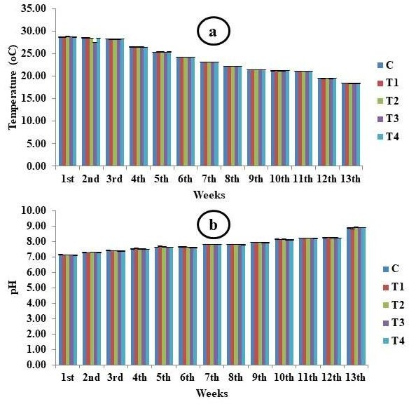

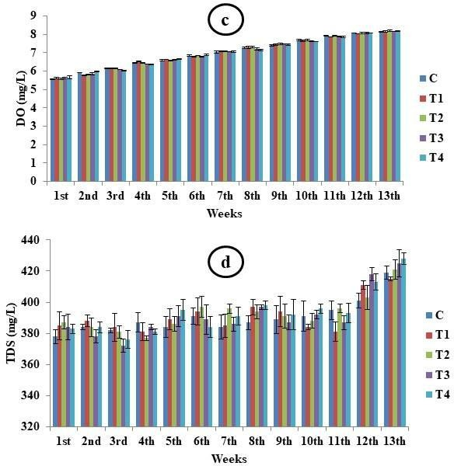

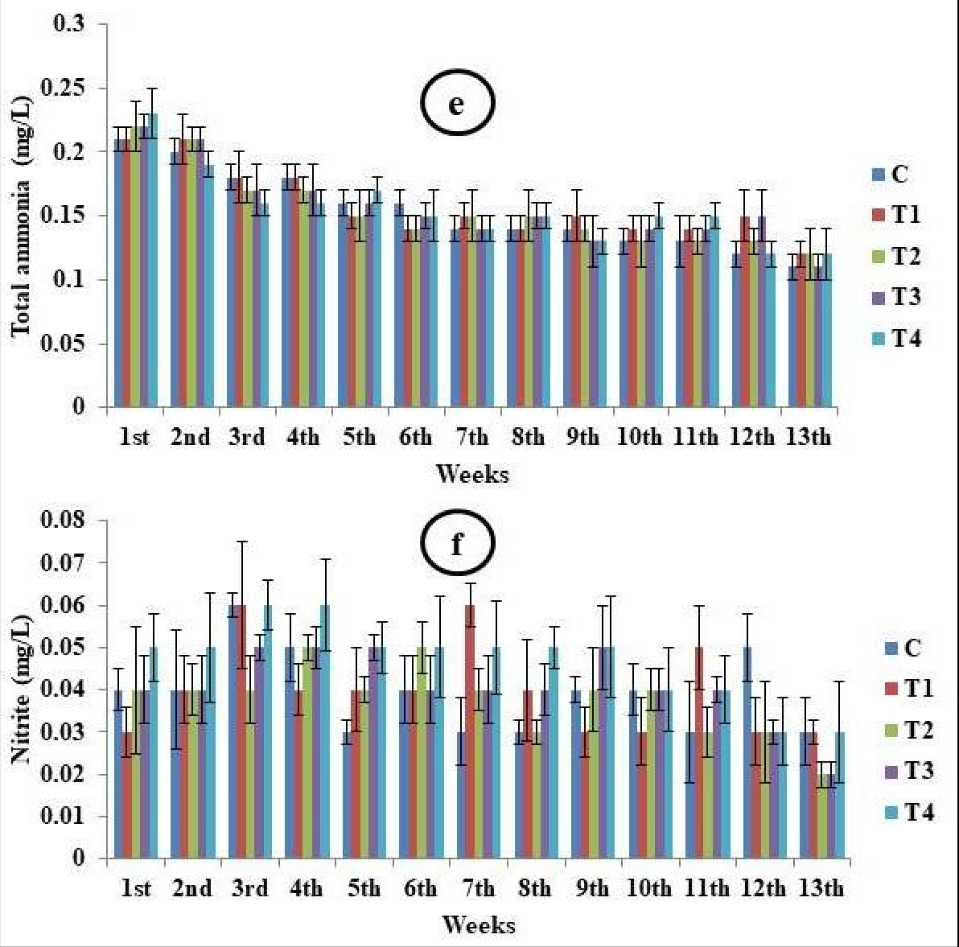
Fig. 1. Water quality parameters recorded under different treatments during the experimental period: (a) Temperature (°C), (b) pH, (c) Dissolved Oxygen (DO; mg/L), (d) Total Dissolved Solids (TDS; mg/L), (e) Total Ammonia (mg/L), and (f) Nitrite (mg/L)

Fish survival, Growth, and Nutrient Utilization

A significant difference (p<0.05) was observed in the survival rate (%) of P. brachypomus fed varying levels of fish silage as a replacement for fish meal in the experimental diets (Table.2). In the T2 treatment, where 50% of the fish meal was replaced with fish silage, the survival rate (97.08±0.75%) was higher compared to other treatments, attributed to the higher content of easily digestible proteins and amino acids (Fagbenro et al., 1994; Fagbenro and

Jauncey, 1995). Similar results were reported by Majumdar et al. (2014), who found that fish silage had no significant effect on the survival of Rohu fish. In contrast, Güllü et al. (2014) found that rainbow trout exhibited 100% survival even when their diet contained up to 60% fish silage. According to Shao et al. (2019), the highest survival rate in L. vannamei was observed when they were fed low levels of fish silage. Similarly, Abd El-Hakim et al. (2007) found that Nile tilapia exhibited good survival rates (96-100%) when fed varying levels of fish silage. The reduced survival rate in the T4 group demonstrates that excessive replacement of fish meal can disrupt nutritional balance and adversely affect fish performance. Throughout the experiment, the weight and length of P. brachypomus fingerlings were measured every 15 days intervals (fig. 2 & 3) with no statistically significant variances (P>0.05) observed in initial weight (2.58±0.03 gm) and length (4.24±0.02 cm) across treatment groups. A notable significant differences (p<0.05) were observed in the body weight and length among all experimental groups on the 15th, 30th, 45th, 60th, 75th and 90th days. The effects of dietary fish silage incorporation on the growth performance and nutrient utilization of P. brachypomus are presented in Table 2. The results showed that the T2 treatment (50% replacement of fish meal with fish silage) exhibited superior growth performance compared to the control and other treatment groups, achieving the highest final body weight (32.16 ± 0.44 g) and final body length (10.26 ± 0.03 cm). This was followed by T1, control, T3, while the lowest values were recorded in T4 (100% replacement of fish meal with fish silage). Similarly, percentage weight gain (%WG) was highest in the T2 group compared with all other treatments and the control group. The Specific Growth Rate (SGR) was also highest in T2 and was statistically similar (p>0.05) to that of T1. The control and T3 groups exhibited significantly lower SGR than T2 and T1; however, they were statistically similar to each other and performed better than T4. Overall, the lowest growth performance was observed in the T4 group. The superior growth observed in the T2 group was likely due to the biochemical properties of fish silage specifically hydrolyzed proteins, short-chain peptides, and free amino acids which enhance nutrient digestion and absorption (Olsen and Toppe, 2017; Toppe et al., 2018). Partial replacement of fish meal appears to improve nutrient availability and metabolic efficiency, resulting in enhanced somatic growth. Fagbenro et al. (1994) and Fagbenro and Jauncey (1995) reported similar findings, showing that growth performance in Oreochromis niloticus and Clarias gariepinus improved with the moderate addition of fish silage. Similarly, Madage et al. (2015) found that replacing fish meal with fish silage increased the final body

weight of red tilapia by 50%. Further evidence of the beneficial effects of moderate silage inclusion on skeletal and tissue development is provided by the greater body length observed in the T2 group. Similarly, Soltan and Tharwat (2006) found that fish fed low levels of silage and control diets exhibited greater body length compared to those fed at higher replacement levels. Studies by Vidotti et al. (2002), Arruda et al. (2009), and Güllü et al. (2014) indicate that fish silage can effectively replace a portion of the fish meal without negatively affecting growth. Soltan et al. (2008) found that partially replacing fish meal with fish silage resulted in improved growth; the best Specific Growth Rate (SGR) was observed in rainbow trout fed a diet containing 20% fish silage. Gonçalves et al. (1989), Ali et al. (1994), Nwanna and Daramola (2001), and Shao et al. (2019) reported similar growth trends with moderate inclusion levels of fish silage. Conversely, the reduced growth observed in treatments T3 (75% replacement) and T4 (100% replacement) indicates that high levels of fish meal replacement adversely affected feed efficiency and nutritional balance. High levels of fish silage can alter the amino acid composition of the diet, reduce feed palatability due to increased acidity, and limit the availability of nutrients essential for growth. Bromley and Smart (1981), Hardy et al. (1984), Jackson et al. (1984), Wilson et al. (1984), and Stone et al. (1989) demonstrated a similar decline in growth performance as the level of silage increased. However, Abd El-Hakim et al. (2007) found that Nile tilapia could completely replace fish meal without adverse effects, indicating species-specific tolerance to the use of fish silage. Furthermore, there was a significant difference (p<0.05) in feed utilization indices among the various treatments. Treatment T2 exhibited the highest Protein Efficiency Ratio (PER) and the lowest Feed Conversion Ratio (FCR), indicating superior feed utilization and protein conversion efficiency. The enhanced FCR and PER observed in T2 may be associated with increased digestibility and availability of hydrolyzed proteins and free amino acids present in fish silage, resulting in more efficient nutrient assimilation and growth. Similar improvements in FCR upon the inclusion of moderate levels of fish silage have been reported by Plascencia-Jatomea et al. (2002), Soltan and Tharwat (2006), Majumdar et al. (2014), Madage et al. (2015), and Güllü et al. (2014). Similar findings regarding PER reported by Fagbenro et al. (1994), Soltan and Tharwat (2006), and Madage et al. (2015) indicating enhanced protein utilization with the inclusion of low to moderate levels of fish silage. According to Vidotti et al. (2002) and Arruda et al. (2009), the inclusion of fish silage did not have any significant adverse effects on feed efficiency parameters in fish.







30

25

20
Weight (gm)
C

15 T1
T2

10
T3

5 T4

0
0 15 30 45 60 75 90
Days

Fig. 2. Average weight (gm) of P. brachypomus fingerlings of different feeding treatments during the 90-day experiment

12
10

8 C
Length (cm)
6 T1
T2

4 T3
2 T4

0
0 15 30 45 60 75 90
Days

Fig. 3. Average length (mm) of P. brachypomus fingerlings of different feeding treatments during the 90-day experiment

Table 2. Growth performance and survival of P. brachypomus under different feeding treatments

Parameters |  |  | Treatments
 | C | T1 | T2 | T3 | T4
Initial weight (gm) | 2.59±0.05 | 2.59±0.09 | 2.67±0.09 | 2.53±0.05 | 2.51±0.08
Final weight (gm) | 20.04±0.10^{c} | 22.60±0.01^{b} | 25.87±0.04ª | 17.73±0.02^{d} | 15.46±0.03e
Initial length(cm) | 4.23±0.06 | 4.32±0.02 | 4.25±0.05 | 4.21±0.02 | 4.23±0.06
Final length (cm) | 8.80±0.03^{c} | 9.68±0.02^{b} | 10.26±0.03ª | 8.08±0.03^{d} | 8.04±0.05^{d}
Weight gain (%) | 674.50±14.48^{c} | 774.94±31.52^{b} | 871.54±35.19ª | 601.48±15.21^{c} | 516.45±21.03^{d}
SGR (% day⁻¹) | 1.94±0.02^{b} | 2.06±0.03ª | 2.16±0.04ª | 1.84±0.02^{b} | 1.71±0.04^{c}
FCR | 2.59±0.02^{b} | 2.37±0.02^{c} | 2.18±0.01^{d} | 2.66±0.06^{b} | 2.87±0.03ª
FER | 0.39±0.02^{c} | 0.42±0.04^{b} | 0.46±0.06ª | 0.38±0.01^{c} | 0.35±0.03^{d}
PER | 0.55±0.02^{c} | 0.62±0.03^{b} | 0.72±0.06ª | 0.47±0.01^{d} | 0.41±0.01e
Survival rate (%) | 92.33±1.20^{b} | 94.33±2.08^{ab} | 97.08±0.75ª | 89.97±1.54^{b} | 80.67±0.51^{c}
Data expressed as Mean±SE (n=3); different superscripts in raw indicate values with significant differences at p<0.05, while values without superscripts show no significant difference at p>0.05; C= Control (0% fish silage), T1= 25% fish silage substitution, T2= 50% fish silage substitution, T3= 75% fish silage substitution, T4= 100% fish silage substitution

Conclusion
The study demonstrated that fish silage can be used as a partial replacement for fish meal in the diet of Piaractus brachypomus fingerlings. Among the tested treatments, the diet containing 50% replacement of fish meal protein with fish silage produced the best growth performance, feed utilization, and survival. This treatment recorded the highest final body weight, final length, percentage weight gain, specific growth rate, protein efficiency ratio, and survival rate, while also showing the lowest feed conversion ratio. Water quality parameters remained within acceptable ranges during the trial, suggesting that dietary inclusion of fish silage did not adversely affect the rearing environment. However, higher replacement levels, particularly 75% and 100%, resulted in reduced growth and feed utilization. Based on the present findings, replacing fish meal protein up to 50% with fish silage may be considered suitable for pacu fingerling feed formulation under controlled rearing conditions. Further evaluation is needed before recommending broader field-level use.

Limitations
The study was limited to a 90-day tank-based feeding trial under controlled conditions. Although growth, survival, feed conversion, and water quality were evaluated, the manuscript does not provide proximate composition, amino acid profile, microbial safety, lipid oxidation status, or digestibility data for the prepared fish silage and experimental diets. Carcass composition and economic analysis were also not included. Some numerical inconsistencies in fish number and final weight require correction. Therefore, the findings should be interpreted as preliminary evidence for partial replacement of fish meal with fish silage in pacu diets.

Declaration of AI Use

This manuscript was prepared through the combined contributions of all author(s), including contributions to the study design, data, content development, results, interpretation, and related scholarly work. The author(s) acknowledge the use of Grammarly and ChatGPT to assist with grammar checking, language refinement, reference formatting. These AI-assisted tools were not used as authors and did not replace the intellectual contributions or scholarly judgment of the author(s). All AI-assisted outputs, including content, references, and interpretations, were carefully reviewed, revised, verified, and approved by the author(s). The author(s) accept full responsibility for the accuracy, integrity, and final content of the manuscript.

Conflict of Interest

The authors declare that they have no conflict of interest.

Data Availability Statement
The data supporting the findings of this study are available from the corresponding author upon reasonable request.

COMPETING INTERESTS DISCLAIMER:
Authors have declared that they have no known competing financial interests OR non-financial interests OR personal relationships that could have appeared to influence the work reported in this paper.

References

Abd El-Hakim, N., Et-Gendy, M. and Salem, M., 2007. Effect of incorporation of fish silage into diets on growth performance and body composition of Nile tilapia (Oreochromis niloticus). Egyptian Journal of Aquatic Biology and Fisheries, 11(2), pp.101-117.
APHA (American Public Health Association), 2022. Standard Methods for the Examination of Water and Wastewater. 24th Edition, American Public Health Association.
Arruda, L.F.D., Borghesi, R., Portz, L, Cyrino, J.E.P. and Oetterer, M. 2009. Fish silage in black bass (Micropterus Salmoides) feed as an alternative to fish meal. Brazilian Archives of Biology and Technology. 5, pp.1261-1266.
Banerjea, S. M., 1967. Water quality and soil condition of fishponds in some states of India in relation to fish production. Indian journal of Fisheries, 14, pp.115-144.
Bhatnagar, A. and Singh, G., 2010. Culture fisheries in village ponds: a multi- location study in Haryana, India. Agriculture and Biology Journal of North America, 1(5), pp. 961-968.
Bhatnagar, A., Jana, S.N., Garg, S.K. Patra, B.C., Singh, G. and Barman, U.K., 2004. Water quality management in aquaculture, In: Course Manual of summerschool on development

of sustainable aquaculture technology in fresh and saline waters, CCS Haryana Agricultural, Hisar (India), pp 203- 210.
Bicudo, A.J.A, Sado, R.Y. and Cyrino, J.E.P. 2010. Growth performance and body composition of pacu Piaractus mesopotamicus (Holmberg 1887) in response to dietary protein and energy levels. Aquaculture Nutrition. 2, pp. 213-222.
Boyd, C.E. and Tucker, C.S., 1998. Chemical, Physical, and Biological Treatments. In Pond Aquaculture Water Quality Management. Boston, MA: Springer US, pp. 498-540.
Boyd, C.E., 2011. Dissolved oxygen requirements in aquatic animal respiration, Global Aquaculture Advocat. Available at https://www.globalseafood.org/advocate/dissolved-oxygen-requirements-in-aquatic-animal-respiration/ (assessed on 26/06/2026).
Bromley, P.J. and Smart, G. 1981. The effects of the major food categories on growth, composition and food conversion in rainbow trout (Salmo gairdneri Richardson). Aquaculture. 1-4, pp.325-336.
Copatti, C.E., Baldisserotto, B., de Freitas Souza, C. and Garcia, L., 2019. Protective effect of high hardness in pacu juveniles (Piaractus mesopotamicus) under acidic or alkaline pH: Biochemical and haematological variables. Aquaculture, 502, pp.250-257.
Costa Jr, C., Wollenberg, E., Benitez, M., Newman, R., Gardner, N. and Bellone, F., 2022. Roadmap for achieving net-zero emissions in global food systems by 2050. Scientific Reports, 12(1), p.15064.
Department of Fisheries, 2025. Handbook of Fisheries Statistics. New Delhi: Ministry of Fisheries, Animal Husbandry and Dairying, Government of India.
DeZuane, J., 1997. Handbook of drinking water quality. John Wiley & Sons. ISBN 0-471-28789-X.
Espe, M. and Lied, E. 1999. Fish silage prepared from different cooked and uncooked raw materials: chemical changes during storage at different temperatures. Journal of the Science of Food and Agriculture, 2, pp. 327-332.
European Inland Fisheries Advisory Commission (EIFAC), 1973. Water Quality Criteria for European Freshwater Fish, Report on Ammonia and Inland Fisheries, Water Resources., 7, pp. 1011-1022.
Fagbenro, O. and Jauncey, K. 1995. Growth and protein utilization by juvenile catfish (Clarias gariepinus) fed dry diets containing co-dried lactic-acid-fermented fish-silage and protein feedstuffs. Bioresource Technology, 1, pp. 29-35.

Fagbenro, O., Jauncey, K. and Haylor, G. 1994. Nutritive value of diet containing dried lactic acid fermented fish silage and soybean meal for juvenile Oreochromis niloticus and Clarias gariepinus. Aquatic Living Resources, 2, pp. 79-85.
Fang, D., Mei, J., Xie, J. and Qiu, W., 2023. The effects of transport stress (temperature and vibration) on blood biochemical parameters, oxidative stress, and gill histomorphology of pearl gentian groupers. Fishes, 8(4), p.218.
FAO. 2026. The State of World Fisheries and Aquaculture 2026 – Blue Transformation: turning vision into impact. Rome. https://doi.org/10.4060/cd8357en
Favero, G.C., dos Santos, F.A.C., da Costa Júlio, G.S., Batista, F.S., Bonifácio, C.T., Torres, I.F.A., Paranhos, C.O. and Luz, R.K., 2022. Effects of water temperature and feeding time on growth performance and physiological parameters of Piaractus brachypomus juveniles. Aquaculture, 548, p.737716.
Ferreira, A.L., Dos Santos, F.A.C., Bonifácio, C.T. and Luz, R.K., 2023. Effects of live prey concentration, salinity, and weaning age on larviculture of Piaractus brachypomus reared in a recirculating aquaculture system. Tropical Animal Health and Production, 55(2), p. 99.
Gonçalves, J, Santos, S, Pereira, V.S, Baptista, I. and Coimbra, J. 1989. The use of fish silage as an ingredient for eel fingerling nutrition. Aquaculture, 1-2, pp. 135-146.
Güllü, K., Acar, Ü., Tezel, R. and Yozukmaz, A., 2014. Replacement of fish meal with fish processing by-product silage in diets for the rainbow trout, Oncorhynchus mykiss. Pakistan Journal of Zoology, 46(6).
Hardy, R.W, Shearer, K.D. and Spinelli, J. 1984. The nutritional properties of co-dried fish silage in rainbow trout (Salmo gairdneri) dry diets, Aquaculture, 1, pp. 35-44.
Hossain, M.I., Shikha, F.H. and Chakrabarty, T., 2018. Comparative Study on Farm Materials and Quality Parameters of Pangus (Pangasianodon hypophthalamus) of Different Farms in Trishal Area. Journal of Environmental Science and Natural Resources, 11(1-2), pp.109-119.
Hussain, S.M, Bano, A.A, Ali, S, Rizwan, M, Adrees, M, Zahoor, A.F, Sarker, P.K, Hussain, M, Arsalan, M.Z.U.H, Yong, J.W.H. and Naeem, A. 2024. Substitution of fishmeal: Highlights of potential plant protein sources for aquaculture sustainability. Heliyon, 10(4).

Jackson, A.J, Kerr, A.K. and Cowey, C.B. 1984. Fish silage as a dietary ingredient for salmon. I. Nutritional and storage characteristics. Aquaculture, 3, pp. 211-220.
Khajuria, S, Kumar, S, Natt, S.K, Uniyal, S, Surasani, V.K.R. and Singh, A. 2026. Biological valorization of Pangas fish processing waste into nutrient-rich fish silage using molasses-assisted Lactobacillus plantarum: fermentation dynamics, nutritional quality, and economic feasibility. Frontiers in Aquaculture, 5, 1813678 p
Khan, I, Kaur, V.I. and Datta, S.N. 2021. Effect of Fish Silage Supplemented Diets on Growth and Health Status of Pangas Catfish, Pangasianodon hypophthalmus Fry. Indian Journal of Animal Research, 3, p. 55.
Khani S, Rajaee T. 2007. Modelling of dissolved oxygen concentration and its hysteresis behavior in rivers using wavelet transform-based hybrid models. CLEAN–Soil, Air, Water, 45(2).
Mach, M, Dolan, S. and Tzafrir, S. 2010. The differential effect of team members trusts on team performance: The mediation role of team cohesion. Journal of Occupational and Organizational Psychology, 3, pp. 771-794.
Madage, S.S.K., Medis, W.U.D. and Sultanbawa, Y., 2015. Fish silage as replacement of fishmeal in red tilapia feeds. Journal of Applied Aquaculture, 27(2), pp. 95-106.
Majluf, P., Matthews, K., Pauly, D., Skerritt, D.J. and Palomares, M.L.D., 2024. A review of the global use of fishmeal and fish oil and the Fish In: Fish Out metric. Science Advances, 10(42), p.eadn5650.
Majumdar, R.K. Deb, S. and Nath, K.B. 2014. Effect of co-dried silage from fish market waste as substitute for fish meal on the growth of the Indian major carp Labeo rohita (Hamilton, 1822) fingerlings. Indian Journal of Fisheries. 4, pp. 63-68.
Maksimenko, A., Belyi, L., Podvolotskaya, A., Son, O. and Tekutyeva, L., 2024. Exploring sustainable aquafeed alternatives with a specific focus on the ensilaging technology of fish waste. Fermentation, 10(5), p.258.
Moon, B.H., Seo, G.T., Lee, T.S., Kim, S.S. and Yoon, C.H., 2003. Effects of salt concentration on floc characteristics and pollutants removal efficiencies in treatment of seafood wastewater by SBR. Water Science and Technology, 47(1), pp.65-70.
Olsen, R.L. and Toppe, J., 2017. Fish silage hydrolysates: Not only a feed nutrient, but also a useful feed additive. Trends in Food Science & Technology, 66, pp.93-97.

Ornamental Aquatic Trade Association (OATA), 2008. Water Quality Criteria – Ornamental Fish. Version 2.0. Westbury, Wiltshire, UK: Ornamental Aquatic Trade Association Ltd. Available at: OATA official website (Accessed: 28 June 2026)
Palkar, N.D, Koli, J.M, Patange, S.B, Sharangdhar, S.T, Sadavarte, R.K. and Sonavane, A.E. 2017. Comparative study of fish silage prepared from fish market waste by using different techniques. International Journal of Current Microbiology and Applied Sciences. 12, pp. 3844-3858.
Pellegrin, L., Nitz, L.F., Maltez, L.C., Copatti, C.E. and Garcia, L., 2020. Alkaline water improves the growth and antioxidant responses of pacu juveniles (Piaractus mesopotamicus). Aquaculture, 519, p.734713.
Plascencia-Jatomea, M., Olvera-Novoa, M.A., Arredondo-Figueroa, J.L., Hall, G.M. and Shirai, K., 2002. Feasibility of fishmeal replacement by shrimp head silage protein hydrolysate in Nile tilapia (Oreochromis niloticus L) diets. Journal of the Science of Food and Agriculture, 82(7), pp.753-759.
Ragasa, C, Osei-Mensah, Y.O. and Amewu, S. 2022. Impact of fish feed formulation training on feed use and farmers income: Evidence from Ghana. Aquaculture, 558, p. 738378.
Rajwa, A., Rowiński, P.M., Bialik, R.J. and Karpiński, M., 2014, April. Stream diurnal profiles of dissolved oxygen—case studies. In 3rd IAHR Europe congress, Porto.
Raziye, R., Bahareh, S.H. and Parastoo, P., 2023. Use of fish waste to silage preparation and its application in animal nutrition. Online Journal of Animal and Feed Research, 13(2), pp.79-88.
Robinette, H.R., 1976. Effect of selected sublethal levels of ammonia on the growth of channel catfish (Ictalurus punctatus). The Progressive Fish-Culturist, 38(1), pp.26-29.
Rustad, T. 2003. Utilization of marine by-products. Electronic Journal of Environmental, Agricultural and Food Chemistry. 4, pp. 458-463.
Santana, T.M., Dantas, F.D.M., Monteiro Dos Santos, D.K., Kojima, J.T., Pastrana, Y.M., De Jesus, R.S. and Gonçalves, L.U., 2023. Fish viscera silage: production, characterization, and digestibility of nutrients and energy for tambaqui juveniles. Fishes, 8(2), p.111.
Santhosh, B. and Singh, N.P., 2007. Guidelines for water quality management for fish culture in Tripura, ICAR Research Complex for NEH Region, Tripura Center, Lembucherra-799210, Tripura (west). Publication, (29).

Shao, J, Jiang, K. and Wang, L. 2019. Litopenaeus vannamei fed diets with different replacement levels of fish meal by fish silage: a molecular approach on intestinal microbiota. Aquaculture Nutrition. 3, pp. 721-728.
Sherrard, J.H., Moore, D.R. and Dillaha, T.A., 1987. Total dissolved solids: Determination, sources, effects, and removal. The Journal of Environmental Education, 18(2), pp.19-24.
Soltan, M.A. and Tharwat, A.A., 2006. Use of fish silage for partial or complete replacement of fish meal in diets of Nile tilapia (Oreochromis niloticus) Sand African catfish (Clarias gariepinus). Egyptian Journal Nutrition and Feeds, 9(2), pp.299-314.
Soltan, M.A., Hanafy, M.A. and Wafa, M.I.A. 2008. An evaluation of fermented silage made from fish by-products as a feed ingredient for African catfish (Clarias gariepinus). Global Veterinaria, 2, pp. 80-86.
Stone, F.E, Hardy, R.W, Shearer, K.D. and Scott, T.M. 1989. Utilization of fish silage by rainbow trout (Salmo gairdneri). Aquaculture, 1-2, pp. 109-118.
Tacon, A.G. and Metian, M., 2008. Aquaculture feed and food safety: the role of the Food and Agriculture Organization and the Codex Alimentarius. Annals of the New York Academy of Sciences, 1140(1), pp.50-59.
Toppe, J.; Olsen, R.L.; Peñarubia, O.R.; James, D.G. Production and Utilization of Fish Silage. A Manual on How to Turn Fish Waste into Profit and a Valuable Feed Ingredient or Fertilizer; FAO: Rome, Italy, 2018; pp. 1-28.
Vidotti, R.M, Carneiro, D.J. and Viegas, E. 2002. Growth rate of pacu, Piaractus mesopotamicus, fingerlings fed diets containing co-dried fish silage as replacement of fish meal. Journal of Applied Aquaculture. 4, pp.77-88.
Volkoff, H. and Rønnestad, I., 2020. Effects of temperature on feeding and digestive processes in fish. Temperature, 7(4), pp.307-320.
Wilson, R.P, Freeman, D.W. and Poe, W.E. 1984. Three types of catfish offal meals for channel catfish fingerlings. The Progressive Fish-Culturist, 2, pp.126-132.
Witschi, W.A. and Ziebell, C.D., 1979. Evaluation of pH shock on hatchery-reared rainbow trout. The Progressive Fish-Culturist, 41(1), pp.3-5.
Yahiya, A., Mohammed, S. and Jacob, J.P., 2020. Acceptance of thermal and pH shock on red belly pacu (Piaractus brachypomus) in adverse rapid environmental conditions. Fisheries Science, 14, pp.01-05.

