Reproductive Strategy and Fecundity Patterns of Puntius sophore and Rasbora daniconius: Implications for Sustainable Fisheries Management

Abstract: - The present study reports the fecundity (F) of both species Puntius sophore and Rasbor daniconius in relation to total length (L), total body weight (W), and gonad weight(G) (Lanler et al., 1977; Bagenal, 1978; Nikolsky, 1963). Capture observations demonstrate the spawning season of P. sophore was identified as June–August with peak spawning in June–July (GSI peak in May: 8.46%), while R. daniconius spawned from April–July with peak in July (GSI: 2.21%). In both species, a highly significant positive correlation was found between GSI and fecundity (P. sophore: r = 0.358, p < 0.001; R. daniconius: r = 0.361, p = 0.002), confirming that gonadal maturity level directly determines egg production. However, the correlations between fecundity and body size (length and weight) were not significant in either species (Bagenal, 1978; Nikolsky, 1963; Langker et al., 1977). P. sophore showed significantly higher GSI and fecundity compared to R. daniconius, indicating greater reproductive investment per spawning event. Fecundity shows a linear relationship between L,G and W.
Keywords: Puntius sophore , Rasbora daniconius, fecundity, Linear relationship, spawning, gonadal maturity.

Introduction
Aquaculture is the fastest growing sector and it is the cultivation of aquatic animals, vertebrates, molluscs, shrimps and Prawns. A review of reproductive biology is important for understanding the life –history patterns of fish species and plays a key role in their conservation as well as sustainable management. Reproductive biology comprises various parameters including gonadal development, spawning periodicity, fecundity, gonadosomatic index (GSI) and the correlation between reproductive parameters and environmental factors. The present study focuses on the comparative reproductive biology of two important small indigenous cyprinid species, Puntius sophore and Rasbora daniconius (Hamilton,1822), commonly recognized in freshwater biodiversity and fisheries research (Jhingran, 1991; Lowe-McConnell, 1987; Talwar & Jhingran, 1991). Such information is critical for developing breeding protocols, stock assessment, and formulating effective management strategies for both wild populations and aquaculture development (Singha et al., 2024).
Fecundity refers to the number of eggs developed by a female fish and is a key indicator for evaluating reproductive potential and population variations. Understanding fecundity correlation with body size parameters (length, weight, gonad weight) assists in predicting egg production and evaluate the reproductive capacity of fish population.
2. Material and Method
Both species puntius sophore and rasbora daniconius are frequently observed occurring cyprinid forage fish in the freshwater of India. Thus, the present study was carried out during July –November the monsoon months at Bhopal, Madhya Pradesh. Fishes were sampled randomly from Upper Lake (Bhopal). After data collection of the total lengths and total weight, the fishes were conserved in 5% formalin for further assessment. The egg cross-sectional measurement was measured at its widest region using a calibrated ocular micrometer.
Result and Discussion

Fecundity
Fecundity is defined as the number of ripening eggs or ova found in the ovary prior to the next spawning event and constitutes a fundamental measure of the reproductive potential of fish populations (Bagenal and Braum, 1978; Murua et al., 2003). Accurate estimation of fecundity is essential for understanding population dynamics, recruitment potential, and for developing sustainable fisheries management strategies (Nikolsky, 1963; Wootton, 1990). In the present study, fecundity was estimated by the gravimetric method (Lagler, 1956), which involves weighing a representative sub-sample of the ovary, counting the number of mature ova in the sub-sample, and extrapolating to the total ovary weight.
The gravimetric approach is appropriate for small-bodied cyprinids when mature oocytes can be separated reliably; however, estimates should be interpreted with consideration of maturity stage, atresia, and spawning strategy because inclusion of immature or spent females can substantially reduce mean fecundity (Murua et al., 2003; West, 1990; Hossain et al., 2012).

Gonadosomatic Index (GSI)
The Gonad somatic Index (GSI) is the most widely used and reliable indicator of the reproductive state and spawning readiness of fish (Lagler, 1956; De Vlaming et al., 1982; West, 1990). It quantifies the proportion of body resources allocated to gonadal development and is calculated as GSI (%) = (Gonad Weight / Total Body Weight) × 100. Higher GSI values indicate active gonadal development and approaching spawning, while lower values signify quiescent, immature, or spent reproductive phases
Although GSI is a practical indicator of reproductive activity, it is best interpreted together with oocyte development and maturity stage because GSI can be affected by body size, ovarian allometry, and partial or protracted spawning patterns (de Vlaming et al., 1982; Somarakis et al., 2004; Flores et al., 2019).

Comparative GSI Analysis
Table 1: Comparative monthly variation in GSI (%) of P. sophore and R. daniconius from Upper Lake, Bhopal
Month | P.s ♀ (N) | P.s ♀ GSI | P.s ♂ (N) | P.s ♂ GSI | R.d ♀ (N) | R.d ♀ GSI
Jan | 2 | 1.27±0.69 | 0 | -- | 5 | 0.32±0.10
Feb | 6 | 0.31±0.08 | 4 | 0.17±0.02 | 5 | 0.21±0.05
Mar | 7 | 0.50±0.15 | 5 | 0.20±0.04 | 6 | 0.47±0.15
Apr | 8 | 1.68±0.82 | 5 | 0.38±0.05 | 6 | 0.96±0.21
May | 8 | 8.46±5.03 | 6 | 0.45±0.04 | 7 | 0.53±0.12
Jun | 10 | 3.90±2.49 | 6 | 0.50±0.05 | 7 | 1.36±0.43
Jul | 10 | 4.16±2.15 | 7 | 0.57±0.08 | 8 | 2.21±0.65
Aug | 11 | 7.03±1.81 | 0 | -- | 7 | 0.73±0.20
Sep | 25 | 2.95±1.16 | 8 | 0.38±0.02 | 1 | 0.80±0.00
Oct | 16 | 0.88±0.29 | 11 | 0.39±0.01 | 10 | 2.02±0.79
Nov | 6 | 0.31±0.08 | 4 | 0.16±0.02 | 5 | 0.39±0.13
Dec | 3 | 1.66±0.77 | 2 | 0.37±0.01 | 7 | 0.75±0.02
Annual | 112 | 3.05±0.59 | 58 | 0.38±0.02 | 74 | 1.02±0.15
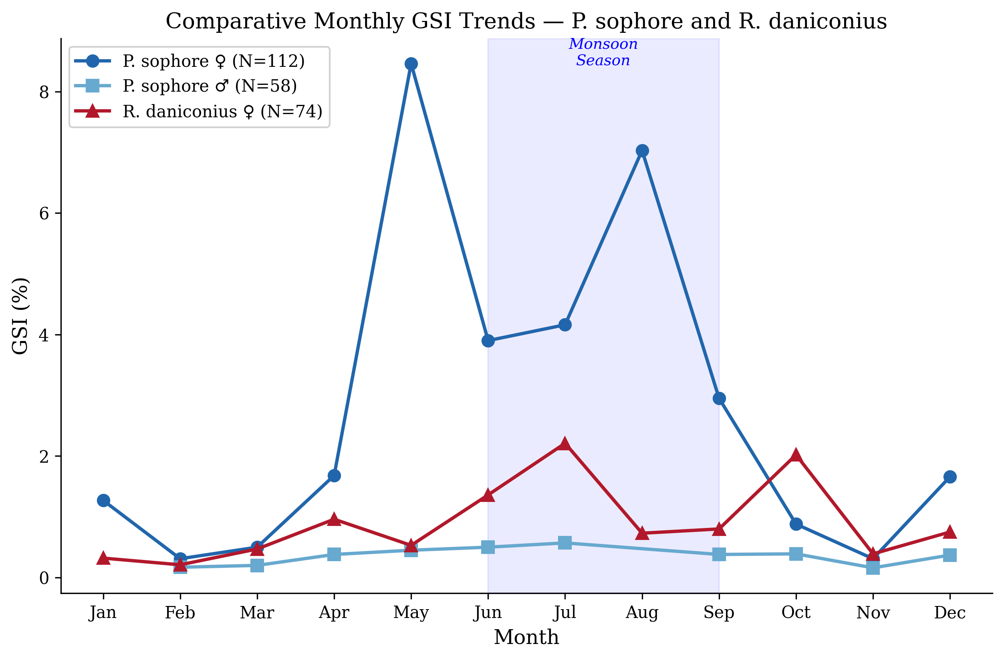
Figure 1: Comparative line graph showing monthly GSI trends of P. sophore (♀ and ♂) and R. daniconius (♀) from Upper Lake, Bhopal
The comparative GSI analysis reveals that while both species exhibit monsoon-associated spawning, their peak GSI months differ slightly. P. sophore females showed the highest GSI in May (8.46%), while R. daniconius peaked in July (2.21%). This temporal offset in peak reproductive activity may represent an adaptive mechanism to reduce inter-specific competition for spawning habitat, food resources for larvae, and nursery grounds — a phenomenon commonly observed in sympatric fish communities in tropical freshwaters (Lowe-McConnell, 1987; Welcomme, 1979).
The higher female GSI of P. sophore during May-August is consistent with reports that the species often shows region-specific breeding peaks during pre-monsoon to monsoon months, and such variation may reflect local temperature, rainfall, water level, and food availability (Hossain et al., 2012; Hasan et al., 2018; Murua et al., 2003).
Table 2: Monthly variation in fecundity (number of ova) of P. sophore and R. daniconius (Female) from Upper Lake, Bhopal
Month | P.s ♀N | P.s ♀Fecundity | R.d♀ N | R.d ♀ecundity | Season
January | 2 | 64.80±40.80 | 5 | 11.80±1.80 | Winter
February | 6 | 401.00±349.16 | 5 | 25.20±9.33 | Winter
March | 7 | 143.29±106.33 | 6 | 10.00±0.00 | Pre-Mon.
April | 8 | 331.62±228.75 | 6 | 29.17±12.92 | Pre-Mon.
May | 8 | 104.25±47.04 | 7 | 12.43±0.87 | Pre-Mon.
June | 10 | 837.60±540.31 | 7 | 16.00±2.59 | Monsoon
July | 10 | 1548.40±1036.34 | 8 | 25.12±3.55 | Monsoon
August | 11 | 721.09±288.98 | 7 | 20.00±2.48 | Monsoon
September | 25 | 1195.68±714.91 | 1 | 15.00±0.00 | Monsoon
October | 16 | 186.36±160.16 | 10 | 23.02±10.65 | Post-Mon.
November | 6 | 34.33±24.33 | 5 | 10.00±0.00 | Post-Mon.
December | 3 | 712.43±441.35 | 7 | 14.86±1.22 | Winter
Annual | 112 | 661.02±196.70 | 74 | 18.37±1.98 | --
P.s ♀ANOVA: F=0.555, p=0.860 NS; R.d ♀ANOVA: F=0.976, p=0.473 NS; Values: Mean±SE
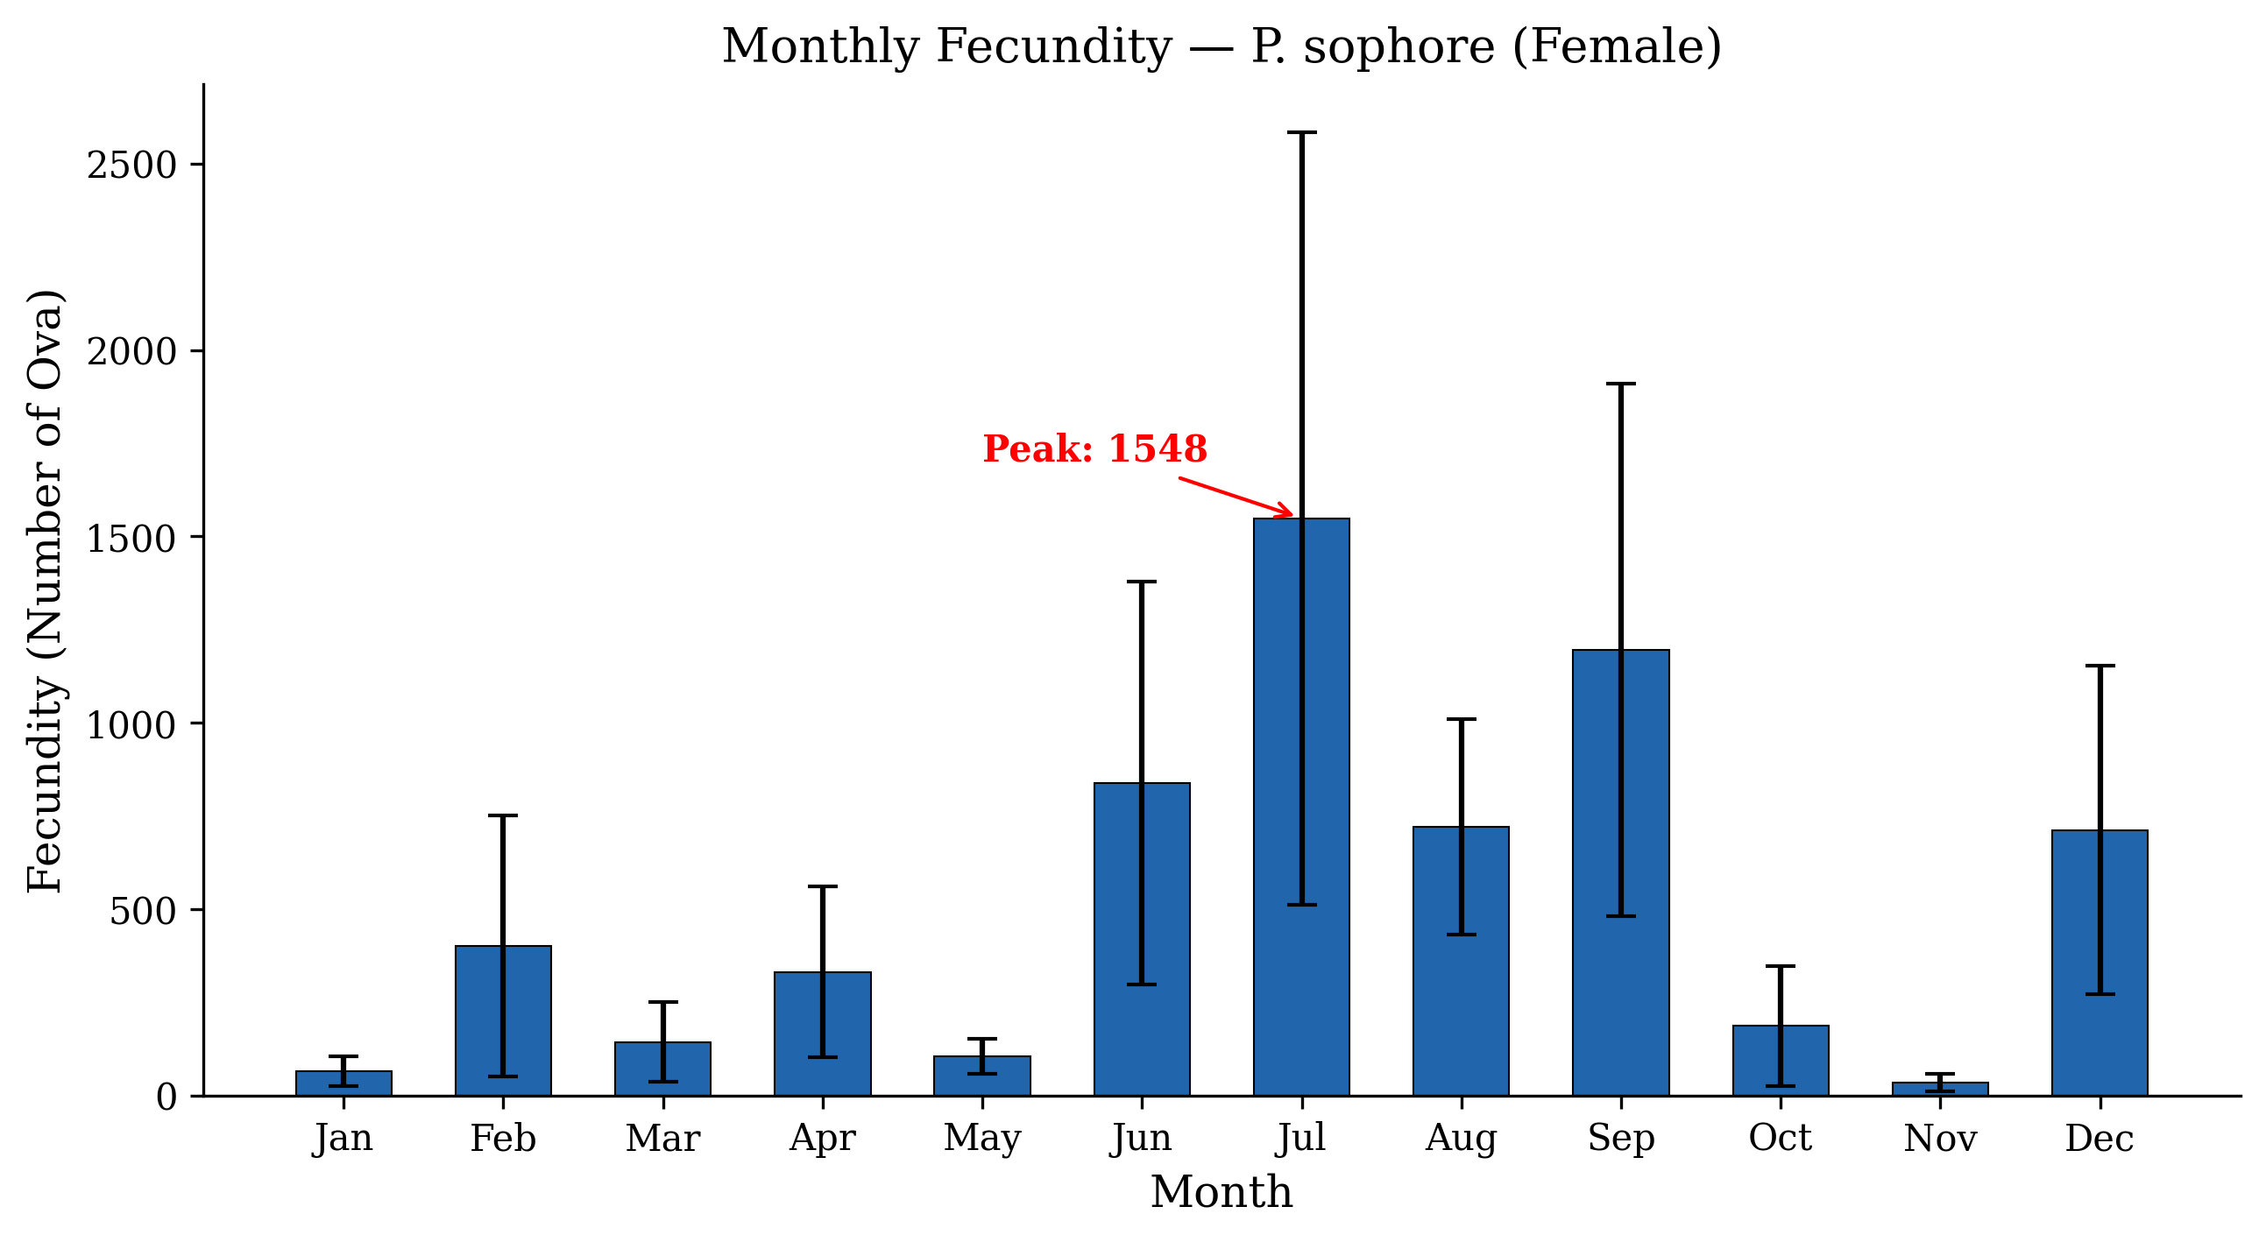
Figure 2: Bar graph showing monthly fecundity of P. sophore (Female) from Upper Lake, Bhopal with error bars (±SE)
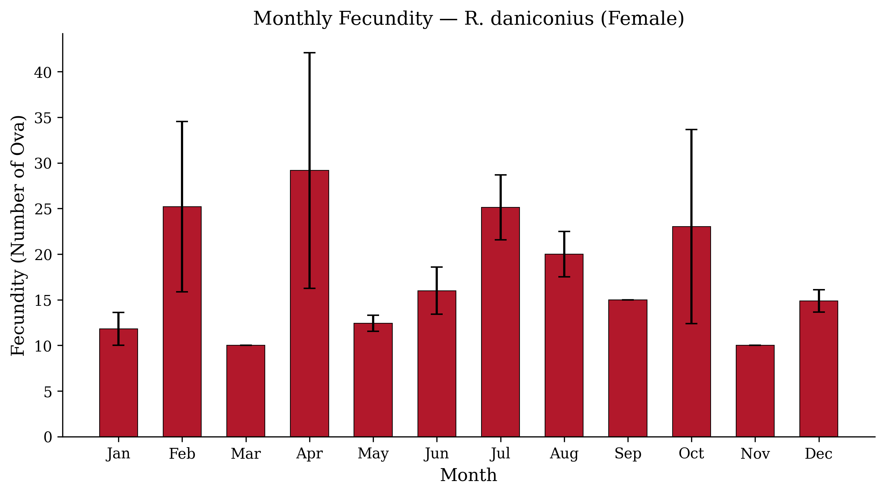
Figure 3: Bar graph showing monthly fecundity of R. daniconius (Female) from Upper Lake, Bhopal with error bars (±SE)
The annual mean fecundity of P. sophore females was 661.02 ± 196.70 ova (SD = 2081.65, range: 10 to 17,052). The highest mean fecundity was recorded in July (1548.40 ± 1036.34), followed by September (1195.68 ± 714.91) and June (837.60 ± 540.31). The lowest fecundity was in November (34.33 ± 24.33). ANOVA showed no significant monthly variation (F = 0.555, p = 0.860), which is attributable to the enormous inter-individual variability within months — the presence of both immature fish (with very low fecundity) and fully mature fish (with high fecundity) in the same monthly sample.
Published fecundity values for P. sophore vary widely across studies. Kant et al. (2016) reported fecundity ranging from 1,560 to 2,314 eggs from Jammu, India. Hossain et al. (2006) from the Padma River, Bangladesh reported a much wider range of 1,488 to 18,708 ova (mean: 5,682 ± 3,703). Bithy et al. (2012) documented fecundity of 7,951 to 23,053 from Bangladesh. Rafiquzzaman et al. (2018) recorded the highest fecundity of 5,053 ± 878.27 (Gazipur) and 5,433 ± 968.26 (Jessore). The present mean fecundity (661.02) is lower than most published reports, likely because the analysis included all maturity stages rather than only gravid females, and because of the generally smaller body size of the Upper Lake population.
Therefore, the lower fecundity observed in Upper Lake should not be interpreted as inherently poor reproductive capacity; rather, it may reflect population size structure, sampling across maturity stages, and local environmental conditions affecting gonadal development (Hossain et al., 2012; Hasan et al., 2018; Murua et al., 2003).
R. daniconius females exhibited considerably lower fecundity with an annual mean of 18.37 ± 1.98 ova (SD = 17.08, range: 5 to 80). The highest fecundity was in April (29.17 ± 12.92) and July (25.12 ± 3.55). This low fecundity is consistent with the species' reproductive strategy — R. daniconius is known to produce small clutches of relatively large eggs, reflecting a K-selected reproductive strategy favouring offspring quality over quantity (Pianka, 1970; Nagendran and Shakuntala, 1979). According to Paul and Sarmah, the fertilized eggs are semi- adhesive in nature and measure approximately 0.8-1.0 mm in diameter, which is considerably larger than the eggs of P. sophore.
Earlier work on R. daniconius reported fecundity to be positively related to body length, body weight, and gonad weight, which indicates that the very low values in the present samples may require careful interpretation in relation to sampling period, maturity status, and possible differences in egg-counting criteria (Nagendran et al., 1981; West, 1990; Murua et al., 2003).

4.8.1 Fecundity Relationships with Morphometric Parameters
Table 3: Pearson correlation coefficients for fecundity relationships in P. sophore and R. daniconius
Relationship | P.s ♀ | P.s ♀p | R.d ♀ | R.d ♀p
Fecundity vs TL | 0.131 | 0.167 NS | -0.015 | 0.896 NS
Fecundity vs BW | 0.153 | 0.107 NS | 0.022 | 0.855 NS
Fecundity vs GSI | 0.358 | <0.001 ** | 0.361 | 0.002 **
** p < 0.01; NS = Not Significant; TL = Total Length; BW = Body Weight; GSI = Gonadosomatic Index
In both species, a highly significant positive correlation was found between GSI and fecundity (P. sophore: r = 0.358, p < 0.001; R. daniconius: r = 0.361, p = 0.002), confirming that gonadal maturity level directly determines egg production. However, the correlations between fecundity and body size (length and weight) were not significant in either species. This contrasts with several published reports where fecundity was positively correlated with body size (Kant et al., 2016; Hossain et al., 2006). The non-significant relationship in the present study is likely because all maturity stages were included in the analysis — in immature and spent fish, fecundity is minimal regardless of body size, which weakens the overall correlation.
The significant association between fecundity and GSI in both species supports the use of GSI as a field-level proxy for reproductive investment; however, the weak relationship with body size suggests that future analyses should separate mature, immature, and spent females, because pooled maturity stages can mask size-fecundity relationships (de Vlaming et al., 1982; Flores et al., 2019; West, 1990).

Conclusions
The study indicates that Puntius sophore and Rasbora daniconius differ in reproductive timing, gonadosomatic index pattern, and fecundity level in Upper Lake, Bhopal. P. sophore showed higher female GSI and higher mean fecundity than R. daniconius, suggesting greater reproductive investment per spawning event. The spawning period of P. sophore was identified mainly from June to August, with peak spawning during June–July, while R. daniconius showed an earlier reproductive period from April to July, with peak activity in July. Fecundity was significantly associated with GSI in both species, indicating that gonadal development is closely linked with egg production. However, fecundity was not significantly related to total length or body weight when all maturity stages were pooled. This suggests that maturity stage should be considered carefully when assessing fecundity relationships. Overall, the findings provide preliminary information on reproductive patterns of these two cyprinid fishes and may help in planning breeding-season protection and sustainable fisheries management.

Limitations
The study is limited by insufficient detail on sampling design, sampling duration, sex-wise sample size, maturity-stage selection, and statistical methods. The manuscript reports monthly data across the year, but the methods state that sampling was conducted during July–November, which requires clarification. Fecundity estimates may be affected by inclusion of immature, mature, and spent females in the same analysis. Environmental variables such as temperature, rainfall, water level, dissolved oxygen, and food availability were not analysed. The comparison between species is mainly descriptive, and the unusually low fecundity values for Rasbora daniconius require further verification.

Declaration of AI Use

This manuscript was prepared through the combined contributions of all author(s), including contributions to the study design, data, content development, results, interpretation, and related scholarly work. The author(s) acknowledge the use of Grammarly and ChatGPT to assist with grammar checking, language refinement, reference formatting. These AI-assisted tools were not used as authors and did not replace the intellectual contributions or scholarly judgment of the author(s). All AI-assisted outputs, including content, references, and interpretations, were carefully reviewed, revised, verified, and approved by the author(s). The author(s) accept full responsibility for the accuracy, integrity, and final content of the manuscript.

COMPETING INTERESTS DISCLAIMER:
Authors have declared that they have no known competing financial interests OR non-financial interests OR personal relationships that could have appeared to influence the work reported in this paper.

Reference
- Singha, S., Kumar, S., Gogoi, K., Saharia, P. K., Dutta, R., Patowary, A. N., Baishya, S., Bhagawati, K., Bordoloi, B., & Sarma, D. K. (2024). Can sympathetic induction be a convenient technique for breeding Amblypharyngodon mola (Hamilton, 1822)? Animal Reproduction Science, 264, 107473. https://doi.org/10.1016/j.anireprosci.2024.107473.
- Bagenal and Braum (1978):
Bagenal, T. B., & Braum, E. (1978). Eggs and early life history. In T. B. Bagenal (Ed.), Methods for Assessment of Fish Production in Fresh Waters (3rd ed., pp. 165–201). Blackwell Scientific Publications.
- Murua, H., Kraus, G., Saborido-Rey, F., Witthames, P. R., Thorsen, A., & Junquera, S. (2003). Procedures to estimate fecundity of marine fish species in relation to their reproductive strategy. Journal of Northwest Atlantic Fishery Science, 33, 33–54.
- Nikolsky (1963):
Nikolsky, G. V. (1963). The ecology of fishes. Academic Press.
- Wootton (1990):
Wootton, R. J. (1990). Ecology of teleost fishes. Chapman & Hall.
- Lagler, K. F. (1956). Freshwater fishery biology. Wm. C. Brown Company.
- Bithi, U. H., Hossain, M. A. R., & Rahman, M. M. (2012). Studies on the fecundity and gonadosomatic index (GSI) of Puntius sophore (Hamilton, 1822). Journal of Fisheries and Aquatic Science, 7(2), 138–145.
- Rafiquzzaman, S. M., Hossain, M. Y., Islam, M. A., Hossain, M. A., & Rahman, M. M. (2018). Reproductive biology and fecundity of Puntius sophore (Hamilton, 1822) from Bangladesh waters. Journal of Fisheries and Aquatic Science, 13(2), 75–83.
- Pianka (1970):
Pianka, E. R. (1970). On r- and K-selection. The American Naturalist, 104(940), 592–597.
- Nagendran and Shakuntala (1979):
Nagendran, N. A., & Shakuntala, K. (1979). Studies on the fecundity of Rasbora daniconius (Hamilton). Matsya, 5, 45–50.
- Paul, S., and Sarmah, S.K. (2011). Mass propagation of ornamental fish species in North Eastern India – A case study on Nandus nandus. Journal of Inland Fisheries Society of India, 43(1): 107–110.

de Vlaming, V., Grossman, G., & Chapman, F. (1982). On the use of the gonosomatic index. Comparative Biochemistry and Physiology Part A: Physiology, 73(1), 31-39. https://doi.org/10.1016/0300-9629(82)90088-3
Flores, A., Wiff, R., Ganias, K., & Marshall, C. T. (2019). Accuracy of gonadosomatic index in maturity classification and estimation of maturity ogive. Fisheries Research, 210, 50-62. https://doi.org/10.1016/j.fishres.2018.10.009
Hasan, T., Hossain, M. F., Mamun, M., Alam, M. J., Salam, M. A., & Rafiquzzaman, S. M. (2018). Reproductive biology of Puntius sophore in Bangladesh. Fishes, 3(2), 22. https://doi.org/10.3390/fishes3020022
Hossain, M. Y., Rahman, M. M., Miranda, R., Leunda, P. M., Oscoz, J., Jewel, M. A. S., Naif, A., & Ohtomi, J. (2012). Size at first sexual maturity, fecundity, length-weight and length-length relationships of Puntius sophore (Cyprinidae) in Bangladeshi waters. Journal of Applied Ichthyology, 28(5), 818-822. https://doi.org/10.1111/j.1439-0426.2012.02020.x
Nagendran, R., Shakuntala, K., Natarajan, G. N., & Vasan, H. R. K. (1981). Observations on the fecundity of the cyprinid Rasbora daniconius (Hamilton). Proceedings: Animal Sciences, 90, 381-388. https://doi.org/10.1007/BF03186016
Somarakis, S., Ganias, K., Tserpes, G., & Koutsikopoulos, C. (2004). Ovarian allometry and the use of the gonosomatic index: A case study in the Mediterranean sardine, Sardina pilchardus. Marine Biology, 146, 181-189. https://doi.org/10.1007/s00227-004-1419-2
West, G. (1990). Methods of assessing ovarian development in fishes: A review. Australian Journal of Marine and Freshwater Research, 41(2), 199-222. https://doi.org/10.1071/MF9900199

