Original Research Article

SPECIES DIVERSITY OF LAND GASTROPODS FAUNA OF ANDAMAN GROUP OF ISLANDS, ANDAMAN & NICOBAR ISLANDS, INDIA

Abstract
The present study assessed the diversity, abundance and distribution of land gastropods from selected localities of the Andaman group of islands, Andaman and Nicobar Islands, India. Field surveys were conducted across 14 sampling stations in South, North and Middle Andaman, including Narcondam Island, during July 2024 to July 2025. Specimens were collected from terrestrial microhabitats such as leaf litter, decaying wood, tree trunks, moist forest floor, under stones and other humid sites using visual search, line transect and hand-picking methods. Collected specimens were identified up to species level using available taxonomic keys, and community structure was assessed using diversity and evenness indices. A total of 216 specimens representing 32 species, 26 genera, 19 families and 2 orders were recorded. Stylommatophora was the dominant order, comprising 27 species and 198 specimens, whereas Architaenioglossa was represented by 5 species and 18 specimens. The most abundant species was Botrychus turritus with 55 individuals, followed by Kalliella microconus with 34 individuals and Discus rotundus with 22 individuals. The Shannon diversity index was 2.69, indicating moderate to high species diversity. Pielou’s evenness index was 0.78, suggesting a relatively even distribution of species, while Simpson’s diversity index was 0.889 and Simpson’s dominance index was 0.111. Higher species richness was observed in forested localities such as Chidiyatapu and Mt. Manipur, whereas some disturbed lowland areas showed comparatively lower richness. The study provides baseline information on land gastropod diversity in the Andaman Islands and highlights the need for continued monitoring and taxonomic verification of terrestrial molluscan fauna in the region.
KEY WORDS:
Mollusca, Land Gastropods, Andaman group of Islands, Malacofaunal diversity, Andaman & Nicobar Islands.
Introduction
Molluscs are a diverse group and serve as reliable bioindicators. The Phylum Mollusca is the second-largest phylum, following Arthropoda. It is the most diverse group, inhabiting a variety of environments ranging from the deepest ocean trenches to intertidal zones, and from freshwater to land (Pallabi & Kushwaha 2003). Gastropoda is the most prominent class within the phylum Mollusca, characterised by animals with well-developed head-bearing tentacles, eyes, and a large muscular foot that assists in crawling (Kakar et al., 2020). Members of this class include snails, limpets, and slugs (Boonngam et al., 2008). The fauna of Indian land molluscs includes 1129 species across 138 genera and 34 families. Snails account for 1,109 species, while slugs comprise 20 species (Ramakrishna et al., 2010). To date, only 56 species have been reported from the Andaman Islands, of which 34 are endemic to this group of islands. This study is the first to provide abundance-based quantitative metrics for land gastropods, filling an important regional gap. The previous work done in the Andaman Islands has concentrated on marine and intertidal taxa, indicating that terrestrial diversity is under-recorded in the archipelago. The work reported herein was undertaken to study the Malacofaunal species present in the Andaman Islands.

MATERIALS & METHODS:
2.1 Study Area:
The Andaman and Nicobar Archipelago, situated in the central part of the Bay of Bengal, comprises 572 islands (Jeeva et al., 2018). The southern tip of this archipelago is located 145 NM from the northern side of Indonesia and 750 NM from the eastern coast of India. This island is scarcely populated compared to mainland India (Jeeva et al. 2018). This pristine environment supports the establishment of well-diversified coral communities. This archipelago is among the 12 mega-biodiverse hotspots and the 25 most endangered eco-regions in the world (Jeeva et al. 2018). The gastropod diversity of the Andaman Islands was studied in different locations of South, North & Middle Andaman. The South Andaman is located between 11˚27’00” and 11˚45’00” N latitude and 92˚30’00” and 92˚46’47” E longitude. South Andaman features a mix of evergreen and moist deciduous forests, along with coastal zones, providing diverse habitats for land molluscs. The area experiences a tropical hot and humid climate, with an average temperature ranging from 18˚C to 36˚C. It receives rainfall for eight months of the year, averaging 3000-3500 mm. The North and Middle Andaman fall between 6˚ and 94˚ E longitude. Tropical rainforests characterise it. The islands have a tropical climate with high humidity and rainfall, influenced by both the northeast and southwest monsoons. The average temperature remains relatively stable throughout the year, ranging from 23 °C to 31 °C. The Andaman & Nicobar Islands are divided into four regions, i.e. North and Middle Andaman, South Andaman, Little Andaman, and Nicobar Group. The GPS coordinates of all the sampling sites are presented in Table 1. A total of 14 sampling sites were surveyed along the Andaman group of Islands (Fig.1).

Table 1. Areas surveyed during the study period

S.No. | Study Sites | Latitude | Longitude
1 | Dhaninallah, Rangat | 12.61614N | 92.95089E
2 | Shyamkund, Rangat | 12.51693N | 92.85511E
3 | Jagannathdera, Diglipur | 13.34645N | 92.98209E
4 | Ramnagar, Diglipur | 13.09342N | 93.02962E
5 | Parlob Island, Rangat | 12.40241N | 92.86973E
6 | Nayasahar, BSI Garden | 11.59084N | 92.68927E
7 | Aamkunj, Rangat | 12.8173N | 92.8885E
8 | Interview Island | 12.97115N | 92.68646E
9 | Mt. Manipur | 11.72282N | 92.73375E
10 | Jagannathdera, Diglipur | 13.3918N | 93.2405E
11 | Karmatang | 12.857412N | 92.915187E
12 | Gandhinagar | 13.352860N | 93.010790E
13 | Chidiyatapu, Sri Vijaya Puram | 11.515483N | 92.702700E
14 | Narcondam Island | 13.451245N | 94.275546E

Figure 1: Map Showing The Location of Survey localities in the Andaman group of islands

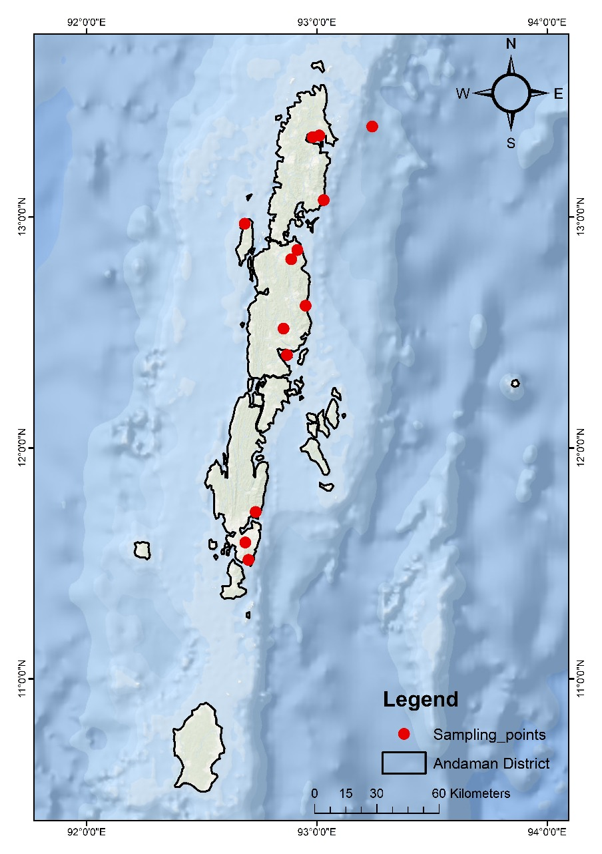
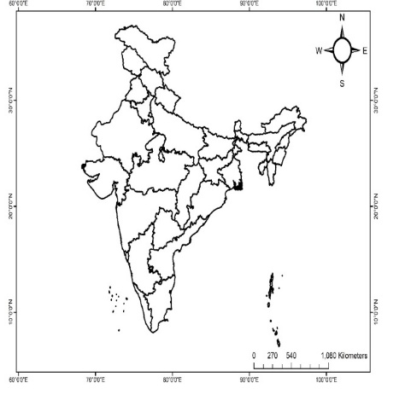

The present study was conducted at various locations in South, North & Middle Andaman, collecting the data from July 2024 to July 2025. A visual search survey method was used for gastropods in terrestrial habitats (Emberton et al., 1996). Field gazettes, such as forceps, zip-lock bags, and plastic containers, were used for the collection and safekeeping of the specimens. The survey sites were surveyed by the line transect method and the hand picking method. All possible macrohabitats of the land snails, including rotten woods, leaves, trunks, leaf litter, trees, under rock surfaces, under forest debris, and humid areas, where the maximum possible availability of land snails was surveyed physically. For land gastropods, intensive field visits were conducted during their active period, specifically during & after rainfall, as well as early morning and night. At least one living individual or dead shell of each species was collected as a voucher specimen and brought to the laboratory in wet or dry conditions. The living shells were collected and preserved in 70% ethyl alcohol in the field and returned to the laboratory for identification. Identification up to species level was done following the Taxonomic keys based on Ramakrishna and Dey (2007) and Mitra et al. (2005). Identified species were stored in suitable containers, labelled, and preserved in the National Zoological Collection at Andaman & Nicobar Regional Centre, Zoological Survey of India, Sri Vijaya Puram.

Estimation of Diversity and Distribution
Species diversity
Shannon diversity index (Shannon & Weaver 1949) was calculated as follows:
H’ = - Σ pi ln (pi),
where ‘H’ is the Shannon Diversity Index and ‘pi’ is the number of individuals in the ith species as a proportion of the total population. ln (pi) is the natural log of pi.
The formula used for calculating Simpson’s index (Simpson 1949) is: D = 1- (Σ n*(n-1)/N*(N-1), where ‘n’ is the number of individuals of a specific species. N is the total number of individuals of all species.
Pielou’s Evenness Index (J) is calculated using the Shannon Diversity Index (H) and ln(S) is the natural logarithm of the total number of species (S) in the community. The formula for Pielou’s Evenness Index (Pielou 1966) is: J’ = H’/H’max = H’ / ln(S).
The relative abundance (percentage composition) of land gastropod species across the Excel 14 sampling stations was calculated using the following formula.
Relative Abundance (%) = (Number of individuals of a species × 100) / Total number of species
Statistical analysis: For data conversion and analysis, Primer-6 was used.

RESULTS:
A total of 216 specimens which belonged to 32 species of land gastropods of 26 genera, 19 families, and 2 orders have been recorded from the surveyed localities in the present study. The complete list of collected species from the Andaman Islands, along with their taxonomic details and population status, is presented in Table 2. Among the order of land gastropod species, Architaeniogloassa was observed as the most dominant group with 82% followed by the order Stylommatophora (18%) only.
At the family level, land gastropod species are dominated by Cyclophoridae. There are 103 species from this family, accounting for 47.7% of the total land gastropod species. The next most abundant family is Oxychilidae with 3 species and 27 specimens (12.5%), followed by Discidae (10.2%). At the species level, Botrychus turritus Broderip,1832 was the most abundant species with 55 individuals (25.5%), followed by Kalliella microconus Mousson, 1865 (15.7%) and Discus rotundus Muller,1774 (10.2%). These three species together constitute over 51% of the entire community. Various species were represented by a single individual each, and they accounted for only 0.46% of the total abundance. The Shannon Diversity Index(H’) was 2.69. This indicates a moderately high diversity of land gastropods in the Andaman Islands. Pielou’s Evenness index was J’=0.78. This suggests a fairly even distribution of land gastropod species. Simpson’s Diversity was 0.889, showing the high diversity of land gastropods. But a low Simpson’s evenness value (0.281) shows that the species are unevenly distributed. Simpson’s dominance index was 0.111.
Table 2: List of Land Gastropods recorded in the Andaman group of Islands
Sl.No. | ORDER | FAMILY | Species | No.of specimens
S.No. | Order | Family | Species | Specimen
1 | Stylommatophora | Succinidae | Succinea floridana Pilsbry, 1905 | 2
2 | Stylommatophora | Pomitiidae | Pomatias rivularis Eichwald, 1829 | 4
3 | Stylommatophora | Camaenidae | Bradybaena similaris A.Férussac, 1822 | 5
4 | Stylommatophora | Camaenidae | Amphidromus everetii Fulton,1896 | 2
5 | Stylommatophora | Camaenidae | Amphidromus liei Joshuathami Thach, 2018 | 1
6 | Stylommatophora | Camaenidae | Aegista herpestes Heude,1885 | 2
7 | Stylommatophora | Oxychilidae | Oxychilus draparnaudi H.Beck, 1837 | 10
8 | Stylommatophora | Oxychilidae | Oxychilus alliarius Miller,1822 | 17
9 | Stylommatophora | Oxychilidae | Oxychilus cellarius O.F. Muller,1774 | 1
10 | Stylommatophora | Helminthoglyptida | Helminthoglypta traskii Newcomb,1861 | 1
11 | Stylommatophora | Gastrodontidae | Aiegopinella nitidula Draparnaud, 1805 | 3
12 | Stylommatophora | Pyramidulidae | Pyramidulla pusilla, Vallot,1801 | 1
13 | Stylommatophora | Zonitidae | Mesomphyx capnodes W.G.Binney,1857 | 1
14 | Stylommatophora | Bulimulidae | Botrychus turritus Broderip,1832 | 55
15 | Stylommatophora | Discidae | Discus rotundus Muller,1774 | 22
16 | Stylommatophora | Discidae | Anguispira picta, G.H.Clapp,1920 | 4
17 | Stylommatophora | Achatinidae | Subulina octana Bruguiere,1789 | 2
18 | Stylommatophora | Achatinidae | Achatina fulica Ferussac,1821 | 7
19 | Stylommatophora | Achatinidae | Limicolaria flammea Muller, 1774 | 1
20 | Stylommatophora | Clausiliidae | Cochlodina dubiosa Clessin,1882 | 1
21 | Stylommatophora | Chronidae | Kalliella barrakporensis Peiffer, 1853 | 5
22 | Stylommatophora | Chronidae | Kalliella microconus Mousson, 1865 | 34
23 | Stylommatophora | Canariellidae | Canariella planaria, Lamarck, 1822 | 4
24 | Stylommatophora | Ariophantidae | Tanyclamys indica, Godwin-Austen, 1883 | 4
25 | Stylommatophora | Helicidae | Drobacia banatica Rousmassler, 1838 | 1
26 | Stylommatophora | Hygromiidae | Monacha cartusianon O.F. Muller, 1774 | 4
27 | Stylommatophora | Hygromiidae | Monacha frequens Mousson,1859 | 4
28 | Architaenioglossa | Cyclophoridae | Lagocheilus polynema Morch,11876 | 4
29 | Architaenioglossa | Cyclophoridae | Cyclophorus malayanus W.H. Benson,1852 | 2
30 | Architaenioglossa | Cyclophoridae | Cyclophorus fulguratus Pfeiffer, 1852 | 9
31 | Architaenioglossa | Cyclophoridae | Cyclophorus Herklostii, E.Von Martens, 1861 | 2
32 | Architaenioglossa | Neocyclotidae | Neocyclotus dysoni L. Pfeiffer, 1853 | 1

Figure 2. A pie chart showing the distribution of land gastropods by Order group

Figure 3. Distribution of the species in different families

DISCUSSION:
The present study investigated the diversity of land gastropods across 14 sampling sites in the North, Middle, and South Andaman Islands, along with the remote Narcondam Island. Surveys were conducted from July 2024 to June 2025. A total of 32 land gastropod species, comprising 216 individuals, were recorded, with a diversity index (H’) of 2.69. This value indicates moderate to high diversity, characteristic of stable, species-rich communities (Silulu et al., 2013). The Shannon evenness (E) index of 0.81 reflects a balanced species distribution. Regarding species dominance, Botrychus turritus Broderip, 1832 was the most abundant (25.5%), followed by Kalliella microconus Mousson, 1865 (15.7%). Over 20 species contributed less than 2% each to the total, suggesting a diverse and well-balanced community (Silulu et al., 2013). While most studies in the Andaman focus on marine and intertidal gastropods, such as Jeeva et al. (2018), who reported a maximum H’ of 3.067 during the monsoon at Rangat (29 species), our findings demonstrate that inland habitats also host substantial gastropod diversity. Compared to earlier comprehensive surveys (Ramakrishna & Mitra, 2005; Mitra et al., 2005; Kakkar et al., 2020), our results reveal some similarities and differences in species composition, habitat associations, and community dominance. The high Simpson’s Diversity index (D = 0.889) suggests that the study area supports a rich and varied assemblage of land gastropods. However, the low Simpson’s Evenness index (0.281) shows that the community is highly uneven. A small number of species were dominant, whereas only one or a few individuals represented various species. Additionally, a low Simpson’s dominance value (0.111) indicates that no single species monopolises the community, though some species still have a numerical advantage over others. Sampling sites such as Chidiyatapu and Mt. Manipur in South Andaman recorded the highest species richness, consistent with previous studies highlighting South Andaman’s dense evergreen forests and relatively undisturbed habitats as biodiversity hotspots. These evergreen and semi-evergreen forests offer microhabitats, moist leaf litter, decaying wood, and stable humidity that support diverse assemblages, including families like Cyclophoridae, Ariophantidae, Helicarionidae, and Subulinidae. This aligns with Ramakrishna et al. (2005), who identified South Andaman as a primary hotspot for terrestrial molluscan diversity due to its habitat heterogeneity and less disturbed landscapes. Middle Andaman supported moderate diversity, with notable records from Dhaninallah, Aamkunj, Shyamkund, and Karmatang. Several species, including Botrychus turritus (55 specimens), were abundant, indicating that the relatively undisturbed moist deciduous and evergreen patches still sustain specialized taxa. Compared to earlier reports by Mitra et al. (2005), our findings suggest stable diversity in Middle Andaman, though some lowland sites show signs of species replacement, likely due to agricultural expansion and habitat fragmentation. North Andaman exhibited lower species richness and abundance compared to earlier studies. Mitra et al. (2005) reported diverse assemblages in pristine forests of North Andaman; however, our results reveal a decline in diversity, probably linked to anthropogenic pressures like increased settlement, agricultural conversion, and logging activities. This trend aligns with Kakkar et al. (2020), who noted similar biodiversity loss and community simplification in North and Middle Andaman. We also observed an increase in the dominance of generalist and invasive taxa, especially Achatina fulica, Limicolaria flammea, and Subulina octana, which thrive in disturbed habitats and outcompete native specialists. The gastropod assemblages on Narcondam Island are ecologically significant, displaying a distinct composition with potentially endemic species. The island’s volcanic origin, geographic isolation, and unique microclimatic conditions contribute to these specialised communities, supporting earlier suggestions by Ramakrishna et al. (2005) regarding the potential for endemism on smaller offshore islands. The current research further provides an updated account of land gastropod diversity and distribution across four major island groups in the Andaman Archipelago: South Andaman, Middle Andaman, North Andaman, and Narcondam Island.
Conclusion
The present study recorded 32 species of land gastropods belonging to 26 genera, 19 families and 2 orders from 14 sampling stations in the Andaman group of islands. A total of 216 specimens were documented during the survey period. Stylommatophora was the dominant order in both species richness and abundance, while Architaenioglossa was represented by comparatively fewer species and specimens. Among the recorded taxa, Botrychus turritus, Kalliella microconus and Discus rotundus were the most abundant species and together formed a major component of the sampled assemblage. The calculated diversity indices, including Shannon diversity, Pielou’s evenness, Simpson’s diversity and Simpson’s dominance values, indicate a moderately diverse land gastropod community with no complete dominance by a single species. Forested localities such as Chidiyatapu and Mt. Manipur supported comparatively higher richness, suggesting the importance of moist and less disturbed habitats for terrestrial gastropods. The findings provide useful baseline information on land gastropod diversity in the Andaman Islands and may support future ecological monitoring, taxonomic studies and conservation-oriented assessments of terrestrial molluscan fauna in the region.
Limitations
The present study was based on field surveys conducted across selected sampling stations in the Andaman group of islands and therefore may not represent the complete land gastropod diversity of the entire archipelago. Sampling was limited to 14 localities, and several microhabitats or seasons may remain insufficiently represented. The study relied primarily on morphological identification using available taxonomic keys; therefore, some species-level determinations may require further confirmation through expert taxonomic review or molecular approaches. The abundance data provide a useful baseline, but they do not allow strong conclusions on long-term population trends, habitat degradation or temporal changes because comparable multi-year data were not generated. Environmental variables such as soil moisture, vegetation structure, canopy cover and disturbance intensity were not quantitatively analysed. Future studies should include wider geographic coverage, repeated seasonal sampling, habitat-level measurements and updated taxonomic validation to strengthen understanding of land gastropod diversity in the Andaman Islands.
COMPETING INTERESTS DISCLAIMER:
Authors have declared that they have no known competing financial interests OR non-financial interests OR personal relationships that could have appeared to influence the work reported in this paper.

REFERENCES:
Boonngam, P., Dumrongrojwattana, P., Matchachdeep, S.(2008). The diversity of land snail fauna in Chonburi Province, Eastern Thailand, Kasetsart J. (Nat. Sci.). 42; 256-263.
Emberton, K.C., Pearce, T.A. and Randalana, R.(1996). Quantitatively sampling land – snail species richness in Madagascan rainforests, Malacologia, 38: 203-212.
Jeeva, C, Mohan, P.M., Sabith, K.K.D.B., Ubare V, V. (2018). Distribution of Gastropods in the Intertidal Environment of South, Middle & North Andaman Islands, India. Open Journal of Marine Science 08(01): 173-195. DOI: 10.4236/ ojmc.2018.81009.
Kakar,S,Ullah,Z, Khan, A.(2020). Diversity and distribution of land snails (Gastropoda: Mollusca) in the different sites of Balochistan Province, Pakistan. International Journal of Biosciences. ISSN: 2220-6655(Print), 222-5234(Online). Vol.16, No.6, p.27-24,2020. http://www.innspub.net.
Magurran, A.E. (2004). Measuring Biological Diversity. African Journal of Aquatic Science 29(2). DOI:10.2307/ 4126959.
Mitra, S.C., Dey, A., and Ramakrishna. (2005). Land and Freshwater Molluscs. P 175-253 In: Fauna of Andhra Pradesh state Fauna Series 5 (Part-5). Invertebrates, 1-572 (Published by the Director, Zool. Surv. India, Kolkata).
Odum, E.P. (1993). Dasar – Dasar Ekologi. Edisi Ketiga. Gajah Mada University Press. Jogjakarta. Pp.134-162.
Pallabi, P, Kushwaha, S (2023). Diversity and distribution of Freshwater Molluscs in Pench Tiger Reserve, Madhya Pradesh. International Journal of Global Science Research Vol. 10, Issue 1, April 2023, pp. 1992-2000.ISSN: 2348-8344 (Online). DOI : 10.26540/ijgsr.v10.i1.2023.231
Pielou, E.C., (1966). The measurement of diversity in different types of biological collections. Journal of Theoretical Biology, 13(1): 131-144.
Ramakrishna, Mitra, S.C, Mukherjee, A.K. (2005). Mollusca fauna of Itanagar Wildlife Sanctuary, Arunachal Pradesh. Records of the Zoological Survey of India A Journal of Indian Zoology. Vol.104, Issue 3-4,2005. DOI: https://doi.org/10.26515/rzsi/v104/i3-4/2005/159296.
Ramakrishna & Dey, A. (2007). Handbook on Indian freshwater molluscs. 399pp. Zoological Survey of India, Kolkata.
Ramakrishna, Mitra,S.C, Dey,A.(2010). Annotated Checklist of Indian Land Molluscs. Issue 306 of Records of the Zoological Survey of India.
Shannon, C.E. and Weaver, W.(1949). The Mathematical Theory of Communication. University of Illinois Press, Urbana, Illinois. 117pp.
Silulu,P.F, Boneka, F.B., Mamangkey, G.F.(2013). Biodiversitas Kerang Oyster (Mollusca, Bivalvia) DI Daerah Intertidal Halmahera Barat, Maluku Utara. Journal IImiah Plata. ISSN:2302-3589.
Simpson, E.H., (1949). Measurement of diversity. Nature, 163: 688.

