Original Research Article
Two new lynx spider species of Hamadruas and Oxyopes, and the first record of Hamadruas Deeleman-Reinhold, 2009 (Araneae: Oxyopidae) from Wai, Maharashtra, India

Abstract
Two lynx spider species belonging to the family Oxyopidae are reported from Wai, Satara District, Maharashtra, India. The study is based on specimens collected from the Kisan Veer Mahavidyalaya campus and examined using standard morphological methods. The specimens were preserved in 70% ethanol, and diagnostic characters were studied with the help of stereomicroscopy and photographic documentation. The paper describes Hamadruas kvmensis sp. nov. and Oxyopes waiensis sp. nov. on the basis of somatic and genital morphology. Hamadruas kvmensis sp. nov. is characterized by a distinctive female epigyne with two dark, elongated spermathecal lobes, comma-shaped anterior portions, a rounded central region, and curved copulatory ducts directed towards the centre. The male is described by the structure of the palp, including an elongated and slightly curved cymbium, a large globular to oval bulb, a prominent sclerotized tegulum, a slender curved embolus, a membranous to semi-sclerotized conductor, and a distinct tibial apophysis. Oxyopes waiensis sp. nov. is characterized by an elongated body, pale yellow to greenish legs with strong black spines, a whitish to silvery abdomen with a reddish-brown median longitudinal band, and a female epigyne with reniform, coiled spermathecae and prominent curved copulatory ducts. The record of Hamadruas from Wai adds to the known regional distribution of the genus in India. Diagnostic descriptions, measurements, illustrations, and distribution maps are provided to support identification and comparison with related species.
Keywords: kvmensis, waiensis, epigynum, spermathecae, Hamadruas, genus, Wai
Introduction
Spiders are one of the most abundant predatory groups in the arthropod world. The family Oxyopidae (lynx spiders) currently includes 449 species under 10 genera distributed worldwide (World Spider Catalog, 2026). They act as indicators of environmental conditions and also serve as biological control agents in agricultural ecosystems. We studied spiders in the K.V.M. College campus. The lynx spider genus Hamadruas was first reported by Thorell (1891). Spiders of the genus Oxyopes Latreille (Araneae: Oxyopidae) were reported from Buxa Tiger Reserve, West Bengal (Biswas, 1995). Deeleman-Reinhold (2009) described lynx spiders collected during a canopy fogging project in northern Borneo (Araneae: Oxyopidae), including the description of a new genus and six new species of Hamataliwa. Hamadruas keralensis and Hamadruas hieroglyphica were reported from Kerala (Sen, 2022). Two lynx spider species from India were also reported by Sankaran (2024). This genus is primarily distributed in the Asian region (World Spider Catalog, 2026).
The species of this genus possess distinctive markings on the abdominal region resembling hieroglyphic symbols. Spiders of this genus can be readily distinguished from other oxyopid genera by the pattern on their abdomen and by the design and structure of the female epigyne (Deeleman-Reinhold, 2009). In the Sahyadri ranges of the Western Ghats, a new species, Oxyopes sataricus, was reported from Satara (Kulkarni, 2012).
Currently, the genus includes ten valid species, of which only four species, namely Hamadruas insulana (Thorell, 1891), Hamadruas sikkimensis (Tikader, 1970), Hamadruas rukminiae (1999), and Hamadruas keralensis (2022), have been reported from India. In the present paper, we describe new species and the first record of the genus Hamadruas from Wai, Maharashtra, India, namely Hamadruas kvmensis sp. nov. and Oxyopes waiensis sp. nov.
Materials and Methods:
The specimens were collected by hand collection and sweeping net method (Fig. 1). The specimens were instantly preserved in 70% ethanol after collection and later examined for morphological analysis using a stereotrinocular microscope (OLYMPUS SZ61, Japan). Images were captured using a Nikon 5300 camera. Selected specimens were dissected to examine the male palp organ and female epigyne. For examination of the female genital organs, the epigyne and internal genital structures were cleaned using a heated 10% potassium hydroxide (KOH) solution (Tikader, 1987). Distribution maps were prepared using QGIS software (QGIS Team, 2026). All measurements are recorded in millimetres. The description of leg segment length includes total length (femur, patella + tibia, metatarsus, tarsus). The abdominal length was recorded from the ventral side, while the height was measured from the spinnerets to the apex. The specimens are deposited in the Western Regional Centre (WRC), Zoological Survey of India (ZSI), Pune, under Registration Nos. AR/1825 and AR/1826.
The abbreviations used in the text and figures are as follows: ALE – Anterior Lateral Eye, AME – Anterior Median Eye, PLE – Posterior Lateral Eye, PME – Posterior Median Eye, CD – Copulatory Duct, FD – Fertilization Duct, S – Spermathecae, WRC – Western Regional Centre, ZSI – Zoological Survey of India.
Result:
Taxonomy
Family OXYOPIDAE Thorell, 1870
Genus Hamadruas Deeleman-Reinhold, 2009.
Type species: Oxyopes hieroglyphicus Thorell, 1887
Diagnosis: For the diagnosis of the genus, see Deeleman-Reinhold (2009) (Figs. 16–20).
Hamadruas keralensis (Sen, 2022) (Figs. 13–17).
Hamadruas kvmensis sp. nov. (Figure 1)
Type Material: Holotype: 1 female (Western Regional Centre, WRC, ZSI, Pune, Reg. No. AR/1825), India, Maharashtra, Satara, Wai, Kisan Veer Mahavidyalaya Campus, 17°94'45.84"N, 76°87'68.01"E, h = 738 m, collected by Rahul Tayade and Vishwas Deshpande.
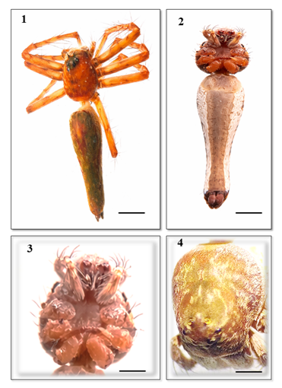
FIGURES 1-2 preserved habitus of the holotype Hamadruas kvmensis sp. nov.:
3. Cephalothorax, ventral view 4. Cephalothorax, dorsal view. Scale lines: 10mm (Figs.1-2); 4mm (3-4).
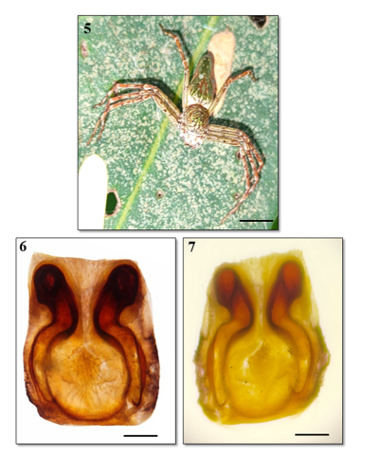
FIGURES 5-7 Hamadruas kvmensis sp. nov.; female 5. Live female, anterior view
6-7 Hamadruas kvmensis sp. nov. epigynum 6 dorsal view 7 ventral view Scale lines: 10 mm (Fig.5), 0.3 mm (Figs.6-7).

Etymology: The species name is derived from the initials of Kisan Veer Mahavidyalaya, Wai, from where the species was collected.
Diagnosis: The female of H. kvmensis sp. nov. can be distinguished from all other described species by its two distinct dark elongated lobes of spermathecae, with the upper part resembling comma-shaped structures. The central area is rounded, forming the median fertilization duct. The darker curved ducts running towards the centre indicate the copulatory ducts (Figure 1).
Description: Female (Holotype: 1 female; the specimen is deposited in the Western Regional Centre, WRC, ZSI, Pune, Reg. No. AR/1825) (Figure 1).
Measurements: Body length 15.1 mm. Carapace length 5.31 mm, width 4.35 mm. Abdomen length 9.54 mm, width 3.55 mm. Eye diameters (mm): AME 0.11; ALE 0.22; PME 0.17; PLE 0.18. Eye interdistances: AME–AME 0.09; AME–ALE 0.13; PME–PME 0.28; PME–PLE 0.42. The first eye row is 0.30 wide, the second eye row is 0.64 wide, the third eye row is 1.35 wide, and the fourth eye row is 0.63 wide. Clypeus height 0.54.
Measurements of legs (mm): I: 18.32 (5.26, 6.0, 5.2, 1.86); II: 18.98 (5.1, 6.2, 5.9, 1.78); III: 15.52 (4.42, 5.15, 4.25, 1.70); IV: 17.84 (5.80, 5.55, 4.78, 1.71). Leg formula: 1243.
Carapace reddish-brown (Figure 4), with scattered grey hairs; margins with dense grey hairs; posteriorly broader and anteriorly narrowed; longer than wide; cephalic region slightly elevated; thoracic region with a longitudinal reddish-brown fovea. Clypeus brown, margins slightly grey with two longitudinal median grey lines. Eyes white, surrounded by black rings; anterior row strongly recurved, posterior row procurved; ocular area greenish. Chelicerae yellow-brown; fangs brown; pro- and retromargins with a single brown tooth. Labium anteriorly brownish and posteriorly yellowish. Sternum yellow. Legs brown, long, with spines and hairs. Abdomen long and anteriorly wider; dorsum grey with yellow spots and median markings (Figure 1); laterally yellow with irregular grey lines; venter yellow with lateral black longitudinal lines and a broad median black band; spinnerets brown. Epigyne as shown in Figures 6–7. Two distinct dark elongated lobes of spermathecae are present, with the upper part resembling comma-shaped structures. The central area is rounded, forming the median fertilization duct. The darker curved ducts running towards the centre indicate the copulatory ducts.

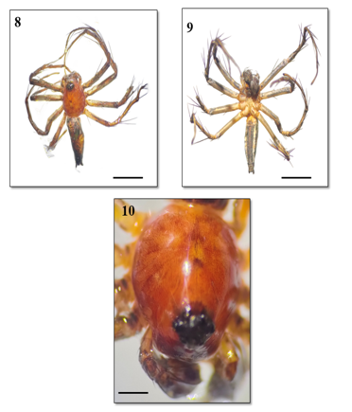
FIGURES 8-10 Hamadruas kvmensis sp. nov.; male 8. Preserved male, dorsal view
9. ventral view 10. Carapace, dorsal view Scale lines: 10 mm (Fig.8-9); 0.4 mm (Figs.10).

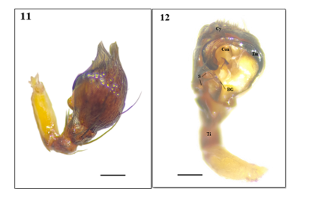
FIGURES 11-12. Hamadruas kvmensis sp. nov.; male, left palp 11. dorsal view 12. ventral view, Scale lines: 0.1 mm (11-12).
Description: Male (Holotype: 1 male; the specimen is deposited in the Western Regional Centre, WRC, ZSI, Pune, Reg. No. AR/1825) (Figs. 8–9).
Male Measurements: Total length 10 mm; carapace length 4 mm, width 4 mm, height 3 mm. Abdomen length 6 mm, height 4 mm. Leg measurements: Leg I: 3/5/2/4/2; Leg II: 3/5/2/4/2; Leg III: 3/5/2/5/2; Leg IV: 3/5/2/4/4.
Cephalothorax: The carapace is oval in shape, slightly arched, and exhibits a reddish-brown to orange colour with a smooth and polished appearance (Fig. 10), covered with long setae. Clypeus smooth, slightly convex, reddish-brown; cuticular region with very fine setae present. Eye arrangement and colour similar to female. Chelicerae, labium, and maxillae pale white (Figs. 8–9).
Legs: Colour pattern similar to female, with cylindrical forwardly pointed setae and devoid of flattened setae.
Abdomen: Abdomen long and anteriorly wider; dorsum grey with yellow spots and median markings (Figs. 8–9).
Palp: Cymbium elongated and slightly curved, apical region blunt. Bulb large, globular to oval. Tegulum prominent and sclerotized, forming the main central part of the bulb. Embolus slender and curved. Conductor membranous to semi-sclerotized, providing support. Tibia with a distinct apophysis. Sensory setae present on tibial and cymbial regions (Figs. 11–12).
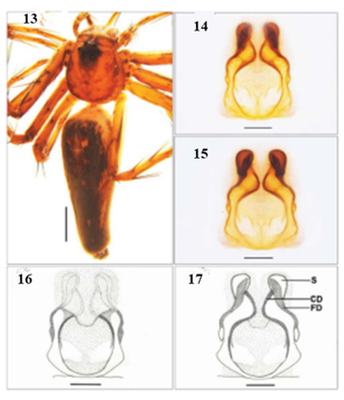
Habitus, of Figures 13 Hamadruas keralensis 14- Epigyne dorsal view, 15- ventral view Scale lines: 13- 2 mm, 14- 0.3 mm. (Sen, 2022).
Type Material: Holotype: 1♀ (ZSI/WGRC/I.R.INV.17220), India: Kerala, Kakkavayal, 11°38'34.27"N, 76°08'07.80"E, h = 751 m, 30.xi.2019, collected by S. Sen.
Etymology: The species name is derived from the name of the state from where the species was collected.
Diagnosis: The female of Hamadruas keralensis can be distinguished from all other described congeners by its triangular spermathecae, thick fertilization ducts that are anteriorly broad and posteriorly narrow, and a pot-shaped epigynal atrium (Figs. 14–15).
Description: Female (Holotype, ZSI/WGRC/I.R.INV.17220) (Fig. 13).
Measurements: Body length 13.44 mm. Carapace length 4.31 mm, width 3.63 mm. Abdomen length 8.74 mm, width 2.81 mm. Eye diameters: AME 0.10; ALE 0.20; PME 0.18; PLE 0.18. Eye interdistances: AME–AME 0.08; AME–ALE 0.11; PME–PME 0.29; PME–PLE 0.40. The first eye row is 0.29 wide, the second eye row is 0.65 wide, the third eye row is 1.30 wide, and the fourth eye row is 0.62 wide. Clypeus height 0.53. Measurements of legs: I: 17.92 (5.20, 6.0, 5.0, 1.72); II: 17.40 (5.0, 6.0, 5.0, 1.40); III: 14.73 (3.98, 4.50, 4.85, 1.40); IV: 16.50 (4.75, 5.60, 4.55, 1.60). Leg formula: 1243. Carapace yellowish-brown (Fig. 13), with scattered grey hairs; margins with dense grey hairs; posteriorly broad and anteriorly narrowed; longer than wide; cephalic region slightly elevated; thoracic region with a longitudinal reddish-brown fovea. Clypeus brown, margins grey with two longitudinal median grey lines. Eyes white, encircled by black rings; anterior row strongly recurved, posterior row procurved; ocular area grey. Chelicerae yellow-brown; fangs brown; pro- and retromargins with a single tooth. Labium and maxillae longer than wide; labium anteriorly brown and posteriorly yellow; maxillae yellow and anteriorly scopulate. Sternum yellow, anterior margin concave, longer than wide. Legs brown, long, with spines and hairs. Abdomen long and anteriorly wider; dorsum grey with yellow spots and median lanceolate markings (Fig. 13); laterally yellow with irregular grey lines; venter yellow with lateral black longitudinal lines and a broad median black band; spinnerets black. Epigyne as shown in Figs. 14–15. Epigynal atrium almost pot-shaped; epigynal rim laterally concave; copulatory openings present at the posterior end of the lateral edges; spermathecae triangular; copulatory ducts long and nearly S-shaped; fertilization ducts thick, anteriorly broad, and posteriorly narrow.

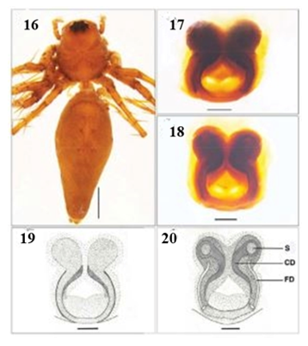
Figures 16 Habitus, of Hamadruas hieroglyphica sp. - female habitus dorsal view;
17-19 epigyne, dorsal view; 18 – 20 epigyne, ventral view Scale lines: 16: 2 mm, 17-18: 0.3 mm. (Sen, 2022).

Taxonomy
Family OXYOPIDAE Thorell, 1870
Genus Hamadruas Deeleman-Reinhold, 2009
Type species: Oxyopes hieroglyphicus Thorell, 1887
Diagnosis: For the diagnosis of the genus, see Deeleman-Reinhold (2009).
Distribution: China and Myanmar (World Spider Catalog, 2026), India – Kerala (Sen and Sudhin, 2022) (Fig. 16), Maharashtra, Satara, Wai (new record, Fig. 1).
Genus Oxyopes:
In 1870, Thorell established the family Oxyopidae, with its type genus Oxyopes, which was created by Latreille in 1804. In 1805, Walckenaer first documented the genus from the Indian subcontinent. Significant contributions to the family Oxyopidae in India were made by Thorell (1887), Tikader (1965), Gajbe (1999, 2000, and 2008), and Biswas and Roy (2005). Bodhke and Vankhede reported two new species of Oxyopes from Koha and Bori villages, Amravati, Maharashtra. While examining the collections from the Wai region of Satara District (Maharashtra), we diagnosed, described, and illustrated a new species in the present study under the name Oxyopes waiensis sp. nov.
Taxonomy
Family OXYOPIDAE Thorell, 1870
Genus Oxyopes, created by Latreille in 1804
Type species: Oxyopes kohaensis Bodhke, 2012.
Oxyopes waiensis sp. nov. (Figs. 21–28)
Diagnosis: Carapace pale yellow in colour dorsally, with an orange band bearing black setae at the middle fovea. Carapace elongated and slightly narrowed anteriorly, semi-translucent, with a distinct median longitudinal marking extending from the foveal region towards the posterior margin. Ocular area distinctly darker brownish and slightly raised. Surface smooth, sparsely covered with fine setae; lateral margins gently rounded without prominent spines; fovea shallow and indistinct.
Abdomen: The abdomen is elongated, cylindrical, and significantly narrowed towards the posterior end. Its colour is mainly whitish to silvery, with a broad continuous reddish-brown median longitudinal band extending from the anterior edge to near the spinnerets. The lateral margins are marked by thin irregular dark (blackish) lines, which may appear fragmented. The dorsal surface is smooth and sparsely covered with short fine setae, giving it a slightly reflective appearance. The posterior end is narrow, with short and inconspicuous spinnerets.
Ventral view of Oxyopes waiensis (opisthosoma and prosoma): The sternum is suboval to elongated, pale yellow, and weakly sclerotized, covered with sparse fine setae; its margins are smooth without noticeable spines. The coxae are similar in colour to the sternum, and the endites (maxillae) are elongated, light yellow, and converging anteriorly. The labium is short, subtriangular, and pale. The chelicerae are light brown to yellowish and relatively slender, without any significant modifications.
Abdomen: The abdomen is elongated and tapers posteriorly; its base colour ranges from whitish to silvery, with a distinct dark median line extending from the epigastric furrow to the spinnerets. The epigastric area is slightly darker and well defined. The book lung covers are pale, oval, and prominently visible anteriorly. The spinnerets are short, terminal, and slightly darker at the tips. The ventral surface is sparsely covered with short fine setae, and the integument is smooth and slightly shiny.
Legs: The legs are long, slender, and spiny, typical of cursorial lynx spiders, and are mainly pale yellow to green in colour. The femora of all legs are elongated and greenish with scattered long black spines, while the patellae are short and light coloured. The tibiae and metatarsi range from yellowish to light brown and bear numerous strong upright black spines arranged in longitudinal rows. The tarsi are slender, tapering distally, and pale with fine setae.
The first and second pairs of legs are significantly more robust and longer than the hind pairs, adapted for prey capture. The femora and tibiae of these legs exhibit distinct dark (blackish) longitudinal bands, especially on their dorsal and lateral surfaces. In contrast, the third and fourth pairs of legs are comparatively slender, lighter in colour, and show less prominent banding. The joints, particularly between the distal tibia and metatarsus and between the metatarsus and tarsus, often display a reddish to pinkish tint. The spination is strong and distinct, with long black upright spines on the femora, tibiae, and metatarsi. The legs appear elongated and spiny, adapted for active hunting.
Epigyne (ventral view): The epigynal plate is small to moderately sclerotized, wider than long, and ranges in colour from pale yellow to light brown. The central region possesses a distinct darkened atrial area with a pair of closely placed copulatory openings. These openings are situated anteriorly and separated by a narrow median septum. The lateral margins are rounded and lack prominent projections. The surface is smooth with fine setae. The posterior margin is slightly curved, without a prominent scape.
Etymology: The species name is derived from name of the Wai tehsil from Maharashtra, India where the species was collected.

FIGURES 21 live habitus of the holotype Oxyopes waiensis sp. nov. dorsal view, 22. Preserved habitus of the holotype Oxyopes waiensis sp. nov., ventral view, Scale lines: 13.4mm (Figs.21-22).

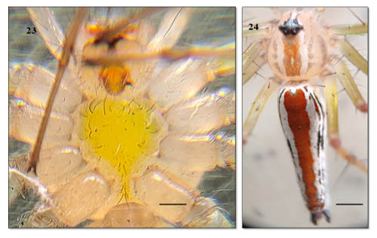
FIGURE 23. Oxyopes waiensis sp. nov. Cephalothorax, ventral view 24. Cephalothorax, abdomen dorsal view. Scale lines: 5mm (Figs.23-24).

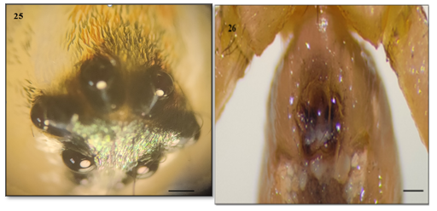

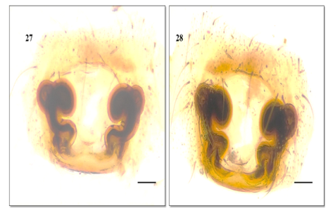
FIGURES 25-28 Oxyopes waiensis sp. nov.; 25. Eye arrangement 26 .female epigynum ventral view 27. Dorsal view 28. Ventral view Scale lines: 0.4mm (Figs.25), 4 mm (Figs.26-28).

FIGURES 29 Oxyopes waiensis sp. nov.; live female with egg sac, Scale line of egg sac: 8mm (fig. 29).

Type Material: Holotype: 1 female (Western Regional Centre, WRC, ZSI, Pune, Reg. No. AR/1826), India, Maharashtra, Satara, Wai, Kisan Veer Mahavidyalaya Campus, 17°94'45.84"N, 76°87'68.01"E, h = 738 m, collected by Rahul Tayade and Vishwas Deshpande.
Description: Oxyopes waiensis sp. nov. Female (Holotype).
Measurements: Total length 13.4 mm; carapace length 5 mm, width 4 mm, height 1.8 mm. Abdomen length 8 mm, height 1.5 mm. Leg measurements: Leg I: 7/1/6/5/2; Leg II: 6.5/1/4.9/6/2; Leg III: 7/1/5/6/2; Leg IV: 7/1/6/5/2.
Epigynum: Spermathecae reniform, more coiled or spiral-shaped (Figs. 27–28). They appear thicker and more compact, with a bulbous anterior part and a curved posterior extension.
Copulatory ducts: Curved tubular structures, highly coiled and prominent, forming a clear spiral pattern leading to the spermathecae.
Atrium: The central area between the spermathecae forms a broad atrium.
Epigynal plate: Smooth, rounded, and weakly sclerotized at the margins. Margins indistinct, gradually blending with the surrounding tissue.
Figure 30: Distribution of the type locality of Hamadruas kvmensis sp. nov.sp, Hamadruas keralensis, (Sen,2022) and Hamadruas hieroglyphica (Thorell, 1887), in India.
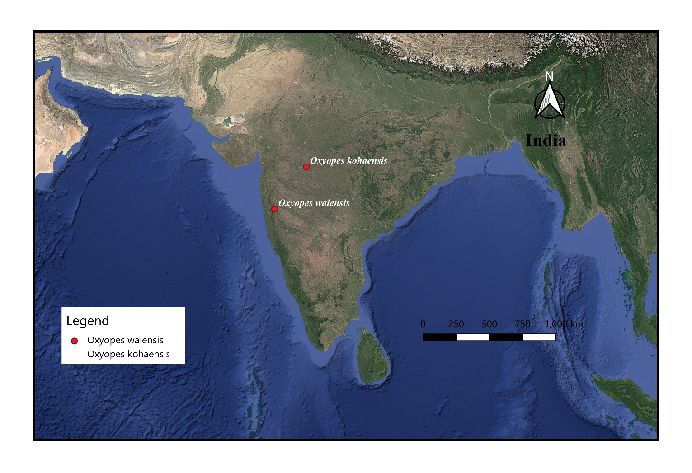Figure 31: Distribution of the type locality of Oxyopes waiensis sp. nov.sp, Oxyopes kohaensis (Bodhke. et al., 2012) in Maharashtra, India.
Discussion:
Hamadruas kvmensis possesses two distinct dark elongated lobes of spermathecae, with the upper part resembling comma-shaped structures. The central area is rounded, forming the median fertilization duct. The darker curved ducts running towards the centre indicate the copulatory ducts. However, in H. keralensis Sen, 2022, the epigynal atrium is almost pot-shaped, the epigynal rim is laterally concave, copulatory openings are situated at the posterior end of the lateral edges, spermathecae are triangular, copulatory ducts are long and nearly S-shaped, and the fertilization ducts are thick, anteriorly broad, and posteriorly narrow. In H. hieroglyphicus Thorell, 1887, the epigynal atrium is nearly apple-shaped with highly sclerotized rims, spermathecae are globular, copulatory openings are situated at the lateral edges, copulatory ducts are thick and arch upward, while the fertilization ducts are long and thin.
Oxyopes waiensis shows a sister relationship with Oxyopes kohaensis Bodkhe, 2012, but differs from it in the following characters: (i) Carapace pale yellow dorsally, with an orange band bearing black setae at the middle fovea; carapace elongated and slightly narrowed anteriorly, semi-translucent, with a distinct median longitudinal marking extending from the foveal region towards the posterior margin, whereas in O. kohaensis the cephalothorax possesses two black bands just above the fovea. The abdomen in O. waiensis is elongated and tapers posteriorly, with a whitish to silvery base colour and a distinct dark median line extending from the epigastric furrow to the spinnerets, whereas in O. kohaensis the abdomen laterally bears black patches, and in O. chittrae the abdomen possesses conspicuous deep brown longitudinal dorsal bands. The epigynal plate in O. waiensis is small to moderately sclerotized, wider than long, pale yellow to light brown in colour, with a darkened atrial area containing a pair of closely placed copulatory openings situated anteriorly and separated by a narrow median septum. The lateral margins are rounded without significant projections, the surface is smooth with fine setae, and the posterior margin is slightly curved without a prominent scape. However, in O. kohaensis, the epigyne and internal genitalia are structurally different.
Conclusions
The present study documents two oxyopid spider species from Wai, Satara District, Maharashtra, India, based on morphological examination of collected specimens. Hamadruas kvmensis sp. nov. is recognized mainly by the structure of the female epigyne and the male palp, both of which provide important diagnostic characters for species-level identification. The female genitalia show elongated spermathecal lobes, a rounded central region, and curved ducts, while the male palp possesses a distinct cymbium, bulb, tegulum, embolus, conductor, and tibial apophysis. Oxyopes waiensis sp. nov. is distinguished by its body colour pattern, leg spination, abdominal markings, and the form of the female epigyne with coiled spermathecae and curved copulatory ducts. The record of Hamadruas from Wai expands the known occurrence of the genus in the region and contributes to the documentation of lynx spider diversity in Maharashtra. The findings also indicate that local habitats such as college campuses may support taxonomically significant arachnid diversity. Further surveys in nearby areas are likely to improve understanding of the distribution and diversity of Oxyopidae in the Western Ghats and adjoining regions.
Limitations
The study is based on a limited number of specimens collected from a single locality in Wai, Maharashtra. As a result, information on intraspecific variation, seasonal occurrence, habitat preference, and population status remains incomplete. The descriptions are based primarily on external morphology and genital structures, and no molecular analysis was included to support species delimitation. Ecological observations are also limited, and the study does not provide detailed data on microhabitat, abundance, behaviour, or prey interactions. For Oxyopes waiensis sp. nov., the description is based on female morphology, and additional material, including males, would strengthen future comparisons. Broader sampling from surrounding areas and comparison with more regional specimens would help confirm the distributional range and diagnostic stability of the proposed species. Future studies combining morphology, molecular data, and ecological information would provide a more complete understanding of these taxa.

COMPETING INTERESTS DISCLAIMER:
Authors have declared that they have no known competing financial interests OR non-financial interests OR personal relationships that could have appeared to influence the work reported in this paper.

References:
Biswas, B. & R. Roy, (2005). Description of three new species of the genus Peucetia and genus Oxyopes (family: Oxyopidae: Araneae) from India. Rec. zool. Surv. India, 105, 37-43.
Biswas, V.; B. Kundu and D. Raychaudhuri. (1995). Spiders of the genus Oxyopes Latreille (Araneae: Oxyopidae) of Buxa Tiger reserve, West Bengal. Acta Arachnol, 45, 53-61.
Bodkhe, A. K. and Vankhede, G. N. (2012). On two new species of spiders of the genus Oxyopes latreille from central India (Arachnida : Araneae : Oxyopidae). Indian J. Arac, 1, 150-155.
Deeleman-Reinhold, C.L. (2009). Description of the lynx spiders of a canopy fogging project in northern Borneo (Araneae: Oxyopidae), with a description of a new genus and six new species of Hamataliwa. Zoologische Mededelingen, 83, 673–700.
Gajbe U.A., (2008): Fauna of India and adjacent countries- Spider (Arachnida: Araneae: Oxyopiae) Rec. zool. Surv. India,3, 1-117.
Gajbe, U. A. & P. Gajbe, (1999). Two new species of Oxyopes Latreille (Araneae: Oxyopidae) from Jabalpur, Madhya Pradesh, India. Geobios New Reports, 18, 13-16.
Gajbe, U.A and P Gajbe, (2000): A new species of genus Oxyopes Latrielle (Araneae: Oxyopidae) from Jabalpur, Madhya Pradesh, India. Rec. zool. Surv. India, 98, 123-125.
Kulkarni, S., Deshpande, V. (2012). A New Species of the Genus Oxyopes Latrielle (Araneae:Oxyopidae) from Sahayadri Ranges of Western Ghats. Rec.Zool. Surv. India, 112, 35-37.
Latreille, P. A., (1804). Histoire naturelle générale et particulière des Crustacés et des Insectes. Paris, 7, 144-305.
QGIS.org, 2026. QGIS Geographic Information System. QGIS Association. http://www.qgis.org
Sankaran, P. (2024). Taxonomic notes on two poorly known lynx spider species from India (Araneae:Oxyopidae). Zootaxa, 5458, 297–300.
Sen, S., Sudhin,P. (2022). New species and a new record of Hamadruas Deeleman-Reinhold, 2009 (Araneae: Oxyopidae) from India. Rec. zool. Surv. India, 122, 345–348.
Thorell, T., (1870). Araneae nonnullae Novae Hollandie, descriptae. Öfvers. Kongl. vet. Akad. Förh, 27, 367-389.
Thorell, T. (1887). Viaggio di L. Fea in Birmania e regioni vicine. II. Primo saggio sui ragni birmani. Annali del Museo Civico di Storia Naturale di Genova, 25, 5–417.
Thorell, T. (1891). Spindlar från Nikobarerna och andra delar af södra Asien. Kongliga Svenska Vetenskaps-Akademiens Handlingar, 24, 1–149.
Tikader, B.K. 1965. On some new species of spiders of the family Oxyopidae from India.Proc. Indian Acad. Sci. 62, 140-144.
Tikader, B. K. (1970). Spider fauna of Sikkim. Records of the Zoological Survey of India 64, 1-83.
Tikader, B.K. (1987). Handbook Indian Spiders. Zoological Survey of India, Culcutta, 251 .
Walckenaer, C. A., (1805). Tableau des aranéides ou caractères essentiels des tribus, genres, familles et races que renferme le genre Aranea de Linné, avec la désignation des espèces comprises. dans chacune de ces divisions. Paris, 88.
World Spider Catalog (2026). World Spider Catalog. Version 27. Natural History Museum Bern, online at http://wsc.nmbe.ch, accessed on {date of access}. doi: 10.24436/2

