Original Research Article

Optimization of dietary Moringa oleifera leaf meal as a fish meal substitute for Labeo rohita during the nursery phase: A comprehensive assessment of growth, survival and nutrient retention, and haematologicalre silience

Abstract
The present study evaluated the use of Moringa oleifera leaf meal as a partial substitute for fish meal in the diet of Labeo rohita during the nursery phase. Five experimental diets were formulated with approximately 35% crude protein and graded levels of M. oleifera leaf meal, comprising a control diet without inclusion and four treatment diets containing 5%, 10%, 15% and 20% inclusion levels. The feeding trial was conducted under laboratory conditions for 20 days using a completely randomized design with three replications per treatment. Growth performance, feed utilization, survival, whole-body proximate composition and haematological parameters were assessed at the end of the trial. The results showed significant differences among dietary treatments. Fish fed the 15% inclusion diet recorded the highest growth response, with weight gain of 514.11 ± 0.92, specific growth rate of 2.10 ± 0.03% day⁻¹, feed conversion ratio of 1.36 ± 0.02 and protein efficiency ratio of 1.72 ± 0.03. Survival ranged from 55.33% to 62.67% among treatments and did not differ markedly across diets. Whole-body protein content was highest in fish fed the 15% inclusion diet, indicating improved nutrient retention at this level. Haematological results also showed comparatively better haemoglobin and red blood cell values in fish receiving the 15% diet, whereas the 20% diet was associated with reduced growth and poorer haematological response. The findings suggest that M. oleifera leaf meal can be used as a partial fish meal substitute in L. rohita nursery diets, with 15% inclusion showing the most favourable response under the conditions of this study.
Keywords: Labeo rohita, Moringa oleifera, nursery rearing, growth performance, feed utilization, haematology.

- Introduction
The world aquaculture industry is undergoing a “Blue Transformation", this transformation is a massive change to meet the aquatic food needs for a world population projected to be 9 billion by 2050 (FAO, 2022). This transformation is dependent on feed security (Naylor et al., 2021). Fish meal (FM) has long been the dominant protein source in intensive aquaculture due to its excellent amino acid profile, high digestibility and essential fatty acids (Gatlin et al., 2017). However, the stagnation of global catch fisheries and the increased demand from the aquaculture and terrestrial livestock sectors have resulted in a major demand-supply mismatch. This has led to severe price volatility with FM prices soaring by about 300% over the past years, threatening the economic viability of aquaculture especially in poor countries (Bu et al., 2018).The problem has led to the emergence of plant-based substances as promising substitutes for FM owing to its abundance, cost-effectiveness and environmental sustainability (Sarker et al., 2022). Amongst the different alternatives, Moringa oleifera popularly known as the “Miracle Tree” has emerged as a potential non-conventional protein source (Adewumi et al., 2022). M. oleifera leaves are rich in nutrients, including around 28–32% crude protein, as well as important amino acids such as lysine, methionine, threonine, leucine, isoleucine, valine, phenylalanine and tryptophan vitamins A (β-carotene), C, E, and B-complex and minerals including calcium, potassium, iron, magnesium, phosphorus, zinc and copper (Teixeira et al., 2014; Adewumi et al., 2022). Moreover, Moringa leaves are rich in bioactive phytochemicals such as flavonoids, phenolic compounds and natural antioxidants, which have been shown to improve metabolic efficiency and disease resistance in aquatic species (Choudhary et al., 2024; Faisal et al., 2024).
Labeo rohita (Rohu) is an important Indian Major carp species known for its fast growth, adaptability, and high consumer preference in Asian countries (Amjad and Abbas, 2021). The nursery phase of L. rohita is a critical ontogenetic stage that determines the availability of healthy seed for grow-out culture and is a key determinant of system production at large (Tanuja et al., 2025; Misra et al., 2026). At this stage, L. rohita larvae shift from a diet of zooplankton to artificial feeds, necessitating elevated protein levels to facilitate somatic development (Das et al.,2020; Shafique et al., 2025). Moreover, various plant ingredients have been assessed for carps, data concerning the ideal inclusion level of Moringa leaf meal during the nursery transition of L. rohita is still scarce.
Haematological parameters provide a reliable, non-lethal diagnostic approach for the evaluation of the nutritional status and physiological responses of fish to dietary changes (Witeska, 2022). The oxygen transporting ability, metabolic vigour and immunological competence are reflected by key markers such as haemoglobin (Hb), red blood cell (RBC) count and white blood cell (WBC) count (Witeska et al., 2023; Hemprabhaand Arya, 2025).
Knowledge about optimum dietary inclusion level of MOLM as a partial fish meal substitute during the nursery phase of L. rohita remains limited. Moreover, most available studies have focused primarily on growth performance, while comprehensive assessments integrating growth, nutrient retention and haematological responses are scarce. Since the nursery stage represents a critical stage as characterized by rapid tissue growth and high nutritional demands, establishing a scientifically validated inclusion level of MOLM is necessary to support sustainable and economically viable rohu seed production. Thus, the aim of this study was to assess the impact of varying levels of MOLM as a partial replacement for fish meal on the growth performance, nutrient retention, and hematological health of L. rohita spawn.
2. Materials and Methods
2.1 Experimental site
The feeding trials as designed in the study was conducted at the wet laboratory of the Department of Aquaculture, College of Fisheries, Acharya Narendra Deva University of Agriculture and Technology (ANDUA&T), Kumarganj, Ayodhya, India. Laboratory environment was strictly regulated for 20 days to minimize external stress factors. All animal handling and experimental methods were followed and maintained n accordance with established ethical guidelines for the care and use of laboratory animals in research.
2.2 Experimental fish and acclimatization
Three days old spawn of L. rohita was procured from Tamsa fish seed hatchery, Bikapur, Ayodhya. The spawns were acclimatized to the laboratory environment for seven days prior to the experiment. During this time, fish were kept in aerated aquariums and fed daily with a finely powdered basal diet (35% CP) to keep them in a stable physiological condition.
2.3 Preparation of Moringa oleifera leaf meal (MOLM)
Fresh leaves of M. oleifera were obtained from the various farms of ANDUA&T campus. Leaves were cleaned with pure water to remove dust and contaminants. The leaves were shade dried at ambient temperature and then dried in a hot air oven at 60 ± 5°C until brittle to preserve the integrity of heat-sensitive bioactive chemicals (Adewumi et al., 2022). The dried leaves were pulverized in a high-speed mechanical grinder and passed through a 150-μm filter to get a homogenous powder meal.
2.4 Diet formulation for L. rohita spawn
Five experimental diets were formulated to include about 35% crude protein which was found as the optimum requirement for L. rohita in nursery stages (Shafique et al., 2025; Sarkar et al., 2019). MOLM was used to replace fish meal at 0% (Control), 5% (T1), 10% (T2), 15% (T3) and 20% (T4) inclusion levels. Mustard oil cake, soya cake, rice bran were adjusted so as to establish iso-nitrogenous balance. The components were mixed with soybean oil and a vitamin and mineral premix, pelleted and dried at 40°C. Table 1 shows the composition of the elements.
Table 1. Ingredient composition (%) of experimental nursery diets for L. rohita spawn
Ingredient | Control (0%) | T1 (5%) | T2 (10%) | T3 (15%) | T4 (20%)
Fish meal | 20 | 19 | 18 | 17 | 16
MOLM | 0 | 5 | 10 | 15 | 20
Mustard oil cake | 29 | 28 | 26 | 24 | 23
Rice bran | 23 | 19 | 18 | 16 | 13
Soya cake | 23 | 23 | 23 | 23 | 23
Soybean oil | 2 | 2 | 2 | 2 | 2
Vit. and Min. Premix | 2 | 2 | 2 | 2 | 2
Salt | 1 | 1 | 1 | 1 | 1
2.5 Experimental design
The experiment was conducted in a completely randomized design (CRD) with five treatments and three replications for each treatment. Spawn was introduced into each 200-liter glass tank at a rate of 200 spawn per tank.
2.6 Feeding management and water quality
The fish were fed 2 times a day at 09.00 and 16.00 h. During the first week, the feeding rate was set at four times of body weight and was raised to eight times in next subsequent week to accommodate fast development. Approximately 25% of the water in each tank was drained daily to remove unconsumed feed and metabolic waste. Physico-chemical parameter such as temperature, pH, dissolved oxygen, total alkalinity and ammonia-N were measured weekly using conventional procedures as per APHA (2017) and has been maintained at optimum level.
2.7 Growth performance
The indices of growth performance were the following:
- Percentage Weight Gain = (Final Weight –Initial Weight)/ Initial Weight * 100
- Specific Growth Rate (SGR, % day⁻¹) = (ln(Final)-ln(Initial)/(t₂-t₁)x 100
- Feed Conversion Ratio (FCR) = Total Feed Consumed / Total Weight Gain
- Protein Efficiency Ratio (PER) = Weight Gain / Protein Intake
- Survival Rate (%) = (No. of fish recovered / No. of fish reared) × 100
2.8 Proximate analysis of feed and carcass composition of fish
The proximate composition of the materials, diets and whole body fish samples were determined in triplicate using the standard methodology of AOAC (2019). Crude protein was determined by the micro-Kjeldahl technique (N×6.25); crude lipid by Soxhlet extraction and ash estimation was done by muffle furnace cremation at 550 ºC.
2.9 Haematological methods
At the end of experiment blood was collected from the caudal vein of the experimental fish using heparinized syringes. Haemoglobin (Hb) was measured by the cyanmethemoglobin technique (Witeska, 2022). Red blood cell (RBC) and white blood cell (WBC) counts were determined by using a Neubauer haemocytometer (Witeska et al., 2023). The packed cell volume (PCV) was determined using the micro-haematocrit method. Erythrocytic indices MCV, MCH and MCHC were calculated using the published method (Kumar & Kangle, 2022).
2.10 Statistical analysis
Data analysis was performed using SPSS version 25.0. One-way analysis of variance (ANOVA) and The Duncan’s Multiple Range Test (DMRT) was used to test for significant differences across treatment means at P < 0.05.
3. Results
3.1 Proximate composition of feed ingredient and experimental diet
Proximate analysis of raw ingredients shows MOLM as a nutritionally rich source of protein for L. rohita. Crude protein content of MOLM is 28.12 ± 0.03%, which is a significant contribution of nitrogenous matter and is comparable to other high-quality plant meals, e.g. mustard oil cake (30.37 ± 0.28%) as shows in Table 2. MOLM has a significant mineral profile as evidenced by its ash concentration of 11.08 ± 0.02%.
The experimental diets were successfully maintained with equal iso-nitrogenous levels among all the treatments (35.1-35.5% CP) fulfilling the nutritional needs of L. rohita spawn. However, the inclusion of MOLM led to a clear linear trend for crude fiber content. As shown in Table 3, the crude fiber increased from 4.5% in the control group to 6.1% in the T4 (20% MOLM) group. Crude lipid levels in the MOLM-containing meals varied from 6.6% to 6.8% and were somewhat higher than the control level of 6.5%. This discrepancy might be due to the inherent lipid content of Moringa leaves. Ash level decreased somewhat with the substitution of fish meal by MOLM, indicating changes in mineral availability.
Table 2. Proximate nutritional profile (%) of conventional ingredients used in diet formulation
Feed Ingredient | Moisture | Ether Extract | Total Ash | Crude Protein | Total CHO
Fish meal | 3.54 ± 0.32 | 5.87 ± 0.19 | 22.93 ± 0.02 | 67.66 ± 0.58 | 0.65 ± 0.71
MOLM | 7.37 ± 0.01 | 8.64 ± 0.03 | 11.08 ± 0.02 | 28.12 ± 0.03 | 36.36 ± 0.03
Mustard oil cake | 8.52 ± 0.12 | 10.73 ± 0.21 | 7.08 ± 0.05 | 30.37 ± 0.28 | 32.62 ± 0.51
Soya meal | 7.37 ± 0.49 | 3.00 ± 0.89 | 11.04 ± 0.18 | 50.74 ± 0.75 | 27.28 ± 0.60
Rice bran | 7.07 ± 0.10 | 1.76 ± 0.72 | 11.78 ± 0.39 | 12.74 ± 0.40 | 59.12 ± 0.33
Values are present in Mean±SD
Table 3. Analyzed proximate composition (%)of experimental diets
Diet Parameter | Control | T1 | T2 | T3 | T4
Crude Protein | 35.5 ± 0.01 | 35.4 ± 0.02 | 35.3 ± 0.03 | 35.2 ± 0.03 | 35.1 ± 0.01
Crude Lipid | 6.5 ± 0.03 | 6.6 ± 0.01 | 6.7 ± 0.01 | 6.8 ± 0.01 | 6.8 ± 0.03
Crude Fiber | 4.5 ± 0.02 | 4.8 ± 0.01 | 5.2 ± 0.01 | 5.7 ± 0.02 | 6.1 ± 0.02
Ash | 8.3 ± 0.03 | 8.2 ± 0.01 | 8.1 ± 0.03 | 8.0 ± 0.02 | 7.9 ± 0.02
Moisture | 8.2 ± 0.15 | 8.3 ± 0.11 | 8.4 ± 0.09 | 8.3 ± 0.12 | 8.5 ± 0.10
Values are present in Mean±SD
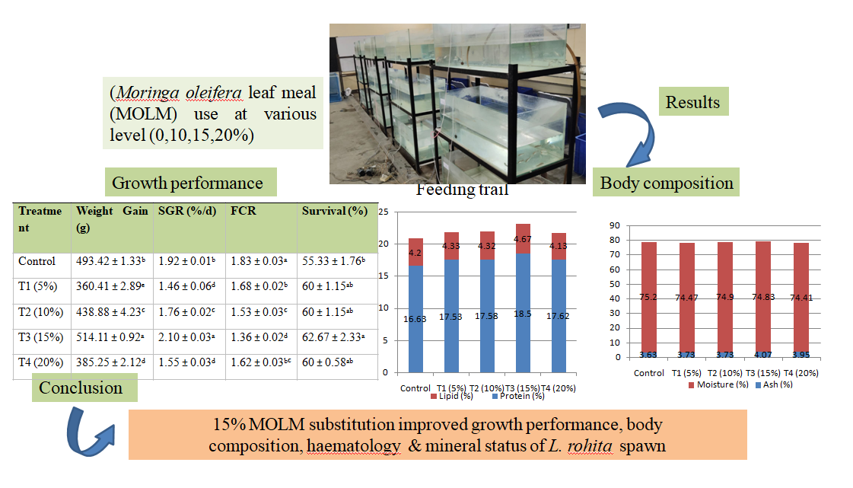
Picture 1. Poster representation

3.2 Water quality parameter
During the 20 days feeding trial, physical and chemical parameters of the water in the tanks were maintained in suitable range for nursery rearing of L. rohita spawnas shown in Table 4. No significant changes (P > 0.05) of water quality were found across different dietary regimens, indicating the pellets prepared from MOLM demonstrating good water stability and did not adversely affect the tank environment.
Table 4. Water quality parameter of experimental units
Parameter | Observed Range
Temperature (°C) | 26.5 -29.2
pH | 7.4 -8.1
Dissolved Oxygen (mg/L) | 6.2 -7.5
Total Alkalinity (mg/L) | 145 -160
Ammonia-N (mg/L) | 0.02-0.05

3.3 Growth performance and feed utilization efficiency
The growth performance of L. rohita spawn revealed a substantial (P < 0.05) response to dietary inclusion of MOLM. The maximum weight gain (514.11 ± 0.92 g) and specific growth rate (2.1 ± 0.03% day⁻¹) was recorded in fish fed T3 diet (15% MOLM) as shown in Table 5, Figure 1. This was significantly higher than the control group (WG: 493.42 ± 1.33 g; SGR: 1.92 ± 0.01% day⁻¹). Performance progressively improved from T1 (5%) to T3 (15%) but declined substantially at T4 (20%) and weight gain decreased to 385.25 ± 2.12 g.
Feed utilization efficiency was in line with the patterns of growth. The T3 group exhibited the best feed conversion ratio (FCR) of 1.36 ± 0.02 and protein efficiency ratio (PER) of 1.72 ± 0.03 which indicated an efficient conversion of dietary protein into body mass. In comparison, the control group had a substantially poorer FCR of 1.83 ± 0.03. The greatest growth was seen at T3; however, by T4 (20% inclusion), the FCR increased significantly (1.62) and the PER decreased (1.42), showing that higher levels of inclusion reduced the bioavailability of nutrients.
Survival rate ranged from 55.33 to 62.67% under different treatments. The T3 group had the highest percentage of survival but statistical analysis showed that the addition of MOLM did not only alters survival substantially compared to the control (P > 0.05), indicating that MOLM does not show fatal toxicity at these doses.
Table 5. Growth performance and survival of L. rohita spawn fed graded levels of MOLM
Treatment | Weight Gain (g) | SGR (%/d) | FCR | PER | Survival (%)
Control | 493.42 ± 1.33ᵇ | 1.92 ± 0.01ᵇ | 1.83 ± 0.03ᵃ | 1.67 ± 0.01ᵃ | 55.33 ± 1.76ᵇ
T1 (5%) | 360.41 ± 2.89ᵉ | 1.46 ± 0.06ᵈ | 1.68 ± 0.02ᵇ | 1.40 ± 0.01ᶜ | 60 ± 1.15ᵃᵇ
T2 (10%) | 438.88 ± 4.23ᶜ | 1.76 ± 0.02ᶜ | 1.53 ± 0.03ᶜ | 1.53 ± 0.02ᵇ | 60 ± 1.15ᵃᵇ
T3 (15%) | 514.11 ± 0.92ᵃ | 2.10 ± 0.03ᵃ | 1.36 ± 0.02ᵈ | 1.72 ± 0.03ᵃ | 62.67 ± 2.33ᵃ
T4 (20%) | 385.25 ± 2.12ᵈ | 1.55 ± 0.03ᵈ | 1.62 ± 0.03ᵇᶜ | 1.42 ± 0.02ᶜ | 60 ± 0.58ᵃᵇ
Different superscripts (a-e) within columns indicate significant difference (P < 0.05).

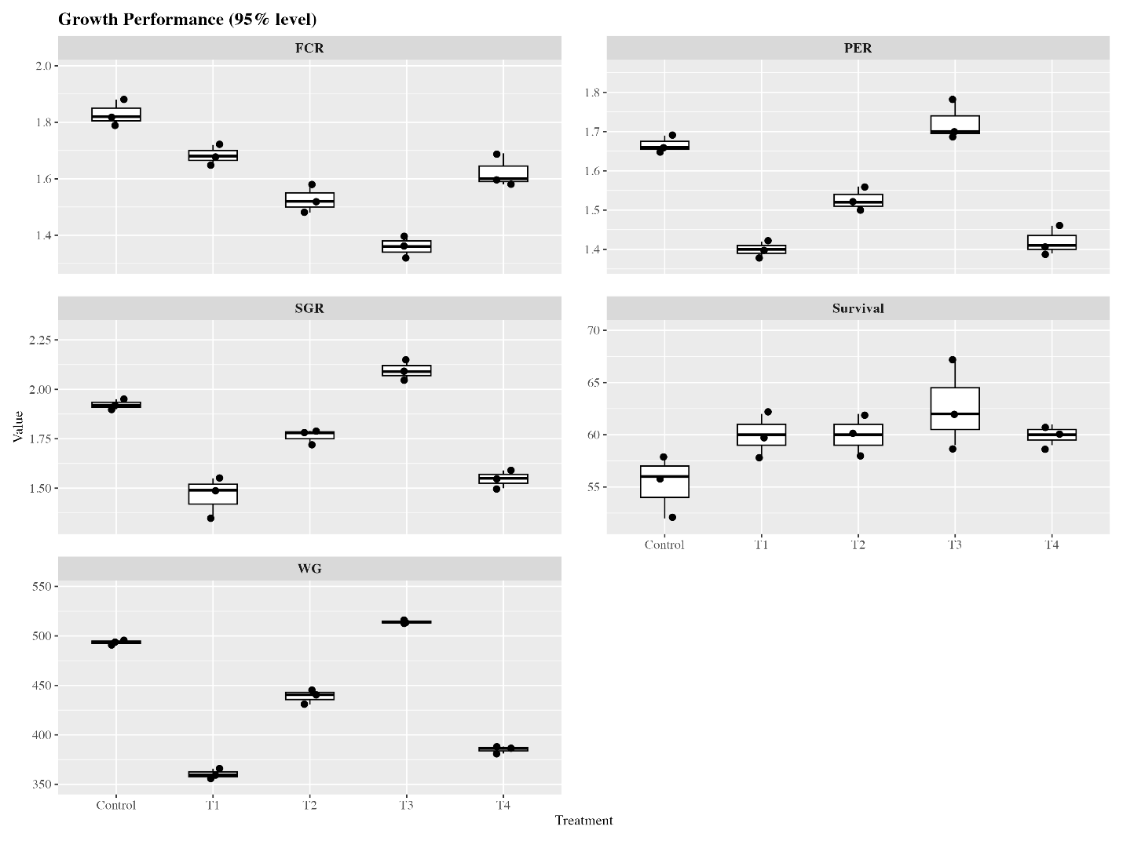
Figure 1:Graphical representation of growth performance of L. rohita

3.4 Whole-body proximate composition
Dietary inclusion of MOLM considerably influenced the retention of nutrients in the body tissues of L. rohita (Table 6, Figure 2). The whole-body protein increased considerably from 16.63 ± 0.22% in the control group to a maximum of 18.5 ± 0.12% in T3 group. The improvement suggests that bioactive compounds in Moringa may boost nitrogen retention and muscle accretion.Lipid deposition was highest in T3 (4.67 ± 0.12 %) and ash content was also substantially higher in T3 (4.07 ± 0.03 %) than control (3.63 ± 0.09 %). These data imply that modest amounts of MOLM promote both somatic development and mineralization of the body. However, T4 group (20%) showed a little reduction in protein (17.62%) and fat (4.13%) content compared to T3, further confirming the performance threshold identified in the growth data. The moisture content of all groups was similar (from 74.41% to 75.2%).
Table 6. Whole-body proximate composition (wet weight, %) of L. rohita
Treatment | Moisture (%) | Protein (%) | Lipid (%) | Ash (%)
Control | 75.2 ± 0.58 | 16.63 ± 0.22ᶜ | 4.2 ± 0.17 | 3.63 ± 0.09ᵇ
T1 (5%) | 74.47 ± 0.2 | 17.53 ± 0.19ᵇ | 4.33 ± 0.18 | 3.73 ± 0.09ᵃᵇ
T2 (10%) | 74.9 ± 0.76 | 17.58 ± 0.19ᵇ | 4.32 ± 0.02 | 3.73 ± 0.1ᵃᵇ
T3 (15%) | 74.83 ± 0.64 | 18.50 ± 0.12ᵃ | 4.67 ± 0.12 | 4.07 ± 0.03ᵃ
T4 (20%) | 74.41 ± 0.16 | 17.62 ± 0.14ᵇ | 4.13 ± 0.07 | 3.95 ± 0.03ᵃᵇ
Note: Different superscripts (a-e) within columns indicate significant difference (P < 0.05).
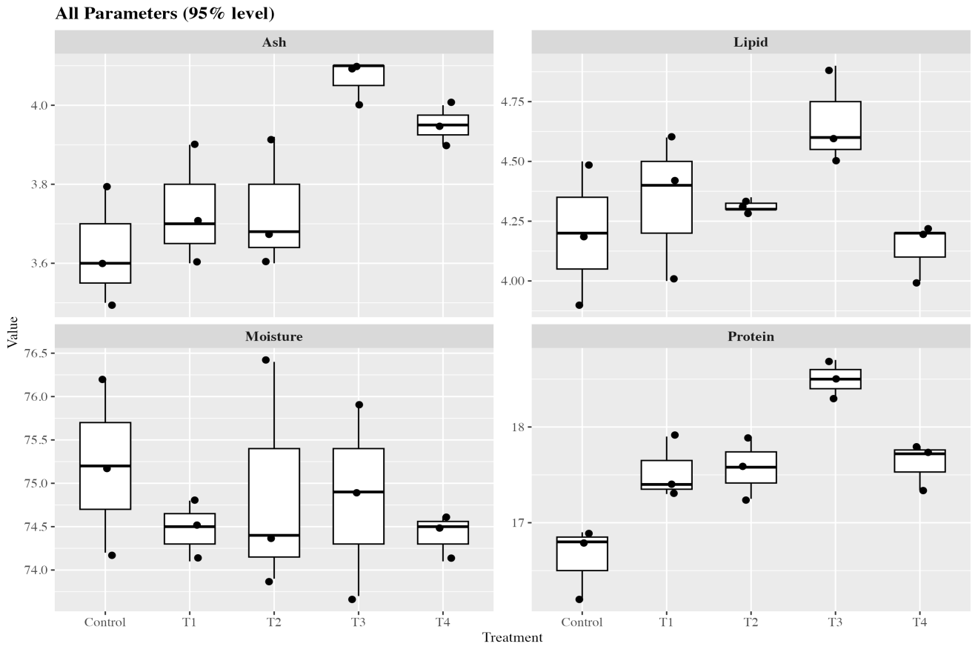
Figure 2: Graphical representation of whole-body proximate composition (wet weight, %) of L. rohita

3.5 Haematological health status
The haematological profile of L. rohita gives an overall picture on the physiological impact of nutrition on health. T3 (15% MOLM) level showed a significant increase compared to the control group in the levels of haemoglobin, red blood cells and packed cell volume. Highest haemoglobin (5.50 ± 0.87 g/dL) and red blood cell count (0.98 ± 0.14 × 10⁶/mm3) were seen in fish treated with T3 suggesting improved oxygen transportation ability as shown in Table 7, Figure 3.However, T4 group (20% inclusion) showed a marked physiological deterioration. Haemoglobin levels were reduced to 1.29 ± 0.1 g/dL and RBC counts to 0.27 ± 0.02 × 10⁶/mm³, both statistically significant (P < 0.05), indicating a potential anaemic state or severe metabolic stress at high inclusion levels. T1 and T3 had considerably higher white blood cell (WBC) counts compared to the control, indicating possible immuno-stimulatory effects, although large variability between the groups meant that differences were not statistically significant (P > 0.05).

Table 7. Haematological parameters of L. rohita spawn under different dietary treatments
Treatment | Hb (g/dL) | RBC (×10⁶/mm³) | PCV (%) | WBC (×10³/mm³)
Control | 4.63 ± 1.85ᵃᵇ | 0.83 ± 0.4ᵃᵇ | 13.13 ± 6.52ᵃᵇ | 17.6 ± 10.4ᵃ
T1 (5%) | 5.20 ± 1.91ᵃ | 1.04 ± 0.4ᵃ | 16.90 ± 8.14ᵃ | 28.5 ± 15.9ᵃ
T2 (10%) | 3.68 ± 0.38ᵃᵇ | 0.72 ± 0.03ᵃᵇ | 11.49 ± 0.2ᵃᵇ | 17.9 ± 0.64ᵃ
T3 (15%) | 5.50 ± 0.87ᵃ | 0.98 ± 0.14ᵃ | 12.97 ± 1.76ᵃᵇ | 25.3 ± 6.6ᵃ
T4 (20%) | 1.29 ± 0.1ᵇ | 0.27 ± 0.02ᵇ | 2.73 ± 0.58ᵇ | 3.97 ± 0
Note: Different superscripts (a-e) within columns indicate significant difference (P < 0.05).

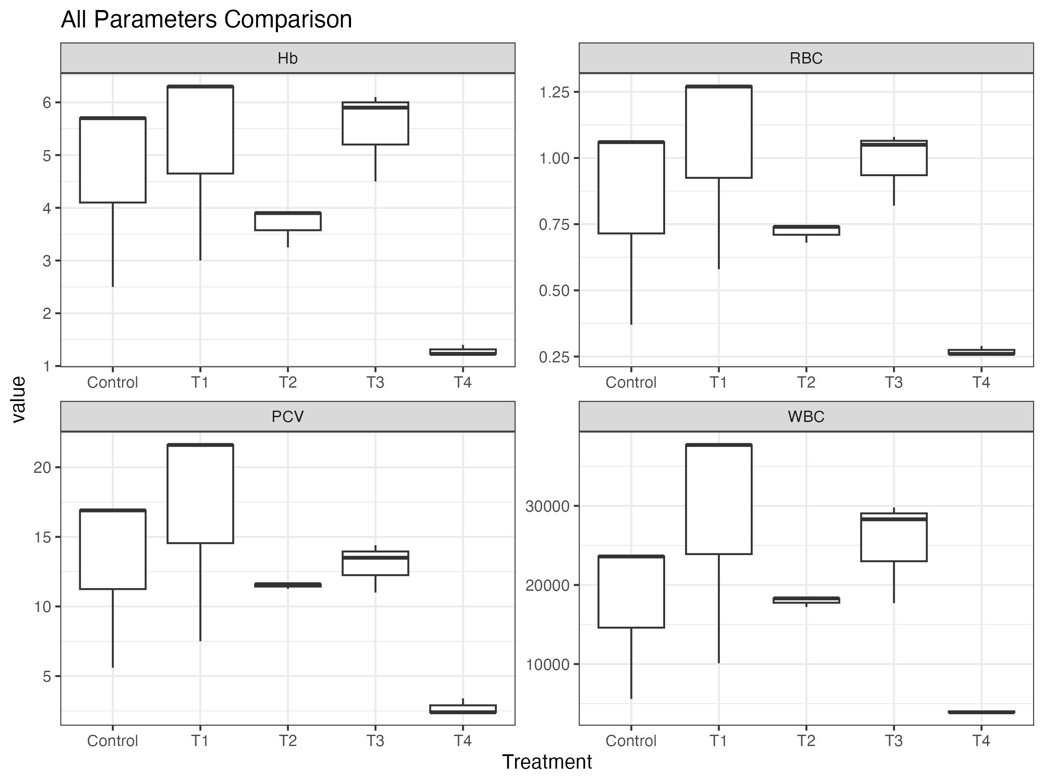
Figure 3: Variation in haematological parameters of L. rohita spawn under different dietary treatments

4. Discussion
4.1 Growth enhancement and nutrient efficiency at 15% MOLM
The results of this study indicates that the incorporation of M. oleifera leaf meal at a level of 15% significantly improves the growth performance and feed utilization of L. rohita during the nursery phase. Present observation are in line with those of Monir et al. (2020) who examined the impacts of adding moringa leaf extract on tilapia feeds and noted that growth indices increased significantly. Similarly, finding of current study also align with those of Faisal et al. (2024) who fed C. mrigala fingerlings diets based on MOLM and noted a considerable improvement in fish growth performance. The findings of Hassaan et al. (2018) had shown that adding 10-20 percent of MOLM to the diets of L. rohita boosted the WG substantially, but adding more MOLM to the diet depicted no improved performance. Similarly, our findings also align with those of Elabd et al. (2019) who fed O. niloticus diets based on MOLM andnoted a considerable improvement in fish growth performance. This optimization is mainly due to the high biological value of Moringa proteins, which offer a balanced essential amino acid profile, including significant levels of lysine and methionine necessary for rapid somatic accretion in carp spawn (Momin and Memiş, 2023; Teixeira et al., 2014). Additionally, bioactive phytochemicals, including flavonoids and phenolic acids, found in Moringa leaves have been demonstrated to enhance the secretion of digestive enzymes, particularly protease and amylase, which subsequently increases nutrient bioavailability (Choudhary et al., 2024; Faisal et al., 2024). The natural antioxidants present in MOLM contribute to the reduction of metabolic oxidative stress, enabling fish to allocate energy from cellular repair to somatic growth (Saleh et al., 2025; Su and Chen, 2020).The significant reduction in FCR (1.36) and increase in PER (1.72) in T3 group indicates that L. rohita spawn are efficient in using nutrients from MOLM at modest levels of inclusion. This follows the notion of “circular nutrition” (Verdegem et al., 2021), where the high-quality plant by-products, increase aquaculture efficiency and minimize environmental nitrogenous load. Moringa leaves are an enriched source of vitamin A, C and E which function as crucial co-enzymes in metabolic pathways in fish leading to better feed conversion (Adewumi et al., 2022; Akib et al., 2024).
The significant reduction in growth and feed efficiency observed at 20% inclusion (T4) indicates a physiological threshold for rohu spawn. This reduction is primarily linked to the elevated crude fibre content (6.1%) present in the T4 diet (Abdel-Latif et al., 2022). Excessive dietary fiber in nursery fish can expedite gastric transit time, thereby significantly diminishing the duration of nutrient interaction with digestive enzymes, which results in incomplete digestion (Naylor et al., 2021; Macusi et al., 2023). Another research contradicted previous findings that adding M. oleifera in the diet inhibits fish growth, this might be due to negative effects of anti-nutrients (saponins, phytates, tannins and phenols) (Mehdi et al., 2016). The reason for the opposite outcome might be attributed to the experimental duration, size of fingerlings, and diet content which were all different in the present study.
Furthermore, the presence of anti-nutritional factors (ANFs) like tannins and phytates in Moringa leaves at elevated levels hinders nutrient absorption (Abdel-Latif et al., 2022). Tannins are recognized for their ability to create indigestible complexes with dietary proteins and to inhibit the activity of trypsin and other proteases (Makkar and Becker, 1997; Worku, 2016). Phytates chelate essential divalent minerals such as Ca²⁺ and Fe²⁺, rendering them biologically unavailable and potentially resulting in mineral deficiencies that inhibit growth (Abdel-Latif et al., 2022; Su and Chen, 2020).
4.3 Body composition
Whole-body proximate analysis results indicated that 15% MOLM optimizes nitrogen retention, as demonstrated by the significantly higher protein deposition (18.5%) in T3-fed fish (Saleh et al., 2025). The result of this experiment was found to be similar to those of Arsalan et al. (2016), who noted that 10% substitution of MOLM showed the maximum CP and 40% inclusion level resulted in minimum CP compared to control group. This indicates that the amino acid composition of Moringa aligns well with the developmental needs of rohu during the fry-to-fingerling transition (Sarkar et al., 2019). The elevated ash content in T3 indicates enhanced skeletal mineralization, facilitated by the bioavailable calcium and phosphorus present in Moringa leaves (Adewumi et al., 2022). Similarly, Ganzon-Naret (2014) found that CP at 10% was significantly higher than that of other MOLM diets when examining the carcass composition of Asian sea bass fed on these diets at different inclusion levels. Ganzon-Naret (2014) reported similar findings, that when MOLM’s proportion in the fish diet increased (10–20%), the ash content of Asian sea bass decreased.
4.4 Haematological resilience
Haematological indices depictedessential evidence of physiological health, representing fish growth and well-being (Fazio2019). According to Ayotunde Ezekiel et al. (2016), when leaves of moringa were added to the feed, the hematological indices of C. garipinus, such as the RBC count, PCV, Hb, and WBC count, improved drastically. Ahmed et al. (2014) exhibited that feeding moringa leaves to Nile tilapia resulted in appreciable increase in their hematological parameters. When moringa leaves were fed to Cyprinus carpio more often, blood parameters including RBC, WBC, Hb, and PCV improved (Adeshina et al., 2018). According to Arsalan et al. (2016) L. rohita exhibited the greatest Hb value and RBC count when 10% of the FM was substituted with moringa leaves. In the present study elevated Hb and RBC levels in the T3 group indicated increased erythropoiesis, likely driven by the high iron concentration and vital vitamins (such as B-12 and folate) found in Moringa (Akib et al., 2024; Hemprabha & Arya, 2025). Nonetheless, the significant reduction in Hb (1.29 g/dL) observed in the T4 group suggests acute physiological stress or mild anemia (Makkar and Becker, 1997). Elevated tannin concentrations in the T4 diet may hinder intestinal iron absorption through the formation of insoluble iron-tannate complexes, which can subsequently impair oxygen transport capacity (Makkar and Becker, 1997; Su and Chen, 2020). The increased WBC counts observed in T1 and T3 indicated a favorable biological trend towards immune priming, influenced by flavonoids like quercetin, which enhance non-specific immune responses in carps (Choudhary et al., 2024; Kumar et al., 2020). The results of this research are comparable to those of Tabassum et al. (2021), who reported that a rise in MOLM led to a reduction in hematological parameters in C. mrigala.
5. Conclusion
The study indicated that dietary inclusion of Moringa oleifera leaf meal influenced growth, feed utilization, body composition and haematological response of Labeo rohita during the nursery phase. Among the tested diets, the 15% inclusion level produced the most favourable results, including higher growth response, improved feed conversion ratio, better protein efficiency ratio and increased whole-body protein content. The haematological profile also suggested a comparatively better physiological response at this inclusion level. In contrast, the 20% inclusion level was associated with reduced growth performance and lower haematological values, indicating that excessive inclusion may negatively affect nutrient utilization and physiological status. These effects may be related to increased dietary fibre and the possible influence of anti-nutritional factors at higher inclusion levels. The findings suggest that M. oleifera leaf meal may serve as a useful plant-based ingredient for partial replacement of fish meal in nursery diets of L. rohita. However, its inclusion should be maintained within an appropriate level to avoid adverse effects on growth and health. Under the conditions of this study, 15% inclusion appeared to be the most suitable dietary level.
Limitations
This study was conducted under laboratory conditions for a short duration of 20 days, and the findings should therefore be interpreted within the limits of the experimental design. The trial used Labeo rohita during the nursery phase, and the results may not directly apply to larger fingerlings, grow-out stages or pond-based farming systems. Although the diets were described as iso-nitrogenous, detailed energy values were not presented, limiting assessment of the iso-caloric claim. Anti-nutritional factors such as tannins and phytates were discussed as possible causes of reduced performance at higher inclusion levels, but these compounds were not directly measured. The survival rate was relatively low across treatments and requires further investigation. Haematological interpretation was limited by the lack of detailed information on fish size, blood sampling procedure and sample number. Longer-term feeding trials, economic analysis and field validation are required before recommending wider adoption of the diet formulation.

COMPETING INTERESTS DISCLAIMER:
Authors have declared that they have no known competing financial interests OR non-financial interests OR personal relationships that could have appeared to influence the work reported in this paper.

6. References
Abdel-Latif, H. M. R., Abdel-Daim, M. M., Shukry, M., Nowosad, J., and Kucharczyk, D. (2022). Benefits and applications of Moringa oleifera as a plant protein source in aquafeed: A review. Aquaculture, 547, 737486.
Adeshina, I., Sani, R. A., Adewale, Y. A., Tiamiyu, L. O., and Umma, S. B. (2018). Effects of dietary leaf meal as a replacement for soybean meal on growth, body composition and health status in juveniles. Croat. J. Fish. 76, 174–182.
Adewumi, A. A., Ajani, E. K., and Oladosu, G. A. (2022). Nutritional evaluation and potential of Moringa oleifera leaf meal as a sustainable feed ingredient in aquaculture. Aquaculture Reports, 24, 101135.
Ahmed, H. S., Adel, M., and Adel, E. (2014). Incorporation of Moringa oleifera leaf in Nile tilapia Oreochromis niloticus diet and its effect on growth performance and immune status. J. Vet. Sci. 1, 8–6.
Akib, M. J., Rahman, M. M., Islam, M. S., Hasan, M. T., Karim, M. R., and Hossain, M. A. (2024). Moringa oleifera as a natural growth stimulator and micronutrient source for poultry. Animals, 14(6), 953.
American Public Health Association. (2017). Standard methods for the examination of water and wastewater (23rd ed.). American Public Health Association.
Amjad, S., and Abbas, S. (2021). Consumer choice and aquaculture potential of Indian major carps in polyculture systems. Pakistan Journal of Agricultural Sciences, 58, 1096-1104.
AOAC International. (2019). Official methods of analysis (21st ed.). AOAC International.
Arsalan, M. Z. H., Hussain, S. M., Asrar, M., Anwar, H., Rehan, M. M. H., Shahzad, M. M., et al. (2016). Effects of Moringa oleifera leaf meal (MOLM) based diets on carcass composition and hematology of Labeo rohita fingerlings. J. Environ. Sci. 9, 214–223.
Ayotunde Ezekiel, O., Ada Fidelis, B., and Udeh Grace, N. (2016). Effect of partial replacement of fishmeal with Moringa oleifera leaf meal on the haematology, carcass composition and growth perfomance of Clarias gariepinus (Burchell 1822) fingerlings. Int. J. Fish. Aquat. Stud. 4, 307–311.
Bu, X., Wang, Y., Chen, S., Zhang, X., Li, J., and Zhao, H. (2018). Fishmeal: A superior protein source but a limited resource in the aquaculture feed industry. Frontiers in Marine Science, 5, 234.
Choudhary, P., Kumar, V., and Singh, R. (2024). Effects of dietary Moringa oleifera leaf meal on growth performance, digestive enzyme activity and immunity in Indian major carps. Aquaculture Nutrition, 2024, 1-12.
Das, K. C., Mohanta, K. N., Nayak, S. K., Mohanty, S., Sahoo, P. K., and Swain, P. (2020). A nursery feed for Indian major carps (Labeorohita) and its evaluation in farmer’s fields. Indian Journal of Animal Nutrition, 36(4), 421-427.
Elabd, H., Soror, E., El-Asely, A., Abd El-Gawad, E., and Abbass, A. (2019). Dietary supplementation of Moringa leaf meal for Nile tilapia Oreochromis niloticus: effect on growth and stress indices. Egypt. J. Aquat. Res. 45, 265–271.
Faisal, M., Rahman, M. M., and Hossain, M. A. (2024). Dietary supplementation of Moringa oleifera leaf improves growth, feed efficiency and antioxidant status in freshwater fish species. Aquaculture International, 32(2), 789-804.
Fazio, F. (2019). Fish hematology analysis as an important tool of aquaculture: a review. Aquaculture 500, 237–242.
Food and Agriculture Organization of the United Nations. (2022). The state of world fisheries and aquaculture 2022: Towards blue transformation. FAO.
Ganzon-Naret, E. S. (2014). Utilization of Moringa oleifera leaf meals as plant protein sources at different inclusion levels in fish meal based diets fed to Lates calcarifer. Anim. Biol. Anim. Husb. 6, 158–167.
Gatlin, D. M., Barrows, F. T., Brown, P., Dabrowski, K., Gaylord, T. G., Hardy, R. W., Herman, E., Hu, G., Krogdahl, Å., Nelson, R., Overturf, K., Rust, M., Sealey, W., Skonberg, D., Souza, E. J., Stone, D., Wilson, R., and Wurtele, E. (2017). Expanding the utilization of sustainable plant products in aquafeeds: A review. Aquaculture Research, 48(7), 360-372.
Hassaan, M. S., Soltan, M. A., Mohammady, E. Y., Elashry, M. A., El-Haroun, E. R., and Davies, S. J. (2018). Growth and physiological responses of Nile tilapia, Oreochromis niloticus fed dietary fermented sunflower meal inoculated with Saccharomyces cerevisiae and Bacillus subtilis. Aquaculture 495, 592–601.
Hemprabha, and Arya, S. (2025). Seasonal variations in haematological and biochemical parameters of Labeorohita from river and pond habitats. Uttar Pradesh Journal of Zoology, 46(18), 157-166.
Hussain, S. M., Ahmed, N., Ali, M., Khan, M. A., and Raza, S. (2020). Moringa oleifera seed meal as a cost-effective replacer for fish meal in carp diets. Indus Journal of Bioscience Research, 3(12), 246-252.
Kumar, L., andKangle, R. (2022). Cyanmethemoglobin method for haemoglobin estimation: A reliable approach in haematological analysis. Asian Journal of Transfusion Science, 16(1), 78-82.
Macusi, E. D., Digal, L. N., Calderon, M. N., and Rodriguez, M. A. (2023). Plant protein sources in aquafeeds: Impacts on growth performance and sustainability in aquaculture. Sustainability, 15(3), 2456.
Makkar, H. P. S., and Becker, K. (1997). Nutrients and anti-quality factors in different morphological parts of the Moringa oleifera tree. Journal of Agricultural Science, 128, 311-322.
Mehdi, H., Khan, N., Iqbal, K. J., Rasool, F., Chaudhry, M. S., and Khan, K. J. (2016). Effect of Moringa oleifera meal on the growth, body composition and nutrient digestibility of Labeo rohita. Int. J. Biosci. 8, 11–17.
Momin, M., and Memiş, D. (2023). Potential use of the miracle tree (Moringa oleifera) leaves in aquaculture: A recent update. Aquatic Sciences and Engineering, 38(1), 1-15.
Monir, W., Abdel-Rahman, M. A., Hassan, S. E. D., and Awad, S. M. (2020). Pomegranate peel and moringa-based diets enhanced biochemical and immune parameters of Nile tilapia against bacterial infection by Aeromonas hydrophila. Microb. Pathog. 145:104202.
Naylor, R. L., Hardy, R. W., Buschmann, A. H., Bush, S. R., Cao, L., Klinger, D. H., Little, D. C., Lubchenco, J., Shumway, S. E., and Troell, M. (2021). A 20-year retrospective review of global aquaculture. Nature, 591, 551-563.
Saleh, N. E., Abdel-Latif, H. M. R., andTousson, E. (2025). Effects of Moringa oleifera supplementation on growth performance, biochemical parameters and body composition in fish. Aquaculture Reports, 30, 101567.
Sarker, P. K., Kapuscinski, A. R., Bae, A. Y., Donaldson, E., Sitek, A. J., Fitzgerald, D. S., and Edelson, O. F. (2022). Use of plant-based feed ingredients in aquaculture: Impacts on fish growth and sustainability. Reviews in Aquaculture, 14(2), 879-903.
Shafique, H., Ahmad, Z., Rehman, F., Ali, S., and Khan, M. U. (2025). Impact of varying protein levels on the growth rate of Labeorohita reared in glass aquaria. BioScientific Review, 7(1), 96-105.
Su, B., and Chen, X. (2020). Current status of Moringa oleifera as a functional feed additive. Frontiers in Veterinary Science, 7, 560.
Tabassum, S., Hussain, S. M., Ali, S., Arsalan, M., Ahmad, B., Asrar, M., et al. (2021). Partial replacement of fish meal with Moringa oleifera leaf meal in practical diets of Cirrhinus mrigala fingerlings. Braz. J. Biol. 83:e246333.
Tanuja, S. S., Sharma, R., Singh, P., and Verma, N. (2025). Pulsed feeding regimes for the rearing of Labeorohita fry: A climate-smart approach. Indian Journal of Animal Research, 59(1), 112-118.
Teixeira, E. M. B., Carvalho, M. R. B., Neves, V. A., Silva, M. A., and Arantes-Pereira, L. (2014). Chemical characteristics and fractionation of proteins from Moringa oleifera leaves. Food Chemistry, 147, 51-54.
Witeska, M. (2022). Haematological methods in fish-Not only for beginners. Aquaculture, 547, 737498.
Witeska, M., Kondera, E., and Bojarski, B. (2023). Haematological and haematopoietic analysis in fish toxicology-A review. Animals, 13(16), 2625.

