Original Research Article

To study the diversity and density of zooplankton in the active and non-active fishing zones of Kollam, Keralam, India

ABSTRACT
This study assessed the diversity and density of zooplankton in active fishing zones and adjacent non-fishing zones off Kollam, Kerala, India. Sampling was carried out monthly from November 2019 to February 2020 in near-shore, coastal, and open-water areas. Active fishing zones were identified using the Indigenous Traditional Knowledge of local fishermen along with observations from a GPS-coupled fish finder, while non-fishing zones were selected from nearby areas without visible fish shoals or active fishing operations during sampling. Zooplankton samples were collected from surface seawater using a 200 µm mesh net and preserved in 4% buffered formalin for laboratory analysis. Organisms were counted using a Sedgwick–Rafter counting cell and identified using standard taxonomic keys. A total of 53 zooplankton taxa were recorded during the study period. Total zooplankton density ranged from 422 to 503 ind. m⁻³, with the highest value recorded at FZ-1 during November and the lowest at NFZ-3 during December. Copepods were the dominant group in both fishing and non-fishing zones, followed by decapod larvae and chordates. The percentage contribution of copepods ranged from 49.6% to 72.1%, while decapod larvae contributed 9.7% to 24.4% of the total zooplankton community. The two-way analysis of variance indicated significant variation in total zooplankton density among months and zones. Although higher zooplankton densities were observed in some active fishing zones during certain months, a consistent pattern separating fishing and non-fishing zones was not evident. The study provides baseline information on zooplankton composition in relation to fishing activity off Kollam.

Keywords: Zooplankton; fishing zone (FZ); non-fishing zone (NFZ); water quality parameters; abundance.
1. INTRODUCTION
Zooplanktons are the prime organisms in the maintenance of aquatic ecology and proper sustenance of complex food webs. They serve as one of the most important biotic components influencing all functional aspects of an ecosystem, such as food chains, food webs, energy flow, and cycling of matter (Sonekar & Chahal et al., 2025). Zooplankton differs in contribution to biomass and total abundance depending on predation rate by zooplanktivorous fishes (Greene et al., 1983)
In India, approximately 54% of the total fish landings are contributed by pelagic fisheries (CMFRI, 2025). A major chunk of the pelagic fishery is contributed by small pelagic fish schools of sardines, mackerel, and anchovies, which are planktivorous in nature. Prasad et al. (1969) postulated that plankton are considered an index of fertility, as the fishery resources of any aquatic system mainly depend on the magnitude of phytoplankton and zooplankton production.
Migration and congregations of fish schools of small pelagic fish, such as sardines, mackerel, and anchovies, in certain niche areas are dynamic in marine ecosystems and are subjected to various hypotheses that are yet to be concluded with concrete evidence. The localized oceanic physical processes, coupled with multiple parameters such as primary productivity, microbial loop, sea surface temperature (SST), thermal fronts, eddies, and upwelling, play a crucial role in the sustenance of fish schools in a particular place, which warrants detailed investigations. The reasons for the aggregation of fish schools in certain regions within the same habitat must be dealt with through thorough investigations, which will be of immense help in ecosystem-based fisheries management.
2. MATERIAL AND METHODS
2.1 Study Area and Sampling Strategy
The present study was conducted in the near-shore, coastal, and open waters off Kollam, located along the southwest coast of India in the southeastern Arabian Sea. Sampling was performed monthly from November 2019 to February 2020. Although the study was originally designed to cover a continuous six-month period extending up to April 2020, subsequent sampling could not be undertaken because of restrictions imposed during the COVID-19 pandemic.
Sampling was carried out in the early morning hours (between 5AM and 8AM) without disturbing the fishing activities. The sampling sites for active fishing and non-fishing zones changed each month due to changes in fish school congregations and availability.
2.2 Identification of Fishing Zones
Active fishing zones were identified based on the Indigenous Traditional Knowledge (ITK) of experienced local fishermen, in combination with acoustic observations obtained using a GPS-coupled fish finder (TF350 Plus). The area and location of active fishing zones keep changing throughout the day because of the dynamic nature of the ocean. Non-fishing zones were selected from adjacent coastal waters that lacked active fishing operations and visible fish shoals during the sampling period.
2.3 Zooplankton collection
Zooplankton samples for qualitative and quantitative analyses were collected by filtering 5 L of surface sea water through using 200µm mesh size zooplankton hand net. These were allowed to settle, filtered, and transferred to 1 L dark plastic sample bottles that were pre-labelled, kept in ice boxes, and brought to the laboratory. After collection, the sample bottles were fixed with 4% buffered formalin (NIO, 2004).
2.4 Qualitative and Quantitative Analysis of Zooplankton:
Zooplankton analysis was carried out using the standard methods described in the zooplankton field manual (NIO, 2004).
2.5 Estimation of zooplankton biomass
According to Biju et al. (2018), biomass or bio-volume is the live weight or quantity of living matter present in the zooplankton and is expressed as average mass per volume of water (mg m-3) or related to sea surface (mg m-2).
Volumetric method – Displacement volume for zooplankton analysis was determined using the standard methods described by Biju et al. (2018). In this method, plankton is filtered through a piece of clean, dried netting material, with the same or smaller mesh size as that of the sampling net. The interstitial water between the organisms was removed using blotting paper. When all the water has been drained, the concentrated zooplankton is transferred with a spatula to a measuring cylinder with a known volume of 4% buffered formalin. The amount of consequent increases in the formalin level with the addition of zooplankton was taken as a measure of its volume.
After estimating zooplankton biomass, the standing stock values were converted into per cubic meter and calculated as follows:
$$Volume of zooplankton \left(\frac{ml}{m3}\right)=\frac{Total volume of zooplankton}{Volume of water filtered (v)}$$
2.7 Counting zooplankton using Sedgwick Rafter counting cell (SRCC)
The quantitative analysis of zooplankton organisms was carried out using Sedgwick Rafter plankton counting cell in accordance to (Archana Devi et al., 2023)
Sedgwick-Rafter (S-R) counting cell with dimensions of 50×20×1 mm and square markings on the inner side. Before filling the S-R cell with the sample, a cover glass was placed to protect the sample from drying out and disturbances by air currents were diagonally placed across the cell, and then the samples were transferred with large droppers in the cell covers were formed. The S-R cell was held back for at least 15 min to allow the zooplankton to settle, and the plankton on the bottom of the S-R cell were enumerated using a Trinocular Microscope (LM 52-1803).
Faunal composition:
$$total number of zooplankton specimens/ individuals of all groups$$
$$(No/m3) =\frac{Total counts of the specimens (x)}{volume of water filtered (V)}$$

Zooplankton samples were sorted and identified to the species level using a Trinocular Microscope with LM 52- 1803 and Binocular Microscope (LM.52-1707) following standard taxonomic keys of Kasturirangan et al., (1964), Wellershaus et al., (1974), Santhanam and Srinivasan et al., (1994), Coway et al. (2003), Sahu et al. (2013) and Biju et al., (2018).
3. RESULT & DISCUSSION

Figure 1. Total zooplankton density between fishing zones and non-fishing zones

3.2 Analysis of Variance (2 way) for total zooplankton density recorded in the fishing and non-fishing zones during the study period.
Table 1. Total zooplankton density recorded in the fishing and non-fishing zones
 | SS | df | MS | F | P-value | F crit
Between months | 9352.125 | 3 | 3117.375 | 132.2322 | 5.19E-11 | 3.2874
Between zones | 2663.208 | 5 | 532.6417 | 22.5935 | 1.72E-06 | 2.9013
Error | 353.625 | 15 | 23.575
Total | 1238.96 | 23

The analysis of variance (2 way) calculated for total zooplankton density recorded in the fishing and non-fishing zones proved that total zooplankton density exhibited significant differences between the zones and also between months (Table 1).
Table 2: Check list of zooplankton species recorded during the study period
No. | Zooplankton Species | FZ-1 | FZ-2 | FZ-3 | NFZ-1 | NFZ-2 | NFZ-3
 | Calanoids
1 | Acartia clausi | + | + | + | + | + | +
2 | Acartia danae | + | + | + | + | + | +
3 | Acartia erythraea | + | + | + | + | + | +
4 | Acartia southwelli | + | + | + | + | + | +
5 | Acartia tonsa | + | + | + | + | + | +
6 | Acrocalanus gibber | + | + | + | + | + | +
7 | Acrocalanus longicornis | + | + | + | + | + | +
8 | Bestiolina arabica | + | + | + | + | + | +
9 | Calanopia elliptica | + | + | + | + | + | +
10 | Canthocalanus pauper | + | + | + | + | + | +
11 | Centropages typicus | + | + | + | + | + | +
12 | Labidocera acuta | + | + | + | + | + | +
13 | Labidocera pavo | + | + | + | + | + | +
14 | Paracalanus indicus | + | + | + | + | + | +
15 | Paracalanus parvus | + | + | + | + | + | +
16 | Parvocalanus crassirostris | + | + | + | + | + | +
17 | Parvocalanus elegans | + | + | + | + | + | +
18 | Pontella danae | + | + | + | + | + | +
19 | Pseudodiaptomus Serricaudatus | + | + | + | + | + | +
20 | Rhincalanus nastus | + | + | + | + | + | +
21 | Subeucalanus crassus | + | + | + | + | + | +
22 | Temora discaudata | + | + | + | + | + | +
 | Cyclopoid
23 | Corycaeus dahil | + | + | + | + | + | +
24 | Farranula gibbula | + | + | + | + | + | +
25 | Oithona linearis | + | + | + | + | + | +
26 | Oithona rigida | + | + | + | + | + | +
27 | Oithona similis | + | + | + | + | + | +
28 | Oithona spinirostris | + | + | + | + | + | +
29 | Oncaea mediterranea | + | + | + | + | + | +
30 | Oncaea venusta | + | + | + | + | + | +
 | Harpacticoid
31 | Clytemnestra scutellata | + | + | + | + | + | +
32 | Euterpina acutifrons | + | + | + | + | + | +
33 | Longipedia coronata | + | + | + | + | + | +
34 | Longipedia weberi | + | + | + | + | + | +
35 | Macrosetella gracilis | + | + | + | + | + | +
 | Decapods
36 | Nauplius | + | + | - | + | - | -
37 | Cirripede cypris | + | + | - | + | + | -
38 | Brachyuran larva | + | - | + | + | + | +
39 | Zoea | - | + | - | + | + | +
40 | Protozoea | + | + | - | - | + | +
 | Amphipods
41 | Hyperia macrocephala | + | + | + | + | + | +
 | Isopods
42 | Eurydice sp. | + | + | + | + | + | +
 | Ostracods
43 | Parasterope sp. | + | + | + | + | + | +
 | Chordates
44 | Oikopleura dioica | + | + | + | + | + | +
45 | Fish eggs | + | + | + | + | + | +
46 | Fish larvae | + | + | + | + | + | +
47 | Pro-larvae | - | + | - | + | - | -
 | Chaetognaths
48 | Sagitta sp. | + | + | + | + | + | +
 | Molluscans
49 | Heteropod (Atlantid) sp. | + | + | + | + | + | +
50 | Janthina sp. | + | + | + | + | + | -
 | Ciliophora
51 | Globigerina sp. | + | + | + | + | + | +
52 | Metacylis tropica | + | - | - | - | - | -
53 | Salpingella attenuata | + | + | + | + | + | +

Figure 2. Percentage composition of major zooplankton groups recorded between fishing and non-fishing zones

Fishing zone (November) Non-fishing zone (November)

Fishing zone(December) Non-fishing zone(December)

Fishing zone (January) Non-fishing zone(January)

Fishing zone (February) Non-fishing zone (February)
Figure 3. Photo showing some zooplankton species encountered during study period
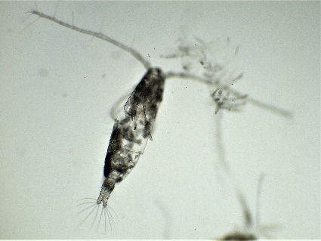 | 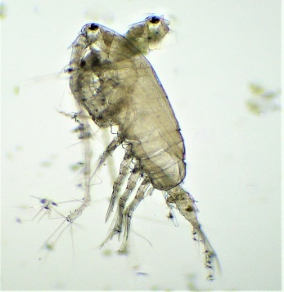
Acartia erythraea | Acrocalanus longicornis
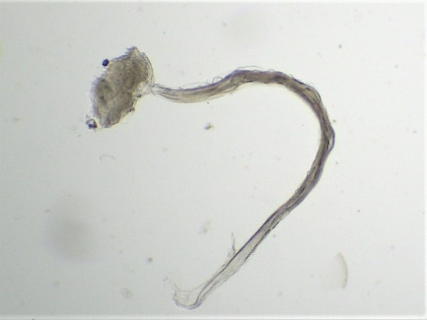 | 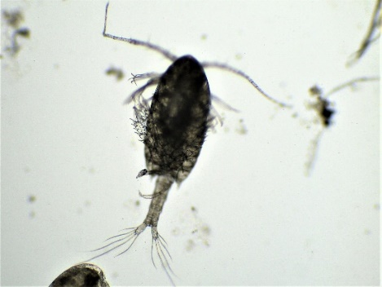
Appendicularians | Calanopia elliptica
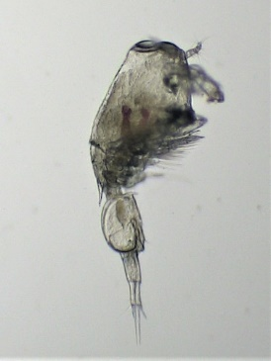 | 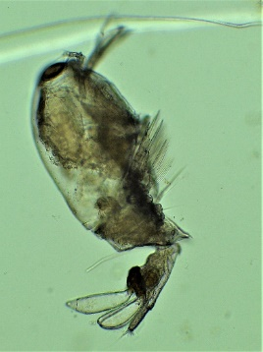
Corycaeus dahil | Farranula gibbula
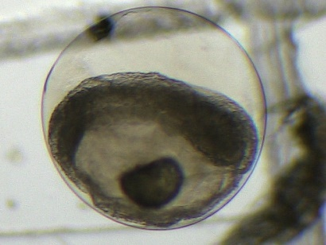 | 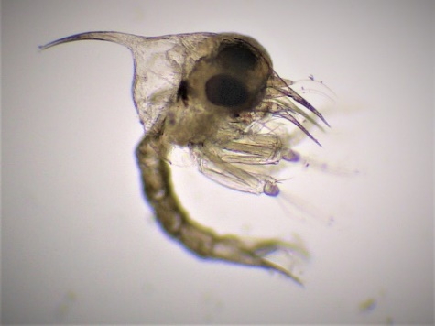
Fish egg | Brachyuran Larvae
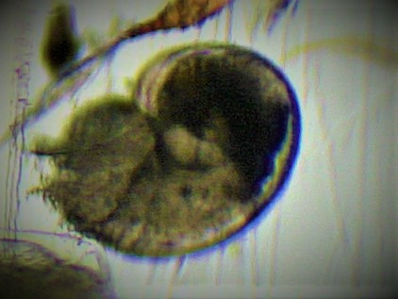 | 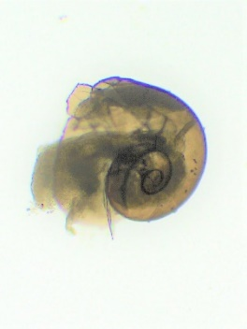
Gastropod larvae | Gastropod larvae
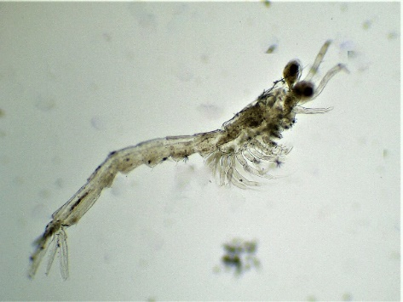 | 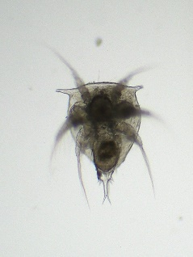
Lucifer hanseni | Nauplius
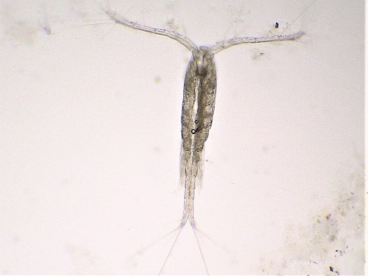 | 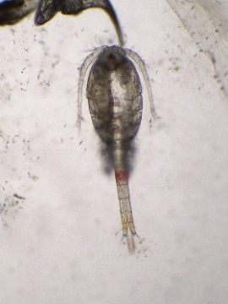
Oithona linearis | Oithona rigida
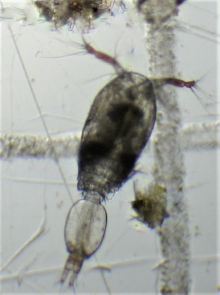 | 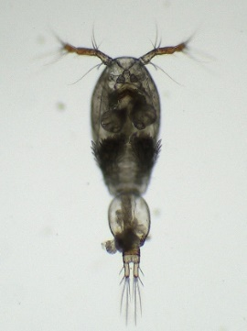
Oncaea mediterranea | Oncaea venusta
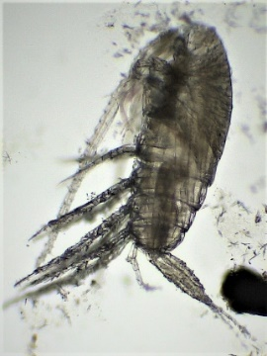 | 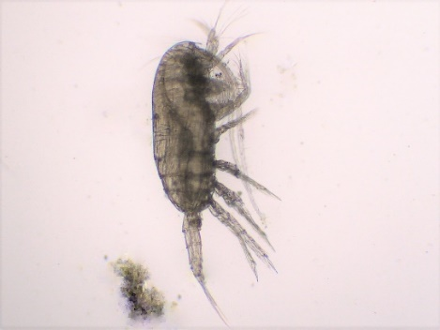
Paracalanus indicus | Paracalanus parvus
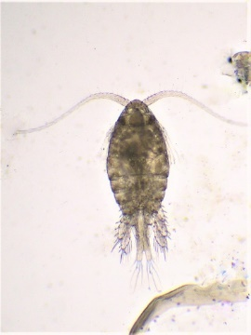 | 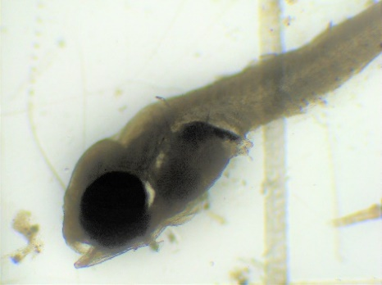
Parvocalanus crassirostris | Post larva of Polynemus Sextarius
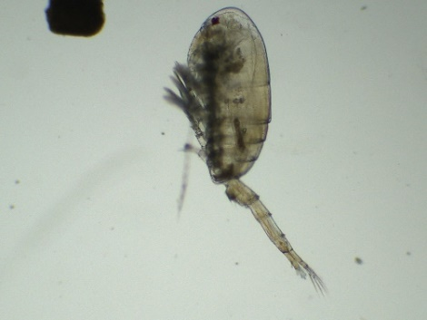 | 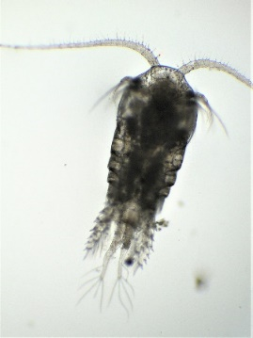
Pseudodiaptomus serricaudatus | Temora discaudata

Copepods were the most dominant group of the zooplankton community recorded throughout the study period at all fishing and non-fishing zones, constituting 49.6–72.1% of the total zooplankton. The dominance of copepods on the south-central west coast of India has been reported by Vijayaraghavan et al. (1982).
Decapod larvae ranked second in abundance after copepods among the zooplankton community found throughout the study period in all fishing and non-fishing zones, constituting 9.7–24.4%, which coincided with the results of Sharma and Wilima et al., (2007). A positive trend was observed in phytoplankton abundance, which was higher during these months, and an inverse trend was observed with copepod species.
Among amphipods, only one species was encountered, Hyperia macrocephala, which appeared in noticeable percentages throughout the study period and was encountered uniformly between the fishing and non-fishing zones. Their abundance was highest in November and lowest in January, which coincides with the results of Antony et al. (1997).
Isopods were represented by a single genus, Eurydice sp. They were collected throughout the study period in all fishing and non-fishing zones. In general, the abundance was higher in November, followed by December, and lowest in January and February.
Among Ostracods, Parasterope sp. was recorded throughout the study period and appeared noticeable at all fishing and non-fishing zones, constituting only 0.1–0.6% of the total zooplankton. It exhibited an almost uniform distribution, with a slight increase in November and December.
Throughout the research period in all the fishing and non-fishing zones, chordates ranked third in abundance after copepods and decapods, constituting 10.9–13.6% of the total zooplankton. In some months, such as January, they outnumbered the decapod population.
Appendicularians constituted the major groups in terms of density, followed by fish eggs and fish larvae, which is in line with the results of Sharma and Wilima et al. (2007).
Chaetognaths were represented by one species, Sagitta sp. This group appeared in noticeable numbers, as reported by Sumitra et al. (1982). The highest density was found in February and was absent in December.
Molluscans larvae were constituted by a single genus, Heteropod (Atlantid), which was sporadically present in the fishing and non-fishing zones during December, with a maximum average density of 12no/m³(January).
In ciliophores,one genus, Globigerina sp., and two species, Metacylis tropica and Salpingella attenuata, were encountered throughout the research period at all fishing and non-fishing zones, constituting 2.0–5.8% of the total zooplankton, which coincides with the results of Sharma and Wilima et al. ( 2007). Salpingella attenuata was the dominant species in these groups, followed by Globigerina sp. and Metacylis tropica.
The total composition revealed that copepods dominated in all months in both the fishing and non-fishing zones, followed by decapods, chordates, ciliophores, amphipods, molluscans, isopods, and ostracods, whereas chaetognaths were the least abundant group, with one species.
Conclusions
The present study documented the diversity and density of zooplankton in active fishing and non-fishing zones off Kollam, Kerala, during November 2019 to February 2020. A total of 53 zooplankton taxa were recorded from the sampled stations. Copepods formed the dominant component of the zooplankton community in both zones throughout the study period, followed by decapod larvae and chordates. The total zooplankton density varied from 422 to 503 ind. m⁻³, with the highest density observed at FZ-1 during November and the lowest at NFZ-3 during December. The statistical analysis indicated significant differences in zooplankton density among months and zones. However, the distribution pattern did not show a consistent separation between fishing and non-fishing zones, as higher densities were observed in both categories during different months. The findings suggest that zooplankton distribution in the study area may be influenced by temporal variability and local environmental conditions in addition to fishing-zone characteristics. This study provides useful baseline information on zooplankton assemblages from the coastal waters off Kollam and may support further investigations on plankton distribution, fish aggregation, and ecosystem-based fisheries assessment in the region.
Limitations
This study has certain limitations that should be considered while interpreting the findings. Sampling was conducted only from November 2019 to February 2020, although the original plan was to continue until April 2020. Therefore, the results represent a restricted seasonal window and may not reflect annual variability in zooplankton distribution. The locations of active fishing and non-fishing zones changed during the study because of the dynamic nature of fish-school occurrence, which may have influenced spatial comparability among stations. Samples were collected from surface waters only, and vertical variation in zooplankton abundance was not assessed. The sampling volume was limited, and the study did not include detailed measurements of environmental variables such as nutrients, chlorophyll concentration, current pattern, salinity, or temperature in relation to zooplankton abundance. Therefore, causal relationships between zooplankton density, fishing activity, and environmental drivers could not be established. Further studies with longer sampling duration, fixed georeferenced stations, and integrated environmental measurements are needed.

ACKNOWELDGEMENTS
This study was supported by the Department of Aquatic Environment Management, Kerala University of Fisheries and Ocean Studies, Panangad, Kochi, Keralam, India.
DISCLAIMER (Artificial Intelligence)
During the preparation of this work, the author used ChatGPT to improve readability. After using this tool, the author reviewed and edited the content as needed and took full responsibility for the content of the published articles.
COMPETING INTERESTS DISCLAIMER:
Authors have declared that they have no known competing financial interests OR non-financial interests OR personal relationships that could have appeared to influence the work reported in this paper.

REFERENCE
Antony, G., Kurup, K. N., Naomi, T. S., Solomon, K., & Mathew, K. J. (1997). Zooplankton abundance and secondary production in the seas around the Andaman-Nicobar Islands. Indian Journal of Fisheries, 44(2), 141-154.
Archana Devi, V. D., Balamurali, R. S., & Thara, S. (2023). Advances in zooplankton studies: An overview. Sustainability, Agri, Food and Environmental Research-DISCONTINUED, 12(1). https://doi.org/10.7770/safer-v12n1-art2793
Biju, A. (2018). Handbook of Marine Zooplankton. Bio-Green Books. ISBN: 978-9386110589.
CMFRI, K. (2025). Marine Fisheries Information Service No. 264.
Conway, D. V., White, R. G., Hugues-Dit-Ciles, J., & Gallienne, C. P., & Robins, D. B. (2003). Guide to the coastal and surface zooplankton of the southwestern Indian Ocean.
Greene, C. H. (1983). Selective Predation in Freshwater Zooplankton Communities. Internationale Revue Der Gesamten Hydrobiologie Und Hydrographie, 68(3), 297–315. https://doi.org/10.1002/iroh.19830680302.
Kasturirangan, L. R. (1963). A key for the identification of the more common planktonic copepoda of Indian coastal waters (No. 2). Delhi: Council of Scientific and Industrial Research.
Prasad, R. R. (1969). Zooplankton biomass in the Arabian Sea and the Bay of Bengal with a discussion on fisheries of the region. In Proc. Nat. Inst. Sci. India (Vol. 35, No. 5, pp. 399-437).
Santhanam, R., & Srinivasan, A. (1994). A manual of marine zooplankton. Oxford & IBH Publishing Company, New Delhi.
Sahu, B. K., Baliarsingh, S. K., Srichandan, S., & Sahu, K. C. (2013). Seasonal variation in zooplankton abundance and composition in Gopalpur creek: a tropical tidal backwater on the east coast of India. Journal of the Marine Biological Association of India, 55(1), 59-64.
Sharma, B. S., & Cyril, W. (2007). Distribution and abundance of zooplankton in relation to petroleum hydrocarbon content along the coast of Kollam(Quilon), south-west coast of India. Journal of Environmental biology, 28(1), 53-62.
Sonekar, D. R., & Chahal, D. P. (2025). Role of zooplankton in aquatic food webs and their influence on fishery management. International Journal of Aquatic Research and Environmental Studies, 5(2), 635–644. https://doi.org/10.70102/ijares/v5i2/5-2-56.
Sumitra-Vijayaraghavan, R. S., & Rao, T. S. S. (1982). Studies on zooplankton from the Arabian Sea off the South Central West Coast of India. Indian J. Mar. Sci, 1, 70-74.
Vijayaraghavan, S., Selvakumar, R.A., and Rao, T.S.S., 1982. Studies on zooplankton from the Arabian Sea off the South-Central West Coast of India. Indian. J. of Mar. Sci Vol.11, pp.70-74.
Wellershaus, S. (1974). Seasonal changes in the zooplankton population in the Cochin Backwater (a South Indian estuary). Hydrobiological Bulletin, 8(1–2), 213–223. https://doi.org/10.1007/bf02254921

