Seasonal Dynamics and Eco-friendly Management of Predatory Wasps (Vespa auraria and Vespa basalis) in Apis mellifera L. Colonies under Stationary and Migratory Beekeeping Systems

Abstract
Honey bees (Apis mellifera) are among the most important pollinators, playing a crucial role in maintaining biodiversity and agricultural productivity. However, their colonies face numerous biotic threats that significantly impact their health, survival, and productivity. Among these threats, predatory wasps have emerged as serious biological enemies. Predatory wasps pose a significant threat to honey bee (Apis mellifera L.) colonies, affecting colony strength and productivity. The present study was conducted to evaluate the seasonal incidence of two major wasp species, Vespa auraria and Vespa basalis, and to assess the field efficacy of different baited traps under stationary (Palampur, Himachal Pradesh) and migratory (Anupgarh, Rajasthan) beekeeping conditions during September 2025 to April 2026. Observations on wasp activity were recorded at two-time intervals (9–10 A.M. and 1–2 P.M.), along with weekly monitoring of trap catches using five bait treatments. The results revealed a distinct seasonal pattern in wasp activity, with peak populations observed during September and October, followed by a gradual decline towards December. V. auraria exhibited higher abundance compared to V. basalis, with maximum activity recorded during afternoon hours (1–2 P.M.). Minimal or no wasp activity was observed from January to April, indicating a strong influence of climatic conditions on population dynamics. Among the bait treatments, fermented fruit juice solution proved to be the most effective attractant, capturing significantly higher numbers of wasps at both locations, followed by fermented honey solution. Control treatments showed no trapping, confirming the effectiveness of bait-based trapping strategies. The efficacy of traps was highest during peak wasp activity months, particularly September. The study highlights the importance of understanding seasonal incidence and behaviour of predatory wasps for timely management interventions. The use of fermented bait traps, especially fruit-based attractants, can serve as an effective, eco-friendly approach for reducing wasp predation in apiaries. These findings provide practical insights for beekeepers to improve colony protection and enhance honey production under varying agro-climatic conditions.
Keywords: Honey bee (Apis mellifera), Vespa auraria, Vespa basalis, seasonal incidence, wasp traps, fermented bait.

Introduction
Honey bees are eusocial and are economically and ecologically significant insect worldwide, functioning as major pollinators in both natural and agricultural ecosystems. Honey bees help people directly by giving important products like pollen, honey, royal jelly, beeswax, and bee venom. They also support the pollination of a wide variety of crops, thereby helping to sustain biological diversity (Johannesmeier & Mostert, 2001). Honey bees belong to the family Apidae, which has nine main species and many subspecies. Out of approximately 20,000 recorded bee species, only a small number produce honey; the majority are either solitary or semi-social and may or may not form colonies. Beekeeping of European honey bees, Apis mellifera, was successfully introduced and domesticated in many states like Punjab, Haryana, Himachal Pradesh, and Jammu & Kashmir in 1962 and is widely practiced in Himachal Pradesh, mainly through migratory methods. In recent years, there has been significant researches in the field of apiculture and honey bee management, as more people domesticate bees for various products like honey and wax and as well as for business purpose (Manoj et al., 2023). However, Apis mellifera population faces many threats that can negatively impact their survival and overall health. There are reports about the incidence of large number of insect pests, infesting honey bees worldwide. Enemies are classified into two categories: pests and predators of honey bees. Predators are those animals which capture other living organism for food. Rest of the enemies cause some harm or disturbances to honey bee colony and considered as pest which can cause heavy damage to bee life and their seasonal activity. Wax moths, mites, wasps, considered as major enemies whereas the minor enemies are cockroaches, spiders, ants, birds etc. which causes nuisance into bee colony (Thakur and Sharma, 1984). These enemies are the significant pest that disrupts the honey bee life cycle, making its management essential for colony health. Among all enemies, wasps, especially predatory hornets and social vespine such as Vespa auraria, Vespa basalis, Vespa velutina, Vespa mandarinia, and various Vespula species, exert strong negative impacts on honey-bee colonies through direct predation, resource theft, and behavioral disruption. These wasps frequently hover or “hawk” in front of hive entrances, capturing foragers and guard bees, which leads to a rapid decline in worker population and reduces the colony’s ability to forage, defend, and thermoregulate brood. Sustained predation pressure often causes honey bees to remain inside the hive, resulting in decreased nectar and pollen intake and subsequent brood reduction or starvation. In severe attacks, wasps invade weakened hives, consuming brood, honey, and wax reserves, which can trigger colony collapse or absconding, particularly during late summer and autumn when wasp populations peak (Monceau & Thiery, 2014). Recent research also shows that invasive hornet species may act as mechanical or biological carriers of honey-bee pathogens, including deformed wing virus and Nosema spp., adding a disease component to the physical predation stress. Environmental factors such as warm temperatures, landscape fragmentation, and the spread of invasive species further intensify predation pressure, making colonies more vulnerable to collapse. So, wasp pressure weakens honey-bee colonies by reducing forager populations, altering normal hive behavior, intensifying nutritional stress, increasing pathogen exposure, and ultimately contributing to seasonal or complete colony failure (Laurino et al., 2020). The population dynamics and activity patterns of predatory wasps are strongly influenced by climatic factors such as temperature, humidity, and seasonal changes. Previous studies have indicated that wasp activity peaks during warmer months and declines during winters (Kim et al., 2019). However, the extent and timing of these seasonal fluctuations vary across different agro-climatic regions and management systems. Therefore, understanding the seasonal incidence and behaviour of wasps is essential for designing timely and effective management strategies.
Various control measures have been employed by beekeepers to mitigate wasp predation, including nest destruction, chemical control, and trapping techniques. Among these, baited trapping has emerged as an eco-friendly, economical, and practical approach (Bacandritsos et al., 2006). Different types of attractants, such as protein-based baits and fermented solutions, have been evaluated for their efficiency in attracting predatory wasps. Fermented baits, in particular, have shown higher effectiveness due to the release of volatile compounds that act as strong olfactory attractants (Dvorak and Landolt, 2006). Studies have demonstrated that fruit-based baits, especially pear, are highly attractive to hornets compared to other food sources (Mishra et al., 1989; Bhatta and Tamrakar, 2011).

Material and method
The studies were conducted in the apiary of Apis mellifera L. colonies under stationary (Palampur, Kangra) and migratory conditions (Anupgarh, Rajasthan). The incidence of predatory wasps in Apis mellifera colonies was recorded at weekly intervals using modified plastic bottle traps. Five trap–bait combinations were evaluated for their effectiveness in attracting and capturing wasps: fish and meat (T₁), fermented sugar solution (T₂), fermented fruit juice (T₃), fermented honey solution (T₄), and water as control (T₅). Plastic bottles (1.5 L) were modified by making three equidistant holes (1.5 cm diameter) fitted with 3 cm plastic tubes to facilitate insect entry. Traps were installed at a height of approximately 1.0 m near the bee colonies. Fermented baits were prepared by allowing respective substrates (sugar solution, fruit juice, and honey solution) to ferment for 24–48 hours at room temperature (25–28°C) using natural or yeast-mediated fermentation. Approximately 150 mL of bait was added to each trap depending on the treatment. Wasps attracted to the bait entered through the tubes and became trapped inside the bottle. Observations on the number of wasps captured were recorded at seven-day intervals, and baits were refilled periodically to maintain effectiveness.
Result and discussions

Performance of Apis mellifera L. honey bee colony
Under stationary conditions

Table1. Colony records of A. mellifera under stationary conditions (Palampur, Kangra, Himachal Pradesh) during September, 2025 to May, 2026
Period | Average colony strength (Bee frames) | Brood area  (cm²) | Pollen area  (cm²) | Honey store  (g)
September,  2025 | 4.15 | 1419.00  (37.68)* | 109.65  (10.51) | 430.00  (20.73)
October | 4.20 | 1386.75  (37.24) | 100.62  (10.07) | 280.00  (16.69)
November | 3.55 | 1302.90  (36.10) | 83.85  (9.20) | 230.00  (15.10)
December | 3.30 | 1283.55  (35.83) | 72.24  (8.54) | 170.00  (12.92)
January,  2026 | 3.40 | 1271.94  (35.67) | 68.37  (8.32) | 80.00  (8.93)
February | 3.15 | 1300.32  (36.07) | 82.56  (9.13) | 90.00  (9.43)
March | 3.60 | 1371.27  (37.04) | 118.68  (10.93) | 134.00  (11.57)
April | 4.05 | 1438.35  (37.93) | 138.03  (11.78) | 250.00  (15.67)
May | 4.40 | 1511.88  (38.89) | 159.96  (12.68) | 280.00  (16.69)
C.D | 0.28 | 0.63 | 0.39 | 2.19

*Figures in parentheses are square root transformed values

Fig.1. Colony parameters in A. mellifera colonies (stationary conditions)

Under migratory conditions
Table 2. Colony records of A. mellifera under migratory (Anupgarh, Rajasthan) and stationary (Palampur, Kangra, Himachal Pradesh) during September, 2025 to May, 2026
Period | Average colony strength (Bee frames) | Brood area  (cm²) | Pollen area  (cm²) | Honey store  (g)
September,  2025 | 4.95 | 1515.75  (38.93)* | 81.27  (9.06) | 430.00  (20.72)
October | 4.75 | 1548.00  (39.34) | 68.37  (8.32) | 380.00  (19.47)
November** | 4.50 | 1532.55  (39.14) | 86.43  (9.34) | 380.00  (19.47)
December** | 4.35 | 1720.86  (41.48) | 103.20  (10.19) | 440.00  (20.98)
January,  2026** | 4.55 | 1802.13  (42.45) | 125.13  (11.22) | 510.00  (22.59)
February** | 4.95 | 1887.27  (43.45) | 143.19  (12.00) | 980.00  (31.31)
March** | 6.80 | 1951.77  (44.18) | 129.00  (11.39) | 770.00  (27.75)
April | 6.45 | 1883.40  (43.39) | 113.54  (10.68) | 280.00  (16.55)
May | 6.65 | 1896.30  (43.55) | 109.65  (10.51) | 260.00  (16.11)
C.D | 0.41 | 1.20 | 0.18 | 1.92
*Figures in parentheses are square root transformed values
**Months of migration period of colonies to Rajasthan

Fig.2. Colony parameters in A. mellifera colonies (migratory conditions
Seasonal incidence of wasps (V. auraria and V. basalis) in A. mellifera colonies under stationary conditions (Palampur, Kangra) and migratory conditions (Anupgarh, Rajasthan) during September, 2025 to December, 2025
Wasps attacking bee colonies in apiary had different and specific periods of activity. In 9-10 A.M. assessment, the average lowest population of V. auraria was 3.00±1.4 wasp/hour/week in December, while the highest population was recorded in the month of October 15.40±2.05 wasp/hour/week. It is evident from the table 6 that, comparatively, a higher population of V. auraria was observed during 1-2 P.M., with the lowest recorded in the month of December 3.60±1.35 wasp/hour/week and highest was in the month of October 16.40±3.00 wasp/hour/week. During 9-10 A.M. assessment, the lowest population of V. basalis was recorded in the month of December 0.40±0.48 wasp/hour/week while the highest population was observed in the month of September 3.60±1.35 wasp/hour/week and during 1-2 P.M. assessment, the lowest population of V. basalis was recorded in the month of December 1.20±0.74 wasp/hour/week while highest was recorded in the month of September 4.20±0.74 wasp/hour/week.
Table 3. Seasonal incidence of wasps (V. auraria and V. basalis) in A. mellifera colonies under stationary conditions (Palampur, Kangra) and migratory conditions (Anupgarh, Rajasthan) during September, 2025 to December, 2025
Months | 9-10 A.M. |  | 1-2 P.M. |  | Pooled
Months | V. auraria | V. basalis | V. auraria | V. basalis | V. auraria | V. basalis
September | 10.60±1.62  (3.39)* | 3.60±1.35  (2.12) | 11.60±1.01  (3.54) | 4.20±0.74  (2.27) | 11.10±0.50  (3.47) | 3.90±0.30  (2.21)
October | 15.40±2.05  (4.04) | 1.20±0.40  (1.47) | 16.40±3.00  (4.15) | 2.40±0.48  (1.83) | 15.90±0.50  (4.11) | 1.80±0.60  (1.66)
November** | 5.40±2.05  (2.49) | 1.60±0.48  (1.60) | 8.40±5.46  (2.96) | 2.00±0.00  (1.73) | 6.90±1.50  (2.79) | 1.80±0.20  (1.67)
December** | 3.00±1.41  (1.96) | 0.40±0.48  (1.16) | 3.60±1.35  (2.12) | 1.20±0.74  (1.45) | 3.30±0.30  (2.07) | 0.80±0.40  (1.33)
*Figures in parentheses are square root transformed values
**Months of migration period of colonies to Rajasthan

Fig 3. Seasonal incidence of Vespa auraria

Fig 4. Seasonal incidence of Vespa basalis
Field efficacy of wasp traps in beekeeper’s apiaries
Five trap–bait combinations were evaluated to determine the efficacy of wasp traps at Saliana (Palampur) and Anupgarh (Rajasthan). The different bait treatments were installed from September, 2025 to May, 2026. Observations were recorded weekly to assess their effectiveness and selectiveness in capturing various species of predatory wasps that are harmful to honey bees (Apis mellifera L.).
Under stationary conditions
The number of Vespa Auraria wasp individuals trapped during different months at Saliana (Palampur) is presented in Table 4. Highest wasps trapping per week were recorded in Fermented fruit juice solution (T3) i.e., 184.40±4.27 which was statistically at par with Fermented honey solution (T4) (168.40±2.93) followed by Fermented sugar solution (T2) and Fish and meat bait, while in Control (T5) no trapping was observed. Highest wasp trapped per week was observed in September (105.28) while minimum was observed in December (2.48). No wasps were trapped from January, 2026 to May, 2026.
The number of Vespa basalis individuals trapped under stationary conditions during different months at Saliana (Palampur) is presented in Table 5. Highest wasp trapping per week was observed in Fermented fruit juice solution (T3) i.e., 45.80±4.95 which was statistically at par with Fermented honey solution (T4) (35.20±3.54) followed by Fermented sugar solution (T2) and Fish and Meat bait (T1). In Control i.e. T5 treatment no trapping was observed. Highest wasp trapped per week was observed in October (25.12) while minimum was observed in December (1.48). No wasps were trapped from January, 2026 to May, 2026 as that of Vespa auraria.

Table 4. Number of wasps (V. auraria) trapped in A. mellifera colonies under stationary conditions (Palampur, Kangra, Himachal Pradesh) during September, 2025 to May, 2026

Months | Fish and meat  (T1) | Fermented sugar solution (T2) | Fermented fruit juice  (T3) | Fermented honey solution (T4) | Control  (T5) | Mean
September,  2025 | 47.20±1.46  (6.94)* | 126.40±3.92  (11.28) | 184.40±4.27  (13.61) | 168.40±2.93  (13.01) | 0.00±0.00  (1.00) | 105.28  (9.17)
October | 20.60±0.80  (4.67) | 40.80±1.16  (6.46) | 92.40±1.62  (9.66) | 82.60±2.15  (9.14) | 0.00±0.00  (1.00) | 47.28  (6.19)
November | 3.80±0.74  (2.18) | 8.40±1.01  (3.06) | 5.40±1.01  (2.52) | 5.80±1.72  (2.58) | 0.00±0.00  (1.00) | 4.68  (2.27)
December | 2.80±0.74  (1.94) | 4.00±1.41  (2.21) | 3.20±0.74  (2.04) | 2.40±1.01  (1.82) | 0.00±0.00  (1.00) | 2.48  (1.80)
January,  2026 | 0.00±0.00  (1.00) | 0.00±0.00  (1.00) | 0.00±0.00  (1.00) | 0.00±0.00  (1.00) | 0.00±0.00  (1.00) | 0.00  (1.00)
February | 0.00±0.00  (1.00) | 0.00±0.00  (1.00) | 0.00±0.00  (1.00) | 0.00±0.00  (1.00) | 0.00±0.00  (1.00) | 0.00  (1.00)
March | 0.00±0.00  (1.00) | 0.00±0.00  (1.00) | 0.00±0.00  (1.00) | 0.00±0.00  (1.00) | 0.00±0.00  (1.00) | 0.00  (1.00)
April | 0.00±0.00  (1.00) | 0.00±0.00  (1.00) | 0.00±0.00  (1.00) | 0.00±0.00  (1.00) | 0.00±0.00  (1.00) | 0.00  (1.00)
May | 0.00±0.00  (1.00) | 0.00±0.00  (1.00) | 0.00±0.00  (1.00) | 0.00±0.00  (1.00) | 0.00±0.00  (1.00) | 0.00  (1.00)
Mean | 8.27  (2.30) | 19.96  (3.00) | 31.71  (3.65) | 28.80  (3.39) | 0.00  (1.00) | 17.75  (2.67)
 | 0.13 | 0.19 | 0.16 | 0.21
*Figures in parentheses are square root transformed values

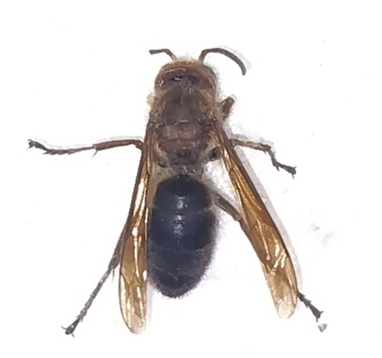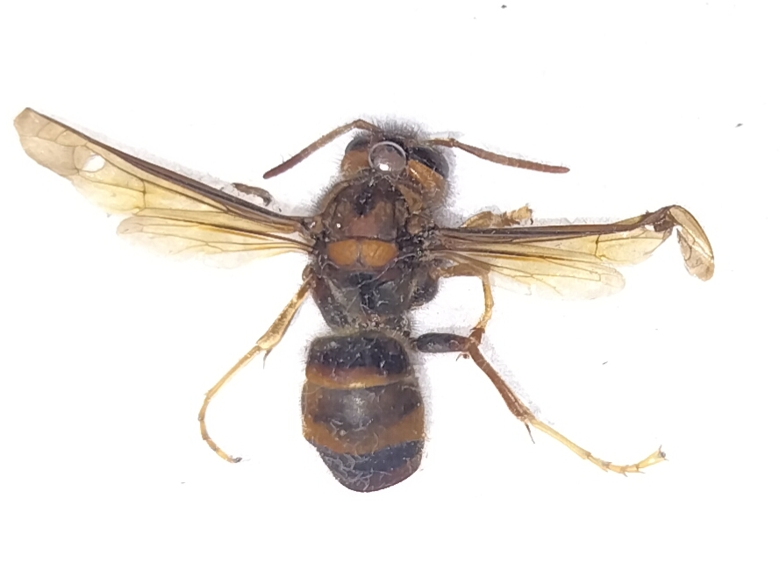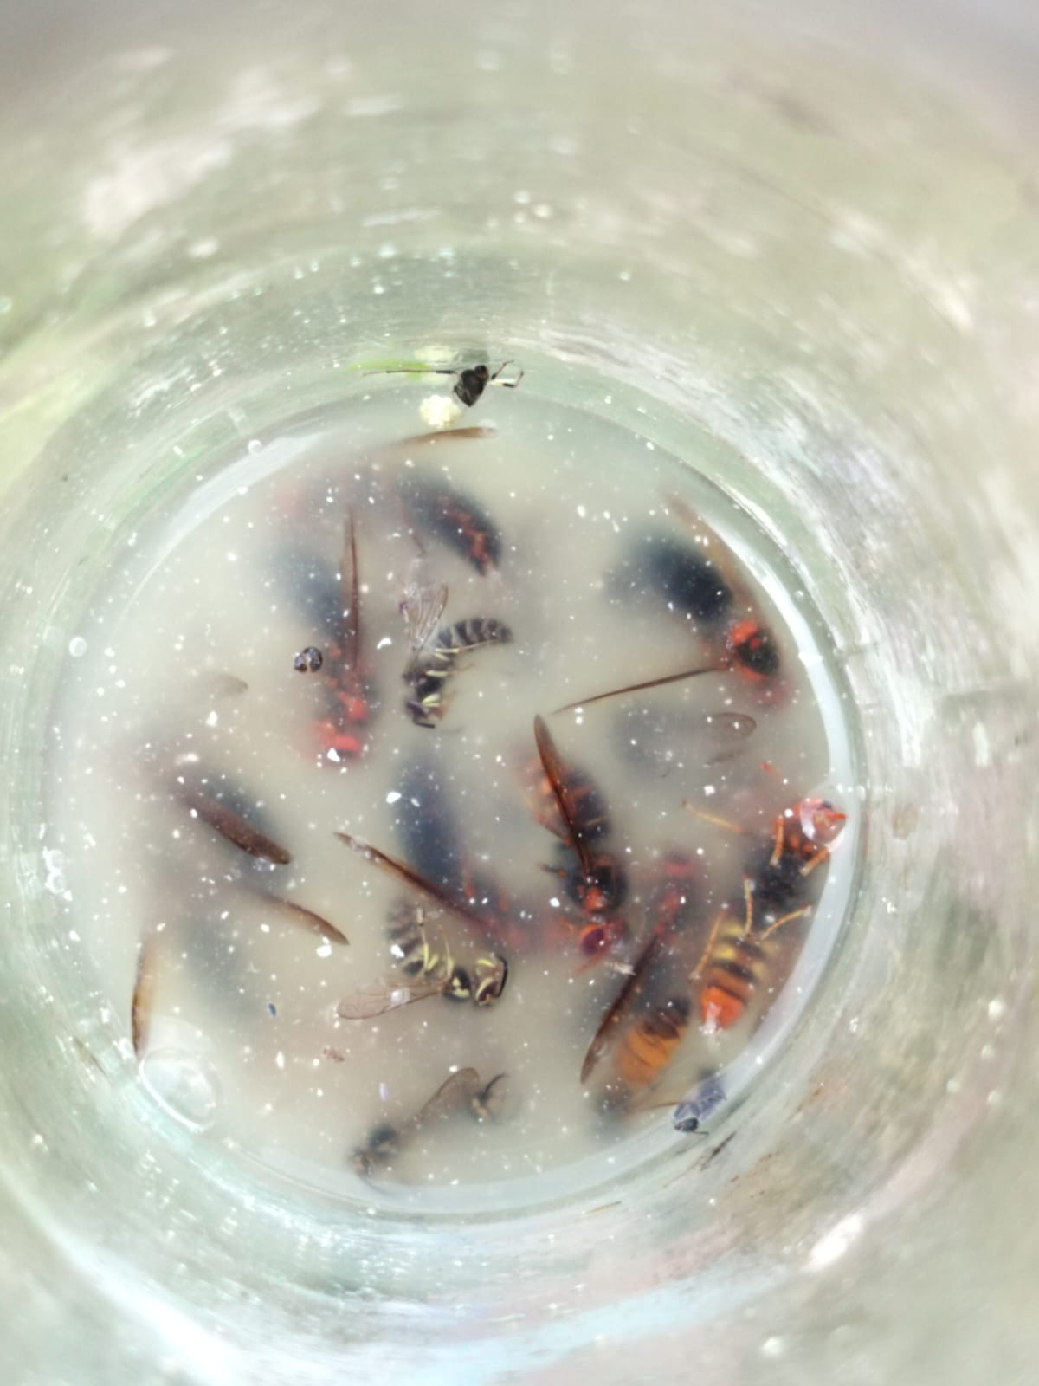
(A) Vespa basalis (B) Vespa auraria (C)Different wasp’s species trapped)
Fig. 5. Different species of predatory wasps trapped
Table 5. Number of wasps (V. basalis) trapped in A. mellifera colonies under stationary conditions (Palampur, Kangra, Himachal Pradesh) during September, 2025 to May, 2026

Months | Fish and meat  (T1) | Fermented sugar solution (T2) | Fermented fruit juice  (T3) | Fermented honey solution (T4) | Control  (T5) | Mean
September,  2025 | 14.60±1.62  (3.94)* | 20.40±1.74  (4.62) | 37.20±4.26  (6.17) | 31.80±2.40  (5.72) | 0.00±0.00  (1.00) | 20.80  (4.29)
October | 14.80±1.72  (3.96) | 29.80±2.78  (5.54) | 45.80±4.95  (6.83) | 35.20±3.54  (6.00) | 0.00±0.00  (1.00) | 25.12  (4.67)
November | 3.60±0.01  (2.13) | 5.80±1.32  (2.59) | 6.80±2.31  (2.76) | 9.20±3.37  (3.15) | 0.00±0.00  (1.00) | 5.08  (2.33)
December | 1.40±0.48  (1.54) | 1.00±0.89  (1.37) | 3.40±1.20  (2.07) | 1.60±1.01  (1.57) | 0.00±0.00  (1.00) | 1.48  (1.51)
January,  2026 | 0.00±0.00  (1.00) | 0.00±0.00  (1.00) | 0.00±0.00  (1.00) | 0.00±0.00  (1.00) | 0.00±0.00  (1.00) | 0.00  (1.00)
February | 0.00±0.00  (1.00) | 0.00±0.00  (1.00) | 0.00±0.00  (1.00) | 0.00±0.00  (1.00) | 0.00±0.00  (1.00) | 0.00  (1.00)
March | 0.00±0.00  (1.00) | 0.00±0.00  (1.00) | 0.00±0.00  (1.00) | 0.00±0.00  (1.00) | 0.00±0.00  (1.00) | 0.00  (1.00)
April | 0.00±0.00  (1.00) | 0.00±0.00  (1.00) | 0.00±0.00  (1.00) | 0.00±0.00  (1.00) | 0.00±0.00  (1.00) | 0.00  (1.00)
May | 0.00±0.00  (1.00) | 0.00±0.00  (1.00) | 0.00±0.00  (1.00) | 0.00±0.00  (1.00) | 0.00±0.00  (1.00) | 0.00  (1.00)
Mean | 3.82  (1.84) | 6.33  (2.12) | 10.36  (2.43) | 8.64  (2.38) | 0.00  (1.00) | 5.83  (1.95)
 | 0.20 | 0.24 | 0.35 | 0.35
*Figures in parentheses are square root transformed values

Under migratory conditions
The number of Vespa auraria individuals trapped under migratory conditions during different months at Anupgarh (Rajasthan) is presented in Table 6. Highest wasp trapping per week was recorded in Fermented fruit juice solution (T3) i.e., 221.60±2.24 which was statistically at par with Fermented honey solution (T4) (210.20±4.53) followed by Fermented sugar solution (T2) and Fish and Meat bait (T1), while in Control (T5) no trapping was observed. Highest wasp trapped per week was observed in September (117.28) while minimum was observed in December (2.48). No wasps were from January, 2026 to May, 2026.
Table 6. Number of wasps (V. auraria) trapped in A. mellifera colonies under migratory (Anupgarh, Rajasthan) and stationary conditions (Palampur, Kangra) during September 2025 to May, 2026
Months | Fish and meat  (T1) | Fermented sugar solution (T2) | Fermented fruit juice  (T3) | Fermented honey solution (T4) | Control  (T5) | Mean
September,  2025 | 46.40±1.01  (6.88) | 111.20±2.78  (10.59) | 221.60±2.24  (14.92) | 210.20±4.53  (14.53) | 0.00±0.00  (1.00) | 117.88  (9.58)
October | 20.60±1.49  (4.64) | 36.40±1.85  (6.11) | 36.80±1.72  (6.14) | 7.40±2.05  (2.87) | 0.00±0.00  (1.00) | 20.24  (4.15)
November | 4.40±1.01  (2.31) | 10.60±1.01  (3.40) | 7.40±1.01  (2.89) | 8.60±2.41  (3.07) | 0.00±0.00  (1.00) | 6.20  (2.53)
December | 2.80±0.74  (1.94) | 3.60±1.01  (2.13) | 4.20±0.74  (2.27) | 1.80±0.74  (1.65) | 0.00±0.00  (1.00) | 2.48  (1.80)
January,  2026 | 0.00±0.00  (1.00) | 0.00±0.00  (1.00) | 0.00±0.00  (1.00) | 0.00±0.00  (1.00) | 0.00±0.00  (1.00) | 0.00  (1.00)
February | 0.00±0.00  (1.00) | 0.00±0.00  (1.00) | 0.00±0.00  (1.00) | 0.00±0.00  (1.00) | 0.00±0.00  (1.00) | 0.00  (1.00)
March | 0.00±0.00  (1.00) | 0.00±0.00  (1.00) | 0.00±0.00  (1.00) | 0.00±0.00  (1.00) | 0.00±0.00  (1.00) | 0.00  (1.00)
April | 0.00±0.00  (1.00) | 0.00±0.00  (1.00) | 0.00±0.00  (1.00) | 0.00±0.00  (1.00) | 0.00±0.00  (1.00) | 0.00  (1.00)
May | 0.00±0.00  (1.00) | 0.00±0.00  (1.00) | 0.00±0.00  (1.00) | 0.00±0.00  (1.00) | 0.00±0.00  (1.00) | 0.00  (1.00)
Mean | 8.24  (2.31) | 17.98  (3.03) | 30.00  (3.36) | 25.33  (3.01) | 0.00  (1.00) | 16.31  (2.53)
 | 0.17 | 0.16 | 0.14 | 0.27

*Figures in parentheses are square root transformed values
**Months of migration period of colonies to Rajasthan

The number of Vespa basalis individuals trapped during different months at Anupgarh (Rajasthan) is presented in Table 7. Highest wasp trapping per week was recorded in Fermented fruit juice solution (T3) i.e., 35.60±3.13 which was statistically at par with Fermented honey solution (T4) (31.80±4.06) followed by Fermented sugar solution (T2) and Fish and Meat bait (T1), while in Control (T5) no trapping was observed. Highest wasp trapped per week was observed in September (21.52) while minimum was observed in December (0.44). From January, 2026 to May, 2026 no wasp trapping was observed.
Table 7. Number of wasps (V. basalis) trapped in A. mellifera colonies under migratory (Anupgarh, Rajasthan) and stationary conditions (Palampur, Kangra) during September 2025 to May, 2026
Months | Fish and meat  (T1) | Fermented sugar solution (T2) | Fermented fruit juice  (T3) | Fermented honey solution (T4) | Control  (T5) | Mean
September,  2025 | 17.20±1.72  (4.26) * | 23.00±3.48  (4.88) | 35.60±3.13  (6.04) | 31.80±4.06  (5.71) | 0.00±0.00  (1.00) | 21.52  (4.38)
October | 1.60±1.01  (1.57) | 9.40 ±.72  (3.17) | 13.20±2.31  (3.75) | 13.80±2.92  (3.82) | 0.00±0.00  (1.00) | 7.60  (2.66)
November | 1.00±0.63  (1.39) | 0.80±0.74  (1.31) | 1.80±0.74  (1.65) | 0.60±0.48  (1.24) | 0.00±0.00  (1.00) | 0.84  (1.32)
December | 0.40±0.48  (1.16) | 0.20±0.46  (1.08) | 1.20±1.16  (1.42) | 0.40±0.48  (1.16) | 0.00±0.00  (1.00) | 0.44  (1.16)
January,  2026 | 0.00±0.00  (1.00) | 0.00±0.00  (1.00) | 0.00±0.00  (1.00) | 0.00±0.00  (1.00) | 0.00±0.00  (1.00) | 0.00  (1.00)
February | 0.00±0.00  (1.00) | 0.00±0.00  (1.00) | 0.00±0.00  (1.00) | 0.00±0.00  (1.00) | 0.00±0.00  (1.00) | 0.00  (1.00)
March | 0.00±0.00  (1.00) | 0.00±0.00  (1.00) | 0.00±0.00  (1.00) | 0.00±0.00  (1.00) | 0.00±0.00  (1.00) | 0.00  (1.00)
April | 0.00±0.00  (1.00) | 0.00±0.00  (1.00) | 0.00±0.00  (1.00) | 0.00±0.00  (1.00) | 0.00±0.00  (1.00) | 0.00  (1.00)
May | 0.00±0.00  (1.00) | 0.00±0.00  (1.00) | 0.00±0.00  (1.00) | 0.00±0.00  (1.00) | 0.00±0.00  (1.00) | 0.00  (1.00)
Mean | 2.24  (1.49) | 3.71  (1.72) | 5.76  (1.98) | 5.18  (1.88) | 0.00  (1.00) | 16.31  (2.53)
 | 0.24 | 0.36 | 0.26 | 0.30

*Figures in parentheses are square root transformed values
**Months of migration period of colonies to Rajasthan

Conclusion: The findings of the present investigation revealed that predatory wasps significantly influence the health and productivity of Apis mellifera colonies in both stationary and migratory beekeeping systems. Wasp activity peaked in October, with mean values of V. auraria (15.90±0.50) and V. basalis (1.80±0.60), followed by September (11.10±0.50; 3.90±0.30). Activity declined in November (6.90±1.50; 1.80±0.20) and reached minimum in December (3.30±0.30; 0.80±0.40). V. auraria was consistently more abundant and more active during afternoon hours (1–2 P.M.). Different treatments were used to check the seasonal abundance of wasps viz., Fish and meat, Fermented sugar solution, Fermented fruit juice, Fermented honey solution, Control. Among these treatments, fermented fruit juice (42.60) was the most effective bait, followed by fermented honey (29.30), whereas control traps showed no captures. Overall, the research emphasizes that timely monitoring of wasp activity and the use of eco-friendly bait traps can help beekeepers minimize colony losses, maintain colony strength, and improve honey production. These management practices can therefore contribute to sustainable and profitable apiculture under different agro-climatic conditions.

References:
- Bacandritsos, N., Papanastasiou, I., Saitanis, C., and Nanetti, A. (2006). Evaluation of bait trapping methods for management of predatory wasps in apiaries. Apiacta, 41(2), 45–52.
- Bhatta, C. P., and Tamrakar, A. S. (2011). Evaluation of bait materials for trapping predatory hornets in honey bee colonies. Nepal Journal of Science and Technology, 12(1), 75–80.
- Dvořák, L., and Landolt, P. J. (2006). Attraction of hornets and social wasps to fermented food baits. European Journal of Entomology, 103(3), 557–561.
- Johannesmeier, M. F., and Mostert, J. C. (2001). Crop pollination by honey bees in South Africa. South African Journal of Science, 97(7–8), 375–378.
- Kim, J. K., Choi, M. B., and Moon, T. Y. (2019). Seasonal activity and distribution patterns of social wasps in relation to climatic factors. Journal of Asia-Pacific Entomology, 22(3), 745–752.
- Laurino, D., Lioy, S., Carisio, L., Manino, A., and Porporato, M. (2020). Vespa velutina and its impact on honey bee colonies: A review. Insects, 11(10), 1–15.
- Manoj, K., Sharma, R., and Verma, P. (2023). Advances in apiculture and honey bee management practices in India. Journal of Entomological Research, 47(2), 145–152.
- Mishra, R. C., Gupta, J. K., and Dogra, G. S. (1989). Comparative attractiveness of different food baits to predatory wasps of honey bees. Indian Bee Journal, 51(4), 109–112.
- Monceau, K., and Thiery, D. (2014). Vespa velutina: A new invasive predator of honeybees in Europe. Journal of Pest Science, 87(1), 1–16.
- Thakur, R. K., and Sharma, P. L. (1984). Studies on pests and predators of honey bees in Himachal Pradesh. Indian Bee Journal, 46(3), 89–94.

