Redescription of Poecilobdella lakshmikantai, A New Species of Leech from
Arunachal Pradesh, India
Abstract:
There are 917 species of leeches globally (Annelida: Hirudinea), with India hosting 88 different species. Eight species have been identified within the genus Poecilobdella, including Poecilobdella granulosa Savigny, 1820; Poecilobdella manilensis Lesson, 1924; Poecilobdella javanica Wahlberg, 1856; Poecilobdella viridis Moore, 1927; Poecilobdella aligarhensis Mandal et al., 2021; and Poecilobdella sukhendui Mandal et al., 2024. Poecilobdella kananbalaae Mandal et al., 2025, Poecilobdella tarubalaae Mandal et al.2025. In the present study, a new species, Poecilobdella lakshmikantai from Dirang, West Kameng District, Arunachal Pradesh, India, is redescribed because it was established in 2025 but not uploaded online. As a result of this finding, Arunachal Pradesh now harbors a total of seven documented leech species.
Key Words: Hirudinidae, New leech, Poecilobdella lakshmikantai, Arunachal Pradesh, India.
Introduction:
Leeches, often perceived as slimy, black, blood-feeding worms inhabiting unclean ponds and marshes, they inhabit a diverse range of aquatic environments including freshwater, estuarine, and marine—as well as moist terrestrial habitats worldwide, with the notable exception of terrestrial Antarctica (Phillips et al., 2020). The world is home to approximately 917 leech species, with India hosting a significant 12% of this diversity (Mandal, 2021). Early research on Indian leeches provided foundational insights, including Baugh's (1960) focus on Indian Rhynchobdellids and Harding and Moore's (1927) comprehensive review, which identified 54 species (36 freshwaters, nine terrestrials, and 10 marine) across 25 genera and five families. Chandra's (1991) work further expanded the understanding of Indian leeches, introducing 30 new species. Among the leech genera found in India, Poecilobdella includes six aquatic species. Mandal’s research has contributed a total of 26 leech records, consisting of eight terrestrials and 18 aquatic species, with notable contributions such as the description of Paraclepsis gardensi (Glossiphonidae, 2004) and Poecilobdella sukhendui (Hirudinidae, 2024). The taxonomic framework for Indian leeches has been greatly shaped by Chandra (1983) and Ghosh (1998), building on earlier global contributions, such as Soos's (1965) work. In the present study, this study redescribes a newly discovered species from Dirang, located in the West Kameng District of Arunachal Pradesh, India (Latitude 27.3584° N, Longitude 92.2409° E; altitude 1500 m).

Materials and methods:
Collection and Preservation: Leech specimens are collected by the help of a deep net. It has three parts (Wooden Handle, Frame of Steel and bag of string net). Collector collected the specimens dipping the deep net below the leeches into the waterbody. The collected leeches were subjected to a cleaning and sterilization process before being placed in a shallow water bath. Gradual anesthesia was induced by applying 70% alcohol drop by drop at regular intervals. This method ensured a slow and humane demise of the leeches. Immediately after death, the specimens were preserved in 4% formalin for long-term storage and perfect dissection of the specimens. Upon proper identification, they were officially deposited and cataloged in the General Non-Chordata (GNC) section, collection of the Zoological Survey of India, Kolkata, for future reference and study.
Material examined:
Holotype: Dirang, located in the West Kameng District of Arunachal Pradesh, India (Latitude 27.3584° N, Longitude 92.2409° E) at an altitude of 1500 meters. One specimen (ZSI-GNC-An 8093/2) collected on 10th September 1984 by Debasish Banerjee.
Results and Discussion:
During a survey conducted by Debasish Banerjee in 2015 on behalf of the (ZSI), several leech specimens were collected, along with other non-chordate groups, from Arunachal Pradesh. Among these specimens, one new species of leech was taxonomically identified by the authors, marking it as a novel species for science. With this discovery, the total number of leech species recorded in India has now reached 89, with Arunachal Pradesh accounting for 7 of these.

Diagnostic characters (Plate-1 to 3):
Poecilobdella lakshmikantai sp. nov. is distinguished from all known congeners by the unique separation of its male and female gonopores by six annuli, a characteristic not observed in other species of the genus Poecilobdella. The species also possesses distinctive morphological features such as 110 annuli, five pairs of eyes, seven black dorsal stripes with dot-like patterning, and a caudal sucker with 42 rays, morphologically resembling the mouth of a sea anemone.

Description
External Morphological Characters
Body Size and Shape: Length: 35 mm; Width: 8 mm. Body dorsoventrally flattened, tapering anteriorly and posteriorly, with a total of 110 annuli.
Coloration and Pattern: In life, the body is reddish-brown; coloration fades in preservation. Dorsal surface exhibits seven black stripes composed of regularly spaced dots; median stripe is faint.
Eye Number and Arrangement: Five pairs of eyes arranged symmetrically on the anterior end.
Somite and Annulation: Anterior region comprises 6 segments; central body has 84 segments; caudal sucker has 10 segments. Total: 110 annuli. Anterior body segments are biannulate, while remaining segments are quadrannulate.
Anterior Sucker: Semicircular, 1 mm wide, with six annuli and bearing three jaws. Two jaws are smaller and anteriorly positioned; third jaw is larger and obliquely sloped. Salivary papillae are abundant on jaws.
Posterior Sucker: Circular, 3 mm in diameter, with 42 prominent sucker rays. The base exhibits six additional ray-like structures, giving the sucker a sea anemone-like appearance.
Position of Clitellum: Clitellar region indistinct in preservation but observed between segments 31 to 38. Clitellum spans 8 annuli.
Male and Female Gonopores: An oval-shaped male gonopore is situated between annuli 31 and 32, and the female gonopore is located on segment 38. The presence of six annuli between the gonopores serves as a defining taxonomic character for this species.
Papillae or Sensory Organs: Each annulus bears sensory receptor organs on small papillae. Additionally, white sensillae are present on every segment, allowing the count of 24 sensillar segments.

Internal Morphological Characters
Pharynx Type: Jawed pharynx with three distinct jaws; jaws are well developed and toothed, indicating a predatory or haematophagous habit.
Crop and Caeca: Crop possesses elongated caeca; the last pair of caeca are particularly enlarged, occupying nearly one-fifth of body length.
Reproductive Structures: Vaginal canal: Short stalked, shorter than the caecum. Epididymis: Long tubular structure, shorter than the caecum. Male and female reproductive openings are widely spaced, with external morphology confirming the separation.

Ecology: Aquatic species collected from a freshwater habitat in Arunachal Pradesh at high altitude (~1500 m), indicating cold-water ecological adaptation.
DISTRIBUTION: India: Arunachal Pradesh.
Table-I. Showing comparison Poecilobdella lakshmikantai sp. nov. with the other six species of the genus Poecilobdella in India.
Characters | Poecilobdella manillensis | Poecilobdella granulosa | Poecilobdella viridis | Poecilobdella javanica | Poecilobdella aligarhensis | Poecilobdella sukhendui | Poecilobdella lakshmikantai
Stripe | Tree pairs pairs dorso-lateral yellow stripes. One bright black median broken constricted line palpable than other stripes. | Two pairs longitudinal yellow stripes. One black median broken constricted line. Four pairs line bordering yellow stripes. Ventral sub marginal black stripes. | Marginal orange stripes. Presence of metameric spots. | Dark stripes. Metameric spots. | Seven broken stripes. Dorso-medial is paller than other six dorso-lateral stripes. | No stripe on the body. | Presence of 7 stripes on dorsal side Ventro lateral 2 stripes
Colour | Brown dorsally, Green ventrally | Olive green dorsally reddish orange ventrally | Dorsal olive green. Ventral grayish green | Olive green to grass green. Margins yellow or orange. | Brown dorsally, cream colored ventrally. | Brown dorsally, fade up ventrally | Reddish brown
Body length | 12.3cm | 9.5cm. | 11.2cm. | 10.7cm. | 41mm. | 14.5 cm. | Length 35 mm. 8mm.
Breadth | 2.8cm. | 2.3cm. | 2.4cm. | 2.1cm. | 9mm. | 3.5 cm. | 8mm.
Breadth of anterior sucker | 1.8mm. | 1.9mm. | 1.7mm. | 1.3mm. | 2mm in diameter, | Anterior sucker 2.1mm. Almost ten times little than posterior sucker. | Anterior sucker 1mm.
Breadth of posterior sucker | Caudal sucker larger than anterior | Caudal sucker little larger than anterior | Caudal sucker smaller than anterior | Caudal suckers larger than anterior and almost broad like maximum breadth of the body | Posterior sucker 5.2mm almost third time larger than the anterior sucker. Not equal to breadth. | Posterior sucker is almost round 2.3cm broad. Sucker rays are 110. | Caudal sucker is round in shape, 3mm. diameter,
Clitellum | Prominent | Prominent | Not prominent | Prominent | Moderate | 37-45 annuli,  9annuli | 31-38 annuli  8 annuli
Gonophores | Separated by 5 annuli | Separated by 5 annuli | Separated by 5 annuli | Separated by 7 annuli | Separated by 5 annuli. Male pore between 33-34 rings. Female pore between 38-39 rings. | Male gonopore large in between 29 and 30 segment. Female genital pore minute between 34-35 segments nearer to 34 segments | Gonopores separated by 6 annuli
Vaginal Stalk | Almost equal  in length of caecum | Equal in length of caecum | Twice the length of caecum | Absent | Larger than the anterior crop caecum | Shorter than caecum. | Short
Breading season | - | - | June-July | - | April-July | May-July | July-September
Eyes | - | - | - | Five pairs eyes on 2,3,4,6 and 9th annuli. | Nine pairs of eyes on rings 3, 4, 6, 8 and 11th rings. Last four annuli having two pairs of eyes on each annuli laterally. First eyes bearing annuli is having only one pair of eyes. | Five pairs eyes on 2,3,5,6 and 8th annuli. | Five pairs  on 3,4, 5, 7 and 10th annuli
Ring | 112 | 101 | 107 | 105 | 108(including 5 rings of posterior sucker). | Total 111 rings | Total 110 rings
Reference | (Lesson, 1842) | ( Sevigny, 1820) | Moore, 1927 | ( Wahlberg, 1856) | Mandal et.al., 2021 | Mandal et.al., 2021 | Recent authors

Plate 1.
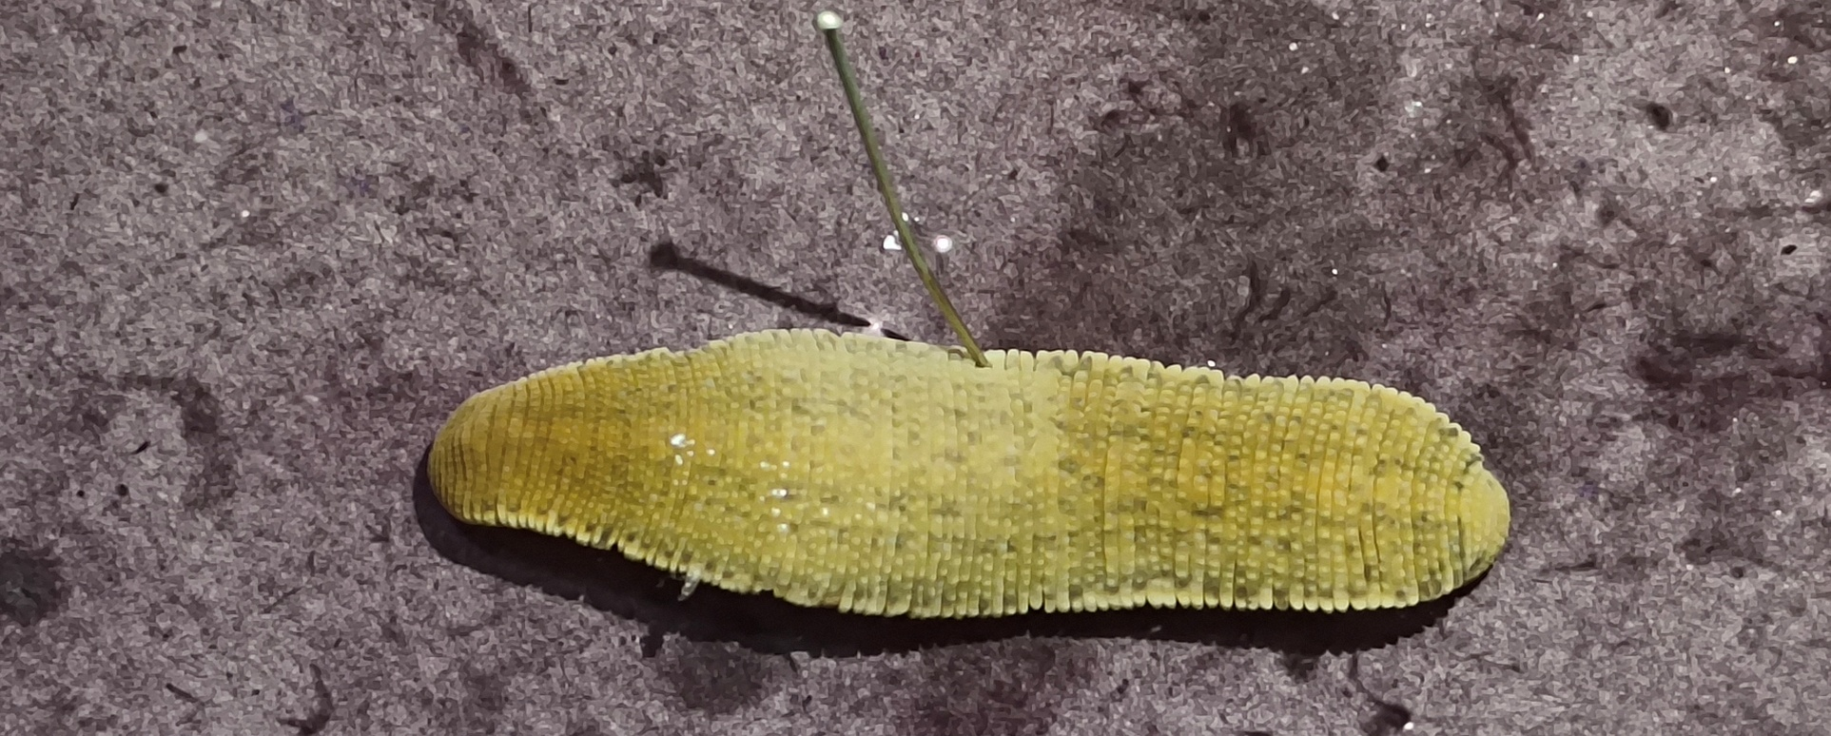
Poecilobdella lakshmikantai (Dorsal view showing 7 pairs of black stripes)

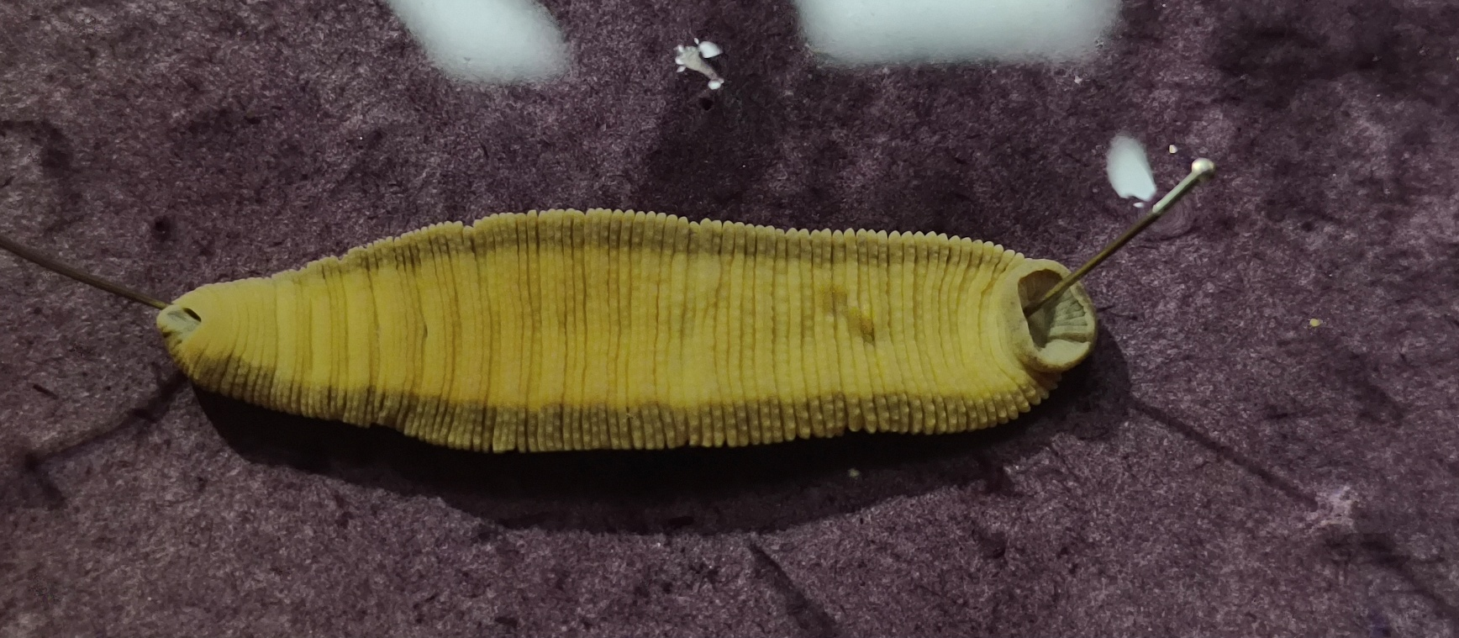
Poecilobdella lakshmikantai (Dorsal view showing 7 pairs of black strip

Plate 2.
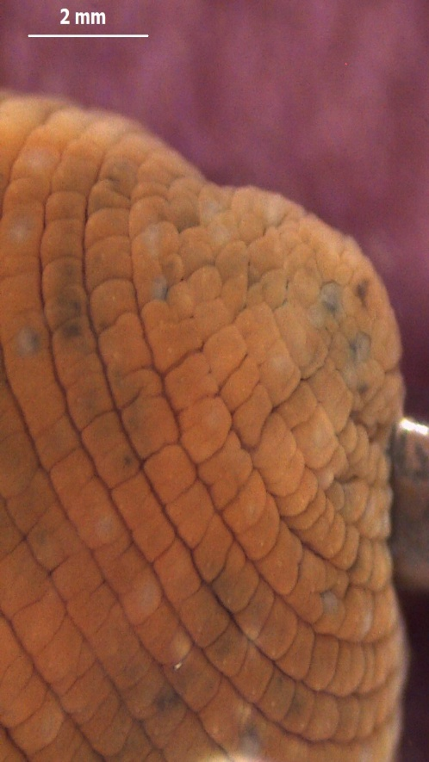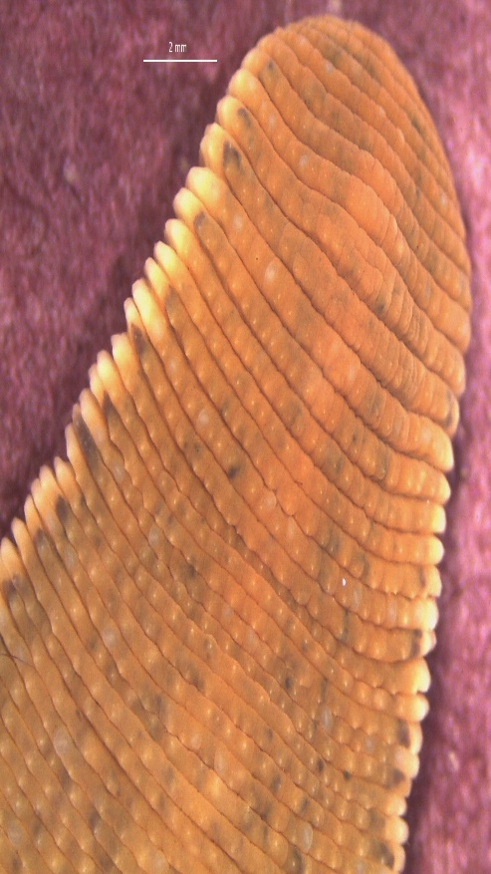
Poecilobdella lakshmikantai (Head) Anterior part of P. lakshmikantai

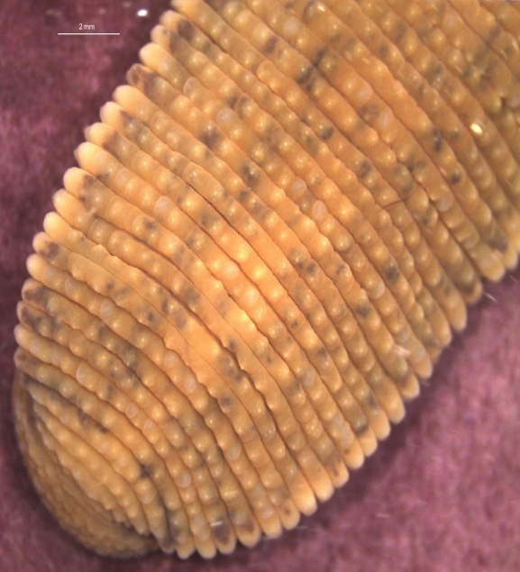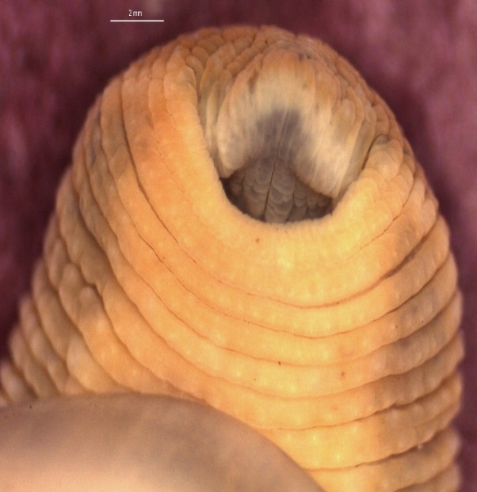
Posterior part of P. lakshmikantai Anterior sucker of P. lakshmikantai

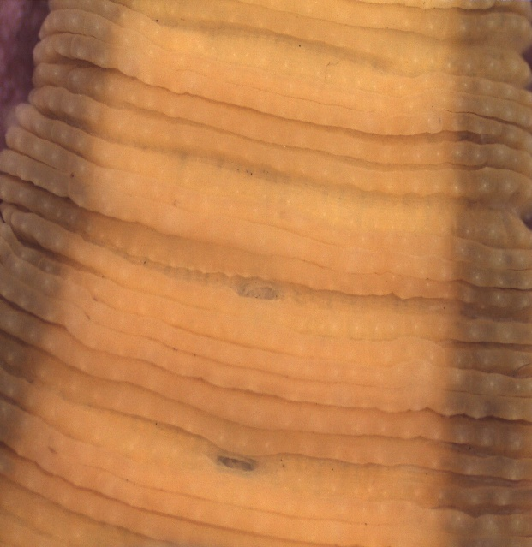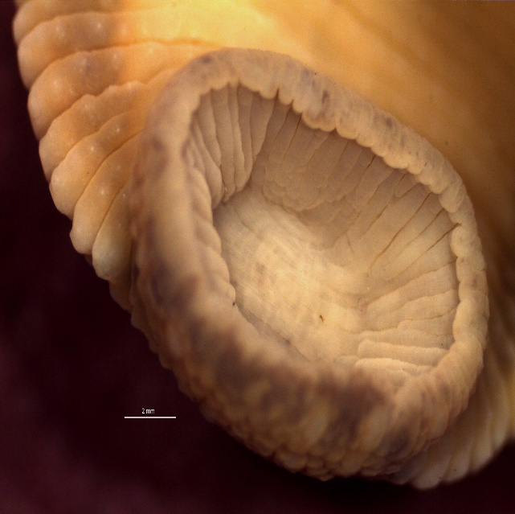
Genital pores of P. lakshmikantai Posterior sucker of P. lakshmikantai

Plate- 3.

Pharynx with salivary gland of P. lakshmikantai Posterior sucker of P. lakshmikantai

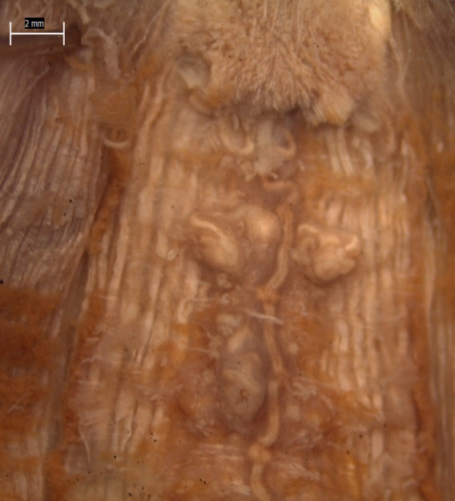

Genital parts (Prostate, Epididymis, Vaginal caecum) Last crop caeca of P.lakshmikantai

Historical Review:
Valuable studies on the taxonomy of leeches (Hirudinea) have been growing enormously worldwide. Several new species are still being described every year from several different regions of the world. According to authoritative studies on leech habitats, leeches are most abundant in temperate lakes and ponds of the Northern Hemisphere; however, none are known to inhabit terrestrial Antarctica (Phillips et al., 2020). Globally, over two decades ago, the number of known leech species exceeded 300 (Ghosh, 1998). Recent assessments have reported a significant increase, with more than 700 species currently recognized worldwide (Phillips et al., 2020). In the northeastern region of India alone, 69 species have been documented to date. As the literature on this subject is vast, only important and relevant works, in the opinion of the authors, are reviewed herein. The early important and classical accounts of leech are given by Linnaeus (1767), Müller (1774) and Savigny (1820). Baird (1869) described some new sucktorial annelids found in the British Museum. Whitman (1886) contributed considerable information on the leeches of Japan.

Annandale (1913) examined the leeches of Lake Tiberius. Harding and Moore (1924, 1927) made significant contributions to the taxonomy of Indian leeches, describing several new species of both aquatic and terrestrial forms. In their comprehensive account of the leech fauna of India, they documented the majority of known species from the region. Additionally, Moore (1927) published a significant book on “The fauna of British India Hirudinea”. Ramamurthi (1968) investigated the oxygen consumption of the common Indian cattle leech, Poecilobdella granulosa. Soos produced a major contribution in leech taxonomy in 1965.
Soota and Ghosh (1977), Chandra (1983), and Ghosh (1998) made significant contributions to the taxonomic classification of Indian leeches, providing valuable references for future researchers. Chandra (1991) authored a comprehensive handbook on Indian leeches, describing 60 species belonging to 25 genera, including 9 terrestrials, 13 marines, and 7 brackish-water species. Additionally,
Ghosh (1998) provided a detailed taxonomic account of the leech fauna of West Bengal, documenting 20 species of which five are terrestrial and one inhabits brackish water. Mandal (2000) observed the breeding season of Placobdella emydae. Mandal (2022, 2021,2024) worked on both aquatic and terrestrial leeches of India and added 26 endemic leeches in India which are new to science. Siddall and Burreson (2011) investigated the evolutionary origins of blood-feeding behavior in leeches. Bandyopadhyay and Mandal (2004) have done good taxonomic work on glossiphonid leeches of West Bengal, India.
Conclusion:
Leeches, among the most specialized members of the phylum Annelida, exhibit remarkable ecological adaptability and predatory efficiency. Although many annelids such as polychaetes are fully aquatic with diverse feeding modes, and oligochaetes demonstrate colonization across marine, freshwater, terrestrial, and even glacial habitats leeches stand apart for their evolutionary advantages. Unlike detritivorous oligochaetes, certain leeches display specialized predatory behaviors, often preying on entire oligochaetes, as observed in cases like the Giant Red Leech. Their highly muscular bodies and resilient integuments make them more damage-resistant, positioning them competitively above many annelid relatives in predatory interactions. The newly described species shows distinct morphological features, including a total of 110 annuli, five pairs of eyes, and a reddish-brown coloration that fades upon preservation. A key taxonomic character distinguishing this species from other members of Poecilobdella is the spacing and placement of the gonopores, which are separated by six annuli a trait not previously documented in the genus. The male gonopore is located between segments 31–32, and is oval in shape, while the female gonopore lies at segment 38. The clitellar region, although faint, spans eight segments from 31 to 38. These defining anatomical and reproductive traits strongly support the designation of this leech as a novel species within the genus Poecilobdella.
REFERENCES
Annandale, N. 1913. The leeches of the lake of Tiberias. J. Proc. Asiat. Soc. Bengal (n.s.) 9(6): 211–214.
Baird, W. 1869. Description of some new suctorial Annelids in the collections of the British Museum. Proc. Zool. Soc. London, pp. 310–318.
Bandyopadhyay, P.K. and Mandal, C.K. 2004. On the occurrence of five leeches, Barbronia weberi, Glossiphonia annandalei, Glossiphonia heteroclita, Batracobdella reticulata and Placobdella undulata in West Bengal. Rec. Zool. Surv. India. 105 (Part 3-4): 93–101.
Baugh, S.C.1960 (Indian bengala). Hemiclepsis bhatiai Baugh, 1960 Kalipahar, Dist. Monghyr, Bihar. Studies on Indian Rhynchobdellid leeches 11.Zool. Anz., Leipzig. 165 (11&12), pp. 468-477.
Chandra, M. 1983. A check-list of leeches of India. Rec. Zool. Surv. India 80: 265–290.
Chandra, M. 1991. The leeches of India- A Handbook. Director Zoological Survey of India (ed.), Publ. Zool. Surv. India, Calcutta, ii +130 p.
Ghosh, G.C. 1998. State Fauna Series 3: Fauna of West Bengal (Part 10): 227–249.
Mandal, C.K. 2000. On the occurrence and breeding season of leech Placobdella emydae in West Bengal. Sci. Cult. 66(7-8): 267–278.
Mandal, C. K, Mridha, S., Yasir, M., Kalam, A., Jameel, M., Anwar, M., Ghosh, S. 2021. Poecilobdella aligarhensis A new leech (Clitellata: Hirudinida) from Aligarh, India.J. Appl Zool. Res. 32 (2).145-149.
Mandal C.K., Reynolds J.W., Hassan M. N. and Deuti K., 2022. One New Leech Haemadipsa zeylanica dhritiiae (Annelida: Hirudinida, Haemadipsidae). Megadrilogica. Vol.27, Number-4, 34-39. (Printed in Canada).
Mandal, C. K, Ghosh, S., Bhattacharjee, R. & Banerjee, D. 2024. An aquatic new leech Poecilobdella sukhendui. J. Appl. Zool. Res 35(2): 184-189

Harding, W.A. 1924. Descriptions of some new leeches from India, Burma and Ceylon. Ann. Mag. Nat. Hist. London 14(9): 489–499.
Harding, W.A. and Moore, J.P. 1927. Fauna British India. Hirudinea. London: Taylor & Francis, xxxviii + 302 p.
Linnaeus, C. 1767. Systema naturae sive regna tria naturae, secundum classes, ordines, genera, species, cum characteribus, differentiis, synonymis, locis. Laurentii Salvii, Holmiae. 12th ed. 1(2): 533–1327.
Moore, J.P. 1898. Leeches of the U.S. National Museum. Proc. U. S. Natl. Mus. 21(1160): 543–563.
Müller, O.F. 1774. Vermium terrestrium et fluviatilium seu Animalium Infusoriorum, Helminthicorum et Testaceorum non marinorum succincta Historia. Copenhague et Leipsik, I (II): 72 p.
Anna J. Philiips, Fredric R. Govedich., Williame. Moser, 2020. Leeches in the extreme: Morphological, physiological and behavioral adaptions to inhospitable habitats. International Journal for Parasitology: Parasites and Wildlife. Vol. 12. 318-325.
Ramamurthi, R. 1968. Oxygen consumption of the common Indian cattle leech Poecilobdella granulosa in relation to osmotic stress. Comp. Biochem. Physiol. 24: 283–287.
Savigny, J.C. (1820) 1822. Système des Annélides, princialment de celles des cotes de l’Ègypte et de la Syrie, offrant les caractères tant distinctift que naturels des orders, familles et genres, avec la description des espèces. Paris: Description de l’Ègypte 1(3): 1–128.
Siddall, M. E. and Burreson, E. M. 2011. Phylogeny of the Euhirudinea: independent evolution of blood feeding by leeches. Canadian Journal of Zoology 73(6):1048-1064.
Soos, A.1965. Indentification key to the leech (Hirudinoidea) genera of the World, with a Catalogue of the species. 111-1V. Acta. Zool. Acad. Hung. 11(3-4): 415-464.
Soota, T.D. and Ghosh, G.C. 1977. On some Indian Leeches. Newsl. Zool. Surv. India 3(6): 359–360.
Whitman, C.O. 1886. The leeches of Japan. Quart. J. Micro. Sci. 26: 317–416.

