EFFECT OF TIGER NUT EXTRACTS ON THE INTESTINE HISTOLOGY OF ADULT ALBINO RATS

ABSTRACT
This study investigated the effect of tiger nut (Cyperus esculentus) extracts on the intestinal histology of adult albino rats. A total of twenty (20) albino rats weighing between 100 g and 130 g were used for the experiment. The animals were acclimatized for two weeks under standard laboratory conditions and randomly divided into four groups (A–D). Group A served as the control and received normal feed and water, while Groups B, C, and D were administered low (0.5 ml), medium (1.5 ml), and high (3 ml) doses of tiger nut extract respectively for a period of two weeks via oral gavage. At the end of the experimental period, the rats were sacrificed under chloroform anaesthesia, and intestinal tissues were harvested, fixed in 10% formol saline, and processed for histological examination using standard Haematoxylin and Eosin staining techniques. Microscopic evaluation revealed that Groups A, B, and C maintained normal intestinal architecture, characterized by intact mucosal layers, well-defined villi, and preserved muscularis externa. However, Group D exhibited mild histopathological alterations, including thinning of the muscularis layer and mild inflammatory cell infiltration. These findings suggest a dose-dependent effect of tiger nut extract on intestinal histology. While low and medium doses appear safe and do not compromise intestinal integrity, high-dose administration may induce mild inflammatory changes and structural alterations. Tiger nut extract is relatively safe at moderate doses but may pose potential risks to intestinal tissue at higher concentrations. Therefore, its consumption should be regulated, and further studies are recommended to explore its long-term effects and underlying mechanisms.

Background of the Study
Tiger nut (Cyperus esculentus) is a perennial plant of the Cyperaceae family widely cultivated in tropical and subtropical regions. Despite its common name, the tiger nut is actually a small edible tuber that has gained significant scientific interest due to its rich phytochemical profile and diverse health benefits. It is widely consumed across Africa, Europe, and parts of the Middle East raw, dried, or processed into beverages like tiger nut milk (horchata) (Edo et al., 2024). The tuber contains high levels of dietary fiber, essential fatty acids, vitamins C and E, and bioactive compounds such as flavonoids, alkaloids, and phenolic acids, which collectively impart antioxidant, anti-inflammatory, and antimicrobial properties (Rebezov et al., 2023). Recent pharmacological evaluations indicate that tiger nut extracts exhibit hypoglycemic, hepatoprotective, cardioprotective, and gastrointestinal benefits. Its high concentration of resistant starch acts as a prebiotic, promoting beneficial gut microbiota growth and enhancing mucosal health (Edo et al., 2023).
The intestine is a vital component of the digestive system, responsible for digestion, nutrient absorption, and maintaining immune defense. Structurally, it is composed of four distinct layers namely the mucosa, submucosa, muscularis externa, and serosa where the mucosal layer features specialized epithelial cells, goblet cells, and villi crucial for expanding the surface area for absorption (Kaye, 2024). Because the structural integrity of these microscopic features is essential for optimal digestion and metabolic health, any structural alteration may lead to impaired function and increased susceptibility to diseases (Su et al., 2024).
Despite the widespread consumption and perceived safety of plant-based foods, there is currently a critical shortage of definitive scientific data regarding the direct impact of Cyperus esculentus on intestinal microarchitecture, particularly when ingested as a concentrated extract. While dietary antioxidants generally protect the gut from inflammation, excessive or highly concentrated botanical extracts can sometimes cause unforeseen tissue alterations, such as villous atrophy, mucosal erosion, or inflammatory infiltration (Fernandes et al., 2024). Most existing literature on the tiger nut focuses primarily on its macronutrient distribution, metabolic benefits, and antimicrobial properties, leaving its specific histopathological effects on the gastrointestinal tract largely unexamined. This knowledge gap raises questions about its safety parameters during prolonged or high-dose intake, making it difficult to establish whether concentrated extracts support intestinal health or risk compromising tissue integrity.

Methodology
Animal Model and Handling
Twenty (20) Adult albino rats of comparable sizes and weights ranging from 100g to 130g (age of rats is five (5) weeks) were procured from the animal farm, Histopathology Laboratory Department of Ambrose Alli University, Ekpoma, Edo State and transferred to the experimental Histopathology Laboratory Department, Ekpoma, where they were allowed two (2) weeks of acclimatization. They was kept in wire mesh cages with tripod that separates the animal from its faeces to prevent contamination.
Grouping of Animal Model
The experimental animals were separated into five groups (A – D). Each group contains ten rats each (n = 5) using 4 big cages to house them. Group A served as the control, while groups B - E served as the test groups.
Substance of Study
The tigernut concentrations was administered using commercially produced distilled water. The drugs were administered orally using oral guavage for two weeks. Each of the animals in group B to D were picked at a time with a hand towel and appropriate volumes of the drugs were administered to the animals orally.
Substance Administration
The administration of tigernut was given orally as follows:
Group A (administered with normal food and water)
Group B (administered with Low dose (0.5ml) of tiger nut extract)
Group C (administered with medium dose (1.5ml) of tiger nut extract)
Group D (administered with high dose (3ml) of tiger nut extract)
Sample Collection and Analysis
The weights of the animals were measured before and after acclimatization and similar weight measurements were done at the end of each phase and the average weight recorded accordingly. The intestine of each rat was obtained at the end of the stage under chloroform anaesthesia and fixed in 10% formol saline for histological processing.

Histological Processing
The tissues were processed using automatic tissue processor according to the processing schedule used in histopathology laboratory of Ambrose Alli University, Ekpoma, Edo State, Nigeria. The fixed plastic cassette tissues in 10% formalin were automatically processed by passing them through different grades of alcohol as follows:
70% alcohol 2hrs
80% alcohol 2hrs
90% alcohol 2hrs
90% alcohol 2hrs
95% alcohol 2hrs
Absolute 2hrs
Xylene 1 2hrs
Xylene II 2hrs
Molten paraffin wax 1 2hrs
Molten paraffin Wax II 2hrs
After the last timing, the tissues were removed from their plastic cassettes and placed at the centre of the metallic tissue mould and then filled with molten paraffin wax. They were also left to solidify after which they were now placed in the refrigerator at 5ºC for 15 minutes. After the blocks were cool in the refrigerator for the time stated above (15 minutes), the blocks were then removed from the metallic case using a knife and after which the paraffin wax at the side of the blocks were removed.
The blocks were then trimmed at 10 microns and cut serially at 5 microns on a rotary microtome. The sections were floated in water bath at 55ºC and picked up by the use of a clean frosted end slides. The frosted end slides were now placed on the hot plate for 40 minutes for adequate attachment of the sections on the slides after which the sections were de-waxed, hydrated, air dried and stored in a slide box ready for staining process.

Staining Procedure
Sections for general tissue structure were stained by Haematoxylin and Eosin technique.
1. The sections were dewaxed in 3 changes of xylene 5 minutes
2. The sections were hydrated through descending grades of alcohol (absolute, 95%, 80% and 70%).
3. The sections were stained with Cole's haematoxylin 5 minutes
4. The sections were rinsed in running tap-water to remove excess stain
5. The sections were differentiated in 1% acid alcohol 15 seconds
6. The sections were blued in running tap water 10 minutes
7. The sections were counterstained with 1% eosin 2 minutes
8. Sections were finally rinsed in water, dehydrated in ascending grades of alcohol (70%, 80, 95% and absolute)
9. The sections were cleared in xylene, air-dried and mounted with dibuthylphthalate propylene xylene (DPX).
The slides were examined under a light microscope and photomicrographs were taken.

Result & Discussion
Micrographs
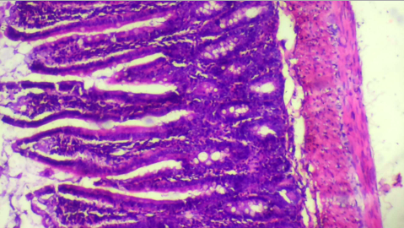
H/EX100
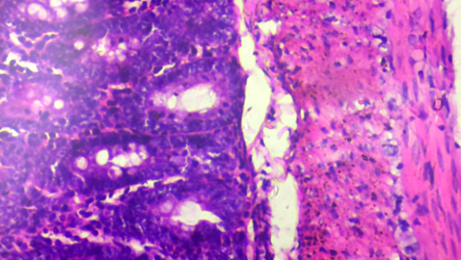
H/EX400
Picture 1. Group A (administered with normal food and water): Normal intestine architecture

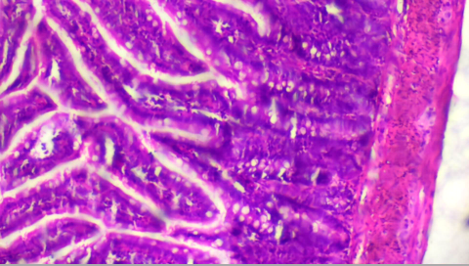
H/EX100
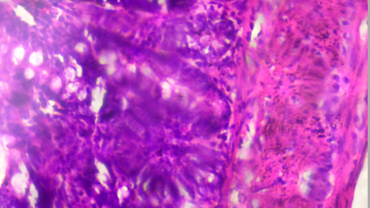
H/EX400
Picture 2. Group B (administered with Low dose (0.5ml) of tiger nut extract) showing normal intestine architecture

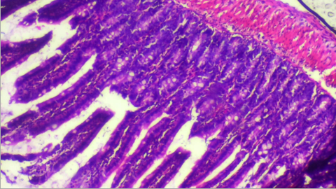
H/EX100
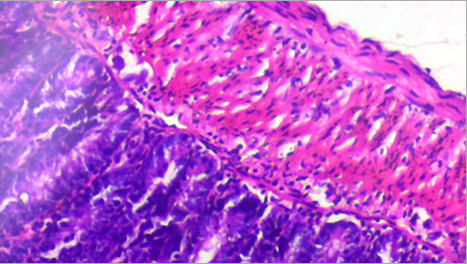
H/EX400
Picture 3. Group C (administered with medium dose (1.5ml) of tiger nut extract) showing normal intestine architecture

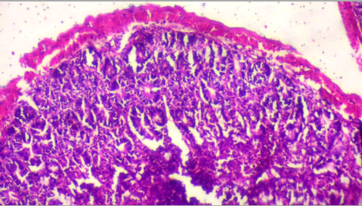
H/EX100
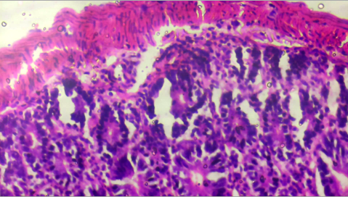
H/EX400
Picture 4. Group D (administered with high dose (3ml) of tiger nut extract) showing intestine architecture with thin muscularis region (blue) surrounded by mild inflammatory cell infiltrates (red)

Table 1. Summary micrograph results
Groups | Findings
Group a | Normal intestine architecture
Group b | normal intestine architecture
Group c | normal intestine architecture
Group d | intestine architecture with thin muscularis region surrounded by mild inflammatory cell infiltrates
key
Group A (administered with normal food and water)
Group B (administered with Low dose (0.5ml) of tiger nut extract)
Group C (administered with medium dose (1.5ml) of tiger nut extract)
Group D (administered with high dose (3ml) of tiger nut extract)

The present study evaluated the effect of tiger nut (Cyperus esculentus) extracts on the intestinal histology of adult albino rats across different dosage groups. The findings revealed that Groups A (control), B (low dose), and C (medium dose) maintained normal intestinal architecture, while Group D (high dose) exhibited a thin muscularis layer accompanied by mild inflammatory cell infiltrates. These observations suggest a dose-dependent effect of tiger nut extract on intestinal tissue integrity.
The normal histological appearance observed in Groups A, B, and C indicates that low to moderate doses of tiger nut extract are relatively safe and may not adversely affect intestinal morphology. This finding may be attributed to the rich presence of antioxidants, dietary fiber, and phytochemicals in tiger nut, which are known to exert protective effects on gastrointestinal tissues by reducing oxidative stress and maintaining mucosal integrity (Edo et al., 2024). Dietary fiber, in particular, enhances epithelial turnover and supports gut barrier function, thereby preserving normal histological architecture (Meldrum & Yakubov, 2025).
This observation is in similarity with studies by Selma-Royo et al. (2022) whose study demonstrated that consumption of a natural tiger nut drink positively altered intestinal microbiota composition by promoting beneficial gut bacteria within a short period of intake, suggesting improved gastrointestinal function and gut health. Similarly, Wang et al. (2023) investigations into tiger nut dietary fiber demonstrated that its functional components can enhance digestive processes and support gut homeostasis. The fiber fraction of tiger nut was associated with prebiotic activity, which may contribute to improved intestinal function and maintenance of gastrointestinal integrity.
However, the findings in Group D, which showed thinning of the muscularis layer and mild inflammatory infiltration, suggest that high doses of tiger nut extract may induce subtle histopathological alterations. The findings of this study are consistent with previous plant-based studies that reported histopathological alterations in intestinal tissues following high-dose exposure to plant extracts. For example, the study by Boudreau et al. (2017) demonstrated that prolonged administration of high doses of Aloe vera resulted in dose-dependent pathological changes in the intestine, including significant alterations in intestinal morphology and tissue architecture. The authors observed significant intestinal lesions associated with exposure to increasing concentrations of the plant constituent. The presence of inflammatory cells observed in this study further suggests an immune response, likely triggered by irritation or mild toxicity at higher concentrations of the extract.
These findings are in contrast with previous experimental studies reporting beneficial histological and functional changes in intestinal tissues following administration of certain plant extracts. For example, Jatsa et al. (2018) demonstrated that administration of Sida pilosa extract produced improvements in intestinal histomorphometry, including enhanced mucosal architecture and restoration of intestinal structural integrity, suggesting a protective effect on the gastrointestinal tract. Similarly, a study by Caban et al., (2018) on polyphenol-rich plant extracts reported improved intestinal morphology and reduced inflammatory responses, attributed to antioxidant and anti-inflammatory phytoconstituents that promote epithelial repair and gut homeostasis.
The observed mild inflammatory infiltrates in Group D may also be linked to oxidative stress imbalance. While tiger nut contains antioxidants, excessive intake may paradoxically lead to pro-oxidant effects, overwhelming the antioxidant defense system and resulting in cellular stress and inflammation (Rajaram et al., 2023). Additionally, high concentrations of certain phytochemicals, such as tannins and saponins, may exert irritative effects on the intestinal mucosa, leading to inflammatory cell recruitment (Hossen et al., 2022).
Overall, the findings of this study demonstrate that while tiger nut extract is relatively safe at low and moderate doses, excessive intake may result in mild histopathological changes, particularly affecting the muscular layer and inflammatory status of the intestine.

CONCLUSION
In conclusion, the administration of tiger nut extract to adult albino rats revealed a dose-dependent effect on intestinal histology. Low and medium doses (0.5 ml and 1.5 ml) did not produce any observable histological alterations, indicating that tiger nut extract is safe at these levels. However, high-dose administration (3 ml) resulted in mild inflammatory changes and thinning of the muscularis layer, suggesting potential adverse effects at elevated concentrations. Therefore, while tiger nut possesses beneficial nutritional and pharmacological properties, its consumption should be moderated to avoid possible intestinal alterations.
References
Boudreau, M. D., Olson, G. R., Tryndyak, V. P., Bryant, M. S., Felton, R. P., & Beland, F. A. (2017). From the cover: aloin, a component of the aloe vera plant leaf, induces pathological changes and modulates the composition of microbiota in the large intestines of f344/N male rats. Toxicological Sciences, 158(2), 302-318.
Caban, M., Owczarek, K., & Lewandowska, U. (2024). Effects of polyphenol-rich extracts on inflammatory bowel diseases. Food Reviews International, 40(9), 2448-2485.
Edo, G. I., Onoharigho, F. O., Jikah, A. N., Oloni, G. O., Samuel, P. O., Rapheal, O. A., ... & Akpoghelie, E. O. (2023). Cyperus esculentus (tiger nut): An insight into its bioactive compounds, biological activities, nutritional and health benefits. Food Chemistry Advances, 3, 100511.
Edo, G. I., Ugbune, U., Ezekiel, G. O., Onoharigho, F. O., & Agbo, J. J. (2024). Cyperus esculentus (tiger nut): its application in agriculture, food, health and nutrition. A review. Vegetos, 37(3), 757-766.
Fernandes, F. A., Oliveira, P. A., Pinto, M. L., Venancio, C., Felix, L., Medeiros-Fonseca, B., ... & Heleno, S. A. (2024). Effects of a Cyperus esculentus L. plant-based beverage on FVB/n female mice. Food and Chemical Toxicology, 194, 115082.
Hossen, I., Hua, W., Ting, L., Mehmood, A., Jingyi, S., Duoxia, X., ... & Junsong, X. (2022). Phytochemicals and inflammatory bowel disease: a review. Critical Reviews in Food Science and Nutrition, 60(8), 1321-1345.
Jatsa, H. B., Femoe, U. M., Njiaza, J., Tombe Tombe, D. S., Mbolang, L. N., Nkondo, E. T., ... & Kamtchouing, P. (2018). Efficacy of Sida pilosa Retz aqueous extract against Schistosoma mansoni–induced granulomatous inflammation in the liver and the intestine of mice: histomorphometry and gastrointestinal motility evaluation. BMC complementary and alternative medicine, 18(1), 247.
Kaye, P. V. (2024). Normal small intestine: anatomy, specimen dissection and histology relevant to pathological practice. Morson and Dawson's Gastrointestinal Pathology, 359-372.
Meldrum, O. W., & Yakubov, G. E. (2025). Journey of dietary fiber along the gastrointestinal tract: role of physical interactions, mucus, and biochemical transformations. Critical Reviews in Food Science and Nutrition, 65(22), 4264-4292.
Rajaram, S., Damasceno, N. R. T., Braga, R. A. M., Martinez, R., Kris-Etherton, P., & Sala-Vila, A. (2023). Effect of nuts on markers of inflammation and oxidative stress: a narrative review. Nutrients, 15(5), 1099.
Rebezov, M., Usman Khan, M., Bouyahya, A., Imran, M., Tufail, T., Loretts, O., ... & Shariati, M. A. (2023). Nutritional and technical aspect of tiger nut and its micro-constituents: An overview. Food Reviews International, 39(6), 3262-3282.
Selma-Royo, M., García-Mantrana, I., Collado, M. C., & Perez-Martínez, G. (2022). Intake of natural, unprocessed tiger nuts (Cyperus esculentus L.) drink significantly favors intestinal beneficial bacteria in a short period of time. Nutrients, 14(9), 1709.
Su, Q. L., Wu, J., Tan, S. W., Guo, X. Y., Zou, D. Z., & Kang, K. (2024). The impact of microplastics polystyrene on the microscopic structure of mouse intestine, tight junction genes and gut microbiota. PLoS One, 19(6), e0304686.
Wang, Y., Wang, W., Wu, Y., JiLiu, J., Hu, X., Wei, M., & Cao, L. (2023). Characterization of manganized soluble dietary fiber complexes from tigernut meal and study of the suppressive activity of digestive enzymes in vitro. Frontiers in Nutrition, 10, 1157015.

