Artificial Intelligence in Zoological Sciences: Applications, Advances, Challenges, and Future Perspectives in Ecology, Aquaculture, Toxicology, and Biodiversity Conservation

ABSTRACT
Artificial intelligence (AI) has emerged as a transformative technology in zoological sciences, providing innovative solutions for biodiversity conservation, ecological research, aquaculture management, fisheries, toxicology, and environmental monitoring. Advances in machine learning, deep learning, computer vision, bioacoustics, remote sensing, and Internet of Things (IoT) technologies have significantly enhanced the collection, processing, and interpretation of complex biological and environmental data. This review examines the diverse applications of AI in species identification, taxonomy, animal behaviour analysis, wildlife monitoring, population assessment, disease surveillance, and zoo management. It further highlights the growing role of AI in ecology and biodiversity conservation through habitat mapping, species distribution modelling, ecological forecasting, climate change assessment, and conservation planning. In aquaculture and fisheries, AI-driven technologies support precision feeding, water-quality monitoring, biomass estimation, disease diagnosis, stock assessment, and sustainable resource management. The review also explores emerging applications of AI in toxicology and ecotoxicology, including predictive toxicity modelling, environmental risk assessment, biomarker discovery, and alternative approaches to animal testing. Despite its considerable potential, AI faces challenges related to data quality, algorithmic bias, model interpretability, computational infrastructure, ethical concerns, cybersecurity, and regulatory governance. Future developments in explainable AI, multimodal systems, digital twins, environmental DNA analytics, and autonomous monitoring platforms are expected to further advance zoological research and sustainable environmental management.
Keywords: Artificial Intelligence; Machine Learning; Zoological Sciences; Biodiversity Conservation; Ecology; Aquaculture; Fisheries; Toxicology; Ecotoxicology; Deep Learning
1. INTRODUCTION
AI has emerged as one of the most transformative technologies in modern science, enabling the processing of large datasets, recognition of complex patterns, and generation of predictive insights. Advances in machine learning (ML), deep learning (DL), computer vision, natural language processing, and big-data analytics have created unprecedented opportunities across biological and environmental sciences. In zoological sciences, which have traditionally relied on field observations, ecological surveys, specimen identification, and experimental investigations, AI is increasingly being adopted to address challenges associated with biodiversity loss, environmental degradation, climate change, emerging diseases, and sustainable resource management (Zhang et al., 2023; Han et al., 2023; Kumar & Deepak, 2025).
The rapid growth of ecological datasets generated from camera traps, drones, satellite imagery, acoustic sensors, biologging devices, environmental DNA (eDNA), and citizen-science platforms has transformed zoological research. Conventional analytical approaches often struggle to manage such large and heterogeneous datasets, whereas AI techniques provide efficient solutions for automated species identification, behavioural analysis, habitat assessment, population estimation, and ecological forecasting (Christin et al., 2019; Weinstein, 2018; Wäldchen & Mäder, 2018; Tabak et al., 2018). These technologies have significantly improved the speed, accuracy, and scalability of biodiversity research.
AI has become particularly important in wildlife ecology and biodiversity conservation. Machine-learning models are increasingly applied to species distribution modelling, habitat suitability assessment, conservation prioritization, and climate-change impact prediction (Tuia, 2022; Evans et al., 2011; Fergus et al., 2024). Similarly, computer vision and deep learning systems can process large volumes of camera-trap images and acoustic recordings, enabling continuous monitoring of wildlife populations and ecosystems (Zhang et al., 2025; Vélez et al., 2023). The integration of AI with citizen-science initiatives has further expanded biodiversity monitoring through automated species recognition and large-scale ecological data collection (Kelling et al., 2013; Advancing Biodiversity Conservation Through AI-Powered Species Classification, 2025).
In ecology, AI-driven approaches have enhanced remote-sensing analysis, land-cover classification, habitat mapping, forest monitoring, and ecosystem modelling (Christin et al., 2019; Stupariu et al., 2022; Frazier & Song, 2024). Explainable Artificial Intelligence (XAI) has further improved model interpretability, increasing confidence in ecological predictions and conservation decision-making (Ryo et al., 2021; Han et al., 2023).
The aquaculture sector has also experienced significant technological advancement through AI-based systems. Applications such as precision feeding, water-quality monitoring, disease diagnosis, growth prediction, stock assessment, and intelligent farm management have improved productivity and sustainability (Mustapha et al., 2021; Wang et al., 2021; Vo et al., 2021; Yang et al., 2025). The integration of AI with the Internet of Things (IoT), cloud computing, and sensor networks has facilitated the development of smart aquaculture systems capable of real-time monitoring and automated decision-making (Chiu et al., 2022; Hu et al., 2023; Lu et al., 2022).
AI is also transforming toxicology and environmental risk assessment. Machine-learning models can predict chemical toxicity, identify biomarkers, assess environmental risks, and support alternative testing strategies, reducing the dependence on animal experimentation (Martinez et al., 2026; Anapana, G and Gudivada, 2020). By integrating biological, chemical, and environmental datasets, AI-driven toxicological frameworks improve predictive accuracy and support evidence-based regulatory decisions.
The convergence of artificial intelligence (AI) with genomics, bioinformatics, environmental DNA (eDNA), omics technologies, remote sensing, and environmental monitoring systems is driving a new era of integrative zoology (Abbas et al., 2025; Von der Heyden et al., 2025; Naser, 2025). These interdisciplinary approaches enhance understanding of species interactions, ecosystem functioning, evolutionary processes, and human impacts on biodiversity. Despite its immense potential, AI faces challenges related to data quality, algorithmic bias, model interpretability, computational demands, ethical concerns, and unequal technological access (Zhang et al., 2023; Kumar & Deepak, 2025; Fergus et al., 2024). Addressing these issues is essential for sustainable zoological research and environmental management.

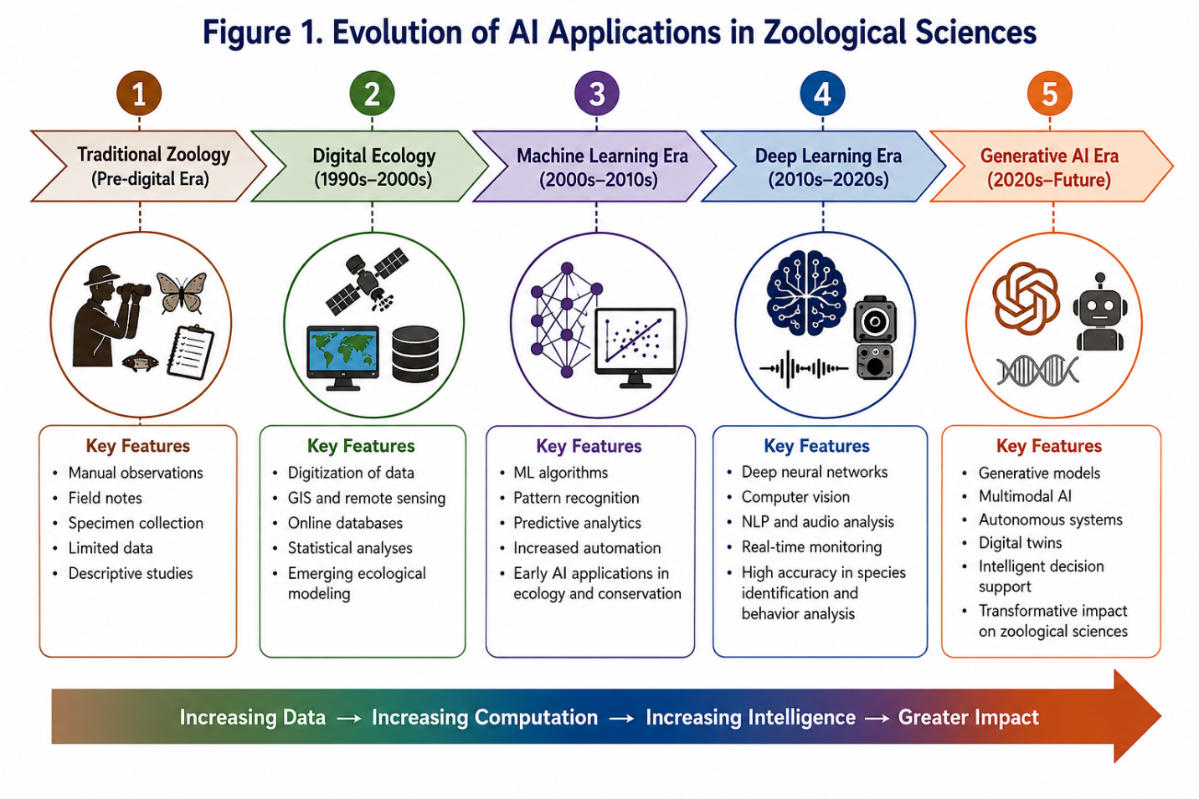
Figure 1. Evolution of Artificial Intelligence Applications in Zoological Sciences.
The chronological evolution of AI applications in zoological sciences illustrates the transition from traditional zoological investigations to machine learning, deep learning, explainable AI, and generative AI-driven research frameworks.
Therefore, this review aims to provide a comprehensive synthesis of current applications, technological advances, challenges, and future prospects of artificial intelligence in the zoological sciences. Particular emphasis is placed on its transformative roles in ecology, aquaculture, toxicology, and biodiversity conservation. By critically examining recent developments and emerging trends, this review highlights how AI is reshaping zoological research and contributing to the sustainable management of biological resources in an increasingly data-driven world.
2. LITERATURE SEARCH METHODOLOGY
This review synthesizes current knowledge on the applications, advances, challenges, and future prospects of artificial intelligence (AI) in zoological sciences, with particular emphasis on ecology, biodiversity conservation, aquaculture, fisheries, toxicology, and ecotoxicology. A systematic literature search was conducted using major scientific databases, including Web of Science, Scopus, Google Scholar, PubMed, ScienceDirect, SpringerLink, Wiley Online Library, and CrossRef.
The search employed combinations of keywords and Boolean operators such as “Artificial Intelligence”, “Machine Learning”, “Deep Learning”, “Computer Vision”, “Zoology”, “Wildlife Monitoring”, “Animal Behaviour”, “Ecology”, “Biodiversity Conservation”, “Species Identification”, “Aquaculture”, “Fisheries”, “Fish Disease Detection”, “Toxicology”, “Ecotoxicology”, “Environmental Monitoring”, “Environmental DNA (eDNA)”, “Remote Sensing”, “Bioacoustics”, and “Conservation Technology”. Additional topic-specific searches were conducted to identify emerging trends and interdisciplinary developments relevant to zoological sciences.
Publications published between 2010 and 2026 were primarily considered, with emphasis on recent studies reflecting current technological advances. Foundational publications published before 2010 were included where necessary to provide historical and conceptual context. Following the removal of duplicate records, titles, abstracts, and keywords were screened for relevance. Eligible publications were evaluated based on scientific quality, methodological rigor, and relevance to AI applications in biological and environmental sciences.
Research articles, review papers, conference proceedings, book chapters, and selected authoritative reports were included. Studies focusing on wildlife biology, ecology, biodiversity conservation, aquaculture, fisheries, toxicology, ecotoxicology, and environmental monitoring were prioritized, whereas publications unrelated to biological applications of AI or lacking sufficient methodological information were excluded.
The selected literature was organized into thematic categories, including AI fundamentals, applications in zoology, ecology and biodiversity conservation, aquaculture and fisheries, toxicology and ecotoxicology, challenges and ethical considerations, and future perspectives. This approach facilitated a structured synthesis of current developments while highlighting emerging opportunities for AI-driven innovation in zoological sciences.
3. FUNDAMENTALS OF ARTIFICIAL INTELLIGENCE IN ZOOLOGICAL SCIENCES
Artificial intelligence (AI) refers to computational systems capable of performing tasks traditionally associated with human intelligence, including learning, reasoning, pattern recognition, decision-making, and prediction. Since its emergence, AI has evolved from rule-based expert systems to advanced machine learning and deep learning frameworks capable of analysing large and complex datasets. Early ecological applications relied on expert systems for natural resource management (Rykiel, 1989), whereas advances in computational power, cloud computing, and big-data analytics have transformed AI into a powerful tool across biological sciences.
In zoological sciences, AI facilitates the analysis of diverse datasets generated from field surveys, camera traps, acoustic sensors, remote sensing platforms, satellite imagery, environmental DNA (eDNA), genomics, and sensor-based monitoring systems. The increasing volume and complexity of biological data have created a need for automated analytical approaches capable of extracting ecological information at unprecedented spatial and temporal scales (Zhang et al., 2025; Han et al., 2023).
Machine learning (ML), a major branch of AI, enables computers to learn patterns directly from data without explicit programming. Supervised learning methods such as Random Forests, Support Vector Machines (SVMs), Artificial Neural Networks (ANNs), and Gradient Boosting Models are widely used for species distribution modelling, habitat suitability assessment, biodiversity monitoring, population estimation, and disease prediction (Evans et al., 2011; Tuia, 2022; Pichler & Hartig, 2023). Unsupervised learning assists in identifying ecological patterns and behavioural classifications, whereas reinforcement learning shows potential for adaptive ecosystem management and autonomous monitoring systems. These approaches have substantially improved ecological forecasting, climate-change modelling, and conservation planning (Han et al., 2023; Kumar & Deepak, 2025).
Deep learning (DL), an advanced subset of ML, utilizes multilayer neural networks to automatically extract hierarchical features from large datasets. Convolutional Neural Networks (CNNs) have demonstrated remarkable success in image-based species identification, wildlife detection, camera-trap classification, habitat monitoring, and behavioural analysis (Christin et al., 2019; Weinstein, 2018; Wäldchen & Mäder, 2018). CNN-based systems can achieve expert-level accuracy while dramatically reducing manual processing requirements (Tabak et al., 2018). Deep learning has also transformed acoustic ecology through automated classification of animal vocalizations from birds, amphibians, insects, and marine mammals (Zhang et al., 2025; Shariq, 2026). Furthermore, DL models support behavioural ecology, remote sensing analysis, habitat mapping, and ecosystem assessment (Jeantet et al., 2026; Liu et al., 2026; Audira et al., 2026; Frazier & Song, 2024; Buchelt et al., 2024).
Computer Vision (CV), a specialized AI domain, enables automated interpretation of images and videos. Integrated with camera-trap systems, CV significantly improves wildlife monitoring by automating species recognition and population assessments (Tabak et al., 2018; Vélez et al., 2023). It also facilitates behavioural studies by analysing locomotion, feeding, social interactions, and reproductive activities (Weinstein, 2018; Jeantet et al., 2026). In aquatic systems, CV supports fish counting, biomass estimation, growth monitoring, and disease detection (Vo et al., 2021; Mandal & Ghosh, 2024). Recent integration with drones, underwater imaging systems, and satellite platforms has expanded applications in marine ecosystem monitoring, habitat assessment, and forest conservation (Goodwin et al., 2022; Buchelt et al., 2024).
The Internet of Things (IoT) and Artificial Intelligence of Things (AIoT) further enhance biological monitoring through interconnected sensor networks that collect real-time environmental and biological data. AI algorithms analyse these data streams to detect anomalies, predict trends, and support management decisions (Mustapha et al., 2021; Hu et al., 2023). Applications include automated feeding, water-quality prediction, disease surveillance, mortality detection, and farm optimization in aquaculture (Chiu et al., 2022; Lu et al., 2022; Ranjan et al., 2023), as well as biodiversity monitoring and habitat management in wildlife conservation.
A major challenge in AI implementation is the “black-box” nature of many advanced algorithms. Explainable Artificial Intelligence (XAI) addresses this limitation by providing interpretable explanations for model predictions. Techniques such as SHAP, LIME, and feature-importance analyses improve transparency and help identify variables driving ecological and environmental predictions (Ryo et al., 2021). Consequently, XAI enhances confidence in species distribution modelling, habitat suitability assessment, biodiversity forecasting, and environmental risk analysis (Han et al., 2023; Pichler & Hartig, 2023).
Recent developments in Generative AI and multimodal learning systems are creating new opportunities for zoological research. Large Language Models (LLMs) and multimodal AI can integrate text, images, acoustic recordings, environmental measurements, and genomic data to support literature synthesis, knowledge extraction, hypothesis generation, and conservation planning (Miao et al., 2025). The integration of AI with genomics, eDNA technologies, remote sensing, digital twins, and bioinformatics is expected to further advance biodiversity research and ecosystem management (Abbas et al., 2025; Von der Heyden et al., 2025).
Overall, the convergence of machine learning, deep learning, computer vision, AIoT, explainable AI, and generative AI has established a robust technological foundation for modern zoological sciences. These technologies are transforming the collection, analysis, interpretation, and application of biological data, creating unprecedented opportunities for research, conservation, aquaculture management, and environmental sustainability.
Table 1. Major artificial intelligence techniques used in Zoological Sciences
AI Technique | Principle | Major Applications | Advantages | Representative References
Machine Learning (ML) | Learns patterns from structured datasets to make predictions and classifications | Species distribution modelling, biodiversity assessment, disease prediction, ecological forecasting, water quality prediction | Handles large datasets, identifies complex relationships, improves prediction accuracy | Tuia (2022); Han et al. (2023); Pichler & Hartig (2023)
Deep Learning (DL) | Multilayer neural networks automatically learn hierarchical features from data | Species identification, camera-trap image classification, fish disease diagnosis, behaviour analysis | High accuracy, automated feature extraction, scalable for large datasets | Christin et al. (2019); Weinstein (2018); Yang et al. (2025)
Convolutional Neural Networks (CNNs) | Specialized neural networks for image recognition and visual data processing | Wildlife monitoring, taxonomy, fish biomass estimation, habitat mapping | Excellent image classification performance, real-time monitoring | Wäldchen & Mäder (2018); Tabak et al. (2018)
Recurrent Neural Networks (RNNs) | Processes sequential and temporal data | Ecological forecasting, animal movement analysis, environmental monitoring | Captures temporal dependencies and dynamic ecological patterns | Han et al. (2023); Frazier & Song (2024)
Computer Vision (CV) | Extracts information from images and videos | Animal behaviour analysis, fish counting, camera-trap monitoring, wildlife tracking | Automated image processing, reduced manual effort | Weinstein (2018); Vo et al. (2021)
Natural Language Processing (NLP) | Analyses and interprets textual information | Literature mining, biodiversity databases, scientific knowledge extraction | Rapid information retrieval and synthesis | Miao et al. (2025); Naser (2025)
Explainable AI (XAI) | Improves transparency and interpretability of AI models | Species distribution modelling, conservation planning, risk assessment | Enhances trust, transparency, and decision-making | Ryo et al. (2021); Han et al. (2023)
Artificial Intelligence of Things (AIoT) | Combines AI with IoT sensors and real-time data streams | Smart aquaculture, environmental monitoring, water quality management | Real-time monitoring and automated decision-making | Hu et al. (2023); Lu et al. (2022)
Generative AI | Generates text, images, simulations, and synthetic datasets | Scientific writing, biodiversity knowledge synthesis, hypothesis generation | Accelerates research and interdisciplinary integration | Miao et al. (2025); Kumar & Deepak (2025)
Multimodal AI | Integrates images, audio, text, genomic, and environmental data | Biodiversity monitoring, ecosystem assessment, conservation planning | Comprehensive ecosystem-level analysis | Abbas et al. (2025); Miao et al. (2025)
Reinforcement Learning | Learns through reward-based interactions with environments | Resource management, adaptive conservation, smart aquaculture systems | Dynamic optimization and adaptive decision-making | Yang et al. (2025); Yue & Shen (2022)
Digital Twin Technology | Creates virtual representations of biological or ecological systems | Ecosystem simulation, aquaculture management, climate adaptation studies | Scenario testing and predictive ecosystem management | Wilson (2024); Miao et al. (2025)

4. APPLICATIONS OF ARTIFICIAL INTELLIGENCE IN ZOOLOGY
Artificial intelligence (AI) has emerged as a transformative technology in zoological sciences, enabling researchers to address complex biological questions through machine learning, deep learning, computer vision, bioacoustics, sensor technologies, and big-data analytics. AI applications now support species identification, behavioural analysis, wildlife monitoring, population assessment, disease surveillance, conservation planning, and zoo management. By automating data collection, processing, and interpretation, AI significantly improves the efficiency, accuracy, and scalability of zoological investigations (Zhang et al., 2023; Balwan & Saba, 2024; Kumar & Deepak, 2025). Furthermore, the integration of AI with genomics, environmental DNA (eDNA), remote sensing, bioacoustics, and behavioural analytics is strengthening biodiversity assessment, conservation planning, disease surveillance, and ecosystem management through evidence-based decision-making (Abbas et al., 2025; Kumar & Deepak, 2025; Balwan & Saba, 2024; Naser, 2025; Zhang et al., 2023).
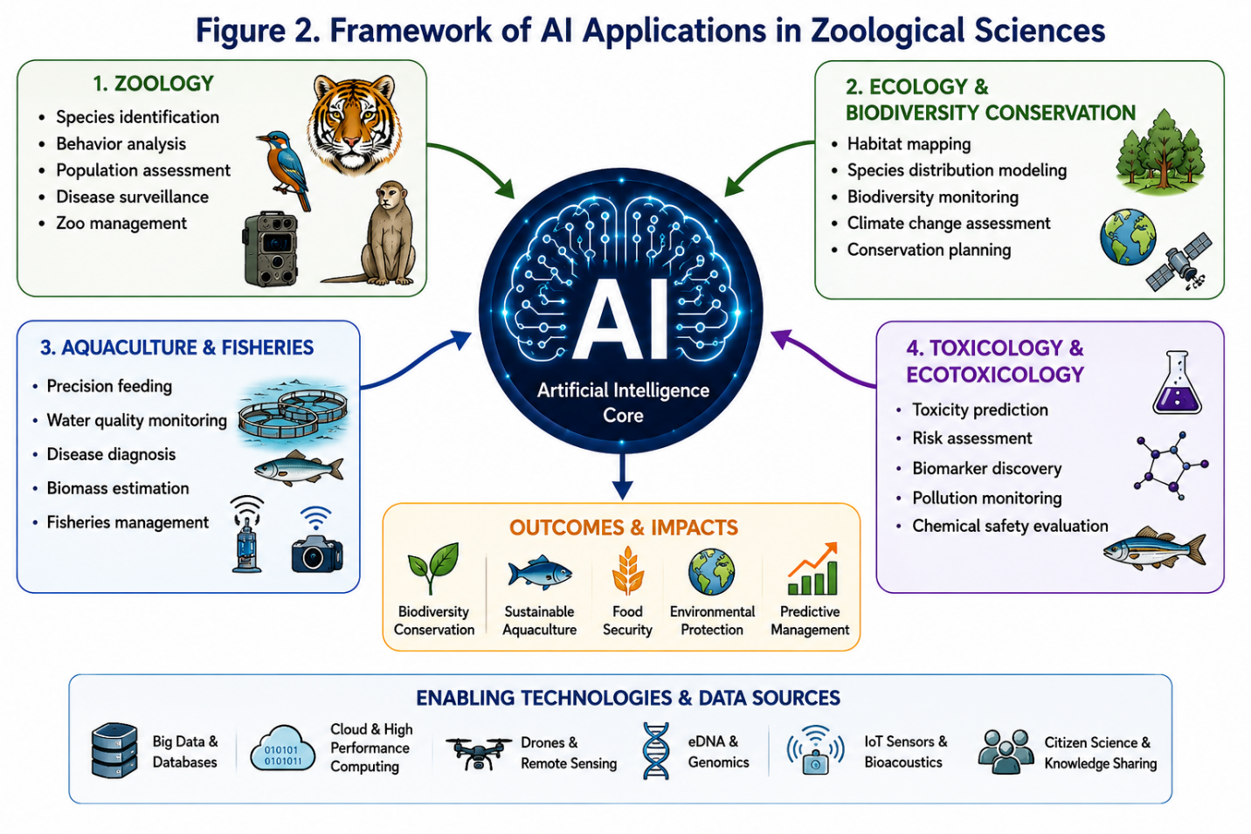
Figure 2. Framework of artificial intelligence applications in zoological sciences.
Overview of major AI application domains in zoological sciences, including zoology, ecology, biodiversity conservation, aquaculture, fisheries, and toxicology, leading to improved environmental management and sustainable resource utilization.
4.1 Species Identification and Taxonomic Research
Species identification is fundamental to biodiversity assessment and conservation management. Traditional taxonomic methods often require extensive expertise and detailed morphological examination. AI-powered image-recognition systems, particularly Convolutional Neural Networks (CNNs), have revolutionized taxonomy by enabling rapid and accurate identification of species from photographs and digital images (Wäldchen & Mäder, 2018; Weinstein, 2018). The integration of AI with citizen-science platforms such as eBird and iNaturalist has further accelerated biodiversity documentation and expanded global biodiversity databases (Kelling et al., 2013). These systems are especially valuable in regions with limited taxonomic expertise (Advancing Biodiversity Conservation Through AI-Powered Species Classification, 2025). Additionally, AI combined with genomics, eDNA, and omics technologies is improving species delimitation, phylogenetic analyses, and evolutionary research (Von der Heyden et al., 2025; Abbas et al., 2025). Morphological datasets also contribute to AI-assisted classification, as demonstrated by Anapana et al. (2025), who reported substantial variation in avian claw morphology among bird species in the Srikakulam region.
4.2 Animal Behaviour Analysis and Ethology
AI has transformed behavioural research by enabling continuous and objective monitoring of animal activities. Computer vision systems can track individuals, quantify movement patterns, and classify behavioural states from video recordings. Deep-learning algorithms have been applied successfully to analyse feeding behaviour, locomotion, social interactions, courtship displays, territoriality, and predator–prey dynamics across diverse taxa (Liu et al., 2026; Audira et al., 2026). Machine-learning approaches integrated with biologging devices and accelerometers have further improved classification of migration, foraging, resting, and reproductive activities. Jeantet et al. (2026) demonstrated the effectiveness of accelerometer-based machine-learning models for identifying behavioural states in wildlife populations. Likewise, passive acoustic monitoring combined with deep learning has enhanced studies of animal communication and social networks by automatically analysing vocalization datasets (Zhang et al., 2025; Shariq, 2026).
4.3 Wildlife Monitoring and Biodiversity Assessment
Wildlife monitoring is one of the most successful AI applications in zoology. Camera traps generate millions of images annually, creating major challenges for manual analysis. Deep-learning algorithms can rapidly identify species, remove empty images, classify behaviours, and estimate abundance with remarkable accuracy (Tabak et al., 2018; Vélez et al., 2023). AI-assisted acoustic monitoring similarly facilitates detection of species-specific vocalizations, allowing researchers to monitor elusive, nocturnal, cryptic, and endangered species across diverse habitats (Fergus et al., 2024; Tuia, 2022). The integration of camera traps, drones, acoustic sensors, and satellite technologies enables real-time biodiversity assessments and supports conservation planning and ecosystem management (Weinstein, 2018; Tabak et al., 2018; Fergus et al., 2024; Tuia, 2022; Vélez et al., 2023). Remote sensing and drone technologies have also improved habitat mapping, nest monitoring, animal detection, and ecosystem assessments at large spatial scales (Buchelt et al., 2024).
4.4 Population Estimation and Species Distribution Modelling
AI has substantially improved population estimation and species distribution modelling (SDM) by integrating information from camera traps, acoustic monitoring systems, remote sensing platforms, and environmental databases. Machine-learning algorithms can estimate abundance, occupancy, population trends, and demographic characteristics more efficiently than conventional approaches (Tabak et al., 2018; Zhang et al., 2025). Algorithms such as Random Forests, Support Vector Machines, and Artificial Neural Networks are widely used to predict habitat suitability, biodiversity hotspots, climate-driven range shifts, and future species distributions (Evans et al., 2011; Kumar & Deepak, 2025). Explainable Artificial Intelligence (XAI) further improves ecological interpretation by identifying environmental variables that strongly influence model predictions (Ryo et al., 2021).
4.5 Animal Health Monitoring, Disease Diagnosis, and Zoo Management
AI technologies are increasingly applied to animal health assessment, disease diagnosis, epidemiological surveillance, and welfare monitoring. Machine-learning models can analyse physiological, behavioural, clinical, and environmental data to detect diseases before visible symptoms appear. Shar et al. (2026) demonstrated that AI-based diagnostic systems enhance the detection of infectious diseases, parasitic infections, metabolic disorders, and nutritional deficiencies. Computer vision and bioacoustic systems can identify behavioural abnormalities and changes in vocalization patterns associated with disease and environmental stress (Zhang et al., 2025; Shariq, 2026). AI also contributes to vector-borne disease surveillance, with Geffroy et al. (2026) highlighting the usefulness of machine learning for predicting mosquito abundance and disease transmission risks. In zoological parks and wildlife rehabilitation centres, AI-driven management systems integrating sensors, cameras, and IoT devices improve welfare monitoring, breeding programmes, veterinary care, and conservation outcomes (Janani et al., 2024).
4.6 Emerging Trends in AI-Driven Zoological Research
The future of zoological research is increasingly characterized by the integration of AI with genomics, eDNA, bioacoustics, biologging technologies, remote sensing, and multimodal data systems. Integrative zoology frameworks combine diverse biological and environmental datasets to generate comprehensive insights into species biology, ecological interactions, and ecosystem functioning (Abbas et al., 2025). Recent advances in generative AI and multimodal language models have expanded opportunities for automated literature synthesis, biodiversity knowledge extraction, and large-scale integration of heterogeneous datasets (Miao et al., 2025). Overall, AI has fundamentally transformed zoological sciences by enhancing species identification, behavioural analysis, wildlife monitoring, population assessment, disease surveillance, conservation planning, and animal welfare management, making it an indispensable tool for modern zoological research.
Table 2. Applications of Artificial Intelligence Across Zoology and Related Disciplines
Field | AI Tools/Technologies | Key Applications | Representative Studies
Zoology | ML, DL, CNNs, Computer Vision | Species identification, taxonomy, behaviour analysis | Zhang et al. (2023); Wäldchen & Mäder (2018); Weinstein (2018)
Wildlife Monitoring | Camera Traps, CNNs, Deep Learning | Species recognition, abundance estimation | Tabak et al. (2018); Vélez et al. (2023)
Bioacoustics | Deep Learning, Acoustic AI | Vocalization analysis, species detection | Shariq (2026); Fergus et al. (2024)
Ecology | ML, XAI, Remote Sensing | Habitat mapping, ecological forecasting | Christin et al. (2019); Han et al. (2023)
Species Distribution Modelling | Random Forest, SVM, Neural Networks | Habitat suitability, climate projections | Tuia (2022); Ryo et al. (2021)
Biodiversity Conservation | AI, Remote Sensing, Multimodal Models | Conservation prioritization, threat assessment | Fergus et al. (2024); Wilson (2024)
Aquaculture | AIoT, Computer Vision, Deep Learning | Precision feeding, growth prediction, disease diagnosis | Mustapha et al. (2021); Vo et al. (2021); Yang et al. (2025)
Fisheries Management | ML, Remote Sensing, Predictive Analytics | Stock assessment, fisheries forecasting | Rowan (2023); Lim (2024)
Toxicology & Ecotoxicology | ML, QSAR, Omics Analytics | Toxicity prediction, risk assessment, biomarker discovery | Martinez et al. (2026); Merugumalla et al. (2025); Anapana et al. (2024)
Genomics and eDNA | ML, Bioinformatics, Multimodal AI | Species detection, population genetics | Abbas et al. (2025); Von der Heyden et al. (2025)
Conservation Technology | Drones, AI Surveillance | Anti-poaching, habitat monitoring | Buchelt et al. (2024); Fergus et al. (2024)

5. ARTIFICIAL INTELLIGENCE IN ECOLOGY AND BIODIVERSITY CONSERVATION
Artificial intelligence (AI) has significantly transformed ecological research and biodiversity conservation by enabling rapid collection, processing, and interpretation of large environmental datasets. Ecological systems involve complex interactions among organisms and environmental variables across multiple spatial and temporal scales, making conventional analytical approaches increasingly inadequate. AI technologies, including machine learning, deep learning, computer vision, and Explainable Artificial Intelligence (XAI), support automated data analysis, predictive modelling, and evidence-based decision-making (Han et al., 2023; Wilson, 2024; Ryo, 2024). These advances have strengthened biodiversity monitoring, habitat assessment, ecological forecasting, and conservation planning, helping address biodiversity loss, habitat degradation, invasive species expansion, climate change, and ecosystem instability (Christin et al., 2019; Borowiec et al., 2022; Pichler & Hartig, 2023; Han et al., 2023; Fergus et al., 2024). Furthermore, XAI improves model transparency by identifying environmental variables responsible for ecological predictions, thereby enhancing biological interpretation and confidence in conservation decisions (Ryo et al., 2021; Evans et al., 2011; Ryo, 2024).
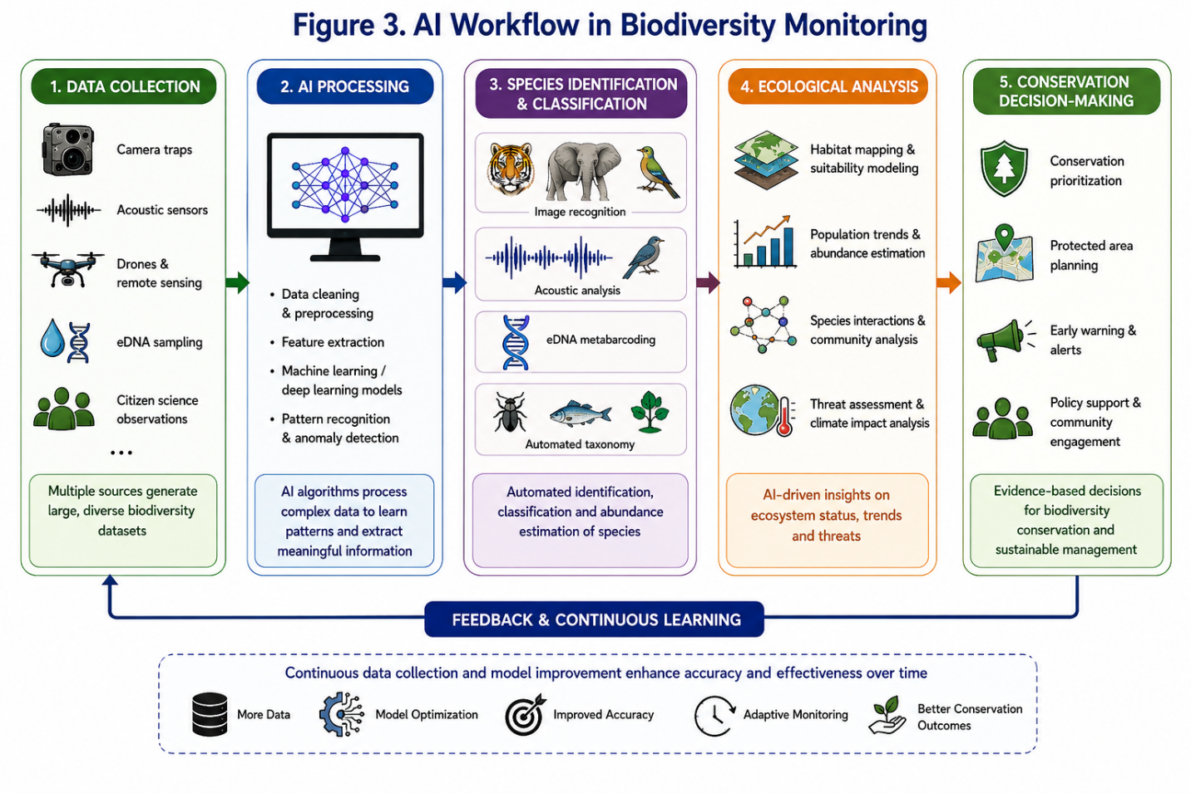
Figure 3. AI-driven biodiversity monitoring and conservation workflow.
General workflow illustrating biodiversity data acquisition through camera traps, drones, acoustic sensors, citizen science platforms, and remote sensing technologies, followed by AI-based analysis and conservation decision-making.
5.1 Biodiversity Assessment and Monitoring
Biodiversity monitoring is fundamental for understanding ecosystem health and guiding conservation actions. Traditional surveys are often labour-intensive and geographically limited. AI has revolutionized biodiversity assessment through automated species detection and classification using images, acoustic recordings, and environmental data. Deep learning algorithms, particularly Convolutional Neural Networks (CNNs), have demonstrated high accuracy in species recognition and biodiversity monitoring (Christin et al., 2019; Wäldchen & Mäder, 2018; Tabak et al., 2018). Citizen-science platforms such as eBird and iNaturalist contribute millions of observations annually, providing valuable datasets for machine learning-based species identification and distribution mapping (Kelling et al., 2013). These AI-assisted approaches improve biodiversity monitoring, particularly in regions with limited taxonomic expertise (Advancing Biodiversity Conservation Through AI-Powered Species Classification, 2025). Emerging multimodal AI systems further integrate images, acoustic data, environmental variables, and textual information to improve ecosystem assessments and facilitate the detection of rare and endangered species (Miao et al., 2025).
5.2 Habitat Mapping and Ecological Forecasting
Habitat mapping is essential for understanding species distributions and conservation priorities. AI-driven approaches effectively analyse remote sensing datasets derived from satellites, drones, LiDAR, and aerial imagery. Machine learning algorithms such as Random Forests, Support Vector Machines, and deep neural networks are widely applied for land-cover classification, vegetation mapping, habitat suitability assessment, and landscape ecological analysis (Stupariu et al., 2022; Frazier & Song, 2024). Deep learning techniques have enhanced environmental change detection and habitat monitoring. AI-assisted drone technologies provide cost-effective tools for high-resolution habitat assessment and forest monitoring (Buchelt et al., 2024). Species Distribution Modelling (SDM) is another major AI application, enabling prediction of habitat suitability, biodiversity hotspots, and climate-driven range shifts (Evans et al., 2011; Tuia, 2022). AI-based ecological forecasting is increasingly valuable for predicting biodiversity responses to climate change and anthropogenic disturbances (Han et al., 2023). XAI further improves ecological understanding by identifying key environmental drivers influencing model predictions (Ryo et al., 2021).
5.3 Wildlife Conservation and Future Directions
AI technologies are increasingly integrated into wildlife conservation programmes to improve monitoring efficiency and management effectiveness. AI-powered camera traps enable continuous wildlife surveillance while minimizing human disturbance. Automated classification systems can identify species, estimate abundance, and detect population trends in near real time (Fergus et al., 2024; Vélez et al., 2023). Similarly, AI-assisted acoustic monitoring supports biodiversity assessment and ecological disturbance detection across terrestrial and aquatic ecosystems (Zhang et al., 2023; Tuia, 2022). AI-driven decision-support systems integrating ecological, environmental, and social datasets assist conservation managers in identifying priority conservation areas, evaluating restoration strategies, and optimizing resource allocation (Fergus et al., 2024).
Climate change remains one of the greatest threats to biodiversity worldwide. Machine learning models integrate climate projections, species occurrence records, remote sensing data, and ecological variables to predict range shifts, biodiversity changes, and ecosystem resilience under future climate scenarios (Han et al., 2023; Wilson, 2024). AI applications also facilitate monitoring of environmental disturbances such as wildfires, habitat degradation, pollution events, and invasive-species outbreaks (Sathishkumar et al., 2023). Future ecological research will increasingly combine remote sensing, environmental DNA (eDNA), genomics, bioacoustics, citizen-science observations, and ecological monitoring data within unified AI-driven frameworks (Abbas et al., 2025; Miao et al., 2025). The growing adoption of explainable AI, cloud computing, digital twins, and autonomous monitoring systems is expected to further enhance the transparency, scalability, and effectiveness of biodiversity conservation and ecosystem management.
6. ARTIFICIAL INTELLIGENCE IN AQUACULTURE AND FISHERIES
Aquaculture is one of the fastest-growing food-production sectors globally and plays a vital role in food security, nutritional sustainability, and economic development. Increasing demand for aquatic food products, coupled with challenges such as disease outbreaks, water-quality deterioration, climate change, environmental degradation, inefficient feed utilization, labour shortages, and resource limitations, has accelerated the adoption of advanced technologies. Traditional management approaches based on manual observations are often inadequate for large-scale operations. Consequently, artificial intelligence (AI) has emerged as a transformative tool capable of enhancing productivity, profitability, sustainability, and environmental stewardship in aquaculture and fisheries (Mustapha et al., 2021; Wang et al., 2021; Yang et al., 2025). The integration of AI with machine learning, deep learning, computer vision, the Internet of Things (IoT), cloud computing, robotics, and advanced sensors has enabled the development of intelligent production systems that support precision aquaculture and data-driven decision-making (Vo et al., 2021; Li & Liu, 2021; Yue & Shen, 2022).
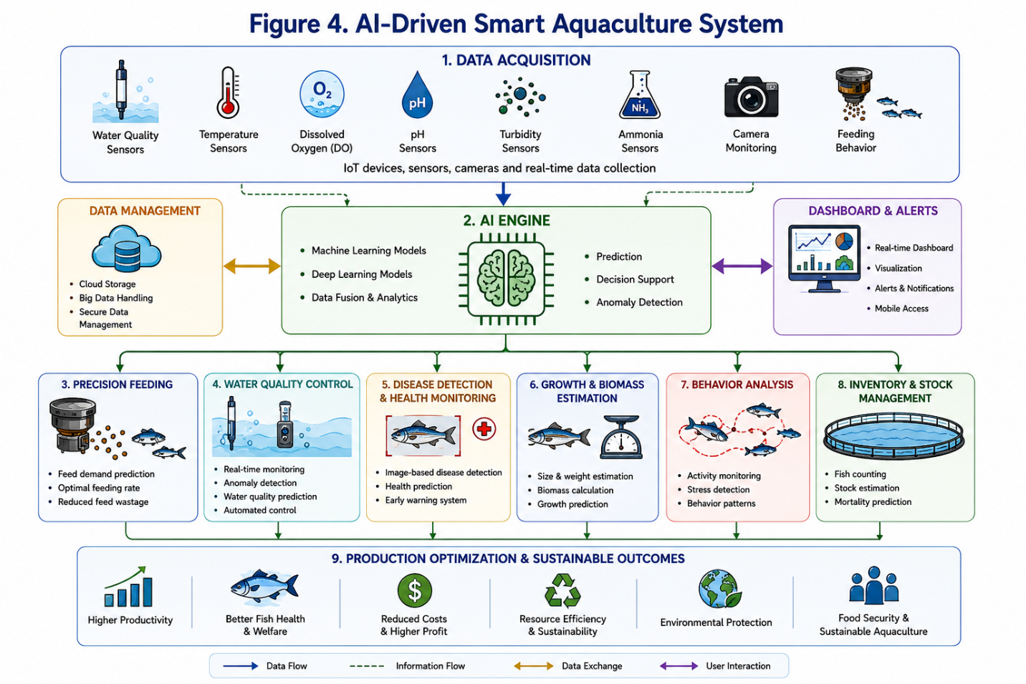
Figure 4. Architecture of an AI-driven smart aquaculture system.
Conceptual framework illustrating sensor-based monitoring, AI analytics, automated feeding systems, disease surveillance, water quality management, and production optimization in precision aquaculture.
6.1 Emergence of Smart Aquaculture Systems
Smart aquaculture represents a major shift from conventional farming practices toward technology-driven production systems. Modern aquaculture farms generate large volumes of data related to water quality, fish growth, feeding behaviour, disease occurrence, and environmental conditions. Artificial intelligence (AI) enables the efficient processing and interpretation of these datasets, providing actionable insights for farm managers and improving operational efficiency (Vo et al., 2021). By integrating AI with Internet of Things (IoT) devices, cloud-computing platforms, and automated equipment, intelligent aquaculture systems can continuously monitor environmental conditions and automatically adjust operational parameters to optimize production outcomes (Wang et al., 2021). These smart systems facilitate remote monitoring, predictive analytics, and automated decision-making, thereby enhancing productivity, profitability, and sustainability across aquaculture operations (Mustapha et al., 2021).
6.2 Water Quality Monitoring and Environmental Management
Water quality is one of the most critical factors influencing fish growth, survival, reproduction, and overall health. Parameters such as dissolved oxygen, temperature, pH, salinity, ammonia concentration, turbidity, and nutrient levels require continuous monitoring. AI-powered monitoring systems integrate sensor networks with machine-learning algorithms to provide real-time environmental assessment and predictive management. These systems can detect anomalies, identify trends, and forecast environmental fluctuations before they adversely affect production (Lu et al., 2022; Hu et al., 2023). AIoT-based technologies can automatically activate corrective measures, including aeration and water exchange, when environmental conditions become unfavourable (Hu et al., 2023). Similarly, AI-enabled buoy systems used in offshore aquaculture provide real-time alerts regarding water-quality changes, thereby reducing mortality risks and improving farm efficiency (Lu et al., 2022). Such technologies contribute significantly to sustainable aquaculture through improved resource utilization, pollution reduction, and enhanced environmental stewardship.
6.3 Precision Feeding and Growth Management
feed costs often account for more than 50% of production expenses, making efficient feeding strategies essential for profitability. AI-driven precision feeding systems analyse fish behaviour, feeding responses, environmental conditions, and growth performance to determine optimal feeding schedules and feed quantities. Computer vision technologies continuously monitor feeding activity and automatically regulate feed delivery according to fish appetite and consumption patterns (Wang et al., 2021; Chang et al., 2021). These systems improve feed conversion efficiency, reduce feed wastage, lower production costs, and minimize environmental impacts (Rather et al., 2024; Yang et al., 2025).
AI also supports non-invasive growth monitoring and biomass estimation. Computer vision and deep-learning algorithms analyse images and video recordings to estimate fish size, weight, growth rates, and biomass with high accuracy (Vo et al., 2021). Furthermore, machine-learning models integrate feeding records, environmental conditions, and physiological parameters to predict growth trajectories and optimize stocking densities, feeding programmes, and harvest schedules (Li & Liu, 2021; Mandal & Ghosh, 2024).
6.4 Disease Detection and Health Management
Disease outbreaks remain one of the most significant challenges affecting global aquaculture sustainability. AI technologies are increasingly employed to monitor fish health using behavioural, physiological, environmental, and imaging data. Computer vision systems can detect abnormal swimming behaviour, reduced feeding activity, surface gasping, colour changes, and visible lesions associated with disease conditions (Rather et al., 2024). Machine-learning algorithms analyse these indicators and identify potential health problems before severe symptoms become evident.
Advanced AI models have been developed to diagnose bacterial, viral, fungal, and parasitic infections in fish and shellfish species, facilitating rapid intervention and improved biosecurity (Yang et al., 2025). In addition, Anapana et al. (2025) emphasized the importance of AI-based early warning systems for disease prediction and biosecurity management in aquatic food-production sectors. Integration with biosensors, molecular diagnostics, and environmental monitoring systems is further enhancing disease-detection accuracy and precision health management.
6.5 Mortality Detection, Welfare Monitoring, and Fisheries Management
AI applications extend beyond health monitoring to mortality detection and welfare assessment. Ranjan et al. (2023) developed MortCam, a deep-learning-based system capable of detecting dead fish in recirculating aquaculture systems and notifying farm operators in real time. Such systems improve biosecurity, reduce disease risks, and facilitate rapid intervention. AI also supports welfare monitoring by analysing behavioural indicators associated with stress, overcrowding, poor water quality, and disease conditions.
In fisheries management, machine-learning algorithms analyse catch statistics, satellite imagery, oceanographic information, and environmental variables to estimate stock abundance, predict recruitment patterns, and identify productive fishing grounds (Rowan, 2023; Lim, 2024). AI-powered remote sensing technologies additionally support monitoring of fishing activities, marine biodiversity, habitat changes, and illegal fishing operations. Anapana et al. (2023) and Anapana (2026) further highlighted opportunities for AI-based forecasting systems to support livelihood planning and climate adaptation among fishing communities.
6.6 Environmental Sustainability and Future Perspectives
AI is increasingly applied to wastewater treatment, nutrient management, pollution control, and environmental monitoring. Machine-learning models can predict wastewater characteristics and optimize treatment processes. Igwegbe et al. (2023) demonstrated the successful application of AI in optimizing electrocoagulation–flocculation processes for aquaculture effluent treatment, improving treatment efficiency while reducing operational costs.
Future developments in aquaculture and fisheries are expected to be driven by advances in AI, robotics, blockchain technology, digital twins, autonomous monitoring systems, and big-data analytics (Yue & Shen, 2022; Lim, 2024). Integration with genomic technologies, environmental DNA (eDNA), remote sensing, and ecosystem modelling will further strengthen sustainable aquatic resource management. As adoption continues to expand, AI will play an increasingly important role in addressing climate change impacts, disease outbreaks, food security concerns, and resource scarcity, ultimately supporting the long-term sustainability of aquaculture and fisheries worldwide.
7. ARTIFICIAL INTELLIGENCE IN TOXICOLOGY AND ECOTOXICOLOGY
Toxicology and ecotoxicology are critical disciplines for understanding the impacts of chemical contaminants on human health, wildlife, and ecosystems. Rapid industrialization, agricultural intensification, pharmaceutical use, and urban development have increased the release of synthetic chemicals into terrestrial and aquatic environments. Traditional toxicity assessments are often costly, labour-intensive, time-consuming, and dependent on animal experimentation. Consequently, artificial intelligence (AI) has emerged as a transformative technology that enhances toxicity prediction, hazard identification, biomarker discovery, and environmental risk assessment while reducing costs and reliance on animal testing (Martinez et al., 2026). In aquatic toxicology, extensive biomarker datasets have strengthened AI applications, including haematological, physiological, behavioural, histopathological, and biochemical responses to contaminants (Anapana et al., 2024; Anapana & Rathnamma, 2025a; Anapana & Rathnamma, 2025b; Anapana & Vakita, 2026; Merugumalla et al., 2025).
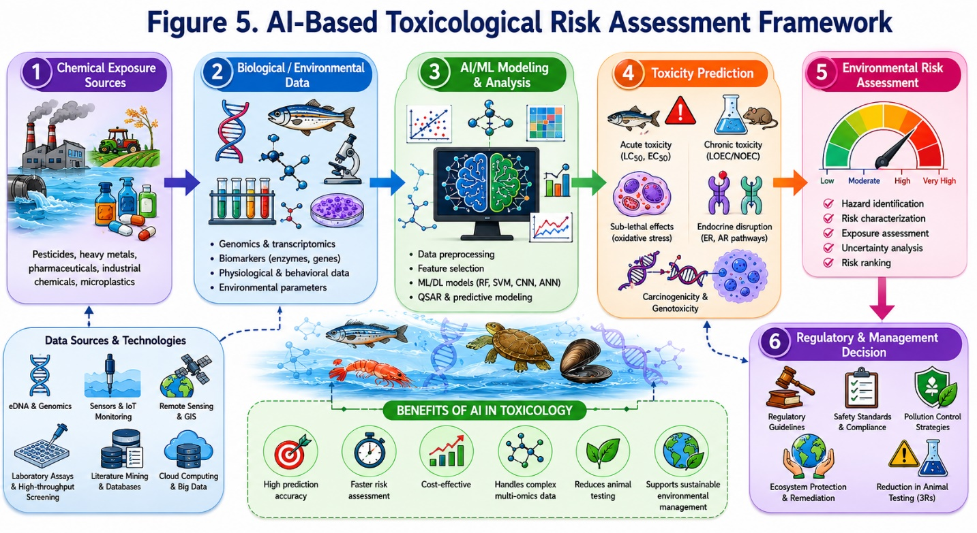
Figure 5. Artificial Intelligence-Based Toxicological Risk Assessment Framework. Conceptual workflow showing the integration of chemical exposure data, biological responses, machine learning models, toxicity prediction, environmental risk assessment, and regulatory decision-making.
7.1 Evolution of AI in Toxicological Research
Historically, toxicological studies relied on laboratory bioassays, chronic exposure experiments, and field observations. Although scientifically valuable, these approaches are often limited by high costs, ethical concerns, and lengthy testing periods. AI has provided a powerful alternative by identifying relationships among chemical structures, biological responses, and toxicological outcomes. Machine-learning algorithms can analyse large toxicological datasets, identify hidden patterns, and predict adverse effects before extensive experimental validation. The integration of AI with cheminformatics, molecular modelling, systems biology, and omics technologies has significantly improved predictive accuracy and mechanistic understanding, enabling more efficient prioritization of hazardous substances and environmental risk evaluation.
7.2 Predictive Toxicology and Machine Learning Applications
Predictive toxicology is one of the most significant applications of AI in modern toxicological science. Machine-learning models utilize chemical descriptors, molecular structures, biological pathways, exposure information, and historical toxicological datasets to predict toxicity endpoints. Algorithms such as Random Forests, Support Vector Machines, Artificial Neural Networks, Gradient Boosting Models, and Deep Neural Networks are widely applied to predict acute and chronic toxicity, carcinogenicity, mutagenicity, endocrine disruption, neurotoxicity, and reproductive toxicity. These approaches frequently perform as well as or better than conventional Quantitative Structure–Activity Relationship (QSAR) models. By integrating chemical properties, exposure pathways, biological responses, and environmental variables, AI-driven systems improve prediction accuracy and facilitate rapid screening of large chemical libraries.
7.3 AI in Ecotoxicology and Environmental Risk Assessment
Ecotoxicology examines the effects of pollutants such as pesticides, heavy metals, pharmaceuticals, microplastics, endocrine-disrupting chemicals, and industrial effluents on organisms and ecosystems. AI technologies provide powerful analytical tools for evaluating complex ecotoxicological datasets. Machine-learning algorithms can assess relationships between contaminant exposure and biological responses across multiple levels of biological organization, improving understanding of toxicity mechanisms, contaminant fate, bioaccumulation, trophic transfer, and ecological vulnerability.
AI also strengthens environmental risk assessment by integrating toxicological, ecological, and environmental datasets into predictive frameworks. These systems estimate exposure levels, toxicity thresholds, environmental persistence, and ecological consequences under different environmental scenarios. Furthermore, AI models can simultaneously evaluate multiple stressors, including pollution, climate change, habitat degradation, and biological interactions, providing a more realistic assessment of environmental risk and supporting adaptive management strategies.
7.4 AI Applications in Aquatic Toxicology
Aquatic ecosystems receive substantial inputs of pesticides, pharmaceuticals, heavy metals, and emerging contaminants, making fish valuable bioindicators of environmental pollution. AI is increasingly used to analyse physiological, behavioural, biochemical, haematological, and histopathological datasets generated through aquatic toxicology studies.
Haematological biomarkers are important indicators of contaminant-induced stress. Significant alterations in blood parameters following azoxystrobin exposure in grass carp demonstrate their usefulness for AI-assisted toxicity prediction (Anapana et al., 2024). Similarly, oxidative stress biomarkers and respiratory parameters provide critical physiological information. Anapana and Rathnamma (2025a) reported oxidative stress and reduced oxygen consumption in azoxystrobin-exposed fish, highlighting the value of multibiomarker datasets for machine-learning applications.
Behavioural responses are highly sensitive indicators of environmental contamination. Behavioural and physiological disturbances observed in grass carp exposed to azoxystrobin demonstrate the utility of behavioural endpoints in AI-based monitoring systems (Anapana & Rathnamma, 2025b). Computer vision and machine-learning technologies enable automated behavioural tracking and real-time detection of contaminant-induced stress responses.
Histopathological datasets are equally valuable for deep-learning applications. Anapana and Vakita (2026) documented extensive multiorgan tissue damage in grass carp following azoxystrobin exposure, demonstrating the potential of AI-assisted lesion detection and tissue classification. Likewise, biochemical biomarkers such as acetylcholinesterase activity can strengthen toxicity prediction models. Merugumalla et al. (2025) reported significant inhibition of acetylcholinesterase activity in Catla catla exposed to ethion, emphasizing the value of neurotoxicity biomarkers for AI-based ecotoxicological assessment.
7.5 AI, Alternative Testing Approaches, and Future Perspectives
Ethical concerns regarding animal experimentation have accelerated the adoption of alternative testing approaches based on the principles of Replacement, Reduction, and Refinement (3Rs) (Anapana & Gudivada, 2020). AI contributes significantly to these objectives through in silico toxicity prediction, reducing dependence on laboratory animals while accelerating safety evaluations. Recent advances in New Approach Methodologies (NAMs), including organ-on-chip systems, high-throughput screening technologies, computational toxicology, and AI-assisted modelling, are transforming chemical safety assessment (Martinez et al., 2026).
The integration of AI with genomics, transcriptomics, proteomics, metabolomics, and bioinformatics is creating new opportunities for systems toxicology. AI can identify biomarkers, characterize molecular pathways, predict adverse outcome pathways, and uncover previously unknown toxicity mechanisms. AI is also increasingly applied to emerging contaminants such as microplastics, nanomaterials, pharmaceuticals, and endocrine-disrupting chemicals. Studies have demonstrated that microplastics can induce oxidative stress, tissue damage, and endocrine disruption in aquatic organisms, highlighting the importance of AI-assisted environmental monitoring and risk assessment (Anapana & Rathnamma, 2024).
Looking ahead, advances in machine learning, Explainable Artificial Intelligence (XAI), digital twins, systems biology, and real-time environmental monitoring are expected to further transform toxicology and ecotoxicology. Future AI frameworks will integrate chemical, biological, ecological, genomic, and environmental datasets into unified predictive systems capable of assessing risks with unprecedented precision. As computational capabilities continue to evolve, AI is expected to become a cornerstone technology for environmental monitoring, toxicological evaluation, and chemical risk assessment.
8. CHALLENGES, LIMITATIONS, ETHICAL CONSIDERATIONS, AND FUTURE PERSPECTIVES OF AI IN ZOOLOGICAL SCIENCES
Artificial intelligence (AI) has become an important tool in zoology, ecology, aquaculture, toxicology, and biodiversity conservation by enhancing data analysis, predictive modelling, automated monitoring, and decision-making. However, its successful implementation depends on data quality, computational infrastructure, transparency, ethical governance, and interdisciplinary collaboration (Zhang et al., 2023; Han et al., 2023; Fergus et al., 2024).
One of the major limitations of AI is the availability of large, accurate, and representative datasets. Zoological and ecological databases often contain incomplete records, taxonomic inconsistencies, geographical biases, and uneven sampling efforts, particularly for rare and endangered species (Tuia, 2022; Christin et al., 2019). Although citizen-science initiatives have expanded biodiversity databases, observations may be influenced by observer expertise and sampling intensity, potentially affecting model reliability (Kelling et al., 2013). Algorithmic bias also remains a concern because models trained in one region may perform poorly in other ecosystems, while camera-trap datasets often overrepresent common species and underrepresent rare taxa (Vélez et al., 2023). Furthermore, many deep-learning models function as “black boxes,” limiting interpretability and stakeholder confidence. Explainable Artificial Intelligence (XAI) approaches, including SHAP, LIME, and feature-importance analyses, improve transparency by identifying variables influencing model predictions (Ryo et al., 2021).
The deployment of AI systems requires substantial computational resources, including high-performance processors, cloud-computing services, GPUs, and large-scale storage infrastructure. These requirements can restrict adoption, particularly in biodiversity-rich developing countries. Ethical concerns also arise from the use of drones, camera traps, acoustic sensors, and satellite surveillance systems, which may unintentionally disturb wildlife or raise questions regarding data ownership, privacy, and benefit-sharing (Buchelt et al., 2024). In toxicological research, AI can reduce dependence on animal experimentation, but predictive models require rigorous validation and regulatory oversight to ensure environmental and public health protection. The principles of Replacement, Reduction, and Refinement (3Rs) remain fundamental to responsible research practices (Anapana, G and Gudivada, 2020). Cybersecurity is another emerging challenge because environmental databases often contain sensitive information on endangered species, breeding sites, and protected habitats. Interdisciplinary knowledge gaps between zoologists and AI developers further emphasize the need for collaborative research, specialized training, and robust governance frameworks (Anapana et al., 2025; Naser, 2025).
Despite these challenges, the future of AI in zoological sciences is highly promising. Advances in explainable AI, multimodal intelligence, digital twins, environmental DNA (eDNA), omics technologies, and autonomous monitoring systems are expected to transform biodiversity assessment and ecosystem management. AI integrated with genomics, transcriptomics, proteomics, metabolomics, and eDNA can identify genetic markers, predict adaptive responses, and improve biodiversity monitoring (Von der Heyden et al., 2025; Abbas et al., 2025). Multimodal AI systems capable of integrating images, audio recordings, environmental measurements, satellite imagery, and genomic data will support comprehensive biodiversity intelligence platforms (Miao et al., 2025). Autonomous camera traps, drones, acoustic sensors, and satellite systems will enable real-time monitoring of species, habitats, invasive species, disease outbreaks, and conservation threats (Fergus et al., 2024; Buchelt et al., 2024; Frazier & Song, 2024; Stupariu et al., 2022). Digital twin technology and precision conservation frameworks will further enhance ecosystem management and conservation planning (Han et al., 2023), while AI-powered aquaculture and fisheries systems will improve resource efficiency and climate adaptation (Yang et al., 2025). Through responsible innovation, ethical governance, and interdisciplinary collaboration, AI is expected to become an indispensable tool for biodiversity conservation, environmental sustainability, and scientific advancement (Anapana et al., 2025).

8.1 Cost-Effectiveness and Accessibility of AI Tools in Low-Resource Settings
The successful adoption of artificial intelligence (AI) in zoological sciences depends not only on technological advancement but also on its affordability and accessibility, particularly in developing countries. Many biodiversity-rich regions face limitations in computational infrastructure, internet connectivity, technical expertise, and financial resources, which can restrict the implementation of advanced AI systems (Zhang et al., 2023; Kumar & Deepak, 2025). Nevertheless, recent developments in open-source software, cloud-based platforms, low-cost sensors, mobile applications, and citizen-science initiatives have significantly improved access to AI technologies for researchers, conservation practitioners, and educational institutions with limited resources (Kelling et al., 2013; Kodiyatar & Shamala, 2025). Affordable AI-powered tools such as camera traps, acoustic monitoring systems, drone-based surveys, and low-cost environmental sensors have enabled efficient biodiversity monitoring, wildlife conservation, and ecological assessments without requiring extensive infrastructure investments (Fergus et al., 2024; Buchelt et al., 2024; Lu et al., 2022). In aquaculture, low-cost AIoT systems support water-quality monitoring, disease detection, and farm management, enhancing productivity while reducing operational costs (Mustapha et al., 2021; Chiu et al., 2022; Hu et al., 2024). Furthermore, cloud computing and collaborative data-sharing platforms facilitate access to computational resources and analytical tools that would otherwise be unavailable to many institutions (Han et al., 2023; Miao et al., 2025). Strengthening training programs, interdisciplinary education, and international collaborations will be essential to bridge technological gaps and ensure equitable access to AI-driven innovations across zoological research, conservation, and environmental management in low-resource settings (Anapana et al., 2025; Abbas et al., 2025; Naser, 2025).
9. CONCLUSION
Artificial intelligence (AI) has emerged as a transformative force in zoological sciences, fundamentally reshaping the way biological systems are studied, monitored, and managed. The integration of machine learning, deep learning, computer vision, bioacoustics, remote sensing, Internet of Things (IoT) technologies, and advanced computational analytics has significantly enhanced the ability of researchers to collect, analyse, and interpret complex biological data. AI is no longer merely a supporting analytical tool but has become a core component of modern zoological research, contributing to biodiversity conservation, ecology, aquaculture, fisheries, toxicology, and environmental management.
The application of AI has greatly improved species identification, behavioural analysis, wildlife monitoring, habitat assessment, population estimation, disease surveillance, and conservation planning. Automated image-recognition systems, camera-trap analytics, acoustic monitoring platforms, and sensor-based technologies have increased the efficiency, accuracy, and scalability of biodiversity assessments while reducing the limitations of conventional field-based methods. These advancements have enabled researchers to monitor ecosystems at unprecedented spatial and temporal scales and support evidence-based decision-making.
In ecology and biodiversity conservation, AI has strengthened habitat mapping, species distribution modelling, ecological forecasting, conservation prioritization, and climate-change adaptation planning. In aquaculture and fisheries, intelligent systems integrating sensors, computer vision, predictive analytics, and automation have improved water-quality management, precision feeding, disease detection, growth prediction, stock assessment, and resource-use efficiency. Similarly, in toxicology and ecotoxicology, AI has accelerated toxicity prediction, environmental risk assessment, biomarker discovery, and alternative testing approaches, contributing to more efficient and ethically responsible chemical safety evaluations.
Despite these achievements, challenges related to data quality, algorithmic bias, model interpretability, computational infrastructure, cybersecurity, ethical concerns, and regulatory frameworks remain important considerations. Addressing these limitations will require interdisciplinary collaboration, transparent methodologies, rigorous validation procedures, and responsible governance. AI should be viewed as a tool that complements rather than replaces scientific expertise, ecological knowledge, and field-based observations.
Looking ahead, emerging technologies such as explainable AI, multimodal intelligence, digital twins, environmental DNA analytics, autonomous monitoring systems, precision conservation, and generative AI are expected to further advance zoological sciences. The convergence of AI with genomics, bioinformatics, robotics, remote sensing, and advanced environmental monitoring technologies will create powerful integrated research frameworks capable of addressing complex biological and environmental challenges.
In conclusion, AI represents a paradigm shift in zoological sciences and offers unprecedented opportunities for understanding, conserving, and sustainably managing biodiversity. Through responsible innovation, interdisciplinary collaboration, and ethical implementation, AI will continue to play a pivotal role in advancing scientific knowledge, supporting environmental sustainability, and safeguarding biological diversity for future generations.
DISCLAIMER (ARTIFICIAL INTELLIGENCE USAGE)
The author(s) declare that no generative Artificial Intelligence (AI) tools, including Large Language Models (LLMs), were used in the writing, editing, analysis, or preparation of this manuscript. All content was prepared solely by the authors.

CONFLICT OF INTEREST
The authors declare that they have no conflicts of interest related to this study.
ETHICAL STATEMENT
Not applicable.
COMPETING INTERESTS DISCLAIMER:
Authors have declared that they have no known competing financial interests OR non-financial interests OR personal relationships that could have appeared to influence the work reported in this paper.

10. References
- Abbas, M., Khan, A. M., Khan, M. M. S. U., Ishaque, I., Irshad, A., Sundhu, M. U., Haidar, S. H., Arshad, M., Farooq, M., & Rafique, S. (2025). Integrative zoology in the 21st century: Unifying genomics, eDNA, morphology, behavior, biologging, bioacoustics, remote sensing, and AI for global biodiversity discovery and conservation. Saudi Journal of Life Sciences, 10(9). https://doi.org/10.36348/sjls.2025.v10i09.005
- Anapana, G. (2026). Microbial bioremediation strategies for heavy metal detoxification in freshwater ecosystems: Advances, mechanisms, and future prospects. In R. Murugesan, H. H. Nagariya, V. Vishwakarma, C. M. Kumar, & T. Saxena (Eds.), Voices of New India 2026: A multidisciplinary compendium of research & innovation (pp. 102–113). Eagle Leap Publication. https://doi.org/10.5281/zenodo.18360523
- Anapana, G. (2026). Socioeconomic vulnerabilities and resilience strategies of coastal fisherfolk: Evidence from Vizianagaram District, Andhra Pradesh, India. International Journal of Multidisciplinary Educational Research, 15(1(6)), 214–228. https://doi.org/10.5281/zenodo.18897376
- Anapana, G., & Gudivada, M. (2020, July 8). A review on ethical issues of animal experimentation India. SSRN. https://ssrn.com/abstract=5078215
- Anapana, G., & Rathnamma, V. (2024). A review on the impact of microplastics on fish and other aquatic organisms. ANU Journal of Natural Sciences. https://doi.org/10.2139/ssrn.5711342
- Anapana, G., & Rathnamma, V. V. (2025a). Azoxystrobin-induced oxidative stress and reduced oxygen consumption in grass carp (Ctenopharyngodon idella): A multi-biomarker toxicity evaluation. Toxicology International, 32(3), 567–578. https://doi.org/10.18311/ti/2025/v32i3/49170
- Anapana, G., & Vakita, V. R. (2026). Multiorgan histopathological alterations in grass carp (Ctenopharyngodon idella) following azoxystrobin exposure. Journal of Applied Biology & Biotechnology, 14(Suppl.), 74–83. https://doi.org/10.7324/JABB.2026.285284
- Anapana, G., & Venkata Rathnamma, V. (2025b). Azoxystrobin-induced behavioural and physiological toxicity in grass carp (Ctenopharyngodon idella): Ecological implications for aquaculture environments. Journal of Chemical Health Risks, 15(4), 717–728. https://doi.org/10.60829/jchr.2025.1206586
- Anapana, G., Barri, S., Dunna, B., & Vakita, V. R. (2023). Impact of socio-economic fluctuations on fishermen families in coastal Vizianagaram. In Community health and sustainable development goals: Perspectives, challenges, and policies (pp. 215–225). Acharya Nagarjuna University. https://doi.org/10.5281/zenodo.17152568
- Anapana, G., Donkada, S., Surarapu, N., & Rathnamma, V. V. (2025). Multidisciplinary integration in zoology education: Bridging biological, computational, and environmental sciences. Uttar Pradesh Journal of Zoology, 46(8), 317–331. https://doi.org/10.56557/upjoz/2025/v46i84916
- Anapana, G., Gurubilli, C. R., Mudunuru, S., & Rathnamma, V. (2024). Toxicological and hematological assessment of azoxystrobin in freshwater fish: A study on grass carp (Ctenopharyngodon idella). African Journal of Biomedical Research, 27(4S), 6996–7003. https://doi.org/10.53555/AJBR.v27i4S.4923
- Anapana, G., Lakshminarayana, V., & Rathnamma, V. V. (2025). Diversity and functional morphology of bird claws in the Srikakulam Region, Andhra Pradesh, India. International Journal of Zoology and Applied Biosciences, 10(5), 89–96. https://doi.org/10.55126/ijzab.2025.v10.i05.012
- Anapana, G., Rathnamma, V. V., Sindhusree, D. C., Shaheen, S., & Amani, Y. (2025). Impact of avian influenza on poultry and aquaculture in Andhra Pradesh: A public health and environmental concern. International Journal of Creative Research Thoughts, 13(3), C104–C114. https://doi.org/10.56975/ijcrt.v13i3.278890
- Audira, G., Huang, J.-C., Yousaf, M. N., Tso, C.-P., Lin, C.-H., & Hsiao, C.-D. (2026). Quantitative measurement of stag beetle behaviors in low light and complex background conditions using DAMM (Detect Any Mouse Model). Scientific Reports. https://doi.org/10.1038/s41598-026-51559-y
- Balwan, W. K., & Saba, N. (2024). Review based study on artificial intelligence and the future of zoology. Cross Current International Journal of Medical and Biosciences, 6(6), 160–167. https://doi.org/10.36344/ccijmb.2024.v06i06.003
- Borowiec, M. L., Dikow, R. B., Frandsen, P. B., McKeeken, A., Valentini, G., & White, A. E. (2022). Deep learning as a tool for ecology and evolution. Methods in Ecology and Evolution, 13, 1640–1660. https://doi.org/10.1111/2041-210X.13901
- Buchelt, A., Adrowitzer, A., Kieseberg, P., Gollob, C., Nothdurft, A., Eresheim, S., Tschiatschek, S., Stampfer, K., & Holzinger, A. (2024). Exploring artificial intelligence for applications of drones in forest ecology and management. Forest Ecology and Management, 551, 121530. https://doi.org/10.1016/j.foreco.2023.121530
- Chamundeswaramma, K. V., Anapana, G., & Rathnamma, V. V. (2026). Climate change intensifies azoxystrobin toxicity in grass carp (Ctenopharyngodon idella). Uttar Pradesh Journal of Zoology, 47(10), 220–233. https://doi.org/10.56557/upjoz/2026/v47i105674
- Chang, C.-C., Wang, J.-H., Wu, J.-L., et al. (2021). Applying artificial intelligence (AI) techniques to implement a practical smart cage aquaculture management system. Journal of Medical and Biological Engineering, 41, 652–658. https://doi.org/10.1007/s40846-021-00621-3
- Chiu, M.-C., Yan, W.-M., Bhat, S. A., & Huang, N.-F. (2022). Development of smart aquaculture farm management system using IoT and AI-based surrogate models. Journal of Agriculture and Food Research, 9, 100357. https://doi.org/10.1016/j.jafr.2022.100357
- Christin, S., Hervet, E., & Lecomte, N. (2019). Applications for deep learning in ecology. Methods in Ecology and Evolution, 10(10), 1632–1644. https://doi.org/10.1111/2041-210X.13256
- Ditria, E. M., Buelow, C. A., Gonzalez-Rivero, M., & Connolly, R. M. (2022). Artificial intelligence and automated monitoring for assisting conservation of marine ecosystems: A perspective. Frontiers in Marine Science, 9, 918104. https://doi.org/10.3389/fmars.2022.918104
- Evans, J. S., Murphy, M. A., Holden, Z. A., & Cushman, S. A. (2011). Modeling species distribution and change using random forest. In C. Drew, Y. Wiersma, & F. Huettmann (Eds.), Predictive species and habitat modeling in landscape ecology (pp. 139–159). Springer. https://doi.org/10.1007/978-1-4419-7390-0_8
- Fergus, P., Chalmers, C., Longmore, S. N., & Wich, S. A. (2024). Harnessing artificial intelligence for wildlife conservation. Conservation, 4(4), 685–702. https://doi.org/10.3390/conservation4040041
- Frazier, A. E., & Song, L. (2024). Artificial intelligence in landscape ecology: Recent advances, perspectives, and opportunities. Current Landscape Ecology Reports, 10(1). https://doi.org/10.1007/s40823-024-00103-7
- Geffroy, B., Machuca, B., Suzán, G., Esponda, F., & Roche, B. (2026). Advances in mosquito-borne disease surveillance using machine learning. New Microbes and New Infections. https://doi.org/10.1016/j.nmni.2026.101757
- Goodwin, M., Halvorsen, K. T., Jiao, L., Knausgård, K. M., Martin, A. H., Moyano, M., Oomen, R. A., Rasmussen, J. H., Sørdalen, T. K., & Thorbjørnsen, S. H. (2022). Unlocking the potential of deep learning for marine ecology: Overview, applications, and outlook. ICES Journal of Marine Science, 79(2), 319–336. https://doi.org/10.1093/icesjms/fsab255
- Han, B. A., Varshney, K. R., LaDeau, S. L., Subramaniam, A., Weathers, K. C., & Zwart, J. (2023). A synergistic future for AI and ecology. Proceedings of the National Academy of Sciences, 120(38), e2220283120. https://doi.org/10.1073/pnas.2220283120
- Hu, W. C., Chen, L.-B., Wang, B.-H., Li, G.-W., & Huang, X.-R. (2024). Design and implementation of a full-time artificial intelligence of things-based water quality inspection and prediction system for intelligent aquaculture. IEEE Sensors Journal, 24(3), 3811–3821. https://doi.org/10.1109/JSEN.2023.3340295
- Igwegbe, C. A., Obi, C. C., Ohale, P. E., et al. (2023). Modelling and optimisation of electrocoagulation/flocculation recovery of effluent from land-based aquaculture by artificial intelligence (AI) approaches. Environmental Science and Pollution Research, 30, 70897–70917. https://doi.org/10.1007/s11356-023-27387-2
- Janani, S., Mounika, G. N., Sasiroopa, A. C., & Rose, S. G. H. (2024). An innovative animal care and management system integrating Internet of Things (IoT) technology. In 2024 IEEE International Conference on Big Data & Machine Learning (ICBDML) (pp. 63–67). IEEE. https://doi.org/10.1109/ICBDML60909.2024.10577376
- Jeantet, L., Oosthuizen, W. C., Chevallier, D., & Dufourq, E. (2026). Towards automated behaviour monitoring in wildlife: A review of machine learning approaches using accelerometer data. PeerJ. https://doi.org/10.7717/peerj.21069
- Kelling, S., Fink, D., La Sorte, F. A., Johnston, A., Bruns, N. E., & Hochachka, W. M. (2013). A human/computer learning network to improve biodiversity conservation and research. AI Magazine, 34(1), 10–14. https://doi.org/10.1609/aimag.v34i1.2431
- Kodiyatar, N., & Shamala, A. (2025). Advancing biodiversity conservation through AI-powered species classification: A focus on deep learning and citizen science integration. Zenodo. https://doi.org/10.5281/zenodo.17116830
- Kumar, A., & Deepak, P. (2025). Artificial intelligence in zoology: Pioneering predictive, data-driven, and ethical approaches to biodiversity research. International Journal for Multidisciplinary Research, 7(5). https://doi.org/10.36948/ijfmr.2025.v07i05.57555
- Li, D., & Liu, C. (2021). Recent advances and future outlook for artificial intelligence in aquaculture. Smart Agriculture, 2(3), 1–20. https://doi.org/10.12133/j.smartag.2020.2.3.202004-SA007
- Lim, L. W. K. (2024). Implementation of artificial intelligence in aquaculture and fisheries: Deep learning, machine vision, big data, internet of things, robots and beyond. Journal of Computational and Cognitive Engineering, 3(2), 112–118. https://doi.org/10.47852/bonviewJCCE3202803
- Liu, J., Liu, T., Hu, Z., et al. (2026). An automated AI framework for quantitative measurement of mammalian behavior. Integrative Zoology, 21(2), 343–358. https://doi.org/10.1111/1749-4877.12985
- Lu, H.-Y., Cheng, C.-Y., Cheng, S.-C., Cheng, Y.-H., Lo, W.-C., Jiang, W.-L., Nan, F.-H., Chang, S.-H., & Ubina, N. A. (2022). A low-cost AI buoy system for monitoring water quality at offshore aquaculture cages. Sensors, 22(11), 4078. https://doi.org/10.3390/s22114078
- Mandal, A., & Ghosh, A. R. (2024). Role of artificial intelligence (AI) in fish growth and health status monitoring: A review on sustainable aquaculture. Aquaculture International, 32, 2791–2820. https://doi.org/10.1007/s10499-023-01297-z
- Martinez, M. N., Mochel, J. P., Allenspach, K., Zdyrski, C., Krishna, S., & Rusyn, I. (2026). New frontiers of drug development through the use of new approach methodologies. The AAPS Journal, 28(4), 112. https://doi.org/10.1208/s12248-026-01263-6
- Merugumalla, S., Anapana, G., & Rathnamma, V. V. (2025). Effects of Ethion (50% EC) on acetylcholinesterase activity in the freshwater fish Catla catla. Uttar Pradesh Journal of Zoology, 46(17), 197–205. https://doi.org/10.56557/upjoz/2025/v46i175223
- Miao, Z., et al. (2025). New frontiers in artificial intelligence for biodiversity research and conservation with multimodal language models. Methods in Ecology and Evolution. https://doi.org/10.1111/2041-210X.70120
- Mustapha, U. F., Alhassan, A.-W., Jiang, D.-N., & Li, G.-L. (2021). Sustainable aquaculture development: A review on the roles of cloud computing, internet of things and artificial intelligence (CIA). Reviews in Aquaculture, 13, 2076–2091. https://doi.org/10.1111/raq.12559
- Naser, M. N. (2025). Twenty-first century zoology: Trends in advance research and education. Bangladesh Journal of Zoology, 53(1), 1–2. https://doi.org/10.3329/bjz.v53i1.82602
- Pichler, M., & Hartig, F. (2023). Machine learning and deep learning—A review for ecologists. Methods in Ecology and Evolution, 14, 994–1016. https://doi.org/10.1111/2041-210X.14061
- Ranjan, R., Sharrer, K., Tsukuda, S., & Good, C. (2023). MortCam: An artificial intelligence-aided fish mortality detection and alert system for recirculating aquaculture. Aquacultural Engineering, 102, 102341. https://doi.org/10.1016/j.aquaeng.2023.102341
- Rather, M. A., Ahmad, I., Shah, A., Hajam, Y. A., Amin, A., Khursheed, S., Ahmad, I., & Rasool, S. (2024). Exploring opportunities of artificial intelligence in aquaculture to meet increasing food demand. Food Chemistry: X, 22, 101309. https://doi.org/10.1016/j.fochx.2024.101309
- Rowan, N. J. (2023). The role of digital technologies in supporting and improving fishery and aquaculture across the supply chain – Quo vadis? Aquaculture and Fisheries, 8(4), 365–374. https://doi.org/10.1016/j.aaf.2022.06.003
- Rykiel, E. J. (1989). Artificial intelligence and expert systems in ecology and natural resource management. Ecological Modelling, 46(1–2), 3–8. https://doi.org/10.1016/0304-3800(89)90066-5
- Ryo, M. (2024). Ecology with artificial intelligence and machine learning in Asia: A historical perspective and emerging trends. Ecological Research, 39(1), 5–14. https://doi.org/10.1111/1440-1703.12425
- Ryo, M., Angelov, B., Mammola, S., Kass, J. M., Benito, B. M., & Hartig, F. (2021). Explainable artificial intelligence enhances the ecological interpretability of black-box species distribution models. Ecography, 44, 199–205. https://doi.org/10.1111/ecog.05360
- Sathishkumar, V. E., Cho, J., Subramanian, M., et al. (2023). Forest fire and smoke detection using deep learning-based learning without forgetting. Fire Ecology, 19, 9. https://doi.org/10.1186/s42408-022-00165-0
- Shar, K. A., Bhutto, K. A., & Bhatti, H. U. (2026). Artificial intelligence in zoology: Uses in animal health monitoring and disease diagnosis. Pakistan Journal of Medical & Cardiological Review, 5(2), 1112–1128. https://doi.org/10.5281/zenodo.19862955
- Shariq, N. (2026). Artificial intelligence in zoology: A systematic review of animal communication studies with implications for Pakistan. Annals of Applied Social Sciences and Development, 1(1). https://www.theaasd.com/index.php/aasd/article/view/3
- Stupariu, M. S., Cushman, S. A., Pleşoianu, A. I., et al. (2022). Machine learning in landscape ecological analysis: A review of recent approaches. Landscape Ecology, 37, 1227–1250. https://doi.org/10.1007/s10980-021-01366-9
- Tabak, M. A., Norouzzadeh, M. S., Wolfson, D. W., Sweeney, S. J., VerCauteren, K. C., Snow, N. P., Halseth, J. M., Di Salvo, P. A., Lewis, J. S., White, M. D., Teton, B., Beasley, J. C., Schlichting, P. E., Boughton, R. K., Wight, B., Newkirk, E. S., Ivan, J. S., Odell, E. A., Brook, R. K., ... Miller, R. S. (2018). Machine learning to classify animal species in camera trap images: Applications in ecology. bioRxiv. https://doi.org/10.1101/346809
- Tuia, D., Kellenberger, B., Beery, S., et al. (2022). Perspectives in machine learning for wildlife conservation. Nature Communications, 13, 792. https://doi.org/10.1038/s41467-022-27980-y
- Vélez, J., McShea, W., Shamon, H., Castiblanco-Camacho, P. J., Tabak, M. A., Chalmers, C., Fergus, P., & Fieberg, J. (2023). An evaluation of platforms for processing camera-trap data using artificial intelligence. Methods in Ecology and Evolution, 14, 459–477. https://doi.org/10.1111/2041-210X.14044
- Vo, T. T. E., Ko, H., Huh, J.-H., & Kim, Y. (2021). Overview of smart aquaculture system: Focusing on applications of machine learning and computer vision. Electronics, 10(22), 2882. https://doi.org/10.3390/electronics10222882
- Von der Heyden, S., Beheregaray, L. B., Fitzpatrick, S., Grueber, C. E., Hu, Y., & Nazareno, A. G. (2025). Advancing species conservation and management through omics tools. Molecular Ecology Resources, 25, e14123. https://doi.org/10.1111/1755-0998.14123
- Wäldchen, J., & Mäder, P. (2018). Machine learning for image-based species identification. Methods in Ecology and Evolution. https://doi.org/10.1111/2041-210X.13075
- Wang, C., Li, Z., Wang, T., et al. (2021). Intelligent fish farm—The future of aquaculture. Aquaculture International, 29, 2681–2711. https://doi.org/10.1007/s10499-021-00773-8
- Weinstein, B. G. (2018). A computer vision for animal ecology. Journal of Animal Ecology, 87(3), 533–545. https://doi.org/10.1111/1365-2656.12780
- Wilson, N. (2024). Artificial intelligence helps drive new frontiers in ecology. BioScience, 74(5), 306–311. https://doi.org/10.1093/biosci/biae016
- Yang, H., Feng, Q., Xia, S., Wu, Z., & Zhang, Y. (2025). AI-driven aquaculture: A review of technological innovations and their sustainable impacts. https://doi.org/10.1016/j.aiia.2025.01.012
- Yue, K., & Shen, Y. (2022). An overview of disruptive technologies for aquaculture. Aquaculture and Fisheries, 7(2), 111–120. https://doi.org/10.1016/j.aaf.2021.04.009
- Zhang, Y., Jiang, X., Zeng, X., Rao, X., & Wang, D. (2025). Integrating passive acoustic monitoring, deep learning, and social network analysis for wildlife ecology and conservation. Integrative Zoology. https://doi.org/10.1111/1749-4877.70040
- Zhang, Y.-J., Luo, Z., Sun, Y., Liu, J., & Chen, Z. (2023). From beasts to bytes: Revolutionizing zoological research with artificial intelligence. Zoological Research, 44(6), 1115–1131. https://doi.org/10.24272/j.issn.2095-8137.2023.263
- Zheng, R., Luo, Z., & Yan, B. (2019). Exploiting time-series image-to-image translation to expand the range of wildlife habitat analysis. Proceedings of the AAAI Conference on Artificial Intelligence, 33(1), 825–832. https://doi.org/10.1609/AAAI.V33I01.3301825

