Effect of Chitosan Extracted from the Shell of Penaeus indicus (H. Milne Edwards, 1837)
on Germination and Early Growth of Mustard Seedlings

Abstract

Chitosan is a biodegradable biopolymer with potential agricultural applications, but its concentration-dependent effects during early crop establishment require careful evaluation. In this study, chitosan was extracted from shrimp shell waste, characterised by Fourier-transform infrared spectroscopy (FTIR) and scanning electron microscopy (SEM), and assessed for its effects on mustard (Brassica juncea) seed germination and early seedling growth under in vitro conditions. Seeds were exposed to 0, 25, 50, 75 and 100 mg L⁻¹ chitosan, and germination percentage, shoot length, root length, total seedling length, seed vigour index (SVI), relative root elongation (RRE), tolerance index (TI), phytotoxicity, biomass and moisture content were evaluated. FTIR analysis indicated characteristic functional groups of chitosan, including peaks at 3449 cm⁻¹ (O–H/N–H stretching), 3233–2888 cm⁻¹ (C–H stretching), 1560 cm⁻¹ (N–H bending), and 1399, 1280 and 1033 cm⁻¹ (C–N/C–O stretching). SEM showed a porous, rough and heterogeneous surface. The control recorded the highest shoot length (5.10 ± 0.41 cm), root length (5.70 ± 0.70 cm), germination percentage (86.15 ± 0.04%) and SVI (930.42). Increasing chitosan concentrations progressively reduced all growth parameters, with the greatest inhibition at 100 mg L⁻¹, where shoot length, root length and SVI declined to 1.16 ± 0.19 cm, 1.34 ± 0.36 cm and 129.22, respectively. Phytotoxicity increased from 24.27% at 25 mg L⁻¹ to 76.48% at 100 mg L⁻¹, while moisture content remained comparatively stable (89.75–91.11%). Linear regression confirmed strong dose-response relationships (R² = 0.939–0.994), with estimated IC₅₀ values of approximately 56–70 mg L⁻¹. The findings indicate that shrimp shell-derived chitosan can inhibit mustard germination and early growth above a concentration-dependent threshold, supporting the need for dose optimisation before agricultural application.
Keywords : Penaeus indicus; shrimp shell waste; chitosan; Brassica juncea; mustard seedlings; seed germination; seed vigour index; phytotoxicity; relative root elongation; dose-response
1. Introduction
Chitosan is a natural animal-derived biopolymer mainly obtained from crustacean shells and is produced through the transformation of chitin (Hamed et al., 2016; Muthu et al., 2021; Iber et al., 2022). The use of crustacean shell waste for value-added biomaterial production is of significant interest in zoological and environmental research because it provides a renewable approach for converting aquatic animal by-products into economically relevant materials (Amiri et al., 2022; Nasirov et al., 2023). Recent evidence further supports this waste-to-resource concept, showing that Penaeus monodon shell waste can be converted into biocompatible chitosan nanoparticles with broad antimicrobial activity, thereby strengthening the relevance of crustacean-derived chitosan for sustainable biomaterial development (Baisakhi et al., 2025). Chitin is the main component of crustacean exoskeletons and is the second most abundant polysaccharide in nature after cellulose; it can be deacetylated into chitosan (Kumari & Kishor, 2020; Ali et al., 2024). Owing to its biodegradability, biocompatibility, non-toxicity and bioactivity, chitosan is one of the most useful polysaccharide derivatives, with applications in agriculture, medicine, food technology and environmental management (Maliki et al., 2022; Lalarukh et al., 2024).
Among the many biological properties of chitosan, its potential effects on seed germination and early plant growth have been increasingly studied. Seed germination is a tightly regulated physiological process that includes imbibition, activation of hydrolytic enzymes, mobilisation of stored reserves and cellular differentiation. Chitosan is known to affect these processes, including seed-coat permeability, hydrolytic enzyme activity, nutrient mobilisation and antioxidant defence activation (Afzal et al., 2020; Chakraborty et al., 2020; Saberi Riseh et al., 2024). These properties may contribute to improved germination efficiency, seedling establishment and early plant vigour. Therefore, studying the impact of chitosan generated from shrimp shell waste on seed germination can both enhance the value of zoological resources and provide an opportunity to use animal-based biopolymers for sustainable agriculture.
Seed germination is one of the most crucial phases in a plant's life cycle and has a direct effect on crop establishment, yield and productivity. Even small improvements during these early developmental stages could substantially influence the resource efficiency of farming methods and food production systems in less developed countries (Shu et al., 2015; Carrera-Castaño et al., 2020). Furthermore, successful germination and early seedling establishment increase plant vigour, stress tolerance and overall crop performance under different environmental conditions. The germination process establishes the initial growth potential of plants; therefore, any factor that affects this stage may influence agricultural sustainability and economic return. Improving seed germination and seedling development is consequently a persistent objective of modern agricultural research aimed at ensuring food security and sustainable crop output (Miransari & Smith, 2014; Reed et al., 2022; Kushwaha et al., 2026). In this context, animal-based biopolymers such as chitosan obtained from shrimp shell waste have emerged as environmentally friendly biomaterials with the potential to enhance early plant developmental processes and support the integrated use of aquatic biological resources.
Mustard (Brassica juncea (L.) Czern.) is an oilseed crop grown in many parts of the world, including South Asia, for edible oil and industrial applications (Panjabi et al., 2019; Hu & Yan, 2025). Nevertheless, its productivity is frequently restricted by abiotic stresses, loss of soil health and suboptimal germination conditions (Bakhsh et al., 2025). Consequently, interest is increasing in green biostimulants that can improve seed performance and plant vigour during early development (Parađiković et al., 2019; Karn et al., 2025). As an economically significant and widely grown oilseed crop, mustard represents a suitable model system for exploring the potential of natural biopolymers to influence early plant development. Additionally, chitosan application provides a synergistic link between zoological by-product utilisation and sustainable agriculture. Understanding the impact of different chitosan concentrations on germination percentage, root and shoot growth and seedling vigour can help optimise its agricultural application (Hemmami et al., 2024; Hidangmayum et al., 2019).
Although chitosan is widely discussed as a plant biostimulant, its biological response is strongly influenced by concentration, crop species and early developmental stage. The available information remains insufficient to define whether shrimp shell-derived chitosan produces beneficial, neutral or inhibitory effects on mustard seedlings under controlled germination conditions (Abo Elsoud & El Kady, 2019). In particular, concentration-dependent responses involving germination, seedling elongation, stress indices, biomass accumulation and water content need to be assessed together to identify the threshold at which chitosan shifts from a potentially useful biopolymer to a phytotoxic agent.
Therefore, the present study was conducted to assess the concentration-dependent effects of shrimp shell-derived chitosan on mustard seed germination and seedling growth under in vitro conditions. The study aimed to determine whether increasing chitosan levels induce inhibitory or phytotoxic responses in key germination and growth indices and to highlight possible value-added applications of crustacean-derived biopolymeric material.

2. Materials and Methods
2.1 Chemicals and Reagents
Glacial acetic acid (CH₃COOH), ethanol (C₂H₅OH), sodium hypochlorite (NaOCl), sodium hydroxide (NaOH) and hydrochloric acid (HCl) of analytical grade (Sigma Aldrich, India) were used. Healthy mustard seeds (B. juncea) were procured from a local market. Shrimp shell waste was collected from a local fish market.
2.2 Chitosan Preparation and Characterisation
Chitosan was extracted using the method of Zahedi et al. (2018), with slight modifications. Shrimp shell waste was washed with distilled water, air-dried for 24 h, dried in an oven at 70 °C for 12 h, ground using a grinder (WG-1099) and sieved (<45 mesh). Proteins were removed with 3.5% NaOH for 1 h at 90 °C, and demineralisation was performed under the same conditions using 1.0 M HCl. Chitin was then converted to chitosan by continuous stirring with 50% NaOH at 90 °C. The final wash was performed to achieve neutral pH, and the resulting product was dried overnight at 60 °C in an oven. Characterisation of the synthesised chitosan was carried out using scanning electron microscopy (SEM; Hitachi SE3000N) and Fourier-transform infrared spectrometry (FTIR; PerkinElmer RXI spectrophotometer).
2.3 Preparation of Chitosan Solution
The chitosan solution was prepared by adding 1.0 g of chitosan powder to 100 mL of acetic acid solution (v/v), stirring constantly for 5 h at room temperature to create a viscous, homogeneous solution, and adjusting the pH to approximately 5.5–6.0 using 1 N NaCl and HCl.
2.4 Surface Sterilisation of Seeds
Seeds were initially washed thoroughly with distilled water, followed by soaking in 70% ethanol for 1 min. Subsequently, the seeds were soaked in 1% NaOCl solution for 3 min and then rinsed three times with sterile distilled water.
2.5 Seed Germination Bioassay
Seed germination was assessed using a standard Petri dish bioassay under laboratory conditions. Two layers of Whatman No. 1 filter paper were placed in sterile glass Petri dishes. Twenty surface-sterilised mustard seeds were evenly placed in each dish. Chitosan (CS) was applied at concentrations of 25, 50, 75 and 100 mg L⁻¹ in triplicate, while distilled water served as the control. Each treatment received 5 mL of the corresponding solution.
The Petri dishes were incubated at 25 ± 2 °C under a 12 h light/12 h dark photoperiod for 7 days.
The germination percentage was calculated using the following equation, as described by Akram et al. (2020) and Li et al. (2021):
$$\text{Germination Percentage (\%)}=\frac{\text{Number of Germinated Seeds}}{\text{Total Number of Seeds}}×100$$

2.6 Seed Vigour Index (SVI)
The seed vigour index (SVI) was calculated using the equation of Rani (2025):
$$\text{SVI}=\text{Germination Percentage}×(\text{Mean Root Length}+\text{Mean Shoot Length})$$
Mean root and shoot lengths were expressed in centimetres (cm).
2.7 Measurement of Root and Shoot Growth
After 7 days of incubation, seedlings from each treatment group were gently and thoroughly rinsed with distilled water. Root and shoot lengths were measured separately using a digital Vernier caliper, and mean values were calculated in centimetres. Because roots were in direct contact with the treatment solutions, root elongation inhibition was considered one of the more sensitive indicators of phytotoxicity.
2.8 Relative Root Elongation (RRE)
Root growth response under treatment conditions was assessed by determining relative root elongation, following López-Bermúdez et al. (2024).
$$\text{RRE (\%)}=\frac{\text{Mean Root Length of Treatment}}{\text{Mean Root Length of Control}}×100$$
Mean values of root and shoot length were reported in centimetres (cm).
A higher RRE indicates lower phytotoxicity and greater root growth.
2.9 Determination of Fresh and Dry Biomass
The fresh weight of seedlings was measured using a digital analytical balance (Mettler-Toledo, XSP6002). Dry biomass was determined by drying two-day-old seedlings for 24 h at 65 °C in a hot-air oven until constant weight was reached and was expressed in milligrams (mg).
2.10 Moisture Content Determination
The water content of seedlings was measured to determine moisture retention capacity and physiological drought-stress response, according to Gairola et al. (2011).
$$\text{Moisture Content (\%)}=\frac{\text{Fresh Weight}-\text{Dry Weight}}{\text{Fresh Weight}}×100$$
Fresh and dry weights of seedlings were expressed in mg.
2.11 Phytotoxicity Assessment
Phytotoxicity was measured according to root growth inhibition compared with the control (Verma & Pandey, 2017).
$$\text{Phytotoxicity (\%)}=\frac{\text{Root Length of Control}-\text{Root Length of Treatment}}{\text{Root Length of Control}}×100$$
Root and shoot values were calculated in centimetres (cm).
2.12 Tolerance Index (TI)
To quantify the resistance capacity of stressed seedlings, the tolerance index was calculated according to Islam et al. (2019).
$$\text{Tolerance Index (TI)}=\frac{\text{Mean Root Length of Treatment}}{\text{Mean Root Length of Control}}$$
Mean root and shoot values were evaluated in centimetres (cm).
A higher TI indicated greater tolerance to stress induced by the treatments.
2.13 Statistical Analysis
All data were expressed as mean ± standard deviation (SD) of three replicates. Significant differences between treatments were assessed using one-way ANOVA with Tukey's HSD post hoc test (p < 0.05). Data were independently validated using the Kruskal–Wallis test. Linear regression was used to assess dose-response relationships, and IC₅₀ values were estimated by linear interpolation. Interdependencies among growth parameters were studied using Pearson correlation analysis. Statistical analyses were performed using jamovi (Version 2.3, The jamovi project, 2024).

3. Results
3.1 Characterisation
Figure 1 shows SEM images in which the chitosan surface was porous, rough and heterogeneous, with irregularly distributed pores. The porous structure indicates effective removal of proteins and minerals during processing, resulting in increased surface area and enhanced adsorption properties. The FTIR spectrum of chitosan confirmed the successful formation of chitosan. The broad peak at 3449 cm⁻¹ corresponds to O–H and N–H stretching vibrations, while the peaks at 3233–2888 cm⁻¹ are attributed to C–H stretching. The absorption band at 1560 cm⁻¹ indicates N–H bending of amino groups, confirming deacetylation. Peaks at 1399, 1280 and 1033 cm⁻¹ correspond to C–N and C–O stretching vibrations of the polysaccharide structure (Fig. 2).

Fig. 1. SEM micrograph of shrimp shell-derived chitosan showing porous, rough and heterogeneous surface morphology with irregular pore distribution.

Fig. 2. FTIR spectrum of shrimp shell-derived chitosan showing characteristic functional groups.

3.2 Effect of Chitosan on Seed Germination and Seedling Growth
Chitosan treatment exerted significant, concentration-dependent effects on all germination and seedling growth parameters of B. juncea. As shown in Table 1, one-way ANOVA indicated statistically significant differences among the five concentrations for total shoot length (F₄,₁₀ = 28.17, p < 0.001), root length (F₄,₁₀ = 7.40, p < 0.01) and total seedling length (F₄,₁₀ = 46.62, p < 0.001). All ANOVA results were independently confirmed by non-parametric Kruskal–Wallis tests (H-statistics: 10.17–13.50; p < 0.05), validating the robustness of the findings independently of distributional assumptions. A progressive reduction was observed in all parameters with increasing chitosan concentration (Figs. 3–4).
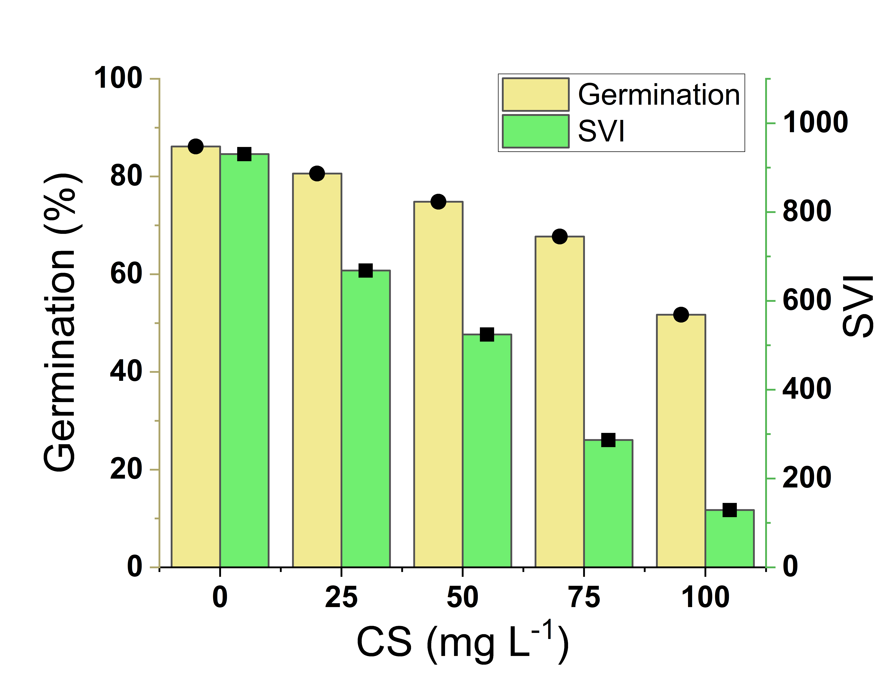

Fig. 3. Effects of chitosan concentration on germination percentage and seed vigour index (SVI).

Control seedlings exhibited the highest shoot length (5.10 ± 0.41 cm) and root length (5.70 ± 0.70 cm). Progressive inhibition of seedling elongation was observed with increasing chitosan concentrations, with the greatest suppression at 100 mg L⁻¹, where shoot length was reduced to 1.16 ± 0.19 cm (~77% inhibition) and root length to 1.34 ± 0.36 cm (~76% inhibition). Tukey's HSD post hoc analysis (Table 1) confirmed that shoot length was significantly lower at all concentrations ≥25 mg L⁻¹ compared with the control (p < 0.05). For root length, significant differences from the control were observed only at concentrations ≥50 mg L⁻¹ (p < 0.05), and the 100 mg L⁻¹ chitosan treatment differed significantly from the 25 and 50 mg L⁻¹ groups (p < 0.05), indicating strong inhibition at the highest concentration. Root growth was markedly affected at elevated doses, indicating susceptibility of root meristematic tissues to chitosan-induced phytotoxicity.
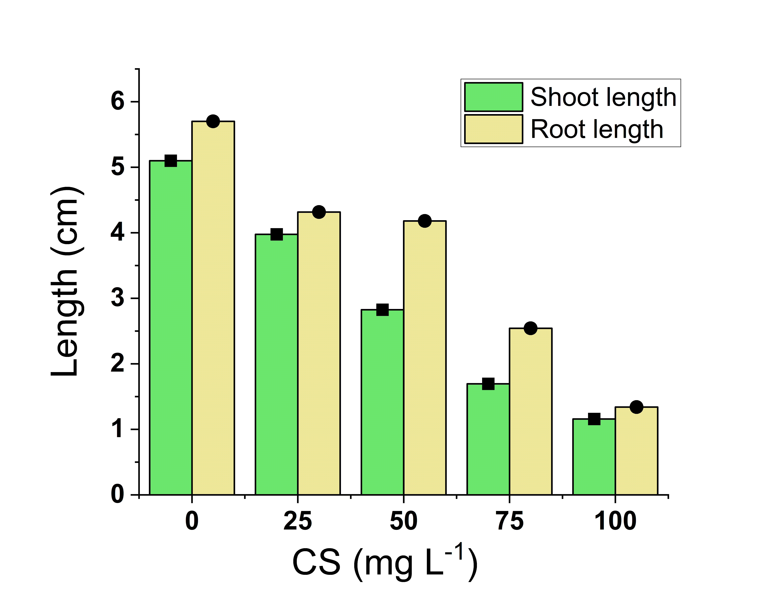

Fig. 4. Effect of chitosan concentration on shoot and root length of mustard seedlings.

Total seedling length declined progressively from 9.67 ± 0.76 cm in the control to 2.50 ± 0.52 cm at 100 mg L⁻¹. Post hoc analysis showed significant differences between the control and all other concentrations, as well as among most individual treatment comparisons; only 25 versus 50 mg L⁻¹ was non-significant (p = 0.59). Germination percentage decreased from 86.15 ± 0.04% in the control to 51.70 ± 0.11% at 100 mg L⁻¹, with each pairwise comparison statistically significant relative to all other groups (p < 0.0001). This reflected very low within-group variance relative to a large between-group effect (F₄,₁₀ = 83,079.64).
Table 1. One-way ANOVA results (F-statistics and p-values) and Tukey's HSD post hoc comparison summary for growth parameters of B. juncea seedlings treated with varying chitosan concentrations.
Parameter | F (4,10) | p-value | Tukey HSD Groupingᵃ
Shoot length (cm) | 28.17 | < 0.001*** | 0 mg/L > 25 mg/L* > {50, 75, 100} mg/Lᵇ (ns among 50–100)
Root length (cm) | 7.40 | 0.005** | 0 mg/L > {50, 75} **; 0 > 100***; 25 vs 100*; 50 vs 100*
Total seedling length (cm) | 46.62 | < 0.001*** | Each pair except 25 vs 50 (p = 0.59) significantly different
Germination (%) | 83,079.64 | < 0.001*** | All pairwise comparisons significant (p < 0.0001)
Significance codes: *** p < 0.001; ** p < 0.01; * p < 0.05; ns = not significant. ᵃ Tukey's HSD (α = 0.05); MSE and df details are given in the statistical appendix. ᵇ Comparisons among 50, 75 and 100 mg/L were non-significant for shoot length.

The seed vigour index (SVI) correspondingly declined from 930.42 in the control to 129.22 at 100 mg L⁻¹, representing a 77% reduction in overall seedling performance. Overall, concentrations ≥50 mg L⁻¹ produced the most marked inhibitory effects on germination and seedling development. A robust dose-response relationship was confirmed for all measured parameters by linear regression (germination percentage: R² = 0.939; total seedling length: R² = 0.994), with all models highly significant (p ≤ 0.007; Table 2). Half-maximal inhibition concentration (IC₅₀) values were estimated as 56.14 mg L⁻¹ for shoot length and 56.22 mg L⁻¹ for SVI, while root length and total seedling length had marginally higher IC₅₀ values of 70.27 mg L⁻¹ and 68.42 mg L⁻¹, respectively. Within the tested concentration range (0–100 mg L⁻¹), germination percentage did not reach 50% inhibition, indicating that germination was relatively more tolerant than post-germination growth parameters.
Table 2. Linear regression parameters, coefficients of determination (R²) and IC₅₀ estimates for the dose-response of B. juncea seedling parameters to chitosan concentration.
Parameter | Slope | Intercept | R² | p-value | IC₅₀ (mg L⁻¹)
Shoot length (cm) | -0.041 | 4.99 | 0.986 | < 0.001*** | 56.14
Root length (cm) | -0.042 | 5.72 | 0.959 | 0.004** | 70.27
Total seedling length (cm) | -0.074 | 9.92 | 0.994 | < 0.001*** | 68.42
Germination (%) | -0.327 | 88.56 | 0.939 | 0.007** | > 100 (not reached)
Seed Vigour Index (SVI) | -7.936 | 904.62 | 0.992 | < 0.001*** | 56.22
Relative root elongation (%) | −0.736 | 100.25 | 0.959 | 0.004** | 70.32
Tolerance index | -0.007 | 1.002 | 0.959 | 0.004** | 70.32
Phytotoxicity (%) | +0.736 | −0.25 | 0.959 | 0.004** | 70.32 (rising)
Model: Y = intercept + slope × [chitosan]. IC₅₀ = estimated concentration (mg L⁻¹) producing 50% inhibition of the control value, derived by linear interpolation. Significance codes: *** p < 0.001; ** p < 0.01.

3.3 Effect of Chitosan on Phytotoxicity and Stress Indices
Phytotoxicity stress indices, relative root elongation (RRE), tolerance index (TI) and percentage phytotoxicity exhibited pronounced concentration-dependent responses (Fig. 5). RRE declined progressively from 100% in the control to 23.52% at 100 mg L⁻¹, while TI decreased correspondingly from 1.000 to 0.235, indicating severe impairment of root growth at higher doses. Conversely, phytotoxicity increased monotonically from 0% in the control to 24.27% at 25 mg L⁻¹ and reached a maximum of 76.48% at 100 mg L⁻¹. For each of these three indices, strong dose-response relationships were confirmed by linear regression (R² = 0.959 for each, p = 0.004; Table 2), with the IC₅₀ for RRE estimated at 70.32 mg L⁻¹. The mathematically inverse relationship between RRE/TI and phytotoxicity is consistent with concentration-dependent suppression of root development.

Table 3. Pearson correlation matrix among all measured and derived growth parameters of B. juncea seedlings across chitosan treatments (n = 15; five concentration levels × three replicates).
 | Shoot L. | Root L. | Total L. | Germ % | SVI | RRE % | Phyto % | TI
Shoot L. | 1.000 | 0.962 | 0.988 | 0.933 | 0.994 | 0.962 | −0.962 | 0.962
Root L. | 0.962 | 1.000 | 0.981 | 0.972 | 0.984 | 1.000 | −1.000 | 1.000
Total L. | 0.988 | 0.981 | 1.000 | 0.972 | 0.991 | 0.981 | −0.981 | 0.981
Germ % | 0.933 | 0.972 | 0.972 | 1.000 | 0.954 | 0.972 | −0.972 | 0.972
SVI | 0.994 | 0.984 | 0.991 | 0.954 | 1.000 | 0.984 | −0.984 | 0.984
RRE % | 0.962 | 1.000 | 0.981 | 0.972 | 0.984 | 1.000 | −1.000 | 1.000
Phyto % | −0.962 | −1.000 | −0.981 | −0.972 | −0.984 | −1.000 | 1.000 | −1.000
TI | 0.962 | 1.000 | 0.981 | 0.972 | 0.984 | 1.000 | −1.000 | 1.000
All correlation coefficients are shown. Diagonal entries (r = 1.000, highlighted in bold) represent self-correlations. Negative correlations are shown in italics. Abbreviations: Shoot L. = shoot length; Root L. = root length; Total L. = total seedling length; Germ % = germination percentage; SVI = seed vigour index; RRE % = relative root elongation; Phyto % = phytotoxicity percentage; TI = tolerance index.

Pearson correlation analysis showed strong interdependencies among the growth-related parameters (r > 0.93; Table 3). Phytotoxicity was negatively correlated with the other indices (r = −0.962 to −1.000), indicating that increasing chitosan concentration systematically reduced growth while proportionally increasing phytotoxic stress. Root length, RRE and TI were perfectly co-correlated (r = 1.000) and inversely correlated with phytotoxicity (r = −1.000), because of the mathematical reciprocity among these derived indices. Strong correlations were observed between SVI and both shoot length (r = 0.994) and total seedling length (r = 0.991), demonstrating the relative uniformity of growth inhibition across all assessed endpoints.
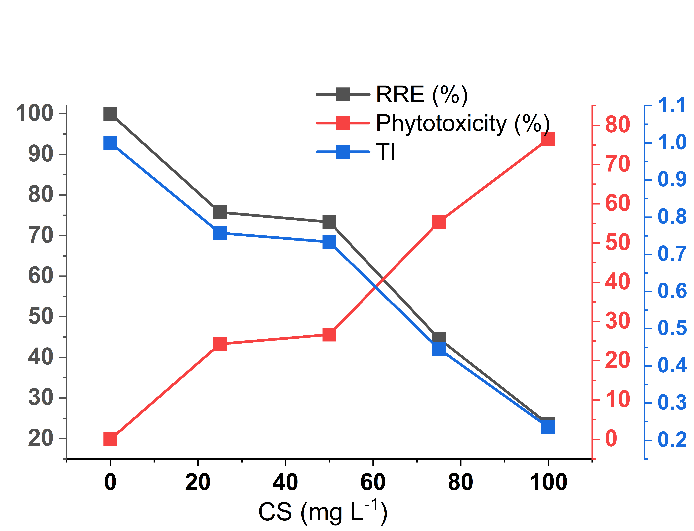

Fig. 5. Effect of chitosan concentration on relative root elongation, tolerance index and phytotoxicity percentage.

3.4 Effect of Chitosan on Biomass Accumulation and Water Content
Chitosan treatment significantly reduced biomass accumulation relative to untreated control seedlings (Fig. 6). Control seedlings recorded the highest fresh biomass (610 ± 0.32 mg) and dry biomass (60 ± 30 mg). At 100 mg L⁻¹, fresh biomass declined to 270 ± 0.02 mg (~56% reduction), and dry biomass declined to 24 ± 0.04 mg (~60% reduction) compared with the control. Similar decreasing patterns were observed for seedling length, germination percentage and SVI with increasing chitosan concentration.
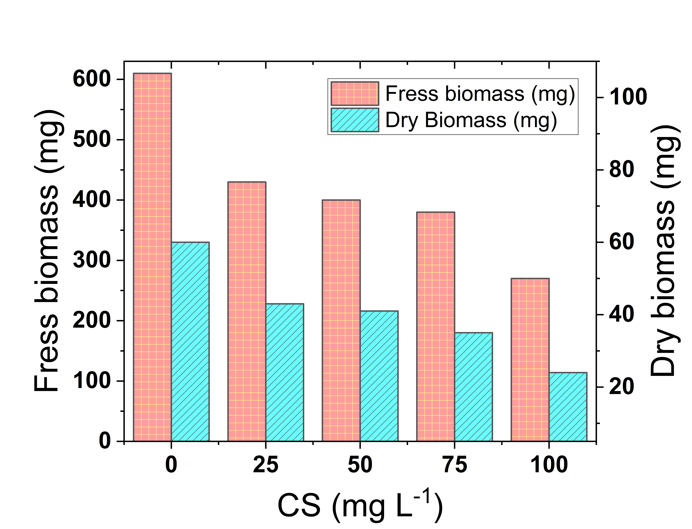

Fig. 6. Influence of chitosan concentration on fresh and dry biomass.

Despite pronounced reductions in total biomass, tissue water content remained relatively stable across all treatments, varying within a narrow range from 89.75% (at 50 mg L⁻¹) to 91.11% (at 100 mg L⁻¹; Fig. 7). The slight inter-treatment variation in water content indicates that growth inhibition was associated with metabolic effects rather than water-deficit stress, while turgor and osmotic control were maintained even at the highest chitosan doses.

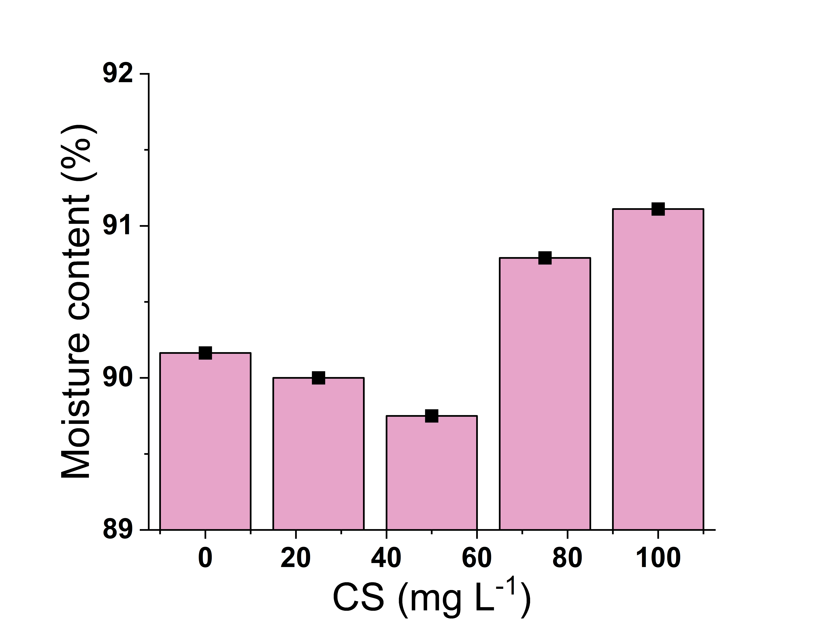

Fig. 7. Influence of chitosan concentration on moisture content.

4. Discussion
The present study demonstrated that shrimp shell-derived chitosan exerted concentration-dependent phytotoxic effects on B. juncea across all measured germination, seedling growth, stress and biomass parameters. Structural characterisation by FTIR (Fig. 2) confirmed successful deacetylation of chitosan, as evidenced by characteristic absorption bands including broad O–H/N–H stretching at 3449 cm⁻¹, C–H stretching at 3233–2888 cm⁻¹ and amine-related vibrations at approximately 1560 cm⁻¹, consistent with bioactive functional groups previously reported (Alimi et al., 2023). The porous, heterogeneous surface morphology observed in SEM analyses (Fig. 1) likely enhanced surface area and seed–polymer interactions, thereby amplifying biological reactivity (Yang et al., 2010; Amaral et al., 2005).
The results confirmed that the inhibitory effects were both statistically significant and systematically structured. One-way ANOVA indicated significant differences among the four tested growth parameters (p < 0.001 for shoot length, total seedling length and germination percentage; p < 0.01 for root length; Table 1). The large F-statistic for germination percentage (F₄,₁₀ = 83,079.64) corresponds to very low within-group variability relative to the robust between-group effect and indicates that chitosan had a repeatable concentration-dependent effect on germination. These results were independently supported by non-parametric Kruskal–Wallis tests (H-statistics: 10.17–13.50, p < 0.05 for all parameters), confirming the robustness of the results across varying distributional assumptions. The strong linear dose-response relationships (R² = 0.939–0.994; Table 2) further confirm a continuous concentration-dependent phytotoxic response.
At 100 mg L⁻¹, germination percentage declined from 86.15% to 51.70%, coinciding with a 77% reduction in SVI (930.42 to 129.22) (Fig. 3). These reductions indicate impairment of early enzymatic activation and reserve mobilisation during germination. Similar inhibitory effects have been documented by Li et al. (2019), who reported that wheat germination was improved by chitosan nanoparticles at low doses (5 µg mL⁻¹) through increased auxin activity. However, this promotive effect was reversed at doses above 50 mg L⁻¹, which is consistent with the IC₅₀ estimates found in the present work (~56–70 mg L⁻¹).
Root elongation was strongly inhibited, with root length declining by ~76% compared with ~77% for shoot length at 100 mg L⁻¹ (Fig. 4). However, Tukey's HSD (Table 1) indicated that shoot length differed significantly from the control at all treatment concentrations (≥25 mg L⁻¹), whereas root length differed significantly from the control only at concentrations ≥50 mg L⁻¹ (p < 0.05). In addition, IC₅₀ estimates suggested marginally higher tolerance for root length (IC₅₀ = 70.27 mg L⁻¹) and RRE (IC₅₀ = 70.32 mg L⁻¹) than for shoot length and SVI (IC₅₀ ≈ 56 mg L⁻¹), which may reflect short-term compensatory responses in roots under mild stress (Table 2). However, the plateau trend in inhibition among high-concentration pairs (50–75–100 mg L⁻¹) suggests that growth can be substantially inhibited within a relatively narrow concentration range.
Lucini et al. (2018) similarly reported that high biopolymer application rates suppressed growth-promoting effects, confirming concentration-dependent and tissue-specific sensitivity.
Phytotoxicity indices provided a quantitative framework for interpreting dose-response toxicity. Linear regression for RRE, TI and phytotoxicity percentage explained substantial variance (R² = 0.959 for each; Table 2), supporting the consistency of the response pattern. Pearson correlation analysis confirmed that phytotoxicity was strongly and negatively correlated with all growth parameters (r = −0.962 to −1.000; Table 3), while all growth-promoting parameters were strongly and positively inter-correlated (r ≥ 0.933). Together, these quantitative relationships indicate that chitosan inhibited biomass accumulation and proportionally enhanced phytotoxic stress. This pattern is consistent with reactive oxygen species (ROS)-mediated oxidative stress at high concentrations, widely accepted as a primary mechanism of growth inhibition by chitosan (Mukarram et al., 2023; Yang et al., 2017; Staszek et al., 2021).
Total biomass reductions (Fig. 6; ~56% in fresh biomass and ~60% in dry biomass at 100 mg L⁻¹) reflect compromised cell expansion, diminished metabolic efficiency and likely diversion of energy resources from growth towards stress-response pathways (Guan et al., 2009). Importantly, tissue water content (Fig. 7) remained stable across all treatments (89.75–91.11%), indicating that growth inhibition operated through metabolic rather than water-deficit mechanisms, consistent with maintained osmotic regulation under polymer stress (Ávila et al., 2023).
In summary, the statistical analyses support a concentration-dependent inhibitory response of B. juncea to chitosan. Lower concentrations produced comparatively weaker inhibition, whereas elevated concentrations ≥50 mg L⁻¹, near or above the estimated IC₅₀ range of 56–70 mg L⁻¹, induced substantial phytotoxicity. This concentration-dependent behaviour, characterised by limited inhibition at lower doses and marked stress at higher doses, is recognised in the chitosan literature (Rico-Chávez et al., 2023; Delgado-Rivera et al., 2026) and emphasises the need for careful dose optimisation when chitosan is used as an agrochemical agent.
4.1 Limitations
The present study was conducted under controlled laboratory conditions using Petri dish bioassays; therefore, the responses observed may not fully represent seedling behaviour under greenhouse or field environments. Only one crop species, B. juncea, and one seedling stage were examined, which limits the wider applicability of the results to other crops or later growth phases. The experiment focused on selected morphological, physiological and statistical indices, while molecular, enzymatic and biochemical mechanisms underlying chitosan-induced inhibition were not directly assessed. The tested concentration range identified clear phytotoxic responses, but intermediate concentrations between 25 and 50 mg L⁻¹ were not included, which restricts precise determination of the lowest inhibitory threshold. In addition, the study did not compare chitosan from different crustacean sources or extraction conditions. Further work under greenhouse and field conditions, with broader crop coverage and mechanistic analyses, would help validate the agricultural relevance of shrimp shell-derived chitosan in practical cultivation systems.
5. Conclusion
This study showed that shrimp shell-derived chitosan possessed characteristic functional groups and a porous, heterogeneous surface morphology, as confirmed by FTIR and SEM analyses. Under in vitro conditions, chitosan exerted clear concentration-dependent effects on mustard seed germination and early seedling growth. The control treatment recorded the highest germination percentage, shoot length, root length and SVI, whereas increasing chitosan concentration progressively suppressed these parameters. At 100 mg L⁻¹, germination declined from 86.15% to 51.70%, SVI decreased from 930.42 to 129.22, and shoot and root lengths were reduced by approximately 77% and 76%, respectively. Stress-related indices also confirmed a strong inhibitory response, with phytotoxicity reaching 76.48%, RRE decreasing to 23.52% and TI falling to 0.235 at the highest concentration. Reductions in fresh and dry biomass further supported the observed suppression of seedling development, while the relatively stable moisture content (89.75–91.11%) suggested that inhibition was not primarily associated with water deficit. Statistical analyses confirmed significant treatment effects and strong dose-response relationships, with IC₅₀ values of approximately 56–70 mg L⁻¹ for key growth parameters. Overall, the findings indicate that shrimp shell-derived chitosan requires careful dose optimisation before use in mustard seed or seedling applications, particularly at concentrations approaching phytotoxic thresholds during initial crop establishment.
Acknowledgements
The authors would like to express their profound gratitude to their families for their steadfast understanding and support during the review process.
Authors' Contributions
The original draft was written and investigated by G. Roy, D. Mondal and S. Mondal. D. Mondal was responsible for final editing, supervision and conceptualisation. The final text has been reviewed and approved by all authors.
Competing Interests
The authors affirm that they have no competing interests.
Disclaimer (Artificial intelligence)
Author(s) hereby declare that NO generative AI technologies such as Large Language Models (ChatGPT, COPILOT, etc.) and text-to-image generators have been used during the writing or editing of this manuscript.

References
- Abo Elsoud, M. M., & El Kady, E. M. (2019). Current trends in fungal biosynthesis of chitin and chitosan. Bulletin of the National Research Centre, 43, 59. DOI: 10.1186/s42269-019-0105-y.
- Afzal, I., Javed, T., Amirkhani, M., & Taylor, A. G. (2020). Modern seed technology: Seed coating delivery systems for enhancing seed and crop performance. Agriculture, 10(11), 526. DOI: 10.3390/agriculture10110526.
- Akram, M., Zahid, M., Farooq, A. B. U., Nafees, M., & Rasool, A. (2020). Effects of different levels of NaCl on the seed germination of Cyamopsis tetragonoloba L. Bangladesh Journal of Botany, 49(3), 625–632. DOI: 10.3329/bjb.v49i3.49995.
- Alimi, B. A., Pathania, S., Wilson, J., Duffy, B., & Celayeta Frias, J. M. (2023). Extraction, quantification, characterization, and application in food packaging of chitin and chitosan from mushrooms: A review. International Journal of Biological Macromolecules, 243, 124195. DOI: 10.1016/j.ijbiomac.2023.124195.
- Amaral, I. F., Granja, P. L., & Barbosa, M. A. (2005). Chemical modification of chitosan by phosphorylation: An XPS, FT-IR and SEM study. Journal of Biomaterials Science, Polymer Edition, 16(12), 1575–1593. DOI: 10.1163/156856205774576736.
- Amiri, H., Aghbashlo, M., Sharma, M., Gaffey, J., Manning, L., Moosavi Basri, S. M., Kennedy, J. F., Gupta, V. K., & Tabatabaei, M. (2022). Chitin and chitosan derived from crustacean waste valorization streams can support food systems and the UN Sustainable Development Goals. Nature Food, 3(10), 822–828. DOI: 10.1038/s43016-022-00591-y.
- Ali, G., Sharma, M., Salama, E.-S., Ling, Z., & Li, X. (2024). Applications of chitin and chitosan as natural biopolymer: Potential sources, pretreatments, and degradation pathways. Biomass Conversion and Biorefinery, 14(4), 4567–4581. DOI: 10.1007/s13399-022-02684-x.
- Ávila, R. G., Magalhães, P. C., Vitorino, L. C., Bessa, L. A., Souza, K. R. D., Queiroz, R. B., et al. (2023). Chitosan induces sorghum tolerance to water deficits by positively regulating photosynthesis and the production of primary metabolites, osmoregulators, and antioxidants. Journal of Soil Science and Plant Nutrition, 23, 1156–1172. DOI: 10.1007/s42729-022-01111-4.
- Bakhsh, M. Z. M., Ikram, M., Ali, A., et al. (2025). Heat stress-induced sterility in oilseed crops: A focus on Brassica napus. Molecular Biology Reports, 52, 652. DOI: 10.1007/s11033-025-10694-x.
- Carrera-Castaño, G., Calleja-Cabrera, J., Pernas, M., Gómez, L., & Oñate-Sánchez, L. (2020). An updated overview on the regulation of seed germination. Plants, 9(6), 703. DOI: 10.3390/plants9060703.
- Chakraborty, M., Hasanuzzaman, M., Rahman, M., Khan, M. A. R., Bhowmik, P., Mahmud, N. U., Tanveer, M., & Islam, T. (2020). Mechanism of plant growth promotion and disease suppression by chitosan biopolymer. Agriculture, 10(12), 624. DOI: 10.3390/agriculture10120624.
- Delgado-Rivera, V. A., Serrano-Fuentes, M. K., Rivera-Villanueva, J. M., Pérez-Sato, J. A., Bello-Bello, J. J., et al. (2026). Chitosan nanoparticles as a biostimulant during in vitro multiplication of vanilla using temporary immersion bioreactors. Molecules, 31(2), 328. DOI: 10.3390/molecules31020328.
- Gairola, K. C., Nautiyal, A. R., & Dwivedi, A. K. (2011). Effect of temperatures and germination media on seed germination of Jatropha curcas Linn. Advances in Bioresearch, 2(2), 66–71.
- Guan, Y. J., Hu, J., Wang, X. J., & Shao, C. X. (2009). Seed priming with chitosan improves maize germination and seedling growth in relation to physiological changes under low temperature stress. Journal of Zhejiang University Science B, 10(6), 427–433. DOI: 10.1631/jzus.B0820373.
- Hamed, I., Özogul, F., & Regenstein, J. M. (2016). Industrial applications of crustacean by-products (chitin, chitosan, and chitooligosaccharides): A review. Trends in Food Science & Technology, 48, 40–50. DOI: 10.1016/j.tifs.2015.11.007.
- Hemmami, H., Ben Amor, I., Ben Amor, A., Zeghoud, S., Ahmed, S., & Alhamad, A. A. (2024). Chitosan, its derivatives, sources, preparation methods, and applications: A review. Journal of the Turkish Chemical Society Section A: Chemistry, 11(1), 341–364. DOI: 10.18596/jotcsa.1336313.
- Hidangmayum, A., Dwivedi, P., Katiyar, D., et al. (2019). Application of chitosan on plant responses with special reference to abiotic stress. Physiology and Molecular Biology of Plants, 25, 313–326. DOI: 10.1007/s12298-018-0633-1.
- Hu, Y., & Yan, Z. (2025). Comprehensive advances in phytochemical components, bioactive functionality, and processing applications of mustard (Brassica juncea (L.) Czern.): A review. Frontiers in Nutrition, 12, 1626333. DOI: 10.3389/fnut.2025.1626333.
- Iber, B. T., Kasan, N. A., Torsabo, D., & Omuwa, J. W. (2022). A review of various sources of chitin and chitosan in nature. Journal of Renewable Materials, 10(4), 1097–1123. DOI: 10.32604/jrm.2022.018142.
- Islam, M. M., Haque, M. S., & Sarwar, A. K. M. G. (2019). Salt tolerance of cowpea genotypes during seed germination and seedling growth. Journal of Bangladesh Agricultural University, 17(1), 39–44. DOI: 10.3329/jbau.v17i1.40661.
- Karn, N., Saini, N., Kumar, A., Nautiyal, D., & Prasad, R. (2025). Sustainable practices in mustard [Brassica juncea (L.) Czem] farming: A comprehensive review. Journal of Agricultural Sciences – Sri Lanka, 20(3), 526–534. DOI: 10.4038/jas.v20i3.11104.
- Kumari, S., & Kishor, R. (2020). Chitin and chitosan: Origin, properties, and applications. In S. Ahmed & S. Ikram (Eds.), Handbook of Chitin and Chitosan: Vol. 1. Preparation and Properties (pp. 1–33). Elsevier. DOI: 10.1016/B978-0-12-817970-3.00001-8.
- Kushwaha, S. S., Singh, H., Singh, A., et al. (2026). A comprehensive review on modern pre-treatments and emerging technologies for seed germination. Discover Agriculture, 4, 102. DOI: 10.1007/s44279-026-00548-w.
- Lalarukh, Hussain, S. M., Ali, S., et al. (2024). Innovation of advanced polymers from seafood waste: Applications of chitin and chitosan. Polymer Advanced Technologies, 35(6), e6471. DOI: 10.1002/pat.6471.
- Li, J., Lens, P. N. L., Ferrer, I., & Du Laing, G. (2021). Evaluation of selenium-enriched microalgae produced on domestic wastewater as biostimulant and biofertilizer for growth of selenium-enriched crops. Journal of Applied Phycology, 33, 3027–3039. DOI: 10.1007/s10811-021-02523-y.
- Li, R., He, J., Xie, H., Wang, W., Bose, S. K., Sun, Y., et al. (2019). Effects of chitosan nanoparticles on seed germination and seedling growth of wheat (Triticum aestivum L.). International Journal of Biological Macromolecules, 126, 91–100. DOI: 10.1016/j.ijbiomac.2018.12.118.
- López-Bermúdez, L. S., Quintana-Obregón, E. A., Rosas-Burgos, E. C., Gálvez-Iriqui, A. C., Gutiérrez-Martínez, P., Lizardi-Mendoza, J., et al. (2024). Acute phytotoxicity and antifungal effect of nanochitosan particles on Colletotrichum fructicola with low susceptibility to chitosan. Current Microbiology, 81, 445. DOI: 10.1007/s00284-024-03909-0.
- Lucini, L., Rouphael, Y., Cardarelli, M., Bonini, P., Baffi, C., & Colla, G. (2018). A vegetal biopolymer-based biostimulant promoted root growth in melon while triggering brassinosteroids and stress-related compounds. Frontiers in Plant Science, 9, 472. DOI: 10.3389/fpls.2018.00472.
- Maliki, S., Sharma, G., Kumar, A., Moral-Zamorano, M., Moradi, O., Baselga, J., Stadler, F. J., & García-Peñas, A. (2022). Chitosan as a tool for sustainable development: A mini review. Polymers, 14(7), 1475. DOI: 10.3390/polym14071475.
- Miransari, M., & Smith, D. L. (2014). Plant hormones and seed germination. Environmental and Experimental Botany, 99, 110–121. DOI: 10.1016/j.envexpbot.2013.11.005.
- Mukarram, M., Ali, J., Dadkhah-Aghdash, H., Kurjak, D., Kačík, F., & Ďurkovič, J. (2023). Chitosan-induced biotic stress tolerance and crosstalk with phytohormones, antioxidants, and other signalling molecules. Frontiers in Plant Science, 14, 1217822. DOI: 10.3389/fpls.2023.1217822.
- Muthu, M., Gopal, J., Chun, S., Devadoss, A. J. P., Hasan, N., & Sivanesan, I. (2021). Crustacean waste-derived chitosan: Antioxidant properties and future perspective. Antioxidants, 10(2), Article 228. DOI: 10.3390/antiox10020228.
- Nasirov, F. A., Abbasov, V. M., Suleymanova, E. M., Aslanbeyli, A. M., & Ahmedova, S. Z. (2023). Chitin and chitosan–Biopolymer materials of the 21st century. Processes of Petrochemistry and Oil Refining, 24(4), 778–824. DOI: 10.36719/1726-4685/96/778-824.
- Parađiković, N., Teklić, T., Zeljković, S., Lisjak, M., & Špoljarević, M. (2019). Biostimulants research in some horticultural plant species—A review. Food and Energy Security, 8(2), e00162. DOI: 10.1002/fes3.162.

- Panjabi, P., Yadava, S. K., Kumar, N., Bangkim, R., & Ramchiary, N. (2019). Breeding Brassica juncea and B. rapa for sustainable oilseed production in the changing climate: Progress and prospects. In C. Kole (Ed.), Genomic Designing of Climate-Smart Oilseed Crops. Springer. DOI: 10.1007/978-3-319-93536-2_6.
- Rani, A. (2025). Effect of vermicompost-to-soil ratios on mung bean seed germination and growth. World Journal of Advanced Studies, 1(1), 17–23.
- Reed, R. C., Bradford, K. J., & Khanday, I. (2022). Seed germination and vigor: Ensuring crop sustainability in a changing climate. Heredity, 128, 450–459. DOI: 10.1038/s41437-022-00497-2.
- Rico-Chávez, A. K., Pérez-Ramírez, I. F., Escobar-Ortíz, A., Feregrino-Pérez, A. A., Torres-Pacheco, I., & Guevara-González, R. G. (2023). Hormetic elicitation of phthalides in celery seeds (Apium graveolens L. var. dulce) and its effect on seedling development. Industrial Crops and Products, 202, 117022. DOI: 10.1016/j.indcrop.2023.117022.
- Saberi Riseh, R., Gholizadeh Vazvani, M., Vatankhah, M., & Kennedy, J. F. (2024). Chitosan coating of seeds improves the germination and growth performance of plants: A review. International Journal of Biological Macromolecules, 278(Part 4), 134750. DOI: 10.1016/j.ijbiomac.2024.134750.
- Shu, K., Meng, Y. J., Shuai, H. W., Liu, W. G., Du, J. B., Liu, J., & Yang, W. Y. (2015). Dormancy and germination: How does the crop seed decide? Plant Biology, 17(6), 1104–1112. DOI: 10.1111/plb.12356.
- Staszek, P., Krasuska, U., Ciacka, K., & Gniazdowska, A. (2021). ROS metabolism perturbation as an element of mode of action of allelochemicals. Antioxidants, 10(11), 1648. DOI: 10.3390/antiox10111648.
- Verma, L., & Pandey, N. (2017). The effect of iron toxicity on seed germination and early seedling growth of green gram (Vigna radiata L. Wilczek). International Journal of Science and Research, 6(8), 1427–1428.
- Yang, B., Li, X., Shi, S., Kong, X., Guo, G., Huang, M., et al. (2010). Preparation and characterization of a novel chitosan scaffold. Carbohydrate Polymers, 80(3), 860–865. DOI: 10.1016/j.carbpol.2009.12.044.
- Yang, J., Cao, W., & Rui, Y. (2017). Interactions between nanoparticles and plants: Phytotoxicity and defense mechanisms. Journal of Plant Interactions, 12(1), 158–169. DOI: 10.1080/17429145.2017.1310944.
- Zahedi, S., Safaei Ghomi, J., & Shahbazi-Alavi, H. (2018). Preparation of chitosan nanoparticles from shrimp shells and investigation of its catalytic effect in diastereoselective synthesis of dihydropyrroles. Ultrasonics Sonochemistry, 40(Pt A), 260–264. DOI: 10.1016/j.ultsonch.2017.07.023.
- Baisakhi, B., Pradhan, J., Das, B. K., Jena, K., Mohanty, D., Ananta, S., Khatun, S., Akhtar, J., Paital, B., & Pati, S. G. (2025). Pnaeus monodon shell waste-derived chitosan nanoparticles show biocompatibility and broad antimicrobial activity. Scientific Reports, 15, 44157. https://doi.org/10.1038/s41598-025-27492-x
- The jamovi project. (2024). jamovi (Version 2.3) [Computer software]. https://www.jamovi.org

