Original Research Article

Assessment of physico-chemical parameters of Shivaganga river in Pune, Maharashtra

Abstract :
The present investigation was undertaken to evaluate the physico-chemical characteristics and overall water quality status of the Shivaganga River in Pune district, Maharashtra. A spatial assessment-based observational study was carried out on river water samples collected from selected sampling sites, namely Khed Shivapur, Khopi and Kelawade, during November 2022 to October 2023 using standard analytical procedures recommended by American Public Health Associations (APHA, 2017). Physical parameters such as temperature, turbidity, electrical conductivity, total dissolved solids and salinity were measured using standard pocket friendly instrument. Chemical parameters including pH, dissolved oxygen (DO), biological oxygen demand (BOD), chemical oxygen demand (COD), total hardness, alkalinity, chlorides, sulphates, phosphates, nitrates and fluorides were analyzed using standard titrimetric and spectrophotometric methods and represented by graphical and tabular formats. Water temperature ranged from 25.11°C to 30.11°C, while pH remained slightly alkaline throughout the study period. Dissolved oxygen concentrations indicated comparatively healthy aquatica conditions; however, lower DO values were observed during summer season months. Elevated turbidity, electrical salinity, BOD, COD values were recorded particularly at Kelawade site, suggesting localized anthropogenic influence and increased organic load. Nutrient such as nitrates and phosphates remained comparatively low, although slightly higher concentrations were observed at downstream stations. Fluorides and sulphates remained within permissible freshwater limits throughout the study period. Thus, Shivaganga River maintains moderately good water quality with relatively stable physico-chemical characteristics. However, increasing anthropogenic activities such as agricultural runoff, domestic wastewater discharge and human interference may gradually influence the ecological health of the river. Among the study sampling sites, Kelawade exhibited comparatively higher pollution-related parameters, indicating greater environmental stress. Continuous monitoring and sustainable management practices are therefore essential for conservation and long-term ecological sustainability of Shivaganga River.
Keywords : Shivaganga River, physico-chemical parameters, freshwater ecosystem. Water quality assessment, Pune district, Maharashtra.
Introduction
Freshwater ecosystems sustain biodiversity while driving agriculture, industries and ecological services. Particularly, riverine systems play a significant role in sustaining human civilization with these purposes (Allan and Castillo,2007). Yet, global river water quality is deteriorating due to rapid urbanization, industrialization, agricultural modernization and anthropogenic disturbances. The physico-chemical parameters of river water are widely used to evaluate the environmental conditions and ecological health of aquatic ecosystems. Parameters such as temperatures, pH, dissolved oxygen, turbidity, conductivity, total dissolved solids, hardness alkalinity, chlorides, nitrates, phosphates, sulphates and fluoride directly influence aquatic metabolism (Dodds and Whiles, 2020). Consequently, tracking river physico-chemical traits is important to assess aquatic health and ensure sustainable water management. Despite their ecological and socio-economic importance, Indian river systems are subjected to have vulnerable water quality due to anthropogenic activities (Botle et al., 2023). Maharashtra is among the rapidly developing states of India, where increasing urbanization and land-use transformation have substantially influenced river ecosystems. According to Maharashtra Pollution Control Board (MPCB), multiple rivers stretch in the state have been categorized under Priority I to Priority V polluted river stretches based on the water quality deterioration and organic pollution levels. Major polluted rivers include Godavari River, Mula River, Mutha River, Bhima River, Indrayani River, Panchganga River and Ulhas River. Rivers flowing through semi-urban and agricultural regions of Pune district are particularly vulnerable to ecological stress caused by domestic wastewater discharge, sand extraction, agricultural inputs and hydrological modifications (Sawant et al., 2023). Shivaganga river is one of important sub-tributary of River Krishna in Pune district, serves vital resources for nearby villages and agricultural areas (Central Pollution Control Board [CPCB], 2022). Hence, present study aims to evaluate the physio-chemical characteristics of the Shivaganga River, by analyzing selected water quality parameters to determine overall water quality status of the river.
Materials and Methods:
Study Sites :
Figure 1 showing geospatial map of Shivaganga River. For present study, after surveying various locations, three sampling sites namely – Site-1- Khed Shivapur (Latitude: 18⁰20’9.8268” N Longitude: 73⁰50’11.9472” E), Site-2- Khopi (Latitude: 18⁰19’28.0524” N Longitude: 73⁰50’36.6864” E) and Site-3- Kelawade (Latitude: 18⁰16’25.4028” N Longitude: 73⁰52’2.082” E) in Figure 2,3, and 4; were selected and monitored throughout the year, from November 2022 to October 2023 on Shivaganga River.
Water Samples collection :
Water samples were collected in every first week of a month from selected sampling sites in 5 litres plastic cans for the analysis of physico-chemical parameters during the study period (APHA, 2017). The parameters like temperature and pH were recorded on sites, while for dissolved oxygen, biological oxygen demand and chemical oxygen demand parameters, the dissolved oxygen was fixed at respective sites in BOD bottles as per protocols (APHA, 2017) and carried to research laboratory in ice-box container.
Assessment of water samples :
Physical parameter such as temperature of water (°C) was measured in situ at each sampling site using a standard mercury thermometer with a range of 0-100°C. Turbidity (NTU), Electrical conductivity (mS/cm), Total Dissolved Solids (mg/l), and Salinity (ppt) was measured by using Systronic Water Analyzer Model No. 371.
Chemical Parameters like pH was recorded at collection sites by using pocket friendly digital pH meter (OAKTON Multi parameter probe). Dissolved Oxygen (DO) was determined using the modified Wrinkler’s method, Biological Oxygen Demand (BOD) was estimated by standard 5 days Incubation method, while Chemical Oxygen Demand was determined by ferrous ammonium sulphate titration method and their results are expressed in terms of mg/l. Total Hardness was estimated by using Systronic Water Analyzer Model No. 371. Total Alkalinity was determined by Sulfuric acid titration method. Chloride concentration in the water samples was determined by silver nitrate titration method. Sulphate concentration in the water samples was determined by the barium chloride titration method. Phosphate concentration in the water samples was determined by the Stannous chloride method. Nitrate concentration was determined by the Brucine method. Fluoride concentration in the water samples was determined by the Zirconium- alizarin spectrophotometric method and their results are expressed in mg/l. Collected data were statistically analyzed and represented by using graphical and tabular formats.
Results :
The present investigation revealed moderate spatial variation in the physico-chemical characteristics of the Shivaganga River, indicating the combined influence of natural processes and anthropogenic activities on river water quality. Most of the analyzes parameters remained within permissible freshwater limits, suggesting that the river ecosystem is comparatively stable; however localized increases in pollution-related parameters were evident at certain sampling sites, particularly at Site – 3 (Kelawade). This might be because of Kelawade site is most accessible site among the all-sampling sites. Clothes washing, cattle cleaning, adjacent crematorium place might pollute the Kelawade site and alters water parameters.
Water temperature remained relatively uniform throughout the study area, reflecting regional climatic conditions and seasonal stability. Average peaked value of temperature was observed at Kelawade site followed by Khopi and Khed Shivapur site (Table 1). May-month of summer season at Khopi site showed highest temperature among all sampling sites (Figure 5A). All sampling sites were showing slightly elevated turbidity levels but comparatively higher turbidity values were recorded at Kelawade (Table 1) during Monsoon months (Figure 5B). Similar trend was recorded in electrical conductivity (Table 1) and its higher value were recorded in the June of summer season (Figure 5C) at Kelawade followed by Khopi. Mean annual Total dissolved solids at all sampling sites were within the permissible limits but Kelawade site showed averaged TDS than the other two site (Table 1). In between the late summer to mid monsoon, TDS values remained high at all sampling locations (Figure 5D). Lowest salinity of water was recorded at Khed Shivapur (Table 1) while Kelawade site showed elevated salinity throughout the study period (Figure 5E). Under chemical parameters assessment, the slightly alkaline pH observed across all sites (Table 1). July to October months showed above averaged values of pH at all sampling sites maintaining alkaline nature of river water (Figure 6F), indicates favorable environmental conditions for freshwater biota and may be associated with bicarbonate buffering and geological characteristics of the river basin. Dissolved oxygen concentration remained within acceptable limits at all sampling stations (Table 1), indicating relatively healthy oxygen conditions in the river. May month of summer showed relatively lowest DO values followed by June and October (Figure 6G). Biological oxygen demand (BOD) was relatively constant throughout study period at all water sampling sites (Table 1). At Kelawade site, a higher demand of oxygen was observed during summer season (Figure 6H). Lower BOD value was recorded at Kelawade site.
Chemical oxygen demand (COD) values showed similar trend to BOD values (Table 1). Least COD levels were observed in January month at Khed Shivapur site, whereas moderate values at Khopi site was recorded and Kelawade site showed highest COD values (Figure 6I) in the June of summer. Moderate alterations in Total hardness are observed at all sampling sites (Table 1). Khopi site exhibited lowest total hardness in November, whereas its higher value was recorded in May of summer at Kelawade site (Figure 6J). Total alkalinity showed great buffering capacity of river water throughout the year (Figure 6K). Average total alkalinity at Khed Shivapur and Khopi were similar while, Kelawade site showed slightly increased values (Table 1). Chloride values at Kelawade sampling sites showed elevation throughout the year (Figure 3). Khed Shivapur was showing lowest Chlorides while Kelawade showed highest Chloride values in July (Figure 7L). Sulphates values were averaged at Khopi sampling sites (Table1). Increased Sulphates were observed at all Site during summer season. all sampling sites during winter months (Figure 7M). Highest phosphate levels were observed at Kelawade whereas, lowest values are recorded at Khed Shivapur site (Table 1). While Average phosphate values are recorded at Khopi Site in January month (Figure 7N). Nutrients such as nitrates and fluorides were remained low throughout the sampling sites. Increasing concentration of nitrates and fluorides from upstream to downstream were recorded. Whereas, Kelawade Site showed highest value of nitrates and Khe Shivapur were exhibited lower values of nitrates (Table 1). All sites showed elevated nitrate values during monsoon (Figure 7O). Low fluorides concentrations were recorded at all sampling sites (Table 1). Comparatively stable values were observed throughout the year at all sampling stations (Figure 7P).
Discussion
The assessment of physico-chemical parameters of Shivaganga River revealed moderate spatial variations in the water quality among selected sampling sites, namely, Khed Shivapur, Khopi and Kelawade. The observed fluctuations in the water quality characteristics appear to be associated with seasonal hydrological changes, geological composition of the river basin, agricultural runoff and localized anthropogenic disturbances. Similar observations have been reported from several Indian river systems influenced by urbanization and agricultural activities (Keerthan et al., 2023; Setia al., 2024). Temperature is considered one of the fundamental ecological variables regulating chemical reactions, dissolved oxygen concentration, microbial metabolism and aquatic productivity (Wetzel., 2001; Boyd, 2015). In the present study, water temperature exhibited comparatively narrow fluctuations among the sampling stations, suggesting relatively stable climatic conditions throughout the study period. Slightly higher temperatures recorded at downstream locations may be associated with reduced riparian vegetation and increased exposure to solar radiation. Similar temperature trends have been documented in tropical freshwater rivers of India (Trivedy and Goel, 1986; Rajaram and Das, 2008). Turbidity values were moderately elevated, particularly at Kelawade, which may be attributed to surface runoff, domestic activities and agricultural disturbances near the riverbank. Increased turbidity is known to reduce light penetration, limit photosynthetic activity and adversely affect aquatic organisms (Chapman, 1996). Similar increases in turbidity have been observed in rivers receiving catchment runoff and anthropogenic inputs during seasonal flow variations (Mishra and Tripathi, 2008; Singh et al., 2005). Electrical conductivity and total dissolved solids showed moderate values across all sampling stations, indicating the presence of dissolved inorganic ions derived from weathering processes and human activities. Increased conductivity reflects increased ionic concentration associated with sewage discharge, fertilizer runoff and mineral dissolution (Hem, 1985). The comparatively higher conductivity recorded at Kelawade may therefore indicate greater anthropogenic influence in downstream stretches of river. Similar findings were reported from the Mithi River and other urban freshwater systems in Maharashtra (Zaware et al., 2014). Increased salinity at Kelawade site may attributed to increased dissolved ionic content from domestic wastewater input, evaporation during summer months.
The pH values remained within slightly alkaline range at all sampling sites, indicating favorable conditions for freshwater biota. Alkaline pH in freshwater systems is commonly associated with bicarbonate buffering capacity, carbonate-rich geological formations and photosynthetic activities (APHA, 2017). Comparable alkaline conditions have been reported in the Godavari, Krishna and Mula-Mutha river systems of Maharashtra (Pote et al., 2012; Kharake et al., 2021). The stable pH range observed during the present study suggests that the Shivagnga River maintains adequate buffering capacity against acidic fluctuations. Dissolved oxygen concentration remained within acceptable limits, indicating relatively healthy oxygen conditions in the river, moderate aeration and comparatively healthy aquatic environment. Lower DO values at certain periods may be associated with increased microbial decomposition and elevated organic load. Similar relationships between dissolved oxygen depletion and organic pollution have been described in tropical river ecosystems (Wetzel, 2001; Sharma and Kansal, 2011). However, elevated BOD and COD values at some locations suggest moderate organic pollution arising from decomposition of organic matter and discharge of domestic waste (Jain et al., 2010). Kelawade site may therefore reflect greater anthropogenic pressure compared to other sampling sites. Higher BOD and COD levels generally indicate increased microbial activity and organic enrichment in freshwater ecosystems (Sharma and Kansal, 2011). The elevated BOD values reflect greater microbial oxygen consumption, whereas increased COD indicates higher concentrations of oxidizable organic and inorganic substances (Metcalf and Eddy, 2003). Comparable observations have been documented in polluted stretches of Indian rivers subjected to anthropogenic stress (Singh et al., 2004; Kumar and Puri, 2012). Total hardness and alkalinity values in the present study classify the river water as moderate hard, which are commonly associated with calcium and magnesium salts originating from geological weathering (Sawyer et al., 2003). Similarly, alkalinity indicate moderate buffering capacity of the river water. Increased alkalinity at downstream region may result from bicarbonate accumulation due to runoff and mineral dissolution. Similar hardness and alkalinity patterns have been reported from rivers in western Maharashtra and other tropical freshwater ecosystems (Karne and Kulkarni, 2009). Chloride concentrations were comparatively higher at Kelawade, possibly due to domestic wastewater discharge and agricultural runoff. Chlorides are commonly used as indicators of anthropogenic contamination in fresh water systems (WHO, 2017). Although the recorded chloride levels remained within permissible limits, and gradual increases may indicate riding human interference in the river basin. Sulphate concentration remained comparatively low throughout the study period, indicating minimal industrial influence and low sulphate mineral dissolution. Nutrient parameters such as phosphates and nitrates were present in loa concentrations; however, slightly elevated nutrient levels at downstream sites may indicate fertilizer leaching from surrounding agricultural fields. Even minor increases in nutrient concentration may contribute to eutrophication and algal proliferation under suitable environmental conditions (Carpenter, 2008). Fluoride and sulphate concentrations remained low throughput the study period and were well within permissible limits, suggesting minimal industrial contamination and predominantly natural geogenic origin. The increasing concentration of nitrates and fluorides from upstream to downstream suggests the cumulative effect of agricultural runoff, sewage and domestic waste, cattle wastes, prolonged water- rock interactions and fertilizers residues (Avtar et al., 2013). Similar fluoride concentrations have been reported in freshwater ecosystems of Maharashtra influenced primarily by natural lithological conditions (Ravindra and Garg, 2007).
Conclusion :
Overall, the findings indicate that the Shivaganga River maintains moderately good water quality, although increasing anthropogenic activities in the surrounding region may gradually influence the ecological health of the river ecosystem. Relatively stable physico-chemical characteristics have been recorded. However, increasing trends in turbidity, BOD and COD, at certain locations indicate localized anthropogenic pressure. Among the study sites, Kelawade exhibited comparatively higher concentrations of pollution-related parameters, suggesting greater environmental stress due to agricultural runoff and human activities such as clothes washing, cattle cleaning, funeral ash wash off etc. Continuous monitoring and sustainable management practices are therefore necessary to prevent further deterioration of water quality and to conserve the freshwater resources of the river basin.

Disclaimer (Artificial intelligence)

Author(s) hereby declare that NO generative AI technologies such as Large Language Models (ChatGPT, COPILOT, etc.) and text-to-image generators have been used during the writing or editing of this manuscript.

References :
- Allan, J. D., & Castillo, M. M. (2007). Stream ecology: Structure and function of running waters (2nd ed.). Springer. https://doi.org/10.1007/978-1-4020-5583-6
- American Public Health Association (APHA). (2017). Standard methods for the examination of water and wastewater (23rd ed.). APHA.
- Avtar, R., Kumar, P., Surjan, A., Gupta, L. N., & Roychowdhury, K. (2013). Geochemical processes regulating groundwater chemistry with special reference to nitrate and fluoride enrichment in Chhatarpur area, Madhya Pradesh, India. Environmental Earth Sciences, 70(4), 1699–1708. https://doi.org/10.1007/s12665-013-2257-7
- Botle, A., Salgaonkar, S., Tiwari, R., Ambadekar, S., & Barabde, G. R. (2023). Brief status of contamination in surface water of rivers of India by heavy metals: A review with pollution indices and health risk assessment. Environmental Geochemistry and Health, 45, 2779–2801. https://doi.org/10.1007/s10653-022-01463-x
- Boyd, C. E. (2015). Water quality: An introduction. Springer. https://doi.org/10.1007/978-3-319-17446-4
- Carpenter, S. R., Caraco, N. F., Correll, D. L., Howarth, R. W., Sharpley, A. N., & Smith, V. H. (1998). Nonpoint pollution of surface waters with phosphorus and nitrogen. Ecological Applications, 8(3), 559–568. https://doi.org/10.1890/1051-0761(1998)008[0559:NPOSWW]2.0.CO;2
- Central Pollution Control Board. (2022). River water quality monitoring in India: Annual report. Ministry of Environment, Forest and Climate Change, Government of India.
- Chapman, D. (1996). Water quality assessments: A guide to the use of biota, sediments and water in environmental monitoring (2nd ed.). UNESCO/WHO/UNEP.
- Dodds, W. K., & Whiles, M. R. (2020). Freshwater ecology: Concepts and environmental applications of limnology (3rd ed.). Academic Press.
- Hem, J. D. (1985). Study and interpretation of the chemical characteristics of natural water (3rd ed.). U.S. Geological Survey Water-Supply Paper 2254.
- Jain, C. K., Bandyopadhyay, A., & Bhadra, A. (2010). Assessment of ground water quality for drinking purpose, District Nainital, Uttarakhand, India. Environmental Monitoring and Assessment, 166, 663–676. doi- 10.1007/s10661-009-1031-5
- Keerthan, L. L., RamyaPriya, R. R., & Elango, L. (2023). Geogenic and anthropogenic contamination in river water and groundwater of the lower Cauvery Basin, India. Frontiers in Environmental Science, 11, 1001052. https://doi.org/10.3389/fenvs.2023.1001052
- Kharake A., and Raut V. (2021). Assessment of water quality index of Godavari River water in Nashik city, Maharashtra. Applied Water Science, 11, 1–13. https://doi.org/10.1007/s13201-021-01432-2
- Kumar, A., & Puri, A. (2012). A review of permissible limits of drinking water. Indian Journal of Occupational and Environmental Medicine, 16(1), 40–44. https://doi.org/10.4103/0019-5278.99696
- Metcalf & Eddy. (2003). Wastewater engineering: Treatment and reuse (4th ed.). McGraw-Hill.
- Mishra, A., & Tripathi, B. D. (2008). Seasonal and temporal variations in physico-chemical and bacteriological characteristics of River Ganga in Varanasi. International Journal of Environmental Research, 2(1), 13–18.
- Sawant, R., Joshi, D. A., & Menon, R. (2023). Case study on river pollution of Pune city and waste management. Evergreen, 10(4), 2620–2631. https://doi.org/10.5109/7160918
- Karne A. V., & Kulkarni P. D. (1995). Studies on Physico-Chemical Characteristics of Freshwater Bodies in Khatav Tahsil, Maharashtra. Nature Environment and Pollution Technology, 8(2), 247–251.
- Pote, S. E., Singal, S. K., & Srivastava, D. K. (2012). Assessment of surface water quality of Godavari River at Aurangabad. Asian Journal of Water, Environment and Pollution, 9(1), 87–91. DOI:10.3233/AJW-2012-9_1_14
- Rajaram, T., & Das, A. (2008). Water pollution by industrial effluents in India: Discharge scenarios and case for participatory ecosystem specific local regulation. Futures, 40(1), 56–69. DOI:10.1016/j.futures.2007.06.002
- Ravindra, K., & Garg, V. K. (2007). Hydro-chemical survey of groundwater of Hisar city and assessment of defluoridation methods used in India. Environmental Monitoring and Assessment, 132, 33–43. https://doi.org/10.1007/s10661-006-9500-6
- Sawyer, C. N., McCarty, P. L., & Parkin, G. F. (2003). Chemistry for environmental engineering and science (5th ed.). McGraw-Hill.
- Sharma, D., & Kansal, A. (2011). Water quality analysis of River Yamuna using water quality index in the national capital territory, India. Applied Water Science, 1(3–4), 147–157. https://doi.org/10.1007/s13201-011-0011-4
- Singh, K. P., Malik, A., Mohan, D., & Sinha, S. (2004). Multivariate statistical techniques for the evaluation of spatial and temporal variations in water quality of Gomti River (India). Water Research, 38(18), 3980–3992. https://doi.org/10.1016/j.watres.2004.06.011
- Singh, M. R., Gupta, A., & Beeteswari, K. H. (2005). Physico-chemical properties of water samples from Manipur River system. Indian Journal of Environmental Protection, 25(7), 617–623.
- Smith, V. H., Tilman, G. D., & Nekola, J. C. (1999). Eutrophication: Impacts of excess nutrient inputs on freshwater, marine, and terrestrial ecosystems. Environmental Pollution, 100(1–3), 179–196. https://doi.org/10.1016/S0269-7491(99)00091-3
- Trivedi, R. K., & Goel, P. K. (1986). Chemical and biological methods for water pollution studies. Environmental Publications.
- Wetzel, R. G. (2001). Limnology: Lake and river ecosystems (3rd ed.). Academic Press.
- World Health Organization. (2017). Guidelines for drinking-water quality (4th ed.). Geneva, Switzerland.
- Zaware, A. V., Kaur, S., & Kumar, R. (2014). Assessment of spatio-temporal variations in physico-chemical characteristics of Mithi River water quality of Mumbai, India. In Proceedings of International Conference on Environmental Issues and Sustainable Development. https://doi.org/10.13140/RG.2.1.3837.3526
- Setia, R., Lamba, S., Chander, S., Kumar, V., Singh, R., Litoria, P. K., & Singh, R. P. (2021). Spatio-temporal variations in water quality, hydrochemistry and its controlling factors in a perennial river in India. Applied Water Science, 11, 169. https://doi.org/10.1007/s13201-021-01504-3

Figures :
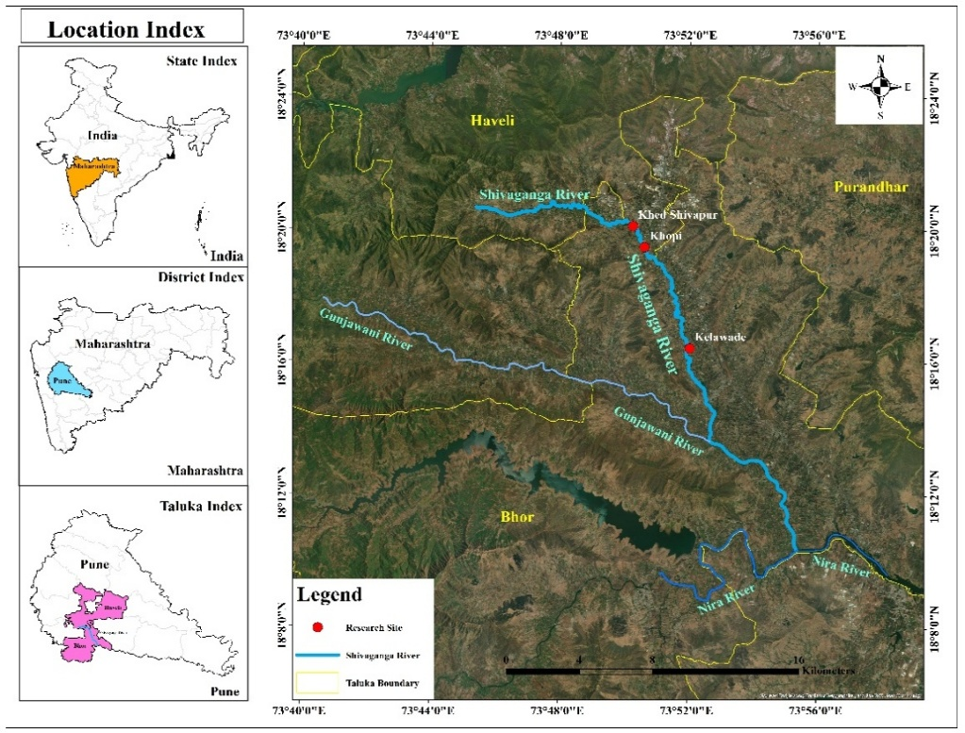
Figure 1: Geospatial map showing sampling sites on Shivaganga River, Pune
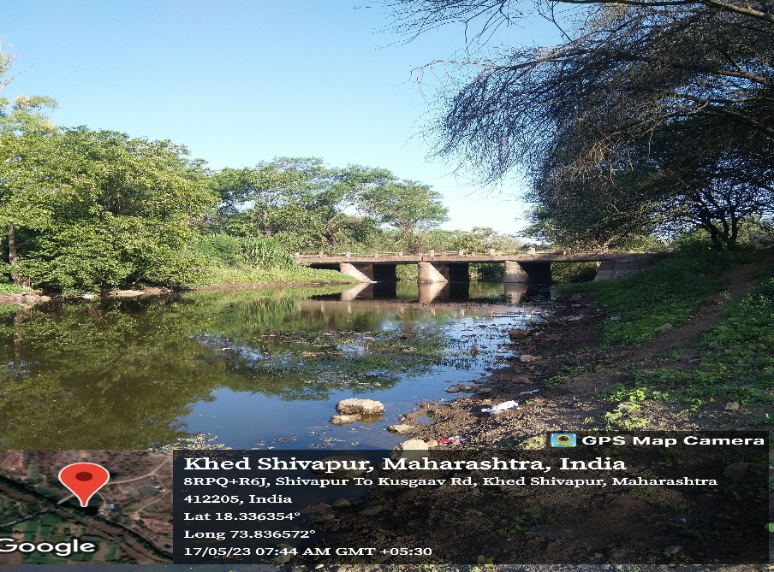
Figure 2 Site No. 1 – Khed-Shivapur
(Latitude: 18⁰20’9.8268” N Longitude: 73⁰50’11.9472” E)

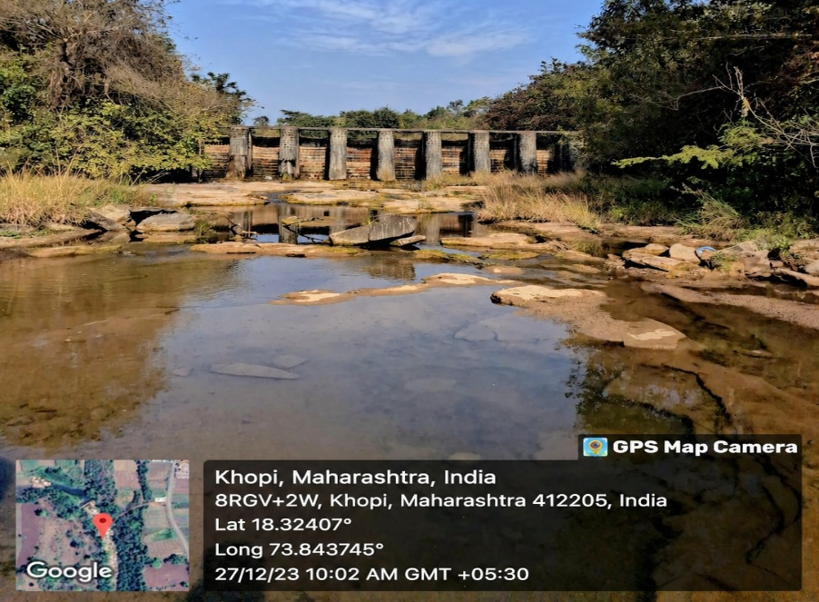
Figure 3 Site No. 1 – Khopi
(Latitude: 18⁰19’28.0524” N Longitude: 73⁰50’36.6864” E)
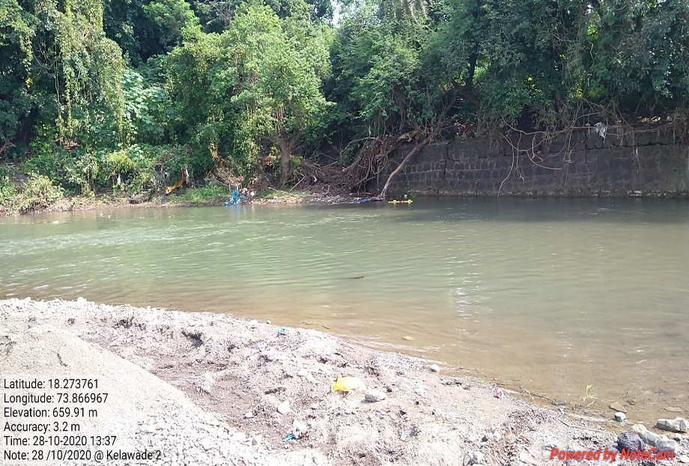
Figure 4 Site No. 1 – Kelawade
(Latitude: 18⁰16’25.4028” N Longitude: 73⁰52’2.082” E)

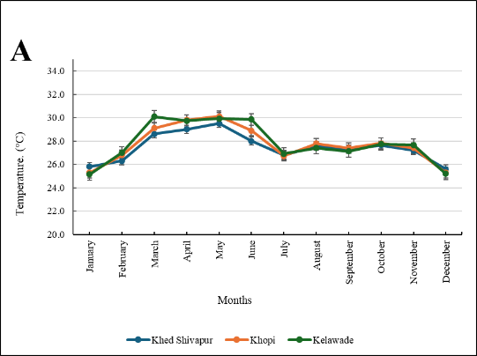 | 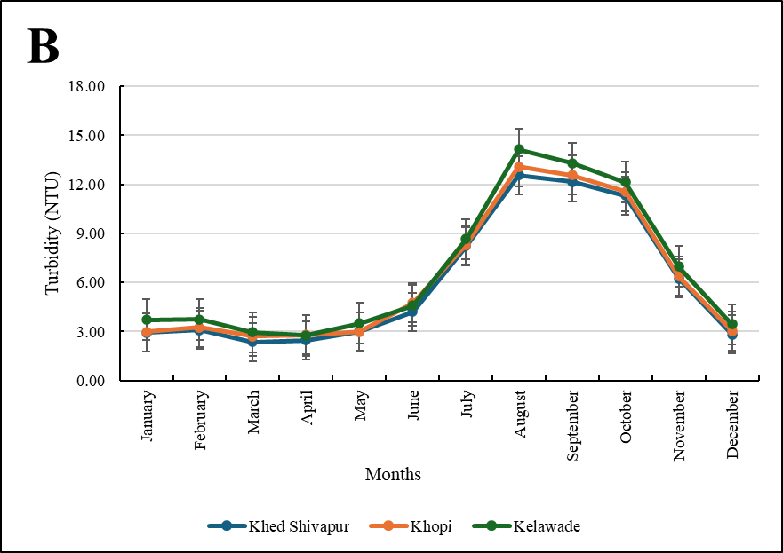
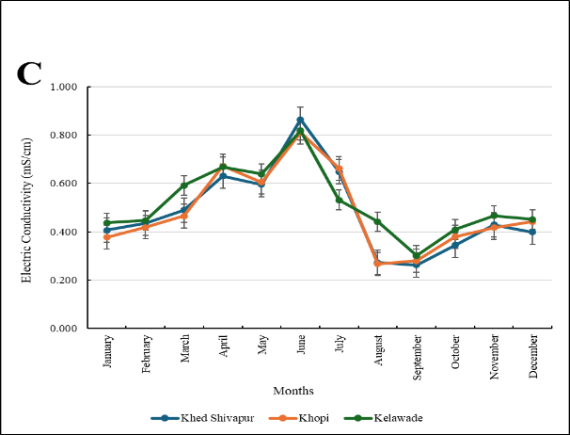 | 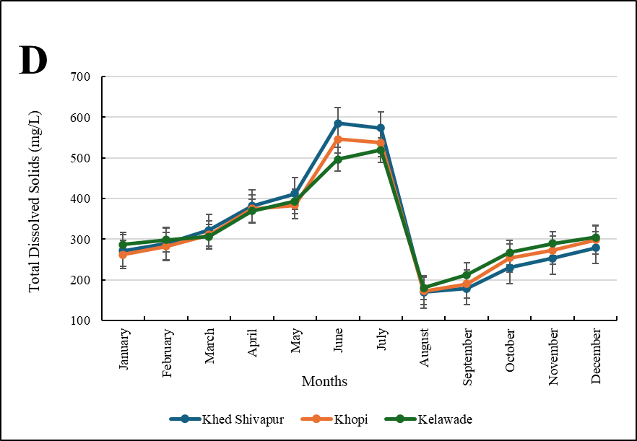
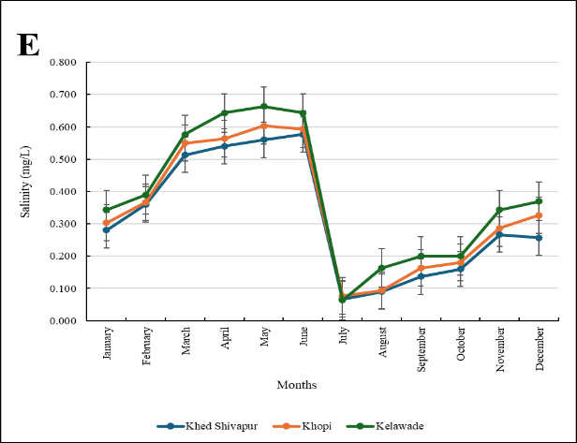 | Figure 5 : Monthly variations in physical parameters A) Temperature B) Turbidity C) Electrical Conductivity D) Total Dissolved Solids E) Salinity at three sites on Shivaganga River

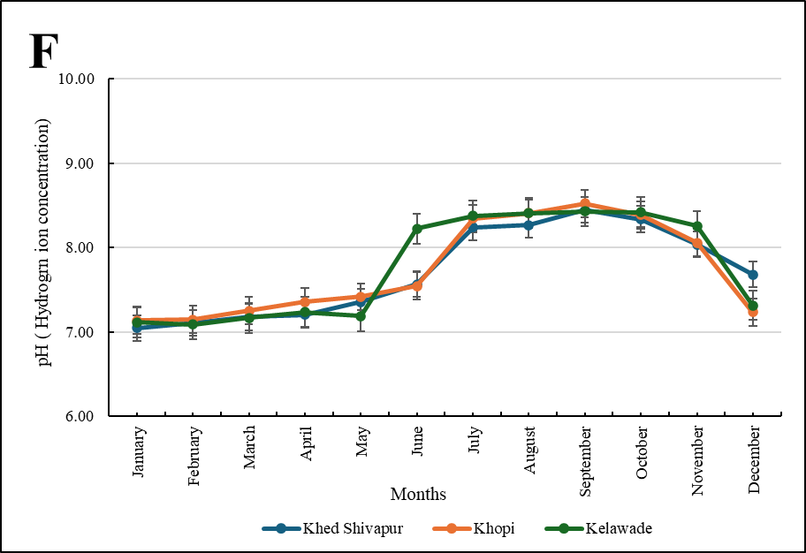 | 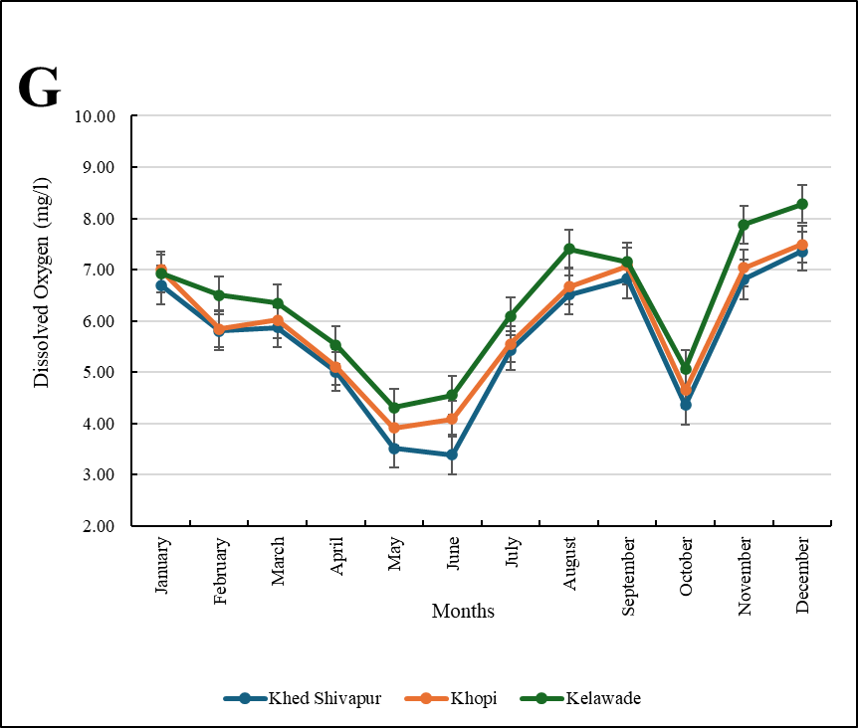
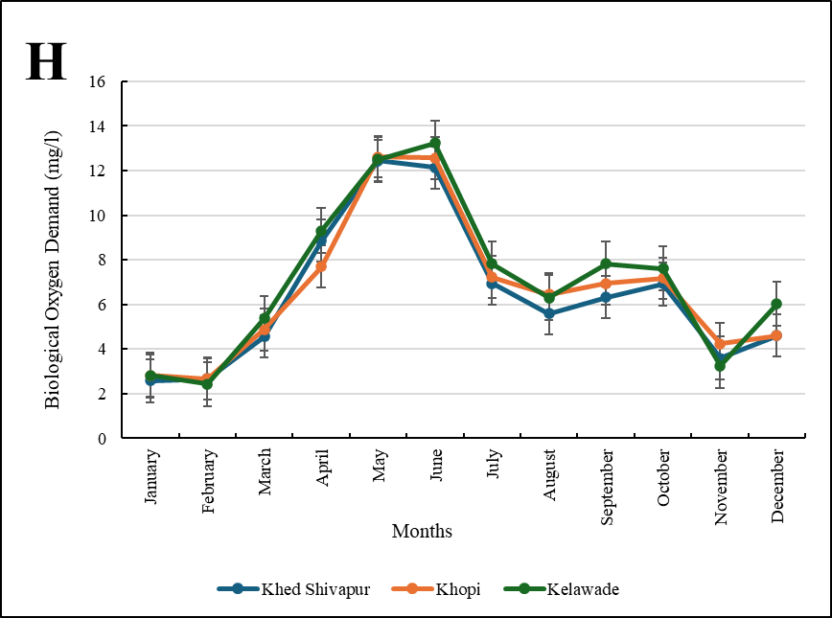 | 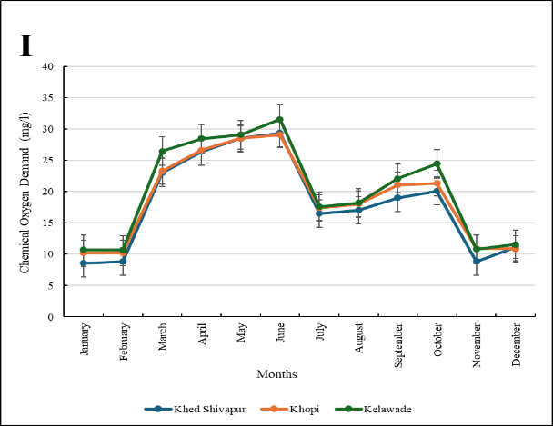
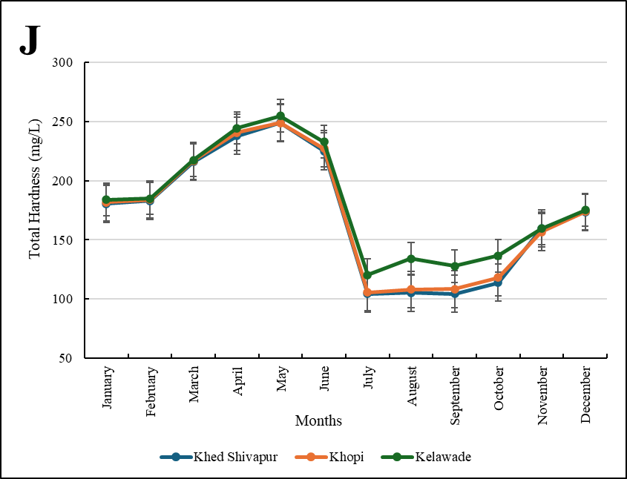 | 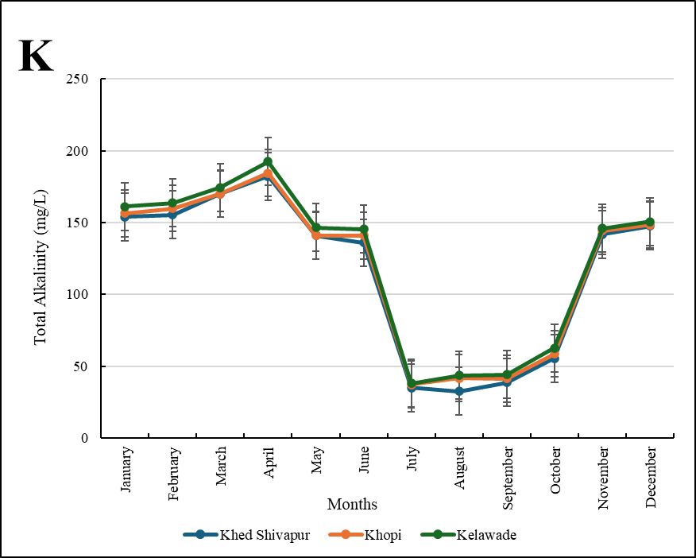
Figure 6 : Monthly variations in chemical parameters F) pH G) Dissolved oxygen H) Biological oxygen demand I) Chemical oxygen demand J) Total Hardness K) Total Alkalinity at three sites on Shivaganga River

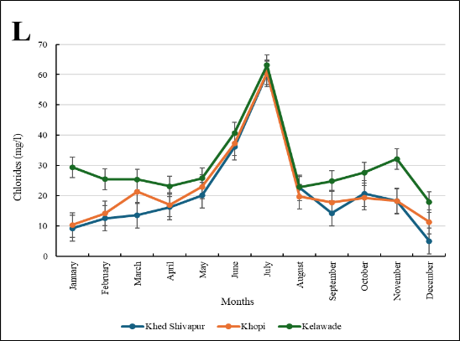 | 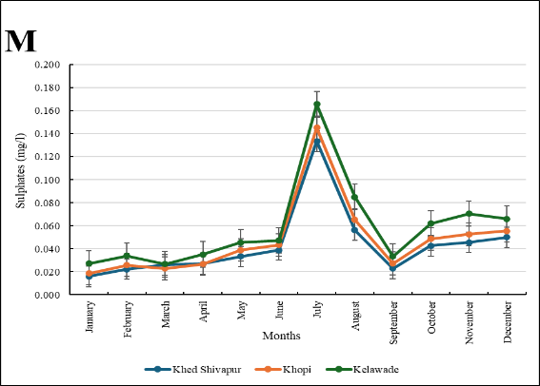
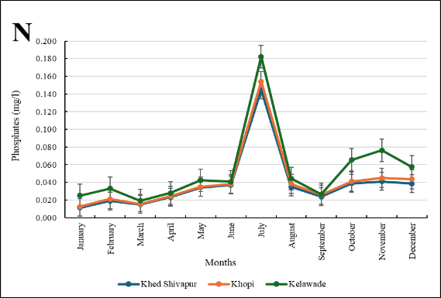 | 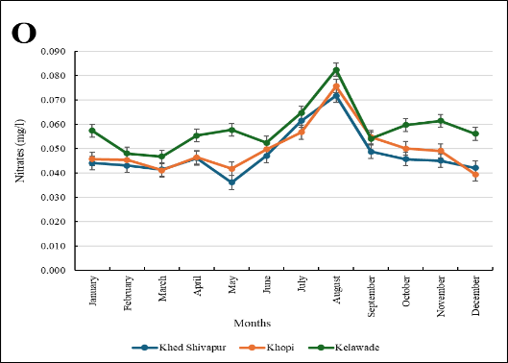
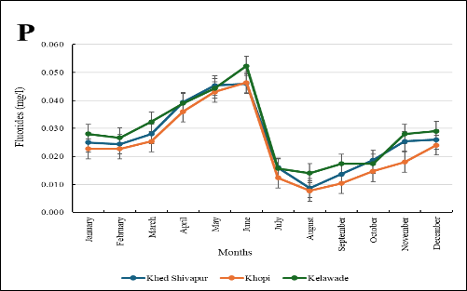 | Figure 7 : Monthly variations in chemical parameters L) Chlorides M) Sulphates N) Phosphates O) Nitrates P) Fluorides at three sites on Shivaganga River

Tables :
Table 1: Summary of annual changes in physico-chemical parameters at threee sites on Shivaganga River
Sr.No. | Parameters | Khed Shivapur  Mean (Min.-Max.) | Khopi  Mean (Min.-Max.) | Kelawade  Mean (Min.-Max.)
1 | Temperature (°C) | 27.44 (25.60 - 29.50) | 27.70 (25.30 - 30.11) | 27.82 (25.16 - 30.10)
2 | Turbidity (NTU) | 5.95 (2.35 - 12.58) | 6.19 (2.70 - 13.07) | 6.66 (2.77 - 14.15)
3 | Electrical Conductivity (mS/cm) | 0.481 (0.262 - 0.864) | 0.483 (0.277 - 0.811) | 0.517 (0.301 - 0.818)
4 | Total Dissolved Solid (mg/l) | 328.87 (169.36 - 585.10) | 323.78 (172.80 - 546.26) | 326.83 (180.20 - 519.09)
5 | Salinity (ppt) | 0.317 (0.067 - 0.577) | 0.342 (0.077 - 0.603) | 0.383 (0.063 - 0.663)
6 | pH | 7.71 (7.05 - 8.45) | 7.73 (7.14 - 8.52) | 7.77 (7.09 - 8.43)
7 | DO (mg/l) | 5.631 (3.390 - 7.357) | 5.868 (3.913 - 7.493) | 6.336 (4.307 - 8.277)
8 | BOD (mg/l) | 6.437 (2.580 -12.433) | 6.660 (2.663 - 12.620) | 7.045 (2.430 - 13.243)
9 | COD (mg/l) | 18.107 (8.557 - 29.327) | 18.961 (10.163 - 29.093) | 20.127 (10.690 - 31.527)
10 | Total Hardness (mg/l) | 171.04 (104.20 - 249.15) | 172.52 (105.53 - 248.76) | 181.04 (120.50 - 254.80)
11 | Total Alkalinity (mg/l) | 115.78 (32.49 -182.20) | 118.64 (37.25 - 184.48) | 122.38 (38.29 - 192.42)
12 | Chlorides (Cl) (mg/l) | 20.715 (5.005 - 60.260) | 22.481 (10.310 - 60.697) | 29.833 (17.913 - 63.077)
13 | Sulphate (SO4) (mg/l) | 0.043 (0.016 - 0.134) | 0.048 (0.019 - 0.145) | 0.058 (0.027 - 0.166)
14 | Phosphate (PO4) (mg/l) | 0.038 (0.011 - 0.145) | 0.041 (0.013 - 0.154) | 0.053 (0.019 - 0.182)
15 | Nitrate (NO3) (mg/l) | 0.048 (0.036 - 0.072) | 0.050 (0.039 - 0.076) | 0.058 (0.047 - 0.082)
16 | Fluoride (F) (mg/l) | 0.026 (0.009 - 0.046) | 0.024 (0.008 - 0.046) | 0.029 (0.014 - 0.052)

