Original Research Article

Evaluation of Anti-Inflammatory and Analgesic Effects of Calendula officinalis extracts in Mice

.
ABSTRACT

Background: Calendula officinalis (marigold) is a widely cultivated medicinal plant traditionally used for centuries to treat various ailments due to its therapeutic properties.
Aims: This study aimed to evaluate the anti-inflammatory and analgesic effects of ethanolic and ethyl acetate extracts of Calendula officinalis in mice.
Study Design: Randomized, controlled, parallel-group, blinded preclinical study.
Place and Duration of Study: Ecosystem and Environmental Sciences Team & Laboratory of Pharmacology, Neurobiology, Anthropology and Environment, between September 2025 and April 2026.
Methodology: A total of 36 adult male Swiss mice were randomly allocated into six groups (n = 6 per group): control (saline), positive controls (acetylsalicylic acid, morphine, or diclofenac depending on the test), and four treatment groups receiving ethanolic extract (100 and 200 mg/kg, p.o.) or ethyl acetate extract (100 and 200 mg/kg, p.o.). Analgesic activity was assessed using the acetic acid-induced writhing test, formalin-induced paw licking test, and hot-plate test. Anti-inflammatory activity was evaluated using the xylene-induced ear edema model.
Results: Both extracts exhibited significant dose-dependent analgesic and anti-inflammatory activities. In the acetic acid-induced writhing test, inhibition of nociception reached 61.59 ± 2.47% for the ethanolic extract and 71.44 ± 2.73% for the ethyl acetate extract at 200 mg/kg. In the formalin test, both extracts significantly reduced licking time in both early and late phases. The hot-plate test showed increased latency, particularly with the ethyl acetate extract, indicating central analgesic activity. In the xylene-induced ear edema model, both extracts significantly reduced inflammation, which was confirmed by histological analysis showing decreased edema and leukocyte infiltration.
Conclusion: Calendula officinalis extracts possess significant antinociceptive and anti-inflammatory properties, likely related to their rich phenolic and flavonoid content. The ethyl acetate extract demonstrated comparatively greater pharmacological activity..

Keywords: Analgesic activity; Anti-inflammatory activity; Calendula officinalis; Ethyl acetate extract; Ethanolic extract

1. INTRODUCTION

Ethnobotany and ethnopharmacology investigate the relationship between plants and humans from a therapeutic perspective, highlighting how traditional medical practices can contribute to the discovery of new therapeutic compounds (Sales et al., 2015). The use of medicinal plants in the treatment of inflammatory conditions and pain has received considerable scientific interest, as natural products are considered promising alternatives to conventional drugs because of their therapeutic efficacy and comparatively lower adverse effects (Allegra, 2019; Shahane et al., 2023).
Calendula officinalis (commonly referred to as Marigold) is a highly cultivated aromatic plant known for its yellow to orange flowers; it has been used for centuries as a remedy in soups and stews for various ailments (Gazim et al. 2008; Arora et al., 2013). Calendula is rich in phytochemicals such as flavonoids, carotenoids, saponins, sterols, triterpenoids, tannins and phenolic acids, which all exhibit a wide variety of biological activities (Dhingra et al., 2022; Sapkota & Kunwar, 2024). Calendula officinalis has been used to treat many different ailments, including fever, jaundice, gastrointestinal disorders and menstrual disorders. Topical applications of flower extracts (including tinctures and balms) have been found effective in promoting wound healing and soothing inflamed or damaged skin (Safdar et al., 2010). Additionally, Calendula flowers are frequently used as antiseptic agents for skin ulcers, eczema, abscesses, boils and oral lesions. Infusions of Calendula have been used to treat toothaches, eye inflammation and insect sting (Shafeie et al., 2015; Ashwlayan, 2018). Furthermore, this medicinal herb has been found to support blood and lymph circulation processes as well as help remove toxins from the body (Ashwlayan, 2018).
Scientific investigations have validated several pharmacological properties of Calendula officinalis, such as its antioxidant, antimicrobial, antiviral, antidiabetic, hepatoprotective, cardioprotective, anti-inflammatory and analgesic effects (Shahane et al., 2023; Zournatzis et al., 2025). Recent studies have shown that the biological effects of C. officinalis are associated with the presence of specific types of phenolic compounds and triterpenoids, which have the ability to alter the activity of inflammatory mediators, such as prostaglandins, nitric oxide (NO), and pro-inflammatory cytokines. In particular, a recent study demonstrated that triterpenoids isolated from C. officinalis exert potent anti-inflammatory effects through the inhibition of interleukin-6 signaling pathways (Golubova et al., 2025).
The extraction solvent plays a key role in determining the phytochemical composition and biological activity of plant extracts, as different solvents selectively extract compounds according to their polarity. For example, Ethanol and ethyl acetate are both commonly used solvents for extracting phenolic and semi-polar compounds that may contribute to analgesic and anti-inflammatory effects. However, comparative studies evaluating the pharmacological effects of ethanol and ethyl acetate extracts of Calendula officinalis remain limited.
Although Calendula officinalis has been traditionally used to treat wounds and relieve certain painful and inflammatory conditions, however there is not enough scientific evidence for a basis to support these traditional uses. The purpose of this study is to determine the antinociceptive and anti-inflammatory properties of ethanolic and ethyl acetate extracts of Calendula officinalis using mouse models. In addition, the phytochemical composition of both extracts was investigated through the quantification of total phenolics, flavonoids, and tannins in order to examine their possible contribution to the observed biological effects.
2. material and methods
2.1. Animals
In this study, we used adult male Swiss mice (25-30g) obtained from the Faculty of Sciences Semlalia, Cadi Ayyad University. A total of 36 mice were used in this study. The animals were housed in cages at room temperature of 25±2°C with a12/12 h light/dark cycle. Mice were fed standard food, and water was provided ad libitum.
The mice were randomly allocated into six experimental groups (n = 6 per group) using a simple randomization method. Group allocation was performed using a computer-generated random number table to ensure unbiased distribution. The groups were as follows: control group, positive control groups (depending on the test: morphine, acetylsalicylic acid, or diclofenac), and four treatment groups receiving ethanolic extract (EE) and ethyl acetate extract (EAE) at doses of 100 and 200 mg/kg (p.o.).
All protocols used in this work adhered to the approved institutional procedures prescribed by the Scientific Procedures on Living Animals ACT 1986 (European Council Directive: 86/609/EEC).
Diet and Feeding Regimen
All mice were fed a standard laboratory pellet diet obtained from a certified animal feed supplier. The diet was formulated to meet the nutritional requirements of laboratory rodents.
Diet Composition (per 100 g of feed):
Carbohydrates: 55–60%
Protein: 18–20%
Fat: 4–6%
Crude fiber: 4–5%
Ash content: 6–8%
Moisture: ≤10%
2.2. Plant Material
Fresh aerial parts of Calendula officinalis were collected in April from the Safi region, Morocco. Voucher samples (MARK-10643) were deposited in the Herbarium of the FSSM, Marrakesh, Morocco.
2.2.1. Crude Extract Preparation
A total of 100 g of dried and powdered aerial parts of Calendula officinalis was extracted by maceration in 2 L of ethanol for 24 h. The resulting mixture was filtered, and the residue was re-extracted with ethanol to ensure exhaustive extraction. The combined filtrates were concentrated under reduced pressure to obtain the crude ethanolic extract (9.2 g). The crude extract was subsequently dissolved in 100 mL of distilled water and transferred to a separatory funnel, where it was successively partitioned with hexane and ethyl acetate (Al-Jadidi and Hossain, 2015). The hexane and ethyl acetate fractions were then concentrated using a rotary evaporator to afford the corresponding crude extracts, with a combined yield of 6.1 g.
2.2.2. Assessment of Total Phenolic Compounds, Tannins and Flavonoids Content in Calendula officinalis Extracts
The total phenolic content (TPC) was determined using the Folin–Ciocalteu method as described by Singleton et al. (1999). Briefly, 20 µL of the extract was mixed with 100 µL of Folin–Ciocalteu reagent and 1.16 mL of distilled water, followed by the addition of 300 µL of sodium carbonate solution. The reaction mixture was incubated at 40°C for 30 min, after which the absorbance was measured at 760 nm. The results were expressed as milligrams of gallic acid equivalents per gram of extract dry matter (mg GAE/g DM).
The total flavonoid content (TFC) was estimated using the aluminium chloride colourimetric method according to Zhishen et al. (1999). Briefly, 0.5 mL of the extract was mixed with 0.5 mL of a 2% aluminium chloride solution prepared in ethanol. The mixture was incubated at room temperature for 1 h, and the absorbance was subsequently measured at 420 nm. The results were expressed as milligrams of catechin equivalents per gram of extract dry matter (mg CAT/g DM).
The total tannin content (TTC) was quantified using the vanillin assay as described by Xu and Chang (2007). Briefly, 100 µL of the extract was mixed with 1 mL of 4% vanillin in methanol and 0.5 mL of hydrochloric acid. Following incubation at room temperature for 15 min, the absorbance was recorded at 550 nm. The results were expressed as milligrams of catechin equivalents per gram of extract dry matter (mg CAT/g DM).
2.3. Assessment of Pharmacological Activities
2.3.1. Antinociceptive Tests
2.3.1.1. Writhing Test
The writhing test is used to evaluate the response of mice to a chemical nociceptive stimulus, thereby assessing peripheral nociceptive sensitivity (Farouk et al., 2008).
Experimental treatments are administered at a volume of 10 ml/kg body weight, 30 minutes prior to the acetic acid injection. Acetic acid (0.6% at 0.1 ml/10g body weight) is then administered intraperitoneally. (following this, animals are placed on a plexiglass surface, and the number of contortions made by each mouse is observed for a 30-minute Farouk et al., 2008).
The percentage of inhibition (IP) of the nociceptive response is calculated using the following formula:
Where:
NC: Number of contortions in the control group; NT: Number of contortions of a tested group.
2.3.1.2. Formalin Test
The formalin-induced nociception test was performed according to the method described by Kebbou et al. (2019). Briefly, 20 µL of 2% formalin was administered by subcutaneous injection into the plantar surface of the right hind paw of each mouse. Prior to formalin administration, animals were allowed to acclimatise to the observation chamber for 5 min. Nociceptive behaviour was assessed by recording the cumulative time spent licking and/or biting the injected paw. Pain-related behaviour was evaluated during two distinct phases: the early (neurogenic) phase, occurring within the first 5 min following formalin injection, and the late (inflammatory) phase, observed between 15 and 30 min post-injection. These phases are considered to reflect acute nociceptive and inflammatory pain responses, respectively (Kebbou et al., 2019). Mice were orally pre-treated with the ethanolic extract (EE) or ethyl acetate extract (EAE) at doses of 100 or 200 mg/kg, 30 min prior to formalin injection.
2.3.1.3. Hot Plate Test
This test consists of placing each mouse into a glass cylinder (20 cm in diameter) on a heated surface (55±0.4°C). Treated mice received two oral doses of EE and EAE at 100 mg/kg and 200 mg/kg. the negative control group received water orally at 0.1 ml/g. the positive control group received Morphine intraperitoneally at 10 mg/kg. The latency to lick one of a paw or jump was noted and recorded as the reaction time. The duration of this test should not exceed 20 seconds to prevent causing damage to the cutaneous tissue of the mice' paws (Ferehan et al., 2021).
2.3.2. Anti-Inflammatory Activity
2.3.2.1. Xylene Induced Mouse Ear Edema
Acute ear oedema was induced according to the method described by Kebbou et al. (2019). Briefly, 30 µL of xylene was topically applied to both the anterior and posterior surfaces of the right ear of each mouse. Adult Swiss albino mice were randomly allocated into six experimental groups: a control group receiving 0.9% saline solution, four treatment groups receiving the ethanolic extract (EE) or ethyl acetate extract (EAE) at doses of 100 or 200 mg/kg orally, and a positive control group treated with diclofenac (10 mg/kg, intraperitoneally).
All treatments were administered 45 min prior to xylene application. Thirty minutes following xylene administration, the animals were euthanised, and circular ear biopsies (6 mm in diameter) were collected from both the treated (right) and untreated (left) ears. The biopsies were weighed immediately, and the extent of oedema was determined by calculating the difference in weight between the right and left ear samples.
2.4. Histological Examination
For histological evaluation, six inflamed ear tissue samples from both the control and treatment groups were collected and fixed in 10% neutral-buffered formalin. Following fixation, the tissues were processed, embedded in paraffin wax, and sectioned at a thickness of 3–4 µm. The sections were mounted onto glass slides and stained with haematoxylin and eosin (H&E) for histopathological examination, according to the method described by Kiernan (2015).
2.5. Statistical Analysis
Results were shown as means ± S.E.M and the comparisons between the experimental groups were made using One Way ANOVA. The values were considered statistically significant when the P-value was less than 0.05, statistical analyses were done using Sigma Plot 12.5 for Windows.

3. results and discussion
3.1. Results
3.1.1. Determination of Total Phenolic Compounds, Tannins and Flavonoids

Phytochemical analysis (Table 1) revealed considerable amounts of total phenolics, flavonoids, and condensed tannins in both studied extracts.

Table 1: Total phenolics, flavonoids and tannins content of ethanol extract and ethyl acetate extract of the Calendula officinalis (Mean ± SEM).

 | Ethyl acetate extract | Ethanol extract
Total phenolic contents (mg GAE/g DW) | 18.14 ± 0.31 | 21.70 ± 0.25
Flavonoid contents (mg /g DW) | 9.65 ± 0.48 | 11.12 ± 0.12
Tannin contents (mg CE/g DW) | 4.82 ± 0.59 | 6.10 ± 0.65

3.1.1. Pharmacological Tests

3.1.1.1. Writhing Test

The results presented in Table 2 indicate that oral administration of the ethanolic extract and ethyl acetate extract at doses of 100 and 200 mg/kg significantly reduced the number of acetic acid-induced writhes compared with the control group (p < 0.001). The highest inhibitory effects were observed at a dose of 200 mg/kg, with writhing inhibition rates of 61% and 71% for the ethanolic and ethyl acetate extracts, respectively, whereas the control group exhibited no inhibition. Aspirin (ASA), used as the reference drug, also produced a marked antinociceptive effect, resulting in a 66.09% inhibition of writhing.

Table 2: Effect of Calendula officinalis ethanolic (EE) and Ethyl Acetate (EAE) extracts on the acetic acid-induced writhing behavior in mice. Ethanolic and ethyl acetate extracts (100 mg/kg and 200 mg/Kg, p.o.) and Acetylsalicylic acid (ASA = 200 mg/kg, i.p.) were administered. Results are presented as Mean ± SEM ***p<0.001 Vs. Control
Groups | Number of writhes | Percentage of writhes inhibition (%)
Control | 151.3 ± 14.61 | 0.0 ± 0.0
ASA (200 mg/kg) | 51.3 ± 5.14 *** | 66.09 ± 3.14
EE (100 mg/kg) | 64.3 ± 3.51 *** | 57.50 ± 2.64
EE (200 mg/kg) | 58.1 ± 3.46 *** | 61.59 ± 2.47
EAE (100 mg/kg) | 52.6 ± 4.79 *** | 65.23 ± 3.07
EAE (200 mg/kg) | 43.2 ± 2.87 *** | 71.44 ± 2.73

3.1.1.2. Hot-plate Test

the hot-plate test results showed a highly significant difference between control and EAE (p < 0.001). The EE exhibited no effect on the hot plate latency. Compared to the control, EAE animals exhibited increased latency, particularly with higher doses (p<0.01). However, the analgesic effect observed in EAE animals, at both doses, was lower than morphine (Figure 1).
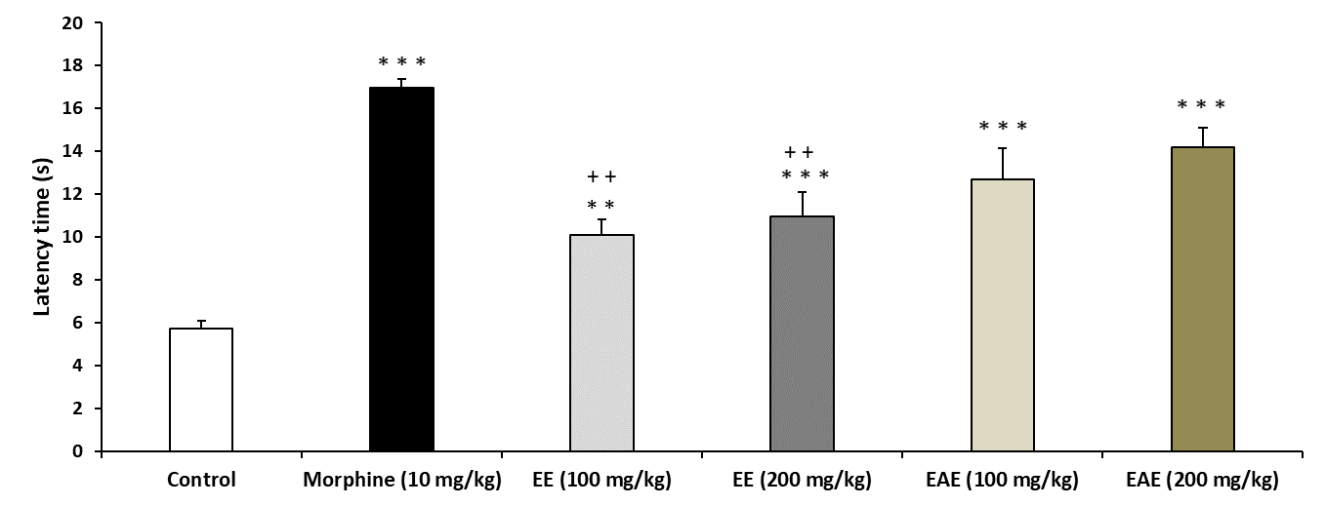
Figure 1: Effect of Calendula officinalis Ethanolic (EE), Ethyl Acetate (EAE) Extracts on the nociceptive response in the hot plate test. Calendula officinalis extracts (D1 = 100 mg/kg, D2 = 200 mg/Kg, p.o.) and Morphine (10 mg/Kg, i.p.) were administered 30 min before testing. Results are presented as Mean ± SEM ***p< 0.001 Vs. Control

3.1.2. Formalin Test

Intraplantar administration of 2% formalin induced the characteristic biphasic nociceptive response, as evidenced by paw-licking behaviour. Pre-treatment with the ethanolic extract (EE) and ethyl acetate extract (EAE) at doses of 100 and 200 mg/kg (p.o.) significantly attenuated both the early and late phases of the formalin-induced nociceptive response in a dose-dependent manner compared with the control group (p < 0.01 and p < 0.001, respectively) (Table 3).
Morphine, used as the reference centrally acting analgesic, produced the most pronounced antinociceptive effect, significantly reducing licking times during both phases of the test and thereby confirming the sensitivity and validity of the experimental model (Table 3). In contrast, acetylsalicylic acid did not produce a significant effect during the early phase, with a licking time of 120.18 ± 3.93 s, but markedly reduced the nociceptive response during the late phase, decreasing the licking time to 41.29 ± 2.11 s (***p < 0.001). This observation is consistent with the predominantly peripheral anti-inflammatory mechanism of action of acetylsalicylic acid (Table 3).

Table 3: The antinociceptive effect of Calendula officinalis extracts (EE and EAE), Morphine (MOR) and Acetylsalicylic Acid (ASA) on formalin-induced pain in mice. Values are represented as the mean ± SEM. Differences between groups were statistically analysed by ANOVA followed by Tukey’s multiple range test. **p<0.01; ***p<0.001 Vs. Control.
 | Total time spent in licking (s)
Group | 1st phase | 2nd phase
Control | 131.37±7.61 | 183.63±6.38
EE (100 mg/kg) | 89.61±6.76** | 64.17±1,02***
EE (200 mg/kg) | 82.34±3.61** | 41.57±4.32***
EAE (100 mg/kg) | 88.51±3.35** | 61.91±1.53***
EAE (200mg/kg) | 71.19±4.24*** | 39.71±1.24***
MOR (10 mg/kg) | 50.85±4.53*** | 31.31±4.01***
ASA (200mg/kg) | 120.18±3.93 | 41.29±2.11***

Anti-Inflammatory Activity

Figure 2 illustrates the effect of Calendula officinalis extracts in the xylene-induced mice ear edema test. following xylene induction, a significant increase in edema was observed in the negative control mice. Diclofenac (10 mg/kg), used as the reference drug, exhibited strong anti-inflammatory activity with an average inhibition of 82.63%, thereby, confirming the validity of the experimental model. importantly, the anti-inflammatory activity data revealed that all tested concentrations of the extracts (EE and EAE at 100 and 200 mg/kg) significantly reduced the xylene-induced edema compared to the control (p<0.001), in a dose-dependent manner.
As illustrated in Figure 3, histological assessment of the ear tissues showed that xylene application induced a marked increase in epidermal thickness, edema, and infiltration of polymorphonuclear (PMN) leukocytes. Oral administration of Calendula officinalis extracts (100 and 200 mg/kg) and Diclofenac (10 mg/kg) significantly reduced these changes.

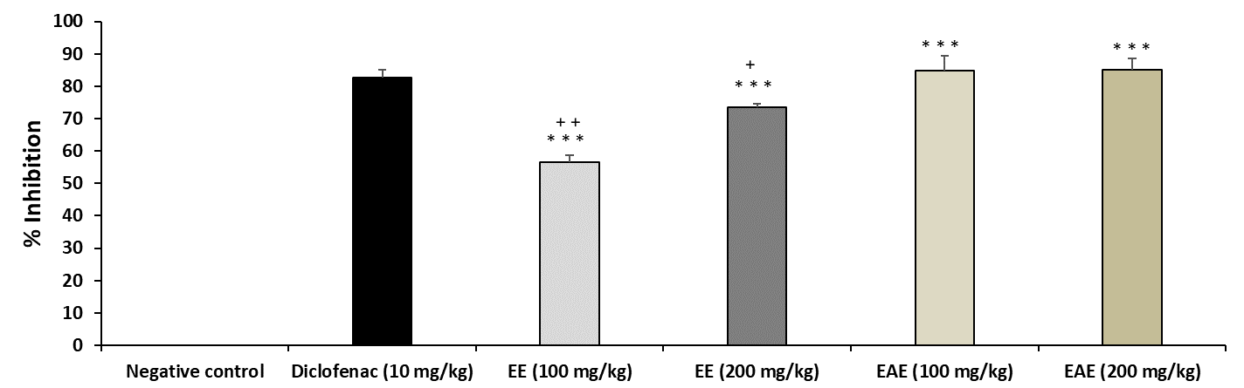
Figure 2: Effect of Ethanolic (EE) and Ethyl Acetate (EAE) extracts on inflammation response in Xylene test. Diclofenac (10 mg/kg i.p), Ethanolic and Ethyl Acetate Extracts (D1 = 100 mg/kg, D2= 200 mg/Kg, p.o.) were administered 45 min before Xylene application. Results are presented as Mean ± SEM.
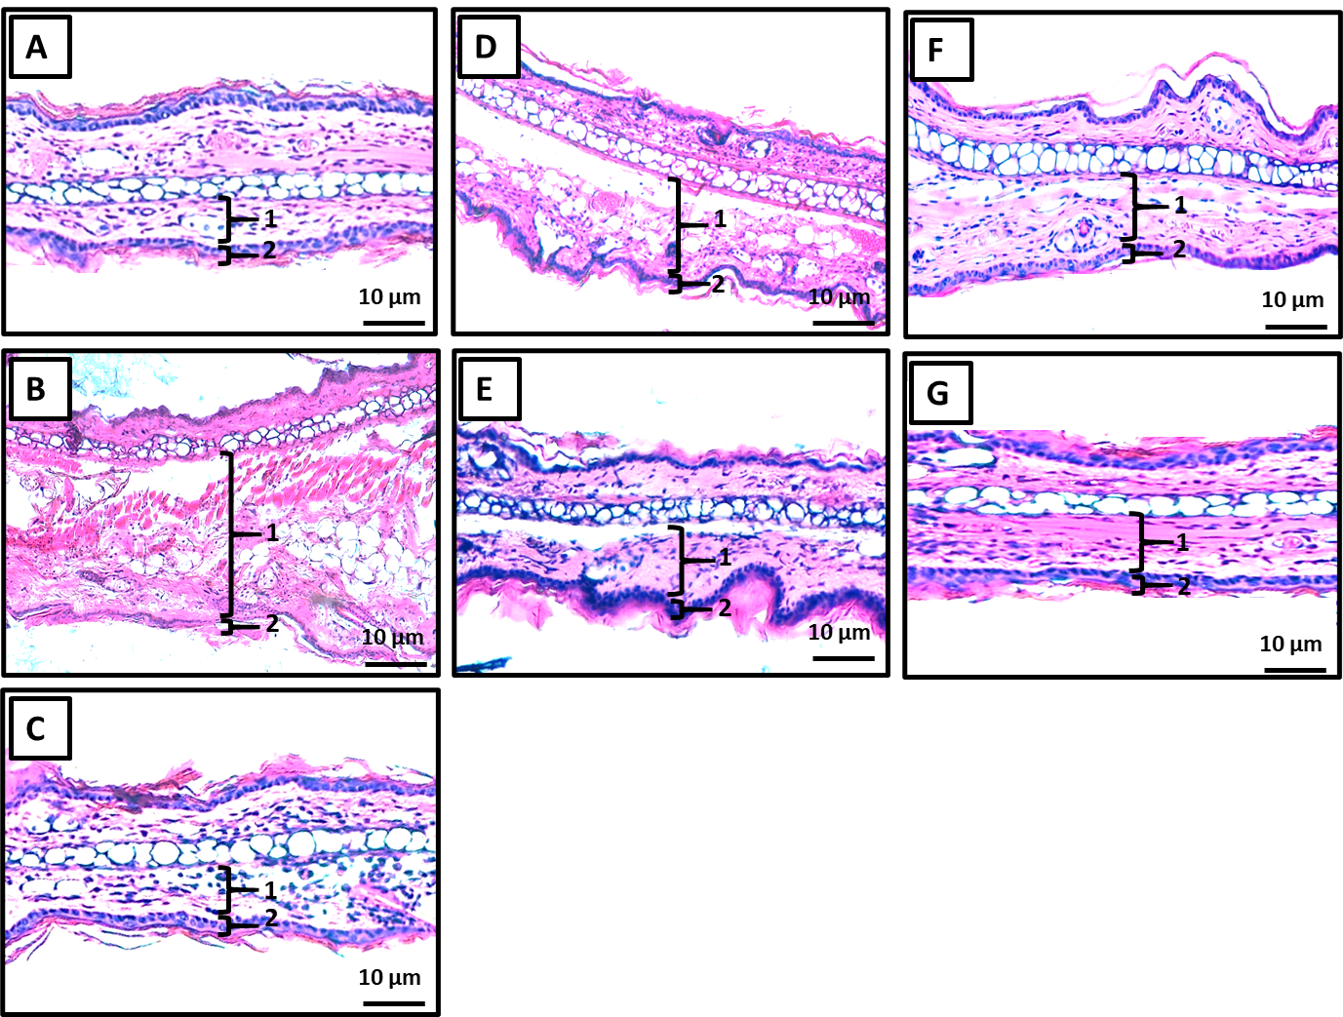

Figure 3: Histopathological sections showing ear swelling induced by Xylene treatment. (A) Normal ear; (B) Xylene-induced model control group; (C) treatment with Diclofenac (10 mg/kg); (D) treatment with Ethanolic Extract (100 mg/kg); (E) treatment with Ethyl Acetate Extract (100 mg/kg); (F) treatment with Ethanolic Extract (200 mg/kg); and (G) treatment with Ethyl Acetate Extract (200 mg/kg). 1: Dermal thickness; 2: Epidermis thickness; (HE ×100).

3.2. Discussion
The results obtained in the present study showed that the ethanolic (EE) and ethyl acetate (EAE) extracts from the aerial parts of Calendula officinalis possess notable antinociceptive and anti-inflammatory properties. These biological activities may be associated with their high content of secondary metabolites, particularly phenolic compounds, flavonoids, and tannins, which are widely recognized for their pharmacological effects. While phytochemical analysis in the present study revealed higher levels of total phenolics, flavonoids, and tannins in ethanolic extract compared with the ethyl acetate extract, another phytochemical analysis of C. officinalis reported the detection of quercetin among isolated constituents and noted higher activity in ethyl acetate fraction compared with aqueous fraction (Deligiannidou et al., 2025), suggesting those mid polar fractions concentrate flavonoids. This difference may be explained by the polarity of ethanol, which facilitates the extraction of phenolic constituents, as previously reported in recent studies investigating the chemical composition of Calendula officinalis (Olennikov & Kashchenko, 2022). These findings suggest that the chemical composition of the extracts plays an important role in the pharmacological effects observed across the different experimental models.
The high content of secondary metabolites in both extracts may be responsible for their pharmacological activities. Indeed, recent studies have shown that Calendula officinalis contains various bioactive compounds, including flavonoids, triterpenoids, carotenoids, and phenolic acids, which are known for their antioxidant and anti-inflammatory properties. Specifically, ethyl acetate and similar mid polar fractions of Calendula have demonstrated higher inhibition of plant lipoxygenase (an inflammation marker) and significant antioxidant capacity (Deligiannidou et al., 2025). These metabolites, as highlighted by Shahane et al., significantly contribute to the plant’s therapeutic effects, particularly through the modulation of processes involved in pain and inflammation (Shahane et al., 2023).
In the writhing test, both extracts considerably reduced the number of writhes, showing a robust peripheral antinociceptive activity. The ethyl acetate extract, administered at a dose of 200 mg/kg, demonstrated the most pronounced impact, with a greater inhibition than that reported with acetylsalicylic acid. This activity may be explained by the inhibition of prostaglandin synthesis, important mediators involved in visceral pain. Similar findings were reported by Garrido Suárez et al., who found that Calendula officinalis provides a peripheral analgesic effect by reducing oxidative stress and local inflammatory reactions (Garrido Suárez et al., 2022).
The formalin test confirmed this antinociceptive activity, as the extracts significantly reduced licking time during both phases of the test. The inhibition of the first phase, related to neuropathic pain, suggests a central action, whereas the effect detected in the second phase shows a peripheral anti-inflammatory action. The extract of EAE at 200 mg/kg was the most effective, similar to that of morphine in the inflammatory phase. These results agree with those reported in the recent literature, in which Calendula officinalis has shown a combined action on both peripheral and central pain mechanisms (Garrido Suárez et al., 2022).
In the hot plate test, only the ethyl acetate extracts significantly increased the latency period, indicating a central antinociceptive effect. The absence of a significant effect with the ethanolic extract may stem from a different distribution of active compounds based on solvent polarity. In this context, Golubova et al. recently discovered several triterpenoids in Calendula officinalis that can modulate pathways related to inflammation and pain perception, potentially explaining the activity observed in the ethyl acetate fraction (Golubova et al., 2025). Phytochemical analysis of Calendula has also detected quercetin. Furthermore, the ethyl acetate fraction was singled out for its higher flavonoid linked antioxidant and LOX inhibitory activity, which could plausibly underlie anti-inflammatory effects relevant to pain modulation (Al-Rifai, 2018).
Regarding anti-inflammatory activity, the xylene-induced auricular edema model showed both extracts significantly reduced inflammation in a dose-dependent manner. Histological analysis confirmed these results, revealing a significant reduction in epidermal thickness, edema, and polymorphonuclear leukocyte infiltration. These findings are consistent with the study conducted by Silva et al. who reported that Calendula officinalis flower extracts reduce acute inflammation by inhibiting leukocyte migration and the release of pro-inflammatory cytokines, including TNF-α and IL-6 (Silva et al., 2021). Furthermore, broader comparisons indicate that ethanolic extracts possess strong antioxidant potential, which underpins many reported anti-inflammatory uses of Calendula (Teodora et al., 2025).
Therefore, the antinociceptive and anti-inflammatory activities reported in this study may be attributed to the synergistic action of the phenolic compounds, flavonoids and triterpenoids contained in the extracts. These compounds have been reported to inhibit enzymes of cyclooxygenase and lipoxygenase pathways, reduce oxidative stress and modulate the production of inflammatory mediators (Shahane et al., 2023).

The results of the present study support the traditional use of Calendula officinalis in the Moroccan traditional medicine for the treatment of pain and inflammatory conditions. However, more studies are needed to isolate the active compounds responsible for these effects and to better elucidate the underlying molecular mechanisms of action.
4. Conclusion
Calendula officinalis extracts have been traditionally used to manage pain, inflammation, and various skin disorders and are widely incorporated into herbal and cosmetic preparations. However, the pharmacological basis of these effects remains unclear. Consequently, this study investigated the antinociceptive and anti-inflammatory activities of ethanolic and ethyl acetate extracts of Calendula officinalis in mice, employing various in vivo experimental models. The findings showed that both extracts exhibited significant and dose-dependent antinociceptive and anti-inflammatory effects. The ethyl acetate extract, in particular, exhibited a more marked effect. This may be attributed to the presence of bioactive compounds such as phenolics, flavonoids, and triterpenoids, which are known to play an important role in regulating pain and inflammatory responses.

COMPETING INTERESTS DISCLAIMER:
Authors have declared that they have no known competing financial interests OR non-financial interests OR personal relationships that could have appeared to influence the work reported in this paper.

Ethical Approval
Animal Ethic committee approval has been collected and preserved by the author(s)

Disclaimer (Artificial intelligence)

Author(s) hereby declare that NO generative AI technologies such as Large Language Models (ChatGPT, COPILOT, etc.) and text-to-image generators have been used during the writing or editing of this manuscript.

Reference:

Al-Jadidi, H. S. K., & Hossain, M. A. (2015). Studies on total phenolics, total flavonoids and antimicrobial activity from the leaves crude extracts of neem traditionally used for the treatment of cough and nausea. Beni-Suef University Journal of Basic and Applied Sciences, 4(2), 93-98.
Allegra, M. (2019). Antioxidant and anti-inflammatory properties of plants extract. Antioxidants, 8(11), 549.
Al-Rifai, A. (2018). Identification and evaluation of in-vitro antioxidant phenolic compounds from the Calendula tripterocarpa Rupr. South African Journal of Botany, 116, 238-244.
Arora, D., Rani, A., & Sharma, A. (2013). A review on phytochemistry and ethnopharmacological aspects of genus Calendula. Pharmacognosy Reviews, 7(14), 179–187.
Arora, D., Rani, A., & Sharma, A. (2013). A review on phytochemistry and ethnopharmacological aspects of genus Calendula. Pharmacognosy reviews, 7(14), 179.
Ashwlayan, V. D. (2018). Traditional uses and medicinal importance of Calendula officinalis. International Journal of Green Pharmacy, 12(2), 87–95.
Deligiannidou, G. E., Papadimitriou, K., Poulios, E., Kontogiorgis, C., Papadopoulou, S. K., & Giaginis, C. (2025). An Update of Phytotherapeutic Advances of Marigold (Calendula officinalis L.) in Wound Healing. Plants, 14(22), 3497.
Dhingra, G., Dhakad, P., & Tanwar, S. (2022). Review on phytochemical constituents and pharmacological activities of plant Calendula officinalis Linn. Biological Sciences, 2(2), 216-228.
Farouk, L., Laroubi, A., Aboufatima, R., Benharref, A., & Chait, A. (2008). Evaluation of the analgesic effect of alkaloid extract of Peganum harmala L.: possible mechanisms involved. Journal of ethnopharmacology, 115(3), 449-454.
Ferehan, H., Laaradia, M. A., Oufquir, S., Aboufatima, R., Moubtakir, S., Sokar, Z., ... & Bagri, A. (2021). Antioxidant, Analgesic and Anti-inflammatory Effects of Ethanolic Extract of Moroccan Lavandula stoechas L. OnLine J. Biol. Sci, 21, 346-358.
Garrido Suárez, B. B., Martínez Sánchez, G., & Hernández Pérez, A. (2022). Topical Calendula officinalis L. inhibits inflammatory pain through antioxidant and peripheral opioid mechanisms. Journal of Integrative Medicine, 21(1), 56–64.
Gazim, Z. C., Rezende, C. M., Fraga, S. R., Dias Filho, B. P., Nakamura, C. V., & Cortez, D. A. G. (2008). Analysis of the essential oils from Calendula officinalis growing in Brazil using three different extraction procedures. Revista Brasileira de Ciências Farmacêuticas, 44(3), 391-395.
Golubova, D., Salmon, M., Su, H., Tansley, C., Kaithakottil, G. G., Linsmith, G., Schudoma, C., Swarbreck, D., O’Connell, M. A., & Patron, N. J. (2025). Biosynthesis and bioactivity of anti-inflammatory triterpenoids in Calendula officinalis. Nature Communications, 16, 6941.
Kebbou, A., Laaradia, M. A., Oufquir, S., Aarab, A., Gabbas, Z. E., Rais, H., ... & Chait, A. (2019). Antioxidant activity, anti-inflammatory and analgesic effects of Caralluma europaea (Eddaghmouss) in mice. OnLine Journal of Biological Sciences, 19(4), 272-285.
Kiernan, J. (2015). Histological and histochemical methods. Scion publishing ltd.
Olennikov, D. N., & Kashchenko, N. I. (2022). Marigold metabolites: Diversity and separation methods of Calendula genus phytochemicals. Molecules, 27(23), 8626.
Safdar, W., Majeed, H., Naveed, I., Kayani, W. K., Ahmed, H., Hussain, S., & Kamal, A. (2010). Pharmacognostical study of the medicinal plant Calendula officinalis L. (family Compositae). Int J Cell Mol Biol, 1(2), 108-116.
Sales, M. D. C., Sartor, E. B., & Gentilli, R. M. (2015). Ethnobotany and ethnopharmacology: traditional medicine and the bioprospection of phytotherapics. Salus J. Health Sci, 1(1), 17-25.
Sapkota, B., & Kunwar, P. (2024). Traditional uses, phytochemistry and pharmacological activities of Calendula officinalis Linn.: A review. Journal of Evidence-Based Integrative Medicine, 29, 1–17.
Shafeie, N., Naini, A. T., & Jahromi, H. K. (2015). Comparison of different concentrations of Calendula officinalis gel on cutaneous wound healing. Biomedical and Pharmacology Journal, 8(2), 979-992.
Shahane, K., Kshirsagar, M., Tambe, S., Jain, D., Rout, S., Ferreira, M. K. M., ... & Lima, R. R. (2023). An updated review on the multifaceted therapeutic potential of Calendula officinalis L. Pharmaceuticals, 16(4), 611.
Silva, D., Ferreira, M. S., Sousa-Lobo, J. M., Cruz, M. T., & Almeida, I. F. (2021). Anti-inflammatory activity of Calendula officinalis L. flower extract. Cosmetics, 8(2), 31.
Singleton, V. L., Orthofer, R., & Lamuela-Raventós, R. M. (1999). Analysis of total phenols and other oxidation substrates and antioxidants by means of folin-ciocalteu reagent. In Methods in enzymology, 299, 152-178.
Teodora, D. A. N., Szabo, K., Ranga, F., & Andrei, S. (2025). Phenolic Profile and Antioxidant Potential of Calendula Officinalis and Achillea Millefolium Eco-friendly Extracts: A Comparative Study. Bulletin of University of Agricultural Sciences and Veterinary Medicine Cluj-Napoca. Food Science and Technology, 82(2), 23-36.
Xu, B. J., & Chang, S. K. (2007). A comparative study on phenolic profiles and antioxidant activities of legumes as affected by extraction solvents. Journal of food science, 72(2), S159-S166.
Zhishen, J., Mengcheng, T., & Jianming, W. (1999). The determination of flavonoid contents in mulberry and their scavenging effects on superoxide radicals. Food chemistry, 64(4), 555-559.
Zournatzis, I., Liakos, V., Papadopoulos, S., & Wogiatzi, E. (2025). Calendula officinalis-A comprehensive review. Pharmacological Research-Natural Products, 6, 100140.

Saha, M., Adams, M. L., & Nelson, S. C. (2009). Review of digit fusion in the mouse embryo. Journal of Embryology and Experimental Morphology, 49(3), (In press).

