Non- Infectious Visceral Gout In Chickens: A Pathological and Epidemiological Study

ORIGINAL RESEARCH ARTICLE
Abstract
Gout is a metabolic disorder in poultry characterized by hyperuricemia and deposition of urate crystals in tissues, which occurs primarily due to renal dysfunction. The present study was conducted to assess the occurrence, pathological features, and epidemiological pattern of non-infectious visceral gout in chicken over a period of one year. A total of 5280 poultry carcasses were examined by postmortem, and detailed gross and histopathological evaluations were performed. Out of 5280 carcasses examined, 867 cases were found positive for visceral gout with an overall prevalence of 16.42%. The highest incidence was recorded in birds of the second week of age (35.46%), followed by the third week (18.18%) and first week (7.27%), while minimal occurrence was observed in birds older than three weeks (2.47%). Clinical signs observed were reduced feed and water intake, lethargy, ruffled feathers, weight loss, and abnormal droppings. Chalky white urate deposits on visceral organs, enlarged kidneys, and distended ureters were noticed grossly during necropsy. Histopathology of kidney sections showed renal tubular degeneration, necrosis, deposition of urate crystal, glomerular alterations and inflammatory changes. The disease showed higher prevalence during colder months, indicating a strong influence of environmental factors. The findings confirm that dietary imbalance, particularly high protein and calcium levels, along with managemental stress, play a significant role in the development of visceral gout.
keywords: Visceral gout, Chicken, Poultry, Hyperuricemia, Urate crystal deposition, Renal pathology, Histopathology, Non-infectious metabolic disorder
- Introduction
Gout is a disease that occurs due to abnormal metabolism of uric acid and it is characterized by hyperuricemia and deposition of uric acid or urate crystals in tissues and joints. Avian urolithiasis, also called gout, results from kidney damage caused by infectious or nutritional diseases, toxin ingestion, or a combination of factors. Growing layer birds are given with high-protein and high-calcium diets, which may predispose them to gout (Eldaghayes et al., 2010). An imbalanced calcium to phosphorus ratio at 3.5:1 contributes to the development of gout (Mir et al., 2005). Vitamin A deficiency, excess vitamin D3, dehydration, high sodium carbonate, copper sulfate, and mycotoxins in feed can cause renal failure and lead to gout (Sandhyarani et al., 2022). Management factors such as high brooding temperature reduce the water intake and increase the risk of gout (Sandhyarani et al., 2022). Also, routine use of antibiotics, anticoccidials, chemicals, and pesticides may lead to toxicity and contribute to the development of gout in poultry (Sandhyarani et al., 2022).
High levels of uric acid lead to the formation of monosodium or calcium urate crystals at different sites, especially in the kidneys and on the serosal surfaces of the liver, heart, air sacs, and joints. These insoluble, sharp crystals cause mechanical injury to the tissues and trigger a progressive inflammatory response (Sandhyarani et al., 2022).
In birds, uric acid is the final end product of protein and purine metabolism and is normally excreted by the kidneys. It is insoluble in water, and because the birds lack the uricase enzyme, it does not get converted into the more soluble allantoin as seen in mammals. Instead, uric acid binds with specific proteins in the proximal convoluted renal tubules, which helps to keep it in a soluble form and prevents the crystal formation. When renal function is impaired or uric acid production is increased, the uric acid accumulates in the blood and causes hyperuricemia. Uric acid itself is not toxic, but when crystallized, it can cause significant mechanical damage to tissues (Lakshmi Namratha et al., 2019).
The objective of the present study was to evaluate the occurrence, pathological features, and epidemiological pattern of non-infectious visceral gout in chicken, with special emphasis on age susceptibility, seasonal variation, and histopathological changes.
- Materials and Methods
The present study was conducted at the Department of Veterinary Pathology, College of Veterinary Science, Rajendranagar, Hyderabad, from April 2025 to March 2026. During the study period, a total of 5280 poultry carcasses belonging to different age groups were subjected to detailed postmortem examination following standard necropsy procedures described by King et al. (2014). Gross pathological lesions were carefully recorded with special emphasis on lesions suggestive of visceral gout. Particular attention was given to the presence of chalky white urate deposits on visceral organs, enlargement and pallor of kidneys, distension of ureters, and accumulation of urates within the abdominal cavity. Cases were excluded from other infectious or metabolic diseases based on the absence of characteristic lesions associated with those conditions and the presence of typical gross and histopathological lesions consistent with visceral gout. Information regarding age, season, flock history, and mortality pattern was collected and utilized for epidemiological analysis.
Representative tissue samples from the kidneys and heart of affected birds were collected immediately after necropsy and fixed in 10% neutral buffered formalin. Following fixation, tissues were processed by routine paraffin embedding technique. Paraffin-embedded tissues were sectioned at 4–5 µm thickness using a rotary microtome and stained with Hematoxylin and Eosin (H&E) according to the method described by Luna (1968). Histopathological examination was carried out under a light microscope to evaluate renal tubular degeneration, necrosis, desquamation of tubular epithelium, urate crystal deposition, glomerular alterations, dilation of Bowman’s space, inflammatory cell infiltration, and myocardial changes.
For definitive diagnosis of gout, demonstration of monosodium urate (MSU) crystals in tissues is essential. However, MSU crystals are water-soluble and may be partially or completely lost during routine tissue processing and staining procedures. Therefore, Gomori Methenamine Silver (GMS) staining was performed according to the method described by Van Aken et al. (2025) to confirm urate crystal deposition. The urate crystals appeared as black needle-shaped deposits within the affected tissues. The prevalence of visceral gout was calculated and age-wise as well as season-wise occurrence of the disease was analyzed descriptively.
- Result & Discussion

3.1 Prevalence:
A total of 5280 poultry carcasses were examined during the study period (April 2025 to March 2026). Out of these total carcasses, 867 birds showed lesions of visceral gout, giving an overall prevalence of 16.42%. The highest occurrence was observed in second week birds where 461 out of 1300 examined birds were affected with visceral gout, representing 35.46% of prevalence, followed by third week with 295 positive cases out of 1623 birds examined, accounting for 18.18% of prevalence and in the first week of age, 80 out of 1100 birds showed visceral gout lesions, corresponding to 7.27% of prevalence. Birds older than three weeks of age exhibited only 31 positive cases of gout, out of 1257 birds examined, with a comparatively lower prevalence of 2.47%. (Table 1). The prevalence observed in the present study indicates that visceral gout remains an important metabolic and pathological disorder affecting poultry production systems, particularly under intensive management conditions.
Table 1. Age-wise occurrence of visceral gout in chicken
Age group | Total examined | Gout positive | Percentage of prevalence
Young 1st week | 1100 | 80 | 7.27
2nd week | 1300 | 461 | 35.46
3rd week | 1623 | 295 | 18.18
Adults > 3weeks | 1257 | 31 | 2.47
Total | 5280 | 867 | 16.42
Out of the total 867 visceral gout positive cases recorded during the study period, 606 cases were observed during the colder months, accounting for the highest seasonal occurrence of 69.90%, whereas 222 cases were recorded during the summer season, representing 25.60% of occurrence. The rainy season showed the lowest incidence with only 39 cases accounting for 4.50% of the total cases (fig 1). These findings clearly showed a marked seasonal variation in the occurrence of visceral gout in poultry. The incidence noted during colder months was about 2.7 and 15.5 times higher than the summer and rainy season respectively, indicating a strong association of cold stress with development of gout in birds. Increased mortality observed during winter may be attributed to reduced water intake, dehydration, impaired renal function, and altered metabolic activity under low environmental temperatures. Young chicks exposed to inadequate brooding temperature are particularly susceptible to dehydration and urate accumulation, resulting in severe renal damage and increased mortality. Cold stress may also reduce renal blood flow and impair excretion of uric acid, leading to hyperuricemia and subsequent deposition of urate crystals in visceral organs. The comparatively lower occurrence during the rainy season may be associated with moderate environmental temperature and better hydration status of birds.
Fig. 1. season- wise occurrence of visceral gout in chicken
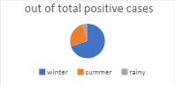
3.2 Clinical signs:
Affected birds showed reduced feed and water intake, lethargy, ruffled feathers, weight loss, and abnormal droppings. Mortality in affected flocks ranged from mild to severe depending on the age of birds, severity of renal damage, and environmental conditions. Young chicks showed sudden mortality without any clinical illness in certain outbreaks. Mortality was comparatively higher during winter months and in poorly managed flocks.
3.3 Gross pathology:
Gross examination of affected birds revealed extensive lesions characteristic of visceral gout. The most prominent finding was widespread deposition of chalky white urates on the serosal surfaces of various visceral organs. Urate deposits were specifically observed on the peritoneal membrane, heart (Fig. 2a), liver (Fig. 2b), intestinal serosa, and mesentery, giving the abdominal cavity a diffuse white frosted appearance. These chalky deposits varied from fine powdery coatings to thick granular accumulations depending on the severity of the condition. The kidneys were enlarged, pale, swollen, and friable, indicating severe renal damage. Prominent renal lobules with whitish discoloration were also observed in some cases. The ureters were markedly distended and filled with semi-fluid to semi-solid chalky white urates, producing a characteristic cord-like appearance (Fig. 2c). In severely affected birds, the lumen of ureter was almost completely packed with thick creamy urates. Whitish streaks were visible through the intestinal wall due to urate deposition beneath the serosal surface (Fig. 2d). Such lesions are considered as classical pathological features of visceral gout in poultry.
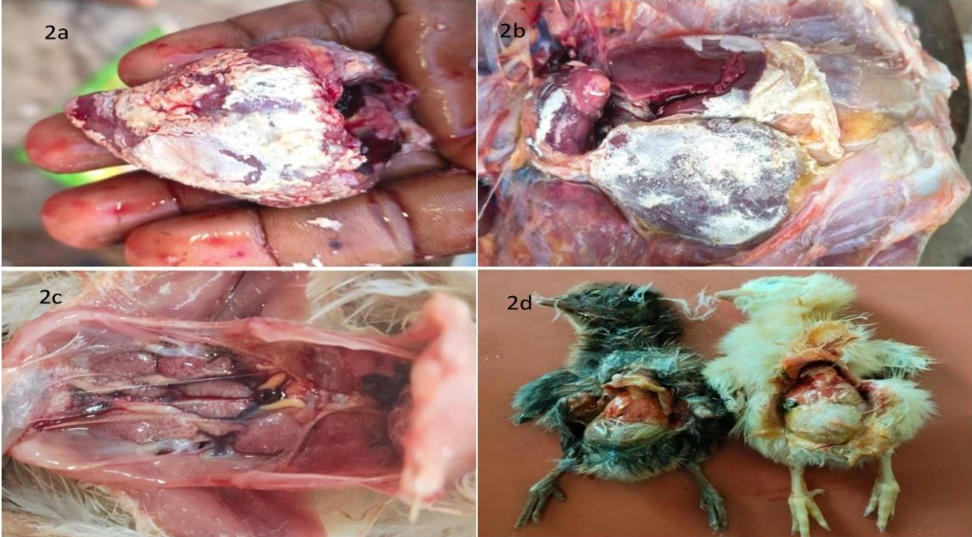
Fig 2. Gross pathological lesions observed in chicken affected with gout
Fig 2a. Urate deposits on heart; Fig 2b. Urate deposits on liver; Fig 2c. Enlarged, pale kidneys with the deposition of urates and bilateral enlargement of ureters; Fig 2d. White, semi-solid, granular coatings on the serosal surface of internal organs, including the intestinal mesentery.
3.4 Histopathology:
Microscopic examination of kidney sections showed moderate to severe tubular degeneration and necrosis. There was desquamation of tubular epithelial cells along with extensive deposition of fine, needle-shaped urate crystals in interstitial space (Fig 3a). Necrotic and atrophic glomeruli, dilation of Bowman’s space and inflammatory cell infiltration was also noted in affected renal tissue (Fig 3b).
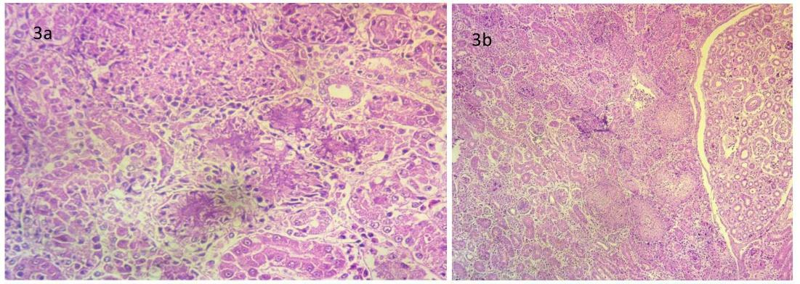
Figure. 3. Histopathological lesions in kidneys of chicken affected with gout. Fig 3a. Kidney section showing presence of urates in interstitial space, degeneration and desquamation of tubular epithelium (H &E x 400); Fig 3b. Kidney section showing necrotic glomeruli, atrophic glomeruli & tubules and increased bowman’s space (H &E x100)
Heart tissue sections examined with H&E revealed degenerative changes, mild inflammatory cell infiltration and disrupted myofibers (Fig 4).
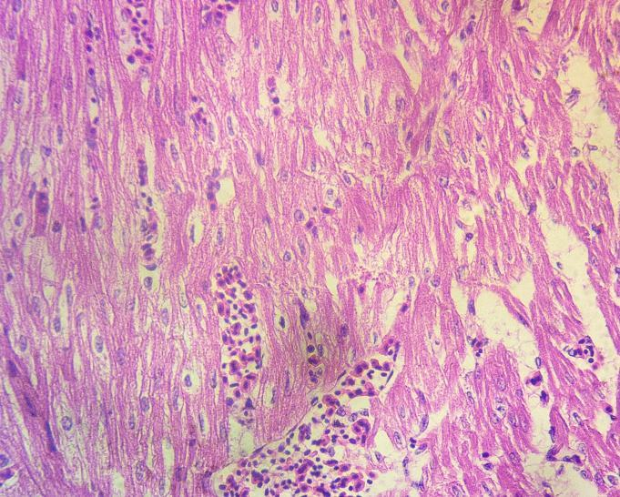
Fig 4. Heart section showing disruption of myofibers and infiltration of inflammatory cells in chicken affected with gout (H &E x 400)
Gomori methenamine silver (GMS) staining clearly demonstrated urate crystal deposits as black to dark brown radiating needle-like structures between myocardial fibers (Fig 5a) and around the blood vessels (Fig 5b). The stain enhanced visualization of crystal aggregates and confirmed their distribution within affected heart tissue.
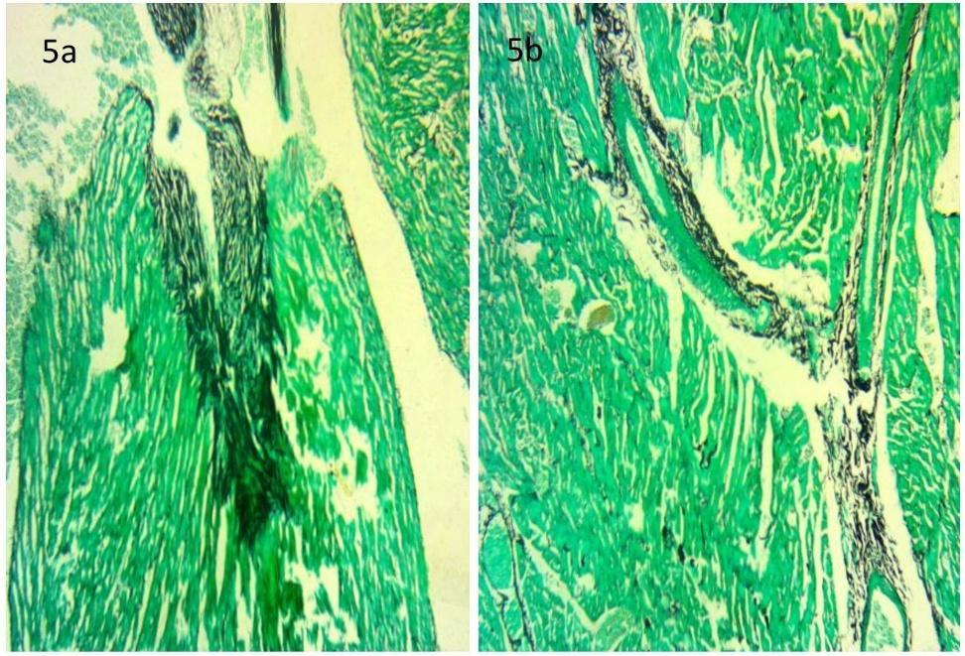
Fig 5. Histopathological lesions in heart of chicken affected with gout with Gomori methenamine silver stain. Fig 5a. Heart section depicting accumulation of urate crystals in between the muscle fibers (GMS x100). Fig 5b. Heart section showing deposition of urate crystals around the capillaries (GMS x100)
Impaired renal function or excessive systemic production of uric acid results in hyperuricemia. The accumulated uric acid subsequently precipitates as monosodium urate crystals within tissues. Although biochemically non-toxic, these crystals can cause severe mechanical injury, inflammation, tissue distortion and pressure necrosis which results in organ dysfunction (Arshad et al., 2025).
Present study revealed the highest prevalence of the disease during colder months, followed by summer, with the lowest incidence in the rainy season. Similar results were earlier reported by Srivastava et al., 2002; Jana et al., 2008; Panigrahi, 2017; Lakkawar et al., 2018; Yadav et al., 2020. Cold temperatures may promote increased production and reduced solubility of uric acid, leading to cold stress and higher mortality due to gout.
Young chicks show higher susceptibility and mortality due to visceral gout compared to adult birds (Mallinson et al., 1984; Wideman, 1988; Wideman et al., 1994; Jana et al., 2008; Singh et al., 2013; Panigrahi, 2017; Yadav et al., 2020). In the current experiment, most cases of mortality occurred in birds under 2 weeks of age, followed by those aged between 2 to 3 weeks, and then in birds below 1 week. Only a few cases of mortality were observed in birds older than 3 weeks. Similar findings have been reported by Singh et al., 2013. Difference in incidence based on age is due to the inclusion of calcium in diet (Singh et al., 2013). At sexual maturity, pullets are shifted to high-calcium diets to support egg production. If the kidneys are already damaged, they may fail to handle the increased calcium load, which can lead to the development of gout (Mitchell, 2015). Urate crystal deposition in the tubular lumen occurs, particularly during peak production (Al-Hamadani and Mohammed, 2009).
In the current investigation, gross examination findings were suggestive of visceral gout, which is considered the more common and acute form of gout observed in poultry. The condition was characterized by the presence of white, chalky urate deposits on the serosal surfaces of several visceral organs including the heart, liver, kidneys, air sacs, peritoneum, and intestinal serosa. These findings were in correlation with Arshad et al., 2025. Enlargement of the kidneys, distension of ureters with semi-fluid to semi-solid chalky white urates were also observed. Similar lesions were earlier reported by Mir et al., 2005.
Histopathological examination of the kidneys revealed degeneration, necrosis and desquamation of tubular epithelium, and extensive deposits of radiating, fine, needle-shaped urate crystals. Similar microscopic findings have been reported in earlier studies (Eldaghayes et al., 2010 & Ravikumar et al., 2019). Glomerular alterations included thickening of Bowman’s capsule, proliferative glomerulonephritis and dilation of Bowman’s space. These were in agreement with Eldaghayes et al., 2010.
However, the present study had certain limitations that should be considered while interpreting the findings. The clinical signs observed in affected birds, including lethargy, decreased feed and water consumption, ruffled feathers, and abnormal droppings, were nonspecific and resembled that of several other metabolic and infectious diseases of poultry. Due to the absence of characteristic early clinical manifestations, diagnosis during the initial stages was difficult under field conditions. In most cases, confirmation of visceral gout was possible only after postmortem examination through the observation of typical chalky white urate deposits on visceral organs and associated renal lesions. The study mainly focused on pathological and epidemiological aspects of non-infectious visceral gout and did not include the molecular diagnostic investigations to rule out infectious agents such as infectious bronchitis virus, avian nephritis virus, and astrovirus associated with renal damage in poultry. The investigation was restricted only to visceral gout, while articular gout was not included in the study. In addition, serum biochemical analysis including estimation of uric acid, creatinine, calcium, phosphorus, and electrolyte levels was not performed to correlate the pathological findings with metabolic disturbances and renal dysfunction in affected birds. Moreover, the study was confined to a limited geographical area, so the findings may not represent the overall geographical distribution and prevalence pattern of non-infectious visceral gout in poultry populations of other regions.
- Conclusion
Non-infectious visceral gout in chicken is strongly associated with nutritional imbalance, renal dysfunction, and environmental stress. This study concluded that young birds, especially during early weeks of age, are more susceptible to the gout. Seasonal variations are also significant with higher incidence in the colder months. Gross and histopathological findings confirmed severe renal damage due to deposition of urate crystals resulting in kidney function impairment. Proper regulation of dietary protein, calcium, and mineral balance, as well as improved management practices such as adequate water supply and temperature control are essential to prevent the occurrence of gout in poultry flocks.
Disclaimer (Artificial intelligence)

Author(s) hereby declare that NO generative AI technologies such as Large Language Models (ChatGPT, COPILOT, etc.) and text-to-image generators have been used during the writing or editing of this manuscript.

References
Al-Hamadani, A. H., & Mohammed, M. H. (2009). The relationship between the lesions of kidneys and the different production stages in layers. Iraqi Journal of Veterinary Sciences, 23(Suppl 1), 211–217.
Arshad, M., Khalid, G., Rahman, M., Yousaf, A., & Habib, F. (2025). Avian Visceral Gout: A Clinicopathological Study in Broiler Chickens. Mathews Journal of Veterinary Science, 9(7), 1-5.
Eldaghayes, I. M., Hamid, M. A., El-Attar, S. R., & Kammon, A. M. (2010). Pathology of gout in growing layers attributed to a high calcium and protein diet. E-International Science Research Journal, 2 (4), 297-302.
Jana, S., Niyogi, D., Mandal, S., Ganguly, S., & Mukhopadhaya, S. K. (2008). Haematological and Serum biochemical alteration in the gout of broiler birds. Indian Journal of Animal Health, 47(2), 113-115.
King, J.M., Roth-Johnson, L., Dodd, D.C., & Newsom, M.E. (2014). The Necropsy Book: A guide for veterinary students, residents, clinicians, pathologists, and biological researchers. The Internet-First University Press.
Lakkawar, A. W., Kumar, R., Venugopal, S., Uma, S., Sathiyaseelan, M., Nair, M. G. et al., (2018). Pathology and management of gout in Giriraja breeder chicks. Journal of Entomology and Zoology Studies, 6(1), 550-554.
Lakshmi Namratha, M., Kumar, Y. R., & Lakshman, M. (2019). Pathology of visceral gout in Layer chicken. International Journal of Recent Scientific Research, 10, 35546-35548.
Luna G L H T. 1968. Manual of histological and special staining techniques. 2nd ed., The Blackstone Division McGraw-Hill Book Company, Inc. NewYork, Toronto London: 1-5 and 9-34.
Mallinson, E. T., Rothenbacher, H., Wideman, R. F., Snyder, D. B., Russek, E., Zuckerman, A. I. et al., (1984). Epizootiology, pathology, and microbiology of an outbreak of urolithiasis in chickens. Avian Diseases, 25-43.
Mir, M. S., Darzi, M. M., Khan, A. A., Ganaie, N. A., Gupta, S., Nashiruddullah, N. et al., (2005). Investigation of an outbreak of gout in Kashmir Favorella poultry. Indian Journal of Veterinary Pathology, 29(1), 35-37.
Mitchell, A. (2015). Gout management in poultry. The Poultry Site. https://www.thepoultrysite.com/articles/gout-management-in-poultry
Panigrahi, S. (2017). Epidemiological studies on chicken astroviruses in gout affected broiler chicken flocks (Doctoral dissertation, LUVAS).
Ravikumar, Y., Sawale, G. K., Ramesh, G., Mahesh, B., Madhuri, D., & Lakshman, M. (2019). Visceral gout in ducks. The Pharma Innovation Journal, 8(1), 256-257.
Sandhyarani, K., Madhuri, D., & Ravikumar, Y. (2022). Review-gout in chicken. Advances in Animal and Veterinary Sciences, 10(3), 702-711.
Singh, N., Ghosh, R. C., & Singh, A. (2013). Prevalence and haemato-biochemical studies on naturally occurring gout in Chhattisgarh. Advances in Animal and Veterinary Sciences, 1(3S), 9–11.
Srivastava, N., Joshi, B. P., Jani, P. B., & Prajapati, K. S. (2002). Epidemiological studies on visceral gout in broiler chicks. In National symposium on Recent Advance in Diagnosis of: Livestock, Poultry and Wildlife with special Emphasis on Hill Area Diseases and XIX Annual Conference of Indian Association of Veterinary Pathologists. Palampur, Hamnchal Pradesh, India.
Van Aken, L., Bielli, A., & Esposito, J. A. (2025). Preservation of tophi in the modified Gomori methenamine silver procedure for urates. Journal of Histotechnology, 1-3.
Wideman, R. F. (1988). Avian kidney anatomy and physiology. Critical Reviews in Poultry Biology, 1(2), 133-176.
Wideman, R. F., Ford, B. C., May, J. D., & Lott, B. D. (1994). Acute heat acclimation and kidney function in broilers. Poultry science, 73(1), 75-88.
Yadav, B. S., Niyogi, D., Gupta, R. K., Singh, S. V., Saif, M., & Jaiswal, S. K. (2020). Incidence and clinicopathological study of gout in broiler birds of Faizabad and Sultanpur districts of eastern Uttar Pradesh. Exploratory Animal and Medical Research, 10(1), 88-91.

