Seasonal Variation in Phytoplankton Diversity and Its Relation with Physico-chemical Characteristics of Lonar Crater Lake, Maharashtra, India

Abstract

Background: Lonar Lake, a unique meteorite impact crater lake in Maharashtra, India, is an extreme saline–alkaline ecosystem that supports diverse and specialized microbial and phytoplankton communities. Its phytoplankton diversity, including cyanobacteria, diatoms, and green algae, is strongly influenced by physico-chemical conditions and serves as a sensitive bioindicator of water quality, eutrophication, and ecological change.

Aim: Phytoplankton diversity is a crucial bioindicator of aquatic health. Hence, the present study was carried out to assess seasonal changes in phytoplankton diversity and water quality, particularly during the pre-monsoon and post-monsoon periods and to determine their influence on phytoplankton community structure in Lonar Carter Lake, thereby indicating the overall health of the corresponding aquatic ecosystem.
Study design: Lonar Crater Lake, Buldhana, M.S. India.
Place and Duration of Study: The present study assessed phytoplankton diversity and water quality in Lonar Lake during the pre-monsoon and post-monsoon seasons, i.e., June 2024 and December 2024, respectively. The samples were collected from four different designated sampling stations in the early morning from the periphery of the Lonar Crater Lake.
Methodology: The standard methods of APHA (2017), Kodarkar (2006), and Trivedy and Goel (1984) were used for the analysis of phytoplankton and Water quality. From the surface to below the surface level, a V-shaped plankton net attached to a sampling bottle at the end was used to collect phytoplankton samples, and the bucket-rope too mechanism was used at certain sampling stations. The samples were stored in plastic bottles containing 4% formalin solution, kept in a cool, dark place. The phytoplankton samples were photographed under the microscope and were identified using standard taxonomic keys.
Statistical Analysis was used to assessed Phytoplankton diversity using the Shannon–Wiener Diversity Index (H′), Pielou's Evenness Index (J′), Margalef’s’ (d) and Simpson's Dominance Index (D) to evaluate species diversity, evenness, and dominance within the phytoplankton community. One-Way Analysis of Variance (ANOVA) was performed to determine significant spatial and seasonal variations in phytoplankton diversity and abundance among sampling stations. Principal Component Analysis (PCA) was employed to identify the major physico-chemical variables influencing phytoplankton distribution and community structure.
Results: The phytoplankton species were assessed, belonging to three major classes comprising Bacillariophyceae, Cyanophyceae, and Chlorophyceae, across four sampling stations (S1, S2, S3, and S4) during June 2024 and December 2024. A total of 36 species were recorded, of which Cyanophyceae contributed the highest number (21 species), followed by 8 species of Bacillariophyceae and 7 species of Chlorophyceae. Among the recorded groups, Cyanophyceae was found to be the dominant class, represented by genera such as Spirulina, Arthrospira, Anabaena, Anabaenopsis, Microcystis, Oscillatoria, Raphidiopsis, and Pseudoanabaena. Bacillariophyceae (diatoms) formed the second major group, represented by species such as Navicula amphirhynchus, Navicula cryptocephalas, Navicula radiosa, Navicula sphaerophora, Pinnularia divergens and Pleurosigma sp. Similarly, Chlorophyceae (green algae) was represented by species such as Chlorella vulgaris, Oocystis sp., Pediastrum integrum, Tetraedron duospinum, Palmella mucosa, Kirchneriella obesa, and Quadrigula lacustris.
Based on the physico-chemical analysis, the lake exhibits elevated salinity, alkalinity, dissolved solids, chloride, phosphorus, COD, and BOD, along with critically low dissolved oxygen concentrations. These findings suggest continuous inputs of organic waste, nutrient-rich runoff, and dissolved salts. The overall water quality status indicated that the lake water was polluted and eutrophic, with significant organic and nutrient contamination. Although post-monsoon conditions show slight improvement due to dilution, the lake remains ecologically stressed and unsuitable for drinking or domestic use without extensive treatment.
Conclusion: The study confirmed that the phytoplankton community of Lonar Lake was a sensitive and reliable indicator of its ecological status. The shifts in species composition observed during pre-monsoon and post monsoon periods also reflects the underlying changes in nutrient load. Therefore, regulation of nutrient inputs, frequent monitoring of the primary producer along with detailed and regular scientific studies are essential steps towards restoring the sustainability of this unique ecological marvel.
Keywords: Diversity, Lonar Crater Lake, Phytoplankton, Water quality, Principal Component Analysis, ANOVA

Introduction:
The Lonar Lake is situated in Buldhana District of Maharashtra State in India. In 1823, it was found by a British officer called Cornet J.E. Alexander. This Lake is third largest natural saltwater body in the world with a diameter of 1.8 kilometres and depth of 150 metres (Taiwade,1994). As it is one of the known meteoritic saltwater crater lakes in the world, Lonar Lake supports and harbours specialized single-celled microorganisms, including bacteria, fungi, protozoa, viruses, and algae. They are key to understanding the potential life in extreme environments. Phytoplankton are sensitive to changes in the aquatic environment and rapidly adapt to changing conditions, thus they are more effective indicators of rapid change in aquatic environments (Sahoo et al., 2024). Therefore, the investigation of the diversity of phytoplankton in the Lonar Lake was deemed necessary as it is the unique saline, alkaline natural laboratory for studying it and also has great ecological significance.
In inland wetland water bodies, the most important, abundant and significant primary producers are phytoplankton, which are affected by physico-chemical variables (Bhaskar et al., 2015; Dalu et al., 2022). Moreover, these autotrophic micro-organisms fix the solar energy to create food sources for the higher trophic level and build a crucial link between biotic and abiotic factors (Malik et al., 2022; Meshram et al., 2018). Phytoplankton includes both eukaryotic green algae (Chlorophyceae) and prokaryotic blue-green algae (Cyanophyceae) which produce half of the world's photosynthetic activity and have an important role in reducing warming and climate change mitigation (Vajravelu et al., 2018). Each aquatic autotroph grows faster and in a short time. Hence, it is acknowledged to remove greater amount of carbon dioxide (CO₂) than forest, crops and other aquatic plants (Singh et al., 2013). Phytoplankton grow rapidly, which enables them to react quickly to the changes in the environment, so they are used as indicators of water quality in freshwater bodies (Meng et al., 2020). They are an important food source for aquatic organisms, including small fish and whales, which form the aquatic food chain. Some common groups of phytoplankton, such as Cyanophyceae (Blue-green algae), Bacillariophyceae (diatoms) and Chlorophyceae (green algae) are found in nutrient-rich water. Cyanobacteria tend to grow in dense colonies or filaments, and have been observed to thrive at high biomass densities. This was the result of the growth of the green algae (Chlorophyta) in highly contaminated lakes or wastewater lagoons and in nutrient rich ponds, where high numbers of organisms were found. In turbid lakes diatoms (Bacillariophyta) are the most important plankton group, as they make up a large part of the biomass, by utilizing most of the silica (Kalff, 2002).
Environmental factors had a significant impact on phytoplankton diversity, temperature affects the metabolic activity of phytoplankton and seasonal succession patterns, while larger size of water bodies and habitat diversity creates more niches, promoting diversity (Borics et al., 2021). Nutrient levels, toxic contaminants, temperature, and pH have direct impacts on their community structure, diversity and species composition (Ragi et al., 2017). They have short life cycles and respond quickly to environmental changes, making them better indicators of rapid change (Dorlikar, et al., 2025). High phytoplankton diversity generally indicates good ecological status, while low diversity and high dominance of a few tolerant species indicate environmental stress (Sahoo et al., 2024). Biomonitoring of phytoplankton is essential to assess the health of aquatic ecosystems which involves tracking changes in species composition with sensitive species declining and tolerant species thriving in polluted environments, where over 1,000 types of algae survive (Palmer, 1969). The presence of phytoplankton generally can signify nutrient enrichment, eutrophication or pollution.
Lonar Lake's unique biota was under threat as its high salinity and alkalinity levels decrease, due continuous inflow of freshwater stream, thereby impacting the diversity of species adapted to this extreme environment (Khobragade et al., 2016). Therefore, identifying the diversity of primary producers, i.e., phytoplankton, which can serve as a bio-indicator of the healthy state of any water body can provide relevant details on the degree of eutrophication and pollution of the aquatic ecosystem. The presence and absence contributed to the relationship between the prey and the predator and the overall diversity of aquatic microorganisms (Dembowska et al., 2018). Therefore, in the current study, a qualitative assessment of the phytoplankton population in the lake was conducted in 2024 across four selected sites to derive viable data on how water quality affects the biodiversity of this special crater Lake. Continuous monitoring of phytoplankton diversity along with some physico-chemical parameters provides valuable insights into the health of Lonar Lake's ecosystem, informing management and conservation efforts. Investigating the lake's unique microbial flora and fauna could highlight its wetland value, supporting its recognition as a Ramsar Site in India.
Material and Methods:
Study Area: Lonar Lake is located between latitude 19°58’ N and longitude 76°31’ E in Deccan Plateau basalt region of Buldhana, Maharashtra, India. The area of Lonar Lake is 1.88 km diameter with 150 m deep. It is circular depression in the basalt flows of the deccan trap. The Lake’s depth varies from season to season and attains its maximum depth during rainy season and has no noticeable outlet. Blue signs mark the sampling stations on the study map: S1, S2, S3, and S4. The phytoplankton were sampled at the sampling stations that were mentioned above, viz.;
Table 1. Sampling sites with their co-ordinates
Sampling Sites | Location | Latitude (°N) | Longitude (°E)
S1 | Kamalajadevi Temple | 19.971737° N | 76.512217° E
S2 | Mor Mahadev Temple | 19.971143° N | 76.510454° E
S3 | Wagh Mahadev Temple | 19.972126° N | 76.512334° E
S4 | Vishnu Temple | 19.976752° N | 76.513932° E

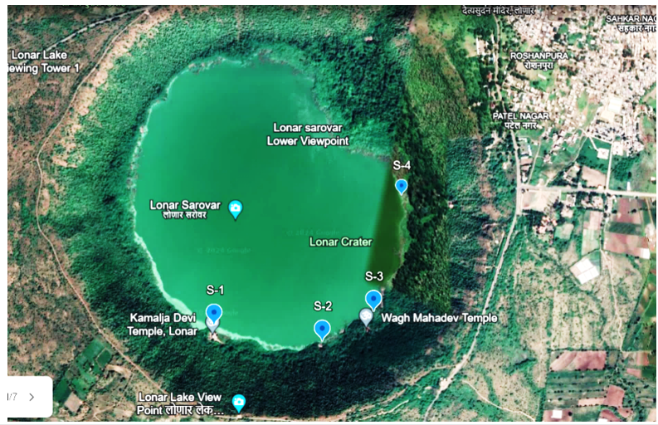
Fig. 1. Image created in Google Earth of sampling stations at Lonar Lake

Phytoplankton Collection: Water samples were collected twice in 2024 from four selected sampling sites during the pre-monsoon (June) and post-monsoon (December) periods. Phytoplankton samples were collected in the early morning from the surface water to below the surface using a V-shaped plankton net fitted with a sampling bottle at its end. At the same time, a bucket-rope mechanism was also employed at certain sampling stations. The collected samples were filtered through a plankton net to concentrate planktonic organisms and preserved in plastic bottles containing 4% formalin solution. The samples were then stored in a cool and dark place until laboratory analysis. To assess abundance, the concentrated sample volume was measured and transferred into a Sedgwick–Rafter counting cell, and the plankton organisms were identified and counted under a microscope using standard procedures. The phytoplankton samples were photographed under the Olympus microscope with model no CH20i under 4X, 10X and 40X resolution. The image of the phytoplankton species was captured by a Mobile camera and were identified using standard taxonomic keys given by Edmondson (1959), Prescott (1951), Needham and Needham (1941), Suthers (2009), Karacaoglu et al. (2004), Roy et al. (2015), Seu-Anoi et al. (2017), Werner (2009), Shivakumara (2015), Kumari et al. (2018), and Rafiullah (2018).

Physico-chemical Analysis: Water samples were collected from different selected sampling stations of Lonar Lake to assess the physico-chemical characteristics. Samples were collected in washed, wide-mouth plastic cans during the pre-monsoon and post-monsoon at early morning hours. Some parameters, such as Temperature, pH, TDS, Electrical Conductivity, and Dissolved oxygen, were analysed in-situ at sampling site using handy meters, and the remaining parameters were analysed in the laboratory. Collected samples were stored in a cool and dark place. Physico-chemical analysis of water was done as per the standard methods recommended by APHA’s 23rd edition (2017), Trivedy and Goel (1984).
Statistical Analysis: Phytoplankton diversity was assessed using the Shannon–Wiener Diversity Index (H′), Pielou's Evenness Index (J′), Margalef’s’ (d) and Simpson's Dominance Index (D) to evaluate species diversity, evenness, and dominance within the phytoplankton community (Shannon and Weaver, 1949; Simpson, 1949; Pielou’s, 1966; Margalef’s, 1958). One-Way Analysis of Variance (ANOVA) was performed to determine significant spatial and seasonal variations in phytoplankton diversity and abundance among sampling stations. Principal Component Analysis (PCA) was employed to identify the major physico-chemical variables influencing phytoplankton distribution and community structure. Correlation analysis was conducted to examine the relationships between phytoplankton groups and environmental parameters. Statistical analyses were performed using appropriate software, and significance was tested at the 5% probability level (p < 0.05).
Results & Discussion:
A total of 36 species of phytoplankton were reported from the four selected sites in the periphery of Lonar crater Lake belonging to three families, viz., Cyanophyceae, Bacillariophyceae and Chlorophyceae as summarized in Table 2. The distribution of phytoplankton species belongs to three major classes (Cyanophyceae, Bacillariophyceae, and Chlorophyceae) in the studied area in June 2024 and December 2024 in four sampling stations (S1, S2, S3, and S4) as shown in the Table 3. There were total of 36 species of which Cyanophyceae species (21) were the most diverse followed by Bacillariophyceae species (8) and Chlorophyceae species (7) respectively. Cyanophyceae was the most dominant phytoplankton with a particular prevalence in pre-monsoon season. These were found to comprise large numbers of the species Spirulina labyrinthiformis, Arthrospirales platensis, Microcystis aeruginosa, Oscillatoria brevis, Pseudoanabaena catenata, Anabaena circinalis and Anabaenopsis raciborskii during this period. The second major group was Bacillariophyceae (diatoms), which included such species as Navicula amphirhynchus, Navicula cryptocephalas, Navicula radiosa, Navicula sphaerophora, Pinnularia divergens and Pleurosigma sp. In the recorded genera, Cyanophyceae proved to be the dominant class with genera like Spirulina, Arthrospira, Anabaena, Anabaenopsis, Microcystis, Oscillatoria, Raphidiopsis and Pseudoanabaena. Other species with moderate distribution during the study period represented in the other classes were Bacillariophyceae (Navicula amphirhynchus, Pinnularia divergens, Navicula cryptocephala, Pleurosigma normanii, Navicula radiosa, Pleurosigma angulatum).
The genera that were previously reported from Lonar Lake by Dabhade (2015), Tandale (2020) and Tandale and Talwankar (2023) were not observed in the present study, such as Chlamydomonas, Oedogonium, Dunaliella salina, Rhizoclonium, Nostoc, Nitzschia, Synedra, Euglena. The majority of these are diatoms such as Cyclotella, Fragilaria and green algae such as Chlamydomonas and Oedogonium, which were generally believed to inhabit relatively stable environments or moderately enriched waters. The fact that they were not present in the current study indicated a potential ecological change within the lake environment. The current phytoplankton community, however, was dominated by cyanobacterial genera, including Microcystis, Anabaena, Arthrospira and Oscillatoria, which were known to be very tolerant of nutrient levels and organic pollution. Such change suggested that it was moving towards eutrophication and disturbed water quality. The diversity of the species of cyanobacteria and diatoms was higher in the present study: Anabaenopsis (A. arnoldii, A. tanganyikae, A. raciborskii), Microcystis (M. aeruginosa, M. ichtyoblabe), Raphidiopsis mediterranea, Pseudoanabaena catenata and Pseudoanabaena galeata. The above taxa have not been reported in the previous studies. Furthermore, some of the green algae species were observed in the present study, but not reported in earlier works, such as Chlorella vulgaris, Kirchneriella obesa, Quadrigula lacustris, Tetraedron duospinum, Palmella mucosa and Pediastrum integrum. The increase of cyanobacteria, particularly, indicated enrichment of nutrients and shift to eutrophic conditions, a symptom of the active changes in ecological status of the lake system.
Table. 2. Family and Class-wise Distribution of Phytoplankton Species at the Lonar Lake
Sr. No | Family | Class | Species
 | Naviculaceae | Bacillariophyceae | Navicula amphirhynchus
 | Pinnulariaceae | Bacillariophyceae | Pinnularia divergens
 | Naviculaceae | Bacillariophyceae | Navicula cryptocephalas
 | Pleurosigmataceae | Bacillariophyceae | Pleurosigma normanii
 | Naviculaceae | Bacillariophyceae | Navicula cuspidata
 | Naviculaceae | Bacillariophyceae | Navicula radiosa
 | Naviculaceae | Bacillariophyceae | Navicula sphaerophora
 | Pleurosigmataceae | Bacillariophyceae | Pleurosigma angulatum
 | Nostocaceae | Cyanophyceae | Raphidiopsis mediterranea
 | Pseudanabaenaceae | Cyanophyceae | Pseudoanabaena catenata
 | Oscillatoriaceae | Cyanophyceae | Spirulina labyrinthiformis
 | Chroococcaceae | Cyanophyceae | Rhabdogloea rhaphidioides,
 | Nostocaceae | Cyanophyceae | Anabaena circinalis
 | Nostocaceae | Cyanophyceae | Anabaenopsis circularis
 | Nostocaceae | Cyanophyceae | Anabaenopsis arnoldii
 | Nostocaceae | Cyanophyceae | Anabaenopsis tanganyikae
 | Oscillatoriaceae | Cyanophyceae | Athrospira platensis
 | Oscillatoriaceae | Cyanophyceae | Spirulina gigantea
 | Chroococcaceae | Cyanophyceae | Rhabdoderma lineare
 | Microcystaceae | Cyanophyceae | Microcystis aeruginosa
 | Microcystaceae | Cyanophyceae | Microcystis ichtyoblabe
 | Chroococcaceae | Cyanophyceae | Chroococcus minutus
 | Oscillatoriaceae | Cyanophyceae | Arthrospira gomontiana
 | Oscillatoriaceae | Cyanophyceae | Spirulina Nordstedtii
 | Oscillatoriaceae | Cyanophyceae | Arthrospira spirulina
 | Oscillatoriaceae | Cyanophyceae | Oscillaoria brevis
 | Nostocaceae | Cyanophyceae | Anabaenopsis raciborskii
 | Oscillatoriaceae | Cyanophyceae | Spirulina subtilissima.
 | Pseudanabaenaceae | Cyanophyceae | Pseudoanabaena galeata
 | Hydrodictyaceae | Chlorophyceae | Quadrigula lacustris
 | Hydrodictyaceae | Chlorophyceae | Tetraedron duospinum
 | Palmellaceae | Chlorophyceae | Palmella mucosa
 | Chlorellaceae | Chlorophyceae | Chlorella vulgaris
 | Oocystaceae | Chlorophyceae | Oocystis sp.
 | Hydrodictyaceae | Chlorophyceae | Pediastrum integrum
 | Selenastraceae | Chlorophyceae | Kirchneriella obesa

Table 3. Spatial and Temporal Diversity of Phytoplankton at the Lonar Lake
Class | Species | Pre-monsoon |  |  |  | Post-monsoon
Class | Species | S1 | S2 | S3 | S4 | S1 | S2 | S3 | S4
Bacillariophyceae | Navicula amphirhynchus | X | ✓ | ✓ | X | ✓ | ✓ | ✓ | X
Bacillariophyceae | Pinnularia divergens | ✓ | ✓ | X | ✓ | ✓ | ✓ | ✓ | ✓
Bacillariophyceae | Navicula cryptocephalas | X | ✓ | ✓ | ✓ | X | X | ✓ | ✓
Bacillariophyceae | Pleurosigma normanii | ✓ | ✓ | ✓ | X | ✓ | ✓ | ✓ | ✓
Bacillariophyceae | Navicula cuspidata | X | ✓ | ✓ | X | X | ✓ | ✓ | ✓
Bacillariophyceae | Navicula radiosa | ✓ | ✓ | ✓ | ✓ | ✓ | ✓ | ✓ | ✓
Bacillariophyceae | Navicula sphaerophora | X | ✓ | X | X | X | X | ✓ | ✓
Bacillariophyceae | Pleurosigma angulatum | X | ✓ | ✓ | X | X | X | ✓ | ✓
Cyanophyceae | Spirulina labyrinthiformis | ✓ | ✓ | ✓ | ✓ | ✓ | ✓ | X | ✓
Cyanophyceae | Raphidiopsis mediterranea | X | ✓ | ✓ | X | X | ✓ | ✓ | ✓
Cyanophyceae | Pseudoanabaena catenata | X | ✓ | ✓ | X | X | ✓ | ✓ | ✓
Cyanophyceae | Rhabdogloea rhaphidioides | X | X | ✓ | ✓ | X | ✓ | ✓ | ✓
Cyanophyceae | Anabaena circinalis | ✓ | ✓ | ✓ | ✓ | ✓ | ✓ | ✓ | ✓
Cyanophyceae | Anabaenopsis circularis | ✓ | ✓ | ✓ | ✓ | ✓ | ✓ | ✓ | ✓
Cyanophyceae | Anabaenopsis arnoldii | ✓ | ✓ | ✓ | X | ✓ | ✓ | ✓ | ✓
Cyanophyceae | Anabaenopsis tanganyikae | ✓ | ✓ | X | ✓ | ✓ | ✓ | ✓ | ✓
Cyanophyceae | Arthrospira platensis | ✓ | ✓ | ✓ | ✓ | X | ✓ | ✓ | ✓
Cyanophyceae | Spirulina gigantea | ✓ | ✓ | ✓ | X | ✓ | ✓ | ✓ | ✓
Cyanophyceae | Rhabdoderma lineare | ✓ | ✓ | ✓ | ✓ | ✓ | ✓ | ✓ | ✓
Cyanophyceae | Microcystis aeruginosa | X | X | ✓ | ✓ | X | ✓ | ✓ | ✓
Cyanophyceae | Microcystis ichtyoblabe | ✓ | ✓ | ✓ | X | X | ✓ | ✓ | ✓
Cyanophyceae | Chroococcus minutus | ✓ | ✓ | ✓ | ✓ | X | ✓ | ✓ | ✓
Cyanophyceae | Arthrospira gomontiana | X | ✓ | ✓ | ✓ | ✓ | ✓ | ✓ | X
Cyanophyceae | Spirulina Nordstedtii | X | ✓ | ✓ | ✓ | ✓ | ✓ | ✓ | X
Cyanophyceae | Arthrospira spirulina | ✓ | ✓ | ✓ | ✓ | ✓ | ✓ | ✓ | ✓
Cyanophyceae | Oscillatoria brevis | ✓ | ✓ | ✓ | ✓ | ✓ | ✓ | ✓ | ✓
Cyanophyceae | Anabaenopsis raciborskii | ✓ | ✓ | ✓ | ✓ | ✓ | ✓ | ✓ | ✓
Cyanophyceae | Spirulina subtilissima | ✓ | ✓ | ✓ | ✓ | ✓ | ✓ | ✓ | ✓
Cyanophyceae | Pseudoanabaena galeata | X | ✓ | ✓ | X | X | ✓ | ✓ | ✓
Chlorophyceae | Chlorella vulgaris | ✓ | ✓ | ✓ | ✓ | ✓ | ✓ | ✓ | ✓
Chlorophyceae | Oocystis sp. | X | ✓ | X | X | X | ✓ | ✓ | X
Chlorophyceae | Kirchneriella obesa | X | ✓ | X | ✓ | X | ✓ | ✓ | ✓
Chlorophyceae | Quadrigula Lacustris | ✓ | ✓ | ✓ | X | X | ✓ | ✓ | ✓
Chlorophyceae | Tetraedron duospinum | X | ✓ | ✓ | X | X | X | ✓ | ✓
Chlorophyceae | Palmella mucosa | ✓ | ✓ | ✓ | ✓ | ✓ | ✓ | ✓ | ✓
Chlorophyceae | Pediastrum integrum | X | X | ✓ | ✓ | X | ✓ | ✓ | X

Table 4. Physico-chemical parameters at different sites of Lonar Crater Lake for Pre-Monsoon and Post- Monsoon, 2024

Sr. No | Parameter | Unit | Pre-Monsoon 2024 |  |  |  | Post- Monsoon 2024
 |  |  | S1 | S2 | S3 | S4 | S1 | S2 | S3 | S4
1 | Temperature | ⁰C | 29 | 28.5 | 29 | 28.9 | 26.1 | 26 | 26 | 27
2 | Transparency | cm | 34 | 29 | 24 | 20 | 29 | 23 | 20 | 27
3 | EC | µS/cm | 496.2 | 744.1 | 800.3 | 796.8 | 682 | 710 | 739 | 747
4 | TDS | mg/l | 3839 | 3882 | 3903 | 3930 | 3255 | 3463 | 3541 | 3168
5 | Salinity (ppt) | ppt | 9600 | 8450 | 9530 | 10250 | 7125 | 6842 | 6235 | 7743
6 | pH |  | 10.65 | 10.7 | 10.73 | 10.46 | 9.18 | 9.5 | 9.1 | 8.99
7 | Alkalinity | mg/l | 2230 | 2310 | 2280 | 2420 | 2170 | 2165 | 2180 | 2260
8 | Hardness | mg/l | 158 | 142 | 154 | 146 | 146 | 134 | 142 | 138
9 | Chlorides | mg/l | 1755.45 | 1775.44 | 1689.47 | 1795.44 | 1545.45 | 1559.8 | 1531.44 | 1503.08
10 | Sulphate | mg/l | 20 | 20 | 22 | 18 | 17 | 16 | 18 | 15
11 | Nitrate | mg/l | 10.30 | 9.26 | 10.17 | 19.69 | 6.22 | 5.84 | 6.10 | 8.32
12 | Phosphorous | mg/l | 0.44 | 0.47 | 0.42 | 0.83 | 0.50 | 0.54 | 0.61 | 0.87
13 | DO | mg/l | 0.9 | 0.84 | 0.79 | 1.1 | 1.3 | 1.2 | 1.1 | 1.6
14 | BOD | mg/l | 22 | 24 | 24 | 20 | 19.8 | 20.4 | 20.7 | 17.7
15 | COD | mg/l | 112.84 | 128.4 | 132.29 | 116.73 | 92 | 112 | 124 | 108
16 | Silicate | mg/l | 7.61 | 7.76 | 7.80 | 13.01 | 5.22 | 5.40 | 5.68 | 6.10

Physico-chemical Analysis: The comparison between pre and post monsoon water quality data for 2024 shows a general improvement in the water quality of the water body after the monsoon season. The water temperature showed a decrease from around 29°C in pre-monsoon to 26–27°C in post-monsoon, indicating water cooling effect due to rainfall and fresh water inputs. The pH values were very high before the monsoon (10.46–10.73) but dropped to more in line with natural water conditions after the monsoon (8.99–9.50). Dissolved oxygen (DO) was also higher, ranging from 0.79–1.1 mg/L to 1.1–1.6 mg/L, which meant that oxygen was available to aquatic life, but less than is desirable for a healthy aquatic system. In comparison biochemical oxygen demand (BOD) at all the sampling stations decreased from 20-24 mg/L to 17.7-20.7 mg/L, which implies that there has been reduction in the biodegradable organic pollution, while the chemical oxygen demand (COD) reduced significantly from all the sampling stations which implies that there has been a reduction in organic and chemical pollution.
The concentration of most of the physico-chemical parameters such as salinity, total dissolved solids (TDS), chlorides, alkalinity, hardness, sulphate and silicate also decreased following monsoon. The effect of the dilution from rainfall and the inflow of fresh water is one of the reasons for this reduction. The electrical conductivity (EC) also generally decreased, again reflecting the lower level of dissolved salts and mineral content. Water transparency was slightly reduced at most stations, which may have been from an increase in suspended sediments and particulate matter that were added to the water body from monsoon runoff. Nutrient concentrations showed mixed trends, with nitrate concentrations significantly decreasing at all stations, indicating dilution and a lesser accumulation of nutrients, and a slight increase in concentrations of phosphorus at most stations, possibly due to surface runoff from the surrounding agricultural and urban areas. The water quality during post-monsoon was favourable as compared with pre-monsoon. The observed decrease in salinity, TDS, chlorides, COD, BOD and nitrate level has shown a decrease in pollution and improvement in water quality due to monsoonal dilution. These benefits have not been enough, however, to raise dissolved oxygen concentrations to desirable levels and to maintain relatively alkaline pH, indicating ecological stress. Hence, it is important to continue monitoring and apply management practices to further enhance its water body health.
Diversity Indices Studied: Species richness and diversity indices were used to describe the average species diversity, species density, dominance, evenness, richness and abundance of the phytoplankton in an aquatic ecological community to assess ecosystem health and stability. Shannon's diversity index was used to measure the entropy or uncertainty of phytoplankton diversity for each sample (Shannon, 1949). The Simpson’s index or concentration of dominance is used to calculate species proportions, which gives more weightage to the common or dominant species (Simpson,1949). The richness index of Margalef’s (1958) is used to measure the species richness in a community according to the number of species and the number of individuals. Pielou's evenness index is a measure of the uniformity of individuals among the species for any ecological community (Pielou's, 1966).
Table 5. Diversity Indices of the Phytoplankton Species in the Study Area
Season | Station | Species richness (S) | Shannon H' | Margalef d | Pielou J' | Simpson D
Pre-Monsoon | S1 | 20 | 2.9957 | 6.3424 | 1.0000 | 0.0000
Pre-Monsoon | S2 | 33 | 3.4965 | 9.1520 | 1.0000 | 0.0000
Pre-Monsoon | S3 | 31 | 3.4340 | 8.7362 | 1.0000 | 0.0000
Pre-Monsoon | S4 | 22 | 3.0910 | 6.7938 | 1.0000 | 0.0000
Post-Monsoon | S1 | 19 | 2.9444 | 6.1132 | 1.0000 | 0.0000
Post-Monsoon | S2 | 32 | 3.4657 | 8.9447 | 1.0000 | 0.0000
Post-Monsoon | S3 | 35 | 3.5553 | 9.5631 | 1.0000 | 0.0000
Post-Monsoon | S4 | 31 | 3.4340 | 8.7362 | 1.0000 | 0.0000

Biodiversity indices in table 5. Show changes in the species diversity and species richness in the four sampling stations, in pre-monsoon and post-monsoon seasons respectively. Species richness (S) varied from 19 to 35 species, with S2 having the highest number of species pre-monsoon (33) and S3 in post-monsoon season (35). S1, on the other hand, recorded the lowest richness in both seasons, pre-monsoon (20 species) and post-monsoon (19 species). The Shannon diversity index, H' ranged from 2.9444 to 3.5553, indicating the moderate to high diversity among all stations. Max Shannon value is found in S3 during the post-monsoon season (3.5553) and the minimum Shannon value is at S1 during the post-monsoon season (2.9444) which means that there is more species diversity at S3 in the post-monsoon season than at S1 in the post-monsoon season.
The Margalef's richness index (d) further ranged from 6.1132 to 9.5631 with the highest value recorded in S3 (post-monsoon) and the lowest value recorded in S1 (post-monsoon). This trend is consistent with the other trend in which S3 had the highest amount of biological richness of the stations surveyed. The evenness index (J') was 1.0000 at all the stations and seasons suggesting even distribution of individuals among species with no dominant species. Similarly, Simpson's diversity index (D) was found as 0.0000 at all the stations indicating very high diversity and very low species dominance. Overall, the findings showed a higher biodiversity and species richness at stations S2 and S3 compared to S1 and S4, and higher diversity in the post-monsoon season, perhaps as a result of better environmental conditions and greater nutrient availability after rains. The evenness values were also consistently high, further suggesting a well-balanced community structure at all sites.

One-Way ANOVA: Physico-chemical Parameters by Seasons
One-Way ANOVA showed significant spatial and seasonal variations in phytoplankton diversity, suggesting that fluctuations in environmental parameters affect community composition and abundance.
Table 6. One-Way ANOVA: Physico-chemical Parameters with Seasons
Parameter | F-statistic | p-value | Significance
Temperature | 90.675 | 0.0001 | ***
pH | 132.553 | <0.001 | ***
DO | 9.457 | 0.0218 | *
BOD | 5.911 | 0.0511 | ns
COD | 2.826 | 0.1437 | ns
EC | 0.019 | 0.8950 | ns
TDS | 35.477 | 0.0010 | **
Transparency | 0.301 | 0.6031 | ns
Alkalinity | 6.392 | 0.0448 | *
Hardness | 5.000 | 0.0667 | ns
Chlorides | 71.253 | 0.0002 | ***
Nitrate | 5.172 | 0.0633 | ns
Phosphorous | 0.495 | 0.5081 | ns
Sulphate | 11.308 | 0.0152 | *
Silicate | 6.648 | 0.0419 | *
Salinity | 25.752 | 0.0023 | **

According to the data, Temperature, pH, DO, TDS, Alkalinity, Chlorides, Sulphate, Silicate, and Salinity, these parameters were significantly different between the seasons. From the seasonal analysis of the lake water chemistry, it was observed that there was a significant difference in the levels of several physico-chemical parameters between pre-monsoon and post-monsoon period which showed strong seasonal effect on the water characteristics of the saline lake ecosystem. A total of eight parameters showed statistically significant inter-seasonal differences indicating that the seasons may be better understood through this dataset. The seasonal difference in the mean values of temperature was significantly high (F = 90.675, p < 0.001), with the mean temperature of pre-monsoon season being higher (28.85°C) than that of post-monsoon season (26.28°C). This rise was estimated to occur during the summer months when there was high solar radiation and warm air temperatures. The pre-monsoon high temperatures may have a positive effect on evaporation and hence on the dissolved salts and other chemical constituents present in lake water.
When all the parameters were examined, pH was found to be the most significant (F = 132.553, P < 0.001) with distinctly alkaline pH in pre-monsoon (10.64) and post-monsoon (9.19) season. High pH values reflect high alkaline conditions typical of saline lakes and could be caused by high photosynthetic activity, carbonate build-up and evaporative concentration during dry periods. Highly alkaline lake conditions were carried over the seasons, indicating a stable soda-rich ecosystem in the lake. Dissolved oxygen (DO) was significant in the revised analysis where it showed a significant seasonal variation (F = 9.457, p = 0.022). The DO concentration (mean 1.30 mg/L) was found to be higher in the post-monsoon season than in the pre-monsoon season (0.91 mg/L). Ecologically significant because of the cooler temperatures following the monsoon which enhance oxygen solubility in water. Furthermore, monsoonal mixing and fresh water inflow could increase oxygenation and oxygen replenishment while the high temperatures and high salinity in the pre-monsoon could decrease oxygen availability.
The total dissolved solids (TDS) also showed significant difference between seasons (F = 35.477, p = 0.001) with higher concentrations during pre-monsoon period, reflecting concentration of the dissolved ions due to intense evaporation and lesser water volume during this period. The monsoon causes the lake's dissolved solid concentrations to drop due to dilution caused by the rain and surface runoff, which shows the lake's strong hydrological control over its chemistry. Alkalinity also varied significantly from one season to another (F = 6.392 and p = 0.045) while the difference between pre- and post-monsoon means was relatively moderate of 2310 mg/L vs. 2194 mg/L. The high alkalinity value of both seasons suggests that carbonate and bicarbonate ions predominate in the lake water. The post-monsoon dilution may be responsible for a decrease in alkalinity, whereas the pre-monsoon high rate of evaporation and mineral concentration could cause an increase in alkalinity.
The chloride concentration has shown a highly significant seasonal difference (F = 71.253, p < 0.001) from 1503 to 1795 mg/L, indicating that salts were concentrated in the lake water during pre-monsoon season. Chlorides are conservative ions that are concentrated as water is lost, and are therefore good indicators of the changes in salinity of closed-basin saline lakes. The mean concentrations of sulphate also differed significantly between seasons (F = 11.308, p = 0.015) with a higher mean concentration during pre-monsoon season (20 mg/L) than during post-monsoon season (16.5 mg/L). The higher concentration of sulphate in the dry season could be due to evaporative concentration and mineral dissolution processes. The known lower concentrations of sulphates following the monsoon may be a diluting effect from the monsoon rains and freshwater inputs.
Significant seasonal variation was also observed for silicate (F = 6.648; p = 0.042), with higher levels during pre-monsoon season. This can be correlated with a high concentration of silicate in the case of high evaporation and higher weathering and sediment interaction. The seasonal changes in the silicate level also could affect the productivity of the diatoms and nutrient cycling in the lake system. The salinity showed highly significant difference among seasons (F = 25.752, p = 0.002) and the salinity range was 6235 - 10250 ppt. During pre-monsoon season salinity was very high (9458 ppt) and during post-monsoon season it was 6986 ppt, which clearly indicates the effect of evaporative concentration during summer months. During the post-monsoon, monsoonal rains dilute the lake water and decrease the concentration of salt in the lake. The large seasonal range in salinity is indicative of the high salinity of the lake and its strong dependence on the balance between inflow and outflow.
There were 7 parameters, BOD, COD, EC, Transparency, Hardness, Nitrate, Phosphorous, which are not statistically significant. Because, the p value is > 0.05. In conclusion, it is evident that the lake experiences significant intra-seasonal physico-chemical changes, mainly due to evaporation over pre-monsoon period and dilution during post-monsoon period. The TDS, chloride, alkalinity, sulphate and salinity were found to be higher throughout the pre-monsoon period while dissolved oxygen was found to be higher during the cooler period in the post-monsoon. These seasonal changes are a reflection of the dynamic ecological processes within this saline lake system and can give clues to the hydro chemical functioning of the lake.
Principal Component Analysis: PCA explained the variations in physico-chemical properties, phytoplankton species richness and diversity which affected water quality in the sites. The maximum variance of 55.1% was explained by PC1 followed by PC2, PC3 and PC4 representing variance of 23.4%, 9.2% and 6.1 %, respectively.
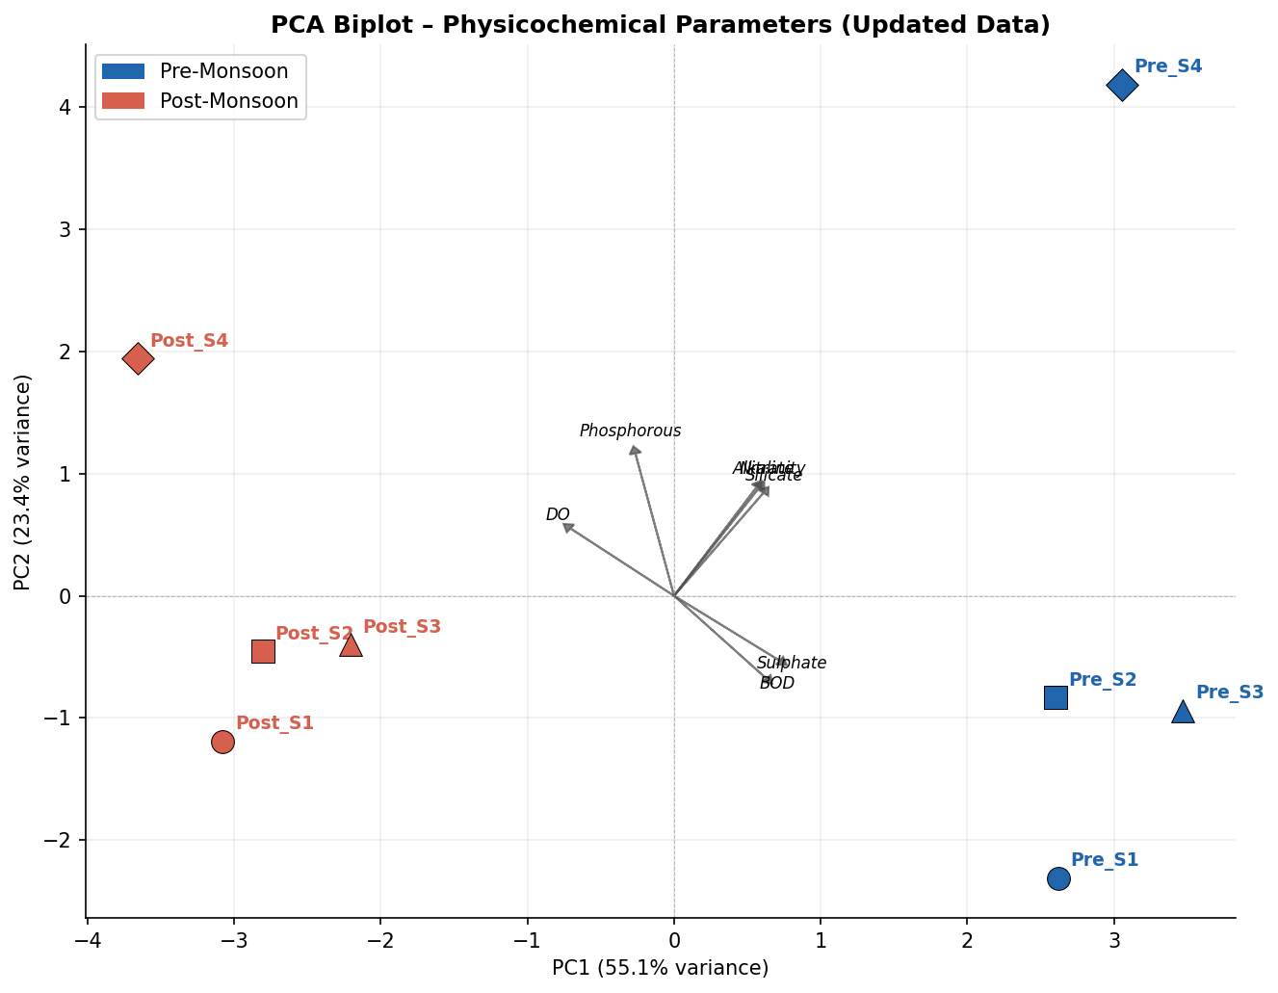
Figure 2. PCA biplot of physico-chemical parameters
Table 7. PCA variance explained by each principal component
PC | % Variance | Cumulative | Key Parameters
PC1 | 55.1% | 55.1% | Chlorides, Salinity, TDS, EC
PC2 | 23.4% | 78.5% | Temperature, pH, DO
PC3 | 9.2% | 87.7% | Alkalinity, Transparency
PC4 | 6.1% | 93.8% | Phosphorous, Nitrate

The data set, PC1 now accounts for 55.1% of variance up from 46.2% and was heavily influenced by Chlorides, Salinity and TDS – all of which experienced significant value revisions. The saline geochemistry of Lonar Crater Lake is now much more influential as seen on the ionic strength axis. The variance accounted for by PC1+PC2 is 78.5%. The pre-monsoon samples were concentrated in the high-ionic-strength range (positive PC1), and the post-monsoon samples were concentrated in the low-ionic-strength range, which was expected to follow the seasonal changes in the Lake’s ionic strength. The Principal Component Analysis (PCA) revealed that four principal components account for 93.8% of the total variation in water quality data, which was considered to be representative of the significant water quality processes related to the lake ecosystem.
To understand the importance of salinity and mineralisation to soil and crop development, PC1 explains the greatest amount of variance (55.1%) and was well correlated with chlorides, salinity, total dissolved solids (TDS) and electrical conductivity (EC). These parameters were closely related to the concentration and dissolved salt content of the water. This component was predominant, suggesting that salinity and mineral enrichment were dominant influenced on water chemistry. Variations in these parameters were much greater in saline-alkaline lakes like Lonar Lake because of high evaporation rates and high concentration of dissolved salts. Thus, PC1 was the salinity–mineralization gradient of a lake ecosystem.
PC2 – Physico-Chemical Environmental Factor PC2 accounts for 23.4% of variance and was related to temperature, pH and dissolved oxygen (DO). These variables affect the biological productivity, metabolism and oxygen dynamics of the aquatic environment. Chemical reactions and microbial activity were influenced by temperature, and pH indicates the alkaline characteristics of the water. Dissolved oxygen is an important parameter of the health of the ecosystem and the biological processes. So, PC2 was considered to be an environmental and biological activity factor that affects aquatic conditions.
PC3 – Water Quality and Light Penetration Factor PC3 has an account for 9.2% of variance and is related to alkalinity and transparency. Alkalinity is a measure of the buffering capacity of water and transparency measures the amount of suspended matter and light penetrating the water. This component indicates the effect of water clarity and carbonate chemistry to the lake ecosystem. So, PC3 can be said to be a water quality and optical characteristic factor. The nutrient enrichment factor (NEF) was measured in PC4.
PC4 accounts for 6.1% of the variation and is mostly composed of phosphorous and nitrate, which are key nutrients controlling primary productivity. Changes in these nutrients can occur from biological uptake, sediment interactions, runoff, and destruction of organic matter. This component is a measure of the nutrient enrichment/trophic status which affects the growth of phytoplankton and the productivity of an ecosystem. Overall, the PCA results indicated that the water quality of the lake was mostly controlled by salinity related parameters (55.1%), followed by physico-chemical (23.4%), water clarity/alkalinity (9.2%) and nutrient dynamics (6.1%). The high cumulative variance (93.8%) confirms that these four factors describe the overall lake environmental variability fairly well, and that salinity and dissolved ions are among the most important components influencing the lake's limnological features.
Class-wise Phytoplankton Composition: Cyanophyceae (58.3% of total phytoplankton species) was the most dominant group at all the sampling stations and seasons, which suggested that cyanobacterial communities were well adapted with the saline-alkaline conditions of Lonar Crater Lake. The salinity levels (6235 – 10250 mg/L) are an important ecological factor that limits growth of a number of freshwater algal taxa and encourages the growth of haloalkaliphilic cyanobacteria. The low abundance of Bacillariophyceae and Chlorophyceae also reflects the selection pressure resulting from the very high lake hydrochemistry. The results showed that salinity and alkalinity were the most important factors controlling the structure of the phytoplankton community and Lonar Crater Lake was a unique saline-alkaline ecosystem with a special microbial and algal community.

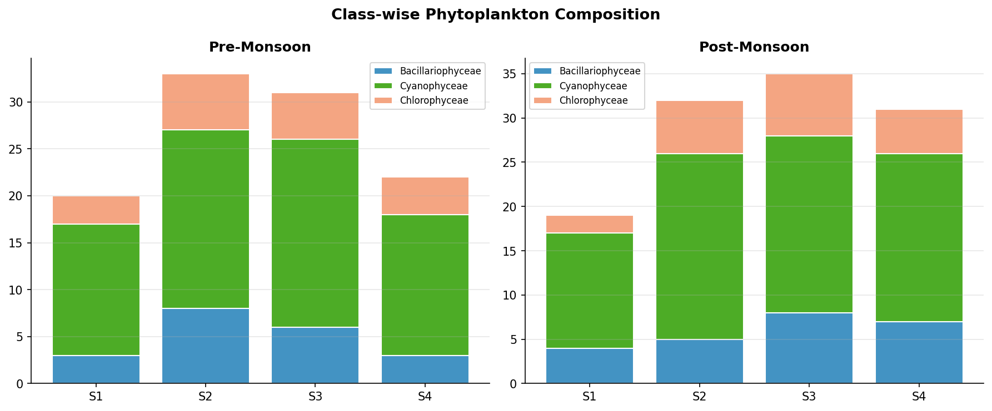
Figure 3. Class-wise Species Composition per Stations and seasons

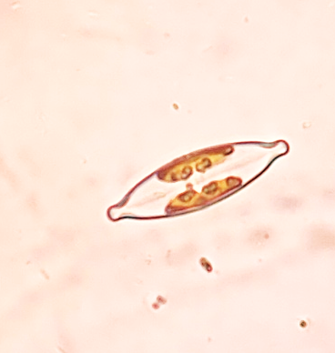  Navicula amphirhynchus | 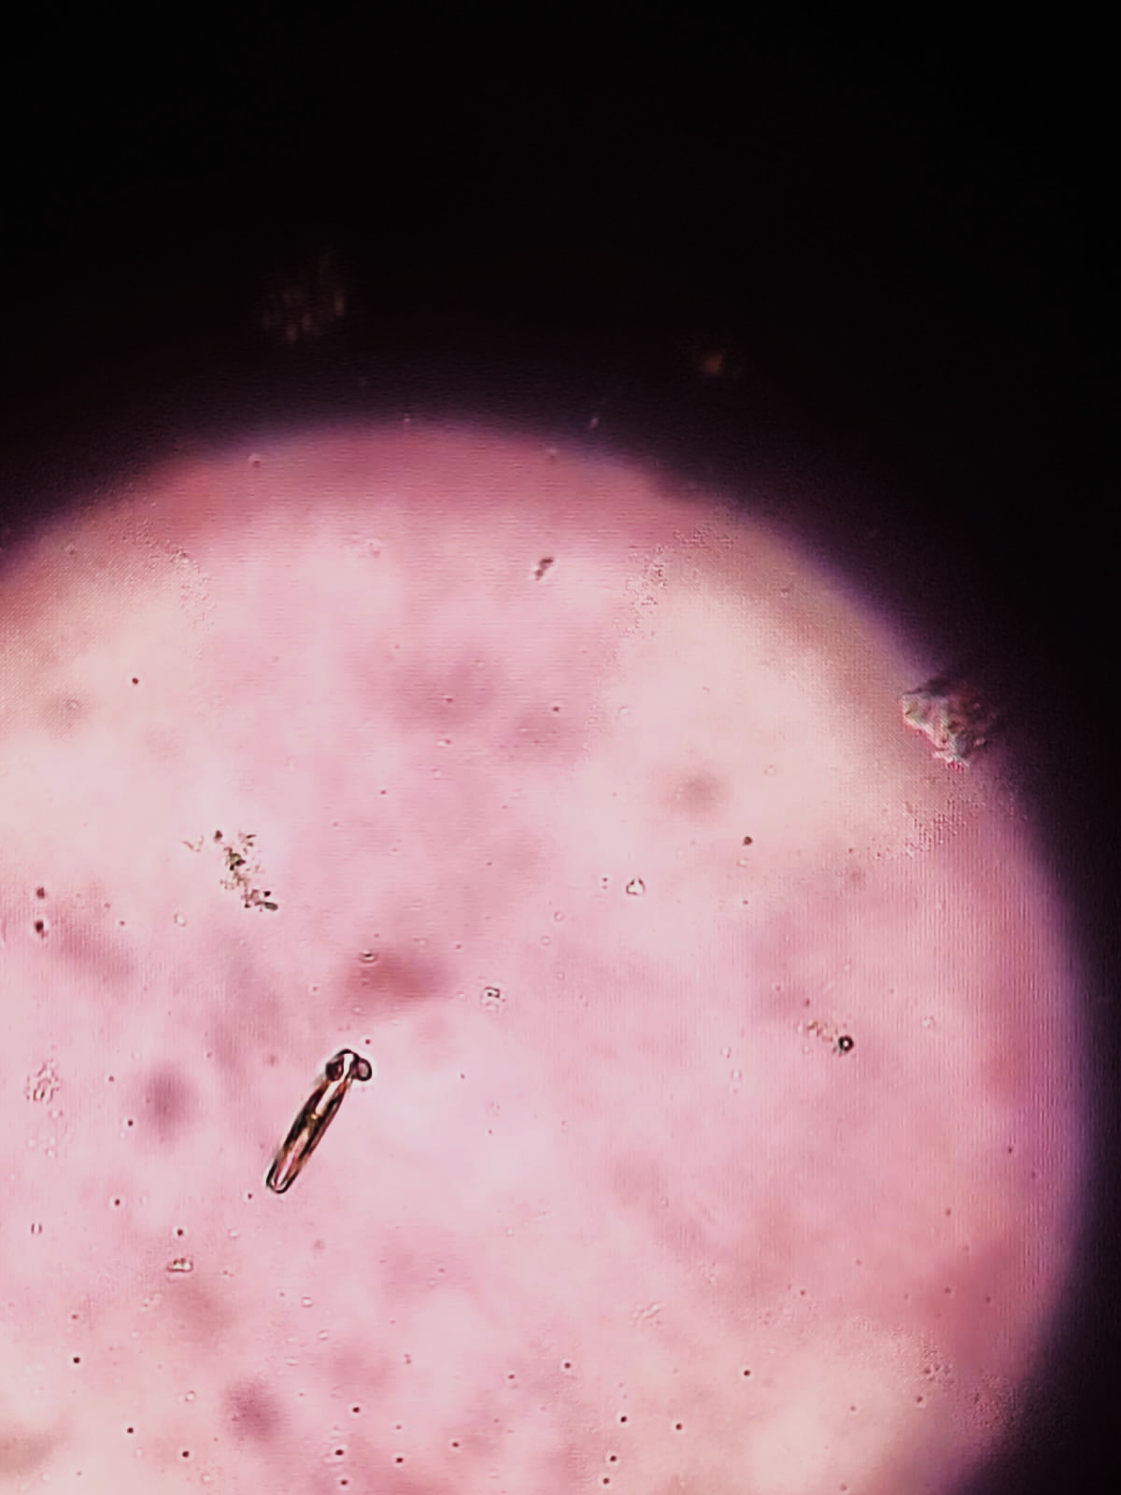  Pinnularia divergens | 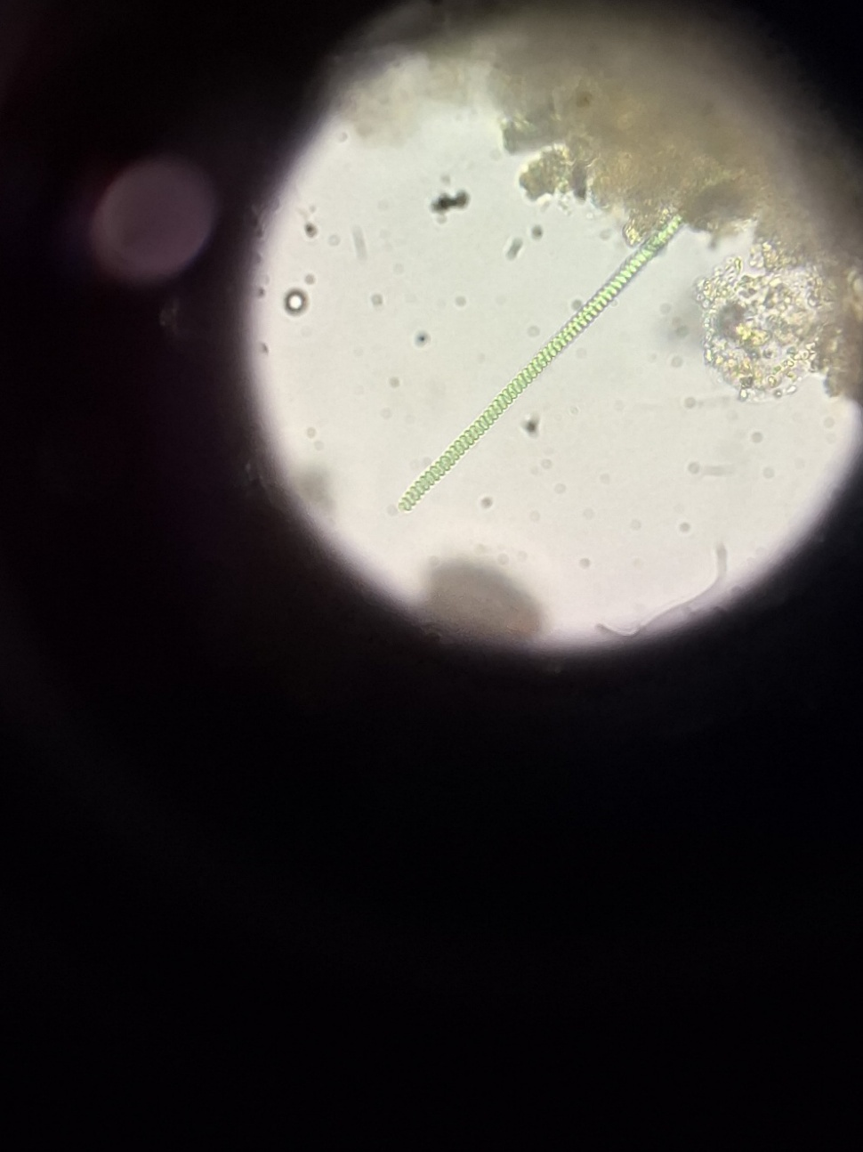  Spirulina labyrinthiformis
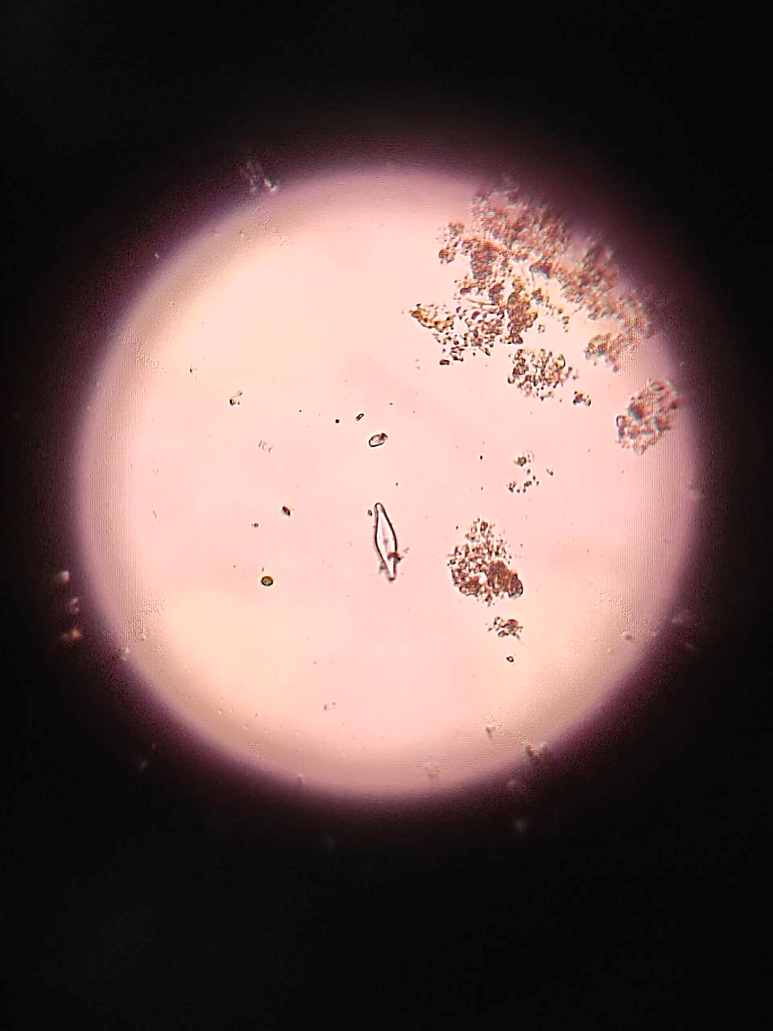  Navicula cryptocephalas | 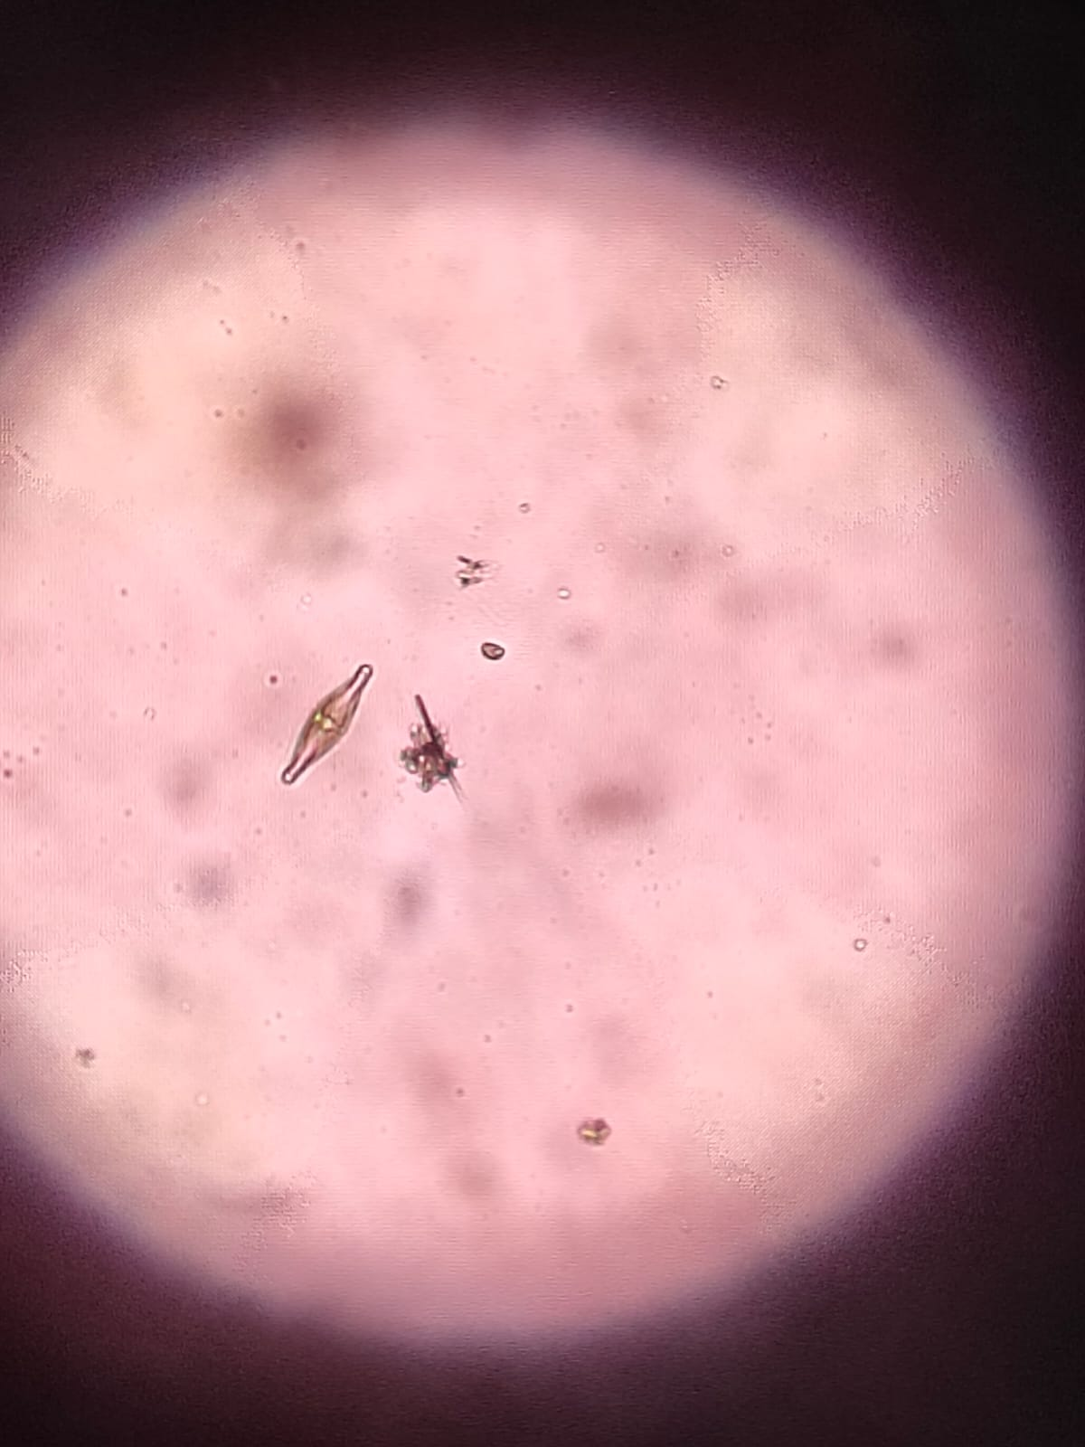  Pleurosigma normanii | 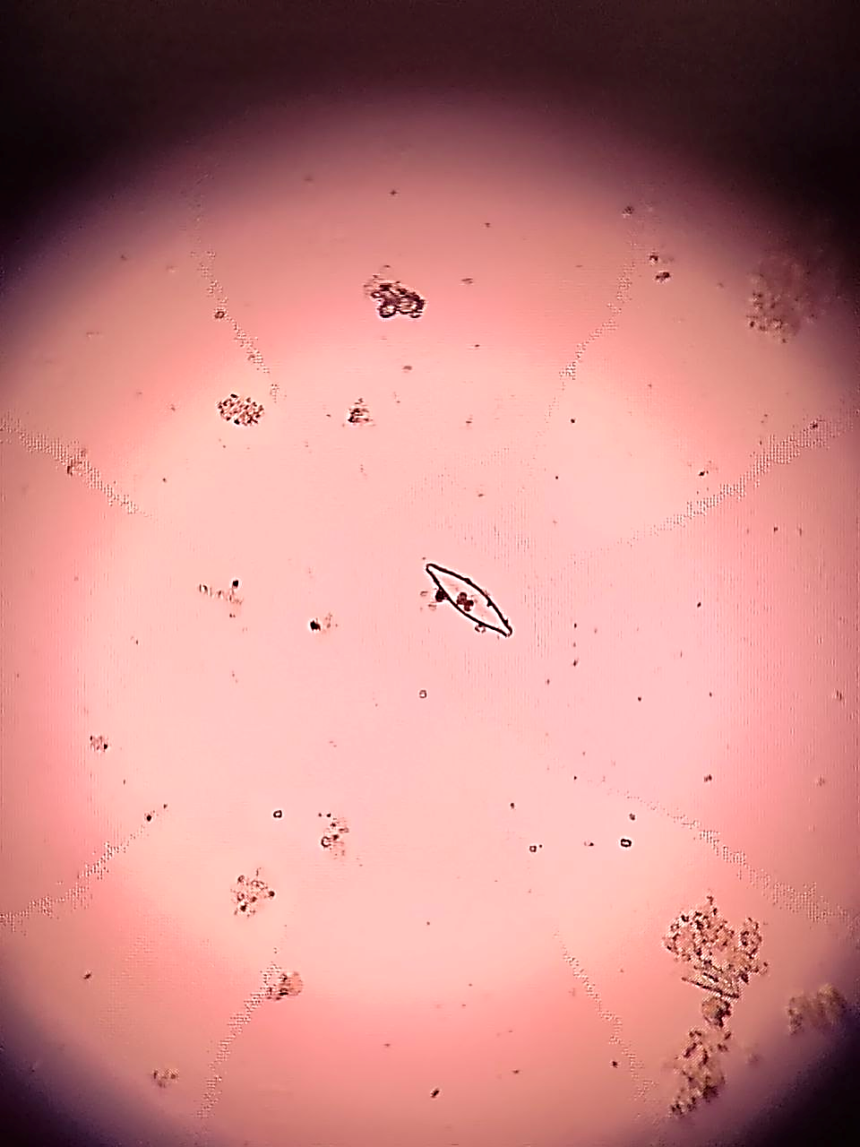  Navicula cuspidata
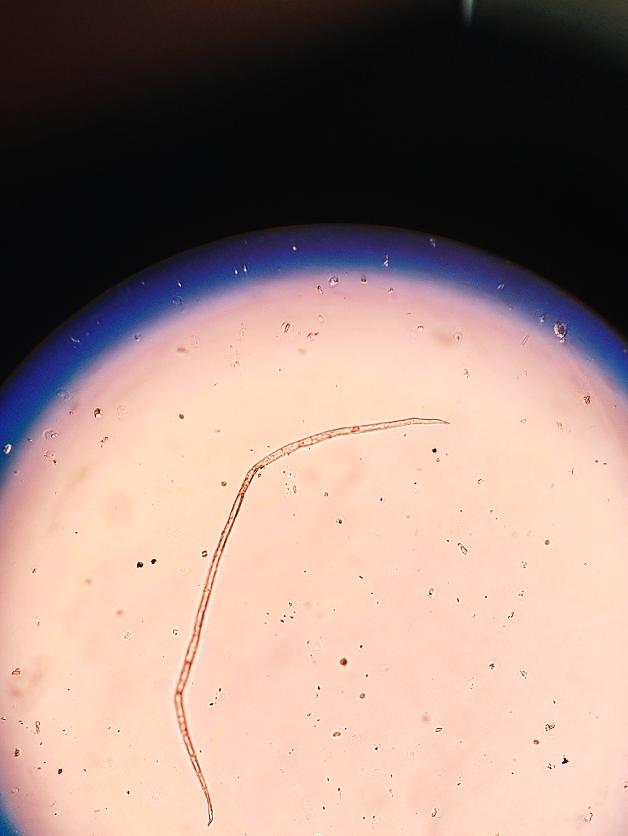  Raphidiopsis mediterranea | 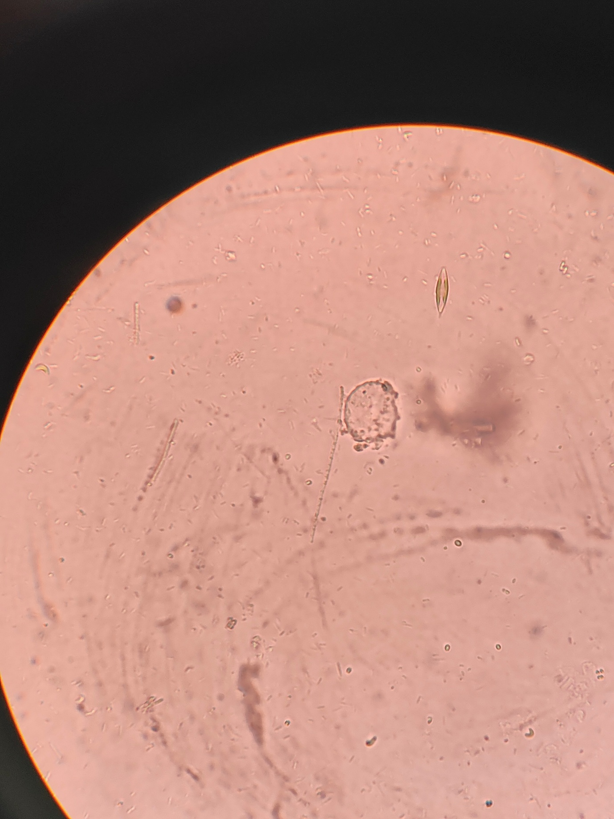  Navicula radiosa | 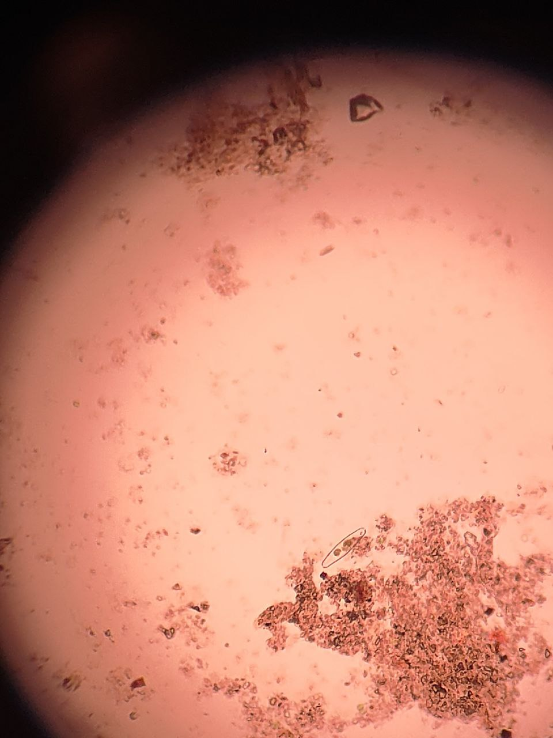  Navicula sphaerophora
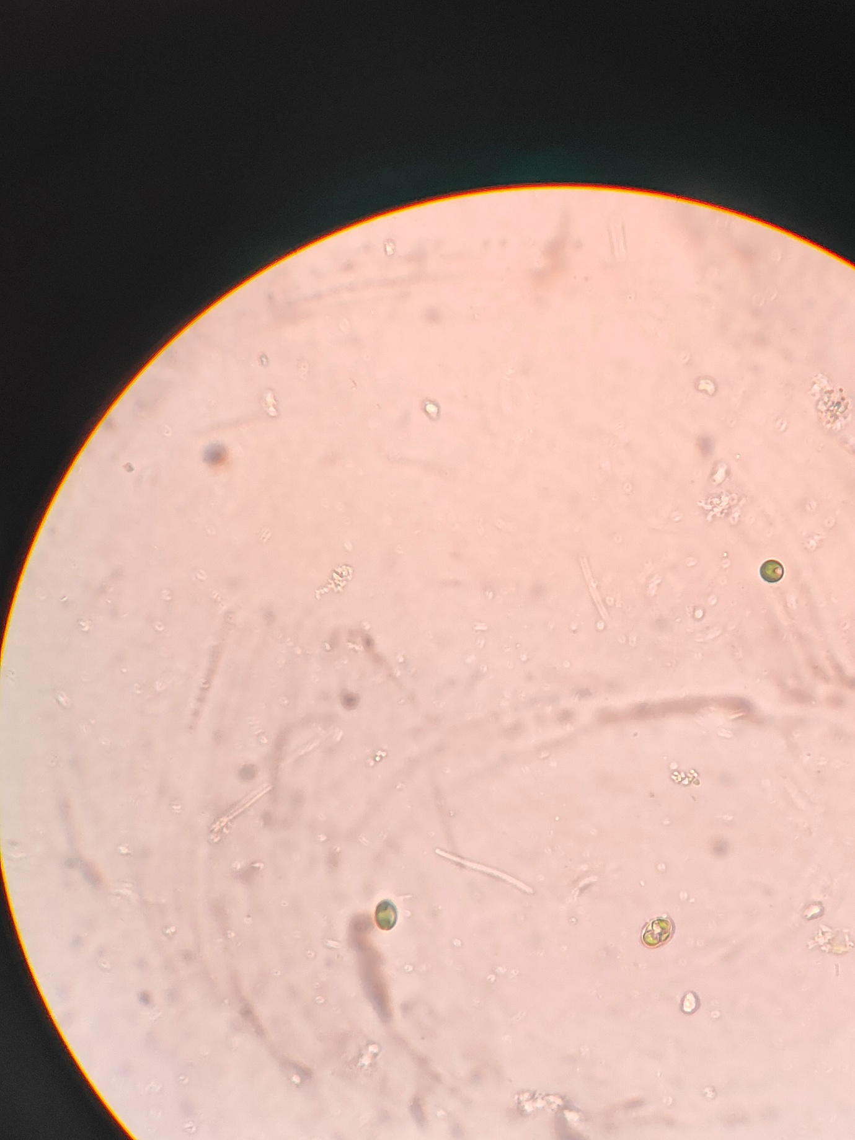  Chlorella vulgaris | 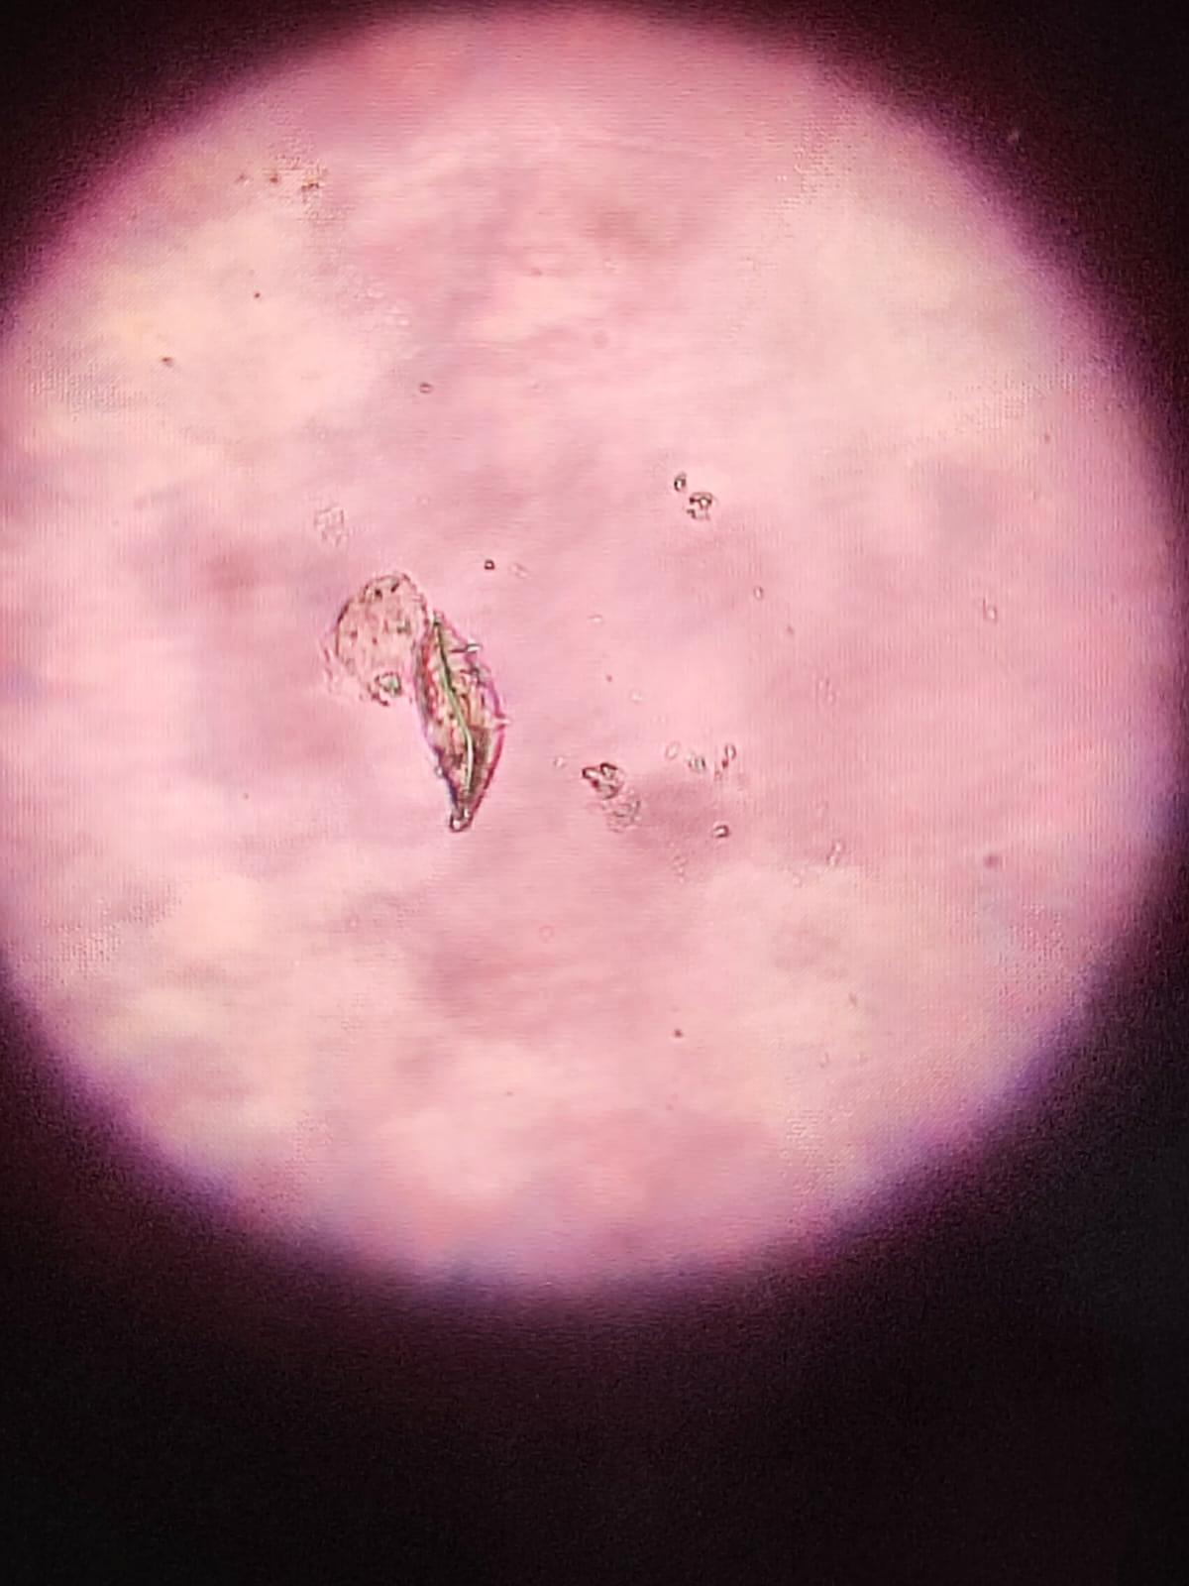  Pleurosigma angulatum | 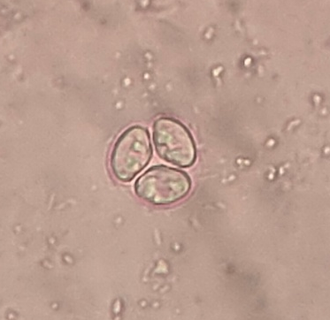  Oocystis sp.
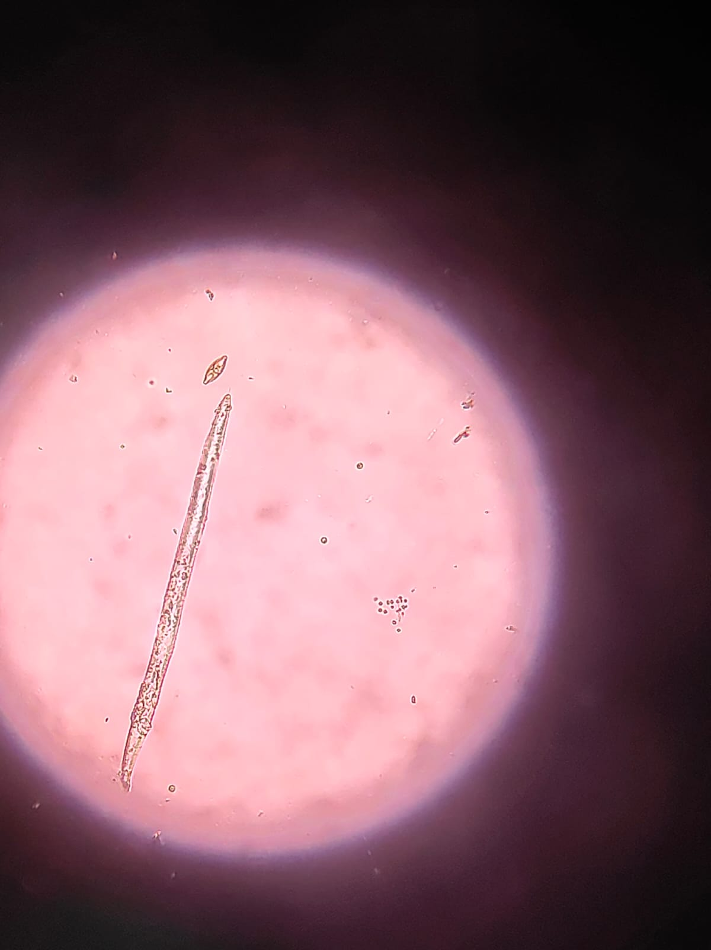  Rhabdogloea rhaphidioide | 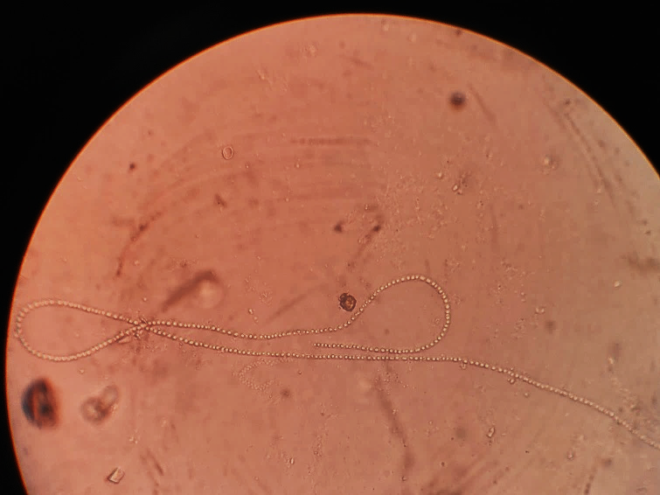  Anabaena circinalis | 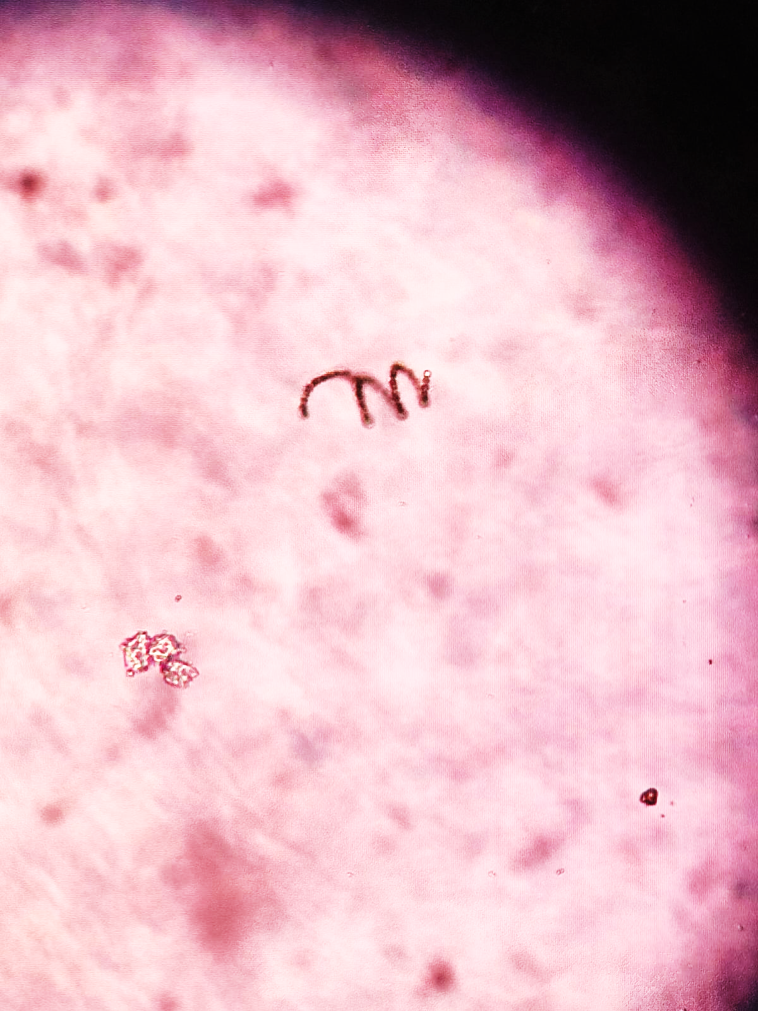  Anabaenopsis circularis
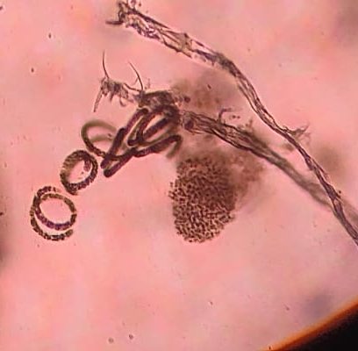  Anabaenopsis arnoldii | 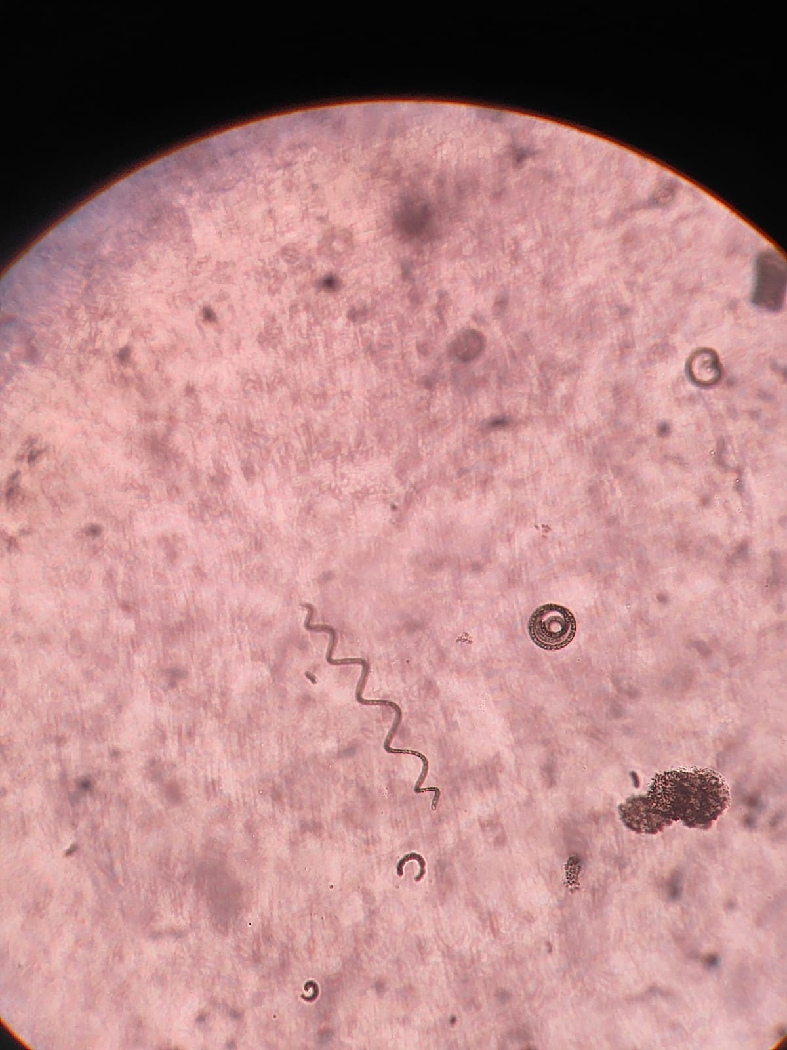  Anabaenopsis tanganyikae | 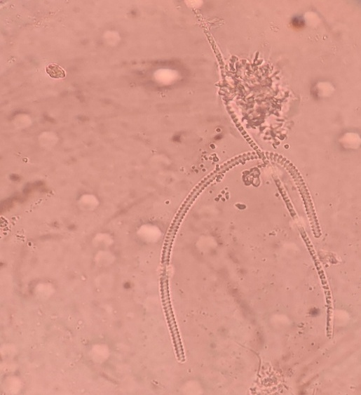  Spirulina gigantea
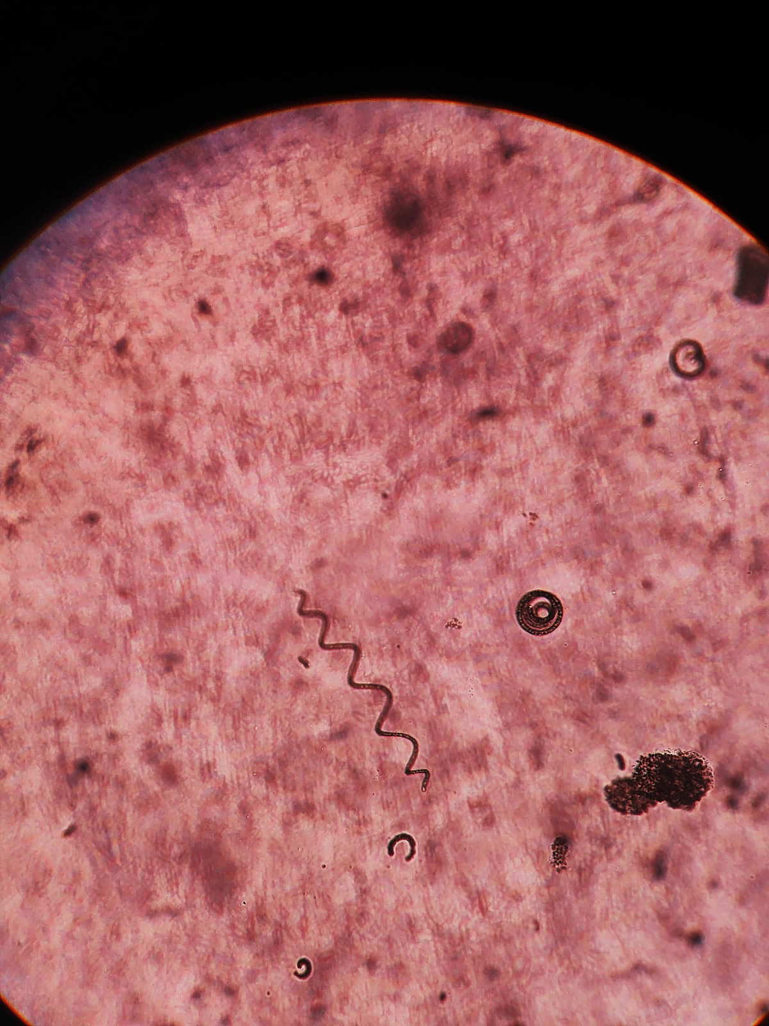  Kirchneriella obesa | 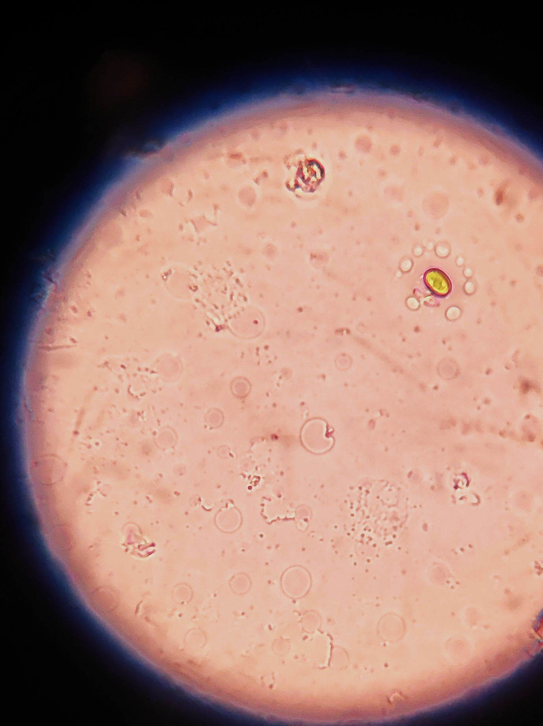  Kirchneriella obesa | 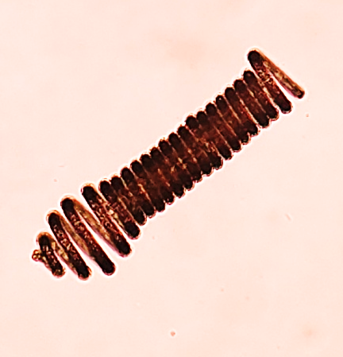  Athrospira platensis
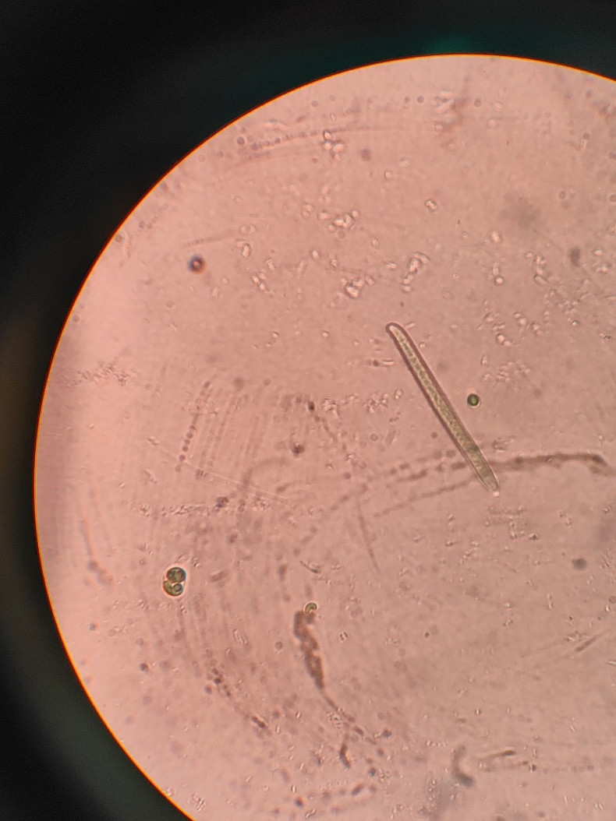  Rhabdoderma lineare | 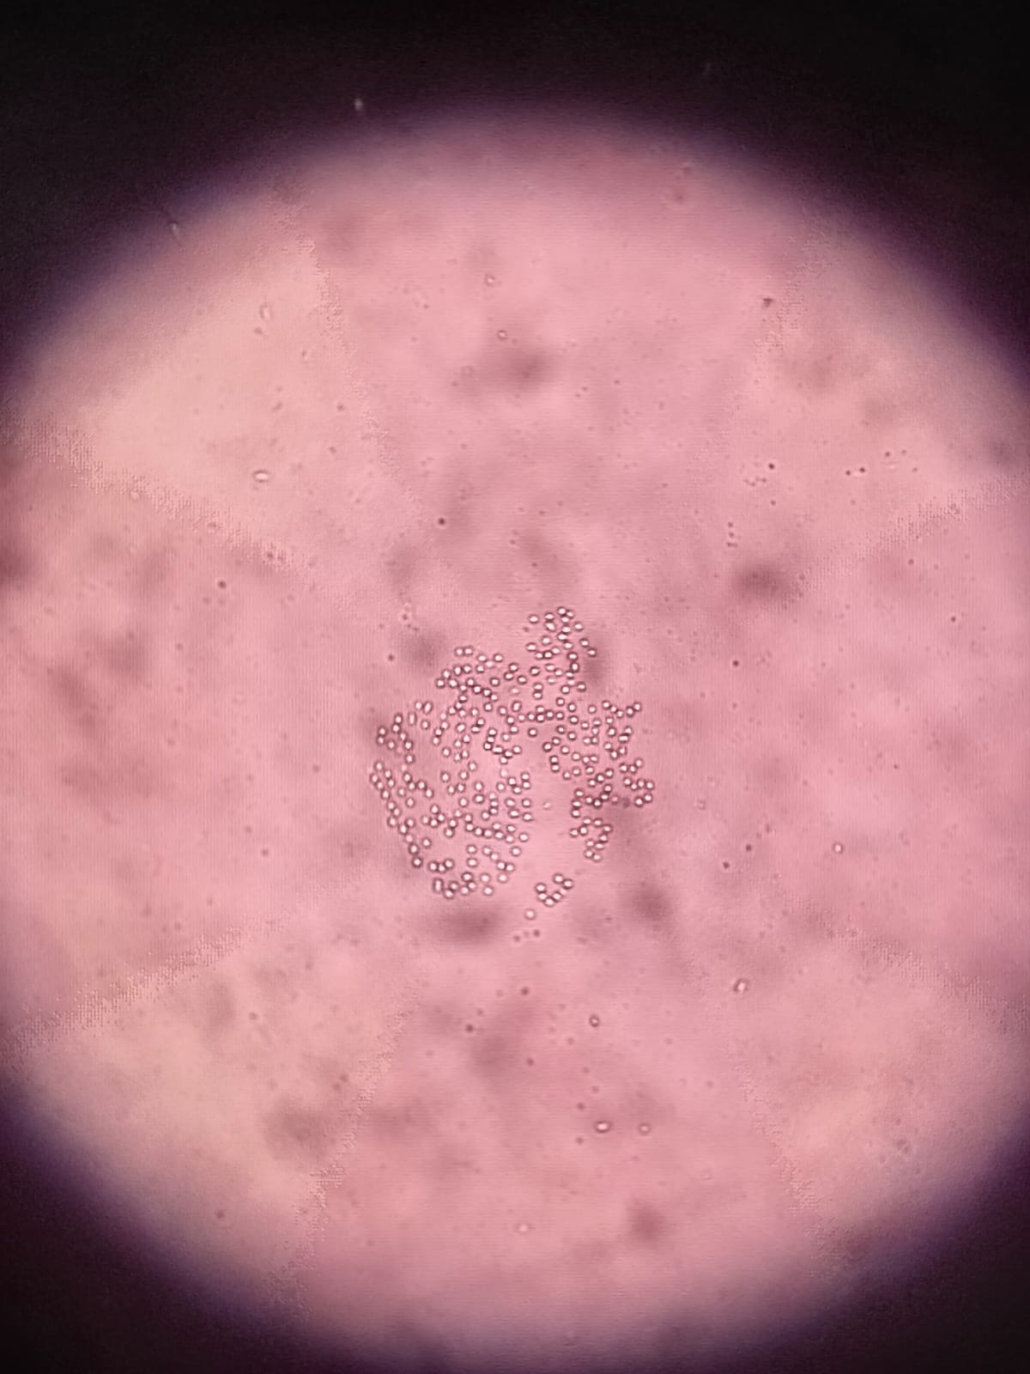  Microcystis aeruginosa | 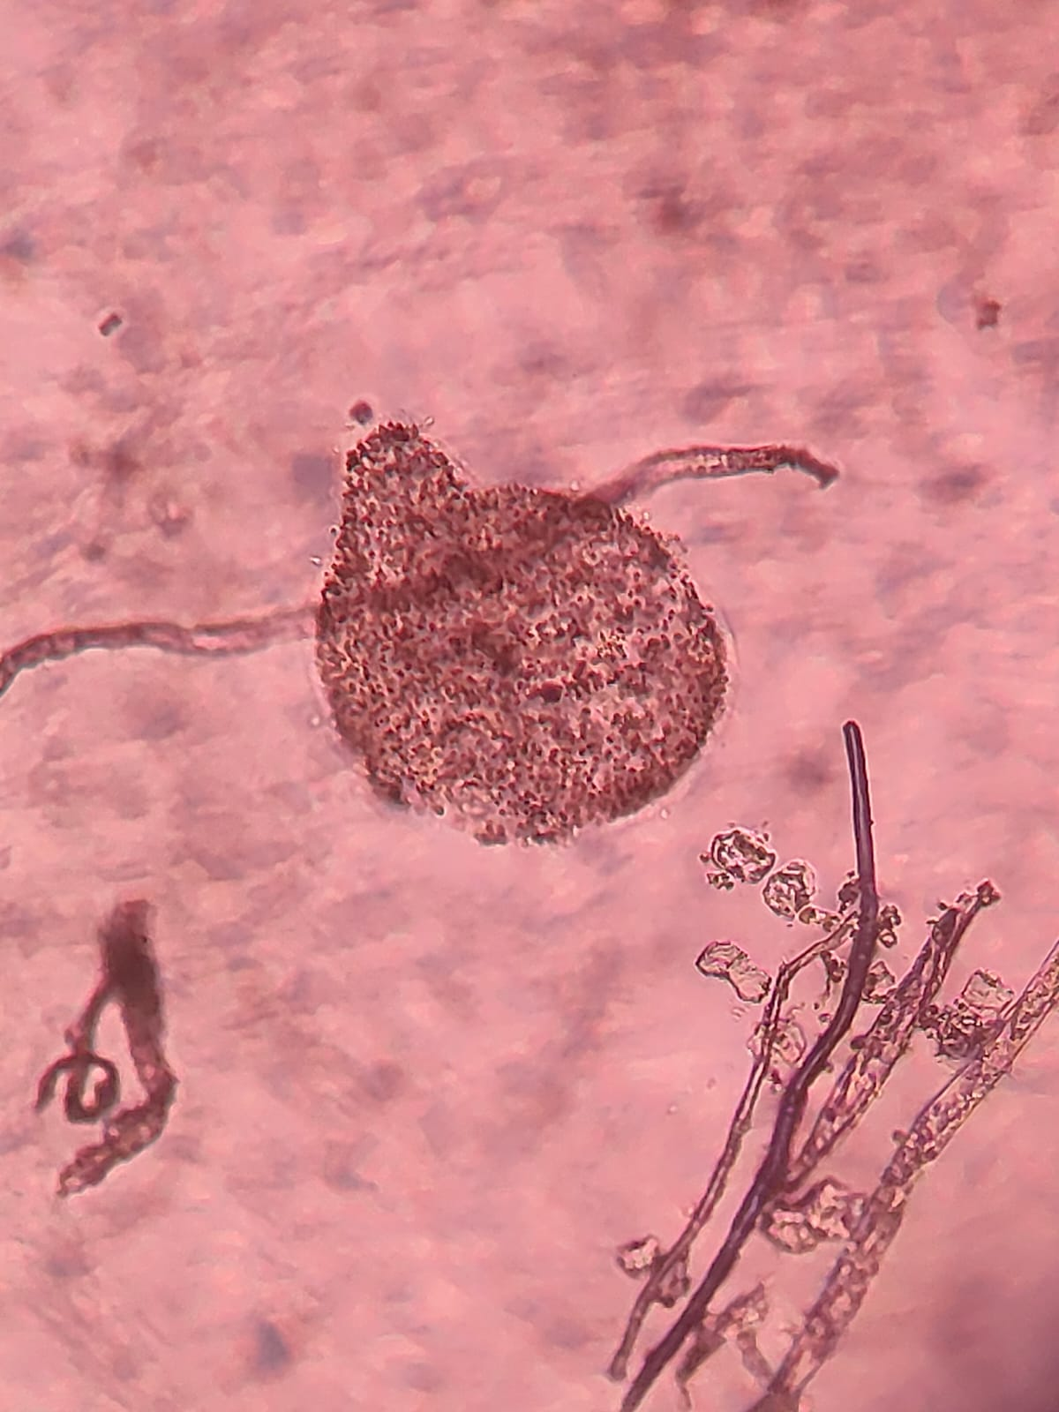  Microcystis ichtyoblabe
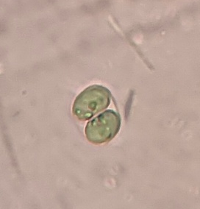  Chroococcus minutus | 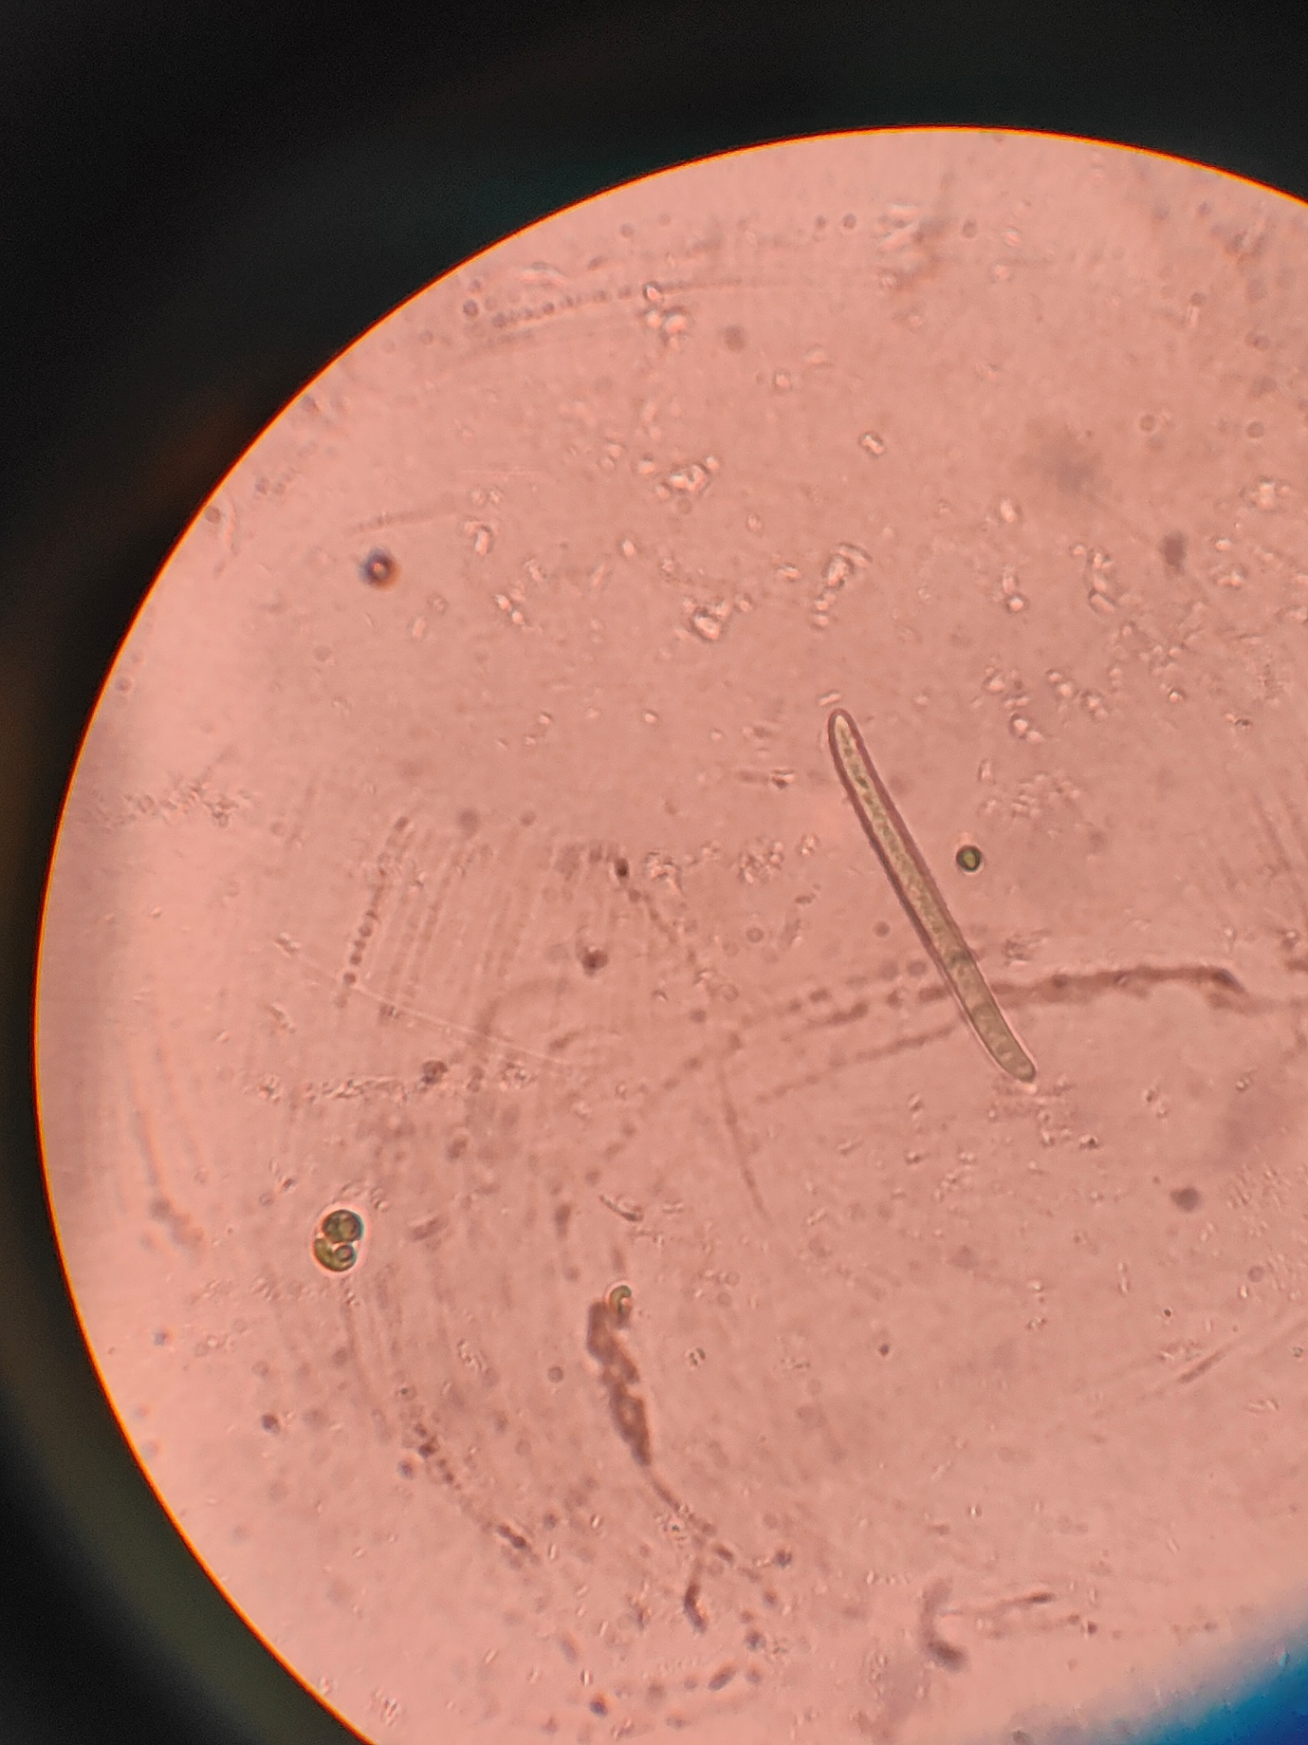  Chroococcus minutus | 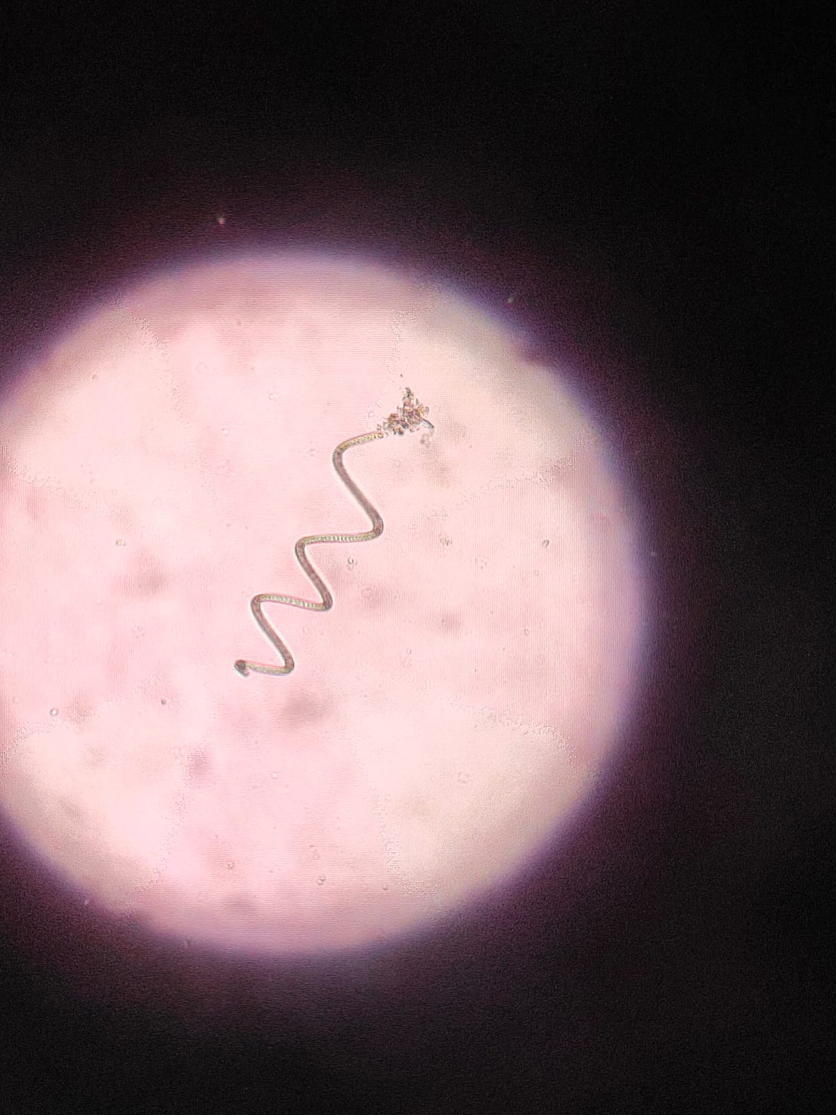  Arthrospira Gomontiana
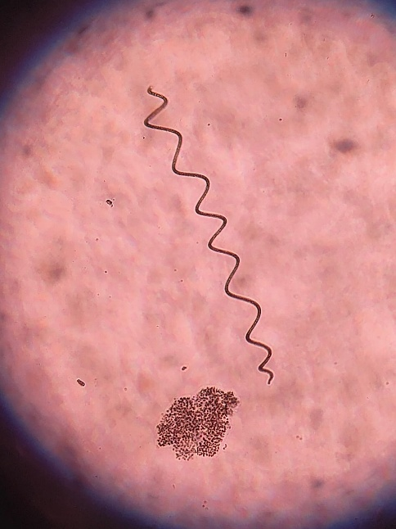  Spirulina Nordstedtii | 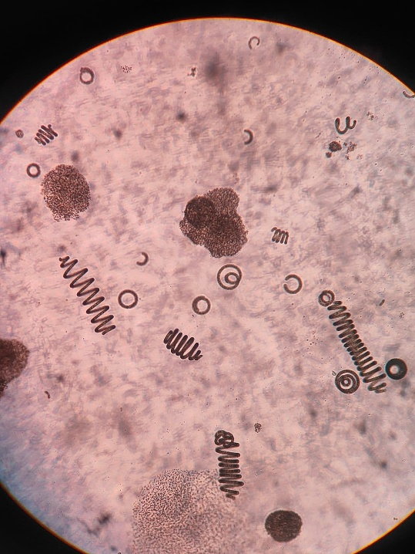  Arthrospira spirulina | 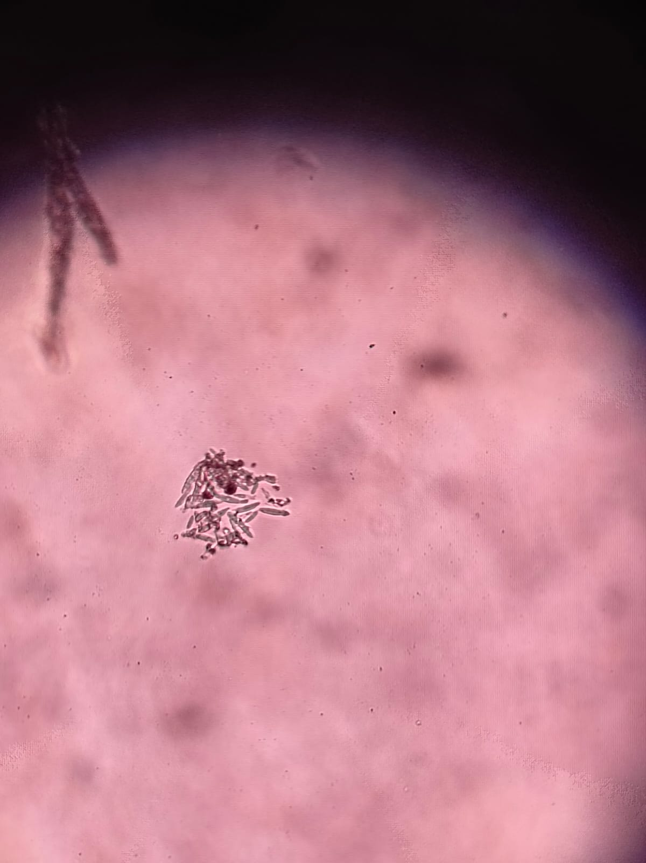  Quadrigula Lacustris
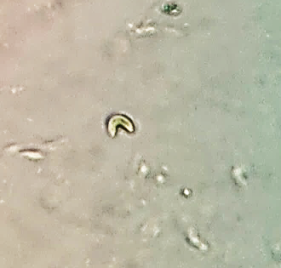  Tetraedron duospinum | 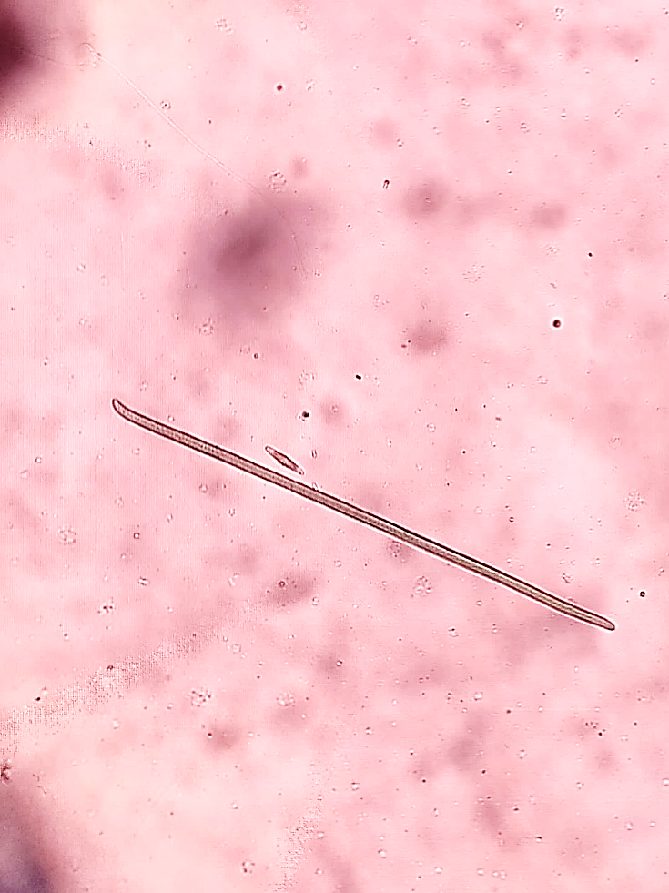  Oscillaoria brevis | 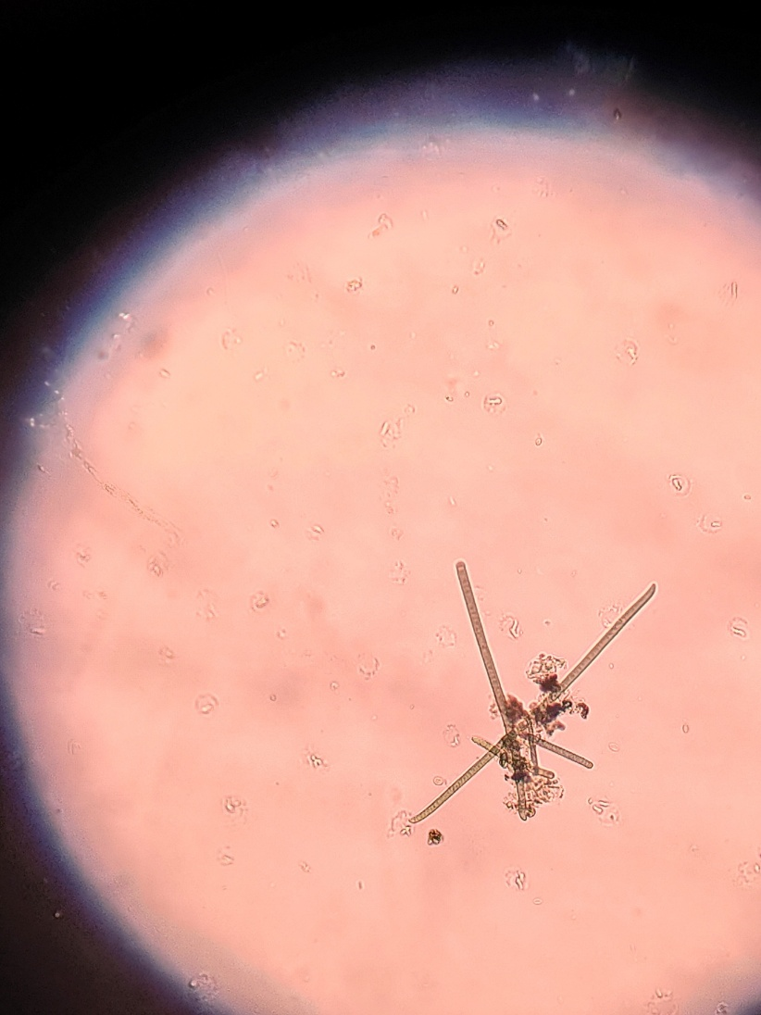  Oscillaoria brevis
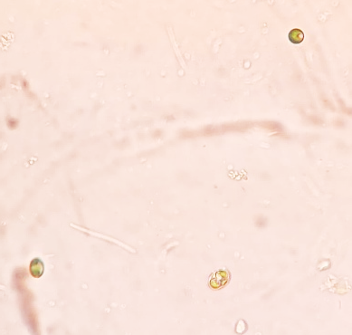  Palmella mucosa | 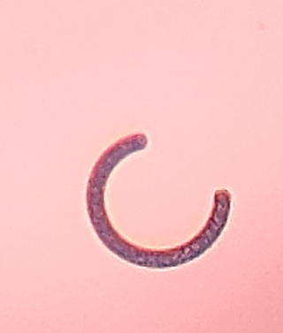  Anabaenopsis raciborskii | 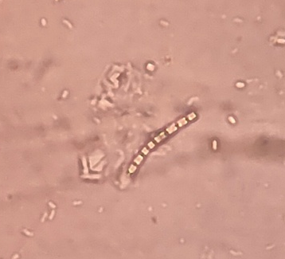  Pseudoanabaena catenata
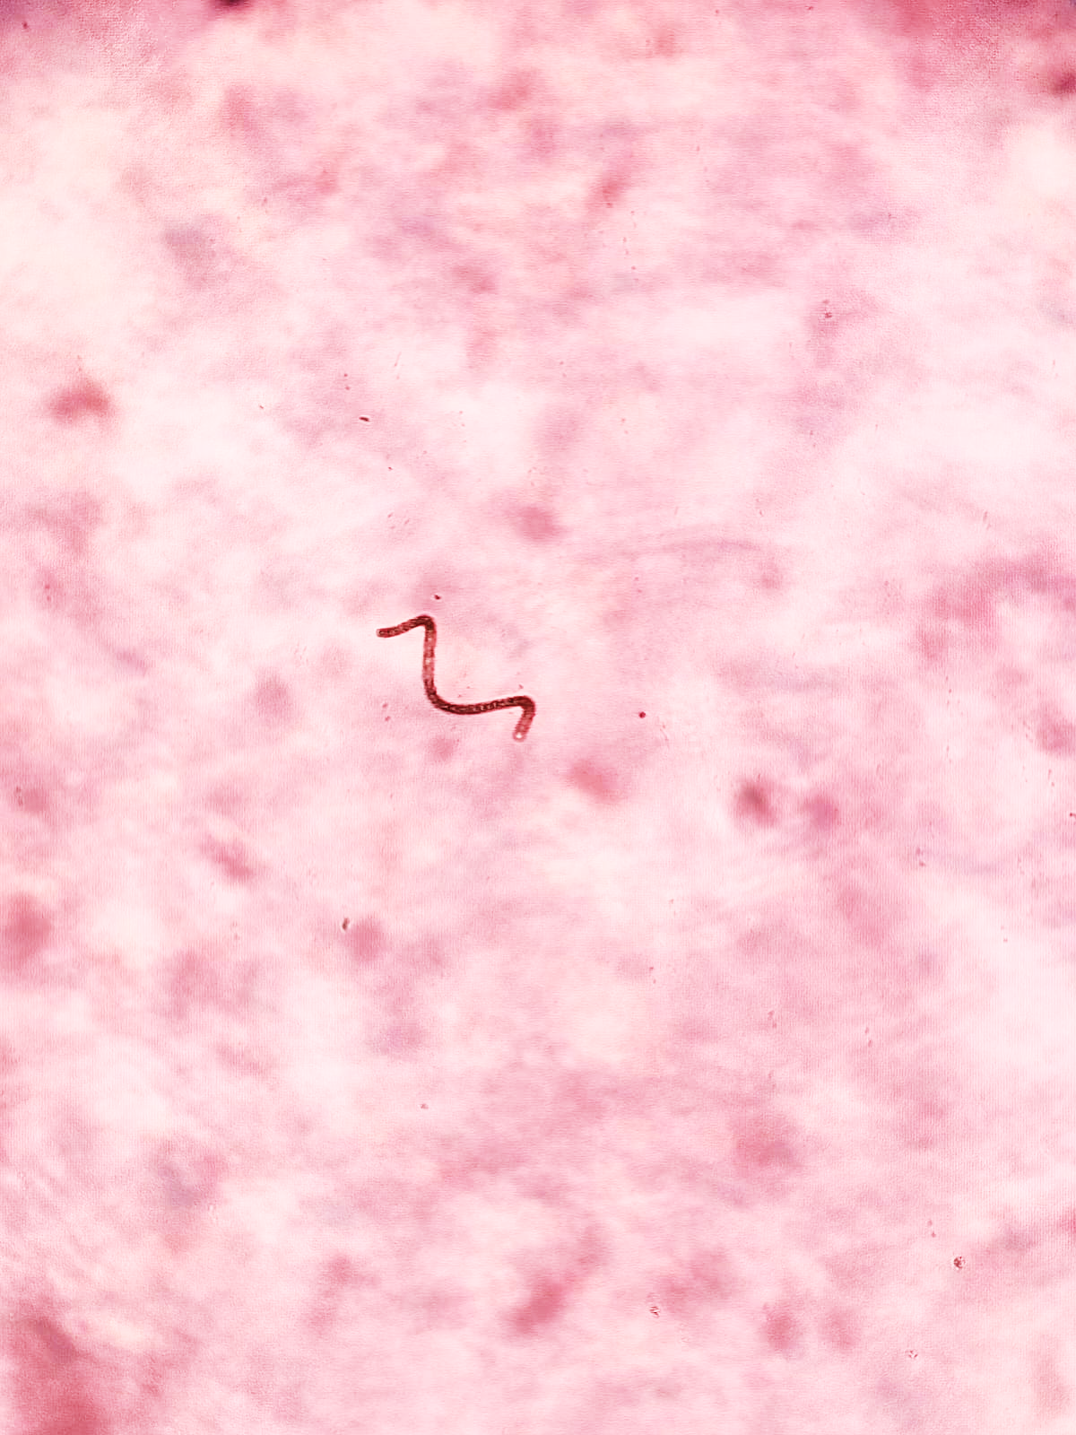  Spirulina subtilissima. | 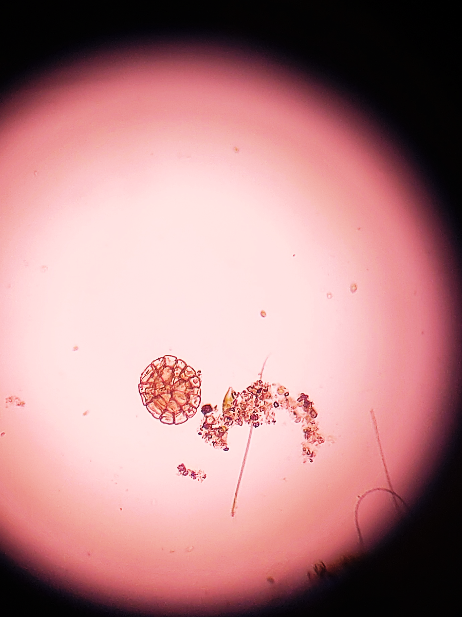  Pediastrum integrum | 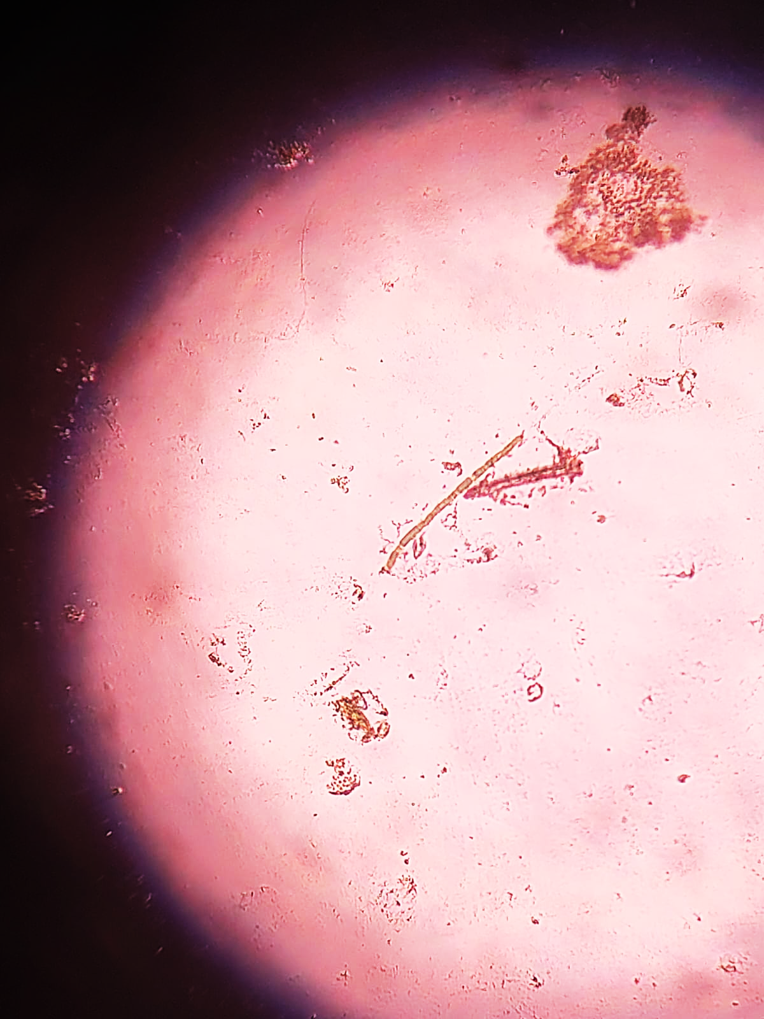  Pseudoanabaena galeata
Fig. 4. Photo Plate of Identified Phytoplankton at Lonar Lake
The diversity of phytoplankton can be a good indicator of the ecological conditions and water quality in aquatic environments. Diversity indices like Shannon–Wiener Diversity Index (H′), Pielou's Evenness Index (J′) and Simpson's Dominance Index (D), together with multivariate statistical methods like One-Way ANOVA and Principal Component Analysis (PCA) give a complete picture of the phytoplankton community structure and of the environmental factors affecting the distribution of the community.
Many measures of species diversity will take both species richness and abundance into account, such as the Shannon–Wiener Diversity Index (H′). The higher H' values are a result of the diversity of species, and the more stable ecosystem; the lower values are a result of environmental stress and the domination of a few species that can tolerate the environment (Shannon & Weaver, 1949). Cyanophyceae may dominate when salinity and alkalinity is high and this may lead to a decrease in phytoplankton diversity because of suppression of less tolerant phytoplankton groups when the salinity and alkalinity is high. This was also noted by Reynolds (2006) who stated that environmental stress is frequently associated with reduced diversity of phytoplankton, and the emergence of dominance of specialized species.
Pielou's Evenness Index (J′) is used to determine the evenness of species distribution in a community (Pielou's, 1966). A value near 1 signifies that the individuals are distributed evenly between the species, whereas, lower values mean that some species are dominant. Lower evenness should be expected in the Lonar lake because the cyanobacteria species are dominating which favour the saline-alkaline conditions. This dominance leads to a non-even distribution of species and lower evenness of communities. Low evenness is typical of ecosystems in which environmental stress is favouring a few highly adapted taxa, according to Magurran (2004).
Simpson's Dominance Index (D) is a measure of the likelihood that two randomly picked individuals in a community will be the same species (Simpson, 1949). The higher the number the more dominant and the less diverse. Hypersaline lakes tend to have higher Simpson's dominance values due to the growth of cyanobacteria and reduction of sensitive freshwater phytoplankton. It is therefore expected that the dominance of Cyanophyceae in Lonar Lake will lead to higher D value, indicating the community structure to be under the control of few species which are ecologically successful.
To test for significant differences in phytoplankton diversity among the sampling stations and seasons, One-Way Analysis of Variance (ANOVA) was used. The significant ANOVA result (p<0.05) means environmental changes affected the phytoplankton community structure, while the non-significant result means there was no significant difference between the ecological conditions of the sites (Zar, 2010). Seasonal variations in salinity, nutrient levels, temperature and dissolved oxygen can result in high levels of diversity indices and phytoplankton abundance. Wetzel (2001) pointed out that the physico-chemical changes were important factors in the succession and diversity of phytoplankton in lake ecosystems.
Significant differences may be due to hydrological processes, availability of nutrients and environmental stress. Salinity and alkalinity were likely to be the major variables that cause variations in the phytoplankton community within and between seasons in Lonar Lake. Principal Component Analysis (PCA) is a very useful multivariate method that can be used to detect the major environmental gradients that affect the biological communities (Jolliffe, 2002). In the present study, PCA accounted for a large percentage of the total variance using four principal components. The chlorides, salinity, total dissolved solids (TDS), and electrical conductivity (EC) had the greatest share of variance (PC1). This indicates that salinity and mineralization were the most important environmental factors controlling phytoplankton composition. Haloalkaliphilic cyanobacteria was more likely to grow in high salinity conditions with less freshwater taxa (Hammer, 1986).
The second principal component (PC2), which was associated with the temperature, pH and dissolved oxygen, represents factors that control photosynthesis, respiration and phytoplankton metabolism. Changes in these parameters were directly linked to changes in primary productivity and species succession (Wetzel, 2001). The third component (PC3), related to alkalinity and transparency, emphasized the impact of water transparency and buffering capacity on phytoplankton growth. Good transparency will improve the amount of light penetrating the water and the rate of photosynthesis, and alkalinity will affect the availability of carbon to algal metabolism. The fourth component (PC4) was associated with the nutrient dynamics in the lake; it was represented by phosphorus and nitrate. Nutrient availability was one of the most important factors affecting phytoplankton biomass and productivity, especially when phytoplankton was actively growing (Reynolds, 2006).
The relationships between the phytoplankton communities and environmental parameters were provided by correlation analysis. The correlations with salinity, alkalinity, pH, EC and TDS between the data for the genus Cyanophyceae were generally positive due to the fact that these taxa were haloalkaliphiles. On the other hand, negative relationships between salinity and conductivity were found in Chlorophyceae and Bacillariophyceae, which were less tolerant of high concentrations of ions (Hammer, 1986). The positive relationship between Shannon diversity and transparency and dissolved oxygen and nutrient availability indicates that better environmental conditions lead to increase in species diversity and evenness. A negative correlation between diversity indices and salinity can be interpreted as the decrease in general phytoplankton diversity with rising salinity stress and increase in dominance of a few special phytoplankton taxa.
The ecological data indicates that the combination of the diversity indices, ANOVA, PCA and correlation analysis shows that physico-chemical conditions play a critical role influencing the diversity of phytoplankton in Lonar lake. Decreases in Shannon diversity and Pielou's evenness values, and increases in Simpson dominance values, suggest that there are a few species of cyanobacteria that are well adapted. Spatial and seasonal variations in phytoplankton community are shown by significant ANOVA results and salinity, conductivity, TDS and chlorides as the dominant environmental factors are identified by PCA. The correlation analysis also shows that salinity and alkalinity have positive relationship with the dominance of cyanobacteria and negative relationship with the diversity of phytoplankton. The results of the present study suggest that the saline alkaline environment of Lonar Lake imposes a high ecological selection pressure, leading to the development of special community of phytoplankton dominated by haloalkaliphilic Cyanophyceae.
Conclusion:
The present study showed the distribution of phytoplankton diversity at four sampling stations (S1, S2, S3 and S4). The species diversity of phytoplankton proved to be a good indicator of ecological health and water quality of the lake ecosystem. This study revealed that the algal community in Lonar Crater Lake was greatly affected by its unique saline-alkaline conditions. Diversity indices showed a lake community with moderate diversity, low evenness and high dominance, suggesting that less species were well adapted to the extreme physico-chemical conditions of the lake. The high percentage of Cyanophyceae indicated the ecological advantage of haloalkaliphilic cyanobacteria in the presence of high salinity, alkalinity and pH. The environmental parameters influenced community composition and abundance as revealed by significant spatial and seasonal variation in phytoplankton diversity that was observed in the study by One-Way ANOVA. PCA revealed that salinity, chlorides, total dissolved solids (TDS), and electrical conductivity (EC) were the primary factors influencing the distribution of phytoplankton, whereas, temperature and pH had secondary importance in influencing the structure of the community, along with dissolved oxygen, transparency and nutrients.
Correlation analysis also revealed that salinity and alkalinity were the major ecological factors which control the diversity and productivity of the phytoplankton in the Lonar Lake. Groups such as the Cyanophyceae were frequently regarded as indicators of eutrophic or highly nutrient waters, and the presence of a balanced Chlorophyceae and Bacillariophyceae was frequently regarded as an indicator of a less polluted water that was relatively unchanging. Seasonal variations also influenced phytoplankton diversity, their species composition and productivity depending on climatic factors. In conclusion, the study indicates that the extreme hydro-chemical conditions of Lonar Crater Lake have resulted in a special community of phytoplankton that was predominantly salt-tolerant Cyanophyceae. Using diversity indices combined with ANOVA, PCA, and correlation analysis, a complete picture of the processes that influence the phytoplankton community structure can be gained and the importance of salinity as the most important factor in structuring phytoplankton diversity in this unique meteorite-impact saline lake ecosystem was confirmed. Therefore, it is essential to monitor water quality and primary producers continuously, and to support ongoing scientific research to ensure the successful management, preservation, and restoration of this unique ecological marvel for sustainability.

Disclaimer (Artificial intelligence)
Author(s) hereby declare that NO generative AI technologies such as Large Language Models (ChatGPT, COPILOT, etc.) and text-to-image generators have been used during the writing or editing of this manuscript.

REFERENCES:
- American Public Health Association (2017). Standard methods for the examination of water and wastewater (23rd ed.), Part 10–22.
- Bhaskar, K., Nautiyal, S., Khan, Y. D. I., & Rajanna, L. (2015). A preliminary study on phytoplankton in fresh water lake of Gogi, Yadgir District, Karnataka. International Journal of Innovative Research in Science, Engineering and Technology, 4(4), 2030–2037.
- Borics, G., Abonyi, A., Salmaso, N., & Ptacnik, R. (2021). Freshwater phytoplankton diversity: Models, drivers and implications for ecosystem properties. Hydrobiologia, 848(1), 53–75.
- Dabhade, D. S. (2015). Lonar Saline Lake: A case study. International Journal of Research in Biosciences, Agriculture and Technology, 3(2), 249–251.
- Dalu, T., Mwedzi, T., & Wasserman, R. J. (2022). Phytoplankton dynamics. In Fundamentals of Tropical Freshwater Wetlands (pp. 189–219). Elsevier.
- Dembowska, E. A., Mieszczankin, T., & Napiórkowski, P. (2018). Changes in the phytoplankton community as symptoms of deterioration of water quality in a shallow lake. Environmental Monitoring and Assessment, 190(2), 95.
- Dorlikar, V. D., Sadulwar, R. G., Narwade, S. S., Shinde, S. S., & Raut, S. D. (2025). Phytoplankton diversity as the best food indicator for insects and fishes from Kapileshwar Lake of Wardha District (M.S.), India. International Academy of Ecology and Environmental Sciences, 15(3), 67–74.
- Edmondson, W. T. (1959). Freshwater biology (2nd ed.). John Wiley & Sons. (Original work published, 1918).
- Hammer, U. T. (1986). Saline Lake Ecosystems of the World. Dordrecht: Dr. W. Junk Publishers.
- Jolliffe, I. T. (2002). Principal Component Analysis (2nd ed.). Springer.
- Kalff, J. (2002). Limnology: Inland water ecosystems. Prentice Hall, 309–322.
- Karacaoglu, D., Dere, S., & Dalkiran, N. (2004). A taxonomic study on the phytoplankton of Lake Uluabat (Bursa). Turkish Journal of Botany, 28, 473–485.
- Khobragade, K. S., & Pawar, V. B. (2016). Physico-chemical analysis of Lonar Lake with reference to bacteriological study. International Journal of Modern Sciences and Engineering Technology, 3(7), 15–22.
- Kodarkar, M. S. (2006). Methodology for water analysis (Physico-chemical, biological and microbiological). IAAB, 1–49.
- Kumari, S., Khan, J. A., & Thakur, M. S. (2018). Study on phytoplankton, zooplankton and ichthyofauna of Motia Lake. Research & Reviews: Journal of Zoological Sciences, 6(2), 25–49.
- Magurran, A. E. (2004). Measuring Biological Diversity. Oxford, United Kingdom: Blackwell Publishing.
- Malik, D. S., & Rathi, P. (2022). The influence of physico-chemical parameters on habitat ecology and assemblage structure of freshwater phytoplankton in Tehri Reservoir, Garhwal (Uttarakhand), India. Proceedings of the National Academy of Sciences, India Section B: Biological Sciences, 92, 541–551. https://doi.org/10.1007/s40011-021-01313-3
- Margalef’s, R. (1958). Information theory in ecology. General Systems, 3, 36–71.
- Meng, F., Li, Z., Li, L., Lu, F., Liu, Y., Lu, X., & Fan, Y. (2020). Phytoplankton alpha diversity indices response to trophic state variation in hydrologically connected aquatic habitats in the Harbin section of the Songhua River. Scientific Reports, 10, 21337. https://doi.org/10.1038/s41598-020-78300-7
- Meshram, D., Bopinwar, S., Sangolkar, L., Ghosh, T. K., & Labhasetwar, P. (2018). Assessment of physico-chemical water quality and phytoplankton diversity in Narikulam Reservoir in Kanniyakumari District, Tamil Nadu, India. Sustainable Water Resources Management, 4, 735–743. https://doi.org/10.1007/s40899-017-0158-8
- Needham J.G. and Needham P.R. 1941. A Guide to The Study of Freshwater Biology with Special Reference to Aquatic Insects and Other Invertebrate Animals and Phyto-Plankton, by fourth edition, New York, Comstock Publishing Company, Inc.
- Palmer, C. M. (1969). A composite rating of algae tolerating organic pollution. Phycology, 5, 78–82.
- Pielou, E. C. (1966). The measurement of diversity in different types of biological collections. Journal of Theoretical Biology, 13, 131–144.
- Prescott, G. W. (1951). Algae of the Western Great Lakes Area (Bulletin No. 31). Cranbrook Institute of Science, 661–933.
- Rafiullah, M. K. (2018). Eco-biodiversity studies on algae of Lonar Crater Lake (Doctoral dissertation). Dr. Babasaheb Ambedkar Marathwada University, Aurangabad, India, 20–57.
- Ragi, M. S., Jaya, D. S., & Moses, S. A. (2017). Influence of water quality on plankton in tropical ponds: A multivariate analysis approach. Lakes and Reservoirs: Research and Management, 22(3), 221–230.
- Reynolds, C. S. (2006). The ecology of phytoplankton. Cambridge University Press, 1–385.
- Roy, A. S., & Pal, R. (2015). Planktonic cyanoprokaryota and bacillariophyta of East Kolkata Wetlands ecosystem: Diversity and taxonomic study. Journal of Algal Biomass Utilization, 6(3), 47–59.
- Sahoo, D., Bera, S. K., Pal, P. P., Tamili, D. K., Sarkar, B., Madhu, N. R., et al. (2024). Plankton as key indicators of the health and stability of aquatic ecosystems: A review. Basic Overview of Environment and Sustainable Development, 3(6), 257–272.
- Seu-Anoi, N. M., Ouattara, A., Cocquyt, C., & Gourène, G. (2017). Study of planktonic cyanobacteria taxa of the Aby lagoon system (Southern Ivory Coast). Journal of Biodiversity and Environmental Sciences, 11(2), 40–51.
- Shannon, C. E., & Weaver, W. (1949). The Mathematical Theory of Communication. University of Illinois Press.
- Shivakumara, L. V., & Pattar, P. V. (2015). Diversity of phytoplankton in rice fields of Davangere Taluk, Karnataka. Journal of Marine Science Research and Development, 5(3), 1–4.
- Simpson, E. H. (1949). Measurement of diversity. Nature, 163, 688.
- Singh, U. B., & Ahluwalia, A. S. (2013). Microalgae: A promising tool for carbon sequestration. Mitigation and Adaptation Strategies for Global Change, 18, 73–95. https://doi.org/10.1007/s11027-012-9393-3
- Suthers, I. M., & Rissik, D. (Eds.). (2009). Plankton: A guide to their ecology and monitoring for water quality. CSIRO Publishing, 1–155.
- Taiwade, V. S. (1995). A study of Lonar Lake: A meteorite impact crater in basalt rock. Bulletin of the Astronomical Society of India, 23, 105–111.
- Tandale, M. (2020). Highly saline water tolerant plankton community in Lonar Crater, India. International Research Journal of Science and Engineering, 77–82.
- Tandale, M. R., & Talwankar, D. S. (2023). Lonar Crater: A case study. Acta Scientific Microbiology, 6(5), 3–6.
- Trivedy, R. K., & Goel, P. K. (1984). Chemical and biological methods for water pollution studies. Environmental Publications, Karad, India, 35-194.
- Vajravelu, M., Martin, Y., Ayyappan, S., & Mayakrishnan, M. (2018). Seasonal influence of physico-chemical parameters on phytoplankton diversity, community structure and abundance at Parangipettai coastal waters, Bay of Bengal, South East Coast of India. Oceanologia, 60(2), 114–127.
- Werner, V. R., & Laughinghouse IV, H. D. (2009). Bloom-forming and other planktonic Anabaena morphospecies from Brazil. Nova Hedwigia, 89 (1,2), 17–47.
- Wetzel, R. G. (2001). Limnology: Lake and River Ecosystems (3rd ed.). Academic Press.
- Zar, J. H. (2010). Biostatistical Analysis (5th ed.). Upper Saddle River, New Jersey: Pearson Education.

