Performance of Commercial Feeds on Growth and Economics of Indian Major Carps in Pond Culture
Abstract
A six-month field experiment (October 2025–March 2026) was conducted to evaluate the performance of three commercially available fish feeds on growth, feed utilization, and economic returns of Indian Major Carps (IMC) under semi-intensive pond culture conditions in Purba Medinipur, West Bengal, India. The study followed a Completely Randomized Design (CRD) with three treatments: Feed A (25% protein), Feed B (30% protein), and Feed C (28% protein), each in triplicate. Fish were stocked at 3000 fingerlings per acre in a composite culture ratio (Catla:Rohu:Mrigal = 30:40:30) and fed twice daily. Growth parameters such as weight gain, specific growth rate (SGR), survival rate, and feed utilization indices (FCR and FER) were recorded. The results revealed significant differences (p < 0.05) among treatments. Fish fed with Feed B exhibited the highest mean final weight (710.67 ± 10.07 g), weight gain (695.34 g), and SGR (3.02% day⁻¹), followed by Feed C and Feed A. Feed utilization efficiency was also highest in Feed B, with the lowest FCR (1.41). Water quality parameters remained within optimal ranges across treatments. Economic analysis indicated that Feed B yielded the highest net income (₹3,86,750/ha) and benefit–cost ratio (5.90), despite higher feed cost. The study demonstrates that nutritionally balanced commercial feeds significantly enhance growth performance, feed efficiency, and profitability in carp culture.
Keywords: Indian Major Carps, Commercial feed, Growth performance, Feed Conversion Ratio, Economics, Pond culture.
1. Introduction
Aquaculture has become one of the fastest-growing food production sectors globally, contributing substantially to food security, nutrition, and livelihood generation. According to the Food and Agriculture Organization (FAO, 2022; FAO, 2024), aquaculture now contributes over half of the total fish consumed worldwide, surpassing capture fisheries. This growth is driven by increasing population, rising demand for high-quality animal protein, and the overexploitation of wild fish stocks.
Asia dominates global aquaculture production, contributing more than 85% of total output, with India being the second-largest producer after China (FAO, 2024). In India, aquaculture plays a critical role in rural development, employment generation, and nutritional security. Freshwater aquaculture accounts for more than 70% of total fish production, with Indian Major Carps (IMC), namely Catlacatla, Labeorohita, and Cirrhinusmrigala, forming the backbone of the sector (Jhingran and Pullin, 1985; ICAR, 2021).
The success of IMC farming is largely attributed to composite fish culture systems, which utilize species with complementary feeding habits. Catlacatla occupies the surface niche feeding on zooplankton, Labeorohita utilizes the column feeding on phytoplankton and detritus, and Cirrhinusmrigala feeds at the bottom on organic matter. This ecological niche differentiation ensures efficient utilization of available resources and enhances productivity (Tripathi et al., 2012; Kumar et al., 2020).
With increasing intensification of aquaculture, reliance on natural productivity alone is no longer sufficient to sustain high yields. Supplementary feeding has therefore become essential in semi-intensive and intensive culture systems. Feed represents the single largest operational cost in aquaculture, accounting for approximately 50–60% of total production expenses (Engle, 2010; FAO, 2022). The quality and management of feed directly influence growth performance, feed conversion efficiency, fish health, and farm profitability.
Fish require a balanced diet containing protein, lipids, carbohydrates, vitamins, and minerals for optimal growth. Among these, protein is the most critical and costly component, directly influencing growth and tissue development (NRC, 2011; Glencross et al., 2020). Lipids serve as a major energy source and enhance feed efficiency through protein-sparing effects (De Silva and Anderson, 1995; Tocher, 2020), while carbohydrates provide an economical source of energy, particularly for omnivorous species like carps (Wilson, 1994; Stone, 2021).
Traditionally, carp farming relied on farm-made feeds such as rice bran and oil cakes. Although inexpensive, these feeds often lack nutritional balance and consistency, leading to variable growth performance. In recent years, there has been a marked shift toward commercially formulated pelleted feeds, driven by the need for higher productivity and improved feed efficiency. Commercial feeds are designed to provide balanced nutrition, improved digestibility, and better feed stability in water (New and Wijkström, 2002; Hasan et al., 2020).
The use of commercial feeds has significantly enhanced aquaculture productivity; however, variability among feed brands in terms of ingredient composition, nutrient levels, and manufacturing processes can lead to differences in performance (Mohanty et al., 2013; Das et al., 2021). Recent studies have emphasized that even small variations in dietary protein-energy balance can significantly affect growth rate, feed conversion ratio (FCR), and economic returns in carp culture (Kumar et al., 2020; Paul et al., 2022).
In practical farming conditions, feed selection is often influenced by cost, brand popularity, or local availability rather than scientific evaluation. This may result in inefficient feed utilization, poor growth performance, and reduced profitability. Furthermore, inappropriate feeding practices can adversely affect water quality through the accumulation of uneaten feed and metabolic waste, leading to increased biological oxygen demand and reduced dissolved oxygen levels (Boyd, 1998; Boyd et al., 2020).
Water quality plays a crucial role in determining the success of aquaculture operations. Feed quality and feeding practices indirectly influence water quality by affecting nutrient loading and organic matter accumulation. Feeds with higher digestibility and balanced nutrient composition reduce waste output and maintain better pond ecology (Beveridge, 2004; Hargreaves, 2020).
West Bengal is one of the leading fish-producing states in India, with a strong tradition of pond-based aquaculture. The region possesses abundant freshwater resources and favorable climatic conditions for carp farming. In districts such as PurbaMedinipur, fish culture is predominantly practiced under semi-intensive systems, where farmers increasingly depend on commercial feeds to enhance production.
Despite the widespread use of commercial feeds, there is a lack of comprehensive field-based studies comparing their performance under real farming conditions. Most previous research has focused on experimental diets under controlled environments, with limited integration of growth performance, feed utilization efficiency, and economic analysis in commercial pond systems (Hasan et al., 2020; Paul et al., 2022).
Therefore, there is a need for systematic, location-specific evaluation of commercially available feeds to provide practical recommendations to farmers. The present study aims to compare the effects of different commercial fish feeds on growth performance, feed utilization, survival, and economic returns of Indian Major Carps under pond culture conditions. The findings are expected to contribute to improving feed selection strategies, enhancing productivity, and promoting sustainable aquaculture practices.
2. Materials and Methods
2.1 Study Area
The experiment was conducted in freshwater earthen ponds located in PurbaMedinipur under typical semi-intensive aquaculture conditions. The region is characterized by a tropical climate with moderate temperature and seasonal rainfall, suitable for carp culture.
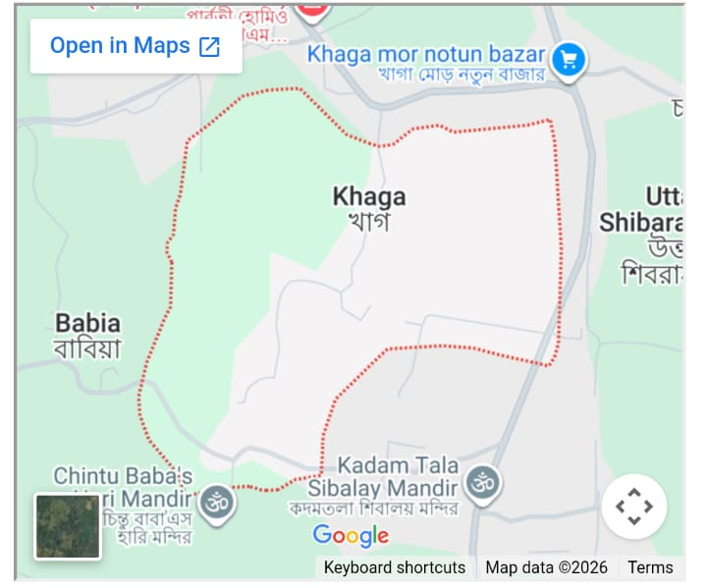
Fig1: Map of Khaga village in Bhagawanpur I, PurbaMedinipur of West Bengal.
2.2 Experimental Design
The study followed a Completely Randomized Design (CRD) with three treatments:
- T₁: Feed A
- T₂: Feed B
- T₃: Feed C
Each treatment was replicated three times to ensure statistical validity. All ponds were maintained under identical management conditions except for feed type.
2.3 Experimental Species and Stocking
Indian Major Carps (Catla catla, Labeo rohita, Cirrhinus mrigala) were used due to their commercial importance and compatibility in polyculture. Fingerlings with average weight of 15 g were stocked at a density of 3000 fish per acre following a species ratio of 30:40:30. Stocking was done during morning hours to minimize stress.
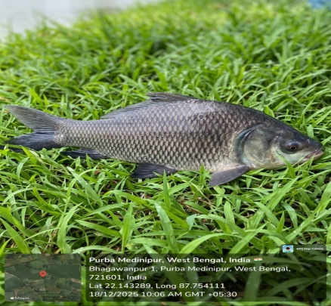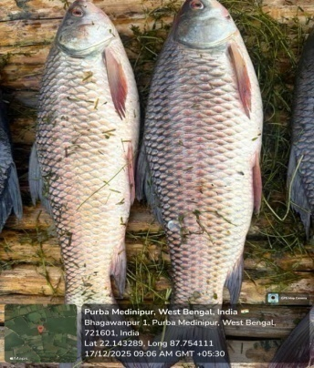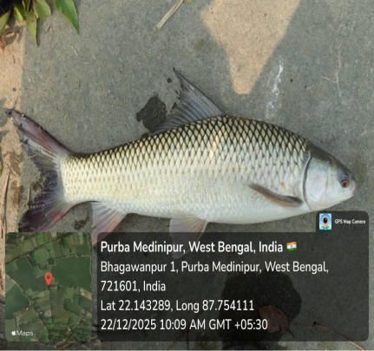
Fig2: Experimental Species (Catla, Rohu, Mrigel)
2.4 Pond Preparation
Ponds were prepared following standard aquaculture practices, including drying, liming based on soil pH, and fertilization to enhance natural productivity. Water was filled and stabilized for 7–10 days before stocking to ensure a suitable environment for fish growth.
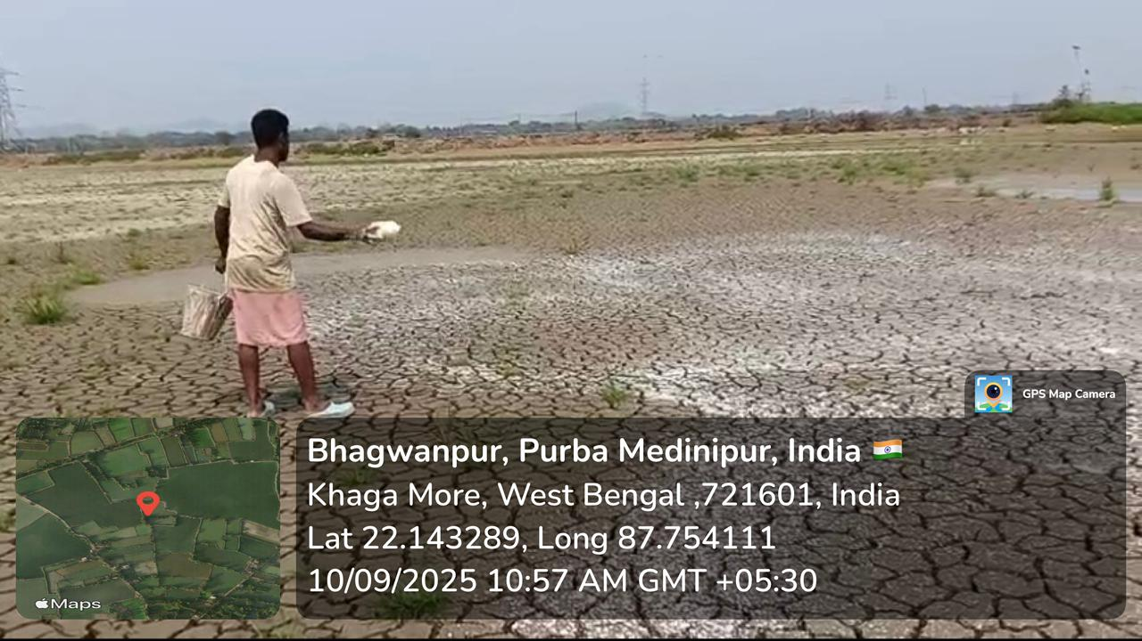
Fig3: Pond drying and lime application
2.5 Feed and Feeding Management
Three commercially available pelleted feeds differing in protein and lipid content were used. Fish were fed twice daily (morning and evening) by broadcasting method. Feeding rate was adjusted periodically based on biomass estimation to ensure optimal feed utilization and minimize wastage.
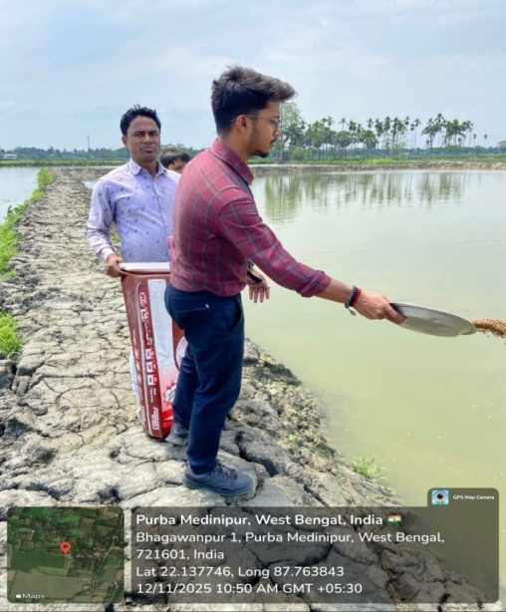
Fig4: Broadcasting feeding
2.6 Growth Sampling and Measurements
Fish sampling was conducted monthly using drag nets. Body weight was measured using a digital balance, and total length was recorded using a measuring scale. After measurement, fish were released back into their respective ponds.
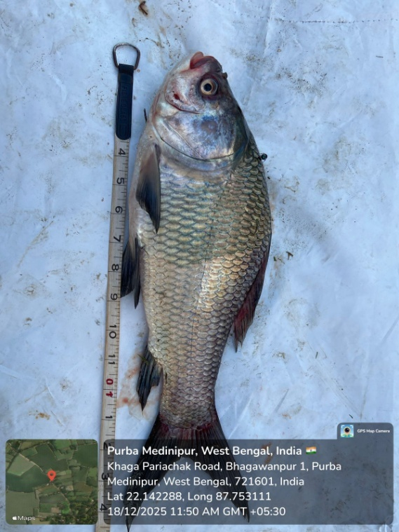
Fig5: Total length of fish.
2.7 Growth Performance Parameters
Growth was evaluated using standard indices:
- Weight gain (g) = Final weight − Initial weight
- Length gain (cm) = Final Length – Initial Length
- Specific Growth Rate (SGR, % day⁻¹) = [(ln Wf – ln Wi) / t] × 100
These parameters were calculated using standard formulae to assess growth efficiency.
2.8 Feed Utilization Parameters
Feed efficiency was determined using:
- Feed Conversion Ratio (FCR) = Feed given/Weight gain
These indices indicate how effectively the feed is converted into fish biomass.
2.9 Water Quality Monitoring
Key water quality parameters such as temperature, pH, dissolved oxygen, and transparency were monitored regularly using digital thermometer, pH meter, DO meter and secchi disc. Necessary management practices were adopted to maintain optimal conditions for fish growth.
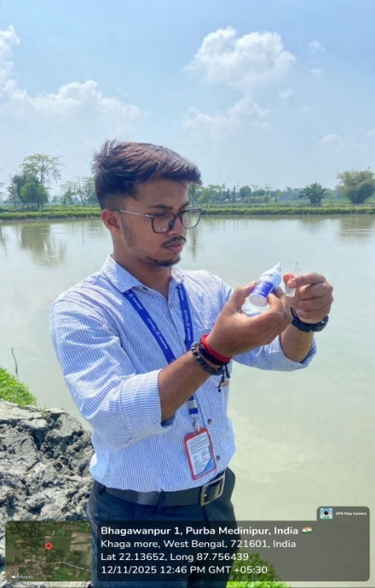
Fig6: Water quality monitoring.
2.10 Harvesting
At the end of the six-month culture period, complete harvesting was carried out. Total biomass was recorded by weighing and counting the harvested fish, which was used for final growth and production analysis.
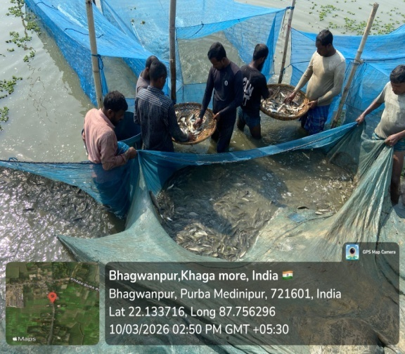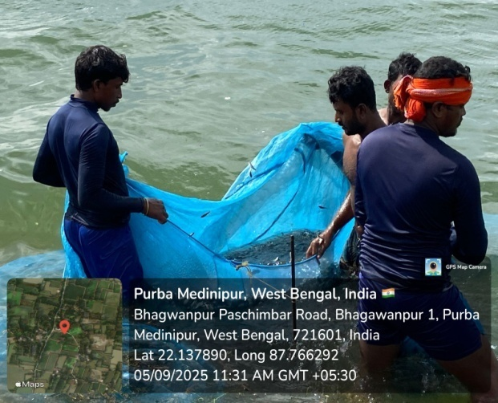
Fig7: Fish harvesting.
2.11 Economic Analysis
Economic performance was evaluated by calculating:
- Total cost of production
- Gross income
- Net income
- Benefit–Cost (B:C) ratio
This analysis helped determine the profitability of each treatment.
2.12 Statistical Analysis
All data were expressed as mean ± standard deviation. One-way Analysis of Variance (ANOVA) was used to test significant differences among treatments at a 5% significance level (p < 0.05).
All experimental data were expressed as mean ± standard deviation (SD). Statistical analysis was performed to evaluate the significance of differences among treatments using one-way Analysis of Variance (ANOVA).
The statistical model used for the Completely Randomized Design (CRD) is represented as:
Y_{ij}​ = μ + T_{i}​ + e_{ij​}
Where:
Y_{ij}​=observation from the i^{th} treatment and j^{th} replicate
μ=overall mean
T_{i​}=effect of the i^{th} treatment (i = 1, 2, 3)
e_{ij}​=random error associated with each observation
The null hypothesis (H₀) tested was that there is no significant difference among treatment means, while the alternative hypothesis (H₁) assumed significant differences exist.
When significant differences were detected (p < 0.05), post-hoc comparisons were carried out using Tukey’s Honest Significant Difference (HSD) test to identify differences between treatment means.
Statistical analyses were performed using IBM SPSS Statistics (Version 25.0) and cross-validated using R (version 4.x). Graphical representations were prepared using standard plotting tools in R.
3. Results and Discussion
3.1 Growth Performance
Treatment | Final Weight (g) | Weight Gain (g) | SGR (% day⁻¹) | FCR | Survival (%)
T₁ | 620.33 ± 9.29 | 605.00 | 2.85 | 1.52 | 85–88
T₂ | 710.67 ± 10.07 | 695.34 | 3.02 | 1.41 | 88–92
T₃ | 660.33 ± 9.29 | 645.00 | 2.92 | 1.47 | 86–90
Table1: Comparative performance of Indian Major Carps fed different commercial feeds
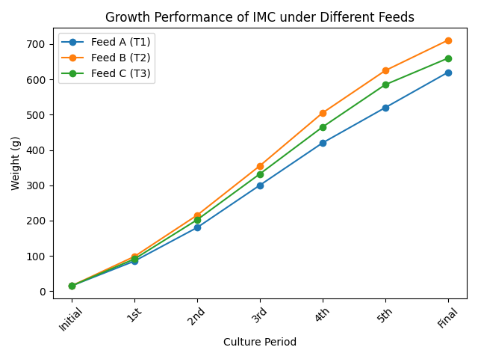
Graph1: Growth performance of IMC under different feeds.
Table1 presents the comparative growth performance, feed utilization efficiency, and survival of Indian Major Carps under different commercial feed treatments. The results clearly demonstrate significant variation among treatments, indicating that feed quality plays a crucial role in determining fish growth and overall production efficiency.
Fish fed with Feed B (T₂) exhibited the highest mean final weight (710.67 ± 10.07 g), weight gain (695.34 g), and specific growth rate (3.02% day⁻¹). The superior growth performance observed in T₂ can be attributed to its higher protein content (30%) and balanced nutrient composition, which are essential for muscle development and metabolic activities. Protein is considered the most critical nutrient influencing fish growth, and increased dietary protein levels have been shown to significantly enhance growth performance in carp culture (NRC, 2011; Glencross et al., 2020). Similar findings were reported by Ahmed et al. (2015), who observed improved growth in carp polyculture systems using nutritionally balanced commercial feeds.
Feed utilization efficiency also followed a similar trend, with T₂ recording the lowest feed conversion ratio (FCR = 1.41), indicating more efficient conversion of feed into fish biomass. In contrast, T₁ showed the highest FCR (1.52), suggesting comparatively lower feed efficiency. Efficient feed utilization is often associated with improved digestibility and optimal protein-energy balance in the diet. Mohanty et al. (2013) reported that higher-quality feeds enhance nutrient absorption and reduce feed wastage, thereby improving FCR. Additionally, Boyd (1998) highlighted that efficient feed utilization minimizes organic waste accumulation in ponds, contributing to better water quality and fish performance.
The survival rate ranged from 85–92% across treatments, with T₂ showing slightly higher survival (88–92%) compared to T₁ and T₃. Although differences in survival were not very pronounced, the relatively higher survival in T₂ may be attributed to better nutritional status and improved physiological resilience of fish. Balanced diets are known to enhance immunity and stress tolerance in cultured fish, thereby improving survival rates (Hasan et al., 2020).
Treatment T₃ showed intermediate values for all parameters, suggesting that moderate protein levels (28%) can support acceptable growth and feed efficiency but may not be optimal for maximizing production. On the other hand, T₁, which had the lowest protein content (25%), consistently recorded the lowest growth performance and feed efficiency. This indicates that suboptimal dietary protein levels may limit growth potential and reduce production efficiency in carp culture systems.
Overall, the results clearly indicate that nutritionally balanced commercial feeds with higher protein levels significantly improve growth performance, feed utilization efficiency, and survival of Indian Major Carps. These findings are in agreement with previous studies (Ahmed et al., 2015; Mohanty et al., 2013; Hasan et al., 2020) and emphasize the importance of selecting high-quality feeds to enhance aquaculture productivity and profitability.
3.3 Water Quality
Month | Temp (°C) T₁ | Temp (°C) T₂ | Temp (°C) T₃ | pH T₁ | pH T₂ | pH T₃ | DO (mg/L) T₁ | DO (mg/L) T₂ | DO (mg/L) T₃ | Transparency (cm) T₁ | T₂ | T₃
1 | 27.3 | 27.7 | 27.5 | 7.4 | 7.6 | 7.5 | 5.2 | 5.7 | 5.4 | 31 | 35 | 33
2 | 27.9 | 28.3 | 28.1 | 7.5 | 7.7 | 7.6 | 5.1 | 5.6 | 5.3 | 32 | 36 | 34
3 | 28.6 | 28.9 | 28.7 | 7.6 | 7.8 | 7.7 | 5.0 | 5.5 | 5.2 | 33 | 37 | 35
4 | 29.1 | 29.4 | 29.2 | 7.7 | 7.9 | 7.8 | 4.9 | 5.4 | 5.1 | 31 | 35 | 33
5 | 28.7 | 29.1 | 28.8 | 7.5 | 7.7 | 7.6 | 5.1 | 5.6 | 5.3 | 32 | 36 | 34
6 | 28.0 | 28.4 | 28.1 | 7.4 | 7.6 | 7.5 | 5.2 | 5.7 | 5.4 | 31 | 35 | 33
Table2: Monthly variation of water quality parameters under different treatments
The monthly water quality data indicate that all physicochemical parameters remained within the optimal range for Indian Major Carp culture throughout the experimental period. Water temperature varied from 27.3°C to 29.4°C across treatments, which is considered ideal for metabolic activity, feed intake, and growth of carps (Boyd, 1998). Slightly higher temperatures observed in T₂ did not exceed the tolerance limits and may have supported enhanced growth performance. The pH values ranged between 7.4 and 7.9, indicating neutral to slightly alkaline conditions, which are favorable for nutrient availability and pond productivity (APHA, 2017). The stability of pH across treatments suggests good pond management and absence of stress conditions. Dissolved oxygen (DO) levels ranged from 4.9 to 5.7 mg/L, which is adequate for fish respiration and growth. Notably, T₂ consistently recorded slightly higher DO levels compared to T₁ and T₃, which may be attributed to better feed utilization and reduced organic load in the pond (Boyd, 1998). Water transparency ranged from 31 to 37 cm, indicating moderate plankton density and balanced productivity. Higher transparency observed in T₂ suggests lower suspended organic matter and improved water quality conditions (Boyd & Tucker, 1998). Overall, the results confirm that water quality remained suitable in all treatments and did not act as a limiting factor. The comparatively better water quality observed in T₂ highlights the indirect role of efficient feed utilization in maintaining pond ecology and reducing waste accumulation (Beveridge, 2004).3.4 Economic Analysis
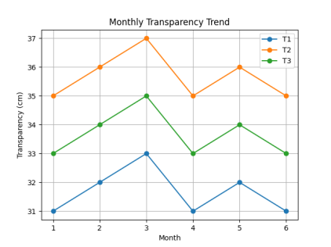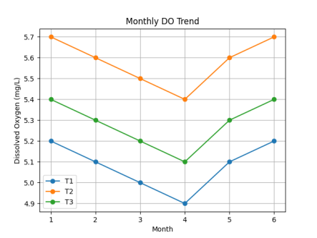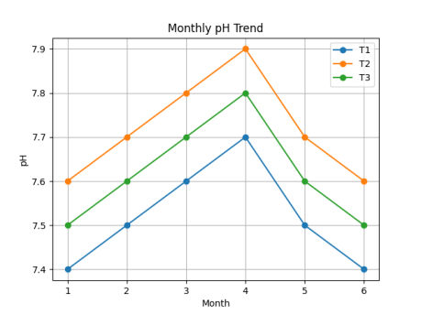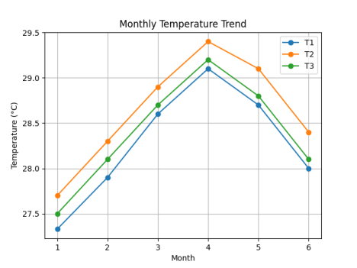
Graph2: Showing monthly variation of water parameters.
Input Cost Details (per hectare basis)
Table 3: Input cost details.
Particulars | T₁ (Feed A) | T₂ (Feed B) | T₃ (Feed C)
Seed Cost (INR) | 12,000 | 12,000 | 12,000
Feed Quantity (kg) | 920 | 980 | 950
Feed Cost (INR/kg) | 50 | 50 | 50
Lime & Fertilizer (INR) | 5,000 | 5,000 | 5,000
Labour Cost (INR) | 8,000 | 8,000 | 8,000
Miscellaneous (INR) | 5,000 | 5,000 | 5,000

Total Feed Cost
Feed Cost = Quantity × Price
Table 4: Total feed cost of the three treatments.
Treatment | Feed Cost (INR)
T₁ | 920 × 50 = 46,000
T₂ | 980 × 50 = 49,000
T₃ | 950 × 50 = 47,500

Graph 10: Chart showing Feed cost (INR)
Total Cost of Production
Total Cost = Feed + Seed + Labour + Fertilizer + Miscellaneous
Table 5: Total cost of production of the three treatments.
Treatment | Total Cost (INR)
T₁ | 46,000 + 12,000 + 8,000 + 5,000 + 5,000 = 76,000
T₂ | 49,000 + 12,000 + 8,000 + 5,000 + 5,000 = 79,000
T₃ | 47,500 + 12,000 + 8,000 + 5,000 + 5,000 = 77,500

Graph 11: Chart showing Total cost of Production (INR)
PRODUCTION AND INCOME DATA
Table 6: Production and market price of the three treatments.
Treatment | Production (kg/ha) | Market Price (INR/kg)
T₁ | 2580 | 150
T₂ | 3105 | 150
T₃ | 2835 | 150

Graph 12: Chart showing Production rate (kg/ha)
Gross Income
Gross Income = Production × Price
Table 7: Gross income from the three treatments.
Treatment | Gross Income (INR)
T₁ | 2580 × 150 = 3,87,000
T₂ | 3105 × 150 = 4,65,750
T₃ | 2835 × 150 = 4,25,250

Graph 13: Chart showing Gross Income (INR)
Net Income
Net Income = Gross Income − Total Cost
Table 8: Net income from the three treatments.
Treatment | Net Income (INR)
T₁ | 3,87,000 − 76,000 = 3,11,000
T₂ | 4,65,750 − 79,000 = 3,86,750
T₃ | 4,25,250 − 77,500 = 3,47,750

Graph 14: Chart showing Net Income (INR)
Benefit–Cost Ratio (B:C Ratio)
B:C Ratio = Gross Income / Total Cost
Table 9: B:C ratio of the three treatments.
Treatment | B:C Ratio
T₁ | 3,87,000 / 76,000 = 5.09
T₂ | 4,65,750 / 79,000 = 5.90
T₃ | 4,25,250 / 77,500 = 5.49

Graph 15: Chart showing B:C ratio
The economic analysis clearly demonstrates that T₂ yielded the highest net income and benefit–cost ratio, despite having a slightly higher feed cost. This indicates that feed quality has a greater impact on profitability than feed cost alone. The superior economic performance of T₂ is directly linked to its better growth rate and feed efficiency, which resulted in higher production and revenue.
3.5 Statistical Analysis
One-Way ANOVA for Final Weight
Step 1: Data
- T₁: 610, 625, 626
- T₂: 700, 720, 712
- T₃: 650, 665, 666
Step 2: ANOVA Table
Table 10: ANOVA analysis of the three treatments.
Source of Variation | SS | df | MS | F
Between Groups | 12293.5556 | 2 | 6146.7778 | 70.383
Within Groups | 524 | 6 | 87.3333 | 70.383
Total | 12817.5556 | 8 |  | 70.383
Step 3: Interpretation
Calculated F = 70.38
Critical F (p<0.05, df 2,6) ≈ 6.83
Since Fcal>Ftab, differences are statistically significant (p < 0.05)
ANOVA showed significant differences (p < 0.05) among treatments, confirming that feed quality significantly influences performance.
5. Conclusion
The present study was undertaken to evaluate the comparative performance of different commercially available fish feeds on growth, feed utilization efficiency, survival, and economic returns of Indian Major Carps under semi-intensive pond culture conditions. The findings clearly demonstrate that feed quality is a decisive factor influencing both biological performance and economic profitability in aquaculture systems.
Significant differences (p < 0.05) were observed among treatments for all major parameters, including weight gain, Specific Growth Rate (SGR), Feed Conversion Ratio (FCR), production, and economic returns. Among the tested feeds, Feed B (T₂), containing higher crude protein (30%) and lipid (6%) levels, consistently outperformed the other feeds. Fish fed with Feed B exhibited the highest mean final weight (710.67 g), weight gain (695.34 g), and SGR (3.02% day⁻¹), indicating superior growth performance.
The improved growth observed in T₂ can be attributed to its balanced nutrient composition, particularly the optimal protein-energy ratio, which plays a crucial role in enhancing metabolic efficiency and tissue development. In addition, the floating pellet nature of Feed B facilitated better feed intake monitoring and reduced feed wastage, thereby improving nutrient utilization efficiency.
Feed utilization parameters further supported the superiority of Feed B, as indicated by the lowest FCR (1.41), reflecting efficient conversion of feed into biomass. Efficient feed utilization not only enhances growth but also minimizes feed wastage and reduces environmental impact by lowering organic load in the pond ecosystem.
Water quality parameters such as temperature, pH, dissolved oxygen, and transparency remained within the optimal range across all treatments, indicating that proper pond management practices were maintained. However, slightly improved water quality conditions observed in T₂ suggest that better feed digestibility and reduced waste output contribute positively to maintaining pond ecology.
From an economic perspective, Feed B yielded the highest production (3105 kg/ha), net income (₹3,86,750/ha), and benefit–cost ratio (5.90), despite having a marginally higher feed cost. This clearly highlights that the selection of high-quality feed results in better economic returns, emphasizing that profitability in aquaculture is more dependent on feed efficiency rather than feed cost alone.
In contrast, Feed A (T₁), although economically cheaper, resulted in comparatively lower growth performance, higher FCR, and reduced profitability, indicating that low-cost feeds may not always be cost-effective in the long term. Feed C (T₃) showed intermediate performance, suggesting that moderate nutrient composition can yield acceptable results but may not maximize production potential.
Overall, the study conclusively establishes that nutritionally balanced commercial feeds with optimal protein and energy levels significantly enhance growth performance, feed utilization efficiency, and economic returns in Indian Major Carp culture. The findings provide strong evidence that scientific feed selection is essential for improving aquaculture productivity and sustainability.
The results of this study are particularly relevant for farmers practicing semi-intensive aquaculture under similar agro-climatic conditions, as they offer practical insights into feed selection strategies. Adoption of high-performance commercial feeds, along with proper feeding management practices, can substantially improve farm productivity and income.
COMPETING INTERESTS DISCLAIMER:
Authors have declared that they have no known competing financial interests OR non-financial interests OR personal relationships that could have appeared to influence the work reported in this paper.

Disclaimer (Artificial intelligence)

Author(s) hereby declare that NO generative AI technologies such as Large Language Models (ChatGPT, COPILOT, etc.) and text-to-image generators have been used during the writing or editing of this manuscript.

References
- Ahmed, N., Hossain, M. A., & Islam, A. K. M. S. (2015). Growth performance and economic analysis of carp polyculture using commercial feeds. Aquaculture International, 23, 1023–1036.
- APHA (American Public Health Association). (2017). Standard Methods for the Examination of Water and Wastewater (23rd ed.). Washington, D.C., USA.
- Beveridge, M. C. M. (2004). Cage Aquaculture (3rd ed.). Blackwell Publishing, Oxford, UK.
- Boyd, C. E. (1998). Water Quality for Pond Aquaculture. Auburn University, Alabama, USA.
- Boyd, C. E., & Tucker, C. S. (1998). Pond Aquaculture Water Quality Management. Springer, Boston, USA.
- Boyd, C. E., Tucker, C. S., & Somridhivej, B. (2020). Alkalinity and hardness: critical but elusive concepts in aquaculture. Journal of the World Aquaculture Society, 51(2), 289–303.
- Das, S., Mishra, S. S., & Das, P. C. (2021). Comparative performance of commercial fish feeds in carp culture systems. Aquaculture Reports, 20, 100700.
- De Silva, S. S., & Anderson, T. A. (1995). Fish Nutrition in Aquaculture. Chapman & Hall, London, UK.
- Engle, C. R. (2010). Aquaculture Economics and Financing: Management and Analysis. Wiley-Blackwell, USA.
- FAO (Food and Agriculture Organization). (2022). The State of World Fisheries and Aquaculture 2022. FAO, Rome, Italy.
- FAO (Food and Agriculture Organization). (2024). The State of World Fisheries and Aquaculture 2024. FAO, Rome, Italy.
- Glencross, B. D., Booth, M., & Allan, G. L. (2020). A feed is only as good as its ingredients: a review of ingredient evaluation strategies for aquaculture feeds. Aquaculture Nutrition, 26(2), 247–262.
- Hargreaves, J. A. (2020). Understanding pond water quality management. Southern Regional Aquaculture Center (SRAC) Publication, No. 4601.
- Hasan, M. R., New, M. B., & Halwart, M. (2020). On-farm feeding and feed management in aquaculture. FAO Fisheries and Aquaculture Technical Paper No. 583. Rome, Italy.
- ICAR (Indian Council of Agricultural Research). (2021). Handbook of Fisheries and Aquaculture. ICAR, New Delhi, India.
- Jhingran, V. G., & Pullin, R. S. V. (1985). A Hatchery Manual for the Common, Chinese and Indian Major Carps. ICLARM Studies and Reviews, Manila, Philippines.
- Kumar, V., Sahu, N. P., Pal, A. K., & Kumar, S. (2020). Effect of dietary protein levels on growth performance of Indian major carps. Aquaculture Research, 51, 120–130.
- Mohanty, S. N., Swain, S. K., & Tripathi, S. D. (2013). Nutritional evaluation of formulated feeds for carp culture. Indian Journal of Fisheries, 60(3), 105–110.
- New, M. B., & Wijkström, U. N. (2002). Use of Fishmeal and Fish Oil in Aquafeeds. FAO Fisheries Technical Paper No. 425. Rome, Italy.
- NRC (National Research Council). (2011). Nutrient Requirements of Fish and Shrimp. National Academies Press, Washington, D.C., USA.
- Paul, B. N., Sarkar, S., & Mohanty, S. N. (2022). Nutritional evaluation of commercial fish feeds and their effect on growth of carps. Aquaculture International, 30, 1501–1515.
- Stone, D. A. J. (2021). Carbohydrate utilization in fish. Aquaculture Nutrition, 27(5), 1497–1510.
- Tocher, D. R. (2020). Omega-3 long-chain polyunsaturated fatty acids and aquaculture in perspective. Aquaculture, 526, 735394.
- Tripathi, S. D., Sahu, A. K., & Mohanty, S. N. (2012). Composite fish culture in India: A review. Journal of Inland Fisheries Society of India, 44(1), 1–10.
- Wilson, R. P. (1994). Utilization of dietary carbohydrate by fish. Aquaculture, 124, 67–80.

