Original Research Article
Biology and Morphometric Analysis of Rice weevil, Sitophilus oryzae (L.) with Emphasis on Larval Growth Patterns

ABSTRACT
A laboratory study investigated the biological and morphometric characteristics of the rice weevil, Sitophilus oryzae (L.). The incubation period ranged from 5-8 days, followed by four larval instars lasting 3-6, 4-7, 6-8 and 7-9 days, respectively. The total larval and pupal durations varied from 23-28 and 6-9 days, respectively, whilst the complete life cycle ranged from 90-123 days. Adult longevity varied from 56-67 days in males and 70-82 days in females. The oviposition period extended from 45-55 days, with fecundity ranging from 186-218 eggs per female and egg hatchability varying between 79.57% and 84.06%. Morphometric observations showed a progressive increase in body dimensions throughout larval development. Egg length and width measured 0.36 ± 0.01 mm and 0.16 ± 0.02 mm, respectively. Larval length increased from 0.51 ± 0.04 to 2.02 ± 0.20 mm, larval width from 0.35 ± 0.04 to 1.52 ± 0.05 mm and head capsule width (HCW) from 0.19 ± 0.01 to 0.46 ± 0.01 mm across successive instars. The relatively uniform growth progression observed among larval instars indicated close conformity with Dyar’s law. Pupal length and width measured 2.71 ± 0.53 mm and 1.57 ± 0.05 mm, respectively, whilst adult females (1.21 ± 0.10 mm) were larger than males (1.15 ± 0.11 mm). Correlation analysis revealed strong positive associations among larval morphometric traits, particularly between larval length and HCW (r = 0.978*) and between instar number and HCW (r = 0.995**), confirming HCW as a reliable parameter for larval instar determination. These findings provide valuable information for accurate stage identification and management of this important storage pest.
Keywords: Rice, Sitophilus oryzae, biology, morphometry, larval instars and Dyar’s law
1. Introduction
Rice (Oryza sativa L.) is widely recognised as one of the most important staple crops, sustaining nearly half of the global population (Nascimento et al., 2015). In India, it forms an integral part of daily diets and plays a vital role in supporting rural livelihoods. The country also contributes significantly to global rice production, accounting for approximately 25.27% of the total output (Chaudhary et al., 2025), thereby reinforcing both national food security and economic stability.
In recent years, rice cultivation in India has shown consistent expansion in both area and productivity. During 2024-25, rice was cultivated over 51.27 million hectares, producing 150.18 million tonnes with an average productivity of 2,929 kg per hectare (Government of India, 2025). Likewise, in Uttar Pradesh during 2025-26, rice occupied an area of 491.52 lakh hectares, yielding 1406.48 lakh tonnes with an average productivity of 2861 kg per hectare (Government of India, 2026). Despite such impressive production levels, substantial post-harvest losses continue to occur during storage due to insect infestation.
Among the various insect pests associated with stored rice, the rice weevil, Sitophilus oryzae (L.), is considered one of the most destructive (Nwaubani et al., 2014). It is widely distributed across tropical and subtropical regions and is regarded as an important phytosanitary and quarantine pest (Hong et al., 2018). Both larval and adult stages of this insect are responsible for grain damage, although the larval stage is generally considered more destructive because development occurs within the grain itself (Gvozdenac et al., 2020). Infestation causes considerable deterioration in grain quality through loss of weight, reduction in nutritional value and increased susceptibility to secondary infestation by fungi and mites, thereby lowering the commercial value of stored produce (Souza et al., 2012).
Infested grains commonly exhibit hollow feeding cavities, powdery frass accumulation, increased moisture content and a characteristic unpleasant odour. Under poor storage and prolonged infestation conditions, grain weight losses may become severe and, in some cases, may reach up to 80 per cent (Park et al., 2004; Beckett et al., 2007). Since the entire developmental cycle of the pest takes place within the grain, early detection and effective management are often difficult under storage conditions. The female weevil penetrates the grain with the aid of its rostrum, deposits a single egg and seals the cavity with a gelatinous plug. Although this plug is not readily visible to the naked eye, it can be detected using suitable staining methods and represents the only external evidence of infestation (Frankenfeld, 1948; Sharifi, 1972). Larvae feed primarily on the germ portion of the grain, causing depletion of proteins and vitamins, whereas adults mainly consume the endosperm, thereby reducing carbohydrate content (Chandaragi et al., 2022). The concealed habit of development, together with a relatively short life cycle, enables rapid multiplication under favourable storage conditions, whilst the flight capability of adults further assists in the spread of infestation.
In view of these concerns, a comprehensive understanding of the biology, life cycle and morphometric characteristics of S. oryzae is essential for the development of effective management strategies. Identification of vulnerable developmental stages may facilitate timely and targeted interventions against the pest. Such an informed and preventive approach is important for minimising post-harvest losses and ensuring the long-term preservation of grain quality and food security.
2. Materials and Methods
The present study on the biology and morphometry of Sitophilus oryzae (L.) was carried out during 2025-2026 at the Department of Entomology, Acharya Narendra Deva University of Agriculture and Technology, Kumarganj, Ayodhya (U.P.), using rice variety TN-1 as the host substrate. A laboratory culture of the insect was maintained on rice grains in 2 L glass jars in BOD (27 ± 1°C and 70 ± 5% relative humidity) (Okpile et al., 2021). The containers were covered with muslin cloth to facilitate aeration, and only healthy, clean and uninfested grains were used throughout the study. All cultures and experimental observations were maintained under uniform environmental conditions.
For experimental observations, newly emerged adults of similar age were selected from the stock culture and introduced into each of the five replicated Petri dishes containing 25 grains at a 1:1 male-to-female ratio of rice weevils. The dishes were covered with muslin cloth to allow ventilation while preventing the escape of insects. Following one week of oviposition, adult weevils were removed in order to prevent further egg deposition and to avoid overlapping of generations. Eggs were recorded daily by examining the grains, and those bearing eggs were transferred to fresh Petri dishes each day to avoid mixing of cohorts, while fresh grains were added to maintain a constant number of grains. Fecundity was determined as the total number of eggs laid per female, and the oviposition rate (eggs day⁻¹) was calculated accordingly. Egg hatching percentage was estimated based on the number of larvae emerging from the total number of eggs laid. Following hatching, larvae were allowed to develop within the grains, and their development was examined by dissecting grains at regular intervals. Successive instars were identified based on morphological characteristics and head capsule measurements. The duration of the egg, four larval instars, pupal and adult stages was recorded to determine the complete life cycle of the insect.
Morphometric observations were recorded for all developmental stages, including egg, larva instars, pupa and adult, using an ocular micrometer fitted to a stereo zoom microscope. Measurements of length, width and head capsule width (HCW) were taken, particularly for larval instars, to confirm instar differentiation and evaluate growth progression. The growth ratio (GR) and percentage increment (IP) were calculated as:
GR =$\frac{HCWn}{HCWn-1}$ , IP = $\frac{(HCWn-HCWn-1)}{HCWn-1}×$100
Where, HCW_{n} and HCW_{n−1} denote the head capsule widths of the current and immediately preceding instars, respectively. The growth pattern was further assessed in accordance with Dyar’s law, expressed as:
HCW_{n} = HCW₁×r^{(n−1)}
Where, HCW₁ is the head capsule width of the first instar, r- is the growth ratio, and n- represents the instar number.
All experimental data were subjected to statistical analysis. Mean values were calculated, and variability was expressed in terms of standard deviation (SD) and standard error of the mean (SE). In addition, Pearson’s correlation coefficient (r) was used to examine relationships among selected morphometric parameters. Statistical analyses were performed using OPSTAT software, while data organisation and basic computations were carried out using Microsoft Excel.
3. Results & Discussion
3.1 Egg stage
The eggs of Sitophilus oryzae were oval, smooth, and translucent white in appearance, gradually becoming opaque prior to hatching. Eggs were laid singly within rice grains. The female created a small cavity using its rostrum for oviposition and subsequently sealed it with a gelatinous secretion, thereby concealing the egg within the grain.
The incubation period of this insect ranged from 5-8 days, with a mean duration of 6.2 ± 1.30 days under laboratory conditions, indicating only slight variation among observations (Table 3). Comparable findings were reported by (Kaundal et al., 2023), who observed an incubation period of 5-7 days with a mean of 5.76 ± 0.09 days. Slightly longer incubation periods were documented by (Devi et al., 2017) on wheat (6.9 days) and by (Prasad et al., 2025) on maize (6.52 days), which may be associated with differences in host substrate and prevailing experimental conditions.
Fecundity ranged from 186-218 eggs per female, with a mean of 200.6 ± 12.73 eggs per female. The oviposition rate remained relatively stable at 3.67 to 4.13 eggs day⁻¹, with a mean of 3.87 ± 0.19 eggs day⁻¹. Egg hatchability varied from 79.57 to 84.06%, with a mean hatchability of 82.08 ± 1.67%, indicating favourable reproductive performance of S. oryzae. The oviposition pattern is illustrated in Figure 1. Egg laying was initially low during the early reproductive phase, increased progressively with advancing adult age and attained a peak between the 14th and 18th day, during which the highest oviposition rate (5.4-5.6 eggs day⁻¹) was recorded. Subsequently, egg production remained comparatively stable for a brief period before gradually declining towards the later stages of the female lifespan and eventually reaching negligible levels. The reproductive parameters recorded in the present investigation were broadly consistent with earlier reports. Kaundal et al. (2023) documented a fecundity of 231.00 ± 3.09 eggs per female, again similar result reported by (Sachin et al., 2023), comparable reproductive performance under controlled laboratory conditions.
The mean egg length was recorded as 0.36 ± 0.01 mm (ranged from 0.34 to 0.38 mm), while the mean egg width was 0.16 ± 0.02 mm (range from 0.14 to 0.18 mm) in Table 1. Comparable values have been reported by (Chaudhary et al., 2025), who recorded egg length ranging from 0.34-0.40 mm (mean 0.36 ± 0.01 mm) and width from 0.13-0.19 mm (mean 0.16 ± 0.01 mm). Similarly, (Subhadarsini et al., 2023) reported mean egg length and breadth of 0.36 mm and 0.19 mm, respectively. The slight variation may be attributed to differences in temperature and experimental conditions.
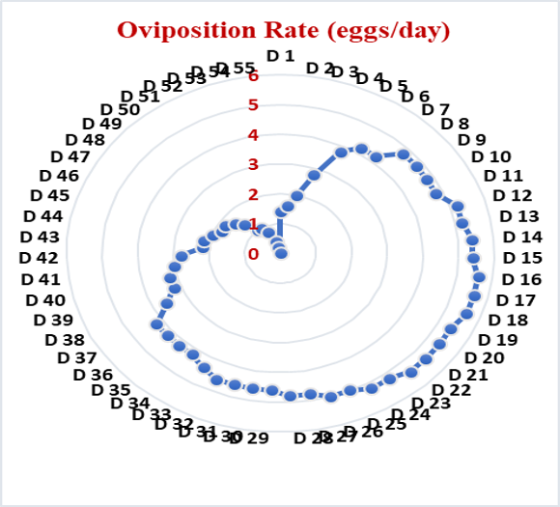

Figure 1 Daily oviposition rate (eggs/day) of S. oryzae.
3.2 Larval stage
The larva of Sitophilus oryzae was apodous, creamy white and characteristically C-shaped, with a distinct brown head capsule. Throughout development, the larval stage remained concealed within the grain, feeding internally. Development proceeded through four distinct instars, separated by three moults prior to pupation.
The duration of the first instar ranged from 3 to 6 days, with a mean of 4.6 ± 1.14 days. The second instar lasted 4 to 7 days (mean 5.6 ± 1.14 days), followed by the third instar, which was completed within 6 to 8 days (mean 7.0 ± 1.00 days). The fourth instar extended from 7 to 9 days, with a mean duration of 7.6 ± 0.89 days. Consequently, the total larval duration ranged from 23 to 28 days, with an average of 24.8 ± 2.28 days, indicating only minor variation among observations (Table 3; Figure 3).
These findings are in close agreement with those of (Kaundal et al., 2023), who reported first, second, third and fourth instar durations of 4-6 days (mean 4.88 ± 0.04 days), 5-6 days (mean 5.72 ± 0.08 days), 7-9 days (mean 8.70 ± 0.10 days) and 6-8 days (mean 7.58 ± 0.04 days), respectively, with a total larval duration of 22-29 days (mean 26.88 ± 0.08 days). Similarly, Sachin et al. (2023) reported first, second, third and fourth instar durations of 5-6 days (mean 5.20 ± 0.40 days), 5-7 days (mean 6.60 ± 0.66 days), 7-9 days (mean 8.60 ± 0.66 days) and 8-10 days (mean 9.40 ± 0.80 days), respectively, with a total larval period ranging from 25 to 32 days (mean 27.40 ± 1.81 days). Prasad et al. (2025) also reported a comparatively longer total larval duration of 28.98 days on rice.
A gradual and consistent increase in larval size was observed across all successive instars. The mean larval length increased from 0.51 ± 0.04 mm (ranged from 0.46 to 0.56 mm) in the first instar to 0.82 ± 0.05 mm (0.75-0.88 mm) in the second instar. This further increased to 1.12 ± 0.06 mm (1.02–1.18 mm) in the third instar and reached 2.02 ± 0.20 mm (1.73-2.25 mm) in the fourth instar. A similar progressive trend was evident in larval width, which increased from 0.35 ± 0.04 mm (0.29-0.40 mm) in the first instar to 0.50 ± 0.06 mm (0.42-0.56 mm) in the second instar, 0.96 ± 0.07 mm (0.86-1.04 mm) in the third instar and 1.52 ± 0.05 mm (1.47-1.58 mm) in the fourth instar (Table 1).
Comparable trends in larval growth have been reported by (Kaundal et al., 2023), who recorded larval lengths of 0.58 ± 0.03, 0.90 ± 0.02, 1.23 ± 0.03 and 2.12 ± 0.12 mm, along with corresponding breadths of 0.41 ± 0.03, 0.52 ± 0.04, 1.04 ± 0.06 and 1.58 ± 0.05 mm for the first to fourth instars, respectively. Similarly, Chaudhary et al. (2025) reported larval length increasing from 0.24 ± 0.03 mm in the first instar to 1.17 ± 0.32 mm in the fourth instar, with larval width ranging from 0.08 ± 0.01 mm to 0.94 ± 0.49 mm across successive instars. Further support is provided by Sachin et al. (2023), who documented an increase in larval body length from 0.57 ± 0.02 mm in the first instar to 2.01 ± 0.21 mm in the fourth instar. These findings are also in agreement with those of (Rojasara and Patel, 2020), who reported a similar gradual increase in larval size from first to last instar.
The head capsule width exhibited a steady increase among the successive instars, with mean values of 0.19 ± 0.01 mm, 0.26 ± 0.02 mm, 0.34 ± 0.01 mm and 0.46 ± 0.01 mm from the first to the fourth instar, respectively. The growth ratio between all instars was 1.35 (first to second instar), 1.34 (second to third instar), and 1.33 (third to fourth instar), indicating a near-uniform pattern of growth. In addition, the percentage increase in head capsule width declined slightly from 35.42% in the second instar to 32.76% in the fourth instar, suggesting a consistent and regulated pattern of development (Table 1; Figure 2). These observations are in accordance with Dyar’s law, as the head capsule width increased in an approximately constant ratio (geometric progression) across successive instars.
Comparable findings were reported by (Sachin et al., 2023), who recorded head capsule widths of 0.31 ± 0.02, 0.40 ± 0.02, 0.50 ± 0.02 and 0.57 ± 0.02 mm from the first to the fourth instar, respectively. Similarly, Prasad et al. (2025) reported head capsule width ranging from 0.38 to 0.55 mm on rice, 0.37 to 0.54 mm on wheat, and 0.39 to 0.56 mm on maize from early to later instars, indicating a consistent pattern of larval growth across different host substrates. These findings further support the applicability of Dyar’s law.

Developmental Stages |  | Body Length (mm) |  |  | Body Width (mm) |  |  | Head Capsule Width (mm)
 |  | Range | Mean ± SD | SE | Range | Mean ± SD | SE | Range | SE | Mean ± SD | GR | IP
Egg |  | 0.34 - 0.38 | 0.36 ± 0.01 | 0.01 | 0.14 - 0.18 | 0.16 ± 0.02 | 0.01 | - | - | - | - | -
Larval Instars | 1st | 0.46 - 0.56 | 0.51 ± 0.04 | 0.02 | 0.29 - 0.4 | 0.35 ± 0.04 | 0.02 | 0.18 - 0.21 | 0.006 | 0.19 ± 0.01 | 0 | 0
Larval Instars | 2nd | 0.75 - 0.88 | 0.82 ± 0.05 | 0.02 | 0.42 - 0.56 | 0.50 ± 0.06 | 0.02 | 0.24 - 0.28 | 0.007 | 0.26 ± 0.02 | 1.35 | 35.42
Larval Instars | 3rd | 1.02 - 1.18 | 1.12 ± 0.06 | 0.03 | 0.86 - 1.04 | 0.96 ± 0.07 | 0.03 | 0.33 - 0.37 | 0.007 | 0.34 ± 0.01 | 1.34 | 33.85
Larval Instars | 4th | 1.73 - 2.25 | 2.02 ± 0.20 | 0.09 | 1.47 - 1.58 | 1.52 ± 0.05 | 0.02 | 0.45 - 0.48 | 0.006 | 0.46 ± 0.01 | 1.33 | 32.76
Pupa |  | 1.97 - 3.42 | 2.71 ± 0.53 | 0.24 | 1.51 - 1.65 | 1.57 ± 0.05 | 0.02 | - | - | - | - | -
Adult | Male | 2.41 - 2.59 | 2.51 ± 0.07 | 0.03 | 0.98 - 1.25 | 1.15 ± 0.11 | 0.05 | - | - | - | - | -
Adult | Female | 2.83 - 3.04 | 2.94 ± 0.08 | 0.04 | 1.08 - 1.31 | 1.21 ± 0.10 | 0.04 | - | - | - | - | -
Table 1 Morphometric analysis of different developmental stages of Sitophilus oryzae
Where; GR- Growth Ratio, IP- Incremental Percentage, SD- Standard Deviation, SE- Standard Error

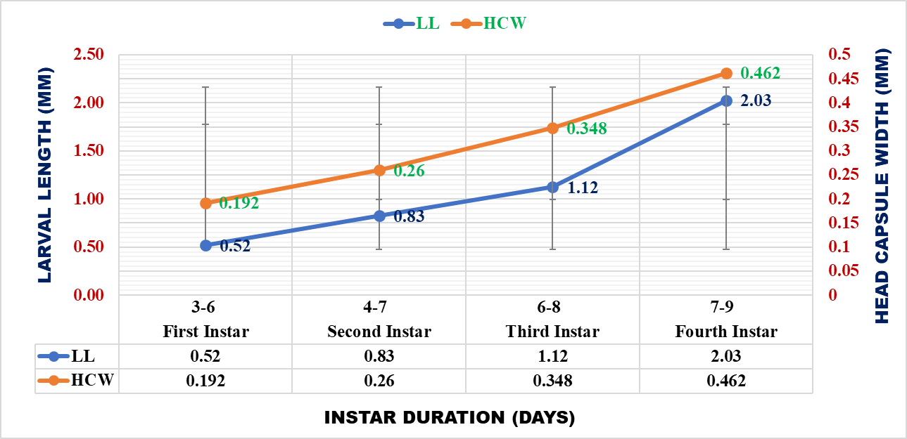
Figure 2 Growth pattern of larval length and head capsule width across instars
3.2.1 Correlation analysis of larval morphometric traits in relation to Dyar’s law
Correlation analysis of larval morphometric traits in S. oryzae revealed consistently strong and statistically significant associations, reflecting a well-defined and orderly pattern of growth across successive instars. Head capsule width (HCW), recognised as a key indicator of larval development, exhibited an exceptionally strong positive correlation with instar number (r = 0.995**), demonstrating a steady and predictable increase in head capsule dimensions with advancing developmental stages.
Larval length (L) also showed a strong positive relationship with HCW (r = 0.978*), whilst larval width (W) displayed an even stronger and highly significant association (r = 0.991**). In addition, larval length and width were closely correlated (r = 0.984*), indicating that overall body dimensions increase in a coordinated and proportionate manner during larval growth. Instar number further exhibited strong correlations with larval length (r = 0.957*) and larval width (r = 0.973*), reinforcing the progressive and systematic nature of growth across developmental stages (Table 2).
The consistently high and significant correlations among all morphometric parameters demonstrate a well-synchronised pattern of larval development, in which changes in body dimensions are closely aligned with head capsule growth. The particularly strong association between instar number and head capsule width (r = 0.995**) provides robust empirical support for Dyar’s law, indicating that head capsule dimensions follow a near-constant geometric progression across successive moults.
Moreover, the uniformity observed among these traits underscores the reliability of head capsule width as a dependable criterion for instar determination. The close alignment between head development and overall body size further suggests that larval growth in S. oryzae proceeds in a coordinated and orderly manner, reflecting a stable and predictable developmental pattern.
Table 2 Correlation matrix among larval morphological parameters of Sitophilus oryzae
Morphological Parameters | Instar | L | W | HCW
Instar | 1 | 0.957* | 0.973* | 0.995**
L | 0.957* | 1 | 0.984* | 0.978*
W | 0.973* | 0.984* | 1 | 0.991**
HCW | 0.995** | 0.978* | 0.991** | 1
Where; L- Length, W- Width, HCW- Head Capsule Width
3.3 Pupal Stage
The pupa of S. oryzae was exarate, soft, and creamy white in colour, gradually darkening prior to adult emergence. The pupal stage remained concealed within the grain, occupying the cavity formed during larval development.
The duration of the pupal stage ranged from 6 to 9 days, with a mean of 7.2 ± 1.30 days, indicating only slight variation among observations (Table 3). Similar duration have been reported by (Kaundal et al., 2023), who observed a pupal period of 6-9 days (mean 7.62 ± 0.08 days), and Sachin et al. (2023), who recorded a slightly higher range of 7-10 days (mean 9.20 ± 0.98 days). In contrast, Chaudhary et al. (2025) reported relatively longer pupal durations of 9-11 days (mean 10 ± 1.4 days). Prasad et al. (2025) also documented pupal periods of 6.43, 6.85 and 7.14 days on rice, wheat and sorghum, respectively. Earlier studies by (Choudhury and Chakraborty, 2014) and (Bhanderi et al., 2015) similarly reported pupal durations of 7-8 days in rice and 6-7 days in sorghum.
An increase in body size was evident at the pupal stage in comparison with the final larval instar. The mean pupal length was recorded as 2.71 ± 0.53 mm (ranged from 1.97-3.42 mm), while the mean pupal breadth was 1.57 ± 0.05 mm (range: 1.51-1.65 mm) (Table 1). These findings are consistent with those reported by (Kaundal et al., 2023), who recorded pupal length ranging from 2.24 to 2.50 mm (mean 2.41 ± 0.08 mm) and breadth from 1.54 to 1.69 mm (mean 1.61 ± 0.05 mm). A similar trend was also noted by (Rojasara and Patel, 2020), who observed pupal length of 2.24-2.40 mm and breadth of 1.53-1.68 mm on rice. In contrast, Bhanderi et al. (2015) reported relatively larger pupae, with a mean length of 3.34 ± 0.09 mm and breadth of 1.67 ± 0.04 mm.

3.4 Adult Biology and Reproductive Parameters
Adults of S. oryzae were small, reddish-brown weevils characterised by a distinct elongated rostrum. Both sexes fed on grains by boring into them, thereby contributing to continued damage during storage.
Adult longevity differed between the sexes, with males surviving for 56-67 days (mean 61.6 ± 4.03 days) and females for 70-82 days (mean 78.0 ± 4.74 days). Females were also larger than males, indicating clear sexual dimorphism. The total life cycle ranged from 90 to 99 days in males (mean 99.8 ± 3.19 days) and 105 to 123 days in females (mean 116.2 ± 7.25 days), reflecting a longer developmental duration in females (Table 3).
These findings are in agreement with Kaundal et al. (2023), who reported male longevity of 54-65 days (mean 60.18 ± 0.82 days) and female longevity of 72-87 days (mean 76.94 ± 0.50 days), along with life cycle durations of 87-110 days (mean 100.44 ± 0.85 days) in males and 105-132 days (mean 119.90 ± 0.44 days) in females. Under fed conditions, Sachin et al. (2023) observed higher longevity, with males surviving for 72-113 days (mean 96.20 ± 12.72 days) and females for 84-119 days (mean 114.40 ± 10.83 days). Similar life cycle durations were also reported by (Bhanderi et al., 2015), who recorded 98.81 ± 2.33 days in males and 117.89-140.96 days in females.
Males exhibited a mean body length of 2.51 ± 0.07 mm (range: 2.41-2.59 mm), whereas females were larger, with a mean length of 2.94 ± 0.08 mm (range: 2.83-3.04 mm). Similarly, the mean body width of males was 1.15 ± 0.11 mm (range: 0.98 to 1.25 mm), while females showed a greater width of 1.21 ± 0.10 mm (range: 1.08 to 1.31 mm) (Table 1). These values are consistent with those reported by (Kaundal et al., 2023), who recorded adult male dimensions of 2.59 ± 0.05 mm in length and 0.78 ± 0.04 mm in breadth, and female dimensions of 3.01 ± 0.06 mm and 0.84 ± 0.05 mm, respectively. Similar adult lengths were noted by (Choudhury and Chakraborty, 2014) on rice (2.9 ± 0.6 mm in males and 2.8 ± 0.6 mm in females). By contrast, Bhanderi et al. (2015) reported variation in adult size on sorghum, suggesting an influence of host substrate and rearing conditions.
Females commenced oviposition 4-6 days after emergence (mean 5.2 ± 0.83 days), followed by a prolonged oviposition phase of 45-55 days (mean 51.8 ± 3.96 days). The post-oviposition period was comparatively shorter, ranging from 16-21 days (mean 18.8 ± 1.92 days) (Table 3). The present observations on pre-oviposition, oviposition and post-oviposition periods closely correspond with earlier findings. Kaundal et al. (2023) reported a pre-oviposition period of 3-6 days, an oviposition period of 55.82 ± 0.53 days and a post-oviposition duration of 15-23 days (mean 19.52 ± 0.39 days). Similar reproductive trends were also documented by (Bhanderi et al., 2015), (Mackled, 2017) and (Rojasara and Patel, 2020).

Developmental Stages |  | Range | Mean ± SD | SE
Incubation period (days) |  | 5-8 | 6.2 ± 1.30 | 0.58
Larval period | 1st Instar | 3-6 | 4.6 ± 1.14 | 0.51
Larval period | 2nd Instar | 4-7 | 5.6 ± 1.14 | 0.51
Larval period | 3rd Instar | 6-8 | 7 ± 1 | 0.45
Larval period | 4th Instar | 7-9 | 7.6 ± 0.89 | 0.40
Total Larva period (days) |  | 23-28 | 24.8 ± 2.28 | 1.02
Pupa period (days) |  | 6-9 | 7.2 ± 1.30 | 0.58
Adult Longevity (days) | Male | 56-67 | 61.6 ± 4.03 | 1.81
Adult Longevity (days) | Female | 70-82 | 78 ± 4.74 | 2.12
Reproductive Parameters | Pre-Oviposion (days) | 4-6 | 5.2 ± 0.83 | 0.37
Reproductive Parameters | Oviposition (days) | 45-55 | 51.8 ± 3.96 | 1.77
Reproductive Parameters | Post-oviposition (days) | 16-21 | 18.8 ± 1.92 | 0.86
Reproductive Parameters | Fecundity (No. of eggs) | 186-218 | 200.6 ± 12.73 | 5.70
Reproductive Parameters | Egg Hatching % | 79.57-84.06 | 82.0 ± 1.67 | 0.75
Reproductive Parameters | Oviposition rate (eggs/day) | 3.67-4.13 | 3.8 ± 0.18 | 0.08
Total Life Cycle | Male (days) | 90-99 | 99.8 ± 3.19 | 1.43
Total Life Cycle | Female (days) | 105-123 | 116.2 ± 7.25 | 3.25
Table 3 Biological parameters of Sitophilus oryzae

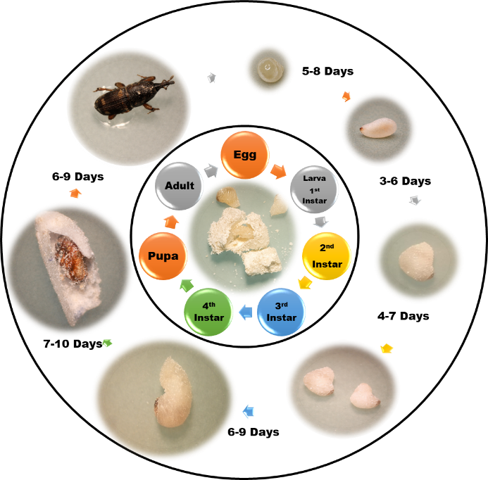

Figure 3 Life cycle of Sitophilus oryzae with developmental duration
Conclusion
The present investigation provides valuable insights into the biological and morphometric characteristics of S. oryzae. A gradual and consistent increase in larval dimensions, particularly head capsule width, was observed across successive instars, demonstrating clear conformity with Dyar’s law. The strong and statistically significant relationships among the measured morphometric traits further indicated a closely coordinated pattern of larval growth and development. Among the various parameters examined, head capsule width proved to be the most dependable indicator for distinguishing larval instars. Overall, the findings contribute to a better understanding of the developmental biology of S. oryzae and may assist in accurate stage identification as well as the formulation of effective stage-specific management strategies for this economically important storage pest.

COMPETING INTERESTS DISCLAIMER:
Authors have declared that they have no known competing financial interests OR non-financial interests OR personal relationships that could have appeared to influence the work reported in this paper.
References
Beckett, S.J., Fields, P.G. & Subramanyam, B. (2007). Disinfestation of stored products and associated structures using heat. In: Heat Treatments for Postharvest Pest Control: Theory and Practice, CABI, Wallingford, UK, pp. 182-237. DOI: https://doi.org/10.1079/9781845932527.0182
Bhanderi, G.R., Radadia, G.G., & Patel, D.R. (2015). Biology of rice weevil, Sitophilus oryzae (Linnaeus) on stored sorghum. Indian Journal of Entomology, 77(3), 307-10. DOI: http://dx.doi.org/10.5958/0974-8172.2015.00063.2
Chandaragi, M. K., Prajapati, A., & Shinde, M. S. (2022). Stored grain insect pests and their management: A review. In K. Alexander & S. Pedge (Eds.), New Frontiers in Entomology (Vol. 1, pp. 119–143). Advent Publishing.
Chaudhary, T., Raghuraman, M., Meena, R.S., Sharma, V., & Kumar, P. (2025). Biology of Sitophilus oryzae (L.) on stored rice. Biological Forum, 17(4), 33-36. DOI: https://doi.org/10.65041/BiologicalForum.2025.17.4.5
Choudhury, S.D., & Chakraborty, K. (2014). Observation on the extent of grain weight loss due to the infestation of Sitophilus oryzae in five selected rice cultivars. Cibtech Journal of Zoology, 3(3), 50-59.
Devi, S.R., Thomas, A., Rebijith, K.B., & Ramamurthy, V.V. (2017). Biology, morphology and molecular characterization of Sitophilus oryzae and S. zeamais (Coleoptera: Curculionidae). Journal of Stored Products Research, 73, 135-141. DOI: https://doi.org/10.1016/j.jspr.2017.08.004
Frankenfeld, J.C. (1948). Staining methods for detecting weevil infestation in grain. U.S. Department of Agriculture, Bureau of Entomology and Plant Quarantine, Washington, D.C. DOI: https://doi.org/10.5962/bhl.title.122344
Government of India. (2025). Ministry of Agriculture & Farmers Welfare, Department of Agriculture & Farmers Welfare. Agricultural statistics at a glance 2024-25. Economics, Statistics and Evaluation Division. Retrieved from https://desagri.gov.in
Government of India. (2026). Ministry of Agriculture & Farmers Welfare, Department of Agriculture & Farmers Welfare. All India crop-wise area, production and yield (time series). Unified Portal for Agricultural Statistics (UPAg). https://upag.gov.in/dash-reports/allindiapy
Gvozdenac, S., Tanaskovic, S., Vukajlovic, F., Prvulovic, D., Ovuka, J., Viacki, V., & Sedlar, A. (2020). Host and ovipositional preference of rice weevil (Sitophilus oryzae) depending on feeding experience. Applied Ecology & Environmental Research, 18(5), 6663-6673. DOI: http://dx.doi.org/10.15666/aeer/1805_66636673
Hong, K.J., Lee, W., Park, Y.J., & Yang, J.O. (2018). First confirmation of the distribution of rice weevil, Sitophilus oryzae, in South Korea. Journal of Asia-Pacific Biodiversity, 11(1), 69-75. DOI: https://doi.org/10.1016/j.japb.2017.12.005
Kaundal, P., Padwal, K.G., Singh, R.N., & Srivastava, C.P. (2023). Biometric studies of rice weevil, Sitophilus oryzae (Linnaeus) (Coleoptera: Curculionidae) on stored rice grains. Journal of Entomological Research, 47(3), 583-586. DOI: http://dx.doi.org/10.5958/0974-4576.2023.00107.X
Mackled, M.I. (2017). Determining the fitness components of Sitophilus oryzae L. on imported wheat in Egypt. Egyptian Academic Journal of Biological Sciences, A. Entomology, 10(4), 119-130.
Nascimento, V. do, Soares Junior, M.S., Caliari, M., Gomes, R. da R., & de Almeida Barros, R. (2015). Quality of raw and parboiled rice from different production systems in the state of Goiás, Brazil. Pesquisa Agropecuária Tropical, 45, 56-64.
Nwaubani, S.I., Opit, G.P., Otitodun, G.O., & Adesida, M.A. (2014). Efficacy of two Nigeria-derived diatomaceous earths against Sitophilus oryzae (Coleoptera: Curculionidae) and Rhyzopertha dominica (Coleoptera: Bostrichidae) on wheat. Journal of Stored Products Research, 59, 9-16. DOI: https://doi.org/10.1016/j.jspr.2014.04.001
Okpile, C., Zakka, U., & Nwosu, L.C. (2021). Susceptibility of ten rice brands to weevil, Sitophilus oryzae L. (Coleoptera: Curculionidae), and their influence on the insect and infestation rate. Bulletin of the National Research Centre, 45, 2. DOI: https://doi.org/10.1186/s42269-020-00459-w
Park, D.S., Peterson, C., Zhao, S., & Coats, J.R. (2004). Fumigation toxicity of volatile natural and synthetic cyanohydrins to stored-product pests and activity as soil fumigants. Pest Management Science, 60(8), 833-838. DOI: https://doi.org/10.1002/ps.807
Prasad, G., Biswal, L., Parija, S., Sasmal, A., Gupta, A.K., & Khulbe, D. (2025). Biology and morphological analysis of rice weevil, Sitophilus oryzae (L.) (Coleoptera: Curculionidae) on different stored cereals. Entomon, 50(4), 423-430. DOI: https://doi.org/10.33307/entomon.v50i4.1579
Rojasara, A.D., & Patel, D.R. (2020). Biology of rice weevil, Sitophilus oryzae (L.). Indian Journal of Entomology, 82(3), 595-597. DOI: https://doi.org/10.5958/0974-8172.2020.00148.0
Sachin, M.S., Guruprasad, G.S., Subhash, B.K., & Kachapur, R.M. (2023). Study on biology of rice weevil, Sitophilus oryzae (L.) on stored maize (Zea mays). International Journal of Novel Research and Development, 8(8), 190-193. DOI: https://ijnrd.org/papers/IJNRD2308022.pdf
Sharifi, S. (1972). Oviposition Site and Egg Plug Staining as Related to Development of Two Species of Sitophilus in Wheat Kernels 1. Zeitschrift für Angewandte Entomologie, 71(1‐4), 428-431. DOI: https://doi.org/10.1111/j.1439-0418.1972.tb01770.x
Souza, A.R., Silva, T.M., & Santos, J.F.L. (2012). Selecao e desenvolvimento de Sitophilus oryzae (Linné, 1763) em três substratos. Magistra, 24, 160-163.
Subhadarsini, A., Pathak, M., Ningthoujam, K., Patidar, R.K., & Rajesh, T. (2023). Studies on biology at different temperature regimes and screening of indigenous stored rice cultivars against rice weevil, Sitophilus oryzae (L.) in Meghalaya. Indian Journal of Hill Farming, 36(2), 164-174. DOI: https://doi.org/10.56678/

