Original Research Article

Comparative Study on Seasonal Management Practices of Kadaknath, Rhode Island Red and Indigenous Chickens under Backyard Poultry Farming in Eastern and North Eastern Plains of Uttar Pradesh

Abstract
The present study was conducted to compare the seasonal management practices followed for Kadaknath, Rhode Island Red (RIR), and indigenous chickens under backyard poultry farming in the Eastern Plain (EP) and North Eastern Plain (NEP) zones of Uttar Pradesh. A total of 240 backyard poultry farmers, with 120 respondents from each zone, were selected for the study. Data were collected through personal interview, direct field observation, and a pre-tested interview schedule. The study covered housing, feeding and watering, breeding, health care, and marketing practices during summer, winter, and rainy seasons. The results showed that semi-intensive rearing with free-range access was the most common system in both zones throughout the year. Kaccha poultry houses were mainly used, while floor type and litter material changed according to season. Scavenging supplemented with home-grown feed or kitchen waste was the main feeding practice, and tap water was the major source of drinking water. Natural breeding and broody-hen incubation were followed by almost all respondents, while home hatching and Krishi Vigyan Kendra supply were the main sources of chicks. Health care practices were mostly traditional, as self-treatment of sick birds, non-vaccination, poor deworming, and open disposal of dead birds were common. Marketing was also local and informal, with most respondents selling birds at their own doorstep, mainly as surplus stock. The study showed that backyard poultry farming in both zones was traditional and low-input in nature. The findings suggest that scientific seasonal management, veterinary support, and farmer training are needed to improve backyard poultry production in the study area.
Keywords: Backyard poultry, Kadaknath, Rhode Island Red, Indigenous chicken, Seasonal management, Uttar Pradesh
1. Introduction
Backyard poultry farming is an important part of the rural livelihood system. It provides eggs, meat, additional income, and nutritional security to farm families. It also supports women and landless households because the birds can be maintained with low investment using family persons, local feed resources, and simple housing. In many villages of Uttar Pradesh, farmers rear indigenous chickens along with improved birds such as Kadaknath and Rhode Island Red (RIR). Season has a strong effect on backyard poultry production. Changes in temperature, humidity, rainfall, feed availability, disease occurrence, and predator pressure influence housing, feeding, watering, breeding, health care, and marketing practices. Because most backyard poultry farmers follow traditional management, seasonal stress can strongly affect bird survival and productivity. Earlier studies have shown that backyard poultry farming is usually low-input and based on locally available resources. Halim (1988) reported wide variation in poultry housing under rural conditions. Mandal et al. (2006) and Khandait (2008) observed that backyard poultry farmers mainly depended on scavenging with little supplementation. Deka and Thakur (2013) and Rahman (2017) found that natural brooding and home hatching were common practices in village poultry systems. Choudhary et al. (2018), Varadharajan and Gnanasekar (2019), and Samantaray et al. (2020) also reported low adoption of scientific health care measures in backyard poultry farming. Although a number of studies are available on backyard poultry management, information on the season-wise comparative management practices of Kadaknath, RIR, and indigenous chickens in the Eastern Plain and North Eastern Plain zones of Uttar Pradesh is limited. Therefore, the present study was undertaken to compare the seasonal management practices adopted for these birds under backyard poultry farming conditions in the selected zones of Uttar Pradesh.
2. Materials and Methods
2.1 Study area
The study was carried out for the period of one year (2025–2026) in the Eastern Plain and North Eastern Plain zones of Uttar Pradesh. From the Eastern Plain zone, Ayodhya and Barabanki districts were selected. From the North Eastern Plain zone, Bahraich and Balrampur districts were selected. These districts were selected purposively because backyard poultry farming was common there and improved birds had been distributed through Krishi Vigyan Kendras (KVKs) under the administrative control of Acharya Narendra Deva University of Agriculture and Technology, Ayodhya.
2.2 Selection of respondents
A total of 240 backyard poultry farmers were selected for the study. Out of these, 120 respondents belonged to the Eastern Plain and 120 respondents belonged to the North Eastern Plain. The respondents were selected from villages where Kadaknath and RIR chicks had been distributed and where backyard poultry rearing was regularly practiced.
2.3 Collection of data
The data were collected through personal interview, field observation, and a pre-tested interview schedule. Information was recorded on the seasonal management practices followed during summer, winter, and rainy seasons.
2.4 Parameters studied
The study covered the following major groups of management practices:
2.4.1 Housing management practices
Type of rearing, type of poultry house, type of floor, litter material, litter changing, cleaning and disinfection of utensils, whitewashing, fumigation, ventilation management, electricity supply, provision of free-range area, laying boxes, and brooding arrangements.
2.4.2 Feeding and watering practices
Type of feeding material offered, feeding frequency, supplementation, source of drinking water, watering frequency, type of drinker, feeding method, type of feeder, feed storage for moisture protection, grit feeding, scavenging time, and provision of warm water.
2.4.3 Breeding management practices
Type of breed reared, criteria for selection of eggs for hatching, brooding method, source of chicks or fertile eggs, breeding method, maintenance of male:female ratio, source of breeding male, criteria for selection of broody hen, hatchability performance, and number of eggs kept under broody hen.
2.4.4 Health care management practices
Treatment of sick birds, vaccination, deworming, disposal of dead birds, use of disinfectants, washing of watering troughs, major cause of mortality, disease incidence, and use of antibiotics, growth promoters, and nutraceuticals.
2.4.5 Marketing practices
Place of sale of birds, time or reason for selling birds, record keeping, and average age at sale of adult birds.
2.5 Statistical analysis
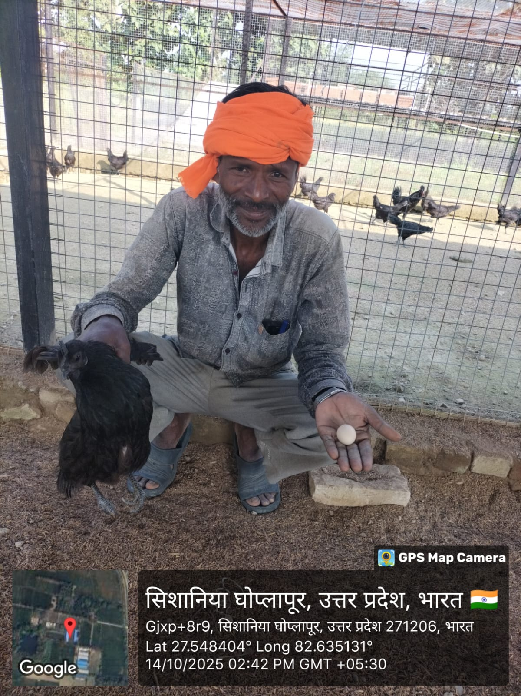
The collected data were compiled and analyzed using simple statistical tool like frequency, percentage, mean, and standard error wherever required. The results were interpreted comparatively between the Eastern Plain and North Eastern Plain zones.
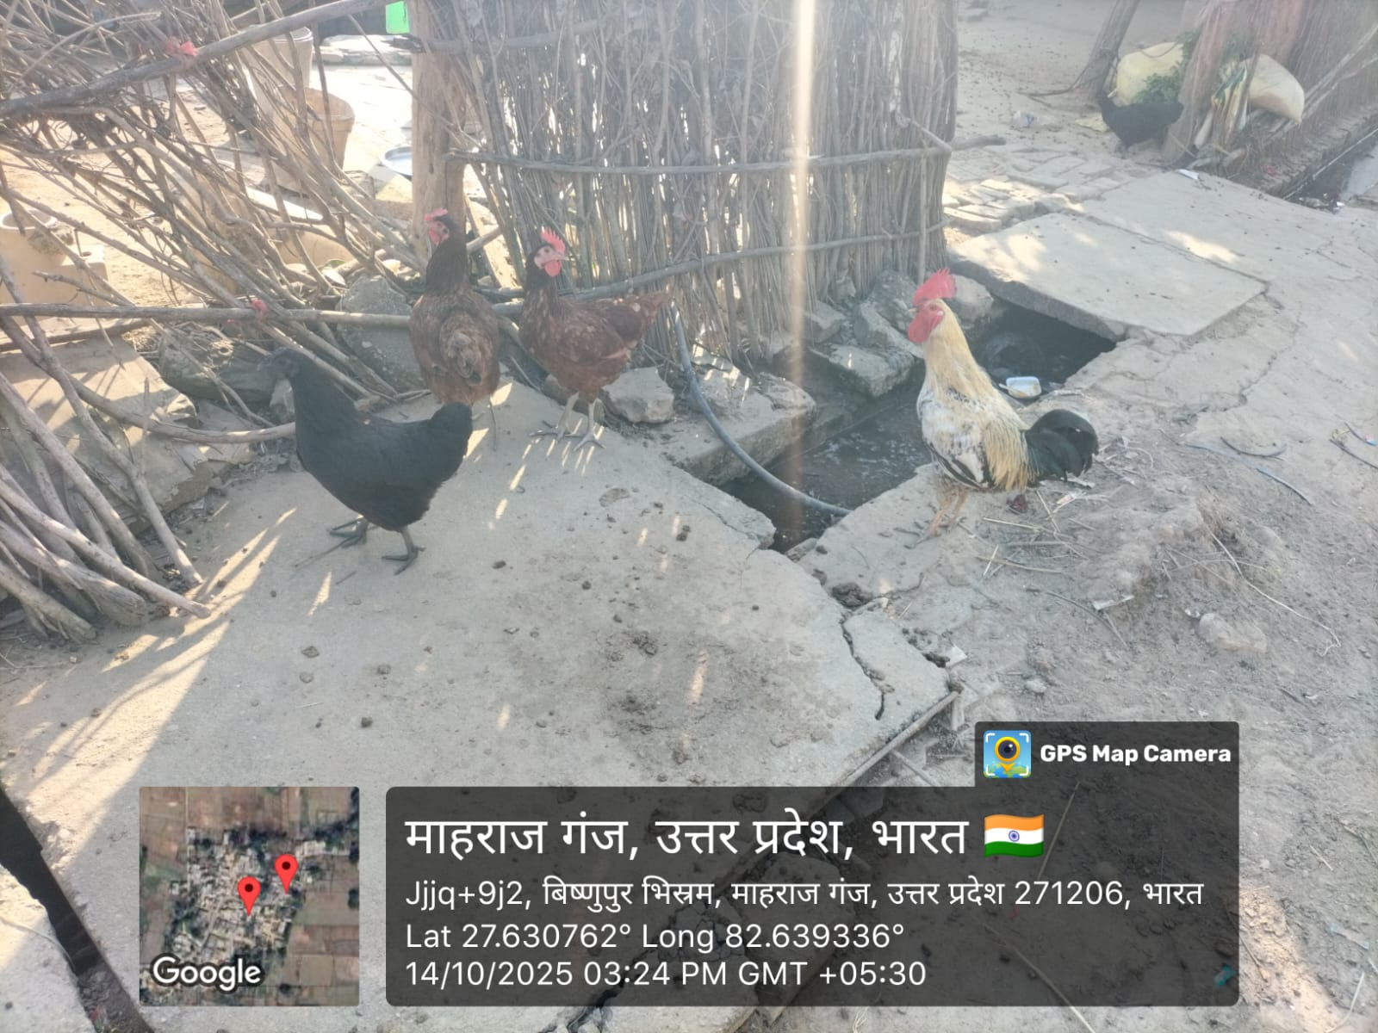
Fig.1. Kadaknath, RIR and Indigenous Birds Fig . 2. Farmer with Kadaknath bird and egg
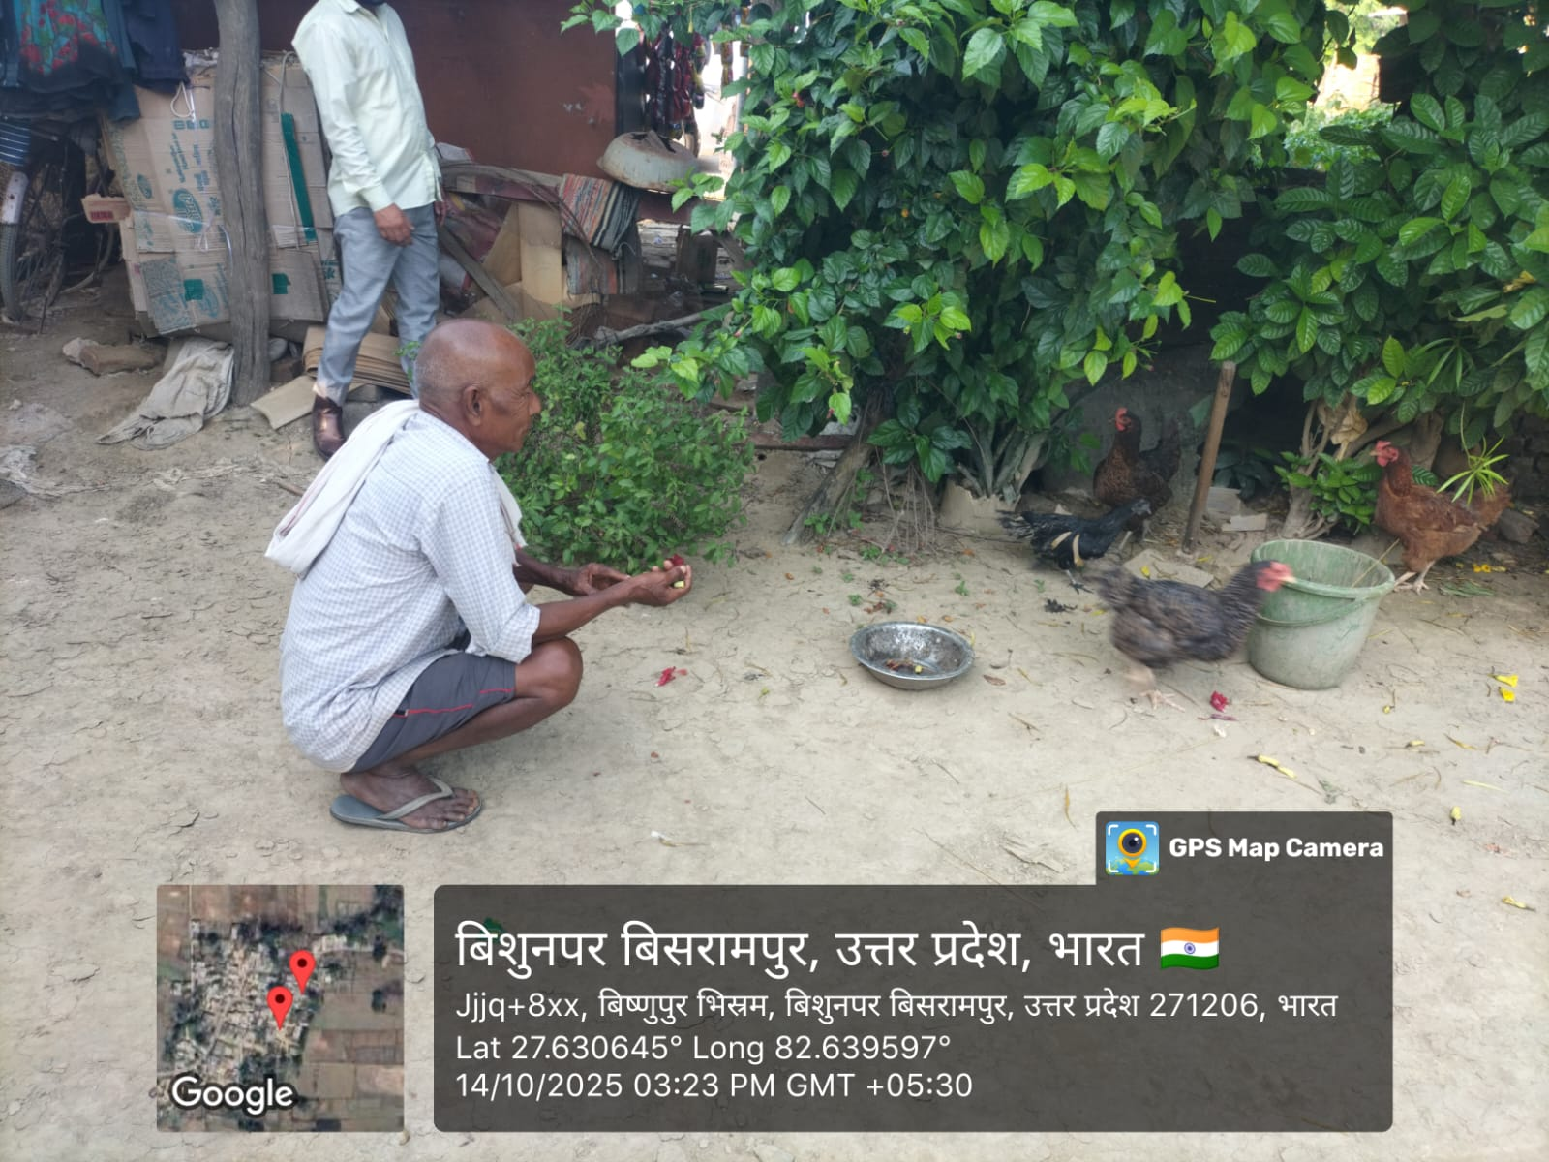
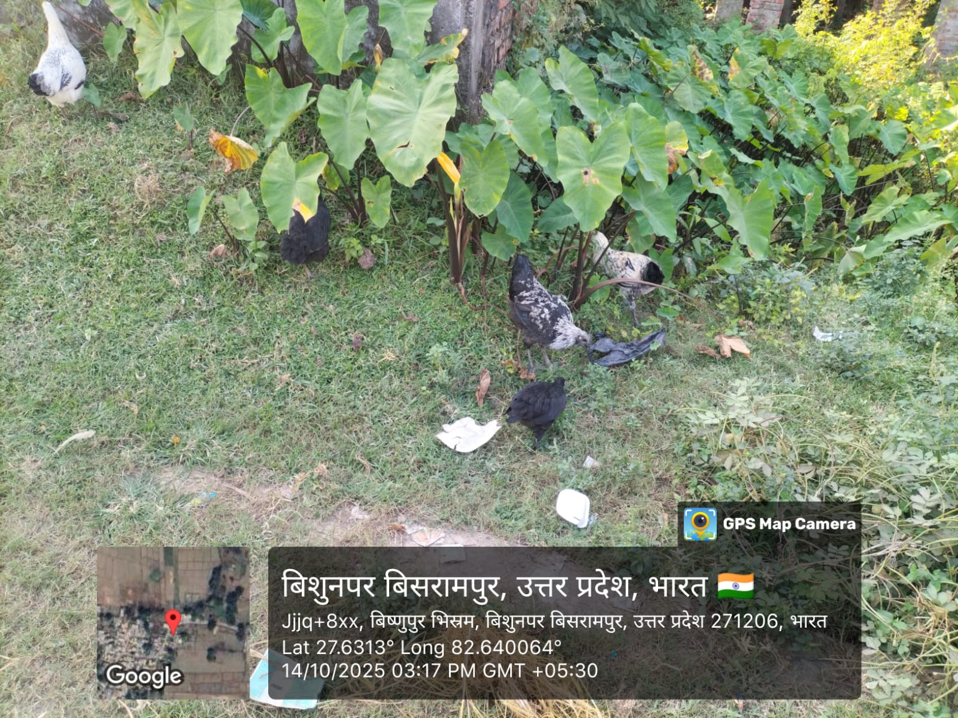
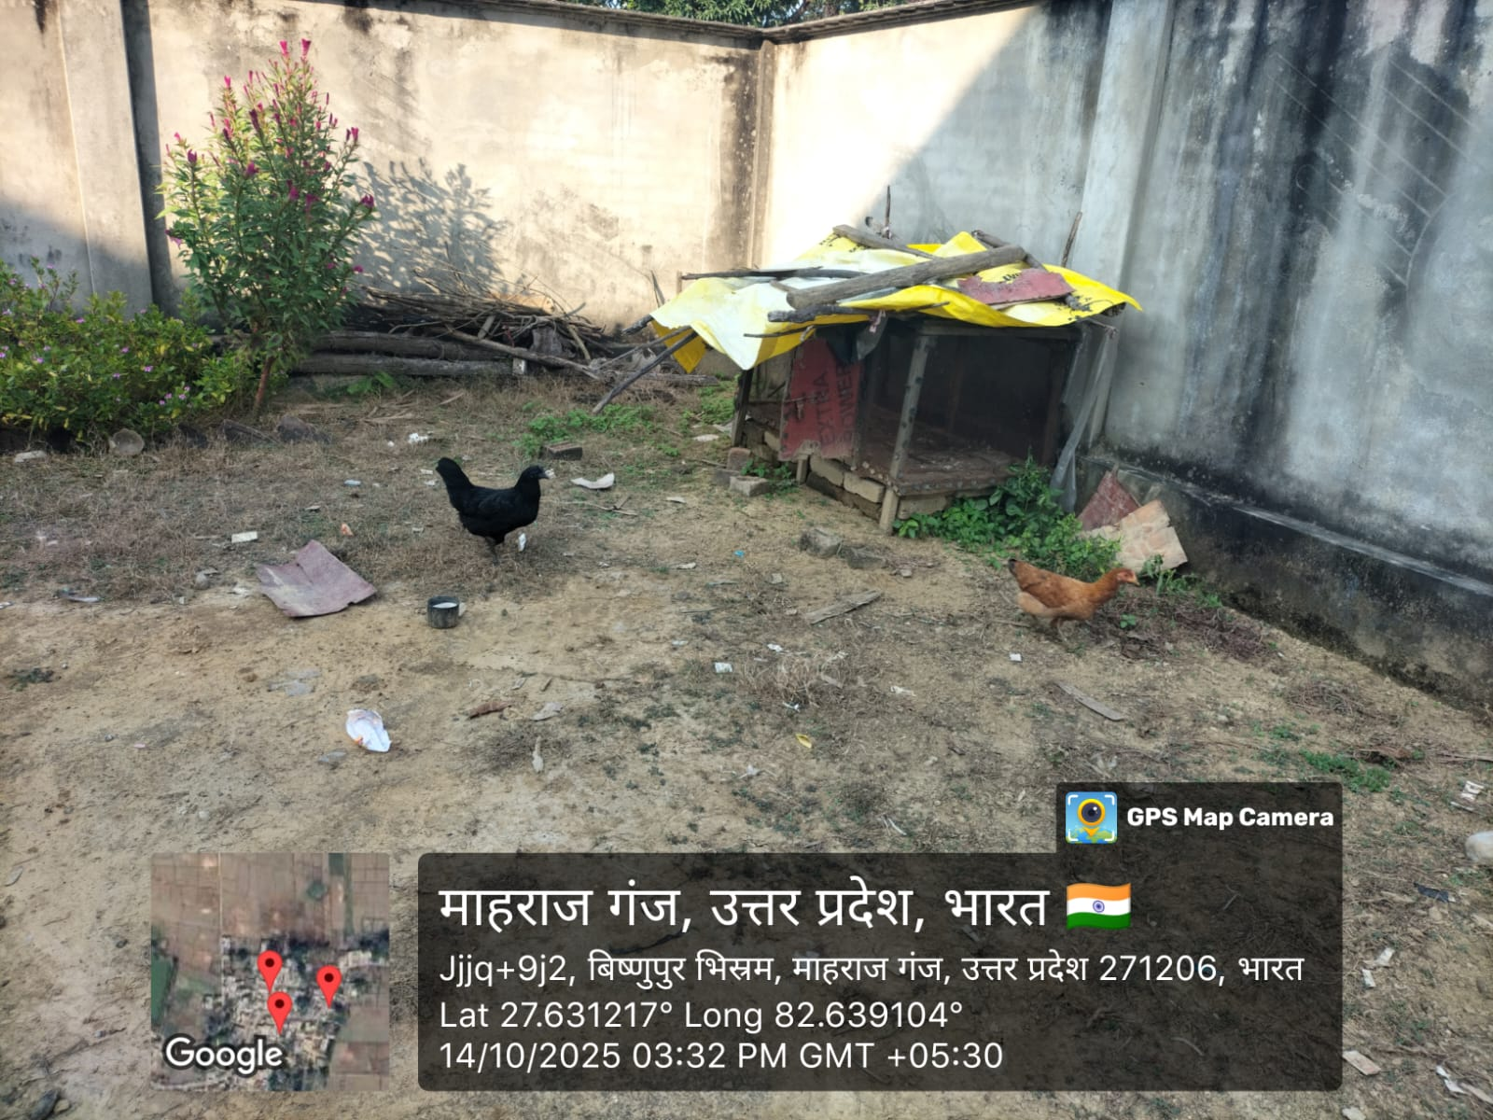
Fig.3. Birds scavenging in free range condition Fig. 4. Birds consuming home grown feed
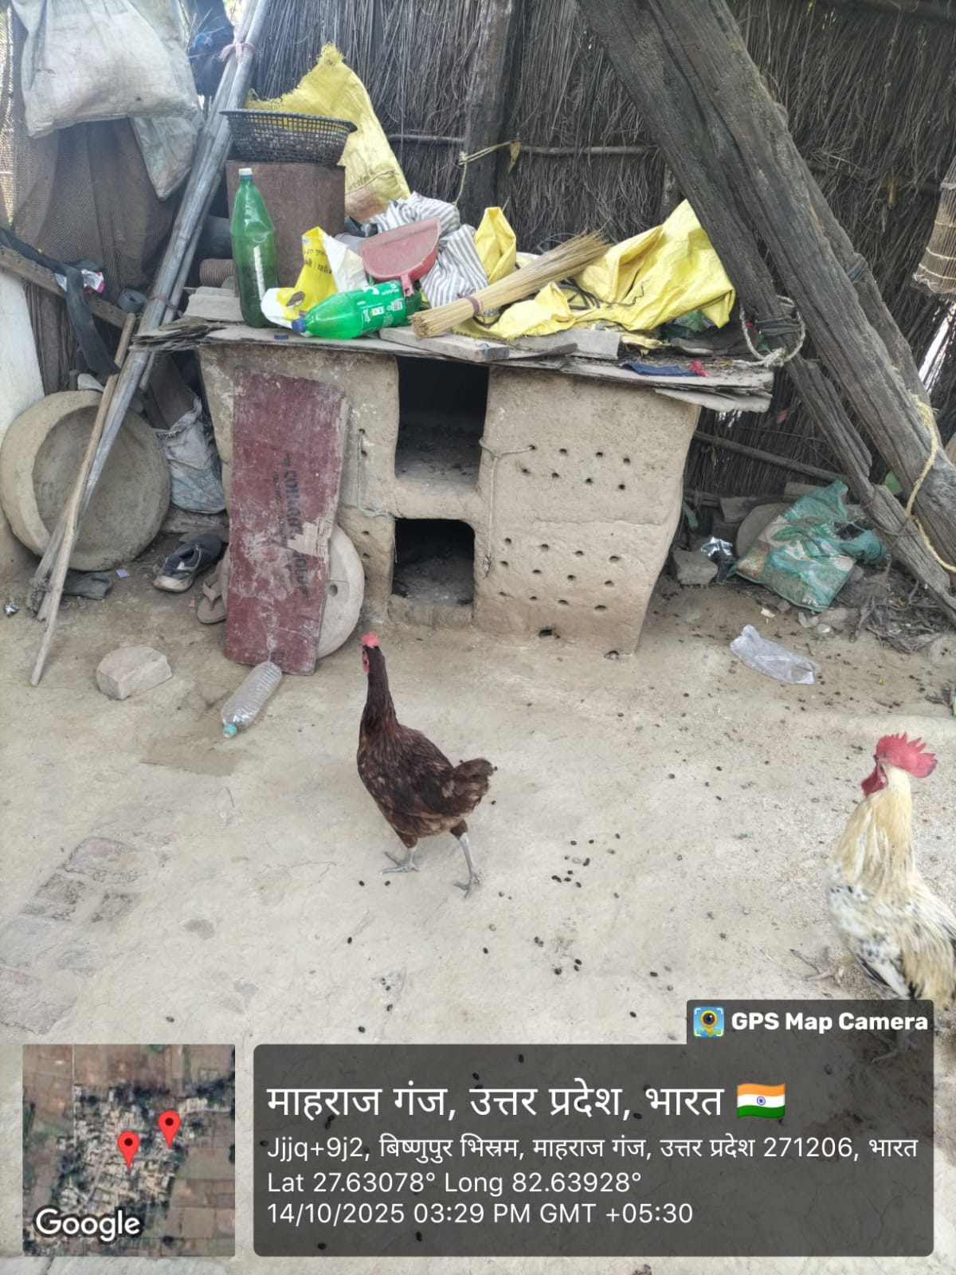
Fig. 5. Kaccha type of housing system Fig. 6. Temporary shelters in rainy season

3. Results and Discussion
3.1 Housing management practices
The study showed that semi-intensive rearing with free-range access was the most common system in both zones in all seasons. None of the respondents practiced intensive rearing. This indicates that backyard poultry farming in the study area was mainly scavenging-based, with some shelter at night. Most respondents in both regions used kaccha poultry houses throughout the year, and this practice was more common in the North Eastern Plain than in the Eastern Plain. A clear seasonal change was observed in the type of floor and litter used. During summer, many farmers used kaccha floors without bedding. In winter and rainy season, the use of bedding increased. Rice husk was more common in winter, while wheat straw was more common in the rainy season. Among the routine housing practices, cleaning and disinfection of utensils and ventilation management were followed by more respondents. On the other hand, litter changing, whitewashing, fumigation, provision of laying boxes, and brooding arrangements were not commonly practiced. The dominance of simple housing and semi-intensive rearing in the present study agrees with the findings of Halim (1988) and Billah et al. (2013), who reported that rural poultry housing was generally simple and made from local materials. The low level of scientific sanitation measures also supports the reports of Desalew et al. (2013) and Sisay et al. (2018). Similar findings were reported by Bugalia and Kumar (2021) in Rajasthan. Thus, the housing system in the study area may be described as traditional and low-cost, with limited scientific improvement.
Table .1 Housing management practices adopted by backyard poultry farmers in different seasons
S. No. | Housing management practices | Summer |  | Winter |  | Rain
 |  | EP | NEP | EP | NEP | EP | NEP
 |  | n- 120 | n- 120 | n- 120 | n- 120 | n- 120 | n- 120
1. | Type of raring
 | Free range
  13 (10.83)
  29 (24.17)
  8 (6.67)
  29 (24.17)
  8 (6.67)
  29 (24.17)
 | Semi-intensive
  107 (89.17)
  91 (75.83)
  112 (93.33)
  91 (75.83)
  112 (93.33)
  91 (75.83)
 | Intensive
  0 (0.00)
  0 (0.00)
  0 (0.00)
  0 (0.00)
  0 (0.00)
  0 (0.00)
2. | Type of poultry house
 | Kaccha | 94 (78.33) | 111 (92.50) | 94 (78.33) | 111 (92.50) | 94 (78.33) | 111 (92.50)
 | Pucca | 26 (21.67) | 9 (7.50) | 26 (21.67) | 9 (7.50) | 26 (21.67) | 9 (7.50)
3. | Type of floor
 | Kaccha with bedding
  13 (10.83)
  24 (20.00)
  88 (73.33)
  92 (76.67)
  63 (52.50)
  79 (65.83
 | Pucca with bedding
  14 (11.67)
  6 (5.00)
  26 (21.67)
  9 (7.50)
  20 (16.67)
  3 (2.50)
 | Kaccha without bedding
  81 (67.50)
  87 (72.50)
  6 (5.00)
  19 (15.83)
  31 (25.83)
  32 (26.67)
 | Pucca without bedding
  12 (10.00)
  3 (2.50)
  0 (0.00)
  0 (0.00)
  6 (5.00)
  6 (5.00)
4. | Litter material used
 | Sawdust
  0 (0.00)
  0 (0.00)
  0 (0.00)
  0 (0.00)
  0 (0.00)
  0 (0.00)
 | Rice husk
  0 (0.00)
  9 (7.50)
  102 (85.00)
  88 (73.33)
  8 (6.67)
  23 (19.17)
 | Wheat straw
  20 (16.67)
  17 (14.17)
  8 (6.67)
  10 (8.33)
  75 (62.50)
  57 (47.50)
 | Jute bags
  7 (5.83)
  4 (3.33)
  4 (3.33)
  3 (2.50)
  0 (0.00)
  0 (0.00)
 | None
  93 (77.50)
  90 (75.00)
  6 (5.00)
  19 (15.83)
  37 (30.83)
  38 (31.67)
5. | Regularly followed arrangements
(a) | Litter changing
 | Yes | 49 (40.83) | 57 (47.50) | 36 (30.00) | 42 (35.00) | 27 (22.50) | 31 (25.83)
 | No | 71 (59.17) | 63 (52.50) | 84 (70.00) | 78 (65.00) | 93 (77.50) | 89 (74.17)
(b) | Cleaning/disinfection of utensils
 | Yes | 76 (63.33) | 69 (57.50) | 81 (67.50) | 74 (61.67) | 92 (76.67) | 86 (71.67)
 | No | 44 (36.67) | 51 (42.50) | 39 (32.50) | 46 (38.33) | 28 (23.33) | 34 (28.33)
(c) | Whitewashing of poultry house
 | Yes | 6 (5.00) | 0 (0.00) | 6 (5.00) | 0 (0.00) | 0 (0.00) | 0 (0.00)
 | No | 114 (95.00) | 120 (100.00) | 114 (95.00) | 120 (100.00) | 120 (100.00) | 120 (100.00)
(d) | Fumigation of poultry shed
 | Yes
  36 (30.00)
  29 (24.17)
  36 (30.00)
  29 (24.17)
  36 (30.00)
  29 (24.17)
 | No | 84 (70.00) | 91 (75.83) | 84 (70.00) | 91 (75.83) | 84 (70.00) | 91 (75.83)
(e) | Ventilation management
 | Yes | 102 (85.00) | 94 (78.33) | 61 (50.83) | 56 (46.67) | 72 (60.00) | 67 (55.83)
 | No | 18 (15.00) | 26 (21.67) | 59 (49.17) | 64 (53.33) | 48 (40.00) | 53 (44.17)
(f) | Electricity supply
 | Yes | 47 (39.17) | 56 (46.67) | 41 (34.17) | 49 (40.83) | 48 (40.00) | 54 (45.00)
 | No | 73 (60.83) | 64 (53.33) | 79 (65.83) | 71 (59.17) | 72 (60.00) | 66 (55.00)
(g) | Provision of free-range area
 | Yes | 120 (100.00) | 120 (100.00) | 120 (100.00) | 120 (100.00) | 120 (100.00) | 120 (100.00)
 | No | 0 (0.00) | 0 (0.00) | 0 (0.00) | 0 (0.00) | 0 (0.00) | 0 (0.00)
(h) | Provision of laying boxes
 | Yes | 38 (31.67) | 34 (28.33) | 46 (38.33) | 41 (34.17) | 43 (35.83) | 39 (32.50)
 | No | 82 (68.33) | 86 (71.67) | 74 (61.67) | 79 (65.83) | 77 (64.17) | 81 (67.50)
(i) | Brooding used
 | Yes | 0 (0.00) | 0 (0.00) | 0 (0.00) | 0 (0.00) | 0 (0.00) | 0 (0.00)
 | No | 120 (100.00) | 120 (100.00) | 120 (100.00) | 120 (100.00) | 120 (100.00) | 120 (100.00)
(Figure in Parenthesis indicate percentage), EP – Eastern Plain, NEP – North Eastern Plain, n- No of respondents
3.2 Feeding and watering practices
The majority of respondents in both zones depended on scavenging supplemented with home-grown feed or kitchen waste during all three seasons. Very few respondents used commercial feed, and none of them depended completely on scavenging alone. Most respondents fed their birds twice daily, especially during winter. Special supplementation was not practiced by any respondent in either zone in any season. Tap water was the main source of drinking water in both regions, although some farmers in the North Eastern Plain also used stagnant or sewage water, which is undesirable. Watering frequency varied with season. In summer and rainy season, many farmers provided water ad libitum, while in winter, watering was more often done twice daily. Plastic drinkers and feeders were the most commonly used, although earthen pots and metal utensils were also used. In summer, feed was more often thrown on the ground, whereas in winter and rainy season feeding in utensils increased. The use of moisture-protected feed storage during the rainy season was very low. Grit feeding and provision of warm water were completely absent. Most respondents allowed birds to scavenge for 6–10 hours per day. These findings are in close agreement with Mandal et al. (2006) and Khandait (2008), who also reported dependence on scavenging with household supplementation. The predominance of twice-daily feeding agrees with Sisay et al. (2018), Bugalia and Kumar (2021), and Singh et al. (2021). The use of tap water as the principal source also agrees with Dinka et al. (2010a) and Weyuma et al. (2015). However, the poor use of moisture-safe feed storage in the rainy season differs from Meena et al. (2022). Overall, feeding and watering in the study area remained practical but mostly traditional.

Table 2. Feeding and watering management practices adopted by backyard poultry farmers in different seasons
S. No. | Feeding and watering practice | Summer |  | Winter |  | Rain
 |  | EP | NEP | EP | NEP | EP | NEP
 |  | n- 120 | n- 120 | n- 120 | n- 120 | n- 120 | n- 120
1. | Type of feeding material offered
 | Scavenging only | 0 (0.00) | 0 (0.00) | 0 (0.00) | 0 (0.00) | 0 (0.00) | 0 (0.00)
 | Scavenging + home-grown feed or kitchen waste | 109 (90.83) | 113 (94.17) | 109 (90.83) | 113 (94.17) | 109 (90.83) | 113 (94.17)
 | Commercial feed | 11 (9.17) | 07 (5.83) | 11 (9.17) | 07 (5.83) | 11 (9.17) | 07 (5.83)
2. | Frequency of feeding
 | One time | 43 (35.83) | 49 (40.83) | 31 (25.83) | 36 (30.00) | 39 (32.50) | 44 (36.67)
 | Two times | 77 (64.17) | 71 (59.17) | 89 (74.17) | 84 (70.00) | 81 (67.50) | 76 (63.33)
3. | Supplementation provided
 | Yes | 0 (0.00) | 0 (0.00) | 0 (0.00) | 0 (0.00) | 0 (0.00) | 0 (0.00)
 | No | 120 (100.00) | 120 (100.00) | 120 (100.00) | 120 (100.00) | 120 (100.00) | 120 (100.00)
4. | Source of drinking water
 | Tap water | 94 (78.33) | 87 (72.50) | 94 (78.33) | 87 (72.50) | 94 (78.33) | 87 (72.50)
 | Stagnant or sewage water | 8 (6.67) | 23 (19.17) | 8 (6.67) | 23 (19.17) | 8 (6.67) | 23 (19.17)
 | Well water | 18 (15.00) | 10 (8.33) | 18 (15.00) | 10 (8.33) | 18 (15.00) | 10 (8.33)
5. | Watering frequency
 | Once daily | 9 (7.50) | 14 (11.67) | 18 (15.00) | 23 (19.17) | 13 (10.83) | 18 (15.00)
 | Twice daily | 26 (21.67) | 31 (25.83) | 39 (32.50) | 42 (35.00) | 28 (23.33) | 32 (26.67)
 | Three times daily | 37 (30.83) | 36 (30.00) | 19 (15.83) | 18 (15.00) | 27 (22.50) | 25 (20.83)
 | Ad libitum | 48 (40.00) | 39 (32.50) | 44 (36.67) | 37 (30.83) | 52 (43.34) | 45 (37.50)
6. | Type of drinker used
 | Earthen pot | 39 (32.50) | 42 (35.00) | 45 (37.50) | 49 (40.83) | 41 (34.17) | 45 (37.50)
 | Plastic | 54 (45.00) | 48 (40.00) | 50 (41.67) | 45 (37.50) | 53 (44.17) | 48 (40.00)
 | Metal utensils | 27 (22.50) | 30 (25.00) | 25 (20.83) | 26 (21.67) | 26 (21.66) | 27 (22.50)
7. | Feeding method
 | Throwing on ground | 68 (56.67) | 75 (62.50) | 59 (49.17) | 67 (55.83) | 51 (42.50) | 58 (48.33)
 | Feeding in utensils | 52 (43.33) | 45 (37.50) | 61 (50.83) | 53 (44.17) | 69 (57.50) | 62 (51.67)
8. | Type of feeder used
 | Earthen | 31 (25.83) | 36 (30.00) | 29 (24.17) | 33 (27.50) | 28 (23.33) | 31 (25.83)
 | Plastic | 56 (46.67) | 49 (40.83) | 61 (50.83) | 53 (44.17) | 59 (49.17) | 52 (43.33)
 | Metallic | 21 (17.50) | 24 (20.00) | 22 (18.33) | 23 (19.17) | 22 (18.33) | 24 (20.00)
 | Any other | 12 (10.00) | 11 (9.17) | 8 (6.67) | 11 (9.16) | 11 (9.17) | 13 (10.84)
9. | Feed storage method for moisture protection
 | Yes | 0 (0.00) | 0 (0.00) | 0 (0.00) | 0 (0.00) | 11 (9.17) | 07 (5.83)
 | NO | 120 (100.00) | 120 (100.00) | 120 (100.00) | 120 (100.00) | 109 (90.83) | 113 (94.17)
10. | Feeding of grit
 | Yes | 0 (0.00) | 0 (0.00) | 0 (0.00) | 0 (0.00) | 0 (0.00) | 0 (0.00)
 | No | 120 (100.00) | 120 (100.00) | 120 (100.00) | 120 (100.00) | 120 (100.00) | 120 (100.00)
11. | Scavenging time provided
 | Less than 6 hours | 29 (24.17) | 33 (27.50) | 37 (30.83) | 42 (35.00) | 25 (20.83) | 29 (24.17)
 | 6–10 hours | 63 (52.50) | 59 (49.17) | 57 (47.50) | 53 (44.17) | 61 (50.83) | 58 (48.33)
 | More than 10 hours | 28 (23.33) | 28 (23.33) | 26 (21.67) | 25 (20.83) | 34 (28.34) | 33 (27.50)
12. | Provision of warm water
 | Yes | 0 (0.00) | 0 (0.00) | 0 (0.00) | 0 (0.00) | 0 (0.00) | 0 (0.00)
 | No | 120 (100.00) | 120 (100.00) | 120 (100.00) | 120 (100.00) | 120 (100.00) | 120 (100.00)
(Figure in Parenthesis indicate percentage), EP – Eastern Plain, NEP – North Eastern Plain, n- No of respondents
3.3 Breeding management practices
The majority of respondents in both regions reared indigenous or desi birds, while the rest kept improved or crossbred birds such as Kadaknath and RIR. Most respondents selected eggs for hatching on the basis of both egg size and egg shape, though some respondents did not follow any selection criteria. Natural breeding was followed by all respondents, and broody hens were universally used for brooding. No respondent used artificial brooders. Chicks and fertile eggs were obtained mainly through home hatching and Krishi Vigyan Kendra supply, while a smaller number of respondents depended on neighbours. None of the respondents obtained chicks from private or government hatcheries. Most respondents did not maintain the recommended male:female ratio, and the majority used their own male birds for breeding. Selection of broody hens was based mainly on previous performance or body size. Hatchability was considered better in winter than in summer or rainy season. Most farmers kept 8–10 eggs under a broody hen. These findings agree with Deka and Thakur (2013) and Rahman (2017), who reported that natural hatching through broody hens was the main source of chicks in backyard systems. The use of own male birds for breeding is similar to the reports of Singh et al. (2021) and Bugalia and Kumar (2021). The poor maintenance of male:female ratio also agrees with Popy et al. (2018) and Kisku et al. (2019). Therefore, breeding management in the study area remained natural, experience-based, and low-input.

Table. 3 Breeding management practices adopted by backyard poultry farmers in different seasons
S. No. | Breeding  management practices | Summer |  | Winter |  | Rain
 | Category | EP | NEP | EP | NEP | EP | NEP
 |  | n- 120 | n- 120 | n- 120 | n- 120 | n- 120 | n- 120
1. | Type of breed reared
 | Indigenous or desi | 79 (65.83) | 85 (70.83) | 79 (65.83) | 85 (70.83) | 79 (65.83) | 85 (70.83)
 | Exotic or crossbred | 41 (34.17) | 35 (29.17) | 41 (34.17) | 35 (29.17) | 41 (34.17) | 35 (29.17)
2. | Criteria for selection of eggs for hatching
 | Egg size | 23 (19.17) | 27 (22.50) | 24 (20.00) | 28 (23.33) | 25 (20.83) | 29 (24.17)
 | Egg shape | 18 (15.00) | 15 (12.50) | 17 (14.17) | 14 (11.67) | 18 (15.00) | 15 (12.50)
 | Both size and shape | 56 (46.67) | 49 (40.83) | 59 (49.17) | 53 (44.17) | 57 (47.50) | 50 (41.67)
 | No selection | 23 (19.16) | 29 (24.17) | 20 (16.66) | 25 (20.83) | 20 (16.67) | 26 (21.66)
3. | Brooding method
 | By broody hen | 120 (100.00) | 120 (100.00) | 120 (100.00) | 120 (100.00) | 120 (100.00) | 120 (100.00)
 | By brooder | 0(0.00) | 0 (0.00) | 0 (0.00) | 0 (0.00) | 0 (0.00) | 0 (0.00)
4. | Source of chicks or fertile eggs
 | KVK | 47 (39.17) | 53 (44.17) | 49 (40.83) | 56 (46.67) | 45 (37.50) | 51 (42.50)
 | Home hatching | 54 (45.00) | 53 (44.17) | 50 (41.46) | 48 (40.00) | 55 (45.83) | 54 (45.00)
 | Neighbours | 19 (15.83) | 14 (11.67) | 21 (17.50) | 16 (13.33) | 20 (16.67) | 15 (12.50)
 | Govt. or private hatchery | 0 (0.00) | 0 (0.00) | 0 (0.00) | 0 (0.00) | 0 (0.00) | 0 (0.00)
5. | Breeding method
 | Artificial insemination | 0 (0.00) | 0 (0.00) | 0 (0.00) | 0 (0.00) | 0 (0.00) | 0 (0.00)
 | Natural breeding | 120 (100.00) | 120 (100.00) | 120 (100.00) | 120 (100.00) | 120 (100.00) | 120 (100.00)
6. | Maintenance of male: female ratio
 | Yes | 39 (32.50) | 34 (28.33) | 44 (36.67) | 39 (32.50) | 40 (33.33) | 36 (30.00)
 | No | 81 (67.50) | 86 (71.67) | 76 (63.33) | 81 (67.50) | 80 (66.67) | 84 (70.00)
7. | Source of male bird for breeding
 | Own male | 111(92.50) | 120 (100.00) | 111(92.50) | 120 (100.00) | 111(92.50) | 120 (100.00)
 | Outside male | 9(7.50) | 0 (0.00) | 9(7.50) | 0 (0.00) | 9(7.50) | 0 (0.00)
8. | Criteria for selection of broody hen
 | Previous performance | 61 (50.83) | 53 (44.17) | 65 (54.17) | 58 (48.33) | 60 (50.00) | 54 (45.00)
 | Body size | 59 (49.17) | 67 (55.83) | 55 (45.83) | 62 (51.67) | 60 (50.00) | 66 (55.00)
9. | Hatchability performance
 | High | 39 (32.50) | 31 (25.83) | 57 (47.50) | 49 (40.83) | 34 (28.33) | 29 (24.17)
 | Low | 43 (35.83) | 49 (40.83) | 29 (24.17) | 34 (28.33) | 47 (39.17) | 52 (43.33)
 | No idea | 38 (31.67) | 40 (33.34) | 34 (28.33) | 37 (30.84) | 39 (32.50) | 39 (32.50)
10. | Number of eggs kept under broody hen
 | 6–8 eggs | 28 (23.33) | 34 (28.33) | 21 (17.50) | 27 (22.50) | 25 (20.83) | 31 (25.83)
 | 8–10 eggs | 64 (53.33) | 58 (48.33) | 71 (59.17) | 65 (54.17) | 66 (55.00) | 59 (49.17)
 | 12–13 eggs | 28 (23.34) | 28 (23.34) | 28 (23.33) | 28 (23.33) | 29 (24.17) | 30 (25.00)
(Figure in Parenthesis indicate percentage), EP – Eastern Plain, NEP – North Eastern Plain, n – No of respondents
3.4 Health care management practices
Health care practices were found to be weak and mainly traditional in both zones. Most respondents treated sick birds themselves, while some consulted local experts and very few sought help from veterinary doctors. Vaccination of chicks was not practiced by any respondent. Regular deworming was also not followed by most farmers, although a small number used herbal or Ayurvedic remedies. Antibiotics, growth promoters, and nutraceuticals were not used. Predators were reported as the major cause of mortality, followed by disease outbreak and adverse weather. Disposal of dead birds was mostly by throwing them in the open, while burial was practiced by fewer respondents. The use of lime or quicklime for disinfection was poor. Most respondents washed watering troughs weekly rather than daily. Disease incidence was moderate in summer and winter but higher during the rainy season. The dominance of self-treatment and low use of veterinary services are in agreement with Mandal et al. (2006), Dinka et al. (2010a), Oladunni and Fatuase (2014), Rahman (2017), Choudhary et al. (2018), and Varadharajan and Gnanasekar (2019). The complete absence of vaccination agrees with Khandait et al. (2011) and Rahman (2017), while the poor deworming practice is also similar to their findings. Open disposal of dead birds and weak sanitation support the observations of Samantaray et al. (2020). The higher disease incidence during the rainy season agrees with Sharma et al. (2013) and Dhara et al. (2022). Hence, health care practices in the study area may be considered largely reactive rather than preventive.
Table 4. Health management practices adopted by backyard poultry farmers in different seasons
S. No. | Health management practices | Summer |  |  | Winter |  | Rain
 |  | EP | NEP |  | EP | NEP | EP | NEP
 |  | n- 120 | n- 120 |  | n- 120 | n- 120 | n- 120 | n- 120
1. | Treatment of sick birds done by
 | Self | 66 (55.00) | 79 (65.83) |  | 66 (55.00) | 79 (65.83) | 66 (55.00) | 79 (65.83)
 | Local expert | 43 (35.83) | 35 (29.17) |  | 43 (35.83) | 35 (29.17) | 43 (35.83) | 35 (29.17)
 | Veterinary doctor | 11 (9.17) | 6 (5.00) |  | 11 (9.17) | 6 (5.00) | 11 (9.17) | 6 (5.00)
2. | Vaccination of chicks
 | Yes | 0 (0.00) | 0 (0.00) | 0 (0.00) |  | 0 (0.00) | 0 (0.00) | 0 (0.00)
 | No | 120 (100.00) | 120 (100.00) | 120 (100.00) |  | 120 (100.00) | 120 (100.00) | 120 (100.00)
3. | Major cause of mortality
 | Disease outbreak | 22 (18.33) | 22 (18.33) | 22 (18.33) |  | 22 (18.33) | 22 (18.33) | 22 (18.33)
 | Weather conditions | 16 (13.33) | 21 (17.50) | 16 (13.33) |  | 21 (17.50) | 16 (13.33) | 21 (17.50)
 | Predators | 82 (68.33) | 77 (64.17) | 82 (68.33) |  | 77 (64.17) | 82 (68.33) | 77 (64.17)
4. | Deworming practice
 | Allopathic medicine | 0 (0.00) | 0 (0.00) | 0 (0.00) |  | 0 (0.00) | 0 (0.00) | 0 (0.00)
 | Homeopathic | 0 (0.00) | 0 (0.00) | 0 (0.00) |  | 0 (0.00) | 0 (0.00) | 0 (0.00)
 | Ayurvedic/ Herbal | 19 (15.83) | 12 (10.00) | 19 (15.83) |  | 12 (10.00) | 19 (15.83) | 12 (10.00)
 | Not followed | 101 (84.16) | 108 (90.00) | 101 (84.16) |  | 108 (90.00) | 101 (84.16) | 108 (90.00)
5. | Use of antibiotics, growth promoters and nutraceuticals
 | Yes | 0 (0.00) | 0 (0.00) | 0 (0.00) |  | 0 (0.00) | 0 (0.00) | 0 (0.00)
 | No | 120 (100.00) | 120 (100.00) | 120 (100.00) |  | 120 (100.00) | 120 (100.00) | 120 (100.00)
6. | Disposal of dead birds
 | Burial | 23 (19.16) | 57 (47.50) | 23 (19.16) |  | 57 (47.50) | 16 (13.33) | 34 (28.35)
 | Burning | 0 (0.00) | 0 (0.00) | 0 (0.00) |  | 0 (0.00) | 0 (0.00) | 0 (0.00)
 | Throwing in open | 97 (80.83) | 63 (52.50) | 97 (80.83) |  | 63 (52.50) | 104 (86.66) | 86 (71.66)
7. | Use of lime or quicklime for disinfection
 | Yes | 20 (16.66) | 8 (06.66) | 20 (16.66) |  | 8 (06.66) | 20 (16.66) | 8 (06.66)
 | No | 100 (83.33) | 112 (93.33) | 100 (83.33) |  | 112 (93.33) | 100 (83.33) | 112 (93.33)
8. | Washing of watering trough
 | Daily morning | 0 (0.00) | 0 (0.00) | 0 (0.00) |  | 0 (0.00) | 0 (0.00) | 0 (0.00)
 | Every third day | 29 (24.17%) | 20 (16.67%) | 29 (24.17%) |  | 20 (16.67%) | 29 (24.17%) | 20 (16.67%)
 | Weekly | 83 (69.17%) | 85 (70.83%) | 83 (69.17%) |  | 85 (70.83%) | 83 (69.17%) | 85 (70.83%)
 | Not washed | 8 (6.67%) | 15 (12.50%) | 8 (6.67%) |  | 15 (12.50%) | 8 (6.67%) | 15 (12.50%)
9. | Disease incidence
 | High | 30 (25.00%) | 22 (18.33%) | 30 (25.00%) |  | 22 (18.33%) | 81 (67.50%) | 74 (61.67%)
 | Moderate | 78 (65.00%) | 83 (69.17%) | 78 (65.00%) |  | 83 (69.17%) | 33 (27.50%) | 36 (30.00%)
 | Low | 12 (10.00%) | 15 (12.50%) | 12 (10.00%) |  | 15 (12.50%) | 6 (5.00%) | 10 (8.33%)
(Figure in Parenthesis indicate percentage), EP – Eastern Plain, NEP – North Eastern Plain
3.5 Marketing practices
Marketing of backyard poultry birds was mainly local and household-based. Most respondents sold birds at their own doorstep in all seasons. Sale through local markets or middlemen was limited. Birds were mainly sold as surplus stock, while the second common reason was the need for money. Record keeping was very poor. Most respondents sold adult birds at about 2.5 years of age, suggesting that birds were first used for egg production and household needs before being sold.
The predominance of doorstep sale agrees with Khandait et al. (2011), Mandal et al. (2006), and Deka and Thakur (2013), who also reported home-based sale of birds and eggs. Similar observations were made by Rahman (2017) and Sharma et al. (2018). The sale of birds due to urgent cash need agrees with Tsegaye et al. (2014) and Khandait et al. (2011). Thus, marketing in the study area was informal, household-centered, and weakly commercialized.
Table 5. Marketing management practices adopted by backyard poultry farmers in different seasons
S. No. | Marketing practices | Summer |  | Winter |  | Rain
 |  | EP | NEP | EP | NEP | EP | NEP
1. | Place of sale of chickens
 | Own doorstep | 109 (90.83) | 113 (94.17) | 109 (90.83) | 113 (94.17) | 109 (90.83) | 113 (94.17)
 | Local market | 7 (5.83) | 5 (4.17) | 7 (5.83) | 5 (4.17) | 7 (5.83) | 5 (4.17)
 | Middlemen | 4 (3.33) | 2 (1.67) | 4 (3.33) | 2 (1.67) | 4 (3.33) | 2 (1.67)
2. | Time or reason for selling birds
 | Surplus birds | 93 (77.50) | 76 (62.33) | 93 (77.50) | 76 (62.33) | 93 (77.50) | 76 (62.33)
 | Requirement of money | 24 (20.00) | 39 (32.50) | 24 (20.00) | 39 (32.50) | 24 (20.00) | 39 (32.50)
 | Any other | 3 (2.50) | 5 (4.17) | 3 (2.50) | 5 (4.17) | 3 (2.50) | 5 (4.17)
3. | Record keeping
 | Yes | 19 (15.83) | 14 (11.67) | 21 (17.50) | 16 (13.33) | 18 (15.00) | 13 (10.83)
 | No | 101 (84.17) | 106 (88.33) | 99 (82.50) | 104 (86.67) | 102 (85.00) | 107 (89.17)
4. | Average age at sale of adult birds
 | 2 years | 43 (35.83) | 48 (40.00) | 36 (30.00) | 42 (35.00) | 40 (33.33) | 45 (37.50)
 | 2.5 years | 57 (47.50) | 51 (42.50) | 63 (52.50) | 57 (47.50) | 60 (50.00) | 54 (45.00)
 | 3 years | 20 (16.67) | 21 (17.50) | 21 (17.50) | 21 (17.50) | 20 (16.67) | 21 (17.50)
(Figure in Parenthesis indicate percentage), EP – Eastern Plain, NEP – North Eastern Plain, n- No of respondents
4. Conclusion
The present study showed that backyard poultry farming in the Eastern Plain and North Eastern Plain zones of Uttar Pradesh was mainly traditional, low-input, and influenced by season. Semi-intensive rearing with free-range access, kaccha housing, scavenging-based feeding, natural breeding, self-treatment of sick birds, and doorstep marketing were the major features of the system. Seasonal differences were clearly seen in floor type, litter use, watering pattern, hatchability perception, and disease incidence, especially during the rainy season.
The study also showed poor adoption of scientific practices such as vaccination, deworming, disinfection, record keeping, and improved feed storage. Therefore, there is good scope to improve backyard poultry production in the study area through farmer training, veterinary extension services, and season-specific management recommendations.
References
Billah, S.M., Nargis, F., Hossain, M.E., Howlider, M.A.R. and Lee, S.H. 2013. Family poultry production and consumption patterns in selected households of Bangladesh. Journal of Agricultural Extension and Rural Development, 1(1): 8-14.
Bugalia, H.L. and Kumar, L. 2021. Feeding, breeding and management practices of backyard poultry rearing in Banswara district of Rajasthan. The Pharma Innovation Journal, SP-10(10): 626-628.
Choudhary, M.S., Kumar, P., Bhushan, B. and Bafanda, R.A. 2018. Relationship between the differential managemental practices of poultry owners and their socio-personal, socio-economic and communicational characteristics in Rajouri District of Jammu and Kashmir State. International Journal of Current Microbiology and Applied Sciences, 7(08): 4533-4543.
Deka, P. and Thakur, D. 2013. Status of backyard poultry farming in Himalayan regions of India. Indian Journal of Poultry Science, 47(1): 102-105.
Desalew, T., Singh, H., Ashenefi, M., Wondimeneh, E. and Tadelle, D. 2013. Study on management practices and marketing systems of village chicken in East Shewa, Ethiopia. African Journal of Agricultural Research, 8(22): 2696-2702.
Dhara, S., Ghosh, A. and Mondal, S. 2022. Health care practices in backyard poultry farming during the rainy season in West Bengal. Indian Journal of Veterinary Medicine, 42(2): 34-41.
Dinka, H., Chala, R., Dawo, F., Bekana, E. and Leta, S. 2010a. Major constraints and health management of village poultry production in Rift Valley of Oromia, Ethiopia. American-Eurasian Journal of Agricultural and Environmental Sciences, 9(5): 529-533.
Halim, A. 1988. Institutional reports on farming system research with particular reference to activities on livestock and poultry. Bangladesh Agricultural Research Council, Dhaka, Bangladesh.
Khandait, V., Gawande, S., Lohakare, A. and Dhenge, S. 2011. Adoption level and constraints in backyard chicken rearing practices at Bhandara district of Maharashtra, India. Research Journal of Agricultural Science, 2(1): 110-113.
Khandait, V.N. 2008. Adoption of backyard poultry practices in Bhandara district of Maharashtra. M.Sc. (Ag.) Thesis, Maharashtra Animal and Fishery Sciences University, Nagpur, India.
Kisku, J., Oraon, J., Pandey, A.K., Singh, B.K. and Chandraker, K. 2019. Study of adoption level and constraints faced by rural women in backyard poultry farming. Journal of AgriSearch, 6(SI): 101-103.
Mandal, M.K., Khandekar, N. and Khandekar, P. 2006. Backyard poultry farming in Bareilly district of Uttar Pradesh, India: An analysis. Livestock Research for Rural Development, 18(7).
Meena, B.S., Meena, L.K. and Sharma, K.C. 2021. Health care practices in backyard poultry farming during winter in Haryana. Indian Journal of Veterinary Medicine, 41(3): 67-74.
Meena, B.S., Meena, L.K. and Sharma, K.C. 2022. Feed storage practices in backyard poultry farming during the rainy season in Rajasthan. Journal of Animal Nutrition, 38(1): 45-52.
Oladunni, M.E. and Fatuase, A.I. 2014. Economic analysis of backyard poultry farming in Akoko North West Local Government Area of Ondo State, Nigeria. Global Journal of Biology, Agriculture and Health Sciences, 3(1): 141-147.
Popy, F.Y., Chowdhury, Q.M.K., Alam, S., Roy, S., Dipta, P.M. and Ahmed, J. 2018. Backyard poultry management and production system at Barlekha Upazila, Moulvibazar, Bangladesh. International Journal of Science and Business, 2(2): 90-100.
Rahman, S. 2017. Status and constraints of backyard poultry farming in Mizoram. Indian Journal of Hill Farming, Special Issue: 76-82.
Samantaray, S.K., Ranabijuli, S., Mohanty, B., Satapathy, B., Panda, P.K. and Behera, M.R. 2020. Adoption level of scientific backyard poultry practices: A socio-technical analysis in the state of Odisha. The Pharma Innovation Journal, SP-9(8): 104-108.
Sharma, S., Iqbal, A., Azmi, S. and Shah, H.A. 2013. Study of poultry coccidiosis in organized and backyard farms of Jammu region. Veterinary World, 6(8): 467-469.
Sharma, V., Kumar, P. and Bhadwal, M.S. 2018. Issues and prospects of indigenous poultry rearing in hilly areas of Jammu and Kashmir state. Livestock Extension, 1(1): 25-32.
Singh, P., Kumar, R. and Yadav, S. 2021. Feed management practices in backyard poultry farming in Uttar Pradesh. Indian Journal of Animal Nutrition, 38(3): 56-68.
Singh, S., Gupta, L. and Choudhary, J.L. 2021. Feeding and breeding practices followed by poultry farmers in Banswara district of Rajasthan. International Journal of Fauna and Biological Studies, 8(3): 32-33.
Sisay, T., Alemayehu, K. and Zeleke, G. 2018. Trends of exotic chicken dissemination in North Western Amhara, Ethiopia: Challenges and opportunities. Nutrition and Food Toxicology, 2: 383-392.
Suleiman, R. and Olukotun, O. 2019. Relationship between adoption level of improved management techniques and poultry farmers’ socioeconomic factors in Igabi Local Government Area of Kaduna State, Nigeria. International Journal of Research and Innovation in Applied Science, 4(10): 1-5.
Tsegaye, B., Gudina, T.V. and Alemseged, H.N. 2014. Evaluation of management practices and marketing systems of village chicken in Ethiopia. African Journal of Tropical Agriculture, 2(10): 105-110.
Varadharajan, A. and Gnanasekar, R. 2019. Analysis of backyard poultry farming in Cuddalore district of Tamil Nadu, India: Implication for sustainable rural development. Asian Journal of Research in Animal and Veterinary Sciences, 4(4): 1-6.
Weyuma, H., Singh, H. and Megersa, M. 2015. Studies on management practices and constraints of backyard chicken production in selected rural areas of Bishoftu. Journal of Veterinary Science and Technology, SP12(3): 2-9.

