Ecological engineering for the management of fruit borers in okra ecosystem by encouraging natural enemies

ABSTRACT: Experiment was conducted to study the Ecological engineering for encouragement of natural enemies against fruit borers of okra under field conditions at College of Horticulture Bagalkot. The treatments were T₁-okra as main crop (untreated check), T₂-okra
+ barrier crop (two rows of 25 days old maize seedlings) + trap crop (one row of 25 days old marigold seedlings), T₃-okra + border crop (two rows of cowpea) + okra intercropped with coriander (5:1) and T₄-okra + barrier crop (two rows of 25 days old maize seedlings) + trap crop (one row of 25 days old marigold seedlings) + border crop (two rows of cowpea) + okra intercropped with coriander (5:1). Results revealed that the treatment T₄ recorded significantly lowest mean shoot damage (5.11%), fruit damage (7.42%) by E. vittella and H. armigera (17.68%) as compared to other treatments. Further, T4 treatment significantly encouraged the build-up of natural enemies like coccinellids (1.95/plant) and spiders population (0.61/plant) suggesting ecological engineering as a fundamental and integral tool for inclusion in integrated pest management. Thus, T₄ treatment superiority was mainly due to excellent ecological engineering provided in the form of barrier, trap, border and intercrops which played a significant role in reducing the insect pests of okra. For the first time recorded the E. insulana adults attracting towards trap crop (Marigold) for mating and egg laying purpose in okra ecosystem.
Key words: Okra, ecological engineering, maize, marigold, cowpea and coriander.

Introduction

Okra [Abelmoschus esculentus (L.) Moench] is commercial vegetable crop cultivated for domestic consumption and export. Its origin is Africa and belongs to family Malvaceae having chromosome number 2n=130. Okra related to cotton family, often referred to, as “Lady Finger”. India ranks second in area and production after China. In India, okra is grown in 0.528 million hectares area with 61.46 lakh tons of production and productivity of 11.64 t per ha. In India, major growing states are Andhra Pradesh, Arunachal Pradesh, Assam, Bihar, Chhattisgarh, Himachal Pradesh, Jammu and Kashmir, Jharkhand and Karnataka. In Karnataka, major okra growing districts are Bagalkot, Mandya, Belagavi, Haveri, Bengaluru, Kolar and Vijayapur.
Okra production is limited by number of factors; among them insect pest attack is the major one. Okra crop is attacked with as many as 45 species of insect pests throughout its cropping period (Nair, 1984). Among them, shoot and fruit borer Earias vittella (Fabricius), Earias insulana and fruit borer Helicoverpa armigera (Hubner) are most serious and major limiting biotic factors in okra cultivation. In general, 48.97 per cent economic loss in fruit yield is noticed due to overall damage by insects (Kanwar and Ameta, 2007). The crop loss estimation for major pests are 3.5 to 90.0 per cent by fruit borers (Nair et al., 1984).
Indiscriminate use of chemical pesticides results in pollution of natural resources like water, soil, reduced density of beneficial insects and soil microorganisms, reduction of pollinators and natural enemies like predators and parasitoids, which play a significant role in suppression of pest population. Due to spraying of spurious chemicals on fresh vegetable crops, pesticide residues remain in the produce, causing health hazards to human beings and also leading to the development of resistance and resurgence in pests. In this contest, ecological engineering practices were carried out against the fruit borers of okra, which includes the integration of barrier, trap, border and inter crops along with the main crop in which border crops act as physical barrier and prevent the movement of adults from one field to another. Further, trap crops attract the fruit borers so as to escape the egg laying or infestation by borers on main crop. Similarly, intercrops during effective flowering period encourages the conservation of natural enemies by providing food source like pollen, nectar and shelter, making them less favorable for pests and more attractive to beneficial insects (Gopi et al., 2019).

Materials and Methods

The experiment was laid out at University of Horticultural Sciences, Bagalkot. Both farm yard manure (2.5 t ha⁻¹) and neem powder (2.5 q ha⁻¹) were incorporated to the soil before sowing. Okra variety, Arka Anamika seeds were procured from Indian Institute of Horticultural Research (IIHR), Bengaluru and sown by maintaining 60 x 45 cm spacing in Randomized Completely Block Design (RCBD) design with four treatments and five replications with a plot size of 6 x 4 m. In the present study, as a part of ecological engineering in okra, totally four crops were selected such as maize as barrier crop, marigold as trap crop, cowpea as border crop and coriander as intercrop/repellent crop.
Out of four crops, two border crops such as maize and marigold, 25 days old seedlings were kept ready in polythene bags for planting at the time of sowing of okra. At the time sowing of okra, two rows of 25 days old maize seedlings were transplanted along border of okra field as barrier crop followed by one row of 25 days old marigold seedlings as trap crop. Further, two rows of cowpea were sown as border crop and one row of coriander as intercrop after every five rows of okra, without affecting the plant population.

Observations on Shoot and fruit borers

- Shoot damage: Total number of shoots along with the infested ones were counted from five okra plants at ten days intervals and expressed as per cent shoot infestation using the following formula.

- Fruit damage: Total number of fruits and number of damaged fruits per plant were recorded from selected plants and was expressed as per cent. The observations were recorded at ten days intervals starting from 50 days after sowing. The per cent fruit damage calculated using the below formula:

Natural enemies

Total number of natural enemies like coccinellids and spiders per plant were recorded at ten days interval starting from 20 days after sowing till the final harvest of the crop on whole plant basis by visual observation. Infested fruits (bored holes on fruits by fruit borers) were collected during harvesting period, then the infested fruits reared in a cage and observed and recorded the emergence of different parasitoids.

Statistical analysis
The data collected from various experiments were subjected to suitable transformation. Further, the data was subjected to single factor ANOVA using statistical software (WASP-2) and different treatments were compared using Duncan’s multiple range test (DMRT).

Table 1. Treatment details for evaluation of ecological engineering for encouragement of natural enemies against major fruit borers of okra
Sl No. | Treatments
T1 | Okra as main crop (untreated check)
T2 | Okra + Barrier crop (two rows of 25 days old maize seedlings) + Trap crop (one row of 25 days old marigold seedlings)
T3 | Okra + Border crop (two rows of cowpea) + okra intercropped with coriander (5:1)
T4 | Okra + Barrier crop (two rows of 25 days old maize seedlings) + Trap crop  (one row of 25 days old marigold seedlings) + Border crop (two rows of cowpea) + okra intercropped with coriander (5:1)

Results

Ecological engineering against fruit borer H. armiger and shoot and fruit borer E. vittella in okra
The treatment T4-okra + barrier crop (two rows of 25 days old maize seedlings) + trap crop (one row of 25 days old marigold seedlings) + border crop (two rows of cowpea) + okra intercropped with coriander (5:1) registered significantly reduced mean fruit per cent damage of H. armigera (17.68%) which was in turn on par with T₂ (22.76%), T₂ which was in turn on par with T₃ (28.22%) which was at par with T₁ untreated check (34.41%) (Table 2).
Among the treatments, T₄ emerged as significantly efficient by recording the lowest shoot damage of E. vittella 5.11 per cent. Second best treatment was T₂ (7.49%). On the contrary T₃ (10.90%) was ineffective which was on par with T₁ (13.52%) (Table 3).
The T₄ treatment was one of the outstanding treatments in reducing per cent fruit damage by E. vittella (7.40%) which was in turn on par with the T₂ (13.42%). However, treatment T₃ recorded (16.60%) which was at par with the T₁ untreated check (16.80%) registered highest damage (Table 4).

Ecological engineering for encouragement of natural enemies against major pests of okra
The treatment T₁ registered significantly lowest mean number of coccinellids 0.50 per plant. Whereas, treatment T₂ 0.94 per plant was recorded. Second best treatment was T₃ (1.40/plant). The superior treatment was T₄ (1.95/plant) indicating effective in encouraging coccinellid population (Table 5).
The treatment T₁ registered highest spider population (0.61/plant) which was statistically on par with both treatment T2 registered 0.52 per plant. Next best module was T3 (0.28/plant). Whereas, T₁ registered lowest spiders (0.21/plant) (Table 6).

Discussion

Among different treatments evaluated against insect pests of okra the data presented in the tables from 2 to 6 indicated that, T₄ comprising of okra with two rows of 25 days old maize as barrier crop, one row of 25 days old marigold as trap crop, two rows of cowpea as border crop and okra intercropped with coriander (5:1) recorded significantly lowest mean of shoot damage (5.11%) and fruit damage (7.42%) by E. vittella, H. armigera (17.68%) as compared

to other treatments. Further, T₄ treatment significantly encouraged the build-up of natural enemies like coccinellids (1.95/plant) and spiders (0.61/plant) suggesting ecological engineering as a fundamental and integral tool for inclusion in (Integrated Pest Management) IPM. Thus, T₄ treatment superiority was mainly due to excellent ecological engineering provided in the form of barrier, trap, border and intercrops which played a significant role in reducing the insect pests of okra through various means of mode of action. It is quite interesting to note that in nature, natural enemy population buildup appears to begin when pest population has attained peak status, by the time enough damage has been caused to the crop. In the present investigation, 25 days old border crops such as maize and marigold were planted along with sowing of main crop, so as to colonise and encourage the natural enemies well in advance to take care of insect pests of okra.
The suppression of pest population and encouragement of natural enemies in T₄ was mainly due to 25 days old maize crop planted at the time of sowing of okra as main crop. The maize plant acted as barrier crop that physically avoided the movement and oviposition of fruit borers. The H. armigera larvae attracted to maize after emergence of cobs and prefers to lay eggs and feed on cobs. Further, planting of one row of 25 days old marigold seedlings on border area acted as trap crop for H. armigera, E. insulana and E. vittella larvae that are migrated to marigold flowers from vegetative stage till fruit maturity stage of okra crop. Further, these larvae were easily detected by parasitoids like tachinids, braconids, Nepiera sp. and Neofacydes sp., and predators like coccinellids, spiders, crysopids, syrphids, wasps, reduviid bug and also predatory birds like yellow wagtail and cattle egret. Further, these border crops were also attracted many pollinators like honey bees and butterflies for pollination. The role played by cowpea as border crop infested with aphid population resulting in secretion of honeydew which further attracted natural enemies. Whereas, coriander as intercrop during vegetative stage repelled the fruit borers due to its odour which hindered the orientation of insect pests. The coriander plants during its peak flowering stage encouraged various natural enemies especially coccinellids by providing food like pollen, nectar and shelter which in turn suppressed the pest population. Overall, barrier, trap, border and intercrops prevented insect pests of okra not reaching to economical injury level. Further, insect pests which are supposed to be present on main crop gets diverted to border and intercrops throughout the cropping season.
Similar findings were corroborated with the authors on okra (Risch, 1981) who reported that higher level of aggregation of natural enemies in habitat manipulation mainly due to early

immigration of natural enemies from the colonization source to mixed crop habitats than mono-cropping because of the greater attractiveness of mixed cropping by providing vital food, shelter and resting sites supported by Abro et al. (2004). Similarly, maize as border crops, marigold as trap crop, cowpea and coriander as intercrop in okra were reported to harbour higher population of coccinellids, spiders, syrphids and crysopids than the sole crop resulting in suppression of fruit borers as observed by Saxena and Basit (1982) and Nderitu et al. (2008). The increased parasitism might be due to the availability of host and existence of favourable microclimate in intercropped zones of the crop diversification (Risch, 1981). Similar opinion was made by Dong, (1984). The current findings were supported by Ramachandra et al. (2013) who stated that, intercropping may reduce pest dispersion, thus affecting the biology of the pest at different stages of its development. These results are of great significance in reducing the pest management system, as crop diversification besides giving additional economic benefit to the farmers.
Further, Altieri and Liebman (1986) confirmed that strong odour from the intercrops hinder the mechanism of orientation to the host plants by insect pests. The present results are in agreement with Abid and Magbool (1990) indicated that, coriander was the best intercrop in reducing pest populations on eggplant, due to presence of alkaloids like linalool and pinene in coriander plants likely through repelling property. Further, fruit borers attracted and trapped in marigold was mainly due to the presence of alkaloids like saponin, triterpenes, sesquiterpenes, scopoletin, flavonoids, quercetin and kaemferol in marigold favoured the attraction of more number of H. armigera on marigold plants as reported by Prasanna Lakshmi and Manjula (2014). Lower infestation of fruit borer on okra due to more activity of spiders and crop diversification diverting tomato fruit borer egg laying away from okra. Similarly, Prasad and Prasad (2002) reported highest per cent reduction of shoot and fruit damage in okra intercropped with maize and marigold by hindering its adult movement and then oviposition. Further, maize terminal bud infested by aphids, Rophalosiphum maydis secreted honeydew and herbivore induced plant volatiles (Powell et al., 1998) which might have attracted coccinellids and other aphidophagous predators and parasitoids, as also reported by (Ninkovic et al., 2001). Conclusions
Among different treatments evaluated against insect pests of okra the treatment T₄ comprising of two rows of 25 days old maize as barrier crop, one row of 25 days old marigold as trap crop, two rows of cowpea as border crop and okra intercropped with coriander (5:1) recorded significantly lowest mean of shoot damage (5.11%) and fruit damage (7.42%) by E.

vittella and fruit borer H. armigera incidence (17.68%) as compared to other treatments. Further, T₄ treatment significantly encouraged the build-up of natural enemies like coccinellids (1.95/plant) and spiders (0.61/plant) suggesting ecological engineering as a fundamental and integral tool for inclusion in IPM. Thus, T₄ treatment superiority was mainly due to excellent crop diversification provided in the form of barrier, border, trap and intercrops which played a significant role in reducing the insect pests of okra through various means of mode of action. Thus, it can be concluded that integration of main crop with different barrier, trap, border and intercrops is most effective eco-friendly, economically feasible, sustainable and can be considered as an integral component of IPM.

References

Abid, M. and Magbool, M. A., 1990, Effects of inter-cropping of Tagetes erecta on root-knot disease and growth of tomato. Int. Nem. Net. News, 7: 41-42.
Abro, G. H., Memon, A. J., Syed, T. S. and Shaikh, A. A., 2004, Infestation of Earias spp. on cotton and okra grown as mono and mixed crops. Pakistan J. Bio., 7 (6): 939-942.
Altieri, M. A. and Liebman, M., 1986, Insect, weed and plant disease management in multiple cropping systems. In: multiple cropping systems, Francis, C.A. (Ed.).
Macmillan publishing company, New York, pp. 183-217.

Anonymous, 1995, Cropping recommendations. Borno state agricultural development programme, Ann. Rep., pp: 76.
Anonymous, 2017, Indian horticultural database, 76-83http://www.nhb.gov.in.

Dong, A. N., 1984, Role of intercropping corn in cotton fields on natural enemy population and its effect on pest control. Envi. Ecology., 5: 526-530.
Gopi, S., Gopali, J. B., Allolli, T. B., Venkateshalu, Waseem, M. A. and Mallikarjun, G. A., 2019, Evaluation of crop diversification based IPM modules against insect pests of okra. Iter. J. Chem. Stu., 7(4): 2772-2777.
Kanwar, N. and Ameta, O. P., 2007, Assessment of losses caused by insect pests of okra.
Pestol., 31(5): 45-47.

Nair, M. R. G. K., 1984, Insects mites of India. Indian council of agricultural research, New Delhi. pp:24.
Nderitu, J., Kasina, M. and Malenge, F., 2008, Evaluating border cropping system for management of aphids (Hemiptera: Aphididae) infesting okra (Malvaceae) in Kenya.
J. Entomol., 5: 262-269.

Ninkovic, V., Abassi, S. A. and Petersson, J., 2001, The influence of aphid-induced plant volatiles on ladybird beetle searching behaviour. Biol. Control., 21: 191-95.
Powell, W., Pennacchio, F., Poppy, G. M. and Tremblay, E., 1998, Strategies involved in the location of host by the parasitoid Aphidius ervi Haliday (Hymenoptera: Braconidae: Aphidiinae). Biol. Control, 11: 104-12.
Prasad, R. and Prasad, D., 2002, Effect of crop association and insecticides on the incidence of shoot and fruit borer of okra (Abelmoschus esculentus). J. Res., 14: 255-56.
Prasanna Lakshmi, R. and Manjula, K., 2014, Ash weevil Myllocerus spp. dominates
Helicoverpa armigera in Kharif groundnut systems. Int. J. Agric. Sci., 10(2): 782-785.

Ramchandra, K. S., Manjula, K., Sumathi, V. and Hariprasad, K. V., 2013, Studies on insect pest complex of maize (zea mays linn.) in different cropping systems and management of major insect pests. Acharya N.G. Ranga Agricultural University. 1-143.
Risch, S. J., 1981, Insect herbivore abundance in tropical monoculture and polycultures; an experimental test of two hypotheses. Ecology., 62: 1325-1340.
Saxena, K. N. and Basit, A., 1982, Inhibition of oviposition by volatiles of certain plants and chemicals in the leafhopper, Amrasca devastans (Distant). J. Chem. Ecol., 8: 329-38.
COMPETING INTERESTS DISCLAIMER:
Authors have declared that they have no known competing financial interests OR non-financial interests OR personal relationships that could have appeared to influence the work reported in this paper.

Table 2: Effect of ecological engineering on per cent fruit damage caused by Helicoverpa armigera in okra

Treatments | Fruit damage (%) |  |  |  |  |  | Mean
Treatments | 50 DAS | 60 DAS | 70 DAS | 80 DAS | 90 DAS | 100 DAS
T1 - Okra as main crop (untreated check) | 18.66 ^{c}  (25.52) | 34.87 ^{c}  (36.12) | 46.26 ^{b}  (42.83) | 46.63 ^{b}  (43.05) | 33.23 ^{c}  (35.13) | 26.79 ^{c}  (31.09) | 34.41 ^{c}  (35.85)
T2 - Okra + two rows maize + one row marigold | 11.10 ^{b}  (19.35) | 24.13^{ab} (29.28) | 30.10 ª  (33.14) | 32.10 ª  (34.38) | 20.15 ^{b}  (26.54) | 18.96 ^{b}  (25.68) | 22.76 ^{ab}  (28.35)
T3 - Okra + two rows cowpea + okra intercropped with coriander (5:1) | 14.66^{bc} (22.42) | 25.66 ^{b}  (30.33) | 30.92 ª  (33.68) | 40.06^{bc} (39.19) | 29.03 ^{c}  (32.50) | 28.96 ^{c}  (32.45) | 28.22 ^{bc}  (31.98)
T4 - Okra + two rows maize + one row marigold + two rows cowpea + okra intercropped with  coriander (5:1) | 7.25 ª  (15.54) | 18.06 ª  (25.03) | 24.99 ª  (29.87) | 32.39 ª  (34.58) | 12.06 ª  (20.22) | 11.36 ª  (19.6) | 17.68 ª  (24.75)
S. Em ± | 1.07 | 1.61 | 1.96 | 2.21 | 1.58 | 1.41 | 1.62
C.D. at 5% | 3.23 | 4.93 | 5.96 | 6.65 | 4.76 | 4.55 | 4.83
DAS; Days After Sowing, S. Em ±; Standard Error Mean, CD; Critical Difference
Figures in parenthesis indicate arc sine transformed values; In a column, means followed by same alphabet do not differ significantly (P=0.05) by DMRT Note: 25 days old maize as barrier crop, 25 days old marigold as trap crop, cowpea as border crop and okra intercropped with coriander (5:1)

Table 3: Effect of ecological engineering on the per cent shoot damage caused by Earias vittella in okra.

Treatments | Shoot damage (%) |  |  |  | Mean
Treatments | 40 DAS | 50 DAS | 60 DAS | 70 DAS | Mean
T1 - Okra as main crop (untreated check) | 10.94 ^{b}  (19.25) | 13.96 ^{c}  (21.87) | 17.09 ^{c}  (24.36) | 12.09 ^{c}  (20.30) | 13.52 ^{c}  (21.50)
T2 - Okra + two rows maize + one row marigold | 5.10 ª  (12.97) | 6.25 ª  (14.39) | 10.37 ^{b}  (18.74) | 8.23 ^{b}  (16.63) | 7.49 ^{b}  (15.79)
T3 - Okra + two rows cowpea + okra intercropped with coriander (5:1) | 9.05 ^{b}  (17.43) | 10.17 ^{b}  (18.52) | 13.25 ^{b}  (21.26) | 11.15 ^{c}  (19.43) | 10.90 ^{c}  (19.19)
T4 - Okra + two rows maize + one row marigold + two rows cowpea + okra intercropped with coriander (5:1) | 4.11 ª  (11.63) | 5.10 ª  (12.98) | 6.12 ª  (14.24) | 5.12 ª  (13.00) | 5.11 ª  (12.99)
S. Em± | 0.76 | 0.86 | 0.9 | 0.78 | 0.87
C.D. at 5% | 2.30 | 2.60 | 2.67 | 2.37 | 2.68
DAS; Days After Sowing, S. Em ±; Standard Error Mean, CD; Critical Difference
Figures in parenthesis indicate arc sine transformed values; In a column, means followed by same alphabet do not differ significantly (P=0.05) by DMRT Note: 25 days old maize as barrier crop, 25 days old marigold as trap crop, cowpea as border crop and okra intercropped with coriander (5:1)

Table 4: Effect of ecological engineering on per cent fruit damage caused by Earias vittella in okra

Treatments | Fruit damage (%) |  |  |  |  |  | Mean
Treatments | 50 DAS | 60 DAS | 70 DAS | 80 DAS | 90 DAS | 100 DAS | Mean
T1 - Okra as main crop (untreated check) | 9.33 ^{c}  (17.72) | 14.03 ^{b}  (21.92) | 23.03 ^{b}  (28.62) | 25.06 ^{b}  (29.96) | 19.25 ^{c}  (25.97) | 10.09 ^{c}  (18.46) | 16.80 ^{b}  (24.12)
T2 - Okra + two rows maize + one row marigold | 5.06 ª  (12.92) | 12.01 ^{b}  (20.16) | 19.10 ^{b}  (25.86) | 24.09 ^{b}  (29.25) | 13.03 ^{b}  (21.12) | 7.25 ^{b}  (15.52) | 13.42^{ab} (21.37)
T3 - Okra + two rows cowpea + okra intercropped with coriander (5:1) | 7.13 ^{b}  (15.42) | 13.13 ^{b}  (21.16) | 20.42 ^{b}  (26.77) | 24.13 ^{b}  (29.32) | 14.06 ^{b}  (21.92) | 7.06 ^{b}  (15.34) | 14.32^{bc} (22.14)
T4 - Okra + two rows maize + one row marigold + two rows cowpea + okra intercropped with  coriander (5:1) | 4.03 ª  (11.52) | 8.03 ª  (16.38) | 11.19 ª  (19.44) | 13.16 ª  (21.17) | 6.03 ª  (14.14) | 2.05 ª  (8.18) | 7.40 ª  (18.5)
S. Em± | 0.70 | 1.03 | 1.13 | 1.46 | 0.90 | 0.73 | 0.98
C.D. at 5% | 2.11 | 3.10 | 3.40 | 4.40 | 2.80 | 2.21 | 2.96
DAS; Days After Sowing, S. Em ±; Standard Error Mean, CD; Critical Difference
Figures in parenthesis indicate arc sine transformed values; In a column, means followed by same alphabet do not differ significantly (P=0.05) by DMRT Note: 25 days old maize as barrier crop, 25 days old marigold as trap crop, cowpea as border crop and okra intercropped with coriander (5:1)

Table 5: Impact of ecological engineering on coccinellids in okra

Treatments | Number of coccinellids/plant |  |  |  |  |  |  |  | Mean
Treatments | 30 DAS | 40 DAS | 50 DAS | 60 DAS | 70 DAS | 80 DAS | 90 DAS | 100 DAS | Mean
T1 - Okra as main crop (untreated check) | 0.10 ^{b}  (0.77) | 0.15 ^{d}  (0.80) | 0.23 ^{c}  (0.85) | 0.52 ^{c}  (1.01) | 0.63 ^{d}  (1.06) | 0.95 ^{c}  (1.20) | 0.80 ^{c}  (1.13) | 0.60 ^{c}  (1.04) | 0.50 ^{d}  (1.00)
T2 - Okra + two rows maize + one row marigold | 0.10 ^{b}  (0.77) | 0.32 ^{c}  (0.90) | 0.43 ^{b}  (0.96) | 1.04 ^{b}  (1.23) | 1.40 ^{c}  (1.37) | 1.88 ^{b}  (1.53) | 1.21^{c} (1.30) | 1.10 ^{b}  (1.26) | 0.94 ^{c}  (1.19)
T3 - Okra + two rows cowpea + okra intercropped with coriander (5:1) | 0.40 ª  (0.97) | 0.50 ^{b}  (1.00) | 0.85 ª  (1.16) | 1.68 ª  (1.47) | 2.16 ^{b}  (1.62) | 2.52 ^{b}  (1.73) | 1.88 ^{b}  (1.53) | 1.24^{ab} (1.31) | 1.40 ^{b}  (1.37)
T4 - Okra + two rows maize + one row marigold + two rows cowpea + okra  intercropped with coriander (5:1) | 0.50 ª  (1.00) | 0.70 ª  (1.09) | 0.90 ª  (1.18) | 2.08 ª  (1.60) | 3.25 ª  (1.93) | 3.80 ª  (2.06) | 2.84 ª  (1.82) | 1.50 ª  (1.41) | 1.95 ª  (1.56)
S. Em± | 0.03 | 0.04 | 0.04 | 0.05 | 0.06 | 0.07 | 0.06 | 0.05 | 0.05
C.D. at 5% | 0.06 | 0.12 | 0.13 | 0.15 | 0.19 | 0.21 | 0.19 | 0.16 | 0.14
DAS; Days After Sowing, S. Em ±; Standard Error Mean, CD; Critical Difference
Figures in parenthesis indicate arc sine transformed values; In a column, means followed by same alphabet do not differ significantly (P=0.05) by DMRT Note: 25 days old maize as barrier crop, 25 days old marigold as trap crop, cowpea as border crop and okra intercropped with coriander (5:1)

Table 6: Impact of ecological engineering on spiders in okra

Treatments | Number of spiders/plant |  |  |  |  |  |  |  | Mean
Treatments | 30 DAS | 40 DAS | 50 DAS | 60 DAS | 70 DAS | 80 DAS | 90 DAS | 100 DAS
T1 - Okra as main crop (untreated check) | 0.10 ^{d}  (0.77) | 0.16 ^{b}  (0.81) | 0.25 ^{c}  (0.86) | 0.30 ^{b}  (0.89) | 0.33 ^{b}  (0.91) | 0.21 ^{b}  (0.84) | 0.26 ^{b}  (0.87) | 0.10 ^{c}  (0.77) | 0.21 ^{b}  (0.84)
T2 - Okra + two rows maize + one row marigold | 0.30 ^{b}  (0.89) | 0.40 ª  (0.94) | 0.50 ª  (1.00) | 0.57 ª  (1.03) | 0.70 ª  (1.09) | 0.80 ª  (1.13) | 0.50 ª  (1.00) | 0.40 ª  (0.94) | 0.52 ª  (1.00)
T3 - Okra + two rows cowpea + okra intercropped with coriander (5:1) | 0.18 ^{c}  (0.82) | 0.25 ^{b}  (0.86) | 0.37 ^{b}  (0.93) | 0.35 ^{b}  (0.99) | 0.38 ^{b}  (0.93) | 0.25 ^{b}  (0.86) | 0.28 ^{b}  (0.88) | 0.20 ^{b}  (0.83) | 0.28 ^{b}  (0.88)
T4 - Okra + two rows maize + one row marigold + two rows cowpea + okra  intercropped with coriander (5:1) | 0.40 ª  (0.95) | 0.49 ª  (0.99) | 0.60 ª  (1.04) | 0.65 ª  (1.06) | 0.80 ª  (1.13) | 0.87 ª  (1.16) | 0.58 ª  (1.03) | 0.50 ª  (1.00) | 0.61 ª  (1.05)
S. Em± | 0.01 | 0.03 | 0.03 | 0.04 | 0.03 | 0.04 | 0.02 | 0.03 | 0.02
C.D. at 5% | 0.03 | 0.09 | 0.10 | 0.13 | 0.10 | 0.13 | 0.06 | 0.06 | 0.06
DAS; Days After Sowing, S. Em ±; Standard Error Mean, CD; Critical Difference
Figures in parenthesis indicate arc sine transformed values; In a column, means followed by same alphabet do not differ significantly (P=0.05) by DMRT Note: 25 days old maize as barrier crop, 25 days old marigold as trap crop, cowpea as border crop and okra intercropped with coriander (5:1)

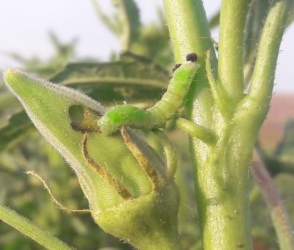
a. H. armigera damage on young fruit
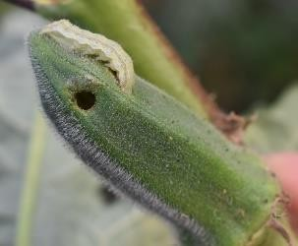
A. H. armigera damage on matured okra fruit

Fig. 1. Infestation of H. armigera on okra in untreated check

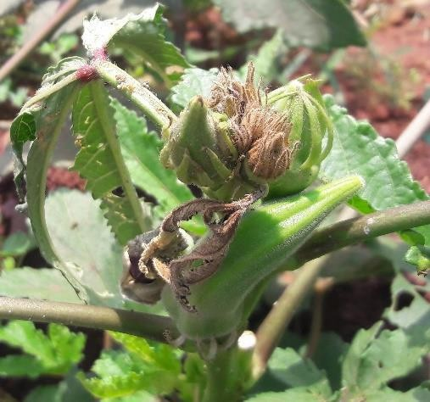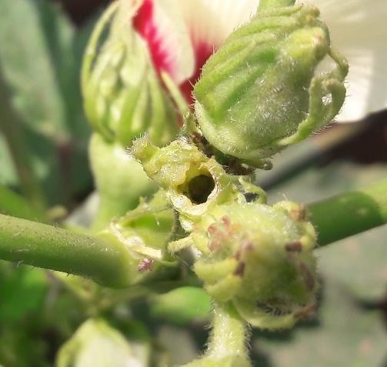
A. Shoot damage by Earias vittella
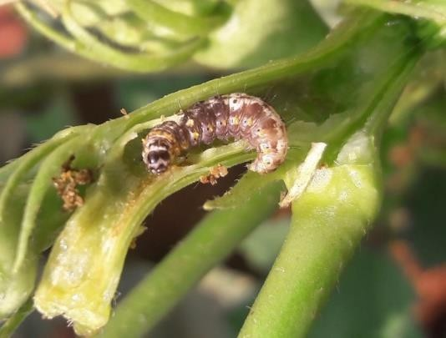
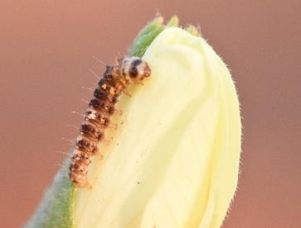
B. Shoot and bud damage by Earias vittella
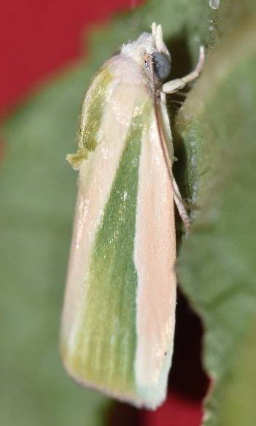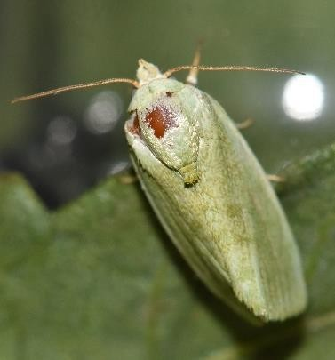
C. Adult Earias vittella D. Adult Earias insulana

Fig. 2. Severity of shoot and fruit borer on okra in untreated check

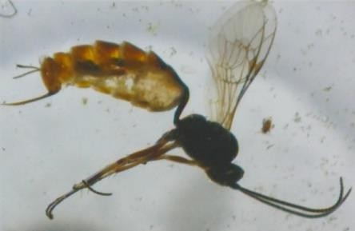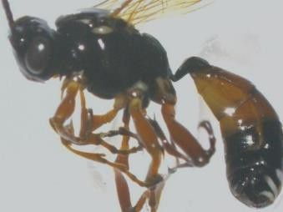
A. Nepiera sp. B. Neofacydes sp.

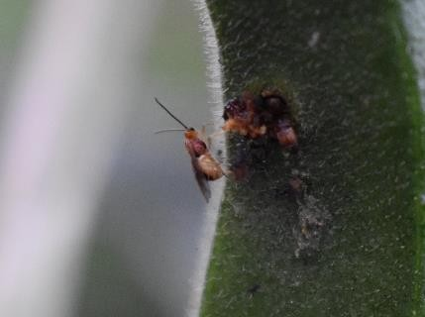
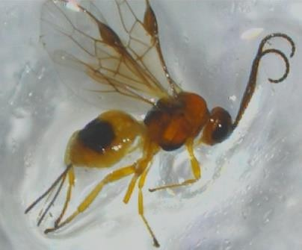
C. Bracon sp. D. Magnified view Bracon sp.

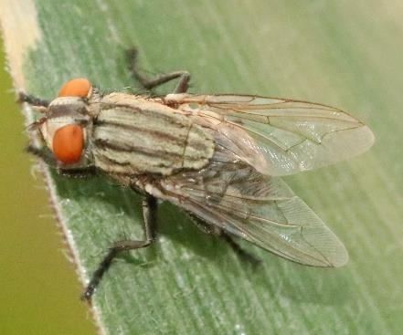
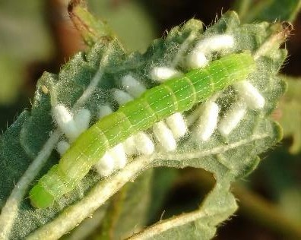
E. Tachinid fly F. Glyptapanteles sp.

Fig.3. Parasitoids recorded in crop diversification in okra ecosystem

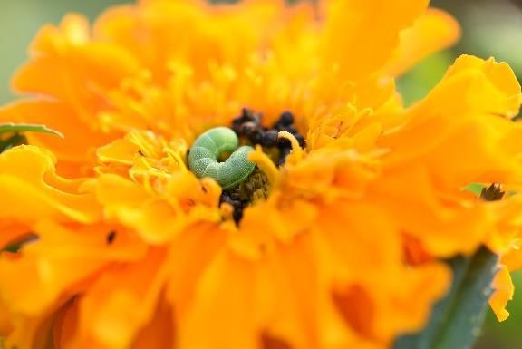  A. Helicoverpa armigera larvae on trap  crop |  |  | 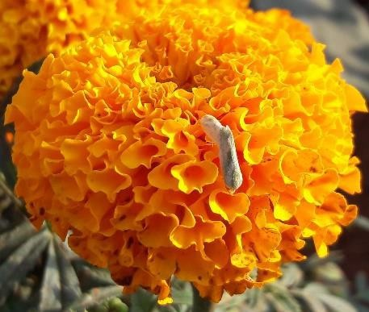  B. 1st time recorded the E. insulana adults attracted towards trap crop (Marigold)  for egg laying
 | 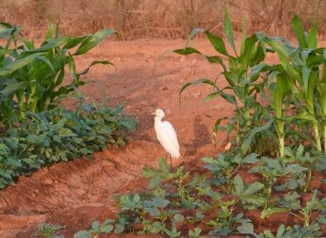 |  |  | 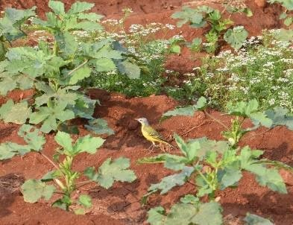
C. Cattle Egret |  |  | D. Yellow wagtail
 | 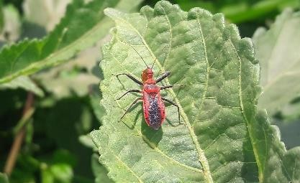 |  |  | 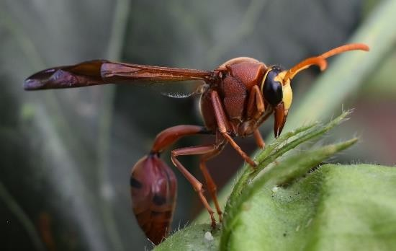
E. Reduviid bug |  |  | F. Wasp, Delta conodeum
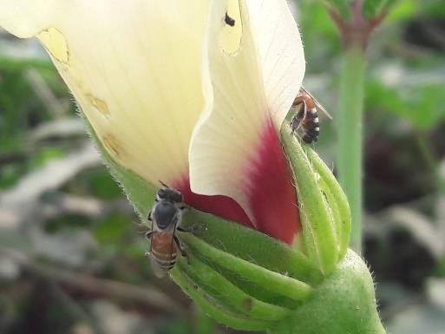  G. Honey bees |  |  | 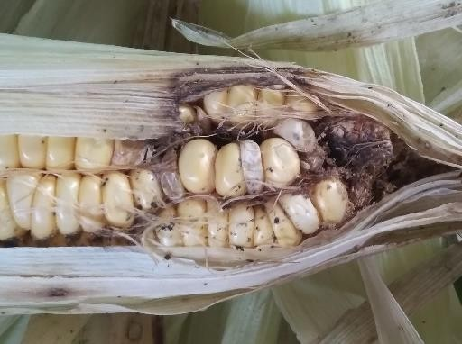  H. Helicoverpa armigera damage on cobs
Fig.4. Trapped insects, predatory birds, predators and pollinators in okra ecosystem

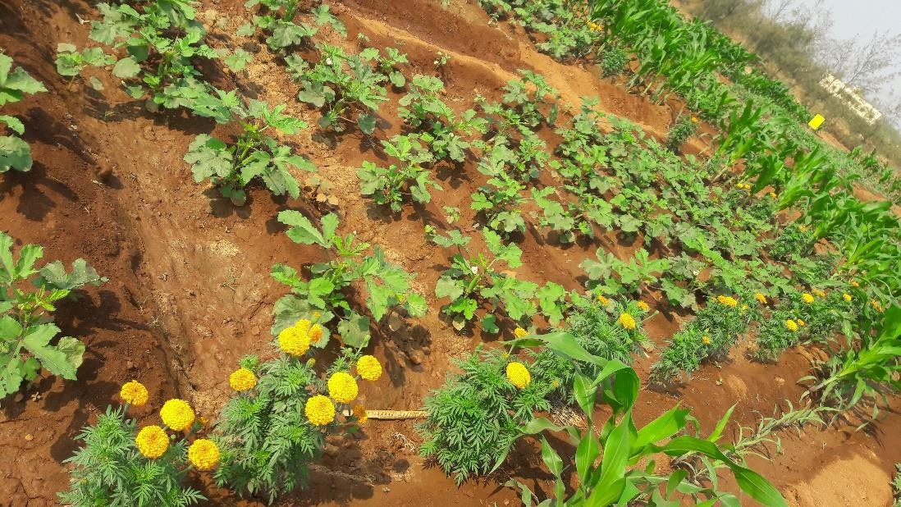

a. Marigold as trap crop and maize as barrier crop
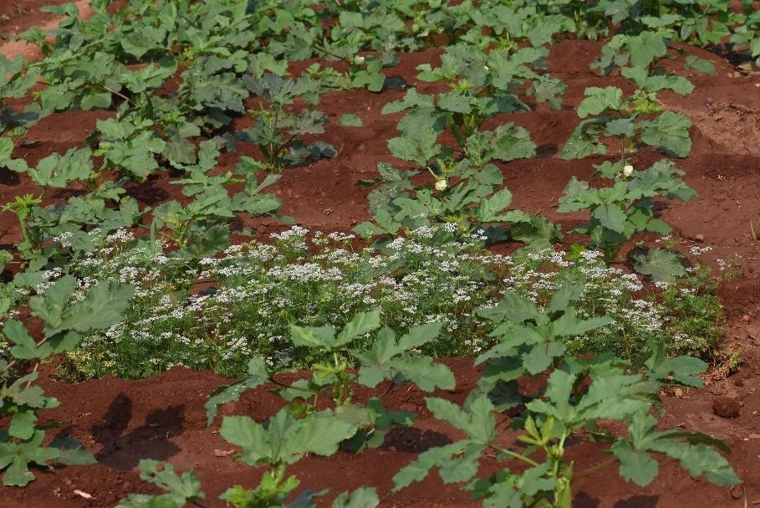
b. Coriander as repellent crop
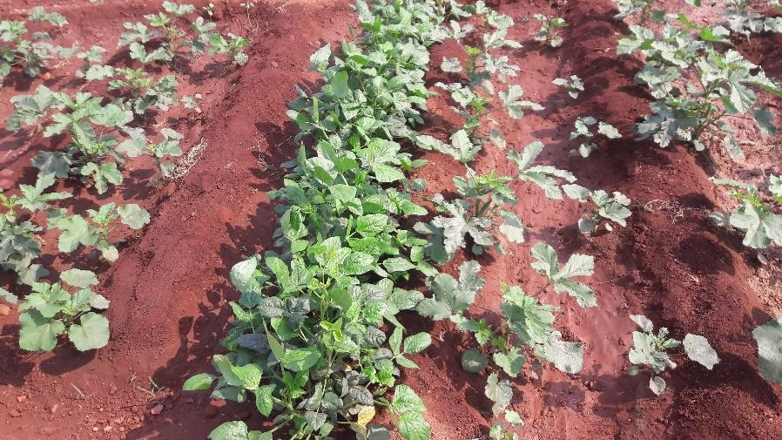
c. Cowpeas as inter crop
Fig. 5. Field view

