Original Research Article
UNVEILING AQUATIC HARMONY: LINKING WATER CHEMISTRY AND ICHTHYOFAUNAL DIVERSITY IN RETTERI LAKE, CHENNAI, TAMIL NADU

ABSTRACT
Urban lakes are increasingly recognized as disappearing biodiversity hotspots, making their scientific assessment vital for sustainable environmental management. This study presents one of the first integrated evaluations of water quality and fish diversity in Retteri Lake, a key urban freshwater ecosystem in Chennai, Tamil Nadu, India, thereby generating crucial baseline data for detecting ecological change, identifying early anthropogenic stress, and guiding evidence-based conservation strategies. By linking limnological parameters with ichthyofaunal community structure, the research provides insights into the ecological health of a major urban lake and supports future restoration and sustainable management in rapidly urbanising regions.
Water samples were collected monthly in triplicate from three location in Retteri lake and analysed for fifteen physico-chemical parameters following APHA (2022) protocols, benchmarked against IS 10500:2012 standards. Fish diversity was assessed using cast and drag nets, with community indices (Shannon–Wiener, Simpson’s, Margalef, Equitability) computed in PAST v2.07. Results revealed elevated TDS (521–631 mg/L), hardness (249–281 mg/L), and magnesium, alongside a sodium peak (132 mg/L; p < 0.001) and rising nitrate (26–38 mg/L), indicating sewage influx and early eutrophication. A total of 481 fish specimens across eight species were recorded, dominated by Cypriniformes, with diversity indices reflecting moderate stability and low dominance.
Keywords: Retteri Lake; urban freshwater ecosystem; water quality; ichthyofaunal diversity; biodiversity indices; eutrophication; ecological monitoring; freshwater conservation.
1. INTRODUCTION
Water is a universal solvent and a fundamental resource for sustaining life and regulating ecological processes. Freshwater ecosystems such as lakes and reservoirs support diverse ichthyofaunal communities and provide essential ecosystem services including food resources, biodiversity conservation, and livelihood support (Öner Berker and Doğan, 2023; Wetzel, 2001; Dudgeon et al., 2006). Physico-chemical characteristics of water bodies directly influence biological productivity and species distribution. Alterations in these parameters, often driven by anthropogenic activities, can significantly affect aquatic biodiversity and ecosystem health (Nelson, 2006).
Fish diversity is widely recognised as a reliable bioindicator of freshwater ecosystem quality and ecological balance (Banothu et al., 2018; Ganasan and Hughes, 1998). Urban water bodies in Chennai are particularly vulnerable to increasing pollution from rapid urbanisation and inadequate wastewater management (Karr, 1981). Retteri Lake, an important lentic freshwater body in north Chennai, has received limited scientific attention despite its ecological significance. The present study therefore aims to assess post-monsoon physico-chemical water quality parameters and ichthyofaunal diversity of Retteri Lake and to evaluate the relationship between water quality and fish community structure.
2. MATERIAL AND METHODS
2.1 Study Area
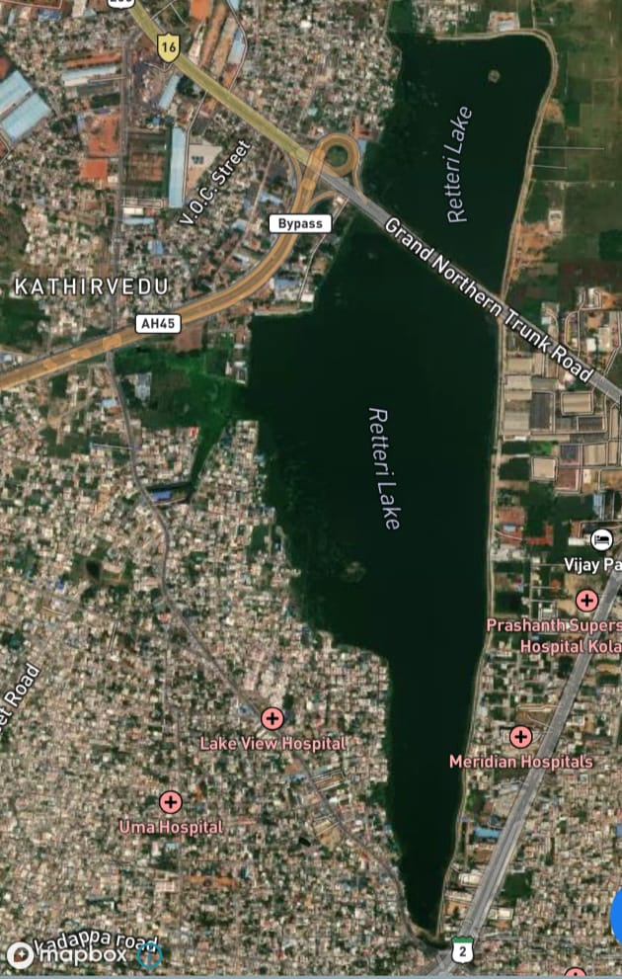
Retteri Lake is a lentic freshwater body located in the Kolathur region of Chennai (Fig. 1). The lake plays a significant role in local water storage, biodiversity support, and groundwater recharge. It is subjected to periodic anthropogenic pressures including urban runoff and domestic effluent discharge. Water samples and fish specimens were collected at three pre-designated sampling stations during the post-monsoon season.

Fig. 1. GPS map of Retteri Lake study site.
2.2 Physico-Chemical Analysis
Water samples were collected in clean polyethylene bottles (1 L), preserved at 4°C and analysed within 24 hours. All analyses followed standard procedures recommended by the American Public Health Association (APHA, 2022). Fifteen parameters were measured: electrical conductivity (EC), pH, calcium (Ca), magnesium (Mg), sodium (Na), potassium (K), bicarbonate (HCO₃), carbonate (CO₃), sulphate (SO₄), chloride (Cl), nitrate (NO₃), fluoride (F), total dissolved solids (TDS), total hardness (TH as CaCO₃), and total alkalinity (TA as CaCO₃). Triplicate measurements were recorded for each station per month. One-way ANOVA followed by Tukey's post-hoc test was applied to evaluate significant monthly variation (P < .05). Results were benchmarked against IS 10500:2012 drinking water standards. Standard analytical precision and limnological interpretations were further supported by Boyd (2015) and Singh et al. (2010).
2.3 Fish Diversity Analysis
Fish specimens were collected using cast nets and drag nets over three consecutive days each month. Specimens were identified using standard taxonomic keys (Talwar and Kacker, 1984; Talwar and Jhingran, 1991; Jayaram, 1999). Biodiversity indices — Shannon–Wiener index (H'), Simpson's index (1–D), Margalef richness index (d), and Equitability (J) — were calculated using the Paleontological Statistics Software Package (PAST), version 2.07 (Hammer et al., 2001). IUCN conservation status was recorded for each species. The ecological interpretation of diversity metrics follows Shannon and Weaver (1949), Simpson (1949), and Pielou (1966).
3. RESULTS AND DISCUSSION
3.1 Physico-Chemical Characteristics
Post-monsoon analysis revealed moderate seasonal variation across all fifteen water quality parameters (Table 1; Fig. 2). Most parameters remained within IS 10500:2012 permissible limits, though elevated TDS and total hardness indicate anthropogenic ionic enrichment. The overall physico-chemical profile reflects moderate water quality suitable for sustaining aquatic life, consistent with findings from comparable urban lentic systems in south India (Khushboo et al., 2025; Poornima et al., 2021). Comparable findings from Indian urban freshwater ecosystems have been documented by Chandra et al. (2017) and Kumar and Dua (2009).
3.1.1 Electrical Conductivity and pH
EC varied significantly across months (F = 655.19, P < .001), with February recording the highest values, indicating ionic enrichment from post-monsoon runoff. No IS standard exists for EC, though elevated values indicate increased dissolved salt loading. pH showed a progressive upward trend from January (6.47) to March (7.07; F = 5.62, P = .031), with all values remaining within the IS 10500:2012 desirable range of 6.5–8.5, indicating water suitable for aquatic life and human use.
3.1.2 Major Cations (Ca, Mg, Na, K)
Calcium remained below the IS desirable limit of 75 mg/L throughout the study, with no significant monthly variation (F = 0.70, P = .510), reflecting stable geological input. Magnesium slightly exceeded the IS desirable limit of 30 mg/L in all months (F = 2.14, P = .046), possibly due to soil leaching. Sodium showed a sharp peak in February (132 mg/L; F = 1197.79, P < .001), indicating anthropogenic contamination from sewage or urban runoff. Potassium remained stable (~9.5 mg/L; F = 1.26, P = .280), reflecting limited agricultural influence.
3.1.3 Bicarbonate, Carbonate, Sulphate, Chloride, Nitrate, and Fluoride
Bicarbonate levels dipped in February (200 mg/L; F = 2.23, P = .030), reflecting post-monsoon dilution, while carbonate was absent throughout the study, indicating bicarbonate-dominated buffering. Sulphate peaked in February (123 mg/L; F = 1159.04, P < .001) but remained within the IS permissible range (200–400 mg/L); elevated values suggest detergent or industrial inputs. Chloride rose from January (113 mg/L) to February (169 mg/L; F = 655.19, P < .001), remaining below the IS desirable limit of 250 mg/L. Nitrate increased steadily from January (26 mg/L) to March (38 mg/L; F = 2.14, P = .046), within permissible limits (≤45 mg/L) but signalling early eutrophication risk. Fluoride remained well below the permissible limit of 1.5 mg/L, with February values slightly elevated (F = 2.14, P = .046), suggesting groundwater influence.
3.1.4 TDS, Total Hardness, and Total Alkalinity
TDS exceeded the IS desirable limit of 500 mg/L in all months, peaking in February (631 mg/L; F = 1159.04, P < .001), though remaining below the permissible limit of 2000 mg/L, indicating anthropogenic ionic loading. Total hardness exceeded the IS desirable limit of 200 mg/L throughout, with March recording the highest value (281 mg/L; F = 1159.04, P < .001), suggesting Ca/Mg salt dominance from rock weathering and urban discharge. Total alkalinity remained within the IS desirable limit of 200 mg/L throughout (F = 2.14, P = .046), indicating a stable buffering capacity of the lake.
Table 1. Post-monsoon variation of physico-chemical parameters at Retteri Lake, Chennai. NS = not significant; IS = Indian Standard 10500:2012.
Parameters | Jan (Mean ± SD) | Feb (Mean ± SD) | Mar (Mean ± SD) | ANOVA (F, P) | Post-hoc (Tukey) | IS 10500:2012
Electrical Conductivity (µS/cm) | 920 ± 3 | 1062 ± 2.5 | 973 ± 4 | F = 655.19,  P < .001 | Feb > Jan, Mar | No IS standard
pH | 6.47 ± 0.25 | 6.53 ± 0.25 | 7.07 ± 0.15 | F = 5.62,  P = .031 | Mar > Jan, Feb | Within desirable (6.5–8.5)
Calcium (mg/L) | 54 ± 2 | 46 ± 2.5 | 52 ± 2 | F = 0.70,  P = .510 | NS | < desirable (75)
Magnesium (mg/L) | 33 ± 2.1 | 32 ± 1.5 | 31 ± 1 | F = 2.14,  P = .046 | Feb ≈ Mar < Jan | > desirable (30)
Sodium (mg/L) | 79 ± 2 | 132 ± 2.6 | 83 ± 1.5 | F = 1197.79,  P < .001 | Feb > Jan, Mar | No IS standard
Potassium (mg/L) | 9.7 ± 0.6 | 9.5 ± 0.5 | 9.5 ± 0.5 | F = 1.26,  P = .280 | NS | No IS standard
Bicarbonate (mg/L) | 237 ± 2.6 | 200 ± 4.2 | 217 ± 2.5 | F = 2.23,  P = .030 | Feb < Jan, Mar | No IS standard
Carbonate (mg/L) | 0 | 0 | 0 | – | – | No IS standard
Sulphate (mg/L) | 84 ± 1.5 | 123 ± 3.5 | 113 ± 2.5 | F = 1159.04,  P < .001 | Feb > Jan, Mar | Within permissible (200–400)
Chloride (mg/L) | 113 ± 1.5 | 169 ± 2 | 163 ± 2.5 | F = 655.19,  P < .001 | Feb, Mar > Jan | < desirable (250)
Nitrate (mg/L) | 26 ± 2.6 | 33 ± 3.5 | 38 ± 3.1 | F = 2.14,  P = .046 | Increasing | Within permissible (≤45)
Fluoride (mg/L) | 0.03 ± 0.02 | 0.25 ± 0.04 | 0.14 ± 0.03 | F = 2.14,  P = .046 | Feb > Jan, Mar | Within permissible (≤1.5)
TDS (mg/L) | 521 ± 1 | 631 ± 2.5 | 613 ± 3.1 | F = 1159.04,  P < .001 | Feb > Jan, Mar | > desirable (500); < permissible (2000)
Total Hardness (mg/L) | 275 ± 3 | 249 ± 2 | 281 ± 3 | F = 1159.04,  P < .001 | Mar > Jan, Feb | > desirable (200); < permissible (600)
Total Alkalinity (mg/L) | 194 ± 2 | 164 ± 3.6 | 175 ± 3 | F = 2.14,  P = .046 | Feb < Jan | Within desirable (200)
*P values reported to 3 digits when P < .01. NS = not significant.

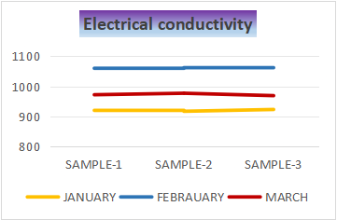 | 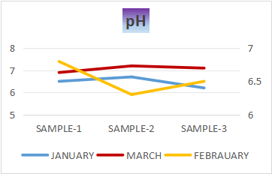 | 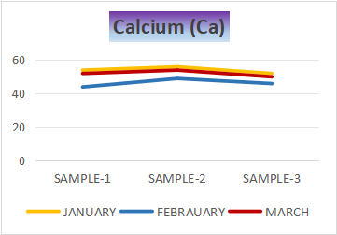
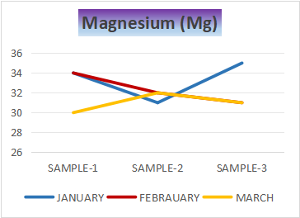 | 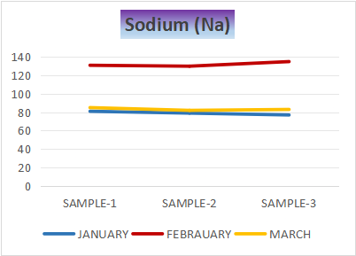 | 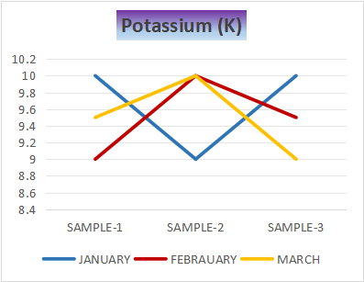
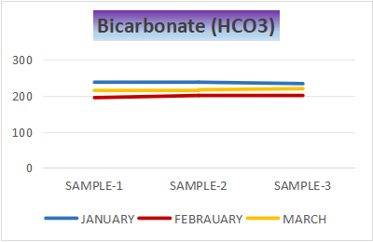 | 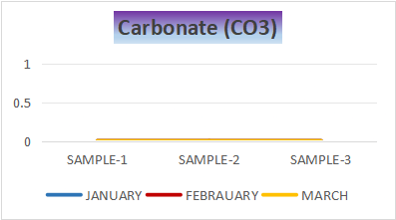 | 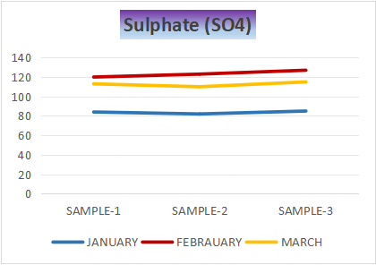
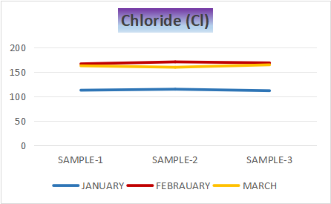 | 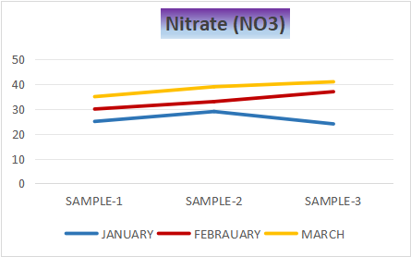 | 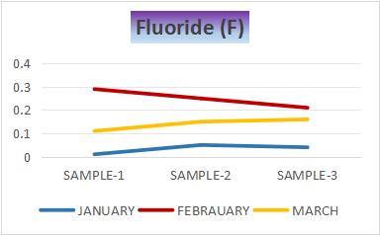
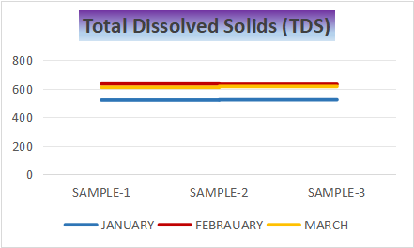 | 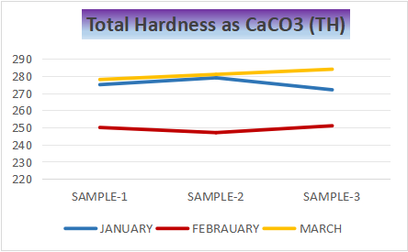 | 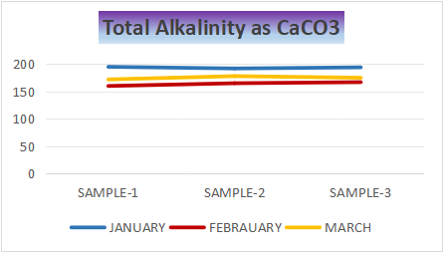

Fig. 2. Graphical representation of post-monsoon physico-chemical parameter variation at Retteri Lake.
Bars/lines represent monthly means ± SD.
Dashed line indicates IS 10500:2012 desirable/permissible limit where applicable.
3.2 Fish Diversity
A total of 481 fish specimens belonging to eight species, five orders, and five families were recorded during the post-monsoon study period (Table 2; Plate 1). Cypriniformes dominated the assemblage with three species (Labeo catla, Labeo rohita, Carassius carassius), followed by Cichliformes with two species (Oreochromis niloticus, Amphilophus citrinellus). Mugiliformes (Mugil cephalus), Siluriformes (Clarias batrachus), and Anabantiformes (Channa striata) each contributed one species. All species were classified as Least Concern (LC) by the IUCN Red List. Carassius carassius recorded the highest total abundance (n = 116), while Clarias batrachus was least abundant (n = 26).
Monthly fish counts declined from January (201) to February (123) and partially recovered in March (157), likely reflecting post-monsoon hydrological and thermal fluctuations. Biodiversity indices indicated a relatively stable and evenly distributed fish community (Table 3; Fig. 3). Shannon–Wiener H' values ranged from 1.93 to 2.03, consistent with moderately diverse lentic communities reported from comparable urban lakes in south India (Poornima et al., 2021; Banothu et al., 2018). Low Simpson's index values (0.07–0.12) confirmed the absence of strong numerical dominance by any single species, while Margalef index values (1.04–1.45) reflected moderate species richness. These indices collectively indicate that Retteri Lake supports an ecologically stable fish community under moderate anthropogenic pressure. Similar diversity trends have also been reported by Gupta and Banerjee (2013), Moyle and Cech (2004), and Odum and Barrett (2005).
Table 2. List of fish species recorded from Retteri Lake, Chennai, Tamil Nadu.
S.No. | Fish Name | Post-Monsoon Season |  |  |  | Habitat | IUCN Status
 |  | Jan | Feb | Mar | Total
Class: Actinopterygii | Order: Cypriniformes | Family: Cyprinidae
1 | Labeo catla (Hamilton, 1822) | 30 | 15 | 20 | 65 | F | LC
2 | Labeo rohita (Hamilton, 1822) | 20 | 12 | 15 | 47 | F | LC
3 | Carassius carassius (Linnaeus, 1758) | 40 | 37 | 39 | 116 | F, M, B | LC
Order: Cichliformes | Family: Cichlidae
4 | Oreochromis niloticus (Linnaeus, 1758) | 22 | 10 | 17 | 49 | F, B | LC
5 | Amphilophus citrinellus (Günther, 1864) | 31 | 20 | 28 | 79 | F | LC
Order: Mugiliformes | Family: Mugilidae
6 | Mugil cephalus (Linnaeus, 1758) | 25 | 15 | 19 | 59 | M, F, B | LC
Order: Siluriformes | Family: Clariidae
7 | Clarias batrachus (Linnaeus, 1758) | 12 | 6 | 8 | 26 | F | LC
Order: Anabantiformes | Family: Channidae
8 | Channa striata (Bloch, 1793) | 21 | 8 | 11 | 40 | F, B, M | LC
Total |  | 201 | 123 | 157 | 481 | Post-monsoon total = 481
Habitat: F = Freshwater, M = Marine, B = Brackish water; IUCN status: LC = Least Concern.
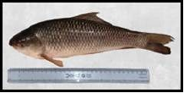 | 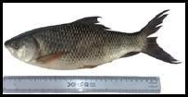 | 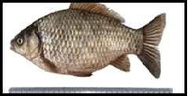
- Labeo catla | - Labeo rohita | - Carassius carassius
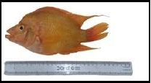 | 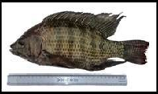 | 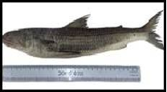
- Amphilophus citrinellus | - Oreochromis niloticus | - Mugil cephalus
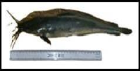 | 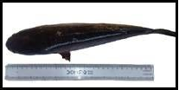
- Clarias batrachus | - Channa striata
Plate 1. Photographic documentation of fish species recorded from Retteri Lake, Chennai, Tamil Nadu, India.
(a) Labeo catla, (b) Labeo rohita, (c) Carassius carassius, (d) Oreochromis niloticus, (e) Amphilophus citrinellus, (f) Mugil cephalus, (g) Clarias batrachus, (h) Channa striata.

Table 3. Fish species diversity indices at Retteri Lake, Chennai.
Month | January | February | March
Taxa (S) | 6 | 6 | 6
Individuals (N) | 201 | 123 | 157
Simpson's Index (1-D) | 0.074 | 0.116 | 0.093
Shannon–Wiener Index (H') | 2.029 | 1.926 | 1.974
Margalef Richness Index (d) | 1.044 | 1.455 | 1.384
Equitability (J) | 1.780 | 1.385 | 1.557
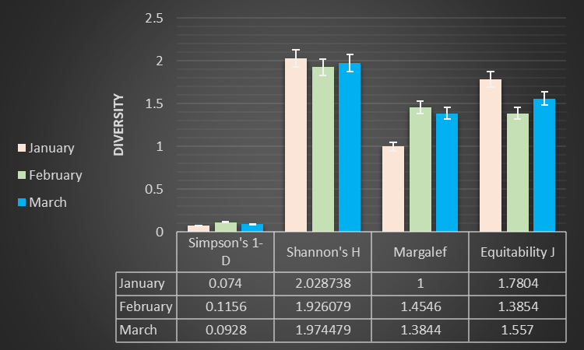
Fig. 3. Graphical representation of fish diversity indices at Retteri Lake, Chennai.
H' = Shannon–Wiener index; 1-D = Simpson's index; d = Margalef richness index; J = Equitability.

4. CONCLUSION
The present study demonstrates that Retteri Lake sustains a stable and moderately diverse fish community despite post-monsoon fluctuations in physico-chemical water quality. Although the water is unsuitable for direct consumption owing to elevated TDS and total hardness, the lake remains ecologically productive. The dominance of Cypriniformes, acceptable diversity index values, and low species dominance collectively reflect an ecosystem that is resilient but under moderate anthropogenic stress. Regular physico-chemical monitoring, controlled discharge of urban runoff and domestic effluent, and conservation-oriented management are strongly recommended to sustain long-term ecological balance and native ichthyofaunal diversity in Retteri Lake.
ETHICAL APPROVAL
This study involved non-invasive field-based collection of fish specimens from a natural freshwater habitat for scientific documentation and immediate release. No laboratory animal experiments were conducted. All field collections were carried out with the permission of the Tamil Nadu Fisheries Department, Government of Tamil Nadu, India, and in accordance with applicable national guidelines for wildlife collection.
COMPETING INTERESTS DISCLAIMER:
Authors have declared that they have no known competing financial interests OR non-financial interests OR personal relationships that could have appeared to influence the work reported in this paper.

REFERENCES
APHA. 2022. Standard Methods for the Examination of Water and Wastewater. 24th ed. American Public Health Association.
APHA, AWWA, WEF. 2017. Standard Methods for the Examination of Water and Wastewater. 23rd ed. American Public Health Association.
Banothu R, Sharma AP, Gurjar UR, Gugulothu R, Mishra A. 2018. Assessment of fish diversity in relation to physicochemical characteristics of Nanak Sagar Reservoir, Uttarakhand. Journal of Entomology and Zoology Studies. 6(2):477–484.
Boyd CE. 2015. Water Quality: An Introduction. Springer.
Chandra S, Singh A, Tomar PK. 2017. Assessment of water quality values in Porur Lake, Chennai. International Journal of Fisheries and Aquatic Studies. 5(3):214–220.
Dudgeon D, Arthington AH, Gessner MO, et al. 2006. Freshwater biodiversity: Importance, threats, status and conservation challenges. Biological Reviews. 81(2):163–182.
Ganasan V, Hughes RM. 1998. Application of an index of biological integrity to fish assemblages of the rivers Khan and Kshipra. Freshwater Biology. 40(2):367–383.
Gopal B. 2013. Future of wetlands in tropical and subtropical Asia, especially in the face of climate change. Aquatic Sciences. 75(1):39–61.
Gupta S, Banerjee S. 2013. Assessment of fish diversity in freshwater ecosystems of West Bengal. International Journal of Biodiversity and Conservation. 5(3):120–129.
Hammer Ø, Harper DAT, Ryan PD. 2001. PAST: Paleontological statistics software package for education and data analysis. Palaeontologia Electronica. 4(1):1–9.
Hynes HBN. 1970. The Ecology of Running Waters. Liverpool University Press.
IUCN. 2024. The IUCN Red List of Threatened Species. International Union for Conservation of Nature.
Jayaram KC. 1999. The Freshwater Fishes of the Indian Region. Narendra Publishing House.
Jhingran VG. 1991. Fish and Fisheries of India. 3rd ed. Hindustan Publishing Corporation.
Karr JR. 1981. Assessment of biotic integrity using fish communities. Fisheries. 6(6):21–27.
Khushboo Kumari, Lekh Raj, Shobha Shrivastava. 2025. Correlation between physicochemical properties of water and zooplankton diversity and abundance in the freshwater ecosystem of the Gandak River. International Journal of Entomology Research. 10(6):116–121.
Kumar A, Dua A. 2009. Water quality index for assessment of water quality of River Ravi. International Journal of Environmental Sciences. 1(4):97–104.
Moyle PB, Cech JJ. 2004. Fishes: An Introduction to Ichthyology. 5th ed. Pearson Education.
Nelson JS. 2006. Fishes of the World. 4th ed. John Wiley & Sons.
Odum EP, Barrett GW. 2005. Fundamentals of Ecology. 5th ed. Thomson Brooks/Cole.
Öner Berker A, Doğan N. 2023. Influence of physico-chemical parameters on ichthyofaunal diversity. International Journal of Fisheries and Aquatic Research. 8(2):1–7.
Pielou EC. 1966. The measurement of diversity in different types of biological collections. Journal of Theoretical Biology. 13:131–144.
Poornima J, Deepalakshmi B, Gowsalya K, Arockia Rita JJ, Elumalai M. 2021. Ichthyodiversity and physicochemical parameters of Puzhal Lake, Chennai. Journal of Emerging Technologies and Innovative Research. 8(9):112–118.
Ramesh R, Purvaja R, Nammalwar P. 2015. Urban aquatic ecosystems of Chennai: Environmental status and conservation strategies. Current Science. 108(8):1453–1460.
Shannon CE, Weaver W. 1949. The Mathematical Theory of Communication. University of Illinois Press.
Simpson EH. 1949. Measurement of diversity. Nature. 163:688.
Singh MR, Gupta A, Beeteswari KH. 2010. Physico-chemical properties of water samples from Manipur River system. Indian Journal of Science and Technology. 3(5):551–554.
Suresh VR, Biswas BK, Vinci GK, Mitra K, Mukherjee A. 2007. Biology and fishery of Catla catla in India. Aquaculture Asia. 12(2):34–39.
Talwar PK, Jhingran AG. 1991. Inland Fishes of India and Adjacent Countries. Oxford & IBH Publishing.
Talwar PK, Kacker RK. 1984. Commercial Sea Fishes of India. Zoological Survey of India.
Wetzel RG. 2001. Limnology: Lake and River Ecosystems. 3rd ed. Academic Press.

