Original Research Article

Forest Degradation and Landscape Transformation in the Pench–Navegaon–Nagzira Wildlife Corridor, Central India: A Multi-Decadal Land Use Land Cover Analysis (2004–2024)

.
ABSTRACT

Land use defined as “The set of anthropogenic activities and arrangements (e.g., cultivation, grazing, timber extraction) in a piece of land for economic and social welfare” (IPCC 2000). This study evaluates multi-decadal Land Use Land Cover (LULC) transitions within the Pench–Navegaon–Nagzira wildlife corridor of Central India between 2004 and 2024. The corridor functions as a critical ecological linkage connecting Pench Tiger Reserve with Navegaon–Nagzira Tiger Reserve. Using supervised satellite image classification, post-classification comparison, and transition matrix analysis, significant structural changes were quantified. Tiger abundance is determined by the quantity and quality of available habitat (Seidensticker et al. 1999). Land use and land cover is the most important variable for tiger movement (Wikra- manayake et al. 2004; Rathore et al. 2012), because it impacts the distribution of prey species, and provides dispersing animals with cover, especially when moving through a human-dominated matrix. In the study, the dominant transition pathways were Deciduous Forest → Scrub Forest (23.75 km²), Deciduous Forest → Reservoirs/Tanks (15.59 km²), Cropped → Reservoirs/Tanks (7.43 km²), Deciduous Forest → Cropped (5.40 km²), and Lake Ponds → Cropped (2.37 km²). The dominant process observed is forest degradation rather than outright urban expansion. Drivers include agricultural encroachment, demographic pressures, forest dependency, infrastructure development, and mining influence in the broader Central Indian Landscape. The findings highlight increasing fragmentation and thinning of forest canopy, posing long-term risks to wildlife connectivity and corridor functionality

Keywords: Forest degradation, wildlife corridor, land use land cover, tiger reserves, habitat

1. INTRODUCTION

The Pench–Navegaon–Nagzira wildlife corridor is a strategically important landscape component within the Central Indian Tiger Conservation Landscape. It facilitates dispersal of large carnivores, particularly tiger (Panthera tigris), between Pench Tiger Reserve (Maharashtra) and Navegaon–Nagzira Tiger Reserve (Maharashtra). The long-term persistence of species in fragmented land- scapes depends on the successful movement of individuals between habitat patches (Thomas 2000). Corridors are essential for maintaining genetic exchange, demographic stability, and long-term viability of wildlife populations in fragmented landscapes. Landscape connectivity is a vital component of biodiversity conservation, and conserving and restoring linkage zones or corridors is a common strategy for mitigating impacts of human-caused landscape change on biodiversity (Taylor et al. 1993; Crooks et al. 2011).
Conserving functional landscapes is a global challenge, it is particularly pertinent in a populous, developing country such as India. With a growing population of approximately 1.4 billion people (Census of India 2011) residing on a landmass that is about one-third of the area of USA, India is undergoing rapid economic growth and development (FAO 2006). Due to a sixfold increase in population, urbanization, agricultural intensification, and economic growth since the 1950s, there has been consid- erable transformation in land use and land cover (Richards and Flint 1994; Tian et al. 2014). Over the last two decades, increasing anthropogenic pressures have altered forest structure across the corridor. Encroachment for agriculture, fuelwood extraction, grazing intensity, and infrastructure expansion have progressively modified canopy density and land cover composition. Understanding the magnitude and pathways of LULC change is fundamental for landscape-level conservation planning.

2. material and methods

The Pench Tiger Reserve – Navegaon Nagzira Tiger Reserve wildlife corridor forms a critical ecological linkage within the Central Indian landscape. It supports movement of tigers and other wildlife between major protected areas and plays a vital role in maintaining genetic connectivity (Dutta et al., 2015; Joshi et al., 2013). The central Indian landscape supports nearly 40 % of the total tiger population in India (Jhala et al. 2011) and has been identified as a global priority landscape for tiger conservation (Sanderson et al. 2010). The habitat consists of undulating landscape with mostly plains and few hills. There are many perennial rivers and streams with mosaic of high forests, meadows and worked areas. This landscape is within the biogeographic zone of the Deccan Plateau (Rodgers and Panwar 1988) and is dominated by tropical dry deciduous and tropical moist deciduous forests (Champion and Seth 1968). However, this corridor is under increasing pressure from agricultural expansion, infrastructure development and other anthropogenic activities, leading to forest degradation, soil fertility decline and habitat fragmentation (Mondal, 2016; Banerjee et al., 2020).
Fig 1a. Study area
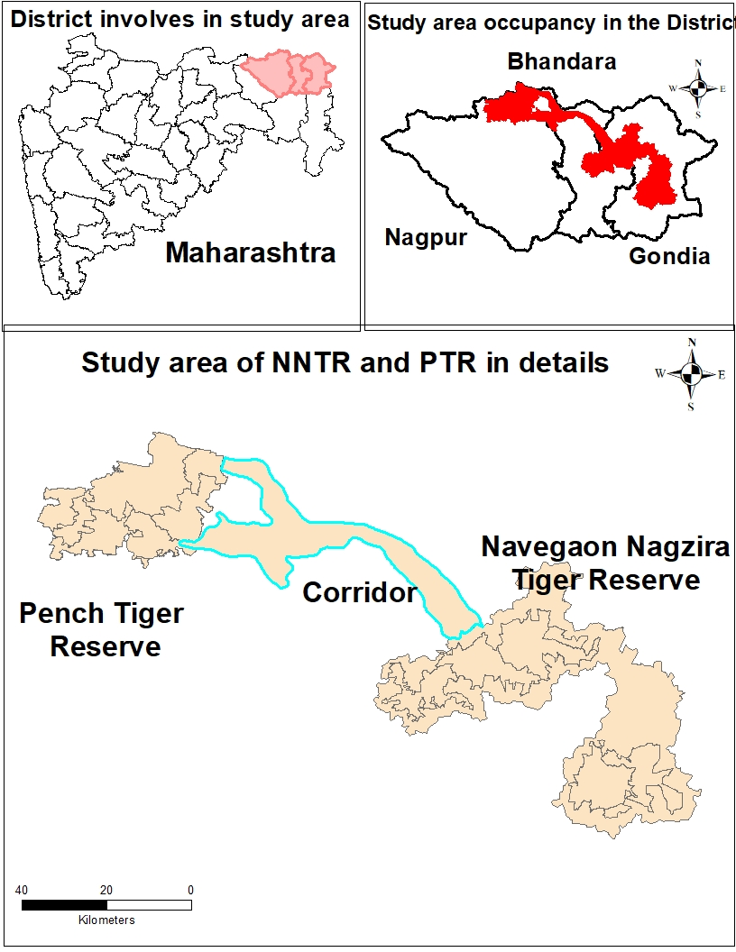

Study area is located in the eastern Vidarbha and lies between the latitude 21.2°N to 21.7°N and longitudes 79.2°E to 80.0°E and covers an area of 593 km². The annual rainfall is 1100 mm to 1300 mm in the eastern Vidarbha and having annual mean temperature 27^{O}C with higher range above 46 ^{O}C in May and lower range below 8^{O}C in December- January in area.

Method
The methodological framework for assessing Land Use Land Cover (LULC) dynamics in the Pench–Navegaon–Nagzira Wildlife Corridor was developed using standard remote sensing and Geographic Information System (GIS) techniques, adapted from established post-classification comparison approaches. Multi-temporal Landsat satellite imagery for the years 2004 and 2024 was acquired to evaluate landscape transformation over a 20-year period. Images were selected from comparable seasonal windows to minimize phenological variation and ensure spectral consistency. All datasets were geometrically corrected and projected to the Universal Transverse Mercator (UTM) coordinate system (WGS 84 datum). Ground truth data were collected through field surveys using handheld Global Positioning System (GPS) instruments to identify representative land cover features and improve classification reliability.
Pre-processing involved geo-referencing satellite scenes using well-distributed ground control points and applying second-order polynomial transformation to achieve spatial alignment. Images were resampled to a 30 × 30 m spatial resolution using the nearest neighbour method to preserve spectral values. Atmospheric correction was not applied, as the adopted post-classification comparison method compensates for inter-date atmospheric and phenological variations.
LULC classification followed the hierarchical system proposed by Anderson et al. (1976), adopting six Level-1 classes relevant to corridor ecology: Dense Forest, Open Forest, Scrub Forest, Agriculture, Uncultivated Land, and Water Bodies. Approximately 150 training samples were selected based on field verification and visual interpretation. A supervised Maximum Likelihood Classification (MLC) algorithm was used to classify each temporal dataset independently due to its statistical robustness and widespread applicability in multi-date LULC studies. Change detection was performed using post-classification comparison, enabling pixel-by-pixel evaluation of transitions between 2004 and 2024. Transition matrices were generated to quantify “from–to” changes, and magnitude and percentage change were computed to assess structural transformation within the wildlife corridor landscape.

3. results and discussion

The land use land cover (LULC) transition analysis for the 593.14 km² landscape between 2004 and 2024 reveals moderate net change but substantial structural reconfiguration. In 2004, Deciduous forest dominated with 373.25 km² (62.93%), followed by Cropped land at 169.16 km² (28.52%). By 2024, Deciduous forest reduced to 328.07 km² (55.32%), reflecting a net decline of 45.18 km² (−7.61% of total area). Cropped land remained nearly stable at 169.82 km² (28.63%), with a marginal net increase of 0.66 km². However, this apparent stability conceals significant bidirectional transitions among classes.
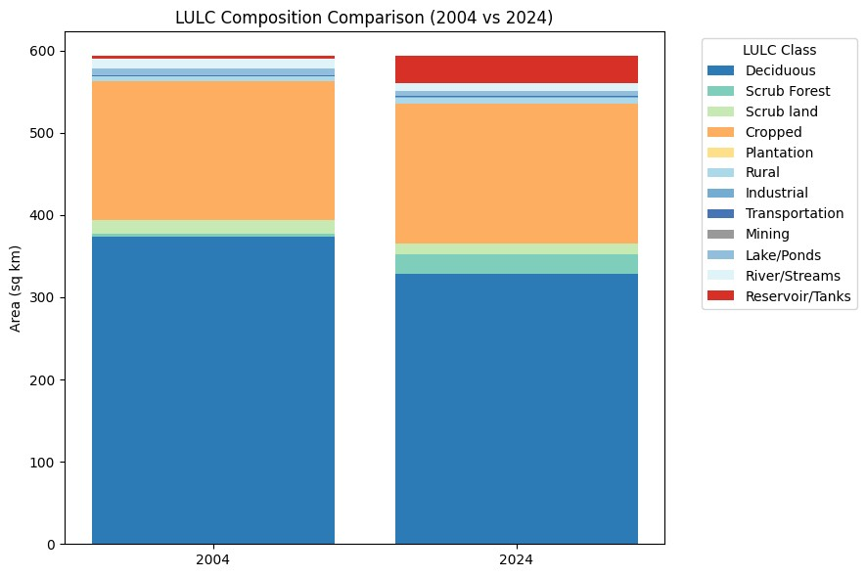
Figure 1b. Net LULC Change (2004–2024)
Forest persistence remained relatively high, with 327.93 km² (87.86%) of Deciduous forest retained. Nevertheless, 23.75 km² transitioned to Scrub Forest, 5.40 km² to Cropped land, and 15.59 km² to Reservoirs/Tanks. Minor conversions also occurred toward Rural (0.04 km²), Industrial (0.21 km²), Transportation (0.05 km²), Lake Ponds (0.17 km²), and River streams (0.12 km²). The increase of Scrub Forest from 3.87 km² in 2004 to 23.75 km² in 2024 represents a gain of 19.88 km², indicating degradation and canopy thinning rather than outright deforestation. Such transitions imply biomass reduction, altered microclimate, and potential soil carbon decline.
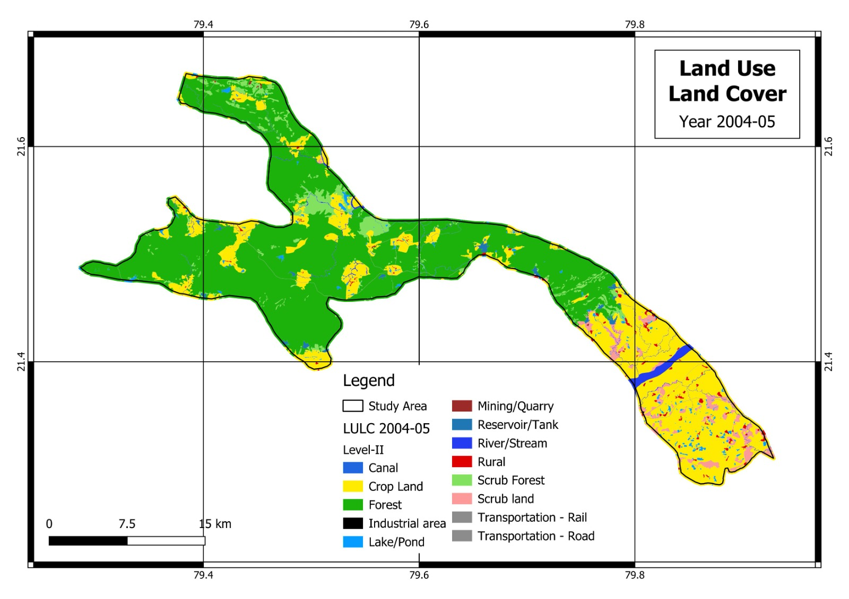
Map 1. Land use land cover of corridor area of 2004-05
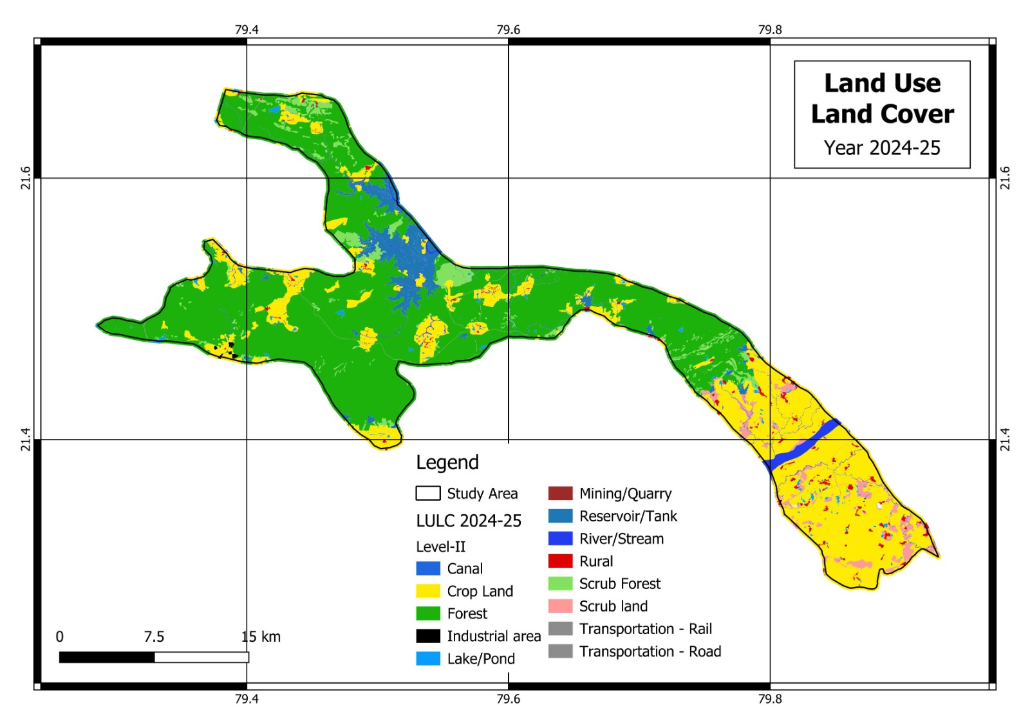
Map 2. Land use land cover of corridor area of 2024-25

Agricultural dynamics show internal redistribution. Of the 169.16 km² Cropped land in 2004, 159.88 km² persisted in 2024. Gains came from Deciduous Forest (5.40 km²), Scrub land (2.17 km²), and Lake Ponds (2.37 km²). Losses occurred toward Reservoirs/Tanks (7.43 km²), Rural (1.35 km²), Industrial (0.27 km²), Lake Ponds (0.16 km²), and River streams (0.07 km²). Although the net increase was only 0.66 km², these exchanges reflect agricultural intensification and localized encroachment into forest margins, balanced by irrigation expansion and infrastructural growth.
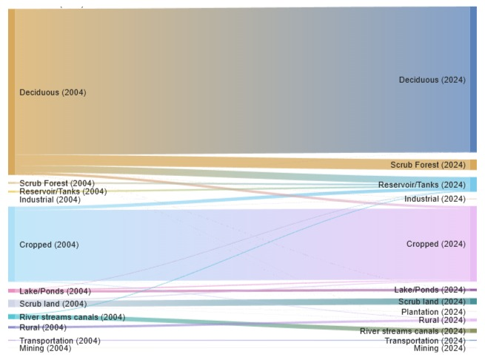
Figure:2 Sankey Diagram of LULC changes in year 2004 & 2024
Scrub land declined from 16.85 km² to 13.97 km², with 13.97 km² remaining stable. Portions converted to Cropped land (2.17 km²) and Plantation (0.19 km²), while small fractions shifted to Rural (0.31 km²), Industrial (0.01 km²), Lake Ponds (0.04 km²), and Reservoirs/Tanks (0.15 km²). The simultaneous increase in Scrub Forest (+19.88 km²) suggests that degraded Deciduous Forest contributed more substantially to scrub expansion than traditional scrub land dynamics alone, underscoring heterogeneous degradation pathways across the landscape.
Built-up categories exhibit moderate growth. Rural area increased from 4.95 km² to 6.65 km², largely sourced from Cropped (1.35 km²) and Scrub land (0.31 km²). Industrial land expanded from 0.04 km² to 0.53 km², mainly from Cropped land and Deciduous Forest (0.21 km²). Transportation remained stable at 1.50 km², and Mining remained unchanged at 0.22 km². Although spatially limited, such expansion contributes to fragmentation and increases edge effects, particularly when occurring adjacent to forest patches.
Hydrological transformation represents the most pronounced change. Reservoirs/Tanks expanded from 3.79 km² in 2004 to 32.99 km² in 2024, marking an increase of 29.20 km². Major sources included Deciduous Forest (15.59 km²) and Cropped land (7.43 km²). In contrast, Lake Ponds decreased from 8.44 km² to 5.58 km² (−2.86 km²), and River streams declined from 11.07 km² to 9.82 km² (−1.25 km²). This indicates consolidation or transformation of smaller natural water bodies into larger engineered reservoirs, reflecting irrigation expansion and hydrological reconfiguration.
The dominant transition pathways were Deciduous Forest → Scrub Forest (23.75 km²), Deciduous Forest → Reservoirs/Tanks (15.59 km²), Cropped → Reservoirs/Tanks (7.43 km²), Deciduous Forest → Cropped (5.40 km²), and Lake Ponds → Cropped (2.37 km²). Collectively, these transitions demonstrate a shift from contiguous mature forest to a heterogeneous agro-forestry–water mosaic. While core forest persistence remains substantial at 327.93 km², degradation, hydrological infrastructure expansion, and incremental anthropogenic growth are reshaping landscape configuration, with implications for carbon storage, habitat continuity, and long-term ecological resilience.
The predominant landscape process within the corridor is structural degradation of dense forest into open and scrub formations. This thinning reduces canopy continuity essential for safe wildlife movement. Agricultural expansion into forest fringes contributes to edge effects and human–wildlife conflict. Drivers of change include demographic growth in forest fringe villages, dependence on forest biomass resources, grazing pressure, infrastructure expansion, and influence of coal mining belts in the broader Central Indian region. Hydrological decline is associated with reduced infiltration due to vegetation thinning.

4. Conclusion

Land use and land cover (LULC) change is one of the most significant drivers of environmental transformation at global, regional and local scales. Rapid population growth, agricultural expansion, infrastructure development, mining and urbanisation have resulted in extensive modification of natural landscapes, particularly in tropical developing countries such as India (Segan et al, 2016). These changes have direct and indirect consequences on soil health, ecosystem functioning and biodiversity conservation. The Pench–Navegaon–Nagzira wildlife corridor has undergone significant structural transformation between 2002 and 2024. Forest degradation, agricultural expansion, and reduction in water bodies collectively threaten long-term corridor functionality. With finite land, increasing human population, and economic demands to build and expand infrastructure, there is tremendous pressure for converting forest lands to other uses. Maintaining movement pathways for wildlife in such a human-dominated landscape is a challenging task, but connectivity maps can be an effective tool to aid conservation and management decisions. Maintaining a well-connected landscape of large and small PAs can help to maintain a self-sustaining, viable population of tigers and other species in this region. In addition to increasing tiger populations that are perilously low, it is imperative to have management plans that encompass forests outside of PAs and mitigate severed connectivity to facilitate dispersal between these populations.
This landscape has potential for sustaining tigers and other species in the region. Enhancement of habitat connectivity in fragmented landscapes is progressively adopted as a strategic conservation measure to counteract the adverse impacts of habitat fragmentation, land-use change dynamics, and climate change (Doerr et al., 2011).With careful planning and with the help of tools that bring transparency to the process, such as these connectivity maps, we believe that pragmatic conservation mechanisms can be devised to sustain the functionality of this landscape for long-term tiger conservation. Integrated conservation planning, assisted natural regeneration, and strict regulation of extractive activities are required to sustain landscape connectivity.

COMPETING INTERESTS DISCLAIMER:
Authors have declared that they have no known competing financial interests OR non-financial interests OR personal relationships that could have appeared to influence the work reported in this paper.

References

Anderson R, Hardy EE, Roach JT, Witmer RE. 1976. A land use and land cover classiﬁcation system for use with remote sensor data. USGS Professional Paper 964, Sioux Falls, SD.kfz
Banerjee, Tania., (2017). Land Use and Land-Cover Change Detection and Its Effect on Bengal Tiger Mortality for Central India. MSU Graduate Thesis. 3121.http://bearworks.missouristate.edu/theses/3121
Bennett, Andrew. (2003). Linkages in the Landscape; The Role of Corridors and Connectivity in Wildlife Conservation. 10.2305/IUCN.CH.2004.FR.1.en.
Champion, S. H., & Seth, S. K. (1968). A revised survey of the forest types of India. New Delhi, India: Government of India, Manager of Publications.
Census of India, 2011. Series 4, Punjab. Paper. (2011). [Chandigarh]: [New Delhi]: Directorate of Census Operations, Punjab; Office of the Registrar General & Census Commissioner, India, Ministry of Home Affairs, Govt. of India
Crooks KR, Burdett CL, Theobald DM, Rondinini C, Boitani L (2011) Global patterns of fragmentation and connectivity of mammalian carnivore habitat. Philos Trans R Soc B Biol Sci 366:2642–2651. doi:10.1098/rstb.2011.0120
Doerr VA, Barrett T and Doerr ED (2011) Connectivity, dispersal behaviour and conservation under climate change: a response to Hodgson et al. Journal of Applied Ecology, 48(1): 143-147.
Dutta T, Sharma S, Maldonado JE, Panwar HS, Seidensticker J (2015) Genetic variation, structure, and gene flow in a sloth bear (Melursus ursinus) meta-population in the Satpura-Maikal landscape of central India. PLoS ONE 10:e0123384. doi:10. 1371/journal.pone.0123384
FAO (2006) Rapid growth of selected Asian economies: lessons and implications for agriculture and food security. Synthesis report. Regional Office for Asia and the Pacific. Food and Agriculture Organization of the United Nations, Bangkok
Habib, B., Ghaskadbi, P., Khan, S., Hussain, Z., & Nigam, P. (2021). Not a cakewalk: Insights into movement of large carnivores in human‐dominated landscapes in India. Ecology and evolution, 11(4), 1653-1666.
Habib B., Nigam P., Mondal I., Hussain Z.,Ghaskadbi P., Govekar R. S.,Praveen N. R., Banerjee J., Ramanujam R. M. and RamgaonkarJ.(2021):Telemetry based tiger corridors of Vidarbha Landscape, Maharashtra, India. Technical Report, Wildlife Institute of India, Dehradun. Pp. 37.
IPCC (2000) Summary for Policymakers. Land use, land-use change, & forestry: a special report of the intergovernmental panel on climate change.
Jhala YV, Qureshi Q, Gopal R, Sinha PR (2011) Status of tigers, co- predators and prey in India. National Tiger Conservation Authority, Govt. of India, New Delhi, and Wildlife Institute of India, Dehra Dun. TR 2011/003 pp-302. http://projecttiger.nic. in/WriteReadData/PublicationFile/Tiger_Status_oct_2010.pdf. Accessed 15 Aug 2011
Joshi A, Vaidyanathan S, Mondol S, Edgaonkar A, Ramakrishnan U (2013) Connectivity of tiger (Panthera tigris) populations in the human-influenced forest mosaic of central India. PLoS ONE 8:e77980. doi:10.1371/journal.pone.0077980
Mondal T, Qureshi Q, Jhala Y and Basu P. An assessment of land use land cover change in Central Highland of Deccan Peninsula and Semi-Arid tracts of India June 2019 DOI: 10.1101/665794
Rathore CS, Dubey Y, Shrivastava A, Pathak P, Patil V (2012) Opportunities of habitat connectivity for tiger (Panthera tigris) between Kanha and Pench national parks in Madhya Pradesh, India. PloS ONE 7:e39996. doi:10.1371/journal.pone.0039996
Richards JF, Flint EP (1994) Historic land use and carbon estimates for South and Southeast Asia 1880–1980. Oak Ridge National Laboratory, Oak Ridge
Rodgers W, Panwar S (1988) Biogeographical classification of India. New Forest, Dehra Dun
Sanderson E, Forrest J, Loucks C, Ginsberg J, Dinerstein E, Seidensticker J, Leimgruber P, Songer M, Heydlauff A, O’Brien T, Bryja G, Klenzendorf S, Wikramanayake ED (2010) Setting priorities for conservation and recovery of wild tigers: 2005–2015. In: Tilson R, Nyhus PJ (eds) Tigers of the world: the science, politics and conservation of Panthera tigris. Academic Press, London, pp 143–161
Seidensticker J, Jackson P, Christie S (1999) Riding the tiger: tiger conservation in human-dominated landscapes. Cambridge University Press, Cambridge
Sharma G, Sharma L and Sharma K (2019) Assessment of land use change and its effect on soil carbon stock using multitemporal satellite data in semiarid region of Rajasthan, India, Ecological Processes (2019) 8:42 https://doi.org/10.1186/s13717-019-0193-5
Segan, Daniel & Murray, Kris & Watson, James. (2016). A global assessment of current and future biodiversity vulnerability to habitat loss–climate change interactions. Global Ecology and Conservation. 5. 12-21. 10.1016/j.gecco.2015.11.002.
Taylor PD, Fahrig L, Henein K, Merriam G (1993) Connectivity is a vital element of landscape structure. Oikos 68:571–573
Thomas CD (2000) Dispersal and extinction in fragmented landscapes. Proc R Soc B Biol Sci 267:139–145. doi:10.1098/rspb. 2000.0978
Tian H, Banger K, Bo T, Dadhwal VK (2014) History of land use in India during 1880–2010: large-scale land transformations recon- structed from satellite data and historical archives. Glob Planet Change 121:78–88. doi:10.1016/j.gloplacha.2014.07.005
Wikramanayake E, McKnight M, Dinerstein E, Joshi A, Gurung B, Smith D (2004) Designing a conservation landscape for tigers in human-dominated environments. Conserv Biol 18:839–844. doi:10.1111/j.1523-1739.2004.00145.x

