Original Research Article

Effect of Chitosan Extracted from the Shell of Penaeus indicus (H. Milne Edwards, 1837) on the Germination and Early Growth of Mustard Seedlings

Abstract
The Chitosan was obtained from shrimp shell waste and characterised using FTIR (Fourier Transform Infrared Spectroscopy) and SEM (Scanning Electron Microscopy), and subsequently studied the effect of Chitosan on seed germination and early phase growth in mustard plant (Brassica juncea). In laboratory conditions, mustard seeds were treated with chitosan in the concentration range 0–100 mg L⁻¹. The Germination percentage, shoot length, root length, Seed Vigor Index (SVI), Relative Root Elongation (RRE), tolerance index (TI) and biomass accumulation were recorded. FTIR spectra confirmed the formation of chitosan with peaks at 3449 cm⁻¹ due to O–H and N–H stretching, peaks 3233–2888 cm⁻¹ corresponding to C–H stretching, a peak in between 1560 cm⁻¹ corresponding to N–H bending, along with peaks at 1399 cm⁻¹ for C–N stretching vibration, peaks at 1280 and 1033 as C-O stretching vibrations. Based on SEM analysis, the surface morphology was observed to be rough, porous, and heterogeneous. The maximum values of shoot length (5.10 cm), root length (5.70 cm), germination percentage (86.15%) and SVI (930.42) were found in control seedlings, whereas the application of 100 mg L⁻¹ chitosan completely inhibited shoot and root lengths to 1.16 cm and 1.34 cm respectively, with value of SVI 129.22 during the seedling test after incubation for twenty-one days from planting date. The phytotoxicity gradually increased from 24.27% at 25 mg L⁻¹to 76.48% at 100 mg L⁻¹. While tissue water content did not change much, higher chitosan concentrations caused a large reduction in fresh and dry biomass. The result shown that higher concentration of Chitosan has strong phytotoxic effects on mustard seed germination and morphological traits with the most significant impact being observed in root growth and seedling vigor.
Keywords
Shrimp shell, Chitosan, pollution, Phytotoxicity, Seed germination, Brassica juncea
1.Introduction
Chitosan, a natural polymer belonging to the class of biopolymers derived from animals mainly obtained from crustacean shells, is the remnant material of chitin transformation (Iber et al., 2022). The use of crustacean shell waste for value-added biomaterial production is of significant interest in zoological and environmental research, because it can provide a renewable approach to convert aquatic animal by-products into economically relevant materials (Nasirov et al., 2023). Chitin is the main component of crustacean exoskeletons and the second most used polysaccharide in nature (behind cellulose) which can be deacetylated into chitosan (Kumari & Kishor, 2020). Due to its biodegradability, biocompatibility, non-toxicity and bioactivity chitosan is one of the most useful polysaccharide derivatives which contributes a number of applications in agriculture, medicine, food technology and environmental management (Lalarukh et al., 2024).
Among the many biological properties of chitosan, its potential for seed germination and early plant growth is an aspect which has become more widely studied. Seed germination is a very strict regulated physiological procedure which includes imbibition, activation of deliquescent enzymes, the metastasis of reserved stores and cellular differentiation. Chitosan is known to affect these processes, including seed coats permeability, hydrolytic enzymes activity, nutrients mobilization and antioxidant defense activators (Chakraborty et al., 2020). These characters might help lead to better germination efficiency, establishment of seedlings and early plant vigour. Thus, the study on shrimp shell waste-derived chitosan affecting seed germination can not only add value to zoological resources but also offer a possibility of using animal-based biopolymers for sustainable agriculture development.
Seed germination is one of the most crucial phases in a plant's life cycle which poses a direct impact on crop establishment, yield, and productivity. Even little improvements made during these early stages of development could have a significant impact on the resource efficiency of farming methods and food production systems in less developed countries (Carrera-Castaño et al., 2020). Furthermore, successful germination and early seedling establishment increases plant vigour, stress tolerance and overall crop performance in different environmental situations. The seed germination process establishes the initial growth potential of plants, and thus any factor that affects this stage may modulate agricultural sustainability as well as economic return. As a result, enhancing seed germination and seedling development represents an enduring goal of contemporary agricultural research directed towards ensuring food security and sustainable crop production (Miransari & Smith, 2014). Animal-based biopolymers such as chitosan obtained from shrimp shell waste without further processing have arisen to provide a source of environmentally-friendly biomaterials in this regard, able to enhance early plant developmental processes and the integrated use of aquatic biological resources.
Mustard (Brassica juncea), an oilseed crop which is grown in many parts of the world as well as South Asia for use as edible oil and industrial applications (Panjabi et al., 2019). Nevertheless, its productiveness is frequently restricted by means of abiotic stresses, loss of soil health and suboptimal germination conditions (Bakhsh et al., 2025). Consequently, the search for green bio stimulants to improve seed performance and plant vigour in early phases of development is increasing (Karn et al., 2025). Mustards are an economically significant and widely grown oilseed crop, thus representing a suitable model system for the exploration of the potential of natural biopolymers to stimulate early plant development. Additionally, the use of chitosan creates a uniquely synergistic application of zoological by-product utilization and sustainable agriculture. This knowledge of the impact of various concentrations of chitosan on germination percentage, root and shoot growth as well as seedling Vigor can help to effectively optimize its application in agriculture.
Thus, the current study was performed to investigate the effect of shrimp-shell-derived chitosan on germination and seedling growth of mustard seedlings under in vitro condition. The study aims to evaluate if chitosan could be utilized as a potential and sustainable seed priming material characterized by key growth parameters, while also demonstrating a value-added application of crustacean-derived biomaterials.
2. Materials and Methods
2.1 Chemicals and Reagents
Glacial acetic acid (CH₃COOH), ethanol (C₂H₅OH), sodium hypochlorite (NaOCl), sodium hydroxide (NaOH), and hydrochloric acid (HCl) of analytical grade (Aldrich India) were used. Healthy mustard seeds (Brassica juncea) were procured from local market. Shrimp shell waste was collected from local fish market.
2.2 Chitosan Preparation and Characterization
Chitosan was extracted using the method of Zahedi et al., 2018 with slight modifications. Shrimp shell waste was washed with distilled water, air-dried for 24 h and then dried in an oven at 70 °C for 12 h, ground using a grinder (WG -1099) and sieved (<45 mesh). Proteins were removed with 3.5% NaOH for 1 h at 90 °C and demineralization was performed under the same conditions using 1.0 M HCl, then chitin was converted to chitosan by continual stirring with 50% NaOH at 90 °C. The final wash was performed in neutral pH, and the resulting product was dried overnight at 60 ° in the oven. Characterization of the synthesized Chitosan was carried out with Scanning Electron Microscopy (SEM; Hitachi SE3000N) and Fourier Transform Infrared Spectrometry (FTIR; PerkinElmer RXI spectrophotometer).
2.3 Preparation of Chitosan Solution
To prepare the chitosan solution, 1.0 g of chitosan powder was added to 100 mL acetic acid solution (v/v) and stirred continuously for 5 h at room temperature to obtain a viscous homogeneous solution and was adjusted to a pH range of approx. 5.5–6.0 with 1 N NaCl and HCl.
2.4 Surface Sterilization of Seeds
Seeds were initially washed thoroughly with distilled water, followed by a 1 min soak in 70% ethanol. Subsequently, the seeds were soaked with 1% NaOCl solution for 3 min and followed by rinsing with sterile distilled water.
2.5 Seed Germination Bioassay
Seed germination was assessed by using the standard Petri dish bioassay at laboratory conditions. Two layers of Whatman No. 1 filter paper were placed in sterile glass Petri dishes. Specifically, twenty surface-sterilized mustard seeds were evenly plated in each of the dishes. Chitosan (CS) was applied at levels of 25, 50, 75, and 100 mg L⁻¹, while distilled water as control. Each treatment was exposed to a volume of 5 mL with the corresponding solution.
The Petri dishes were submerged at 25 ± 2 °C in a photoperiod of 12 h light/12 h dark for 7 days.
The germination percentage was measured using the following equation as per Li et al., 2021:
$$\text{Germination Percentage (\%)}=\frac{\text{Number of Germinated Seeds}}{\text{Total Number of Seeds}}×100$$

2.6 Seed Vigor Index (SVI)
Seed vigor index (SVI) was calculated followed by the equation of Rani, 2025:
$$\text{SVI}=\text{Germination Percentage}×(\text{Mean Root Length}+\text{Mean Shoot Length})$$
2.7 Measurement of Root and Shoot Growth
After 7-days of incubation, seedlings from each treatment group were gently rinsed thoroughly in distilled water. The root and shoot length were also measured separately using digital Vernier caliper. Mean values were calculated in cm. As roots were in contact with contaminants, root elongation inhibition had conventionally been viewed as one of the more sensitive expressions of phytotoxicity.
2.8 Relative Root Elongation (RRE)
Root growth response was assessed under treatment conditions by determining relative root elongation following López-Bermúdez et al. (2024).
$$\text{RRE (\%)}=\frac{\text{Mean Root Length of Treatment}}{\text{Mean Root Length of Control}}×100$$
Higher the RRE, the lower the phytotoxicity and more root growth.
2.9 Determination of Fresh and Dry Biomass
We obtained wet weight of the seedlings using a digital analytical balance (Mettler-Toledo, XSP6002). The dry biomass was determined by drying two-day-old seedlings for 24 h at 65 °C in a hot air oven until reaching constant weight.
2.10 Moisture Content Determination
Water content of the seedlings was measured for moisture retention capacity and physiological drought stressing response according to Gairola, Nautiyal & Dwivedi, 2011.
$$\text{Moisture Content (\%)}=\frac{\text{Fresh Weight}-\text{Dry Weight}}{\text{Fresh Weight}}×100$$
2.11 Phytotoxicity Assessment
The phytotoxicity was measured according to the root growth inhibition comparing to control (Verma & Pandey 2017).
$$\text{Phytotoxicity (\%)}=\frac{\text{Root Length of Control}-\text{Root Length of Treatment}}{\text{Root Length of Control}}×100$$
2.12 Tolerance Index (TI)
To measure the resistance capacity of stressed seedlings, tolerance index was calculated according to Islam et al., 2019.
$$\text{Tolerance Index (TI)}=\frac{\text{Mean Root Length of Treatment}}{\text{Mean Root Length of Control}}$$
Higher TI indicated more tolerance against the stress induced by treatments.
3. Results
3.1 Characterization
Figure 1 showed SEM images where chitosan surface was found to be porous, rough, and heterogeneous with irregularly distributed pores. The porous structure indicates effective removal of proteins and minerals during processing, resulting in increased surface area and enhanced adsorption properties. FTIR spectrum of Chitosan confirmed the successful formation of chitosan. The broad peak at 3449 cm⁻¹ corresponds to O–H and N–H stretching vibrations, while the peaks at 3233–2888 cm⁻¹ are attributed to C–H stretching. The absorption band at 1560 cm⁻¹ indicates N–H bending of amino groups, confirming deacetylation. Peaks at 1399, 1280, and 1033 cm⁻¹ correspond to C–N and C–O stretching vibrations of the polysaccharide structure (Figure 2).

Figure 1.SEM micrographs of shrimp shell-derived chitosan showing a porous, rough, and heterogeneous surface morphology with irregular pore distribution at different magnifications: (A) scale bar = 50 μm; (B) scale bar = 2 μm.

Figure 2. FTIR spectrum of shrimp shell-derived chitosan showing characteristic functional groups
3.2 Effect of Chitosan on Seed Germination and Seedling Growth
In general, the effects of chitosan treatment on germination and seedling growth parameters of mustard seedlings were significant and concentration-dependent. There was a gradual reduction in shoot length, root length, total seedling length, germination percentage as well as seed Vigor index (SVI) with increase in concentration of chitosan (Figures 3–4).
Control seedlings had the highest shoot and root lengths (5.10 ± 0.41 cm and 5.70 ± 0.70, respectively). The elongation of seedlings was significantly inhibited by increasing concentrations of chitosan, with the most pronounced inhibition occurring at 100 mg L⁻¹ (where shoot length was reduced to 1.16 ± 0.19 cm and root length to 1.34 ± 0.36 cm). Inhibition of root growth seems to be more at higher concentrations, indicating a high sensitivity of the root tissues to chitosan.
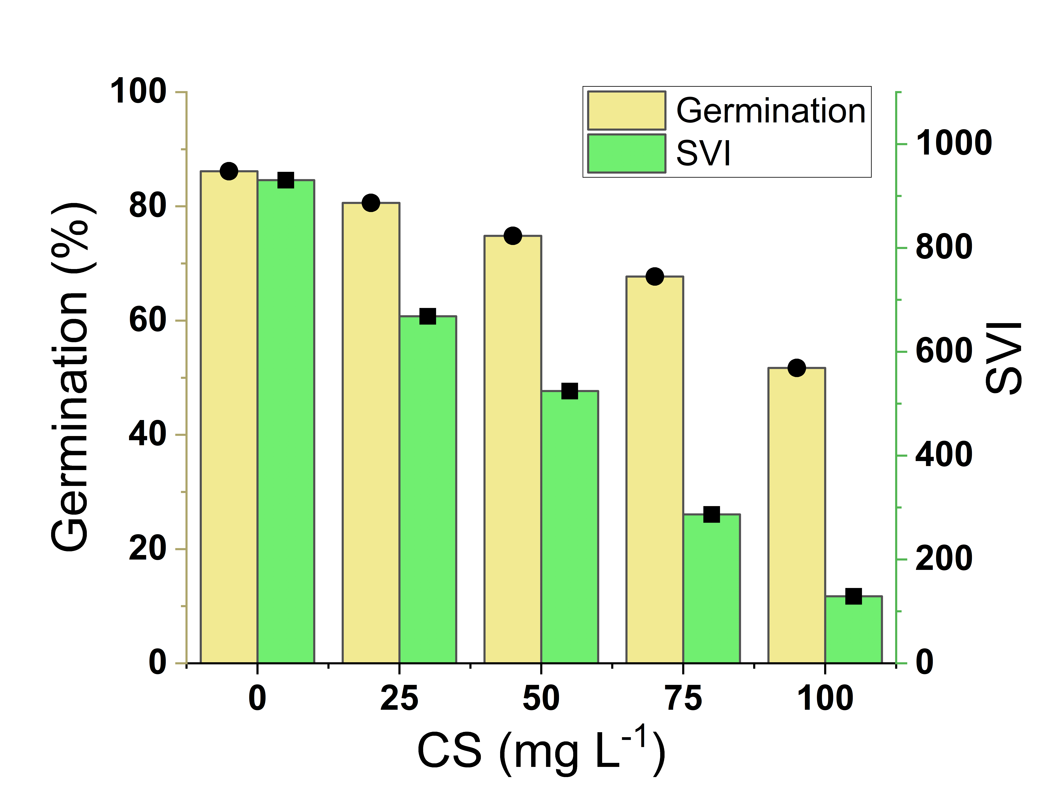

Figure 3. The germination percentage and seed Vigor index (SVI) under effect of chitosan concentration
Likewise, total seedling length decreased gradually from 9.67 ± 0.76 cm in control seedings to 2.50 ± 0.52 cm at the concentration of 100 mg L⁻¹. The percentage of seed germination also decreased with the increase in chitosan concentration, from 86.15 ± 0.04% on control to 51.70 ± 0.11% at the highest concentration tested.
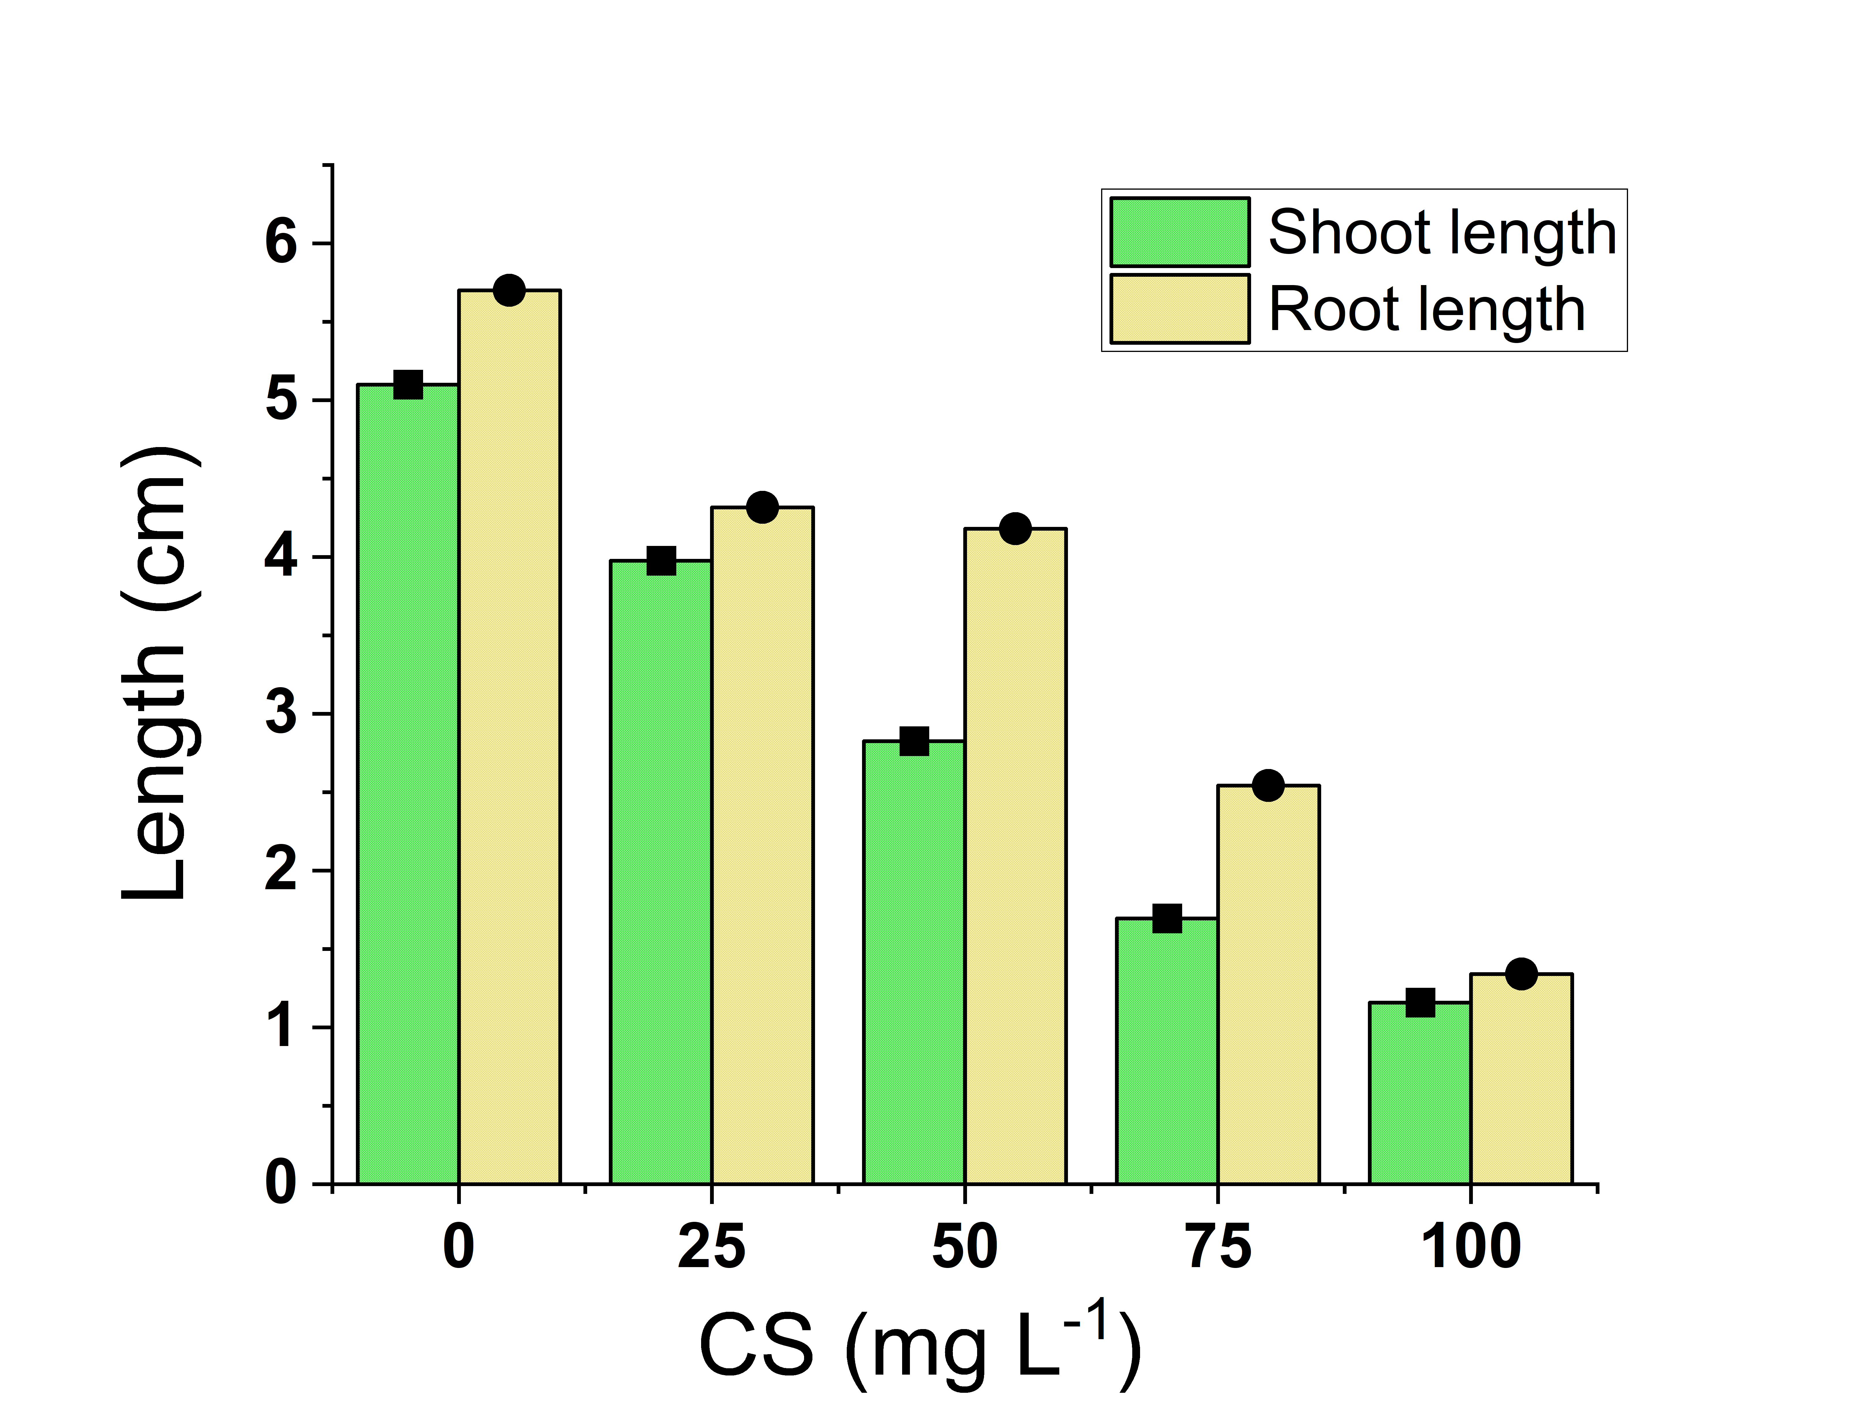

Figure 4. Influence of Chitosan concentration on the shoot and root length of mustard seedlings.

The Vigor Index of seed further showed significant decrease in all the treatments. The highest SVI value (930.42) was observed for control seedlings, while seedling performance was strongly affected when seedlings were treated with 100 mgL⁻¹ chitosan, the SVI decreasing to 129.22 (77% decreased compared to control).
In general, concentrations higher than 50 mg L⁻¹ resulted in the greatest inhibitory effects on seed germination and seedling growth.
Similarly, total seedling length declined progressively from 9.67 ± 0.76 cm in control seedlings to 2.50 ± 0.52 cm at 100 mg L⁻¹ concentration. Germination percentage also decreased with increasing chitosan concentration, falling from 86.15 ± 0.04% in the control to 51.70 ± 0.11% at the highest concentration tested.
The Seed Vigor Index showed substantial reduction across treatments. Control seedlings recorded the highest SVI value (930.42), whereas seedlings treated with 100 mg L⁻¹ chitosan exhibited a drastic decline to 129.22, reflecting severe impairment of overall seedling performance.
Overall, concentrations above 50 mg L⁻¹ produced substantial inhibitory effects on seed germination and seedling development.
3.3 Effect of Chitosan on Phytotoxicity and Stress Indices
The enhancement or reductions, from control influence parameters related to phytotoxicity, increased significantly due to exposure with chitosan like Relative Root Elongation (RRE), Tolerance index (TI) and percentage of phytotoxicity outline in figure 5.
The relative root elongation reduced progressively with elevated chitosan concentration. Seedlings from control maintained 100 % elongation, while seedlings treated with 100 mg L⁻¹ showed only 23.52 % relative elongation. Also, tolerance index values exhibited a nearly similar decreasing trend which reduced from 1.00 in control seedlings to 0.24 at the maximum concentration.
However, the percentage of phytotoxicity elevated gradually with increasing chitosan dosage. Great phytotoxicity was observed in the seedlings of the control group, while it increased to 24.27% at a concentration of 25 mg L⁻¹ and reached its maximum of 76.48% at a density between100 mg L⁻¹ level. The RRE/TI clearly exhibited a concentration-dependent toxic effect whereby as the concentration of chitosan increased, the phytotoxicity on mustard seedling growth was more pronounced (illustrated as the inverse relationship between RRE and TI).
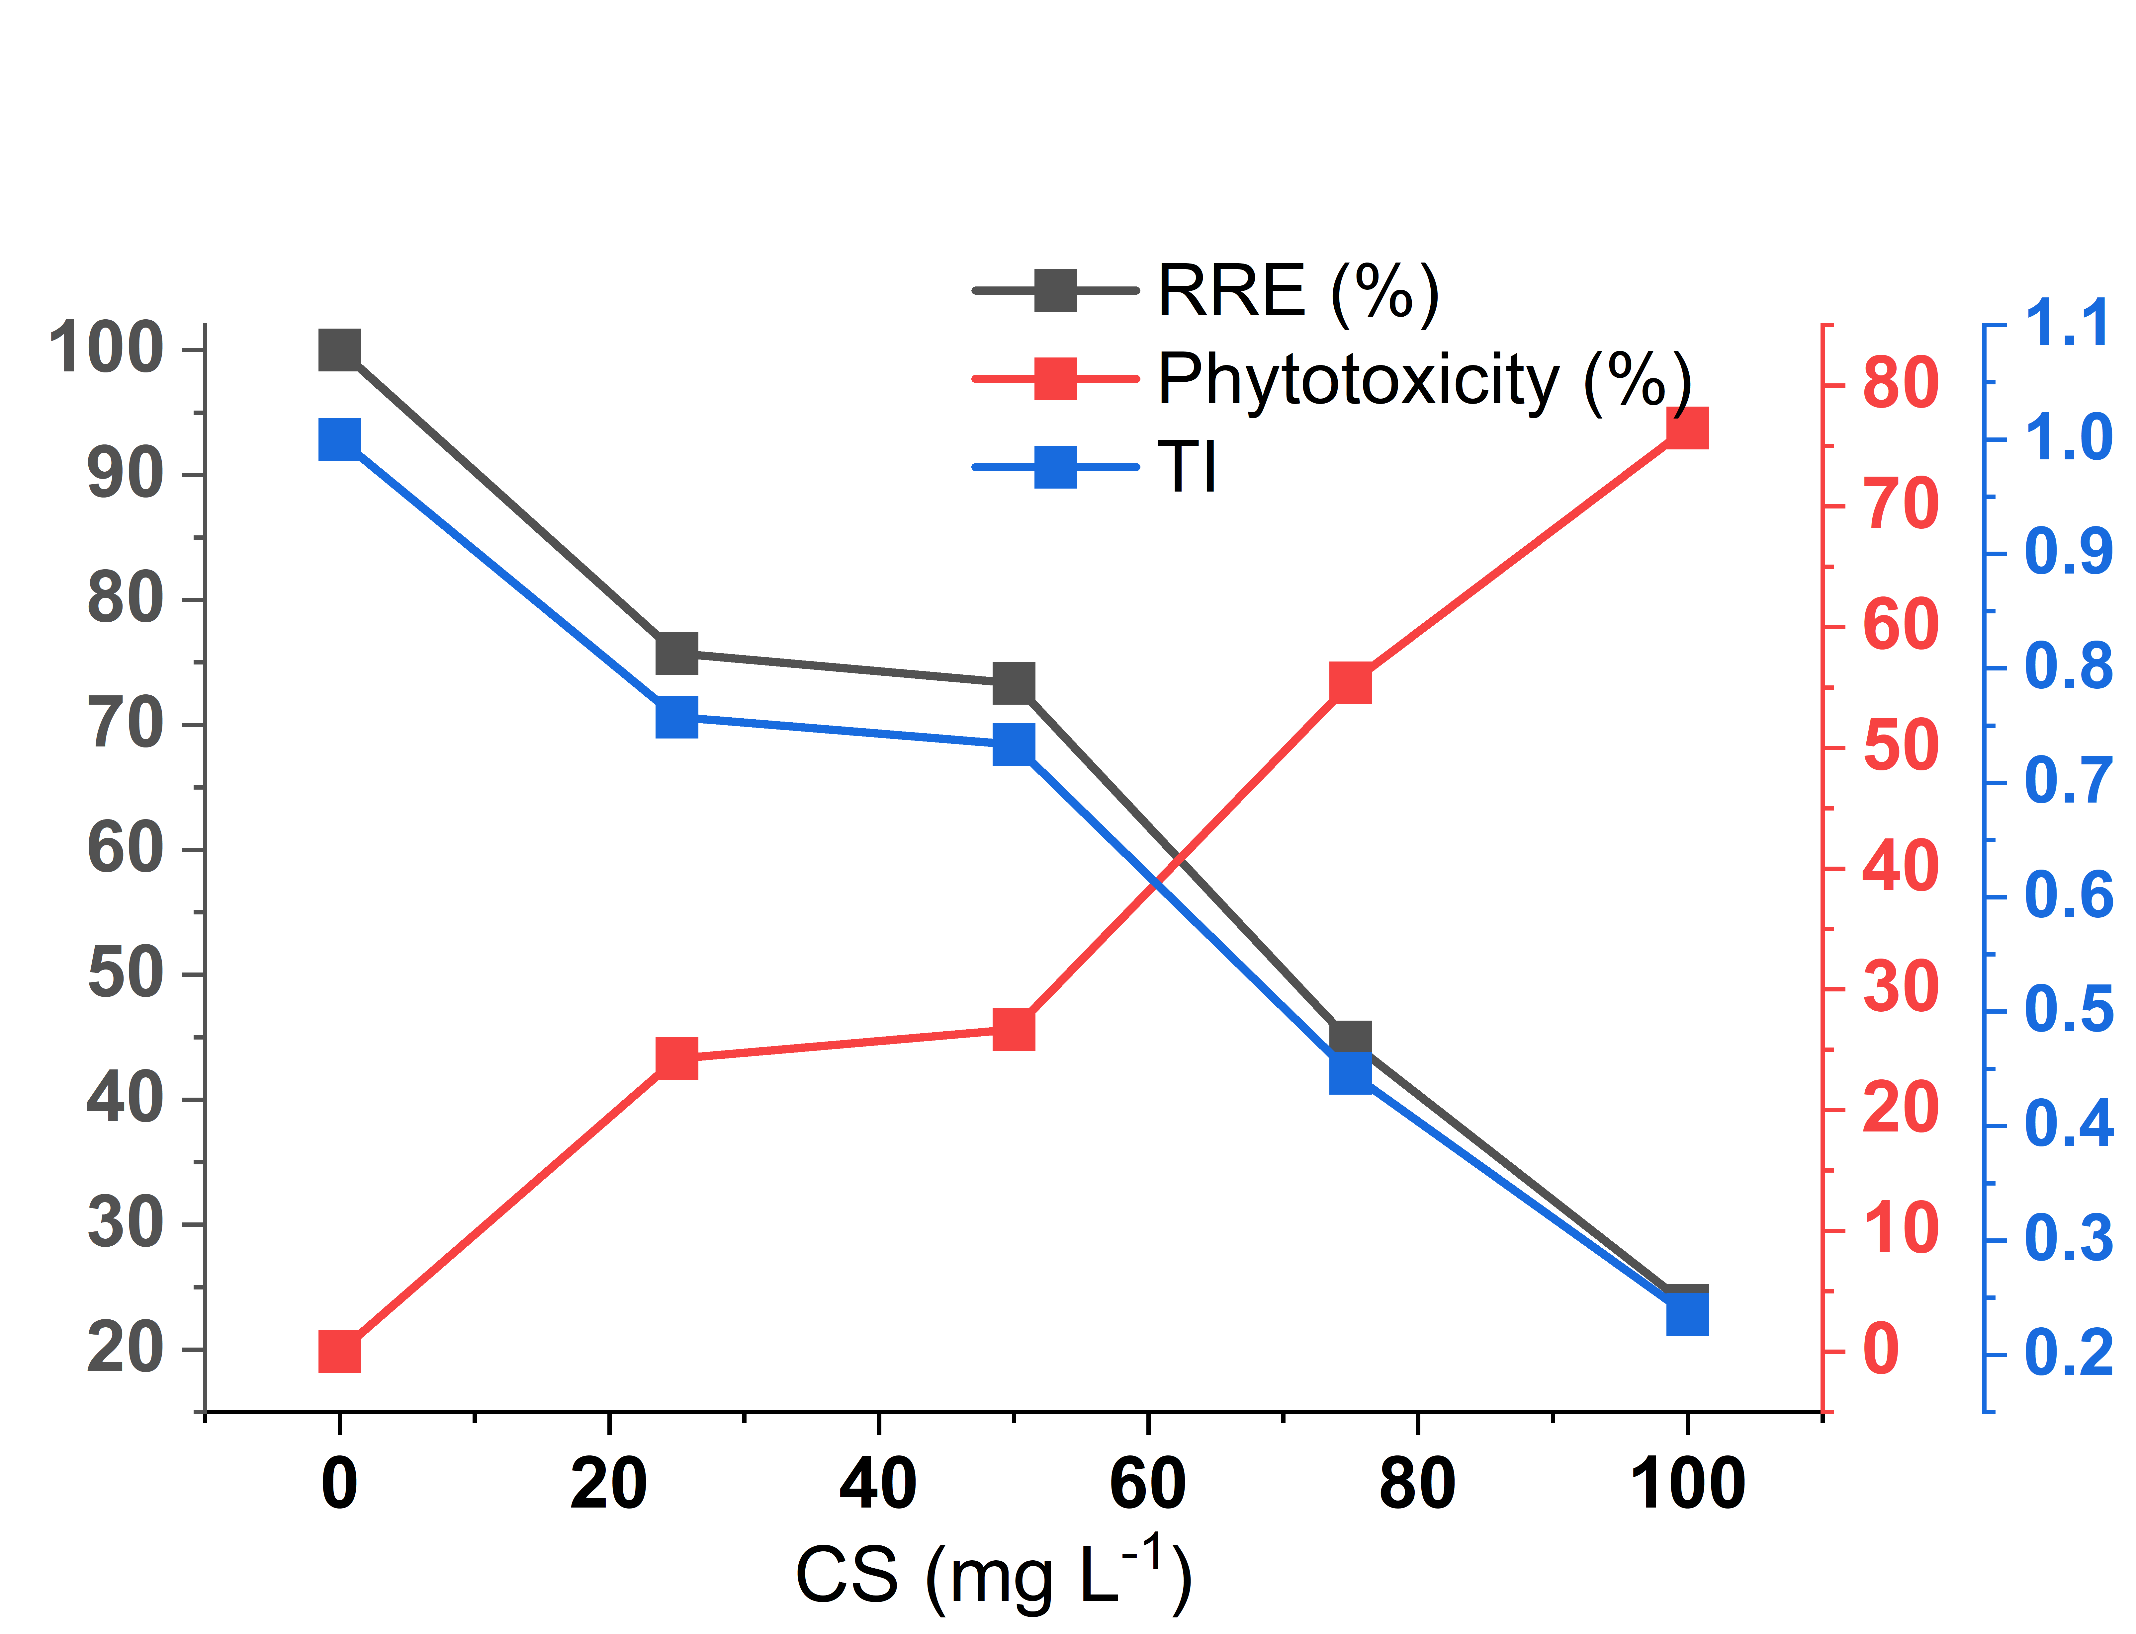

Figure 5. Effect of chitosan concentration on relative root elongation, tolerance index, and phytotoxicity percentage.

3.4 Effect of Chitosan on Biomass Accumulation and Water Content
Chitosan treatment mostly decreased biomass accumulation compared to non-treated control plants. The new and old biomass decreased with the increase in concentration.
Fresh biomass (610 ± 0.32 mg) and dry biomass (60 ± 30 mg) of control seedlings was highest. In comparison, for seedlings treated with 100 mg L⁻¹ inhibition was considerable and fresh and dry biomass decreased to 270 ± 0.02 mg and 24 ± 0.04 mg, respectively (Figure 6).
The variation in water content was relatively minor among treatments. The minimum water content (89.75%) was obtained at 50 mg L⁻¹ and the maximum value (91.11%) at 100 mg L⁻¹ concentration of CS treatment. Although total biomass accumulation was lower, treatment effects on water content were small (Figure 7).
These results suggest that increasing concentrations of chitosan negatively affected biomass production but had less effect on tissue water content.
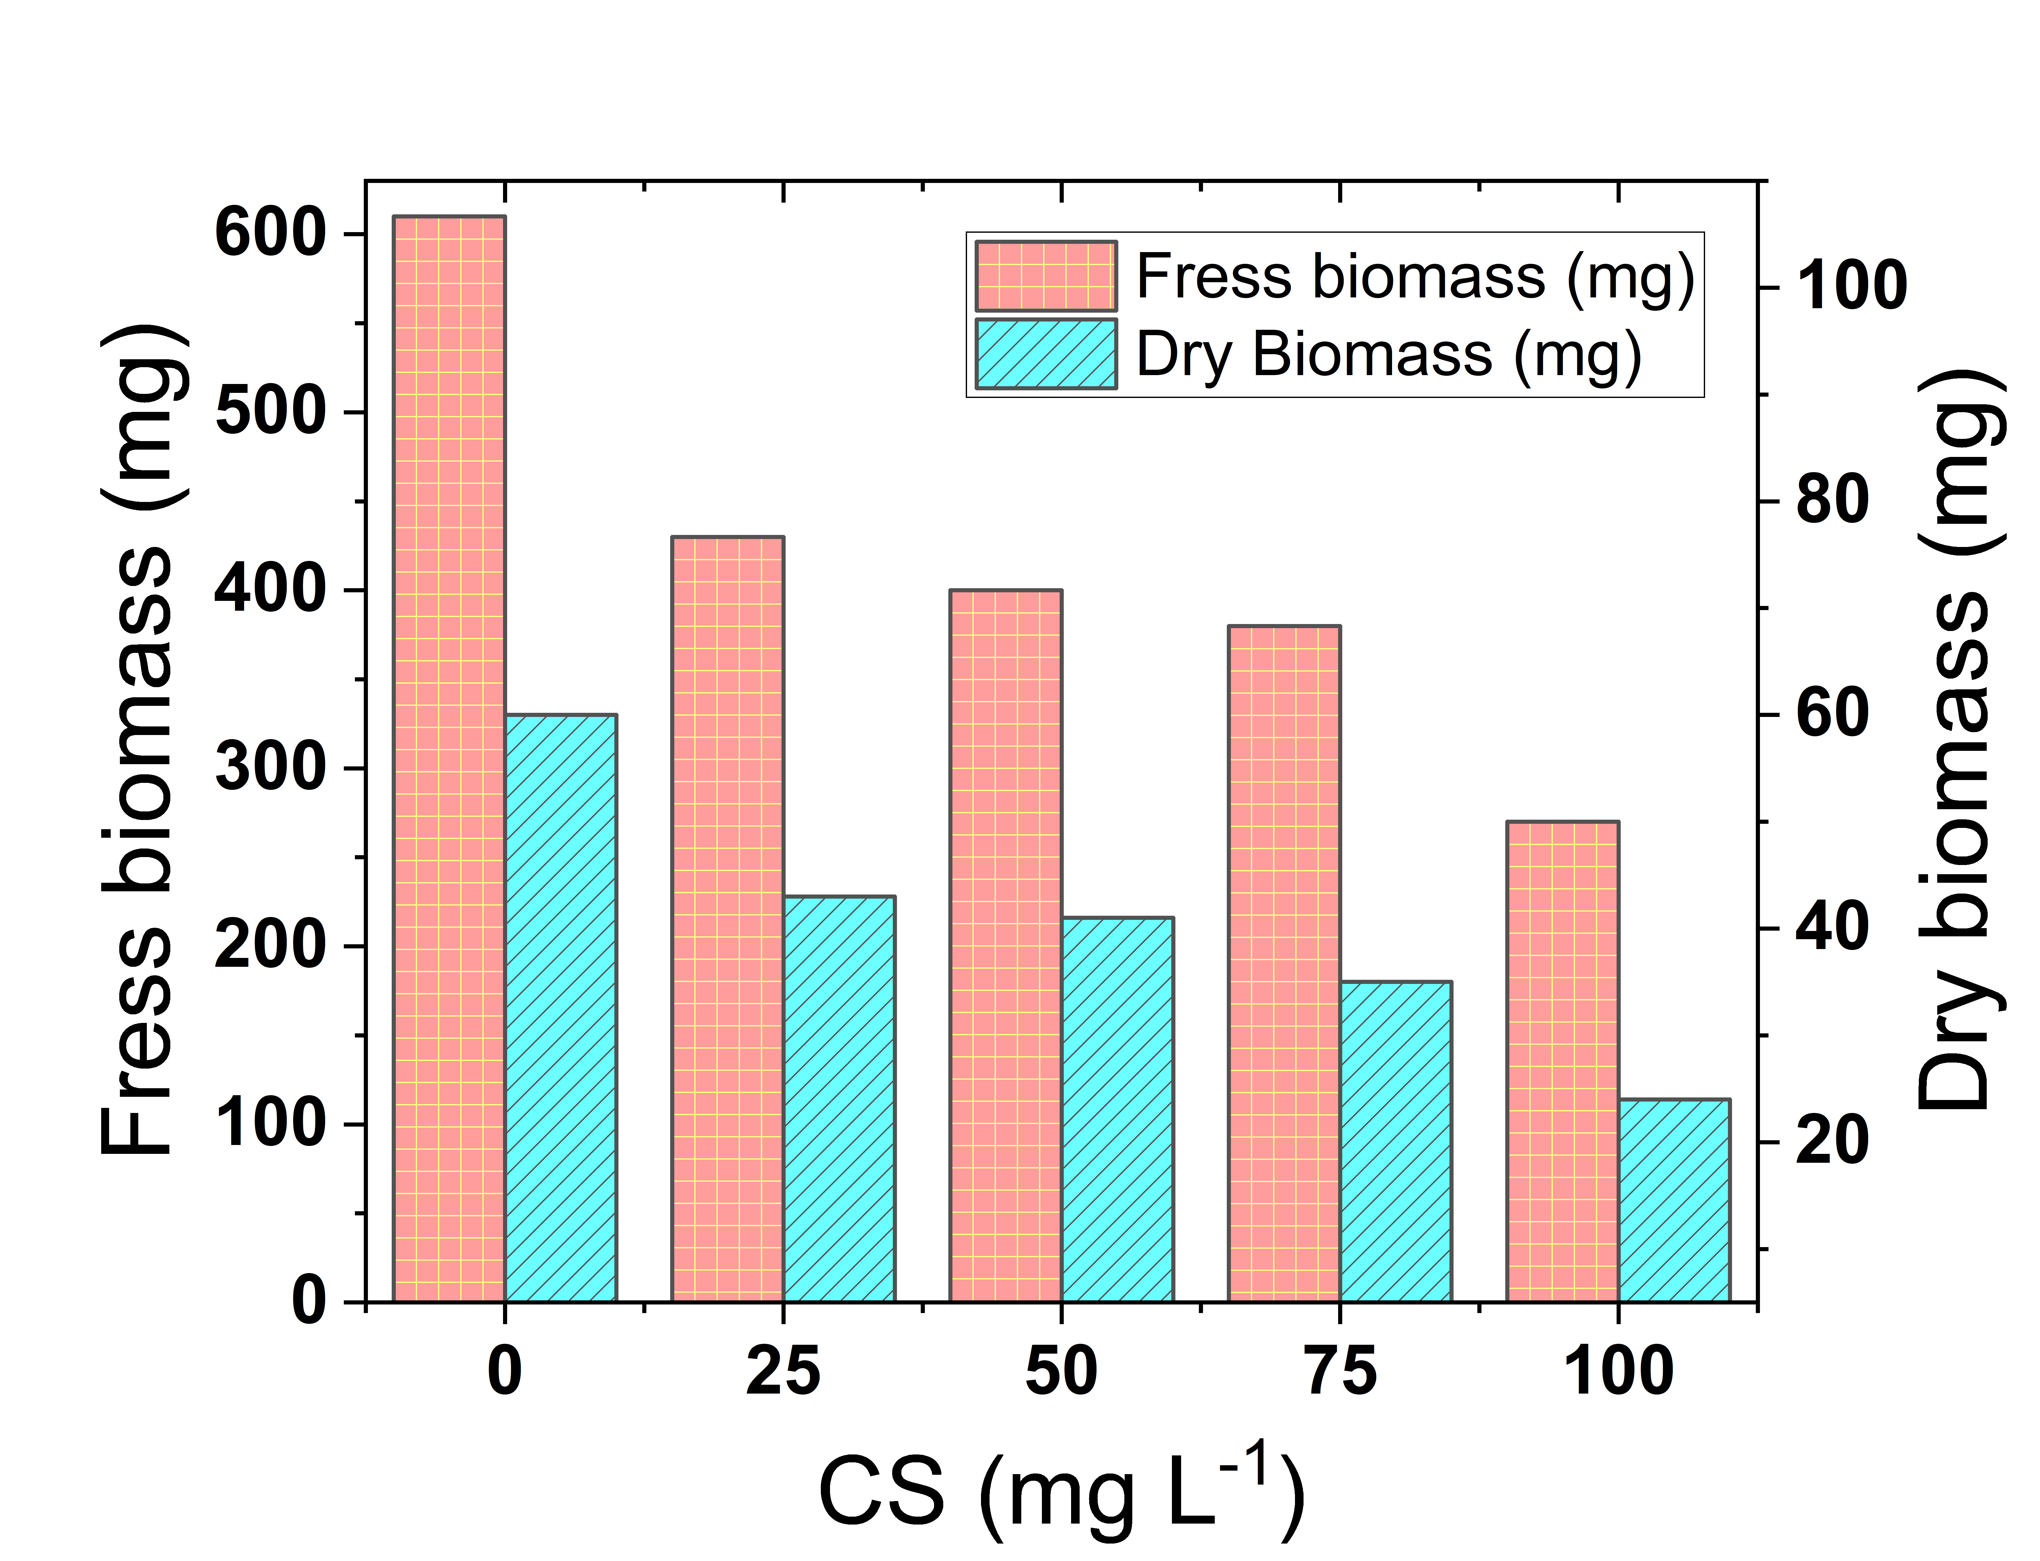

Figure 6. Influence of chitosan concentration on the fresh and dry biomass
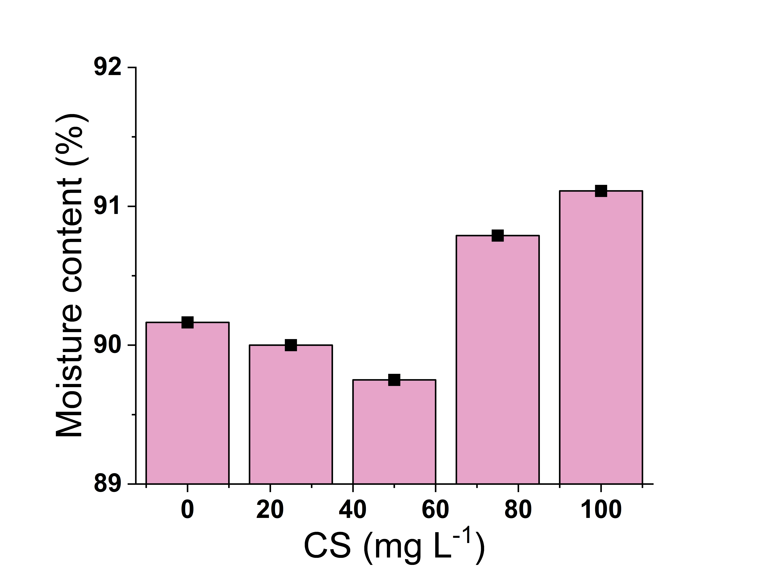

Figure 7. Influence of chitosan concentration on moisture content

4. Discussion
The present work demonstrated that shrimp shell-derived chitosan exerted a phytotoxic effect on Brassica juncea, in a concentration-dependent manner in germination, seedling growth and biomass accumulation. Based on FTIR analysis (Figure 2), deacetylated chitosan was successfully formed with the presence of characteristic absorption bands, which were broad O–H/N–H stretching at 3449 cm⁻¹, C–H stretching at 3233–2888 cm⁻¹ and amine-related vibrations around 1560 cm⁻¹ corresponding to bioactive functional groups (Alimi et al., 2023). The porous and heterogeneous surface morphology observed in SEM studies probably increases the surface area of the polymer and enhances seed–polymer interaction (Yang et al., 2010). These types of structural characteristics have been linked to show enhanced biological reactivity of chitosan on plant systems (Amaral et al., 2005).
In biological assays, seedlings showed progressively poorer germination and seedling performance with the increasing concentration of chitosan. At 100 mg L⁻¹, germination was reduced from an average of 86.15% in the control to 51.70%, showing a dramatic decrease in seed vigor index (930.42–129.22). This decline indicates impairment in the activation of enzymes and use of reserves at early germination stages. Similar inhibitory effects were documented by Li et al. (2019), who found that while greater doses (50 mg L⁻¹) decreased this promotive impact, 5 µg/mL chitosan nanoparticles improved wheat germination through increased auxin activity.
Root growth was significantly more inhibited than shoot growth, with root length decreasing from 5.70 cm in control to 1.34 cm at 100 mg L⁻¹ (~76% inhibition). The roots are more sensitive to treatment as they are bathed directly in the medium and meristematic tissues have a greater tendency towards growth inhibition. For instant, Lucini et al. (2018) found that the biopolymer at a high application rate (0.48 mL plant⁻¹) significantly decreased the growth-promoting effects found with a low application, highlighting that root and biomass enhancement was concentration-dependent and could be reduced by excessive application rates.
Dose responses were quantified using phytotoxicity indices, where yield losses showed a linear to exponential increase over time. At the highest concentration, relative root elongation and tolerance index were 23.52% and 0.24, respectively, while phytotoxicity increased to 76.48%. These inverse relationships are often linked to polymer toxicity, particularly with oxidative stress-induced cellular damage and associated metabolic dysfunction (Yang et al., 2017; Staszek et al., 2021). Accumulation of reactive oxygen species (ROS) induced by chitosan has been accepted as a main mechanism of growth inhibition at high concentrations (Mukarram et al., 2023).
Total biomass accumulation displayed a similar pattern, with decreases in fresh (610 mg to 270 mg) and dry (60 mg to 24 mg) biomass at the dose of 100 mL L⁻¹. This reduction is indicative of compromised cell expansion, reduced metabolic efficiency, and the shunting of energy from growth processes to stress response (Guan et al., 2009). In plants treated with high concentrations of chitosan, a reduction in carbohydrate utilization and biosynthetic activity was detected, which may have led to suppression of biomass generation (2009).
Notably, tissue water content did not differ among treatments (≈ 89.75–91.11%) reflecting that growth inhibition was not related to the water deficit effect. These provided evidence that chitosan stress deleteriously affected metabolic processes instead of plant water status, which was maintained by osmotic balance. Similar results have been stated for stress physiology in which biomass was reduced but relative water content remained unaffected (Ávila et al., 2023).
The results indicate a possible biphasic (hormetic) response of chitosan in Brassica juncea; low concentrations may stimulate plant growth, while higher doses (>50 mg L⁻¹) have phytotoxic effects. This dual response is well known and attributed to defence signalling stimulation at low doses and oxidative stress induction in higher doses (Rico-Chávez et al., 2023; Delgado-Rivera et al., 2026).
5. Conclusion
This investigation verified that the chitosan extracted from prawn shells had a porous, diverse surface shape and distinctive functional groups (O–H and N–H stretching, N–H bending, and C–N and C–O stretching vibrations), indicating proper extraction and strong reactivity. The seed germination experiment of Brassica juncea illustrated with the dose dependent response. The germination, seed vigor, root and shoot growth, biomass accumulation and tolerance index decreased linearly with the increase in the concentration of chitosan; nevertheless, do not give rise to an increment in total phytotoxicity. Root growth was the most sensitive parameter that was significantly inhibited at concentrations higher than 50 mg L⁻¹ and completely suppressed at 100 mg L⁻¹. Even though moisture content of seedlings seemed stable over treatments, significant decrements in biomass provide clear signs of growth suppression resulting from substantial metabolic and physiological impairment rather than water deficit.
In mustard seedlings, low concentrations of chitosan function as a bio stimulant while higher concentrations are deemed phytotoxic. Therefore, these results highlight the need to optimise agronomical application doses and provide insight into the physiological and oxidative stress mechanisms underlying growth inhibition that should be elucidated.

COMPETING INTERESTS DISCLAIMER:
Authors have declared that they have no known competing financial interests OR non-financial interests OR personal relationships that could have appeared to influence the work reported in this paper.

References
- Abo Elsoud, M. M., & El Kady, E. M. (2019). Current trends in fungal biosynthesis of chitin and chitosan. Bulletin of the National Research Centre, 43, 59. DOI: 10.1186/s42269-019-0105-y.
- Alimi, B. A., Pathania, S., Wilson, J., Duffy, B., & Celayeta Frias, J. M. (2023). Extraction, quantification, characterization, and application in food packaging of chitin and chitosan from mushrooms: A review. International Journal of Biological Macromolecules, 243, 124195. DOI: 10.1016/j.ijbiomac.2023.124195.
- Amaral, I. F., Granja, P. L., & Barbosa, M. A. (2005). Chemical modification of chitosan by phosphorylation: An XPS, FT-IR and SEM study. Journal of Biomaterials Science, Polymer Edition, 16(12), 1575–1593. DOI: 10.1163/156856205774576736.
- Ávila, R. G., Magalhães, P. C., Vitorino, L. C., Bessa, L. A., Souza, K. R. D., Queiroz, R. B., et al. (2023). Chitosan induces sorghum tolerance to water deficits by positively regulating photosynthesis and the production of primary metabolites, osmoregulators, and antioxidants. Journal of Soil Science and Plant Nutrition, 23, 1156–1172. DOI: 10.1007/s42729-022-01111-4.
- Bakhsh, M. Z. M., Ikram, M., Ali, A., et al. (2025). Heat stress-induced sterility in oilseed crops: A focus on Brassica napus. Molecular Biology Reports, 52, 652. DOI: 10.1007/s11033-025-10694-x.
- Carrera-Castaño, G., Calleja-Cabrera, J., Pernas, M., Gómez, L., & Oñate-Sánchez, L. (2020). An updated overview on the regulation of seed germination. Plants, 9(6), 703. DOI: 10.3390/plants9060703.
- Chakraborty, M., Hasanuzzaman, M., Rahman, M., Khan, M. A. R., Bhowmik, P., Mahmud, N. U., Tanveer, M., & Islam, T. (2020). Mechanism of plant growth promotion and disease suppression by chitosan biopolymer. Agriculture, 10(12), 624. DOI: 10.3390/agriculture10120624.
- Delgado-Rivera, V. A., Serrano-Fuentes, M. K., Rivera-Villanueva, J. M., Pérez-Sato, J. A., Bello-Bello, J. J., et al. (2026). Chitosan nanoparticles as a biostimulant during in vitro multiplication of vanilla using temporary immersion bioreactors. Molecules, 31(2), 328. DOI: 10.3390/molecules31020328.
- Gairola, K. C., Nautiyal, A. R., & Dwivedi, A. K. (2011). Effect of temperatures and germination media on seed germination of Jatropha curcas Linn. Advances in Bioresearch, 2(2), 66–71.
- Guan, Y. J., Hu, J., Wang, X. J., & Shao, C. X. (2009). Seed priming with chitosan improves maize germination and seedling growth in relation to physiological changes under low temperature stress. Journal of Zhejiang University Science B, 10(6), 427–433. DOI: 10.1631/jzus.B0820373.
- Hemmami, H., Ben Amor, I., Ben Amor, A., Zeghoud, S., Ahmed, S., & Alhamad, A. A. (2024). Chitosan, its derivatives, sources, preparation methods, and applications: A review. Journal of the Turkish Chemical Society Section A: Chemistry, 11(1), 341–364. DOI: 10.18596/jotcsa.1336313.
- Hidangmayum, A., Dwivedi, P., Katiyar, D., et al. (2019). Application of chitosan on plant responses with special reference to abiotic stress. Physiology and Molecular Biology of Plants, 25, 313–326. DOI: 10.1007/s12298-018-0633-1.
- Iber, B. T., Kasan, N. A., Torsabo, D., & Omuwa, J. W. (2022). A review of various sources of chitin and chitosan in nature. Journal of Renewable Materials, 10(4), 1097–1123. DOI: 10.32604/jrm.2022.018142.
- Islam, M. M., Haque, M. S., & Sarwar, A. K. M. G. (2019). Salt tolerance of cowpea genotypes during seed germination and seedling growth. Journal of Bangladesh Agricultural University, 17(1), 39–44. DOI: 10.3329/jbau.v17i1.40661.
- Karn, N., Saini, N., Kumar, A., Nautiyal, D., & Prasad, R. (2025). Sustainable practices in mustard [Brassica juncea (L.) Czem] farming: A comprehensive review. Journal of Agricultural Sciences – Sri Lanka, 20(3), 526–534. DOI: 10.4038/jas.v20i3.11104.
- Kumari, S., & Kishor, R. (2020). Chitin and chitosan: Origin, properties, and applications. In S. Ahmed & S. Ikram (Eds.), Handbook of Chitin and Chitosan: Vol. 1. Preparation and Properties (pp. 1–33). Elsevier. DOI: 10.1016/B978-0-12-817970-3.00001-8.
- Kushwaha, S. S., Singh, H., Singh, A., et al. (2026). A comprehensive review on modern pre-treatments and emerging technologies for seed germination. Discover Agriculture, 4, 102. DOI: 10.1007/s44279-026-00548-w.
- Lalarukh, Hussain, S. M., Ali, S., et al. (2024). Innovation of advanced polymers from seafood waste: Applications of chitin and chitosan. Polymer Advanced Technologies, 35(6), e6471. DOI: 10.1002/pat.6471.
- Li, J., Lens, P. N. L., Ferrer, I., & Du Laing, G. (2021). Evaluation of selenium-enriched microalgae produced on domestic wastewater as biostimulant and biofertilizer for growth of selenium-enriched crops. Journal of Applied Phycology, 33, 3027–3039. DOI: 10.1007/s10811-021-02523-y.
- Li, R., He, J., Xie, H., Wang, W., Bose, S. K., Sun, Y., et al. (2019). Effects of chitosan nanoparticles on seed germination and seedling growth of wheat (Triticum aestivum L.). International Journal of Biological Macromolecules, 126, 91–100. DOI: 10.1016/j.ijbiomac.2018.12.118.
- López-Bermúdez, L. S., Quintana-Obregón, E. A., Rosas-Burgos, E. C., Gálvez-Iriqui, A. C., Gutiérrez-Martínez, P., Lizardi-Mendoza, J., et al. (2024). Acute phytotoxicity and antifungal effect of nanochitosan particles on Colletotrichum fructicola with low susceptibility to chitosan. Current Microbiology, 81, 445. DOI: 10.1007/s00284-024-03909-0.
- Lucini, L., Rouphael, Y., Cardarelli, M., Bonini, P., Baffi, C., & Colla, G. (2018). A vegetal biopolymer-based biostimulant promoted root growth in melon while triggering brassinosteroids and stress-related compounds. Frontiers in Plant Science, 9, 472. DOI: 10.3389/fpls.2018.00472.
- Miransari, M., & Smith, D. L. (2014). Plant hormones and seed germination. Environmental and Experimental Botany, 99, 110–121. DOI: 10.1016/j.envexpbot.2013.11.005.
- Mukarram, M., Ali, J., Dadkhah-Aghdash, H., Kurjak, D., Kačík, F., & Ďurkovič, J. (2023). Chitosan-induced biotic stress tolerance and crosstalk with phytohormones, antioxidants, and other signalling molecules. Frontiers in Plant Science, 14, 1217822. DOI: 10.3389/fpls.2023.1217822.
- Nasirov, F. A., Abbasov, V. M., Suleymanova, E. M., Aslanbeyli, A. M., & Ahmedova, S. Z. (2023). Chitin and chitosan–Biopolymer materials of the 21st century. Processes of Petrochemistry and Oil Refining, 24(4), 778–824. DOI: 10.36719/1726-4685/96/778-824.
- Panjabi, P., Yadava, S. K., Kumar, N., Bangkim, R., & Ramchiary, N. (2019). Breeding Brassica juncea and B. rapa for sustainable oilseed production in the changing climate: Progress and prospects. In C. Kole (Ed.), Genomic Designing of Climate-Smart Oilseed Crops. Springer. DOI: 10.1007/978-3-319-93536-2_6.
- Rani, A. (2025). Effect of vermicompost-to-soil ratios on mung bean seed germination and growth. World Journal of Advanced Studies, 1(1), 17–23.
- Rico-Chávez, A. K., Pérez-Ramírez, I. F., Escobar-Ortíz, A., Feregrino-Pérez, A. A., Torres-Pacheco, I., & Guevara-González, R. G. (2023). Hormetic elicitation of phthalides in celery seeds (Apium graveolens L. var. dulce) and its effect on seedling development. Industrial Crops and Products, 202, 117022. DOI: 10.1016/j.indcrop.2023.117022.
- Staszek, P., Krasuska, U., Ciacka, K., & Gniazdowska, A. (2021). ROS metabolism perturbation as an element of mode of action of allelochemicals. Antioxidants, 10(11), 1648. DOI: 10.3390/antiox10111648.
- Verma, L., & Pandey, N. (2017). The effect of iron toxicity on seed germination and early seedling growth of green gram (Vigna radiata L. Wilczek). International Journal of Science and Research, 6(8), 1427–1428.
- Yang, B., Li, X., Shi, S., Kong, X., Guo, G., Huang, M., et al. (2010). Preparation and characterization of a novel chitosan scaffold. Carbohydrate Polymers, 80(3), 860–865. DOI: 10.1016/j.carbpol.2009.12.044.
- Yang, J., Cao, W., & Rui, Y. (2017). Interactions between nanoparticles and plants: Phytotoxicity and defense mechanisms. Journal of Plant Interactions, 12(1), 158–169. DOI: 10.1080/17429145.2017.1310944.
- Zahedi, S., Safaei Ghomi, J., & Shahbazi-Alavi, H. (2018). Preparation of chitosan nanoparticles from shrimp shells and investigation of its catalytic effect in diastereoselective synthesis of dihydropyrroles. Ultrasonics Sonochemistry, 40(Pt A), 260–264. DOI: 10.1016/j.ultsonch.2017.07.023.

